Submission to the Regional Economic Development Strategy and Service Model Review
Department of Economic Development, Jobs, Transport and Resources (DEDJTR)
April 2015

Table of Contents
- Introduction 3
- Recommendations 4
- Manufacturing’s role in Victorian Regional Growth 5
  - Food Processing 7
  - Engineering 7
- Regional Service Delivery 9
- Education and Training 10
- ICT/Broadband Capacity 13
- Energy and Environmental Costs 14
Principal contact person for the report: Jim Dannock

Introduction

The Australian Industry Group (Ai Group) welcomes the opportunity to make a submission to the review of the Victorian Government’s Regional Economic Development Strategy and Service Delivery Model.
The Ai Group represents businesses across industries including manufacturing, construction, transport and services. Our members operate throughout the country, in rural, regional and metropolitan Australia. In Victoria, Ai Group is actively involved with regional members through our offices in Ballarat, Bendigo and Albury/Wodonga.
Ai Group believes that good policy settings by federal, state and local governments are central in ensuring Australian businesses can be globally competitive. Reforms that reduce costs for business and help industry to grow, raise productivity and create sustainable and challenging jobs are keys to the future of Australian industry - including those in regional Victoria. This includes, but is not limited to, help in expanding into overseas markets, skills development, a flexible workplace relations system, infrastructure development, encouraging innovation and reducing red tape.
We have proposed policies that would benefit Victorian industry including the regions in our Victorian budget submission and pre-election statements and we have attached copies of these submissions below.
In the current submission we complement the more general policies put forward in the pre- election and budget submissions with a more focussed emphasis on the manufacturing industry in regional Victoria. While Ai Group is a broad-based industry association, we retain a particularly strong presence in the manufacturing sector and in view of the extent of the structural challenges this sector is experiencing, we felt that a focus on manufacturing was particularly relevant.
Manufacturing has played a major part in the growth of regional economies in Victoria. The sector should be a key part of a regional development strategy to ensure the region remains diversified. This submission examines the contribution the industry makes to regional Victoria and the types of manufacturing. We then step through some key recommendations specific to regional Victoria on government service delivery, education and training, ICT, and energy and environment. Our recommendations are listed below and we would welcome the opportunity to meet with the External Advisory Board.

Recommendations

We recommend that the Victorian Government:
  - continue the strong focus on regional development and encouraging regional industry to thrive, including programs that support the growth and competitiveness of manufacturing through encouraging innovation in regional Victoria;
  - ensure government funding decisions take into account the full benefits of investing in manufacturing in regional areas;
  - encourage regional industry clusters to develop;
  - provide clear points of contact within Government for industry in regional Victoria;
  - develop strategies with industry to improve the engagement of students in STEM skill areas in regional Victoria;
  - continue to advocate for the roll out of high-speed internet to regional Victoria; and

  - consider the impact on the competitiveness of regional manufacturers from regulatory changes in the energy and water sectors.

Manufacturing’s role in Victorian Regional Growth

The manufacturing sector has a high flow on impact to the local economy through the goods and services it purchases. Regional manufacturers are being penalised when investing in their business to make them more competitive and productive, when the policy outcome required to access government support is linked to the number of jobs created. Contributions to the region’s growth in economic output and value add should also be a consideration.
Manufacturing in regional Victoria has faced many of the challenges seen at the national level in recent years. The persistently high Australian dollar, which has only recently returned to long-run levels, together with the lingering effects of the global financing crisis, and an escalation in energy costs has put the industry under significant competitive pressure. The result has led to a closure of some businesses and the restructure of many businesses together with jobs losses. However, the industry remains an important driver of economic activity throughout regional Victoria and contributes to a diversified economy.
While gross regional product (GRP) for manufacturing in regional Victoria from the ABS is not available, modelling by REMPLAN for a number of key regions highlights the contribution manufacturing makes to regional Victorian economies. For the Loddon Mallee region manufacturing is the largest contributor to GRP at $6.95 billion or 24.05% of the total GRP (Graph 1). It is a similar story for the Grampians region at $4.948 Billion or 24.06% (Graph 2)1.
There are considerable flow-on benefits of the manufacturing sector with regional exports of $3,286 billion or 48.0% of total region exports and $2,392 billion or 45.6% for the Loddon Mallee and Grampians regions, respectively. Value added by the manufacturing sector is $1.477 billion or 11.1% of total region value add and $1,108 billion or 10.9% for the Loddon Mallee and Grampians regions, respectively.
However, ABS employment data highlights the challenges regional manufacturers have experienced in recent years. Over the decade to 2011, employment in the manufacturing sector in regional Victoria declined by 15.5% or 9,884 jobs to 71,868. This contrasts with an 11.6% or 62,272 jobs increase all sectors in the region2. The experience of manufacturing in regional Victoria is reflects a national trend for manufacturing as it faced increasing global competition and a sustained period of a high Australian dollar.

1 REMPLAN Regional Economic Modelling, 2014. http://www.economicprofile.com.au/ [7 April 2015] 2 Australian Bureau of Statistics, Expanded Community Profile Greater Melbourne and rest of Victoria, (2001, 2011) www.abs.gov.au/websitedbs/censushome.nsf/home/data?opendocument#from-
banner=LN [7 April 2015]

Chart 1 – Economic Output – Loddon Mallee Region2

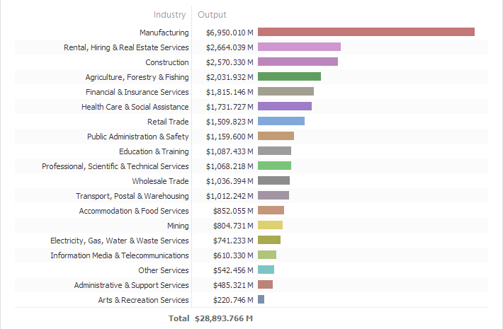
Manufacturers are leading the increase in productivity in the regional economy with investment in innovative new products and business processes.
Chart 2 – Economic Output – Grampians Region2

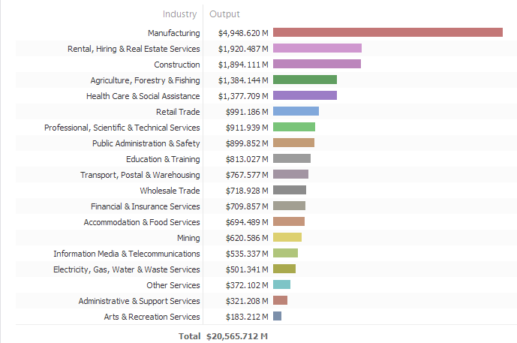

Variations within regions
Regional Victorian manufacturing has evolved from the competitive advantages of manufacturing in the region together with policy decisions of governments and global forces. This has included decentralisation policies by state governments, support for investment in key infrastructure, programs to attract skilled labour, and support for tertiary education delivery.

Since the commencement of Regional Development Victoria in 1999, there has been a strong focus on regional development policy including dedicated funding to support regional communities; the Regional Infrastructure Development Fund (RIDF) and the Regional Growth Fund (RGF). This funding has included investment support for industry. These policy directions have clearly delivered significant investment in regional Victoria and need to continue. In addition to the investment occurring in manufacturing, regional centres are becoming preferred destinations for attracting skilled workers and their families for lifestyle reasons.

Food Processing

Food processing initially built a dominant place in regional manufacturing given the advantage of being close to its source of supply. Improvement in transport and logistics now means that proximity to supply is not as critical, so food processing has consolidated its investment in regional Victoria to achieve economies of scale in its operations. The supply chain relationship has changed with the demise of the traditional agricultural cooperative.
Food processing has clustered around areas with access to competitively-priced water and energy. The Goulburn Murray Irrigation District supports agriculture in NSW along the Murray and there is a greater concentration of food processors in the Goulburn Valley where there is significant access to natural gas. In Victoria, food processing is supported by natural flow of water and access to natural gas.
Regional manufactures are feeling the pressure on their global competitiveness of increasing water and energy prices. While some traditional food processors are growing larger, small-to-medium enterprises (SME) are becoming an increasingly important part of the industry. SMEs are more integrated along the supply chain developing their business based on provenance; paddock to plate. These businesses will generally develop higher margins in their business and in most instances are export-focused.

Case Study
Kagome Australia is a tomato and vegetable processor in Echuca. They are concerned about increasing water and energy costs compared to their main competitors in California. They project that their natural gas price will be $A10 GJ by 2017 compared to $A4.60/GJ in California. They access water through the water trading market, and require a competitive and transparent market so they can best plan and manage risk within their business.

Engineering

Engineering firms are also a key part of the manufacturing sector in regional Victoria. These businesses have developed through locating close to customers but also benefited from decades of decentralised policies of government supporting their relocation outside metropolitan areas.
This part of the manufacturing sector has been hit the hardest by global competition and the major restructure of the manufacturing sector. This includes suppliers to the car industry that have restructured their businesses in light of reduced demand and the pending closure of the car industry by 2017.
There are a number of defence industry companies operating in regional Victoria including Tier 1 suppliers who are developing commercial relationships with other regional suppliers.The Victorian Government’s policies on procurement have a significant impact on regional manufacturers. There are a number of regionally based original equipment manufacturers (OEM) that provide benefit the regional economy through the supply of government procured goods and services.
Innovation in product and business processes is a key focus for this grouping of regional manufacturers into the future. That innovation will need to be supported through access to a skill workforce and programs to support innovation.

Regional Service Delivery

For the past 15 years, Victoria has been the leading State in the delivery of regional development outcomes that have supported the growth of regional and rural centres. This has included discretionary funding that has supported the investment in a significant number of government, business and community programs and projects. It is important that this regional development focus continues.
Strategic planning for regional development has largely been the responsibility of local government, local advocacy groups (e.g. Committee for Ballarat) and regional planning committees such as the Regional Development Australia. This is best described as a “place based” approach.
The Terms of Reference are seeking views on other models of service delivery. There have been a number of networks/clusters developed over the years with varied success involving a group of like-minded businesses within a particular industry sector. These can vary from informal networks to commercially-focused clusters. Generally, their formation is through an evolution of these approaches. We see a role for Regional Industry Clusters being supported by government which involves groupings of manufacturers in regional areas.
The Ballarat Industry Innovation Group was funded from the previous Manufacturing Productivity Network as part of an “industry” policy outcome, when in fact it also delivers a regional development outcome.
SMEs in the food processing sector have different needs than larger manufacturers in regional areas. They are generally involved in all aspects of the supply chain and would benefit through greater government support for cluster activities.
From the original focus of Regional Development Victoria (RDV) as autonomous government agency and a single point of contact for regional business, there have been changes that have seen RDV more integrated into different departments. This has become more confusing for business and harder to engage with the Government. Ai Group would recommend that the RDV build stronger relationships and clearer points of contact with industry in the regions.

Education and Training

Regional economies have varied access to education and training depending where they live. Regional tertiary institutions have traditionally delivered education and training according to the need for a particular region. But the recent move to a “demand-driven” model means these institutions are developing strategies to grow their business within their areas of competitive advantage. This change has meant the loss of some training and education courses in regional areas, but presents opportunities for new models of delivery to meet the skills needs of the future regional workforce.
Table 1 – Non-School Qualification by Industry and Region

Qualifications by Industry | Metropolitan Victoria |  |  |  | Regional Victoria
 | Higher Education | Vocational | No Post School Qualification | Higher Educatio | Vocational  n | No Post School Qualification
Accommodation and food services | 14.5% | 26.7% | 58.8% | 5.7% | 28.5% | 65.8%
Administrative and support services | 24.5% | 29.1% | 46.4% | 8.5% | 34.6% | 56.9%
Agriculture, forestry and fishing | 18.4% | 27.1% | 54.5% | 8.0% | 30.1% | 62.0%
Arts and recreation services | 30.9% | 27.4% | 41.7% | 16.6% | 34.5% | 48.9%
Construction | 9.5% | 51.6% | 38.9% | 3.7% | 57.0% | 39.3%
Education and training | 65.0% | 18.5% | 16.6% | 57.9% | 24.4% | 17.6%
Electricity, gas, water and waste services | 34.9% | 31.0% | 34.1% | 15.7% | 50.7% | 33.6%
Financial and insurance services | 47.7% | 21.6% | 30.7% | 22.3% | 30.8% | 46.9%
Health care and social assistance | 46.2% | 29.9% | 23.9% | 34.4% | 38.6% | 27.0%
Inadequately described/Not stated | 18.8% | 24.4% | 56.8% | 6.8% | 26.5% | 66.7%
Information media and telecommunications | 43.1% | 24.4% | 32.5% | 21.2% | 34.7% | 44.1%
Manufacturing | 18.9% | 34.1% | 47.0% | 7.9% | 41.6% | 50.4%
Mining | 47.5% | 27.3% | 25.2% | 11.5% | 48.4% | 40.1%
Other services | 17.2% | 51.0% | 31.8% | 7.7% | 58.4% | 33.9%
Professional, scientific and technical services | 60.8% | 18.9% | 20.3% | 41.8% | 29.1% | 29.2%
Public administration and safety | 41.4% | 29.5% | 29.1% | 24.0% | 40.2% | 35.8%
Rental, hiring and real estate services | 25.5% | 35.3% | 39.2% | 11.6% | 42.8% | 45.6%
Retail trade | 16.8% | 23.4% | 59.8% | 6.0% | 26.2% | 67.8%
Transport, postal and warehousing | 16.7% | 29.9% | 53.4% | 5.0% | 32.0% | 63.0%
Wholesale trade | 25.0% | 27.2% | 47.9% | 7.6% | 33.9% | 58.4%
Total | 32.0% | 29.3% | 38.7% | 17.6% | 36.3% | 46.1%
The regional workforce has a lower level of non-school qualification when compared to the metropolitan areas. Table 1 shows the breakdown of tertiary and non-tertiary qualifications by industry in the regional and metropolitan workforces in Victoria.

Higher education qualifications for employees in metropolitan Victoria are nearly double at 32.0% of the total metropolitan workforce, compared to 17.6% of the total regional workforce. A regional economy has relied on a greater proportion of its workforce having vocational qualifications compared to the metropolitan area. Regional Victoria has a higher proportion of employees not holding a non-post school qualification at 46.1%, compared to 38.7% in metropolitan Victoria.
Table 2: Change in number of government subsidised enrolments by delivery region, 2009 to 20143
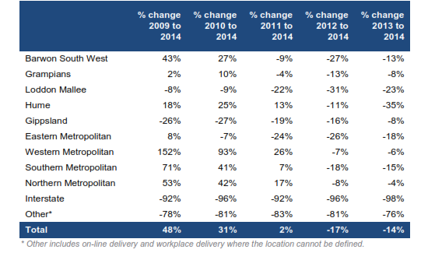
Data from the Victorian Department of Education and Training indicates a significant reduction in government subsidised enrolments in training from 2013 to 2014. There were declines in all regional areas in the range of 8 to 35 per cent.
In addition to this decline there is also a significant decline in the number of enrolled students in training in regional areas from 2013 to 2014. Two regional areas, Loddon Mallee and Gippsland, now have lower numbers in training compared to 2009. These low levels of participation and government subsidised training places represent a serious challenge to the development of workforce skills in regional areas of Victoria.
In the manufacturing sector only 7.9% of the regional workforce has higher education qualifications, 41.6% having vocational qualifications, and 50.4% having no post school qualification. For metropolitan Victoria this is 18.9%, 34.1% and 47.0%, respectively.
Regional manufacturing falls behind in attracting university qualified workers, with a greater dependence on the vocationally qualified workforce. This is in contrast to the Education & Training and Health Care & Social Assistance sectors where the qualification profiles in higher education and VET are more closely correlated. For manufacturers to compete in the future, the qualification mix needs to change with university-qualified employees, needing to represent a larger proportion of the workforce. The accompanying case study from Keech Australia is an example of the changes occurring in the sectors skills mix.

3 Victorian Training Market Report 2014, Department of Education and Training, March 2015.

Table 3: Students enrolled in government subsidised training by region, 2009 to 20144

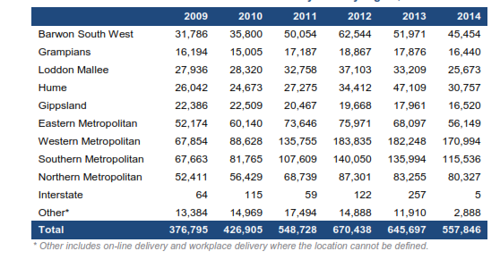
Key regional manufacturing sectors such as engineering and food processing will rely heavily on a workforce with STEM skills. In March 2015, the Ai Group released the Progressing STEM Skills in Australia⁵ report which highlighted the increasing importance of STEM (Science, Technology, Engineering and Mathematics) skills in the Australian workforce. The report highlighted that the participation of primary and secondary students in STEM related subjects is decreasing and performance is below many countries in international comparisons. Participation by university students in STEM related disciplines is not keeping pace with the needs of the economy.
The ability to bridge the gap between regional Victoria and metropolitan areas will depend on how well government, schools, tertiary institutions and business work together into the future. The Victorian Government’s past commitment to Trade Training Centres has better resourced schools and supported an uptake of VET subjects in schools. We also support the commitment of the Victorian Government to investment in Technical Colleges. Important to the success of this initiative will be local industry involvement as well as a focus on developing the STEM skills of young people.

4 Victorian Training Market Report 2014, Department of Education and Training, March 2015. 5 The Australian Industry Group, Progressing STEM Skills in Australia (March 2015) http://www.aigroup.com.au/portal/site/aig/policy/reports/

ICT/Broadband Capacity

As regional manufacturers become more integrated into global markets, the need to transfer information reliably and quickly around the global is paramount to their success.
Ai Group research⁶ found that 75 per cent of businesses see high-speed broadband as important to their business over the next two to three years. However, the majority have not begun to prepare for the NBN. This is largely due to perceptions that the NBN will not be available to the business in the short to medium term and a perception that businesses are not a priority in the rollout.
Not all business users feel that the rollout of the network is urgent, as around 60 per cent are satisfied with their current infrastructure. Yet for the minority who are dissatisfied - more likely to be small-to-medium businesses or businesses in outer metropolitan or regional areas – the need for better infrastructure is acute. This is particularly more difficult for rural manufacturers who may not be able to reliably connect to their system at parent companies elsewhere in the world.

6 The Australian Industry Group, The Business End of Broadband: What Businesses Want from High-Speed Broadband (October 2013) www.aigroup.com.au/policy/reports/archive2014.

Energy and Environmental Costs

Regional manufacturers face similar wholesale prices for electricity and gas, but generally face a higher cost impost for access to these energy sources.
In January 2015, electricity networks servicing regional areas increased their charges by 15- 18%. This has increased annual costs for some regional manufacturers by hundreds of thousands of dollars. This amount is determined by the Australian Energy Regulator and is passed on as a separate cost to the charges for electricity use. While regional manufacturers have benefitted from a reduction in wholesale electricity prices driven by reductions in demand, they have little ability to avoid rising network costs – particularly since networks have often responded to increased energy efficiency by shifting emphasis to fixed charges. Manufacturers are heavily exposed to international competition and have little ability to recover cost increases through higher prices to customers.
The total cost of service for electricity supply is higher in regional Victoria, and since 2011 regional electricity users have endured the highest cumulative increase in network charges: 103% for SP Ausnet (Eastern Victoria) and 54% for Powercor (Western Victoria).
The market for gas on the East Coast of Australia is being transformed by the development of new LNG export facilities in Queensland, which will link these gas markets to international gas prices for the first time in history. Gas supply is tight and domestic contracting very challenging, primarily because of uncertainty about the ability of coal seam gas developments to achieve the huge and rapid ramp up required to meet LNG export commitment.
Economic modelling commissioned by the Australian Industry Group⁷ found that the impact on Victorian manufacturing from a plausible scenario for rising gas prices would be more than $24 billion in cumulative lost output to 2021, in net present value terms.
Gas prices are still rising, despite a likely-temporary drop in global oil prices, and manufacturers are finding it difficult to secure long term supply at prices that make them competitive. Access to competitively price natural gas is critical for many regional manufacturers, particularly in food processing sector.
There are increased costs to regional manufacturers of meeting ever increasing environmental standards. These costs impact on their competitiveness and regional policy needs to deliver programs that support manufacturers to reduce their waste and use energy more efficiently.

7 Deloitte Access Economic, Gas market transformations – economic consequences for the manufacturing sector (July 2014) www.aigroup.com.au/policy/reports/archive2014.

