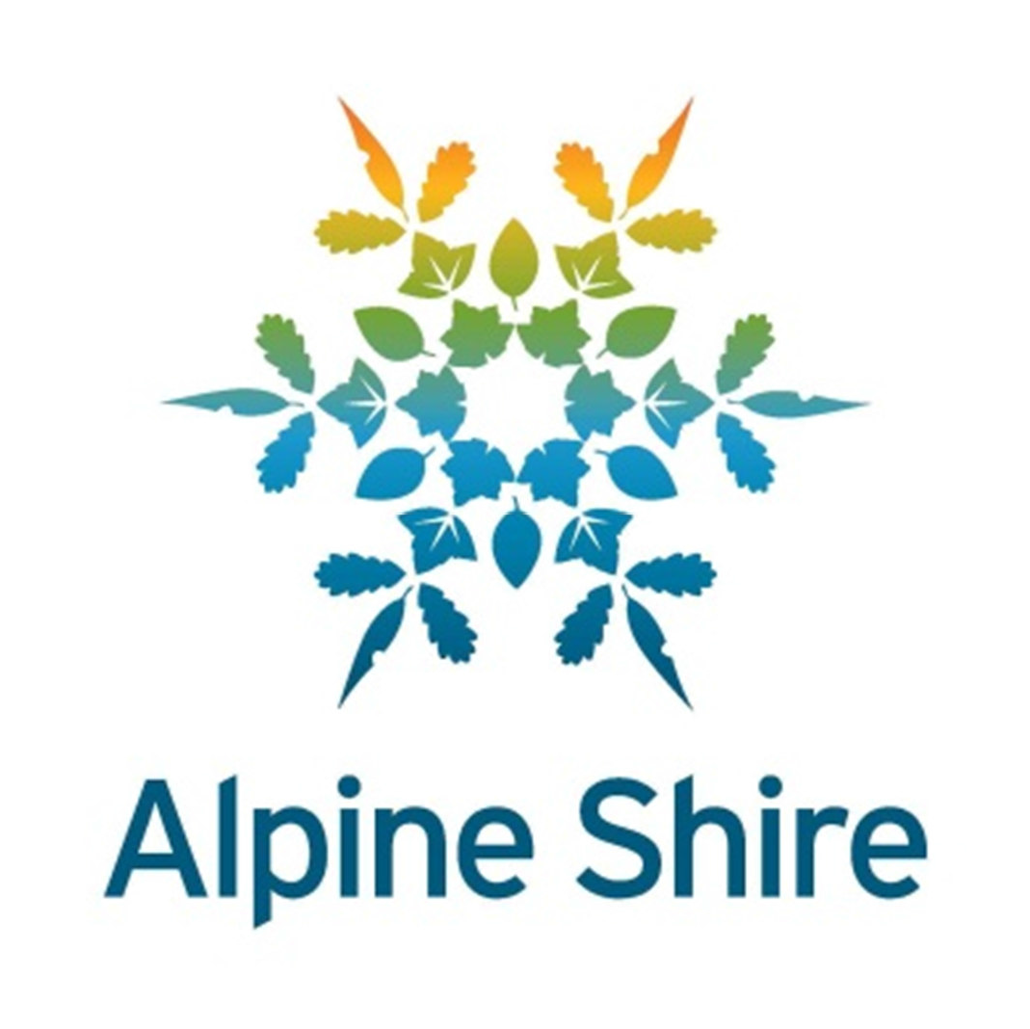21 April 2015
The Hon. Jaala Pulford MP
Minister for Agriculture, Minister for Regional Development 8 Nicholson Street
EAST MELBOURNE VIC 3002
Dear Minister,

Review of the Department of Economic Development, Jobs, Transport and Resources' Regional Service Delivery Model and Strategic Directions for Regional Policy.
Thank you for the opportunity to provide input into the review of DEDJTR’s regional service model with a particular focus on driving sustainable growth in regional and rural areas of Victoria.
Alpine Shire Council is appreciative of the opportunity to contribute to the review and requests that this contribution be included as a submission to the review.
Primarily Council considers that there is a great need for the continuation of the role of Regional Development Victoria. This agency has performed a vital role as partner and facilitator of an extensive range of community infrastructure and economic development projects in the Alpine Shire and across Victoria.
The development of the Hume Regional Growth Plan also provides a framework for the development of the regional components of the Hume region leaving local initiatives to Local Councils. There is an urgent need to ensure that the momentum gained through the development of the plan and local programs is continued, so that the aims of your government to create jobs, support industry, and boost investment are realised.
The following are some key points for your consideration:
- The diversity of municipalities needs to be a key consideration in how the Department engages across Victoria. As a small rural Council we have limited ability and capacity to engage with and influence local economic

drivers. Regional cities, large rural and small rural councils need to be treated differently and small rural Councils must not be forgotten if the focus is on larger regional cities and towns. A one size fits all approach doesn’t work.
- Regional Development Victoria provide a well-informed, critical link between local government and the State.
- Most Councils work well with their neighbours and others in the region – Regional Development Victoria and other agencies have a role to play in ensuring that productive relationships are brokered between regions.
- It is important for State Initiatives to be translated into local and regional programs. These need to be tangible and able to be implemented at a local level.
- Greater flexibility and speed of response time in funding programs to support new business investment is critical. This also allows businesses to progress into building and development with confidence.
- Funding programs through all departments including Regional Development Victoria need to be coordinated. Processes need to be consistent and have fast turnaround times. The programs need to be flexible enough to ensure that projects both private and public can be accommodated.
- Creating jobs, supporting industry and boosting investment are very important to our Council. How this is done in our shire maybe different to other areas. The Alpine Shire relies on tourism and agriculture as key employers and economic drivers of the economy. These two industries are supported by many small and very small businesses. Council’s approach to supporting these businesses is to provide community infrastructure that improves the quality of life for residents and visitors. This high quality environment aids in attracting new and expanding businesses. Support from DEDJTR and all government agencies needs to support this approach both in the private and public sectors.
I believe that the following specific points face most of rural Victoria and should be considered as part of the review:
- Build on regional and local strengths – for the Alpine Shire this is agriculture, tourism and to a lesser extent, lifestyle.
- Growth in our municipality is dependent on communications, especially high speed internet connectivity. Patchy mobile telephone coverage is also an issue with numerous blackspots across the shire. Inadequate, and in some cases non-existent, communication infrastructure clearly inhibits the relocation or establishment of business.
- Educational opportunities are limited – particularly tertiary but also at the secondary level. Families leave the Shire to enable their children to attend schools in Wangaratta and Albury-Wodonga.
Council has a clear direction in how it wants the Shire to grow and develop. Council will continue to promote local infrastructure and improve facilities and through that, have a positive influence on the wellbeing of residents. This is where we believe we can make a difference, and influence growth and development.
The Alpine Shire Council has adopted and is implementing a 10-year Long Term Financial Plan to make itself sustainable within the emerging constrained (and contracting) financial environment. And whilst Council has transformed its business over the last 12 months to become more efficient and to greatly reduce its reliance on external funding, any cuts are acutely felt. The recent announcements to cut the Country Roads and Bridges fund, the Local Government Infrastructure fund, and to freeze Commonwealth Financial Assistance Grants make it difficult to deliver the good services and infrastructure that our communities expect and demand.
In conclusion, Council is very appreciative of the strong support it has always received from Regional Development Victoria over many years and considers that there is great potential to build on the strengths of this approach to all regional service delivery – no matter which agency is involved. I would be happy to participate further in this review and provide any additional information that may assist.
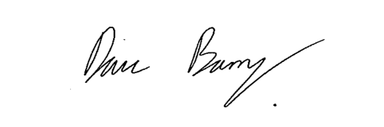
Yours sincerely,
Dave Barry
Chief Executive Officer

