10 April 2015
To Whom It May Concern
Re: Regional Economic Development Strategy Delivery Model Review
While I appreciate the broader scope of the above review, I am writing with specific focus on issues related to implementation of regional strategy, which I consider to be a major weakness in the process of delivery of economic outcomes for regional areas.
In highlighting particular issues, it demonstrates a major strategy implementation failing of the current delivery model, not only in the Hume region, but potentially across Victoria. Greater attention is required to resourcing of the implementation stage of any regional plan and to appropriately assign responsibility and accountability for delivery.
As an example, I refer to The Hume Strategy 2010-2012 (Hume Strategy) as developed by the Hume Regional Management Forum. This is a valuable document which at a strategic level captures key areas of priority. It is not however evident who is responsible for developing specific sector strategies, creating initiatives and driving implementation to support the plan.
In particular, Key Direction 5 - Embracing Learning for Life, highlights that “The region’s education assets and abilities are important for social cultural and economic development as well as for retaining and attracting young people and should be built upon.”
There is no doubt that improved educational attainment is a key driver of employment outcomes and is particularly important in the Hume Region which currently suffers from low educational attainment levels linked to extremely high youth unemployment.
Low educational attainment not only limits job readiness, but contributes to many negative social outcomes.
Given this situation, it is imperative in any regional plan that initiatives in the area of Education and Training are prioritised to ensure that the usual long lead times for results are respected and able to be achieved.
A subsequent report entitled State of the Hume Region 2010-2012 (published by Department of Planning and Community Development in August 2012) states with regard to establishment of a collaborative approach to develop a regional education sector strategy, that “Progress is not according to plan but actions are in place to bring it back on track.”2011
This situation remains to the current time and as Board Chair of the key provider of vocational education and training in the Hume Region, it is very concerning that there has been no overarching education strategy developed to support the Hume Strategy. In the current environment, the absence of an educational strategy for the Hume Region is a critical omission.2
Many systemic factors have mitigated against development and implementation of a more specific education strategy in the Hume region, not the least of which have been a number of policy changes brought about by changes of government.
Some of these relevant to the Vocational Education and Training (VET) sector are currently being addressed by the government’s VET Funding Review. However greater coherency across government policy areas such as Regional Development, Education and Local Government is also a critical success factor in ensuring that potential conflicts do not undermine regional development strategy.
Despite such unfortunate disruptions, GOTAFE has maintained a focus on improving access and developing new education pathways consistent with the intention of the plan.
- GOTAFE is currently a key partner in the Better Together Alliance which is a collaboration between the major secondary schools in Greater Shepparton. Along with La Trobe University, GOTAFE will be the partner responsible for development and operation of a new Trades Skills Centre at McGuire College. This provides the opportunity for better integration of the school and VET sector in order to provide a more seamless transition of students through the offering of more comprehensive vocational and HE pathways and is a model for future expansion.
- GOTAFE also continues to develop pathways for students into Higher Education as evidenced by recent agreements with La Trobe University to articulate GOTAFE Diploma of Nursing graduates into a Bachelors qualification and with Charles Sturt University with the joint establishment of a university study campus in Wangaratta and the development and delivery of a Bachelor of Veterinary Technology qualification.
If such initiatives were able to be incorporated into a more cohesive regional plan, the opportunity to realise broader regional outcomes could be greatly enhanced and expedited.
While having a regional development strategy in place is an important first step, the key to achieving outcomes is effective implementation which requires a greater onus an assigning responsibility, accountability and sufficient resource to the task.
Overall, it seems that responsibilities are currently delegated to working parties and committees without sufficient governance frameworks or project management resource provided.
Again, I use this as an example of a broader issue of bringing regional development plans to life and trust that you will give due consideration to this issue of effectiveness of implementation as a key element of a meaningful regional delivery model.
Yours sincerely
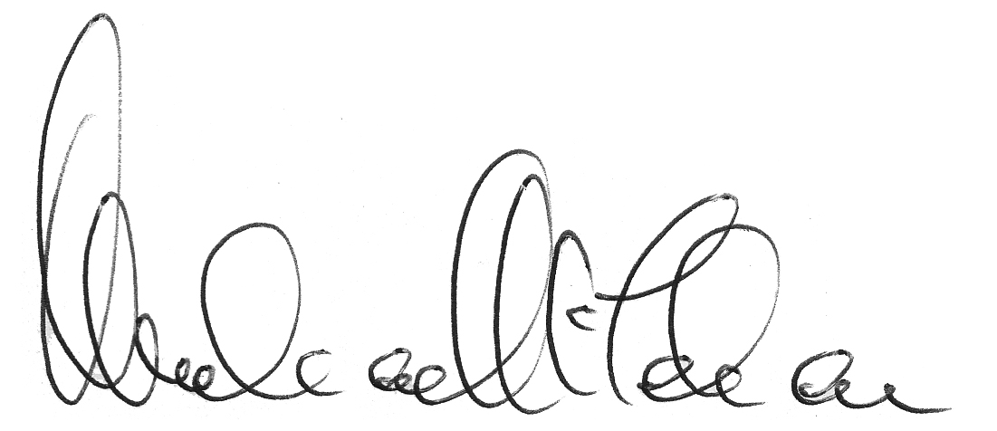
Michael Tehan
Board Chair
Goulburn Ovens Institute of TAFE

