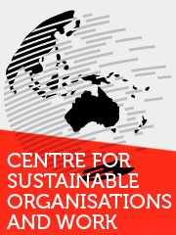
Centre for Sustainable Organisations and Work
RMIT University
Building 80, Level 9
445 Swanston Street
Melbourne VIC 3000
Australia
10 April 2015
Hon. Ms Jaala Pulford, MP
Minister for Regional Development
Parliament of Victoria
Melbourne, Australia.
Dear Minister
Please find attached submission for the review into Victoria’s regional economic development strategy and service delivery model.
This submission is on behalf of three researchers from the Centre for Sustainable Organisations and Work, RMIT University.
We would be happy to make an oral submission to the Review if appropriate.
Yours sincerely
Dr Richard Phillips
Research Fellow

Review: Department of Economic Development, Jobs, Transport and Resources - regional economic development strategy and service delivery model

Submitted by the Centre for Sustainable Organisations and Work (RMIT University) and the Global Cities Research Institute (RMIT University)

Contact: Dr Richard Phillips and Professor Peter Fairbrother

Summary

Regional economic strategies and service delivery models should:
- Consider over-arching forms of governance in relation to regional economic development.
- Develop policy in relation to the lived experience of citizens within localities.
- Identify regional and sub-regional clusters in relation to regional economy, labour markets and residential patterns.
- Include a diverse range of representatives including unions, business, young people, community and religious groups.

The conditions of effective regional development are complex and varied. Drawing on three detailed studies the following is presented. The three studies are:

Unions and Regional Regeneration (2014 – 2016):

The Australian Research Council commissioned the Centre for Sustainable Organisations and Work to examine ‘Unions and Regional Regeneration’ in the North West Tasmania region.

Unions have played positive roles in regional redevelopment. But, in North West Tasmania, they are marginal. This project examines the barriers to such involvement. It shows how unions can engage to support regeneration of regional economies. The outcome of the project is to understand the conditions for sustainable regeneration. Conducting this research adds to theories about social change and social mobilisation. More specifically it will help us understand the role of unions, their capacities and organisation to support economic, political and environmental change towards sustainable futures.

Skilling the Bay – Geelong Regional Labour Market Profile (2012):

This study set out to understand the current and future skills needs in the Regional Geelong Area (RGA- comprising four Local Government Areas (LGAs) of the City of Greater Geelong, Borough of Queenscliffe, Surf Coast Shire and the Golden Plains Shire). This involved firstly, identifying the types of skills and qualifications workers currently possess, and how these may (or may not) meet current or future skills needs of Regional Geelong Area businesses; and secondly, suggesting potential future skills demands of employers with a consideration of changes in demand. Through this research we were able to:
- Understand the position of displaced and vulnerable workers along with their career aspirations as they confront changes in employment and labour market conditions; and
- Inform the development of a long-term vision for jobs and training in the Regional Geelong Area.

Skilling the Bay - Final Report (PDF, 3.37Mb)

Skilling the Bay - Attachment to Final Report - An International Study of Comparator Cases (PDF, 1.31Mb)

Identification of opportunities to support structural adjustment in the Latrobe Valley region (2012):

The Commonwealth Department of Regional Australia, Local Government, Arts and Sport commissioned the Centre to examine opportunities and barriers for investment, job growth and economic revitalisation in the Latrobe Valley.

This study proposed key considerations and priorities for the future of the region and Gippsland as a whole.

LVSA Final Report (PDF, 5.8Mb)

The important lesson from these three case studies is that the promotion of regional economic development and the delivery of services model should include three aspects.
- There should be a mechanism that draws councils together around economic issues at both the regional and sub-regional level.

An example of this arrangement is the Cradle Coast Authority, North West Tasmania.

Over the last two decades, public policy formation in industry regeneration has devolved from the State/Commonwealth level to the regional level, with local Councils taking a prominent role. In 2000, the Cradle Coast Authority was established when the nine local councils decided they needed a ‘stronger voice in the region…we need an economic driver’ (Burnie Council official, 19 October 2011; Cradle Coast Authority, 2012a). This Authority has been successful in securing development funding and promoting industrial redevelopment in the region, although without a ‘clean’ technology focus. It is governed through a two-tier structure comprising representatives from each Council as well as from industry, but not unions per se (Cradle Coast Authority, 2012b).
- Effective regional development should take into account the lived reality of those in the locality.

Policy makers should consider the diversity of lived experiences of community members at a range of levels. One way to examine this is through demographic data.

For example, household composition data show that the traditional nuclear family of a couple with children constitutes less than half of households in many areas (Figure 1).

Figure 1: Household composition, Latrobe Valley Region and Greater Melbourne
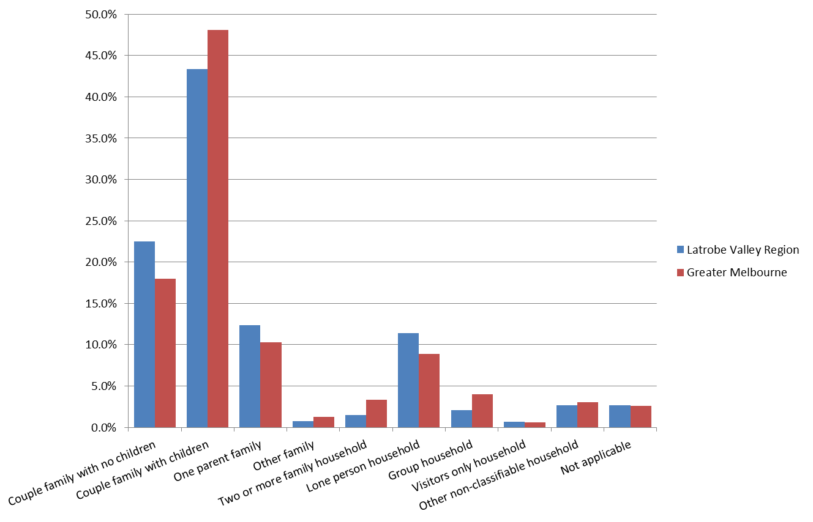

Source: Australian Census of Population and Housing, 2011

This diversity should be taken into account in order to develop appropriate service provision.

The lived experiences of community members are also starkly evident in population movements. Many regions face challenges associated with the availability of education, employment and lifestyle opportunities. When these opportunities are not consistent with the aspirations of residents, some choose to leave the region. This has a disproportionate impact on young adult populations, and is reflected in the age profile of many regions when compared with major metropolitan areas (Figure 2).

Figure 2: Age distribution, Latrobe Valley Region and Greater Melbourne, 2011
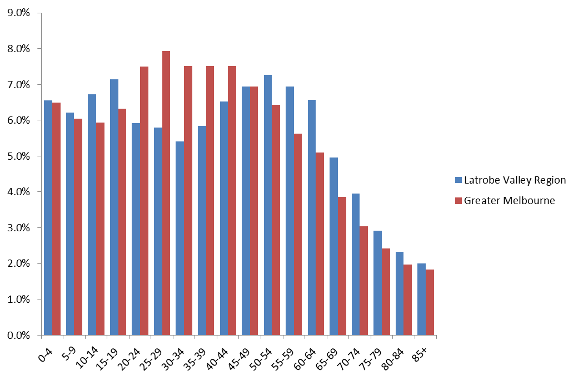

Source: Australian Census of Population and Housing, 2011

These patterns are also evident in North West Tasmania (Figure 3). Such a pattern has social, political, and economic implications.

Figure 3: North West Tasmania residents by Age Group and LGA, 2011
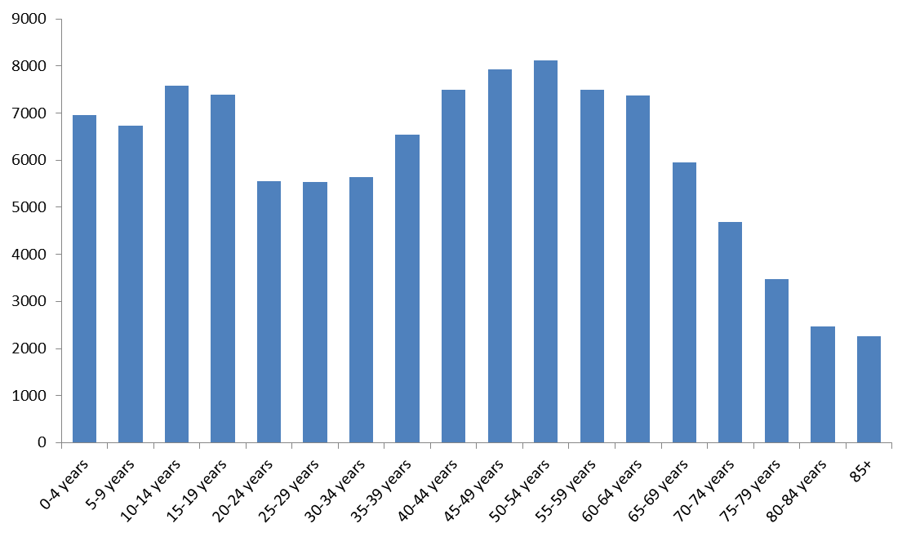

Source: ABS Census of Population and Housing, 2011

- The material lives of those living in a region need to be examined.

This involves learning about people’s experiences of coping with the consequences of economic and other policies.

Unemployment

Evidence from Australia and internationally suggests that when a person loses a job, especially where a local economy is characterised by few large employers, then that individual is likely to find it hard to find equivalent work and stable work. Such processes impact on earnings and living standards for households in stark ways.
I don't spend any money on myself anymore. Out of mine I pay the phone, the Hydro, that's $200 a fortnight, because that comes out each week out of my bank accounts. I've got the car insurance, the contents insurance, which I won't let lapse and that comes out every month. I've got life insurance that I've still kept going, that comes out every month. So every month I'll probably have a spare $40. [Tasmania 2014]
Biography: Worked in the textile factory, closed 2009, period of unemployment, job and company moved part of enterprise off-shore, no work, now doing voluntary work at children’s school and partner training to become a teaching assistant, paid for by couple.

These types of challenges are faced by many.
All I've got is the local market. I do one Sunday in a month over here which gives me probably $100 cash money [selling homemade goods, second-hand books, plants]. That is all the extra income that I get. I went from a well-paid, excellent job that was a terrific job. I'd been there a long, long time. I was a union delegate onsite - to it being nothing. To be absolutely nothing - no income and being forced due to my heart condition to be on a pension, which is half the minimum basic wage. (Household 01, Tasmania, 2014)
Biography: Union delegate, factory closes, 2009/10 (move from Australia off-shore). Lost job, health impact and now a pensioner. Still acts as de facto leader in the locality

These experiences are not experienced by individuals alone, but by individuals as members of households.
let me tell you about being a pensioner. You get it one day and it's gone the next. So you - once a fortnight we put petrol in the vehicle and we go to Burnie up the coast or Wynyard to do whatever shopping we have to do. That is it. That is the only shopping we do. It's the only trip we make. We do it together. We argue all the way up and all the way back. (Household 02, Tasmania, 2014)

The implication is that when considering regional development and the delivery of services then the assessment and evaluation should be in terms of individuals as members of households, since it is in the unit that insecurity and change is experienced and it is here that decisions are made.

Meeting regulatory requirements

One challenge for households is to negotiate their ways through the regulations that define the household as a household. There are occasions where the rules and regulations impact on the very viability of a household.
[support assessment where partner requires full-time care and payments mean mortgage cannot be paid] I mean, what am I supposed to do? Am I supposed to do it? Because … according to them, my income, I could afford - according to them, I could afford to give half my wages over to him. That didn't include the fact that he left half the debt. He left his share of the mortgage and his share of the bills and his share of the insurance, all those things (Victoria 2014).

Such situations may be relatively infrequent, but they indicate the ways in which challenging and indeed threatening arrangements have to be dealt with by households rather than by individuals as such. The rules that govern arrangements for an individual are experienced by the household, in this case as a couple.

Gendered wage disparities

As known, gender equality remains a mirage. This is most clearly evident in relation to wages and earnings. Of course, over a life cycle the relationships can change, although seldom as indicated below.
now she’s a coordinator she’s hit the $100,000. So she’s over the moon that she can now say - if you were in any other community that was away from construction she probably earned good money all her life. But compared to a welder - when she was earning $40,000 I was earning $100,000. That’s the trouble. It was so out of whack (Victoria 2014).

The point here is that the disparity in the early stages of this couples lives is the norm, rather than the current situation. In developing policy in relation to regional economic development these patterns should be taken into account. When households face changing employment patterns and possibilities then couples within households often have to assess their futures in ways that may question conventional gender stereotypes. Again, these are consideration that should be taken into account by policy makers.

The complexity of regional economies

These aspects draw attention to how a regional economy works and more fundamentally the clustering and focus of economic activity and relationships. Often policy is constructed in relation to administrative and planning boundaries, such as councils, water authorities and so forth. It is however important to take into account the actual relationships and inter-linkages that define regional economies, and sub-zones within broader regions. Not only does this have implications in relation to the locations of workplaces, connection with residential areas, it also impacts on transport of people and goods, as well as the services for and sources to enterprises.

Current research in NW Tasmania is examining the utility of understanding regions in terms of functional economic zones rather than in terms of local government areas.
If we mapped some of the other business transactions or social transactions, what I'm suggesting is that's actually a functional economy. So there's the West Coast and then there's King Island, maybe even the far northwest around [unclear], but there's probably three or maybe four separate economies in the region. We just happen to be a part of that one. So because these people all have their own jurisdictions, I can only write an economic development plan for (Name of Council). So what I'm saying is that we have a micro economy, but we have to learn to plan how to work within a regional economy. Now, at the moment there are six councils and all these other players all doing their own thing within what effectively is a functional economy. So it's not really hard to work out what the drivers of that economy are, but there isn't any focus on what the drivers are and no one has actually pulled any resources at that scale to actually deal with the drivers (LGA 01, Tasmania 2015).

Such patterns are also evident in the regions that define the labour markets and regional economies. In the absence of such considerations policy tends to connect in superficial or highly specific ways, often without broader implications for the region. This aspect is recognised:
This is a community that's quite fluid across boundaries. We know that people travel from Wynyard to Waratah to Devonport to work; vice-versa everything in between. Our mantra at the moment is we're not here to compete with each other - that is amongst the nine councils - we're competing against the northern region, the southern region and the mainland. It might be that we can't get projects in every local government area, but we should be trying to focus on those projects that bring the most economic benefit to the region (Regional Organisation, 01, Tasmania).

Boundary questions

If economic sub-zones are a feature of regional economies, then consideration should be given to the boundaries and in particular to the porosity of boundaries between zones.
So the way I'm trying to write this local economic development plan is to say, okay, from what a jurisdiction point of view, council, you have to do what you can do, but you have no control effectively over your economy. If you want to have control over your economy, you need to start developing some sort of collective decision making and some collective governance arrangements that allow people to come together at this scale where the drivers of a regional economy come from. You need to start to build some competitiveness and productivity in this space (LGA 01, Tasmania).

Such aspects have implications for the focus of policy and support, the site of decision-making and the implications for a region as a whole.

From the bottom up

To initiate a pattern of development and to provide the basis for service delivery, it is also necessary to give content to the decentralisation of decision-making that has become the mark of government policies and approaches.
You start small and you start on something, but at the end of the day regeneration actually starts from the ground up, not the top down. Government can't impose a regeneration or it can't come in with a silver bullet. We actually have to start looking at what are the basics around those drivers? That means actually engaging the communities at the ground level or businesses at the ground level of working within (LGA 01, Tasmania).

Such steps require ways of enabling and involving those in economic sub-zones to play an active and positive role in the process. The appropriate models and approaches are not always self-evident.
The [business] model - there's been a lot of talk about this in the last few weeks. The actual model of a private enterprise approach to developing State infrastructure is fairly unusual. So we have an independent board, as I said, we have one director from the State Government, the rest are a skills-based board, there's no representatives. As I said, we're given a list of jobs to do. Then how we do them, subject to certain compliances and things, we do it ourselves. We have a very strong relationship with both levels of government (Business 01,Tasmania, 2014).

When proposing policy to address displacement and transition, it is important to recognise that there are three distinct types of policy response – reactive, dispersed and comprehensive:
- Reactive policies are those that deal with the direct impact of displacement, with little attempt to focus on long term development strategies;
- Dispersed policies are effective practices that go beyond simply dealing with initial impacts, but they are not co-ordinated in ways that amount to an overall strategic response;
- Comprehensive policies have a shared vision and strategy by actors within the region, as well all levels of government and are implemented by and across workforces and economic development agencies.

Each approach has different implications for outcomes.

Dr Richard Phillips

RMIT University

Centre for Sustainable Organisations and Work

Professor Peter Fairbrother

RMIT University

Director, Global Cities Research Institute

Director, Centre for Sustainable Organisations and Work

Dr Matthew Walker

RMIT University

Centre for Sustainable Organisations and Work

