Page 1
Ovens Murray Digital Plan
PART 2 - DATA COLLECTION FINDINGS AND ANALYSIS

Table of Contents

Glossary 4
Context of the Digital Plan 5
Ovens Murray Regional Place/Sector Overview 7
Analytical Framework 22
Ovens Murray General Characteristics 27
1.1 The Land and the People 27
  - The Community 27
  - The Economy 28
  - Structural Change 28
  - Digital Intensity – now and in 3‐5 years 28
  - General Characteristics Informing Digital Planning 29
- Regional Supply Overview 30
  - Fixed Broadband 30
  - Mobile Coverage 32
  - LP‐WAN Coverage 34
  - Other Connectivity Options 36
  - SLIM Analysis 36
- Significant Places 37
  - Wodonga 37
  - Albury 39
  - Wangaratta 40
  - Benalla 42
  - Mansfield 43
  - Beechworth 45
  - Myrtleford 47
  - Bright 48
  - Rutherglen 50
  - Baranduda 52
  - Mount Beauty – Tawonga South 53
  - Chiltern 55
  - Corryong 57
  - Yackandandah 58
  - Tallangatta 60
  - Porepunkah 61
  - Oxley 63
  - Sawmill Settlement 64
- Primary Production 66
  - Land Use Classification 66
  - Fixed Broadband Supply 67
  - Mobile Coverage 70
  - LP‐WAN Coverage 74

- Tourist Destinations 76
  - Mount Buffalo National Park 76
  - Murray to Mountains Rail Trail 77
  - King Valley Prosecco Road 78
  - Rutherglen Wine Region 80
  - Ned Kelly Touring Route 81
  - Mount Buller 83
  - Mount Hotham 84
  - Falls Creek 86
- Transport Corridors 88
  - Introduction 88
  - Freeways/Motorways 89
  - A/B Grade Roads 89
  - C‐Grade Roads 94
  - Rail 94
Appendix A. Acknowledgements & Qualifications 96
Appendix B. Fieldwork 98
Appendix C. Common Themes: Needs & Opportunities 99
Fixed broadband 99
Mobile connectivity 99
Public WiFi 100
Support for Internet of Things 100
Government infrastructure 100
Digital literacy 101
Appendix D. LGA Digital Needs Report 102
Appendix E. Ovens Murray Stakeholder Study 128

Glossary
ABS: Australian Bureau of Statistics
ADII: Australian Digital Inclusion Index, RMIT‐Swinburne‐Telstra ACCC: Australian Competition and Consumer Commission BB‐IoT: Broadband Internet of Things
Cat‐M1: Narrowband IoT technology
CRCP: Victorian Government $45 million Connecting Regional Communities Program
DJPR: Department of Jobs, Precincts and Regions (Victoria)
F: Fixed internet access services – NBN fixed line, fixed wireless and satellite connections
FTTC: Fibre to the curb NBN fixed line technology – capable of providing very fast internet access
FTTN: Fibre to the node NBN fixed line technology – access speed limited by long copper loops for some customers
FTTP: Fibre to the premise NBN fixed line technology – capable of providing extremely fast internet access
GIS: Geographic information system
GRP: Gross Regional Product (the regional equivalent of Gross Domestic Product – GDP)
IoT: Internet of Things
LCCC: Local Community Connectivity Centres ‐ facilities providing high bandwidth connectivity for the public
LGA: Local government area
M: Mobile services – third, fourth and fifth generation technology (3G, 4G, 5G)
MBSP: Mobile Black Spot Program (Commonwealth Government)
MOOC: Massive Online Open Courses
NB‐IoT: Narrowband Internet of Things
NBN: National Broadband Network – the government‐owned wholesale network covering all premises in Australia
NBN Co: The Commonwealth Government‐owned business responsible for building and operating the NBN
MNO: Mobile network operator
OPGW: Overhead power ground wire
RDAC: Regional Development Advisory Committee – group comprising chairs of the nine non‐metropolitan Regional Partnerships
SLA: Service Level Agreement
SLIM: State Level Information Management database
VMP: Victoria Mobile Program
WiFi: Free public WiFi service – for resident and visitor mobile access in public places and some neighbourhoods

Context of the Digital Plan

What is a Digital Plan?
The Ovens Murray Digital Plan is underpinned by an evidence‐based, place‐based analysis of the supply of and demand for digital services and skills. This analysis is aimed at identifying ‘unmet needs’ and potential solutions, for both the present and in 3‐5 years.
This Digital Plan will form the basis for Ovens Murray Regional Partnership advocacy to all levels of government, as well as informing engagement and collaboration with industry and community groups. It will also be a valuable resource to other stakeholders in the region for their own advocacy and action. The Ovens Murray Digital Plan has two parts:
- Part 1 presents a summary of the analysis undertaken and the Regional Partnership’s key focus areas, priority actions and projects.
- Part 2 (this report) presents the detailed research and analysis undertaken in developing the Digital Plan and can be used by interested stakeholders requiring more detailed information.
The Digital Plans developed for each Regional Partnership region across Victoria complement other regional plans prepared by the government to strengthen local economies and communities across regional Victoria – including Infrastructure, Transport, Skills and Growth Plans.
While informing the development of digital policies and programs for the regions, the digital plans are not a commitment to any particular course of action by the Victorian Government.

Why are Digital Plans needed?
Region‐level digital plans are needed to effectively reduce the persistent country‐city digital divide: regional shortfalls in access to digital services, the ability to effectively use these services, and their affordability relative to their capital city counterparts. The digital divide matters more than ever as the realities of the increasingly pervasive digital world strike home:
- Households around the world rely more and more on digital entertainment, communications and shopping, banking, news and other personal services
- Communities increasingly stay connected and safe, and community services are delivered more effectively, through digital platforms
- Businesses of all sizes rely on digital advances – high bandwidth fixed and mobile communications, data capture and analysis, artificial intelligence and digitally‐driven production techniques – to increase productivity and remain competitive.

How will the Digital Plans be used?
The nine Digital Plans provide forward‐looking guidance to Regional Partnerships, local governments and business, household and community groups in identifying digital priorities and advocating and developing solutions.
This Digital Plan will be:
- Used by the Regional Partnership as the basis for its actions and advocacy on digital issues, particularly in communicating the recommendations of this plan to relevant stakeholder groups for their consideration, action and response
- Shared with local, state and Commonwealth governments to raise awareness of the digital issues affecting the region and assist in their own advocacy, policy and program development
- Shared with industry and local businesses to encourage them to identify and target investment to areas of highest need across the region

- Made available publicly for interested community members, households and businesses in the region and for other organisations keen to utilise this research and analysis for their own advocacy and activities.

How were the Digital Plans prepared?
Digital Plans were prepared through:
- Extensive face‐to‐face consultation with the Regional Partnerships and local Digital Plan Working Groups
- In‐depth interrogation of the SLIM database
- Fieldwork comprising an online survey of all local governments in regional Victoria, and face‐to‐face interviews in each region
- Independent expert advice on the fundamental drivers of unmet needs and potential solutions
- Confirmation from each Regional Partnership that the Digital Plan hits the mark as a tool for them and their stakeholders in driving place‐based solutions to unmet digital needs.

Ovens Murray Regional Place/Sector Overview
The following table provides an overview of the place/sector typology, digital users and digital unmet needs that were identified through the background research and analysis.
Table 1 Overview of characteristics and unmet needs across different place and sector perspectives

Place/Sector (typology) | Characteristics (place/user) | Digital ‘Unmet Needs’
Cities/towns/localities
Businesses | Concentration of public services (education, health, admin), retail, small business in cities, larger towns | Access to business grade broadband, including on town fringes  Improved digital skills
Households | High‐medium population densities, suitable for NBN fixed line services | Access to affordable, high‐capacity broadband Improved digital skills
Communities | Varying digital literacy & ability to afford broadband | Access to affordable broadband Increased digital skills
Primary production areas
Farming | Low population density  Variety of farming systems – broadacre cropping & grazing, intensive horticulture  & livestock  Increasing use of digital farming Varying digital literacy | Mobile coverage  Customised solutions (e.g. on‐farm WiFi) Broadband & narrowband IoT coverage  Digital literacy – farmers, farm service providers
Forestry | Remote, unpopulated locations Unmanned forest monitoring  Occasional human presence for forest management & harvesting | Narrowband IoT coverage Mobile coverage
Tourist sites
Permanent attractions | Both town & remote locations, including Alpine Resorts  Visitors with high digital literacy & dependence (e.g. TripAdvisor, GPS, Facebook) | Mobile coverage  Public WiFi – general and site‐specific  High bandwidth fixed broadband for WiFi backhaul System resilience
Events | Highly seasonal/periodic | Temporary mobile peak capacity requirements High bandwidth fixed broadband for WiFi backhaul
Transport corridors
Road | Motorists & freight  Mix of major (VicRoads) & minor (local council) roads | Continuous mobile coverage
Rail | Passengers & freight  Increased need for high quality mobile 4G (5G) connectivity | Continuous mobile coverage  Repeaters on the new VLocity trains when operational on the North East line

Ovens Murray population centres, primary production areas, tourist sites & transport corridors

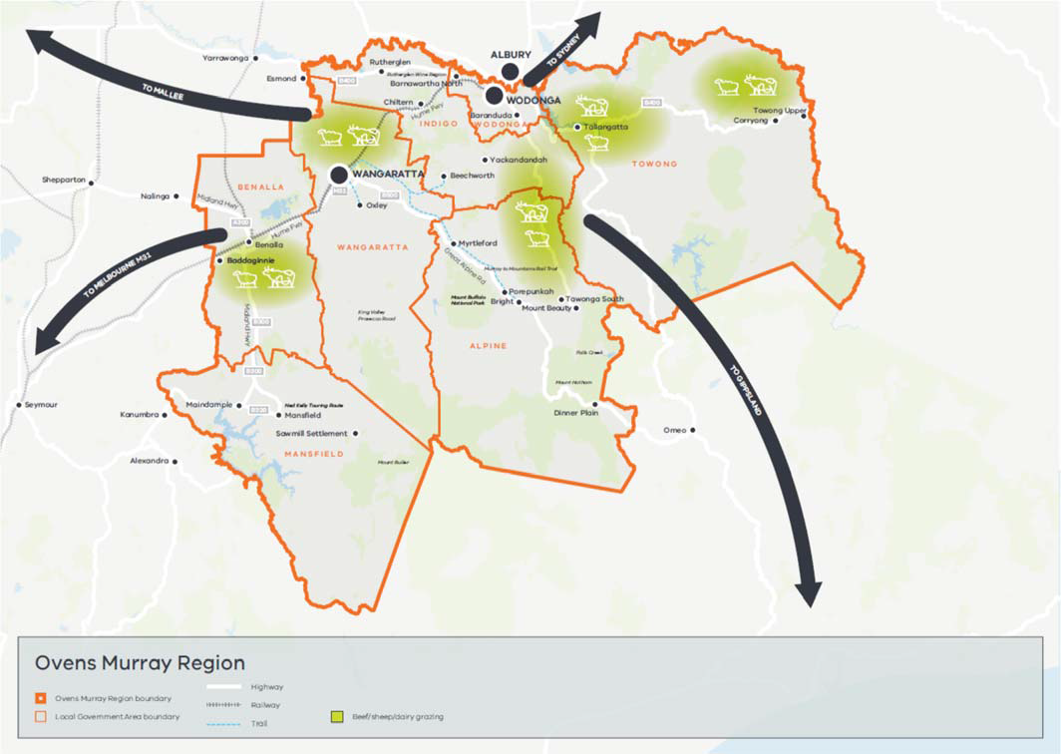

Figure 1 Ovens Murray population centres, primary production areas, tourist sites & transport corridors

Key factors considered in the development of the Ovens Murray Digital Plan include the following (details on the approach to digital planning are given in the Analytical Framework section below):
  - Significant regional diversity
  - Structural change and trends
  - Digital intensity of industry sectors
  - Digital divide and digital inclusion
  - Business grade broadband services
  - Competing broadband networks.

Significant Regional Diversity
  - Population Density ‐ differs widely across the region, from 92 residents per square kilometre for Wodonga LGA to 0.9 for Towong
  - Median Age – varies quite significantly across the region, from 50 in Towong to 36 in Wodonga

  - Industry sectors supporting employment – eight industries1 make up 75 percent of Ovens Murray employment.
- These and other key indicators are shown in the following charts:

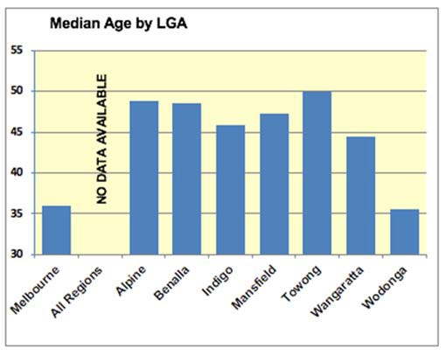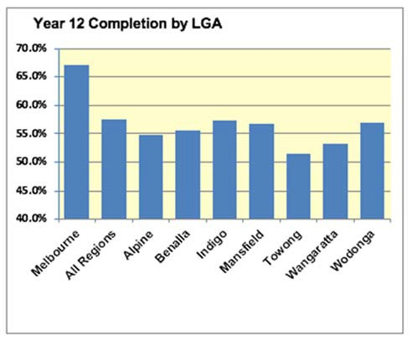

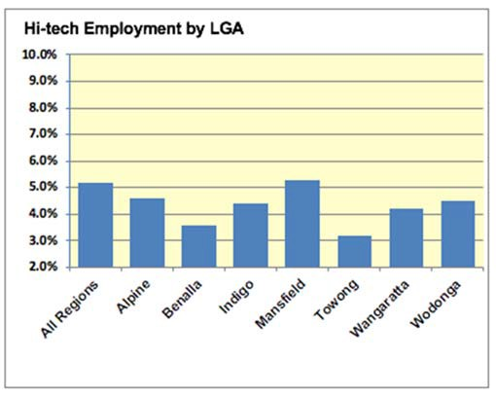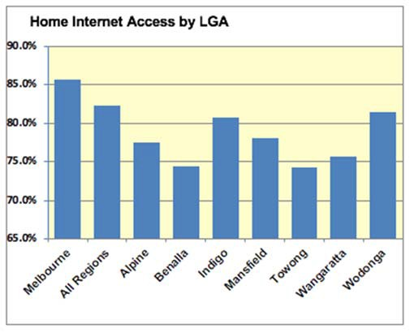

Structural Change
- Health, manufacturing and retail are the top three industries in the region in terms of employee numbers, with only health among them showing growth over the past ten years. This observation strongly supports the view the traditional industries are being replaced by technology driven service industries. Health is in fact the fastest growing industry, with tourism and education the other notable growth industries.
- When considering GRP, top industries correspond well to employee numbers, with health, manufacturing and agriculture among the top industries. This strongly suggests that health and manufacturing should be a focus for digitalisation, especially since manufacturing is the fastest declining industry in terms of employee numbers but still the largest contributor to GRP.

1 Agriculture, Forestry & Fishing 7%, Manufacturing 10%, Construction 8%, Retail Trade 10%, Tourism 9%, Education & training 8.0%, Health Care and Social Assistance 14%, Public Admin & Safety 8%

Digital Intensity
- Analysis of the digital intensity requirements of the eight industries representing 75 percent of the Ovens Murray employment reveals that five of the industries will rely more heavily on digital services over the next 3‐5 five years. These include health care/community assistance, tourism and agriculture/forestry, for which digital intensity needs to rise strongly over the next 3‐5 years to retain competitiveness.
- Agriculture and tourism, in particular, need to shift from their current low to high digital intensity over the next 5 years to be competitive in Australia and internationally, and health and community care need to digitise quickly for leading‐edge effectiveness.
Table 2 Comparison of digital intensity requirements now and in 3‐5 years across key sectors

Regional sector | Digital intensity now (current practice) |  | Digital intensity needed in 3‐5 years (best practice)
Healthcare & social assistance |  | Fixed access for patient records |  | Patient & GP fixed and mobile connectivity.  Digitisation of records, analytics & data transparency.  Robot‐assisted operations
Education & training |  | School, home fixed & mobile access |  | Student fixed & mobile home connectivity, online learning. Augmented & virtual reality in classrooms for enhanced teaching methods
Construction |  | Fixed & mobile connectivity |  | Fixed & mobile connectivity, digital models
Tourism |  | Mobile coverage of tourist hot spots |  | Mobile road coverage. WiFi & IoT at popular venues.  Augmented/virtual reality tours
Manufacturing |  | Fixed connectivity |  | Fixed connectivity, industrial IoT, fault prevention & data analytics for logistics
Public admin & safety |  | Resident fixed & mobile connectivity, connected public infrastructure |  | Resident fixed & mobile, IoT‐for Smart Cities, enhanced security & digital profiles for individuals
Agriculture/forestry |  | Mobile coverage of farming areas Nascent use of IoT |  | Wide narrowband and broadband IoT access, apps and skills for intensive and broadacre horticulture,  cropping & livestock
Retail trade |  | Shop & building access |  | Retail at threat from online shopping. IoT can help retail stores connect to customers through promotions and mobile payment methods
Legend:

 | Low |  | Medium |  | High

Ovens Murray unmet needs hotspots: fixed, mobile, IoT and public WiFi access

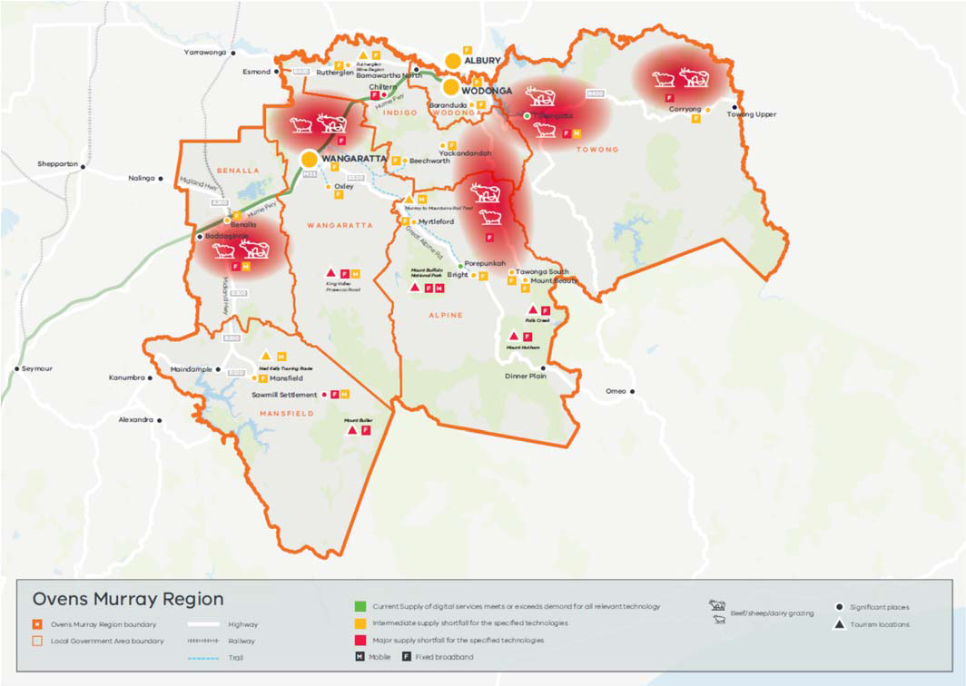
Figure 2 Ovens Murray unmet needs hotspots: fixed, mobile, IoT and public WiFi access.

Coverage maps indicate that businesses and households in population centres down to quite small localities (500 residents) are generally well served with effective fixed and mobile connectivity (and high bandwidth IoT coverage provided by the mobile carriers). Narrowband IoT networks and public WiFi coverage across significant population centres are patchy and warrant careful consideration of how shortfalls are best addressed. What is not shown is the important and challenging issue of digital ‘have nots’ amongst the ‘haves’. It is critical these ‘below the surface’ digital divide issues are not be overlooked.
The high‐level picture for households and businesses in primary production areas and at more isolated tourist sites is not so positive, with mobile coverage for farms and tourists lacking and below par fixed connectivity for farm offices and residences and tourist site operators. However, limits to widespread remediation exist, as the per user costs of fixed line access and blanket mobile coverage rise exponentially with remoteness. Connectivity for both one‐way and two‐way IoT appears to be generally good for the level of demand currently across farming areas analysed. These networks will be important for future competitiveness of these businesses in
the next 3‐5 years.
Mobile coverage on major roads is indicated as good (subject to localised blackspots not shown on publicly available coverage maps), but less so for more minor roads. Mobile coverage along the Wodonga‐Melbourne rail corridor (North East line) is good, as is in‐carriage reception. Mobile coverage is good for trains beyond Seymour, but in‐carriage reception may be compromised on VLocity trains not yet fitted with repeaters. The ‘lived experience’ of patchy mobile coverage around Seymour is also noted.

Digital Supply and Demand Rating Methodology
The following tables describe the rating methodology used for fixed, mobile, public WiFi and IoT access
Fixed access rating methodology
Reflecting the needs of users relative to service quality provided by different fixed and mobile technology types and the situation in metropolitan areas, the following rating standards have been used.

FIXED ACCESS SUPPLY RATING
For businesses
Rated High where:
  - Mainly FTTP or FTTC (as these technologies can deliver the forthcoming Enterprise Ethernet business grade service), AND/OR
  - There are one or more competing network providing comparable business grade services at similar prices to NBN business grade service
Rated Medium where:
  - Mainly FTTN (as users face uncertainty about the availability of the forthcoming Enterprise Ethernet service at a premise as this service cannot be provided over access long loops), AND
  - There are no alternative networks offering comparable business grade services at similar prices
Rated Low where:
  - Mainly fixed wireless (as no fixed wireless business grade service in the pipeline, fixed wireless services are only available up to 50 Mbps and fixed wireless information rates can be significantly degraded when network use spikes), OR
  - Mainly satellite (as there is no specification available for the mooted business‐grade satellite service, latency issues are inherent and current satellite services are only available up to 25 Mbps and there are data limits), AND
  - There are no alternative networks offering comparable business grade services at similar prices
For households
Rated High where:
  - NBN FTTP, FTTC or FTTN are available (as this is comparable to the metro household situation), AND/OR
  - There are one or more competing networks offering 100 Mbps+ service at comparable prices to NBN
Rated Medium where:
  - NBN fixed wireless is available, AND
  - There are no competing networks offering 100 Mbps+ service at comparable prices to NBN
Rated Low where:
  - Only NBN satellite is available, AND
  - There are no competing networks offering 100Mbps+ service at comparable prices to NBN

FIXED ACCESS DEMAND RATING
Demand for fixed access by businesses and households is rated High as both groups need fixed line network performance to meet their current and emerging digital needs. These rating benchmarks apply for the present and in 3‐5 years as the quality of NBN FTTN performance is expected to improve in line with user needs.²

Mobile access rating methodology
Local accuracy of mobile access availability is limited by the need to use high‐level publicly available mobile coverage maps. Government discussions with mobile network operators on access to more detailed information are occurring. In addition, local “ground‐truthing” of mobile coverage will be included in future updates of the Digital Plan.3

Supply
For both businesses and households (same supply ratings as access to mobile services is very important for both businesses and households and they have similar mobile service performance needs):
Rated High where:
- Two or more 4G networks are available Rated Medium where:
- Only one 4G network is available Rated Low where:
- There is no coverage by any mobile network, OR
- The only coverage available is predominantly 3G
Demand
- Demand is rated High for all mobile users now and in 3‐5 years, reflecting mobile’s importance for all.

Narrowband (LP‐WAN) IoT access rating methodology 4

Supply
The present supply of LP‐IoT is rated:
- High for near‐complete coverage by at least one LP‐WAN network
- Medium or Low for patchy or no coverage
- At least two networks requirement for High in 3‐5 years.5
Demand
Demand by businesses in larger centres and for farms is rated Medium at present and High in 3‐5 years; and Low (now) and Medium (3‐5 years) for businesses in smaller centres and households, reflecting an explosion in IoT interest and use.

2 It is anticipated NBN Co will commence a program of shortening the length of copper loops in FTTN areas once rollout is completed in 2020.
3 Note that decisions on Victorian government funding for mobile blackspots are not based on the high-level mobile coverage maps it is necessary to use in the digital plans
4 Sigfox and Taggle network coverage is considered, NNNCo and Telstra Cat-M1 network coverage were not considered in the analysis as this information was not publicly available at the time of analysis.
5 High bandwidth and 2-way IoT are provided by mobile carriers.

Public WiFi

Supply
Supply of public WiFi is rated:
- High where it is available in relevant public places and disadvantaged localities
- Medium or Low for incomplete or no coverage
- For now, and in 3‐5 years.
Demand
Demand by residents is rated according to income levels (high where incomes are low), reflecting the importance of mobile access to everybody for everyday life.6

The following color‐coded summary tables provide a snapshot of the current supply/demand balance and unmet needs for each category. The colour coding in the tables is as follows:
Green ‐ indicates that current supply meets or exceeds demand Orange – indicates an intermediate supply shortfall
Red – indicates a major supply shortfall.

Significant Places Analysis
Digital supply‐demand balance for selected population centres is shown in Table 3, red shading indicating major supply shortfall relative to demand, Orange an intermediate supply shortfall and green where current supply meets or exceeds demand. Note the light green shading for mobile access denotes reservations, based on local mobile access experience, about the good coverage indicated by public coverage maps.
The list of significant places below has been developed by selecting all population centres greater than 1,000 population as well as including the next largest population centre within each local government area below 1,000 to provide a representation of smaller population centres in the analysis as well.
Table 3 Significant places: current unmet digital access needs.

Place LGA Name User type |  |  |  | Access
 |  |  |  | Fixed  Supply / Demand | Mobile*  Supply / Demand | LP‐WAN IoT  Supply / Demand | WiFi  Supply / Demand
City | Wodonga | Wodonga  (pop. 35, 130) | Business | M/H | H/H | H/M | n.a.
 |  |  | Home | H/H | H/H | H/L | M/L
 |  |  | Community | n.a. | H/H | n.a. | M/L
 | Albury | Albury  (pop. 47, 974) | Business | M/H | H/H | H/M | n.a.
 |  |  | Home | H/H | H/H | H/L | M/L
 |  |  | Community | n.a. | H/H | n.a. | M/L

6 This broad measure could be improved by using more detailed information on disadvantaged locations from the ABS Socio-economic Index (SEIFA) and the Jesuit Social Services study Dropping of the Edge: 2015 (postcode level)

 | Wangaratta | Wangaratta  (pop. 18, 566) | Business | M/H | H/H | H/M | n.a.
 |  |  | Home | H/H | H/H | H/L | L/M
 |  |  | Community | n.a. | H/H | n.a. | L/M
Town | Benalla | Benalla  (pop. 9, 298) | Business | M/H | H/H | H/M | n.a.
 |  |  | Home | H/H | H/H | H/L | L/H
 |  |  | Community | n.a. | H/H | n.a. | L/H
 | Mansfield | Mansfield  (pop. 3, 410) | Business | M/H | H/H | H/M | n.a.
 |  |  | Home | H/H | H/H | H/L | L/M
 |  |  | Community | n.a. | H/H | n.a. | L/M
 | Shire of Indigo | Beechworth  (pop. 2, 929) | Business | M/H | H/H | H/M | n.a.
 |  |  | Home | H/H | H/H | H/L | L/L
 |  |  | Community | n.a. | H/H | n.a. | L/L
 | Alpine Shire | Myrtleford  (pop. 2, 782) | Business | M/H | H/H | L/M | n.a.
 |  |  | Home | H/H | H/H | L/L | L/H
 |  |  | Community | n.a. | H/H | n.a. | L/H
 | Alpine Shire | Bright  (pop. 2, 310) | Business | M/H | H/H | L/M | n.a.
 |  |  | Home | H/H | H/H | L/L | L/H
 |  |  | Community | n.a. | H/H | n.a. | L/H
 | Shire of Indigo | Rutherglen  (pop. 2, 109) | Business | M/H | H/H | H/M | n.a.
 |  |  | Home | H/H | H/H | H/L | M/L
 |  |  | Community | n.a. | H/H | n.a. | M/L
 | Wodonga | Baranduda  (pop. 1, 764) | Business | M/H | H/H | H/M | n.a.
 |  |  | Home | M/H | H/H | H/L | L/L
 |  |  | Community | n.a. | H/H | n.a. | L/L
 | Alpine Shire | Mount Beauty  – Tawonga South  (pop. 1, 688) | Business | M/H | H/H | L/M | n.a.
 |  |  | Home | H/H | H/H | L/L | L/H
 |  |  | Community | n.a. | H/H | n.a. | L/H
 | Shire of Indigo | Chiltern  (pop. 1, 244) | Business | L/H | H/H | H/M | n.a.
 |  |  | Home | M/H | H/H | H/L | L/L
 |  |  | Community | n.a. | H/H | n.a | L/L
 | Shire of Towong | Corryong  (pop. 1, 195) | Business | M/H | H/H | L/L | n.a.
 |  |  | Home | H/H | H/H | L/L | L/H
 |  |  | Community | n.a. | H/H | n.a. | L/H
Local | Shire of Indigo | Yackandandah  (pop. 999) | Home | M/H | H/H | H/L | L/L
 |  |  | Community | n.a. | H/H | n.a. | L/L
 | Shire of Towong | Tallangatta  (pop. 935) | Home | H/H | H/H | L/L | L/M
 |  |  | Community | n.a. | H/H | n.a. | L/M
 | Alpine Shire | Porepunkah  (pop. 642) | Home | H/H | H/H | L/L | L/L
 |  |  | Community | n.a. | H/H | n.a. | L/L
 | Wangaratta | Oxley  (pop. 429) | Home | M/H | H/H | H/L | L/L
 |  |  | Community | n.a. | H/H | n.a. | L/L
 | Shire of Mansfield | Sawmill Settlement (pop. 197) | Home | L/H | M/H | L/L | L/L
 |  |  | Community | n.a. | M/H | n.a. | L/L
Legend Red ‐ Major supply shortfall | Orange ‐ Intermediate supply shortfall | Green ‐ current supply meets or exceeds demand. Based on SLIM interrogation and subject to the local accuracy limitations of the mobile coverage and other data in SLIM.

* Mobile coverage taken from public carrier coverage maps which may not reflect detailed coverage at the local level.

Commentary
Fixed access supply in Ovens Murray cities and larger towns is currently favourable for households, but under par for businesses as the prevailing NBN FTTN technology will not uniformly support effective business grade services and alternative NBN‐equivalent broadband services are not available. The situation is less favourable for small towns and localities where NBN fixed wireless predominates. Mobile access is generally good for the 18 Ovens Murray places examined according to the publicly‐available coverage maps used, recognising the limitations with these data in identifying localised blackspots and contrary feedback from local people on mobile access difficulties. Coverage of narrowband IoT networks across Ovens Murray places is generally adequate and not constraining as demand is also low at present, notwithstanding the potential future demand for IoT in agriculture. The supply of public WiFi is low across the region, not meeting latent demand in places with below‐average household incomes.
Looking forward 3‐5 years, while government advocacy, demand aggregation and co‐funding programs for fixed network upgrades may be effective at the margin (guided by the CRCP enhanced broadband trials), widespread fixed access upgrades will be difficult to achieve due to network cost constraints. Furthermore, 5G mobile coverage in smaller locations may lag demand.

Fixed access
Fixed access for cities and towns with population in excess of 1500 residents, and for some smaller places, is predominantly provided by NBN FTTN technology. While this satisfactorily meets current household needs (on par with metropolitan households), it represents an intermediate supply shortfall for businesses as FTTN will not uniformly support the pending NBN Enterprise Ethernet business grade service due to long loop lengths for some premises. For some smaller towns and localities NBN fixed wireless is the prevailing network technology, meaning an intermediate supply shortfall for households and major shortfall for businesses as the NBN business grade service will not be offered on its FW network.
Looking forward 3‐5 years, while NBN FTTP and fibre to the curb (FTTC) networks would support future business demand for business grade services, widespread upgrades will however be difficult to achieve. Nonetheless government advocacy, demand aggregation and co‐funding programs for enhanced broadband may be effective at the margin for smaller population centres, guided by lessons from the Victorian Government Connecting Regional Communities Program (CRCP) enhanced broadband trials in Morwell and Horsham.

Mobile access
Mobile access is shown to be good for all the Ovens Murray cities, towns and localities examined (down to 300 residents) with near‐complete 4G coverage by at least two carriers (recognising there will be specific sites which experience unsatisfactory mobile performance not reflected in the public coverage maps used).
However, the 3‐5 year outlook is not so uniformly positive, with only the largest population centres likely to have 5G coverage (based on carriers targeting large and rapidly growing populations). Importantly, the introduction of 5G services in these cities will at some point create greater competition between mobile fixed access providing a potential solution for individual premises and neighbourhoods with poor fixed access.

Narrowband (LP‐WAN) IoT 7
While coverage of narrowband IoT networks across Ovens Murray cities, towns and localities is currently mixed, demand by businesses, local governments and households is also low with little apparent unmet need at present.
Looking forward 3‐5 years ‐ IoT network coverage is expected to increase substantially, driven by rising demand and the relatively low cost of low bandwidth IoT networks and applications (use of low‐cost spectrum and long signal carrying distances). Demand developments are less clear – while there is widespread expectation that IoT use will increase in the near future, what is not apparent is whether these largely premise‐specific business and household IoT needs will be met by in‐premise WiFi systems coupled with fixed backhaul or by public IoT networks. While not currently being trialled in Ovens Murray, the Victorian Government ‘On‐Farm Internet of Things (IoT) Trial, which is part of the Connecting Regional Communities Program, will help inform likely IoT demand from agriculture.

Public WiFi
A key benefit of free public WiFi at present is providing non‐digitally connected, disadvantaged residents and visitors with access to the internet. At present supply of public WiFi is low in all places considered (with exception of Wodonga), while demand is rated high in the five locations with below‐average household incomes. Accordingly, on the basis of the methodology and limited data used, there appears to be an unmet need for public WiFi in some mid‐sized and smaller locations.
Looking forward 3‐5 years ‐ It is expected some local governments will roll out public WiFi in public places and disadvantaged neighbourhoods in response to these and their own “smart city” unmet needs. This suggests a potential role for targeted Commonwealth and State government programs – with the current CRCP free public WiFi trials in Shepparton and Geelong providing useful lessons on the design of such programs.
However, falling mobile data prices, and scope for mobile networks to support low power Smart City sensors may mean public WiFi becomes less relevant for social and local government service delivery purposes.
Monitoring of trends is required.

Skills and affordability
Primary measures of digital literacy, availability of IT professionals and workforce preparedness for the future digital world, including on a place and sector basis, are extremely limited, existing at best at a high level of aggregation. As a result, further local data collection is required to identify skills gaps and shape needed remedial action. Nevertheless, there are a range of secondary indicators that, taken together, give a broad indication of skills availability (supply) at an LGA level – age, education, the proportion of households that access the internet at home, the share of employment in high‐technology industries and the ‘ability’ component of the Australian Digital Inclusion Index (ADII). Based on these broad indicators, there appears to be a significant skills shortfall in Ovens Murray relative to Melbourne, and substantial differences between LGAs. Furthermore, at any location in the region, there will be individuals and businesses with low digital skills.
Looking forward 3‐5 years, workforce preparedness for successful employment in the digital age is important for the whole of Victoria, with shortfalls in regional areas likely to be greater than in Melbourne given lower education level and older populations. The importance accorded digital skills apparent from the digital plan consultations highlights the need for data collection on skill supply and demand. The SmartSkills component of the SmartFarms initiative could play a role here in increasing digital and STEM skills in the region.
Affordability of digital services has not been considered in the Digital Plan analysis and warrants attention in the next generation digital plan.

7 Sigfox and Taggle network coverage is considered, NNNCo network coverage is not considered in the Plan analysis as this information is not publicly available.
Options to address Ovens Murray digital services affordability issues have not been considered in this initial digital plan, pending better information on the nature and importance of any affordability gaps. Data collection is the immediate need.

Primary Production Areas Analysis
Digital supply‐demand balance for selected primary production areas is shown in Table 4, red shading indicating major supply shortfall relative to demand, Orange an intermediate supply shortfall and green where current supply meets or exceeds demand. Note the light green shading for mobile access denotes reservations, based on local mobile access experience, about good coverage indicated by public coverage maps.
Table 4 Primary production areas: current unmet digital access needs

User  Land Use Location Type |  |  | Access
 |  |  | Mobile*  Fixed Supply /  Supply / Demand Demand |  | LP‐WAN IoT  Supply / Demand
Beef, Sheep, dairy grazing | Around Benalla | Business | L/H | M/H | H/M
 |  | Home | L/H | M/H | H/L
Beef, sheep, dairy grazing | King Valley | Business | L/H | H/H | H/M
 |  | Home | M/H | H/H | H/L
Beef, sheep, dairy grazing | North of Wangaratta | Business | L/H | H/H | H/M
 |  | Home | M/H | H/H | H/L
Beef, sheep, dairy grazing | Around Corryong | Business | L/H | H/H | L/M
 |  | Home | L/H | H/H | L/L
Beef, sheep, dairy grazing | Around Tallangatta | Business | L/H | M/H | H/M
 |  | Home | L/H | M/H | H/L
Legend Red ‐ Major supply shortfall | Orange ‐ Intermediate supply shortfall | Green ‐ current supply meets or exceeds demand. Based on SLIM interrogation and subject to the local accuracy limitations of the mobile coverage and other data in SLIM.
* Mobile coverage taken from public carrier coverage maps which may not reflect detailed coverage at the local level.

Commentary
Primary production in Ovens Murray is very diverse and includes significant activity in livestock, dairy, horticulture, viticulture, timber, niche products and smaller scale artisanal production and value adding. The primary production areas are confined to beef/sheep/dairy grazing locations as, apart from wine production which is covered in the tourist destinations analysis in section 5 below, this is the predominant primary production activity. The unmet needs picture is mixed for these primary production areas with fixed and mobile supply in most of them rated low‐to‐medium. Low power IoT supply‐demand balance is in transition – supply is generally high, and demand is only now starting to rise and is generally rated medium.

Fixed access
Current situation ‐ fixed access in the Ovens Murray primary production areas is predominantly NBN satellite technology, with some fixed wireless. Business and household demand is, however, uniformly high, meaning major unmet demand in the primary production areas considered.
Looking forward 3‐5 years ‐ It is anticipated fixed access supply will change little in the next 3‐5 years without policy intervention. With demand inexorably rising, this means the level of unmet demand for fixed access will become more severe. However, policies to materially alleviate this situation are likely to be prohibitively expensive.

Mobile coverage
Current situation ‐ Mobile coverage in the primary production areas of Ovens Murray examined is reasonable (for the areas analysed), with more closely‐settled places competitively served by more than one 4G network (with undocumented localised gaps) but supply less satisfactory elsewhere. With demand for mobile services uniformly high, supply shortfall for some grazing areas are apparent.
Looking forward 3‐5 years ‐ there is likely to be little market driven improvement on coverage and 5G technology is unlikely to replace 4G. Rising demand in the face of largely static supply will mean the unmet demand situation will worsen. Redesigned mobile blackspot programs will be needed to ameliorate this growing supply‐demand gap.

Narrowband IoT
Current situation ‐ Narrowband IoT coverage is currently reasonably good across much of the Ovens Murray primary production areas, but with some areas showing an intermediate shortfall in supply of IoT networks.
Looking forward 3‐5 years ‐ demand for such coverage is expected to grow strongly, as is supply, with the supply‐demand balance unclear. That said, there may be a valid role for government market stimulation where more acute supply shortfalls become apparent.

Tourist Destinations Analysis
Digital supply‐demand balance for selected tourist destinations is shown in Table 5, red shading indicating major supply shortfall relative to demand, Orange an intermediate supply shortfall and green where current supply meets or exceeds demand. Note the light green shading for mobile access denotes reservations, based on local mobile access experience, about the good coverage indicated by public coverage maps.

Table 5 Tourist destination: current unmet needs

Type Location LGA Type |  |  |  | Access
 |  |  |  | Fixed  Supply / Demand | Mobile*  Supply / Demand
Permanent | Mount Buffalo | Alpine | Operator | L/H | L/H
 |  |  | Visitor | n.a. | L/H
 | Murray to Mountains Rail Trail | Wangaratta, Indigo, Alpine | Operator | n.a. | M/H
 |  |  | Visitor | n.a. | M/H
 | King Valley Prosecco Road | Wangaratta | Operator | L/H | M/H
 |  |  | Visitor | n.a. | M/H
 | Rutherglen Wine Region | Indigo | Operator | M/H | H/H
 |  |  | Visitor | n.a. | H/H
 | Ned Kelly Touring Route | Mitchell, Benalla, Wangaratta, Indigo, Mansfield | Operator | n.a. | M/H
 |  |  | Visitor | n.a. | M/H
 | Mount Buller | Mount Buller Village | Operator | L/H | H/H
 |  |  | Visitor | n.a. | H/H
 | Mount Hotham | Mount Hotham Village | Operator | L/H | H/H
 |  |  | Visitor | n.a. | H/H
 | Falls Creek | Falls Creek Village | Operator | L/H | H/H
 |  |  | Visitor | n.a. | H/H
Legend Red ‐ Major supply shortfall | Orange ‐ Intermediate supply shortfall | Green ‐ current supply meets or exceeds demand. Based on SLIM interrogation and subject to the local accuracy limitations of the mobile coverage and other data in SLIM.
* Mobile coverage taken from public carrier coverage maps which may not reflect detailed coverage at the local level. Outdoor coverage is considered to be generally sufficient for tourist destinations.

Commentary
Here only fixed and mobile access technologies are relevant – fixed for site operators for WiFi backhaul and day‐to‐day conduct of the business and mobile for both visitors and operators.

Present situation: Fixed access supply is generally low relative to demand (satellite technology) beyond the towns. Mobile coverage of some of the Ovens Murray tourist destinations considered generally matches demand, with the more remote trails and road routes under‐served (subject to the local accuracy of publicly available coverage maps). However, with sharp peaks in visitor numbers in some locations during popular events and seasonal demand (e.g. the snowfields), network capacity limitations exist.
In 3‐5 years: Demand for fixed access at tourist sites is expected to continue to rise strongly in coming years as live streaming of events becomes more prevalent and digital access and digital enhancements to permanent attractions becomes more important to their visitor appeal and financial viability. Mobile coverage demand will also grow as ready mobile connectivity becomes the mandatory norm for any event or permanent attraction – including coverage on surrounding roads for navigational map applications.

Transport Corridors Analysis
Digital supply‐demand balance for selected transport corridors is shown in Table 6, red shading indicating major supply shortfall relative to demand, Orange an intermediate supply shortfall and green where current supply meets or exceeds demand. Note the light green shading for mobile access denotes reservations, based on local mobile access experience, about the good coverage indicated by public coverage maps.
Here only mobile access is relevant.
Table 6 Transport corridors: current unmet needs

Road Class | ID | From | To | Comment | Mobile*  Supply / Demand
M | M31 | Baddaginnie | Wodonga | 4G coverage by 3 carriers | H/H
A | AB300 | Maindample | Nalinga | 4G coverage by 3 carriers | H/H
B | B320 | Kanumbra | Mansfield | 4G coverage by 2+ carriers | H/H
B | B400 | Esmond | Barnawartha | 4G coverage by 3 carriers | H/H
B | B400 | Wodonga | Towong Upper | Incomplete coverage | L/H
B | B500 | Wangaratta | Dinner Plain | Poor coverage in alpine regions | M/H
Rail |  | Melbourne | Albury | 4G coverage by 3 operators for the whole route; good in‐train reception Melbourne‐Seymour; in‐train reception testing required Seymour‐Albury | H/H
Legend Red ‐ Major supply shortfall | Orange ‐ Intermediate supply shortfall | Green ‐ current supply meets or exceeds demand. Based on SLIM interrogation and subject to the local accuracy limitations of the mobile coverage and other data in SLIM.
* Mobile coverage taken from public carrier coverage maps which may not reflect detailed coverage at the local level.
Table 6 summarises the limited analysis of mobile coverage supply and demand on major and more minor roads and the North East line rail link in Ovens Murray, conducted to demonstrate the place‐and‐sector approach for transport corridors and note any preliminary patterns.

Commentary
The pattern from the indicative sample of major and minor roads shows good mobile coverage on major (Class
A) thoroughfares, with weaker coverage on intermediate (Class B) roads – and likely poorer coverage on minor (Class C) roads. However, examination of more roads is required to confirm these patterns.
Looking forward 3‐5 years, this tentative pattern is expected to continue, with intervention required to lift mobile coverage on more minor roads.

These findings, if substantiated by further analysis, also have two‐way implications: drivers will experience better mobile coverage to the extent they travel on the more significant roads, and mobile blackspot programs aiming to achieve good coverage on more minor roads are likely to be expensive and warrant careful targeting.
External mobile coverage on the rail corridor is good. In‐carriage mobile connectivity is planned for the new long haul VLocity trains that will run on the North East line in 2021.

Analytical Framework
The digital planning framework has been developed to systematically analyse the significant body of supply, demand and other key information gathered to support the digital planning process, which in turn provides
the evidence-base to recommend priorities on a place and sector‐based level. This approach takes into account the significant diversity within the region. Analysis is conducted to provide a view of the current supply and demand situation and a three to five‐year forward view. The framework is designed to be flexible, repeatable, easy to use and at the summary level at a glance, and guide where to focus action to address the digital divide. Further development of this framework is required in subsequent digital plans.
The planning framework for the Ovens Murray Digital Plan takes inputs from multiple information sources including:
- General regional characteristics
- Supply characteristics at a regional level
- Place‐based analysis of population centres, the rural hinterland and key primary production areas, tourist destinations and transport corridors
- State Level Information Management (SLIM) database
- Regional Digital Plans: Common Themes report
- Regional Partnership and Digital Plan Working Group feedback
- Local government surveys and onsite fieldwork
- Australian Digital Inclusion Index (ADII)
- Australian Bureau of Statistics (ABS) information
- Other sources highlighted in this document.
Shortfalls in internet access are identified by comparing supply and demand for public network access services classified by technology type (fixed, mobile, Internet of Things (IoT)and WiFi) in different locations and for the various user groups (businesses, households, communities, visitors and road and rail travellers). This is done by assigning High, Medium and Low ratings (H, M, L) ratings for the supply of, and demand for, these services.
Analysis is first conducted for the present, to understand what needs fixing to catch up to capital city and international standards. It is also done looking forward 3‐5 years – where supply is expected to be without further state government intervention relative to where the region needs to be in 3‐5 years to be a competitive business location and an attractive place to live and work.
The potential solutions canvassed give a range of options for reducing the digital divide for consideration by the Regional Partnership, local, State and Commonwealth governments and local business and community leaders.

The ‘digital divide’
In essence, the Ovens Murray Digital Plan addresses the country‐capital city digital divide (access, ability and affordability) by:
- Examining the geographic, demographic, social, economic characteristics of the region and the important structural changes occurring
- Identifying shortfalls in the availability and performance of internet access technologies, in a place and sectoral frame that reflects the region’s characteristics and structural change challenges
- Canvassing potential solutions to address unmet needs
- Highlighting the need for good information skills gaps and the affordability of digital services.
The usual focus of the digital divide is on the situation in the regions relative to capital city locations. However, the significant diversity in geographic, demographic, social and economic characteristics within a region means there are also digital divides within regions and localities. Accordingly, effective digital planning needs to be place‐ and sector‐specific and able to identify priorities at this detailed level. However, current data limitations

mean some of the analysis this, the first Ovens Murray Digital Plan, relates to the high‐level city‐country digital divide and simply acknowledges and discussing the locally‐based digital divide issue.
The digital divide between regional Victorian residents, businesses and students and their capital city counterparts – the gap between them in the availability of digital services, the ability of residents and workers to use digital services (digital skills), and the affordability of digital services and digital expertise – is reflected in the RMIT‐Swinburne‐Roy Morgan‐Telstra Digital Inclusion Index (DII) which measures these aspects in
different locations. This shows a substantial gap between regional Victoria and Melbourne – rural Victoria rated 56 and Melbourne 65. The divide also exists within the region. These digital divides are shown in the charts below.

Digital Inclusion Index Victoria ‐ 2019
Digital Melbourne
Inclusion Index Victoria ‐ 2019
Geelong*
Rural Vic
West Vic
NW Vic
East Vic
North Vic
Figure 3 Summary of 2019 RMIT‐Swinburne‐Roy Morgan‐Telstra Digital Inclusion Index (DII) findings across Victorian regions
*Sample size <150, exercise caution in interpretation Source: Roy Morgan, April 2018‐March 2019

Digital technologies
Fixed networks provide high speed internet access at a set location (for example an office, factory or residence), currently at a relatively low price compared to mobile access. The NBN, an Australia‐wide ubiquitous wholesale public access network will, in conjunction with retail service providers, be the main fixed access means for most Australian households and smaller businesses when completed in 2020. It comprises three core technology types – fixed line (cable‐based), fixed wireless and satellite (Sky Muster). NBN fixed line technology in turn comprises fibre to the premise (FTTP – the ‘gold standard’), fibre to the curb (FTTC – short copper loops to premises with effective performance close to that of FTTP) and fibre to the node (FTTN – longer copper loops which can degrade service quality).8
What this high‐level analysis does not show are technology boundary effects that can determine broadband ‘haves’ and ‘have nots’ at the local level – that some people in a given location are supplied with different technology and accordingly experience different service quality to their neighbours. For example, where NBN infrastructure cuts over from fixed line to fixed wireless technology (or FTTP to FTTN within fixed line technology), users on either side of the boundary will experience different service quality. This will often occur on the fringes of, and sometimes within cities, towns and localities.

8 It is anticipated NBN Co will commence a program of shortening the length of copper loops in FTTN areas once rollout is completed in 2020.

The analysis also does not show critical service quality issues that are not due to the NBN infrastructure connecting users’ premises. This includes retail service providers not purchasing enough NBN and backhaul data throughput capacity to meet the speed and reliability needs of users (and advertised service performance).
Awareness of these important issues is essential to understanding the user experience and addressing the various dimensions of the digital divide. The SLIM database provides the means to capture and analyse the locations affected by the above limitations, which will help build the evidence base around these issues.
However, this will take time beyond this first iteration of the Digital Plan. In the meantime, fieldwork and case study analysis will be used to build the evidence necessary for effective advocacy for measures which address such service quality anomalies, for example through NBN Co extending its technology boundaries and retail service providers purchasing sufficient data capacity.
Mobile networks provide ‘untethered – on‐the‐move’ internet access from the three major networks (Telstra, Optus and Vodafone) and one emerging network (TPG). 3G and 4G mobile technologies are currently in use. Mass deployment of high‐performance 5G service is planned to commence in capital cities and larger regional centres in 2020. Coverage (service availability) depends on local topography and the location and aerial orientation of mobile towers, and for these reasons is absent or poor quality in some locations.
The Digital Plan has, by necessity, taken the mobile coverage maps publicly provided by the carriers as the starting point for analysis – better data held by the carriers has not yet been made available. What this necessarily‐superficial, second‐best analysis does not show is the significant variation in the real‐world connectivity experience of mobile users, with many gaps in coverage, and poor‐quality service, in areas shown as fully covered.
Furthermore, mobile users have increasingly higher expectations of the services that they can access on smartphones, ranging from traditional voice and critical emergency communications through to web browsing data apps and video streaming. The situations in which people want to access mobile services are also changing. Once primarily considered a service for on‐the‐move outdoor use, mobile services are increasingly substituting for fixed services in the home and at work for a significant share of users. However, the publicly available coverage maps fail to distinguish between traditional voice and other narrowband services on the one hand, and high quality mobile broadband access on the other – that is, they do not provide enough information for regional users in particular to identify locations where higher bandwidth services will (and will not) work well.
The Victorian Government understands user disappointment and disillusionment with mobile connectivity in regional areas and has joined industry stakeholders in calling for mobile carriers to publish the richer and more accurate coverage data they possess to accurately identify unmet needs and possible ameliorative actions. The Government in conjunction with the Australian Competition and Consumer Commission (ACCC) and the Commonwealth Government is actively pressing the mobile carriers to publish more useful coverage data and supports the ACCC in its public commitment to take regulatory action if cooperative progress is not made.
The SLIM database is capable of capturing and analysing more detailed location‐specific information on the availability and quality of mobile coverage in regional areas, with improved coverage data to be incorporated in future iterations of SLIM and the digital plans when this becomes available.
Internet of Things networks provide one‐way and two‐way communications between sensors and central data storage and analysis facilities. These can be high bandwidth (HB‐IoT) for large data volumes in either direction, or low volume low power (LP) IoT (typically one way, from a remote sensor in a paddock, factory of residence).
High bandwidth IoT is currently delivered on existing mobile networks (with wider coverage). LP‐IoT is currently provided on LP‐WAN networks by operators such as Taggle and Sigfox, although the mobile network operators are examining the technology and business case for providing low power IoT applications on their networks.

Public WiFi networks provide a no‐cost‐to‐user link between mobile devices (e.g. smartphones and tablets) and mobile service providers.9 Free public WiFi is typically provided by local governments for disadvantaged citizens, the wider public and visitors in larger cities and towns.10 Local government WiFi networks also support Smart City applications.

Digital skills
Ensuring wide access to digital technologies can only be effective if consumers and the workforce have the skills to properly take advantage of these developments. Necessary digital skills fall into three broad groups: the general digital literacy of consumers and the workforce (familiarity and competence with every‐day digital services), the availability of information technology (IT) professionals for recruitment and provision of advisory services, and workforce preparedness for successful employment in an age of ongoing digital disruption – the capacity of individuals for independent learning, flexibility, knowledge management, design thinking and innovation and risk‐taking.
There are few (if any) direct measures of skills supply and demand (particularly at a place and sector level), requiring local data collection to accurately identify skills gaps and shape needed remedial action.
There are, however, a number of secondary indicators that, taken together, can give a broad indication of skills availability at a local government area (LGA) and region level – age, education, the proportion of households that access the internet at home, the share of employment in high‐technology industries and the ‘ability’ component of the Digital Inclusion Index.
Matching these supply‐side indicators with demand metrics to identify unmet skills is not possible at present – collection of data for this purpose is urgently required.

Digital services affordability
The affordability of digital services (and skills) relative to other regions and Melbourne is a function of both their price and the ability of businesses, local governments and consumers to pay.
There is no clear evidence that public network fixed and mobile access services are more expensive in regional locations, as NBN Co is required to price its wholesale services uniformly Australia‐wide, and broadband and mobile service providers price nationally not on a location basis. Nonetheless it is likely many regional users pay more for these services on a quality‐adjusted basis – an equally‐priced fixed wireless or satellite service does not in general provide the same value‐for‐money as an equivalent fixed line service. Similarly, an equally‐ prices mobile service will be lower value‐for‐money for regional users that frequently experience blackspots and service degraded service.11
In addition, unconfirmed anecdotal evidence indicates regional users are not offered the same range of specials and one‐off customer retention incentives as their capital city counterparts. Anecdotal evidence also suggests the cost of bespoke connectivity solutions (such as a dedicated fibre connection) is higher in the regions as there are fewer competing suppliers.
Regarding ability to pay, it is well known that annual household incomes in the regions are on average substantially lower than in Melbourne: around $50,000 compared to $80,000. This means regional consumers in general, and these in lower‐income regions and LGAs in particular, have a lower ability to pay than their capital city peers. Evidence on the ability to pay of regional businesses compared to this in capital city locations has not been yet been investigated. Finally, a local government IT manager has indicated IT costs are a substantially higher share of the budget in the regions than for local governments in Melbourne.

9 The provider of the free public WIFI service – typically a local government (which may in turn commission a mobile operator to provide the service) meets the cost of the link
10 Free public WiFi is also provided by the operators of some cafes, fast food restaurants, shopping centres, airports, tourist locations and other commercial premises to improve customers’ on-site experience.
11 The price of IoT services in the regions relative to capital city locations has not yet been conducted, but is expected to be higher on a quality-adjusted basis

State Level Information Management (SLIM) database
The State Level Information Management (SLIM) database is an interactive place‐based repository of current information on the availability of digital services, key demand drivers and place‐based data on the characteristics of each region. The development of the SLIM database is a CRCP initiative funded by the Victorian Government. SLIM has initially been prepared for state government use only from a variety of public and commercial‐in‐confidence data. The protocols necessary for wide use are being developed to support future versions of digital plans.

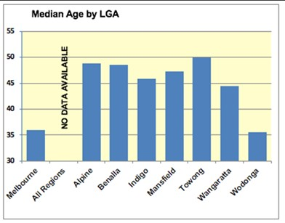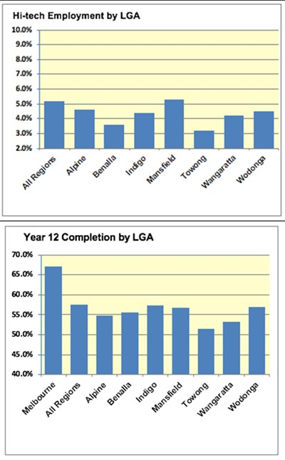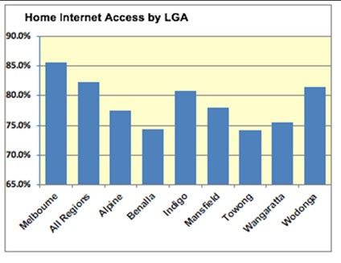

Ovens Murray General Characteristics

1.1 The Land and the People
Key features are:
- North‐East of the state, adjoining the Goulburn and Gippsland regions and Victorian‐NSW border
- Approximately 15,000 km² (relatively small)
- Population approx.125,000 (2016) – population density 5 residents /km2 (low for regional Victoria)
- Seven local government areas (LGAs) –Alpine (population 12,500), Benalla (14,000), Indigo (16,000), Mansfield (8,600), Towong (6,000), Wangaratta (29,000) and Wodonga (40,000).
- Main cities and towns: Wodonga (population 35,000), Wangaratta (19,000) and Benalla (9,000)
- Substantial LGA diversity – size, population, density and land use – usual for regional Victoria.

The Community
Whilst there are noteworthy variations across the region, the following summarises the overall profile:
- Age: 29% of population <25 years, 50% 25‐64, 21% 65+ – slightly younger than regional Victoria average (30:50:20 average)
- Education: 36% of the population have post‐ secondary qualifications – higher than regional Victoria average (34%)
- Income: average income for workers $41,000 – close to regional Victoria average of $40,000
- Unemployment: 4.9% total, 9.5% youth – lower than regional average (5.9% total, 11.5% youth)
Some of the more noteworthy variations across the region are demonstrated in the following charts.

The Economy
Gross Regional Product (GRP) (2017) for the Ovens Murray region is $6.4 billion, a 4% increase over the past 10 years compared to 2.6% growth for total regional Victoria. International exports are valued at
$0.7 billion (2017), with export‐intensity (exports relative to GRP) close to the regional Victoria average (11% vs 12%).
Eight industries make up three quarters of Ovens Murray employment:
- Health/social care (14% of jobs), manufacturing (10%), retail trade (10%)
- Tourism (9%), construction (8%), education and training (8%), public admin. and safety (8%)
- Agriculture/forestry (7%).
Employment across occupational categories is as follows:
- Professional (17% of residents), technical & trades (16%), managers (15%)
- Clerical & administration (11%), Community & personal services (12%)
- Labourers (12%), Sales (10%), machine operators & drivers (7%)

Structural Change
Health, manufacturing and retail are the top three industries in the region in terms of employee numbers, with only health among them showing growth over the past 10 years. This observation strongly supports the view the traditional industries are being replaced by technology driven service industries. Health is in fact the fastest growing industry overall, with tourism and education the other notable growth industries.
When considering contribution to GRP, two top industries (health and manufacturing) correspond well to employee numbers, with agriculture to exception (strong GDP contribution, relatively small employment share). This strongly suggests that health, manufacturing and agriculture should be a focus for digitalisation, especially since manufacturing is the fastest declining industry in terms of employee numbers but still the largest contributor of GRP.

Digital Intensity – now and in 3-5 years
Table 7 Comparison of digital intensity requirements now and in 3‐5 years across key sectors 12

Industry | Digital intensity now (current practice) |  | Digital intensity needed in 3‐5 years (best practice)
Healthcare & social assistance |  | Fixed access for patient records |  | Patient & GP fixed and mobile connectivity ‐ telehealth. Digitisation of records, analytics & data transparency. Robot‐assisted operations
Education &training |  | School, home fixed & mobile access |  | Student fixed & mobile home connectivity, online learning. Augmented & virtual reality in classrooms for enhanced teaching methods
Construction |  | Fixed & mobile connectivity |  | Fixed & mobile connectivity, digital models
Tourism |  | Mobile coverage of tourist hot spots |  | Mobile road coverage. WiFi & IoT at popular venues. Augmented/virtual reality attractions
Manufacturing |  | Fixed connectivity |  | Fixed connectivity, industrial IoT, fault prevention & data analytics for logistics
Public admin & safety |  | Resident fixed & mobile connectivity, connected public infrastructure |  | Resident fixed & mobile, IoT‐for Smart Cities, enhanced security & digital profiles for individuals

12 McKinsey Digital – Digital Australia: Seizing the opportunity from the Fourth Industrial Revolution; OCED – A taxonomy of digital intensive sectors

Agriculture/forestry |  | Mobile coverage of farming areas |  | Wide narrowband and broadband IoT access, apps and skills for horticulture, viticulture & livestock
Retail trade |  | Shop and building access |  | Retail at threat from online shopping. IoT can help retail stores connect to customers through promotions and mobile payment methods
Legend:

 | Low |  | Medium |  | High

General Characteristics Informing Digital Planning
This summary of the Ovens Murray characteristics and structural change demonstrates the significant regional diversity and the many factors that need to be considered when developing a regional digital plan. In this plan, a framework has been developed that attempts to address regional diversity and take into account the current and future needs of people, businesses, places and industry sectors. The framework includes place and sector‐based analysis of digital supply and demand necessary for identifying specific unmet digital needs and identifying priorities. Further development of this framework is required in subsequent digital plans.

Regional Supply Overview

Fixed Broadband
Coverage by Land Area
The map following shows NBN coverage of the Ovens Murray region, with the LGA boundaries marked.
Areas served with FTTP, FTTC and FTTN represent less than 0.5% of the land area in the region and accordingly are barely visible at the scale of this map. Many of these locations are discussed in Section 3.
Of note, at the scale of this map is the proportion of the region that is not shaded with any colour – representing the areas that are serviced with the lowest performing of NBN Co’s access technologies – satellite coverage.
Also visible at this scale are the areas where fixed wireless has been deployed (dark purple) or will be deployed (light purple) and some of the larger population centres where FTTP (brown) or FTTN (blue) has (or is due to be) deployed.

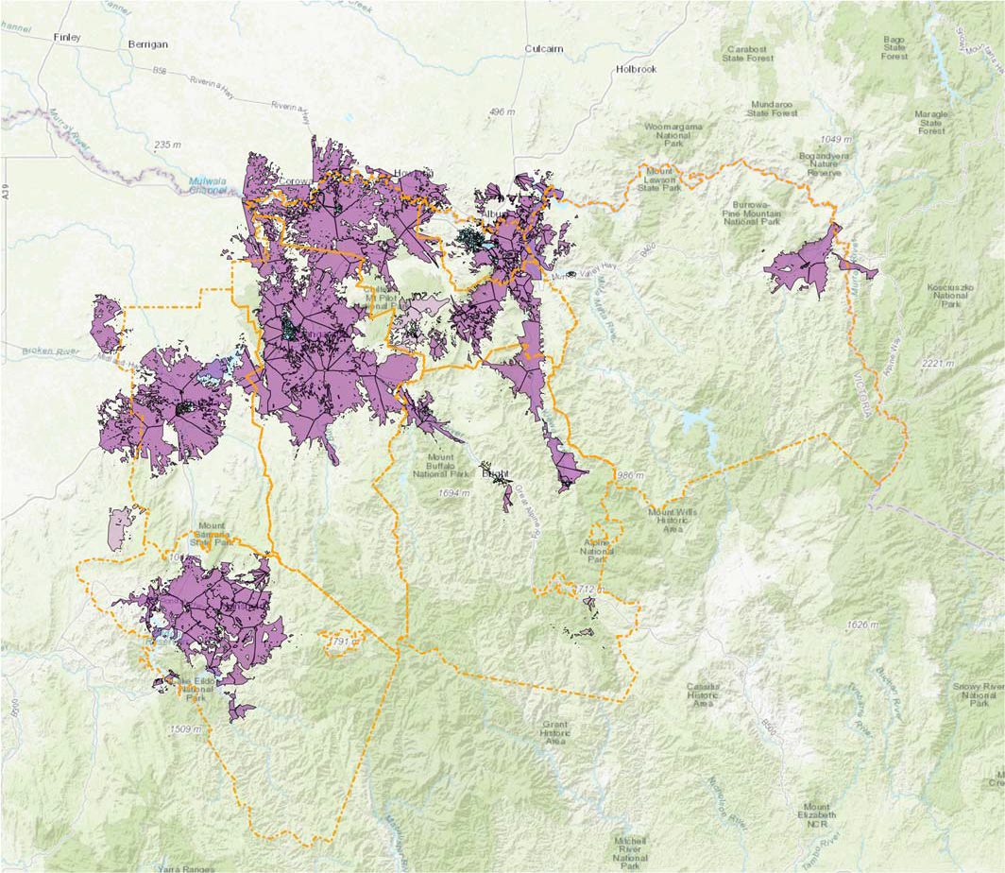
Figure 4 An Overview of NBN Technology Coverage of the Ovens Murray Region (SLIM)

The split between fixed wireless and satellite coverage is particularly relevant in assessing how well areas of the region are served. The following table summarises NBN Co’s present or planned use of these technologies for each LGA (noting the figures for Wodonga are distorted (favourably) by the comparatively small size of the region with a higher proportion of FTTN; and the Towong and Alpine LGAs have very little fixed wireless coverage.
LGA | No. Bus. | Approximate Coverage (%)
 |  | FTTP | FTTB FTTC | FTTN | FW | SAT
Alpine | 547 | 0% | 25% | 23% | 33% | 20%
Benalla | 528 | 0% | 36% | 34% | 14% | 16%
Indigo | 474 | 0% | 10% | 29% | 28% | 32%
Mansfield | 384 | 0% | 32% | 14% | 43% | 11%
Towong | 221 | 0% | 17% | 25% | 7% | 51%
Wangaratta | 1,125 | 0% | 0% | 76% | 15% | 9%
Wodonga | 1,196 | 1% | 0% | 92% | 0% | 7%
Region (no.) | 4,475 | 9 | 533 | 2,506 | 736 | 691

LGA | Area (km2) | NBN Technology (% Area)
 |  | Fixed Wireless (FW) | Satellite (SAT)
Alpine | 4,793 | 5% | 95%
Benalla | 2,349 | 16% | 83%
Indigo | 2,034 | 19% | 80%
Mansfield | 3,858 | 17% | 83%
Towong | 6,670 | 2% | 98%
Wangaratta | 3,651 | 29% | 71%
Wodonga | 437 | 5% | 85%
Region (km2) | 23,792 | 2,874 | 20,813

Coverage of Businesses
Across the Ovens Murray region, there are 4,475 businesses registered with Workcover. The NBN technology that either currently serves (or is destined to serve) these businesses is as shown in the chart below.

Satellite
15%
FTTC/FTTK
12%
FW
17%
FTTN
56%
Figure 5 Businesses served by different NBN technologies

Differences across the LGAs that make up the region are quite significant, as summarised in the table below.

Coverage of Dwellings
NBN Co’s use of different technologies to service particular residential areas has been examined visually within SLIM by zooming to a detailed (town or street level) view.
At an overview level, the following table summarises coverage by technology type for GNAF13 addresses (see important qualification in footnote) that lie within residential‐zoned areas.

Satellite FTTP
6% 5%
FW
13%
FTTC/FTTK
11%
FTTN
65%
Figure 6 GNAF addresses served by different NBN technologies
LGA | No. Res. | Approximate Coverage (%)
 |  | FTTP | FTTB FTTC | FTTN | FW | SAT
Alpine | 5,430 | 0% | 25% | 60% | 12% | 3%
Benalla | 5,704 | 0% | 56% | 32% | 9% | 4%
Indigo | 5,683 | 1% | 6% | 49% | 27% | 17%
Mansfield | 5,418 | 0% | 11% | 10% | 57% | 21%
Towong | 1,569 | 0% | 43% | 39% | 4% | 14%
Wangaratta | 10,740 | 2% | 0% | 89% | 8% | 1%
Region (no.) | 19,291 | 12% | 0% | 86% | 0% | 2%

13 The GNAF database contains addresses in land that is zoned commercial, industrial and residential. As such, it excludes properties located (for example) within land zoned for farming.

Whilst NBN Co’s satellite solution is intended to service the most remote 3% of the population, a very much higher proportion will be reliant on it in the Indigo, Mansfield and Towong LGAs. The overall percentage (6%) is also higher than the national average and could possibly be higher if the additional dwellings in farming areas were to be included.

General Notes
Supporting development of this plan was an analysis of common technology problems and potential solutions observed across regional Victoria.
This analysis outlined the strengths and weaknesses of all NBN Co’s various delivery technologies. In summary:
- users in satellite areas suffer the greatest performance limitations and are most likely to find their digital future constrained by performance limitations. For such users, access to higher performing connectivity in nearby population centres may be particularly valuable; and
- some users in both fixed wireless and FTTN areas may be limited by their connection technology, especially as needs grow into the future.

Mobile Coverage
Public Coverage Maps
Access to mobile coverage data is currently under discussion between the Victorian Department of Jobs Precincts and Regions (DJPR) and the mobile network operators (MNOs).
In the interim, only very high‐level perspectives can be obtained from the public coverage maps provided by each of the three established mobile network operators, which often do not capture localised blackspots due to topography and other reasons.

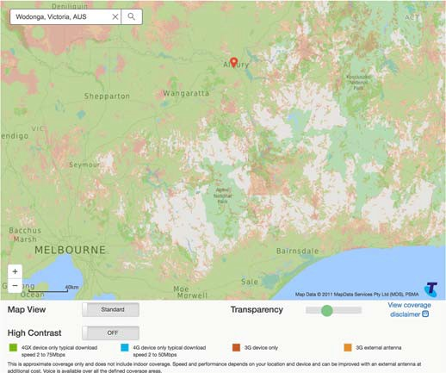
Figure 7 Telstra Public Coverage Map of Ovens Murray Region

Telstra’s public coverage map indicates good coverage with:
- 4GX (typically download speed 2 to 75 Mbps) in green;
- 3G in dark brown; and
- 3G with external antenna in light brown.
By simple visual examination of this map, Telstra appears to support coverage over at least 90% of the region.
The Optus public coverage map (see next page) is based on using a nominated device outdoors. For the purposes of this report, a handheld iPhone 6 has been assumed. In interpreting the map:
- purple indicates 4G Plus coverage;
- blue indicates 3G coverage; and
- yellow indicates 3G coverage with an external antenna.
By simple visual examination of this map, Optus appears to offer coverage of at least 90% of the region, comparable to Telstra.

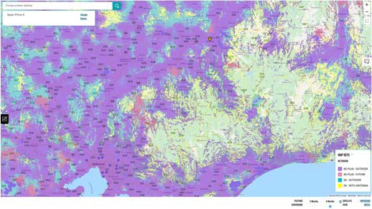
Figure 8 Optus Public Coverage Map of Ovens Murray Region

The most noteworthy gap evident in both Telstra and Optus coverage is in the Alpine National Park. Smaller coverage gaps are scattered across the region, most commonly in areas of hilly terrain.
As for Optus, Vodafone’s public coverage maps are based on using a nominated device, and for comparison with the Optus map, an iPhone6 has been assumed.

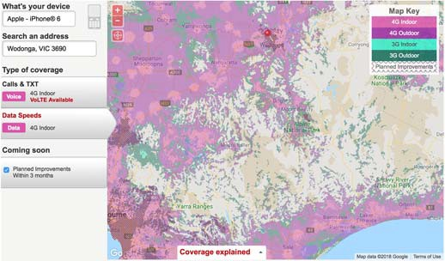
Figure 9 Vodafone Public Coverage Map of Ovens Murray Region

In interpreting the map:
- light pink indicates 4G indoor coverage;
- dark pink indicates 4G outdoor coverage;
- light green indicates indoor 3G coverage;
- dark green indicates outdoor 3G coverage; and
- shaded areas indicate where coverage enhancements are due to take place in the near future.
Based on the maps, Vodafone’s coverage is not as extensive as that of Telstra and Optus but appears to include good coverage of the major roads and more heavily populated areas.

Crowd‐sourced Coverage Information
In practice, the public coverage maps provided by the carriers do not always accord with end‐user experience. A range of applications have been developed to capture users’ real world experiences and integrate these into databases.
An example is the OpenSignal14 application and database, and a sample of the maps produced from these sources (in this case, in the area of Ararat) is provided below. These applications can provide useful insights into (especially) transport mobile blackspots – but are less useful in assessing wide area coverage because of the difficulties of testing everywhere.

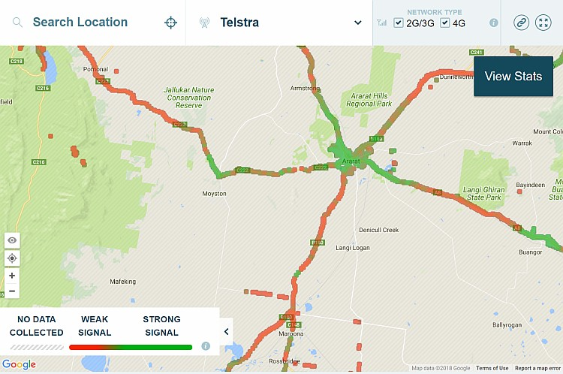
Figure 10 OpenSignal Mapping of Coverage around Ararat

The use of these applications by stakeholders (such as local government staff) may be valuable in building evidence of transport mobile blackspots.

General Notes
Coverage is constantly evolving as a result of ongoing MNO investment in new base stations ‐ including new base stations supported by the Commonwealth Mobile Blackspot Programs (MBSP) and the Victorian Government’s Blackspot Programs (VMP).
In addition, the mobile networks are evolving through successive technology generations.
In particular, fifth generation (5G) mobile technology is expected to commence general deployment in 2020, bringing with it significantly increased capacity, the ability to support a vastly increased number of devices and new features of particular relevance to Internet of

14 See https://opensignal.com/networks, accessed on 10 July 2018.

Things (IoT) applications.
Mobile coverage is discussed in the analysis that is provided in Section 3 for cities, towns and smaller localities in the region. In all cases, the outlook 5 years hence depends significantly on the pace and extent to which 5G technology is rolled out in regional areas of Victoria.
The mobile network operators are progressively introducing support for the Cat‐M1 and NB‐IOT protocols – suited to various IoT purposes. To date, only Optus has provided information for inclusion in SLIM. The Optus coverage relates to agricultural IoT trials being conducted in the north of the state and in Gippsland. Coverage that extends to any areas of this region is noted.

Mobile Coverage Challenges
The market dynamics of the fixed and mobile markets vary considerably in Australia.
In the fixed broadband market, the Australian Government responded with the NBN initiative to address a growing divide between urban and rural areas. In urban areas, high population densities and concentrated consumer spending attract network investment and competition. In addition, Telstra was required to grant other carriers access to its copper network to moderate what would otherwise have been a near‐monopoly grip on the market.
There has been no similar intervention in Australia’s mobile network ‐ though the challenges are broadly parallel. In particular, investment has flourished in urban areas, but has languished in rural areas where there is insufficient revenue‐generating traffic to drive commercial returns. As a result, only around one third of Australia’s landmass enjoys mobile coverage. The percentage in Victoria is significantly higher – estimated at around 75% ‐ as a consequence of comparatively high population densities.
It is not realistic to expect 100% coverage of Australia’s vast land‐mass. However, with the advent of smart phones and data capabilities, the mobile networks are becoming ever more important to all Australians for many different purposes including (but not limited to):
- social amenity
- occupational health and safety (noting that in emergency situations, triple‐zero calls can be made on any available network)
- on‐the‐spot access to information and services relevant to one’s business, lifestyle and/or well‐ being
- supporting IoT applications
- as a supplement (or alternative) to a fixed broadband service, especially in areas served only by NBN Co’s satellite service.
At the present level of coverage (by any MNO) many of the potential socio‐economic benefits remain ‘out of reach’. In this context, pushing the boundaries of mobile network coverage promises social‐economic benefits that can be disproportionate to the additional revenue opportunities available to carriers.
The challenges for the MNOs are understandable. If investment in extending coverage to an area does not generate sufficient additional revenue generating traffic to be profitable, it is not a prudent use of shareholder funds.
The structure of the mobile market in Australia leads to the question of what constitutes a mobile blackspot.
Most Australians subscribe to one and only one mobile network – and for many such Australians, a blackspot exists if the particular operator that they have chosen does not offer coverage relevant to their location and transport patterns.
However, one of the benefits of the vigorous competition that prevails to attract mobile users in urban areas is a rich array of competitively priced options. As a result, for those users whose preferred MNO does not provide coverage in all the areas that they frequent, the cost of subscribing to a secondary plan is typically not prohibitive. There are also ‘dual SIM’ phones that facilitate management of connectivity in a two‐network environment.

LP-WAN Coverage
General Notes
LP‐WAN technologies are designed for low‐bandwidth transmission of small packets of information, with the radio technology supporting battery life of several years, making it well‐suited for remote IoT sensors.
Two‐way protocols can be used for both monitoring (for example, meters, alarms etc.) and control responses. In contrast, one‐way protocols support only monitoring, but typically achieve longer battery life by obviating the need to “listen” for transmissions.

The original providers of LP‐WAN technology coverage are:
- NNNCo, with LoRaWAN technology; LoRa is a two‐ way protocol; at this stage, no information about coverage is available
- Thinxtra, with Sigfox technology – Sigfox is also a two‐way protocol; and
- Taggle, a one‐way technology used widely for water meter reading.
Deployment of these LP‐WAN technologies (LoRa, Sigfox and Taggle) is driven by project‐specific opportunities, rather than by up‐front investment in coverage in the hope that applications will follow.
The major mobile network operators are rapidly moving into the provision of LP‐WAN services (NB‐IoT), with data available for digital plan analysis on Optus NB‐IoT coverage at the time of report preparation.
In addition to utilising LP‐WAN technologies, Smart City and Smart Town initiatives can often take advantage of short‐range technologies such as WiFi, coupled with backhaul provided by an NBN service, an
independently sourced connectivity solution or a mobile network service.
Given the low bandwidth utilised by these technologies, much less infrastructure investment is required to provide coverage to large areas.

LoRa
An Australian company, NNNCo Pty. Ltd., is a leading proponent of LoRa technology and is known to be working in a range of ‘Smart City’ and rural applications. Details of coverage established in support of these projects are not published. In addition to NNNCo, various other parties are known to have deployed LoRa base stations for trial purposes and/or for particular applications.

Sigfox
Sigfox publishes a global coverage map15. The diagram below shows coverage in the Ovens Murray region in blue. In contrast to the Taggle map (see following), the Sigfox map appears to take account of topographic occlusions – as evidenced by the irregular patterns of
coverage at the fringes of coverage areas.

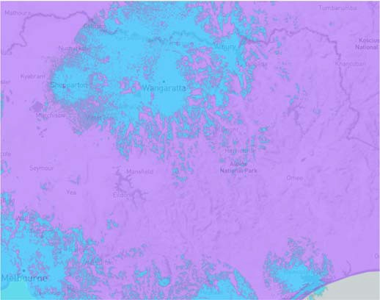
Figure 11 Sigfox Coverage of Ovens Murray Region.

Based on this map, there may be some coverage around the fringes of the Ovens Murray region.

Taggle
Taggle has provided indicative coverage maps for inclusion in the SLIM geographic information system (GIS), but they do not reflect any topographic occlusions that may affect communications at the margins. Nominal coverage is as shown in orange in the diagram that follows – field testing to confirm communications towards the fringes of coverage areas
would be prudent as additional base stations may need to be deployed to assure good connectivity.

15 Map derived from Sigfox coverage map published at http://www.sigfox.com/en/coverage (accessed on 3 July 2018).

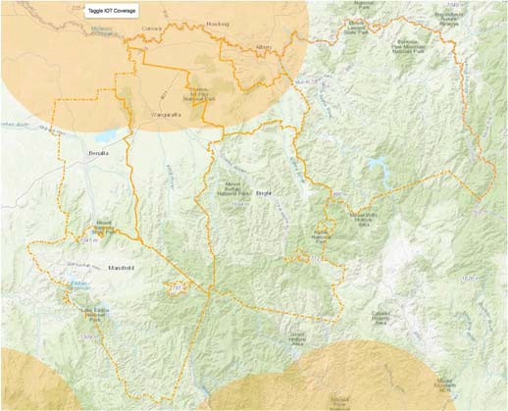
Figure 12 Taggle Coverage of the Ovens Murray Region (SLIM)

Other Connectivity Options
The Victorian Government agency VicTrack has fibre links running along regional rail corridors. The analysis of places notes where VicTrack fibre passes through (or nearby) a population centre. Access to the fibre may be possible subject to commercial arrangements, and the availability of suitable access points.
Also, in the context of “other” connectivity options, the power transmission network commonly includes
optical fibre in the Overhead Power Ground Wires (OPGWs) that protect the power lines below from lightning strikes. Whilst it is not known if fibre capacity is available and accessible on any particular segment of the power transmission network, the proximity of a location to the power transmission network is noted where applicable.
In various locations, commercial providers such as Telstra, Optus and Nextgen may be able to offer connectivity solutions for a wide range of purposes. Details of their infrastructure are currently not available in SLIM.

SLIM Analysis
Whilst various of the broad perspectives offered in this report are based on information from the SLIM GIS, SLIM is at its most powerful for detailed analysis of particular areas. Stakeholders are encouraged to build familiarity with the system when it is publicly available in order to be able to investigate particular needs in their jurisdictions, combining the information in SLIM with local knowledge.

Significant Places

The 18 places selected for analysis in this section include all cities (population16 > 10,000), all towns (population > 1,000) and the largest locality (population <1000) in each LGA that makes up the Ovens Murray region. The 18 Significant Places appear below in descending order of population, with the exception of Albury.
In combination, the 18 places accommodate 82.1% of the region’s population of 174,75617. The
proportion included in the analysis would be higher if those living in the immediate surrounds of each named place were to be counted.
The region is home to another 14 localities with populations of between 185 and 1,000 ‐ in combination representing another 4,291 (2.6%) of the population in the region.
The balance of the region’s population (15.3%) is living in communities with a population of less than 185, or on isolated properties (farms and the like). Based on an average Victorian household size of 2.6 as reported by the ABS18, this equates to an estimated 10,283 households outside of the places considered in the following subsections.
The source of data in this section is cited for the first (only) reference of its type.

Wodonga
Wodonga is a city on the Victorian side of the border with New South Wales, 300 kilometres northeast
of Melbourne in the Murray regional tourism area. It is located wholly within the boundaries of the City of Wodonga LGA. It is separated from its twin city in New South Wales, Albury, by the Murray River. Founded as a customs post with Albury, the town grew subsequent to the opening of the first bridge across the Murray in 1860.

16 All population figures cited in this report are based on the 2016 Census, published by the Australian Bureau of Statistics.
17 Population figures include the 2016 Australian Bureau of Statistics Albury UCL population of 47,974.
General characteristics of the city that provide an indication of the city’s likely telecommunications demand profile include:
- The population of Wodonga grew by 18.2% over a decade to 35,130 in 2016 above the median growth rate of 10.5% for the 18 major places analysed in the region
- 17,072 people aged 15 and over reported being in the labour force in the week preceding the 2016 Census, with 57.2% being in full‐time employment and 31.2% in part‐time employment (with the balance ‘away from work’ on the date of the census)
- 10.1% of the labour force classified themselves as managers, 16.3% as professionals and 12.6% as clerical and administrative workers
- 4.2% of the labour force cited their industry of employment as hospitals (except psychiatric hospitals) and 2.7% cited aged care residential
- The city has a private and a public hospital
- The city has 10 primary schools, 4 primary/secondary schools, 2 secondary schools, a special development school, a community college, a university and a TAFE
- With a median age of 36, Wodonga has one of the youngest populations in regional Victoria
- ABS report a median annual household income of
$63.9K for Wodonga, above the median of $55.8K for the places analysed in the region but below Melbourne’s $80.4K
- Data in SLIM on businesses registered with Workcover indicates approximately 1,103 businesses in the city or its near surrounds
- In 80.6% of dwellings, at least one person accessed the internet from home
Skills
ABS Census data indicates:
- 22.4% of people aged 15 and over having gained a diploma, advanced diploma, bachelors degree or higher educational qualification

18 Much of the data for locations and larger areas is sourced from the ABS Quickstats site (see http://www.censusdata.abs.gov.au/census_services/getproduct/census/2016/quickstat/2?opendocument).

- another 21.7% have completed level III or IV trade certificates; and
- another 12.2% have completed year 12.
ABS Industry employment data from 2016 indicated that the Wodonga LGA had 4.5% employment in the industry sectors with strong technology exposure.

Fixed Broadband
The map below shows the status of the NBN rollout in Wodonga as advised by NBN Co in September 2018. The purple / striped areas show the locations currently serviced by NBN Fixed Line services, the purple / spotted areas show locations serviced by NBN Fixed Wireless services and white areas locations serviced by NBN Satellite. The brown / striped areas show the locations where NBN Fixed Line services are planned or under construction.

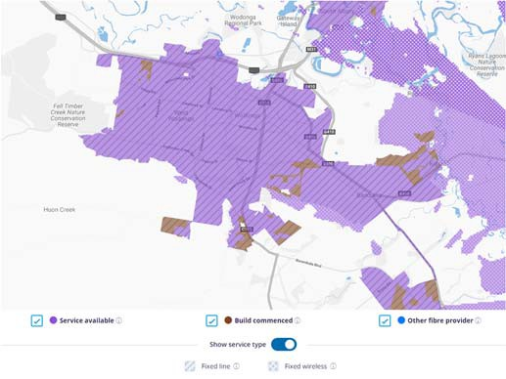
Figure 13 NBN Coverage of Wodonga (NBN Co)

Our analysis reveals that Wodonga is predominantly served by a FTTN rollout with some premises receiving FTTP which appears to be located in new developments around the city's perimeter. Areas adjacent to Wodonga to the east are served by Fixed Wireless however as shown in the map above the majority of the surrounding areas to the city only have access to NBN Satellite services. Analysis of aerial imagery does not reveal any significant concentrations of premises in these areas.

Mobile Coverage
Based on public coverage maps:
- Telstra shows 4GX outdoor handheld device coverage (with a typical download speed of 2‐75 Mbps) across the entire city.
- Optus shows 4G Plus outdoor coverage across the entire city.
- Vodafone shows 4G indoor coverage across the entire city.
In summary, there appear to be no mobile coverage issues in the city, with the three major mobile network operators all offering service.

LP‐WAN Coverage
There is extensive Taggle and SigFox coverage in Wodonga.

Public WiFi Coverage
There are free public WiFi zones in the Wodonga CBD, available 24 hours a day. The service was implemented in 2009 and may require an upgrade.
The Wodonga Library also has 24 hour free WiFi.

Other
VicTrack fibre is available approximately 32kms away in Barnawartha.
No details are available of optical fibre connectivity provided by other carriers.
330v power is available in Wodonga and its surrounding suburbs.

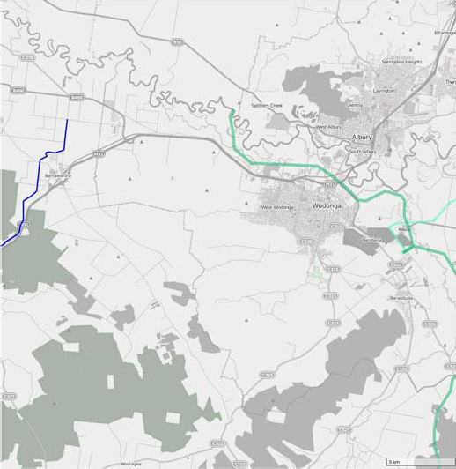
Figure 14 VicTrack fibre (blue) and power (green) transiting Wodonga (SLIM)

Albury
Albury is a city on the New South Wales side of the border with Victoria, 300 kilometres northeast
of Melbourne. It is separated from its twin city
in Victoria, Wodonga, by the Murray River. It is being considered in the digital plan analysis because of its strong relationship with Wodonga.
General characteristics of the city that provide an indication of the city’s likely telecommunications demand profile include:
- The population of Albury grew by 9.6% over a decade to 47,974 in 2016 below the median growth rate of 10.5% for the 18 major places analysed in the Ovens Murray region
- 22,979 people aged 15 and over reported being in the labour force in the week preceding the 2016 Census, with 55% being in full‐time employment and 32.9% in part‐time employment
- 10.5% of the labour force classified themselves as managers, 19.4% as professionals and 13% as clerical and administrative workers
- 4.6% of the labour force cited their industry of employment as hospitals (except psychiatric hospitals) and 2.4% cited aged care residential
- The city has 2 private and 2 public hospitals
- The city has 13 primary schools, 2 primary/secondary schools, 5 secondary schools, a special development school, a community college, a university and a TAFE
- With a median age of 39, Albury is younger than the median of 47 for the places analysed in the region and older than the Victorian median of 37
- The ABS report a median annual household income of $60K for Albury, above the median of $55.8K for the places analysed in the region but still below Melbourne’s $80.4K
- In 78.6% of dwellings, at least one person accessed the internet from home

Skills
ABS Census data indicates:
- 23.8% of people aged 15 and over having gained a diploma, advanced diploma, bachelors degree or higher educational qualification
- another 20.1% have completed level III or IV trade certificates; and
- another 12.6% have completed year 12.
ABS Industry employment data from 2016 indicated that the Albury LGA had 5.5% employment in the industry sectors with strong technology exposure.

Fixed Broadband
The map below shows the status of the NBN rollout in Wodonga as advised by NBN Co in September 2018. The purple / striped areas show the locations currently serviced by NBN Fixed Line services, the purple / spotted areas show locations serviced by NBN Fixed Wireless services and white areas locations serviced by NBN Satellite. The brown / striped areas show the locations where NBN Fixed Line services are planned or under construction.

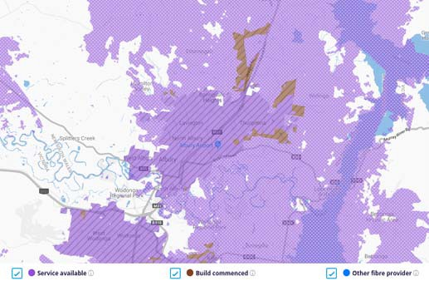
Figure 15 NBN Coverage of Albury (NBN Co)

Our analysis reveals that Albury city and surrounding suburbs have NBN Fixed Line coverage however, the technologies in the area cannot be specified due to limitations within the SLIM application.

Mobile Coverage
Based on public coverage maps:
- Telstra shows 4GX outdoor handheld device coverage (with a typical download speed of 2‐75 Mbps) across the entire city.
- Optus shows 4G Plus outdoor coverage across the entire city.
- Vodafone shows 4G indoor coverage across the entire city.
In summary, there appears to be no mobile coverage issues in the city, with the three major mobile network operators all offering service.

LP‐WAN Coverage
There is extensive Sigfox coverage in Albury. Taggle coverage is assumed to be equivalent to that found in Wodonga.

Public WiFi Coverage
24 hour free WiFi is available at the Albury Airport and at Dean and David streets in the CBD.
Free WiFi is available at Albury City Library during opening hours.

Other
VicTrack fibre is available approximately 32kms away in Barnawartha.
No details are available of optical fibre connectivity provided by other carriers.
330v power is available in Wodonga and its surrounding suburbs.

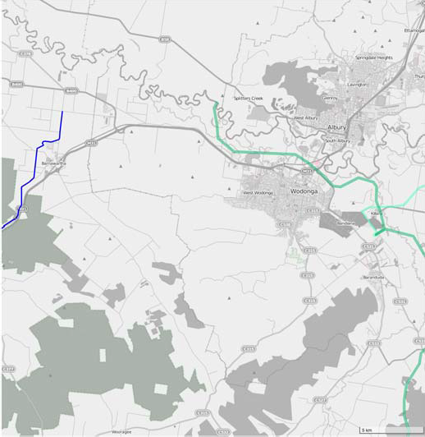
Figure 16 VicTrack fibre (blue) and power (green) transiting Albury

Wangaratta
Wangaratta is a regional centre in the High Country regional tourism area of north eastern Victoria, around 250 km from Melbourne along the Hume Highway. The city is located at the junction of the Ovens and King rivers, which drain the north western slopes of the Victorian Alps. Wangaratta is the administrative centre and the most populous city in the Rural City of Wangaratta local government area.
General characteristics of the city that provide an indication of the city’s likely telecommunications demand profile include:
- The population of Wangaratta grew by 10.2% over a decade to 18,566 in 2016, around the median growth rate of 10.5% for the 18 major places analysed in the region
- 8,224 people aged 15 and over reported being in the labour force in the week preceding the 2016 Census, with 53.3% being in full‐time employment and 35.3% in part‐time employment
- 10.2% of the labour force classified themselves as managers, 18.5% as professionals and 12.1% as clerical and administrative workers
- 7.3% of the labour force cited their industry of employment as hospitals (except psychiatric hospitals) and 2.7% cited aged care residential
- The city has one public and one private hospital
- The city has 7 primary schools, 2 primary/secondary schools, 2 secondary schools, a special development school, and a TAFE
- With a median age of 44, Wangaratta is just younger than the median of 47 for the places analysed in the region and older than the Victorian median of 37
- The ABS report a median annual household income of $53.1K for Wangaratta, below the median of
$55.8K for the places analysed in the region and below Melbourne’s $80.4K
- Data in SLIM on businesses registered with Workcover indicates approximately 842 businesses in the city or its near surrounds
- In 73.6% of dwellings, at least one person accessed the internet from home

Skills
ABS Census data indicates:
- 21.7% of people aged 15 and over having gained a diploma, advanced diploma, bachelors degree or higher educational qualification
- another 18.9% have completed level III or IV trade certificates; and
- another 10.7% have completed year 12.
ABS Industry employment data from 2016 indicated that the Wangaratta LGA had 4.2% employment in the industry sectors with strong technology exposure.

Fixed Broadband
The map below shows the status of the NBN rollout in Wangaratta as advised by NBN Co in September 2018. The purple / striped areas show the locations currently serviced by NBN Fixed Line services, the purple / spotted areas show locations serviced by NBN Fixed Wireless services and white areas locations serviced by NBN Satellite. The brown / striped areas show the locations where NBN Fixed Line services are planned or under construction.

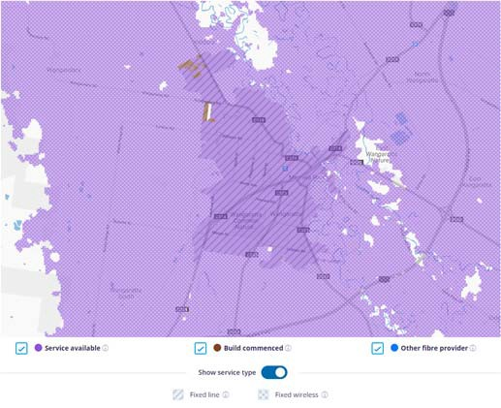
Figure 17 NBN Coverage of Wangaratta (NBN Co)

Our analysis reveals that Wangaratta city area is predominantly served by NBN FTTN with several locations at the city’s perimeter receiving FTTP. NBN Fixed Wireless serves the surrounds of the city with some pockets of NBN Satellite service to the north, east and further to the west as shown in the map above. The majority of businesses fall within the FTTN rollout area.

Mobile Coverage
Based on public coverage maps:
- Telstra shows 4GX outdoor handheld device coverage (with a typical download speed of 2‐75 Mbps) across the entire city.
- Optus shows 4G Plus outdoor coverage across the entire city.
- Vodafone shows 4G indoor coverage across the entire city.
In summary, there appear to be no mobile coverage issues in the city, with the three major mobile network operators all offering service.

LP‐WAN Coverage
There is extensive Taggle and SigFox coverage in Wangaratta.
Optus is involved in agricultural trials being conducted as part of the CRCP. That coverage footprint does not extend to Wangaratta

Public WiFi Coverage
24 hour free WiFi is available at the Wangaratta Open Door Neighbourhood House, Pangerang Community House, the Wangaratta Library and the Wangaratta Visitor Information Centre.

Other
VicTrack fibre transits the south western fringe of the city, following the route of the North East rail line (see map following).
No details are available of optical fibre connectivity provided by other carriers.
220v power is available approximately 17kms south of the city.

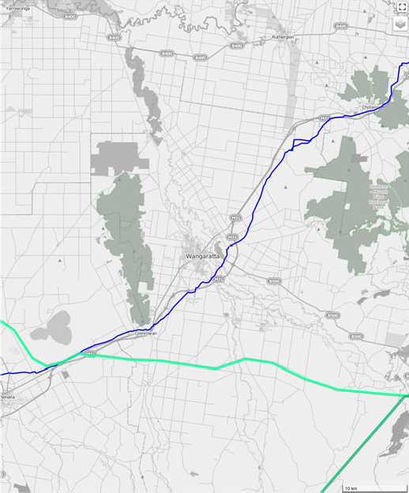
Figure 18 VicTrack (blue) and power company (green) network near Wangaratta

Benalla
Benalla is a regional centre located on the Broken River in the High Country regional tourism area of north eastern Victoria, about 212 kilometres northeast of Melbourne. It is the administrative centre for the Rural City of Benalla local government area. Industries include agricultural support services, tourism, a medium density fibre board factory, Thales Australia ammunition factory and aviation, and the LS Precast concrete facility which is upscaling to service Melbourne’s West Gate Tunnel project.
General characteristics of the town that provide an indication of the town’s likely telecommunications demand profile include:
- The population of Benalla grew by 1.9% over a decade to 9,298 in 2016 below the median growth rate of 10.5% for the 18 major places analysed in the region
- 3,711 people aged 15 and over reported being in the labour force in the week preceding the 2016 Census, with 53.5% being in full‐time employment and 34.0% in part‐time employment
- 10.8% of the labour force classified themselves as managers, 15.6% as professionals and 11.1% as clerical and administrative workers
- 4.8% of the labour force cited their industry of employment as hospitals (except psychiatric hospitals) and 4.0% cited aged care residential
- One public hospital is located in the town
- The town has 3 primary schools, 2 secondary schools, 4 campuses of a primary/secondary school, a special development school and a TAFE
- With a median age of 49, Benalla is older than the median of 47 for the places analysed in the region and older than the Victorian median of 37
- The ABS report a median annual household income of $45.4K for Benalla, below the median of $55.8K for the places analysed in the region and below Melbourne’s $80.4K
- Data in SLIM on businesses registered with Workcover indicates approximately 363 businesses in the town or its near surrounds
- In 71.9% of dwellings, at least one person accessed the internet from home

Skills
ABS Census data indicates:
- 18.4% of people aged 15 and over having gained a diploma, advanced diploma, bachelors degree or higher educational qualification
- another 18.8% have completed level III or IV trade certificates; and
- another10.7 % have completed year 12.
ABS Industry employment data from 2016 indicated that the Benalla LGA had 3.6% employment in the industry sectors with strong technology exposure.

Fixed Broadband
The map below shows the status of the NBN rollout in Benalla as advised by NBN Co in September 2018. The purple / striped areas show the locations currently serviced by NBN Fixed Line services, the purple / spotted areas show locations serviced by NBN Fixed Wireless services and white areas locations serviced by NBN Satellite. The brown / striped areas show the locations where NBN Fixed Line services are planned or under construction.

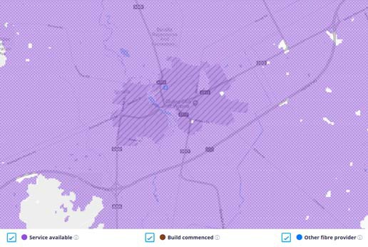
Figure 19 NBN Coverage of Benalla (NBN Co)

Our analysis reveals that Benalla town centre predominantly has access to a mix of NBN FTTN and FTTC. Surrounding Benalla in the less densely populated surrounds is NBN Fixed Wireless services. The NBN FTTN and FTTC services in the town are interspersed, which may lead to a number of residents and businesses being situated directly adjacent to higher capacity NBN services than what they are able to access.
Examining satellite imagery of the area reveals a number of premises close by to the south of the town which are served by Fixed Wireless services. Recent

publicity has highlighted performance issues with the NBN Fixed Wireless service, culminating in NBN Co’s decision to discontinue plans for a 100/40 Mbps service, at least for the time being.

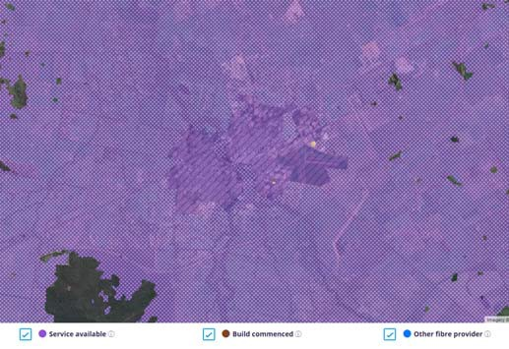
Figure 20 Aerial imagery showing NBN Fixed Line and Fixed Wireless areas in Benalla (NBN Co)

Mobile Coverage
Based on public coverage maps:
- Telstra shows 4GX outdoor handheld device coverage (with a typical download speed of 2‐75 Mbps) across the entire town.
- Optus shows 4G Plus outdoor coverage across the entire town.
- Vodafone shows 4G indoor coverage across the entire town.
In summary, there appear to be no mobile coverage issues in the town, with the three major mobile network operators all offering service.

LP‐WAN Coverage
There is SigFox coverage and limited Optus NB‐IoT coverage in Benalla. Tests should be conducted to determine the extent of the Optus coverage footprint.
Taggle is not currently available in Benalla.

Public WiFi Coverage
Free WiFi access available at the Benalla Library.
Access to free WiFi services may be valuable for those living just a short distance from the city for whom NBN satellite connectivity is the only fixed broadband option.

Other
VicTrack fibre transits through the centre of Benalla, following the route of the train line. Utilising spare capacity on this fibre could enable high‐speed connectivity to Melbourne.
220v power transits the northern fringe of the city.

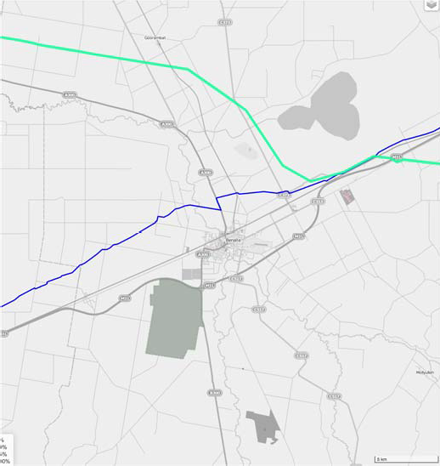
Figure 21 VicTrack (blue) fibre and power company (green) fibre transiting Benalla

Mansfield
Mansfield is a town in the foothills of the Victorian Alps approximately 180 kilometres northeast of Melbourne in the High Country regional tourism area. Mansfield is the seat of the Mansfield local government area and gateway to the Mount Buller Alpine Resort. Mansfield was formerly heavily dependent on farming and
logging but is now a growing tree‐change location and tourist centre.
General characteristics of the town that provide an indication of the town’s likely telecommunications demand profile include:
- The population of Mansfield grew by 19.9% over a decade to 3,410 in 2016 above the median growth rate of 10.5% for the 18 major places analysed in the region

- 1,603 people aged 15 and over reported being in the labour force in the week preceding the 2016 Census, with 55.6% being in full‐time employment and 36.2% in part‐time employment
- 13.1% of the labour force classified themselves as managers, 15.1% as professionals and 10.1% as clerical and administrative workers
- 4.7% of the labour force cited their industry of employment as hospitals (except psychiatric hospitals) and 3.1% cited local government administration
- One public hospital is located in the town
- The town has 2 primary schools and a primary/secondary school
- With a median age of 44, Mansfield is younger than the median of 47 for the places analysed in the region and older than the Victorian median of 37
- The ABS report a median annual household income of $53.7K for Mansfield, below the median of
$55.8K for the places analysed in the region and below Melbourne’s $80.4K
- Data in SLIM on businesses registered with Workcover indicates approximately 258 businesses in the town or its near surrounds
- In 76.1% of dwellings, at least one person accessed the internet from home

Skills
ABS Census data indicates:
- 18.9% of people aged 15 and over having gained a diploma, advanced diploma, bachelors degree or higher educational qualification
- another 22.1% have completed level III or IV trade certificates; and
- another 12.1% have completed year 12.
ABS Industry employment data from 2016 indicated that the Mansfield LGA had 5.3% employment in the industry sectors with strong technology exposure.

Fixed Broadband
The map below shows the status of the NBN rollout in Mansfield as advised by NBN Co in September 2018. The purple / striped areas show the locations currently serviced by NBN Fixed Line services, the purple / spotted areas show locations serviced by NBN Fixed Wireless services and white areas locations serviced by NBN Satellite. The brown / striped areas show the
locations where NBN Fixed Line services are planned or under construction.

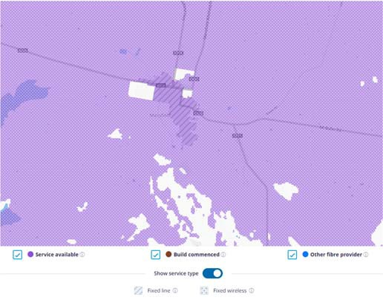
Figure 22 NBN Coverage of Mansfield (NBN Co)

The map above appears to show some notable areas to the west and north of the town which only have access to NBN Satellite services. The area adjacent to the NBN Fixed Line service area to the north includes a number of premises as revealed by satellite imagery (see below).
Our analysis reveals that Mansfield town centre is predominantly served by a mix of NBN FTTN and FTTC. The areas surrounding Mansfield are mostly served by Fixed Wireless services.
Satellite imagery reveals a number of premises close by to the west, east and north of the town immediately adjacent to NBN FTTC/FTTN services which are served by Fixed Wireless services.

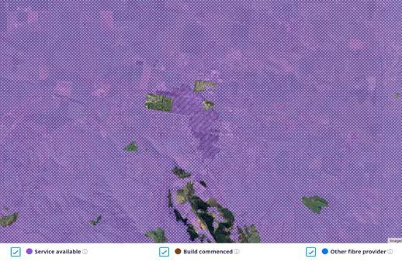
Figure 23 Aerial imagery showing NBN Fixed Line and Fixed Wireless areas in Mansfield (NBN Co)

Mobile Coverage
Based on public coverage maps:

- Telstra shows 4GX outdoor handheld device coverage (with a typical download speed of 2‐75 Mbps) across the entire town.
- Optus shows 4G Plus outdoor coverage across the entire town.
- Vodafone shows 4G indoor coverage across the entire town.
In summary, there appear to be no mobile coverage issues in the town, with the three major mobile network operators all offering service.

LP‐WAN Coverage
Taggle, Optus NB‐IoT and SigFox is not currently available in Mansfield.

Public WiFi Coverage
Free WiFi access available at the Mansfield Library.
Access to free WiFi services may be valuable for those living just a short distance from the city for whom NBN satellite connectivity is the only fixed broadband option.

Other
220v power transits both the northern and southern fringes of the city, connecting near Tolmie.

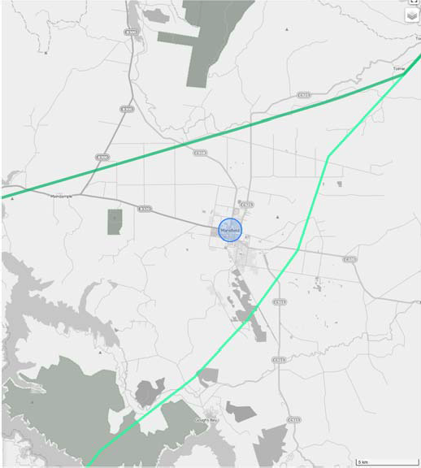
Figure 24 Power company network near Mansfield

Beechworth
Beechworth is an historic town located in the northeast of Victoria, famous for its major growth during the gold rush days of the mid‐1850s. It is located 284 kilometres northeast of Melbourne in the High Country regional tourism area. Beechworth's many historical buildings are well preserved, and the town has re‐invented itself and evolved into a popular
tourist destination and growing wine‐producing centre.
General characteristics of the town that provide an indication of the town’s likely telecommunications demand profile include:
- The population of Beechworth grew by 10.7% over a decade to 2,929 in 2016 just above the median growth rate of 10.5% for the 18 major places analysed in the region
- 1,359 people aged 15 and over reported being in the labour force in the week preceding the 2016 Census, with 48.9% being in full‐time employment and 39.8% in part‐time employment
- 14.3% of the labour force classified themselves as managers, 25.7% as professionals and 8.5% as clerical and administrative workers
- 5.7% of the labour force cited their industry of employment as hospitals (except psychiatric hospitals), 4.4% cited aged care residential and 4.3% cited local government administration
- One public hospital is located in the town
- The town has 3 primary schools
- With a median age of 51, Beechworth is older than the median of 47 for the places analysed in the region and older than the Victorian median of 37
- The ABS report a median annual household income of $56.8K for Beechworth, just above the median
of $55.8K for the places analysed in the region but still below Melbourne’s $80.4K
- Data in SLIM on businesses registered with Workcover indicates approximately 136 businesses in the town or its near surrounds
- In 79.1% of dwellings, at least one person accessed the internet from home

Skills
ABS Census data indicates:
- 36.4% of people aged 15 and over having gained a diploma, advanced diploma, bachelors degree or higher educational qualification
- another 16.0% have completed level III or IV trade certificates; and

- another 8.9% have completed year 12.
ABS Industry employment data from 2016 indicated that the Indigo LGA had 4.4% employment in the industry sectors with strong technology exposure.

Fixed Broadband
The map below shows the status of the NBN rollout in Beechworth as advised by NBN Co in September 2018. The purple / striped areas show the locations currently serviced by NBN Fixed Line services, the purple / spotted areas show locations serviced by NBN Fixed Wireless services and white areas locations serviced by NBN Satellite. The brown / striped areas show the locations where NBN Fixed Line services are planned or under construction.

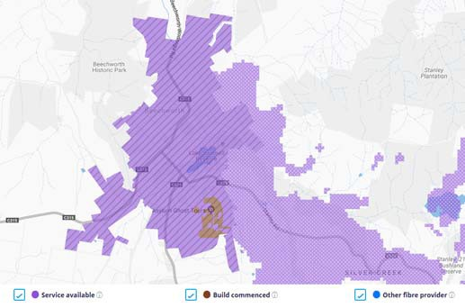
Figure 25 NBN Coverage of Beechworth (NBN Co)

Our analysis reveals that the town of Beechworth predominantly served by a mix of NBN FTTN and FTTC, with a small area to the south of the town that will receive FTTP. As shown in the coverage map above, other than the region to the east and southeast of Beechworth that is served by Fixed Wireless, the remaining areas surrounding the town are served by NBN Satellite services. These surrounding areas do not include many premises based on satellite imagery. Our analysis shows that the majority of businesses in Beechworth are covered by NBN Fixed Line services.

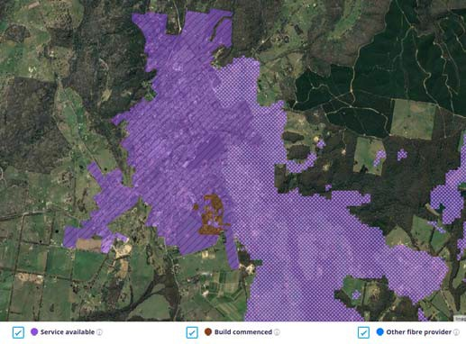
Figure 26 Aerial imagery showing NBN Fixed Line and Fixed Wireless areas in Beechworth (NBN Co)

Mobile Coverage
Based on public coverage maps:
- Telstra shows 4GX outdoor handheld device coverage (with a typical download speed of 2‐75 Mbps) across the entire town.
- Optus shows 4G Plus outdoor coverage across the entire town.
- Vodafone shows marginal mobile coverage in parts of the town with no coverage over the balance, but with some new coverage under construction.
In summary, residents have options for good coverage in the town and surrounding area from two of the three mobile network operators.

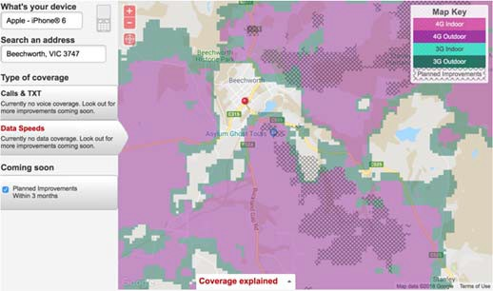
Figure 27 Vodafone mobile coverage in Beechworth.

LP‐WAN Coverage
Taggle IoT coverage is available in Beechworth.

Public WiFi Coverage
Free WiFi is available at the Beechworth Library. Access to free WiFi services may be valuable for those living just a short distance from the city for whom NBN satellite connectivity is the only fixed broadband option.

Other
Beechworth is neither on the VicTrack or power networks.

Myrtleford
Myrtleford is a town in northeast Victoria, 280 km northeast of Melbourne in the High Country regional tourism area and 46 km southeast of Wangaratta on the Great Alpine Road. Myrtleford is part of the Alpine Shire local government area. The post office opened on 26 July 1858 as Myrtle Creek and was renamed Myrtleford in 1871. Tobacco growing was a major industry around Myrtleford before growers exited the industry in 2006. The timber industry is now a major employer in Myrtleford.
General characteristics of the town that provide an indication of the town’s likely telecommunications demand profile include:
- The population of Myrtleford grew by 2.0% over a decade to 2,782 in 2016 below the median growth rate of 10.5% for the 18 major places analysed in the region
- 1,141 people aged 15 and over reported being in the labour force in the week preceding the 2016 Census, with 52.8% being in full‐time employment and 34.0% in part‐time employment
- 8.8% of the labour force classified themselves as managers, 12.0% as professionals and 9.5% as clerical and administrative workers
- 6.1% of the labour force cited their industry of employment as hospitals (except psychiatric hospitals) and 5.2% cited aged care residential
- One public hospital is located in the town
- The town has 1 primary school and a primary/secondary school
- With a median age of 49, Myrtleford is older than the median of 47 for the places analysed in the region and older than the Victorian median of 37
- The ABS report a median annual household income of $45.7K for Myrtleford, below the median of
$55.8K for the places analysed in the region and below Melbourne’s $80.4K
- Data in SLIM on businesses registered with Workcover indicates approximately 145 businesses in the town or its near surrounds
- In 70.2% of dwellings, at least one person accessed the internet from home

Skills
ABS Census data indicates:
- 15.2% of people aged 15 and over having gained a diploma, advanced diploma, bachelors degree or higher educational qualification
- another 19.1% have completed level III or IV trade certificates; and
- another 10.7% have completed year 12.
ABS Industry employment data from 2016 indicated that the Alpine LGA had 4.6% employment in the industry sectors with strong technology exposure.

Fixed Broadband
The map below shows the status of the NBN rollout in Myrtleford as advised by NBN Co in September 2018. The purple / striped areas show the locations currently serviced by NBN Fixed Line services, the purple / spotted areas show locations serviced by NBN Fixed Wireless services and white areas locations serviced by NBN Satellite. The brown / striped areas show the locations where NBN Fixed Line services are planned or under construction.

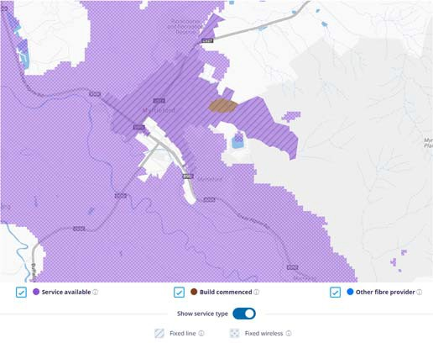
Figure 28 NBN Coverage of Myrtleford (NBN Co)

Our analysis reveals that the town of Myrtleford have received a mix of NBN FTTN and FTTC within the NBN Fixed Line footprint shown above, with a new development near the centre of the town (marked brown above) that will receive FTTP.
As shown in the coverage map above, the areas to the east of the town only have access to NBN Satellite services along with an area to the southwest of the town. Satellite imagery of the area to the east shows a limited number of premises in this region with mainly unpopulated hilly terrain. Satellite imagery also shows a number of aggregations of premises to the south of the NBN Fixed Line footprint that are served by Fixed Wireless.

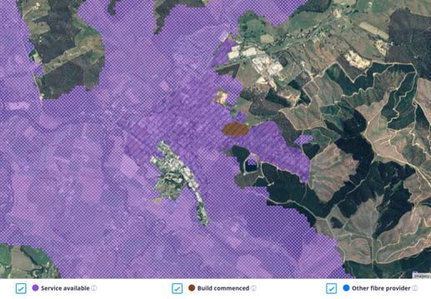
Figure 29 Aerial imagery showing NBN Fixed Line and Fixed Wireless areas in Myrtleford (NBN Co)

Mobile Coverage
Based on public coverage maps:
- Telstra shows 4GX outdoor handheld device coverage (with a typical download speed of 2‐75 Mbps) across the entire town.
- Optus shows 4G Plus outdoor coverage across the entire town.
- Vodafone shows 4G indoor and outdoor coverage across the entire town.
In summary, there appear to be no mobile coverage issues in the town, with the three major mobile network operators all offering service.

LP‐WAN Coverage
There is no known IoT coverage available in Myrtleford.

Public WiFi Coverage
Free WiFi is available at the Myrtleford Library. Access to free WiFi services may be valuable for those living just a short distance from the city for whom NBN satellite connectivity is the only fixed broadband option.

Other
220v and 330v power is available in the northern fringes of the town.

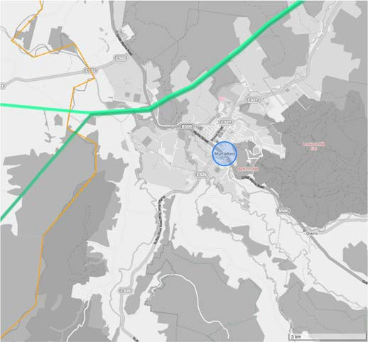
Figure 30 Power transiting Myrtleford

Bright
Bright is a town located 321 kilometres northeast of Melbourne and a key visitor destination in the High Country regional tourism area. Bright is part of the Alpine Shire local government area. It’s a base for exploring the Ovens River, surrounding valleys and the peaks of Mount Buffalo National Park and Alpine National Park, as well as Mount Hotham, a popular ski resort. The region is also known for wineries and autumn foliage. Bright is a popular entry point for the Murray to Mountains Rail Trail, an iconic walking and cycling path. Bright is also the last service centre on the Great Alpine Road before it traverses Mount Hotham and Dinner Plain into Gippsland.
General characteristics of the town that provide an indication of the town’s likely telecommunications demand profile include:

- The population of Bright grew by 9.4% over a decade to 2,310 in 2016, just below the median growth rate of 10.5% for the 18 major places analysed in the region
- 975 people aged 15 and over reported being in the labour force in the week preceding the 2016 Census, with 51.5% being in full‐time employment and 39.2% in part‐time employment
- 16.7% of the labour force classified themselves as managers, 16.5% as professionals and 10.3% as clerical and administrative workers
- 5.6% of the labour force cited their industry of employment as hospitals (except psychiatric hospitals) and 3.5% cited local government administration
- One public hospital is located in the town
- The town has a primary/secondary school
- With a median age of 50, Bright is older than the median of 47 for the places analysed in the region and older than the Victorian median of 37
- The ABS report a median annual household income of $49.2K for Bright, below the median of $55.8K for the places analysed in the region and below Melbourne’s $80.4K
- Data in SLIM on businesses registered with Workcover indicates approximately 133 businesses in the town or its near surrounds
- In 79.2% of dwellings, at least one person accessed the internet from home

Skills
ABS Census data indicates:
- 29.3% of people aged 15 and over having gained a diploma, advanced diploma, bachelors degree or higher educational qualification
- another 16.3% have completed level III or IV trade certificates; and
- another 11.4% have completed year 12.
ABS Industry employment data from 2016 indicated that the Alpine LGA had 4.6% employment in the industry sectors with strong technology exposure.

Fixed Broadband
The map below shows the status of the NBN rollout in Bright as advised by NBN Co in September 2018. The purple / striped areas show the locations currently serviced by NBN Fixed Line services, the purple / spotted areas show locations serviced by NBN Fixed Wireless services and white areas locations serviced by
NBN Satellite. The brown / striped areas show the locations where NBN Fixed Line services are planned or under construction.

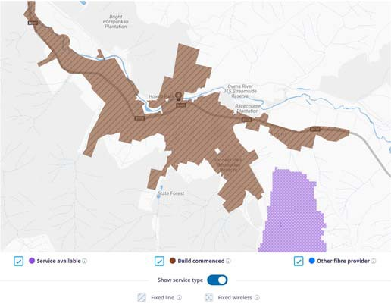
Figure 31 NBN Coverage of Bright (NBN Co)

Our analysis reveals that the town of Bright, along with the adjacent town of Porepunkah to the west, do not yet have NBN services available. Our analysis reveals that Bright will predominantly receive a mix of NBN FTTN and FTTC. Other than an area to the southeast of Bright that is able to access NBN Fixed Wireless as shown in the coverage map above, the remaining surrounding areas of Bright only have access to NBN Satellite. However, satellite imagery reveals that much of this area is unpopulated, hilly terrain.

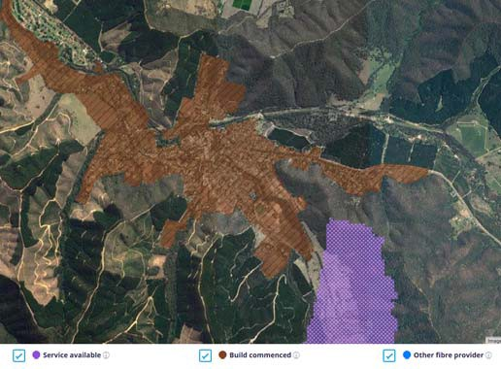
Figure 32 Aerial imagery showing NBN Fixed Wireless and satellite areas (NBN Co)

Mobile Coverage
Based on public coverage maps:

- Telstra shows 4GX outdoor handheld device coverage (with a typical download speed of 2‐75 Mbps) across the entire town.
- Optus shows 4G Plus outdoor coverage across the entire town.
- Vodafone shows 4G indoor and outdoor coverage across the entire town.
In summary, there appear to be no mobile coverage issues in the town, with the three major mobile network operators all offering service.

LP‐WAN Coverage
There is no known IoT coverage available in Bright.

Public WiFi Coverage
Internet access is available at the Bright Library. Access to free WiFi services may be valuable for those living just a short distance from the city for whom NBN satellite connectivity is the only fixed broadband option.

Other
220v power is available in the northern fringes of the town.

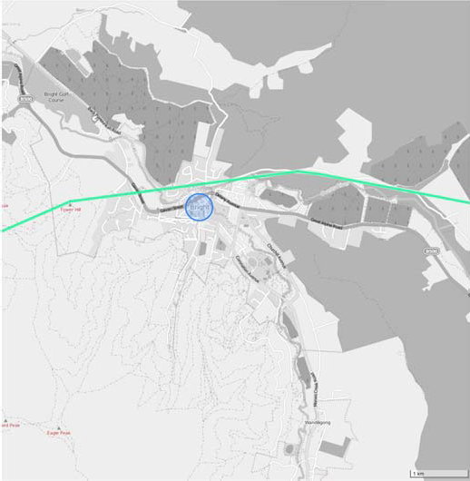
Figure 33 Power company network near bright.

Rutherglen
Rutherglen is a small town in north eastern Victorian. It is located north of Wangaratta and west of Wodonga, in the High Country regional tourism area, just 10 kilometres from the Murray River at the border towns of Wahgunyah and Corowa near the Murray
River border with New South Wales. Originally a gold‐ mining town of the mid‐19th century, it has since developed into a major wine producing area, with 17 wineries all located within a short drive from the town centre.
General characteristics of the town that provide an indication of the town’s likely telecommunications demand profile include:
- The population of Rutherglen grew by 6.0% over a decade to 2,109 in 2016, below the median growth rate of 10.5% for the 18 major places analysed in the region
- 970 people aged 15 and over reported being in the labour force in the week preceding the 2016 Census, with 56.3% being in full‐time employment and 32.0% in part‐time employment
- 13.6% of the labour force classified themselves as managers, 15.0% as professionals and 11.5% as clerical and administrative workers
- 3.5% of the labour force cited their industry of employment as aged care residential
- The nearest hospital is located in Wodonga to the east
- The town has 2 primary schools
- With a median age of 47, Rutherglen has the median age for the places analysed in the region and is older than the Victorian median of 37
- The ABS report a median annual household income of $55.8K for Rutherglen, which is the median for the places analysed in the region and below Melbourne’s $80.4K
- Data in SLIM on businesses registered with Workcover indicates approximately 85 businesses in the town or its near surrounds
- In 74.8% of dwellings, at least one person accessed the internet from home

Skills
ABS Census data indicates:
- 22.2% of people aged 15 and over having gained a diploma, advanced diploma, bachelors degree or higher educational qualification

- another 21.6% have completed level III or IV trade certificates; and
- another 10.7% have completed year 12.
ABS Industry employment data from 2016 indicated that the Indigo LGA had 4.4% employment in the industry sectors with strong technology exposure.

Fixed Broadband
The map below shows the status of the NBN rollout in Rutherglen as advised by NBN Co in September 2018. The purple / striped areas show the locations currently serviced by NBN Fixed Line services, the purple / spotted areas show locations serviced by NBN Fixed Wireless services and white areas locations serviced by NBN Satellite. The brown / striped areas show the locations where NBN Fixed Line services are planned or under construction.

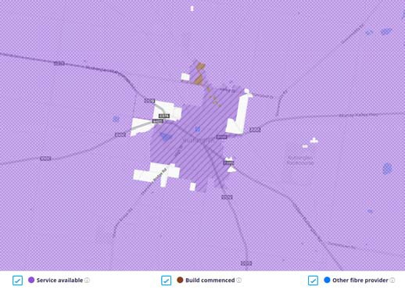
Figure 34 NBN Coverage of Rutherglen (NBN Co)

Our analysis reveals that the town of Rutherglen have predominantly received NBN FTTN within the NBN Fixed Line footprint. The coverage map above indicates that small areas to the east, west, north and southwest of the town only have access to NBN Satellite services, while in other fringe areas premises can access NBN Fixed Wireless services.
Aerial imagery reveals some pockets of premises surrounding the fixed line footprint within the NBN Satellite service areas. These premises are likely to experience significantly poorer service quality than the nearby premises within the fixed line boundary.

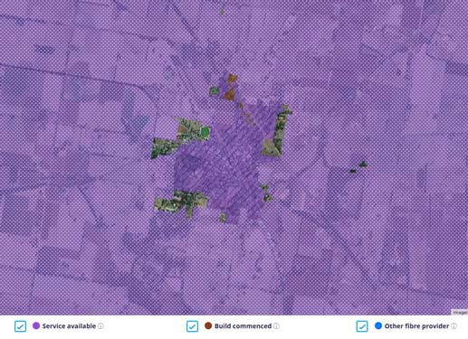
Figure 35 Aerial imagery showing NBN Fixed Wireless, Fixed Line and satellite areas (NBN Co)

Mobile Coverage
Based on public coverage maps:
- Telstra shows 4GX outdoor handheld device coverage (with a typical download speed of 2‐75 Mbps) across the entire town.
- Optus shows 4G Plus outdoor coverage across the entire town.
- Vodafone shows 4G indoor coverage across the entire town, with new coverage under construction.
In summary, there appear to be no mobile coverage issues in the town, with the three major mobile network operators all offering service.

LP‐WAN Coverage
Extensive Taggle IoT and Sigfox coverage is available in Rutherglen.

Public WiFi Coverage
Free WiFi is available at the Rutherglen Library and Visitor Information Centre. Access to free WiFi services may be valuable for those living just a short distance from the city for whom NBN satellite connectivity is the only fixed broadband option.

Other
Rutherglen is neither on the VicTrack or power networks.

Baranduda
Baranduda forms part of the Leneva‐Baranduda growth corridor 12 kilometres to the southeast of Wodonga’s central business area and is within close proximity to Wodonga’s Bandiana Military Area. It is around 323 kilometres northeast of Melbourne. Major employers of the town’s residents include the
industries of defence, hospitals and primary education.
General characteristics of the locality that provide an indication of the locality’s likely telecommunications demand profile include:
- The population of Baranduda grew by 28.9% over a decade to 1,764 in 2016, above the median growth rate of 10.5% for the 18 major places analysed in the region
- 911 people aged 15 and over reported being in the labour force in the week preceding the 2016 Census, with 59.8% being in full‐time employment and 31.5% in part‐time employment
- 11.4% of the labour force classified themselves as managers, 20.3% as professionals and 14.6% as clerical and administrative workers
- 4.4% of the labour force cited their industry of employment as hospitals (except psychiatric hospitals), 2.9% cited central government administration and 2.7% cited aged care residential
- The nearest hospital is located nearby in Wodonga
- The locality has 2 primary schools and a primary/secondary school
- With a median age of 34, Baranduda has one of the youngest populations in regional Victoria and below the Victorian median of 37
- The ABS report a median annual household income of $88.5K for Baranduda, the highest among the 17 places analysed in the region and above Melbourne’s $80.4K
- Data in SLIM on businesses registered with Workcover indicates approximately 45 businesses in the locality or its near surrounds
- In 93.5% of dwellings, at least one person accessed the internet from home

Skills
ABS Census data indicates:
- 34.1% of people aged 15 and over having gained a diploma, advanced diploma, bachelors degree or higher educational qualification
- another 25.5% have completed level III or IV trade certificates; and
- another 10.5% have completed year 12.
ABS Industry employment data from 2016 indicated that the Wodonga LGA had 4.5% employment in the industry sectors with strong technology exposure.

Fixed Broadband
The map below shows the status of the NBN rollout in Baranduda as advised by NBN Co in September 2018. The purple / striped areas show the locations currently serviced by NBN Fixed Line services, the purple / spotted areas show locations serviced by NBN Fixed Wireless services and white areas locations serviced by NBN Satellite. The brown / striped areas show the locations where NBN Fixed Line services are planned or under construction.

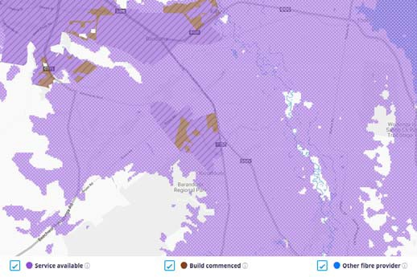
Figure 36 NBN Coverage of Baranduda (NBN Co)

Our analysis reveals that Baranduda will predominantly receive an NBN FTTN and FTTP rollout within the NBN Fixed Line footprint, with much of the FTTP rollout currently under construction.
The coverage map above indicates that the immediate surrounds to the NBN Fixed Line area have access to NBN Fixed Wireless where a number of premises appear to be located. Satellite imagery does not reveal many premises located in the areas served by NBN Satellite.

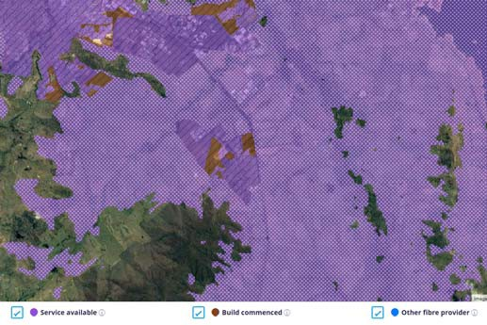
Figure 37 Aerial imagery showing NBN Fixed Wireless, Fixed Line and satellite areas (NBN Co)

Mobile Coverage
Based on public coverage maps:
- Telstra shows 4GX outdoor handheld device coverage (with a typical download speed of 2‐75 Mbps) across the entire town.
- Optus shows 4G Plus outdoor coverage across the entire town.
- Vodafone shows 4G indoor coverage across the entire town, with new coverage under construction in the area.
In summary, there appear to be no mobile coverage issues in the locality, with the three major mobile network operators all offering service.

LP‐WAN Coverage
Taggle IoT and Sigfox coverage is available in Baranduda.

Public WiFi Coverage
There are no known Free Public WiFi services available in Baranduda.

Other
Baranduda is not on the VicTrack transmission route. 220v Power transits the northern and eastern fringes of the town.

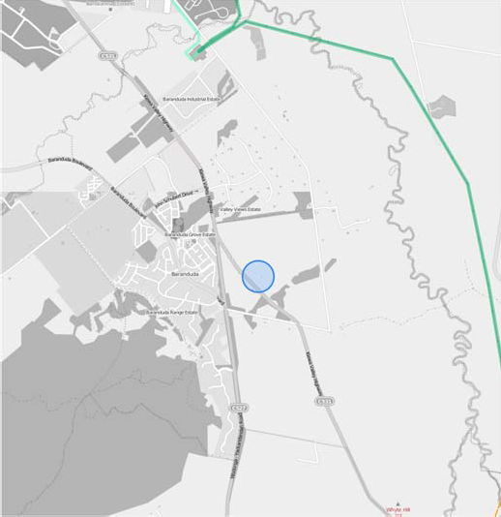
Figure 38 Power company network near Baranduda

Mount Beauty – Tawonga South
Mount Beauty‐Tawonga South is a small population centre in north eastern Victoria around 346 kilometres northeast of Melbourne in the High Country regional tourism area. The locality lies alongside the Kiewa River, at the junction of the Kiewa Valley Highway and Bogong High Plains Road in the Alpine Shire local government area and is the gateway to the Falls Creek Alpine Resort. The area experiences distinct seasonal variation with each season has its own attractions, including skiing, bushwalking, horse riding, gliding, bike riding (mountain and road) as well as fishing (river and lake).
General characteristics of the location that provide an indication of the location’s likely telecommunications demand profile include:
- The population of Mount Beauty‐Tawonga South was 1,688 in 2016. ABS statistics are not available for this population centre in the same format for 2006 so a 10‐year growth rate cannot be provided.
- 726 people aged 15 and over reported being in the labour force in the week preceding the 2016 Census, with 52.1% being in full‐time employment and 38.0% in part‐time employment
- 14.6% of the labour force classified themselves as managers, 18.5% as professionals and 10.1% as clerical and administrative workers

- 9.9% of the labour force cited their industry of employment as accommodation, 6.5% cited primary education and 5.2% cited hospitals (except psychiatric hospitals)
- One public hospital is located in the town
- The location has 2 primary school
- With a median age of 50, Mount Beauty‐Tawonga South is older than the median of 47 for the places analysed in the region and older than the Victorian median of 37
- The ABS report a median annual household income of $49.6K for Mount Beauty‐Tawonga South, below the median of $55.8K for the places analysed in the region and below Melbourne’s $80.4K
- Data in SLIM on businesses registered with Workcover indicates approximately 84 businesses in the location or its near surrounds
- In 81.8% of dwellings, at least one person accessed the internet from home

Skills
ABS Census data indicates:
- 33.4% of people aged 15 and over having gained a diploma, advanced diploma, bachelors degree or higher educational qualification
- another 19.1% have completed level III or IV trade certificates; and
- another 9.0% have completed year 12.
ABS Industry employment data from 2016 indicated that the Alpine LGA had 4.6% employment in the industry sectors with strong technology exposure.

Fixed Broadband
The map below shows the status of the NBN rollout in Mount Beauty ‐ Tawonga South as advised by NBN Co in September 2018. The purple / striped areas show the locations currently serviced by NBN Fixed Line services, the purple / spotted areas show locations serviced by NBN Fixed Wireless services and white areas locations serviced by NBN Satellite. The brown /
striped areas show the locations where NBN Fixed Line services are planned or under construction.

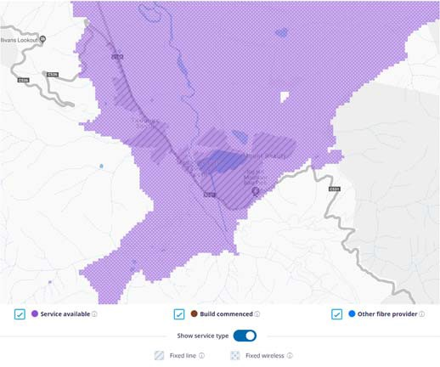
Figure 39 NBN Coverage of Mount Beauty ‐ Tawonga South (NBN Co)

Our analysis reveals that Mount Beauty ‐ Tawonga South is predominantly served by NBN FTTN within the NBN Fixed Line footprint, with the surrounding areas served by NBN Fixed Wireless.
Much of the surrounding areas to the NBN Fixed Wireless footprint which only have access to NBN Satellite are unpopulated hilly areas and bushland, as shown by satellite imagery. There is an area to the southwest of the NBN Fixed Line footprint served by NBN Fixed Wireless that contains a number of premises. The majority of businesses in the town are served by NBN FTTN.

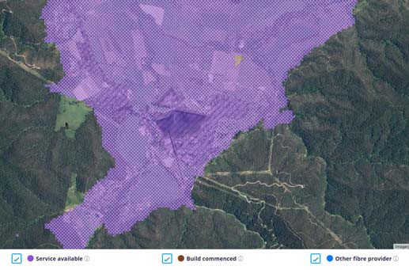
Figure 40 Aerial imagery showing NBN Fixed Wireless, Fixed Line and satellite areas (NBN Co)

Mobile Coverage
Based on public coverage maps:

- Telstra shows 4GX outdoor handheld device coverage (with a typical download speed of 2‐75 Mbps) across the entire town.
- Optus shows 4G Plus outdoor coverage across the entire town.
- Vodafone shows 4G indoor coverage across the entire town.
In summary, there appear to be no mobile coverage issues in the location, with the three major mobile network operators all offering service.

LP‐WAN Coverage
There is no known IoT coverage available in Mount Beauty ‐ Tawonga South.

Public WiFi Coverage
Public WiFi services are available at the Mount Beauty Library.

Other
Mount Beauty ‐ Tawonga South is not on the VicTrack transmission route. 66v Power transits the southern and western fringes of the town.

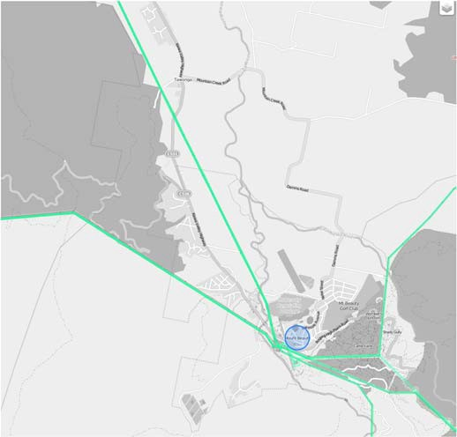
Figure 41 Power company network around Tawonga and Mount Beauty

Chiltern
Chiltern is an historic town in the northeast of Victoria between Wangaratta and Wodonga, in the Shire of
Indigo. The town is close to the Chiltern‐Mount Pilot National Park and within the High Country regional tourism area. The discovery of gold in late 1858 and early 1859 brought a huge shift in population into the Chiltern – Black Dog Creek area. Chiltern was once on the main road between Melbourne and Sydney but is now bypassed by the Hume Freeway running one kilometre to the east.
General characteristics of the town that provide an indication of the town’s likely telecommunications demand profile include:
- The population of Chiltern grew by 17.0% over a decade to 1,244 in 2016, above the median growth rate of 10.5% for the 18 major places analysed in the region
- 582 people aged 15 and over reported being in the labour force in the week preceding the 2016 Census, with 51.5% being in full‐time employment and 34.7% in part‐time employment
- 8.9% of the labour force classified themselves as managers, 11.5% as professionals and 11.7% as clerical and administrative workers
- 4.5% of the labour force cited their industry of employment as hospitals (except psychiatric hospitals), 3.8% cited aged care residential and 3.6% cited local government administration
- The nearest hospitals are located in Wodonga to the east or Beechworth to the southeast.
- The town has 2 primary schools
- With a median age of 46, Chiltern is younger than the median of 47 for the places analysed in the region but older than the Victorian median of 37
- The ABS report a median annual household income of $60.6K for Chiltern, above the median of $55.8K for the places analysed in the region but still below Melbourne’s $80.4K
- Data in SLIM on businesses registered with Workcover indicates approximately 26 businesses in the town or its near surrounds
- In 77.1% of dwellings, at least one person accessed the internet from home

Skills
ABS Census data indicates:
- 17.6% of people aged 15 and over having gained a diploma, advanced diploma, bachelors degree or higher educational qualification
- another 21.7% have completed level III or IV trade certificates; and

- another 10.3% have completed year 12.
ABS Industry employment data from 2016 indicated that the Indigo LGA had 4.4% employment in the industry sectors with strong technology exposure.

Fixed Broadband
The map below shows the status of the NBN rollout in Chiltern as advised by NBN Co in September 2018. The purple / striped areas show the locations currently serviced by NBN Fixed Line services, the purple / spotted areas show locations serviced by NBN Fixed Wireless services and white areas locations serviced by NBN Satellite. The brown / striped areas show the locations where NBN Fixed Line services are planned or under construction.

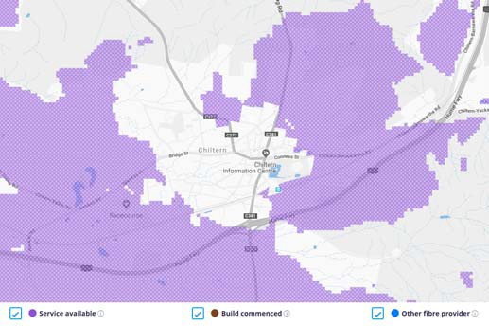
Figure 42 NBN Coverage of Chiltern (NBN Co)

The NBN coverage map above reveals that the NBN rollout has largely not reached Chiltern yet, with the town only able to access NBN Satellite services. The areas surrounding Chiltern, excluding the north, have access to NBN Fixed Wireless however satellite imagery does not show a large number of premises in these areas. Our analysis reveals that Chiltern will be served by NBN Fixed Wireless services in future.

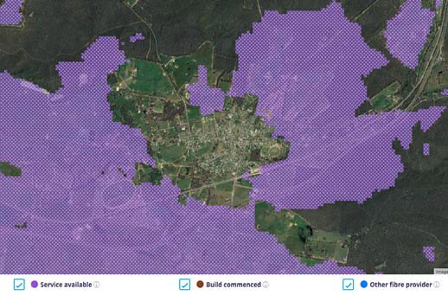
Figure 43 Aerial imagery showing NBN Fixed Wireless and satellite areas (NBN Co)

Mobile Coverage
Based on public coverage maps:
- Telstra shows 4GX outdoor handheld device coverage (with a typical download speed of 2‐75 Mbps) across the entire town.
- Optus shows 4G Plus outdoor coverage across the entire town.
- Vodafone shows 4G indoor and outdoor coverage across the entire town.
In summary, there appear to be no mobile coverage issues in the town, with the three major mobile network operators all offering service.

LP‐WAN Coverage
Taggle and Sigfox IoT coverage is available in Mount Chiltern.

Public WiFi Coverage
Public WiFi services are available during limited operating hours at the Chiltern Library.

Other
VicTrack fibre transits the southern fringe of Chiltern, along the rail corridor.

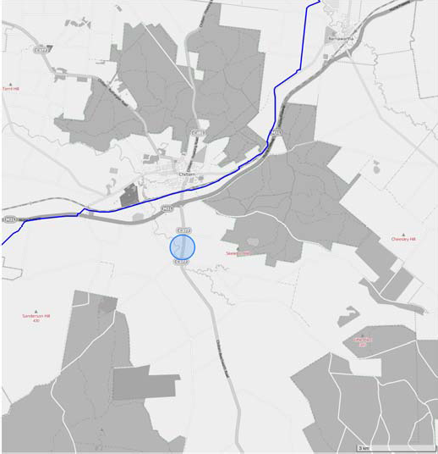
Figure 44 VicTrack fibre around Chiltern

Corryong
Corryong is a small town in Victoria, 120 kilometres east of Albury‐Wodonga and 431 kilometres northeast of Melbourne. The town is located in the High Country regional tourism area near the upper reaches of
the Murray River and close to the New South
Wales border in the Shire of Towong local government area. It is also the location of the Man From Snowy River Bush Festival.
General characteristics of the town that provide an indication of the town’s likely telecommunications demand profile include:
- The population of Corryong declined by 2.7% over a decade to 1,195 in 2016, below the median growth rate of 10.5% for the 18 major places analysed in the region
- 435 people aged 15 and over reported being in the labour force in the week preceding the 2016 Census, with 52.4% being in full‐time employment and 36.1% in part‐time employment
- 12.6% of the labour force classified themselves as managers, 16.1% as professionals and 8.3% as clerical and administrative workers
- 8.8% of the labour force cited their industry of employment as hospitals (except psychiatric hospitals)
- One public hospital is located in the town
- The town has a primary school and a primary/secondary school
- With a median age of 50, Corryong is older than the median of 47 for the places analysed in the region and older than the Victorian median of 37
- The ABS report a median annual household income of $42.5K for Corryong, below the median of
$55.8K for the places analysed in the region and below Melbourne’s $80.4K
- Data in SLIM on businesses registered with Workcover indicates approximately 59 businesses in the town or its near surrounds
- In 64.7% of dwellings, at least one person accessed the internet from home

Skills
ABS Census data indicates:
- 14.6% of people aged 15 and over having gained a diploma, advanced diploma, bachelors degree or higher educational qualification
- another 20.2% have completed level III or IV trade certificates; and
- another 10.2% have completed year 12.
ABS Industry employment data from 2016 indicated that the Towong LGA had 3.2% employment in the industry sectors with strong technology exposure.

Fixed Broadband
The map below shows the status of the NBN rollout in Corryong as advised by NBN Co in September 2018.
The purple / striped areas show the locations currently serviced by NBN Fixed Line services, the purple / spotted areas show locations serviced by NBN Fixed Wireless services and white areas locations serviced by NBN Satellite. The brown / striped areas show the

locations where NBN Fixed Line services are planned or under construction.

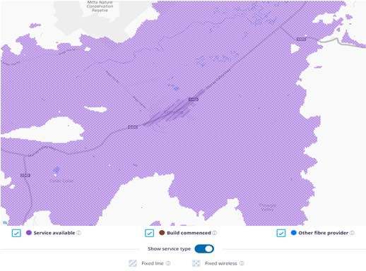
Figure 45 NBN Coverage of Corryong (NBN Co)

Our analysis reveals that the town of Corryong is predominantly served by NBN FTTN and NBN FTTC within the NBN Fixed Line footprint shown above. There is consistent coverage of NBN Fixed Wireless in the areas surrounding to the NBN Fixed Line footprint. Further out from the town NBN Fixed Wireless is replaced by access to NBN Satellite, however these satellite service areas are largely hilly, unpopulated areas, particularly to the north and east based on an analysis of aerial imagery.

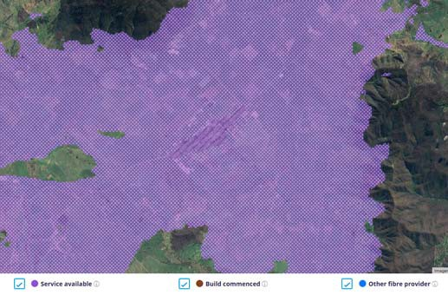
Figure 46 Aerial imagery showing NBN Fixed Wireless, Fixed Line and satellite areas (NBN Co)

Mobile Coverage
Based on public coverage maps:
  - Telstra shows 4GX outdoor handheld device coverage (with a typical download speed of 2‐75 Mbps) across the entire town.
  - Optus shows 4G Plus outdoor coverage across the entire town.
  - Vodafone shows no mobile coverage in the area.
In summary, residents have options for good coverage in the town and surrounding area from two of the three mobile network operators.

LP‐WAN Coverage
There is no known IoT coverage available in Corryong.

Public WiFi Coverage
Free public WiFi services are available at the Corryong Visitor Information Centre and Library.

Other
220v Power transits approximately 2km north of Corryong.

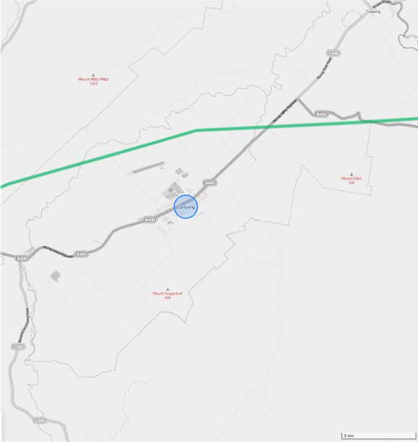
Figure 47 Power company network near Corryong

Yackandandah
Yackandandah is a small historic town in northeast Victoria, 313 kilometres northeast of
Melbourne in the High Country regional tourism area. It is near the regional cities of Wodonga and Albury and is close to the tourist town of Beechworth. It is a former gold mining centre. The area is now predominantly a dairy farming and forestry region, as

well as a tree‐change and visitor destination. It also has a thriving community renewable energy network, Totally Renewable Yackandandah, that is working towards 100% energy sovereignty by 2022.
General characteristics of the town that provide an indication of the town’s likely telecommunications demand profile include:
- The population of Yackandandah grew by 50.7% over a decade to 999 in 2016, well above the median growth rate of 10.5% for the 18 major places analysed in the region
- 446 people aged 15 and over reported being in the labour force in the week preceding the 2016 Census, with 53.4% being in full‐time employment and 36.8% in part‐time employment
- 15.0% of the labour force classified themselves as managers, 31.0% as professionals and 10.3% as clerical and administrative workers
- 5.7% of the labour force cited their industry of employment as hospitals (except psychiatric hospitals) and 4.3% cited aged care residential
- The nearest hospital is located in Beechworth to the southwest
- The town has 1 primary school
- With a median age of 48, Yackandandah is older than the median of 47 for the places analysed in the region and older than the Victorian median of 37
- The ABS report a median annual household income of $61.9K for Yackandandah, above the median of
$55.8K for the places analysed in the region but still below Melbourne’s $80.4K
- Data in SLIM on businesses registered with Workcover indicates approximately 31 businesses in the town or its near surrounds
- In 78.7% of dwellings, at least one person accessed the internet from home

Skills
ABS Census data indicates:
- 35.4% of people aged 15 and over having gained a diploma, advanced diploma, bachelors degree or higher educational qualification
- another 15.9% have completed level III or IV trade certificates; and
- another 8.5% have completed year 12.
ABS Industry employment data from 2016 indicated that the Indigo LGA had 4.4% employment in the industry sectors with strong technology exposure.

Fixed Broadband
The map below shows the status of the NBN rollout in Yackandandah as advised by NBN Co in September 2018. The purple / striped areas show the locations currently serviced by NBN Fixed Line services, the purple / spotted areas show locations serviced by NBN Fixed Wireless services and white areas locations serviced by NBN Satellite. The brown / striped areas show the locations where NBN Fixed Line services are planned or under construction.

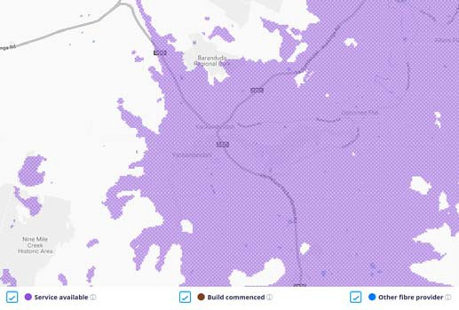
Figure 48 NBN Coverage of Yackandandah (NBN Co)

The NBN coverage map above shows that Yackandandah have NBN Fixed Wireless services with the surrounds to the north and west serviced only by NBN Satellite. Satellite imagery below indicates that the NBN Satellite areas cover unpopulated, hilly terrain.

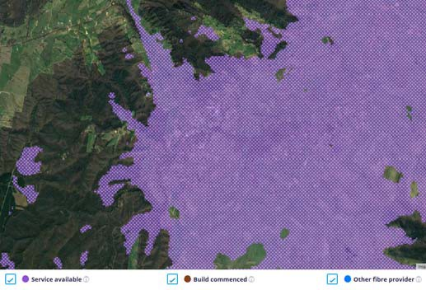
Figure 49 Aerial imagery of Fixed Wireless services in Yackandandah (NBN Co)

Mobile Coverage
Based on public coverage maps:

- Telstra shows 4GX outdoor handheld device coverage (with a typical download speed of 2‐75 Mbps) across the entire town.
- Optus shows 4G Plus outdoor coverage across the entire town.
- Vodafone shows partial 3G and 4G outdoor coverage across a portion of the town, with no coverage across the majority.
In summary, residents have options for good coverage in the town and surrounding area from two of the three mobile network operators, with partial (marginal) coverage from the third operator.

LP‐WAN Coverage
Taggle and Sigfox IoT coverage is available in Yackandandah.

Public WiFi Coverage
Free public WiFi services are available at the Yackandandah Library.

Other
Yackandandah is neither on the VicTrack or Power transmission networks.

Tallangatta
Tallangatta is a town in north eastern Victoria 349 kilometres northeast of Melbourne in the High Country regional tourism area. The town is in the Towong Shire local government area and lies on the banks of
the Mitta Arm of Lake Hume, approximately 38 kilometres southeast of Albury‐Wodonga along
the Murray Valley Highway. The original Tallangatta township (Old Tallangatta) was founded in the 1870s with a considerable amount of gold and tin mining occurring in the late 19th and early 20th century. The town was relocated in the 1950s to allow for construction of the Hume Dam. Beef and dairy farming are now the dominant industry.
General characteristics of the town that provide an indication of the town’s likely telecommunications demand profile include:
- The population of Tallangatta declined by 1.6% over a decade to 935 in 2016 below the median growth rate of 10.5% for the 18 major places analysed in the region
- 390 people aged 15 and over reported being in the labour force in the week preceding the 2016 Census, with 49.5% being in full‐time employment and 32.8% in part‐time employment
- 9.5% of the labour force classified themselves as managers, 17.1% as professionals and 10.3% as clerical and administrative workers
- 11.0% of the labour force cited their industry of employment as hospitals (except psychiatric hospitals) and 6.0% cited local government administration
- One public hospital is located in the town
- The town has 2 primary schools
- With a median age of 45, Tallangatta is younger than the median of 47 for the places analysed in the region but older than the Victorian median of 37
- The ABS report a median annual household income of $52.7K for Tallangatta, below the median of
$55.8K for the places analysed in the region and below Melbourne’s $80.4K
- Data in SLIM on businesses registered with Workcover indicates approximately 49 businesses in the town or its near surrounds
- In 75.5% of dwellings, at least one person accessed the internet from home

Skills
ABS Census data indicates:
- 20.9% of people aged 15 and over having gained a diploma, advanced diploma, bachelors degree or higher educational qualification
- another 23.4% have completed level III or IV trade certificates; and
- another 8.0% have completed year 12.
ABS Industry employment data from 2016 indicated that the Towong LGA had 3.2% employment in the industry sectors with strong technology exposure.

Fixed Broadband
The map below shows the status of the NBN rollout in Tallangatta as advised by NBN Co in September 2018. The purple / striped areas show the locations currently serviced by NBN Fixed Line services, the purple / spotted areas show locations serviced by NBN Fixed Wireless services and white areas locations serviced by NBN Satellite. The brown / striped areas show the

locations where NBN Fixed Line services are planned or under construction.

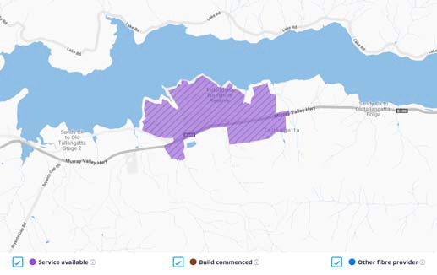
Figure 50 NBN Coverage of Tallangatta (NBN Co)

Our analysis reveals that the town of Tallangatta is predominantly served by NBN FTTN and NBN FTTC within the NBN Fixed Line footprint shown above.
Although the areas outside the town only have access to NBN Satellite, aerial imagery shows few premises in these surrounding areas.

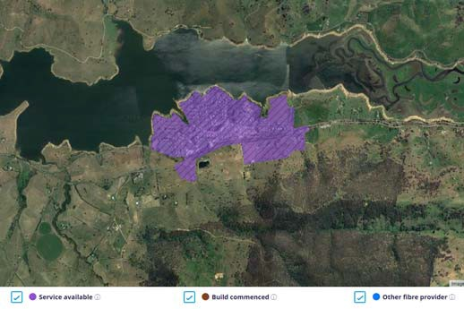
Figure 51 Aerial imagery of NBN Fixed Line services in Tallangatta (NBN Co)

Mobile Coverage
Based on public coverage maps:
- Telstra shows 4GX outdoor handheld device coverage (with a typical download speed of 2‐75 Mbps) across the entire town.
- Optus shows 4G Plus outdoor coverage across the entire town.
- Vodafone shows 4G indoor and outdoor coverage across the entire town.
In summary, there appear to be no mobile coverage issues in the town, with the three major mobile network operators all offering service.

LP‐WAN Coverage
There is no known IoT coverage available in Tallangatta.

Public WiFi Coverage
Free public WiFi services are available at the Tallangatta Library.

Other
Tallangatta is neither on the VicTrack or Power transmission networks.

Porepunkah
Porepunkah is a small town in northeast Victoria on the Great Alpine Road, at the foot of Mount Buffalo 320 kilometres northeast of Melbourne and 8 kilometres (11 mins) northwest of Bright. It is part
of Alpine Shire local government area and is located in the High Country regional tourism area on the banks of the Ovens River, near the Buckland River junction.
There are several vineyards and wineries in the Porepunkah district, which is part of the cool‐ climate Alpine Valleys wine region.
General characteristics of the town that provide an indication of the town’s likely telecommunications demand profile include:
- The population of Porepunkah grew by 9.0% over a decade to 642 in 2016 below the median growth rate of 10.5% for the 18 major places analysed in the region
- 321 people aged 15 and over reported being in the labour force in the week preceding the 2016 Census, with 51.4% being in full‐time employment and 38.9% in part‐time employment
- 16.5% of the labour force classified themselves as managers, 13.2% as professionals and 11.0% as clerical and administrative workers
- 7.0% of the labour force cited their industry of employment as hospitals (except psychiatric hospitals)
- A hospital is located nearby in Bright to the southeast
- The town has 1 primary school

- With a median age of 45, Porepunkah is younger than the median of 47 for the places analysed in the region and older than the Victorian median of 37
- The ABS report a median annual household income of $59.7K for Porepunkah, above the median of
$55.8K for the places analysed in the region but still below Melbourne’s $80.4K
- Data in SLIM on businesses registered with Workcover indicates approximately 17 businesses in the town or its near surrounds
- In 79.5% of dwellings, at least one person accessed the internet from home

Skills
ABS Census data indicates:
- 24.0% of people aged 15 and over having gained a diploma, advanced diploma, bachelors degree or higher educational qualification
- another 24.6% have completed level III or IV trade certificates; and
- another 12.0% have completed year 12.
ABS Industry employment data from 2016 indicated that the Alpine LGA had 4.6% employment in the industry sectors with strong technology exposure.

Fixed Broadband
The map below shows the status of the NBN rollout in Porepunkah as advised by NBN Co in September 2018. The purple / striped areas show the locations currently serviced by NBN Fixed Line services, the purple / spotted areas show locations serviced by NBN Fixed Wireless services and white areas locations serviced by NBN Satellite. The brown / striped areas show the
locations where NBN Fixed Line services are planned or under construction.

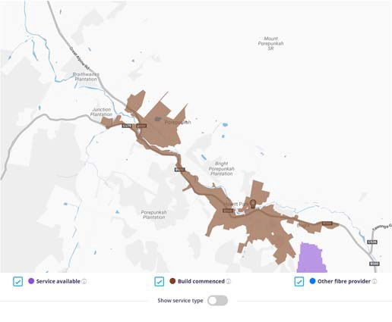
Figure 52 NBN Coverage of Porepunkah (NBN Co)

The NBN coverage map above shows that Porepunkah’s NBN network is currently under construction. Our analysis reveals that the town will predominantly be served by NBN FTTC within the NBN Fixed Line footprint shown above, noting there is continuous NBN Fixed Line services in a narrow region stretching from Porepunkah to Bright to the southeast.
The areas surrounding Porepunkah are served by NBN Satellite. Aerial imagery shows few premises outside of the NBN Fixed Line footprint, however there are several businesses to the northwest of the Fixed Line footprint that are outside the coverage area.

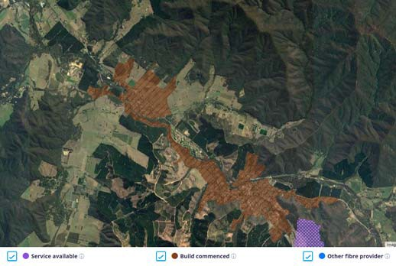
Figure 53 Aerial imagery of NBN Coverage in Porepunkah (NBN Co)

Mobile Coverage
Based on public coverage maps:
- Telstra shows 4GX outdoor handheld device coverage (with a typical download speed of 2‐75 Mbps) across the entire town.
- Optus shows 4G Plus outdoor coverage across the entire town.
- Vodafone shows 4G indoor and outdoor coverage across the entire town.
In summary, there appear to be no mobile coverage issues in the town, with the three major mobile network operators all offering service.

LP‐WAN Coverage
There is no known IoT coverage available in Porepunkah.

Public WiFi Coverage
There are no known Free Public WiFi services available in Porepunkah.

Other
Porepunkah is neither on the VicTrack or Power transmission networks.

Oxley
Oxley is a town in north eastern Victoria, located on Snow Road, 13 kilometres (8 mins) south‐east of Wangaratta, in the Rural City of Wangaratta and the High Country regional tourism area. Oxley derives its name from the Oxley Plains, which were named in 1824 by the explorers Hume and Hovell after John Oxley, the Surveyor‐General of New South Wales.
Oxley is located on the Gourmet Trail tourist route, adjacent to the King Valley wine district.
General characteristics of the town that provide an indication of the town’s likely telecommunications demand profile include:
- The population of Oxley grew by 48.4% over a decade to 429 in 2016 well above the median growth rate of 10.5% for the 18 major places analysed in the region
- 190 people aged 15 and over reported being in the labour force in the week preceding the 2016 Census, with 59.5% being in full‐time employment and 35.8% in part‐time employment
- 13.5% of the labour force classified themselves as managers, 24.9% as professionals and 9.3% as clerical and administrative workers
- 7.4% of the labour force cited their industry of employment as hospitals (except psychiatric hospitals) and 5.2% cited local government administration
- The nearest hospital is located in Wangaratta to the northwest
- The town has 1 primary school
- With a median age of 39, Oxley is younger than the median of 47 for the places analysed in the region and just above the Victorian median of 37
- The ABS report a median annual household income of $73.6K for Oxley, above the median of $55.8K for the places analysed in the region but still below Melbourne’s $80.4K
- Data in SLIM on businesses registered with Workcover indicates approximately 12 businesses in the town or its near surrounds
- In 84.1% of dwellings, at least one person accessed the internet from home

Skills
ABS Census data indicates:
- 27.3% of people aged 15 and over having gained a diploma, advanced diploma, bachelors degree or higher educational qualification
- another 24.5% have completed level III or IV trade certificates; and
- another 15.1% have completed year 12.
ABS Industry employment data from 2016 indicated that the Wangaratta LGA had 4.2% employment in the industry sectors with strong technology exposure.

Fixed Broadband
The map below shows the status of the NBN rollout in Oxley as advised by NBN Co in September 2018. The purple / striped areas show the locations currently serviced by NBN Fixed Line services, the purple / spotted areas show locations serviced by NBN Fixed Wireless services and white areas locations serviced by NBN Satellite. The brown / striped areas show the

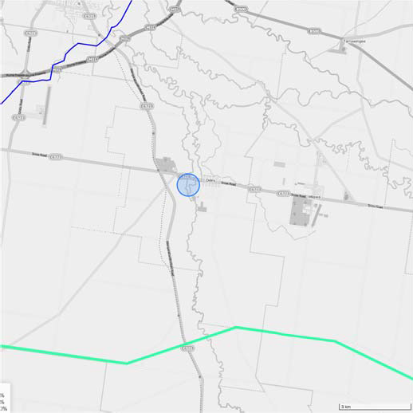locations where NBN Fixed Line services are planned or under construction.
about 5kms south of Oxley.

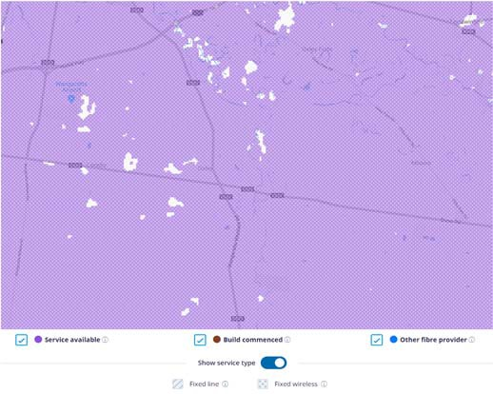
Figure 54 NBN Coverage of Oxley (NBN Co)

The NBN coverage map above shows that Oxley and its surrounding areas have broad coverage of NBN Fixed Wireless services with a few small areas to the north and west of the town where only NBN Satellite is available.

Mobile Coverage
Based on public coverage maps:
- Telstra shows 4GX outdoor handheld device coverage (with a typical download speed of 2‐75 Mbps) across the entire town.
- Optus shows 4G Plus outdoor coverage across the entire town.
- Vodafone shows 4G indoor and outdoor coverage across the entire town.
In summary, there appear to be no mobile coverage issues in the town, with the three major mobile network operators all offering service.

LP‐WAN Coverage
Taggle and Sigfox IoT coverage is available in Oxley.

Public WiFi Coverage
There are no known Free Public WiFi services available in Oxley.

Other
VicTrack fibre is available approximately 6km north west of Oxley. 220v Power transmission is available

Figure 55 VicTrack fibre (blue) and power transiting Oxley

Sawmill Settlement
Sawmill Settlement is a small town in north eastern Victoria located approximately 145 kilometres northeast of Melbourne in the High Country tourism area. The town is located in the Shire of Mansfield local government area at the foot of Mount Buller and experiences seasonal growth from a relatively small base due to its role as a popular accommodation
centre during the winter snow season.
General characteristics of the town that provide an indication of the town’s likely telecommunications demand profile include:
- The population of Sawmill Settlement grew by 12.6% over a decade to 197 in 2016, above the median growth rate of 10.5% for the 18 major places analysed in the region
- 100 people aged 15 and over reported being in the labour force in the week preceding the 2016 Census, with 67.0% being in full‐time employment and 20.0% in part‐time employment
- 22.8% of the labour force classified themselves as managers, 8.7% as professionals and 8.7% as clerical and administrative workers
- 46.3% of the labour force cited their industry of employment as accommodation
- The nearest hospital is located in Mansfield to the West

- The nearest schools are located in Merrijig to the west
- With a median age of 44, Sawmill Settlement is younger than the median of 47 for the places analysed in the region and older than the Victorian median of 37
- The ABS report a median annual household income of $58.5K for Sawmill Settlement, above the median of $55.8K for the places analysed in the region but still below Melbourne’s $80.4K
- Data in SLIM on businesses registered with WorkCover indicates approximately 5 businesses in the town or its near surrounds
- In 68.0% of dwellings, at least one person accessed the internet from home

Skills
ABS Census data indicates:
- 39.7% of people aged 15 and over having gained a diploma, advanced diploma, bachelors degree or higher educational qualification
- another 19.2% have completed level III or IV trade certificates; and
- another 17.1% have completed year 12.
ABS Industry employment data from 2016 indicated that the Mansfield LGA had 5.3% employment in the industry sectors with strong technology exposure.

Fixed Broadband
The map below shows the status of the NBN rollout in Sawmill Settlement as advised by NBN Co in September 2018. The purple / striped areas show the locations currently serviced by NBN Fixed Line services, the purple / spotted areas show locations serviced by NBN Fixed Wireless services and white areas locations serviced by NBN Satellite. The brown / striped areas show the locations where NBN Fixed Line services are planned or under construction.

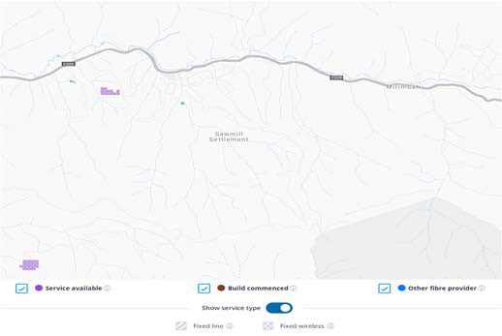
Figure 56 NBN Coverage of Sawmill Settlement (NBN Co)
The NBN coverage map above shows that Sawmill Settlement and its surrounding areas only have access to NBN Satellite. Our analysis reveals there are around five Workcover registered businesses in this area.

Mobile Coverage
Based on public coverage maps:
- Telstra shows 4GX coverage (with a typical download speed of 2‐75 Mbps) and 3G handheld coverage across the entire town.
- Optus shows patchy 4G Plus outdoor coverage across parts of the town.
- Vodafone shows similarly patchy 3G and 4G outdoor coverage across parts of the town.
In summary, Telstra is the only carrier to show full coverage in the town, although the other two show coverage in parts of the town and surrounds.

LP‐WAN Coverage
There is no known IoT coverage available in Sawmill Settlement.

Public WiFi Coverage
There are no known Free Public WiFi services available in Sawmill Settlement.
Other
Sawmill Settlement is neither on the VicTrack or Power transmission networks.
Page 65

Primary Production

Land Use Classification
The Victorian Land Use Information System sub‐ classifies primary production land use in the following categories shown in the map legend.
As is evident from the land use map following, the overwhelming categorization of primary production
land across the region is classified as Grazing (sheep and beef). The Ovens Murray Regional Partnership area boundary is shown in red.
Whilst the region is also known for horticulture, viticulture and timber production, grazing is the focus of analysis as it is the dominant primary production activity in the region.

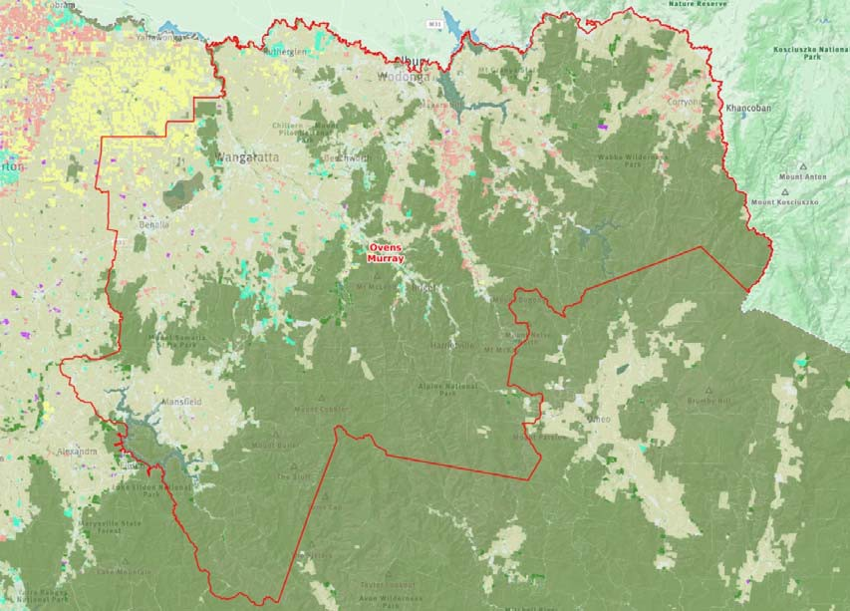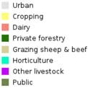
Disclaimer: This map is a snapshot generated from Victorian Government data. This material may be of assistance to you but the State of Victoria does not guarantee that the publication is
without flaw of any kind or is wholly appropriate for your particular purposes and therefore disclaims all liability for error, loss or damage which may arise from reliance upon it. All persons accessing this information should make appropriate enquiries to assess the currency of the data.
03 Sep, 2018 13:27:18
Invest in
VICTORIAN AGRICULTURE
Ovens Murray Regional Land Use
Legend
20km

Figure 57 Primary production land in the Region (https://invest.agriculture.vic.gov.au)

The character of digital needs and opportunities will inevitably vary for different types of agriculture. A few examples are:
- in livestock production areas, detailed animal tracking, identification, biometrics and feed management can optimise yields;
- in cropping areas, technology for real‐time machinery monitoring and guidance is becoming
more common, and satellite imagery can provide valuable insights into crop development and health;
- in irrigation areas, soil moisture monitoring and water management are becoming increasingly important to minimise costs and maximise production;

- in all areas, general access to information where and when it is needed can support informed decision‐making; and
- with agriculture posing many occupational health and safety risks, access to communications in emergency situations can make the difference between life and death.
In the light of this, all forms of agriculture will need to utilise information technology and digital communications more actively in the future if they are to remain globally competitive.
Accordingly, it is relevant to consider the supply of fixed broadband (important at residences and business locations in rural land), mobile coverage (for both voice and data communications) and LP‐WAN coverage (for emerging IoT applications).

Fixed Broadband Supply
NBN Services
The map below shows NBN coverage of the Ovens Murray region.

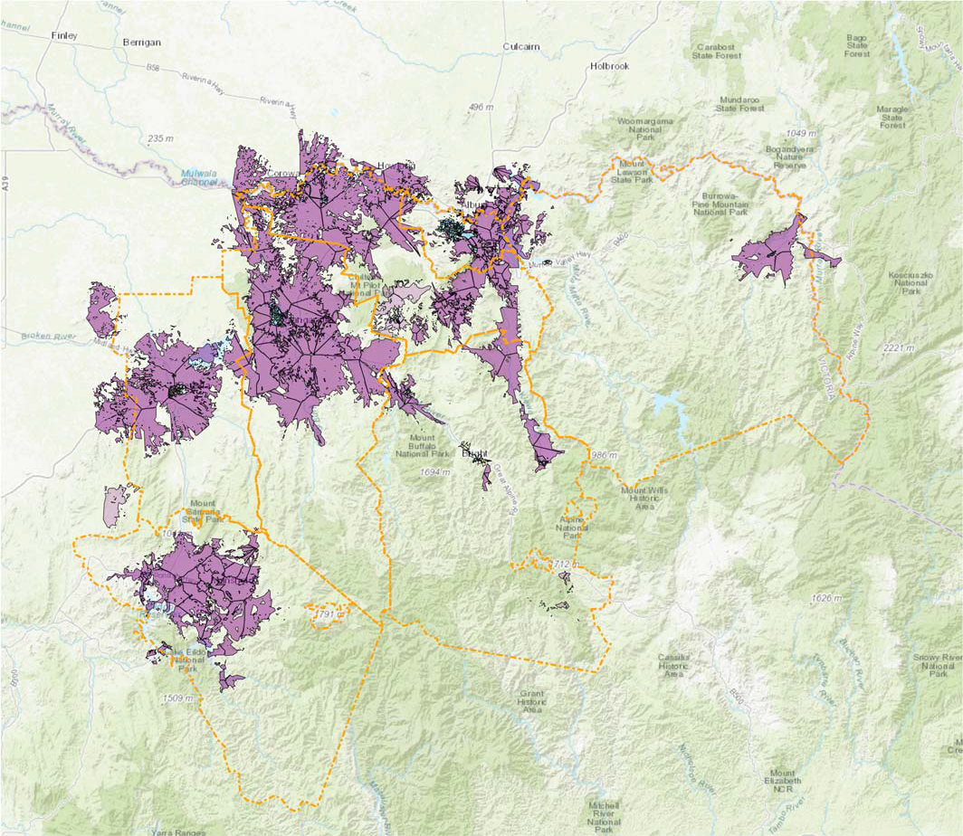
Figure 58 NBN Co Coverage of the Ovens Murray Region (NBN Co)

The most significant feature is the split between fixed wireless coverage (in purple) and the areas with
satellite coverage (no colour). Technologies such as FTTP, FTTC and FTTN are barely visible at the scale of

this map – but since these technologies are limited to population centres, they are only marginally relevant to an analysis of primary production land).
Overall, by simple visual estimation, it appears that around 50% of rural land in the Ovens Murray region has access to NBN Co’s satellite solution, and most of the remainder has access to (or is due to receive) the higher‐performing Fixed Wireless solution.
By Local Government Area, the indicative percentage of the area of rural land with satellite coverage is shown in the following table.

LGA | Population in Rural Land19 | Estimated Area of Satellite Coverage
Alpine | 4,007 | 95%
Benalla | 4,664 | 60%
Indigo | 7,662 | 50%
Mansfield | 5,115 | 60%
Towong | 3,282 | 95%
Wangaratta | 8,465 | 50%
Wodonga | 19,859 | 60%
Note that the rural population is not necessarily evenly distributed across the rural land, and therefore the number of homes and businesses in NBN Co’s satellite footprint does not necessarily correlate with the proportion of satellite coverage by land area.
Grazing
- Beef / sheep / dairy
- The area around Benalla
The map below shows NBN Fixed Wireless coverage with relatively even coverage in the nearby surrounds to Benalla but then transitioning into NBN Satellite where the majority of grazing would take place.
Farms located closer in proximity to Winton, Goorambat, Tarnook, Baddaginnie and to the south of Goomalibee are likely to have access to NBN Fixed Wireless coverage.

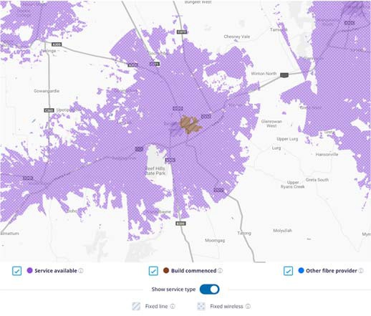
Figure 59 NBN Coverage of the grazing area around Benalla (NBN Co)

Grazing
- Beef / sheep / dairy
- The King Valley between Mt Beauty and Baranduda
The map below shows relatively contiguous NBN Fixed Wireless coverage in a narrow region stretching from Baranduda in the north near Wodonga to Mount Beauty to the south.
Farms located relatively close to Gundowring, Upper Gundowring, Kergunyah South, Coral Bank, Tawonga and Tawonga South are likely to have access to NBN Fixed Wireless coverage.

19 The number of individuals living in rural areas is estimated by subtracting the number in cities, towns and localities with a population greater than 185 from the total population in the LGA.

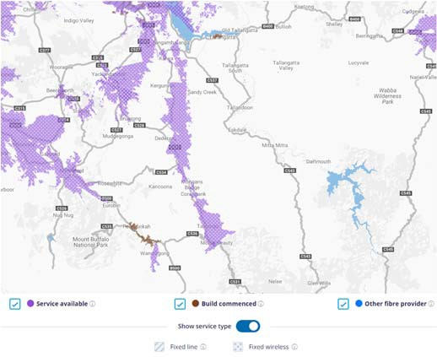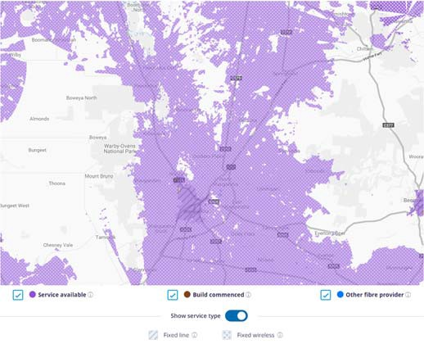

Figure 60 NBN Coverage of the grazing area from Baranduda to Mount Beauty (NBN Co)

Grazing
- Beef / sheep / dairy
- The area north of Wangaratta
The map below shows relatively good coverage of NBN Fixed Wireless services in the corridor to the north of Wangaratta. There tends to be NBN Satellite only available in the areas to the east and west of this corridor.
Farms located closer in proximity to Wangandary, Londrigan, Wandara, Eldorado, Dockers Plains and Kilawarra are likely to have access to NBN Fixed Wireless coverage. Access is likely to be patchier for farms around Boorhaman and Boralma.
Figure 61 NBN Coverage of the grazing area north of Wangaratta (NBN Co)

Grazing
- Beef / sheep / dairy
- The area around Corryong
The map below shows NBN Fixed Wireless coverage to around a 5 to 10 kilometre distance from Corryong depending on the direction. Beyond this area only NBN Satellite services are available to farms.

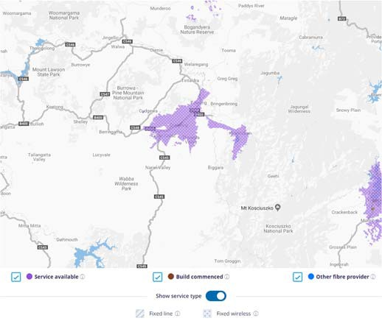
Figure 62 NBN Coverage of the grazing area around Corryong (NBN Co)

Grazing
- Beef / sheep / dairy
- The area around Tallangatta

The map below shows no NBN Fixed Wireless coverage in the area around Tallangatta. Some limited NBN
Fixed Wireless begins to become available to farms located further to the west.

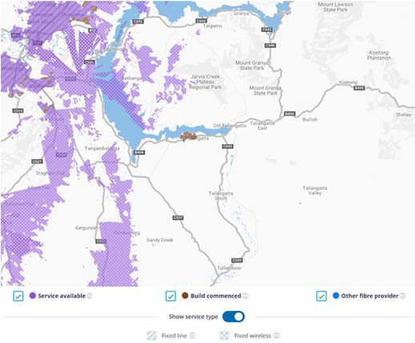
Figure 63 NBN Coverage of the grazing area around Tallangatta (NBN Co)

Other Fixed Connectivity Options
For those living in rural areas where satellite is the only technology supported by NBN Co, there are several noteworthy technology alternatives:
- Wireless technologies (microwave and enhanced WiFi configured for long‐reach) can be used to extend capacity from an area with better service;
- The mobile network operators are starting to introduce plans with high data allowances that may substitute or augment a satellite service; and
- Other providers (notably Telstra) may be able to provide a service.

More Detailed Supply‐Demand Analysis
More detailed information on local areas – down to
the level of individual businesses can be obtained using SLIM – as illustrated in the map following showing the area around Ararat as an example of SLIM capabilities.
In this map:
- green areas show individual agricultural land parcels;
- purple areas show NBN fixed wireless coverage;

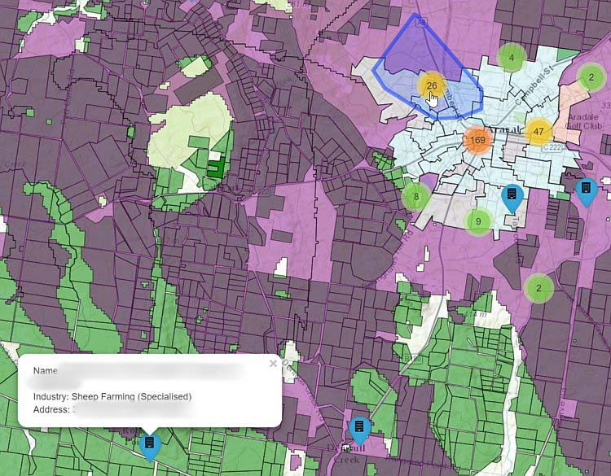
Figure 64 SLIM outputs at a more detailed level (SLIM)

- the ‘popup’ at the bottom left shows details of an individual sheep farming business at the location marked with the blue marker;
- the coloured circles indicate the number of businesses in an area; and
- the hand‐shape pointer touching on the circle with the number “26” is lighting up (with blue boundary and shading) the area within which those 26 businesses are located.

Mobile Coverage
Coverage maps published by each of the three major mobile network operators are provided in Section 2.2.
Simple visual examination of these maps of Telstra, Optus and Vodafone suggests extensive coverage across the region, with most coverage gaps confined to alpine terrain and national or state parks.
Looking to the future, the ability of the mobile networks to support agricultural IoT applications will be enhanced by the activation of the NB‐IoT and Cat‐ M1 protocols, and by the advent of 5G. The mobile network operators’ plans for regional areas are not known.

Grazing
- Beef / sheep / dairy
- The area around Benalla
Due to the size of the area under consideration, public coverage maps do not provide sufficient resolution to conduct detailed analysis, so comments are general in nature. Based on public coverage maps:

- Telstra shows 4GX and 3G outdoor handheld device coverage across most of the region, with some 3G external antenna coverage towards the southeast.
- Optus shows 4G Plus and 3G outdoor coverage across the region.
- Vodafone 4G indoor and outdoor coverage centred around Benalla and Winton with 4G outdoor completing coverage along the main roads, however there are black spots south of Warrenbayne and north of Goorambat.

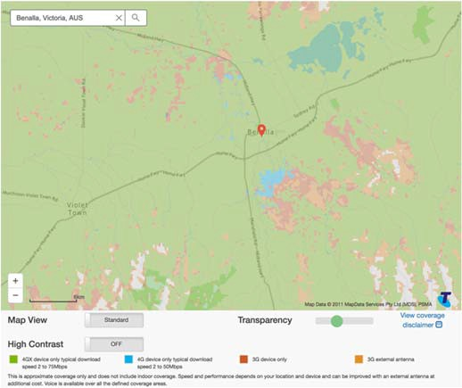
Figure 65 Telstra coverage in the extended area around Benalla

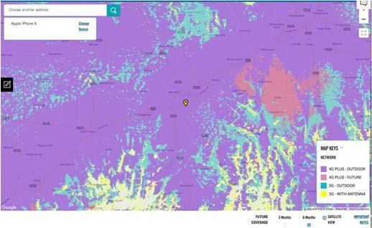
Figure 66 Optus coverage in the extended area around Benalla

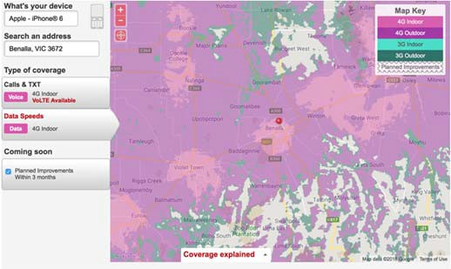
Figure 67 Vodafone coverage in the extended area around Benalla

In summary, residents have options for good coverage in the town and surrounding area from two of the three mobile network operators, with partial coverage from the third operator.

Grazing
- Beef / sheep / dairy
- The King Valley between Mt Beauty and Baranduda
Due to the size of the area under consideration, public coverage maps do not provide sufficient resolution to conduct detailed analysis, so comments are general in nature. Based on public coverage maps:
- Telstra shows 4GX, 4G and 3G outdoor handheld device coverage along the Kiewa Valley Highway. No black spots are evident.
- Optus shows continuous 4G Plus outdoor coverage across the along the valley. No black spots are evident.
- Vodafone shows continuous 4G outdoor coverage along the entire valley road. No black spots are evident, although Vodafone’s coverage does not extend significantly into the surrounding mountainous areas.

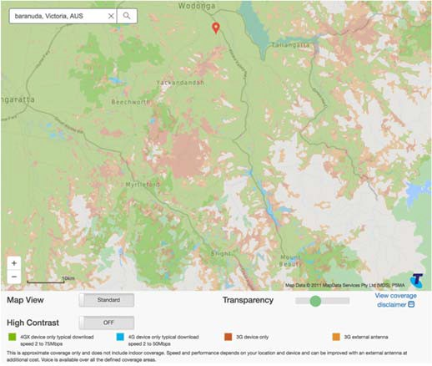
Figure 68 Telstra coverage along the Kiewa Valley Highway between Baranduda and Mt Beauty

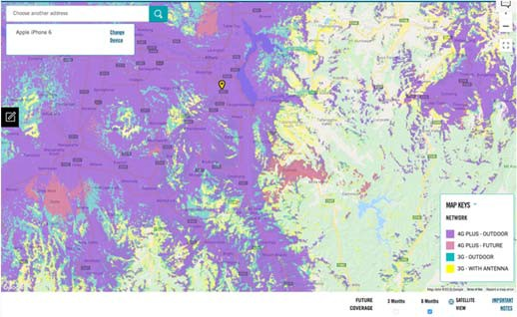
Figure 69 Optus coverage along the Kiewa Valley Highway between Baranduda and Mt Beauty

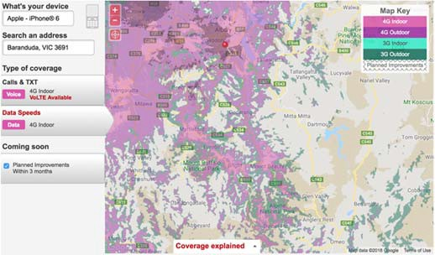
Figure 70 Vodafone coverage along the Kiewa Valley Highway between Baranduda and Mt Beauty

In summary, residents have options for good coverage in the town and surrounding area from two of the three mobile network operators, with partial coverage from the third operator.

Grazing
- Beef / sheep / dairy
- The area north of Wangaratta
Due to the size of the area under consideration, public coverage maps do not provide sufficient resolution to conduct detailed analysis, so comments are general in nature. Based on public coverage maps:
- Telstra shows continuous 4GX outdoor handheld device coverage (with a typical download speed of 2‐75 Mbps) as far as Rutherglen.
- Optus similarly shows continuous 4G Plus outdoor
coverage as far as Rutherglen.
- Vodafone also shows continuous 4G indoor and outdoor coverage, with new coverage under construction near Springhurst.

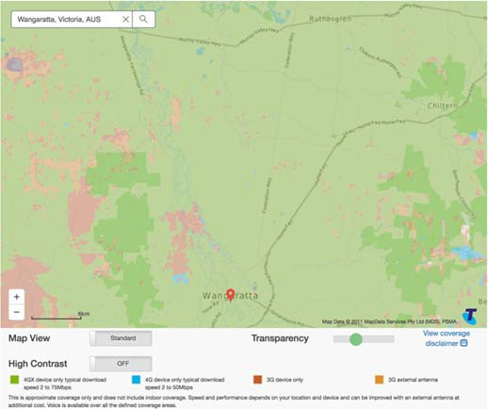
Figure 71 Telstra coverage north of Wangaratta

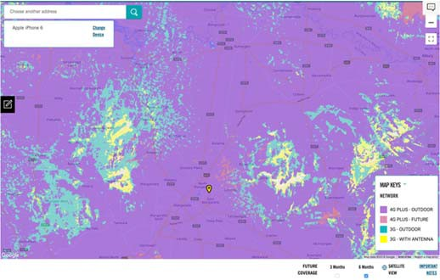
Figure 72 Optus coverage north of Wangaratta

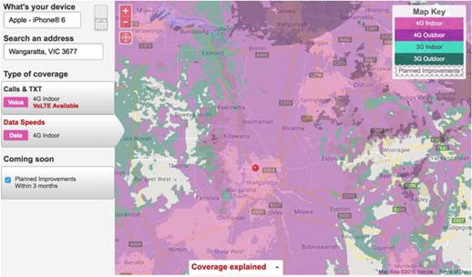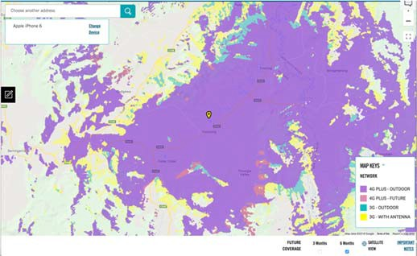

Figure 73 Vodafone coverage north of Wangaratta

In summary, there appear to be no mobile coverage issues in the region, with the three major mobile network operators all offering service.

Grazing
- Beef / sheep / dairy
- The area around Corryong
Due to the size of the area under consideration, public coverage maps do not provide sufficient resolution to conduct detailed analysis, so comments are general in nature. Based on public coverage maps:
- Telstra shows 4GX outdoor handheld device coverage (with a typical download speed of 2‐75 Mbps) covering the valley floor, however coverage does not extend into surrounding alpine areas.
- Optus shows similar coverage with 4G Plus outdoor
coverage.
- Vodafone shows no coverage in the area.

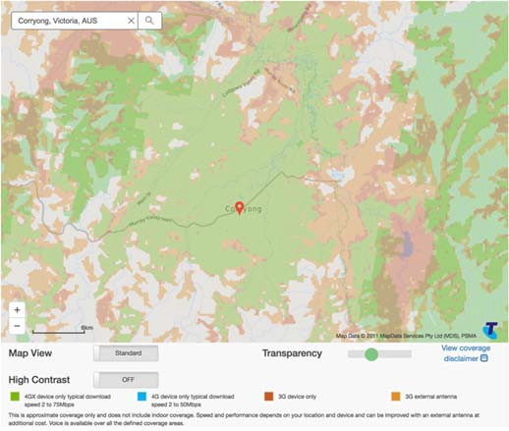
Figure 74 Telstra coverage around Corryong
Figure 75 Optus coverage around Corryong

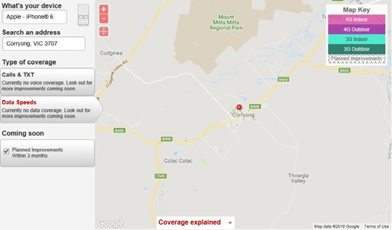
Figure 76 Vodafone coverage around Corryong

In summary, there appears to be at least two mobile carriers with continuous handheld device coverage covering the valley floor, however coverage does not extend significantly into the surrounding alpine areas.

Grazing
- Beef / sheep / dairy
- The area around Tallangatta
Due to the size of the area under consideration, public coverage maps do not provide sufficient resolution to conduct detailed analysis, so comments are general in nature. Based on public coverage maps:
- Telstra shows 4GX outdoor handheld device coverage (with a typical download speed of 2‐75 Mbps) along the Murray Valley Highway however surrounding hilly areas form coverage ‘shadows’ with poor or no coverage.
- Optus shows 4G Plus outdoor coverage across the entire area, with some coverage shadows.
- Vodafone shows continuous 4G indoor and outdoor coverage with areas of poor or no coverage in the same hilly areas.

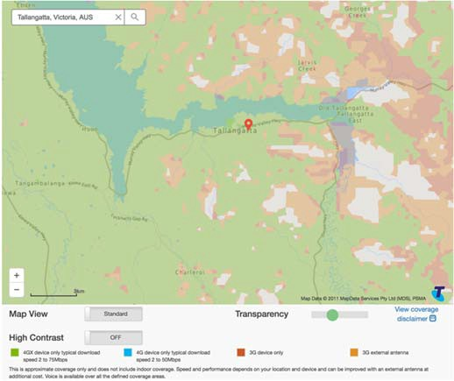
Figure 77 Telstra coverage around Tallangatta

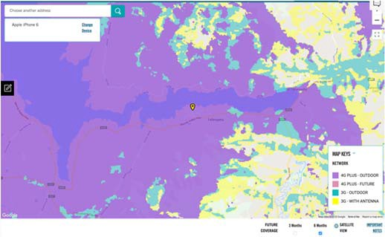
Figure 78 Optus coverage around Tallangatta

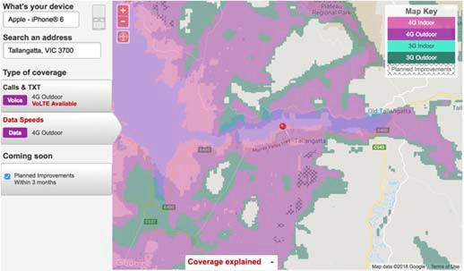
Figure 79 Vodafone coverage around Tallangatta

In summary, there appear to be no mobile coverage issues in the area, with the three major mobile network operators all offering service.

LP-WAN Coverage
Coverage maps for two of three major LP‐WAN technologies (Sigfox and Taggle) are provided in Section 2.3. Coverage of the third major LP‐WAN technology (LoRa) is unknown.
Based on these maps:
- Sigfox coverage is available in the north western region around Wangaratta;
- Taggle coverage appears to be available towards the northern areas including Wangaratta, Rutherglen and Wodonga; and
- Very limited Optus NB‐IOT is available west of Benalla only.
In areas towards the fringes of coverage footprints, testing is necessary to confirm the viability of communications connectivity. If it is marginal, better antennas and antenna positioning may help, or the installation of additional base stations may be necessary to get reliable communications.
Agricultural IoT trials currently being undertaken in other regions may yield further insight into the needs, opportunities and barriers in the adoption of IoT technologies.

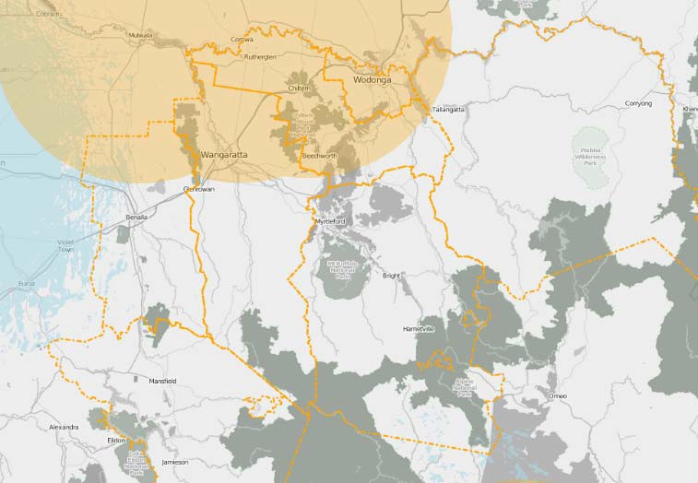
Figure 80 Taggle and Optus NB‐IOT coverage in north western
region of Ovens and Murray

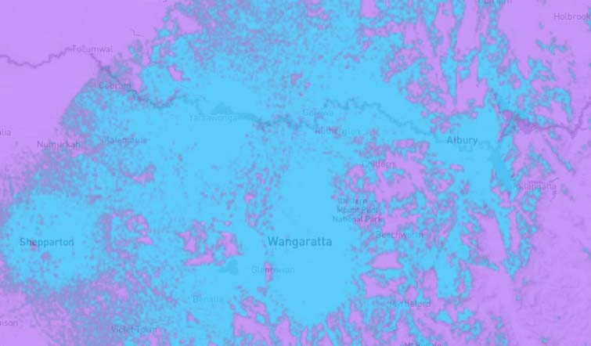

Figure 81 SigFox coverage around Wangaratta

Grazing
- Beef / sheep / dairy
- The area around Benalla
Taggle coverage appears to be available up to 11 kilometres north of Benalla.
Sigfox maps show extensive coverage in and around the area.
The very limited Optus NB‐IOT coverage is available west of Benalla.

Grazing
- Beef / sheep / dairy
- The King Valley between Mt Beauty and Baranduda
The SLIM database and public maps for SigFox and Taggle IOT show extensive coverage in the area.

Grazing
- Beef / sheep / dairy
- The area north of Wangaratta
The SLIM database and public maps for SigFox and Taggle IOT show extensive coverage in the area.

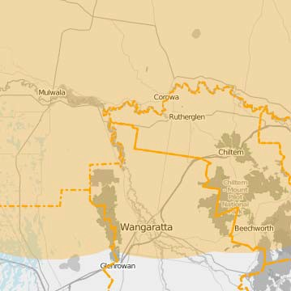Figure 82 Taggle IOT coverage north of Wangaratta

Grazing
- Beef / sheep / dairy
- The area around Corryong
The SLIM database and public maps for SigFox, Taggle IOT and the Optus NB‐IOT trials show no coverage in the area.

Grazing
- Beef / sheep / dairy
- The area around Tallangatta
Taggle coverage is available up to 5 kilometres west of Tallangatta.
Sigfox maps show extensive coverage in and around the area.

Tourist Destinations

The Ovens Murray region, with the exception of Wodonga, sits within the High Country regional tourism area and features numerous tourist attractions, including many beyond the sample covered in this section. Some of these locations are prone to significant visitor peaks during the snow season, long weekends, school holidays and major events.
For such destinations, the communication demands tend to comprise:
- the needs of the host, predominantly comprising fixed broadband connectivity
- the needs of tourists visiting the region, predominantly comprising mobile connectivity and potentially WiFi connectivity in the surrounding towns or at accommodation venues.
The communications options for population centres across the region are discussed in Section 3, and an overview of mobile coverage outside these centres is provided in Section 2.2.
For major events, mobile coverage is a primary concern, not just for the event venue itself, but also for the surrounding area. Visitors increasingly rely on network access for purposes such as navigation, general information and payments using eftpos.

Mount Buffalo National Park
- One of the oldest national parks in Australia
Mount Buffalo National Park is a 31,000 hectare national park located in the Australian Alps.
Winter snow provides for snow play, snowshoeing and limited cross country skiing, tobogganing and snow shoeing. Year‐round activities include bush walking, river caving, kayaking, abseiling and rock climbing on the Mount Buffalo plateau and picnics, camping and canoeing at Lake Catani. Plants, animals, waterfalls and panoramic scenery are abundant on the short and long walking trails.
Reactivation of the heritage Mount Buffalo Chalet and increasing visitation to Mount Buffalo National park is a regional tourism priority.
Fixed Broadband
Our analysis reveals that the park falls into the NBN Satellite footprint, including the Mount Buffalo Park Office.

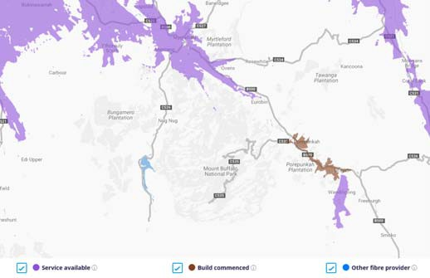
Figure 83 NBN Coverage of Mount Buffalo National Park (NBN Co)

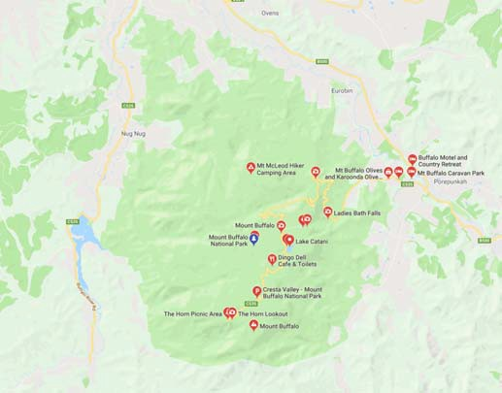
Figure 84 Map of the Mount Buffalo National Park (Google)

Mobile Coverage
Based on public coverage maps:
- Telstra shows non‐continuous 4GX outdoor handheld device coverage (with a typical download speed of 2‐75 Mbps), 4G device, 3G device and 3G external antenna coverage of Mt Buffalo road which accesses the highly frequented tourist locations in the park.

- Optus shows non‐continuous 4G plus outdoor, 3G outdoor and 3G with antenna coverage of Mt Buffalo road with various blackspots evident.
- Vodafone shows mostly 4G outdoor and 3G outdoor coverage of Mt Buffalo road with small blackspots evident.
In summary, there appears to be partial coverage in the park from the three mobile network operators.

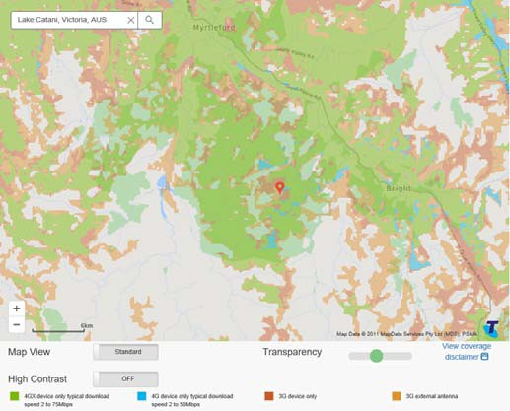
Figure 85 Telstra coverage of Mount Buffalo National Park

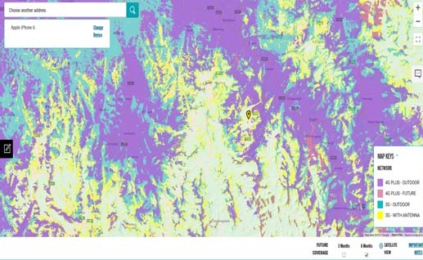
Figure 86 Optus coverage of Mount Buffalo National Park

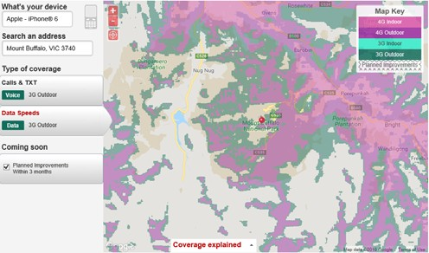
Figure 87 Vodafone coverage of Mount Buffalo National Park

Murray to Mountains Rail Trail
- Cycling and walking rail trail
The Murray to Mountains Rail Trail ‘spine’ is a sealed 100km off‐road shared trail from Wangaratta to Bright with a spur that follows the old rail route to Beechworth and a number of connecting trails such as Bright to Wandiligong.
Popular tourist towns of Wangaratta, Beechworth, Rutherglen and Bright are on route to explore fine gourmet produce, wines and craft beer. The cycling trail showcases the diverse landscape including bushland, valleys and mountain ranges.
Significant investment is underway through the Ride High Country initiative to develop new connections, including Beechworth to Yackandandah, and optimise the cycle experience along the trail.

Recognised as Victoria’s premier cycling destination, the High Country also hosts a number of competitive national road cycling and mountain bike events.

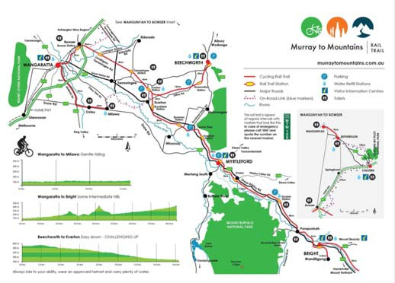

Figure 88 Map of the Murray to Mountains Rail Trail

Figure 89 A destination on the Murray to Mountains Rail Trail20

Fixed Broadband
Refer to Significant Places section for fixed broadband coverage of each of the towns.

Mobile Coverage
Based on public coverage maps:
- Telstra shows 4GX outdoor handheld device coverage (with a typical download speed of 2‐75 Mbps) across most of the trail with patchy 3G device coverage.
- Optus shows 4G Plus outdoor, 3G outdoor and 3G with antenna coverage however, 4G Plus is scheduled for certain areas. Blackspots are evident between Everton and Beechworth.
- Vodafone shows 4G outdoor, 4G indoor and 3G outdoor coverage across the route with blackspots evident between Everton and Beechworth and a section near Bowmans Forest.
In summary, there appears to be good coverage on the trail from one mobile network operator, with partial coverage from the other two operators.

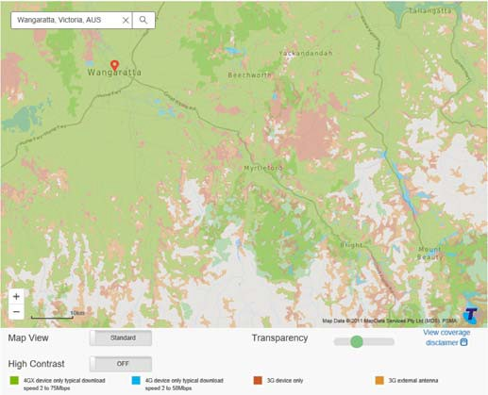
Figure 90 Telstra coverage of the Murray to Mountains Rail Trail

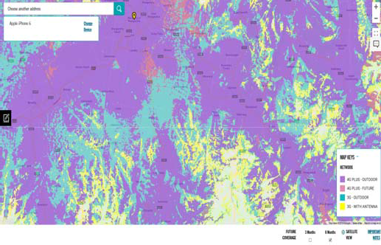
Figure 91 Optus coverage of the Murray to Mountains Rail Trail

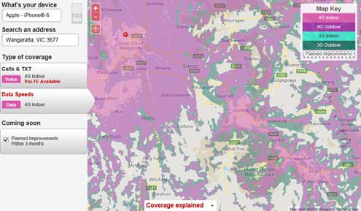
Figure 92 Vodafone coverage of the Murray to Mountains Rail Trail

King Valley Prosecco Road
- Italian inspired food and wine region
King Valley is a popular wine region situated south of Wangaratta, with the King River flowing through the area.
The Italian inspired valley is famous for its fine cuisine and great wines which is highlighted by the potentially ‘game changing’ King Valley Prosecco Road initiative, spearheaded by well-known winemakers, including Brown Brothers, Chrismont, Pizzini, Dal Zotto and Sam Miranda.

20 https://www.visitmelbourne.com/Regions/High-Country/Things- to-do/Outdoor-activities/Cycling/Recreational-riding/Cycling- trails/Murray-to-Mountains-Rail-Trail

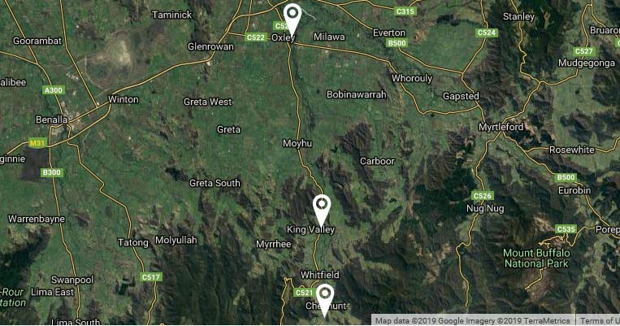
Figure 93 Aerial view of Prosecco Road

Figure 94 Winery in King Valley region 21

Fixed Broadband
Our analysis reveals NBN Fixed Wireless services the Milawa area which includes the Brown Brothers and Sam Miranda wineries.
Further analysis reveals that further down the trail, NBN Satellite services the remaining wineries along the King Valley.

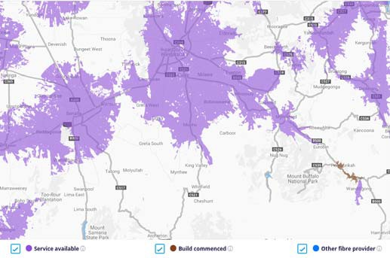
Figure 95 NBN Coverage of King Valley and surrounds (NBN Co)

Mobile Coverage
Based on public coverage maps:
- Telstra shows 4GX outdoor handheld device coverage (with a typical download speed of 2‐75 Mbps) of the King Valley region including each of the wineries on the trail. The roads including the Wangaratta‐Whitfield road, to each destination has 4GX coverage with minimal 3G device and 3G external antenna coverage in the Cheshunt area. No blackspots are evident.
- Optus shows 4G Plus outdoor coverage of each of the wineries however, Chrismont has 3G outdoor coverage. The roads including Wangaratta‐Whitfield Road, to each destination has 4G Plus coverage (or 4G Plus scheduled for the future) with minimal 3G outdoor and 3G with antenna coverage in the Cheshunt area. No blackspots are evident.
- Vodafone shows 4G outdoor coverage in the northern region of King Valley which includes the Sam Miranda and Brown Brothers wineries. 4G outdoor and 3G outdoor coverage exists for Wangaratta‐Whitfield Road however, no coverage is provided on the route from King
Valley town to Cheshunt, covering the remaining wineries.
In summary, there appears to be medium coverage from all three mobile network operators.

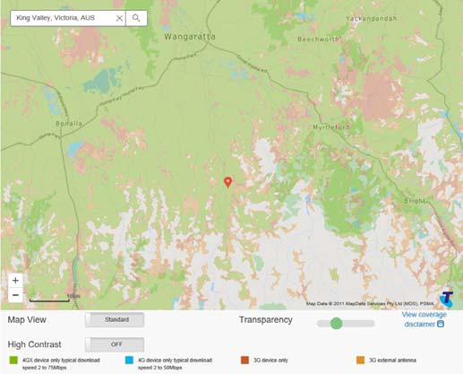
Figure 96 Telstra coverage of King Valley Prosecco Road

21 https://www.visitkingvalley.com.au/food-wine/wineries/

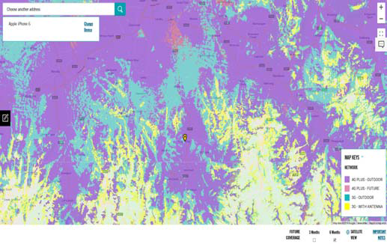
Figure 97 Optus coverage of King Valley Prosecco Road

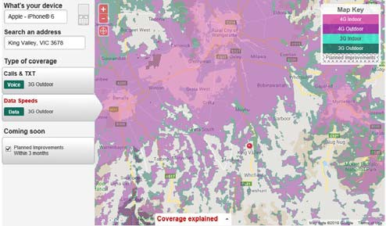
Figure 98 Vodafone coverage of King Valley Prosecco Road

Rutherglen Wine Region
- Popular wine producing region
The Rutherglen region is known for its production of fine wines with 18 wineries located in the area and a number of restaurant and vineyard accommodation options. Once a gold mining town, this area has gained a reputation for producing award‐winning wines and celebrating local produce.
Outdoor activities such as camping, fishing, swimming, boating and cycling are other activity options.
The Rutherglen events calendar includes the Rutherglen Regatta, Tastes of Rutherglen, Winery Walkabout, Rutherglen Agricultural Show, Tour de Rutherglen and Rutherglen Farmers Market.

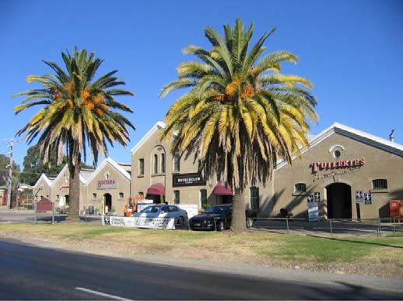
Figure 99 Jolimont Cellar22

Fixed Broadband
Our analysis reveals the town of Rutherglen is predominately serviced by NBN FTTN Fixed Line with a number of wineries and the Rutherglen Visitor Information Centre falling into the NBN Fixed Line footprint.
Further analysis reveals NBN Fixed Wireless and patches of NBN Satellite services the immediate surrounding area including various other wineries however, Rutherglen Estates Wines falls into the NBN Satellite footprint but is due to receive NBN Fixed Wireless services.

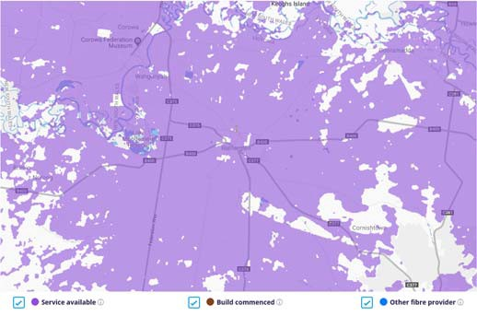
Figure 100 NBN Coverage of the Rutherglen Wine Region (NBN Co)

22 https://www.wineselectors.com.au/selector-magazine/wine/five- of-the-best-rutherglen-wineries-and-cellar-doors

Mobile Coverage
Based on public coverage maps:
- Telstra shows 4GX outdoor handheld device coverage (with a typical download speed of 2‐75 Mbps) of the region.
- Optus shows 4G Plus outdoor coverage of the region.
- Vodafone shows 4G indoor and outdoor
coverage of the region.
In summary, there appears to be no mobile coverage issues in the region, with the three mobile network operators all offering service.

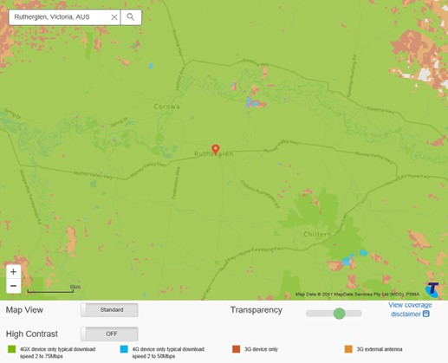
Figure 101 Telstra coverage of Rutherglen Wine Region

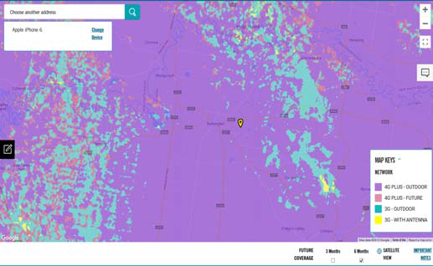
Figure 102 Optus coverage of Rutherglen Wine Region

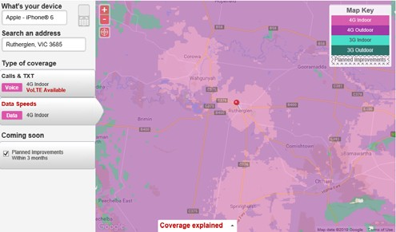
Figure 103 Vodafone coverage of Rutherglen

Ned Kelly Touring Route
- Journey through the life of Ned Kelly
The Ned Kelly Touring Route is a 458 kilometre round trip travelling from Melbourne to Mansfield.
The duration of the journey is two days and includes stops at Beveridge, Benalla, Glenrowan, Beechworth, Greta, Powers Lookout and Mansfield to visit numerous sites documenting the life of Ned Kelly.
The journey begins with the birthplace of Ned Kelly and concludes in Melbourne at the Old Melbourne Gaol where Ned Kelly was imprisoned and subsequently hanged.
The region’s ‘Ned Kelly Alive’ initiative is currently seeking investment for activation at key destinations along the route, including digitally enabled VR and AR.

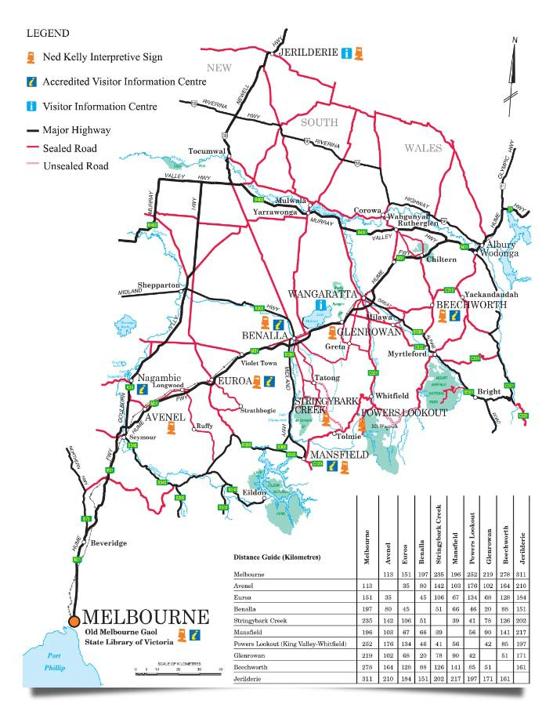
Figure 104 Map of the Ned Kelly Touring Route 23

Figure 105 Ned Kelly statue in Glenrowan24

Fixed Broadband
Refer to Significant Places section for fixed broadband coverage of each of the towns.

Mobile Coverage
Based on public coverage maps:

23 https://nedkellytouringroute.com.au/destinations/glenrowan/
- Telstra shows 4GX outdoor handheld device coverage (with a typical download speed of 2‐75 Mbps) coverage on majority of the route with patchy 3G device and 3G external antenna coverage however, blackspots are evident on Mansfield‐Whitfield road between Greta and Mansfield.
- Optus shows 4G Plus outdoor, 3G outdoor, 3G with antenna coverage on the route with 4G plus scheduled in the future however, there is a significant stretch on the Mansfield‐Wangaratta road between Powers Lookout and Mansfield without coverage.
- Vodafone shows 4G indoor, outdoor and 3G outdoor coverage on the route however, blackspots are evident on Beechworth‐ Wangaratta, Wangaratta‐Whitfield and Mansfield‐Whitfield roads. Improvements are planned in Mansfield and the extended area.
In summary, there appears to be reasonably reliable coverage on majority of the route from the three mobile network operators, however blackspots are evident.

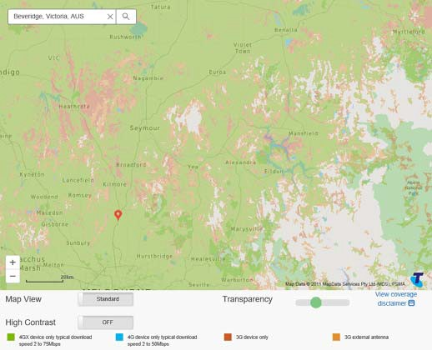
Figure 106 Telstra coverage of the Ned Kelly Touring Route

24 https://www.visitvictoria.com/regions/melbourne/things-to- do/history-and-heritage/old-melbourne-gaol

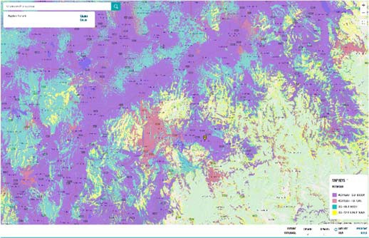
Figure 107 Optus coverage of the Ned Kelly Touring Route

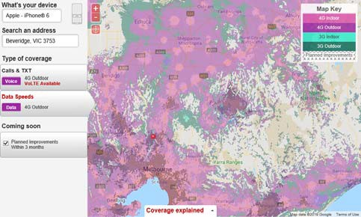
Figure 108 Vodafone coverage of the Ned Kelly Touring Route

Mount Buller
- Premier snow destination

Mount Buller is a fully serviced alpine resort village approximately 208 kilometres east of Melbourne that is accessed via Mansfield township and is home to one of the major snow resorts in Australia, attracting local and international snow enthusiasts. Its proximity to Melbourne means that it attracts numerous day visitors.
The variety of activities that can be undertaken in winter include skiing, snowboarding, tobogganing, sled dog tours and helicopter flights. A range of accommodation to suit different budgets is available from basic accommodation to luxurious alpine retreats. Conference facilities are also available in the village.
Activities in the warmer months include cross‐ country and downhill mountain biking along the 40 km Australian Alpine Epic Trail and Mount Buller
Bike Park, as well as walking, hiking and trail running.

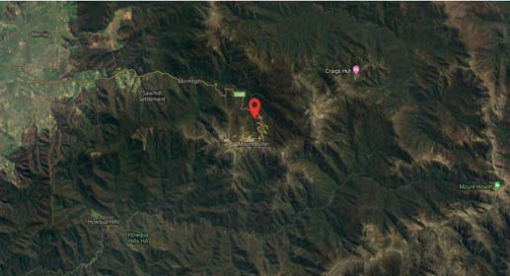
Figure 109 Aerial view of Mount Buller

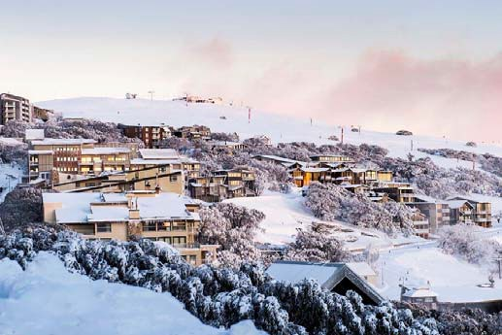
Figure 110 Mount Buller Ski Resort25

Fixed Broadband
Our analysis reveals that Mount Buller falls into the NBN Co’s Satellite footprint.
Further analysis reveals that the nearby town of Mansfield is serviced by NBN FTTN and FTTC Fixed Line Services with the Mansfield Visitor Information Centre serviced by NBN FTTC Fixed Line. The surrounding area of Mansfield is serviced by NBN Fixed Wireless.

25 https://www.visitvictoria.com/things-to-do/outdoor- activities/skiing/mt-buller

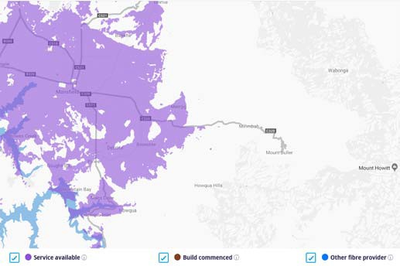
Figure 111 NBN Coverage of Mount Buller (NBN Co)

Mobile Coverage
Based on public coverage maps:
- Telstra shows 4GX outdoor handheld device coverage (with a typical download speed of 2‐75 Mbps) of the village with 4GX and 3G device coverage provided on Mt Buller Road leading into village.
- Optus shows 4G Plus outdoor coverage of the village with 4G Plus outdoor and 3G outdoor providing coverage on Mt Buller Road leading into village.
- Vodafone shows 4G indoor and outdoor coverage of the village with 4G outdoor, 4G indoor and 3G outdoor coverage provided on Mt Buller Road leading into the village.
In summary, there appears to be good coverage of the village and Mt Buller Road from the three mobile network operators.

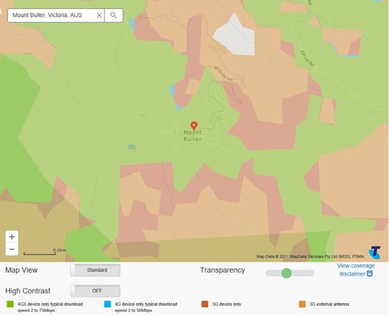
Figure 112 Telstra coverage of Mount Buller

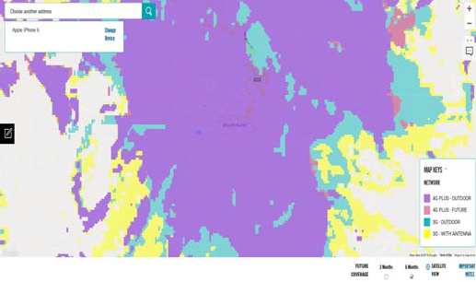
Figure 113 Optus coverage of Mount Buller

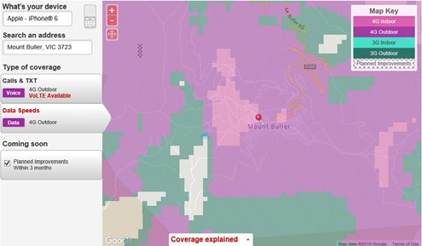
Figure 114 Vodafone coverage of Mount Buller

Mount Hotham
- Australia’s highest alpine village

Mount Hotham is a mountain with Australia’s highest alpine village, located approximately four and a half hours from Melbourne and can be accessed through Gippsland via Omeo or Bright in the Ovens Murray region.
With more than 320 hectares of snow fields, skiing, snowboarding, tobogganing and sledding are popular outdoor activities to partake in the winter. Warmer months offer the opportunity to walk along the cross‐country ski trails and numerous alpine
walks, including the Mount Feathertop summit along the Razorback from Mount Hotham to Federation Hut or from Harrietville along the Bungalow Spur.
Horse riding, fishing and mountain biking are also options.
The region is currently seeking investment in through the Growing Mount Hotham Project to unlock benefits from the proposed Mount Hotham Great Alpine Village Development and Falls to Hotham Alpine Crossing iconic walking trail.

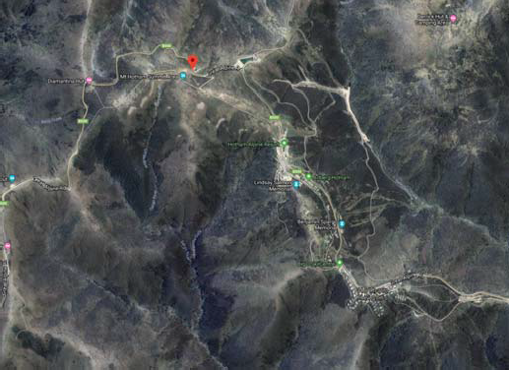
Figure 115 Aerial view of Mount Hotham 26

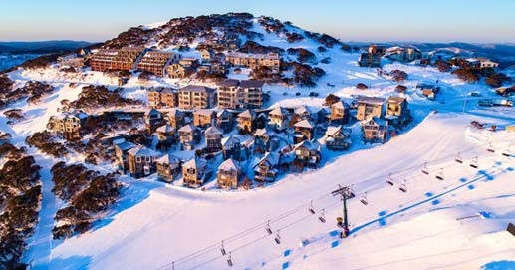
Figure 116 Mount Hotham27

Fixed Broadband
Our analysis reveals Mount Hotham, including the Mount Hotham Visitor Information Centre, falls into the NBN Satellite footprint.

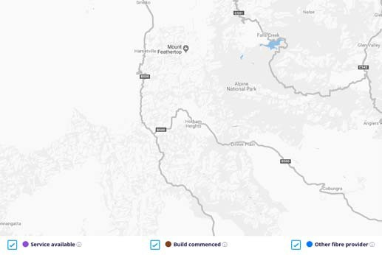

26 https://www.mthotham.com.au/on-mountain/conditions/snow- cams
Figure 117 NBN Coverage of Mount Hotham (NBN Co)

Mobile Coverage
Based on public coverage maps:
- Telstra shows 4GX outdoor handheld device coverage (with a typical download speed of 2‐75 Mbps) of Hotham Heights with 4GX, 4G and 3G device coverage provided on Great Alpine Road leading into the village.
- Optus shows 4G Plus outdoor coverage across most of the area with patches of 3G outdoor however, 4G Plus is scheduled to replace the 3G outdoor coverage. 4G Plus is providing coverage to the Great Alpine Road leading into the village with patches of 3G outdoor however, 4G Plus is scheduled to replace the 3G outdoor coverage.
- Vodafone shows 4G indoor and 4G outdoor coverage of the village with 4G indoor, 4G outdoor and 3G outdoor providing coverage on the Great Alpine Road leading into the village.
In summary, there appears to be good coverage of the village and Great Alpine Road leading into the village from the three mobile network operators.

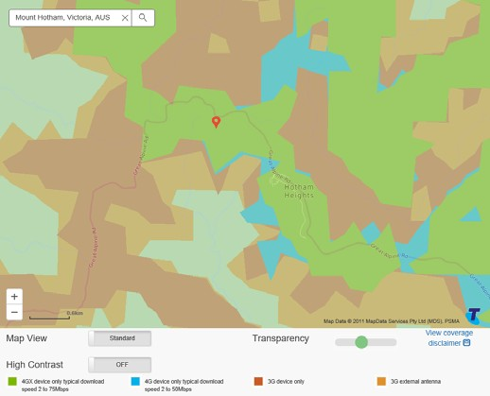
Figure 118 Telstra coverage of Mount Hotham

27 https://nedkellytouringroute.com.au/destinations

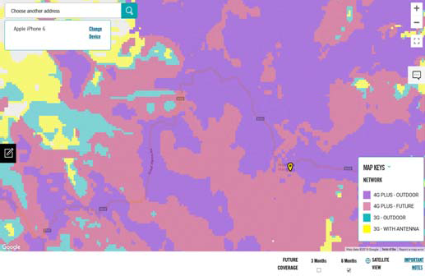
Figure 119 Optus coverage of Mount Hotham

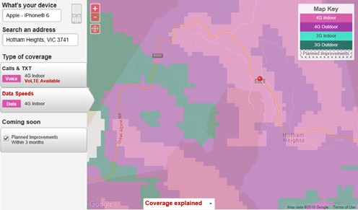
Figure 120 Vodafone coverage of Mount Hotham

Falls Creek
- Largest Alpine Resort
Australia’s largest alpine resort resides in Falls Creek, with activities such as cross‐country skiing, snowboarding, tobogganing and downhill skiing attracting snow enthusiasts in winter.
Falls Creek is accessed through the township of Mount Beauty and outside the snow season, travel beyond Falls Creek along the Bogong High Plains Road touring route takes you into the Mitta Valley, with the option of then travelling through Angler’s Rest and Omeo to Mount Hotham and on to Bright.
Summer activities include hiking, boating, cycling, mountain biking, trail running and fishing. Different types of accommodation are available to suit different budgets ranging from budget dorm options to luxurious penthouse apartments and spa suites.

Fixed Broadband
Our analysis reveals Falls Creek, including the Visitor Information Centre, falls into the NBN Satellite footprint.

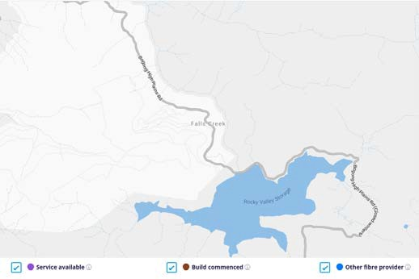
Figure 121 NBN Coverage of Falls Creek (NBN Co)

Mobile Coverage
Based on public coverage maps:
- Telstra shows 4G outdoor handheld device coverage (with a typical download speed of 2‐50 Mbps) of Falls Creek with 4G outdoor handheld device and 3G device providing coverage to Bogong High Plains Rd leading into the resort.
- Optus shows 4G Plus outdoor coverage of Falls Creek with 4G Plus outdoor providing coverage to Bogong High Plains Rd leading into the resort.
- Vodafone shows 4G indoor and 4G outdoor coverage of Falls Creek with 4G indoor and 4G outdoor providing coverage to Bogong High Plains Rd leading into the resort. Improvements are planned for this area.
In summary, there appears to be good coverage of the resort and Bogong High Plains Rd from the three mobile network operators.

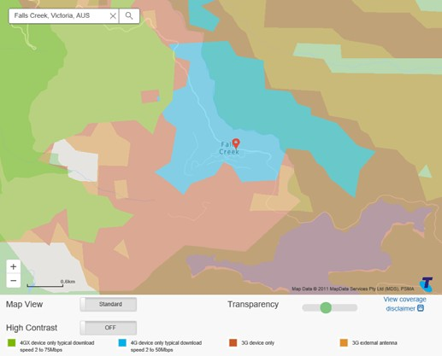
Figure 122 Telstra coverage of Falls Creek

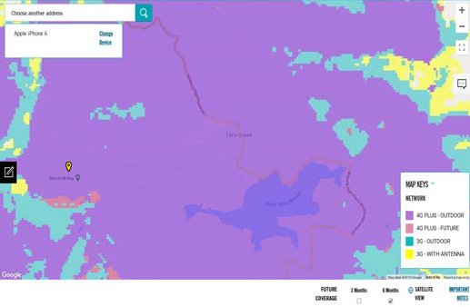
Figure 123 Optus coverage of Falls Creek

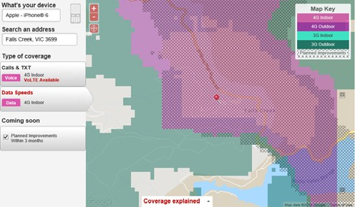
Figure 124 Vodafone coverage of Falls Creek

Transport Corridors

Introduction
For the purposes of transport, only cellular network coverage is considered in this report. Fixed broadband is, by its nature, inapplicable to mobile users. IoT applications utilising LP‐WAN technologies may emerge in the future but are not ‘on the radar’ at this stage.
In terms of meeting the needs of mobile users, this report considers both road and rail. In the case of rail services along the North East line, mobile reception depends not only on the availability of coverage along the route, but also on the design of carriages (which can block signals) and the provision of any internal repeaters (to boost internal reception). The Victorian Government has funded new long haul VLocity trains on the North East line which are being designed with repeaters to boost the on‐board mobile signal when operational. The important consideration for this report is therefore the level of mobile coverage along the route.
In the case of road transport, the main indicator of demand is the road classification (designated M/A, B or C‐grade roads)28. It is recognised that there may be other local roads that carry high traffic volumes or that have a poor accident history and where there is poor
coverage. Local knowledge is the most effective means of identifying such locations.
In terms of rating the severity of blackspots, it is a pragmatic reality that many regional Australians favour Telstra in the belief that it has the best geographic coverage. In practice (and based purely on visual examination of coverage maps), Optus appears to offer comparable coverage in Victoria – though for those travelling nationally, Telstra’s lead more broadly may be still be a compelling attraction.
This leads to the following 3‐level scheme for rating the severity of a transport blackspot:
- where there is no coverage by any network.
- where there is neither Telstra nor Optus coverage; and
- where there is no Telstra coverage.
Discussions with the MNOs are underway to explore incorporation of the public coverage information into SLIM. If and when such information becomes available, it will become more practical to identify and describe transport corridor mobile blackspots more easily and efficiently.
Fieldwork consultations for the digital plan commencing at the time of preparation of this report may also yield more accurate insights into significant transport corridor mobile blackspots.

28 “A” and “B” routes are arterial highways (classification AH). “C” routes typically link smaller population centres to larger regional centres, or roads (classification AO).

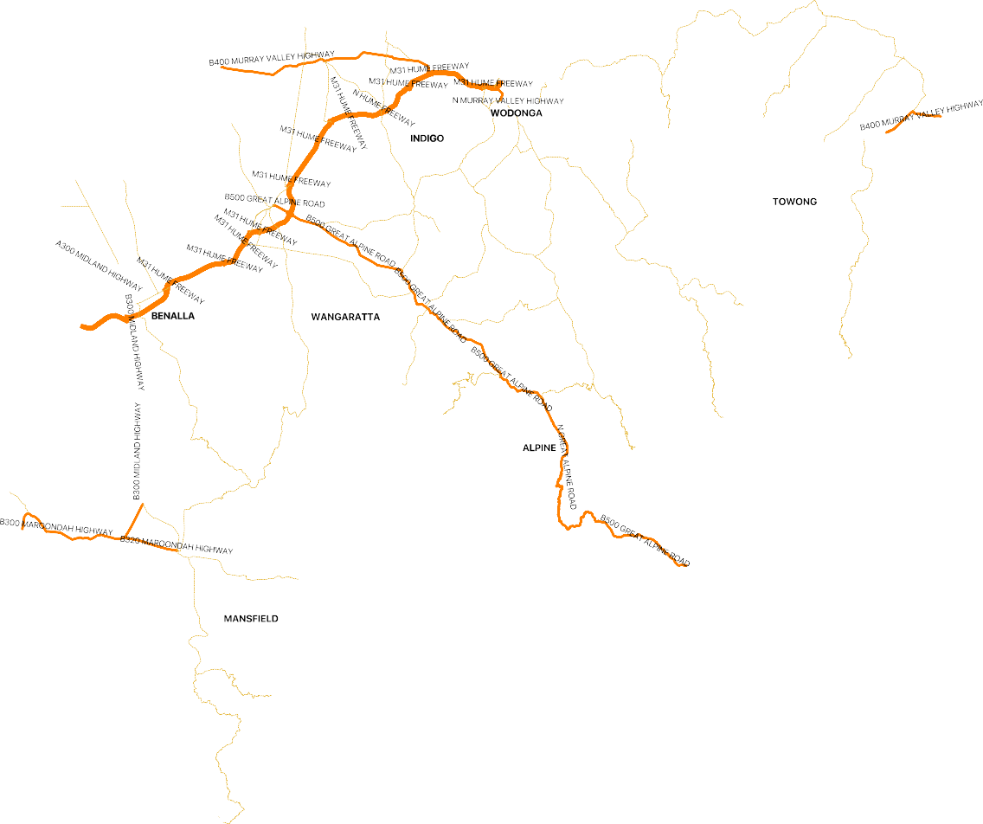

Figure 125 Ovens Murray region declared roads

Freeways/Motorways
Practical experience of call dropouts and coverage blackspots when driving some of the roads suggests that the carrier coverage maps tend to overstate the quality of coverage, however cars fitted with external antennae will receive more consistent coverage.
There is one motorway in the region with a visual scan of public carrier maps shown below.
M31 Hume Freeway (~125km)
- From Baddaginnie on the western border of the Benalla LGA
- To Wodonga on the Victorian border
Maps show continuous 4G outdoor coverage or better by all three mobile carriers, with both Optus and Vodafone constructing new coverage along the route.

A/B Grade Roads
There are a number of A and B roads in the region. Those listed in the table below are the most significant ones that have been reviewed by a visual scan of public carrier maps.

Highway Name | Approx Start | Approx End | Dist (km)
A300/B300 Midland Highway | Maindample | Nalinga | 85
B320 Maroondah Highway | Kanumbra | Mansfield | 42
B400 Murray Valley Highway | Esmond | Barnawatha N | 53
B400 Murray Valley Highway | Wodonga | Towong Upper | 163
B500 Great Alpine Road | Wangaratta | Dinner Plain | 161

A300/B300 Midland Highway (~85km)
- From Maindample
- To Nalinga
This highway forms a ring road from Geelong to Bendigo, Ballarat, Shepparton, Benalla, Mansfield and

Lilydale. The section of the highway within the region is illustrated below.

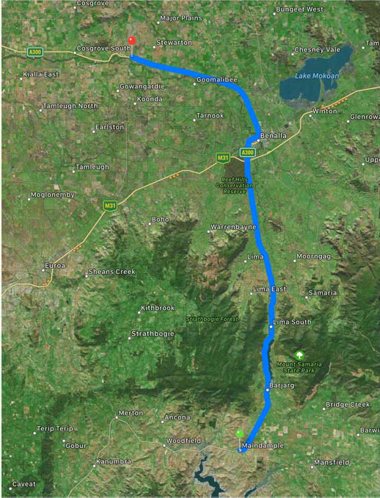
Figure 126 A300/B300 Midland Highway (Google Maps)

Based on public coverage maps:
- Telstra shows 4GX outdoor handheld device coverage (with a typical download speed of 2‐75 Mbps) across the majority of the route, with coverage falling to 3G handheld and external antenna north of Benalla and in the mountainous areas near Barjarg and Swanpool.
- Optus shows 4G Plus outdoor coverage across the route.
- Vodafone shows no coverage between Lima South and Warrenbayne but otherwise shows continuous 4G outdoor coverage.

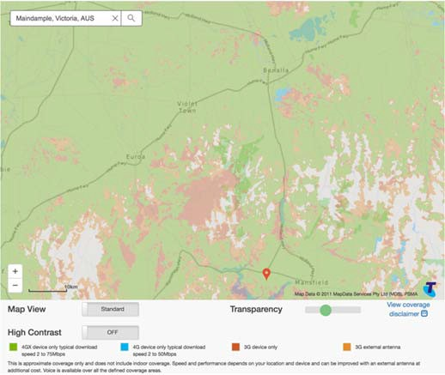
Figure 127 Telstra coverage on the section of the Midland Highway

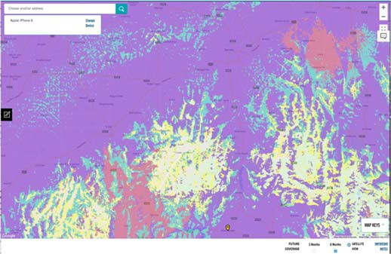
Figure 128 Optus coverage on the section of the Midland Highway

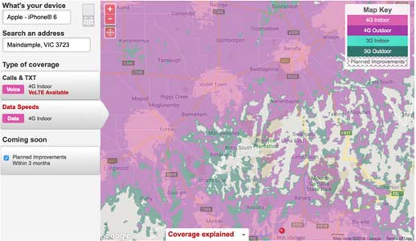
Figure 129 Vodafone coverage on the section of the Midland Highway

In summary, there appear to be no mobile coverage issues on the route, with the at least two mobile network operators all offering service.

B320 Maroondah Highway (~42km)
- From Kanumbra

- To Mansfield
This highway connects metropolitan Melbourne to Mansfield. The section of the highway within the region is illustrated below.
Based on public coverage maps:
- Telstra shows 4GX outdoor handheld device coverage (with a typical download speed of 2‐75 Mbps) across the route.
- Optus shows near‐continuous 4G and 3G outdoor coverage across the route, with significant new coverage under construction between Kanumbra and Merton.
- Vodafone shows continuous coverage continuous 4G outdoor coverage across the route, with a small area of 3G outdoor coverage near Bonnie Doon.

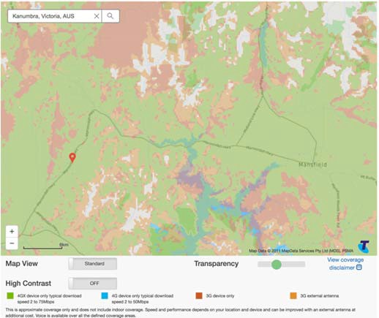
Figure 130 Telstra coverage on Maroondah Highway

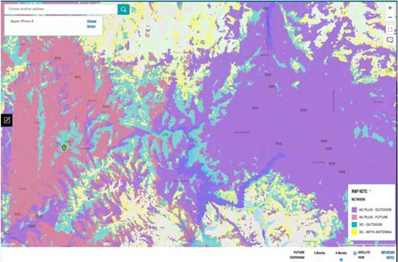
Figure 131 Optus coverage on Maroondah Highway

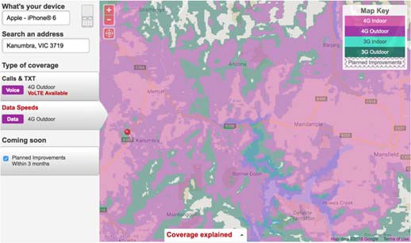
Figure 132 Vodafone coverage on Maroondah Highway

In summary, there appear to be no mobile coverage issues on the route, with the at least two mobile network operators all offering service.

B400 Murray Valley Highway (~53km)
- From Esmond
- To Barnawatha North
This highway connects the Rutherglen area with the Wangaratta‐Yarrawonga Rd in the west and the Hume Freeway in the east. The section of the highway within the region is illustrated below.

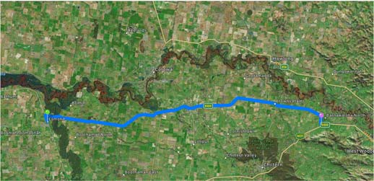
Figure 133 B400 Murray Valley Highway (Google Maps)

Based on public coverage maps:
- Telstra shows 4GX outdoor handheld device coverage (with a typical download speed of 2‐75 Mbps) across the route.
- Optus shows near‐continuous 4G and 3G outdoor
coverage across the route.
- Vodafone also shows continuous coverage continuous 4G outdoor coverage or better across the route.

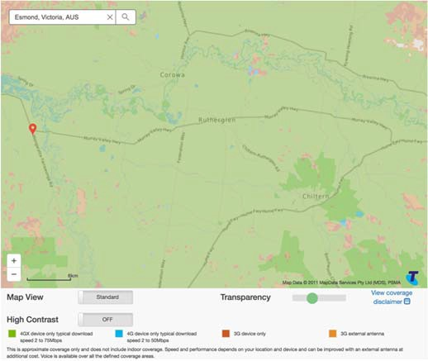
Figure 134 Telstra mobile coverage on the Murray Valley Highway

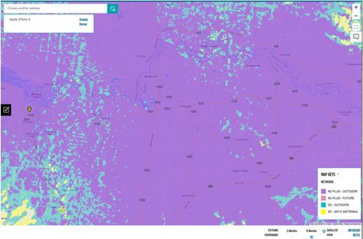
Figure 135 Optus mobile coverage on the Murray Valley Highway

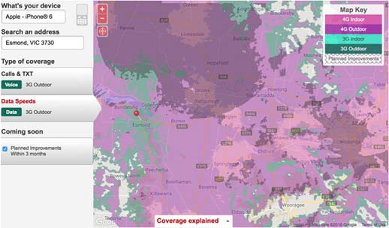
Figure 136 Vodafone mobile coverage on the Murray Valley Highway

In summary, there appear to be no mobile coverage issues on the route, with all three mobile network operators offering service.

B400 Murray Valley Highway (~163km)
- From Wodonga
- To Towong Upper
This highway connects the Hume Freeway near Wodonga to the Victorian border near Corryong in the west, traversing Lake Hume, Tallangatta and the forested alpine areas making up the majority of the Towong LGA. The section of the highway within the region is illustrated below.

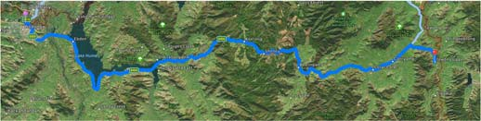
Figure 137 B400 Murray Valley Highway (Google Maps)

Based on public coverage maps:
- Telstra poor to no highway coverage between Old Tallangatta and the approach to Corryong but otherwise shows 4GX outdoor coverage.
- Optus also shows no highway coverage between Old Tallangatta and Corryong.
- Vodafone shows no coverage at all past Old Tallangatta.

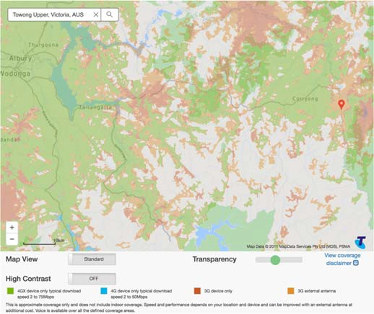
Figure 138 Telstra coverage between Wodonga and near Corryong on the Murray Valley Highway

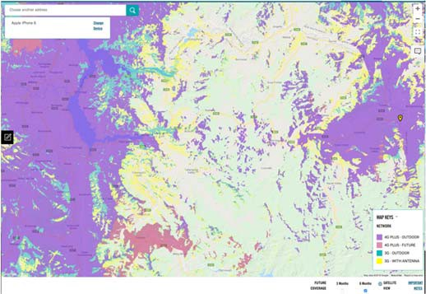
Figure 139 Optus coverage between Wodonga and near Corryong on the Murray Valley Highway

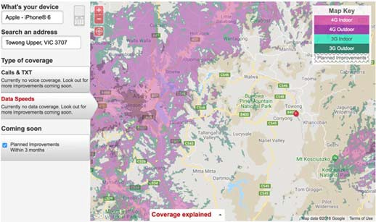
Figure 140 Vodafone coverage between Wodonga and near Corryong on the Murray Valley Highway

In summary, there appears to be consistent mobile coverage on the route as far as Old Tallangatta, however the remaining 87km of the route.

B500 Great Alpine Road (~161km)
- From Wangaratta
- To Dinner Plain
This tourist highway connects Wangaratta (and the Hume Freeway) to Bairnsdale passing through the townships of Myrtleford, Bright and the Mount Hotham Village and providing year‐round access to the Victorian Alps. The section of the highway within the region is illustrated below.

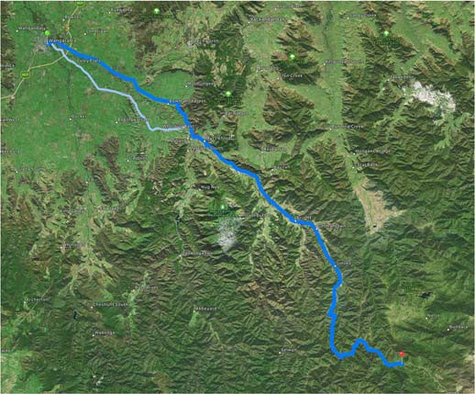
Figure 141 B500 Great Alpine Road (Google Maps)

Based on public coverage maps:
- Telstra shows 4GX and 3G outdoor handheld device coverage across the route, although coverage beyond Bright appears highly affected by the terrain.
- Optus shows near‐continuous 4G outdoor coverage across the route, although again terrain beyond Bright would be expected to affect coverage quality.
- Vodafone also shows continuous 4G outdoor coverage across most of the route, with areas of poor to no coverage between Bright and Hotham Heights.

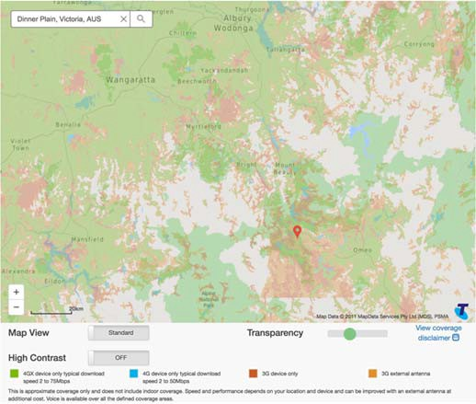
Figure 142 Telstra coverage on Great Alpine Road as far as Dinner Plain

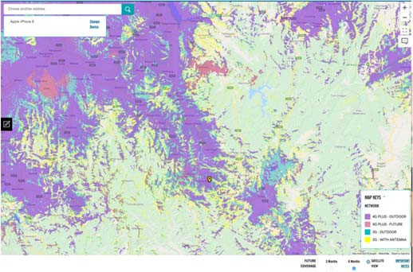
Figure 143 Optus coverage on Great Alpine Road as far as Dinner Plain

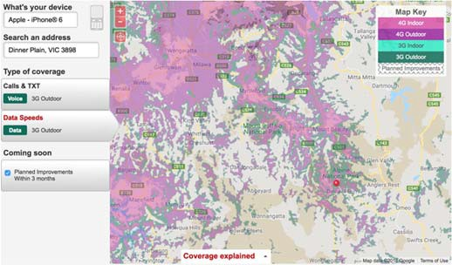
Figure 144 Vodafone coverage on Great Alpine Road as far as Dinner Plain

In summary, there appear to be good mobile coverage between Wangaratta and Bright, however there is poor to no coverage on the alpine section to Hotham Heights.

C-Grade Roads
There are 54 declared C roads in the region forming a mesh between major and small communities. In general, the is good highway coverage in the populated and low‐lying areas of the region, however the large areas of alpine terrain and low population density means that the majority of highway mobile coverage is extremely unreliable particularly for 000 emergency calls

Rail
Melbourne – Seymour
The Victorian Government is undertaking a program to improve mobile services on regional rail routes. This project includes installation of in‐train mobile repeaters in all VLocity rail cars as well as improved track‐side mobile coverage in certain areas.
As a result of this program, passengers travelling from the region to the Melbourne‐Seymour leg will benefit from improved track‐side coverage from all three MNOs by the end of the 2018 calendar year.

Melbourne – Albury
The route length of approximately 220km carries up to 6 services per weekday between Melbourne and Albury. Annual patronage for 2017‐18 was 79,000 ‐ a 6% decline on 2016‐17.
The route is not currently served VLocity rolling stock and therefore there are no in‐train repeaters in the trains which V/Line uses to service this route. However, these cars also do not suffer from the severe radio frequency shielding as the VLocity rail cars.
Consequently, mobile carrier public coverage maps can be used as a guide to current Classic Fleet in‐train mobile coverage.
As the rail primarily basically follows the Hume Freeway, trackside coverage for all three mobile carriers is predictably continuous and of good quality.

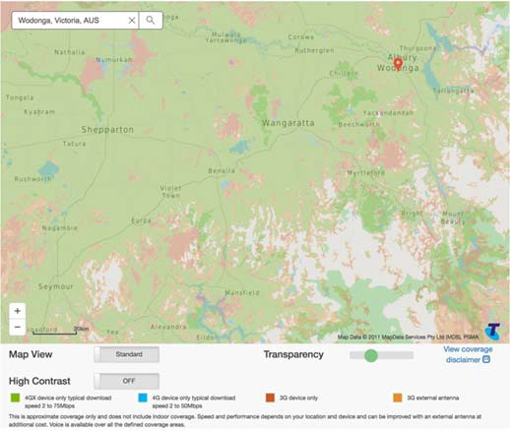
Figure 145 Telstra rail coverage between Seymour and Wodonga

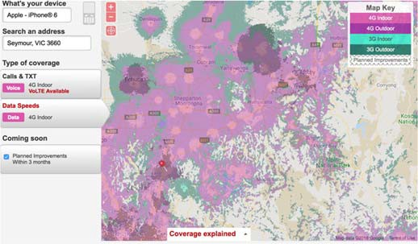

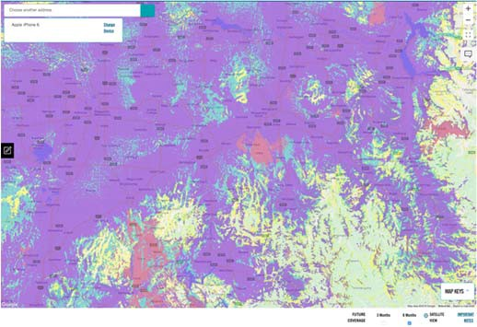Figure 146 Optus rail coverage between Seymour and Wodonga
Figure 147 Vodafone rail coverage between Seymour and Wodonga

In summary, there appear to be no mobile coverage issues on the route, with the three major mobile network operators all offering service, noting that localised conditions such as cuttings and overpasses may temporarily disrupt continuous coverage as the train passes through. Further measurement of in‐train mobile coverage may be required and reported mobile disruption experienced by users around Seymour needs to be considered.

Appendix A. Acknowledgements & Qualifications

Acknowledgements
This report includes numerous images and cites many details about locations that have been obtained from a range of sources. Citing a reference for commonly accessed data sources would clutter the document and undermine the flow of relevant information. Accordingly, this section sets out some important acknowledgements regarding data sources.
- The Australian Bureau of Statistics (ABS) provides a rich repository of information at varying levels of aggregation. Two sources in particular have been used extensively over the period from May 2018 to October 2018 during which this report was prepared.
- Data by Region29 – providing statistics at the level of Local Government Area (LGA).
- Quickstats30 ‐ providing statistics at varying levels of aggregation, but in particular, at the level of urban centre/locality (UCL) and slightly higher levels of aggregation as appropriate.
- These data are primarily drawn from the June 2016 Population Census.
- Screen images generated by the State Level Information Management (SLIM) Graphical Information System (GIS) are compiled from various sources, and typically include an acknowledgement of the relevant sources in the bottom right corner of the image. Such acknowledgements have often been clipped from the images presented in this report, but are acknowledged (based on the type of background) as follows:
- For grey street map backgrounds: “Leaflet |
© OpenStreetMap”
- For coloured street map backgrounds: “Leaflet | Tiles © Esri – Source: Esri, DeLorme, NAVTEQ, USGS, Intermap, iPC, NRCAN, Esri Japan, METI, Esri China (Hong Kong), Esri (Thailand), TomTom, 2012”
- For satellite imagery backgrounds: “Leaflet | Tiles

29 See http://stat.abs.gov.au/itt/r.jsp?databyregion
© Esri – Source: Esri, i‐cubed, USDA, USGS, AEX, GeoEye, Getmapping, Aerogrid, IGN, IGP, UPR‐ EGP, and the GIS User Community”
- For plain grey background: “Leaflet | Tiles © Esri
– Esri, DeLorme, NAVTEQ”
- For topographic backgrounds, “Leaflet | Tiles © Esri – Source: Esri, De Lorme, NAVTEQ, TomTom, Intermap, iPC, USGS, FAO, NPS, NRCAN, Geobase, Kadaster NL, Ordnance Survey, Esri Japan, METI, Esi China (Hong Kong), and the GIS User Community”
- For any screen capture of Telstra’s public coverage map that does not show an acknowledgement of the data sources, the following acknowledgement applies: “Map Data
© 2011 MapData Services Pty Ltd (MDS), PSMA”.
- For any screen capture of Optus’s public coverage that does not show an acknowledgement of the data sources, the following acknowledgement applies: “Map data
©2018 Google”.
- For any screen capture of Vodafone’s public coverage that does not show an acknowledgement of the data sources, the following acknowledgement applies: “Map data
©2018 GBRMPA, Google”.
- For any screen capture of Sigfox coverage that does not show an acknowledgement of the data source, the following acknowledgement applies: “Leaflet”.
- Region‐level Digital Inclusion Index data has been purchased from Roy Morgan.

Qualifications
- The ABS periodically makes corrections to its data (including the 2016 Census data utilised widely in this report), so minor discrepancies may be noted between figures cited in this report and data obtained from the ABS website.

30 See for example http://quickstats.censusdata.abs.gov.au/census_services/getpr oduct/census/2016/quickstat/UCL211002?opendocument

- Coverage by different network technologies reflects the situation at a point in time. Network operators regularly expand and reconfigure the networks with resulting changes to coverage. Before placing reliance on any information presented in this report, it is prudent to obtain the latest available information.
- Mobile reception depends on many factors including the type of device, whether the device has an external antenna and the like. Both the Optus and Vodafone public coverage maps
require nominating a device. For consistency, the coverage maps shown are based on a “middle of the range” iPhone6.
- A fourth Mobile Network Operator (MNO) – TPG
– is in the process of entering the Australian market. Its coverage intentions are not currently known.

Appendix B. Fieldwork

Two streams of fieldwork tap into the practical experience of the six local governments in Ovens Murray and gather information for the business case feasibility analysis of the top priority projects (tourism and maternal health monitoring digital applications):
- A detailed online survey of local governments (refer to Appendix D)
- Face‐to‐face onsite interviews by expert market research field staff
- Analysis of existing studies provided by respondents.

Online survey of local governments
The survey was sent to the CEO and senior economic development officer (or equivalent) in each local
government in August 2018. It sought local government information and views on:
- The importance in their LGA of common unmet digital needs including digitals skills, mobile coverage, NBN service quality, public WiFi, Internet‐ of‐things knowledge and uptake, and access to government infrastructure
- The locations and industries in which these unmet needs impact most severely
- Digital proficiency training needs and more IT professionals
- The location of residential and business developments, and tourist sites, in their LGA
- Details on any digital hubs in their LGA
- The relative importance of the priority digital projects identified by the Regional Partnership and the Digital Plan Working Group.

Appendix C. Common Themes: Needs & Opportunities
Six common themes on priority unmet needs have emerged from discussions with Regional Partnerships and Digital Plan Working Groups:
- Fixed broadband – NBN service quality
- Mobile coverage – the prevalence of blackspots
- IoT – uptake and use
- Public WiFi – the benefits
- Access to government assets
- Digital skills – digital literacy, supply of IT professionals, workforce preparedness for the future.
A summary of issues in these areas follows.

Fixed broadband
Fixed broadband is still the most common means of accessing the Internet from homes, businesses and service providers, including in the health and education sectors.
Fixed broadband access to the Internet is typically delivered over a mix of fibre/copper cables (providing potentially the best performance), terrestrial wireless (with medium performance), or over satellite (the last resort, often with the lowest performance and the highest cost).
In Australia the National Broadband Network Company (NBN Co) and the Retail Service Providers (RSPs) providing service to end users on the NBN are playing an increasingly important role. As the National Broadband Network (NBN) is constructed, they are becoming the major providers for fixed broadband across Australia. In most, but crucially not all, cases the NBN can deliver an improvement over the current fixed broadband providers.
Performance and costs are driven partly by technology, and partly by commercial choices of the RSPs. The latter in turn are significantly driven by a complex NBN wholesale model. The NBN itself has been designed and is being operated first and foremost as a residential/consumer/micro business broadband network. As such, it often does not provide adequate support for the more complex needs of businesses and community service providers – yet in regional locations it is frequently called on to do in the absence of cost‐ equivalent connectivity options.
The planned terrestrial NBN coverage is limited, with reliance on satellite to fill many gaps outside of the major population centres. Today the NBN is still only partially deployed, with another two years until completion. As NBN Co does not offer interim solutions, many regional areas will be waiting some time to be connected. The roll‐ out has also highlighted procedural failures that are only now getting appropriate attention. All of these factors combine to further entrench the digital disadvantage of regional and rural areas.
On a more positive note, the NBN is looking to provide technology upgrade paths in the years ahead, pushing fibre deeper into the community and enhancing their fixed‐wireless capabilities. Moreover, alternatives to the NBN do exist, from small‐scale community‐led efforts, through various NBN/RSP competitors deploying their own infrastructure, up to futuristic, multi‐national companies potentially offering entirely new platforms over the next decade.

Mobile connectivity
Mobile connectivity provides untethered coverage over a wide area. With increasingly more powerful and portable devices and a rich application eco‐system, it offers huge socio‐economic utility.
Significant applications include voice and video communications, data access, and support for the emerging Internet of Things (IoT).

Coverage blackspots affect not only social amenity, but increasingly business efficiency. Almost every sector of economic activity is evolving to exploit the opportunities that have become available with anywhere, anytime access to information and services via the mobile networks. Without mobile connectivity, individuals and businesses will find themselves at a growing disadvantage.
Blackspots in mobile coverage can limit the delivery of emergency and other community support services. In many regional areas not all Mobile Network Operators (MNOs) offer coverage, with investment decisions driven by commercial considerations. This means consumers and businesses have to estimate their coverage needs, subscribe to the most appropriate service(s) and deal with shortcomings.
The reasons for coverage blackspots are diverse and complex. Even where the MNO maps indicate coverage should be available, practical experience often falls far short of MNO representations. Local environmental factors, largely unavoidable, play a key role – and some manageable infrastructural factors such as transmitter technologies, locations, and congestion have significant impact. Even older‐style rail carriages can disrupt mobile services dramatically for passengers, despite proximity to transmitters.

Public WiFi
With appropriate hardware, WiFi can provide high‐capacity bandwidth throughout a building, across a site or event venue, and even across a rural property – all at a relatively low cost. It can support internet applications ranging from high‐bandwidth video communication down to broad‐area monitoring and control of various devices and sensors in IoT contexts. Virtually all modern smart phones, tablets and notebook computers have built‐in WiFi capabilities.
Establishing WiFi coverage is not sufficient on its own. It depends on other high‐speed links to connect devices with the wider Internet. This ‘backhaul’ is usually the major cost constraint on large‐scale deployments. It is also more vulnerable to security intrusions compared with commercial mobile/fixed wireless services.
Various businesses and government agencies offer WiFi, often for free, to attract and support casual use by locals, tourists, business travellers and in some cases to support disadvantaged members of the community who may not be able to afford fixed or mobile connectivity.

Support for Internet of Things
The concept behind the IoT is the use of multiple sensors, control devices, communications and analytics to streamline processes traditionally involving manual intervention. Application areas range from smart homes to smart cities, smart grids, smart transport, smart farms and smart industries.
IoT brings numerous technical challenges, especially when dealing with many, widely distributed (sometimes moving) sensors – often with severe power limitations. Industry is actively trialling a vast number of alternative approaches, from leveraging mobile phone networks, to WiFi and whole new technology approaches for low‐ powered local and wide area wireless transmissions.
Standards are still emerging, and widespread adoption will take significant analysis and planning. However, the opportunities are vast, and investment is accelerating. Several trials of low‐power wide‐area networks (LP‐WAN) are underway in parts of Victoria, predominantly in agricultural contexts and some infrastructure‐monitoring and meter‐reading services.

Government infrastructure
The Victorian Government has a number of significant infrastructure assets to support communications across Victoria, including optical fibre links along some rail routes, and a range of wireless communications towers to

support emergency and other services. While mainly dedicated to their respective primary purposes, there is often spare capacity that could be made available to address shortcomings in commercial supply
While many of these assets are available for commercial use, little of this has occurred. The CRCP TIL initiative is addressing a number of these issues.

Digital literacy
Building a rich, highly‐capable and far‐reaching infrastructure is only effective if the community has the skills to properly take advantage of it, and if the community and infrastructure are properly supported.
Statistics on the skills and support needs across the state are either almost non‐existent, or available only at a very high level of aggregation. As a result, further local data collection is needed to shape remedial plans.
Various indicators strongly suggest that many regional and rural communities are less likely than those in urban centres to have the people with the necessary skills to drive digital progress. At the same time, these communities stand to gain the same or possibly greater, benefits from leveraging digital technologies.
The digital infrastructure at the core of this report potentially provides a vast array of opportunities to remediate that situation with online learning – for example, using YouTube, MOOCs (massive online open courses), and interactive training providers.
However, the learning journey needs to start with some baseline skills in the region so that people can find and engage with those materials. Access to this foundational education also needs to be effective and affordable. Much of the investigation undertaken suggests this is not yet the case.
There are some opportunities to provide local support frameworks through existing and proposed community centres. These deserve further consideration, possibly within a broader state‐wide strategy to boost digital literacy across all age groups.

Appendix D. LGA Digital Needs Report

© 2019 Ernst & Young. All Rights Reserved. Liability limited by a scheme approved under Professional Standards Legislation Page 1 28521 – DEDJTR – Victorian Digital Plan Report – Ovens and Murray – V2 – 15th March 2019

DJPR
LGA Digital Needs

Ovens and Murray report

EY Sweeney contacts:

DEDJTR contact: Project no.
Date:
Lewis Jones, Matthew Bond and
Emma Matschoss Steve Anderson 28521
15th March 2019

MELBOURNE
8 Exhibition St
Melbourne VIC 3000 Australia GPO Box 67 Melbourne VIC 3001
T 61 3 9288 8651

15th March 2019
Department of Jobs, Precincts and Regions Attention: Steve Anderson
Level 32, 121 Exhibition Street
Melbourne, 3000

LGA Digital Needs Report – Ovens and Murray

Dear Steve,

Enclosed is digital needs report for Ovens and Murray.

This report has been prepared in accordance with the terms and conditions of the proposal accepted on/or dated 5th April 2018.

Please contact myself or Matthew Bond if you have any questions regarding this report. We look forward to discussing this report with you in due course.
Yours sincerely
Lewis Jones Matthew Bond Managing Director ‐ Melbourne Director
EY Sweeney EY Sweeney

Page 2
© 2019 Ernst & Young. All Rights Reserved. Liability limited by a scheme approved under Professional Standards Legislation 28521 – DEDJTR – Victorian Digital Plan Report – Ovens and Murray – V2 – 15th March 2019

Contents

4 Introduction

6 Methodology

8 Key findings

10 Telecommunication access and reliability

15 LGA digital proficiency andskills

17 Region specific issues

20 LGA characteristics

EY Sweeney is accredited under the International Standard, ISO 20252.
All aspects of this study were completed in accordance with the requirements of that scheme.
Also please note that EY Sweeney’s liability is limited by a scheme approved under professional standards legislation. A copy of the scheme can be obtained from us upon request.

© 2019 Ernst & Young. All Rights Reserved. Liability limited by a scheme approved under Professional Standards Legislation Page 4 28521 – DEDJTR – Victorian Digital Plan Report – Ovens and Murray – V2 – 15th March 2019

Report disclaimer
Our Report may be relied upon by DJPR for the purpose set out in the scope section/proposal only pursuant to the terms of our engagement letter dated 15 June 2018. We disclaim all responsibility to any other party for any loss or liability that the other party may suffer or incur arising from or relating to or in any way connected with the contents of our report, the provision of our report to the other party or the reliance upon our report by the other party.

Introduction

Background

Under the Connecting Regional Communities Program (CRCP), a Digital Plan is being developed for each of the nine Regional Partnerships (highlighted opposite). The Digital Plan is a forward‐looking place and industry based analysis of digital access services and skills supply, demand, unmet needs and affordability.

Barwon Loddon Campaspe
Goulburn Ovens and Murray
Gippsland Great South Coast
Wimmera Southern Mallee Mallee
Central Highlands

9 regions across Victoria formed part of this study.

The Digital Plan will include potential solutions for addressing the unmet needs of each region. The development of these Digital Plans has been informed through an extensive consultation process with the nine Regional Partnerships.

Representatives of the LGAs within each of the nine regions were invited to share their thoughts and experiences to allow for greater understanding about the digital, telecommunication and skills needs of each LGA and where gaps exist.

The results from the survey are an important input into each regional Digital Plan. This allows the regions to gain a better understanding of the economic situation and priorities, in order to take advantage of evolving digital economy opportunities.

This report focuses on the information provided by
LGA’s within the Ovens and Murray region.

Page 5
© 2019 Ernst & Young. All Rights Reserved. Liability limited by a scheme approved under Professional Standards Legislation 28521 – DEDJTR – Victorian Digital Plan Report – Ovens and Murray – V2 – 15th March 2019

© 2019 Ernst & Young. All Rights Reserved. Liability limited by a scheme approved under Professional Standards Legislation Page 6 28521 – DEDJTR – Victorian Digital Plan Report – Ovens and Murray – V2 – 15th March 2019

Methodology

Objectives and methodology

Objectives

The overall aim of the survey is to provide local councils with the opportunity to submit information on the digital, telecommunication and skills needs of each LGA and where gaps exist.
Methodology

The study involved the conduct of 7 x 30‐minute online surveys conducted between February and March 2019.
Sample structur |  |  | e
Total |  |  | n=7*
LGA | Alpine | Shire | 1
 | Rural City of Benalla |  | 1
 | Shire of Indigo |  | 1
 | Shire of Mansfield |  | 1
 | Shire of Towong |  | 1
 | Rural City of Wangaratta |  | 1
 | City of Wodonga |  | 1
Region Live  within the LGA  Length of service within LGA | Yes | 4
 | No |  | 4
 | 1 to 2 years |  | 1
 | 3 to 5 years |  | 3
 | 6 to 10 years |  | 4
 | 11 to 20 years |  | ‐
 | 21 years plus |  | ‐

The final achieved sample structure is shown opposite.

Sample from the survey was provided by the Department of Jobs, Precincts and Regions (DJPR). Participants were classified as a representative of their LGA at an Economic Development Officer or Senior Executive level.

*Note: due to the small sample size, all results throughout this report are reported at an individual respondent level. To that end, results are not expresses as a % or numerically.

Page 7

© 2019 Ernst & Young. All Rights Reserved. Liability limited by a scheme approved under Professional Standards Legislation 28521 – DEDJTR – Victorian Digital Plan Report – Ovens and Murray – V2 – 15th March 2019

© 2019 Ernst & Young. All Rights Reserved. Liability limited by a scheme approved under Professional Standards Legislation Page 8 28521 – DEDJTR – Victorian Digital Plan Report – Ovens and Murray – V2 – 15th March 2019

Key findings

Key findings

Most common negative impacts

The areas where strong negative impacts are most prevalent across the region are Benalla, Wangaratta, Alpine Shire and Mansfield.

Most statements measuring digital competency and capability highlight the challenges LGAs across Ovens and Murray all face to some extent. Poorer than expected NBN capability has a strong or very strong negative impact on six out of seven LGAs.

Aside from NBN coverage, lack of access to existing government telecommunications infrastructure is a common complaint. Mobile phone coverage and reliability also attracts criticism.

Rural and farming areas are the location that is impacted by the majority of technology and connectivity aspects assessed. In addition, tourist areas across the region are the second most common area to be negatively affected.

Greatest impacts on digital adoption

According to LGA representatives, connectivity and training in basic skills will have the greatest impact on digital adoption in the residential and business communities. Affordability is called out by six of the seven LGAs in respect to adoption in the residential and small business communities.

Connectivity is a common thread across all LGAs in relation to the positive impact it would have on digital adoption in both small and larger businesses and councils.

Within Ovens and Murray, Indigo, Benalla and Wangaratta all confirm they have a digital hub. Indigo is the only LGA to report the level of usage (estimated to be at 25% to 49%). Opening hours, willingness to travel to the hub and only a marginal increase in speed and reliability are cited as the reasons for limited uptake.

Most important telecommunications focus areas
Aligning with the negative impact tourist areas across the region experience due to technology and connectivity levels, digital services to support tourism initiatives is classified as very important by all but one LGA (Towong). This is followed by high quality digital connectivity between health care locations, professionals and patients.

When asked to rank these focus areas in order of most to least relevant, high quality digital connectivity between health care locations, professionals and patients is consistently ranked the top one or two most important focus areas across five out of seven LGAs. Digital services to support tourism initiatives is also deemed the highest priority for three LGAs. Improvement to connectivity along the Hume Corridor is commonly ranked least relevant for five out of seven LGAs.

KEY FINDINGS

Telecommunication access and reliability

Impact on LGA

 Overall, the majority (six out of nine) of statements negatively impact each LGA across Ovens and Murray to some extent.
Negative impact on LGA
Lack of access to existing government
telecommunications

No impact A slight at all negative
A moderate
negative impact
A strong A very strong
negative negative Don’t know
impact impact
People’s lack of general digital
proficiency
A shortage of skilled technology professionals
Access to technology skills training
The affordability of technology training
Poor mobile phone coverage and reliability
Poorer than expected NBN capability and reliability
No or inadequate public Wi‐Fi, including in small towns
Limited knowledge and take‐up of Internet‐of‐ things (IOT)
infrastructure such as
broadband cabling or towers

 Across most statements, Benalla, Wangaratta, Alpine Shire and Mansfield indicate that they are facing strong or very strong negative impacts due to digital competency and capacity levels. In comparison, Wodonga and Indigo Shire do not feel the level of negative impact as strongly.

 Poorer than expected NBN capability has a strong or very strong negative impact on six out of the seven LGAs. Lack of access to existing government telecommunications infrastructure has an adverse affect on five out of the seven LGAs.

Legend
Alpine Shire Shire of Mansfield

Shire of Towong Shire of Indigo

Impact of technology and connectivity on specific LGA locations

 Mobile phone coverage and mobile Wi‐Fi negatively impact nearly every facet across the seven Ovens and Murray LGAs.
Negative impact on LGA by location
Base: Total sample (n=7)
PQu4b. lic traFnosr peoacrht of the locat
this specific location

ions shown belo
inyour LGA. Ift

w, please select
here isnonegat

the technology
ive impact,plea

or connectivity
se select‘no im

aspects that ar
pact / not applic

e negatively imp
able’.

acting
No impact / Mobile
Not phone applicable coverage
Existing
telco infrastructure access
NBN
Mobile
Wi‐Fi
IoT
Digital
proficiency
/ skills
Residential areas

Rural/remote/farming areas

Parklands
Tourist areas
Major roads
Minor roads
Town centres
Education
establishments

 Rural and farming areas are the location that is impacted by the majority of technology and connectively aspects measured. All LGAs are universal in their perception that mobile phone coverage, existing telco infrastructure access and NBN negatively impact rural areas.

 Tourist areas across Ovens and Murray are the second most common area to be impacted across most aspects measured.

Legend
Alpine Shire Shire of Mansfield

Shire of Towong Shire of Indigo

Base: Total sample (n=7)
Q5. For each of the industries shown below, please select the technology or connectivity aspects that are negatively impacting
this specific industry in your LGA. Ifthere isnonegative impact,please select ‘no impact / not applicable’.

Impact of technology and connectivity on specific industries

 Looking at the impact of each technology and connectively aspect on various industries, Agriculture within Wodonga and Health Care and Social Assistance within Benalla are the only two which do not register a negative impact.
Negative impact on LGA by industry
No impact / Not applicable |  | Mobile Existing  phone telco  coverage infrastructure  access |  | NBN | Mobile Wi‐Fi | IoT | Digital proficiency  / skills
Agriculture
Manufacturing
Tourism
Construction
Education and Training
Health Care and Social Assistance
Public Administration and Safety Services

 Again, mobile phone coverage and mobile Wi‐Fi appears to adversely affect the majority of LGAs across most industries. Particularly so
for Tourism, Construction and Agriculture.

 NBN is another aspect that negatively impacts most industries across Ovens and Murray.

Legend
Alpine Shire
Shire of Mansfield
Shire of Towong
Shire of Indigo
City of Wodonga
Rural City of Benalla
Rural City of Wangaratta

Base: Total sample (n=7)
Q6. Do you have access to any studies or data that focus on each of the following issues in your LGA or that are relevant to your LGA?

Access to information on issues

 There is varying accessibility to studies or data that focus on connectively or technology aspects across the LGAs.
Access to studies / data that focus on issues
Yes |  | No | Don’t know
People’s lack of general digital proficiency
A shortage of skilled technology professionals
Access to technology skills training
The affordability of technology training
Poor mobile phone coverage and reliability
Poorer than expected NBN capability and reliability
No or inadequate public Wi‐Fi, including in small towns
Limited knowledge and take‐up of Internet‐of‐ things (IOT)
Lack of access to existing government telecommunications infrastructure such as broadband cabling or towers

 With the exception of Alpine Shire and Towong, all LGAs have access to studies focused on digital proficiency. A similar number (five out of seven) can also access
studies related to poor mobile phone coverage.

 As highlighted previously, lack of access to existing telecommunications infrastructure has a strong negative impact across most LGAs.
However, no location has access to studies of this type.

Legend
Alpine Shire
Shire of Mansfield
Shire of Towong
Shire of Indigo
City of Wodonga
Rural City of Benalla
Rural City of Wangaratta

KEY FINDINGS

LGA digital proficiency and skills

Digital adoption: impact on the community, small and large business

 LGA representatives were asked to rate the impact a number of options will have on the digital adoption for: (1) the community; (2) small business and; (3) larger businesses and council.
Digital adoption: impact on the community, small and large business
Larger Community Small business businesses and
council
Changing attitudes through education
Training in basic skills
Increasing affordability
More IT Professionals
Connectivity
Other
Base: Total sample (n=7)  NQo7an.e of tWheitshein your LGA, which of the following will have the greatest im  Q7b. Within your LGA, which of the following will have the greatest im | pact on digital adoptio pact on digital adoptio | n in the community? n in small business?
Q7c. Within your LGA, which of the following will have the greatest im | pact on digital adopti | on in larger businesses | and council?
Don’t know

 Connectivity is a common thread across all LGAs in relation to the positive impact it would have on digital adoption in small business.

 All seven LGAs indicate that training in basic skills and connectivity will have the greatest impact on digital adoption in the community.

 Digital adoption in larger businesses and council will likely benefit from all options measured, with five out of seven LGAs selecting all items.

Legend
Alpine Shire
Shire of Mansfield
Shire of Towong
Shire of Indigo
City of Wodonga
Rural City of Benalla
Rural City of Wangaratta

Page 16
© 2019 Ernst & Young. All Rights Reserved. Liability limited by a scheme approved under Professional Standards Legislation 28521 – DEDJTR – Victorian Digital Plan Report – Ovens and Murray – V2 – 15th March 2019

KEY FINDINGS

Region specific issues

Base: Total sample (n=7)
Q7. Recent working group meetings across representatives in your region have identified a number of potential telecommunication focus areas. How important is each of these focus areas in your LGA?

Telecommunications focus areas

 Despite some LGA nuances, the majority of telecommunications focus areas are rated very or fairly important across Ovens and Murray.
Importance of telecommunications focus areas
Very important |  | Fairly important | Not very important | Not at all important | Don’t  know
High quality inter‐operable digital connectivity between health care locations, professionals and patients
Address the following through multi‐purpose digital hubs: small, home and residential digital literacy, networking on digital initiatives and solutions, digital based entrepreneurship in business
Improve connectivity along Human transport corridor, including public transport
Digital connectivity and renewable energy investments
‘’BeyondNBNMk1’’ and 4G– helpingbusinesses in the region embrace change and new technologies
Digital services to support tourism initiatives

 Digital services to support tourism initiatives is classified as very important by all LGAs, with the exception of Towong (who classifies this as fairly important).

 Six of the seven LGAs rate high quality inter‐ operable digital connectivity between health care locations, professionals and patients as very important.

Legend
Alpine Shire
Shire of Mansfield
Shire of Towong
Shire of Indigo
City of Wodonga
Rural City of Benalla
Rural City of Wangaratta

Telecommunications focus areas ranked most important

 When asked to rank the telecommunications focus areas in order of most to least important, there are varying views across the LGAs.
Telecommunications focus areas ranked most important

High quality inter‐operable digital
connectivity between health care 2 1 6
locations, professionals and 3 2 1 2
patients
Address the following through multi‐purpose digital hubs: small, home and residential digital
literacy, networking on digital 3 2 5 1 4 2 4
initiatives and solutions, digital
based entrepreneurship in business

Improve connectivity along Hume
transport corridor, including 4 5 4 6 6 5 6
public transport

Digital connectivity and
renewable energy investments 6 6 3 5 3 6 5

‘’Beyond NBN Mk1’’ and 4G –
helping businesses in the region
embrace change and new 5 3 2 2 5 3 1
technologies

Digital services to support tourism initiatives

 High quality digital connectivity between health care locations, professionals and patients is rated the most (or second most) relevant to all LGAs except Indigo and Mansfield. On the other hand, improvement to connectivity along the Hume Transport Corridor is rated the least relevant to all LGAs except Indigo and Alpine Shire.

 Both Indigo, Wodonga and Alpine Shire participants rate digital services to support tourism initiatives as the most relevant to their LGAs.

1
4
1
4
1
4
3

Base: Total sample (n=7)
Q8. Please order the relevance of these potential telecommunications focus areas for your LGA from 1 meaning the most relevant to 6 meaning the least relevant.

KEY FINDINGS

LGA characteristics

LGA characteristics

 Multiple characteristics are common across all seven LGAs in Ovens and Murray. This includes plans for significant business development over the next 5 years and numerous events that attract many tourists.
LGA characteristics
Yes
No
Don’t know
There is/are significant residential development(s)
underway or planned in the next 3 years
There is/are significant business development(s) underway or planned in the next 5 years
There is/are significant event(s) that attract many tourists
There is/are places of social disadvantage where free public Wi‐Fi would make a significant difference
There is/are Digital Hubs (for the purposes of this survey a Digital Hub is shared/collaborative working space)
There is a substantial seasonal influx of temporary residents and tourists
Businesses that are limited in their operations by inadequate broadband or mobile coverage
Businesses requiring very high‐speed broadband would relocate within the LGA if broadband was made available
A shortage of skilled technology professionals is impacting specific areas within the LGA
Access to technology skills training is impacting specific areas within the LGA
The affordability of technology training is a barrier to building skills capability

 All LGAs agree that businesses are limited in their operations due to inadequate broadband or mobile coverage. On the flip side, if broadband was made available, six out of seven LGAs believe that businesses requiring these high‐speed services would relocate to their LGA.

 Wangaratta, Indigo and Benalla all confirm they have a digital hub.

Legend
Alpine Shire
Shire of Mansfield
Shire of Towong
Shire of Indigo
City of Wodonga
Rural City of Benalla
Rural City of Wangaratta

Base: Total sample (n=8)
Q9. Which of the following apply to your LGA?

LGA digital hubs

 Follow up questions centred around digital hubs were asked of any LGA who mention these hubs are present in their LGA. Within Ovens and Murray, Indigo, Benalla and Wangaratta all confirm they have a digital hub. There is some consistency in the main offerings of each hub, as highlighted opposite.
LGA digital hubs (Indigo, Wangaratta and Benalla)

Main offerings of digital hub How digital hubs are funded

 High speed broadband connectivity
 Networking / entrepreneurship events Victorian Government funded
 High speed broadband connectivity
 Training in digital literacy
 Co‐working space LGA funded
 Facilities for tele‐workers

 Training in digital literacy
 Networking / entrepreneurship events LGA funded
 E‐education and training

Percentage of maximum possible Aspects that limit usage of
usage digital hubs achieve digital hubs

Don’t know

25% to 49%  Opening hours
 Willingness to travel to the hub
 Marginal only advantage in terms of
Don’t know broadband speed and reliability
Base:
Q11
LGAs who have a digital hub (n=3)
What is/are the main offerings of the digital hub(s) in your LGA?
How is/are the digital hub(s) in your LGA funded?
Q13.

Q14.
Q12.
What percentage of their maximum possible usage do the
digital hub(s) achieve in your LGA?
What aspects do you think limit the usage of this/these digital hub(s) in your LGA?

 The Wangaratta hub is funded by the Victorian Government, whilst both Benalla and Indigo are funded by the LGA.

 Currently Indigo’shubattracts between 25% and 49% of its maximum usage. Opening hours, lack of willingness to travel to the hub and only a marginal increase in speed and reliability are cited as the reasons for limited uptake.

?

Legend
Shire of Indigo
Rural City of Benalla
Rural City of Wangaratta
?

Other digital and telco topics equally significant to LGAs (unprompted)

“Small rural schools need further education and teacher training in order to deliver relevant and appropriate education within the digital space.”

Rural City of Wangaratta
“A free Wi-Fi hub over Benalla CBD – similar to Fed Square and other regional locations would be ideal.”

Rural City of Benalla
“If we had a business hub with high speed internet, video conferencing capability etc, it would be a game changer for Mansfield.”

Shire of Mansfield

Base: LGAs who chose to leave a comment (n=3)
Q16. In addition to the topics you have been asked about earlier, are there other digital and telecommunication topics that you believe are equally as significant for your LGA?

© 2019 Ernst & Young. All Rights Reserved. Liability limited by a scheme approved under Professional Standards Legislation
Page 24 28521 – DEDJTR – Victorian Digital Plan Report – Ovens and Murray – V2 – 15th March 2019
MELBOURNE SYDNEY
8 Exhibition St 200 George St
Melbourne VIC 3000 Australia Sydney NSW 2000 Australia
GPO Box 67 Melbourne VIC 3001 GPO Box 2646 Sydney NSW 2001
T 61 3 9288 8651 T 61 2 9248 5060
PERTH
11 Mounts Bay Rd
Perth WA 6000 Australia
GPO Box M939 Perth WA 6843 T 61 8 9429 2222
CANBERRA
121 Marcus Clarke St Canberra ACT 2601 Australia
GPO Box 281 Canberra ACT 2601
T 61 2 6267 3888

EY | Assurance | Tax | Transactions | Advisory

About EY
EY is a global leader in assurance, tax, transaction and advisory services. The insights and quality services we deliver help build trust and confidence in the capital markets and in economies the world over. We develop outstanding leaders who team to deliver on our promises to all of our stakeholders. In so doing, we play a critical role in building a better working world for our people, for our clients and for our communities.

EY refers to the global organisation, and may refer to one or more, of the member firms of Ernst & Young Global Limited, each of which is a separate legal entity. Ernst & Young Global Limited, a UK company limited by guarantee, does not provide services to clients. For more information about our organisation, please visit ey.com.

© 2019 Ernst & Young, Australia. All Rights Reserved.

ED None.

eysweeney.com.au

Appendix E. Ovens Murray Stakeholder Study

Page 128

© 2019 Ernst & Young. All Rights Reserved. Liability limited by a scheme approved under Professional Standards Legislation Page 1 28521 – DJPR – Victorian Digital Plan Report – Ovens and Murray stakeholder study report V1 March 2019

DJPR
Victorian Digital Plan

Ovens and Murray stakeholder study

EY Sweeney contacts:

DJPR contact: Project no.
Date:
Lewis Jones, Matthew Bond,
Thomas White and Milena Savanovic Steve Anderson
28521
13th March 2019

MELBOURNE
8 Exhibition St
Melbourne VIC 3000 Australia GPO Box 67 Melbourne VIC 3001
T 61 3 9288 8651

13th March 2019
Department of Jobs, Precincts and Regions Attention: Steve Anderson
Level 32, 121 Exhibition Street
Melbourne, 3000

Victorian Digital Plan – Ovens and Murray stakeholder study

Dear Steve,

Enclosed is the Ovens and Murray stakeholder study.

This report has been prepared in accordance with the terms and conditions of the proposal accepted on/or dated 5th April 2018.

Please contact myself or Matthew Bond if you have any questions regarding this report. We look forward to discussing this report with you in due course.
Yours sincerely
Lewis Jones Matthew Bond Managing Director - Melbourne Director
EY Sweeney EY Sweeney

Page 2
© 2019 Ernst & Young. All Rights Reserved. Liability limited by a scheme approved under Professional Standards Legislation 28521 – DJPR – Victorian Digital Plan Report – Ovens and Murray stakeholder study report V1 March 2019

EY Sweeney is accredited under the International Standard, ISO 20252.
All aspects of this study were completed in accordance with the requirements of that scheme.
Also please note that EY Sweeney’s liability is limited by a scheme approved under professional standards legislation. A copy of the scheme can be obtained from us upon request.

Contents

4 Methodology

6 Context

- Industry profiles

- Health

16 Education

22 Tourism

28 Business and agriculture

34 Summary findings

© 2019 Ernst & Young. All Rights Reserved. Liability limited by a scheme approved under Professional Standards Legislation Page 4 28521 – DJPR – Victorian Digital Plan Report – Ovens and Murray stakeholder study report V1 March 2019

Report disclaimer
Our Report may be relied upon by DJPR for the purpose set out in the scope section/proposal only pursuant to the terms of our engagement letter dated 15 June 2018. We disclaim all responsibility to any other party for any loss or liability that the other party may suffer or incur arising from or relating to or in any way connected with the contents of our report, the provision of our report to the other party or the reliance upon our report by the other party.

Methodology

Methodology

Objectives
Sample structure
Interviews Participants
(n=) (n=)
Health | 2 3
Education | 4 4
Tourism | 2 2
Business (and agriculture) | 10 11
Total | 18 20

The overall aim of the survey is to provide specified industry stakeholders the opportunity to provide their thoughts on the digital, telecommunication and skills needs of the Ovens and Murray region.

Methodology

The study involved the conduct of 18 stakeholder discussions, including both one on one interviews and mini-group discussions. Interviews were conducted face to face when possible, with the remining discussions conducted over the phone. Fieldwork was conducted between Tuesday 29th January and Friday 15th February.

The respondents can be characterised into four key industries: Health, Education, Tourism and Business. The final achieved sample structure is shown opposite. Please note that a large portion of the discussions classified as ‘Business’ also crossed into the remaining industries. Therefore, insights from one discussion have been used to evaluate multiple industries.

Sample was provided by the Department of Jobs, Precincts and Regions (DJPR).

Page 5
© 2019 Ernst & Young. All Rights Reserved. Liability limited by a scheme approved under Professional Standards Legislation 28521 – DJPR – Victorian Digital Plan Report – Ovens and Murray stakeholder study report V1 March 2019

© 2019 Ernst & Young. All Rights Reserved. Liability limited by a scheme approved under Professional Standards Legislation Page 6 28521 – DJPR – Victorian Digital Plan Report – Ovens and Murray stakeholder study report V1 March 2019

Context

Current digital landscape

The current digital landscape in the Ovens and Murray region is going through a considerable moment of change. While a number of digital initiatives have been successfully launched, there are still many needs which the community would like to see addressed.

A number of factors impact the current digital landscape, including…
 The community… The community is actively interested in advancing the region’s digital capabilities.
 Local heroes… Strong advocacy from local community members, teachers, students, software developers that want to the see the community embrace and adapt digital solutions to help better the region.
 Digital education… Both schools and the wider education sector are supporting those who may not have the technical know-how on what and how they need to digitally advance their businesses and/or homes.
 Business backing… While current infrastructure may not support all the region’s digital requirements, large businesses and technologically driven individuals are investing in the region.
 Ag-tech… A region rich in farming/agriculture and wineries, farmers and businesses are continually trying to assist the region to continue digital growth and advancing their businesses with ag-tech (e.g. water sensors and heat collars).

Page 7
© 2019 Ernst & Young. All Rights Reserved. Liability limited by a scheme approved under Professional Standards Legislation 28521 – DJPR – Victorian Digital Plan Report – Ovens and Murray stakeholder study report V1 March 2019

Infrastructure and education barriers

The community has a unified voice in expressing their frustrations and urgency for a stronger and more reliable digital capacity.
Universal barriers include...

 Connectivity outside town centres… When stepping outside the larger regional town centres, such as Albury-Wodonga and Wangaratta, the lack of mobile coverage quickly becomes apparent. This impacts the community in a number of ways, including;

- Businesses need to move their operation to town centres.

- Children are unable to reach their parents, or those visiting the Alpine region also lack any mobile reception.
- Farmers aren’t able to utilise digital innovations which help remove labour intensive tasks.
- Business can’t move to cloud based storage and solutions because the available bandwidth and fibre optics in the region aren’t sufficient, which in turn hinders cloud implementation.
- Deters those currently working and living in metropolitan areas from moving to the region. Their digital reliance and
expectations are seen to be quite unrealistic to what the region is able to provide.
 Digital literacy support… While there are selected businesses that are embracing digital, there are still far too many businesses in the region that lack the experience, knowledge and know-how to even have a digital booking system or a social media presence for their business.

 Lack of awareness… despite the region’s drive for a digital future, the community lacks awareness of current initiatives. If people are unaware of the digital initiatives being offered, the region will struggle to build a digital future.

Page 8

© 2019 Ernst & Young. All Rights Reserved. Liability limited by a scheme approved under Professional Standards Legislation 28521 – DJPR – Victorian Digital Plan Report – Ovens and Murray stakeholder study report V1 March 2019

© 2019 Ernst & Young. All Rights Reserved. Liability limited by a scheme approved under Professional Standards Legislation Page 9 28521 – DJPR – Victorian Digital Plan Report – Ovens and Murray stakeholder study report V1 March 2019

Industry profiles

© 2019 Ernst & Young. All Rights Reserved. Liability limited by a scheme approved under Professional Standards Legislation Page 10 28521 – DJPR – Victorian Digital Plan Report – Ovens and Murray stakeholder study report V1 March 2019

Health

Health: Current state

Mobile Health Services Information sharing

“We have telehealth which allows us to connect with quite a few of our patients and clients located in other areas. We also provide specialist services to some of the urgent care centres that are within our catchment area or our neighbours. So we have conjunctive regional partnerships, working with our health services nearby and looking at how we can work together as much as we can. It remains a challenge for us in terms of managing this effectively as we can, and just making sure we have the right equipment for our staff to make sure we can perform our role.”

“Faxes are the only thing supported in terms of transferring patient information. Secure messaging is used and needs a degree of encryption associated. All GPs and other health services should be able to use the same platform. At the time faxes were developed it was revolutionary, but there’s many different ways to communicate now, particularly in terms of secure messaging. It’s about the sender and receiver being aligned which requires investment and ongoing management.”

Health: Current state

Current state
The Ovens and Murray healthcare industry is leading a number of initiatives that are perceived to have the ability to benefit not only the region, but the wider state. Despite their proactive initiatives, many are currently reliant on outdated or subpar infrastructure.

Existing initiatives Benefits to the region and community

 Mobile care… Programs such as Telehealth provide the opportunity to connect with patients in broader catchment areas (i.e. rural and remote locations). These services also allow staff to engage with other health providers outside the region to share knowledge and help treat a broader range of patients (if they are a specialist in that area).

 Information sharing… Development of an online patient information sharing system is already underway, with health providers working within the Ovens and Murray region playing a pivotal role. This system is designed to provide patient information to health providers across the state for treatment and patient management purposes.

 Infrastructure upgrades… Health providers have begun actioning internal connectivity upgrades to support their internal Information and Communication Technology (ICT) systems.

 Specialist access… Health providers can arrange patient appointments or staff training with specialists located in other locations (i.e. Melbourne).

 Patient comfort… Patient appointments can be held within the comfort of their own home, minimising health risks and travel time.

 Information efficiency… Healthcare workers can record patient information live into their system when conducting home visits, replacing time consuming paper based data entry methods.

 Information access… Relevant health care providers have access to patient information, leading to a more holistic health service.

 Faster systems… Internal ICT updates have allowed health providers to support their internal management systems and streamline patient management.

 Initiative support… Faster internal connectivity helps support existing initiatives including telehealth and information sharing systems.

Health: Current barriers

Key barriers Impacts

“You could maybe get a small

◆ Infrastructure… Both internal and regional connectivity remains a key barrier for health providers. Internet speeds within the hospital are based on outdated infrastructure and regional connectivity is not strong or reliable enough to effectively deliver online based health initiatives.

 Digital literacy… Local residents, predominantly the elderly, do not have the digital knowledge required to operate the technology to utilise health initiatives run by health providers (i.e. Telehealth).

 Bureaucracy… Despite their progress, the region encounters a number of bureaucratic barriers including laws and interstate relations. For initiatives such as ‘patient information sharing’, a number of privacy laws come in to play, impacting how initiatives are executed and by whom.
Additionally, as the region borders both Victoria and New South Wales, certain areas and departments have to act in the interest of two governments, often representing two political agendas.
 Increased hospital visits… More patients have to visit hospitals rather than receive care in their homes.

 Slow service… Treatment of patients can be slowed due to ‘clunky’ ICT systems.

◆ Security… Anything regarding the sharing of patient information encounters a number of legal and social issues that must be managed with sensitivity and care.

 Investment… Any initiatives that include government approval or consultation can take time, resources and financial investment.

 Forgotten… When two governments are involved, regions can sometimes feel ‘forgotten’ as they are represented by both.
amount of service in these areas but it is nowhere near strong enough to support the services we offer.”

“There are lots of older people that do not have ICT knowledge… and they are the ones who often need the help.”

Health: Moving forward…

Key priorities What is needed
Perceived benefits to the region
Financial support of current health initiatives is felt to likely lead to a

 Improve rural health care… Provide digital
services (i.e. Telehealth) to hard to reach / rural patients, reducing the need for them to travel far distances to receive healthcare.

 Update internal ICT capabilities… Continue improving internal ICT systems and internet connectivity in order to support digital health initiatives, patient management, and new equipment.

 Execute information sharing system… Work to manage the information sharing initiative to ensure it is executed properly and to its full potential.

 Increase digital literacy… Support community initiatives to increase the regional digital knowledge so residents can take advantage of the technology lead health initiatives.
 ICT investment… ICT and connectivity
improvements are required within health provider facilities to bring their systems up to date and support digital initiatives.

 Improved regional connectivity… Regional connectively requires upgrading in order for digital health initiatives to be executed to their full potential.

 Mini hub(s)… In the absence of updated regional connectivity, more access to ‘smaller hubs’ outside the regional town centres would be optimal. These hubs would provide residents with a location where they can utilise traditional and digitally focussed health initiatives without travelling all the way to a central town (i.e. Wangaratta).

◆ Digital training… Educational sessions are required to instruct residents how to best utilise digital health initiatives.

 Consistent funding… Short-term funding models do not suit health provider operations, particularly in the digital space. A more long
term funding model is believed to be required to effectively roll out digital initiatives within region.
more efficient and effective delivery of health services to the region. In turn this can lead to providing greater accessibility of care to those
in remote locations, and help bring specialised care without the travel.

“We are all dressed up with nowhere to go… there is certainly appetite to use digital technology to help deliver these services… they just don’t have the service to use it.”

Health: Potential investment initiatives

Mobile care… Investment into regional connectivity to support mobile care services (i.e. Telehealth).
Mini hubs... Include mini health hubs in rural towns to minimise travel for those in rural areas.

Updated equipment… Invest in equipment and technology to increase access to telehealth services.
Education... Give more patients the knowledge to utilise digital health services (i.e. Telehealth).

Internal connectivity… Improve internal connectivity within hospitals to support engagement between health services (i.e. specialists).
Encrypted communication technology... allow health providers
to share patient information securely.

Long term funding… Provide long term security for digital health initiatives by reducing the need to regularly apply for grants and/or funding.

© 2019 Ernst & Young. All Rights Reserved. Liability limited by a scheme approved under Professional Standards Legislation Page 16 28521 – DJPR – Victorian Digital Plan Report – Ovens and Murray stakeholder study report V1 March 2019

Education

Education: Current state

Community education Engaging students

“You’ll have these businesses who have been working for 40 years in the same way. Now that might have worked up until now but they are slowly losing business or becoming too expensive because they haven’t adopted new technologies within their business or how they operate. If they don’t start to think they will use robotics or computer technology then they could become too expensive or slow. There is this motorbike mechanic who services old bikes. There is a certain bike that has a hub that isn’t made anymore or is too hard to get so he comes in and prints it using the 3D printer.”
“We have had some kids come in here who are disengaged from school. We give them a task with a different structure to traditional school and they think of these amazing ideas and solutions. We need to engage these kids otherwise they will be on the streets. Which is a big problem around here. You might have the most disengaged student who is the last one off the bus turning into the first one off the bus because they’re finally engaged. We are trying to offer them something here to keep the people and skills in the region. We are hoping if we give them the technology skills they will want to stay in the region.”

Education: Current state

Current state
The Ovens and Murray region have a number of advanced digital offerings within the education sector, although an overall lack of engagement threatens its potential impact and growth in the region.

Existing initiatives Benefits to the region and community

 Digital hubs… Central digital hubs including the GOTAFE Engineering Hub and Wangaratta Library Hub, offer the region a space to advance their digital literacy and utilisation. These hubs have a number of regional development objectives including:
- Develop digital literacy of the region.
- Advance local business offerings with the use of digital technology.
- Engage students to consider a career in technology.
 Advanced Infrastructure… Educational providers (predominantly Tertiary education) have invested in infrastructure that ensures fast and reliable internet. Such upgrades include:
- On campus connectivity (i.e. Rnet) provides students with fast and reliable internet.
- Defence ICT infrastructure has been upgraded to allow for secure online education for Australian Defence Force (ADF) members.
 Competitions, events and festivals… A range of student initiatives have been implemented within the digital space to engage school students and encourage new career pathways. These initiatives include the VEX Robotics Championship, STEM Expo, Digital Innovation Festival, the Interscience Program, and Launch Victoria Entrepreneur program.
 Rural engagement… Research aimed at engaging rural students is underway, including exploring the use of SMART classrooms (i.e. CSIRO technology).
◆ Student engagement… Access to digital hubs and technology programs will engage students with the tech sector and technology based career opportunities.
◆ Talent retention… By engaging students in the digital sector and encouraging them to participate in competitions, events, festivals and programs, it is believed that more will consider a career in this field. There is hope that these students will study and work locally, advancing the region’s digital presence.
◆ Increased digital literacy… Through exposure and engagement, residents (predominantly students and engaged businesses) are becoming more digitally advanced, ultimately increasing the region’s digital literacy.

 Region recognition… As the region grows its digital presence (through events and programs), so does its recognition within the sector. It is anticipated that this recognition will lead to an increase in industry presence and job opportunities.

Education: Current barriers

Key barriers Impacts

“We tell school about what is on offer

 Hub access… Digital hubs are often closely aligned with education providers, which can limit its appeal and access to the wider community.
◆ Digital literacy… The Ovens and Murray region is the third lowest on the Digital Inclusion Index. This has created a gap between the digital initiatives being executed and the community engagement and/or ability to participate.
◆ Digital opportunity… The Ovens and Murray region lacks digital appeal to those interested in technology. Despite current initiatives, the absence of relevant courses and programs continue to drive residents to Melbourne.
Additionally, there is a lack of relevant career opportunities in the region.
 Connectivity… The region’s unreliable connectivity means students struggle to study online when not on campus, which means they either don’t do their homework or are coming in before school/staying later. Additionally, those interested in technology have to travel to central locations (i.e. hubs).
 Awareness… Despite the digital initiatives in the region, awareness remains limited as residents (including students) lack awareness of what's available.
 Wealth… Many residents and schools are not in the financial position to engage with the technology sector, as they cannot afford to purchase the required equipment or even pay to travel to central locations (i.e. hubs).
 Exclude wider community… While the digital hub’s alignment with education increases tertiary participation, the wider community’s access is limited, which can deter local businesses or residents from accessing.

 ‘Brain drain’… If the region cannot meet the needs of digitally driven students (i.e. courses and jobs) they will continue to move to major cities, taking with them their knowledge and skills.

 Waste resources… If students are not exposed to the digital opportunities available in the region, the uptake of digital course and careers will continue to remain low.
but they say they can’t afford to pay for a bus to get the students here.”

“Some of the smartest kids don’t work well in the old school structures… they need to see this (digital) stuff to get them interested.”

Education: Moving forward…

Key priorities What is needed
Perceived benefits to the region…
Many of the digital initiatives in the region are due to individual passion

 Increase student engagement… Work to
provide digital pathways to a wider range of students in the region. Additionally, SMART classrooms will be explored to engage rural students.

 Keep skilled workers in the region… Extend the regions digital offering (e.g. tertiary courses and careers) so skilled residents stay in the region and attract others.

 Engage ‘influencers’… Engage with businesses and industry leaders to promote and support the digital initiatives being executed in the region.

 Improve digital literacy… Educate locals to improve the regions ‘Digital Inclusion Index’.

◆ Utilise current infrastructure… Maximise the use of existing digital hubs, ensuring all infrastructure is utilised as much as possible.
 School funding… Funding ‘in need’ schools and
education providers will allow them to send their students to existing digital hubs and engage them in relevant digital initiatives (e.g. programs and events).

◆ Support current infrastructure… Promote and invest in existing digital infrastructure (i.e. hubs) in the form of additional trained staff and extended operating hours and programs.

 Long term funding… To ensure current infrastructure and initiatives can be refined and utilised over a long period, continually building rather than discarding or abandoning what has already been developed.
and drive, despite a lack of funding. If investments are to be made, digital education engagement would reach a much wider catchment of residents, providing greater digital prosperity for the region. Yet, the lack of digital career pathways remain a key barrier to reaching this prosperity.

“The innovation hub is amazing. There is nothing like that anywhere else around here… it is hard though because TAFES don’t have the money to offer it properly.”

Education: Potential investment initiatives

Influencers… Engage industry bodies, large businesses and ‘digital leaders’ to promote digital opportunities and keep skilled people in the region.

Long term funding… Existing digital infrastructure will be refined according to digital advancements and regional needs, remaining relevant and useful to the region.
Broaden student engagement… Fund school visit to tech engineering hubs (i.e. GOTAFE) and enter them in digital competitions, increasing awareness and engagement.

Digital pathways… Provide local digital based tertiary courses such as tech schools.

Tech staff… Fund additional staff and community training nights at existing digital hubs, expanding its offering to the wider community.
SMART classrooms… Provide rural students with access to tertiary education.

© 2019 Ernst & Young. All Rights Reserved. Liability limited by a scheme approved under Professional Standards Legislation Page 22 28521 – DJPR – Victorian Digital Plan Report – Ovens and Murray stakeholder study report V1 March 2019

Tourism

Tourism: Current state

Digital initiatives Emergency situations

“Well when we first put the licence plate recognition system everyone thought it was crazy. You know what are you doing that for, that’s madness. The beauty of digital capacity is you can almost do anything and getting the right mindset. Do I have to put a sticker on everyone’s windscreen as they go past? No, but they were they doing that for 30 years.
You know what’s to say that someone wouldn’t pay? Well with licence plate recognition we know whether they’ve paid or not. So it’s almost that capacity to adapt. ”
“Impacts emergency scenarios – in the event of code red or a fire. The stakeholders and I have very little confidence the mobile network will function effectively to facilitate our ability to communicate to guests and our community about the current emergency situation. This has been documented across Australia that the phone system can’t deal with those sort of scenarios. We have satellite phones in the office to contact emergency response but it doesn’t enable us to communicate to any of the people in the resort or the surrounding areas. ”

Tourism: Current state

Current state
The Ovens and Murray geographical positioning faces barriers to the advancement of digital infrastructure, which leaves many visitors without connection when they arrive.

Existing initiatives Benefits to the region and community

 Digital solutions… The region has begun investing in digital initiatives such as the license plate recognition in the Falls Alpine region and solar energy to allow wineries and local businesses to potentially operate off-the-grid in the future.

 Networking and seeking information… Those working in the tourism industry understand the importance of continuing growth in the digital sector. Therefore, they are attending conferences and education sessions, where they gain insight as to what other regions are doing in the digital space. There is a sense of pride gained when promoting their region and this is demonstrated by their continuous drive to seek information.

 Connecting the community… The tourism sector has engaged an initiative to advance the online presence of local tourism operators and business, in which they can promote themselves and engage with one another, sharing knowledge and offerings.

 Solar energy… Larger businesses are taking the initiative to be solar powered and looking into how their area can be off-the-grid.

 Staying at the forefront… By seeking out the best digital innovations and learning, the region is prepared to implement relevant digital initiatives to improve the tourist experience.

 Broadening audience reach… By having the support and intel to applying digital solutions to their businesses, such as helping update their websites, giving them a social media presence, this then has a more immediate and direct impact to businesses in the region by enabling them to reach a broader audience, in turn this is helping promote what the region has to offer.

 Tourist ease… With more digital solutions being put into place (i.e. licence plate recognition), less is required of tourists to visit and experience local attractions. This has the potential to increase visitation to the region.

 Strong sense of community… The strong sense of pride and community spirit helps drive the region forward and not be forgotten. By networking and promoting what the region has to offer it results in awards such as having a site win awards based on its popularity as a tourism spot.

Tourism: Current barriers

Key barriers Impacts

 Lack of financial support… In order to be competitive and compete as a leading tourist destination, businesses are heavily investing their own funds into digital improvements and basic infrastructure (i.e. mobile signal).

 Fluctuating population… Telecommunication providers are failing to recognise the true population of the region, particularly in the Alpine region when the area hits their peak tourism season. Attendance is averaged over the year, rather than during specific periods (i.e. snow season).

◆ Unreliable infrastructure… When hosting large events such as ‘winery days’ where large numbers of visitors are given access to the businesses’ Wi-Fi, as well as effecting cloud based systems businesses are trying to utilise. Additionally, in some parts of the region, the only television signal available is from Alice Springs.

 Manual booking processes… Many businesses in the region still don’t have an online booking business, relying on outdated manual operations, a large competitive issue in the era of Airbnb etc.

 Geography and resilience… The rugged and isolated nature of much of the regions means that connectivity is limited and seen to be fragile in the event of damage (man-made or natural i.e. bushfire).

 A fragile digital ecosystem… When large scale events bombard the connectivity of the region, local business are put out as the network cannot handle the volume in a burst. Busy weekends and peak season tourism impacts local businesses who are then unable to use basic business necessities such as EFTPOS, which means they need to either close, or find other means of payment which come at the inconvenience of their visitors.

 Emergency services… The lack of connectivity in the region (particularly in the Alpine region) means the local emergency services are not equipped to respond or even be aware of some of the emergency situations. This is also outside their ‘peak’ snow season, extending to bushfire season and
ensuring that all lines of communication accessible at all times.

 Dated reputation… In this current digitally led climate tourists expect internet access wherever they go. Therefore, when they encounter blackspots or low connectivity areas, their view of the region is impacted.

◆ Tourist effort… When local businesses rely on outdated operating systems (i.e. booking), tourists are often required to call up and reserve their stay or participation.

 Lack of support… This large disparity in how visitation numbers are recorded and analysed in the region means its need for connectivity upgrade is often rejected as they are not seen as in need.

Tourism: Moving forward…

Key priorities What is needed
Perceived benefits to the region…
With greater digital connectivity, the region will be able to attract

 Foundation infrastructure… Implement and
develop digital solutions such as emergency broadcasting systems (messages over radio network), moisture sensors in the vineyards, license plate recognition.

 Accessible digital support… Provide accessible digital education and support tailored to businesses and their needs. Farmers and those working in agriculture may need to set up a social media profile to let people know that they sell their produce directly, or wineries may need to update their website to have an online booking system.

 RFID technology and tracking… Accurately track visitation numbers with the use of digital technology (i.e. RFID), for safety (emergency services) and investment opportunities.

 Global networking and best practice… Engage in digital networking opportunities to understand how to best serve the digital needs of the region, particularly in the areas of solar energy, Alpine recycling and visitor experiences.
 Stronger infrastructure and network… To begin
implementing and improving these digital developments in the region, it is imperative that the fibre optic cables, Wi-Fi signal, and foundation equipment is available.

 Tech support… Businesses need more accessible tech support in the region. Someone who can come to them and spend the time with them and understand their businesses needs and requirements.

 Government backing… Government funding is required to help minimise the independent business funding being put into keeping the tourism industry relevant through the use of digital initiatives.
investors and digital innovators. With this backing, the region will be better equipped to start mimicking some of the larger digital advancements happening at similar global sites.
With investors and innovators being attracted to the region better develop and grow the region.

“Get people connected! The sooner people are connected the faster things grow. Currently just being connected is our major issue.”

Tourism: Potential investment initiatives

Ebikes… When people come to the region they are able to explore the natural landscapes outside of their car.

Fibre optic in a loop… Currently one fibre optic cable running directly in and out of Falls region. A loop would help prevent total loss of connection should.
Networking globally… By seeking out the best initiatives happening globally, the region is better equipped to attract a broader the investors and innovators.

Support of Strava style applications… Have active visitors connected to the Alpine region all year around (i.e. cycling, running).

Telco options… Currently Hotham only services by Telstra network due to the need for private investment/partnership.

Cloud based storage and solutions… Off mountain back‐up cloud storage for resilience in case of bushfire or other issue.

RFID technology and tracking… Enabling the Alpine region to track visitors, which will save lives, money and resources if someone goes missing.

Emergency management systems… Ability to override radio network (i.e. Citylink/Linkt) to notify visitors of any issues on/off mountain.

© 2019 Ernst & Young. All Rights Reserved. Liability limited by a scheme approved under Professional Standards Legislation Page 28 28521 – DJPR – Victorian Digital Plan Report – Ovens and Murray stakeholder study report V1 March 2019

Business and agriculture

Business and agriculture: Current state

Local businessesonline Flooding the network

“[The region is] starting to get better at running workshops, but then [they can] still at a bit of a loss when they go home.
Helping local businesses have a presence online. We help them with their website – we ask, is it functional? are they on social media? how do they manage their booking service? We also works with local government to help advance Google analytics for the region.”
“You need to be present on social media (Facebook, Instagram, etc.) so that people are visiting can have a wine experience and share that, which helps grows tourism for the area. We’re unable to do that… We had two events last year which had an influx of 5000 people and networks went completely offline due to over saturation. That also took down all the businesses around like service stations, pubs and bakeries.”

Business and agriculture: Current state

Current state
Businesses and agriculture operating in the Ovens and Murray region find themselves attracted or returning to the region because of the lifestyle it lends and the community sprit. Yet, businesses operating in the region with the digital knowledge and expertise to advance their operations feel severely hindered in their abilities to advance due to the lack of infrastructure available.

Existing initiatives Benefits to the region and community

 Artificial Intelligence and Ag-tech… Wineries are using artificial intelligence (AI) to help harvest, using moisture sensors in the soil, cooling towers for temperature monitoring for wine sanitation, dam levels are hands off and controlled from mobile phones. Additionally, diary agriculture produces significant financial benefits for farmers and the region. By accessing knowledge and digital products (heat collars etc.) breeding and productivity have been seen to be significantly increased (>25%).

 Supporting local… Promoting and growing digital hubs and co-working spaces in the region. They’re lending and extending their expertise to all locals who are still quite uncertain of the digital space.

 Lending their expertise… Digitally advanced businesses in the region are lending their experience to the community and building up their digital presence. These experts are eager to help and develop the digital proficiency of local businesses and the wider region, driven by individuals within groups/co-ops with limited external help.

 Highly motivated… Tying in their passion for digital and the community, many of the businesses running in the region are motivated to lend their expertise to the local businesses.

◆ Growth… With more businesses moving portions of their business online, their operations are often faster, cheaper and of equal or better quality, ultimately reaching a wider audience and increasing their market competitiveness.

 Understanding community needs… Those working in the digital space understand the challenges the town is facing and are able to help them navigate around these and with their digital expertise can be solutions focused.

 Local business growth… Access to digital hubs allow local businesses to advance their business offerings through the utilisation of technology equipment (e.g. 3D printers). This has allowed businesses to stay relative and profitable in their markets.

◆ Greater productivity… An aging agriculture sector can see strong productivity and financial benefits by embracing new methods, training and technology.

Business and agriculture: Current barriers

Key barriers Impacts

 Wi-Fi when travelling… The train line is located in an area that is considered a ‘blackspot’. This train line is used by many locals and visitors that need to travel to Melbourne to meet with clients, see health care professionals/specialists, or attend lectures.

◆ Infrastructure… The current infrastructure lacks the capacity to support business systems and operations.

 Job roles… The region is struggling to attract a diverse range of job roles, such as marketing, commerce, and engineering. The region is perceived to lack digital or tech opportunities and advancement.

 Lacking digital proficiency… Even large businesses in the region have only created digital roles in the past 12 months.

 Connection range… With the limited range of connection available in the region, those working in agriculture are having to drive 30km just to check the pumps are working.

 Understanding… Businesses in the region feel they don’t know what they don’t know. The opportunities in tech and digital are so broad, and are beyond their day-to-day operations they recognise that they simply don’t know what they could be doing.

 Lack of investment… Without being at the forefront of what is happening in the digital space, businesses will start to lose their contracts with large businesses who look to them for their expertise.

 Attracting new demographics… With the train line being mostly a blackspot and unable to connect to any services, people are unable to use that time productively. Visitors and locals can start to evaluate their proximity to metro areas, which becomes a barrier in attracting a younger demographic to the region – who are nearly always connected.

 Keeping talent… As locals start to grow into these new job roles, where you need to be connected or digitally innovative.

 Failing businesses… Many local businesses have been in operation for decades under the same operations/systems. If these businesses evolve with the digital world, they may loose business or even close down.

◆ Inertia… No expertise in what to do next means that businesses/farms can stick with what they know, meaning they are waiting to be shown and/or falling further beyond those with the capacity to change.

Business and agriculture: Moving forward…

Key priorities What is needed
Perceived benefits to the region…
Stronger and more reliable connections will help businesses and

 Improve digital proficiency… Have a region
which is more technically savvy and understanding of what digital options are available to them and their business.

◆ Better internet connectivity… Farmers need to be able to access the same level of connection as their head office. This will help feedback information and start to remove the unnecessary manual processes (such as driving out to check the dam levels).

 Attracting digital jobs… Demonstrate that you can live outside a metropolitan region and still be on the forefront of the digital world. Help bridge the metro and regional divide.

 Encouraging STEM in students… Starting their development early to help keep those digitally advanced in the region for the long- term.

 Understanding what could be done… Businesses/farms without the digital know- how need the knowledge before they can truly start to benefit.
 Upgrade infrastructure… Invest in superior
connectivity infrastructure that aligns with major regional industries (i.e. agriculture).

 Digital education support… Not only do people need to learn and understand how hubs can help their businesses and the region, they need a safe and supportive space to start executing these digital advancements.

 Understanding of opportunities… Digital leaders to assist local businesses utilise technology within their businesses/farms.
farms in their desire to grow their reach and improve production. The businesses operating in the digital field can continue to work with large clients and as the region grows, as will growth, digital proficiency and infrastructure.

““Before we get people engaged, we need to get the basics right. The cafes here don’t offer free Wi-Fi like they do in Melbourne.
It is not improving, mobile network outside the centre of time when we had 2G was fine, and now with 4G I need to drive from where I live. This stuff is out of my control, and why would people want to get involved if they can’t connect to the network.”

Business and agriculture: Potential investment initiatives

Digital education… The digital hub needs to educate the community about how they can best utilise technology such as, training an aging workforce with advancements in ag‐tech.

Fab labs… Being used globally as a safe and controlled space which encourages digital fabrication.

Connection with global initiatives and best practice… Engage and learn from leading digital businesses, incorporating relevant initiatives into the region.
Tech support… Cheap and accessible tech support, where fees aren’t exorbitant to users who need basic support.

Wi-Fi on the train… Keep people connected between the city and the country.

Stronger connections… Agriculture must be able to access internet connection in remote locations.

© 2019 Ernst & Young. All Rights Reserved. Liability limited by a scheme approved under Professional Standards Legislation Page 34 28521 – DJPR – Victorian Digital Plan Report – Ovens and Murray stakeholder study report V1 March 2019

Summary findings

Summary insights

Diverse needs Support Awareness

Digital needs of the region remain diverse, with each industry engaging in numerous initiatives.
However there are a number of consistent themes across industries, where investment could benefit the many, including; connection, literacy and awareness
Digital initiatives are often lead by passionate individuals and organisations, yet there is a lack of large scale industry support and funding to make a substantial impact to the region.
There is a lack of awareness of digital opportunities in the region, impacting uptake and engagement.
Clear communication and guidance is required to effectively engage the community.

Literacy Talent loss

Digital literacy in the region is low. Therefore, digital training must accompany digital initiatives which are being implemented in the region.
Despite the regions push for a digital future, the lack of digital opportunities available in the region is resulting in skilled people moving to metropolitan areas.

© 2019 Ernst & Young. All Rights Reserved. Liability limited by a scheme approved under Professional Standards Legislation
Page 36 28521 – DJPR – Victorian Digital Plan Report – Ovens and Murray stakeholder study report V1 March 2019
MELBOURNE SYDNEY
8 Exhibition St 200 George St
Melbourne VIC 3000 Australia Sydney NSW 2000 Australia
GPO Box 67 Melbourne VIC 3001 GPO Box 2646 Sydney NSW 2001
T 61 3 9288 8651 T 61 2 9248 5060
PERTH
11 Mounts Bay Rd
Perth WA 6000 Australia
GPO Box M939 Perth WA 6843 T 61 8 9429 2222
CANBERRA
121 Marcus Clarke St Canberra ACT 2601 Australia
GPO Box 281 Canberra ACT 2601
T 61 2 6267 3888

EY | Assurance | Tax | Transactions | Advisory

About EY
EY is a global leader in assurance, tax, transaction and advisory services. The insights and quality services we deliver help build trust and confidence in the capital markets and in economies the world over. We develop outstanding leaders who team to deliver on our promises to all of our stakeholders. In so doing, we play a critical role in building a better working world for our people, for our clients and for our communities.

EY refers to the global organisation, and may refer to one or more, of the member firms of Ernst & Young Global Limited, each of which is a separate legal entity. Ernst & Young Global Limited, a UK company limited by guarantee, does not provide services to clients. For more information about our organisation, please visit ey.com.

© 2019 Ernst & Young, Australia. All Rights Reserved.

ED None.

eysweeney.com.au

REGIONAL PARTNERSHI PS OVENS MURRAY

