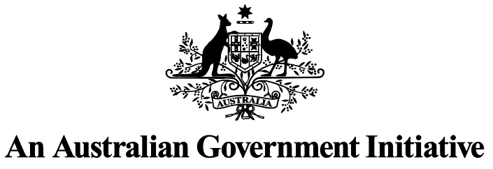 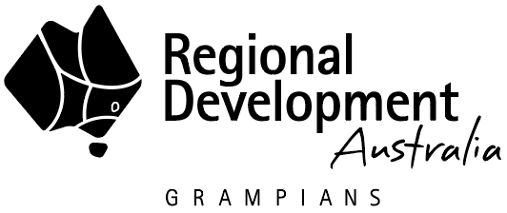 

Regional Development Australia Grampians

Business Plan 2025-26

Published by the Victorian Government Regional Development Australia

June 2025

Melbourne Victoria

© Copyright State Government of Victoria 2025

This publication is copyright. No part may be reproduced by any process except in accordance with provisions of the *Copyright Act 1968*.

Authorised by the Victorian Government, Melbourne

**Contact**

Regional Development Australia

E: [rda.grampians@rdv.vic.gov.au](mailto:rda.grampians@rdv.vic.gov.au)

Web: [rda.vic.gov.au](https://www.rda.gov.au/rda-network/victoria)

Designed by DJSIR Design Studio

Printed by Finsbury Green

**Disclaimer**

The information contained in this report is provided for general guidance and assistance only and is not intended as advice. You should make your own inquiries as to the appropriateness and suitability of the information provided. While every effort has been made to ensure the currency, accuracy or completeness of the content, we endeavour to keep the content relevant and up to date and reserve the right to make changes as required. The Victorian Government, authors and presenters do not accept any liability to any person for the information (or the use of the information) which is provided or referred to in the report.

Except for any logos, emblems, trademarks, artwork and photography, this document is made available under the terms of the Creative Commons Attribution 3.0 Australia licence.

**Acknowledgement of Country**

The RDA Grampians Committee acknowledges the Traditional Custodians of the land across the Grampians region, the Wadawurrung, Dja Dja Wurrung, Eastern Maar, Gunditj Mara, Jupagalk, Wotjobaluk and Wurundjeri People. The RDA recognises all Traditional Custodians of the Grampian’s region and their continuing connection to the land and waterways. RDA promotes inclusion, mutual respect and a shared commitment to genuine engagement, partnership and participation of our Indigenous communities.

## Contents

Chair's Foreword 3

The Grampians Region 5

Regional Vision 7

RDA Charter 8

Collaboration Statement 9

Communications Strategy 11

Strategic Focus Areas and Alignment 13

RDA Grampian’s approach 14

RDA Grampians Key Strategic Priorities and Business Activities 15

# Chair's Foreword

I am pleased to introduce the 2025-26 RDA Grampians Business Plan. As the new Chair of the Committee, I am honoured to take on this role and continue building on the strong foundations laid by my predecessor, Stuart Benjamin, who served with dedication and vision over the past 12 years.

This Plan reflects the collaborative efforts of the RDA Grampians Committee, working in partnership with government, industry, and our regional stakeholders. Our mission remains clear: to foster economic growth and regional resilience across the Grampians region.

Our region is home to globally significant agriculture, dynamic manufacturing, and natural assets that power Victoria. We also acknowledge the Traditional Owners of these lands, Wadawurrung, Eastern Maar, Dja Dja Wurrung, Barengi Gadjin, and Wurundjeri peoples and pay our respects to their Elders past and present.

Our region faces complex challenges but also stands on the brink of transformational opportunity. While parts of the Grampians are among Victoria’s fastest growing, others continue to experience deep disadvantage. Recent bushfires have placed further strain on key sectors such as agriculture and tourism, and like many regions, we are navigating broader economic headwinds and a decline in labour productivity. Yet, with substantial investment on the horizon and strong regional leadership, there is real potential to create lasting, positive change. These circumstances underscore the vital importance of collaboration, and the role RDA Grampians plays in shaping bold, place-based solutions that can leave a lasting legacy for our region.

Our Committee continues to deliver meaningful impact. Over the past year we have:

Influenced national telecommunications reform through the ACCC Regional Mobile Infrastructure Inquiry, helping secure the Federal Government’s commitment to universal mobile coverage via satellite.

Supported the **Grampians New Energy Taskforce** (GNET) to position our region as a renewable energy leader, advancing investment in wind, solar, hydrogen and storage.

Championed the **Regional Investment Attraction Project** (RIAP), unlocking opportunities in value-added agriculture, advanced manufacturing, and food production.

Delivered *Grampians 2025 and Beyond*, a landmark forum uniting all 11 LGAs, Traditional Owner Corporations, and government partners to shape the region’s future.

Looking ahead, we are excited to welcome three new members to our Committee in July 2025 and farewell others who have contributed significantly to our work. The strength of RDA Grampians lies in the expertise, regional connection, and diverse perspectives of our members. Together, we help accelerate Australian Government priorities while ensuring our local voices are heard and reflected in national decision-making.

This Business Plan outlines our vision, strategic actions, and priority sectors, which are aligned with the **Australian Government’s Regional Investment Framework** (RIF) and the **Victorian Government’s Regional Economic Development Strategy** (REDS) for the Grampians region. These frameworks provide a shared foundation for long-term economic planning, helping to coordinate efforts across all levels of government.

Our work is grounded in data and local intelligence and driven by the belief that inclusive growth and proactive leadership are vital to shaping a strong, sustainable future.

At its core, this Plan is about partnerships. Our success depends on the ongoing support of local leaders, community organisations, industry, and all levels of government. By working together, we can unlock the Grampians’ full potential and help build Australia’s future from the regions up.

**Michael Tudball**

Chair RDA Grampians Committee

# The Grampians Region

The Grampians region, located in western Victoria, is a diverse and dynamic part of the state that plays a critical role in Victoria’s economy. Spanning from the western edge of Greater Melbourne to the South Australian border, the region is home to vibrant communities, strong industries, and unique natural assets. It encompasses 11 Local Government Areas, including key centres such as Ballarat, Horsham, Ararat, Stawell, and Hepburn.

The region has a population of over 270,000 people and contributes significantly to Victoria’s economy through its strengths in agriculture, manufacturing, tourism, education, and health services. Agriculture is a cornerstone of the region, with grain and livestock production supporting both domestic markets and international exports. The region is also experiencing growing investment in mineral sands mining and large-scale renewable energy projects, including wind, solar, and emerging bioenergy initiatives.

Ballarat, as the largest city in the region, acts as a major hub for services, innovation, and infrastructure development. The broader region benefits from well-established transport links, proximity to the national freight network, and access to skilled labour through local training and higher education providers.

The Grampians is also renowned for its natural beauty and cultural heritage, including the Grampians (Gariwerd) National Park and significant Aboriginal cultural sites, which support a strong and growing tourism sector.

With a focus on sustainable economic development, regional collaboration, and inclusive growth, the Grampians is well positioned to respond to emerging challenges and opportunities. Strategic investment in housing, workforce, infrastructure, and industry development will be key to unlocking the region’s full potential in the years ahead.

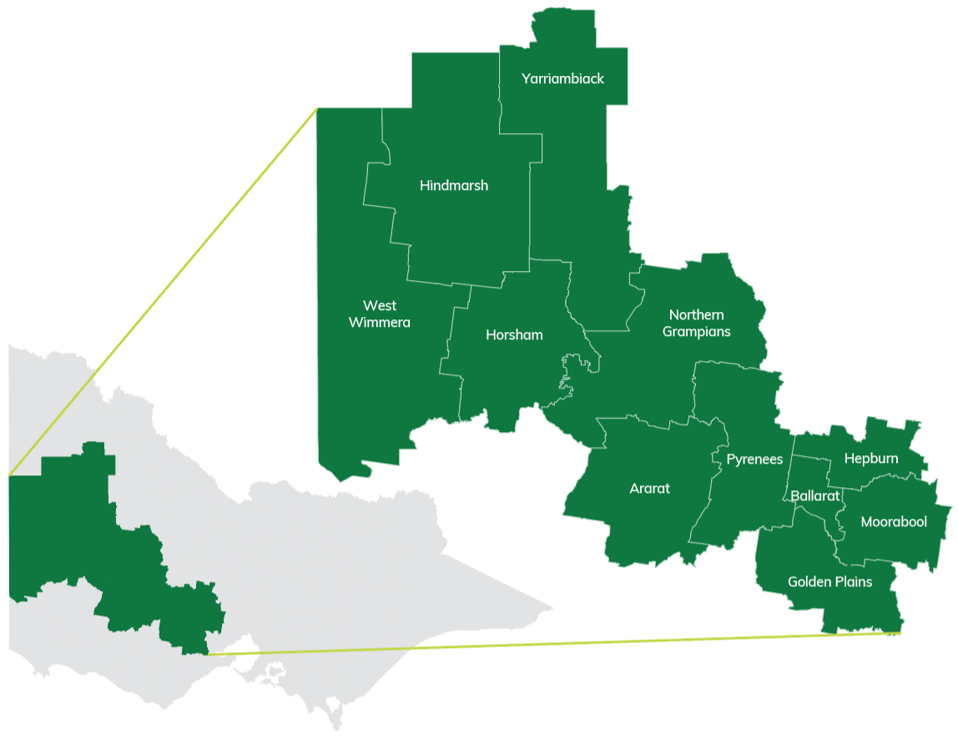

# Regional Vision

Attract people to live, work, play and invest in the Grampians region to drive sustainable, inclusive and dynamic economic growth.

## RDA Grampians Committee Members and Executive Support Team

| **Name** | **Position** |
| --- | --- |
| Michael Tudball | Chair |
| Justin Gilbert | Member |
| Linda Kwok | Member |
| Christine Ferguson | Member |
| Zoe Allan | Member |
| Paul Atheron | Member |
| Jessica Kelly | Member |
| David Matthews | Member |
| Peter Downs | Member |
| Howard Wilbury | Member |
| Sarah Henderson | Executive Officer |
| Kane Boardman | Manager Regional Coordination |
| Kelly Smith | RDA Grampians Coordinator |

# RDA Charter

On 28 July 2023 the Australian Government introduced the RDA Charter (the Charter). This Charter outlines the role and expectations for the RDA Network to help drive economic growth, innovation and entrepreneurship by facilitating investment in regional communities, industries and environments. RDA Grampians will achieve the aims of the Charter through its work with its broad range of stakeholders, collaborating with other RDA Committees and all three levels of government and will:

Focus their activities and strategy on delivery of the Regional Investment Framework (RIF) in their region, including investment in people, places, services, and industries and local economies.

Support regional stakeholders, including local government and the not-for-profit-sector, to seek grant opportunities that advance strategic regional priorities.

Support decarbonisation efforts and the transformation to a net zero economy and enable regional linkages between sectors to achieve these aims.

Build the evidence for economic development, including innovation and diversification strategies

Facilitate meaningful engagement across the three levels of government to ensure investments deliver better outcomes for regions.

Contribute relevant data and local intelligence to support the evidence base to inform regional development strategies, program design and policy responses.

Taking a whole-of-region approach, RDA Grampians takes a strategic view of the challenges and opportunities that exist within the Grampians region and is well placed to leverage and coordinate regional effort and influence policy decisions by:

Collaborating with integrity, transparency, respect and accountability

Engaging with diverse communities, especially First Nations people

Supporting the Government’s ambition of ‘no one held back, and no one left behind’, and

Supporting gender equality opportunities in the regions.

# Collaboration Statement

## Victorian RDA Network

RDA Grampians is an active contributor to the Victorian RDA Chair’s Network, a collaborative platform that identifies and advances state-wide priorities across the regional development landscape. Focus areas include key worker housing, digital capability, workforce and skills development, and renewable energy transition. This network enables knowledge sharing and coordinated action to amplify the impact of each RDA across Victoria.

RDA Grampians also supports and collaborates with the RDA Melbourne Committee as it continues to shape its role in strengthening economic, employment, and investment connections between metropolitan Melbourne and regional Victoria, particularly in areas where cross-regional opportunity and alignment can be leveraged.

## Regional Partnerships

The Victorian Government has established nine Regional Partnerships to elevate the voice of regional communities and ensure their priorities are reflected in state-level decision-making. Within the Grampians region, RDA Grampians works closely with both the Wimmera Southern Mallee and Central Highlands Regional Partnerships.

Since their inception, RDA Grampians has actively contributed to these partnerships, helping to build strong collaborative relationships across local, state, and federal governments. This engagement enhances our advocacy, deepens our regional insights, and strengthens our ability to connect national policy priorities with place-based regional needs.

## Regional Development Victoria

RDA Grampians maintains a close working relationship with Regional Development Victoria, supporting the implementation of the Victorian Government’s Economic Growth Statement and Regional Economic Development Strategies (REDS), alongside other strategic initiatives for the Grampians region.

Our ongoing collaboration with RDV strengthens our ability to provide robust, evidence-based advice to the Australian Government on regional issues, while ensuring alignment with Victorian Government priorities.

## Local Government Areas

RDA Grampians works in partnership with all 11 Local Government Areas across the region, supporting councils to articulate priorities, identify funding opportunities, and connect with state and federal government programs. We are a trusted partner and entry point for regional and rural councils seeking tailored support to advance locally led economic development initiatives.

## Australian Government Agencies

RDA Grampians continues to build strong relationships with Australian Government departments and agencies aligned to our key strategic focus areas. With the support of the Department of Infrastructure, Transport, Regional Development, Communications, Sport and the Arts, we facilitate regular engagement with federal entities to share intelligence, strengthening partnerships, and support two-way communication between Canberra and the region.

## Aboriginal Economic Development – Yuma Yirramboi Strategy

RDA Grampians supports the Victorian Government and Aboriginal Victorians’ shared vision to generate greater individual and collective wealth for Aboriginal Victorians. This includes attracting private and public sector investment to Aboriginal projects.

In line with the Victorian Aboriginal Economic Strategy (2013-2020) which the Yuma Yirramboi Strategy builds on, the Business Plan will seek to promote “Landmark Projects” – i.e. those projects identified as having high indications for success and the scope to deliver integrated outcomes to the Aboriginal community through skills, jobs, and enterprise. Other projects identified for investment attraction will also be assessed in terms of the level of traditional owner and engagement undertaken, or required, as a key project readiness assessment measure.

# Communications Strategy

RDA Grampians’ Communications Strategy aims to strengthen our regional identity, increase visibility, and support effective two-way engagement with stakeholders and government. The strategy focuses on four key outcomes:

Raise **awareness** of RDA Grampians’ role and impact across the region.

**Promote** federal programs, funding opportunities, and strategic priorities.

**Support** clear communication of Australian Government messaging.

**Engage** local stakeholders to inform advice and align with regional needs.

To achieve this, a 12-month Communications Plan will guide activity across four strategic priorities:

## 01. Identify & Profile

Share federal funding updates, government messaging, and regional initiatives through digital channels and event participation.

## 02. Stakeholder Communication

Provide updates to key stakeholders and create opportunities for feedback on programs, opportunities and priorities.

## 03. Product Development

Develop key documents and materials (e.g. advocacy strategies, workforce plans, media releases, case studies) that communicate RDA Grampians’ work.

## 4. Engagement & Consultation

Host and participate in roundtables, briefings, and forums to strengthen relationships and gather local insights.

**Ongoing activities include:**

Bimonthly Committee meetings with expert briefings.

Updates on the RDA Grampians website and social media posts on the RDA Grampians LinkedIn account.

Attendance at forums and key industry events, such as RDA National Forum, Regional Australia Institute Conferences.

Contributions to reports, submissions, and policy discussions.

This approach ensures RDA Grampians is connected, visible, and actively shaping the regional development agenda.

# Strategic Focus Areas and Alignment

RDA Grampians’ strategic focus areas are aligned with the Australian Government’s **Regional Investment Framework** (RIF) and the Victorian Government’s **Regional Economic Development Strategies** (REDS) for the Grampians region. These frameworks guide long-term economic planning and enable alignment across all levels of government by using evidence-based analysis to identify regional challenges, opportunities, and priorities.

RDA Grampians applies these principles to focus on four key strategic areas that reflect both the region’s strengths and its most pressing challenges:

**Adding value to agriculture** by promoting local value-adding that reduces reliance on raw product exports and supports a sustainable and productive agricultural sector.

**Enabling mineral sands mining** by supporting emerging and existing projects to drive economic diversification and maximise regional and state-wide benefits.

**Strengthening regional manufacturing** by growing jobs and industry capability through addressing workforce shortages, housing needs, and regulatory barriers.

**Harnessing the renewable energy transition** to ensure investment in energy projects delivers long-term economic and community benefits.

These focus areas reflect the Grampians region’s comparative advantages and align with our role in helping shape regional development through collaboration, data-driven insights, and targeted support for transformational projects.

# RDA Grampian’s approach

RDA Grampians takes a collaborative, place-based approach to regional development, working closely with local government, Regional Partnerships, industry, and state and federal agencies to align efforts and unlock the region’s economic potential.

We are committed to building regional capacity by supporting our key industries in agriculture, mining, manufacturing, and renewable energy. We will continue to identify opportunities that leverage local strengths that drive sustainable economic growth. Our work is guided by strong partnerships, strategic alignment, and a shared vision for regional prosperity.

RDA Grampians will:

**Actively participate in the Victorian RDA Chair’s Network** to contribute to whole-of-state initiatives and ensure regional perspectives inform cross-regional strategies and collaboration.

**Provide expert regional advice** to all three levels of government, with a strong focus on engaging local government partners to align efforts across the region.

**Identify and support government and industry investment opportunities** that align with the region’s competitive advantages, and work with partners, including Invest Victoria and Global Victoria, to attract and facilitate new investment in emerging and established industries.

**Collaborate with Regional Partnerships and local government** to ensure a unified voice for the Grampians region, align strategic planning, and maximise the impact of government programs and funding.

**Strengthen stakeholder capacity** by supporting councils, businesses, and communities to engage with government, unlock funding, and grow their role in the regional economy.

**Maximise the benefits of the renewable energy transition** by ensuring that incoming investment delivers long-term community outcomes, supports new job creation, and strengthens regional infrastructure.

**Champion regional opportunities** by connecting local priorities with state and federal government initiatives, fostering innovation, and helping to position the Grampians as a destination for sustainable industry growth.

**Support capacity building** across the region by assisting with equipping local leaders, councils, businesses with the knowledge, tools, and connections they need to grow, adapt, and succeed in a changing economic landscape.

Through these actions, RDA Grampians will continue to play a vital role in coordinating regional efforts, influencing policy, and driving outcomes that deliver lasting benefits for our communities.

# RDA Grampians Key Strategic Priorities and Business Activities

## Priority

### Adding value to what we grow while preserving and enhancing our productive agricultural sector.

**Goal:** Reducing the amount of raw product that leaves the region unprocessed and ensuring the long-term sustainability and productivity of our agricultural sector.

**Priority evidenced by:** A 5% increase in meat and meat product manufacturing in the Grampians may generate up to $56 million in output and create up to 104 full-time jobs, while the same increase in fruit and vegetable product manufacturing may generate up to $41 million in output and up to 67 full-time jobs.

**To achieve our goal our business activities will focus on:**

Enhance supply chains, processing capacity and value add opportunities.

Improve transport and digital connectivity to support agriculture.

Enhance workforce skills and education.

Support secondary industries that enable and enhance the growth and success of the agriculture sector.

Supporting the agricultural sector to respond to and build resilience to climate change impacts, including drought and natural disasters.

## Priority

### Making mineral sands mining work for our region and the State.

**Goal:** To enhance economic diversification, we will support development of new and existing mining projects across the Grampians region.

**Evidenced by:** The ongoing operation of mineral sands mines in the Grampians region will be a major economic driver, creating 1,472 jobs annually and contributing $378.8 million to GRP each year, fuelling growth and prosperity in the region.

**To achieve our goal our business activities will focus on:**

Leverage the investment in mining projects to deliver lasting economic and community benefits for the region.

Enable growth through policy and infrastructure support for mining.

Improve road, rail, and digital networks to support exploration and transport of mineral sands.

Enhance workforce skills and education.

Facilitate increased housing supply to meet workforce demand driven by growth in the mining sectors.

Support secondary industries that enable and enhance the growth and success of the mining sector.

## Priority

### Strengthening regional manufacturing to increase jobs and capability.

**Goal:** To support resolving workforce attraction, worker housing challenges and reducing regulatory complexity and uncertainty that inhibit growth in our manufacturing sector.

**Evidenced by:** If employment in advanced manufacturing in the Grampians increased by 10%, $205 million would be added to the regions’ economy and $109 million additional would be paid in salaries and wages in the Grampians region.

**To achieve our goal our business activities will focus on:**

Strengthen regional manufacturing capability and capacity.

Proactively advocate for the reduction of regulatory barriers to investment and process efficiency.

Invest in skills development and workforce attraction specific to advanced manufacturing.

Expand supply chain integration with agriculture, mining, and renewables.

Encourage innovation and investment in emerging technologies.

Support secondary industries that enable and enhance the growth and success of the manufacturing sector.

## Priority

### Ensuring the Grampians region gets maximum benefit and minimum negative impact from the transition to renewables.

**Goal:** Leverage the investment in energy generation, storage, and distribution projects to deliver lasting economic and community benefits for the region.

**Evidenced by:** The Grampians leads all RDA regions in renewable energy production, with an operating capacity of 2,840 MW – a figure set to more than double with approved projects.

**To achieve our goal our business activities will focus on:**

Ensure Community Benefit Funds are structured to deliver long-term, place-based outcomes for local communities.

Advocate for infrastructure upgrades to support grid access and reliability.

Develop training pathways to build a renewable-ready workforce.

Facilitate increased housing supply to meet workforce demand driven by growth in the renewable energy sector.

Support secondary industries that enable and enhance the growth and success of the renewable sector.

# OUTCOME 1

### Facilitate regional economic development outcomes, through investment in:

### Skills and local leadership

### Opportunities for First Nations people

### Infrastructure

### Connectivity

### Decarbonisation

### Industry growth.

### What will we do?

| **Activity:** | **Initiative type:** | **RDA’s anticipated role:** | **Timeframe of activity:** | **Expected outcomes:** |
| --- | --- | --- | --- | --- |
| 1.1: Develop regionally aligned workforce pathways across agriculture, mining, manufacturing and renewables | Skills and local leadership | Contribute to | July 25 – June 26 | * Engagement with TAFEs, Universities and training providers to align regional training to industry needs * Deliver targeted industry engagement to identify skills gaps * Increased visibility of career pathways across key industries * Regional workforce retention and attraction improved   **RDA Grampians Strategic priorities supported:** Priorities 1–4 |
| 1.2: Collaborate with Traditional Owner Corporations on regional development projects and engagement | Opportunities for First Nations people | Contribute to | July 25 – June 26 | * Stronger inclusion of First Nations perspectives in regional initiatives * Identification of First Nations economic development opportunities * Improved partnerships with Traditional Owner Corporations   **RDA Grampians Strategic priorities supported:** Priorities 1–4 |
| 1.3: Advocate for infrastructure investment that enables sector growth across the region | Infrastructure | Lead/ championed | July 25 – June 26 | * Clear infrastructure priorities identified through subcommittee work * Coordination with RDV and LGAs to support funding submissions * Support business case development and infrastructure advocacy   **RDA Grampians Strategic priorities supported:** Priorities 1–4 |
| 1.4: Identify and advocate for improved digital and freight connectivity | Connectivity | Contribute to | July 25 – June 26 | * Identification and mapping of digital blackspots and freight pinch points that hinder regional economic growth, enabling targeted infrastructure and policy responses * Engagement with telecommunications operators and State and Federal departments responsible for digital and freight connectivity * Inclusion of connectivity priorities in regional planning documents   **RDA Grampians strategic priorities supported:** Priorities 1-4 |
| 1.5: Maximise regional benefits from the transition to renewables | Decarbonisation | Lead/ championed | July 25 – June 26 | * Support local governments and communities in engaging with renewable energy developers * Ensure community benefit schemes deliver long-term place-based outcomes * Facilitate industry training and housing coordination to support incoming workforce * Explore opportunities around renewable gas to benefit the region, through both local production (supply) and regional usage (demand), supporting circular economy outcomes and energy resilience   **RDA Grampians strategic priorities supported:** Priority 1-4 |
| 1.6: Build local capacity in value-add industries and supply chains | Industry Growth | Lead/ championed | July 25 – June 26 | * Facilitate innovation and enhance local procurement opportunities to strengthen regional participation in major transition projects * Strengthen local supply chains in agriculture, mining, and manufacturing * Encourage investment in regional processing and product development * Support business capacity building by improving access to strategic information, networks, and learning opportunities (e.g. AI Forum and industry development initiatives)   **RDA Grampians strategic priorities supported:** Priorities 1–4 |

# OUTCOME 2

### Support regional stakeholders, including local government and the not-for-profit-sector, to seek grant opportunities that advance strategic regional priorities.

### What will we do?

| **Activity** | **Expected outcomes:** |
| --- | --- |
| **2.1: Provide tailored support to stakeholders for grant and funding applications**  Draft letters of support  Review grant submissions  Provide guidance on application processes and eligibility  Share intelligence on upcoming federal and state opportunities aligned with regional priorities | Increased number of high-quality applications from LGAs and businesses within our region  Improved funding success rate across key industries  Stronger alignment of applications with local strategic priorities  **RDA Grampians strategic priorities supported:** Priorities 1–4  **Benefit to region:** Greater access to funding, enabling projects in infrastructure, skills, industry innovation, and housing |
| **2.2: Share grant information sessions and targeted funding workshops with regional stakeholders**  Share information sessions on funding opportunities  Provide project development support to our LGA’s  Encourage participation from stakeholders in priority sectors (agriculture, manufacturing, mining, renewables) in funding rounds | Enhanced capability of local partners to develop competitive proposals  Increased participation in Federal and State funding programs  Strengthened connections between proponents and funding agencies  **RDA Grampians strategic priorities supported:** Priorities 1–4  **Benefit to region:** More proactive and skilled approach to project planning and funding acquisition |
| **2.3: Support cross-sector partnerships and collaborative applications**  Facilitate regional partnership-building in cross-sector industries  Encourage joint submissions for multi-stakeholder projects (e.g. workforce housing, innovation hubs, regional freight solutions)  Support regional alignment across government priorities through consultation and briefings | Increased number of collaborative and high-impact regional projects  Stronger alignment with federal/state investment objectives  Greater regional cohesion and reduced duplication of effort  **RDA Grampians strategic priorities supported:** Priorities 1–4  **Benefit to region:** Greater influence, scale, and return on investment through collaborative projects |
| **2.4: Track and report on stakeholder support and grant success**  Maintain a record of all funding support activities (e.g. letters, advice, reviews)  Monitor grant outcomes to evaluate impact  Use data available to us to shape future support and advocacy  Collate regional intelligence and feedback to inform and influence the design of future government funding programs | Clear evidence of RDA Grampians’ impact in supporting regional development  Better targeting of support and resources  Improved reporting to stakeholders and government  Regional insights actively inform state and federal funding priorities and program design, ensuring alignment with local needs and opportunities  **RDA Grampians strategic priorities supported:** Priorities 1–4  **Benefit to region:** Transparent, outcomes-focused support for regional growth |

# OUTCOME 3

### Contribute to, and where appropriate, drive local economic development planning and strategy development.

### What will we do?

| **Activity** | **Expected outcomes:** |
| --- | --- |
| **3.1: Lead coordination of RDA Grampians strategic priorities and subcommittee work**  Facilitate regular subcommittee meetings across Infrastructure and Connectivity; Workforce, Skills & Housing; and Industry Innovation  Support alignment of subcommittee work with RDA’s strategic priorities  Monitor and report on outcomes from subcommittee meetings  Provide committee members with site visits and regional tours to build knowledge, strengthen local connections, and support informed decision-making | Cross-sector coordination of priorities and enabling projects  Better identification of constraints, gaps, and opportunities across sectors  Informed and regionally aligned strategy development  **RDA Grampians strategic priorities supported:** Priorities 1–4  **Benefit to region:** A more cohesive, integrated approach to long-term economic development |
| **3.2: Support local economic development planning with regional data and place-based insights**  Provide data and advice to support council planning processes and REDS alignment  Contribute to local government strategic plans (e.g. economic, workforce, housing)  Facilitate workshops and input sessions with councils, regional stakeholders and Regional Partnerships | Greater alignment between council and regional development strategies  Data-driven policy and influence of investment decisions at the local level  Support for LGAs with capacity to engage in planning  **RDA Grampians strategic priorities supported:** Priorities 1–4  **Benefit to region:** Improved project prioritisation and stronger regional voice in policy design |
| **3.3: Participate in and contribute to regional planning and leadership forums**  Support region-wide initiatives, such as forums, workshops, and conferences through sponsorship or active facilitation  Build and maintain relationships with government and regional leaders to align efforts  Work closely with Regional Partnerships to align efforts, share intelligence, and strengthen regional advocacy | Enhanced coordination and shared understanding of regional development needs  Stronger regional leadership and advocacy  Increased visibility of RDA’s role and contributions  **RDA Grampians strategic priorities supported:** Priorities 1–4  **Benefit to region:** More unified advocacy and cross-agency alignment |
| **3.4: Promote and support regional initiatives with broader economic development impact**  Champion regionally significant initiatives that align with strategic priorities and unlock investment (e.g. AI capability building, ag-tech, regional freight infrastructure, sustainable childcare, and regional housing solutions)  Support LGAs and regional stakeholders to develop compelling investment proposals  Contribute to pilot projects where appropriate | Support innovation and transition across key industries  Increase the region’s readiness for investment and transformation  Strengthen case-making for future federal/state investment  **RDA Grampians strategic priorities supported:** Priorities 1–4  **Benefit to region:** Increased regional capability and competitiveness |

# OUTCOME 4

### Contribute relevant data and local intelligence to support the evidence base to inform regional development strategies, program design and policy responses.

### What will we do?

| **Activity** | **Expected outcomes:** |
| --- | --- |
| **4.1: Provide regional intelligence and advice to all levels of government**  Provide briefings to Federal and State departments  Meetings with Members of Parliament and government agencies  Participation in consultation processes (e.g. parliamentary inquiries, departmental submissions) | Federal and state programs better reflect regional priorities  Strengthened regional advocacy based on place-based insights  Improved policy responsiveness to regional needs  **RDA Grampians strategic priorities supported:** Priorities 1–4  **Benefit to region:** Greater influence on program design and government investment |
| **4.2: Monitor and share regional economic data and trends**  Keep committee members informed on updated regional data dashboards and profiles  Share insights through briefings, reports and committee meetings  Highlight sector performance, emerging investment opportunities, and key developments across our region’s economic driver industries | Stakeholders have access to accurate, localised data  Better decision-making at local, regional, and state levels  Informed business planning and investment attraction  **RDA Grampians strategic priorities supported:** Priorities 1–4  **Benefit to region:** Improved strategic decision-making and investment targeting |
| **4.3: Inform the development of government strategies and programs**  Provide written submissions and targeted input into strategy development  Participate in pilot projects and design workshops  Feed insights into REDS refresh, the Regional Investment Framework (RIF) and other regional strategies and programs | Local priorities embedded in long-term Federal and State strategies  Tailored program design that suits regional needs  Promote early regional involvement in new initiatives  **RDA Grampians strategic priorities supported:** Priorities 1–4  **Benefit to region:** Programs that deliver greater local impact and value |
| **4.4: Capture and elevate regional and industry insights**  Stakeholder roundtables, surveys, and structured interviews  Participation in forums and site visits across the region  Ongoing intelligence gathered via subcommittees  Build strong connections with key industries through targeted engagement and relationship-building by the committee  Strengthen the RDA Grampians profile across the region to encourage meaningful conversations and collaboration  Create and participate in networking opportunities to foster cross-sector connections and knowledge exchange | Improved regional visibility and credibility of RDA Grampians  Stronger relationships with industry leaders and stakeholders  Targeted regional insights that inform strategic priorities and investment advocacy  Increased industry engagement in economic development initiatives  Enhanced collaboration and knowledge-sharing through expanded regional networks  Better understanding of on-the-ground challenges and opportunities  Qualitative insights to complement data trends  Input directly informs RDA’s advice and advocacy  **RDA Grampians strategic priorities supported:** Priorities 1–4  **Benefit to region:** Stronger representation of regional voices and lived experience |

Local people developing local solutions [rda.gov.au](https://www.rda.gov.au/)