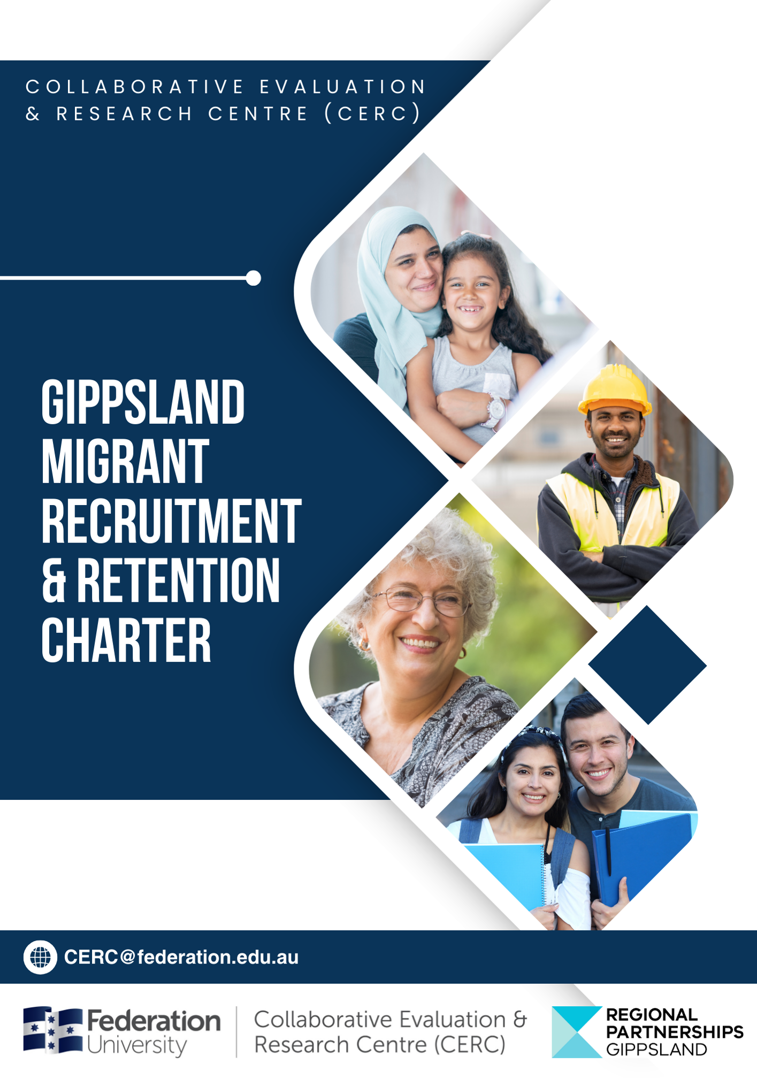
  - COLLABORATIVE EVALUATION & RESEARCH CENTRE (CERC)

© Federation University Australia 2024 except where noted.

To cite this Report:
Porter, J.E., My, S., Simic, M., Coombs, N., Miller, E.M., Soldatenko, D., Abdelkader, A., Hualda, LTA. (2024). Gippsland Migration Recruitment & Retention Charter. [Report]. Federation University Australia. https://doi.org/10.35843/GMRRCCERC24

https://federation.edu.au/cerc
ISBN: 9781922874337

Report Status and Use
This report has been prepared by CERC for Regional Partnership Victoria in connection with the Gippsland Migrant Recruitment & Retention Charter. It is provided for the purposes of reporting on the project and must be read subject to any applicable agreement, including any provisions dealing with use of, reliance on, disclosure of, and publication of the report. This report reflects the information, data and analysis available as at 22 June 2026 and should be read in light of its stated scope, methodology, assumptions and limitations.

Acknowledgements
The Collaborative Evaluation & Research Centre (CERC) Federation University Gippsland acknowledges Aboriginal and Torres Strait Islander People as the Traditional Owners and Custodians of the land, sea, and nations and pays our respects to Elders past, present, and emerging. The CERC further acknowledges our commitment to working respectfully to honour their ongoing cultural and spiritual connections to this Country.
The Gippsland Migrant recruitment and retention Charter was developed by the Collaborative Evaluation and Research Centre (CERC) at Federation University Australia in partnership with the Regional Partnership Gippsland, with funding from the Victorian Government. The Charter represents the voices and experiences of Migrants living and working in Gippsland at the time of the scope of work in July 2024.
For more information contact the authors on email address - cerc@federation.edu.au


The Charter
This Charter is a commitment to shared values and principles for the recruitment and retention of Migrants in Gippsland. The Charter provides its supporters with a clear outline of strategies and approaches suggested by all those that participated in the development of the Charter through the voices of Migrants.

The Regional Partnership Gippsland
The Gippsland Regional Partnership is one of nine established by the Victorian government in 2016 in recognition that the way to understand the challenges and opportunities of a region is through local communities. Gippsland Regional Partnership is made up of community and business leaders, and senior local and state government officers. The role of the Partnership is to engage with communities and local stakeholders to identify priorities and develop collaborative solutions to local problems. The Charter is the result of identifying the need to address regional workforce challenges and look for opportunities to enhance recruitment and retention across Gippsland, while also enhancing welcoming and culturally safe community activities.

Before we start
The Charter acknowledges the members of the Regional Partnership who are committed to working with the community to find sustainable solutions to address regional workforce challenges. It recognises the Migrants who live and work in Gippsland who generously shared their lived experiences and lessons learnt about transitioning to a regional community. Their commitment to the process and the goal of finding solution-focused approaches is to be commended. The Charter also acknowledges the businesses and organisations who shared their learnings of employing a migrant workforce highlighting the benefits to their companies and to the local communities.
The Charter builds upon the insights provided by the people who live, work and study in Gippsland and who took part in the many workshops, interviews, and data collection to inform the development and co-design of the Charter.

How was the Charter created?
The Charter was co-designed through a series of workshops, individual interviews with key stakeholders, focus group discussions and workshop activities. There were three phases in the development of the Charter. Phase 1 incorporated a scoping workshop to explore the issues and inform the development of a shared vision and understanding of the complexities of Migrants in regional Victoria. A comprehensive review of the current literature was conducted to inform project activities and add to the body of knowledge on the topic. Phase 2 involved engagement with key stakeholders, local businesses, agencies, support service providers, local and state government staff, and regionally based migrants to inform the direction of the project. Phase 3 incorporated a series of co-design workshops to build upon the findings of the other two phases and to develop a set of guiding principles from each core stakeholder group, which later informed the drafting of the 6 guiding principles of the Charter.

Figure 1. Project phases.

Charter values
The core values of Migrant recruitment and retention in Gippsland were developed as part of the co-design workshops and are representative of the voices of the participants. The values should be a way in which organisations engage with Migrants and develop their recruitment and retention implementation strategies. The Charter values include:
Inclusion
- Create inclusive workplaces, communities, and regional towns.

Awareness
- Create awareness of the benefits of Migrants to businesses and communities.

Support
- Provide support for Migrants and the Migrant service sector.

Welcoming
- Be welcoming to Migrants and their families.

Orientation
- Create resources to ensure Migrants are orientated to work, town and community.

Opportunity
- Provide opportunities for Migrants to network, live and succeed in regional areas.

Working in partnership
There were six key stakeholder groups identified that work together to support Migrants to transition to regional areas. It is through understanding the roles and responsibilities of each of the stakeholders that we begin to develop effective and sustainable support services and mechanisms to improve the lives of Migrants and regional communities. The Migrant recruitment and retention model outlines how each of the six stakeholders reduces barriers and enhances opportunities for Migrants.
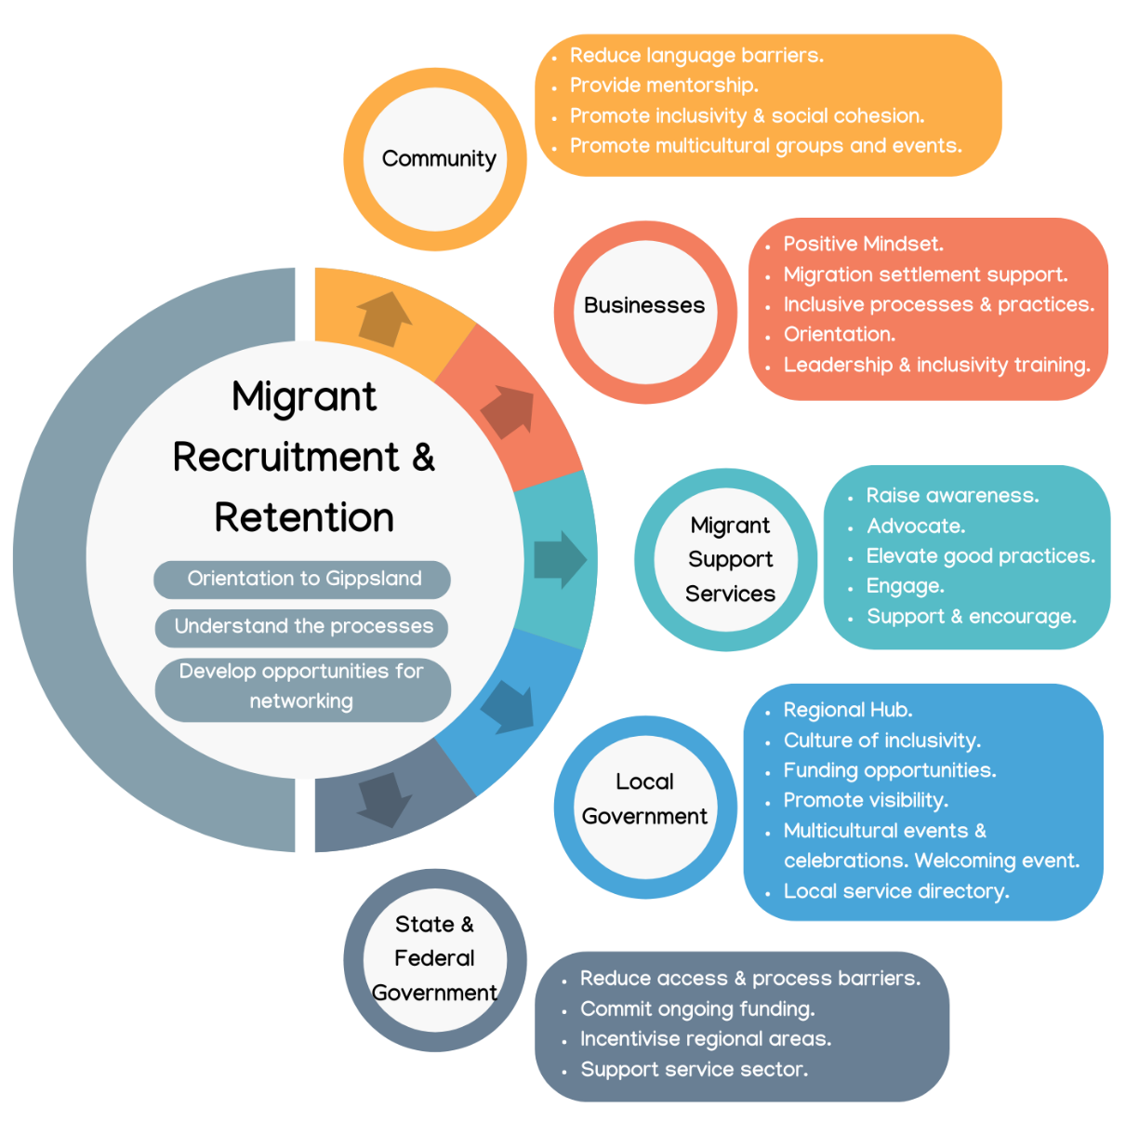
Figure 2 Stakeholder Model
The framing of the Charter
The Charter was informed by the findings of a scope of work that included individual interview, workshops, case studies and stakeholder engagement. Figure 3 outlines the data sets that informed the Charter.
Figure 3. Data sets

Workshop data produced a set of guiding principles for each of the stakeholder groups using co-design and co-creation techniques and workshop activities. The set of principles were then crafted into the higher level six main guiding principles that are presented in the following table. It was deemed important to not only develop a set of guiding principles but to outline implementation strategies and allocate responsibility for delivery. The following key provides a visual representation of the key stakeholder group responsible for the implementation of each Migrant recruitment and retention principle.

Figure 4 Stakeholder responsibility key
Icon | Key | Icon | Key
 | Migrants |  | Migrant Support Services
 | Businesses |  | Local Government
 | Community |  | State & Federal Government

Migrant Recruitment and Retention Guiding Principles
Guiding Principles | Implementation strategies | Responsibility
1. Develop and maintain a positive mindset toward people from migrant backgrounds. | 1.1 Employers remain open to hiring entry-level staff from migrant backgrounds. | 
 | 1.2 Education for employers on the benefits of hiring people from migrant backgrounds for their businesses. | 
 | 1.3 Awareness campaign to showcase positive benefits of a diverse and multicultural regional community. | 
2. Promote inclusivity/social cohesion and awareness of diverse communities. | 2.1 Provide funding opportunities to regional migrant communities to implement initiatives for their members to promote social inclusion. | 
 | 2.2 Local governments extend the scope of their existing “Disability Access and Inclusion Plan” to include social inclusion, ensuring migrants benefit from local government programs and services.
 | 2.3 Organise multicultural regional events and celebrations, promote visibility of multicultural communities. | 
 | 2.4 Employers enhance inclusive organisational processes and practices and inclusivity training. | 
 | 2. 5 Run information sessions, including information linked to Centrelink, health systems and local health services. | 
 | 2.6 Create a local service directory for regional migrants and new arrivals. | 
3. Reduce language barriers for people from migrant backgrounds. | 3. 1 Develop an orientation program about regional areas to be given to migrants before and or upon arrival including “Welcome to Australia”, “Workplace Migrant Orientation”. | 
 | 3.2 Provide regional mentorship to people from migrant backgrounds. | 
 | 3.3 Education providers provide English training locally, opportunities for regional migrants to attend formal language courses. | 
 | 3.4 Run a multicultural community ambassador program to support regional migrants. | 
 | 3.5 Support regional migrants and employers understand the visa information, and processes. | 
4. Develop opportunities for broader community networking and connection. | 4.1 Local governments introduce initiatives to foster connections between relevant stakeholders in their local areas.
 | 4.2 Appoint a community connection support worker to work on migration matters. | 
 | 4.3 Provide funding opportunities to regional migrant communities and migrant support services.
 | 4.4 Establish a multicultural regional hub for migration settlement support. | 
5. Elevate and build upon good practices. | 5. 1 Local government has a shared vision and objectives to attract and retain migrants for Gippsland.
5. Elevate and build upon good practices. | 5.2 Advocate for regional migration reforms to simplify sponsorship processes and reduce red tape and costs to encourage and incentivise Small to Medium Employers to recruit and/or sponsor migrant workers. | 
5. Elevate and build upon good practices. | 5.3 Review and/or pilot regional migration good practices. | 
6. Incentivise migrants to settle in regional areas. | 6.1 Provide incentives to businesses to sponsor regional migrants and offer migration settlement support.
6. Incentivise migrants to settle in regional areas. | 6.2 Businesses develop a strategic plan with particular attention to recruitment and retention of regional migrants.
6. Incentivise migrants to settle in regional areas. | 6.3 Incentivise migrants to settle in regional areas via relaxing visa requirements and policy changes at all levels of government.
6. Incentivise migrants to settle in regional areas. | 6.4 Commit ongoing funding to the Settlement Engagement and Transition Support (SETS) program to incentivise the support service sector.

What is the Charter and who is it for?
The Charter was developed for all stakeholders who are engaging in exploring Migrants as a solution to meet current and future workforce needs in regional Gippsland. The Charter provides a practical guide to inform organisational Migrant policies and procedures.
It gives voice to community aspirations and guides stakeholders in planning and delivering Migrant recruitment and retention strategies. It uses a process of co-design that informs and actively engages with individuals, organisations, communities, and Migrants
It gives voice to community aspirations and guides stakeholders in planning and delivering Migrant recruitment and retention strategies. It uses a process of co-design that informs and actively engages with individuals, organisations, communities, and Migrants.

Committing to the Migrant Recruitment and Retention Charter
The Charter requires the commitment of communities, organisations, and government to work collaboratively towards a sustainable and supportive Migrant strategic implementation plan.

Why the Charter matters to Gippsland
The Charter is the first step towards finding sustainable workforce solutions for regional Gippsland incorporating a Migrant workforce. The Charter highlights the need for a collaborative approach to supporting Migrants to transition to a regional area and acknowledges the importance of the development of the guiding principles the role they play in informing change. The Charter is designed to be a living document and should be reviewed and updated to reflect the changes in the governmental policy and Migration rule and regulations. Gippsland will benefit from the inclusion of Migrants enhancing the diversity and richness of the community.
Supporter Network:











www.federation.edu.au/cerc
Office 1E219 | Building 1E | Gippsland Campus
PO Box 3191 Gippsland Mail Centre Vic 3841
T 03 5122 6440 M 0412 142 055
CERC@federation.edu.au
Federation.edu.au
1800 333 864 (1800 FED UNI)
International phone: +61 3 5327 9018
 /feduniversity

