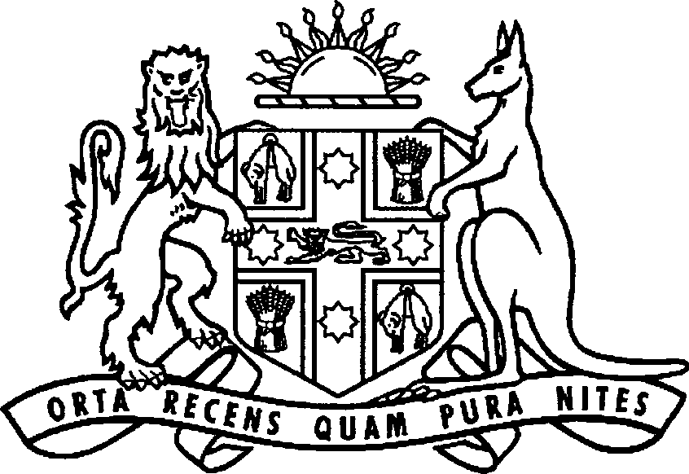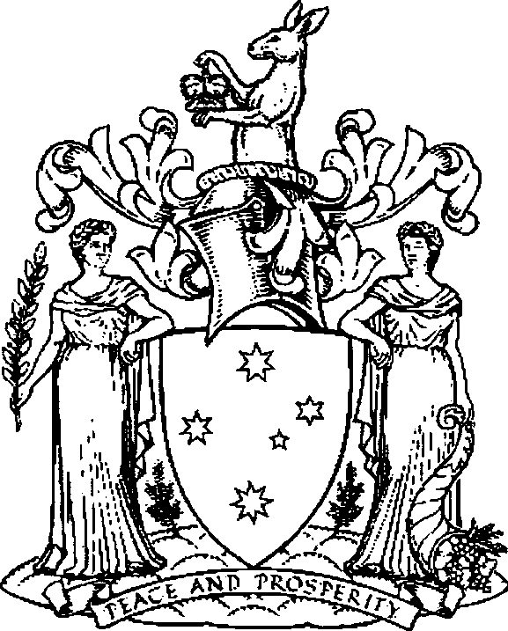

New South Wales Victoria

New South Wales and Victoria

Memorandum of Understanding for Cross-Border Collaboration

2019-2021

Introduction
The Premier of New South Wales (NSW), The Hon Gladys Berejiklian MP, and the Premier of Victoria, The Hon Daniel Andrews MP, confirm the NSW and Victorian Governments' commitment to strengthen cross-border collaboration between the two states.
This agreement is the inaugural Memorandum of Understanding between the jurisdictions which is specifically designed to address cross-border issues. It applies to state government agency activities in the border regions of NSW and Victoria, and the respective Local Government Areas (LGAs).

Purpose
Changing demographics, intrinsic economic and social linkages, and complex service delivery issues underscore the importance of a collaborative approach to supporting border communities and businesses.
The NSW and Victorian Governments acknowledge the importance and interdependence of both jurisdictions in the border region, and the ongoing requirement to work closely and collaboratively to improve social and economic outcomes. This Memorandum of Understanding for Cross-Border Collaboration reflects this intent.
Benefits of a close working relationship between the NSW and Victorian Governments include:
- Enabling cooperative leadership and management of strategic issues in key locations along the border;
- Enhancing critical cross-border relationships in government service delivery, regional economic development, and resource management, and
- Encouraging the development of shared goals and strategies for border regions and the communities that work and live therein.

Objectives of the Memorandum of Understanding
The objectives of this Memorandum of Understanding for Cross-Border Collaboration are to:
- Provide an authorising environment for both governments to collaborate on areas of mutual interest;
- Identify and resolve cross-border issues that impede regional economic and social development;
- Develop opportunities to align planning processes and practices to support efficient infrastructure development;
- Provide efficient and consistent service delivery to border communities;
- Enable information sharing and networking opportunities between government agencies, and
- Develop long-term strategic regional management and cooperation.

Principles for Cross-Border Collaboration
- Cross-border collaboration is to be outcomes focused.
- Areas of focus will be driven by priority areas identified in this Memorandum of Understanding, however cross-border collaboration on other areas should occur where opportunities are identified.
- Collaboration will be driven by the responsible agencies in each government and at the local level where possible.
- Collaboration will take into account national and state objectives and work underway.
- Consultation will occur with relevant Ministers and their government agencies, local governments, communities, business and industry groups, and regional organisations to identify, consider and resolve cross-border issues.

Key Focus Areas
The NSW and Victorian Governments agree the priority actions under this Memorandum of Understanding each year through the Annual Work List. In general, these actions will cover:

Improved service delivery
Residents living in cross-border regions should have equitable and simple access to services and information. The NSW and Victorian Governments commit to maximise alignment of service delivery and minimise the need for individuals to navigate both service systems.
Administrative arrangements should enable re-imbursement for the delivery of services to each other's citizens where appropriate.

Simplifying regulation for residents, businesses and organisations
Business and communities in border regions are often required to navigate regulatory, legislative and policy gaps and duplication. The NSW and Victorian Governments will work to enhance growth and confidence through the identification and reduction of these impediments.

Joint regional development opportunities
Border communities regularly identify opportunities for joint support, investment and delivery that require engagement between the two states to activate. The NSW and Victorian Governments will support the joint consideration of such opportunities.

The Memorandum of Understanding in Operation

Annual Work List
The NSW and Victorian Governments agree there will be Annual Work List, with actions addressing the Key Focus Areas. The Annual Work List will guide the work of each Cross­ Border Commissioner in relation to the NSW/Victorian border. The Annual Work List will be endorsed by the responsible Minister in each state.

Roles and responsibilities
Recognising the need to identify the roles and responsibilities of the NSW and Victorian Governments under this Memorandum of Understanding, it is agreed:
- Premiers will write to their respective Ministers outlining requirements and expectations to give effect to this Memorandum of Understanding;
- State Ministers within each government may be tasked with delivering a priority area and reporting progress to the Premiers;
- Taskforces will be convened as necessary to consider key priority issues (particularly for complex issues requiring a multi-agency approach} and make recommendations to the Premiers or state Ministers;
- State Ministers and their agencies remain responsible for the planning and delivery of state services; and
- This Memorandum of Understanding does not limit the actions of ministers and agencies to proactively address other cross-border issues.

NSW and Victorian Cross-Border Commissioners
The Office of the NSW Cross-Border Commissioner was created by the NSW Government in 2012, and the Victorian Government established the Victorian Cross Border Commissioner in 2018. The Commissioners' roles are to advocate for the resolution of cross-border issues on behalf of businesses, organisations and residents in border communities. The Commissioners are ideally placed to auspice and inform the work under this Memorandum of Understanding and identify emerging cross-border issues on the NSW and Victorian border.

Meeting and reporting
With the support of the respective Premiers' departments, the respective Cross-Border Commissioners will convene an annual meeting at the officer level at the end of each calendar year discussing the implementation and update of the Annual Work List. The Cross­ Border Commissioners will co-chair these meetings.
Government agencies in each jurisdiction may contact the Cross-Border Commissioners to assist in resolving cross-border issues.

Engagement
The NSW and Victorian Governments recognise the importance of ongoing engagement with regional stakeholders, particularly in local government and regional organisations. Regional stakeholders assist both governments in meeting the objectives of this Memorandum of Understanding and delivering on priority action areas through a deeper understanding of issues, possible solutions and emerging concerns. The NSW and Victorian Cross-Border Commissioners are responsible for coordinating regional stakeholder engagement as required pursuant to this Memorandum of Understanding.

Status of the Memorandum of Understanding
The NSW and Victorian Governments acknowledge the provisions of this Memorandum of Understanding are not legally enforceable but rely on the spirit of cooperation between the two jurisdictions.
This agreement does not remove power from either government to make policy decisions, and final policy decisions remain with each jurisdiction.

Review of this Memorandum of Understanding
This Memorandum of Understanding will be reviewed and formally updated every three years.
Activity and priorities will be reviewed every 12 months, with any revised priorities approved by both jurisdictions.
This Memorandum of Understanding may be amended at any time by agreement in writing of both parties.

Dispute Resolution
Where any dispute arises under this Memorandum of Understanding, the NSW and Victorian Governments will take all necessary steps to resolve the dispute expeditiously by mutual agreement.

Commencement
This Memorandum of Understanding commences on the date of execution.

