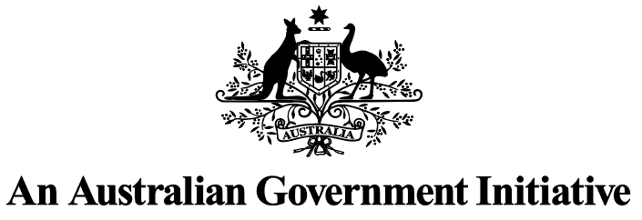 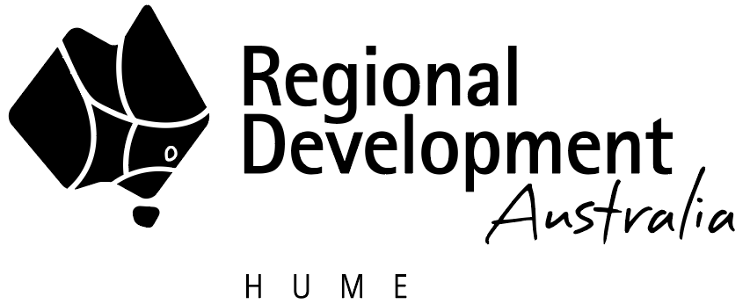 

Regional Development Australia Hume

Business Plan 2025-26

Published by the Victorian Government Regional Development Australia

July 2025

Melbourne Victoria

© Copyright State Government of Victoria 2025

This publication is copyright. No part may be reproduced by any process except in accordance with provisions of the *Copyright Act 1968*.

Authorised by the Victorian Government, Melbourne

**Contact**

Regional Development Australia

E: [rda.hume@rdv.vic.gov.au](mailto:rda.hume@rdv.vic.gov.au)

Web: [rda.vic.gov.au](https://www.rda.gov.au/rda-network/victoria)

Designed by DJSIR Design Studio

Printed by Finsbury Green

**Disclaimer**

The information contained in this report is provided for general guidance and assistance only and is not intended as advice. You should make your own inquiries as to the appropriateness and suitability of the information provided. While every effort has been made to ensure the currency, accuracy or completeness of the content, we endeavour to keep the content relevant and up to date and reserve the right to make changes as required. The Victorian Government, authors and presenters do not accept any liability to any person for the information (or the use of the information) which is provided or referred to in the report.

Except for any logos, emblems, trademarks, artwork and photography, this document is made available under the terms of the Creative Commons Attribution 3.0 Australia licence.

**Acknowledgement of Country**

We acknowledge the traditional custodians of the land on which we live. We recognise their continuing connection to land, waters and culture and pay our respects to their Elders past, present and emerging. We support initiatives that encourage greater unity, knowledge, cultural awareness and respect for the first occupants of our land.

The Hume region is home to the largest population of First Nations people in Victoria outside of Melbourne. The region is on traditional lands, including those lands of the Yorta Yorta, Taungurung and Wurundjeri Nations, as well as other Traditional Owner groups in Victoria who are not formally recognised.

RDA Hume works closely with First Nations organisations to encourage stronger community links and local representation and to build shared prosperity in the region.

## Contents

Chair’s Foreword 3

The Hume Region 4

Regional Vision 5

RDA Charter 6

Collaboration Statement 7

Communications Strategy 9

Strategic Focus Areas and Alignment 11

RDA Hume’s Approach 12

RDA Hume Work Plan 2025-26 13

Outcomes and Performance Indicators 16

# Chair’s Foreword

As I begin my role as Chair of Regional Development Australia (RDA) Hume, we are nearing the completion of the selection process for our new committee members.

I want to take this opportunity to sincerely thank all committee members for their dedication and invaluable contributions, including members who have reapplied and those who are moving on to new opportunities. The commitment of members truly reflects the collaborative spirit and community focus that makes the Hume region such a special place.

I am excited to work alongside the new committee as we continue to strengthen our engagement and support for our vibrant region here in Victoria.

Our recent discussions with Local Government Authorities and Alpine Resorts Victoria have reinforced just how important the RDA Hume Committee is in advancing the goals of our key partners. These conversations also remind us of the importance of staying actively engaged to effectively represent the interests of our partners across the many forums we participate in.

Over the past year, RDA Hume has remained focused on critical issues such as housing availability, water security, workforce development, energy, and infrastructure. These priorities are essential for supporting investment and maintaining the liveability that makes our region so attractive.

Looking ahead, we will develop and deliver the Hume Regional Workforce Strategy 2025-28. This strategy will help us deepen our engagement with employers, industry groups, education providers, and development bodies, to align workforce capabilities with employer needs and attract further investment.

We will also be working on the Hume Regional Advocacy Strategy, which will strengthen our ability to represent the region and our stakeholders with a clear and influential voice.

RDA Hume will continue to play a vital role in supporting the many institutions that contribute to the prosperity and wellbeing of our communities.

The coming years hold great promise for RDA Hume as we work to cement our position as a trusted partner and a driving force for positive economic growth across the region.

**Brett Luxford**

Chair RDA Hume Committee

# The Hume Region

The Hume region is comprised of a rich social, cultural and economic tapestry that is resilient and innovative. Home to more than 320,000 people, the region offers a diversity of lifestyles including fast growing peri urban localities, idyllic country villages and bustling regional centres.

The region’s economy is underpinned by businesses across multiple sectors, including agriculture, manufacturing, defence, tourism, food and wine, health care and social assistance to name a few.

The rich list of natural assets, such as the Murray River and Alpine resorts, sustain both our businesses and our active lifestyles.

Ideally situated along well-established road and rail transport links that connects an embedded and growing supply chain capability, the Hume region is ready for investment and open for business.

With a focus on water access and security, infrastructure that unlocks regional growth, stronger energy resilience and transition, and more skills and training to support our workforces, RDA Hume will continue to work with communities to realise a future underpinned by strong economies.

*As at 22 May 2025.

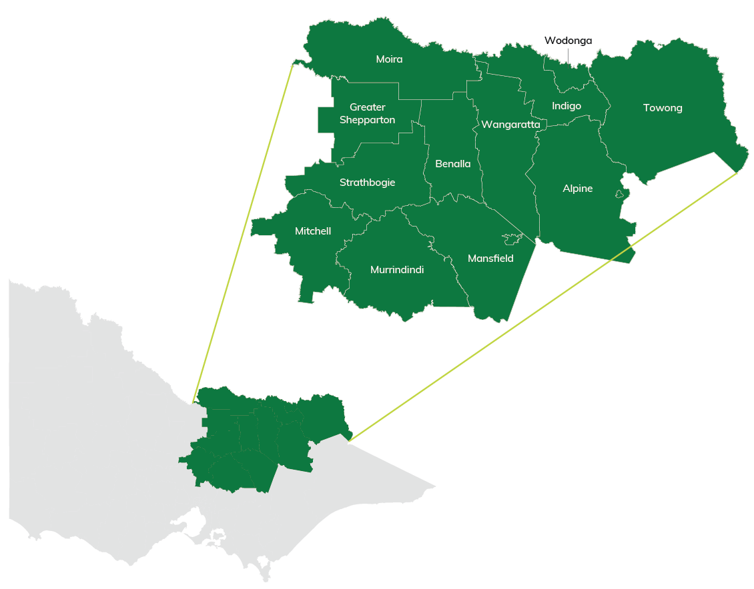

# Regional Vision

The Hume region is Victoria’s heartbeat

The Hume region is the lifeblood of Victoria through its productive and beautiful landscapes, its deep connections to its people and cultures, and its strategic location in the heart of the state amongst the nation’s arterial network.

The region sustains future generations through its rich primary production and food producing capabilities, and through its access to services and vibrant and empowered communities.

## RDA Hume Executive and Support Team

|  |  |
| --- | --- |
| **Name** | **Position** |
| Brett Luxford | Chair |
| Linda Nieuwenhuizen | Acting Deputy Chair |
| Charlie Bird | Executive Officer |
| Kate McRae | Manager Regional Coordination |
| Claire Connolly | RDA Hume Coordinator |

# RDA Charter

On 28 July 2023 the Australian Government introduced the RDA Charter (the Charter). The Charter outlines the role and expectations for the RDA Network to help drive economic growth, innovation and entrepreneurship by attracting investment into regional communities, industries and environments.

RDA Hume will achieve the aims of the Charter through its work with a broad range of stakeholders and by collaborating with other RDA Committees and all three levels of government. The Committee will:

Focus its activities and strategy on delivering the Regional Investment Framework (RIF) in the Hume region, supporting investment in the people, places, services, and industries that underpin our local economies.

Support regional stakeholders, including local government and the not-for-profit-sector, to seek grant opportunities that advance strategic regional priorities.

Support decarbonisation efforts and the transformation to a net zero economy and enable regional links between sectors to achieve these aims.

Build the evidence for economic development, including innovation and diversification strategies.

Facilitate meaningful engagement across the three levels of government to ensure investments deliver better outcomes for people and regions.

Contribute relevant data and local intelligence to support the evidence base to inform regional development strategies, program design and policy responses.

Taking a whole-of-region approach, RDA Hume adopts a strategic view of the challenges and opportunities that exist within the region and is well placed to coordinate regional effort and influence policy decisions by:

Collaborating with integrity, transparency, respect and accountability

Engaging with diverse communities, especially First Nations people

Supporting the Government’s ambition of ‘no one held back, and no one left behind’, and

Supporting gender equality opportunities in regions.

# Collaboration Statement

## Victorian RDA Network

RDA Hume is actively involved with the Victorian RDA Chair’s Network which comes together to identify and undertake projects relating to state-wide focus areas and priorities. This includes projects across key worker housing, digital capability, workforce and skills, and renewable energy.

RDA Hume remains committed to working with and supporting the RDA Melbourne Committee as it strengthens its role in identifying and developing opportunities to boost economic growth, jobs and investment between Melbourne and regional Victoria.

## Regional Partnerships

The Victorian Government established the nine Regional Partnerships to give regional communities a greater say about what matters to them and to ensure their priorities are heard at the highest levels. There are two Regional Partnerships in the Hume region, the Ovens Murray Regional Partnership and the Goulburn Regional Partnership.

RDA Hume has been represented on both Regional Partnerships since July 2016. This partnership has deepened RDA Hume’s collaboration across all three tiers of government. It has also increased the Committee’s knowledge and advocacy to the Australian Government and helps connect the Commonwealth’s regional priorities and goals with local and state levels of government.

## Regional Development Victoria

RDA Hume will continue its collaboration with Regional Development Victoria (RDV) to support the Victorian Government to implement its Economic Growth Statement, Regional Economic Development Strategies (REDs) and the related strategic priority activities for the Hume region.

RDA Hume’s active support of both the Victorian Government’s Economic Growth Statement, REDs and the Regional Partnerships, has strengthened its capacity to provide comprehensive advice on socio-economic issues and economic development opportunities to the Australian Government.

## Local Government Areas

RDA Hume has strong and well-established links with all 12 local government areas and Alpine Resorts Victoria within its geographic footprint. The Committee continues to be a direct entry point for smaller regional and rural councils to communicate their priorities and seek support to develop solutions with all levels of government.

## Australian Government Agencies

RDA Hume will continue to develop relationships with other Australian Government departments and agencies that include portfolios that relate to the Committee’s key strategic focus areas with support from the Department of Infrastructure, Transport, Regional Development, Communications, Sport and the Arts. This includes hosting sessions with Australian Government entities throughout the year to strengthen relationships and support the sharing of information.

# Communications Strategy

RDA Hume Communications Strategy will facilitate four key outcomes:

Continue to develop RDA Hume’s identity and raise its profile within the Hume region.

Regular communication with key stakeholders to promote Australian Government programs and funding opportunities.

Support development and dissemination of Australian Government messaging.

Planned engagement with stakeholders to gather local insights that will inform advice to all three levels of government.

To implement these strategies, RDA Hume will develop a communications plan for the next 12 months that focuses on the following strategic priorities and accompanying actions:

## 01. Identify & Profile

Regular communications relating to Australian Government funding opportunities, federal messaging on economic development interests, insights and updates on government programs and events across the region. Posting on social media platforms to share key events and messages and attendance at relevant expos and events.

## 02. Key Stakeholder Communication

Emails sent to key local government stakeholders with an overview of current RDA ‘hot’ issues, events and funding opportunities. This communication will also support direct engagement with key stakeholders to gather input and feedback on specific projects.

## 03. Product Development

Collateral items such as the Workforce Development Strategy 2025-28, Hume Regional Advocacy Strategy, media releases and other material as required.

## 04. Engagement & Consultation

Engage with local government on priority planning, industry roundtables, forums, workshops and industry briefings.

**Other planned communication activities include:**

Bimonthly Committee meetings that include sessions where other government agencies and industry experts brief RDA Hume and seek feedback on key priority focus areas or themes.

Updates of the RDA Hume website and social media posts on the RDA Hume LinkedIn account.

Team training to ensure that accessibility of information is maintained across digital platforms.

RDA Hume attendance at Ministerial Online Briefings, RDA National Forum, Regional Australia Institute Conferences and other events as opportunities present.

Contribute to reports and submissions as opportunities present.

The RDA Hume Communications Strategy and activities will align with the external communications strategy for placed-based partnerships led by the Strategic Communications branch within the Department of Jobs, Skills, Industry and Regions.

# Strategic Focus Areas and Alignment

RDA Hume’s strategic focus areas align with the Regional Investment Framework (RIF) and the Goulburn and Ovens Murray Regional Economic Development Strategies (REDS). These federal and state strategies reflect the long-term aims and activities planned to strengthen Hume’s regional economies.

They prioritise alignment across all three levels of government, using evidence-based data and analysis to identify key challenges and opportunities, providing a unified regional voice.

RDA Hume’s areas of strategic focus include:

Water

Infrastructure to unlock regional growth

Energy security and transition

Workforce and skills development.

These focus areas are fundamentally linked with key sectors within our region outlined in the matrix below. By mapping the intersection between our strategic focus areas, and key sectors for the Hume region, RDA Hume will develop targeted and measurable initiatives to help address economic development barriers, drive innovation and investment, and support transformative economic development.

|  |  |  |  |  |  |  |
| --- | --- | --- | --- | --- | --- | --- |
| **Category** | **Manufacturing** | **Defence** | **Freight and logistics** | **Visitor economy** | **Agriculture** | **Health and social assistance** |
| Water | Yes |  |  | Yes | Yes |  |
| Infrastructure to unlock regional growth | Yes | Yes | Yes | Yes | Yes | Yes |
| Energy security and transition | Yes |  | Yes |  | Yes |  |
| Workforce and skills development | Yes | Yes | Yes | Yes | Yes | Yes |

# RDA Hume’s Approach

RDA Hume will:

Continue to participate in the Victorian RDA Chair’s network to achieve successful outcomes for their identified whole of state RDA initiatives.

Provide high level expert regional advice to all three levels of government, including local government engagement and attendance at Hume Regional Local Government Network.

Identify government and industry investment opportunities that complement regional strengths and competitive advantages.

Provide responses to specific priorities by continuing to make connections between Australian and Victorian Government programs, funding opportunities and strategies.

# RDA Hume Work Plan 2025-26

RDA Hume has identified the following focus areas, key actions and measures to be progressed in 2025-26.

| **Strategic Focus Area** | **Key Actions** | **Measures** |
| --- | --- | --- |
| **Water**  Work in partnership with Regional Partnerships to support water access and security. | Advocate for the postponement of uncoordinated water buy-backs until alternative water saving measures outlined in the Victorian *Planning our Basin future together* strategy have been considered.  Advocate to the Australian Government to partner with the Victorian Government to fund and deliver initiatives outlined in the Victorian *Planning our Basin future together* strategy.  Identify existing place-based support to determine the role for RDA Hume.  Develop the Hume Region Advocacy Strategy.  Work in partnership with the Goulburn and Ovens Murray Regional Partnerships to support an aligned approach to transition support. | Attend meetings, forums and industry gatherings with key regional stakeholders to understand the impacts of water buy-backs and the challenges for the Hume region.  Delivery of the Hume Region Advocacy Strategy.  Stakeholder engagement on the impact of water buy-backs in the Hume region. |
| **Infrastructure to unlock regional growth**  Identify and advocate for funding of critical enabling infrastructure that strengthens the Hume region’s competitive advantage and attracts investment. | In partnership with stakeholders, identify key investment priorities for enabling infrastructure to support transformative projects across the Hume region.  Identify opportunities to improve connectivity, liveability and resilience by applying a region wide lens to infrastructure needs that will increase value and investment.  Connect with tourism stakeholders across the region to facilitate economic opportunities to drive growth in the visitor economy.  Work with key federal and state agencies to align regional projects with investment opportunities. | Stakeholder engagement to identify key investment priorities.  Advocacy at a national level to support funding for critical enabling infrastructure that will support transformative projects for communities, industry and business.  Support provided for transformative economic development grant applications for Australian Government funding programs. |
| **Energy security and transition**  Support the Hume region’s energy security, reliability and transition to net zero by identifying opportunities, threats and key areas of investment while backing the energy transition of key industries. | Engage with industry and stakeholders to identify issues, challenges and opportunities for energy security and transition.  Analyse existing strategic work undertaken in the Hume region that identifies key areas of investment and determine the role for RDA Hume in supporting this work.  Understand the impact of energy transition for the Ovens Murray region noting a Renewable Energy Zone has not been identified within its footprint.  Work with key Australian and Victorian Government departments, and agencies to align regional projects with investment opportunities.  Advocate at a national level for funding to support the transition of key industries. | Engagement and collaboration with key stakeholders to address RDA Hume strategic priorities.  Attendance at forums for key regional stakeholders to support energy security and transition.  Stakeholder engagement regarding energy security and transition.  Advocacy at a national level to support the energy transition of key industries. |
| **Workforce and skills development**  Strengthen the Hume regional economy through the development of a localised workforce strategy that supports transformative change through capacity building and leveraging the region’s strengths across all sectors. | Develop the Hume Regional Workforce Strategy 2025-28.  Support stakeholders and contribute to the delivery of the Hume Regional Workforce Strategy 2025-28.  Engage with stakeholders to identify opportunities for local economic development workforce priorities.  Support sustainable solutions for workforce, skills and population growth in the Hume region.  Engagement across all levels of government to advocate key directions outlined in the Hume Regional Workforce Strategy 2025-28.  Maintain and update RDA Hume’s Local Government Strategic Engagement Plan to monitor skills gaps, issues and examples of good practice. | Development of the Hume Regional Workforce Strategy 2025-28.  Stakeholder engagement to identify opportunities for local economic development workforce priorities. |
| **Housing**  Advocate and support the development of diverse, fit for purpose accommodation solutions that meet the needs of the Hume region. | Advocate for continued investment in a diverse range of fit for purpose housing solutions for the Hume region.  Advocate for funding to address critical enabling infrastructure gaps that are limiting new housing development. | Delivery of the Hume Region Advocacy Strategy. |

# Outcomes and Performance Indicators

## Summary of Outcomes

### Summary of key strategic priorities for upcoming year:

#### Water

Work in partnership with Regional Partnerships to support water access and security.

#### Infrastructure to unlock regional growth

Identify and advocate for funding of critical enabling infrastructure that strengthens the Hume region’s competitive advantage and attracts investment.

#### Energy security and transition

Support the Hume region’s energy security, reliability and transition to net zero by identifying opportunities, threats and key areas of investment while backing the energy transition of key industries.

#### Workforce and skills development

Strengthen the Hume regional economy through the development of a localised workforce strategy that supports transformative change through capacity building and leveraging the region’s strengths across all sectors.

#### Housing

Advocate and support the development of diverse, fit for purpose accommodation solutions that meet the needs of the Hume region.

### Summary of key business activities for upcoming year:

1. Development and delivery of the Hume Regional Workforce Strategy 2025-28.
2. Development and execution of the Hume Regional Advocacy Strategy, aligned to the 2025-26 strategic priorities.
3. Engage and collaborate with key stakeholders to address RDA Hume strategic priorities.
4. Engage with regional stakeholders, such as the Ovens Murray and Goulburn Regional Partnerships to identify and advocate for opportunities that align with RDA Hume’s priorities.
5. Identify and support transformative economic development grant applications for Australian Government funding programs.

### Summary of key outcomes for upcoming year:

1. Facilitate regional economic development outcomes, through investment in skills and local leadership, opportunities for First Nations people, infrastructure, connectivity, decarbonisation and industry growth.
2. Support regional stakeholders, including local government and the not-for-profit sector, to seek grant opportunities and advance strategic regional priorities.
3. Contribute to, and where appropriate, drive local economic development planning and strategy development.

# OUTCOME 1

### Facilitate regional economic development outcomes, through investment in Skills and Local Leadership, Opportunities for First Nations people, Infrastructure, Connectivity, Decarbonisation and Industry growth.

**Performance indicators**

a. How does the activity align with your top 5 strategic priorities?

What are the expected outcomes this activity?

How will they benefit the RDA and region?

Estimated percentage of budget allocated to activity

Provide measurable expected outcomes.

b. Please separate these in terms of outcomes that your RDA has:

Lead/championed – heavily involved with the outcome

Contributed to – moderately involved with the outcome

Otherwise assisted – marginally involved with the outcome.

Note timeframe for each activity.

## PART 1 – FOR THE ANNUAL BUSINESS PLAN

### What will we do?

|  |  |  |
| --- | --- | --- |
| **Activity:** | **Initiative Type:** | **Expected Outcomes:** |
| RDA Hume will:  1.1 Identify and advocate for funding of critical enabling infrastructure that will add value to the Hume region’s value proposition and optimise value and investment. **(L/C – ongoing)**  1.2 Identify key investment priorities for enabling infrastructure to support transformative projects across the Hume region.  **(C – ongoing)**.  1.3 Identify opportunities to improve connectivity, liveability and resilience within the Hume region.  **(C – ongoing)**.  1.4 Support the Hume region’s energy security, reliability and transition to net zero by identifying significant opportunities and threats, key areas of investment and advocating to support the energy transition of key industries. **(L/C – ongoing)**.  1.5 Analyse existing strategic work and key areas of investment opportunity to determine the role for RDA Hume. **(L – ongoing)**.  1.6 Advocate for continued investment in a diverse range of fit for purpose housing solutions for the Hume region. **(C– ongoing)** | Opportunities for First Nations people  Infrastructure  Industry Growth  Infrastructure    Connectivity  Decarbonisation  Skills and Local leadership    Infrastructure | RDA Hume’s activities will provide the following outcomes:   * Support for applications to Australian Government funding programs that support precinct and infrastructure development. * The continuation of the Local Government Engagement Program and stakeholder engagement to identify transformative regional projects across skills and leadership, opportunities for First Nations people, infrastructure, connectivity, decarbonisation and industry growth. * Engagement with stakeholders and Australian and Victorian Government departments and agencies to align regional projects with investment opportunities. * Engagement and collaboration with key stakeholders to address RDA Hume strategic priorities. * Attend forums for key regional stakeholders regarding energy security, reliability, transition and renewable energy. |

# OUTCOME 2

### Support regional stakeholders, including local government and the not-for-profit-sector, to seek grant opportunities that advance strategic regional priorities.

**Performance indicators**

a. how does the activity align with your top 5 strategic priorities?

What are the expected outcomes this activity?

How will they benefit the RDA and region?

Provide details of where you will support awareness raising and/or engagement with grant opportunities and the preparation of grant applications.

b. Please separate these in terms of outcomes that your RDA has:

Lead/championed – heavily involved with the outcome

Contributed to – moderately involved with the outcome

Otherwise assisted – marginally involved with the outcome.

Note timeframe for each activity.

#### Part 1 – For The Annual Business Plan

### What will we do?

| **Activity:** | **Expected Outcomes:** |
| --- | --- |
| RDA Hume will:  2.1 Connect with tourism stakeholders across the region to facilitate economic opportunities to drive growth in the visitor economy.  **(L/C – ongoing)**.  2.2 Conduct Stakeholder engagement to identify regional workforce and skills priorities and develop the Hume Regional Workforce Strategy to support sustainable solutions for workforce, skills and population growth in Hume.  **(L – by end June 2026)**.  2.3 Provide information and support to applicants to create compelling Australian Government and Victorian Government funding applications where appropriate. **(L/C – ongoing)**.  2.4 Provide letters of support for applicants where the project will contribute to long term economic growth for the region and is an identified priority project.  **(L – ongoing)**.  2.5 Actively promote and distribute information to regional business, communities and industry on grants, programs, research and other national and state government initiatives.  **(L – ongoing)**.  2.6 Continue its collaboration with its cross-border partners. **(C/O – ongoing)**. | RDA Hume’s activities will provide the following outcomes:   * Development of the Hume Regional Workforce Strategy 2025-28. * Delivery of the Hume Regional Advocacy Strategy 2025-28. * Support transformative economic development grant applications for Australian Government funding programs with application preparation assistance and letters of support. * Engagement and collaboration with key stakeholders to address RDA Hume strategic priorities. * Attendance at forums for key regional stakeholders to support energy security, reliability and transition. * An up to date understanding of priority projects through RDA Hume’s Local Government Engagement. * Sharing Australian Government funding opportunities and open grant information monthly with RDA Hume committee, stakeholders and the RDV Hume team. * Using the RDA Hume LinkedIn platform to raise awareness of RDA Hume. * Identifying opportunities for economic prosperity and any advocacy role required for RDA Hume with our cross-border partners. |

# OUTCOME 3

### Contribute to, and where appropriate, drive local economic development planning and strategy development.

**Performance indicators**

a. how does the activity align with your top 5 strategic priorities?

What are the expected outcomes this activity?

How will they benefit the RDA and region?

b. Please separate these in terms of outcomes that your RDA has:

Lead/championed – heavily involved with the outcome

Contributed to – moderately involved with the outcome

Otherwise assisted – marginally involved with the outcome.

Note timeframe for each activity.

#### Part 1 – For The Annual Business Plan

### What will we do?

| **Activity:** | **Expected Outcomes:** |
| --- | --- |
| RDA Hume will:  3.1 Work in partnership with the Goulburn and Ovens Murray Regional Partnerships to support an aligned approach to transition support. **(C/O – ongoing)**.  3.2 Identify existing place-based support to determine the role for RDA Hume.  **(L – ongoing)**.  3.3 Develop the Hume Regional Advocacy Strategy aligned to the 2025-26 strategic priorities. **(L – by end December 2025)**.  3.4 Engage with key stakeholders including local leaders, innovators, industry experts and other regional stakeholders to coordinate advice to government on Hume RDA strategic focus areas.  **(L – ongoing)**.  3.5 Conduct Stakeholder engagement to identify regional workforce and skills priorities and develop the Hume Regional Workforce Strategy 2025-28 to support sustainable solutions for workforce, skills and population growth in Hume.  **(L – by end June 2026)**.  3.6 Support the Hume region’s energy security, reliability and transition to net zero by identifying significant opportunities and threats, key areas of investment and advocating to support the energy transition of key industries.  **(L/C – ongoing)**.  3.7 Engage with industry and stakeholders to identify issues, challenges and opportunities for energy security and transition. **(C – ongoing)**. | RDA Hume’s activities will provide the following outcomes:   * Creating a detailed understanding of the impacts of water buy-backs across Hume’s extensive agri-food value chains. * Supporting a regional approach to navigating economic transition accelerated by water buy-backs. * Evidence-based advice to the Australian Government on critical regional economic issues to inform policy development or support required to mitigate challenges – such as negative impacts of water buy-backs. * Development of the Hume Regional Workforce Strategy 2025-28. * Delivery of the Hume Regional Advocacy Strategy 2025-28. * Attendance and participation in online briefings, meetings, and conferences held by Australian Government Ministers with carriage of the RDA Network and/or related portfolios. * Supporting events and activities that help identify issues and build capacity to respond to the RDA Hume strategic priorities. * Undertaking regular engagement across all levels of government to advocate key directions outlined in the Hume Regional Workforce Strategy 2025-28. |

Local people developing local solutions [rda.gov.au](https://www.rda.gov.au/)