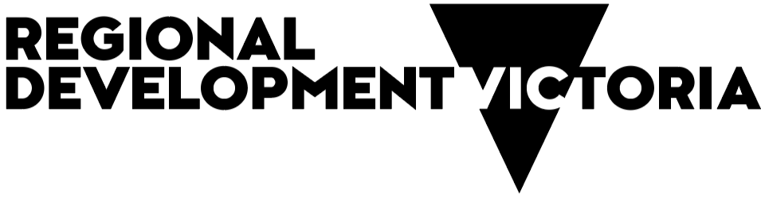

Annual Report 2024–25
Contents
Chief Executive foreword 5
RDV Executive team 2024-25 7
Regional Victoria – a vital part of our state 9
An overview of Regional Development Victoria 9
Organisational structure 10
Regional Partnerships 11
Overview 11
Key achievements for 2024-25 11
Reporting on Regional Partnerships 13
Barwon 13
Great South Coast 16
Wimmera Southern Mallee 18
Central Highlands 21
Ovens Murray 23
Goulburn 26
Mallee 29
Loddon Campaspe 31
Gippsland 33
Regional Development Australia 36
Highlights 36
Cross Border Commissioner: Working with border communities 42
Cross border priorities 42
Regional intelligence and future opportunities 45
Geelong City Deal 46
Key achievements in 2024-25 46
Progress of other GCD projects underway in 2024-25 48
Tiny Towns Fund 49
Regional Worker Accommodation Fund 50
Council Support Package 51
Growing Regions Program (GRP) and regional Partnerships and Precincts Program (rPPP) 52
Natural disaster relief 53
Economic Growth Statement 54
Regional report Barwon South West 55
Regional Director’s report 55
Regional highlights 56
Key outcomes 57
Regional report Gippsland 59
Regional Director’s report 59
Regional highlights 60
Key outcomes 61
Regional report Grampians 63
Regional Director’s report 63
Regional highlights 64
Key outcomes 65
Regional report Hume 67
Regional Director’s report 67
Regional highlights 68
Key outcomes 69
Regional report Loddon Mallee 72
Regional Director’s report 72
Regional highlights 73
Key outcomes 74
Regional Jobs and Infrastructure Fund 77
Financials 2024-25 79
2024-25 output targets and performance against Budget Paper 3 measures 79
Income and expenditure report for the period ended 30 June 2025 80
Contact information 81

Acknowledgment
We acknowledge the Traditional Aboriginal Owners of Country throughout Victoria and pay our respect to them, their connections to land, sea and community. We pay our respects to their Elders past and present and future Traditional Owners.
Published by the Victorian Government
Regional Development Victoria Annual Report 2024–25
October 2025 Melbourne Victoria
© Copyright State Government of Victoria 2025
This publication is copyright. No part may be reproduced by any process except in accordance with provisions of the Copyright Act 1968.
Authorised by the Victorian Government, Melbourne
ISBN 1448 9341 (press)
ISBN 2652 2101 (pdf/online/MS word)
Contact
Regional Development Victoria
Level 31, 121 Exhibition Street
Melbourne 3000
T: 13 22 15
E: rdv@rdv.vic.gov.au
Web: rdv.vic.gov.au
Designed by DJSIR Design Studio
Disclaimer
The information contained in this report is provided for general guidance and assistance only and is not intended as advice. You should make your own inquiries as to the appropriateness and suitability of the information provided. While every effort has been made to ensure the currency, accuracy or completeness of the content, we endeavour to keep the content relevant and up to date and reserve the right to make changes as required. The Victorian Government, authors and presenters do not accept any liability to any person for the information (or the use of the information) which is provided or referred to in the report.
Except for any logos, emblems, trademarks, artwork and photography, this document is made available under the terms of the Creative Commons Attribution 3.0 Australia licence.
Accessibility
This document is available in PDF at rdv.vic.gov.au

Chief Executive foreword
In 2024-25, Regional Development Victoria (RDV) fostered strong economic growth across regional Victoria. As the state’s dedicated regional economic development agency, we worked alongside industry, businesses and local communities to create lasting employment opportunities. By leveraging our place-based policies, programs and projects, we supported regions and cross border areas to thrive, ensuring sustainable progress and prosperity.
The Victorian regional economy is now worth $118 billion. Our regions account for around a quarter of the state’s economic output, population, small businesses and employment. With a low unemployment rate of 3.7%, our regions are a great place to work and live. RDV attracted more than $800 million in private sector investment over 2024-25, and we are delivering more than 634 projects across our communities.
As part of the Victorian Government’s Economic Growth Statement, RDV is delivering the Trunk Infrastructure Fund to unlock the Regional Economic Growth initiative, the Regional Investment Front Door and the Regional Launching Pad pilot. Through the Victorian Investment Fund, RDV is partnering with industry to secure business investment that creates jobs, which supports innovation and underpins Victoria’s long-term economic growth in priority sectors. The development and rollout of these strategic programs will boost our economy and make it easier and faster to do business in regional Victoria.
In 2024-25, RDV delivered the first round of approved projects under the Regional Worker Accommodation Fund (RWAF). The fund directly supported 24 projects to activate key worker housing by partnering directly with employers. At the time of writing, projects submitted under Round 2 of RWAF are being considered for assessment. Successful projects were also announced under Rounds 1 and 2 of the Tiny Towns Fund this year, supporting the delivery of 347 regional projects in our littlest towns.
RDV continued to support regional communities facing natural disasters this year. In collaboration with local governments and other parts of the Victorian Government, we worked to strengthen resilience in times of drought and bushfire, playing a central role in coordinating responses that foster solutions for affected communities and regions.
Victoria’s 9 Regional Partnerships have continued to engage deeply with their communities to identify regional priorities, develop critical strategic insights and provide solution-focused advice directly to government. Our Regional Partnerships have strongly advocated on essential key priorities, ranging from key worker housing and investment attraction, through to building awareness and support for reconciliation and Treaty readiness in our regions
With our RDA committees we undertook a robust campaign this year to recruit new Chairs, Deputy Chairs and committee members for the next phase of the program. We will continue to address regional challenges and drive opportunities for economic growth together.
In Gippsland and the Latrobe Valley, RDV worked with partners to further economic opportunities that strengthen local communities, following the integration of the remaining functions of the Latrobe Valley Authority (LVA). Over its 7 years of operation, the LVA facilitated $234 million in Victorian Government transition investment and supported more than 1,500 workers and their families affected by the Hazelwood power station closure. As the region continues its economic transformation, RDV is dedicated to long-term prosperity through a targeted, forward-thinking approach.
This year also marks the 6th year of the Geelong City Deal. The façade of the Nyaal Banyul Geelong Convention and Event Centre has been installed, and the building is now watertight. The landmark Twelve Apostles Precinct Redevelopment is also underway and will provide a world-class Visitor Experience Centre and gateway to the Shipwreck Coast. Both projects remain on track for completion in 2026.
I’d like to acknowledge the dedication, expertise and passion of our staff. They’ve been instrumental in driving meaningful outcomes for the regions. Their deep knowledge, diverse skills and unwavering commitment have not only shaped impactful initiatives but also strengthened the fabric of our communities. To our place-based regional teams, I’d like to extend an enormous thank you for engaging with me in place during my first year. It is your hard work and vision that continues to guide us forward.
It’s a privilege to be back with Regional Development Victoria, leading a talented team dedicated to driving positive outcomes for our regional communities. I’m also immensely grateful to be working with our exceptional regional stakeholders throughout Victoria, including members of our Regional Partnerships and Regional Development Australia Committees who have supported RDV’s work.
I look forward to continuing to work with you as we deliver outcomes for regional Victoria.
Xavier Csar
Chief Executive Officer
Regional Development Victoria

RDV Executive team 2024-25
Xavier Csar
Chief Executive Officer
October 2024 – present
Brett Davis
Cross Border Commissioner
Jeremy Levine
Executive Director,
Place Based Strategy,
Insights and Coordination
David Burns
Executive Director,
Priority Projects and Business Performance
July 2024 – January 2025
Anthony Schinck
Executive Director,
Regional Economic Growth and Investment
Brett Ince
Regional Director,
Barwon South West
Sara Rhodes Ward
Regional Director,
Gippsland
Sarah Henderson
Regional Director,
Grampians
Charlie Bird
Regional Director,
Hume
October 2024 – present
Leanne Rosewall
Regional Director,
Loddon Mallee
With many thanks to the following individuals for acting in the RDV executive team; Rachaele May, Acting Chief Executive Officer, July 2024 – August 2024; Anthony Schinck, Acting Chief Executive Officer, August 2024 – October 2024; Jim Rodgers, Acting Executive Director, Priority Projects and Business Performance, November 2024 – January 2025; Mark Byatt, Acting Regional Director, Hume, July 2024 – October 2024.

Regional Victoria – a vital part of our state
Rural and regional Victoria is home to one in four Victorians. It accounts for 793,000 jobs and 24% of the state’s small businesses, employing anywhere from 1 to 19 staff. Victoria has a regional economy that generates over $118 billion and accounts for a fifth of Victoria’s total economy.

An overview of Regional Development Victoria
Regional Development Victoria is the Victorian Government’s dedicated regional economic development agency.
A statutory authority operating within the Department of Jobs, Skills, Industry and Regions (DJSIR), RDV facilitates economic growth and investment across rural and regional Victoria.

Purpose
RDV supports vibrant, thriving and inclusive regional communities by creating jobs, delivering vital infrastructure and enabling transformative investment.
RDV works with all levels of government, businesses and communities to promote a coordinated approach that facilitates strong economic growth and investment outcomes for regional Victoria. By drawing on local knowledge and collaboration, RDV ensures that rural and regional Victoria remains a vibrant place to live, work, and invest.

Organisational structure
RDV forms an organisational group within the Department of Jobs, Skills, Industry and Regions.
RDV has a unique presence throughout rural and regional Victoria, with our operations in place delivered through 5 RDV regions:
Barwon South West
Gippsland
Grampians
Hume
Loddon Mallee.
Each RDV region is led by a Regional Director, who works collaboratively to coordinate and deliver regional economic development initiatives across their region.
RDV’s work is backed by the specialist expertise of the following teams:
Economic policy, strategy and coordination
Data and insights
Program delivery
Investment attraction.

Regional Partnerships

Overview
The Victorian Government’s Regional Partnerships are collaborative bodies that bring together community members, business leaders, local government and regional stakeholders to advise the government on the economic priorities and opportunities that matter most in each region.
There are 9 Regional Partnerships across Victoria, each focused on a specific geographic area. They work closely with Regional Development Victoria (RDV) and other government agencies to turn local insights into action.
In delivering the Victorian Government’s renewed economic development agenda, the updated key functions of Regional Partnerships are:
providing advice to the government on matters related to regional economic development
consulting with the government on significant policies, directions and reforms relevant to regional Victoria’s economy
collaborating with community, business and government partners to facilitate regional economic outcomes, drawing on evidence-based research, advice and data.

Key achievements for 2024-25
A successful Regional Partnership recruitment campaign attracted more business and industry representatives to Regional Partnerships across Victoria.
Regional Partnerships continued to work on important opportunities to realise their regional economic strengths, such as:
Hosted roundtables and brought key stakeholders together to inform strategic plans, government policy and support targeted investment for much needed housing in regional Victoria
Continued to advocate for support to help the Goulburn Murray region navigate economic transition challenges, such as water buybacks, business closures and biosecurity events, while promoting the Goulburn Murray Resilience Strategy to drive economic diversification and strengthen regional adaptability
Supported localised opportunities to gain social acceptance for expanding renewable energy infrastructure, to fully leverage the economic and environmental benefits
Provided data and evidence to support multiple housing projects, utilising surplus Victorian Government land available for housing development to address critical housing needs across regional Victoria
Launched the Migrant Recruitment and Retention Charter for Gippsland region, to support cultural diversity, improve settlement and retention of migrants, and address workforce needs
The Great South Coast Regional Partnership engaged with stakeholders and government to coordinate support, address feed and water shortages and advocate for long-term resilience and targeted regional investment in response to ongoing drought conditions impacting agriculture
Continued investment facilitation of value-adding economic growth projects in agriculture, food and fibre, advanced manufacturing and mining
Advocated for the provision of childcare in small rural communities, resulting in targeted investment, informed policy and improved access, which will enable more opportunities for women to participate in the workforce.
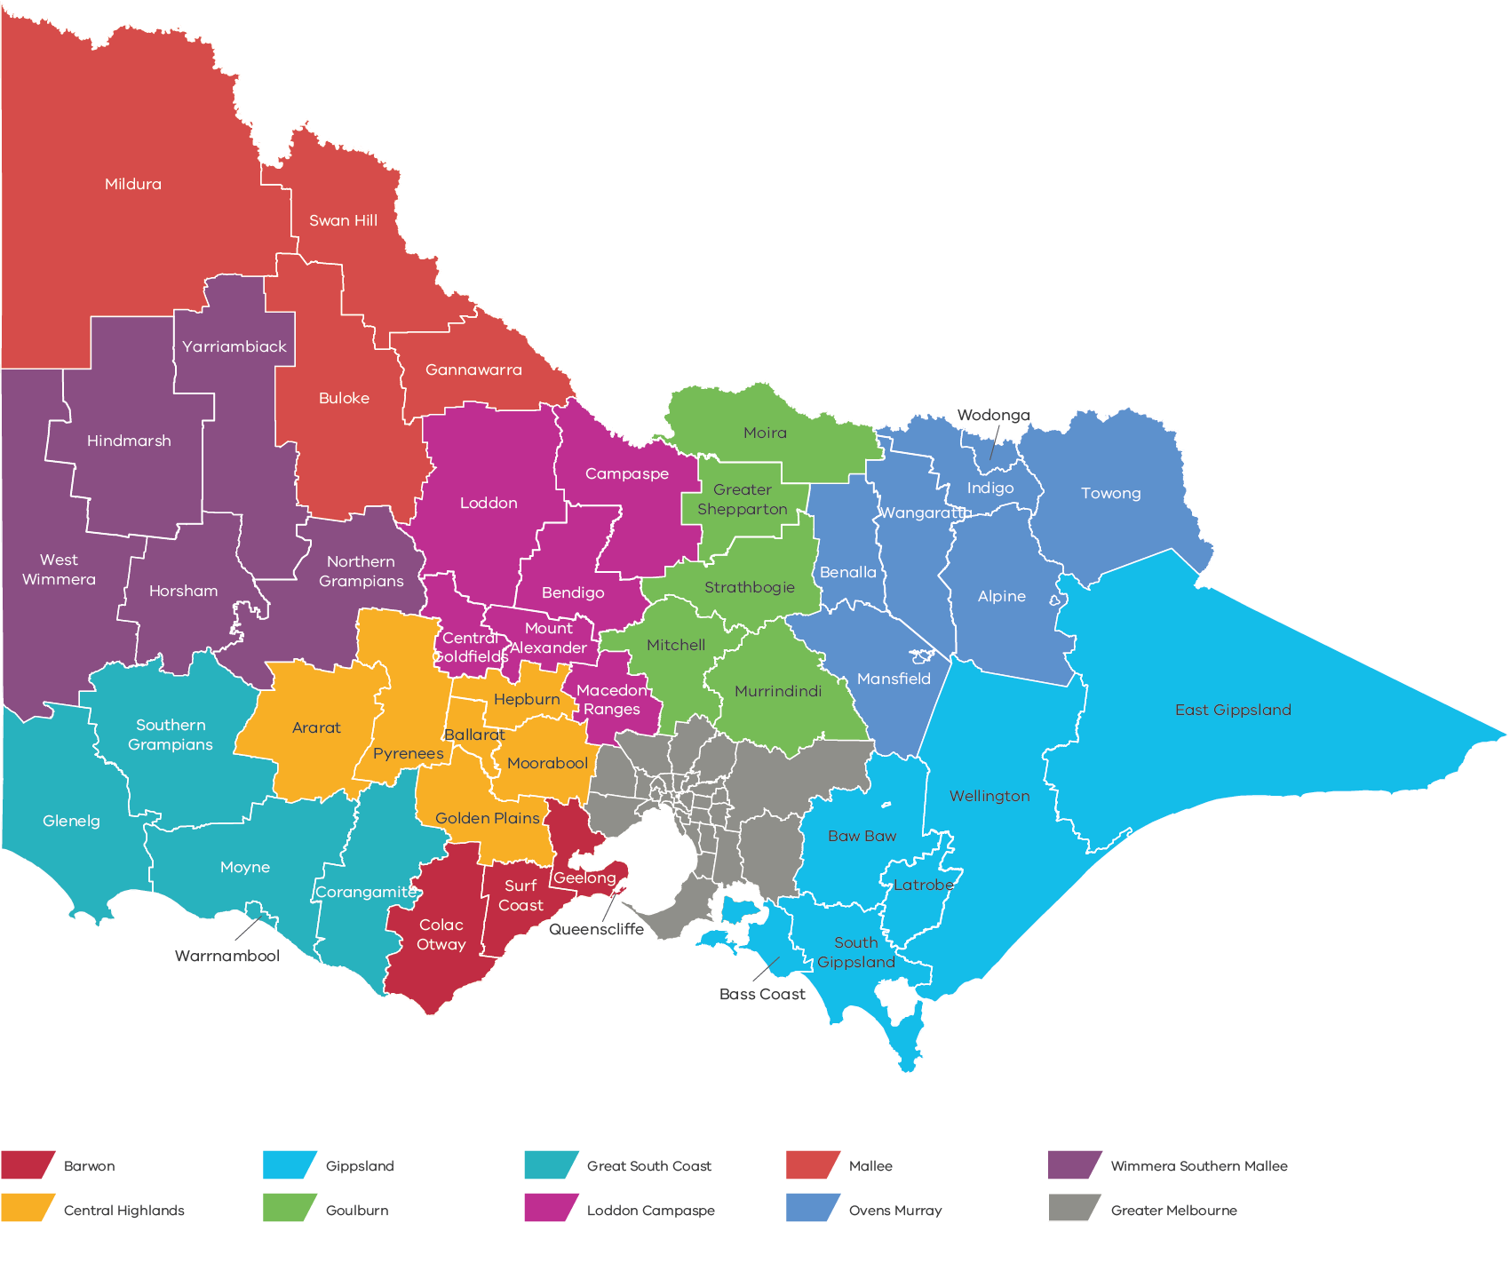

Reporting on Regional Partnerships

Barwon
In 2024-25, the Barwon Regional Partnership (RP) continued its focus on ‘Good Growth’ and identified priority initiatives that will address some of the challenges and opportunities faced by the Barwon region.

Regional priorities
Priority precincts – Increase housing density along key transport nodes by activating housing supply through a new mechanism to fast-track integrated planning and delivery of precincts along the Geelong Regional Rail Network
Accelerating the clean economy – Expand renewable energy infrastructure by accelerating investment in the clean economy, including staged investment into a regional alternative water grid
Caring for Country – Invest in a permanent physical presence for the Wadawurrung in Geelong, serving as a centre to effectively be able to meet the demand of growth and their own self-determination
Inclusive growth – Embed proven social procurement outcomes through targeted and supported training programs in Victorian Government-funded infrastructure projects.

Highlights
Made a submission to the Plan for Victoria (PfV) with a strong focus on enabling good growth, highlighting priorities such as housing targets, priority precincts, unlocking government-owned land, social outcomes, employment precincts, enabling infrastructure, climate resilience, Caring for Country and Aboriginal economic self-determination
Convened a housing roundtable with over 40 stakeholders to identify ways to accelerate higher density housing, with strong support for unlocking surplus state-owned land along the Geelong Rail Corridor to boost affordable and market supply
Established a twice-yearly forum with local government CEOs, the Department of Transport and Planning and the Land Coordinator-General to fast-track strategic site activation, supported by a new Priority Precincts and Surplus Government Land Tracker to identify and fast-track potential surplus government land for housing
Hosted a Walk on Country during National Reconciliation Week, led by Wadawurrung woman and BRP member Corrina Eccles, followed by a yarn on enabling Aboriginal self-determined economic development pathways with First Nations leaders, BRP members and Central Highlands guests
Responded to the Plan for Victoria, with G21 Geelong Region Alliance, City of Greater Geelong, Surf Coast Shire and Committee for Geelong by jointly presenting an alternative vision, Plan for Victoria: Geelong in the Future, to the Minister for Planning, advocating for support to refresh the Central Geelong Framework Plan and recognise Central Geelong as a priority precinct in the PfV
Collaborated with regional leaders to advance priority projects ahead of the 2025 Australian Federal Election, securing $5 million toward Avalon Airport developments and a further $5 million, matched by the Victorian Government, to support a $10 million investment in Barwon Water’s Alternative Water Grid
Facilitated a roundtable between the Department of Transport and Planning, private sector investors and developers to explore Plan for Victoria targets and how the Central Geelong Framework Plan aligns with investment attraction, project feasibility and development opportunities in Central Geelong
Partnered with Regional Development Australia Barwon South West, the Great South Coast RP, Wannon Water, Barwon Water and Deakin University to deliver the Barwon South West Renewable Hydrogen Prospectus. Released in June 2025, the prospectus represents the collective vision of over 40 organisations that are united in their mission to accelerate the national energy transition through the development of a local renewable hydrogen industry in the Barwon South West region
Undertook recruitment, reappointing 4 existing members, including the Chair and Deputy Chair and welcomed 4 new representatives, who together bring diverse expertise to inform, collaborate and advise on priorities, challenges and opportunities that support Barwon’s growth.
355,095
Population (2024)
24.8%
Population growth (2024–2036)
$24.7B
Gross Regional Product (2024)
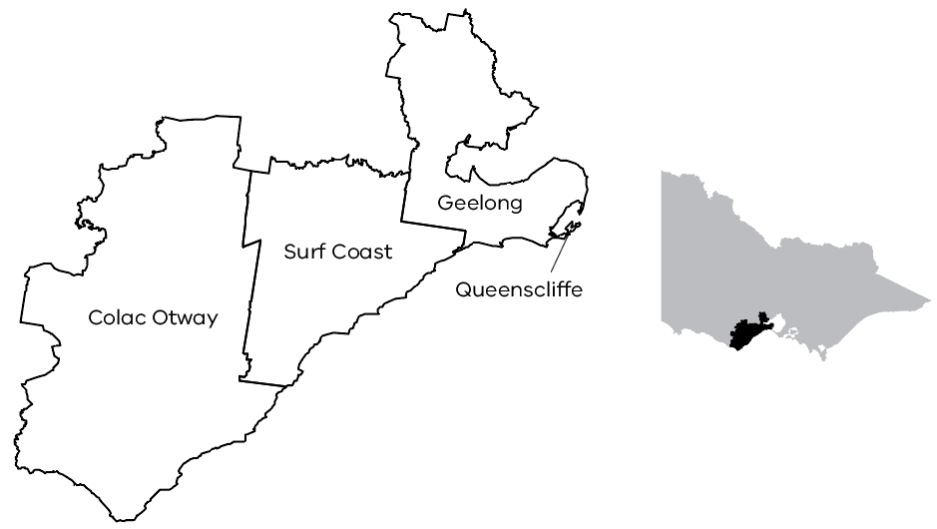

Case study

Barwon Region – Fast-tracking infill housing along the Geelong Rail Corridor
Responding to Plan for Victoria (PfV) targets of 128,000 new homes in Greater Geelong, with 77,500 dwellings designated for infill development, the Barwon RP convened a housing roundtable with over 40 participants from the Department of Transport and Planning, Council CEOs, community housing providers, and Barwon RP members. The roundtable focused on identifying mechanisms to accelerate higher-density housing, with strong consensus on unlocking surplus state-owned land along the Geelong Rail Corridor as a key lever for promoting affordable housing and supporting the market housing supply.
In partnership with RDV, the Department of Transport and Planning, the Land Coordinator-General and local governments, Barwon RP established an inter-agency working group to progress activation of strategic housing sites.
This working group enabled direct engagement with council leadership and government agencies to fast-track land release and shape policy directions that enable infill development. To further accelerate outcomes, Barwon RP held a roundtable with Department of Transport and Planning and private sector representatives to identify and address barriers to delivering higher density housing in Central Geelong.
Building on Plan for Victoria, the BRP together with regional stakeholders and local government, developed a proposed precinct map for Central Geelong aligned with the PfV framework. This was presented to the Minister for Planning in May 2025, accompanied by practical examples to support investment in higher density housing. The ongoing initiative aims to position Central Geelong as a focal point for infill development and ensure the region delivers housing at the scale and pace required.

Great South Coast
In 2024-25, the Great South Coast Regional Partnership (GSCRP) continued to focus on enabling strategic investment and supporting initiatives aligned with regional priorities. This included work to advance infrastructure planning, strengthen economic opportunities and progress policy development that contributes to long-term growth, sustainability and resilience across the region.

Regional priorities
Food and fibre value-add – The Great South Coast is Victoria’s leading food and fibre producing region, generating over $2.3 billion in annual output. With 72.2% of commodities exported as raw products, the GSCRP continues its focus on value-added processing as a key opportunity to support industry diversification and job creation
Economic participation – Workforce constraints remain a key barrier to growth across multiple sectors. The ongoing shortage of qualified early childhood education and care workers continues to limit workforce participation, particularly for women. The GSCRP has highlighted this issue in regional workforce forums and through engagement with government and industry stakeholders
Roads and water infrastructure – The need for targeted investment in regional roads and water infrastructure remains a high priority for the Great South Coast region. These assets are critical to supporting growth in the agriculture, tourism and clean energy sectors. There is increasing demand for water from emerging industries and supply is highly variable due to the effects of climate change and exacerbated by the current drought conditions being experienced in the region. Infrastructure and regulatory constraints are impacting the ability to efficiently manage water allocation across the region
Clean energy – The Great South Coast region has access to diverse energy resources, including wind, wave, gas and geothermal. The GSCRP is working with stakeholders to support coordinated investment and development that aligns with energy transition objectives
Work in 2024-25 focused on ensuring that planning processes, benefit-sharing mechanisms, and stakeholder engagement frameworks were in place to enable future projects and support local communities.

Highlights
Worked with RDV, CSIRO and Corangamite Shire on the Enabling Infrastructure – Camperdown Production Precinct project, funded by the Victorian Government’s Investment Fast Track Fund, to explore treated wastewater solutions. Continued support has seen the project progress toward a funding application under the Australian Government’s regional Precincts and Partnerships Program to attract investment in food and fibre manufacturing, logistics and advanced processing
Supported a delegation of representatives from Great South Coast Economic Futures, Food and Fibre Great South Coast and Agriculture Victoria to attend the EvokeAG conference in Brisbane. This was the region’s second year attending the event, building on the success of last year’s attendance to promote the region to national and international agrifood technology investors
Partnered with Regional Development Australia Barwon South West, the Barwon Regional Partnership, Wannon Water, Barwon Water and Deakin University to deliver the Barwon South West Renewable Hydrogen Prospectus. Released in 2025, the prospectus represents the collective vision of over 40 organisations that are united in their mission to accelerate the national energy transition through the development of a local renewable hydrogen industry in the Barwon South West region.
106,245
Population (2024)
2.8%
Population growth (2024–2036)
$8.6B
Gross Regional Product (2024)
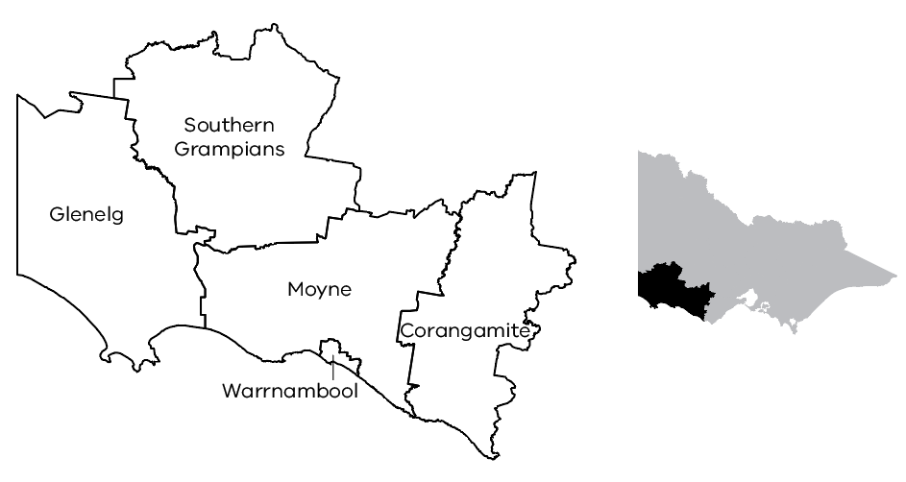

Case study

Drought response and regional advocacy
Seasonal conditions impacted agricultural production across the Great South Coast, with effects observed in the Southern Grampians local government area in 2024-25.
In August 2024, the GSCRP met with stakeholders and identified significant issues relating to feed and water availability. These conditions were followed a dry autumn and limited spring rainfall, which affected pasture establishment and reduced cash flow across the farming sector.
The GSCRP engaged with government agencies to support coordinated response efforts, including:
escalating concerns relating to water and fodder logistics
promoting available financial support programs and advisory services
coordinating feedback to inform departmental briefings.
The Rural Assistance Commissioner visited the region to engage with stakeholders ahead of a visit from the Minister for Agriculture. Following this engagement, the Minister announced a $13.53 million support package for farming communities impacted by the drought. Of the 11 local government areas eligible for assistance, 5 are located within the Great South Coast region.
An additional $37.7 million of drought support was announced in May 2025.
With drought conditions continuing to impact the agriculture sector, the Great South Coast Regional Partnership remains focused on providing advice to support coordinated, long-term resilience measures and targeted investment to sustain regional communities.

Wimmera Southern Mallee
In 2024-25 the Wimmera Southern Mallee Regional Partnership (WSMRP) continued to advocate for key enablers to achieving economic, social and cultural development within the Wimmera Southern Mallee community, but with a sharpened focus on regional economic development.

Regional priorities
The focus areas for the WSMRP underwent a major revision in October 2024 and will be used to guide the activities for the partnership over its next term. These focus areas and their enablers will inform the WSMRP’s annual workplans over the next 4 financial years, starting in July 2025
Food and fibre – Support and foster value-add opportunities to WSM’s primary production industries, particularly food manufacturing and extractive processing of grains, pulses and oilseeds in the region. Target new rural pipelines and water reuse projects that underpin future intensive regional primary production and food processing
Connectivity – Ensure community access to emerging digital technologies to eliminate mobile phone and internet blackspots. Identify regional road upgrades that deliver road freight efficiencies and continue to encourage rail freight as a viable alternative to road transport. Advocate for WSM infrastructure to support an inter-modal hub with rail access to 4 ports
Clean economy – Through education and collaboration, minimise community and landholder resistance for renewable energy infrastructure. Establish and implement best practice frameworks for co-existence of mining and renewable energy with agriculture. Collaborate and support the community to realise the tangible economic benefits from hosting renewable energy infrastructure and mineral sands mining
Housing – Work with all levels of government to accelerate regional housing development. The WSMRP will focus on funding trunk infrastructure to encourage private sector housing developments and implement strategies to maximise the availability of existing housing for the rental market
Workforce and skills – Identify future regional workforce and skills requirements in the mining, construction, food manufacturing, tourism and service sectors. Partner with educational providers to enhance the availability of training and skills courses in-region. Working with employers to attract and retain new workers and their families in WSM
Care economy – In partnership with employers, promote how to attract, train and retain workers in the care economy, with a particular emphasis on early childhood education and care workers. Promote extending long day care childcare services in smaller rural townships to activate a latent regional workforce.

Highlights
Welcomed the appointment of Chair, Kendra Clegg, Deputy Chair, Ray Kingston and new members for the upcoming term
In a leadership capacity, engaged with VicGrid regarding the Draft Victorian Transmission Plan, the proposed Western Renewable Energy Zone and the framework of the VicGrid Community Benefits Fund to maximise the benefits of renewable energy infrastructure and transmission lines to the regional community
Provided strategic insights on the VicGrid Community Benefits Fund, including how it will meet the interests of the Wimmera Southern Mallee region and its communities.
47,907
Population (2024)
-1.3%
Population growth (2024–2036)
$4.7B
Gross Regional Product (2024)
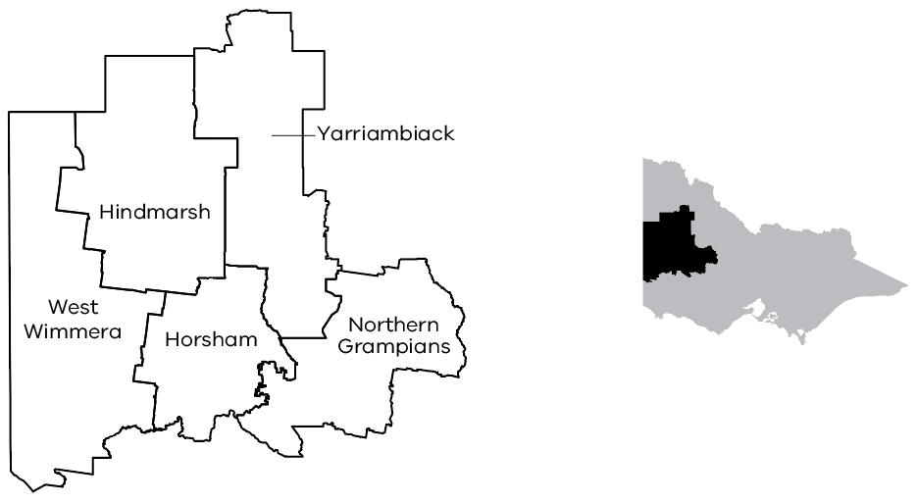

Case study

Engagement on the renewable energy infrastructure and mineral sand mines
One of WSMRP’s guiding focus areas is to ensure the regional community realises tangible benefits of hosting of renewable energy infrastructure – with a focus on the delivery of legacy projects.
This year, the WSMRP took on a proactive approach and leadership position to community consultation when concerns were raised regarding the installation of upcoming renewable energy infrastructure (including the installation of electricity transmission lines) planned by VicGrid.
By leveraging this approach and sharing their strategic insights directly with VicGrid, the WSMRP strongly advocated for community in the development of the proposed Wimmera Southern Mallee Renewable Energy Zone (REZ) and the Grampians Wimmera REZ. As an outcome of this advocacy approach, the proposed zone areas are now geographically smaller, targeted, and help to alleviate regional community anxiety over potential future wind farm locations. This outcome will directly support the regional community to realise the tangible benefits of their planned renewable energy infrastructure.
This proactive approach is being extended to community engagement practices with mineral sand mines proponents via a Wimmera Southern Mallee Development-led program. The WSMRP wishes to ensure best practice engagement with the community to support regional economic outcomes for the region.

Central Highlands
In 2024-25, the Central Highlands Regional Partnership (CHRP) honed its regional priorities to drive transformational economic growth for the communities of the Central Highlands. The Central Highlands is a vital contributor to Victoria’s economy – an economy that has grown in relative terms faster than any other state over the past decade.
The CHRP is prioritising growth of high-quality jobs and productive capacity in its pursuit of transformational economic growth for the region, and has identified 3 regional priorities:

Regional priorities
Food and fibre – Convert the Central Highlands’ strengths in primary production to capture greater high-value processing and profit in the region
Advanced manufacturing – Continue to evolve the Central Highlands’ strong manufacturing base towards specialised advanced manufacturing opportunities
Circular economy – Activate the Central Highlands’ circular economy to maximise net-zero economy opportunities.

Highlights
Supported the development of a regional Strategic Transport Assessment, in collaboration with the Department of Transport and Planning, to gain greater understanding of how public transport can also be part of the region’s growing economic development, social and housing needs. This assessment is being co-funded by the Greater Ballarat Alliance of Councils (GBAC) and the Victorian Government’s Flexible Local Transport Solutions Program. The work includes an in-depth analysis of current transport routes, including public transport, freight and residential traffic
Developed 2 submissions to inform the Draft Renewable Energy Zone (REZ) Community Benefits Plan and the draft Victorian Transmission Plan in consultation with VicGrid and RDA Grampians
Facilitated the Central Highlands Housing First Feasibility and Business Case in partnership with the Central Highlands Homelessness Alliance and key regional social housing providers. This work was welcomed by housing services in the region and used by multiple organisations to inform their submissions into the Victorian Parliamentary Inquiry into the Supply of Homes in Regional Victoria. It will also underpin a regional housing pilot program in 2025-26
Advised the government on regional housing issues and collaborated with Central Highlands councils and the Victorian Land Coordinator-General to identify surplus government land to support housing targets outlined in Victoria’s Housing Statement
Supported delivery of the Western Victorian Grain Supply Chain Study. Victoria’s grain industry plays a pivotal role in the agricultural sector, accounting for 39% of all national exports. Rail and road transport are vital to the domestic and bulk overseas export supply chain, transporting produce from farms in regional areas to storage facilities and ports. Despite recent improvements to the regional transport infrastructure, there are still opportunities for further enhancements to bring lasting benefits and enhance freight efficiency for the grain industry and supply chain network. This study informs what investment is required to progress those opportunities
Recruited a new Chair, as well as new business and community members to commence the third term of the CHRP.
223,669
Population (2024)
22.8%
Population growth (2024–2036)
$13.1B
Gross Regional Product (2024)
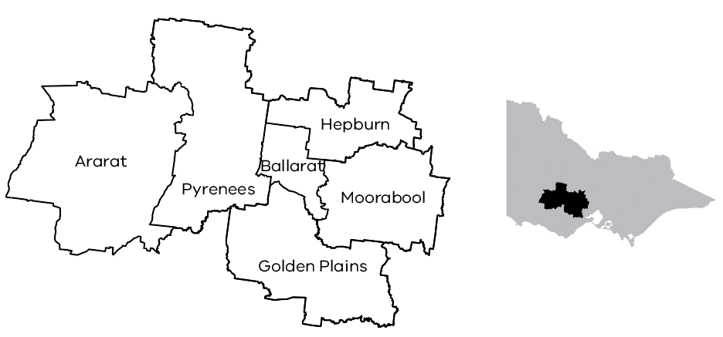

Case study

Supporting housing in the Central Highlands
The Central Highlands population is growing faster than the regional Victorian average and the housing market is failing to deliver new housing stock to meet this growth. A critical lack of appropriate, affordable and sustainable housing is blocking transformational opportunities and contributing to significant economic development barriers in the Central Highlands. In response, the CHRP worked with regional partners and the Victorian Government to support the delivery of private, rental and public housing in the Central Highlands by:
clarifying the type of housing needed in the Central Highlands – published the Central Highlands Housing Guiding Principles to articulate the specific housing needs of our regional communities and presented these to the Victorian Government
supporting Victoria’s Housing Statement – engaged with Homes Victoria to seek the region’s fair share of the $5.3 billion Big Housing Build Fund, the $1 billion Regional Housing Fund and the $150 million Regional Worker Accommodation Fund
investigating surplus government land for new housing – facilitated discussions between the Victorian Land Coordinator-General and regional councils to identify opportunities for new housing on surplus government land in Ballarat and Ararat
informing a future model of regional social housing provision – led a regional collaboration with social housing service providers to better understand the levels of need for social housing in the Central Highlands and explore international best practice models for delivering those services into the future.

Ovens Murray
In 2024-25, the Ovens Murray Regional Partnership (OMRP) continued to strengthen regional collaboration, deepening its understanding of transformational opportunities, ensuring the region’s unique perspective was included in government strategies and advocating for investments in key enablers to achieve sustained economic growth and prosperity in the region.

Regional priorities
Economic resilience and prosperity – Drive regional economic growth and prosperity by leveraging our key and emerging industries – agriculture, tourism, manufacturing and logistics, while addressing housing and workforce shortages
Climate change and renewable energy – Position Ovens Murray as a climate adaptation leader with a renewable energy future. Champion and protect our environmental assets central to our regional offering. Build on our climate change resilience and economic competitive advantage to deliver benefits the regional community
Connectivity as a crucial enabler – Connect Ovens Murray to other regions and the world by establishing strong telecommunications networks, a digitally-literate population and innovative industries. Ensure an efficient, effective and integrated transport network that connects our communities and enables industry supply chains.

Highlights
Welcomed 5 new business and community members including a new Chair and Deputy Chair, and 2 ex-officio members
Built capability and capacity of the Ovens Murray Digital Futures Coordination Group through training and information sharing, and strengthened regional collaboration to progress the implementation of the Ovens Murray Digital Plan
Worked with VicGrid to understand the draft Victorian Transmission Investment Framework and the proposed Renewable Energy Zones Community Benefits Scheme, providing a formal response to government with recommendations
Deepened understanding of the Victorian Government’s Planning our Basin Future Together prospectus and the implications for the region, noting that 38% of water in the Murray Darling Basin comes from the Ovens Murray region
Worked with the Department of Transport and Planning to provide a formal response to the draft Plan for Victoria ensuring the region’s unique needs were considered, accurate local data was used and enabling infrastructure considerations were included
Expanded awareness and understanding of regional trunk infrastructure requirements as a critical enabler for economic and community growth and developed an evidenced-based communiqué highlighting opportunities that could be harnessed within the region through investment for discussion with government
Deepened understanding of the infrastructure investment plans for Albury Wodonga Health (AWH) and impacts to the region’s economic growth, highlighting risks and opportunities to government
Worked with the Department of Transport and Planning to improve understanding of regional transport data and land-use planning and commenced development of the Ovens Murray Integrated Transport Strategy to enable the region’s economic growth opportunities
Strengthened understanding of regional intelligence and potential economic growth opportunities by examining local data, calling on local intelligence and assessing alignment with state and Australian government strategies and policy directions, utilising the information to identify and align priorities for the OMRP into the future.
137,634
Population (2024)
11.5%
Population growth (2024–2036)
$8.8B
Gross Regional Product (2024)
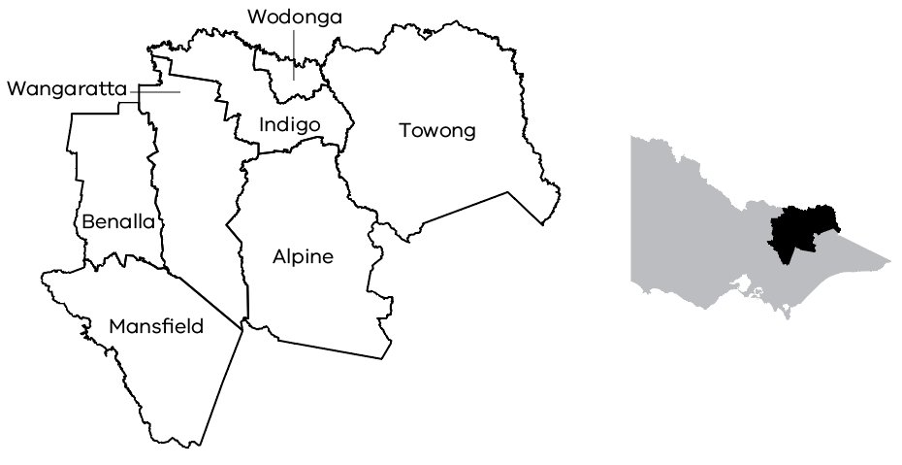

Case study

Ovens Murray Digital Plan and Digital Futures Coordination Group
Launched in early 2024, the renewed Ovens Murray Digital Plan (the Digital Plan) provides a roadmap to “leading the way in digital inclusion, innovation and entrepreneurship – creating a smart region that connects people, attracts talent, encourages innovation, and creates jobs and growth for the 21st century.”
The Digital Plan embraces 2 key themes: 1) enable and lift regional ambition, and 2) reduce the digital divide.
In 2024, a focus was to build the capability and capacity of the Digital Futures Coordination Group (a working group of the OMRP with 46 members from industry, government, health, education and telecommunications) through training in identified topics under the 6 action pillars of the Digital Plan: digital awareness, skills, safety, data use, connectivity and governance.
A highlight was the ‘deep dive’ into digital safety with presentations from NBN Company’s Chief Security Officer, Telstra’s Cyber Influence Senior Analyst and the Victorian Government’s Head of Cyber Safe Communities.
The multiplier impact of this powerful cross-sector collaboration was further demonstrated through the events that followed, including:
Digital safety communication events across the 7 local government areas
A cyber security roadshow with events in Wangaratta, Wodonga and Beechworth, led by AgBiz Assist and supported by NBN Co, AgriFutures, StartUp ShakeUp, Community Business Connect, Indigo IT Labs and the Australian Government
Victorian Women’s Trust’s Rural Women Online free digital skills workshops held over 5 days in Yackandandah with over 300 participants across age cohorts.
The Digital Futures Coordination Group also supported the Regional Development Australia Melbourne Committee and Rural City of Wangaratta to deliver an AI Forum in Wangaratta in 2025 with over 140 registrations from a diverse range of backgrounds and industries across the region.

Goulburn
In 2024-25, the newly appointed Goulburn Regional Partnership (GRP) continued to identify priorities to support and bolster transformational economic growth opportunities in the region.

Regional priorities
Support economic transition in the Goulburn Murray Irrigation District (GMID) – Continued to advocate for support for the region to navigate economic transition punctuated by issues such as water buybacks, major business closures, biosecurity events and other shocks. These issues highlight the significance of agriculture within the region and reliance on major employers within the agri-food value chain across parts of the region. The GRP previously supported the development of the Goulburn Murray Resilience Strategy which is providing evidence and framework for the region to diversify and build its adaptive capacity
Lake Eildon activation – Supported delivery of the Lake Eildon Activation Masterplan – which was developed in 2020 to identify opportunities to leverage greater visitor economy yield from Lake Eildon through new tourism product offerings and a thriving houseboat industry
Building shared prosperity for First Nations peoples – Continue to support the economic development aspirations and shared prosperity aim of the region’s First Nations peoples. The GRP has advocated for initiatives identified in the Goulburn Murray Regional Prosperity and Productivity Plan and have supported Traditional Owner groups to secure funding for initiatives such as Yorta Yorta’s Aboriginal Economic Hub in Shepparton, the Cultural Connections Centre in Barmah as well as Taungurung Land and Water Council’s Cultural Centre Feasibility Study and Business Case.

Highlights
Collaborated with Moira Shire Council to undertake a stakeholder forum to develop a funding proposal which went on to secure $815,000 from the Australian Government’s regional Precincts and Partnerships Program for the Thompson’s Beach and Kennedy Park Regional Precinct Plan
Continued to facilitate discussions with Goulburn Murray Water, Murrindindi Shire Council and the Department of Transport and Planning about activation of freehold land at Lake Eildon for future development opportunities
Farewelled outgoing inaugural members in late 2024 and recruited and inducted 5 new members in early 2025
Undertook a refresh and relaunch of the Goulburn Murray Resilience Strategy
Worked with the Place Based Strategy, Insights and Coordination team to develop and present a snapshot of the Goulburn region’s economy to support Regional Partnership induction
Supported the Eildon Boat Club to secure $814,700 from the Australian Government’s regional Precincts and Partnerships Program to develop its Maritime Community Hub
Supported Yorta Yorta Nation Aboriginal Corporation to secure Regional Tourism Investment Funding for the Yorta Yorta Cultural Connections Centre in Barmah
Held a Regional Partnership meeting at Numurkah in Moira Shire to continue to support economic transition for Goulburn Murray Irrigation District (GMID) by discussing regional drought impacts which have informed policy development and government response.
184,436
Population (2024)
42.2%
Population growth (2024–2036)
$11.2B
Gross Regional Product (2024)
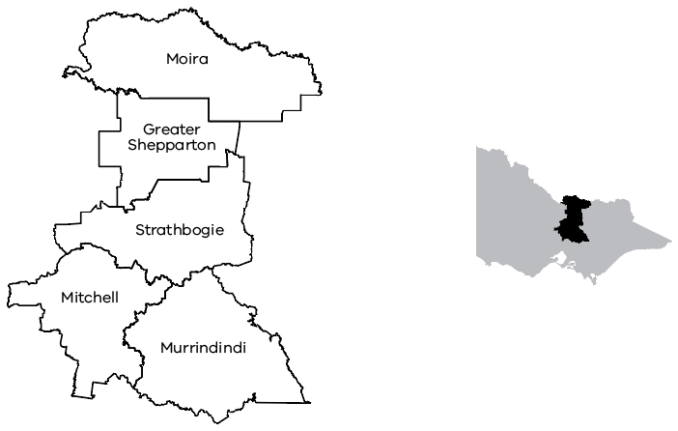

Case study

Activation of Lake Eildon
The Lake Eildon Development Masterplan continued to deliver economic benefit and prosperity for the community in 2024-25. Originally developed in 2020 using seed funding from the GRP, the Masterplan outlines a package of projects and initiatives to support economic growth and greater visitor economy yield for the lake as a regionally significant tourism asset.
Since the development and implementation of the Masterplan, several projects have been fully realised, including the recently completed Gough’s Bay Boat Club redevelopment and Eildon Reserves development.
The GRP also supported the Eildon Boat Club to secure $814,700 from the Australian Government’s Regional Precincts and Partnerships Program to develop a Maritime Community Hub to further develop Eildon’s world-leading houseboat industry and create a new community hub. This year also saw the GRP secure funding for design and feasibility of the Eildon Hotel development.
The GRP continues to support and facilitate positive discussions with Goulburn Murray Water, Murrindindi Shire Council and the Department of Transport and Planning about activating freehold land for future development opportunities around Lake Eildon.

Mallee
In 2024-25 the Mallee Regional Partnership (MRP) maintained its focus on supporting initiatives that recognise the strengths of the region, including agribusiness and the cross border economy, and sought to address economic enablers such as workforce housing and childcare.

Regional priorities
Workforce housing – Workforce attraction is an ongoing area of focus for communities across the Mallee, with available housing a key constraint to workforce attraction and retention
Tri-State Economic Zone – Harnessing the potential of the region’s cross border zone is a key priority for both the MRP and RDA Loddon Mallee. The northern Mallee border region covers 14 local government areas across New South Wales, Victoria and South Australia and is experiencing the emergence of large-scale, new and expanded projects across the critical minerals mining, renewable energy and irrigated horticulture sectors
Childcare in rural communities – Improving access to childcare in rural and regional communities is a priority for increasing workforce participation.

Highlights
Supported the Loddon Mallee Housing Group to progress strategic opportunities in the region and promoted opportunities to develop housing through initiatives such as the Regional Worker Accommodation Fund
Supported the Swan Hill Rural City Council to plan and construct 8 worker accommodation houses in Ronald Street, Robinvale
Contributed to the Cross Border Industry Taskforce and the Tri-State Economic Zone Working Group to support increased collaboration in the cross border region
Collaborated with the WSMRP and the LCRP to deliver the Sustainable Childcare for Rural Kids project and explored opportunities to bring stakeholders together to promote enhanced childcare access
Supported the Central Murray Regional Transport Forum in the development of the Central Murray Regional Transport Strategy.
95,080
Population (2024)
4.7%
Population growth (2024–2036)
$7.0B
Gross Regional Product (2024)
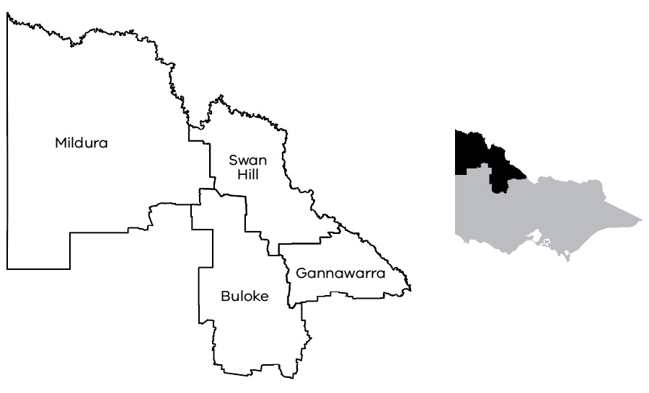

Case study

Cross Border Industry Taskforce
RDV is supporting the industry-led Cross Border Industry Taskforce (CBIT), facilitating discussions across Victorian Government with counterparts in New South Wales and South Australia to activate support to address workforce and economic opportunities arising from investment in renewable energy, mineral sands mining and irrigated agriculture in the region.
The taskforce, which comprises members from mineral sands mining companies, horticulture operations, civil construction and logistics sectors from New South Wales, Victoria and South Australia, is focused on meeting workforce and resourcing needs of the region’s 2 emerging industries, critical minerals and renewable energy production, while supporting and continuing to see development in the significant agricultural and horticultural region.
The MRP is supportive of the goals of the CBIT and works with RDV to support connections into Victorian Government through relationships with Cross Border Commissioners and government departments.
Opportunities for continued collaboration and alignment to support economic growth of the cross border region are being strengthened through collaborative work that aligns key strategic priorities of the partnership – particularly in relation to economic enablers such as worker housing, skilled workforce and childcare.

Loddon Campaspe
Central Victoria’s Loddon Campaspe region has a diverse population and a buoyant economy. The Loddon Campaspe Regional Partnership (LCRP) was renewed in December 2024 with revised Terms of Reference and 6 new community members joining the partnership in 2025. The LCRP is committed to continuing to pursue key economic outcomes for the region with a strengthened focus on economic development.

Regional priorities
Investment facilitation – Continue to invest in facilitation for value-add economic growth in agriculture, food and fibre, advanced manufacturing and mining
Loddon Campaspe Digital Futures – Create a Bendigo Regional Digital Innovation Hub in collaboration with LaTrobe University, to accelerate investment in new economy jobs and provisioning of digital capability in skills, connectivity and capacity enhancing services across the region
Employment – Drive actions to support sustainable regional growth ambitions and improved integrated infrastructure planning.

Highlights
Supported the Bendigo AI Digital Summit with over 120 participants, held at LaTrobe University, in partnership with RDA Melbourne
Supported advancement of the region’s digital capability via the development of a Bendigo Regional Digital Innovation Hub proposal through the Australian Government’s regional Precincts and Partnerships Program, inclusive of Deloitte’s new digital back-of-house digital hub in partnership with Latrobe University based at its Bendigo campus
Supported the Bendigo Art Gallery redevelopment, a $45 million expansion and redevelopment project, which will be the largest-ever construction project to be led by the City of Greater Bendigo
Supported the completion of the Maryborough Railway Station upgrade and activation including the ‘Truth Telling, Healing and Creating for Community on Djaara Country’ project which provides visitors with insights into the history of the Traditional Owners of the area.
259,954
Population (2024)
15.5%
Population growth (2024–2036)
$15.9B
Gross Regional Product (2024)
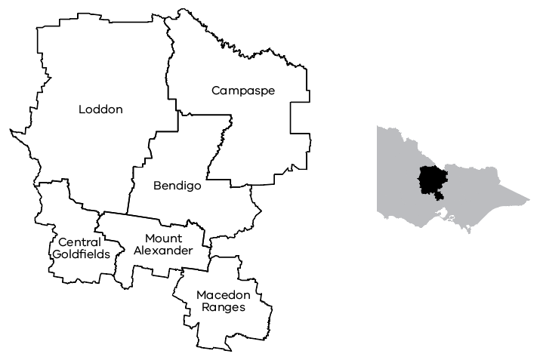

Case study

Universal early childhood education and care (ECEC) for rural areas – delivering children, families and the economy
This initiative focused on addressing the ‘childcare desert’ across north-western Victoria. The LCRP joined forces with the Wimmera Southern Mallee Regional Partnership and the Mallee Regional Partnership alongside our RDA Loddon Mallee and Grampians committees to seek improved access to childcare in rural areas.
This advocacy included the creation of a taskforce to advocate for improved outcomes for rural childcare based on findings of the Sustainable Childcare for Rural Kids Report. The report, which considered 10 small rural townships with un-serviced or underserviced childcare needs across Wimmera Southern Mallee, Mallee and the Loddon Campaspe regions, was co-funded by RDV through the Mallee, Loddon Campaspe and Wimmera Southern Mallee Regional Partnerships.
The taskforce continues to advocate for improved access to childcare in small rural communities – supporting increased productivity of the local economy, enabling workforce participation of women and providing much needed support for families and children.

Gippsland
In 2024-25, the Gippsland Regional Partnership (GRP) concentrated on advancing several core initiatives outlined in its Priority Action Plan. A major area of focus involved responding to community and stakeholder feedback, particularly around the urgent need for workforce housing solutions and infrastructure improvements. At the same time, the GRP continued to prioritise its strategic goal of attracting and retaining a skilled workforce, with a strong emphasis on migration as a key enabler. Efforts were made to lay the groundwork for the future, including the recruitment process for members of the 2025-28 Regional Partnership, ensuring continued leadership and representation for the region.

Regional priorities
Strengthen migrant attraction and retention – Finalise the key initiative to attract and retain migrants by launching and activating the Migration Charter
Community Resilience – Actively engage in the Gippsland New Energy Conference to promote and advocate for the strategic development of the Gippsland Renewable Energy Zone, highlighting its potential to drive regional economic growth, energy security and sustainability.

Highlights
Opened applications for key leadership and governance roles, including Chair, Deputy Chair, and committee member positions. The call for expressions of interest attracted strong community interest. Following a comprehensive selection process, 6 new community members were successfully appointed to the partnership, bringing fresh perspectives, diverse experience and a continued commitment to advancing Gippsland’s regional priorities
Launched The Migration Charter in November 2024, an important framework to build a positive and welcoming Gippsland for migrants. The charter was developed with valuable support, guidance and research from Federation University’s Collaborative Evaluation and Research Centre. This collaboration culminated in a practical guide aimed at attracting, supporting and retaining a migrant workforce – an essential requirement for the region’s continued growth, productivity and long-term prosperity
Leveraged insights from the workforce housing project to guide feedback and submission on Plan for Victoria
Submitted a response to Victoria’s 30 Year Infrastructure Strategy, addressing 24 recommendations to advocate for the region’s needs. Key areas of support included expanding TAFE to drive innovation and strengthen trade skills in renewable energy; rezoning land near existing infrastructure to increase housing options and to improve access to public transport for employment, health services and education; and enhancing the competitiveness, reliability and efficiency of rail freight to better connect regional products to market.
311,284
Population (2024)
14.8%
Population growth (2024–2036)
$24.5B
Gross Regional Product (2024)
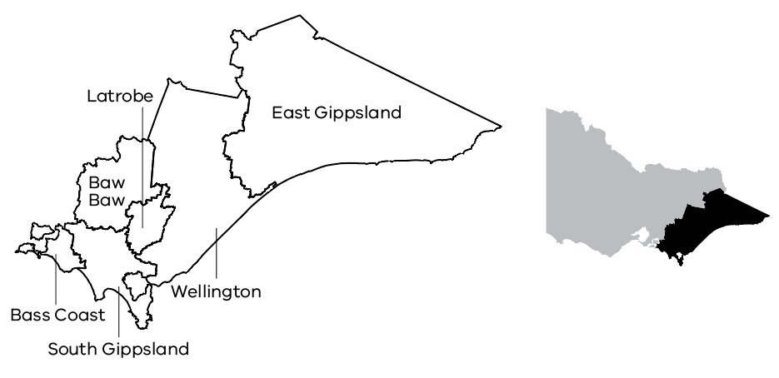

Case study

Gippsland Migrant Recruitment and Retention Charter
In 2023, the GRP partnered with the Collaborative Evaluation and Research Centre at Federation University to advance a key strategic priority focused on migrant workforce attraction and retention. With $50,000 in funding from the partnership, Federation University led a series of co-designed engagements between September 2023 and May 2024 to better understand the experiences and sentiments of migrant workers across Gippsland. These engagements provided valuable insights into the factors that influence both the attraction and retention of migrants in the region and deepened understanding of the challenges and opportunities faced by migrant communities.
A key outcome of the project was the development of the Gippsland Migrant Recruitment and Retention Charter, a practical guide designed to support employers and communities across Gippsland in attracting, welcoming and retaining migrant workers. The charter outlines shared values, guiding principles and evidence-informed strategies drawn directly from the lived experiences of migrants in Gippsland.
Launched in November 2024, the charter represents a region-wide commitment to inclusive workforce development. The launch and activation of the charter were supported by a $10,000 contribution from the RDA Gippsland Committee, reinforcing a collaborative regional approach to addressing workforce challenges and supporting long-term settlement and participation of migrants in Gippsland’s economy and communities.

Regional Development Australia
Regional Development Australia (RDA) Committees are a national network made up of local people creating local economic opportunities.
RDA Committees form a national network of 50 locally driven advisory groups focused on creating economic opportunities within their regions.
In Victoria, 6 RDA Committees – Barwon South West, Gippsland, Grampians, Hume, Loddon Mallee and Melbourne – operate as advisory bodies supported by RDV. These committees work closely with Regional Partnerships, all levels of government and place-based authorities to address regional challenges and foster opportunities for economic growth.
The RDA initiative in Victoria benefits from a strong and cohesive network of Chairs that meet regularly throughout the year. This collaboration enables a coordinated approach to advance statewide priorities for regional and rural communities. Supported by RDV, RDA Chairs play a vital role in developing strategic submissions, advising government and supporting efforts to attract investment to regional Victoria.
In 2024-25, Victoria’s RDA committees delivered a work program which supported 4 statewide themes:
Economic growth
Economic enablers, such as housing, digital connectivity, innovation and productivity
Clean economy
Workforce participation.

Highlights
Undertook a robust recruitment campaign for Chair, Deputy Chair and member appointments, ensuring strong regional representation on all Victorian RDA Committees
Designed and conducted local engagements with newly elected council members within local government, together with regional stakeholders to build the understanding of RDA’s role, purpose and strategic direction, whilst supporting alignment of shared priorities to support economic development
Hosted thought leadership events aimed at regional business to build productivity, efficiencies and strategies for adopting artificial intelligence (AI) technologies
Developed strategic investment prospectuses to support targeted investment attraction opportunities
Initiated and led early development of the Tri-State Economic Zone (TSEZ), bringing together cross border leaders to explore a collaborative economic model focused on horticulture, trade, transport, skills and regulatory alignment
Worked with education providers, industry and workers to identify skills and jobs required to grow, support and maintain the regional economy
Commissioned a comprehensive housing study in the Hume region that identified key barriers to housing supply, such as infrastructure costs and limited housing diversity. Findings will be used to inform advocacy and support strategic planning for future development across the region
Worked closely with proponents to promote the awareness and opportunities of Australian Government programs, resulting in 9 strategic projects funded by the regional Precincts and Partnerships Program.

Barwon South West case study

Renewable hydrogen and energy investment opportunity
In 2024-25, RDA Barwon South West (BSW) supported the Great South Coast Economic Futures Stage 2 to drive on investment facilitation, knowledge sharing and business case development. The project, led by Deakin University achieved notable outcomes including the completion of the Agricultural, Food and Fibre Prospectus 2025, and input into the RDA-funded Barwon South West Hydrogen Investment Prospectus (launched June 2025).
The project showcased the Great South Coast to potential investors by exhibiting in EvokeAg, a leading agrifood technology and innovation event held in Brisbane.
The Economic Futures project also delivered the South West Hydrogen in Dairy Investor Showcase and the Great South Coast Food & Fibre Strategic Plan for Investment Attraction and Climate Resilience. All these outcomes align with the RDA BSW Committee’s strategic priorities for the 2024-25 year.

Gippsland case study

Building adaptive capacity for energy transition
The RDA Gippsland Committee is focused on supporting Gippsland in its transition to net zero, with 2 key initiatives delivered in 2024-25 to build the region’s adaptive capacity.
The committee led a delegation to Canberra, taking a positive renewable energy message to federal policy makers in consultation with local government, business and industry. Key components of the advocacy campaign included:
calls to develop a national offshore wind target to catalyse domestic supply chain growth
targeted investment for Gippsland’s vocational education and training and tertiary education to support workforce readiness
a National Port Strategy to support the establishment of offshore wind and enhance Gippsland’s access to market
investment in enabling social infrastructure, ensuring residential, industrial and commercial land is adequately serviced to meet anticipated industry demand, backed by service planning to respond to projected workforce changes
promotion of community benefit models that emphasise meaningful partnerships, moving beyond compensatory approaches to generate lasting, positive impact.
Building on the advocacy efforts of the RDA Gippsland Committee, the team commissioned 2 Economic Insights forums to ensure the region has access to credible, high-quality economic data that supports strategic planning, drives economic uplift and helps realise Gippsland’s full potential to benefit from the transition to renewable energy. Delivered in Bairnsdale and Morwell, the forums bought together a broad cross section of regional stakeholders from business and industry, educational institutions, councils, community and all levels of government.
The forums highlighted facets of the economy worthy of a deeper dive and focus, including land development, renewable energy supply chain and business development within the M1 growth corridor, housing, and import levels within the region. RDA Gippsland will continue to drive progress to realise benefits, identify constraining factors and discuss opportunities to optimise development of the region in these areas.

Grampians case study

Grampians Regional Forum
RDA Grampians delivered the Grampians 2025 and Beyond: A State of the Region Forum. The event brought together over 130 regional leaders, including councillors and executives from all 11 of our local government areas, Traditional Owner representatives, government executives, and industry stakeholders to shape a shared vision for economic growth.
With 60% of councillors newly elected in our region, the forum offered an opportunity to engage with regional data, strategic insights and regional priorities beyond individual municipal boundaries. The aim was to equip leaders with the insights needed to make informed, future-focused decisions.
The forum program centred around 3 expert-led panel discussions designed to deepen understanding of the region’s key economic drivers – mineral sands mining, renewable energy, agriculture and advanced manufacturing.
The discussions highlighted the scale of change already underway and encouraged practical thinking around how to manage economic transitions, forge effective partnerships and ensure that growth translates into tangible benefits for our communities.
According to post-event surveys, 96% of attendees found the content relevant to their work, and 90% rated the networking opportunities as excellent or good.
Building on this strong foundation, RDA Grampians is committed to embedding a spirit of regional collaboration into its ongoing work to support a coordinated, strategic and connected approach to economic development across the Grampians.

Supporting regional transition through bioenergy
RDA Grampians partnered with the Victorian Bioenergy Network to host a regional Bioenergy Forum in Ballarat. One of several events held across the state, the forum aimed to build momentum around bioenergy as a viable renewable energy source.
Over the next decade, renewable energy production will be a key driver of regional economic growth and future job creation, delivering long-term community benefits and helping to build vibrant, resilient communities across the Grampians region.
The Bioenergy Forum brought together leaders from industry and government who are working to advance the use of biomass across key sectors including agriculture, water, food production, waste and manufacturing.
In the Grampians region, robust agricultural and manufacturing sectors currently produce large volumes of organic waste with untapped potential for renewable energy generation. Bioenergy presents a practical, local solution by sustainably transforming waste into clean energy, reducing or offsetting rising energy costs, strengthening regional energy security, and helping these sectors meet their environmental emissions targets.
Technologies like biogas and renewables offer essential pathways to decarbonise hard-to-abate industrial sector byproducts. The forum highlighted the region’s potential to attract significant investment in infrastructure, technology and workforce development in resource recovery. By harnessing this opportunity, RDA Grampians can position the region as a leading contender in circular economy innovation.
RDA Grampians will continue to support these efforts by promoting opportunities and strengthening partnerships which help navigate the transition toward low-emissions energy solutions that maximise our region’s strengths.

Hume case study

Hume Housing Prospectus
The RDA Hume 2024-25 Business Plan identified housing as a significant barrier to economic development in the Hume region. To begin to understand how to address this barrier, the RDA Hume committee commissioned a study that would draw on the expertise of local government, the Victorian Government and the private sector.
The study undertook extensive data analysis, stakeholder engagement and feasibility analysis to identify potential development opportunities. It provided significant insight into barriers affecting the supply of new housing in the Hume area, including:
the need to diversify the types of housing to meet future need and changing demographics
identifying significant cost barriers to development such as enabling trunk infrastructure (water, electricity etc.)
understanding market requirements for a development project to be financially feasible.
This work has informed the advocacy efforts of RDA Hume including a submission to the Victorian Parliamentary Inquiry into the supply of homes in regional Victoria, and representations to other Victorian Government departments for the potential supply of land for future housing.

Loddon Mallee case study

Strengthening tri-state collaboration and supporting the concept of a Tri-State Economic Zone
The RDA Loddon Mallee Regional Development Australia committee, the Mallee Regional Partnership, and the Victorian Cross Border Commissioner have been working in partnership to understand the economic potential of the Mallee region’s cross border zone. Together, they commenced preliminary investigations into possible tri-state collaboration opportunities.
A scoping study exploring the feasibility and benefits of a Tri-State Economic Zone (TSEZ) spanning New South Wales, Victoria and South Australia revealed a substantial economic base in the region, representing more than $1.7 billion in horticultural exports. The TSEZ presents a unique opportunity to leverage shared regional strengths in workforce development, freight and logistics, planning, skills and horticulture.
In 2024-25, the partnership established the TSEZ Working Group, bringing together the CEOs of local councils from the Murray, Mallee and Riverland regions, the relevant RDA Chairs and government representatives across the 3 states.
The Working Group supported further exploration into the TSEZ. With funding from RDA Loddon Mallee, a stakeholder engagement plan was developed to identify potential areas of focus for the economic zone.
The project will continue to explore potential governance models and key areas of focus including workforce outcomes, improved transport and freight efficiencies, expansion of horticulture and agribusiness, minerals processing, waste management, skills training and the visitor economy.

Melbourne case study

Regional forums
In 2024-25, RDA Melbourne continued to build on its capital city RDA mandate by assisting regional Victorian RDAs to realise their strategic directions, investigate collaborative opportunities and develop projects to benefit the regional economy. Innovation and productivity gains through adoption of technology was a focus for RDA Melbourne.
RDA Melbourne held a series of forums throughout regional Victoria centred around supporting industry and business to build their capacity to integrate artificial intelligence (AI). With over 400 participants attending the forums, RDA Melbourne successfully encouraged and showcased how business and individuals can benefit from the adoption and usage of this technology. The key insights were how AI can enhance competitiveness and optimise productivity, introducing participants to resources tailored to their AI journey.
RDA Melbourne partnered with regional RDA committees, the Rural City of Wangaratta, LaTrobe University, Swinburne University, Deakin University and industry bodies such as the National AI Centre (NAIC), Australian Regional AI Network, Advanced Robotics for Manufacturing Hub and the Future Skills Organisation to bring expertise, knowledge and information to regional businesses. Recommendations were put forward to support further advancements in productivity, digital adaptation, skill development and continuous improvement – all characteristics of a strong innovation system.
Phase 2 of this project will examine how innovation hubs and their relationship with regional businesses can be further optimised. This will be undertaken in late 2025.

Cross Border Commissioner: Working with border communities
Throughout 2024-25, Victoria’s Cross Border Commissioner remained committed to supporting border communities, ensuring their unique challenges were addressed.
Based at RDV’s Portland office, the Commissioner travelled extensively, covering over 50,000 kilometres, and engaging with communities along Victoria’s borders, from Nelson in the southwest to Murrayville, Mildura, Wodonga, Tallangatta in the northeast and Mallacoota in the east.
There are 28 local government areas located along Victoria’s borders. These border communities, home to over 575,000 residents, stretch across both sides of the state’s land boundaries. They include major urban centres such as Portland, Albury-Wodonga, Mildura, Mallacoota, and Echuca-Moama, as well as smaller, more remote towns like Bendoc and Bonang in far East Gippsland, Murrayville in the far northwest, and Nelson in Victoria’s southwest corner.

Cross border priorities
Through engagement with hundreds of stakeholders, including local government representatives, health service providers, emergency responders, business leaders and community members, the Commissioner shaped the following 2024-25 cross border priorities:
Economic development: Tri-state economic collaboration, infrastructure improvements, and critical minerals mining
Workforce: Vocational education and training access, subsidies and skills mobility through automatic mutual recognition
Health infrastructure: Workforce constraints, different health settings, funding challenges, catchments beyond state lines
Policing and justice: Regulatory variations, information sharing, workforce issues, Justices of the Peace, warrants and child protection
Emergency management: Advising on cross border community impacts before, during and after emergency events to minimise adverse consequences.

Stakeholder collaboration and strategic influence
Building on previous efforts, the Commissioner spearheaded initiatives to enhance governance and service delivery, including:
ensuring cross border impacts are considered in government decision making to prevent or reduce anomalies
advancing provisions in government programs that explicitly support isolated border communities
promoting complementary growth opportunities such as the portability of TAFE subsidies, automatic mutual recognition and improved funding access
strengthening intergovernmental relationships through agreements with New South Wales and South Australia.
Additionally, the Commissioner provided strategic input on emergency management, including natural disaster response and biosecurity events, fostering collaboration to address cross border risks effectively.

Forums and engagements
The Commissioner played a pivotal role in driving key regional discussions, bringing stakeholders together by hosting and attending influential events that promoted cross border collaboration and policy outcomes:
Forums hosted:
Cross Border Health Summit (Renmark) – bringing together health service providers from Victoria, New South Wales and South Australia
Ambulance Working Group – a spinoff from the Health Summit, the Commissioner met twice with representatives from Ambulance organisations from the three states hearing about key issues for these service providers in border settings
Victoria/South Australian Local Government Authority CEOs Forum (Portland)
Cross Border Policing Forum (Albury)
Cross Border Councils Breakfast (Canberra)
Infrastructure planning on the border with senior representatives from the Department of Transport and Planning and Transport for New South Wales.
Key events attended:
2024 Australian Local Government Australia (ALGA) Conference (Canberra)
Regional Australia Institute Regions Rising (Canberra)
CFA Emergency Management Forum (Lakes Entrance)
Murray River Group of Councils meeting (Wodonga)
Quarterly Commissioner Forums (Adelaide, Mildura, Canberra)
Meeting with National Skills Commissioner Prof Barney Glover (Canberra)
Meeting with Minister Kirsty McBain, MP, Minister for Regional Development, Local Government and Territories; and Minister for Emergency Management.

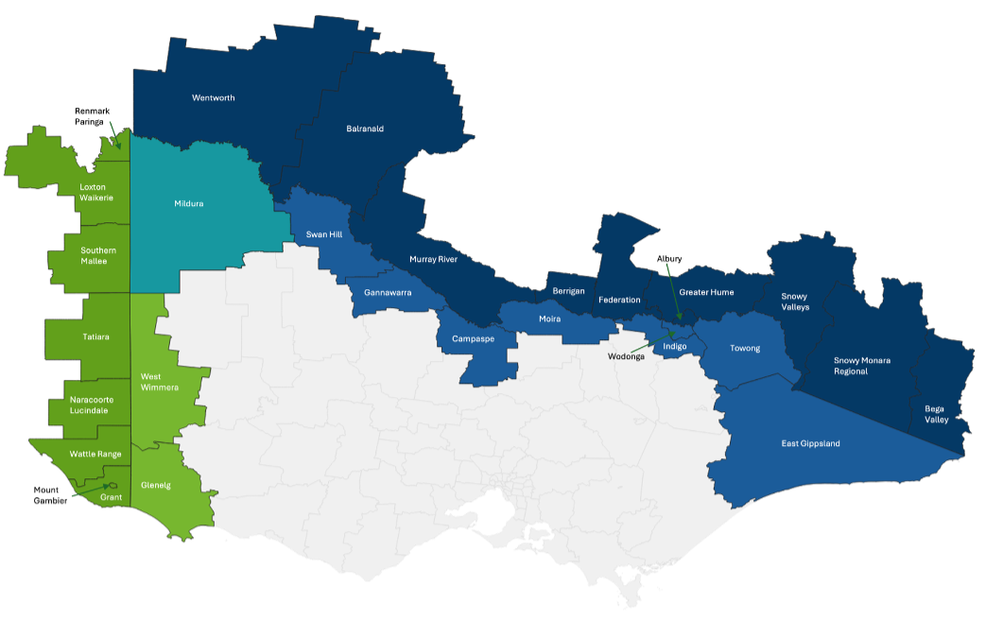

Key achievements
The Commissioner delivered key initiatives to enhance cross border collaboration:
Finalised the Draft Victorian Cross Border Commissioner’s Strategic Plan 2024-26
Developed and signed the Inaugural South Australian Memorandum of Understanding for Cross Border Collaboration in October 2024
Signed the revised and updated New South Wales Memorandum of Understanding in May 2025
Addressed 404 cross border anomaly enquiries since program inception, with a 73% resolution rate as of May 2025
Targeted letters of advice outlining key cross border anomalies were provided to all department secretaries and key agencies, strengthening policy engagement and ensuring greater awareness and coordination on interstate challenges
Facilitated the inclusion of cross border recognition, supporting integrated service delivery and development of border cities such as Mildura, Wodonga and Echuca, in Plan for Victoria
Introduced a Responsible Service of Alcohol (RSA) free online bridging course which allows individuals holding a nationally accredited RSA qualification from another state or territory to have their certification recognised in Victoria
Resolved a national food manufacturer’s supply chain crisis within 24 hours, through rapid intervention alongside the New South Wales Cross Border Commissioner, to secure business continuity and 90 jobs through coordination between Agriculture Victoria and New South Wales Department of Primary Industries.

Regional intelligence and future opportunities
Emerging insights gathered from internal and external stakeholders highlight growing interest in cross border economic collaborations, which could further harmonise regulatory controls and create new opportunities for trade, economic growth and community wellbeing.

Geelong City Deal
The $676.15 million Geelong City Deal (GCD) is a 10-year partnership between all levels of government working with industry, community, the private sector and First Peoples to revitalise Geelong and achieve the potential of the Great Ocean Road economy.
2024-25 marks the sixth year of GCD delivery, with 20 of 32 projects now complete. The GCD’s 2 major projects (the $449.1 million Nyaal Banyul Geelong Convention and Event Centre (GCEC) and the $126 million Twelve Apostles Precinct Redevelopment) remain on track for completion in 2026.

Key achievements in 2024-25

Nyaal Banyul Geelong Convention and Event Centre
GCD’s flagship project, the Nyaal Banyul GCEC, is now more than half-way through construction. Structural and exterior works were completed in May 2025, with work on the interior well underway, including the 1,000 seat Plenary Hall and 2 large exhibition hall spaces.
Completion of the 25,000-tile façade celebrates the partnership with the Wadawurrung Traditional Owners Aboriginal Corporation through continued co-design processes. The façade, which reflects Geelong’s Western Beach cliffs, represents the deep cultural significance for the Wadawurrung People.
Sustainability remains a key pillar of the Nyaal Banyul design, with 1,100 solar panels now installed ensuring that the building will be powered entirely by renewable energy. This is one of several initiatives which target Climate Active Carbon Neutral and 5-star Green Star Buildings certifications.
Construction of one of regional Victoria’s largest social infrastructure projects has continued to support significant progress against social procurement commitments, including up to 45,000 employment hours for local apprentices and trainees, and directly employed 28 trainees and apprentices who have experienced barriers to employment.
As delivery of the precinct’s upscale Crowne Plaza Hotel tracks ahead of schedule, the focus is turning towards opening. The future operator, Victorian Convention and Event Trust, began taking event bookings in September 2024, and with enquiries to date, it’s expected that Nyaal Banyul will be reaping the benefits when the centre is completed in 2026.

Twelve Apostles Precinct Redevelopment
The $126.42 million Twelve Apostles Precinct Redevelopment continues to progress as a major initiative under the Geelong City Deal, delivering transformative infrastructure to enhance visitor experiences and protect the iconic Shipwreck Coast.
Further to the additional $18 million in funding provided by the Victorian Government in May 2024, the project reached a key milestone with the appointment of Kane Constructions as the head contractor for the delivery of the new Twelve Apostles Visitor Experience Centre (VEC) in December 2024. Construction commenced in January 2025 with the footprint and external façade of the building now clearly visible, and the project on track for completion by the end of 2026.
RDV continues to work with future managers, the Great Ocean Road Coast and Parks Authority (GORCAPA) to progress detailed operational planning ensuring the facility delivers world-class visitor services while preserving the region’s natural and cultural values.
The ongoing partnership with the Eastern Maar Aboriginal Corporation (EMAC) continues to play a central role in shaping the cultural narrative, design integration and interpretive strategy, ensuring self-determined Traditional Owner values and stories are embedded within the precinct.
Together, these efforts reflect a strong commitment to delivering a precinct that supports regional economic development through sustainable tourism, creating local jobs and strengthening the visitor economy.
The GCD Shipwreck Coast Priority Projects includes 8 projects under the Private Sector Business Enablement Fund leveraging over $150 million in private sector investment aimed at supporting precinct activation. These projects include accommodation projects and new visitor experiences in the region. In December 2023, a formal Partnerships Victoria agreement was signed between the Victorian Government and private sector, appointing Plenary Conventions to develop the project. Plenary Conventions has confirmed an initial investment of $120 million to secure what will be Geelong’s largest hotel, with a further $130 million earmarked to create a mixed-use development within the precinct at a later date.
The Villas, Anglesea Golf Club – service road civil works, sewer and stormwater connections, new power connection, potable water and NBN connection infrastructure works completed in August 2024
Power Creek Footbridge in Timboon – fabrication and installation of a new footbridge, associated landscaping works and visitor amenity works completed in August 2024
Geelong Smart Cities initiatives – initiatives in central Geelong utilising smart technologies to collect and analyse data to enhance community safety, optimise public space and reduce congestion completed in October 2024
Central Geelong City arrivals – new ‘Momenta’ art installation at Rippleside Park and works on the corner of Bellerine and Little Malop Streets completed in December 2024
Great Ocean Road retreat enabling works, Peterborough – power and telecommunication installations, road and stormwater infrastructure to support the accommodation investment completed in April 2025
Intersection realignment and road sealing at Princetown and Gallum Roads – works to improve safety and accessibility near the Apostles Whey Cheese Factory completed in May 2025.

Progress of other GCD projects underway in 2024-25
Moolap Management Masterplan – continued to progress the Environmental Management Masterplan including community consultation on the issues, opportunities and constraints report
Apollo Bay Harbour Redevelopment – a draft precinct plan has been prepared in consultation with the community and key stakeholders including EMAC, the Apollo Bay Fishermen’s Co-operative and the Community Reference Group
Point Grey Redevelopment, Lorne – a draft urban design framework (UDF) including site masterplan was developed in consultation with key stakeholders including EMAC, precinct partners and the Community Reference Group and was released for public consultation in June 2025
Improvements to tourism infrastructure at Kennett River – precinct plan was finalised with input from the community, the Community Reference Group and key stakeholders.

Tiny Towns Fund
In 2024-25, Round 2 of the Tiny Towns Fund (TTF) opened for applications with 159 successful projects across regional Victoria announced in May 2025, representing approximately $5.1 million of grants awarded to communities partnering with government to deliver important local projects and priorities.
This built on the success of Round 1 of TTF, where 188 regional projects were supported. Across both rounds, the program is now supporting a total of 347 regional projects across more than 300 small towns.
TTF supports community-driven projects from public art, street furniture and hiking trails, to sporting club improvements, playgrounds and community hall upgrades – projects that enhance Victoria’s smallest towns, strengthen community connections and encourage more visitors to all corners of the state.
TTF is a 4-year initiative (2023-24 to 2026-27) with $17.5 million for projects in regional and rural Victoria and $2.5 million allocated for projects in interface local government areas on the edge of metropolitan Melbourne.
TTF provides grants of between $5,000 and $50,000 to directly support community groups, local organisations and councils in towns with a population of up to 5,000 people across. The fund supports local projects to provide better public places and spaces to Victoria’s smallest communities.
Round 3 of TTF will open in 2025-26.

Case study

Silo Art – Waaia Community Incorporated
This $46,000 project was funded under Round 2 of the Tiny Towns Fund to develop silo art in the northern Victorian community of Waaia. This project was also the location for the announcement of successful Round 2 regional projects by the Minister for Regional Development in April 2025.

Regional Worker Accommodation Fund
In October 2024, the Premier and the Minister for Regional Development announced the successful projects under Round 1 of RWAF at Goulburn Valley Health in Shepparton. RWAF grants range from $150,000 to $5 million to provide key worker housing across regional Victoria. To date, RWAF has allocated $73,112,211 towards 24 projects, and helped activate investment $240 million to create 996 key worker bedrooms.
Round 2 of RWAF opened for applications following the announcement, and closed in January 2025. Recommended projects now under consideration by government and are to be announced in 2025-26.
Round 2 was delivered through a single, direct-to-application process rather than through the initial EOI process held for Round 1, given the strong interest in the program which generated many potential projects to reapply under Round 2 with better-developed and more shovel-ready projects.
The RWAF program provides new housing options for regional communities investing in housing, accommodation and infrastructure that increase the supply of appropriate and affordable housing and accommodation for key workers and their families in regional communities.

Case studies

George Weston Foods – Castlemaine
RWAF supported George Weston Foods in Castlemaine to develop key worker accommodation at its Don Smallgoods manufacturing facility. This grant uses innovative construction and modular building methods to create affordable accommodation for skilled employees in the food manufacturing and meat processing sector.

Goulburn Valley Health – Shepparton
RWAF helped to activate Stage 2 of the Goulburn Valley Health Doctor’s accommodation project in Shepparton. This project provides key worker housing for the northern Victorian health sector, and releases rental properties held by Goulburn Valley Health back into the private rental market, supporting more local housing choice.

Council Support Package
In 2024-25 projects approved under the $25 million Council Support Package (CSP) continued to be delivered across regional Victoria.
The CSP has helped activate a total of 27 local government infrastructure projects, both large and small. The fund has supported councils across all Victorian regions to invest in projects that will deliver lasting economic, social, environmental, sporting and wellbeing benefits for people living in regional and rural Victoria.
The CSP is helping councils deliver projects and activities that:
drive visitation to the regions
create better public spaces for socialising and hosting events
empower volunteers
strengthen businesses and communities
promote Traditional Owner culture, participation and leadership.
The CSP has been delivered across 2 funding streams with a focus on Regional Cities and Rural Council areas respectively.

Stream 1 Regional Cities ($23 million)
In Stream 1, there are 5 projects of up to $5 million to Greater Geelong, Greater Bendigo, City of Ballarat and Latrobe City Council, and $3 million awarded to the Greater Shepparton City Council.

Stream 2 Regional and Rural Councils ($2 million)
In Stream 2, currently there are 22 projects in delivery with funding of up to $100,000 per project.

Case study
John Landy Athletics Field Facility Upgrade ($5 million) – a major upgrade of the pavilion, grandstand, and immediate surrounds at John Landy Athletics Field in partnership with funding from the City of Greater Geelong.

Case study
Lakes Entrance Water Sports Pavilion ($100,000) – a new Lakes Entrance Water Sports Pavilion at Cummingham Arm to safely house water sport equipment, enhancing the tourism product offering and complementing the Krauatungalung Walk, in partnership with funding from East Gippsland Shire Council.
All projects are actively being monitored as part of standard grant management practices.

Growing Regions Program (GRP) and regional Partnerships and Precincts Program (rPPP)
Throughout 2024-25, RDV worked in partnership with the Australian Government to deliver funding to successful grant recipients in regional Victoria under the GRP and rPPP.
Grants under these programs are for economic and community development projects with decisions on successful projects made by the Australian Government.
In 2024-25, 25 grants were awarded with the Victorian Government receiving a total of $122,175,369 in grant funds for RDV to manage. This work involved grant contracting, the payment of grant instalments and grant monitoring and reporting.
These projects comprise:
16 projects under the GRP ($78,171,446)
9 projects under the rPPP ($44,003,923).
The GRP is a $600 million Australian Government initiative delivering investment in infrastructure across Australia’s regional, rural and remote areas. It provides funding of between $500,000 and $15 million to local government entities and incorporated not-for-profit organisations for capital works projects.
The regional Partnership Precinct Program (rPPP) is a $400 million Australian Government initiative that supports precincts across regional, rural and remote Australia to deliver transformative investment for better land use integration and to ensure infrastructure investment considers and complements the broader region, its surrounding communities, spaces, transport and activities.
The rPPP has 2 streams. Stream 1 grants of up to $5 million are for master planning, consultation, design, business cases and partnership establishment and Stream 2 grants of between $5 million and $50 million help deliver one or more elements of a precinct such as enabling public infrastructure, open spaces or a particular building that catalyses or complements other investment within a precinct.

Case study

Mitchell Shire Council – Seymour Community Wellbeing Hub Stage 1
Mitchell Shire Council received $15 million in funding under the Growing Regions Program (GRP) to deliver its Seymour Community Wellbeing Hub Stage 1 project. The project is expected to generate $95.6 million in economic benefit through construction and ongoing operations, including the creation of 35 direct and indirect jobs. The facility will provide a multi-purpose community space, café and health hub to support community health and wellbeing in Seymour.

Natural disaster relief
RDV Grampians played an important role during the 2024-25 Gariwerd National Park bushfires, working with impacted businesses and community groups by connecting them to Government support during and after this natural disaster. RDV Grampians provided business intelligence into the Incident Control Centre when required to assist decision making with regards to short, medium and long term supports offered.
RDV Grampians was a key advisor during the development and implementation of the Business Bushfire Recovery Grant Package ($5,000 grants for impacted businesses) delivered by Small Business Victoria.
RDV Grampians has been working with Grampians Wimmera Mallee Tourism and DJSIR Tourism and Events team to shape a strategic direction for tourism in Gariwerd (Grampians National Park) and surrounds following the fire impacts.

Economic Growth Statement
The Economic Growth Statement was released by the Victorian Government in December 2024. RDV contributed to the statement and advocated for a strong focus on regional Victoria’s pivotal role in driving the State’s future economic growth.
The statement identifies 5 priority sectors to provide industry with confidence to invest in our state. Each of these priority sectors is significant to Victoria’s regional economies.
Advanced manufacturing and defence
Health technologies and medical research
Circular economy
Digital technologies
Agribusiness.
These priority sectors align with the statement’s 4 key actions to unlock economic opportunities:
- Open doors: Backing business to invest, expand and innovate
- Cut red tape: Making it simpler to do business in Victoria
- Build new skills: Ensuring a workforce that is ready to go
- Reach every community: A strong Victoria underpinned by a strong regional Victoria.
RDV is playing a key role in the implementation of the statement, leading the delivery of 3 initiatives and supporting several others. RDV is leading the following initiatives:
- Provide $10 million to unlock trunk infrastructure in regional Victoria: By investing in trunk infrastructure – things like water supply, sewerage, roads and electricity – we will open up more industrial land across regional Victoria
- Pilot new Regional Launching Pads: Launching Pads will offer new shared collaboration spaces, enabling regional businesses, entrepreneurs and investors to meet, work and collaborate
- Provide a new web portal focused on regional Victoria’s economic opportunities. This will highlight business investment opportunities in regional Victoria for overseas and domestic businesses.

Regional report Barwon South West
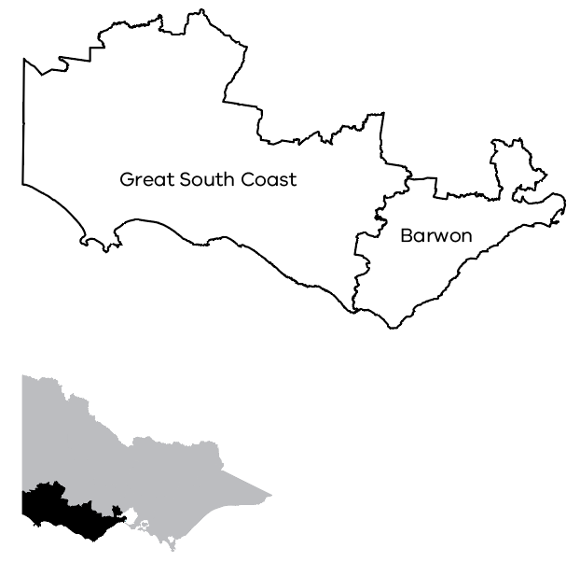

Regional Director’s report
Brett Ince
Regional Director, Barwon South West
2024-25 was a significant year for economic development and diversification outcomes. Nationally significant investments were attracted to the region. The Minister for Regional Development joined the Deputy Prime Minister, and South Korea’s Defense Acquisition Minister for the formal opening of the $170 million Hanwha Armoured Vehicle Centre of Excellence within the Greater Avalon Employment Precinct.
Portland diversification priority infrastructure projects were completed, and the final round of Portland Diversification Fund projects was established. Alcoa’s announcement of an additional 9-year power deal with AGL Energy was also great news for Glenelg’s largest employer, Portland Aluminium Smelter.
Substantial progress was made on major projects; Nyaal Banyul, the $449.1 million Geelong Convention and Event Centre precinct is on track for completion in 2026 and the $126 million Twelve Apostles Precinct Redevelopment is taking shape, with construction on the Visitor Experience Centre well underway.
We are supporting employers through the Regional Worker Accommodation Fund with new, affordable, purpose-built accommodation projects to enable businesses to attract and retain staff.
During the year we recruited new members to our place-based committees, our Regional Partnerships and the Regional Development Australia Barwon South West Committee.
The renewable hydrogen industry credentials of Barwon South West were demonstrated with the opening of Australia’s first dedicated hydrogen research and demonstration facility, Hycel Technology Hub at Deakin University Warrnambool. We supported the Barwon South West Renewable Hydrogen Prospectus, and in June 2025, Viva Energy’s new Geelong hydrogen refuelling station opened, providing Australia’s first commercially scaled and publicly accessible station for heavy transport vehicles.
Gunditjmara Traditional Owners were supported to complete projects such as the Budj Bim Commercialisation Project and Wadawurrung Traditional Owners completed their Yanbil Wadawurrung Jar cultural tourism plan.
Our focus on the development of central Geelong continued in collaboration with the Revitalising Central Geelong Partnership and through facilitating roundtable discussions between the Department of Transport and Planning and private sector developers.
Across our region, smaller communities are also benefitting from 66 new projects approved under the Tiny Towns Fund – projects that will make a difference to towns like Apollo Bay where a new community hub will be established.

Regional highlights
Regional Worker Accommodation Fund (RWAF) projects were started by 3 Barwon South West organisations in Colac, Timboon and Warrnambool. With combined Victorian Government and co-contributions, the construction of the purpose-built accommodation will result in 51 new, affordable beds for key workers including health practitioners and educational and hospitality workers. The RWAF accommodation in the Barwon South West region will also free up much-needed properties to return to the private rental market
Supported the Warrnambool Community Garden by providing funding for a new tractor and rotary hoe to prepare new garden beds, while a shed for equipment and more workshop space was also built. The Warrnambool Community Garden is run by a passionate team of 190 members and around 30 volunteers, who dedicate their time to educating people of all ages about locally and sustainably grown produce
Completed projects in communities with populations below 5,000 people through the Tiny Towns Fund. Supported the Casterton-Sandford Football and Netball Club with $50,000 for upgraded community and player facilities, upgraded the Merino Public Hall ($11,312) and supported Nelson Public Reserves ($19,401) to upgrade outdoor furniture. There are 66 Tiny Towns projects being supported in the Barwon South West region
Supported the completion of Yanbil Wadawurrung Jar (Visit Wadawurrung Country) a cultural tourism plan that provides a comprehensive framework designed to empower Wadawurrung people by expanding cultural educational art and tourism businesses. Provided $300,000 of support to Wadawurrung Traditional Owners Aboriginal Corporation
Supported Prestige Jayco Caravans in Newcomb, Geelong to create 9 new jobs and add an estimated 15 direct jobs by completion of the Regional Jobs Fund 2020-22 program. The funding has helped Prestige Caravans invest in redeveloping and expanding its facilities.

Key outcomes

Portland North Employment Precinct and Bunnings leasehold
Enabled the construction of key road and drainage infrastructure at the Portland North Employment Precinct that opened the door to more businesses like Bunnings to set up shop in Portland. Bunnings employs more than 50 locals at its Portland store, which adds to 50 roles during construction. The Portland North Employment Precinct was delivered by Glenelg Shire Council and was funded by $2.5 million from the Portland Economic Diversification Plan to strengthen and expand the local economy.

Greater Avalon Employment Precinct (GAEP)
Collaborated with industry and government stakeholders to highlight commercial investment and infrastructure development opportunities within the Greater Avalon Employment Precinct (GAEP). The area is the largest and most significant precinct of commercial and industrial land in regional Victoria. The proposed development of the GAEP aims to maximise strategic transport connections such as Avalon Airport, Geelong Port and nearby arterial road and rail links. This precinct provides significant employment opportunities including Hanwha Defence Australia, Cotton On Group, Australia Post and Petstock.

Hardwood Timber Manufacturing Hub
Supported the hardwood timber manufacturing sector to explore new ways to use Victorian timber. The Future Fibre – Hardwood Timber Manufacturing Hub Feasibility Study was made possible by a $500,000 investment through the Portland Diversification Fund. The project is supported the Green Triangle Forest Industries Hub Association to investigate the potential for glue laminated timber and laminated veneer lumber to meet Australia’s growing demand for construction grade timber products.

Supported commercial opportunities for Gunditjmara Traditional Owners
Supported Gunditjmara Traditional Owners to progress the next stages of the development of Budj Bim Cultural Landscape with an investment of $7 million (Regional Tourism Infrastructure Projects – RDV) for new visitor infrastructure to be built at Tae Rak. Detailed design for new infrastructure was completed.
The completion of the $500,000 Budj Bim Commercialisation Project supported the development of commercial business structures and legal advice to secure intellectual property rights. Gunditj Mirring was supported to acquire 2 new tour buses to accommodate the increased number of cultural tours.

World-class Victorian Sailing School delivered
Delivered the final component of the $26 million first stage of the Geelong Waterfront Safe Harbor Project with the completion of the Victorian Sailing School building redevelopment – a shared-use facility between the Victorian Sailing School and the Royal Geelong Yacht Club. Upgrades have improved safety, capacity, access and education for members and the public. The revitalised waterfront precinct will not only help Geelong host premier sailing events, but it will also support first class education and training programs for Victorian students.

Delivered new and upgraded roads for heavy vehicles in Glenelg Shire
Delivered new and upgraded roads for heavy vehicles to access timber plantations in Glenelg Shire along with improved truck access to industrial sites in Portland through the Local Freight Roads – Portland project. Upgrades included Heathfield Lindsay Road, Mumbannar-Wanwin Road, Wilsons Road and Fitzgerald Street with an investment of $4.8 million from the Portland Economic Diversification Plan.

East Beach Port Fairy
Completed the $1.27 million East Beach Precinct project in Port Fairy (Regional Infrastructure Fund). The improvements to the northern section included new toilet and shower amenities, landscaping, creation of a large lawn area for passive recreation, 2 new shelters with BBQ facilities, seating and furniture, and roadworks and car park improvements.
The area is a popular destination for residents and visitors.

Investing in value-added food manufacturing
Supported Farm Foods to invest in their Manufacturing Facility in Breakwater, Geelong and upgrade equipment and technology through the Regional Jobs Fund. The now completed project involved the implementation of new planning and quality systems, as well as upgrading equipment to move towards automated processing lines in 2024-25. The new high technology food processing machinery manufactures products faster.

Regional report Gippsland
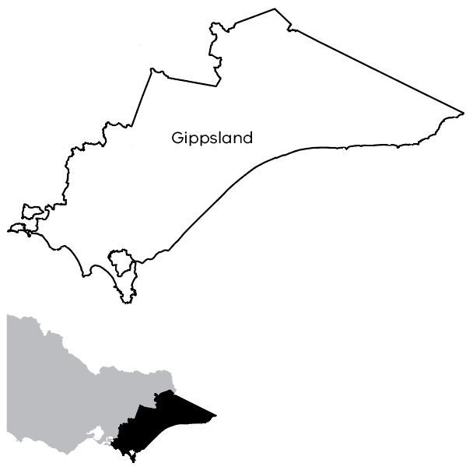

Regional Director’s report
Sara Rhodes-Ward
Regional Director, Gippsland
2024-25 year marked a pivotal chapter for Gippsland as we continued to embrace transformation while honouring the enduring legacy of our region’s history. Our collective efforts were guided by a shared sense of purpose, to position Gippsland as a resilient, innovative and productive regional powerhouse supporting constant growth and prosperity. The region is continuing to embrace transition and growth in the key sectors of energy production and transmission, engineering and construction, agriculture, dairy, tourism and hospitality, healthcare and education.
Our energy transition continued to dominate, with Gippsland at the forefront of Australia’s journey to net zero. RDV Gippsland and the RDA Gippsland Committee reaffirmed their commitment to the region’s clean energy future through continued support of the Gippsland New Energy Conference. The event brought together all levels of government, industry leaders and community advocates to exchange ideas, challenge perspectives and share insights from Gippsland’s energy transition. A standout moment was the aligned release of GLaWAC’s Pathways to Partnership proposal – an innovative model that positions Aboriginal economic self-determination at the heart of the energy transition.
RDV proudly supported GippsDairy in the redevelopment of its 10-year Strategic Plan. This comprehensive strategy sets clear priorities and defines the strategic objectives to guide the industry over the next decade. It addresses both pre and post-farm gate opportunities and challenges, ensuring a holistic approach to industry growth. By identifying key areas for collaboration and investment, the Strategic Plan will strengthen long-term sustainability and resilience for Gippsland’s important dairy sector.
The M1 growth corridor continued to be a focus of strategic work, recognising that business and industry are not defined by administrative boundaries. The rapidly expanding urban edge of Southeast Melbourne presents a significant opportunity to attract investment into Gippsland. RDV is actively working to identify the channels through which prosperity and value can flow into the region, leveraging this corridor as a gateway for sustainable growth and economic integration.
We extend our heartfelt thanks to the community, businesses and industry leaders who partnered with RDV Gippsland over the past 12 months. Your collaboration, insight and dedication have been instrumental in driving positive change across our region. Whether advancing major infrastructure projects, fostering innovation, supporting local jobs, shaping our shared transition to a low carbon economy or enhancing your beautiful tiny town, the progress we’ve made is a direct result of your commitment to Gippsland’s future. We’re proud to work alongside you.

Regional highlights
As part of Regional Car Parks Fund (RCPF) program, significant progress was made in the delivery of a total of 900 car parking spaces in the Latrobe Valley. To date, 356 car spaces are open for public use and construction began in Traralgon for a multi-level carpark with planning underway for a similar facility in Morwell
Delivered the Deadly in Gippsland Expo celebrating the innovation, expertise and cultural richness of First Nations businesses across Gippsland; improved the pedestrian link between Ted Summerton Reserve and the Moe Railway Station providing a key connection between residential areas and the Moe Railway Station; and launched an Economic Development & Placemaking Small Business Grant Program to support businesses looking to locate within the Moe or Morwell CBD. These projects were part of the Council Support Package introduced in June 2024
Upgraded the 80-year-old historic Gelantipy Hall kitchen, with a $50,000 grant from the Tiny Towns Fund Round 1. The works included new plaster walls, floor coverings, electrical works, modern cabinetry and state-of-the-art appliances. These improvements transformed the kitchen into a functional space capable of preparing hot, fresh food for community events, as demonstrated by a recent cheese making workshop and a 70th birthday celebration.

Key outcomes

Gippsland Logistics and Manufacturing Precinct
Celebrated the completion of initial works to bring online the first lots of the highly anticipated Gippsland Logistics and Manufacturing Precinct (GLaMP). With Stage 1A of the development done, construction can begin on site, bringing new industry and jobs to the Latrobe Valley.

Revitalising Buchan’s urban environment
Following a $2 million investment from the Local Economic Recovery – Regional Economic Programs Fund, completed significant streetscape improvements to Main Road in Buchan. The reconfigured roadway optimises parking, provides an essential bicycle throughfare that links users to the Buchan Caves and the Recreation Reserve, and integrates attractive landscaping. These enhancements support the Buchan Caves initiative, to create a more accessible, welcoming and economically resilient town centre

Enhancing community spaces in Omeo
As part of a $200,000 grant from the Living Local – Regional fund, upgraded Omeo’s main street as part of RDV’s commitment to boosting local infrastructure and liveability through targeted investments. This initiative revitalised a key transportation artery and complemented other Victorian Government projects – such as the Omeo Mountain Bike Park and the Justice heritage precinct to attract visitors and encourage economic activity. By enhancing shared public spaces, this investment directly benefits residents while promoting a vibrant community atmosphere.

Lakes Entrance Sports Pavilion
Opened the new Water Sports Pavilion at Lakes Entrance in February 2025, a vital enhancement to the region’s recreational and tourism infrastructure. Positioned on the picturesque Cunningham Arm, the pavilion supports existing tourism attractions such as the Aqua Park, while enabling the expansion of new activities including kayaking and paddleboarding to create a year-round destination for visitors and locals alike.
This investment also connects seamlessly with the Krauatungalung Walk (K-Walk), an all-abilities walking circuit that showcases Indigenous culture through public art installations. With a total project cost of $233,733, the initiative delivered strong economic benefits to the local community by creating 20 full-time equivalent construction jobs and 10 direct jobs when operational. Through this project, RDV continues to support inclusive tourism, cultural celebration and job creation in Gippsland.

Gippsland Supply Chain Resilience Program
Supported forestry transition through the provision of the Gippsland Supply Chain Resilience Program. The program provides wraparound support to businesses connected to white paper manufacturing supply chain with identified vulnerabilities and positions them to take on new strategic opportunities. Delivered in partnership with regional businesses, the program provides tailored diagnostics, expert advice and capability building support to help businesses better understand and diversify their supply chains.
Closed the first 2 Streams of the GSCRP at the end of February 2025. With a starting list of 75 businesses that were potentially impacted by the closure of the natural timber harvesting industry, RDV supported 10 businesses either directly or indirectly through this program
Opened the Stream 3 implementation stage for the GSCRP in June 2025 and engaged businesses in their diagnostic studies and Resilience Business Plans to ensure they were ready to implement in early 2025-26.

Regional Worker Accommodation Fund (RWAF)
Commenced projects across Gippsland in Newborough, Wonthaggi, Bairnsdale and Omeo to deliver 70 fit-for-purpose bedrooms under Round 1 of the Regional Worker Accommodation Fund (RWAF). These housing projects provide affordable key worker housing to essential healthcare workers, where the health sector is one of the largest employers and biggest contributors to Gippsland’s regional economy.
The broader reach of the projects will enable the region to attract and retain key workers and their families. Gippsland is leading the way with 2 state firsts: the Newborough project is on track to be the first completed RWAF project in Victoria while the Wonthaggi project is the first healthcare project approved under the Department of Transport and Planning’s Development Facilitation Program.

Regional report Grampians
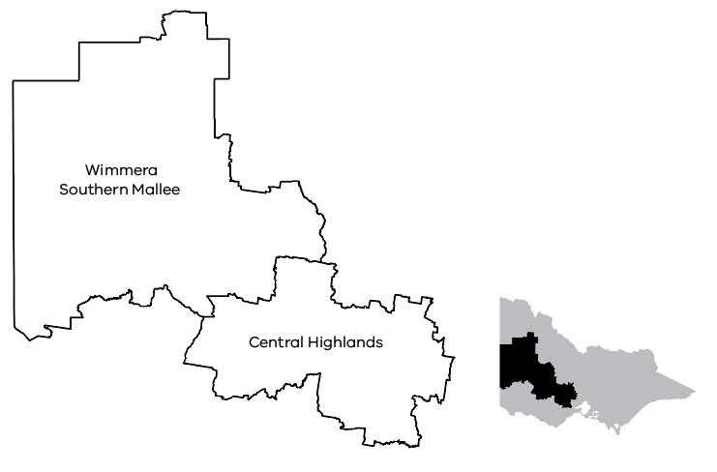

Regional Director’s report
Sarah Henderson
Regional Director, Grampians
The past 12 months delivered significant success and challenges to the Grampians region. The ongoing impact of drought and bushfires continued to pose challenges to our economic growth capability. Yet amidst this, we celebrated great achievements including the attraction of a global food manufacturing giant into the region.
The Grampians region is developing stronger climate resilience for business and community prosperity and longevity. Clean energy generation and transmission infrastructure is expanding, and this is providing significant local employment and supply chain opportunities. In partnership with the Industry Capability Network (ICN) we are realising the benefits of large-scale government projects for regional businesses.
The region is also progressing towards supporting the development of critical minerals mining which will require a skilled, local workforce for construction and operations.
The RDV Grampians team is passionate about working across government, businesses and our communities to achieve enhanced economic outcomes as we move through this transition. Our team is playing a key role in supporting diversification of the regional economy into food processing and advanced manufacturing as well as the expansion of agribusiness. This strategic move will make the Grampians economy more resilient to drought and fluctuating commodity prices. In addition, our team supported the sustainability and expansion of manufacturing businesses in the region including CE Bartlett (defence), Thomas Foods (meat processing) and J.G King (window joinery).
We celebrated the completion of key projects that bring vibrancy and enhanced liveability to our regional cities including the re-opening Her Majesty’s Theatre in Ballarat – a $16 million project to restore Australia’s oldest continuously-operating live theatre.
Our team is working hard to help unlock solutions to some of the stumbling blocks to regional prosperity. Labour force availability is a key ingredient for economic growth. Unlocking the latent workforce, including the potential of people with carer responsibilities, is one initiative that we are intensely involved in through our partnership with regional employers, the Victorian Skills Authority and education providers including Federation University.
To support and sustain the growth of our region, our team remains committed to strengthening our existing relationships with key business and community leaders to ensure decision-making and investment meets our regional needs. We look forward to working with our newly appointed Regional Partnerships and RDA committee through this new term to deliver solutions tailored to the unique needs and challenges of our local economy.

Regional highlights
Opened the first 32 kilometres of the Djuwang Baring Mountain Bike Trails at Creswick in August 2024. The construction of the bike paths was funded via a $2.56 million RDV-administered Regional Tourism Infrastructure Fund (RTIF) grant. An additional RTIF grant of $2.2 million funded the creation of the Hammon Park Trailhead and gave $100,000 to help Hepburn Shire Council promote the project. The trails provide interpretive signage to give riders a deeper understanding of, and appreciation for, Dja Dja Wurrung Country and the Djaara Traditional Owners. The project is helping to position Creswick as a visitor destination, providing improved recreation options and enhanced liveability for locals.
Delivered Regional Worker Accommodation Fund (RWAF) supported dwellings in the state at Hopetoun in the Southern Mallee region. The 4 new homes, each with 3 bedrooms, are being built for Rural Northwest Health. The ability to offer brand-new homes is a significant drawcard for Rural Northwest Health in attracting staff members and their families and will support the health service to reopen their local urgent care centre. When the homes are let, the cost of rent will be substantially below market rate and salary packaged.

Key outcomes

Ballarat and District Aboriginal Cooperative (BADAC) Elders Village opened
The BADAC Elders Independent Living Community was delivered in September 2024 with $2.6 million funding via the Regional Infrastructure Fund 2020-22. Elders were fully engaged in the design and cultural details for the village. The project delivered one-bedroom and 2-bedroom units to accommodate 16 elder residents, plus on-site managers quarters, medical treatment rooms, a central hall, gardens and other spaces. The facility enables Aboriginal elders to be supported by other members of the Aboriginal community in a culturally familiar and culturally safe independent living arrangement.

Her Majesty’s Theatre Ballarat restored
Reopened the restored Her Majesty’s Theatre to patrons in November 2024 thanks to the support of a $10 million RDV-administered grant from the Victorian Government. The works to restore Her Majesty’s included installing elevators to provide all-abilities access to the stage and auditorium, improved building fire safety standards and a new box office. The works preserve the identity and character of Her Majesty’s Theatre while making the facility more accessible for the community.

Thomas Foods International – cold storage facilities opened
Opened the newly constructed cold-room facilities for lamb processing and storage at the Thomas Foods International Abattoir in Stawell. The project also delivered innovative technology to connect all areas of the abattoir to an inline traceability system which feeds product information to end users and farmers, increasing customer confidence in the product and helping Thomas Foods capitalise on new export opportunities.

Spotlight on Sebastopol projects completed
Completed the 3 remaining projects under the 2019-20 Budget ‘Regional Development – Initiatives’. The $5 million grant supported projects that revitalised, beautified and reactivated one of Ballarat’s established neighbourhoods, including Yarrowee River Access, the St Georges Reserve Lighting project, and the Hertford Street Bike Path Connection.

Warracknabeal historic courthouse renovated
Renovated the Warracknabeal Courthouse to create artist-in-residence accommodation and a creative hub as part of a package of Silo Art Trail initiatives funded by RDV and undertaken by Yarriambiack Shire and Grampians Wimmera Southern Mallee Tourism. The stunning renovated building will draw tourists and artists to the Southern Mallee region.

Grampians Bioenergy Forum
Organised and hosted the RDA Grampians-sponsored Bioenergy Forum at Federation University, Ballarat in June 2025. This was one of several events held across the state, intended to bring together leaders from industry and government to build momentum around bioenergy being a viable, renewable energy source. This forum was particularly significant for the Grampians region, where our robust agricultural and manufacturing sectors produce large volumes of organic waste with untapped potential for renewable energy generation.

Victorian State Commissioner for China – Hosted visits to businesses
Hosted the Victorian State Commissioner for China to the region in January 2025. One-on-one meetings were held between the Commissioner and key regional businesses connected into supplier or customer markets in China. This included WIM Resources, a critical minerals mining company, and other businesses looking to export to China.

Regional report Hume
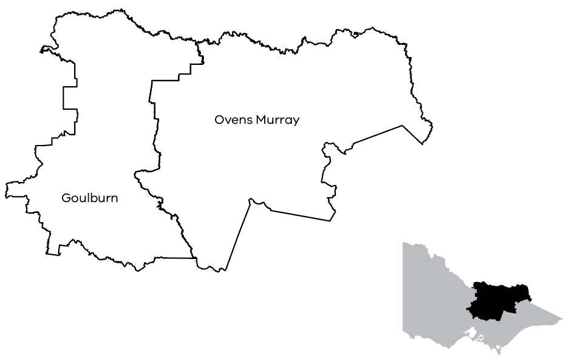

Regional Director’s report
Charlie Bird
Regional Director, Hume
The Hume region’s contrasting landscapes, stretching from the rolling hills of the Upper Murray all the way down to the peri-urban areas around Wallan, and from the snowfields and High Country to the productive Goulburn Murray Irrigation District, create a diverse economic environment with significant growth potential.
Hume’s economy includes an agricultural region at the forefront of global food production as well as growing manufacturing, transport and logistics industries that benefit from its strategic location along key transport corridors. Tourism is also a strong contributor to the region’s prosperity, driven by Hume’s outstanding natural attractions, such as the Victorian Alpine Resorts and the Murray River, as well as world-class food and beverage experiences.
In October 2024, we welcomed the Premier’s announcement of the Regional Worker Accommodation Fund Round 1 in Shepparton, which will boost the availability of affordable housing for workers and their families. Several Hume region projects were announced in Round 1, including Goulburn Valley Health’s project to build 15 self-contained apartments on site at the Shepparton Hospital for doctors and health professionals, with construction now well underway.
Water security, exacerbated by worsening drought conditions and water buybacks is a significant risk to Hume’s strong agricultural and food manufacturing sectors. Our team is working closely with key stakeholders to develop a coordinated and strategic approach to support the resilience, sustainability and growth for impacted businesses.
The Hume team supported Agriculture Victoria in its response to significant biosecurity events in the Hume region which severely impacted on 2 major agriculture employers, requiring an immediate and collaborative inter-agency response. In January 2025, the Tomato Brown Rugose Fruit Virus was detected in a large hydroponic tomato-growing facility, bringing its commercial operations to a halt and resulting in job losses. The following month, Avian influenza was detected across 4 poultry farms near Euroa, resulting in significant business disruption and impacts on production. With the support of the Cross Border Commissioner, the team supported the business and agricultural sector with addressing restrictions on the supply chain.
These biosecurity events were followed by the Bega Group’s announcement of a phased closure of its cheese processing plant in Strathmerton. The team took immediate action coordinating a response in collaboration with Bega Group, Moira Shire Council and the Australian Government to address the impact of the closure, ensure appropriate employment support was in place for the 300 impacted workers and seek opportunities to strengthen the broader regional economy.
These challenges highlighted the importance of the work that we do, galvanising the team in its pursuit to raise the economic prosperity of the Hume region collectively with its Regional Partnerships, Regional Development Australia Hume Committee, local councils and businesses.

Regional highlights
Continued support and collaboration with all levels of government remain central to advancing Albury Wodonga Regional Projects, which are critical to the region’s long-term growth and prosperity. Significant milestones included the commencement of the $7.5 million Key Health Worker Accommodation project to support Albury Wodonga Health’s workforce; an additional $2 million for Wodonga TAFE’s Advanced Manufacturing Centre of Excellence, enhancing training and innovation capabilities in the region’s growing industrial sector; and the $5 million Wodonga Creek Precinct development led by the City of Wodonga which aims to revitalise key natural and recreational assets by creating a vibrant community space that celebrates the unique character of the Wodonga Creek area. These initiatives build on previous successes such as the Wodonga TAFE Heavy Vehicle Technology Program and together are driving positive economic outcomes. RDV continues to work closely with project partners to ensure effective implementation across the 8 strategic initiatives, supporting tangible impacts in housing, health, workforce development and cross border harmonisation
Continued to advocate for greater economic inclusion and parity for Aboriginal people in the region. An initiative identified in the Goulburn Murray Regional Prosperity Plan and supported by the Goulburn Regional Partnership, the Yorta Yorta Nation Aboriginal Corporation’s application to establish an Aboriginal Economic Hub in Shepparton was successful. The Hub will offer TAFE-based training courses, an exhibition and retail space, as well as provide a venue for community meetings and workshops.
The Taungurung Land and Waters Council commenced engagement with a range of stakeholders, including RDV Hume, in the development of a business case for the Taungurung Cultural Centre, a new, inclusive gathering place for the Taungurung community as well as the wider public to celebrate First Peoples’ culture.
Supported Chrismont Wines to leverage the King Valley’s growing cycling tourism market through the Ride Chrismont project. The project involved the construction of 3 self-contained, luxury accommodation units, the purchase of a fleet of e-bikes as well as the construction of an on-site bike servicing space offering facilities for cyclists to repair, tune and safely store their bicycles. Following a program of workshops where cellar door and restaurant staff built a deep understanding of King Valley’s cycling experiences, along with an expanded food offering prepared specifically for cyclists, Chrismont Wines’ expanded visitor offering is projected to add up to $1.5 million per annum in flow-on economic benefits to the region.

Key outcomes

More jobs in Wodonga with Mars Petcare expansion
Monitored progress of Mars Petcare’s $112.6 million expansion of its manufacturing facility that will enable production of more than 290 million single-serve cat food pouches each year for Australian and New Zealand markets. The expansion, which was supported through the Regional Jobs Fund will create around 60 new jobs and bring the company’s Wodonga workforce to almost 500 people. The new facility is expected to be operational in early 2026.

New water supply infrastructure supported cherry orchard growth
Supported Koala Cherries’ investment in the construction of a water irrigation pipeline to draw water from the Goulburn River to supply its existing orchards, as well as enable the development of a further 85 hectares of cherry orchards to supply domestic and overseas export markets. Mitigating risk to water security, the project constructed a 9-kilometre water irrigation pipeline from the Goulburn River to the cherry orchards at Yarck. The pipeline will deliver approximately 1,200 mega litres per annum to supply storage infrastructure at the cherry orchards.

Added a new ‘Darling’ to Prosecco Road
Provided support for the development of an all-weather cellar door at Darling Estate in the King Valley, adding another authentic visitor experience to ‘Prosecco Road.’ The new building’s spectacular location with views across the vineyard to Mount Cobbler restores recycled timbers and tin from the estate’s heritage shearing shed and celebrates the Darling family’s 100-year history in the King Valley. This project builds on the Victorian Government’s investment in creating a world-class wine, food and cycling experience along ‘Prosecco Road.’

New hub for all seasons at Mount Hotham
Supported the $7 million development of the Mount Hotham Snow Play and Activity Hub, a multi-purpose venue that includes public amenities, a food and retail offering, and a multi-functional events space. In addition to its use as day facilities for the snow play experience in winter, the Hub is also ideally positioned to support green-season activation, providing a natural launch point for biking and hiking as well as being able to host summertime concerts, functions and events.

Delivered an integrated hub for High Country riders
Supported the $1 million Rocky Valley Bike Hub development, an integrated facility that caters to the growing number of cyclists visiting Mount Beauty and the High Country. With new accommodation designed to capture the cycling market, a bike workshop and new spaces to rest, recover and socialise, the Rocky Valley Bike Hub is projected to create 70 new jobs and generate over $10 million in economic activity over the next 5 years.

Progressed the activation of Lake Eildon
Provided support for the $2 million redevelopment of the Goughs Bay Boat Club, transforming its lakeside bistro, dining and function areas into a high-quality visitor experience. The project was a key priority identified in the Lake Eildon Masterplan, which aims to improve product on the lake, increase employment and promote visitation.

Invested in whisky business
Supported Casella Wines with its $19.2 million whisky production manufacturing facility at Morris Wines in Rutherglen. The project supported 30 full-time jobs during construction while shoring up 12 existing roles to increase whisky production and export sales. The funding also supported the expansion and fit out of the distillery and refreshed 1972 cellar door designed by iconic Australian architect Robin Boyd. The Morris Whisky brand has grown to become one of the top selling Australian single-malt whiskies in Australia and is increasing its overseas exports.

Boosted overseas export and domestic logistics and storage in Shepparton
Finalised J.D.K Management Pty Ltd.’s project to expand and fit out its food storage and distribution centre through the establishment of an additional 5,000 square metres of ultra-modern cool room facilities, resulting in reduced waste, food miles and lowering CO2 emissions. In addition to creating 20 jobs, the $5 million project increased production capacity for J.D.K Management Group’s clients who service both domestic and overseas export markets.

Olive oil product sales boom after warehouse expansion
Supported Rich Glen Pty Ltd with the expansion of its warehouse and production capacity, which has enabled the company to meet the growing market demand for its food and skincare products. The project involved construction of storage, warehouse and administration facilities, additional processing and manufacturing space as well as the purchase of new plant equipment. Project outcomes have exceeded Rich Glen’s initial expectations, allowing it to expand its workforce to a total of 62 positions and plan for further investments that will boost its capacity and improve environmental outcomes.

Reactivated a High Country icon
Facilitated a partnership between Parks Victoria and Belgravia Group to reactivate the Mount Buffalo Chalet. An iconic venue in a pristine alpine setting, the chalet has reopened to school students participating in outdoor education programs. Future development at the chalet, including a café, information centre and conservation work, will provide a year-round visitor experience for the public and ensure that the site is preserved for its architectural, historical and social significance.
Built in 1910, the chalet is the largest timber accommodation building in Australia and is included on both the Victorian Heritage Register and the National Heritage List. The reactivation of the chalet is expected to create more than 50 jobs.

Regional report Loddon Mallee
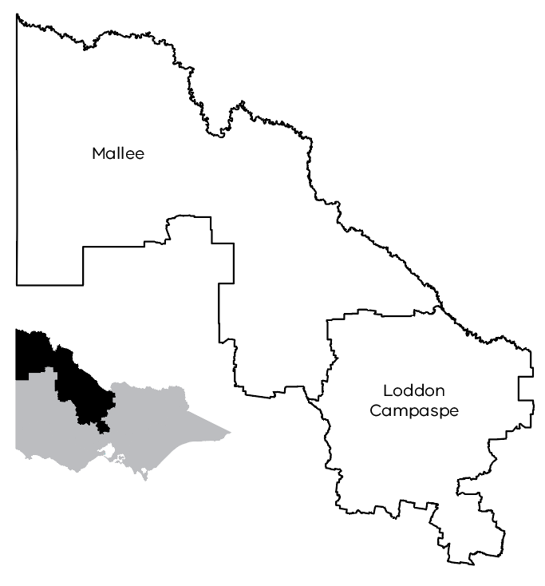

Regional Director’s report
Leanne Rosewall
Regional Director, Loddon Mallee
The Loddon Mallee region covers more than a quarter of Victoria and is one of the consistently warmer climates in the state. People are attracted to the region for its natural environment, heritage towns, produce, restaurants and wineries.
Loddon Mallee has a thriving and growing economy in agribusiness, advanced manufacturing, building and construction, mineral sands, renewable energy, tourism and financial services. As a major food-producing area, the region has vibrant manufacturing and service sectors.
In 2024-25 RDV, Loddon Mallee continued to support business investment to drive economic outcomes across the region. The team engaged with business and industry stakeholders providing support and leveraging opportunities. Most of these interactions focused on our priority sectors including advanced manufacturing, agribusiness, digital technologies and the circular economy.
One of many highlights for our region this year was to see the Indigenous Interpretive Gardens project (garingilan gatjin wii) recognised in the 2025 LGPro Award for Excellence in the First Nations Community Partnership category and as a finalist in the Victorian Premier’s Design Awards. The garden is a place for sharing Dja Dja Wurrung culture and wellbeing and encourages respect and reconciliation for the community and visitors to the precinct.
Building on previous investment by RDV to install powder drying technology, Kagome Australia is launching a new product to the market using upcycled tomato seeds. This 100% Australian oil is a result of a partnership with Native Extracts and is being promoted as a sustainable solution to food waste in the beauty industry. The oil is rich in antioxidants and essential fatty acids, making it suitable for various skincare and beauty products. Tomato skin powder is also being used as an ingredient for pet foods.
Having outgrown its current facilities, the Bendigo Art Gallery Redevelopment will increase its capacity and allow the gallery to build on the success of the blockbuster shows and showcase the best international and local exhibitions. The redevelopment will generate approximately 260 jobs during the 2-year construction period. Modelling also shows that once completed, the expanded gallery will create 170 new local jobs and inject up to $35 million in annual spending into the local economy.
The development and delivery of a Regional International Engagement Strategy has been identified as a flagship initiative for Regional Development Australia (RDA) Loddon Mallee, reflecting the region’s ambition to build stronger global connections and enhance export capacity. As part of this process, RDA Loddon Mallee convened a targeted consultation with key industry stakeholders to help shape the strategy and ensure it reflects the region’s strengths and opportunities in overseas markets. Representatives from key export sectors, including wine, dried fruits and almonds were invited to share their insights on current market trends, export challenges and emerging international opportunities. These sectors are among the Loddon Mallee region’s most significant contributors to international trade and their input has been critical in identifying strategic priorities, target markets and enabling actions needed to elevate the region’s global profile.
The region continues to work closely with partners through the Loddon Campaspe and Mallee Regional Partnerships, as well as the RDA Loddon Mallee committee to realise opportunities for the region.

Regional highlights
Completed the Foreshore Nature play project upgrade at the Johansen Reserve at Cullulleraine in November 2024. Millewa-Carwarp Landcare Group received $168,125 through the Living Local – Regional Grants fund for the upgrade which included outdoor play spaces featuring a ninja warrior course, pivot swing, pump track and flying fox, designed with a nature theme and local resources in mind
Completed Stage 1 of the Pyramid Hill Community Centre Development in April 2025 after Loddon Shire Council received $600,000 funding through the Regional Infrastructure Fund. The project has provided the community with a new allied health wing, multi-purpose community space, new kitchen and storage facilities
Attracted nearly 2,000 attendees to Rochester Go Kart Club’s state-series event in March 2025 after it received $44,740 from the Tiny Towns program. The grant supported the club to provide a modern and contemporary kitchen facility to service significant local, state and national karting competitions. For a town that was heavily impacted by flood events in 2022, the project ensures that the club can support many new events in the region.

Key outcomes

Bendigo Art Gallery Redevelopment
Released an expression of interest for suitable head contractors for $45 million Bendigo Art Gallery Redevelopment project in June 2025. Construction of a new second-floor blockbuster exhibition space, innovative learning centre, theatrette, and Traditional Owner Place of Keeping for Dja Dja Wurrung cultural materials is expected to commence in early 2026. The Victorian Government is contributing $21 million to this project.

Bendigo Regional Employment Precinct
Continued to support the City of Greater Bendigo on the Bendigo Regional Employment Precinct (BREP). It will provide 294-hectares of industrial land for businesses looking to expand or relocate to Greater Bendigo, addressing a shortage of industrial land and facilitating employment opportunities for the growing community. Following an allocation of $6 million from Victorian Government, the City of Greater Bendigo is now working closely with RDV, Development Victoria, Victorian Planning Authority and the Department of Transport and Planning to deliver planning works and enabling infrastructure.

Garingilan Gatjin Wii Indigenous Interpretive Garden in Maryborough
Created an interpretive garden adjacent to the Central Goldfields Art Gallery in Maryborough with $225,000 in funding from the Regional Tourism Investment Fund. Central Goldfields Shire Council partnered with the Dja Dja Wurrung Clans Aboriginal Corporation to deliver a cultural space for ceremony, healing and learning, and supported the creation of 3.4 full-time equivalent construction jobs for Dja Dja Wurrung Enterprises Pty Ltd, also known as DJANDAK.
The project was awarded the 2025 LGPro Award for Excellence in the First Nations Community Partnership category and was a finalist in the Victorian Premier’s Design Awards. The garden is a place for sharing Dja Dja Wurrung culture and wellbeing and encourages respect and reconciliation for the community and visitors to the precinct.

Ngiwa-Kulaithi Play Precinct in Robinvale
Opened the Ngiwa-Kulaithi Play Precinct in Robinvale with $990,450 in grant funding awarded to Swan Hill Rural City Council from the Regional Tourism Investment Fund. The $2 million project transformed the local riverfront into a contemporary and vibrant play precinct and community space that celebrates the region’s rich and diverse cultural heritage.

Holstein Milk Processing Facility Water Treatment Plant in Kyabram
Delivered a water treatment processing facility at the Holstein Milk Processing Company’s Goulburn Valley Creamery site in Kyabram in November 2024. The company received support through the Regional Jobs Fund.
This investment doubled the processing capacity for the business to 100 million litres of milk per year, delivered 17 new operational jobs to the Kyabram region and supported the local supply chain by increasing frozen milk storage capacity as a result of the upgrade in partnership with a local business.
The new state-of-the-art facility is housed in the historic Kyabram IXL Jam Factory and produces products under the Goulburn Valley Creamery and Henry Jones brands, selling both domestically and overseas.

Tongala Abattoir Redevelopment and Modernisation
Completed the HW Greenhams Tongala Abattoir factory upgrade with the support from the Regional Jobs Fund, delivering 230 new jobs to the region. This project saw the modernisation of the site including new plant equipment enabling the business to move up the value chain to offer premium chilled meat products. This investment has led to new overseas and domestic commercial contracts, including a new agreement with Woolworths. The upgrade has made the Tongala site more a competitive and sustainable operation prepared for the future.

Regional Precincts and Partnership Program (rPPP) and Growing Regions Program (GRP)
Supported the delivery of 3 rPPP and 5 GRP projects across the region with a total project value of $42.1 million. Projects included:
Mt Alexander Shire Council – Frederich Street and Mechanics Lane upgrade (rPPP)
Swan Hill Rural City Council – Transforming the Heart of Swan Hill Precinct (rPPP)
Bendigo Kangan Institute – Bendigo East Urban Renewal Precinct (rPPP)
Swann Hill Rural City Council – Reinvigorating Our Riverfront (GRP)
City of Greater Bendigo – Heathcote Civic Community Hub Stage 1 (GRP)
Bendigo Foodshare - Community Hub for Central Victoria (GRP)
Campaspe Shire Council – Victoria Park Multi-purpose Facility (GRP)
Central Goldfields Shire Council - Deledio Recreation Reserve Pavilion Redevelopment (GRP).

Cohuna Bowls Club
Upgraded the Cohuna Bowls Club after it received $9,712 towards new outdoor seating under the Tiny Towns Fund Round 1. The new seats make it easier for volunteers to maintain the property so they can spend less time fixing broken furniture and more time bowling and creating social connections.

Regional Jobs and Infrastructure Fund
Throughout 2024-25, a portfolio of legacy projects and grants allocated under the Regional Jobs and Infrastructure Fund (RJIF) continued to be delivered, with 45 projects reaching completion.
The RJIF was closed for new applications under existing Regional Infrastructure Fund, Regional Jobs Fund and Investment Fast Track Fund programs. The RJIF legacy portfolio has 137 remaining projects that are being actively monitored and continue to be delivered by proponents.

Case studies (completed projects)

Hepburn Shire Council – Trentham Community Hub
Developed a multi-purpose facility at the existing Trentham Mechanics Institute, including installation of a library, visitor information centre, meeting and function rooms, hall upgrade and seating for up to 180 people. A grant of $3.5 million was provided to the Hepburn Shire Council under the Regional Infrastructure Fund. The upgrade partnered with other government programs to maximise the outcomes of the redevelopment and facility use has increased significantly.

Wellington Shire Council – Great South Rail Trail (GSRT) extension
Opened a 21km extension of the GSRT between Welshpool and Alberton as an eastern terminus due to a grant of $6 million being provided to the Wellington Shire Council under the Regional Infrastructure Fund. The GSRT is now one of Victoria’s longest trails and was delivered in partnership with the Wellington Shire Council and South Gippsland Shire Council. The project included the installation of 14 bridges and 4 overpasses, as well as new seating and signage. It builds on previous government investment in other stages of the GSRT.

Mt Buller and Mt Stirling Resort Management Board – Mt Buller electricity upgrade
Installed and upgraded electrical assets from Merrijig to Mt Buller as a result of a $3.6 million grant provided to the Mt Buller and Mt Stirling Resort Management Board under the Regional Infrastructure Fund. The project included installing an additional 4.0MV of electrical capacity with 36 new poles, changing over 57 existing poles, upgrading existing overhead lines and installing 600 metres of underground high voltage cabling. The project has grown the resort’s snow-making capacity and helped deliver new investment in apartments at Mt Buller to expand tourist accommodation. It has also boosted tourism visitation over the snow season with visitor numbers now exceeding the 10-year average.
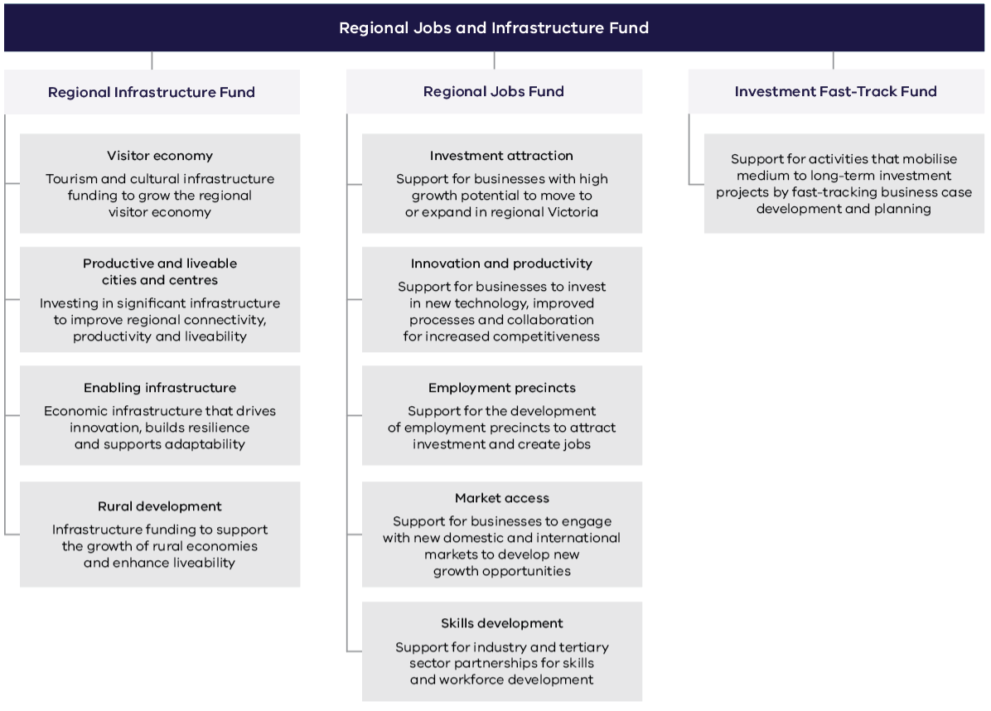

Financials 2024-25

2024-25 output targets and performance against Budget Paper 3 measures

Quantity
Performance measures | Unit of measure | 2024-25 actual | 2024-25 target | Performance variation (%)
Actual export sales generated for regional businesses as a result of participation in government programs | $ million | 101 | 35 | 188.6%
Economic development and service delivery projects supported | number | 262 | 120 | 118.3%
Jobs in regional Victoria resulting from government investment facilitation services and assistance | number | 428 | 250 | 71.2%
New investment in regional Victoria resulting from government facilitation services and assistance | $ million | 403 | 250 | 61.2%
Participant satisfaction with implementation of Regional Development Victoria programs | per cent | 98 | 90 | 8.9%

Income and expenditure report for the period ended 30 June 2025

Income from transactions
Regional Development Victoria | 2025 (FY) ($000’s) | 2024 (FY) ($000’s)
Output appropriations | 172,819 | 150,694
Grants | 9,555 | 3,449
Interest income | 11,035 | 10,537
Other income | – | –
Total income from transactions | 193,409 | 164,680

Expenses from transactions
Regional Development Victoria | 2025 (FY) ($000’s) | 2024 (FY) ($000’s)
Grants and other transfers | (118,542) | (133,498)
Employee expenses | (27,915) | (22,979)
Depreciation and amortisation | (296) | (281)
Interest expense | (51) | (16)
Other operating expenses | (53,404) | (26,543)
Total expenses from transactions | (200,208) | (183,317)
Net result from transactions (net operating balance) | (6,799) | (18,637)

Contact information

Regional Development Victoria business centres and offices
Ballarat
300-304 Mair Street
Ballarat VIC 3350
Phone: 1800 878 981
Bendigo
Galkangu – Bendigo GovHub
195-229 Lyttleton Terrace
Bendigo VIC 3550
Phone: 1800 950 146
Geelong
Federal Mills Precinct
33 Mackey Street
North Geelong VIC 3215
Phone: 1800 950 145
Gippsland
Latrobe Valley GovHub
65 Church Street
Morwell VIC 3840
Phone: 1800 325 217
Melbourne
Level 35, 121 Exhibition Street
Melbourne VIC 3000
Phone: 1800 878 969
Mildura
Cnr. Koorlong Ave and 11th Street
308-390 Koorlong Ave
Irymple VIC 3498
Phone: 1800 950 146
Portland
13A Richmond Street
Portland VIC 3305
Phone: 03 9623 1300
Shepparton
409-415 Wyndham Street
Shepparton VIC 3630
Phone: 1800 878 963
Wangaratta
Wangaratta Government Centre
1st Floor, 62 Ovens Street
Wangaratta VIC 3677
Phone: 1800 878 963
Warrnambool
703-709 Raglan Parade
(PO Box 105)
Warrnambool VIC 3280
Phone: 1800 950 145
Wodonga
1 McKoy Street (DEECA)
Wodonga VIC 3690
Phone: 1800 878 963
Web: rdv.vic.gov.au
Email: rdv@rdv.vic.gov.au

