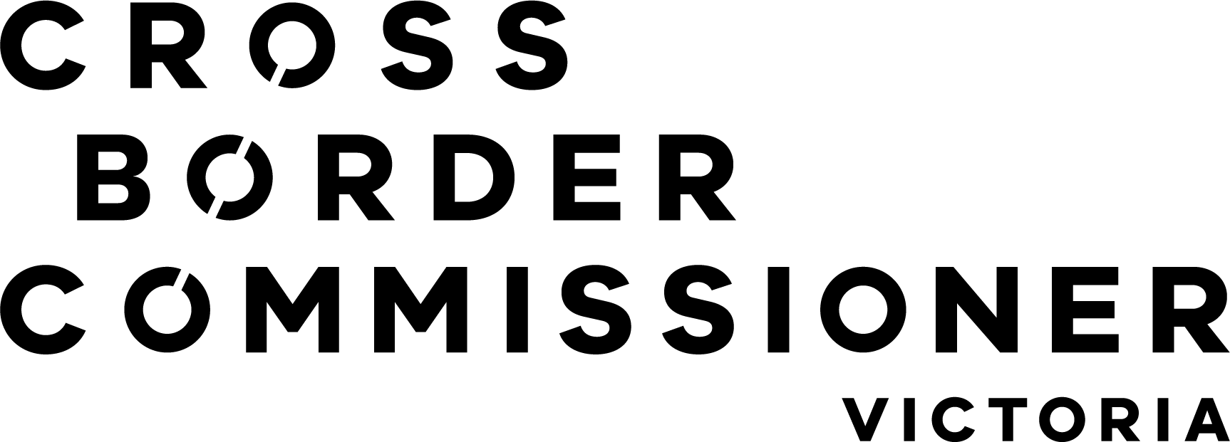 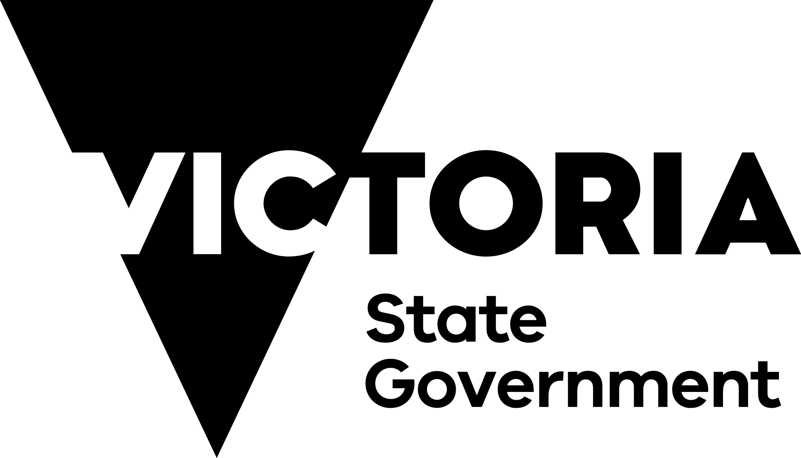

Strategic Plan 2024 – 2026

**Acknowledgement of Country**

We proudly acknowledge Victoria’s Traditional Owners and their ongoing strength in practising the world’s oldest living culture. We recognise the diversity of Victoria’s Traditional Owners in being distinctive communities with their own set of laws, customs and processes built upon tens of thousands of years of knowledge. We acknowledge the Traditional Owners’ lands and waters on which we live and work and pay our respects to their Elders, past and present.

Authorised by the Victorian Government

121 Exhibition Street Melbourne Victoria 3000

© Copyright State of Victoria 2024

Except for any logos, emblems, trademarks, artwork and photography this document is made available under the terms of the Creative Commons Attribution 3.0 Australia license.

# Contents

Minister’s Foreword 3

Introduction 4

Office of the Victorian Cross Border Commissioner 8

Targeted Focus Areas 10

Priority Actions 12

Outcomes 14

Memoranda of Understanding 15

Approach 16

# Minister’s Foreword

Victoria is home to vibrant and diverse border communities that showcase the best of what our state has to offer. Approximately **300,000 Victorians** live in towns and districts along the borders of New South Wales and South Australia, while the overall combined population of these border regions exceeds **575,000 people**, spanning **29 Local Government Areas**.

These close-knit communities prosper on shared access to health, education, employment, retail, recreation, and economic development opportunities. The unique blend of cultures and resources enriches the lives of residents and fosters a strong sense of community spirit. However, these communities also face unique challenges due to differing regulations and business practices between neighbouring states.

Victoria’s Cross Border Commissioner plays a crucial advocacy role, providing a unique situational awareness between the Victorian Government, border communities, and other jurisdictions. This role is strengthened by existing Memoranda of Understanding with New South Wales and South Australia. The challenges faced by these communities, especially during pandemics, natural disasters, and economic shocks highlight the critical importance of the Cross Border Commissioner’s advocacy.

The unique border settings provide a platform for the Cross Border Commissioner to unite various agencies and communities, fostering collaboration and understanding. This approach helps to break down barriers and creates harmonious integration across borders, paving the way for innovative, place-based opportunities. By focusing on equity and prosperity, the Cross Border Commissioner enhances access to health services, skills development, and job opportunities, ensuring that no one is left behind.

The Victorian Government proudly supports the needs of those living on our state’s borders. We are committed to ensuring that these communities continue to thrive and benefit from the myriad opportunities available.

I am proud to endorse this Strategic Plan for 2024-2026, which serves as a vital blueprint for assisting our border communities and unlocking the abundant potential that lies along our borders.

Hon. Jaclyn Symes

Minister for Regional Development

# Introduction

Following representation by the Mallee Regional Partnership, the Victorian Government appointed its first Cross Border Commissioner in 2018. The Cross Border Commissioner supports government agencies in addressing border-related issues, ensuring that the unique needs of border communities are met by encouraging these agencies to ***Ask the Border Question***.

Residents along Victoria’s borders maintain business and social networks that extend into New South Wales (NSW) and South Australia (SA). However, differences in policy, regulations, and service delivery between the states can discourage cross border employment and study opportunities, increase business costs, and complicate access to services.

The Cross Border Commissioner works in partnership with border residents, businesses, and community organisations to identify and advocate for necessary change along Victoria’s borders. The Commissioner is in a unique position to provide situational awareness between border communities, the state, and other jurisdictions.

By consulting with individuals, communities, businesses, and engaging with key stakeholders, the Commissioner advances any problems with relevant agencies and reports issues directly to Department Secretaries and Ministers.

The goal is to simplify cross-border business operations that yield significant economic benefits. Addressing barriers to investment, skills, education, justice, health, and other services improves outcomes for border communities, making these areas better places to live and work.

## Victoria’s Border Communities

Victoria is bordered by 3 states. Two are land borders – NSW to our north and SA to our west. The third is Tasmania, with the border located in Bass Strait.

More than 575,000 people live in our border communities, which span both sides of each land border. These communities are diverse, ranging from major urban centres like Albury-Wodonga, Mildura and Echuca-Moama to smaller, isolated communities like Bendoc and Bonang in the northern reaches of far east Gippsland, Lindsay Point in Victoria’s far northwest and Nelson in Victoria’s southwest corner.

Towns and communities do not need to be adjacent to each other to form strong cross border connections. Portland and Mount Gambier, despite being over an hour’s drive apart, share significant economic ties.

Traditional Owners groups often operate across state borders creating a unique set of challenges for First Nations communities and organisations.

These border communities are interconnected through cultural and economic bonds that span both sides of the border. Sporting competitions, festivals, schools, hospitals, businesses, and employment provide opportunities for residents from both sides, fostering interaction and mutual support.

### Population of Cross Border Regions

* Victorias population 299,575. These regions are;
* Glenelg
* West Wimmera
* Mildura
* Swan Hill
* Gannawarra
* Campaspe
* Moira
* Wodonga
* Indigo
* Towong
* East Gippsland.
* South Australia’s population 89,157. These regions are;
* Renmark Paringa
* Loxton Waikerie
* Southern Mallee
* Tatiara
* Naracoorte Lucindale
* Wattle Range
* Mount Gambier
* Grant.
* New South Wales population 187,106. These regions are;
* Wentworth
* Balranald
* Murray River
* Berrigan
* Federation
* Albury
* Greater Hume
* Snowy Valleys
* Snowy Monara Regional
* Bega Valley.

**Total population** **of all 3 Cross Border Regions 575,838**

*ABS Local Government Area data (2023)*

## Border Issues: Anomalies and Opportunities

Regulatory differences, such as variations in road rules, employment laws and business licensing can create confusion and additional costs for residents and businesses, discouraging cross border work, investment and study opportunities.

Access to essential services like health and education can be more difficult or costly due to differing state policies. Inconsistent state responses can complicate management and access to services during emergencies, such as pandemics, natural disasters, and economic shocks. Additionally, ensuring reliable public transport connections between border communities remains a challenge.

The Cross Border Commissioner plays a crucial role in addressing these issues and many other anomalies by advocating for beneficial changes and fostering collaboration between states.

Making it easier to do business in other states has significant economic benefits, while addressing practice and regulatory barriers for people accessing education, justice, health and human services can improve health and social outcomes in border communities.

Navigating and coordinating joint actions and investments can be challenging when two state government budget processes are involved. However, the most efficient investments often involve a single build, event, or program/action based in one state that serves residents in both states.

If these anomalies can be addressed, participation would significantly increase supporting strong and vibrant communities.

### Examples of issues raised by border communities fall into 3 categories

#### Differing rules and regulations

* Road rules
* Transport
* Load limits
* Skills training
* Trade and business licensing

#### Differing policies and practices

* Policing
* Mutual recognition of skills
* Emergency management
* Building and land use planning

#### Joint Opportunities for Collaboration

* Marketing tourism offerings
* Joint Emergency Service operations
* Border infrastructure planning
* Health services planning

# Office of the Victorian Cross Border Commissioner

The Cross Border Commissioner is based in a border community and travels regularly along Victoria’s borders to meet with fellow border residents and businesses, ensuring that their unique needs are addressed and advocating for their interests.

Brett Davis

Cross Border Commissioner

## Our Vision

To foster seamless cross border relations, connecting communities and creating opportunities for economic, social, and cultural prosperity.

## Our commitment

Victoria’s Cross Border Commissioner advocates for change for border communities and businesses. The Cross Border Commissioner focuses on the positive outcomes of cross border collaboration that enhance the economic, social, and cultural prosperity of Victoria and its neighbouring states.

## Statement of Intent

The Cross Border Commissioner advocates for change by:

* Providing an effective mechanism for border communities and businesses to raise cross border anomalies and opportunities.
* Connecting the people and agencies best able to support specific border issues and opportunities.
* Supporting government agencies to ***Ask the Border Question*** in the design and review stage of their work, to avoid, reduce or simplify border anomalies.
* Collaborating with the Minister for Regional Development and the Parliamentary Secretary for Regional Victoria, reporting cross border issues, trends, systemic observations and priorities to Cabinet.
* Working in collaboration with the NSW and SA Cross Border Commissioners, as defined in the cross border MoUs, and participating in biannual national meetings with other cross border jurisdictions.
* Engaging with Tasmanian agencies as required.
* Working with Traditional Owners communities and organisations.
* Sharing information and experiences across border communities, departments, and agencies to build capacity for resolving future cross border issues.

# Targeted Focus Areas

Through extensive engagement with border communities and businesses, the Cross Border Commissioner has identified 7 Targeted Focus Areas to improve economic, social, and cultural prosperity in Victoria’s border regions. Consideration of the needs and sensitivities of Traditional Owners is embedded across all Targeted Focus Areas.

These Targeted Focus Areas support the Priority Actions identified in the following section.

## Economic Development

Maximising economic opportunities requires a cross border approach, as customers, employees, services, and supply chains cross borders. The Cross Border Commissioner will advocate for harmonisation efforts through mechanisms like Regional Partnerships to enable legislative reform for border businesses and communities and establishing a dedicated Tri-State Economic Zone to drive regional development outcomes and galvanise private investment.

## Skills and Workforce

Access to quality education and vocational training is crucial for the future of cross border communities. The Cross Border Commissioner will work to address issues such as school access, training subsidies, and data sharing, and will advocate for the mutual recognition of licenses between Victoria, NSW, and SA to enhance job opportunities and reduce red tape.

## Infrastructure, Transport, and Digital Connectivity

Strengthening infrastructure, transport, and digital connectivity is essential for better social, economic, and environmental outcomes. The Cross Border Commissioner will facilitate joint actions to enhance public transport, integrate cross border bus services, improve freight networks, and align licensing for transport services. Developing joint information systems will help communities navigate regulatory differences, while harmonising road rules with neighbouring jurisdictions has broader economic and road safety benefits for interstate visitors and road freight businesses.

## Simplification of Regulatory Framework

Cross border issues are rarely considered in legislative change. Aligning legislative frameworks and implementing regional strategies for key industries is vital. The Cross Border Commissioner will advocate for policies that reflect the shared nature of cross border communities, addressing issues like liquor regulation, mutual recognition, and business licensing. Efforts will also focus on ensuring fair access to state programs and identifying joint funding opportunities and legislation compatibility.

## Health, Safety, and Community Wellbeing

A borderless approach to healthcare and community wellbeing is necessary for cross border communities. The Cross Border Commissioner will advocate for recognising cross border health catchments in state health planning and enhancing interagency collaboration.

## Natural Resources, Primary Industries and Agriculture

The Cross Border Commissioner will continue to collaborate with neighbouring states on agriculture, biosecurity, and natural resources, with the aim of advocating for alignment in legislative frameworks and regional strategies for key industries.

## Emergency Management and Community Resilience

Effective emergency management and community resilience are critical. The Cross Border Commissioner will continue to support connections between emergency management agencies and advocate for data sharing and collaboration to ensure border regions are better prepared for future challenges. Additionally, the Commissioner will work with neighbouring jurisdictions on community safety, justice, policing, and child protection issues.

# Priority Actions

The Cross Border Commissioner’s primary function is advocacy, with particular focus on the following Priority Actions.

## Increase collaboration between governments

* Engage with border businesses, residents, local governments, community organisations, First Nations organisations and other stakeholders to provide effective council in addressing cross border issues.
* Work with other jurisdictions to address cross border issues, principally through neighbouring Cross Border Commissioners offices.
* Provide input into Australian Government and Victorian Government reviews and inquiries to address cross border issues.
* Provide advice to the Victorian Government about prioritised cross border issues, including joint priorities identified under MoUs.
* Represent border communities and businesses at relevant cross border forums.

## Create Economic Development opportunities

* Advocate for policy changes that stimulate economic growth and development and reduce the cost and complexity of doing business across Victoria’s borders.

## Better access to services for border communities

* Collaborate with Victorian government departments and agencies, and other jurisdictions to improve planning and access to essential services, such as education, justice, health and community services in border communities.
* Advocate for the inclusion of First Nations/Traditional Owners requirements in the design and review of services provided in border communities.

## Reduce or simplify border anomalies

* Advocate for changes and opportunities that harmonise and streamline regulatory controls, across Victoria’s borders.
* Advocate for the needs of cross border communities and businesses to be considered in the design or review of policy, procedures, regulations and legislation compatibility.
* Enhance our agencies’ capability to incorporate cross border considerations into their work by encouraging the***Ask the Border Question***.

## Emergency Management

* Provide advice on issues impacting cross border communities before, during and after emergency events to minimise adverse consequences.
* Support access to Victorian and neighbouring jurisdictions’ networks during emergency events.

# Outcomes

The Cross Border Commissioner measures outcomes through several key areas:

* Advocacy and Resolution
* Successfully advocating for and resolving issues that affect border communities, such as regulatory differences and service delivery challenges.
* Economic Benefits
* Facilitating easier business operations across borders, which lead to economic growth and reduced costs for businesses.
* Improved Access to Services
* Addressing barriers to accessing education, health, justice, and other essential services, thereby improving health and social outcomes for residents.
* Targeted Engagement
* Successfully engaging with border residents, businesses, and community organisations involves genuinely hearing and acknowledging their issues. True success is measured by seeing people and agencies act on these concerns with sincere intent.
* Interstate Collaboration
* Working with counterparts in neighbouring states, such as through MoUs, to ensure cohesive and cooperative cross border policies.
* Regulatory Alignment
* Work towards aligning regulations and standards across borders to reduce compliance costs for businesses. This can make it easier for companies to operate in multiple jurisdictions.

These measures help ensure that the unique needs of Victoria’s border communities, including Traditional Owners, are met, increasing participation, supporting vibrant border communities and making better places to live and work.

# Memoranda of Understanding

In 2020, the Premiers of Victoria and New South Wales signed a Memorandum of Understanding (MoU) for Cross Border Collaboration, initially covering the period from 2019 to 2021. This agreement was subsequently extended until December 2023. In 2024, both jurisdictions renewed the MoU, extending its effectiveness from 2024 to 2028.

In 2024, the Premiers of Victoria and South Australia signed their inaugural MoU for Cross Border Collaboration, which will be in effect from 2023 to 2026.

These MoUs underscore the recognition by each state government of the critical importance and interdependence of their jurisdictions in the border regions. They emphasise the necessity for ongoing, close, and collaborative efforts to enhance economic, social, and cultural prosperity in these areas.

The Commissioner will support existing agreements and arrangements to provide coordinated government services across the borders of Victoria, NSW, and South Australia. These services include health, ambulance, policing, emergency, and human services.

# Approach

| Actions | Directions |
| --- | --- |
| Raise –   * Issues and opportunities are raised with the Cross Border Commissioner. | Inform |
| Research –   * All issues are investigated to ensure they are cross border in nature. * If an issue *is not* a cross border issue it is referred to the appropriate department / agency for action. These issues are not recorded or reported. * If an issue *is* a cross border issue it progresses through the department / agency referral process and is recorded and reported. | Act / Advocate |
| Refer –   * All cross border issues are referred to the relevant department / agency for initial advice and review, and action if appropriate. | Effect change / Advise outcomes |
| Facilitate –   * **Some** issues, where they are significant through cost or impact, are complicated, involve unfamiliar agencies, or where referral has not produced action, move to facilitation. This involves bringing together the key departments / agencies to face those affected, pull apart an issue, and seek a solution. | Effect change / Advise outcomes |
| Design –   * A **small number** of priority issues, and where facilitation has not produced action, move into solution design. The Cross Border Commissioner (usually with affected parties) initiates solution design to prosecute a case for change. | Effect change / Advise outcomes |
| Report –   * Reporting to the Minister for Regional Development. * Department of Jobs, Skills, Industry and Regions Annual Reporting. * Reporting across government departments / agencies on issues and observations. | Report / Evaluate |