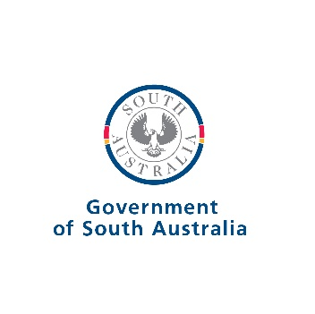



South Australia and Victoria

Memorandum of Understanding for   
Cross-Border Collaboration  
2023-2026

Government of South Australia

Government of Victoria

# December 2023

# Introduction

The Premiers of South Australia and Victoria confirm, through this Memorandum of Understanding (MOU), their respective Governments’ commitment to strengthen cross-border collaboration between governments and their agencies, with a particular focus on outcomes for the numerous close-knit communities living and working along and across the border between Victoria and South Australia.

# Objectives of this MOU

Border communities benefit from access to health, education, employment, social, recreation and other services on both sides of the border, but also face a peculiar set of challenges that can result from differences in the way neighbouring state governments and their agencies conduct their business.

The objectives sought through this MOU are to:

* Provide an authorising environment for both governments to collaborate on areas of mutual interest;
* Identify and resolve cross-border issues that impede economic and social outcomes for border communities;
* Develop opportunities to share and align policy and practice to support efficient and equitable outcomes for border communities;
* Provide efficient and consistent service delivery and operating environment to border communities; and
* Enable information sharing, collaboration and networking opportunities between government agencies.

# Principles for Cross-Border Collaboration

* Cross-border collaboration will focus on outcomes for border communities.
* Cross-border collaboration in any area of mutual interest should occur where opportunities exist.
* Collaboration will be driven by the responsible agencies in each government and at the local level where possible.
* Consultation will occur with relevant Ministers and their government agencies, local governments, communities, business and industry groups, and regional organisations to identify areas for collaboration.
* The Cross Border Commissioners of Victoria and South Australia will be key conduits for the improvement of collaboration and the identification of priority areas.

# Priority Areas for Collaboration

The Cross Border Commissioners of Victoria and South Australia will work within the respective government of each Cross Border Commissioner, and together, to identify Priority Areas for Collaboration (PACs) under this MOU. PACs will reflect border-related matters of mutual interest and concern between the Governments of Victorian and South Australia, consistent with the objectives and principles above.

PACs will be agreed, from time to time, between each government by the respective Ministers of each state assigned responsibility for border issues. The manner in which the respective Ministers and their respective Cross Border Commissioners engage within their own governments in relation to PACs remains at the discretion of each state.

For the avoidance of doubt:

* It is expected that only a small number (circa 5) of PACs will be in place at any one time;
* It is recognised that Cross Border Commissioners and agencies of each state will, from time to time, have cause to collaborate on other matters as circumstances arise;
* State Ministers and their agencies remain responsible for the planning and delivery of state services; and
* The identification and agreement of PACs is not intended to limit the potential for cross-border collaboration on other matters.

# Status of this MOU

The Governments of Victoria and South Australia acknowledge the provisions of this MOU are not legally enforceable but rely on a spirit of cooperation between the two jurisdictions.

This MOU does not remove power from either government to make policy decisions, and final policy decisions remain in control of each jurisdiction.

# Review of this MOU

This MOU will be reviewed and formally updated as required during the final year of its duration.

This MOU may be amended or extended at any time by the written agreement of both parties.

# Dispute Resolution

Where any dispute arises under this MOU, the Governments of Victoria and South Australia will take all necessary steps to resolve the dispute expeditiously by mutual agreement.

**Commencement**

This MOU commences on the date of execution and expires three years thereafter.