Barwon Regional Partnership
Information for applicants

About Us
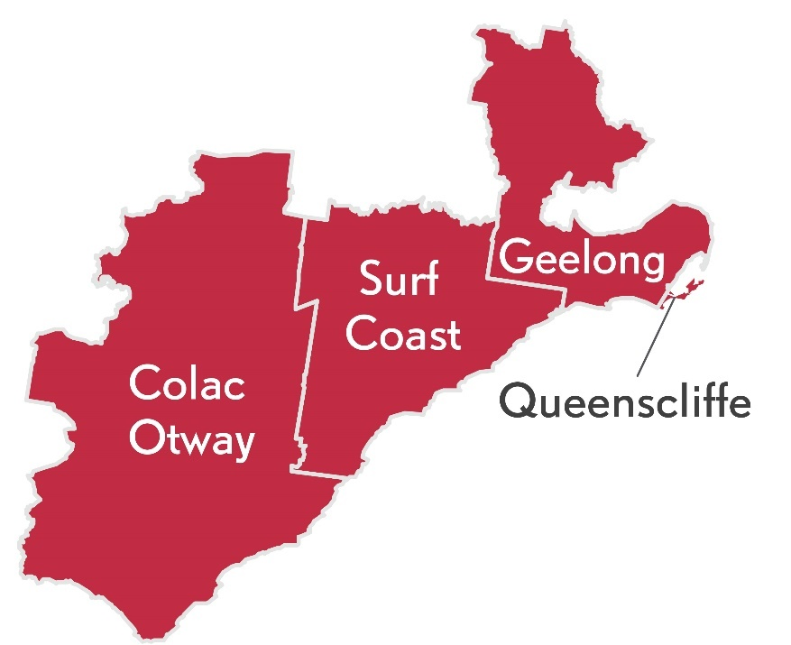
From the famous Great Ocean Road coastline to the Otway forests, from rich farmland to the streets of Victoria’s biggest regional city, Geelong, our region spans spectacular and diverse landscapes.

We have a dynamic economy, with a strong manufacturing and processing sector, and great potential for growth in the professional services, tourism, international education, healthcare, information and communication technologies and agribusiness sectors.

Our region spans the City of Greater Geelong, Borough of Queenscliffe, Colac Otway Shire, and Surf Coast Shire, and has:
- A Gross Regional Product of $16.7 billion;
- A population of 316,900;
- More than 10 per cent of residents speaking a language other than English at home and more than 16 per cent born overseas.

What is the role of Regional Partnerships?
The Barwon Regional Partnership is one of nine Partnerships across the state, established by the Victorian Government, recognising that local communities are in the best position to understand the challenges and opportunities faced by their region. Regional Partnerships act as a voice for their regions and advise the Victorian Government on regional priorities that reflect the unique needs and strengths of their region.
This involves engaging with rural and regional communities and a range of Government agencies, business and industry groups, community based organisations, Traditional Owner groups and Regional Development Australia Committees.

Major achievements of the Barwon Regional Partnership include:
- Connecting key stakeholders and decision-makers to progress Geelong City Deal, which has now attracted more than $370 million in funding;
- Advocating for the Geelong Project, an innovative youth homelessness prevention program.

Who are we looking for?
We acknowledge that Barwon Regional Partnership business is conducted on Aboriginal land, including the lands of the Wadawurrung people and Eastern Maar people, as well as other Traditional Owner groups in Victoria who are not yet formally recognised. We are aiming to attract people from all parts of the Barwon region and people from diverse backgrounds including:
- Aboriginal and Torres Strait Islander Victorians;
- people from LGBTIQ+ communities;
- people with disability;
- people from culturally and linguistically diverse backgrounds;
- young people; and
- women.
We are seeking a combination of emerging and experienced regional leaders for all Partnerships.

FAQs

What happens after I apply?
Your application will be assessed by a selection panel. Interviews are expected to be completed during October 2020, with the final outcomes of the application process expected in January 2021.

If you proceed to interview, we will ask if you require any adjustments to the interview process. This can include changing the way we conduct the interview (for example, by phone or video conference instead of in person) or having a support person or advocate present.

If you are interested in applying, we encourage you to contact your local Regional Development Victoria office for a confidential discussion (see Key Contacts below).

What is expected of Regional Partnership members?
The Barwon Regional Partnership is currently holding a minimum of four meetings (currently online) per year. Most members also participate in working groups focusing on different aspects of Regional Partnership work and attend events and stakeholder engagement sessions from time to time.

Other expectations are laid out in the Position Description.

I am running for the upcoming Local Government elections. Can I also apply for the Regional Partnership?

Each Local Government area is represented on its relevant Partnership by its Chief Executive Officer. The Partnerships span multiple Local Government Areas and take a strategic, region-wide lens to most of the issues they tackle. Any interested person from a regional Victorian community is welcome to apply to be a Regional Partnership member. Please consider the time you will be able to commit to the Partnership.

If you wish to withdraw your application at any stage in the process, please let us know.

Key Contacts
The below contacts are available Monday–Friday, 9am–5pm, using the National Relay Service 133 677 if required.
Executive Officer:
Paul Roth, Regional Director
Regional Development Victoria Barwon South-West
t: 0407 483 095
Coordinator:
Dr Ragini Flower, Regional Strategy Coordinator
Regional Development Victoria Barwon South-West
t: 0436 819 003
e: barwon.partnership@rdv.vic.gov.au <barwon.partnership@rdv.vic.gov.au>

