Goulburn

Regional Economic Development Strategy

**State Government of Victoria**

**Department of Jobs, Precincts and Regions**

**Acknowledgement of Country**

The Department of Jobs, Precincts and Regions acknowledge the Traditional Owners of the lands and waters on which we live and work, and pay our respects to their Elders past, present and emerging.

We acknowledge that the Goulburn Regional Partnership region is on traditional lands, including those lands of the Yorta Yorta, Taungurung and Wurundjeri Nations, as well as other Traditional Owner groups in Victoria who are not formally recognised.

We acknowledge the diversity of Aboriginal Victorians, their communities and cultures, the intrinsic connection to Country, the contribution and interest of Aboriginal people and organisations in developing a prosperous region. This Strategy is committed to advancing the principles of Aboriginal self-determination and supporting communities to realise self-determined economic development objectives.

# Preface

Rural and regional Victoria is home to 1.6 million, or 1 in 4, of Victoria’s residents and over 147,000 businesses. The Victorian Government is committed to making Victoria home to the nation’s most vibrant and successful regional economies.

The Department of Jobs, Precincts and Regions (DJPR) is delivering Regional Economic Development Strategies (REDS) for Victoria’s nine Regional Partnership regions. The REDS contribute to DJPR’s vision for regional Victoria to be a resilient and thriving place to live, work and do business. The REDS provide a consistent socioeconomic evidence base, and strategic framing of medium- to long-term directions to activate economic development opportunities.

**The REDS seek to:**

1. Identify a socioeconomic evidence base for the region, including demographics, business and industry dynamics, and local endowments that can be used by all stakeholders, and will provide a baseline for monitoring future performance.
2. Acknowledge and reveal the depth of work, analysis, and planning already in place in regions and create a mechanism to support and progress established regional directions, where supported by the current evidence base.
3. Harness and enhance the region’s comparative strengths as drivers of growth in the medium- to long-term.
4. Identify opportunities for public and private investment.
5. Influence and inform rural and regional economic policy and program design across government.
6. Support the prosperity and well-being of rural and regional Victoria through increased rural competitiveness and productivity.

The REDS do not replace existing local strategies. Rather, the REDS are informed by local work to identify economic development priorities and provide a platform to increase the visibility of these priorities and support regional communities to advocate for shared outcomes.

## How have the REDS been developed?

The REDS have been developed using a consistent methodology across the state, comprising:

* **data analysis** to consistently describe each region’s industry composition, economic and socioeconomic trends and existing regional endowments
* **policy analysis** to identify existing local strategies and plans to understand regional development priorities and shape an economic narrative for the region

**stakeholder engagement** to identify opportunities and challenges under each strategic direction.

## How can I use the REDS?

The REDS can be used by all levels of Government, regional communities and business to coordinate investment and collaborate for shared outcomes.

DJPR will use the REDS to drive strategic whole-of-government activity in the regions, informed by a contemporary understanding of economic performance and comparative advantage.

Regional communities and businesses can use the REDS to:

* communicate innovative capacity in their region, now and in the future
* collaborate with government to better understand regional strengths, challenges and opportunities

attract investment to the region based on clearly identified strategic priorities.

The REDS should be read in conjunction with the relevant *REDS Supporting Analysis* which provides the consistent evidence base for each region.

**Figure 1: Map of Regional Partnership Regions and Constituent LGAs**

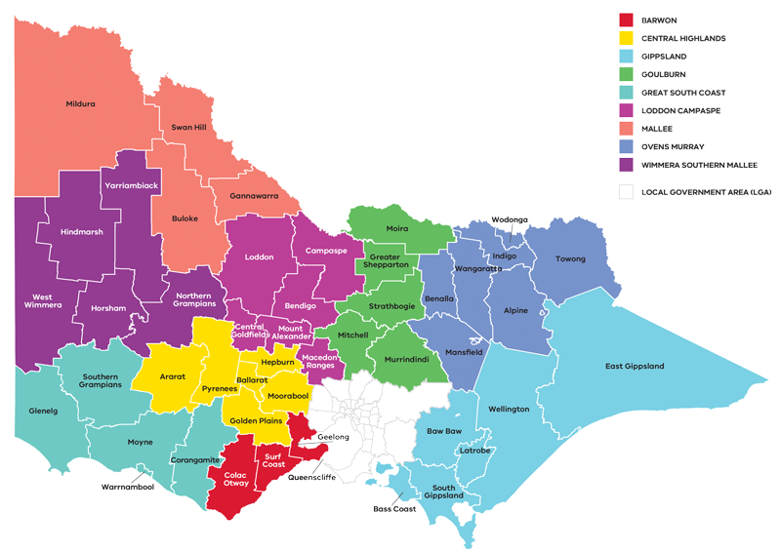

Figure 1: Map of Regional Partnerships – Long Alternate Text

Contents

01 Introduction 4

Regional readiness to activate strategic directions 6

Local priorities and strategies 6

02 Regional profile 7

Employment by industry 9

Output by industry 10

03 Comparative advantage 11

3.1 Endowments 12

3.2 Revealed industry specialisation 14

04 Strategic directions 18

Goulburn’s strategic directions 19

Enabling factors for economic growth 19

Integrating Aboriginal economic opportunities 20

4.2 Focus on continued growth and development of the visitor economy, leveraging natural assets and Aboriginal heritage 25

4.3 Strengthen renewable energy generation and the role of the circular economy 28

4.4 Leverage the role of Shepparton as the regional capital and industry hub 32

05 Implementation 35

RRV will use the REDS to coordinate investments and activities in place 35

Local stakeholders, industry leaders and government service providers can use the REDS to advocate for shared outcomes 36

RRV will monitor the implementation of the REDS 36

Contact us 36

Appendix 38

Figure 1: Map of Regional Partnerships – Long Alternate Text 38

Figure 2 Map of Goulburn – Long Alternate Text 38

Figure 3 Goulburn industry Employment – Long Alternate Text 39

Figure 4 Goulburn industry output (gross value add) – Long Alternate Text 41

Figure 5 Goulburn industry employment location quotient and growth – Long Alternate Text 43

Figure 6 Goulburn industry output (GVA) location quotient and growth – Long Alternate Text 44

# 01 Introduction

The *Goulburn Regional Economic Development Strategy* (the Goulburn REDS) sets out the medium- to long-term strategic directions for driving economic growth and development across the region.

The Goulburn Regional Partnership region is often described as the ‘food bowl of Australia’, covering a large part of the Goulburn Murray Irrigation District (GMID) and encompassing the local government areas of Greater Shepparton, Mitchell, Moira, Murrindindi and Strathbogie. The region is home to the Yorta Yorta, Taungurung and Wurundjeri Nations who are the recognised Traditional Owners who have lived, worked and cared for their country and its and resources for many thousands of years.

Stretching from Melbourne’s northern peri-urban fringe to the banks of the Murray River, economic opportunities in the region are influenced by agricultural innovation, abundant natural resources and the region’s attractiveness as a place to live and work. As an integral part of Australia’s food bowl, the region has irrigation-based industries including dairy, horticulture and viticulture, as well as dryland farming operations that support business growth and employment throughout the regional agri-food supply chain. The regional city of Greater Shepparton is the primary location for health, cultural and education services and has historically been a driver of regional output and population growth. The Mitchell Shire is in Melbourne’s northern growth corridor and is projected to be the most populous local government area in the region by 2030, surpassing Greater Shepparton.

The Goulburn region is specialised in agriculture and manufacturing as well several population-based sectors that support construction activity and the visitor economy. Goulburn’s local endowments contribute to industry specialisation, including:

* irrigation infrastructure in the GMID
* strong road and rail networks that connect the region to domestic and international markets

natural assets that support tourism around Lake Eildon National Park and the Murray River.

**Strategic directions**

The Goulburn REDS defines four strategic direction for economic development in the region, based on comprehensive data analysis and review of existing policies and strategies:

1. Enhance productivity and resilience in the **agricultural and food product manufacturing sectors**
2. Focus on continued growth and development of the **visitor economy**, leveraging natural assets and Aboriginal heritage
3. Strengthen **renewable energy generation** and the role of the circular economy
4. Leverage the role of **Shepparton as the regional capital and industry hub**.

**For each of the directions, the Goulburn REDS provides:**

* a rationale for its inclusion as part of the strategy
* an overview of opportunities and challenges which are likely to support or hinder future growth
* a summary of work underway and the policy context to support desired outcomes
* the implication of the direction for the region’s Aboriginal communities

examples of how the direction could be activated.

The Goulburn REDS recognises that approaches to regional economic development occur in an uncertain environment. While most of the analysis focuses on internal development drivers, it also considers the impact of, and opportunities emerging due to external trends, including the COVID-19 pandemic, patterns in global trade, a changing climate and technological change.

The Goulburn REDS acknowledges that the Aboriginal and cross-border communities within the region face unique challenges and opportunities, which are also reflected in the strategic directions.

## Regional readiness to activate strategic directions

The Goulburn region is focused on maintaining the region’s reputation as the agri-food powerhouse of Australia. Initiatives and institutions in the region support business innovation, specialisation and collaboration to build resilience and activate economic opportunities. These include:

* the network of Goulburn Ovens Institute of TAFE campuses throughout the region that support the ongoing development of local skills, most notably at the William Orr working farm and Melbourne University’s Dookie campus
* the concentrated cluster of internationally renowned food product manufacturers in the Greater Shepparton area, which creates local efficiencies through an ability to attract and retain skilled workers and concentrate expertise in the region

Agriculture Victoria’s SmartFarm at Tatura which, in collaboration with the Mildura SmartFarm, enables research and innovation to deliver high-quality fruit from orchard to export market.

Other important institutions in the region that contribute to economic development include the Kaiela Institute in Shepparton – an Aboriginal-led analysis and policy think tank – and the network of community energy groups that contribute to future opportunities in renewable energy.

## Local priorities and strategies

The *2020 Goulburn Murray Resilience Strategy* and *2021 Goulburn Murray Regional Prosperity Plan* are the most contemporary bodies of work that have informed the REDS economic narrative and strategic directions.

The *Goulburn Murray Resilience Strategy* responds to the macro drivers of change in the region –including increasing global uncertainty, the effects of climate change and industry transition –to set a vision and strategy for the region. The *Goulburn Murray Resilience Strategy* outlines eight resilience principles to assist the region to better deal with change and identifies areas of intervention to address each principle. The areas of investment include futures of agriculture, learning for change, circular economy, natural and built assets and leadership and coordination.

The *Goulburn Murray Regional Prosperity Plan* sets out a place-based vision to generate an additional $150 million Gross Regional Product (GRP) per annum by 2036 for the region through the economic inclusion, prosperity and shared value of Yorta Yorta and Aboriginal people. The plan includes six strategic themes focused on community, relationships, culture, leadership and skill development.

The Goulburn REDS also takes into consideration other State, regional and sub-regional policies and strategies as set out in the supporting documentation.

**Figure 2: Map of Goulburn**

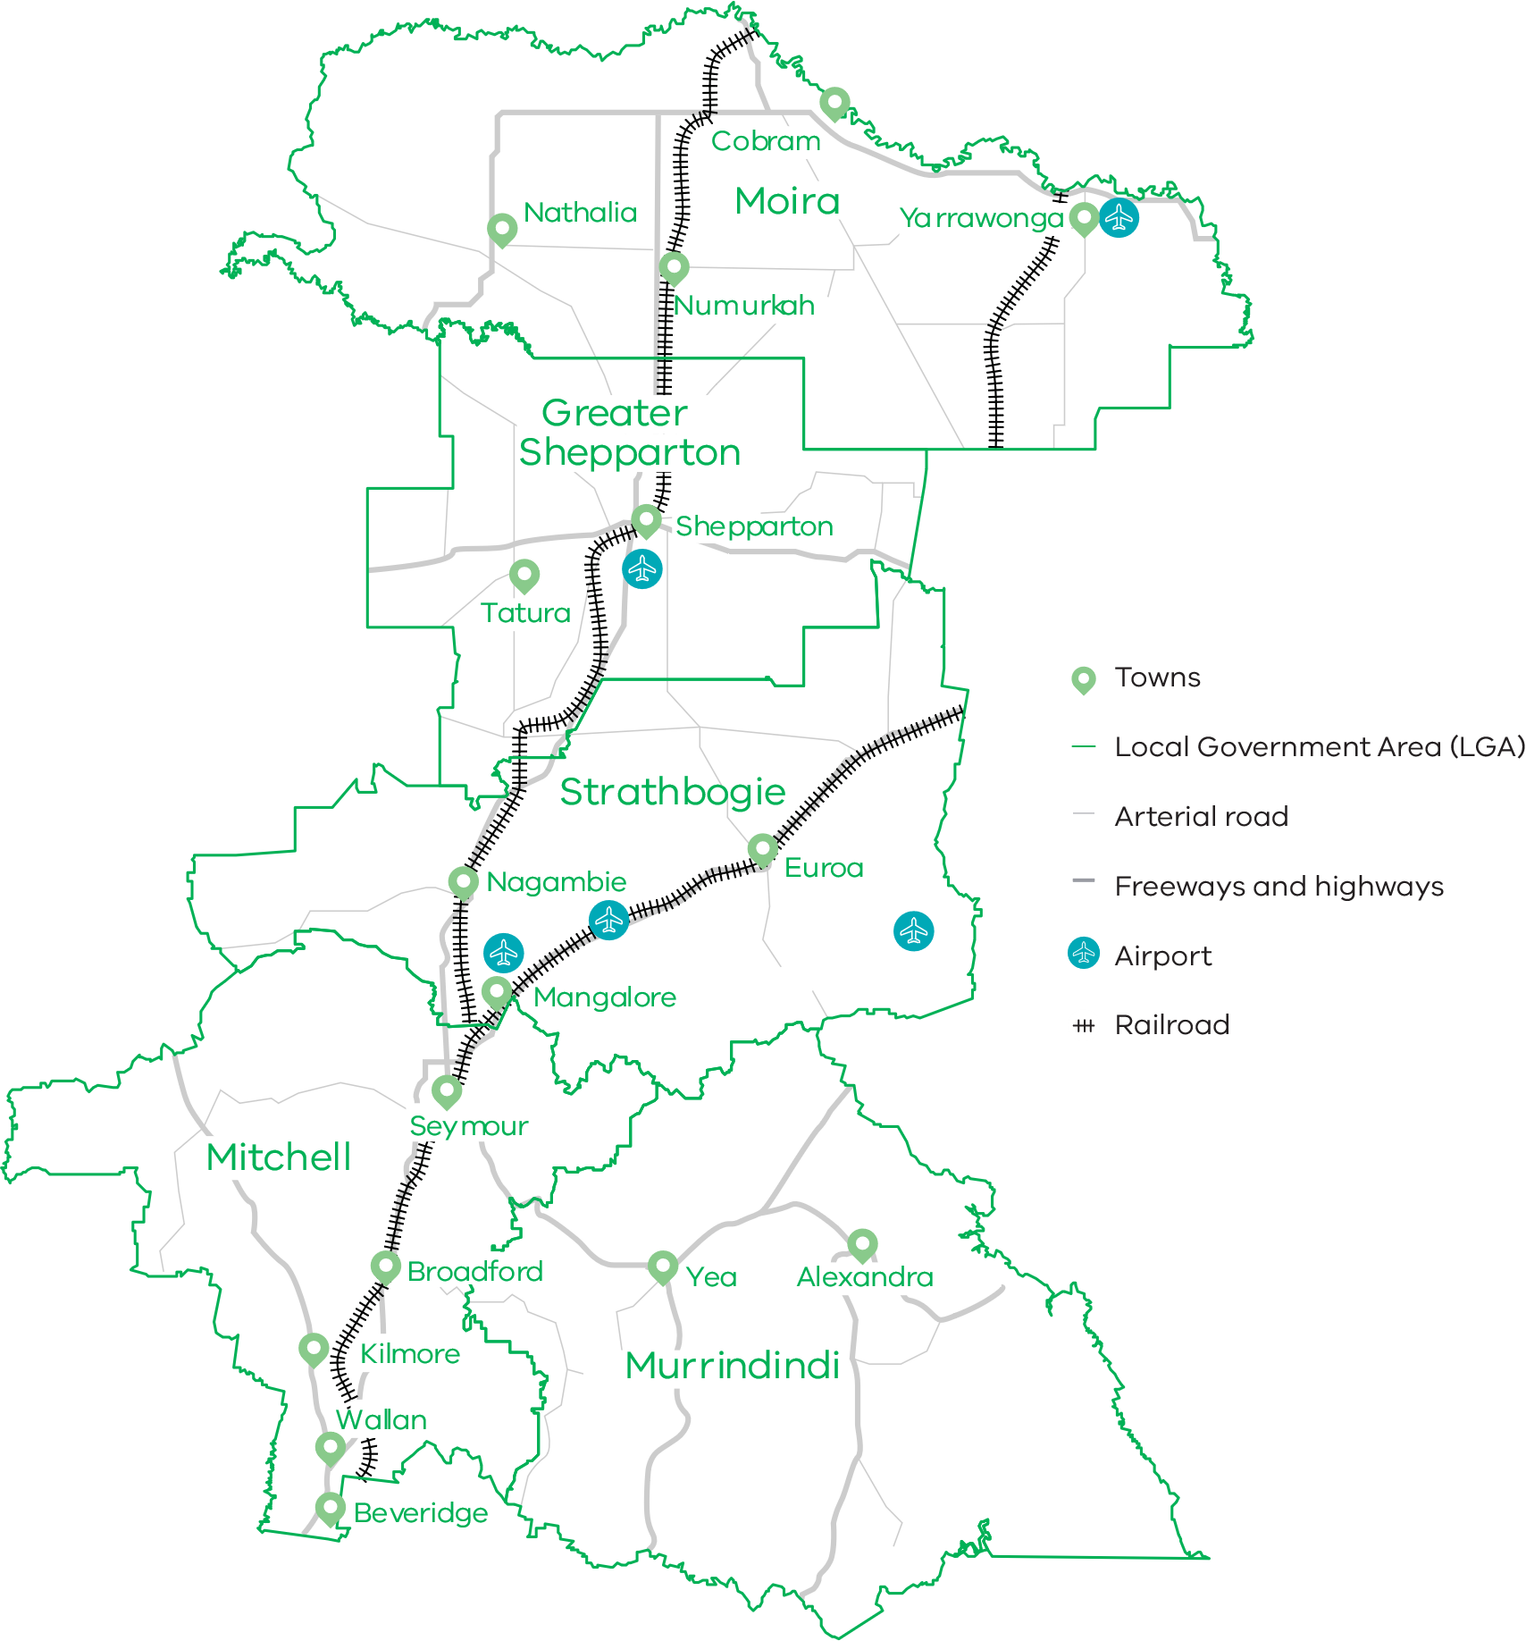

Figure 2 Map of Goulburn – Long Alternate Text

# 02 Regional profile

|  |  |
| --- | --- |
| $8.0 | Gross regional product (billion) (2020) |
| 170,400 | Population (2020) |
| 5.0% | Population growth (2011-20) |
| 41 | Median age (2020) |
| 61.4% | Working age (15-64) (2020) |
| 19.4% | Population aged over 65 (2020) |
| 2.3% | Are Aboriginal and/or Torres Strait Islander (2016) |
| 10.0% | Speak a language other than English at home (2016) |
| 13.0% | Were born overseas (2016) |

| Local Government Area | Population[1] (2020) | Projected growth[2] (2021-36) |
| --- | --- | --- |
| Greater Shepparton | 67,100 | 14.7% |
| Mitchell | 47,600 | 95.1% |
| Moira | 30,000 | 7.3% |
| Murrindindi | 14,700 | 13.6% |
| Strathbogie | 11,000 | 9.5% |

Greater Shepparton is currently the region’s population centre. Population growth in the past decade has been higher in Goulburn than the regional Victorian average. This growth has been driven mostly by Mitchell Shire and its peri-urban townships of Wallan, Kilmore, Seymour, Broadford and Beveridge. Growth in Mitchell Shire will continue, influenced by its proximity to the peri-urban fringes of Melbourne, which provides access to metropolitan markets and economies.

In Mitchell, Murrindindi and Strathbogie shires, population growth for those between the ages of 0-15 and 25-44 is growing at more than double the rate of regional Victorian averages. This indicates that families are attracted to southern Goulburn, likely due to lower living costs and proximity to metropolitan Melbourne’s employment and education centres.

Young people, aged 15-24, are migrating out of Goulburn at higher rates than regional averages, likely seeking employment and education opportunities. This indicates that Goulburn may be experiencing difficulty retaining younger residents.

|  | Goulburn % | Regional average % | Metro Melbourne % |
| --- | --- | --- | --- |
| Unemployment rate[3] (September 2021) | 4.0 | 4.2 | 6.0 |
| Labour force participation rate[4] (2020) | 61.1 | 60.9 | 65.8 |
| Average annual employment growth[5] (2011–20) | 1.3 | 1.0 | 2.1 |

The labour force participation rate in Goulburn (61.1% per cent) is higher than the regional Victorian average.

The female participation rate (56.6 per cent) is significantly lower than for men (66.0 per cent). The largest employing sectors for women are healthcare and social assistance, retail trade, education and training and accommodation and food services.

**Table 1: Employment in largest employing industries by workers (2020) and gender (2016)**

|  | Workers | Male | Female |
| --- | --- | --- | --- |
| Healthcare and social assistance | 9,300 | 15.8% | 84.2% |
| Agriculture, forestry and fishing | 9,200 | 69.9% | 30.1% |
| Construction | 7,200 | 88.6% | 11.4% |
| Retail trade | 7,000 | 40.7% | 59.3% |
| Manufacturing | 6,900 | 73.2% | 26.8% |

Source: National Institute of Economic and Industry Research, 2020 and ABS Census, 2016

## Employment by industry

The region has realised considerable employment growth in construction and health care and social assistance over the past 20 years. Employment growth in the health care and social assistance sector is consistent with trends across the state and is supported by a growing and ageing population in the Goulburn region.

The agriculture, forestry and fishing sector had been experiencing a slow decline since 2001 but recently experienced employment growth starting in 2016, likely associated with emerging industries in the region (including hydroponic horticulture) and increasing demand for agricultural support services. The recent sharp decline in employment in agriculture may be associated with the coronavirus pandemic and access to workers.

Manufacturing is also undergoing a revival in the Goulburn region, largely driven by food product manufacturing, and has seen employment growth since 2016.

**Figure 3: Goulburn industry employment (2001-20)**

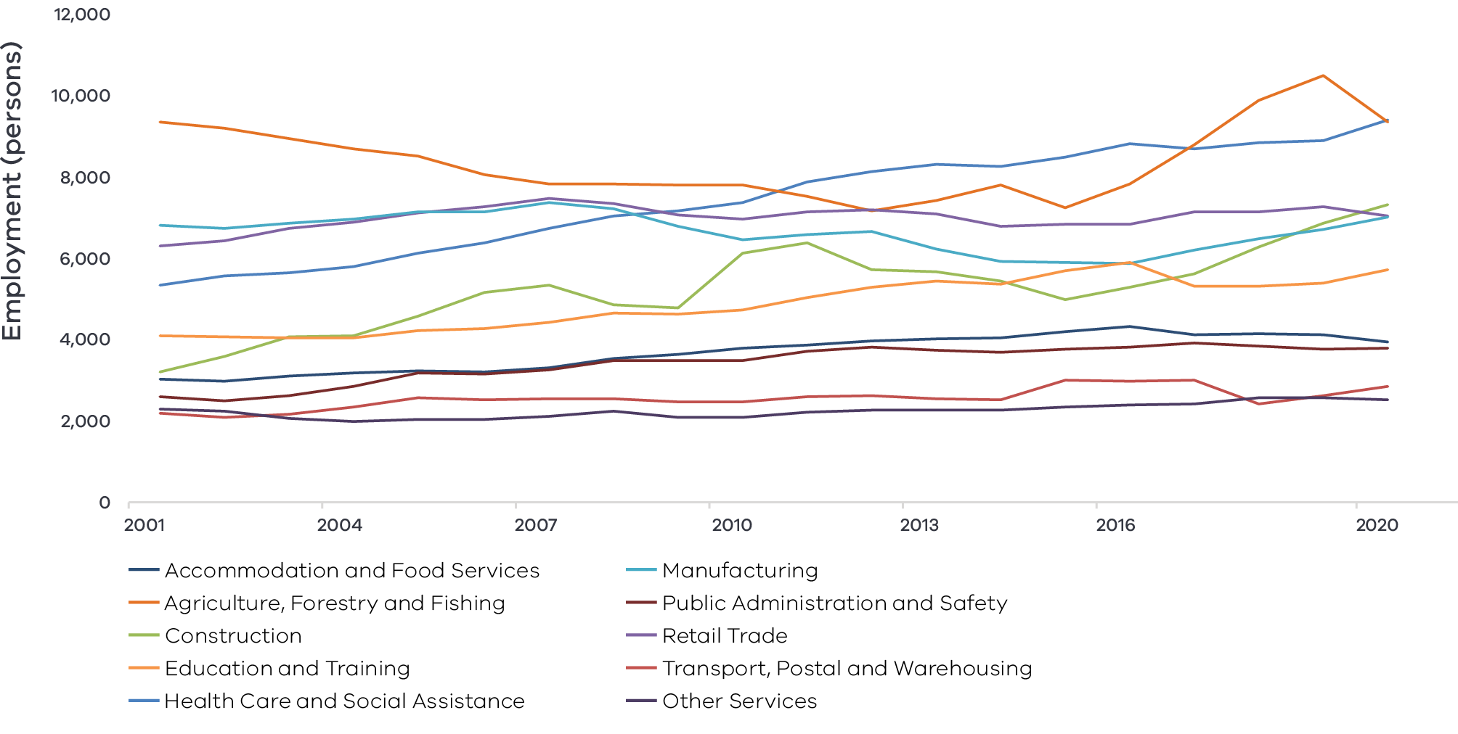

Figure 3 Goulburn industry Employment – Long Alternate Text

## Output by industry

GVA across the region has steadily grown over the last 20 years with only some periods of minor decline around the Millennium Drought and Global Financial Crisis. The health care and social assistance sector saw strong and steady growth over the past two decades. Several key industries have faced periods of both growth and decline in the past 20 years. Manufacturing and construction have experienced large increases to GVA since 2015. The agriculture, forestry and fishing industry has been the largest contributor to the region’s GVA since 2001 but has experienced significant declines in output since 2015 due to dry seasonal conditions, high temporary water prices and transition in the dairy sector.

### $6.4 billion Gross Value Added (GVA) (2020)

**Top sectors by GVA ($ million):**

|  |  |  |
| --- | --- | --- |
| 1 | Construction: | $824.4 |
| 2 | Health care and social assistance: | $759.5 |
| 3 | Manufacturing: | $758.1 |
| 4 | Agriculture, forestry and fishing: | $750.5 |
| 5 | Education and training: | $462.9 |

**Figure 4: Goulburn industry output (Gross Value Add) (2001-20)**

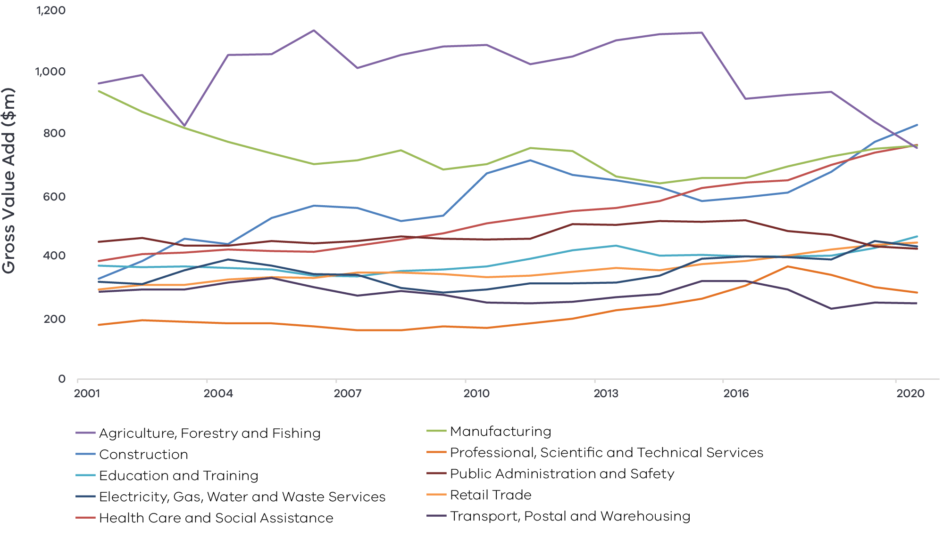

Figure 4 Goulburn industry output (gross value add) – Long Alternate Text

National Institute of Economic and Industry Research, 2020

### Regional exports

International export value from the region has steadily increased over the past decade from $812.2 million in 2010 to $1.2 billion in 2020. Top export commodities in 2020 include:

1. Manufacturing, valued at $640.0 million
2. food product manufacturing valued at $544.0 million (accounts for 85.6 per cent of the industry value)
3. primary metal and metal product manufacturing valued at $20.2 million
4. basic chemical and chemical product valued at $19.4 million
5. Agriculture, valued at $300 million
6. Accommodation and Food Services, worth $60.6 million
7. Transport, postal and warehousing, worth $41.8 million and
8. Wholesale Trade, worth $38.6 million.

# 03 Comparative advantage

For the purposes of the REDS, ‘comparative advantage’ is defined simply as a description of what the region does well compared to other regions. This includes both the relative competitiveness of the region’s businesses as well as cultural, social and environmental factors.

Contemporary place-based development emphasises the importance of local endowments as a driver of local comparative advantage. In economic terms, endowments refer to any natural, human, cultural and built resources present in a place which can be harnessed to support economic activity. Regional economic strengths can also be identified using other measures including location quotient analysis, shift share analysis and industry cluster analysis. A comprehensive assessment of these measures is included in the *Goulburn Regional Economic Development Strategy – Supporting Analysis*.

## 3.1 Endowments

### Natural endowments

#### Fertile land and water access

Most land (78 per cent) in the Goulburn region is used for primary production which supports horticulture, dairy, cropping and livestock grazing. The region has fertile alluvial soils and significant water assets which include Goulburn, Broken, Murray, Campaspe and Ovens Rivers and Broken Creek. These water assets support storage at Eildon and extensive irrigation infrastructure, including in the Goulburn Murray Irrigation District.

#### Environmental assets

Natural assets underpin opportunities in the Goulburn region’s nature tourism and renewable energy sectors. Across the region, there are five National Parks and a further seven State and Regional Parks. Significant natural assets include Lake Eildon, the Cathedral Ranges and the Barmah National Park, which hosts cultural and environmentally significant Ramsar wetlands site. River systems, sun hours, wind resources and biowaste (mostly from agricultural and forestry activities) support opportunities in the renewable energy sector.

### Cultural endowments

#### Aboriginal heritage

Greater Shepparton has one of the largest Aboriginal populations in Victoria, which contributes to the region’s cultural and business opportunities. Important sites on the lands of the Yorta Yorta people span the Victorian and New South Wales (NSW) borders and include a range of forest, wildlife reserves and waterways. A Joint Management Plan for Barmah National Park between the Victorian Government and the Yorta Yorta Nation recognises Yorta Yorta as the Traditional Owners of the area and enables Yorta Yorta to share responsibility for and participate in the management of the park. Aboriginal art is showcased throughout the region. The Aboriginal Street Art Project in Shepparton is a collaborative effort between local government, service providers and the Rumbalara Cooperative, Yorta Yorta Nation Aboriginal Corporation and local Aboriginal communities. It aims to celebrate the local Aboriginal history and culture within the region by recognising ancestors and significant elders through street art. The Shepparton Arts Museum (SAM) includes a focus on Aboriginal and Torres Strait Islander art and the Mitchelton Gallery of Aboriginal Art in Nagambie exhibits works from a range of Aboriginal communities across Australia, including the local Taungurung People.

### Built endowments

#### The GMID

The GMID underpins the region’s status as Australia’s ‘food bowl’. The GMID is the largest irrigation system in Victoria, covering 9,950 square kilometres and accounting for more than 70 per cent of water stored in Victoria and 90 per cent of water used in irrigation across the state. Recent dry season conditions and high temporary water prices have affected irrigators in the region, but the GMID remains a critical asset to the future security of agriculture in the region. The $2 billion Connections Project, funded by the Victorian and Australian Governments, will generate water savings and boost irrigator productivity in northern Victoria.

#### Food manufacturing hub

Greater Shepparton is an important city in Australia’s food bowl with strong fruit and dairy industries, significant processing infrastructure and capabilities and transport links to Melbourne and Brisbane. Several important food manufacturing companies have establishing operations in the region, creating a cluster of specialised infrastructure and workers.

#### Transport connections

Located centrally in the State and between two major domestic markets – Melbourne and Sydney – the region is strategically positioned to reach domestic and international markets. By road most major centres in Victoria are only a few hours from Goulburn, and the southern parts of the region also have train connections to Melbourne. Strong transport networks have supported the region’s international exports to grow from $812.2 million in 2010 to $1.2 billion in 2020, primarily driven by export of manufactured goods. The extensive transport networks include two major rail corridors and six highway connections, including the Hume Freeway and Midland Highway, which connect the region with Melbourne’s air and sea ports. Mangalore Airport, currently an aviation and training facility, has the potential to be a significant intermodal transport hub for the region.

#### Tertiary education institutions

The region is home to TAFE, University and training campuses that offer pathways to higher education in Melbourne and throughout the region. Goulburn Ovens Institute of TAFE (GOTAFE) offer over 250 courses and pathways to La Trobe and Charles Sturt University. GOTAFE hosts campuses in Seymour, Shepparton and Wallan. University campuses include University of Melbourne’s Dookie agricultural college and Rural Clinical School in Shepparton, and La Trobe University in Shepparton.

#### Transmission infrastructure

The Hume region, which includes Goulburn, has two main high voltage transmission lines and five major electrical terminal stations. This infrastructure has supported renewables growth to date and has capacity for future augmentation. The Victorian Central North Renewable Energy Zone is within the Goulburn region, and has been identified for potential investments via minor augmentations to add network capacity and avoid generator curtailment due to network thermal limitations.

### Human endowments

#### Culture of resilience

In the face of significant change across the region, leaders in Goulburn are seeking to shift from a ‘persistence’ mindset to an active ‘adaptation and transformation mindset’. The Regional Resilience Taskforce acts as the custodians of the Goulburn Murray Resilience Strategy and translates the region’s shared vision and voice into resilience building action.

#### Community energy groups

The Hume region, which includes Goulburn, has the highest number of community energy groups within a single region in Australia. Community energy groups manage community energy projects to benefit the local region. This contributes to a strong social licence for renewable energy activities and developments.

#### Innovative agricultural workforce

Structural changes across the agricultural sector will increase demand for workers with technical, business and multi-disciplinary skills. The region has access to skilled agricultural workers and strong agricultural training facilities to prepare workers of the future. Livestock farmers are the largest employing occupation in the region and crop farmers are the seventh.

## 3.2 Revealed industry specialisation

Location Quotient (LQ) analysis provides further insight into the local economy’s underlying structure and comparative advantages that may not be evident from a region’s endowments. This form of analysis compares an industry’s size and growth (as measured by employment and output) as a proportion of total economic activity, relative to the Victorian average. The higher the LQ, the more concentrated, and therefore significant, an industry is to the local economy relative to Victoria on average. Scores above 1.25 are considered to indicate notable specialisation compared to the rest of the state. Further analysis is provided in the *Goulburn Regional Economic Development Strategy – Supporting Analysis*.

### Employment specialisations

**Figure 5: Goulburn industry employment location quotient and growth**

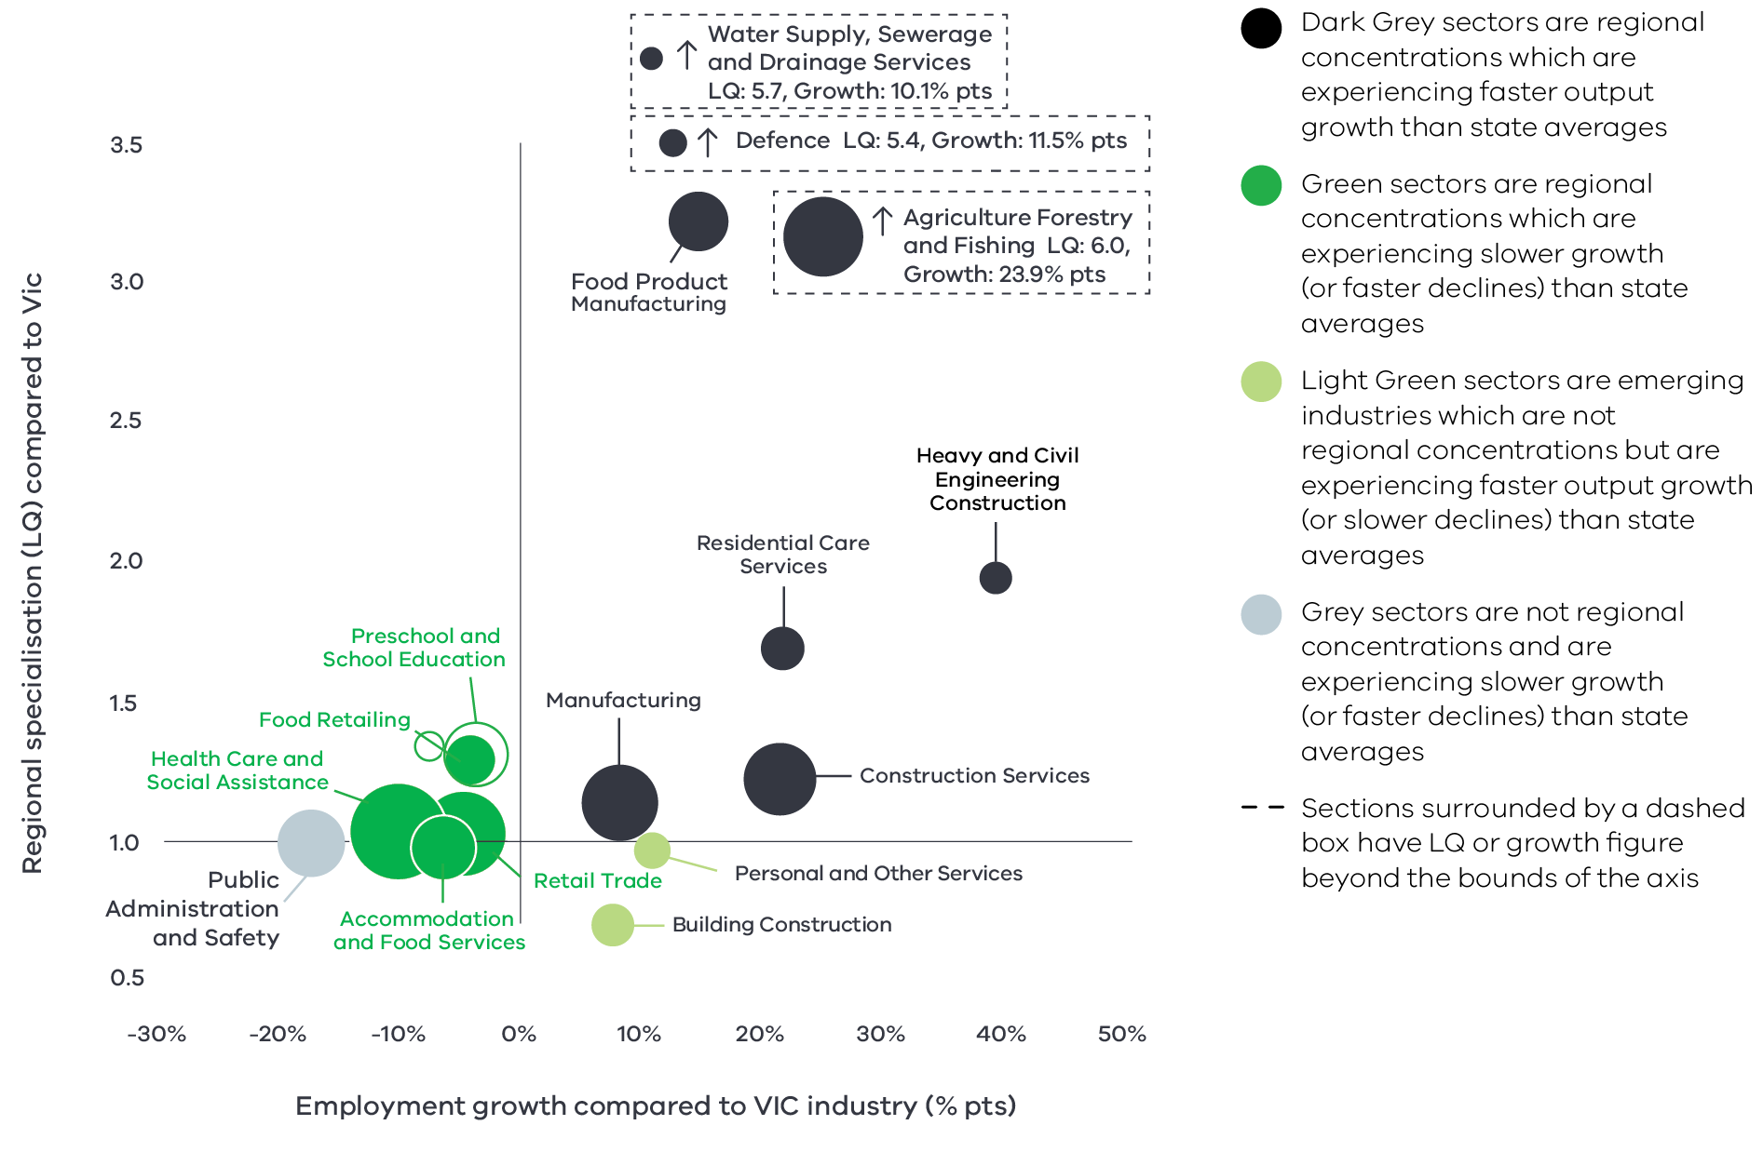

Figure 5 Goulburn industry employment location quotient and growth – Long Alternate Text

Source: National Institute of Economic and Industry Research, 2020

Note this chart represents a selection of Industries and Sub-industries that represent a notable size and or concentration within the region. Some sub-industries presented are sub-sectors of industries that are presented alongside it and therefore measures cannot be aggregated between the two. Other industries are not displayed. For greater detail refer to the supporting analysis pack for this REDS strategy.

**Figure 5** depicts selected industries and sub-industries in the regional economy in 2020 where:

* The size of each bubble indicates the number of people employed in the (sub)industry in 2020. The bigger the bubble, the more people employed in the industry.
* The vertical position indicates the (sub)industry’s degree of employment concentration relative to the Victorian economy. For example, a value of 3.2 means that, as a share of total employment in the local economy, the (sub)industry employs 3.2 times as many people than the Victorian average.

The horizontal position indicates the difference in each (sub)industry’s employment growth (2015-20) between the region and the Victorian average. For example, a 15 per cent value indicates that regional employment in the (sub)industry has grown 15 percentage points faster (between 2015 and 2020) relative to the industry’s average growth rate in Victoria.

**Agriculture, forestry and fishing:** The agriculture, forestry and fishing sector is an important employer in the region, employing six times as many workers than the Victorian average and growing 23.9 percentage points faster than the Victorian average. This implies a strong employment advantage in the sector relative to the rest of the state. Irrigation infrastructure and Goulburn Murray Water, Australia’s largest rural water corporation, also support employment specialisation in water supply, sewerage and drainage services.

**Food product manufacturing:** The region is seeing a resurgence in the manufacturing sector led by food product manufacturing. Food product manufacturing employs 3.2 times more people in the Goulburn region than Victorian averages and employment is growing 15 percentage points faster than Victorian averages. It is an important employment growth sub-sector for Goulburn and critical to the broader agri-food supply chain.

**Heavy and civil engineering construction:** Goulburn has an employment specialisation in heavy and civil engineering construction with an LQ score of 1.94 and employment growth 40 percentage points faster than the state average. This is partially due to major road, rail, industry and irrigation infrastructure upgrades throughout the region but also demonstrates an underlying employment strength in specialised construction.

**Population services:** At a sector level, the region is not specialised in population services such as health care and social assistance, education and training and construction. This is partly due to relatively lower population growth as compared to other regions and metropolitan Melbourne (except in Mitchell Shire). Among health care and social assistance services, the region is specialised in residential care services with employment growth outpacing the Victorian average by 21.7 percentage points, which may be due to population ageing. Among education and training, the region is concentrated in preschool and school education but experiencing employment declines at faster rates than the Victorian average.

**Defence:** Goulburn has an employment specialisation in defence with an LQ score of 5.4 and employment growth 11.5 percentage points above the Victorian average. This is concentrated in Mitchell Shire, home to the Puckapunyal defence site, which supports many personnel and a permanent resident population.

### Output specialisation

Similar to employment specialisation, Goulburn demonstrates output specialisation in manufacturing, defence, water services and heavy and civil engineering construction. Manufacturing is a regional output specialisation led by food product manufacturing with an LQ score of 5.05 and output growth 24 percentage points above the Victorian average. Water supply, sewerage and drainage services is also a regional output specialisation, servicing the GMID and underpinning the region’s significant agri-food supply chain. This reinforces the region’s unique strengths in these industries.

There are however some differences in the agriculture and population services industries:

**Agriculture, forestry and fishing:** In contrast with employment concentrations, which showed that employment growth in Goulburn’s agriculture industry exceeded state-wide averages, agricultural output growth in Goulburn is currently lagging behind the Victorian average by 6 percentage points. This is likely associated with dry season conditions in the GMID and transition in the dairy sector since 2016.

**Population services:** Education and training and retail trade emerge as output concentrations, growing faster than state averages, while health care and social assistance lags state averages. Parts of the construction sector that meet increasing demand for housing are out-performing Victorian averages. This includes construction services and building services. Specialisation in construction must be considered in the broader context of construction growth across the state, which may dampen the signs of regional advantage.

There are also different areas of specialisation that support market access and the region’s agricultural and manufacturing sector including road transport, repair and maintenance and waste collection, treatment and disposal services. Waste services, with an LQ score of 2.53 and growth 140 percentage points faster than state averages, is a regional strength. With growing interest in the circular economy, particularly in Shepparton, waste services offer opportunities for future expansion and business growth.

### Emerging areas of specialisation

Beyond the relatively established sectors, personal and other services and store-based retailing are showing output growth rates above the Victorian average but are not yet areas of regional specialisation. Both of these sub-sectors are associated with servicing the needs of growing populations and do not necessarily indicate underlying strengths of the regional economy.

**Figure 6: Goulburn industry output (GVA) location quotient and growth**

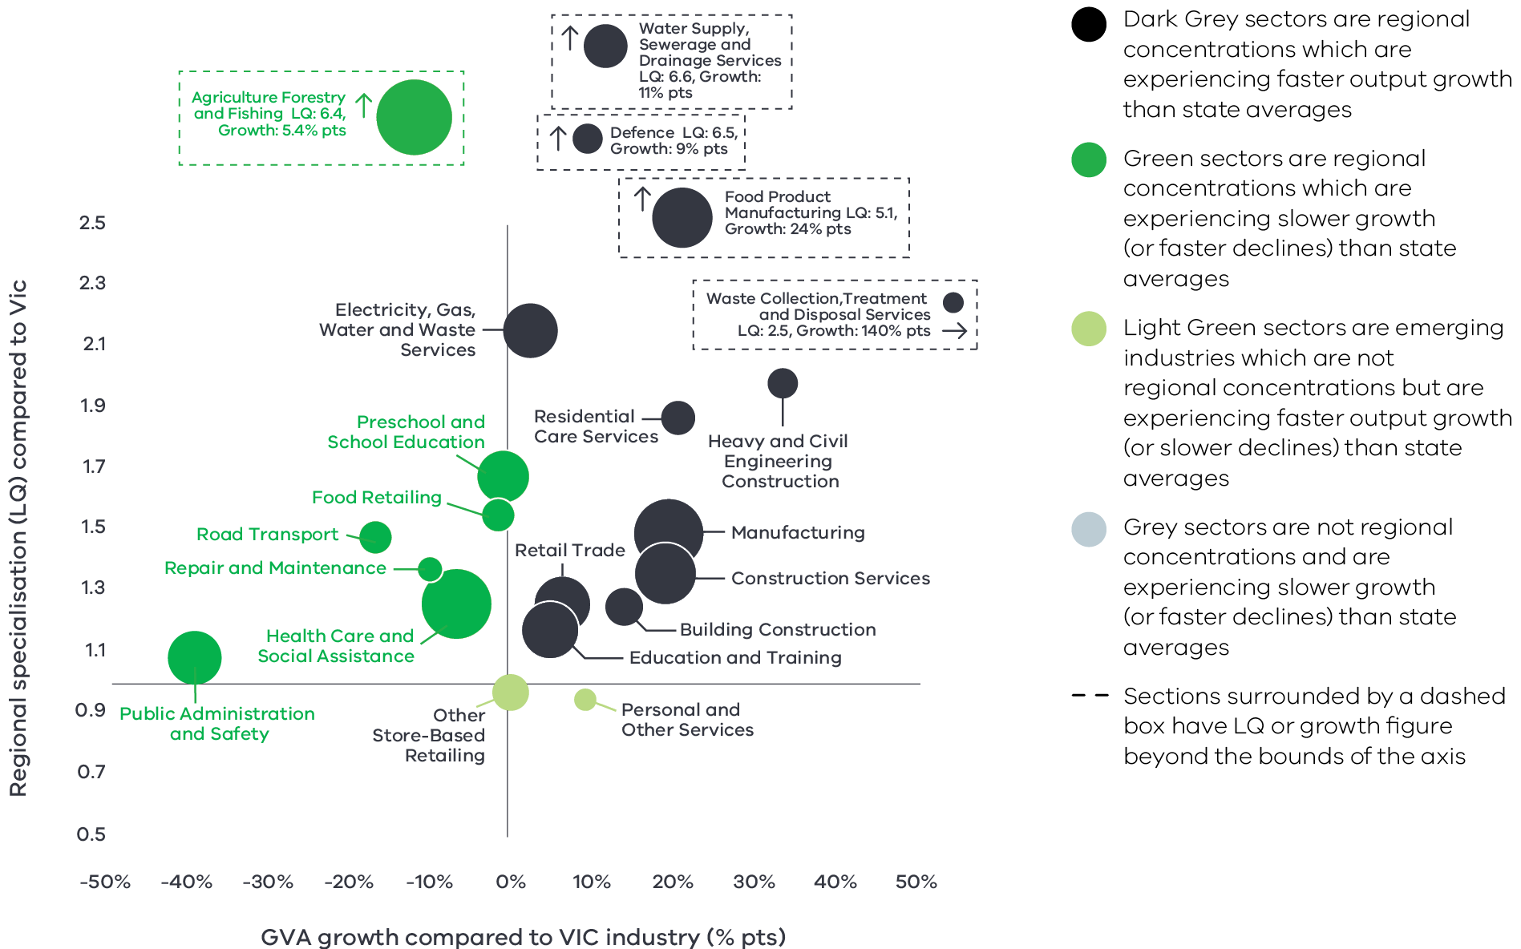

Figure 6 Goulburn industry output (GVA) location quotient and growth – Long Alternate Text

Source: National Institute of Economic and Industry Research (2020). Note this chart represents a selection of Industries and Sub-industries that represent a notable size and or concentration within the region. Some sub-industries presented are sub-sectors of industries that are presented alongside it and therefore measures cannot be aggregated between the two. Other industries are not displayed. For greater detail refer to the *Goulburn Regional Economic Development Strategy – Supporting Analysis*.

Figure 6 identifies Goulburn’s economic output specialisation in terms of Gross Value Added (GVA). Using the same approach as Figure 5, this analysis compares selected industries and sub-industries in the regional economy, including their size and growth as a proportion of total economic GVA relative to Victorian averages.

# 04 Strategic directions

The four strategic directions for the Goulburn region have been identified based on the opportunities emerging from the region’s endowments, industry specialisations, and socioeconomic context. The directions have been refined based on a review of local policies and strategic planning.

The following section discusses each strategic direction, providing:

* a rationale for its inclusion as part of the strategy
* an overview of opportunities and challenges which are likely to support or hinder future growth
* a summary of work underway and the policy context to support desired outcomes
* the implication of the direction for the region’s Aboriginal communities

examples of how the direction could be activated.

## Goulburn’s strategic directions

1. Enhance productivity and resilience in the agricultural and food product manufacturing sectors
2. Focus on continued growth and development of the visitor economy, leveraging natural assets and Aboriginal heritage
3. Strengthen renewable energy generation and the role of the circular economy
4. Leverage the role of Shepparton as the regional capital and industry hub.

## Enabling factors for economic growth

This REDS identifies opportunities in key areas that can help drive regional economic growth. However, each region’s capacity to activate these opportunities and grow is partly determined by cross-cutting enabling factors that support economic activity. Consideration of these enabling factors – and targeted investments and initiatives to strengthen them – will help support achievement of the strategic directions in this REDS.

|  |  |
| --- | --- |
| **Digital connectivity**  Access to reliable internet and mobile services allows for access to new markets, facilitates efficiency gains and opens up opportunities for innovation. Good digital connectivity can also facilitate more inclusive access to services and flexible working arrangements. | 63 to 70 – Australian Digital Inclusion Index Score in Goulburn in 2021[6]  (Victorian average: 71) |
| **Transport connectivity**  Road and rail infrastructure, ports and airports provide critical linkages between production locations and markets; efficient transport connections and public transport services are a key factor in workforce mobility and local amenity. | 4.0 – Overall access to roads, public transport in the Hume RDA region[7]  (Regional Victoria: 4.1 and Victoria: 5) |
| **Workforce and population growth**  An adaptive and productive workforce is key to businesses competitiveness; access to both skilled and unskilled labour ensures business can sustain and expand activities. | 61.6% – Local workforce in Goulburn employed in skilled occupations in 2021[8]  (Regional Victoria: 62.2%, Melbourne: 67.3%) (2021)  13.0% – Residents with a bachelor’s degree or higher in 2016[9]  (Regional Victorian: 17.0 %, Melbourne: 31.0%) |
| **Housing**  The availability and affordability of housing determines a region’s ability to attract and retain local staff and supports community cohesion and better life outcomes for individuals and families. | 0.6% – Average rental property vacancy rate in the 6 months leading up to June 2021[10]  (Compared to benchmark of 2.5%)  29.6% – Increase in median rent in Hume RDA region from 2016 to 2020[11]  (Victoria, 6.9%, Regional Victoria 28.6%) |

Note: 1. The Australian Digital Inclusion Index (ADII) is a composite index used to measure digital inclusion across three dimensions of Access, Affordability and Digital Ability. 2. ‘Access to roads and public transport was measured by asking respondents to rate their access to the following types of services in their local community, on a scale ranging from ‘very poor’ (1) to ‘very good’ (7): (i) Quality of local roads; and (ii) Access to public transport (including taxis, buses, trains). A single measure of overall access to roads and public transport was then constructed based on the average score of a person’s responses to these two items.3. Skill level is defined as a function of the range and complexity of the set of tasks performed in a particular occupation. Skilled workers are defined as being classed between an ANZSCO

Skill level of 1-3, while low skilled is classed as 4 or 5. 4. A rental property vacancy rate of 2.5% refers to a benchmark at which the market is balanced between landlords and tenants.

## Integrating Aboriginal economic opportunities

The Victorian Government is taking concrete steps to align with Aboriginal self-determination principles. Key Victorian Government policies and processes to realise self-determination goals include the:

* Treaty Process which seeks to redefine the relationships between Aboriginal communities, the state and non-Aboriginal Victorians.
* Victorian Aboriginal Affairs Framework 2018-23 (VAAF) which is the overarching framework for working with Aboriginal Victorians to drive positive socioeconomic outcomes across the state, including to activate economic opportunities and prosperity via achieving wealth equality, facilitating workforce participation in all sectors at all levels and realising Aboriginal income potential.

Self Determination Reform Framework, which guides public sector action to enable self-determination in line with the VAAF across four domains: people, systems, outcomes and accountability.

The Victorian Government is also party to the National Agreement on Closing the Gap and has committed to meeting the associated outcomes – including in relation to increasing engagement of Aboriginal and Torres Strait Islanders in employment, education and training.

An analysis of relevant policies and commitments relating to Aboriginal economic development in the region (listed in the *Goulburn Regional Economic Development Strategy – Supporting Analysis*), including Traditional Owner strategic plans, where developed, has identified five opportunities for Aboriginal economic development:

* Identify opportunities to leverage natural resources for economic benefit, including through adopting traditional agricultural techniques and practices.
* Pursue greater Aboriginal ownership of land to sustainably manage resources.
* Promote recognition of the land, its waters and its cultural significance to ensure that economic activities sustainably generate benefits and heal existing damage.
* Encourage the use of cultural places and practices to tell stories, maintain traditions and create economic opportunities, particularly in the visitor economy.

Enhance Aboriginal participation across industries with a particular focus on occupations which serve the local Aboriginal population.

Each strategic direction in the Goulburn REDS considers the relevance of that direction to local Aboriginal communities in light of the above opportunities.

Self-determined priorities for Aboriginal economic development in the region will be aligned to the six pillars of the Victorian Aboriginal Employment and Economic Strategy. These priorities will also guide Victorian Government decision-making on economic development in the region and will be integrated into future updates of the REDS.

## 4.1 Enhance productivity and resilience in the agriculture and food product manufacturing sectors

### Significance

The Goulburn region is often described as the ‘food bowl of Australia’ and the agriculture industry is its most historically important and specialised sub-sector by output and employment. The region has irrigation-based industries including dairy, horticulture and viticulture as well as dry land farming operations. These are supported by agriculture-related industries such as food processing, packaging, transport and specialist engineering and electrical trades. The agriculture and food supply chain provides employment for a large part of the region’s workforce.

There is a strong link between the manufacturing and agriculture sectors in the region, with the food product manufacturing sub-sector being the biggest and most specialised manufacturing sub-sector for the region. The sub-sector has achieved considerable growth compared to the rest of Victoria, especially over the last five years.

**Goulburn farms produce[12]**

* 29.4% of Victoria’s fruit (excluding grapes)
* 12.6% of Victoria’s Dairy
* 11.5% of Victoria’s beef

9.7% of Victoria’s sheep meat

### Opportunities

#### Changing food demand

Growing demand for safe and high-quality food in Asia and other emerging markets creates export opportunities for Goulburn’s food and fibre supply chain, particularly fresh fruit. Demand for alternative proteins, nutraceuticals and low emissions products is also increasing in Australia and internationally. Strengthening food safety capabilities, broadening traceability and exploring niche food product opportunities will support the region to maintain its existing reputation of premium, high quality food and fibre products and expand into new markets.

#### Advanced capabilities

New technologies and globalisation are transforming the outlook of the manufacturing and agricultural industries. Positioning the local supply chain to invest in advanced capabilities has the potential to offset traditional market barriers of cost and distance while increasing the productivity of the industry. For food product manufacturing, embracing advanced capabilities allow for the greater personalisation of goods to meet demand and to implement origin and traceability systems for strong product integrity.

#### Native food production

There is a growing interest in locally produced native foods and botanicals. The Dja Dja Wurrung and Taungurung corporations are investigating projects to trial and develop the case for agricultural development of native crops. Traditional Owners in northern Victoria are part of a national network applying regenerative farming practices for improved environmental outcomes and realising commercial opportunities in honey, plant-based skincare products, native wildflowers and other native foods. The revival of traditional food crops has multiple objectives including sustainable land management, utilisation of natural resources and return of economic advantage to Traditional Owners.

#### Agricultural diversity

The GMID region, with its significant irrigation infrastructure and high-quality soil and water resources, attracts significant investment. There is an opportunity for further diversification in land use and production across the region, including growing intensive agriculture industries (glasshouses, piggeries and poultry), increasing native food and fibre production, expanding on-farm solar and exploring waste-to-energy opportunities to enhance resource efficiency. Goulburn can develop and implement higher intensity sustainable farming practices to realise higher output for the region.

### Challenges

#### Increasing competition

Local agricultural producers face increasing competition in global markets from lower cost producers. The introduction of tariffs on certain agricultural products by some trading partners has added additional complexity to the international trading environment.

#### Climate change

The region faces an increasing frequency of adverse weather events and variable conditions. Rainfall will continue to be very variable, but over the long term it is expected to continue to decline across most seasons. Furthermore, the region is expected to experience almost double the number of extreme heat days per year by the 2050s. Changing conditions and high-impact events will put pressure on infrastructure and will influence water availability, production yields and output quality. Increased irrigation efficiencies and diversification of water sources will be critical to manage lower water availability and remain competitive.

**By 2050s[13]**

* Median temperature could rise by 2.4°C
* Median annual rainfall could decline by 22%

Double the amount of extreme heat days (35°C) to 29.6 days

#### Digital connectivity and capability

The Goulburn community are advocating for improved digital connectivity to increase innovation and technology adoption in the region. The 2021 Australian Digital Inclusion Index shows all LGAs in the region scored below the state average (71.0) on the index, with Moira and Strathbogie scoring lowest, while Mitchell scored highest. A recent audit shows there are gaps in the region’s enabling digital infrastructure including fixed broadband, mobile coverage networks available for the LP-WAN Internet of Things[14] and deficient public Wi-Fi. This affects all residents but also creates business disruption and limits development. Current demand for LP-WAN IoT is low and increasing both availability and capability would support industry transition to more efficient monitoring and production systems.

#### Demand for workers

Labour shortages, particularly among pickers and packers at peak harvest, are a major concern for enterprises in the Goulburn region. International and inter-state border closures related to the COVID-19 pandemic have exacerbated these shortages. An aging workforce is an impending concern: the median age of farmers in 2016 was 56 years. With many farmers expected to retire in the coming decade, educating and introducing more young farmers is needed. There is scope to increase collaboration across schools, TAFEs, training organisations and industry to promote training and career pathways among school leavers and young people.

### The policy environment

Enhancing productivity and resilience in the agricultural sectors is closely aligned with national, state and local priorities. In particular:

* The Australian Government’s *Make it Happen – The Australian Government’s Modern Manufacturing Strategy* and the Victorian Government’s *Food and Fibre Sector Strategy* both highlight that food and beverage manufacturing is a priority industry.
* The Australia Government’s *Agriculture Workforce Strategy and Roadmap* details the plan to attract, retain, upskill and modernise the agriculture workforce.
* The Victorian Government’s *Stronger, innovative, sustainable: A new strategy for agriculture in Victoria* focuses on themes of recovery, growth, modernisation, biosecurity and promotion in the agriculture industry.
* The *Goulburn Murray Resilience Strategy* identifies ‘futures of agriculture’ as one of five interventions to build the ability of the agriculture sector to address climate change and other future challenges.
* The *Goulburn Digital Plan* prioritises addressing digital coverage, encouraging digital update and building digital capabilities and skills to increase business innovation and support business decision making across the region.

The *Connecting Victoria* initiative, announced in mid-2021, is fast-tracking new mobile and broadband infrastructure through a $550 million investment across Victoria.

The Victorian Government is taking action to reduce Victoria’s emissions to net zero by 2050 and build resilient communities prepared to adapt to the impacts of climate change. Further development of Goulburn’s agriculture and food product manufacturing sectors will be shaped by the sector pledges which outline the actions to cut emissions from each sector, including in agriculture, energy, industrial processes, land use, transport and waste.

### Aboriginal inclusion

This direction aligns with the Aboriginal economic opportunity for traditional agricultural practices to be promoted as a mechanism for maintaining traditions and creating economic opportunities. For example, the Taungurung Land and Waters Council have expressed aspirations for viable, ethical and sustainable business on Country including fire management, pest control, harvesting and collecting traditional plants and foods, establishing seed banks and water management. Specific interventions, such as promoting career pathways and Aboriginal enterprises, could be considered to maximise the benefits to Aboriginal communities.

### How can we unlock this strategic direction?

To unlock this opportunity and drive growth, local, State and Commonwealth partners could work together to:

* Improve awareness of new and emerging opportunities associated with changing consumer preferences.
* Support the development of local research capabilities to address local issues and enhance productivity in the agriculture and manufacturing sectors.
* Take advantage of existing funding and incentives in place to support local manufacturing and attract new investment.
* Ensure local producers are engaged in local, State and national conversations about climate change adaptation and mitigation practices in the agriculture and manufacturing sectors.
* Advocate for market access opportunities and strengthen biosecurity, food safety capabilities and traceability across supply chains.
* Support initiative to address blackspots and other barriers to digital connectivity, in collaboration with telecommunications providers.

Foster partnerships to support the development of Traditional Owner-led food businesses based on principles of self-determination.

## 4.2 Focus on continued growth and development of the visitor economy, leveraging natural assets and Aboriginal heritage

### Significance

The region’s parks and waterways as well as its vibrant food and wine scene make the visitor economy a significant contributor to the region’s economy. Natural assets include Lake Eildon, the Murray River and Cathedral Ranges as well as the Barmah Forest, the world’s largest River Red Gum Forest, in the Moira-Berrigan cross-border region. Visitor sites include year-round attractions, signature annual festivals, periodic events and hiking trails that are frequently visited.

Prior to the COVID-19 pandemic, visitor numbers and expenditure were growing year-on-year, with domestic overnight visitors making up the fastest growing tourist category. In 2019 the total number of visitors was 4.7 million with an expenditure of $836 million. Restrictions associated with the COVID-19 pandemic, including border closures and venue density limits, have severely reduced visitor numbers and expenditure. Supported by the region’s proximity to metropolitan Melbourne and other significant urban centres such as Bendigo and Wangaratta, the region is well placed to meet demand from domestic visitors throughout the recovery period.

### Opportunities

#### Unique offerings

Regions with a clear and specific brand have seen strong success in visitor economy growth. The Goulburn region has a diverse range of offerings with their own unique brand. The visitor economy in the northern part of the region is aligned with the Murray River and includes areas on the NSW side of the border. Murray River tourism focuses on nature-based tourism and golf supported by food, wine and agritourism. Southern parts of the region are more closely tied with adventure activities at Lake Eildon and the Yarra Valley wine region, which extends into the peri-urban areas of Metropolitan Melbourne. The visitor economy in the southern regions focuses on food and wine, creative and nature-based tourism. Recognition, coordination, investment and development of the diverse regional brands from the individual operators up to all levels of Government will pave the way to success for the region’s visitor economy.

#### Hero experiences

‘Hero’ experiences attract high levels of domestic and international visitation and encourage private investment in surrounding areas. Realising the potential of such sites in Goulburn can strengthen the overall visitor economy in the region. Experiences can be a group of complementary experiences, or a single major hero project. There are multiple natural assets in the region that have the potential to become hero experiences, such as Lake Eildon, the Cathedral Ranges and the proposed Murray River Adventure Trail which would be a multi-sport adventure trail extending along the length of the Murray River. Other hero attractions include the Shepparton Art Museum and the Strathbogie wine region.

#### Aboriginal heritage

The region is home to important Aboriginal cultural heritage assets of the Yorta Yorta, Taungurung and Wurundjeri peoples. This includes the Yorta Yorta people’s long association with the Barmah Forest Ramsar site and various permanent Aboriginal art exhibits throughout the region, such as the Shepparton Art Museum which hosts a significant collection of South East Australian Aboriginal art. The region can capitalise on the increased interest and demand for Aboriginal knowledge and culture by the wider community. Stronger connections with local Aboriginal groups should be developed to promote enterprise, strengthen regional links to arts, innovation and training and ensure recognition of culturally significant traditions, landscapes and waterways.

#### Agritourism

Primary production accounts for 78 per cent of land use in the Goulburn region. Agritourism offers opportunities to diversify agricultural income streams by developing farm trails and repurposing existing infrastructure to link farmers directly to consumers. Enhancing major food and wine events such as GoFish Nagambie, Four Vines Running Festival, and the Numurkah Foodbowl Festival, will attract visitors to the region and raise the profile of agritourism throughout the year. Identifying export pathways for smaller producers and niche products would increase the international profile of the region as well.

### Challenges

#### Digital capabilities and capacity

The ways visitors experience tourism and access information are changing. Visitors increasingly use internet research and social media to plan holidays and gather visitor information. Tourism businesses need to invest and adapt to new technologies such as digital marketing and share economy platforms to enhance the visitor experience, but this requires reliable internet connectivity. The 2020 *Goulburn Digital Plan* highlights inadequate digital infrastructure for the region’s top visitor locations and a significant digital capability divide in comparison to other regional and metropolitan areas, which affects the visitor experience and business innovation. 2021 Connecting Victoria roundtable discussions identified a number of key digital issues for the region, including a need for competitive internet speeds to attract tourism from major cities.

#### Risk management

The international and state border closures due to the COVID-19 pandemic are likely to have lasting effects on visitation patterns to the region and highlight the importance of risk management and planning as well as building business resilience to recover from the external shocks. Before the COVID-19 pandemic, Victoria’s regions were facing significantly greater competition from international and domestic tourism markets. Other states and territories are now more aware than ever of the importance of the visitor economy to support diversification and drive long-term growth. Coming out of the COVID-19 pandemic, there will be strong competition to attract visitors to the region.

### The policy environment

Growing the visitor economy is closely aligned with national, state and local priorities. In particular:

* The Victorian Government’s *Visitor Economy Recovery and Reform Plan* (2021) aims to attract more tourists to the State, support regional jobs and deliver a significant recovery from the combined effects of the 2020 summer bushfires and the COVID-19 pandemic. This includes delivering a state-wide destination master plan underpinned by priority sector plans (the first sector priorities to be developed will be the *Nature-Based Tourism Plan* and the *First Peoples’ Tourism Plan*) and the establishment of Visitor Economy Partnerships across Victoria.
* The Victorian Government is working on a state-wide First Peoples’ Tourism Plan.
* Murray Regional Tourism’s destination management plan provides an overarching tourism strategy focused on strategic development themes that span across the nature-based tourism, epicurean, sports and events and heritage-based opportunities.

Tourism North East’s master plan for Lake Eildon and the *Activating Lake Eildon* project explores the potential of Lake Eildon as a key tourism asset within the region by enhancing water-based tourism, activating nature-based tourism and improving destination villages around the Lake.

### Aboriginal inclusion

The *Goulburn Murray Regional Prosperity Plan* identifies that creating and enhancing Aboriginal tourism experiences through culture provides an untapped economic and social opportunity that will benefit the entire region. Approximately 17 per cent of the Aboriginal population in the Goulburn region is employed in sectors that support the visitor economy. As well as offering direct business opportunities, growth in the broader visitor economy may therefore increase Aboriginal economic participation.

### How can we unlock this strategic direction?

To unlock this opportunity and drive growth, local, State and Commonwealth partners could work together to:

* Coordinate tourism planning across governments and tourism boards to align priorities and maximise investment outcomes.
* Strengthen the planning and marketing capacity of local governments who haven’t previously engaged with Regional Tourism Boards.
* Identify regional tourism offerings that have current and future ‘hero’ potential as well as the supporting offerings that elevate the region.
* Take advantage of existing funding and incentives to support tourism providers to pursue digital innovation and improve capability across the share economy and digital marketing platforms.
* Develop and promote Aboriginal tourism opportunities in the region based on the principles of self-determination, including connecting existing assets to increase interest and impact.

Continue to work with telecommunications providers to deliver high quality digital connectivity that aligns with regional tourism opportunities.

## 4.3 Strengthen renewable energy generation and the role of the circular economy

### Significance

Goulburn’s population have been enthusiastic, innovative and early adopters of electric and renewable energy technology. At present, the region is generating significant renewable energy output from a range of different sources. Solar farms and biogas generators operate in the north and wind turbines and hydro power are the key renewable sources in the south. Hume, which includes the Goulburn region, has the highest number of community energy groups within a single region in Australia, which underpins strong social licence within the community to realise the full potential of a sustainable energy future.

The region’s existing electrical transition infrastructure and natural resources (water, sunlight, wind, biowaste) will contribute to the ongoing success of the region’s renewable energy sector. Two main high voltage transmission lines service the region, including a 220kV line from Shepparton to Wodonga via Glenrowan and Dederang and a 330kV from South Morang on Melbourne’s outskirts to Dederang and to NSW. Other sub-transmission lines also exist.

### Opportunities

#### Distributed Energy Resources (DER)

Energy is increasingly generated and stored locally. Resources that are created or stored locally and connected to the local distribution grid are called distributed energy resources, or DER. Common DER renewable energy sources include rooftop solar, solar hot water, energy storage and micro grids. DER can also include ‘demand response’, which involves consumers being rewarded for reducing power by ‘switching off’ key appliances or shifting activity to smooth out peak demand for energy. Hume, which includes the Goulburn region, is well positioned to become a national leader in DER and Mondo Power is already partnering with government and community to deliver a three-year DER trial in the region.

#### Solar, pumped hydro, bioenergy and hydrogen

The region has significant natural endowments that can support future renewable energy growth. The region:

* has multiple large scale solar farms proposed for development
* hosts enough pumped hydro potential to meet the need of a 100 per cent renewable energy grid in Australia, although as at 2021, there are no proposals for investment-ready pumped hydro in the region
* is ranked third in the state for bioenergy potential
* has access to water and renewable energy which are prerequisite for renewable hydrogen

is experiencing a boom in road freight transport, which could support hydrogen freight pilots.

The diversity of energy sources means the region can be at the forefront of any new technologies or developments as global momentum continues to increase the efficiency of renewable generation. Pumped hydro energy storage can address renewable energy storage problems. Renewable hydrogen is in its early stages but is shaping to be a game changer for energy and fuel markets locally and worldwide. Co-locating renewable energy, such as solar and bioenergy, could support on-farm income diversification and reduce input costs.

#### Strengthening local supply chains and workforces

Maximising ‘development spillover’ can occur through ensuring that renewable energy projects strengthen existing local supply chains and lead to employment in regional Victoria. The region has a skilled workforce and notable business clustering in the electricity, gas, water and waste services sector. Capturing the economic value of renewable energy in the region can be realised through:

* developing linkages with other sectors such as manufacturing, agriculture and extractives
* on-farm renewable energy generation to reduce input costs in energy intensive industries
* sourcing locally produced inputs
* training a local skilled workforce
* locally owned generation assets

fostering local innovation.

#### Circular economy

A circular economy seeks to reduce the environmental impacts of production and consumption, while enabling economic growth through more productive uses of natural resources. Greater Shepparton and Moira have concentrated agricultural bioenergy feedstocks that could be harnessed for energy generation. Waste to energy generation could support resilience in the region, given both the high demand for resources and large amounts of waste generated in the process. There are also opportunities for waste processing and associated resource recovery, supported by the region’s growing population and recent restrictions on exporting waste internationally. Waste processing and resource recovery can reduce landfill and unlock opportunities for future employment and innovation growth.

### Challenges

#### Transmission infrastructure

The Goulburn region has an existing strength in renewable energy due to generation and transmission infrastructure. To achieve further growth in the sector and activate future connection opportunities, upgrades to this infrastructure could be considered.

#### Land use tensions

The Goulburn region is home to highly productive agricultural land and the GMID, which underpins the region’s agri-food supply chain. New renewable energy activities can create land use competition as well as amenity impacts. Future renewable energy activity needs to consider the potential impact on the agricultural sector, including the Victorian Government’s objective to plan and manage for sustainable change within irrigation districts under the Victoria Planning Provisions. Exploring opportunities to co-locate solar farms with agriculture could lead to farm income diversification and reduce land-use tensions.

### Work underway and the policy environment

Growing the renewable energy sector in the region is closely aligned with national, state and local priorities. In particular:

* *Victoria’s Climate Change Strategy* provides a roadmap towards net-zero emissions by 2050. It includes interim targets to reduce emissions and pledges for energy, agriculture, transport, waste and forestry sectors.
* Victoria’s *Community Engagement and Benefit Sharing in Renewable Energy Development in Victoria* outlines leading practice community engagement and benefit sharing for renewable energy development in Victoria.
* Victoria’s *Recycling Victoria: A new economy* is the state’s circular economy policy and 10-year action plan to reduce waste and pollution and improve recycling in a way which delivers economic benefit.
* The *Hume Renewable Energy Roadmap* describes the current and future renewable capabilities of the region identifying solar and bioenergy as a key priority for the region and hydropower as an emerging opportunity.
* The *Goulburn Murray Resilience Strategy* identifies ‘circular economy’ as a priority intervention stream, that aims to eliminate waste, encourage continual use of resources and support renewable energy generation.
* The Victorian government has a suite of state-wide policies and initiatives to support the State’s energy sector to transition to net-zero emissions, which are available on [energy.vic.gov.au](https://www.energy.vic.gov.au/).

The Victorian Government’s Renewable Energy Zones will shape future investment in large scale renewable energy generation and transmission through Victoria. The Australian Energy Market Operator (AEMO) identified two renewable energy zones that cross into the Goulburn region: Ovens Murray and Central North.

### Aboriginal inclusion

Local Aboriginal stakeholders are focused on maximising benefits from investments in renewable energy projects. A desired outcome of the Goulburn Murray Prosperity Plan is for there to be sustainable, clean and Aboriginal owned energy sources for the community. Both the Yorta Yorta Nation Strategic Plan and Taungurung Country Plan advocate for effective solutions to mitigate harmful effects of climate change on our future generations.

Increased investment in the renewable energy sector is likely to create employment opportunities in the construction, energy and waste services and professional, scientific and technical services industries. Construction is the second largest employer of Aboriginal people in the region and increased construction activity could lead to enhanced Aboriginal participation and business opportunities. By contrast energy and waste services and professional, scientific and technical services industries are smaller employers and targeted interventions may be required to increase Aboriginal participation in these sectors.

Renewable energy and circular economy investments should consider the needs of Traditional Owners and Aboriginal communities and any potential land use conflicts.

### How can we unlock this strategic direction?

To unlock this opportunity and drive growth, local, State and Commonwealth partners could work together to:

* Improve coordination of existing and prospective investments to maximise the local benefits of renewable energy.
* Foster a culture of innovation that explores new opportunities and provides solutions to local and external problems.
* Plan for a wide range of possible futures to build the region’s resilience towards uncertain conditions.

Promote the use of Traditional Owner cultural practices and participation in renewable energy projects.

## 4.4 Leverage the role of Shepparton as the regional capital and industry hub

Greater Shepparton is the key centre in the Goulburn region and is the fifth largest regional capital in Victoria. Greater Shepparton is a critical hub for tertiary, mainstream and specialist health, cultural and higher education services. Melbourne University runs the Dookie Agricultural College and a School of Rural Health in Shepparton, and La Trobe University’s Shepparton campus offers courses in arts, business, education and nursing. A number of internationally renowned food processing industries are established in the Greater Shepparton area.

Greater Shepparton supports and is supported by a network of other settlements that have distinct characteristics. These settlements provide attractive places to live and work and extend employment and service offerings throughout the region. Concentrated industry growth in Shepparton can be leveraged upon to grow towns such as Seymour, Nagambie and Yarrawonga which will enable Goulburn to retain the strength of its diverse rural and regional communities.

In line with national trends, the Goulburn region is experiencing rural transition. There are fewer and larger farms with increasing productivity and efficiency and increasing numbers of rural residents that are supported by off-farm income. At the same time, population-based sectors are expanding. This creates both opportunities and pressures for regional hubs to supply employment and housing opportunities to those transitioning away from rural settings.

**Greater Shepparton is an industry and employment hub:**

* 39% of Goulburn’s population[15]
* $3.7 billion Contribution to the regional economy[16]

4,000+ Workers commute to Shepparton for work[17]

### Opportunities

#### Agri-food research and innovation hub

Innovation has the potential to increase productivity. Climate change, resource scarcity and technological advancements pose challenges to the agri-food sector and coordinating local research into local solutions can strengthen the industry’s resilience and boost productivity. A local hub, leveraging Shepparton’s critical mass of agricultural education institutions and food product manufacturing companies, could better harness, refine and share local knowledge and encourage innovation and export of ideas related to irrigation agriculture and agri-food. Encouraging and enabling research and development in the region could allow Goulburn to become both a driver and an adopter of innovation.

#### Workforce to meet growing industries

The top employing sectors across regional Victoria are health care and social assistance, construction, retail trade, manufacturing and education and training. Shepparton’s network of education institutions means it is a strategic education and training location for the future workforce not only for the Goulburn region, but across the northern parts of Victoria.

#### Youth development

While overall population growth is strong in the Goulburn region, there is significant outward migration of young people (aged 15-24) across all local government areas, consistent with trends across regional Victoria. Shepparton, with its tertiary assets and employment options, could play a stronger role in providing education and training pathways for priority industries that encourage youth to remain in the region. Addressing the opportunity gaps for young people could also ensure low skilled or entry level positions are filled across the region.

### Challenges

#### Housing

There is evidence of housing shortages and housing stress in Greater Shepparton[18]. Recent trends show unprecedented numbers of people moving from metropolitan Melbourne to regional and rural Victoria, bringing forward unexpected demand on the already tight housing market in many areas. There are five proposed major growth corridors in the Shepparton-Mooroopna urban area, but investment in physical and social infrastructure is needed to meet the growing demand for housing. Adequate housing is critical for economic participation and for attracting skilled migrants to the region.

#### Digital infrastructure

Digital connectivity and capability are increasingly important for social, education and business interactions. The Goulburn region experiences significantly lower levels of digital access than other regional areas of Victoria and in particularly metropolitan Melbourne, creating a digital divide between communities and businesses. To remain competitive and attract migrants, the region requires National Broadband Network (NBN) service and greater availability of 4G networks to meet the needs to business and community and address black spot issues.

#### Intra-regional transport

For Shepparton to play a role as a regional hub and extend services to other parts of the region, intra-regional transport is critical for worker mobility and access to services. Access to public transport is lower than the state average for all local government areas in Goulburn. Reforming public transport and integrating innovative, flexible options will be critical to leverage Shepparton’s hub to extend services across the region, support workers to access employment networks and relieve population pressures in the regional capital.

### The policy environment

There is a strong focus on learning for change and agricultural expertise in the *Goulburn Murray Resilience Strategy*. This includes advocacy for a Goulburn Murray learning centre for agriculture and land management and a Goulburn Murray regional hub in the proposed One Basin Cooperative Research Centre (CRC) which would connect communities, industry and researchers to manage climate and water risks in the Murray-Darling Basin.

To support mobility across the region, the Australian and Victorian Government’s Regional Rail Revival program is upgrading the Shepparton Line. This will deliver more frequent and reliable services and allow modern VLocity trains to travel to and from Shepparton for the first time.

The Victorian Planning Authority, in consultation with Greater Shepparton City Council and Government agencies, is preparing the Shepparton South East Precinct Structure Plan to guide new urban development in Shepparton. The Plan will provide up to 2,500 homes to accommodate a population of more than 6,000 and include a retail centre and extensive aged care accommodation. Initiatives to address the need for affordable housing include:

* The Victorian Government’s Big Housing Build will invest 25 per cent of the total $5 billion program across regional Victoria, including $45 million in Greater Shepparton.

The 2020 *Greater Shepparton City Council Affordable Housing Strategy*, which provides a framework to guide future residential development towards affordable housing provision and facilitate actions to ensure dwellings are appropriate for use by very low-, low- or moderate-income households.

### Aboriginal inclusion

The *Goulburn Murray Regional Prosperity Plan* recognises that Shepparton has been at the forefront of Aboriginal community-led reform. Greater Shepparton has the largest Aboriginal population in the region and is home to the Rumbalara Aboriginal Co-operative and Kaiela Institute. The Prosperity Plan notes the forthcoming Munarra Centre for Regional Excellence in Shepparton will become a national exemplar for community engagement and culturally responsive education, supporting Aboriginal people with enhanced education and employment outcomes and delivering broader, long-term economic benefits and shared prosperity to the region and Australia.

### How can we unlock this strategic direction?

To unlock this opportunity and drive growth, local, State and Commonwealth partners could work together to:

* Develop infrastructure solutions with an eye to addressing current pressures and future needs of the regional population
* Explore opportunities to extend the benefits from consolidating the role of Shepparton as the regional capital with the northern and central parts of the Goulburn region

Carefully examine journey to work arrangements and public transport needs to ensure residents can access employment and education opportunities.

# 05 Implementation

The Goulburn REDS outlines the RRV Group’s strategic approach for focusing its future economic development activities, including through policy, investment and program delivery, in the region. It is not a prescriptive roadmap for Victorian Government economic development action in Goulburn.

## RRV will use the REDS to coordinate investments and activities in place

RRV is committed to pursuing the strategic directions through future policy design, investment and program implementation, as well as through collaboration across government and with regional partnerships, to deliver positive economic outcomes for the region. The Goulburn REDS will provide a central point for coordination for current and future work streams and investments.

RRV recognises that effective planning policy and controls will be a key enabler of inclusive, sustainable economic growth in the Goulburn region. Victoria’s Regional Growth Plans provide broad direction for land use and development, and enable economic growth by ensuring that infrastructure investment is coordinated, appropriate services are provided, and development meets community expectations. The Regional Development and Planning portfolios will pursue opportunities to ensure that as relevant state-led land use planning strategies, policies and controls are updated, they are aligned with the REDS strategic directions.

## Local stakeholders, industry leaders and government service providers can use the REDS to advocate for shared outcomes

The Goulburn REDS, along with the supporting *Goulburn Regional Economic Development Strategy – Supporting Analysis* document, provides a starting point for an evidence-based, strategic approach to regional development. This approach is an ongoing process where specific development actions and projects can be proposed and considered in the context of alignment with the REDS.

Regional Development Victoria – Hume will remain the main point of contact in the region for facilitating and coordinating regional development outcomes.

The Goulburn Regional Partnership which comprises community and business leaders, CEOs of constituent Local Governments, State Government personnel and a representative from Regional Development Australia will continue to be the main advisory body to the Minister for Regional Development and other government decision-makers on local issues and priorities.

The Goulburn REDs will provide Jobs Victoria with important context and understanding of local economic priorities and opportunities that will be a critical input into the planning and prioritisation of Jobs Victoria’s work and collaboration activities with our Service Partners. Jobs Victoria assists people looking for work, connects employers with the staff they need, administers wage subsidy programs and supports significant local employment transitions.

## RRV will monitor the implementation of the REDS

The strategic directions in this Strategy focus on medium- to long-term drivers of growth and opportunity but will be used immediately to guide investment in the region. Notwithstanding this timeframe, the strategic directions will continue to evolve and progress as actions and investment are made. To ensure ongoing relevance and accuracy, Rural and Regional Victoria will periodically update and refresh this Strategy.

## Contact us

Department of Jobs, Precincts and Regions

Level 31, 121 Exhibition Street, Melbourne, VIC 3000

T: +61 (03) 9651 9999

[djpr.vic.gov.au](https://djpr.vic.gov.au/)

Authorised and published by the Victorian Government.

Department of Jobs, Precincts and Regions  
Level 31, 121 Exhibition Street,   
Melbourne, VIC 3000  
Telephone (03) 9651 9999

March 2022

Unless indicated otherwise, this work is made available under the terms of the Creative Commons Attribution 3.0 Australia Licence. To view a copy of this licence, visit [creativecommons.org/licenses/by/3.0/au](https://creativecommons.org/licenses/by/3.0/au/)

It is a condition of this Creative Commons Attribution 3.0 Licence that you must give credit to the original author who is the State of Victoria.

ISBN 978-1-76090-547-7 (Print)

ISBN 978-1-76090-548-4 (pdf/online/MS word)

# Appendix

## Figure 1: Map of Regional Partnerships – Long Alternate Text

The **Mallee** region is located in northwest Victoria and contains the LGAs of Mildura, Swan Hill, Buloke and Gannawarra.

The **Wimmera Southern Mallee** region is located in western Victoria and contains the LGAs of West Wimmera, Hindmarsh, Yarriambiack, Horsham and Northern Grampians.

The **Great South Coast** region is located in southwest Victoria and contains the LGAs of Glenelg, Southern Grampians, Moyne, Warrnambool and Corangamite.

The **Barwon** region is located to southwest of metropolitan Melbourne and contains the LGAs of Geelong, Queenscliffe, Surf Coast and Colac Otway.

The **Central Highlands** region is to the west of metropolitan Melbourne and contains the LGAs of Ararat, Pyrenees, Golden Plains, Moorabool, Ballarat and Hepburn.

The **Loddon Campaspe** region is northwest of metropolitan Melbourne and contains the LGAs of Macedon Ranges, Mount Alexander, Central Goldfields, Loddon Campaspe and Bendigo.

The **Goulburn** region is north of metropolitan Melbourne and contains the LGAs of Mitchell, Murrindindi, Strathbogie, Greater Shepparton and Moira.

The **Ovens Murray** region is located in the northeast of Victoria and contains the LGA’s of Mansfield, Benalla, Wangaratta, Alpine, Indigo, Towong and Wodonga.

The **Gippsland** region is located in the east of Victoria and contains the LGAs of Bass Coast, South Gippsland, Baw Baw, Latrobe, Wellington and East Gippsland.

Click here to return to document

## Figure 2 Map of Goulburn – Long Alternate Text

The Goulburn region is made up of the Murrindindi, Mitchell, Strathbogie, Greater Shepparton and Moira Local Government Areas.

The Goulburn region has major rail and road connections south to Melbourne and regional airports in Yarrawonga, Shepparton and Mangalore. Shapparton, Numurkah, Nagambie, Seymour, Broadford, Kilmore, Wallan and Beveridge are connected via a rail line running north. Yarrawonga and Euroa are connected south to Seymour via a rail line running north east.

Several significant roads link towns and regional centres across the Goulburn region.

Click here to return to document

## Figure 3 Goulburn industry Employment – Long Alternate Text

The largest employing industries in descending order are Health Care and Social Assistance, Agriculture, Forestry and Fishing, Construction, Retail Trade, Manufacturing, Education and Training, Accommodation and Food Services, Public Administration and Safety, Transport, Postal and Warehousing and Other Services

The following industries have grown in employment since 2001; Health Care and Social Assistance, Construction, Retail Trade, Manufacturing, Education and Training, Accommodation and Food Services, Public Administration and Safety, Transport, Postal and Warehousing and Other Services.

The following industry has declined in employment since 2001; Agriculture, Forestry and Fishing.

Simplified Table of data for Figure 3.

|  |  |  |  |  |  |  |  |  |  |  |
| --- | --- | --- | --- | --- | --- | --- | --- | --- | --- | --- |
|  | Health Care and Social Assistance | Agriculture, Forestry and Fishing | Construction | Retail Trade | Manufacturing | Education and Training | Accommodation and Food Services | Public Administration and Safety | Transport, Postal and Warehousing | Other Services |
| 2001 | 5306 | 9249 | 3205 | 6252 | 6739 | 4070 | 3032 | 2590 | 2193 | 2293 |
| 2002 | 5534 | 9093 | 3584 | 6375 | 6685 | 4040 | 2987 | 2512 | 2099 | 2257 |
| 2003 | 5609 | 8849 | 4043 | 6681 | 6806 | 4031 | 3113 | 2625 | 2181 | 2069 |
| 2004 | 5742 | 8587 | 4081 | 6821 | 6896 | 4031 | 3179 | 2848 | 2360 | 1991 |
| 2005 | 6080 | 8435 | 4561 | 7054 | 7070 | 4192 | 3223 | 3175 | 2572 | 2063 |
| 2006 | 6335 | 7969 | 5133 | 7200 | 7069 | 4244 | 3190 | 3155 | 2527 | 2049 |
| 2007 | 6670 | 7742 | 5290 | 7396 | 7288 | 4409 | 3308 | 3253 | 2542 | 2135 |
| 2008 | 6985 | 7751 | 4832 | 7264 | 7141 | 4615 | 3525 | 3475 | 2561 | 2263 |
| 2009 | 7089 | 7713 | 4750 | 6989 | 6715 | 4611 | 3616 | 3474 | 2468 | 2097 |
| 2010 | 7300 | 7733 | 6066 | 6900 | 6402 | 4699 | 3768 | 3479 | 2480 | 2095 |
| 2011 | 7804 | 7457 | 6337 | 7086 | 6525 | 5013 | 3857 | 3702 | 2590 | 2219 |
| 2012 | 8061 | 7108 | 5670 | 7130 | 6597 | 5243 | 3956 | 3791 | 2623 | 2268 |
| 2013 | 8213 | 7339 | 5632 | 7028 | 6168 | 5412 | 3996 | 3727 | 2561 | 2288 |
| 2014 | 8183 | 7719 | 5411 | 6727 | 5881 | 5332 | 4019 | 3672 | 2538 | 2270 |
| 2015 | 8388 | 7176 | 4943 | 6782 | 5850 | 5641 | 4184 | 3749 | 3009 | 2344 |
| 2016 | 8713 | 7747 | 5248 | 6776 | 5817 | 5847 | 4308 | 3790 | 2985 | 2392 |
| 2017 | 8596 | 8699 | 5585 | 7079 | 6141 | 5277 | 4092 | 3908 | 3011 | 2423 |
| 2018 | 8760 | 9762 | 6214 | 7067 | 6417 | 5266 | 4133 | 3825 | 2425 | 2577 |
| 2019 | 8800 | 10380 | 6795 | 7192 | 6646 | 5341 | 4113 | 3762 | 2630 | 2584 |
| 2020 | 9308 | 9245 | 7239 | 6971 | 6948 | 5665 | 3920 | 3774 | 2847 | 2520 |

Click here to return to document

## Figure 4 Goulburn industry output (gross value add) – Long Alternate Text

The industries with the largest gross value add in 2020 in descending order are Construction, Health Care and Social Assistance, Manufacturing, Agriculture, Forestry and Fishing, Education and Training, Retail Trade, Electricity, Gas, Water and Waste Services, Public Administration and Safety, Professional, Scientific and Technical Services and Transport, Postal and Warehousing.

The following industries have grown in gross value add since 2001; Construction, Health Care and Social Assistance, Forestry and Fishing, Education and Training, Retail Trade, Electricity, Gas, Water and Waste Services, Public Administration and Safety, Professional, Scientific and Technical Services and Transport, Postal and Warehousing.

The following industry has declined in gross value add since 2001; Manufacturing, Agriculture, Public Administration and Safety and Transport, Postal and Warehousing.

Click here to return to document

Simplified Table of data for Figure 4. Data in this table is in ($) millions.

|  |  |  |  |  |  |  |  |  |  |  |
| --- | --- | --- | --- | --- | --- | --- | --- | --- | --- | --- |
|  | Construction | Health Care and Social Assistance | Manufacturing | Agriculture, Forestry and Fishing | Education and Training | Retail Trade | Electricity, Gas, Water and Waste Services | Public Administration and Safety | Professional, Scientific and Technical Services | Transport, Postal and Warehousing |
| 2001 | 326 | 383 | 936 | 959 | 367 | 291 | 316 | 444 | 176 | 284 |
| 2002 | 384 | 406 | 867 | 988 | 362 | 306 | 309 | 458 | 190 | 290 |
| 2003 | 456 | 411 | 816 | 822 | 366 | 305 | 352 | 432 | 185 | 291 |
| 2004 | 437 | 419 | 770 | 1053 | 360 | 322 | 387 | 432 | 181 | 313 |
| 2005 | 523 | 415 | 733 | 1056 | 355 | 330 | 367 | 448 | 180 | 327 |
| 2006 | 562 | 413 | 698 | 1133 | 336 | 327 | 340 | 440 | 169 | 297 |
| 2007 | 555 | 432 | 711 | 1010 | 334 | 346 | 339 | 447 | 157 | 271 |
| 2008 | 512 | 452 | 743 | 1054 | 350 | 345 | 296 | 463 | 158 | 285 |
| 2009 | 531 | 472 | 680 | 1080 | 356 | 341 | 281 | 454 | 169 | 273 |
| 2010 | 669 | 506 | 698 | 1085 | 366 | 329 | 291 | 452 | 165 | 248 |
| 2011 | 709 | 525 | 750 | 1023 | 389 | 335 | 309 | 456 | 181 | 244 |
| 2012 | 663 | 544 | 740 | 1049 | 417 | 347 | 311 | 503 | 196 | 251 |
| 2013 | 646 | 556 | 657 | 1100 | 432 | 360 | 313 | 499 | 223 | 266 |
| 2014 | 622 | 578 | 634 | 1120 | 400 | 353 | 334 | 513 | 238 | 277 |
| 2015 | 578 | 620 | 652 | 1126 | 404 | 373 | 391 | 511 | 260 | 318 |
| 2016 | 590 | 637 | 652 | 909 | 398 | 383 | 398 | 515 | 303 | 318 |
| 2017 | 607 | 645 | 690 | 922 | 399 | 400 | 395 | 481 | 366 | 292 |
| 2018 | 674 | 696 | 724 | 932 | 400 | 420 | 389 | 467 | 338 | 228 |
| 2019 | 769 | 735 | 747 | 835 | 425 | 434 | 449 | 431 | 297 | 248 |
| 2020 | 824 | 759 | 758 | 751 | 463 | 444 | 429 | 424 | 281 | 246 |

Click here to return to document

## Figure 5 Goulburn industry employment location quotient and growth – Long Alternate Text

The graph is divided into four quadrants.

The first quadrant identifies the industries that are a) experiencing slower employment growth (or faster declines) than state averages and b) have higher levels of employment specialisation than state averages.

The following industries are in quadrant 1:

* Preschool and School Education
* Food Retailing
* Health Care and Social Assistance
* Accommodation and Food Services

Retail Trade

The second quadrant identifies the industries that are a) experiencing faster employment growth (or slower declines) than state averages and b) have higher levels of employment specialisation than state averages.

The following industries are in quadrant 2:

* Water Supply, Sewerage and Draining Services
* Defence
* Food Product Manufacturing
* Agriculture, Forestry and Fishing
* Heavy and Civil Engineering Construction
* Residential Care Services
* Manufacturing

Construction Services

The third quadrant the industries that are a) experiencing slower employment growth (or faster declines) than state averages and b) have lower levels of employment specialisation than state averages.

The following industries are in quadrant 3:

Public Administration and Safety

The fourth quadrant identifies industries that are a) experiencing faster employment growth (or slower declines) than state averages an b) have lower levels of employment specialisation than state averages.

The following industries are in quadrant 4:

* Building Construction

Personal and Other Services

Click here to return to document

## Figure 6 Goulburn industry output (GVA) location quotient and growth – Long Alternate Text

The first quadrant identifies the industries that are a) experiencing slower GVA growth (or faster declines) than state averages and b) have higher levels of GVA specialisation than state averages

The following industries are in quadrant 1:

* Agriculture, Forestry and Fishing
* Preschool and School Education
* Food Retailing
* Road Transport
* Repair and Maintenance
* Health Care and Social Assistance

Public Administration and Safety

The second quadrant identifies the industries that are a) experiencing faster GVA growth (or slower declines) than state averages and b) have higher levels of GVA specialisation than state averages.

The following industries are in quadrant 2:

* Water Supply, Sewerage and Drainage Services
* Defence
* Food Product Manufacturing
* Waste Collection, Treatment and Disposal Services
* Electricity, Gas and Waste Services
* Residential Care Services
* Heavy and Civil Engineering Construction
* Manufacturing
* Construction Services
* Retail Trade
* Building Construction

Education and Training

The third quadrant the industries that are a) experiencing slower GVA growth (or faster declines) than state averages and b) have lower levels of GVA specialisation than state averages.

There are no industries in the third quadrant.

The fourth quadrant identifies industries that are a) experiencing faster GVA growth (or slower declines) than state averages an b) have lower levels of GVA specialisation than state averages.

The following industries are in quadrant 4:

* Other Store Based Retailing

Professional, Scientifical and Technical Services

Click here to return to document

1. Australian Bureau of Statistics, 2020
2. Victoria in Future 2019, Department of Environment, Land, Water and Planning. The COVID-19 pandemic has changed Victoria’s population pathway from near-record growth levels to population losses. However, Victoria’s regions appear to have experienced little disruption to growth patterns. Migration from Melbourne to the regions has been at record levels according to the latest ABS data, offsetting most regional losses to overseas or interstate. There remains considerable uncertainty around the distribution of the increased regional migration, and the permanence of this trend, but available evidence points to continuing regional growth. Data from the 2021 Census will be vital in determining the impacts on the strongest migration attractors (eg regional centres and peri-urban areas) versus those regions which may have experienced losses from the temporary migrant workforce. Given current information, the pre-pandemic VIF2019 projections remain fit for purpose for regional planning.
3. National Skills Commission, 2022
4. ABS Census, 2016
5. National Institute of Economic and Industry Research, 2020
6. Thomas J. et al., 2021, *Australian Digital Inclusion Index*
7. Regional Wellbeing Survey, 2020
8. Department of Education and Training, 2021
9. ABS Census, 2016
10. RRV analysis, SQM, 2021
11. DHHS rental Report – June Quarter, 2021
12. Agriculture Victoria 2021, analysis using Regional Industry Structure and Employment (RISE) model
13. Department of Environment, Land, Water and Planning, 2019, Goulburn Climate Projections 2019 (based on high emissions scenario, where 2050s refers to the period from 2040 to 2059)
14. LA-WAN IoT is the availability of Low Powered Wide Area Networks that can support Internet of Things applications like remote sensors and devices which are becoming increasingly relevant to industry applications
15. ABS, 2020
16. National Institute of Economic and Industry Research, 2020
17. ABS Census, 2016
18. Greater Shepparton City Council, 2020, Affordable Housing Strategy; Houses for People