Gippsland

Regional Economic Development Strategy – Summary

State Government of Victoria

The Gippsland REDS uses data and evidence to profile the region’s economy and identify key strategic directions to drive economic growth.

Regional Profile

Gippsland Regional Profile
Population (2020) | 291,000
Population growth (2011-20) | 12.0%
Gross regional product (2020) | $18 Billion
Figure 1: Map of Gippsland
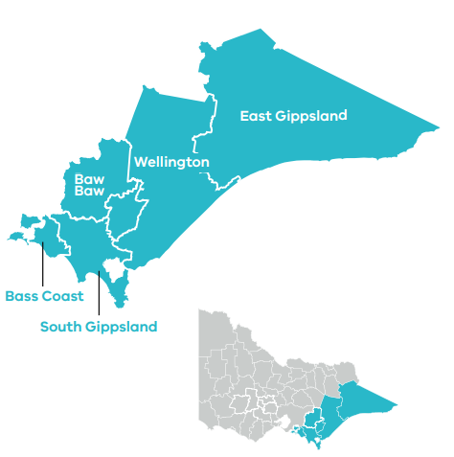

Employment
Unemployment rate (September 2021) | Average annual employment growth (2011–20)
Gippsland: 6.1%  Regional average: 4.2%  Metropolitan Melbourne: 6.0% | Gippsland: 0.8%  Regional average: 1.0%  Metropolitan Melbourne: 2.1%

Top employing sectors (2020)
Industry | Workers
Health care and social assistance | 17,100
Retail trade | 11,800
Construction | 11,400
Agriculture, forestry and fishing | 10,300
Education and training | 10,200
Manufacturing | 8,900

Top sectors by gross value add (2020)
Industry | Gross value add
Mining | $4.3 Billion
Construction | $1.4 Billion
Health care and social assistance | $1.2 Billion
Agriculture, forestry and fishing | $1.0 Billion
Electricity, gas, water and waste services | $975.7 Million
Manufacturing | $869.9 Million

Strategic Directions
Gippsland’s five strategic directions have been identified using an evidence base that considers the region’s unique attributes, existing and emerging industries, and socioeconomic context.

1. Maximise the role of the food and fibre industry in the local economy
Activating the food and fibre innovation ecosystem through on-farm innovation, local research and development, and attracting a skilled workforce will help to develop future-focused industries and unlock new markets.

2. Accelerate advanced manufacturing capabilities in the region
Immediate opportunities in food product manufacturing, energy supply chains and health manufacturing can be linked to collaborative research and digitalisation to encourage innovation and investment.

3. Pursue opportunities emerging from energy industry transition, including in clean and renewable energy and earth resources
The international and domestic focus on renewable energy and climate change mitigation is driving opportunities to activate clean energy and carbon capture and storage potential, and positions the region to supplement existing strengths in energy production with hydrogen and earth resources.

4. Support growth and diversification in the visitor economy
Creating experiences that enable year-round visitation and promoting the region’s Aboriginal heritage and agritourism will be central to driving growth in the tourism industry and creating further opportunities to showcase the region’s significant attractions.

5. Enhance regional specialisation in health care and social assistance
Stronger partnerships between industry and education and training providers will facilitate career pathways in health care and social assistance, supporting labour market inclusion and meeting the increasing demand for services.
Please refer to the Gippsland REDS and Supporting Analysis for further detail and sources.
Prepared by the Department of Jobs, Precincts and Regions, May 2022. For more information see: rdv.vic.gov.au.

