Great South Coast

Regional Economic Development Strategy

**State Government of Victoria**

**Department of Jobs, Precincts and Regions**

**Acknowledgement of Country**

The Department of Jobs, Precincts and Regions acknowledge the Traditional Owners of the lands and waters on which we live and work, and pay our respects to their Elders past, present and emerging.

We acknowledge that the Great South Coast Regional Partnership region is on traditional lands, including those lands of the Gunditjmara, Wadawurrung and Eastern Maar people and Wotjobaluk, Jaadwa, Jadawadjali, Wergaia and Jupagalk Nations as well as other Traditional Owner groups in Victoria who are not formally recognised.

We acknowledge the diversity of Aboriginal Victorians, their communities and cultures, the intrinsic connection to Country, the contribution and interest of Aboriginal people and organisations in developing a prosperous region. This Strategy is committed to advancing the principles of Aboriginal self-determination and supporting communities to realise self-determined economic development objectives.

# Preface

Rural and regional Victoria is home to 1.6 million, or 1 in 4, of Victoria’s residents and over 147,000 businesses. The Victorian Government is committed to making Victoria home to the nation’s most vibrant and successful regional economies.

The Department of Jobs, Precincts and Regions is delivering Regional Economic Development Strategies (REDS) for Victoria’s nine Regional Partnership regions. The REDS contribute to DJPR’s vision for regional Victoria to be a resilient and thriving place to live, work and do business. The REDS provide a consistent socioeconomic evidence base, and strategic framing of medium- to long-term directions to activate economic development opportunities.

The REDS seek to:

1. Identify a socioeconomic evidence base for the region, including demographics, business and industry dynamics, and local endowments that can be used by all stakeholders, and will provide a baseline for monitoring future performance.
2. Acknowledge and reveal the depth of work, analysis, and planning already in place in regions and create a mechanism to support and progress established regional directions, where supported by the current evidence base.
3. Harness and enhance the region’s strengths as drivers of growth in the medium- to long-term.
4. Identify opportunities for public and private investment.
5. Influence and inform rural and regional economic policy and program design across government.
6. Support the prosperity and well-being of rural and regional Victoria through increased rural competitiveness and productivity.

The REDS do not replace existing local strategies. Rather, the REDS are informed by local work to identify economic development priorities and provide a platform to increase the visibility of these priorities and support regional communities to collaborate for shared outcomes.

## How have the REDS been developed?

The REDS have been developed using a consistent methodology across the state, comprising:

* data analysis to consistently describe each region’s industry composition, economic and socioeconomic trends and existing regional endowments
* policy analysis to identify existing local strategies and plans to understand regional development priorities and shape an economic narrative for the region

stakeholder engagement to identify opportunities and challenges under each strategic direction.

## How can I use the REDS?

The REDS can be used by all levels of Government, regional communities and business to coordinate investment and collaborate for shared outcomes.

DJPR will use the REDS to drive strategic whole-of-government activity in the regions, informed by a contemporary understanding of economic performance and comparative advantage.

Regional communities and businesses can use the REDS to:

* communicate innovative capacity in their region, now and in the future
* collaborate with government to better understand regional strengths, challenges and opportunities

attract investment to the region based on clearly identified strategic priorities.

The REDS should be read in conjunction with the relevant REDS Supporting Analysis which provides the consistent evidence base for each region.

**Figure 1: Map of Regional Partnership Regions and Constituent LGAs**

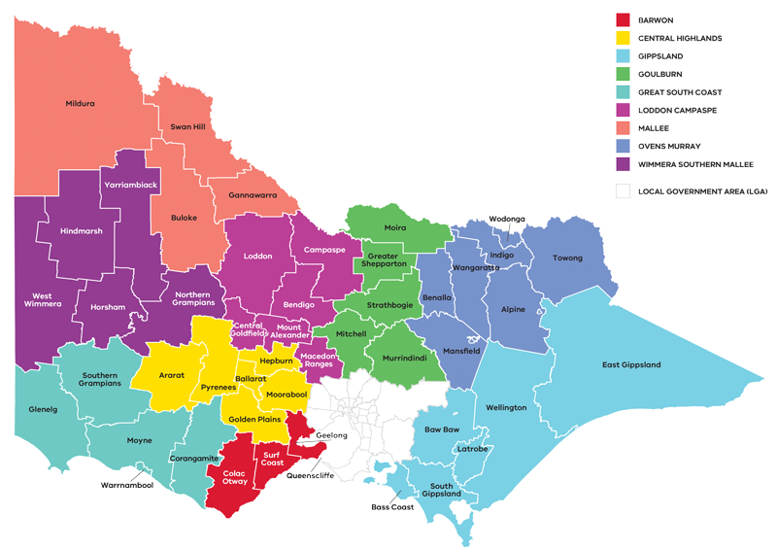

Figure 1: Map of Regional Partnerships – Long Alternate Text

Contents

Preface 1

How have the REDS been developed? 2

How can I use the REDS? 2

01 Introduction 4

Strategic directions 5

Regional readiness to activate strategic directions 6

Local priorities and strategies 6

02 Regional profile 7

Employment by industry 9

Output by industry 10

Regional exports 11

03 Comparative advantage 11

3.1 Endowments 12

3.2 Revealed industry specialisation 14

04 Strategic directions 17

Great South Coast’s strategic directions 18

Enabling factors for economic growth 18

Integrating Aboriginal economic opportunities 19

4.1 Add value to and diversify within the agri-food supply chains 20

4.2 Maximise the potential of the region’s energy resources 25

4.3 Grow and equip the workforce needed to enable future economic opportunities 29

4.4 Expand existing strengths in cultural and nature-based visitation 32

4.5 Capture the potential of the ‘Green Triangle’ cross-border economic zone 37

05 Implementation 40

Contact us 41

Appendix 42

Figure 1: Map of Regional Partnerships – Long Alternate Text 42

Figure 2 Map of Great South Coast – Long Alternate Text 42

Figure 3 Great South Coast industry Employment – Long Alternate Text 43

Figure 4 Great South Coast industry output (gross value add) – Long Alternate Text 45

Figure 5 Great South Coast industry employment location quotient and growth – Long Alternate Text 47

Figure 6 Great South Coast industry output (GVA) location quotient and growth – Long Alternate Text 48

Figure 7 Agricultural map of the Great South Coast – Long Alternate Text 49

Figure 8 How renewable hydrogen is made and used – Long Alternate Text 49

Figure 9 Great South Coast visitor numbers by visitor type (2015-2020) – Long Alternate Text 49

Figure 10 Analysis of access to digital connectivity for tourist locations in the Great South Coast – Long Alternate Text 50

# 01 Introduction

The Great South Coast Regional Economic Development Strategy (the Great South Coast REDS) identifies the medium- to long-term strategic directions for driving economic growth and development across the region.

The Great South Coast Regional Partnership region (the region) is situated in the southwest corner of Victoria encompassing the local government areas (LGAs) of Corangamite, Glenelg, Moyne, Southern Grampians, and Warrnambool. The region is home to Gunditjmara, Wadawurrung and Eastern Maar peoples and Wotjobaluk, Jaadwa, Jadawadjali, Wergaia and Jupgalk Nations, who are the recognised Traditional Owners who have lived, worked and cared for their country and its resources for many thousands of years.

The region stretches eastward along the Great Ocean Road up to the South Australian border in the west. The Shipwreck Coast and Twelve Apostles attract thousands of visitors annually who come to enjoy the spectacular coastline and natural scenery. The region is also home to internationally recognised areas of Aboriginal significance, including Budj Bim Cultural Landscape and Tower Hill. Agriculture is the dominant land use, economic driver and employer for the region. Natural resources including water, timber and wind are abundant in the region, underpinning its current and future economy. The city of Warrnambool is the economic hub for employment and service provision in the region and is connected by road and rail to major consumer and visitor markets.

## Strategic directions

The Great South Coast REDS defines five strategic directions for economic development in the region, based on comprehensive data analysis and review of existing policies and strategies:

1. Add value to and diversify within the **agri-food supply chain**
2. Maximise the potential of the region’s **energy resources**
3. Grow and equip the **workforce** needed to enable future economic opportunities
4. Expand existing strengths in **cultural and nature-based visitation**
5. Capture the greater potential of the **‘Green Triangle’** cross-border economic zone.

For each of the directions, the Great South Coast REDS provides:

* a rationale for its inclusion as part of the strategy
* an overview of opportunities and challenges which are likely to support or hinder future growth
* a summary of work underway and the policy context to support desired outcomes
* the implication of the direction for the region’s Aboriginal communities

examples of how the direction could be activated.

The Great South Coast REDS recognises that approaches to regional development occur in an uncertain environment. While most of the analysis focuses on internal development drivers, it also considers the impact of, and opportunities emerging due to external trends, including the COVID-19 pandemic, patterns in global trade, a changing climate and technological change.

The REDS acknowledges that the Aboriginal and cross-border communities in the Great South Coast region face unique challenges and opportunities, which are also reflected in the strategic directions.

## Regional readiness to activate strategic directions

Continuous place-based business innovation and collaboration are key to building resilience and activating economic opportunities. Innovation activity in the Great South Coast centres around its major industry of agriculture as well as the development of renewable energy technologies such as renewable hydrogen and microgrids. Deakin University Warrnambool Campus will be a key institution to drive further innovation as its research and course offerings align towards high value opportunities in the region.

Some of the key projects that contribute to regional innovation include:

* Hycel, Australia’s first hydrogen fuel cell manufacturing, safety, testing and pilot program at Deakin Warrnambool in partnership with the City of Warrnambool and national and international industry partners.
* The Port Fairy Smart Energy Precinct is a collaborative project between local businesses that have shared ambitions in relation to increasing their uptake of reliable locally generated renewable energy and a desire to deliver broader community benefits.

The Hamilton SmartFarm, focused on delivery of transformational impact in forage innovations for dairy and other livestock industries, cropping in the high rainfall zone and red meat productivity.

## Local priorities and strategies

The Great South Coast Group, a formal alliance of government, industry and community, is the key economic development organisation that works collectively for the benefit of the entire region. The 2010 Great South Coast Regional Strategic Plan outlines priorities (great connections, communities, economies, eco-tourism and agriculture) that have guided economic development activity across the region for the past decade.

More recently, there have been two key strategic documents that prepare the region for future economic growth:

* The 2020 Great South Coast Economic Futures report which identifies and analyses seven emerging economic opportunities for the region with strong credentials for attracting large-scale investment and economic growth and stability.

The Renewable Energy Transition to 2035 for the Great South Coast report from CSIRO who were commissioned to undertake strategic foresighting of the role renewable energy development could have in the region to 2035. The outcomes and suggested policy options from the report deliver a pathway to achieving a sustainable renewable energy industry, as well as bolstering other major industries with widespread renewable integration.

These reports have been drawn upon extensively as key information sources in developing the Great South Coast REDS as well as other State, regional and sub-regional policies and strategies set out in the supporting analysis documentation.

**Figure 2:** Map of the Great South Coast

Map showing an overview of Great South Coast, with key transport infrastructure. A detailed description is provided via the link below.

Figure 2 Map of Great South Coast – Long Alternate Text

# 02 Regional profile

|  |  |
| --- | --- |
| $5.8 | Gross regional product (billion) (2020) |
| 104,200 | Population (2020) |
| 2.4% | Population growth (2011-20) |
| 44 | Median age (2020) |
| 60.6% | Working age (15-64) (2020) |
| 21.6% | Population aged over 65 (2020) |
| 1.6% | Are Aboriginal and/or Torres Strait Islander (2016) |
| 3.1% | Speak a language other than English at home (2016) |
| 8.2% | Were born overseas (2016) |

The population is relatively evenly spread across LGAs except for the City of Warrnambool where just over a third of all residents in the region live. The region has experienced population growth in the past decade however it has been lower than the regional Victoria average. The population in Warrnambool and Moyne is expected to grow at a subdued pace, while the population in the Glenelg, Corangamite and Southern Grampians LGAs is expected to decline. Low population growth has largely driven by a net outflow of residents aged 15-44 years.

|  |  |  |
| --- | --- | --- |
| Local Government Area | Population[1] (2020) | Projected growth[2] (2021-36)1 |
| Corangamite | 15,900 | -5.8% |
| Glenelg | 19,600 | -4.2% |
| Moyne | 17,000 | 10.6% |
| Southern Grampians | 16,100 | -6.7% |
| Warrnambool | 35,500 | 11.8% |

|  |  |  |  |
| --- | --- | --- | --- |
|  | Great South Coast % | Regional average % | Metro Melbourne % |
| Unemployment rate[3] (September 2021) | 3.9 | 4.2 | 6.0 |
| Labour force participation rate[4] (2016) | 62.8 | 60.9 | 65.8 |
| Average annual employment growth[5] (2011–20) | 0.2 | 1.0 | 2.1 |

**Table 1:** Employment in largest employing industries by workers (2020) and gender (2016)

|  | Workers | Male | Female |
| --- | --- | --- | --- |
| Agriculture, forestry and fishing | 10,700 | 70.1% | 29.9% |
| Healthcare and social assistance | 7,200 | 17.1% | 82.9% |
| Retail trade | 4,800 | 39.4% | 60.6% |
| Manufacturing | 4,600 | 77.6% | 22.4% |
| Education and training | 4,000 | 27.6% | 72.4% |

Source: National Institute of Economic and Industry Research, 2020 and ABS Census, 2016

The labour force participation rate in Great South Coast (62.8 per cent) is higher than the regional Victorian average. The female participation rate (57.8 per cent) is significantly lower than for men (68.1 per cent). The largest employing sectors for women are healthcare and social assistance, retail trade, education and training and agriculture, forestry and fishing.

## Employment by industry

Over the past decade, total employment growth in the region has averaged 0.2 per cent per annum. Growth has been concentrated in sectors where employment outcomes are driven by population changes. In particular, ageing populations have supported strong employment growth in health care and social assistance, while employment in the education and training sectors reflects overall population growth in the region. The agriculture, forestry and fishing sector remains the region’s most significant employing industry despite slow employment declines to 2012 and a sharp fall over the past two years which partly offset gains to 2018.

Other prominent employing industries in the region include retail trade and manufacturing. Retail trade has experienced a slow decline while manufacturing has started to experience a downward trend starting in 2010, which signifies a shift towards greater automation in the manufacturing production process and the reduction of employment in the metal product manufacturing sub-industries.

**Figure 3:** Great South Coast industry employment (2001-20)

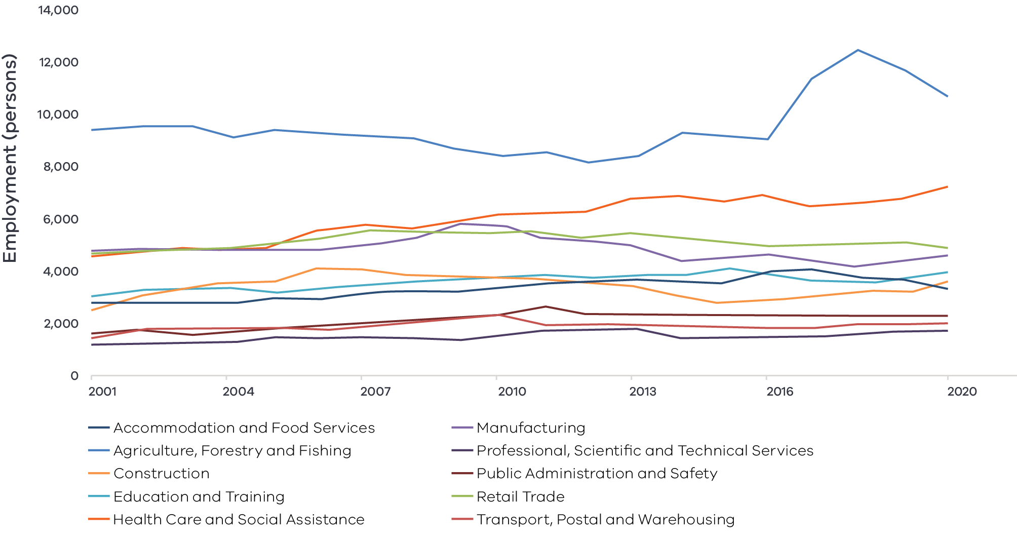

Figure 3 Great South Coast Industry Employment – Long Alternate Text

Source: National Institute of Economic and Industry Research, 2020

Note: Top 10 employing industries in 2020 presented in chart, based on Journey to Work employment estimates.

## Output by industry

Total GVA in the region has been relatively stable over the past two decades, however trends have varied across industries. Agriculture, forestry and fishing remains the largest contributing industry to the region’s total GVA despite large fluctuations in output over the past 20 years. To an extent, volatility is expected in the industry due to a greater reliance on external factors such as climate and fluctuating prices, but it remains clear that the industry is the backbone of the economy with its contribution significantly higher than any other industry. The health care and social assistance sector has realised significant and steady GVA growth over the past two decades which is consistent with trends across regional Victoria. It surpassed the manufacturing industry in 2017 to become the region’s second largest industry by GVA.

### $4.8 billion Gross Value Added (GVA) (2020)

**Top sectors by GVA:**

|  |  |  |
| --- | --- | --- |
| 1 | Agriculture, forestry and fishing: | $1.2 billion |
| 2 | Health care and social assistance: | $530.4 million |
| 3 | Manufacturing | $477.0 million |
| 4 | Construction: | $324.4 million |
| 5 | Education and training: | $321.3 million |

**Figure 4:** Great South Coast industry output (Gross Value Added) (2001-20)

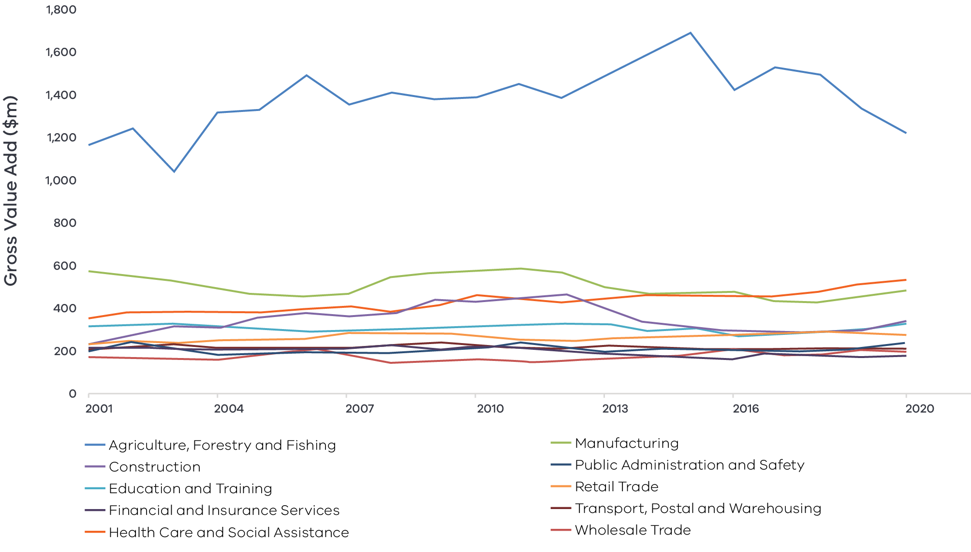

Figure 4 Great South Coast industry output (gross value add) – Long Alternate Text

Source: National Institute of Economic and Industry Research, 2020

## Regional exports

Strong connections to international markets via major freight routes connected to port access as well as demand for agricultural products support the top export sectors (2020):

1. Agriculture, forestry and fishing: $803.4 million
2. Manufacturing: $432.4 million
3. Accommodation and food services: $57.8 million

# 03 Comparative advantage

For the purpose of the REDS, ‘comparative advantage’ is defined simply as a description of what the region does well compared to other regions. This includes both the relative competitiveness of the region’s businesses as well as cultural, social and environmental factors.

Contemporary place-based development emphasises the importance of local endowments as a driver of comparative advantage. In economic terms, endowments refer to any natural, cultural, built or human resources present in a place which can be harnessed to support economic activity. Regional economic strengths can also be identified using other measures including location quotient analysis, shift share analysis, and industry cluster analysis. A comprehensive assessment of these measures is included in the Great South Coast Regional Economic Development Strategy – Supporting Analysis.

## 3.1 Endowments

### Natural endowments

#### Geography and climate

A temperate climate and rainfall that is both higher and more reliable than the Victorian average as well as extensive groundwater systems create strong conditions for agricultural production. This supports the major commodities in the region including beef, dairy and sheep, and creates opportunities for other high yielding and high-quality produce. The region also has extensive coastline and inland areas that allow for various aquaculture methods.

#### Wind power

The region is recognised for having a large amount of quality wind resources spread across the region. These resources have grown in value due to the widespread uptake and integration of renewable energy generation across the state.

#### Natural gas resources

The Otway Basin is a 150,000 sq km onshore and offshore basin that spans the region’s coastline into South Australia. The basin contains a significant amount of natural gas and is a current source of offshore commercial extraction.

#### Environmental assets

The region is home to many iconic landscapes which have been developed into economic precincts attracting visitors all year round and providing environmental, social and cultural amenity to the region. Major landscapes include the Shipwreck Coast, Twelve Apostles, Cape Bridgewater, the southern area of the Grampians National Park, Budj Bim Cultural Landscape, Tower Hill, Glenelg River and Hopkins River.

### Cultural endowments

#### Aboriginal sites and heritage

There are several heritage sites across the region which hold economic, social, environmental and cultural heritage value to the Aboriginal communities including Budj Bim Cultural Landscape, Koroitj (Tower Hill) and Gariwerd (the Grampians). The region is home to the Wadawurrung, Gunditjmara and Eastern Maar people and Wotjobaluk, Jaadwa, Jadawadjali, Wergaia and Jupgalk Nations.

#### Shipwreck coast

The Shipwreck Coast has a rich maritime history that attracts visitors to the region. Flagstaff Hill Maritime Museum and Village in Warrnambool showcases the history to the public.

#### Cultural events

The region hosts several food and wine, music and art-based festivals throughout the year that attracts visitors, supports the creative economy and promotes local produce. These include:

* Wunta Fiesta
* Port Fairy Folk Festival
* Hooked on Portland
* Heywood Wood Wine and Roses Festival

Lake Bolac Eel Festival.

#### Art galleries

The region is home to the Warrnambool Arts Gallery (including the First Peoples Eastern Marr Gallery) and the Hamilton Art Gallery.

### Built endowments

#### Transport linkages

The region is well connected to markets via road (Princes Highway), port (Port of Portland) and rail. The transport network effectively moves the regions quality produce around the State for consumption and export, however passenger rail from Melbourne only goes as far as Warrnambool reducing the movement of people to the region.

#### Tertiary institutions

There are two universities that operate in the region. Deakin University Warrnambool Campus provides specialist education, research, development and commercialisation paths across a number of fields such as advanced materials, energy and water as well as offering more general courses. RMIT University Hamilton is a smaller regional campus focused on applied research as well as undergraduate and postgraduate course offerings in conjunction with RMIT Melbourne campus. Vocational training is facilitated through multiple campuses across the region run by South West TAFE. Agriculture Victoria’s Hamilton SmartFarm also runs Rural Industries Skills Training.

#### Transmission and pipeline infrastructure

The region has two major transmission lines. A 500kV transmission line that links the traditional source of energy (Latrobe Valley) and the major demand locations of Melbourne and Geelong with the Portland Aluminium smelter and a 275kV transmission line connecting Portland to South Australia via the Heywood interconnector. There is also an extensive network of pipeline infrastructure that is utilised by the gas industry and has potential use for a future renewable hydrogen industry.

#### Agricultural businesses

The region is home to some of Victoria’s largest dairy, beef, lamb and wool producers. The size of these businesses provides productivity and efficiency benefits through economies of scale and density of production.

### Human endowments

#### Skilled workforce

The region’s workforce is highly skilled exceeding regional Victoria’s average share of skilled workers. Expertise has accumulated predominantly in the agriculture industry as well as the energy and manufacturing industries through the construction and connection of renewable energy generators, aluminium smelting and natural gas operations.

#### Engaged community

The region has a strong, multi-generational base of skilled and experienced community leaders that advocate for the region’s main industries. Collaboration and cooperation between local governments is also a strength of the region.

## 3.2 Revealed industry specialisation

Location Quotient (LQ) analysis provides further insight into the local economy’s underlying structure and comparative advantages that may not be evident from a region’s endowments. This form of analysis compares an industry’s size and growth (as measured by employment and output) as a proportion of total economic activity, relative to the Victorian average. The higher the LQ, the more concentrated, and therefore significant, an industry is to the local economy relative to Victoria on average. Scores above 1.25 are typically considered to indicate specialisation compared to the rest of the state. Further analysis is provided in the Great South Coast Regional Economic Development Strategy – Supporting Analysis.

### Employment specialisation

#### Agriculture, forestry and fishing:

Agriculture, forestry and fishing is the largest employing industry in the region. Among sub-industries, agriculture has an employment LQ of 8.8, signifying the relatively high level of employment concentration in the region compared to the Victorian average. The sector is experiencing employment growth that is 6.0 percentage points higher than the average for the sub-industry in the state. In addition, the agriculture, forestry and fishing support services sub-industry is highly concentrated with an employment LQ of 18.7, the highest of any sub-industry in the region. This sub-industry is also growing 181.0 percentage points greater than the Victorian average for the sub-industry, indicating a very strong regional specialisation.

#### Food product manufacturing:

Manufacturing in the region only has a mild employment concentration, but food product manufacturing has one of the highest employment concentrations with an LQ of 2.6. In addition, the sub-industry is experiencing employment growth 11.3 percentage points greater than the Victorian average. Complementing the agriculture specialisation, strong industry performance in food product manufacturing supports the prominent agri-food industry in the region which will be a key part of the region’s economy moving forward.

#### Visitor economy

There are several industries and sub-industries that contribute to activity in the visitor economy. The most relevant is the accommodation and food services industry which has a slight employment concentration in the region with an LQ of 1.1 but is currently experiencing employment growth that is 4.8 percentage points slower than the Victorian average. However, the accommodation sub-industry has a notable specialisation in the region, with a sizeable employment concentration shown by an employment LQ of 2.5 as well as employment growth that is 14.5 percentage points greater than the Victorian average.

**Figure 5:** Great South Coast industry employment location quotient and growth

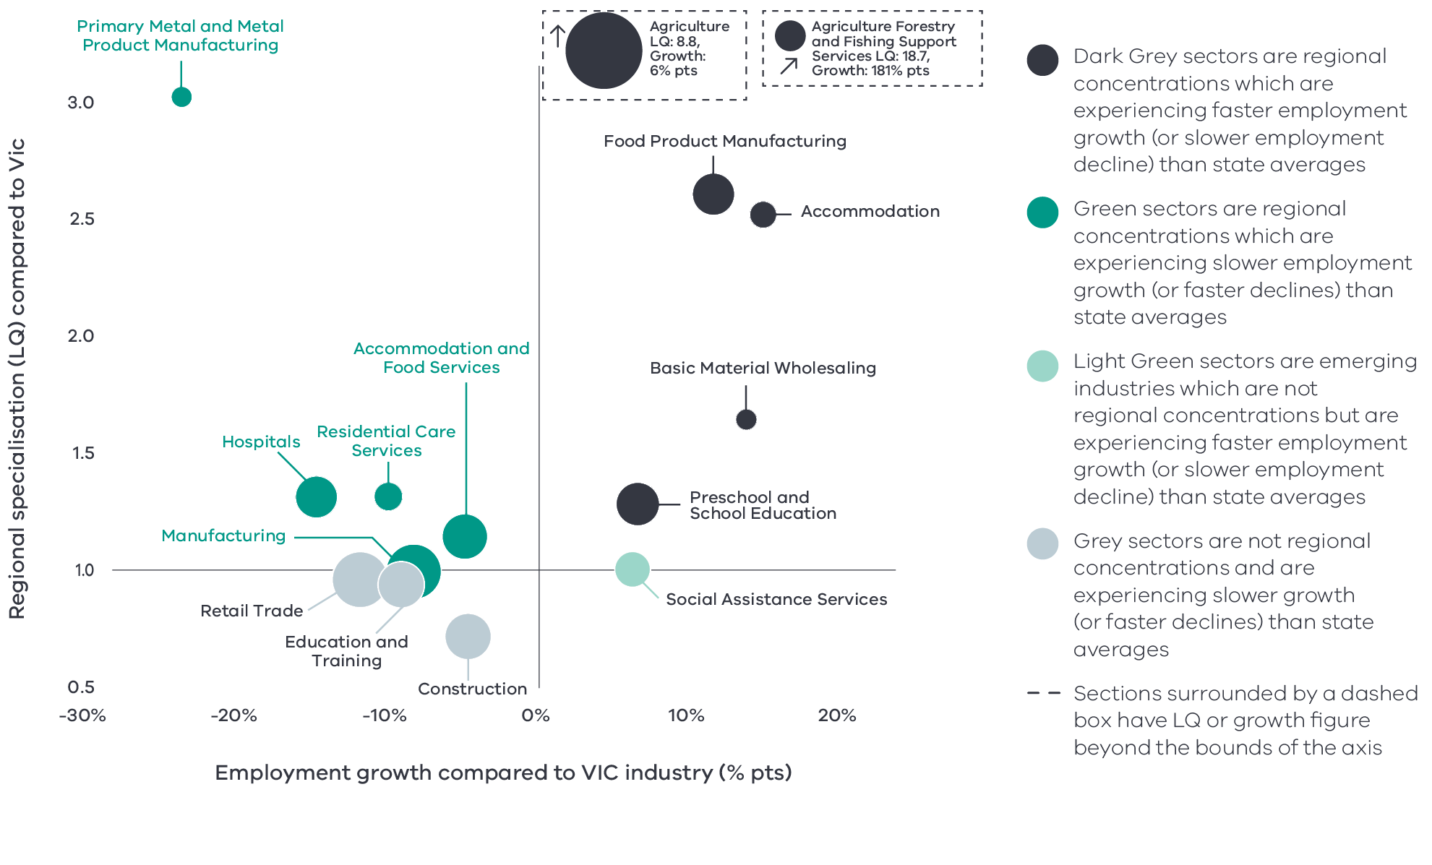

Figure 5 Great South Coast industry employment location quotient and growth – Long Alternate Text

Source: National Institute of Economic and Industry Research, 2020

Note: this chart represents a selection of industries and sub-industries that represent a notable size and or concentration within the region. Some sub-industries presented are sub-sectors of industries that are presented alongside it and therefore measures cannot be aggregated between the two. Other industries are not displayed. For greater detail refer to the supporting analysis pack for this REDS strategy.

**Figure 5** depicts selected industries and sub-industries in the regional economy in 2020 where:

* The size of each bubble indicates the number of people employed in the (sub)industry. The bigger the bubble, the more people employed in the industry.
* The vertical position indicates the (sub)industry’s degree of employment concentration relative to the Victorian economy. For example, a value of 9.6 means that, as a share of total employment in the local economy, the (sub)industry employs 9.6 times as many people than the Victorian average.

The horizontal position indicates the difference in each (sub)industry’s employment growth (2015 to 2020) between the region and the Victorian average. For example, a 11.2 per cent value indicates that regional employment in the (sub)industry has grown 11.2 percentage points faster (between 2015 and 2020) relative to the industry’s average growth rate in Victoria.

### Output specialisation

Output concentrations in Great South Coast are largely consistent with observations for employment concentration. There are however some differences in some industries and in the agri-food supply chain.

**Figure 6:** Great South Coast industry output (GVA) location quotient and growth

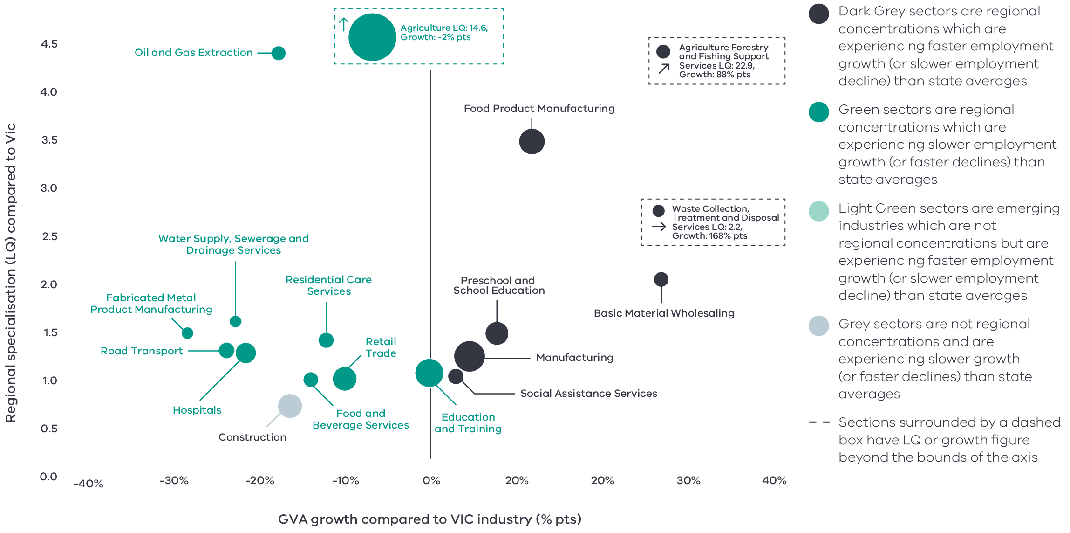

Figure 6 Great South Coast industry output (GVA) location quotient and growth – Long Alternate Text

Source: National Institute of Economic and Industry Research, 2020

Note: this chart represents a selection of industries and sub-industries that represent a notable size and or concentration within the region. Some sub-industries presented are sub-sectors of industries that are presented alongside it and therefore measures cannot be aggregated between the two. Other industries are not displayed. For greater detail refer to the supporting analysis pack for this REDS strategy.

**Figure 6** identifies the Great South Coast’s economic output specialisation in terms of Gross Value Added (GVA). Using the same approach as Figure 5, this analysis compares selected industries and sub-industries in the regional economy, including their size and growth as a proportion of total economic GVA relative to Victorian averages.

#### Agriculture:

While it also has a very strong output concentration, agriculture GVA in the region is growing 2 percentage points lower than the average for the state which reflects the impacts of climate and pricing pressures on the region’s major outputs.

#### Manufacturing:

Manufacturing which was experiencing slower employment growth when compared to the Victorian average has attained output growth that is 4.5 percentage points greater than the state-wide average and also has an output LQ of 1.24. While it does not meet the threshold of specialisation it indicates the greater automation and mechanisation in the industry which has been leading to an increase in efficiency and diminished reliance on labour inputs.

### Emerging sectors of specialisation

In addition to prominent sectors, there are also some emerging industries that currently do not have large employment or output concentrations in the region but are experiencing above average growth and may lead to greater opportunities in the future. One of the sub-industries identified as an emerging sector is social assistance services which is experiencing employment growth and output growth greater than the state-wide average for the industry. This may be driven in part by the COVID-19 pandemic and the greater need for care in the region but is likely also in response to the large amount of net internal migration of residents aged between 0-14 years in Warrnambool and surrounding Moyne shire.

# 04 Strategic directions

The five strategic directions for the Great South Coast region have been identified based on the opportunities emerging from the region’s endowments, industry specialisations, and socioeconomic context. The directions have been refined based on a review of local policies and strategic planning.

The following section discusses each strategic direction, providing:

* a rationale for its inclusion as part of the strategy
* an overview of opportunities and challenges which are likely to support or hinder future growth
* a summary of work underway and the policy context to support desired outcomes
* the implication of the direction for the region’s Aboriginal communities

examples of how the direction could be activated.

## Great South Coast’s strategic directions

1. Add value to and diversify within the **agri-food supply chain**
2. Maximise the potential of the region’s **energy resources**
3. Grow and equip the **workforce** needed to enable future economic opportunities
4. Expand existing strengths in **cultural and nature-based visitation**
5. Capture the greater potential of the **‘Green Triangle’** cross-border economic zone.

## Enabling factors for economic growth

This REDS identifies opportunities in key areas that can help drive regional economic growth. However, each region’s capacity to activate these opportunities and grow is partly determined by cross-cutting enabling factors that support economic activity. Consideration of these enabling factors – and targeted investments and initiatives to strengthen them – will help support achievement of the strategic directions in this REDS.

|  |  |
| --- | --- |
| **Digital connectivity**  Access to reliable internet and mobile services allows for access to new markets, facilitates efficiency gains and opens up opportunities for innovation. Good digital connectivity can also facilitate more inclusive access to services and flexible working arrangements. | 62 to 65 – Australian Digital Inclusion Index Score in Great South Coast in 2021[6]  (Victorian average: 71) |
| **Transport connectivity**  Road and rail infrastructure, ports and airports provide critical linkages between production locations and markets; efficient transport connections and public transport services are a key factor in workforce mobility and local amenity. | 4.2 – Overall access to roads and public transport in Barwon South West RDA region[7]  (Regional Victoria: 4.1 and Victoria: 5) |
| **Workforce and population growth**  An adaptive and productive workforce is key to businesses competitiveness; access to both skilled and unskilled labour ensures business can sustain and expand activities. | 63.2% – Local workforce in Great South Coast was employed in skilled occupations in 2021[8]  (Regional Victoria: 62.2%, Melbourne: 67.3%) (2021)  15.0% – Residents with a bachelor’s degree or higher in 2016[9]  (Regional Victorian: 17.0 %, Melbourne: 31.0%) |
| **Housing**  The availability and affordability of housing determines a region’s ability to attract and retain local staff and supports community cohesion and better life outcomes for individuals and families. | 0.4% – Average rental property vacancy rate in the 6 months leading up to June 2021[10]  (Compared to benchmark of 2.5%)  31.1% – Increase in median rent in Barwon South West RDA region from 2016 to 2020[11]  (Victoria, 6.9%, Regional Victoria 28.6%) |

Note: 1. The Australian Digital Inclusion Index (ADII) is a composite index used to measure digital inclusion across three dimensions of Access, Affordability and Digital Ability. 2. ‘Access to roads and public transport was measured by asking respondents to rate their access to the following types of services in their local community, on a scale ranging from ‘very poor’ (1) to ‘very good’ (7): (i) Quality of local roads; and (ii) Access to public transport (including taxis, buses, trains). A single measure of overall access to roads and public transport was then constructed based on the average score of a person’s responses to these two items.3. Skill level is defined as a function of the range and complexity of the set of tasks performed in a particular occupation. Skilled workers are defined as being classed between an ANZSCO Skill level of 1-3, while low skilled is classed as 4 or 5. 4. A rental property vacancy rate of 2.5% refers to a benchmark at which the market is balanced between landlords and tenants.

## Integrating Aboriginal economic opportunities

The Victorian Government is taking concrete steps to align with Aboriginal self-determination principles. Key Victorian Government policies and processes to realise self-determination goals include the:

* Treaty Process which seeks to redefine the relationships between Aboriginal communities, the state and non-Aboriginal Victorians.
* Victorian Aboriginal Affairs Framework 2018-23 (VAAF) which is the overarching framework for working with Aboriginal Victorians to drive positive socioeconomic outcomes across the state, including to activate economic opportunities and prosperity via achieving wealth equality, facilitating workforce participation in all sectors at all levels and realising Aboriginal income potential.

Self Determination Reform Framework, which guides public sector action to enable self-determination in line with the VAAF across four domains: people, systems, outcomes and accountability.

The Victorian Government is also party to the National Agreement on Closing the Gap and has committed to meeting the associated outcomes – including in relation to increasing engagement of Aboriginal and Torres Strait Islanders in employment, education and training.

An analysis of relevant policies and commitments relating to Aboriginal economic development in the region (listed in the Great South Coast Regional Economic Development Strategy – Supporting Analysis), including Traditional Owner strategic plans, where developed, has identified five opportunities for Aboriginal economic development:

* Identify opportunities to leverage natural resources for economic benefit, including through adopting traditional hunting and agricultural techniques.
* Invest in the growth of Aboriginal owned industry development including nature based and cultural tourism, business enterprise and procurement.
* Pursue greater Aboriginal ownership of land to sustainably manage resources.
* Focus on restoring landscape systems and promoting recognition of the land, its waters and its cultural significance to ensure that economic activities generate benefits.

Encourage the use of cultural places and practices as a mechanism for telling stories, maintaining traditions and creating economic opportunities, particularly in the tourism sector.

Each strategic direction in the Great South Coast REDS considers the relevance of that direction to local Aboriginal communities in light of the above opportunities.

Self-determined priorities for Aboriginal economic development in the region will be aligned to the six pillars of the Victorian Aboriginal Employment and Economic Strategy. These priorities will also guide Victorian Government decision-making on economic development in the region and will be integrated into future updates of the REDS.

## 4.1 Add value to and diversify within the agri-food supply chains

### Significance

The Great South Coast is often referred to as a powerhouse agricultural economy. The climate, soil and water conditions make it one of Australia’s richest agricultural zones. Similar to other agricultural economies across Victoria, the last five years have seen declines in output and productivity signalling that the industry is experiencing an adjustment period marked by farm aggregation, rapid technological change, changing climate conditions and a globally competitive environment. The outlook for the industry to return to growth is positive, but it is largely dependent on how the industry adapts to the changes and capitalises on new opportunities.

Manufacturing also plays a major role in the region’s economy, particularly in the agricultural supply chain. The food product manufacturing sub-sector is the largest and one of the most specialised manufacturing sub-sectors for the region. The sub-sector has achieved considerable growth compared to the rest of Victoria, especially over the last five years, indicating that greater local processing is adding more value to the region’s high-quality dairy, meat, seafood and grains.

**Great South Coast farms produce:[12]**

* 15.3% of Victoria’s beef
* 25.2% of Victoria’s dairy

23.9% of Victoria’s sheep

The agri-food sector (Agriculture, Forestry & Fishing and Food Product Manufacturing) employs a quarter of the workforce and generates a third of regional economic output.[13]

**Figure 7:** Agricultural map of the Great South Coast

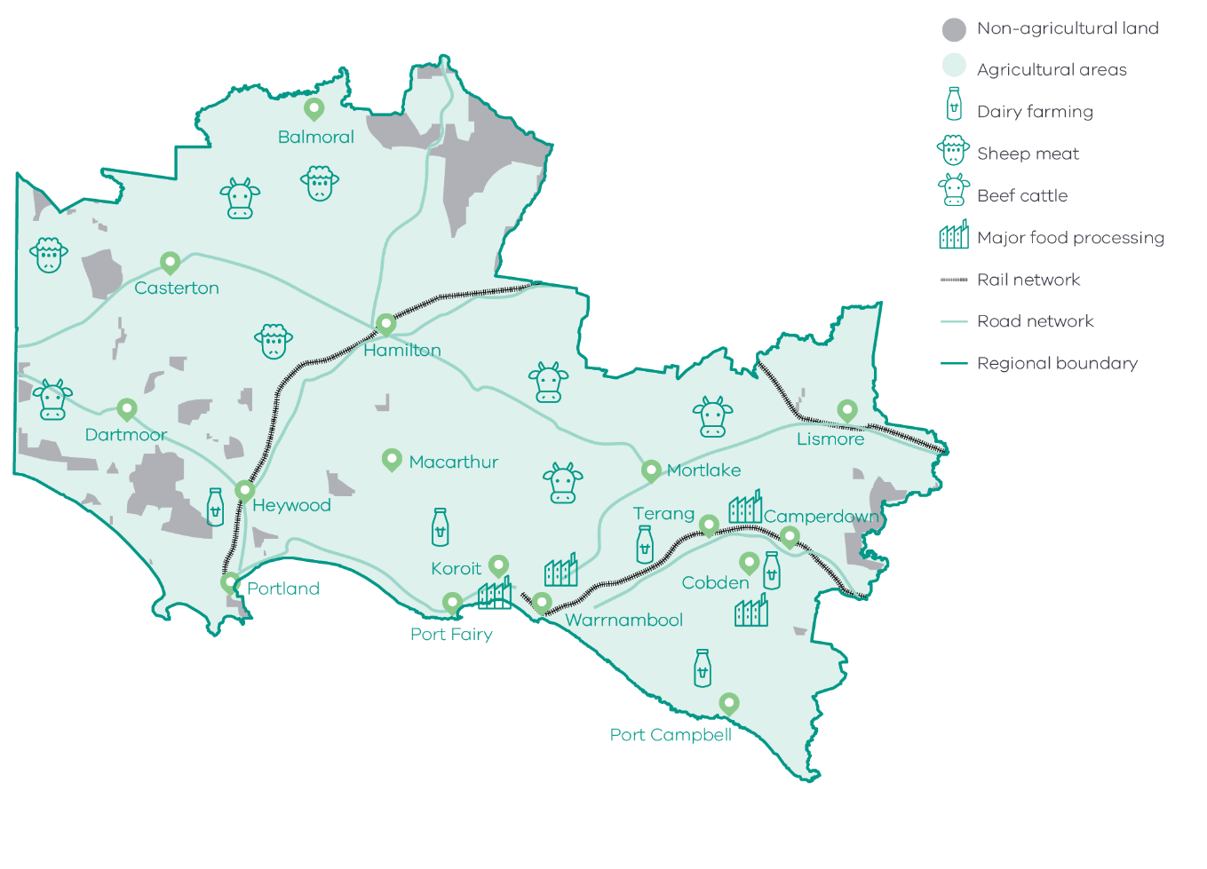

Figure 7 Agricultural map of the Great South Coast – Long Alternate Text

### Opportunities

#### Agricultural diversity

Dairy, beef and sheep account for 80 per cent of the agricultural production of the region. Regional conditions are conducive to these commodities but there are opportunities to capitalise on natural endowments and diversify into higher value produce. The sustainable use of groundwater resources enabled by effective policies can provide an opportunity to develop high value agriculture and horticulture precincts. Sustainable land-based aquaculture is another major diversification opportunity for the region, building on its legacy in wild catch fisheries.

#### Changing food demand

Growing demand for safe and high-quality food in Asia and other emerging markets creates export opportunities for the region’s food and fibre supply chain. Strengthening food safety capabilities, broadening traceability and exploring niche food product opportunities will support the region to maintain its existing reputation of premium, high quality food and fibre products and expand into new markets. Furthermore, the region could play a considerable role in driving low emissions food product manufacturing to meet consumer demands for low emissions food as well as State emissions reduction targets.

#### Advanced capabilities

New technologies and globalisation are transforming the outlook for the agriculture and manufacturing and industries. Positioning the local supply chain to invest in advanced capabilities has the potential to offset traditional market barriers of cost and distance while increasing the productivity of the industry. For food product manufacturing, embracing advanced capabilities allow for the greater personalisation of goods to meet demand and enhances the ability to implement origin and traceability systems for strong product integrity.

#### Increasing value add

Food product manufacturing has been growing   
but a large amount of agricultural production still leaves the region as raw product. Capturing greater value in these products prior to leaving the region could be a key growth pillar for the region’s food industry and will require coordination and investment. The success and expertise of existing value-adding operations in the dairy sector could be built upon to generate more end-to-end value chain activity. Value can also be created by investing in a more efficient and modern freight network that incorporates new technologies, reduces transport costs and allows more produce to flow to consumer markets.

### Challenges

#### Increasing competition

Local agricultural producers face increasing competition in global markets from lower cost producers. The introduction of tariffs on certain agricultural products by some trading partners has added additional complexity to the international trading environment and highlighted the importance of having diversity amongst trading partners.

#### Climate change

The food industry will need to respond to higher temperatures, decreased rainfall and an increasing frequency of extreme weather events. These trends will put pressure on infrastructure and influence water and land availability, production yields and output quality.

**By 2050s:[14]**

* Median temperature could rise 1.9°C
* Median spring rainfall could decline 20%

11.6 days More than double the amount of extreme heat days (35°C)

#### Digital connectivity and integration

Despite high demand from community and industry, poor digital access continues to be a barrier to innovation and the adoption of technology, particularly as it relates to primary production. The Great South Coast Digital Plan showed that there are fixed broadband supply issues for primary production businesses and intermediate mobile supply issues throughout the region.

#### Workforce

Attracting and growing a workforce of sufficient scale and skills to activate the agriculture industry is an ongoing issue in the region due in part to its small population base, housing shortages and growing competition from other sectors such as healthcare and the visitor economy. Negative industry perceptions and a lack of understanding about potential career pathways also play a role in discouraging prospective workers into the industry.

### The policy environment

Diversifying and adding value to the agri-food supply chains is closely aligned with national, state and local priorities. In particular:

* The Victorian Government’s Stronger, innovative, sustainable: A new strategy for agriculture in Victoria focuses on themes of recovery, growth, modernisation, biosecurity and promotion in the agriculture industry.
* The Australian Government’s Make it Happen – Modern Manufacturing Strategy and the Victorian Government’s Food and Fibre Sector Strategy both highlight that food and beverage manufacturing is a priority industry.
* The National Agriculture Workforce Strategy and Roadmap which outlines how to attract, retain, upskill and modernise the agriculture workforce.
* The Victorian Government’s Review – The Future of Agriculture Training in Victoria – will examine the delivery of training in the Agriculture sector and ensure courses delivered by TAFEs meet the needs of agriculture students and employers now and into the future.
* Growing our Regional Futures 2021-2023 is the Food and Fibre Great South Coast Inc. strategy to grow the value of regional food and fibre production, with a focus on driving local value-adding, realising water opportunities, nurturing food and fibre careers, and advocating for the sector.
* The Great South Coast Economic Futures report outlines pathways for securing investments in high value sectors in the region. Sustainable land-based aquaculture precincts and high value water secure agriculture and horticulture precincts are both identified as high value pathways.

Victoria’s Climate Change Strategy details the State Government’s roadmap to net zero and climate resilience which includes $20 million in emissions reduction activities over the next four years through the Agriculture Sector Pledge.

### Aboriginal inclusion

This direction aligns with the Aboriginal economic opportunity for traditional practices to be promoted as a mechanism for maintaining traditions and creating economic opportunities. Traditional Owner groups have identified commercial opportunities in native bush food development and traditional Aboriginal and modern aquaculture, particularly at Budj Bim Cultural Landscape.

Aboriginal employment in the agriculture, forestry and fishing and manufacturing sectors makes up almost 17 per cent of the Aboriginal workforce but this is proportionately lower than the non-Aboriginal workforce. As such, industry growth may have a smaller impact on Aboriginal communities than the non-Aboriginal population. Specific interventions, such as promoting career pathways and supporting Aboriginal enterprises, could be considered to maximise the benefit to Aboriginal communities.

### How can we unlock this strategic direction?

To unlock this opportunity and drive growth, local, State and Commonwealth partners could work together to:

* Sustainably capture the full potential value of water resources.
* Attract talented people to the food and fibre sector by promoting clearer career pathways and offering more integrated learning approaches.
* Identify opportunities to improve the food industry supply chains through:
* Diversification and value-adding
* Replacing inputs imported into the region, where efficient to do so
* New logistics arrangements and better freight connections
* Adding a cost-effective new supply chain link
* Collaboration among regional businesses
* Facilitating agriculture businesses to attract investment.
* Improve electricity distribution networks to enable the full capacity of farmlands to be utilised.
* Support businesses to identify and develop new and emerging product opportunities to keep pace with changing consumer preferences.
* Strengthen the capability and depth of the agricultural research and extension-focused institutions within the region that can respond to the threats and opportunities to the agriculture and manufacturing sectors.
* Foster partnerships with Traditional Owners to support the development of an authentic native food and aquaculture industries, in line with the principles of self-determination.
* Advocate for market access opportunities and strengthen biosecurity, food safety capabilities and traceability across supply chains.

Support telecommunications providers to deliver high quality digital connectivity that aligns with regional economic priorities.

## 4.2 Maximise the potential of the region’s energy resources

### Significance

The region’s abundance of energy resources has placed it in a position to pursue future economic growth while providing a sustainable future for its industries and residents. The region is on track to become a nationally significant centre for many productive facets of the renewable energy sector, from leading applied research pilots through to generation, storage and export. The region’s growing wind, solar and bioenergy generation capability paired with transmission infrastructure and a skilled workforce provides a robust platform for future developments into emerging renewable technologies. The potential for offshore gas exploration and extraction to meet current energy needs will also bolster the region’s energy industry.

The region is positioned to realise a future where new renewable energy industries are bringing diversity to the economy as well as boosting productivity, innovation and competitiveness across existing industries. Reaching this outcome will require a coordinated effort across the complex stakeholder environment to reach its highest potential.

### Opportunities

#### Widespread renewable integration

Renewable energy generation capability is well progressed in the region with some of the highest quality wind resources, including off-shore wind potential, in Victoria. This is in addition to solar farms and bioenergy facilities. With the region on track to develop a dynamic and vibrant renewable energy industry, the focus shifts towards embedding renewable energy across the economy to realise its greatest potential and delivering local benefits. Analysis suggests that achieving widespread integration of renewable energy across the region’s key industries is the highest value pathway to maximising employment opportunities and value as well as the indirect benefits such as innovation hubs, lower energy costs, manufacturing and skill retention.

#### Renewable hydrogen

The technology behind renewable hydrogen as a sustainable energy storage and fuel source continues to improve with its potential contribution to net zero emissions widely recognised. The Great South Coast has the conditions where a renewable hydrogen industry can thrive with the region positioned to realise new employment opportunities and business growth while building a more sustainable future. This is due to its access to world-class wind generation, water resources, a skilled workforce, a deep-water port (for export), gas network infrastructure and research institutions. The new Hycel Technology Hub located at Deakin University Warrnambool Campus will be a critical asset for the region to contribute to the development of renewable hydrogen technology as well as prepare the region for future commercial production.

#### New business opportunities

There are opportunities emerging along the renewable energy supply chain for current and future businesses in the region. The region’s history of value-adding to raw materials could be further developed to meet local content requirements for new energy projects. As wind turbines in the region age there are opportunities for businesses to refurbish, service and decommission the installations. There is also a need for the development of innovative solutions to turn biowaste into renewable energy or deal with the waste materials generated by decommissioned wind turbines.

#### Natural gas

Alongside offshore gas development, the passage of the Petroleum Legislation Amendment Act (2020) allows for the restart of onshore conventional gas exploration from 1 July 2021. The change in legislation opens up opportunities for new gas discoveries and production across the Otway Basin to supplement Victoria’s demand for natural gas. The additional industry activity would provide for local jobs and various regional economic benefits.

**Figure 8:** How renewable hydrogen is made and used

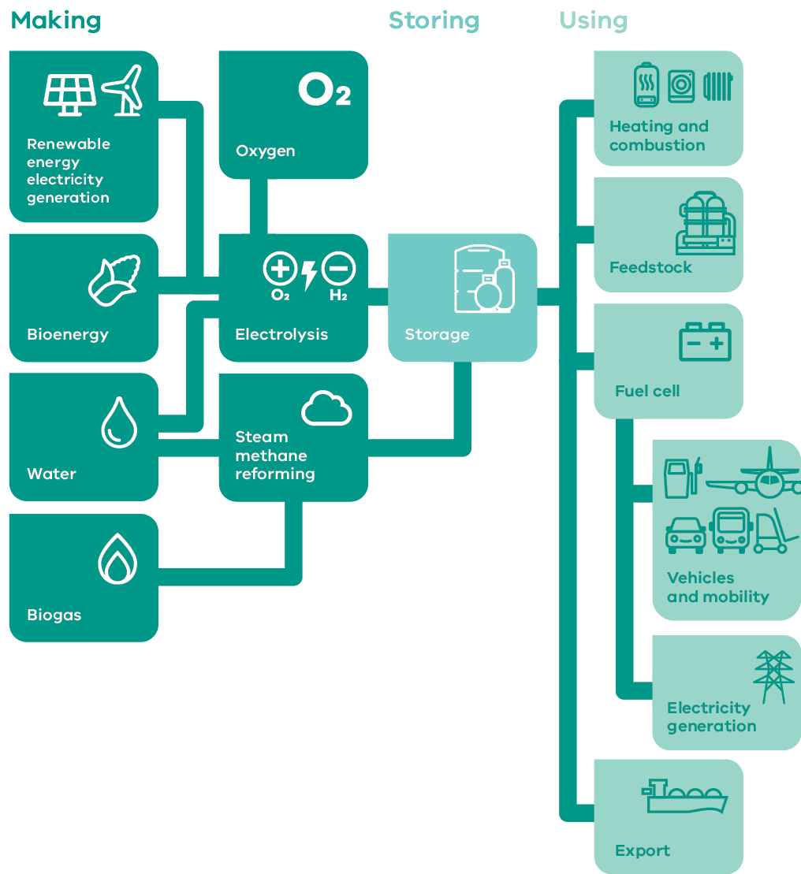

Figure 8 How renewable hydrogen is made and used – Long Alternate Text

### Challenges

#### Connections to transmission and distribution infrastructure

While the region has great capacity to generate renewable energy, it can only reach its potential if that capacity can efficiently and effectively access transmission and distribution infrastructure. Wind farm growth has been somewhat ad hoc in the region to date which can make connection and investment into infrastructure difficult. Furthermore, the ability for energy intensive businesses to commence or expand operations is hampered by three-phase power not being readily available through the local distribution networks. Optimising and coordinating future developments with connections to the main State electricity grid and local networks is increasingly important for a renewable future.

#### Social license

Local support for renewable energy projects is critical for their success. Regional stakeholders suggest that past experiences with renewable energy projects in the region have been disappointing in terms of levels of disruption, unclear information, and economic benefits for the local community. This has contributed to a lack of social license for further renewable energy generation projects in the region. There are also concerns around the actual and perceived environmental impact that natural gas extraction might have on the region which must also be considered in future developments. Undertaking genuine and ongoing community consultation and ensuring existing regional development plans deliver local benefits and address local issues could be used to help inform and empower the community to embrace a renewable energy future.

### The policy environment

Maximising the abundance of natural resources is closely aligned with national, state and local priorities. In particular:

* The Australian Energy Market Operator has identified the region as a Renewable Energy Zone: V4 South West. The Victorian Government is using these Renewable Energy Zones to target investment towards strengthening the transmission network in Victoria to enable an orderly and coordinated transition to renewable energy and engage with local communities to ensure that they benefit. It does so through the new co-ordinating body VicGrid.
* Victoria’s Climate Change Strategy provides a roadmap towards net-zero emissions by 2050. It includes interim targets to reduce emissions and pledges for energy, agriculture, transport, waste and forestry sectors.
* The Victorian Offshore Wind Policy Directions Paper sets out a pathway to establish an offshore wind industry and sets a state-wide target of 9GW of offshore wind energy generation by 2040.
* The Victorian Renewable Hydrogen Industry Development Plan sets out a blueprint to capitalise on renewable hydrogen’s economic opportunity, including creating long-term jobs and new career pathways and enabling the state’s transition to net-zero emissions.
* Victoria’s Recycling Victoria: A new economy is the state’s circular economy policy and 10-year action plan to reduce waste and pollution and improve recycling in a way which delivers economic benefit.
* CSIRO’s Renewable Energy Transition to 2035 for the Great South Coast uses strategic foresighting to demonstrate that a Renewable Valley scenario is predicted and viewed as the highest value pathway in employment and output for renewable energy development to 2035. The scenario sees traditional industries being supplemented with diversification into emerging sectors and widespread integration of renewable energy into supply chains supporting new industries.
* The Barwon South West Renewable Energy Roadmap describes the current and future renewable capabilities of the region identifying wind as a key priority for the region.
* The Great South Coast Economic Futures report outlines pathways for securing investments in high value sectors in the region. Renewable hydrogen industrial research and development investments and a collaborative regional renewables generation, transmission, storage, investment and policy forum are both identified as high value pathways.

The Victorian government has a suite of state-wide policies and initiatives to support the State’s energy sector to transition to net-zero emissions, which are available on [energy.vic.gov.au](https://www.energy.vic.gov.au/).

### Aboriginal inclusion

Local Aboriginal stakeholders are focused on maximising benefits from investments in renewable energy projects. The Wadawurrung Healthy Country Plan aims for Wadawurrung wind farms to be generating income and employment by 2027. Increased investment in the renewable energy sector is likely to create employment opportunities in the construction, energy and waste services and professional, scientific and technical services industries. Aside from construction, Census results indicate that there were no Aboriginal workers employed in these industries in 2016. Future investments and activities could include a focus on creating pathways to Aboriginal employment in these industries, and promoting Aboriginal owned businesses. Opportunities in this strategic direction may have environmental impacts. Engagement with Aboriginal communities is necessary to ensure impacts are minimised and cultural places protected.

### How can we unlock this strategic direction?

To unlock this opportunity and drive growth, local, State and Commonwealth partners could work together to:

* Advocate for transmission infrastructure and distribution that unlocks the region’s renewable energy potential.
* Improve coordination of existing and prospective energy investments to maximise the local benefits by aiming to:
* source resident labour and local inputs
* leverage existing and required infrastructure for other compatible developments
* encourage social responsibility contributions to the local community.
* Explore the pathways to achieving widespread integration of renewable energy across the region’s industries and supply chains.
* Explore the development of a hydrogen economy by supporting industrial scale project demonstrations.

Promote new business growth in the renewables supply chain.

## 4.3 Grow and equip the workforce needed to enable future economic opportunities

### Significance

The region’s workforce will be a key asset to capitalise on future economic growth opportunities and meet the needs of an ageing population. Projections indicate that employment in the dominant agriculture industry will decline as it becomes more automated and capital intensive, but there will be greater need to expand the workforce in the energy industry and the population-based service sectors of education and health. Compounding workforce and demographic challenges of low unemployment, low population growth and high youth migration indicates that realising future employment and growth projections will require a two-pronged strategy of attracting an external workforce as well as retaining and activating the local existing and future workforce.

Equipping the workforce with the right skills will also be key to building a productive workforce. Education levels in the Great South Coast are lower than the regional Victorian average. As the requirement for tertiary skills in major industries and service sectors grows, there will be a need for a more skilled workforce.

### Opportunities

#### Harnessing technology

Technological change across the region presents opportunities to grow and equip the workforce. The provision of education services has been dramatically altered by digital technology. Students can access educational opportunities without having to leave the region and the educational offerings of the universities in the region can be enhanced. The ability to work from anywhere enabled by digital technology has been the catalyst for metropolitan residents migrating to the region in the wake of the COVID-19 pandemic. In the short-term this has a limited impact on the local workforce, but the long-term effects could improve the attraction of external workers migrating to the region. Maintaining and improving digital infrastructure across the region will be key to unlocking these opportunities for the workforce.

#### Specialised research and skills

Educational institutions in the region have had to balance pursuing applied research and education in areas of strength in the regional economy, with a more conservative approach into mainstream offerings. If the pathways to realising high value opportunities identified by this strategy and other local strategies are to be pursued, there is a strong case for universities and TAFEs to focus their research and course offerings in areas of local strength such as renewable energy, renewable hydrogen and water secure agriculture. This could help to address young worker emigration by providing stronger connections from training to employment.

#### Inclusive employment

There is evidence of low economic participation in certain groups in the region including women, young people and the Aboriginal workforce. Encouraging businesses to provide employment opportunities for these groups provides an avenue for maximising the use of labour supply already in the region, addressing workforce shortages and creating a more diverse workforce. Ensuring inclusive work practices, policies and strategies will be critical to ensuring that inclusive employment generates long term and lasting benefits.

#### Stimulating migration

Attracting new workers to rural and regional areas is dependent on the availability of economic opportunities, liveability including access to key services, and promotion of the region. While this strategy demonstrates the economic opportunities and the enabling factors that underpin liveability, the region could pursue complementary avenues for bringing new workers to the region. Targeted promotional activity that appeals to market segments more attracted to move to regional Victoria or advocating for stronger international and domestic skilled migrant policies have been highlighted as key components of an overall population attraction strategy.

**Table 2:** Key employment indicators across the Great South Coast’s demographic cohorts

|  | Aboriginal[15] | Non- Aboriginal | Male | Female | Living with a disability | Not living with a disability |
| --- | --- | --- | --- | --- | --- | --- |
| Unemployment | 17.9% | 4.6% | 4.9% | 4.6% | 12.3% | 4.7% |
| Participation | 57.7% | 63.1% | 68.1% | 57.8% | 9.8% | 66.8% |

Source: ABS Census 2016

### Challenges

#### Housing shortages and connecting infrastructure

Access to suitable housing in the region is a barrier to attracting workers and unlocking future economic opportunities. Over time, the combined effect of various housing dynamics such as the increase of short term stay rentals in coastal areas, limited development activity in small markets and the rising cost of connecting services has led to a shortage of housing for rent or purchase across the region. As a result, many workers are now commuting into the region at cost or are seeking employment opportunities elsewhere. This threatens the region’s ability to source the labour required to realise the economic opportunities noted in this strategy. Interventions to alleviate the housing shortages in the region may require a place-based and innovative approach to finding workable solutions.

#### Industry transition

Employment in heavy manufacturing in the region has declined over the past five years and is expected to continue consistent with trends in deindustrialisation. The city of Portland is at the forefront of this transition with a major employer in the heavy manufacturing sector facing an uncertain future. While these businesses provide significant local economic benefit, there is a need to reduce the local economy’s reliance on large employers and build more resilience to protect from any future shocks. Economic diversification is a long-term priority for the area as well as ensuring there are pathways for the transition of skilled workers into other industries.

### The policy environment

Growing and equipping a future-ready workforce is closely aligned with local priorities. In particular:

* The Great South Coast Economic Futures report outlines pathways for securing investments in high value sectors in the region. Closer tertiary institution support for these high value sectors is seen as a high value pathway.
* The Growing Our Regional Futures Strategy focuses on nurturing careers in the food and fibre industry.
* The Key and Essential Worker Housing Supply Action Plan aims to increase the supply of rental and ownership accommodation for permanent and seasonal key workers from a range of industries across the Great South Coast.

The Great South Coast Regional Skills Demand Profile forecasts the demand for labour across the major industries in the region to identify future barriers in the labour market.

### Aboriginal inclusion

The Aboriginal population has lower economic engagement than the general population, particularly among young people. Efforts to better align career pathways and increase employment readiness and opportunities could significantly benefit Aboriginal communities in the Great South Coast.

### How can we unlock this strategic direction?

To unlock this opportunity and drive growth, local, State and Commonwealth partners could work together to:

* Explore place-based responses to regional housing shortages.
* Actively promote the region as an attractive region to live and work.
* Ensure that the voices of underrepresented groups, such as youth, women, those living in rural settings and Aboriginal people are included in employment, training and workforce planning initiatives.

Align educational offerings with the region’s existing and emerging industries.

## 4.4 Expand existing strengths in cultural and nature-based visitation

### Significance

The Great South Coast is an area of natural beauty with coastlines, mountains and forests that attract many domestic and international visitors across the year. The western expanse of the Great Ocean Road and the development of the Budj Bim Cultural Landscape are the centrepieces of the visitor economy which directly and indirectly supports many jobs and businesses. Prior to the COVID-19 pandemic, visitor economy growth was strong with visitor numbers and expenditure growing year-on-year.

The majority of visitors to the region come on day trips, which limits the economic multiplier potential for local businesses and accommodation providers. The concentrated nature of most visitation in certain areas has also increased pressure on road and services infrastructure. The challenge of growth lies in developing attractions, accommodation offerings and an environment that encourages longer stays and dispersal and therefore greater spend.

**Figure 9:** Great South Coast visitor numbers by visitor type (2015-20)

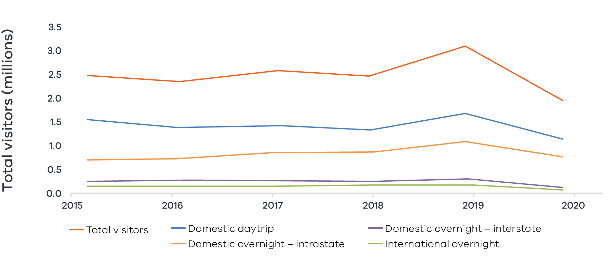

Figure 9 Great South Coast visitor numbers by visitor type (2015-2020) – Long Alternate Text

Source: Tourism Research Australia research data, as reported by DJPR – Tourism, Events and the Visitor Economy Research Unit 2021

### Opportunities

#### Strengthen and develop ‘hero’ opportunities

‘Hero’ experiences attract high levels of domestic and international visitation and, in doing so, create a ‘halo’ effect of private investment in surrounding areas. Experiences can be a group of complementary experiences, or a single major hero project. The region has an advantage in natural and cultural attractions with hero potential, some of which have targeted development plans already in place.

Natural: The Great Ocean Road, Shipwreck Coast and the Grampians Ranges are well recognised visitation sites that have benefitted from development activity in the past but have the potential for elevation with continued development. The region is also recognised for its hot spring and spa tourism potential due to its suitable geological conditions and access to mineral springs. A focus on this market opportunity is seen as a pathway to strengthening a wider range of offerings for the region such as epicurean experiences, specialty accommodation or ecotourism. The region’s volcanic history and geography is also a future source of natural attraction with plans underway to develop sites and build tourism routes.

Cultural: Many of the regional natural attractions are also places of significant cultural importance for the Traditional Owners, which adds significant value to these assets for tourism purposes. Through these assets the region has the opportunity to capitalise on the increased interest in Aboriginal knowledge, culture and experiences by the wider community. The development of these assets could build stronger connections with local Aboriginal communities to support self-determination, promote Aboriginal enterprise and ensure recognition of culturally significant traditions and landscapes. Budj Bim Cultural Landscape, recently designated as a UNESCO World Heritage Site, has major hero potential and work is already underway with recent significant investments towards its masterplan development.

Improving the accessibility and visitor experience of these attractions will encourage visitors to increase their length of stay and spend in the region. Transport connectivity, infrastructure investments and high-quality accommodation development have been recognised within the region as a need for improving these attractions.

#### Changing visitation trends

The COVID-19 pandemic is changing the way people travel, with many Australians substituting overseas holidays with domestic travel. There is a short- to medium-term opportunity to influence domestic tourists looking to spend their holidays in a regional setting. There are signs this is already occurring with average visitor spend among domestic intra- and inter-state overnight visitors substantially increasing in 2020 as compared to 2019. Targeted marketing and branding strategies to this demographic could harness this higher spend and create ongoing opportunities once visitor numbers return to normal.

#### Agritourism

Agritourism offers opportunities to showcase the region’s credentials as a world-class producer of ‘clean’ agricultural products and link farmers directly to consumers. Specific opportunities may include farm stays, producer tours or the development of food and wine trails. Developing the region’s brand around its agricultural identity similar to other parts of the state such as the Yarra Valley Wine region could also be an opportunity to encourage visitation.

### Challenges

#### Degradation and loss of amenity

A large section of the visitor economy in the Great South Coast relies on natural assets. Projected sea level rises and resultant coastline degradation, increased fire risks and drying natural environments as a result of climate change may threaten nature-based tourism experiences in the region in the long-term. Concentrated visitation to environmental attractions can also harm the environmental amenity through overcrowding and pollution as well as impacting visitor experience.

#### Seasonality

Visitation to the region is often concentrated at certain times due to highly popular assets, the climate and the coastal nature of the region. The impact of seasonality leads to overdemand at certain time periods and limited demand at other times, which leads to volatile outcomes for some visitor economy businesses. This places pressure on infrastructure, workforce supply and availability of accommodation, which needs to support high visitor numbers but only for short or specific periods.

#### Digital capabilities and capacity

The ways visitors experience the region and access information are changing. Visitors increasingly use internet research and social media to plan holidays and gather visitor information. Visitor economy businesses need to invest and adapt to new technologies such as digital marketing and share economy platforms to enhance the visitor experience, but this requires digital skills and reliable internet and mobile connectivity. The 2020 Great South Coast Digital Plan highlights that many tourist locations in the region experience inadequate fixed access coverage and a significant digital capability divide in comparison to other regional and metropolitan areas, which affects the visitor experience and business innovation.

**Figure 10:** Analysis of access to digital connectivity for tourist locations in the Great South Coast

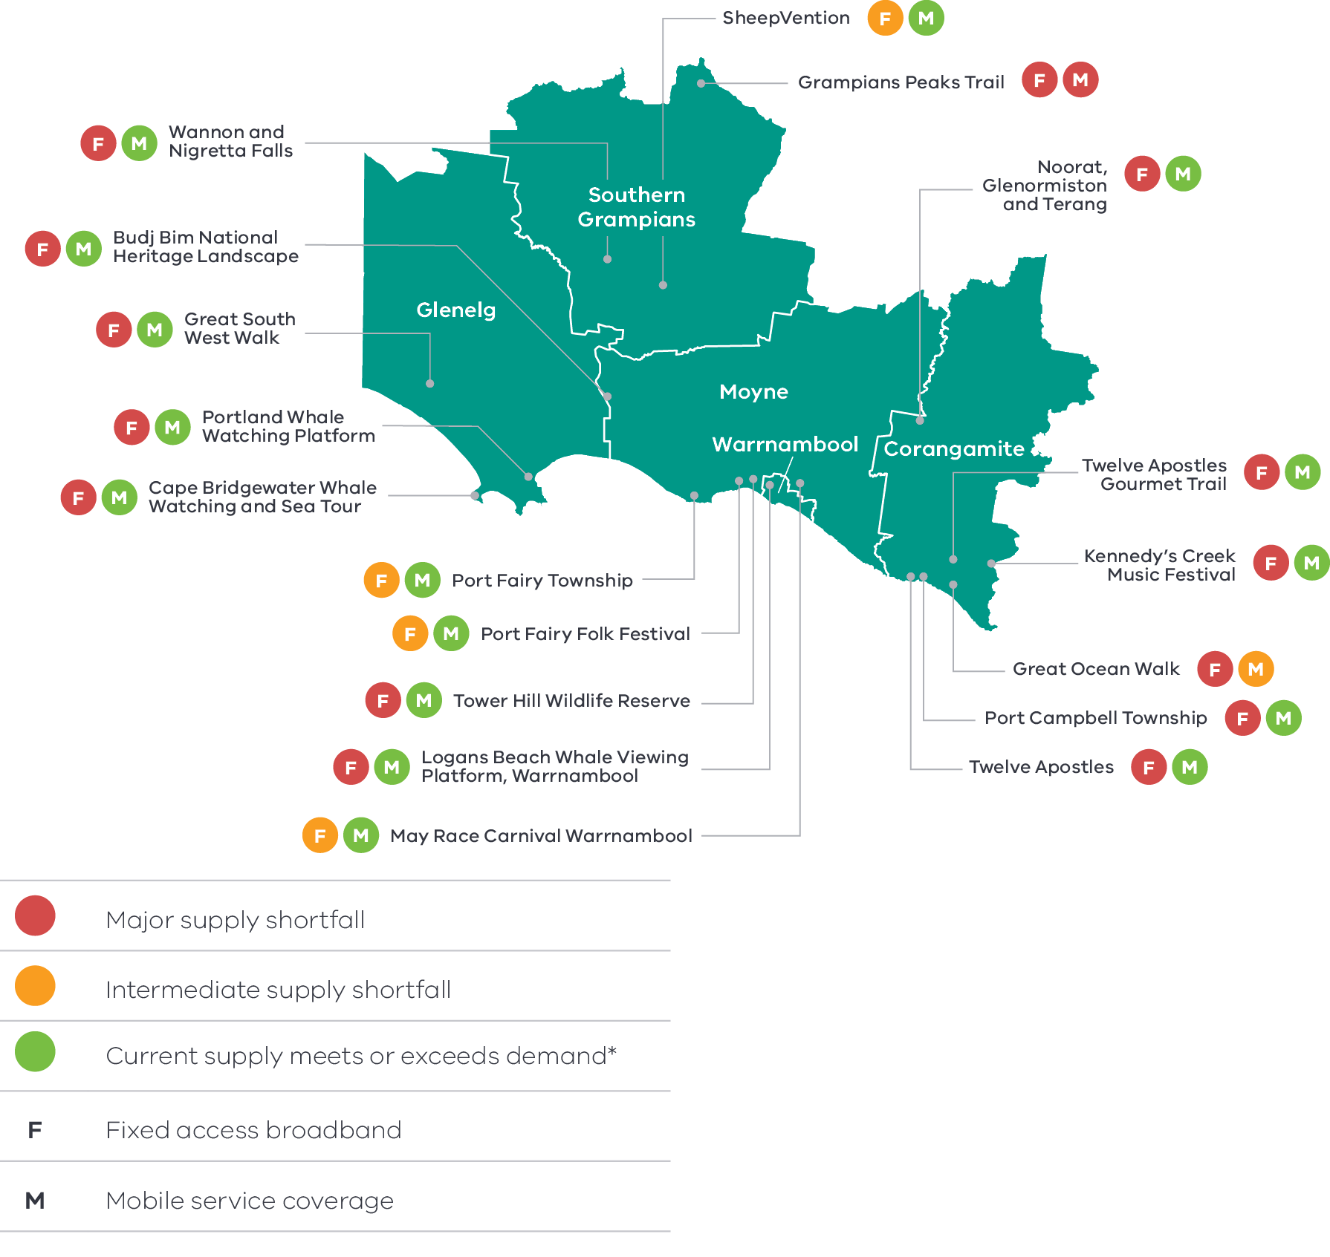

Figure 10 Analysis of access to digital connectivity for tourist locations in the Great South Coast – Long Alternate Text

All locations have issues with **fixed access broadband services**. Most tourist spots appear to have adequate **mobile coverage**, but national parks and lakes are underserved.

*Note that there are reservations, based on local mobile access experience, about the good coverage indicated by public coverage maps.

Source: Great South Coast Regional Partnership, 2020, Regional Digital Plan

### The policy environment

Expanding cultural and nature-based visitation is closely aligned with national, state and local priorities. In particular:

* The Victorian Government’s Visitor Economy Recovery and Reform Plan (2021) aims to attract more tourists to the State, support regional jobs and deliver a significant recovery from the combined effects of the 2020 summer bushfires and the COVID-19 pandemic. This includes delivering a state-wide destination master plan underpinned by priority sector plans (the first sector priorities to be developed will be the Nature-Based Tourism Plan and the First Peoples’ Tourism Plan) and the establishment of Visitor Economy Partnerships across Victoria.
* The Creative Industries Strategy for South West Victoria (2020) will drive investment in the conditions needed for creative endeavours to thrive in the Great South Coast and has seven objectives including increased recognition of First Nations culture and heritage in the region.
* The Great South Coast Economic Futures report outlines pathways for securing investments in reliably high value sectors in the region. High value tourism networks – including hot springs and Traditional Owner cultural tourism are both identified as high value pathways.
* The Geelong City Deal is a 10 year plan to revitalise Geelong and unlock the potential of the Great Ocean Road visitor economy. The deal will deliver on key visitor economy infrastructure projects along the Great Ocean Road including the Shipwreck Coast.
* The Visitor Economy Master Plan for the Great Ocean Road Region 2021-2030 and the 2020 Great Ocean Road Visitor Economy Workforce Development Strategy have been developed to support regional visitor economy growth and address visitor economy workforce needs. A key objective of the Visitor Economy Master Plan is to increase the yield generated from visitation through the provision of quality visitor experiences, providing significant economic benefits to local communities. Many of the priorities such as the Shipwreck Coast Masterplan are underway.
* Shipwreck Coast Masterplan (2015) aims to protect the fragile coastline between Princetown and the Bay of Islands, improve opportunities for visitors and strengthen the local economy and employment opportunities through sustainable tourism.
* The 2014 Budj Bim Master plan presents a strategic vision for the site based on the conservation and sustainable use of the landscape for cultural, visitation and community purposes. As of 2021, infrastructure works have begun funded by the Regional Tourism Infrastructure Fund.

The Connecting Victoria initiative, announced in mid-2021, is fast-tracking new mobile and broadband infrastructure through a $550 million investment across Victoria.

### Aboriginal inclusion

Local Aboriginal communities have used the visitor economy as a means for sharing cultural places, traditions and practices with the wider community as well as creating economic opportunities. Over 18 per cent of Aboriginal workers are employed in industries which support visitation in the Great South Coast, such as accommodation and food services, arts and recreation and retail trade. This indicates that there is a skilled and capable workforce ready to lead further opportunities in the visitor economy, especially Aboriginal experiences. The visitor economy is also instrumental in providing avenues for Aboriginal businesses and corporations to commercialise their own opportunities which is a strong pathway to economic inclusion and self-determination for Aboriginal communities.

### How can we unlock this strategic direction?

To unlock this opportunity and drive growth, local, State and Commonwealth partners could work together to:

* Identify regional tourism offerings that have current and future ‘hero’ potential to elevate the region as well as progress those offerings that already have significant strategic planning in place.
* Audit existing tourism assets to ensure they are of the type and quality to meet future needs.
* Support visitor economy operators to innovate and improve capability across marketing and share economy platforms.
* Develop solutions for the visitor economy to adapt to a warmer climate and rising sea levels.
* Support interested Traditional Owner groups to develop and promote Aboriginal tourism offerings.
* Establish mechanisms for collaboration between visitor economy operators.
* Continue to work with telecommunications providers to deliver high quality digital connectivity that aligns with regional economic priorities.

Identify ways to develop commercial opportunities through supporting existing offerings or facilitating private sector investment.

## 4.5 Capture the potential of the ‘Green Triangle’ cross-border economic zone

### Significance

The Green Triangle is a historic region that spans the border area in the far south west corner of Victoria and South Australia’s Limestone Coast. It gets its name from being one of Australia’s major forestry regions with an end-to-end supply chain of softwood and hardwood plantations through to the Port of Portland. While the industry is an important contributor the economy, the region has much more to offer beyond forestry through the economic hubs of Portland, Mt Gambier and Hamilton as well as stunning coastlines and landscapes such as Discovery Bay, Limestone Coast and Budj Bim Cultural Landscape. Despite this, the Green Triangle has been unable to attract residents to the area and faces a number of economic challenges.

Cross-border economic and social activity has resulted in strong relationships among the communities, local councils and industry groups on both sides of the border. There is potential to leverage these strong ties to promote the identity and connections of the region beyond the forestry industry with the aim of encouraging migration and visitation as well as addressing the need for economic diversification in Victoria’s border community.

### Opportunities

#### Maximising the forestry industry advantage

The climate and the topography of the Green Triangle paired with the deep seaport in Portland makes it a premier location for growing, processing and exporting wood fibre. A productive industry and skilled workforce supports over 7,000 direct and indirect jobs in the region. With global demand for wood fibre expected to increase significantly to 2050, the region is positioned to capitalise on this demand and grow into a world leading sustainable forestry production and innovation hub. Furthermore, there is great potential for the industry to play a role in reaching emissions targets through carbon sequestration activities and bioenergy supply.

#### Collaboration on high value opportunities

Many of the future growth opportunities and assets that exist in the Great South Coast such as water aquifers, transmission infrastructure, aquaculture precincts and visitation networks expand into South Australia. While there is recognition that both administrative regions can benefit from developing these opportunities, joint investment and planning can be difficult to navigate. A commitment to further recognition, structure and collaboration between governments and stakeholders in the region will enable the future economic opportunities to reach their potential across the Great South Coast and the wider region.

#### Improving flows

Flows of goods, services and people throughout the Green Triangle do not recognise administrative boundaries, but the infrastructure that they travel on is managed by different jurisdictions. Coordinated, consistent and equitable investment into the transportation network will allow the flow of goods, services and people to become more efficient, productive and profitable. Improving road quality on both sides of the border and the frequency of public transport connections in The Green Triangle would encourage flows in the region.

### Challenges

#### Regulatory overlap

The unintended consequences of regulatory structures that straddle the border impact communities and businesses daily. Differing regulations for the movement of raw goods, groundwater access, biosecurity, forestry training requirements are currently restricting economic activities. Addressing regulatory overlap will allow businesses to operate seamlessly and more efficiently in the region.

#### Attracting workers

Attracting and retaining workers has been a major barrier to realising economic opportunities and realising growth in the Green Triangle. Low population growth, an ageing population and high emigration of young working aged people have left the region needing to look externally to fill employment vacancies. While the Green Triangle has much to offer prospective workers, a shortage in supply of housing limits the opportunities significantly. Physical distance from major population hubs such as Melbourne and Adelaide is also a major factor in attracting residents.

### Work underway in the policy environment

Capturing the greater potential of the Green Triangle economic zone is supported by state and local priorities. In particular:

* The Victorian Cross Border Commissioner advocates for cross-border communities, businesses and organisations to their respective State Governments.
* The Great South Coast Economic Futures report outlines pathways for securing investments in reliably high value sectors in the region. Cross-border collaboration with south-east South Australian communities is identified as a high value pathway.

The Green Triangle Forest Industry Strategic Plan developed by the Green Triangle Forest Industries Hub, a network of nine companies operating in the region, sets a path forward for the forestry industry towards 2050.

### Aboriginal inclusion

To the extent that harnessing the potential of cross-border zones creates more economic activity in sectors like forestry, aquaculture, renewable energy, or tourism, there could be opportunities for Aboriginal employment and businesses. There are also cultural sites of significance to the Bungandidj people – the Traditional Owners of the Limestone Coast to bring into the Aboriginal tourism proposition for the region.

### How can we unlock this strategic direction?

To unlock this opportunity and drive growth, local, State and Commonwealth partners could work together to:

* Seek opportunities for joint action or investment between jurisdictions on both sides of the border.
* Facilitate the growth of the forestry industry into a world class innovation and production hub.

Proactively make improvements to differing regulatory conditions.

# 05 Implementation

The Great South Coast REDS outlines Rural and Regional Victoria (RRV) Group’s strategic approach for focusing its future economic development activities, including through policy, investment and program delivery, in the region. It is not a prescriptive roadmap for Victorian Government economic development action in the Great South Coast.

#### RRV will use the REDS to coordinate investments and activities in place

RRV is committed to pursuing the strategic directions through future policy design, investment and program implementation, as well as through collaboration across government and with regional partnerships, to deliver positive economic outcomes for the region. The Great South Coast REDS will provide a central point for coordination for current and future work streams and investments.

RRV recognises that effective planning policy and controls will be a key enabler of inclusive, sustainable economic growth in the Great South Coast region. Victoria’s Regional Growth Plans provide broad direction for land use and development, and enable economic growth by ensuring that infrastructure investment is coordinated, appropriate services are provided, and development meets community expectations. The Regional Development and Planning portfolios will pursue opportunities to ensure that as relevant state-led land use planning strategies, policies and controls are updated, they are aligned with the REDS strategic directions.

#### Local stakeholders industry leaders and government service providers can use the REDS to advocate for shared outcomes

This Great South Coast REDS, along with the supporting Great South Coast Regional Economic Development Strategy – Supporting Analysis document, provides a starting point for an evidence-based, strategic approach to regional development. This approach is an ongoing process where specific development actions and projects can be proposed and considered in the context of alignment with the REDS.

Regional Development Victoria – Barwon South West will remain the main point of contact in the region for facilitating and coordinating regional development outcomes.

The Great South Coast Regional Partnership which comprises community and business leaders, CEOs of constituent Local Governments, members from the Regional Development Australia Barwon South West Committee and State Government personnel will continue to be the main advisory body to the Minister for Regional Development and other government decision-makers on local issues and priorities.

The Great South Coast REDS will provide Jobs Victoria with important context and understanding of local economic priorities and opportunities that will be a critical input into the planning and prioritisation of Jobs Victoria’s work and collaboration activities with our Service Partners. Jobs Victoria assists people looking for work, connects employers with the staff they need, administers wage subsidy programs and supports significant local employment transitions.

#### RRV will monitor and evaluation the implementation of the REDS

The strategic directions in this Strategy focus on medium- to long-term drivers of growth and opportunity but will be used immediately to guide investment in the region. Notwithstanding this timeframe, the strategic directions will continue to evolve and progress as actions and investment are made. To ensure ongoing relevance and accuracy, Rural and Regional Victoria will periodically update and refresh this Strategy.

## Contact us

Department of Jobs, Precincts and Regions

Level 31, 121 Exhibition Street, Melbourne, VIC 3000

T: +61 (03) 9651 9999

[djpr.vic.gov.au](https://djpr.vic.gov.au/)

Authorised and published by the Victorian Government.

Department of Jobs, Precincts and Regions  
Level 31, 121 Exhibition Street,   
Melbourne, VIC 3000  
Telephone (03) 9651 9999

March 2022

Unless indicated otherwise, this work is made available under the terms of the Creative Commons Attribution 3.0 Australia Licence. To view a copy of this licence, visit [creativecommons.org/licenses/by/3.0/au](https://creativecommons.org/licenses/by/3.0/au/)

It is a condition of this Creative Commons Attribution 3.0 Licence that you must give credit to the original author who is the State of Victoria.

ISBN 978-1-76090-549-1 (Print)

ISBN 978-1-76090-550-7 (pdf/online/MS word)

# Appendix

## Figure 1: Map of Regional Partnerships – Long Alternate Text

The **Mallee** region is located in northwest Victoria and contains the LGAs of Mildura, Swan Hill, Buloke and Gannawarra.

The **Wimmera Southern Mallee** region is located in western Victoria and contains the LGAs of West Wimmera, Hindmarsh, Yarriambiack, Horsham and Northern Grampians.

The **Great South Coast** region is located in southwest Victoria and contains the LGAs of Glenelg, Southern Grampians, Moyne, Warrnambool and Corangamite.

The **Barwon** region is located to southwest of metropolitan Melbourne and contains the LGAs of Geelong, Queenscliffe, Surf Coast and Colac Otway.

The **Central Highlands** region is to the west of metropolitan Melbourne and contains the LGAs of Ararat, Pyrenees, Golden Plains, Moorabool, Ballarat and Hepburn.

The **Loddon Campaspe** region is northwest of metropolitan Melbourne and contains the LGAs of Macedon Ranges, Mount Alexander, Central Goldfields, Loddon Campaspe and Bendigo.

The **Goulburn** region is north of metropolitan Melbourne and contains the LGAs of Mitchell, Murrindindi, Strathbogie, Greater Shepparton and Moira.

The **Ovens Murray** region is located in the northeast of Victoria and contains the LGA’s of Mansfield, Benalla, Wangaratta, Alpine, Indigo, Towong and Wodonga.

The **Gippsland** region is located in the east of Victoria and contains the LGAs of Bass Coast, South Gippsland, Baw Baw, Latrobe, Wellington and East Gippsland.

Click here to return to document

## Figure 2 Map of Great South Coast – Long Alternate Text

The Great South Coast region is made up of the Glenelg, Southern Grampians, Moyne, Warrnambool and Corangamite Local Government Areas.

Rail links to Portland and Warrnambool also connect Heywood, Hamilton, Dunkeld, Terang and Camperdown with regions to the north and east (along with Melbourne).

Portland, Warrnambool and Port Fairy each have sea ports and Casterton, Portland, Hamilton, Warrnambool and Cobden each have regional airports.

Several major road connections link towns and regional centres across the Great South Coast region.

Click here to return to document

## Figure 3 Great South Coast industry Employment – Long Alternate Text

The largest employing industries in descending order are Agriculture, Forestry and Fishing, Health Care and Social Assistance, Retail Trade, Manufacturing, Education and Training Construction, Accommodation and Food Services, Public Administration and Safety, Transport, Postal and Warehousing and Professional, Scientific and Technical Services.

The following industries have grown in employment since Agriculture, Forestry and Fishing, Health Care and Social Assistance, Retail Trade, Education and Training Construction, Accommodation and Food Services, Public Administration and Safety, Transport, Postal and Warehousing and Professional, Scientific and Technical Services.

The following industry has declined in employment since 2001; Manufacturing.

Simplified Table of data for Figure 3.

|  |  |  |  |  |  |  |  |  |  |  |
| --- | --- | --- | --- | --- | --- | --- | --- | --- | --- | --- |
| Year | Agriculture, Forestry and Fishing | Health Care and Social Assistance | Retail Trade | Manufacturing | Education and Training | Construction | Accommodation and Food Services | Public Administration and Safety | Transport, Postal and Warehousing | Professional, Scientific and Technical Services |
| 2001 | 9369 | 4521 | 4692 | 4662 | 2997 | 2523 | 2736 | 1570 | 1478 | 1228 |
| 2002 | 9519 | 4656 | 4758 | 4815 | 3148 | 3028 | 2788 | 1662 | 1625 | 1255 |
| 2003 | 9524 | 4797 | 4857 | 4864 | 3305 | 3288 | 2839 | 1562 | 1648 | 1258 |
| 2004 | 9200 | 4743 | 4885 | 4779 | 3304 | 3514 | 2839 | 1644 | 1629 | 1254 |
| 2005 | 9370 | 4993 | 5096 | 4869 | 3211 | 3659 | 2928 | 1793 | 1717 | 1418 |
| 2006 | 9255 | 5484 | 5272 | 4879 | 3281 | 4028 | 2944 | 1920 | 1773 | 1411 |
| 2007 | 9131 | 5661 | 5472 | 4974 | 3440 | 4021 | 3092 | 2047 | 1885 | 1495 |
| 2008 | 9092 | 5642 | 5504 | 5216 | 3545 | 3770 | 3232 | 2123 | 1961 | 1409 |
| 2009 | 8616 | 5877 | 5422 | 5770 | 3585 | 3723 | 3308 | 2206 | 2079 | 1393 |
| 2010 | 8499 | 6228 | 5426 | 5615 | 3684 | 3753 | 3464 | 2345 | 2165 | 1506 |
| 2011 | 8496 | 6249 | 5431 | 5267 | 3794 | 3686 | 3590 | 2535 | 1978 | 1712 |
| 2012 | 8220 | 6214 | 5318 | 5174 | 3770 | 3508 | 3558 | 2343 | 1937 | 1699 |
| 2013 | 8359 | 6732 | 5378 | 4953 | 3885 | 3356 | 3606 | 2313 | 1964 | 1701 |
| 2014 | 9270 | 6796 | 5221 | 4416 | 3870 | 3022 | 3525 | 2320 | 1954 | 1512 |
| 2015 | 9130 | 6642 | 5050 | 4474 | 4007 | 2864 | 3506 | 2308 | 1930 | 1515 |
| 2016 | 9004 | 6777 | 4926 | 4601 | 3940 | 2955 | 3870 | 2238 | 1926 | 1535 |
| 2017 | 11333 | 6484 | 4926 | 4289 | 3648 | 3078 | 4057 | 2210 | 1894 | 1529 |
| 2018 | 12382 | 6586 | 4971 | 4160 | 3600 | 3147 | 3779 | 2192 | 1946 | 1570 |
| 2019 | 11665 | 6780 | 4999 | 4288 | 3688 | 3240 | 3641 | 2232 | 1937 | 1623 |
| 2020 | 10683 | 7228 | 4849 | 4590 | 3952 | 3480 | 3349 | 2238 | 1965 | 1677 |

Click here to return to document

## Figure 4 Great South Coast industry output (gross value add) – Long Alternate Text

The industries with the largest gross value add in 2020 in descending order are Agriculture, Forestry and Fishing, Health Care and Social Assistance, Manufacturing, Construction, Education and Training, Retail Trade, Public Administration and Safety, Transport, Postal and Warehousing and Professional, Scientific and Technical Services, Wholesale Trade and Financial and Insurance Services.

The following industries have grown in gross value add since 2001; Agriculture, Forestry and Fishing, Health Care and Social Assistance, Construction, Education and Training, Retail Trade, Public Administration and Safety, Transport, Postal and Warehousing and Professional, Scientific and Technical Services, Wholesale Trade.

The following industry has declined in gross value add since 2001; Manufacturing, Financial and Insurance Services.

Simplified Table of data for Figure 4. Data in this table is in ($) millions.

|  |  |  |  |  |  |  |  |  |  |  |
| --- | --- | --- | --- | --- | --- | --- | --- | --- | --- | --- |
| Year | Agriculture, Forestry and Fishing | Health Care and Social Assistance | Manufacturing | Construction | Education and Training | Retail Trade | Public Administration and Safety | Transport, Postal and Warehousing | Wholesale Trade | Financial and Insurance Services |
| 2001 | 1161 | 350 | 563 | 216 | 304 | 222 | 197 | 190 | 165 | 204 |
| 2002 | 1239 | 372 | 548 | 270 | 313 | 238 | 234 | 216 | 161 | 208 |
| 2003 | 1039 | 382 | 526 | 307 | 324 | 236 | 197 | 221 | 161 | 202 |
| 2004 | 1320 | 379 | 492 | 309 | 315 | 247 | 179 | 207 | 151 | 201 |
| 2005 | 1342 | 368 | 465 | 347 | 299 | 254 | 177 | 201 | 176 | 206 |
| 2006 | 1495 | 393 | 450 | 370 | 288 | 254 | 185 | 203 | 198 | 200 |
| 2007 | 1362 | 394 | 470 | 365 | 288 | 269 | 191 | 205 | 177 | 210 |
| 2008 | 1406 | 381 | 540 | 374 | 294 | 272 | 184 | 225 | 145 | 218 |
| 2009 | 1384 | 407 | 563 | 425 | 303 | 268 | 194 | 231 | 144 | 202 |
| 2010 | 1402 | 449 | 575 | 431 | 311 | 256 | 213 | 216 | 148 | 204 |
| 2011 | 1454 | 428 | 579 | 439 | 322 | 248 | 231 | 202 | 140 | 205 |
| 2012 | 1393 | 420 | 561 | 454 | 319 | 244 | 199 | 206 | 144 | 192 |
| 2013 | 1507 | 448 | 499 | 396 | 318 | 259 | 187 | 216 | 163 | 178 |
| 2014 | 1603 | 462 | 469 | 327 | 296 | 261 | 205 | 212 | 168 | 167 |
| 2015 | 1701 | 459 | 473 | 306 | 295 | 263 | 207 | 200 | 176 | 160 |
| 2016 | 1429 | 457 | 472 | 290 | 269 | 265 | 197 | 206 | 193 | 157 |
| 2017 | 1526 | 447 | 432 | 285 | 278 | 263 | 194 | 206 | 180 | 178 |
| 2018 | 1506 | 472 | 423 | 281 | 283 | 272 | 196 | 211 | 171 | 173 |
| 2019 | 1341 | 514 | 452 | 295 | 292 | 273 | 209 | 202 | 190 | 163 |
| 2020 | 1225 | 530 | 477 | 324 | 321 | 270 | 233 | 201 | 187 | 166 |

Click here to return to document

## Figure 5 Great South Coast industry employment location quotient and growth – Long Alternate Text

The graph is divided into four quadrants.

The first quadrant identifies the industries that are a) experiencing slower employment growth (or faster declines) than state averages and b) have higher levels of employment specialisation than state averages.

The following industries are in quadrant 1:

* Primary Metal and Metal Product Manufacturing
* Hospitals
* Manufacturing
* Residential Care Services

Accommodation and Food Services

The second quadrant identifies the industries that are a) experiencing faster employment growth (or slower declines) than state averages and b) have higher levels of employment specialisation than state averages.

The following industries are in quadrant 2:

* Agriculture
* Agriculture, Forestry and Fishing Support Services
* Accommodation
* Food Product Manufacturing
* Basic Material Wholesaling

Preschool and School Education

The third quadrant the industries that are a) experiencing slower employment growth (or faster declines) than state averages and b) have lower levels of employment specialisation than state averages.

The following industries are in quadrant 3:

* Retail Trade
* Education and Training

Construction

The fourth quadrant identifies industries that are a) experiencing faster employment growth (or slower declines) than state averages an b) have lower levels of employment specialisation than state averages.

The following industry is in quadrant 4:

Social Assistance Services

Click here to return to document

## Figure 6 Great South Coast industry output (GVA) location quotient and growth – Long Alternate Text

The first quadrant identifies the industries that are a) experiencing slower GVA growth (or faster declines) than state averages and b) have higher levels of GVA specialisation than state averages.

The following industries are in quadrant 1:

* Agriculture
* Oil and Gas Extraction
* Water Supply, Sewerage and Drainage Services
* Fabricated Metal Product Manufacturing
* Road Transport
* Hospitals
* Residential Care Services
* Food and Beverage Services
* Retail Trade

Education and Training

The second quadrant identifies the industries that are a) experiencing faster GVA growth (or slower declines) than state averages and b) have higher levels of GVA specialisation than state averages.

The following industries are in quadrant 2:

* Agriculture, Forestry and Fishing Support Services
* Food Produce Manufacturing
* Waste Collection, Treatment and Disposal Services
* Preschool and School Education
* Basic Material Wholesaling
* Manufacturing

Social Assistance Services

The third quadrant the industries that are a) experiencing slower GVA growth (or faster declines) than state averages and b) have lower levels of GVA specialisation than state averages.

The following industries are in quadrant 3:

Construction

The fourth quadrant identifies industries that are a) experiencing faster GVA growth (or slower declines) than state averages an b) have lower levels of GVA specialisation than state averages.

There are no industries in the fourth quadrant.

Click here to return to document

## Figure 7 Agricultural map of the Great South Coast – Long Alternate Text

This is a map showing agricultural activities in the Great South Coast region.

Several agricultural activities take place in the Great South Coast region. Sheep meat farming occurs in the area around Casterton and Balmoral in the region’s west. Beef cattle farming occurs near Dartmoor and Balmoral in the region’s west and in the area around and to the north of Mortlake. Dairy farming occurs near Haywood and Portland, Koroit, Terang, Cobden and Port Campbell.

Major food processing centres are located in Camperdown, Cobden, Warrnambool and Koroit.

Click here to return to document

## Figure 8 How renewable hydrogen is made and used – Long Alternate Text

This infographic shows a high-level snapshot of how renewable hydrogen is made and used. It highlights two processes: electrolysis (which may have the following inputs: renewable energy electricity generation, bioenergy, water, oxygen) and steam methane reforming (which may have the following inputs: water and biogas). After it is made renewable hydrogen can be stored and used for the following purposes: heating and combustion, feedstock, fuel cells (for vehicles and mobility or electricity generation), export.

Click here to return to document

## Figure 9 Great South Coast visitor numbers by visitor type (2015-2020) – Long Alternate Text

Between 2015 and 2020 the largest number of visits were from Domestic Day Trips followed by Domestic Overnight – Intrastate trips, by Domestic Overnight – Interstate trips and final international overnight trips.

Between 2016 and 2019 all visitor types grew. In 2020, all visitor types contracted.

Simplified table of data for figure 9.

|  |  |  |  |  |  |  |
| --- | --- | --- | --- | --- | --- | --- |
| Number of Visitors by visitor type (Year ending March) | 2015 | 2016 | 2017 | 2018 | 2019 | 2020 |
| Domestic daytrip | 1,507,000 | 1,350,000 | 1,385,000 | 1,299,000 | 1,659,000 | 1,122,000 |
| Domestic overnight *Interstate* | 185,000 | 226,000 | 227,000 | 193,000 | 252,000 | 64,000 |
| Domestic overnight *Intrastate* | 658,000 | 674,000 | 822,000 | 831,000 | 1,037,000 | 745,000 |
| International overnight | 90,000 | 102,000 | 107,000 | 114,000 | 115,000 | 29,000 |

Click here to return to document

## Figure 10 Analysis of access to digital connectivity for tourist locations in the Great South Coast – Long Alternate Text

Simplified summary of analysis (as at 2020) is set out below.

| **Great South Coast tourist location** | **Digital connectivity analysis** |
| --- | --- |
| * Port Fairy Township * Port Fairy Folk Festival * May Race Carnival Warrnambool * SheepVention | Fixed access broadband – intermediate supply shortfall;  Mobile service coverage – current supply meets or exceeds demand |
| * Wannon and Nigretta Falls * Budj Bim National Heritage Landscape * Great South West Walk * Portland Whale Watching Platform * Cape Bridgewater Whale Watching and Sea Tour * Tower Hill Wildlife Reserve * Logans Beach Whale Viewing Platform, Warrnambool * Twelve Apostles * Port Campbell Township * Kennedy’s Creek Music Festival * Twelve Apostles Gourmet Trail * Noorat, Glenormiston and Terang | Fixed access broadband – major supply shortfall; Mobile service coverage – current supply meets or exceeds demand |
| Great Ocean Walk | Fixed access broadband – major supply shortfall;  Mobile service coverage – intermediate supply shortfall |
| Grampians Peak Trail | Fixed access broadband – major supply shortfall;  Mobile service coverage – major supply shortfall |

Click here to return to document

1. Australian Bureau of Statistics, 2021
2. Victoria in Future 2019, Department of Environment, Land, Water and Planning. The COVID-19 pandemic has changed Victoria’s population pathway from near-record growth levels to population losses. However, Victoria’s regions appear to have experienced little disruption to growth patterns. Migration from Melbourne to the regions has been at record levels according to the latest ABS data, offsetting most regional losses to overseas or interstate. There remains considerable uncertainty around the distribution of the increased regional migration, and the permanence of this trend, but available evidence points to continuing regional growth. Data from the 2021 Census will be vital in determining the impacts on the strongest migration attractors (e.g. regional centres and peri-urban areas) versus those regions which may have experienced losses from the temporary migrant workforce. Given current information, the pre-pandemic VIF2019 projections remain fit for purpose for regional planning.
3. National Skills Commission, 2022
4. ABS Census, 2016
5. National Institute of Economic and Industry Research, 2020
6. Thomas J. et al., 2021, *Australian Digital Inclusion Index*
7. Department of Education and Training, 2021
8. Regional Wellbeing Survey, 2020
9. ABS Census, 2016
10. RRV analysis, SQM, 2021
11. DHHS rental Report – June Quarter, 2021
12. Agriculture Victoria, 2021, analysis using Regional Industry Structure and Employment (RISE) model
13. National Institute of Economic and Industry Research, 2020
14. Department of Environment, Land, Water and Planning, 2019, *Great South Coast Climate Projection 2019* (based on ‘high emissions’ scenario)
15. Includes ‘Aboriginal’, ‘Torres Strait Islander’ and ‘Both Aboriginal and Torres Strait Islander’ fields.