Goulburn

Regional Economic Development Strategy – Summary

State Government of Victoria

The Goulburn REDS uses data and evidence to profile the region’s economy and identify key strategic directions to drive economic growth.

Regional Profile

Goulburn Regional Profile
Population (2020) | 170,400
Population growth (2011-20) | 15.0%
Gross regional product (2020) | $8.0B
Figure 1: Map of Goulburn
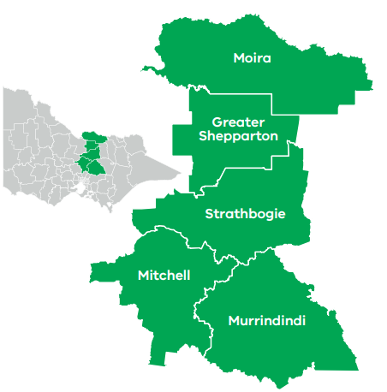

Employment
Unemployment rate (September 2021) | Average annual employment growth (2011–20)
Goulburn: 4.0%  Regional average: 4.2%  Metropolitan Melbourne: 6.0% | Goulburn: 1.3%  Regional average: 1.0%  Metropolitan Melbourne: 2.1%

Top employing sectors (2020)
Industry | Workers
Health care and social assistance | 9,300
Agriculture, forestry and fishing | 9,200
Construction | 7,200
Retail trade | 7,000
Manufacturing | 6,900
Education and training | 5,700

Top sectors by gross value add (2020)
Industry | Gross value add
Construction | $824.4 Million
Health care and social assistance | $759.5 Million
Manufacturing | $758.1 Million
Agriculture, forestry and fishing | $750.5 Million
Education and training | $462.9 Million
Retail trade | $443.6 Million

Strategic Directions
Goulburn’s four strategic directions have been identified using an evidence base that considers the region’s unique attributes, existing and emerging industries, and socioeconomic context.

1. Enhance productivity and resilience in the agricultural and food product manufacturing sectors
The region will benefit from opportunities to increase agricultural diversity, invest in advanced manufacturing capabilities, and take advantage of overseas demand for high-quality food including growing interest in native foods.

2. Focus on continued growth and development of the visitor economy, leveraging natural assets and Aboriginal heritage
Parks, waterways and a vibrant food and wine scene position the region to benefit from visitor economy growth opportunities such as agritourism, ‘hero experiences’, and other unique offerings. The region can also capitalise on its Aboriginal heritage to grow and diversify its cultural tourism offering.

3. Strengthen renewable energy generation and the role of the circular economy
Investment in solar, pumped hydro, bioenergy and hydrogen will strengthen local supply chains by developing linkages with other sectors such as agriculture and manufacturing. Distributed energy resources and circular economy also create new pathways to strengthen the region’s energy resilience.

4. Leverage the role of Shepparton as the regional capital and industry hub
Concentrated industry growth in Shepparton can be leveraged to promote settlement across the region and provide employment pathways for local youth, boost productivity and encourage agri-food research and development.
Please refer to the Goulburn REDS and Supporting Analysis for further detail and sources.
Prepared by the Department of Jobs, Precincts and Regions, May 2022. For more information see: rdv.vic.gov.au.

