Loddon Campaspe

Regional Economic Development Strategy

**State Government of Victoria**

Department of Jobs, Precincts and Regions

Acknowledgement of Country

The Department of Jobs, Precincts and Regions acknowledge the Traditional Owners of the lands and waters on which we live and work, and pay our respects to their Elders past, present and emerging.

We acknowledge that the Loddon Campaspe Regional Partnership region is on traditional land, including the lands of the Wurundjeri, Dja Dja Wurrung, Taungurung and Yorta Yorta People, as well as other Traditional Owner groups in Victoria who are not formally recognised.

We acknowledge the diversity of Aboriginal Victorians, their communities and cultures, the intrinsic connection to Country, the contribution and interest of Aboriginal people and organisations in developing a prosperous region. This Strategy is committed to advancing the principles of Aboriginal self-determination and supporting communities to realise self-determined economic development objectives.

# Preface

Rural and regional Victoria is home to 1.6 million, or 1 in 4, of Victoria’s residents and over 147,000 businesses. The Victorian Government is committed to making Victoria home to the nation’s most vibrant and successful regional economies.

The Department of Jobs, Precincts and Regions is delivering Regional Economic Development Strategies (REDS) for Victoria’s nine Regional Partnership regions. The REDS contribute to DJPR’s vision for regional Victoria to be a resilient and thriving place to live, work and do business. The REDS provide a consistent socioeconomic evidence base, and strategic framing of medium- to long-term directions to activate economic development opportunities.

The REDS seek to:

* Identify a socioeconomic evidence base for the region, including demographics, business and industry dynamics, and local endowments that can be used by all stakeholders, and will provide a baseline for monitoring future performance.
* Acknowledge and reveal the depth of work, analysis, and planning already in place in regions and create a mechanism to support and progress established regional directions, where supported by the current evidence base.
* Harness and enhance the region’s strengths as drivers of growth in the medium- to long-term.
* Identify opportunities for public and private investment.
* Influence and inform rural and regional economic policy and program design across government.

Support the prosperity and well-being of rural and regional Victoria through increased rural competitiveness and productivity.

The REDS do not replace existing local strategies. Rather, the REDS are informed by local work to identify economic development priorities and provide a platform to increase the visibility of these priorities and support regional communities to collaborate for shared outcomes.

## How have the REDS been developed?

The REDS have been developed using a consistent methodology across the state, comprising:

* data analysis to consistently describe each region’s industry composition, economic and socioeconomic trends and existing regional endowments
* policy analysis to identify existing local strategies and plans to understand regional development priorities and shape an economic narrative for the region

stakeholder engagement to identify opportunities and challenges under each strategic direction.

## How can I use the REDS?

The REDS can be used by all levels of Government, regional communities and business to coordinate investment and collaborate for shared outcomes.

DJPR will use the REDS to drive strategic whole-of-government activity in the regions, informed by a contemporary understanding of economic performance and comparative advantage.

Regional communities and businesses can use the REDS to:

* communicate innovative capacity in their region, now and in the future
* collaborate with government to better understand regional strengths, challenges and opportunities

attract investment to the region based on clearly identified strategic priorities.

The REDS should be read in conjunction with the relevant REDS Supporting Analysis which provides the consistent evidence base for each region.

**Figure 1: Map of Regional Partnership Regions and Constituent LGAs**

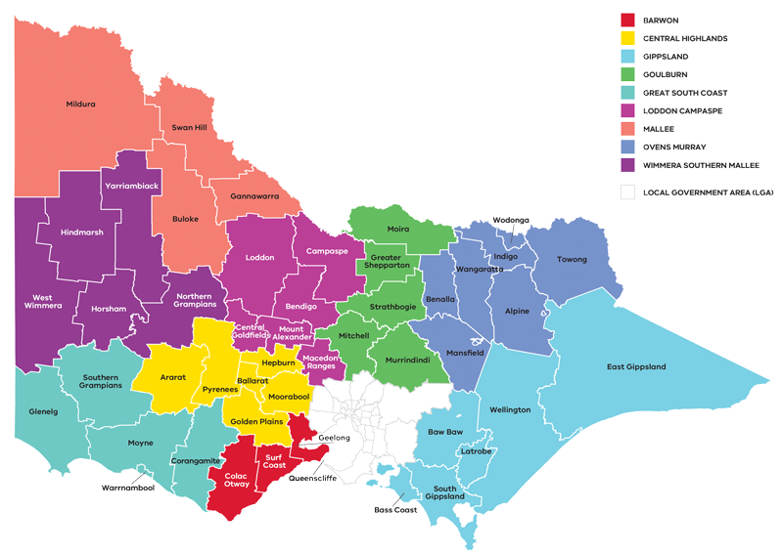

Figure 1: Map of Regional Partnerships – Long Alternate Text

Contents

Preface 1

How have the REDS been developed? 2

How can I use the REDS? 2

01 Introduction 4

Regional readiness to activate strategic directions 6

Local priorities and strategies 6

02 Regional profile 7

Employment by industry 9

Output by industry 10

Regional exports 11

03 Comparative advantage 11

3.1 Endowments 12

3.2 Revealed industry specialisation 13

Loddon Campaspe’s strategic directions 17

Enabling factors for economic growth 17

Integrating Aboriginal economic opportunities 19

4.1 Support growth in agriculture and food product manufacturing to enhance value adding throughout the supply chain 20

4.2 Pursue diversification of the tourism sector by leveraging natural, cultural, and built endowments 24

4.3 Maximise gains in the ‘employment and innovation corridor’ to attract professional services workers and entrepreneurial activity 28

4.4 Foster better links between education providers, industry, research, employers and students to develop career pathways and a workforce that meets the future needs of the region 31

4.5 Leverage local opportunities to strengthen value chains and diversify into new industries, including in mining, renewable energy and waste processing 35

05 Implementation 38

RRV will use the REDS to coordinate investments and activities in place 39

Local stakeholders, industry leaders and government service providers can use the REDS to advocate for shared outcomes 39

RRV will monitor the implementation of the REDS 40

Contact us 40

Appendix 41

Figure 1: Map of Regional Partnerships – Long Alternate Text 41

Figure 2 Map of Loddon Campaspe – Long Alternate Text 41

Figure 3 Loddon Campaspe industry Employment (2001-20) – Long Alternate Text 42

Figure 4 Loddon Campaspe industry output (gross value add) – Long Alternate Text 44

Figure 5 Loddon Campaspe industry employment location quotient and growth – Long Alternate Text 46

Figure 6 Loddon Campaspe industry output (GVA) location quotient and growth – Long Alternate Text 47

Figure 7 Agricultural land use in Loddon Campaspe – Long Alternate Text 48

Figure 8 Loddon Campaspe visitor expenditure by visitor type (2015-2020) – Long Alternate Text 48

Figure 9 Loddon Campaspe visitor numbers by visitor type (2015-2020) – Long Alternate Text 48

# 01 Introduction

The *Loddon Campaspe Regional Economic Development Strategy* (the Loddon Campaspe REDS) sets out the medium- to long-term strategic directions for driving economic growth and development across the region.

The Loddon Campaspe Regional Partnership region is at the heart of Victoria, encompassing the local government areas of Campaspe, Central Goldfields, Greater Bendigo, Loddon, Macedon Ranges and Mount Alexander. The region has been home to the Dja Dja Wurrung, Yorta Yorta, Taungurung and Wurundjeri people who have lived, worked and cared for their people and resources for many thousands of years.

Stretching from Melbourne’s north-west peri-urban region to the to the banks of the Murray River, the Loddon Campaspe region has a diverse economy centred around the City of Bendigo, which is one of Victoria’s largest and fastest growing regional cities. The region has strengths in agriculture, mining, food processing and tourism based on its local endowments, including the region’s strategic location, road and rail network, fertile environment, abundance of natural parks, Aboriginal heritage and mineral resources.

**Strategic directions**

The Loddon Campaspe REDS defines five strategic directions for economic development in the region, based on comprehensive data analysis and review of existing policies and strategies:

1. Support growth in **agriculture and food product manufacturing** to enhance value adding throughout the supply chain
2. Pursue diversification of the **tourism sector** by leveraging natural, cultural, and built endowments
3. Maximise gains in the **‘employment and innovation corridor’** to attract professional services workers and entrepreneurial activity
4. Foster better links between education providers, industry, research, employers and students to develop **career pathways** and a **workforce** that meets the future needs of the region
5. Leverage local opportunities to **strengthen value chains** and **diversify into new industries**, including in mining, renewable energy and waste processing.

For each of the directions, the REDS provides:

* a rationale for its inclusion as part of the strategy
* an overview of opportunities and challenges which are likely to support or hinder future growth

a summary of work underway and the policy context to support desired outcomes

* the implication of the direction for the region’s Aboriginal communities

examples of how the direction could be activated.

The Loddon Campaspe REDS recognises that approaches to regional economic development occur in an uncertain environment. While most of the analysis focuses on internal development drivers, it also considers the impact of, and opportunities emerging due to external trends, including the COVID-19 pandemic, patterns in global trade, a changing climate and technological change.

The Loddon Campaspe REDS acknowledges that the Aboriginal and cross-border communities within Loddon Campaspe face unique challenges and opportunities, which are also reflected in the strategic directions.

## Regional readiness to activate strategic directions

There is strong evidence of innovation or innovative capacity in the Loddon Campaspe Regional Partnership region, particularly in the City of Greater Bendigo and along the employment and innovation corridor running from Gisborne through to Echuca-Moama.

The region is home to the Bendigo Kangan Institute (with campuses in Bendigo, Castlemaine and Echuca) and La Trobe University Bendigo, and also has a local presence from Deakin, Melbourne, Monash and RMIT universities. The region also benefits from several collaborative industry groups, including the:

* Bendigo Manufacturing Group representing 25 member companies that works with education providers and local government to develop career pathways and regional development outcomes in the manufacturing sector.
* METS Export Hub designed for regional Victorian companies to develop and grow mining export markets.
* Northern Poultry Cluster that supports collaboration among members related to system upgrades, waste management, planning, stockfeed and value adding.
* Daylesford Macedon Tourism, Bendigo Regional Tourism and Murray Regional Tourism peak bodies, that coordinate development of the tourism industry and support local operators.

Goulburn Murray Resilience Taskforce, a community driven taskforce that includes Loddon Campaspe Regional Partnership members and which aims to embed resilience strategies in governance structures and processes and act as custodian of the *Goulburn Murray Resilience Strategy.*

## Local priorities and strategies

The *2019 Loddon Campaspe Economic Growth Strategy* is the most contemporary body of work that has informed the REDS economic narrative and strategic directions.

The *Loddon Campaspe Economic Growth Strategy* is a strategic document developed by the Loddon Mallee Regional Development Australia committee in collaboration with the Loddon Campaspe Regional Partnership and community. It outlines the strategy for the Loddon Campaspe region to invest in skills, build capability and leverage current and future capital infrastructure through a package of targeted investments.

The Loddon Campaspe REDS also takes into consideration other State, regional and sub-regional policies and strategies as set out in the supporting documentation.

**Figure 2: Map of Loddon Campaspe**

Figure 2 Map of Loddon Campaspe – Long Alternate Text

# 02 Regional profile

|  |  |
| --- | --- |
| $11.7 | Gross regional product (billion) (2020) |
| 249,200 | Population (2020) |
| 13.4% | Population growth (2011-20) |
| 42 | Median age (2020) |
| 61.1% | Working age (15-64) (2020) |
| 20.0% | Population aged over 65 (2020) |
| 1.6% | Are Aboriginal and/or Torres Strait Islander (2016) |
| 4.4% | Speak a language other than English at home (2016) |
| 9.8% | Were born overseas (2016) |

| Local Government Area | Population[1] (2020) | Projected growth[2] (2021-36) |
| --- | --- | --- |
| Greater Bendigo | 119,000 | 25.8% |
| Macedon Ranges | 50,000 | 24.7% |
| Campaspe Shire | 36,500 | 3.5% |
| Mount Alexander | 20,000 | 9.0% |
| Central Goldfields | 13,000 | 5.7% |
| Loddon | 7,500 | -2.2% |

Loddon Campaspe’s population grew by 13.4 per cent between 2011 and 2020, outpacing the average rate of growth across regional Victoria. Much of this growth has been driven by Bendigo, the region’s capital and the third largest city in regional Victoria, and the Macedon Ranges, a peri-urban region with close proximity to Melbourne. While the region’s total population is projected to continue increasing, this growth will not be evenly distributed across the region, with higher growth rates expected in Bendigo and in the southern shires (reflecting proximity to metropolitan Melbourne’s employment and education centres).

The cultural diversity of the Loddon Campaspe population has been increasing over recent years, although the percentage of residents born overseas or speaking another language at home remains lower than the regional Victorian average. The region’s Aboriginal population accounts for 1.6 per cent of the total, with higher proportions in some LGAs. Young people (aged 15–24) are migrating out of Loddon Campaspe LGAs at higher rates than regional averages, except for the Greater Bendigo LGA.

|  | Loddon Campaspe  % | Regional average  % | Metro Melbourne  % |
| --- | --- | --- | --- |
| Unemployment rate[3] (September 2021) | 4.1 | 4.2 | 6.0 |
| Labour force participation rate[4] (2016) | 61.0 | 60.9 | 65.8 |
| Average annual employment growth[5] (2011–20) | 1.3 | 1.0 | 2.1 |

## Employment by industry

The labour force participation rate in Loddon Campaspe (61.0 per cent) is in line with the regional average (60.9 per cent), but significantly below that of metropolitan Melbourne (65.8 per cent). The early-career population (aged 25-34) and women have particularly low participation rates.

The regional unemployment rate has been relatively volatile over the past decade, and recently increased from 4.1 per cent in the March 2020 quarter (prior to the COVID-19 pandemic) to 5.2 per cent in 2021. The unemployment rate is higher in certain areas, including Central Goldfields (10.9 per cent), and amongst certain cohorts, including Aboriginal communities (16.5 per cent).

Employment growth in Loddon Campaspe over the last decade has been slower than regional Victoria and metropolitan Melbourne. It has largely been driven by job creation in the health care and social assistance sector, consistent with trends across Victoria and reflecting the ageing population in the region.

**Figure 3: Loddon Campaspe industry employment (2001-20)**

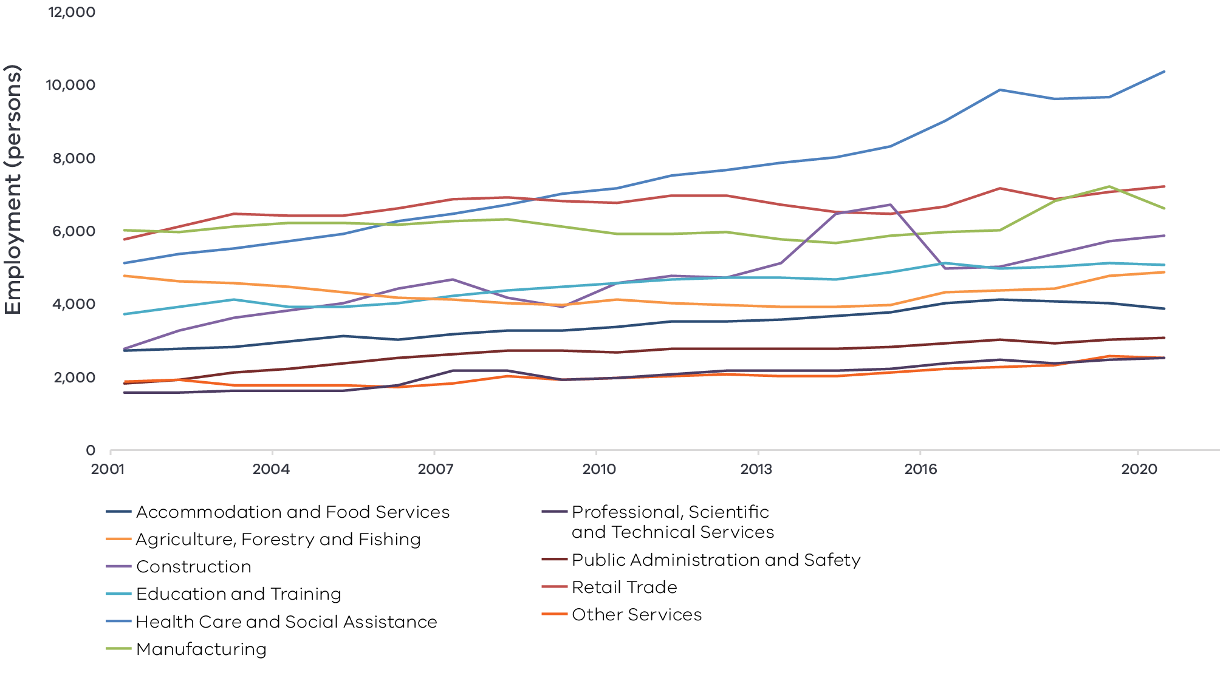

Figure 3 Loddon Campaspe industry Employment (2001-20) – Long Alternate Text

Source: National Institute of Economic and Industry Research, 2020

Note: Top 10 employing industries in 2020 presented in chart, based on Journey to Work employment estimates

**Table 1: Employment in largest employing industries by workers (2020) and gender (2016)**

|  | Workers | Male | Female |
| --- | --- | --- | --- |
| Healthcare and social assistance | 17,300 | 18.9% | 81.2% |
| Retail trade | 12,000 | 41.9% | 58.1% |
| Manufacturing | 11,000 | 72.1% | 27.9% |
| Construction | 9,800 | 89.6% | 10.4% |
| Education and training | 8,500 | 28.1% | 71.9% |

Source: National Institute of Economic and Industry Research, 2020 and ABS Census, 2016

The labour force participation rate in Loddon Campaspe (61.0 per cent) is slightly higher than the regional Victorian average. The female participation rate (57.1 per cent) is lower than for males (61.3 per cent). The largest employing sectors for women are health care and social assistance, education and training, retail trade and accommodation and food services.

## Output by industry

Industry output has grown most rapidly in population-driven sectors such as health care and social assistance, construction, and education and training. The traditional industries of manufacturing and agriculture, forestry and fishing have declined in output since 2001. Manufacturing has rebounded over the past five years but agriculture, forestry and fishing has continued to decline to almost half the output of 2001. Financial and insurance services are the second largest contributor to regional output. This reflects the position of Bendigo as the headquarters of Bendigo and Adelaide Bank, one of Australia’s largest banks. Output growth has been uneven across the region, with growth largely occurring in Greater Bendigo, the Macedon Ranges and Mount Alexander. The Campaspe, Loddon and Central Goldfields areas have experienced declines in output since 2001.

### $9.2 billion Gross Value Added (GVA) (2020)

**Top sectors by GVA:**

|  |  |  |
| --- | --- | --- |
|  | Health care and social assistance: | $1,298.5 |
|  | Financial and insurance services: | $979.9 |
|  | Manufacturing: | $974.8 |
|  | Construction: | $920.4 |
|  | Education and training: | $656.6 |

**Figure 4: Loddon Campaspe Industry Output (Gross Value Add) (2001-20)**

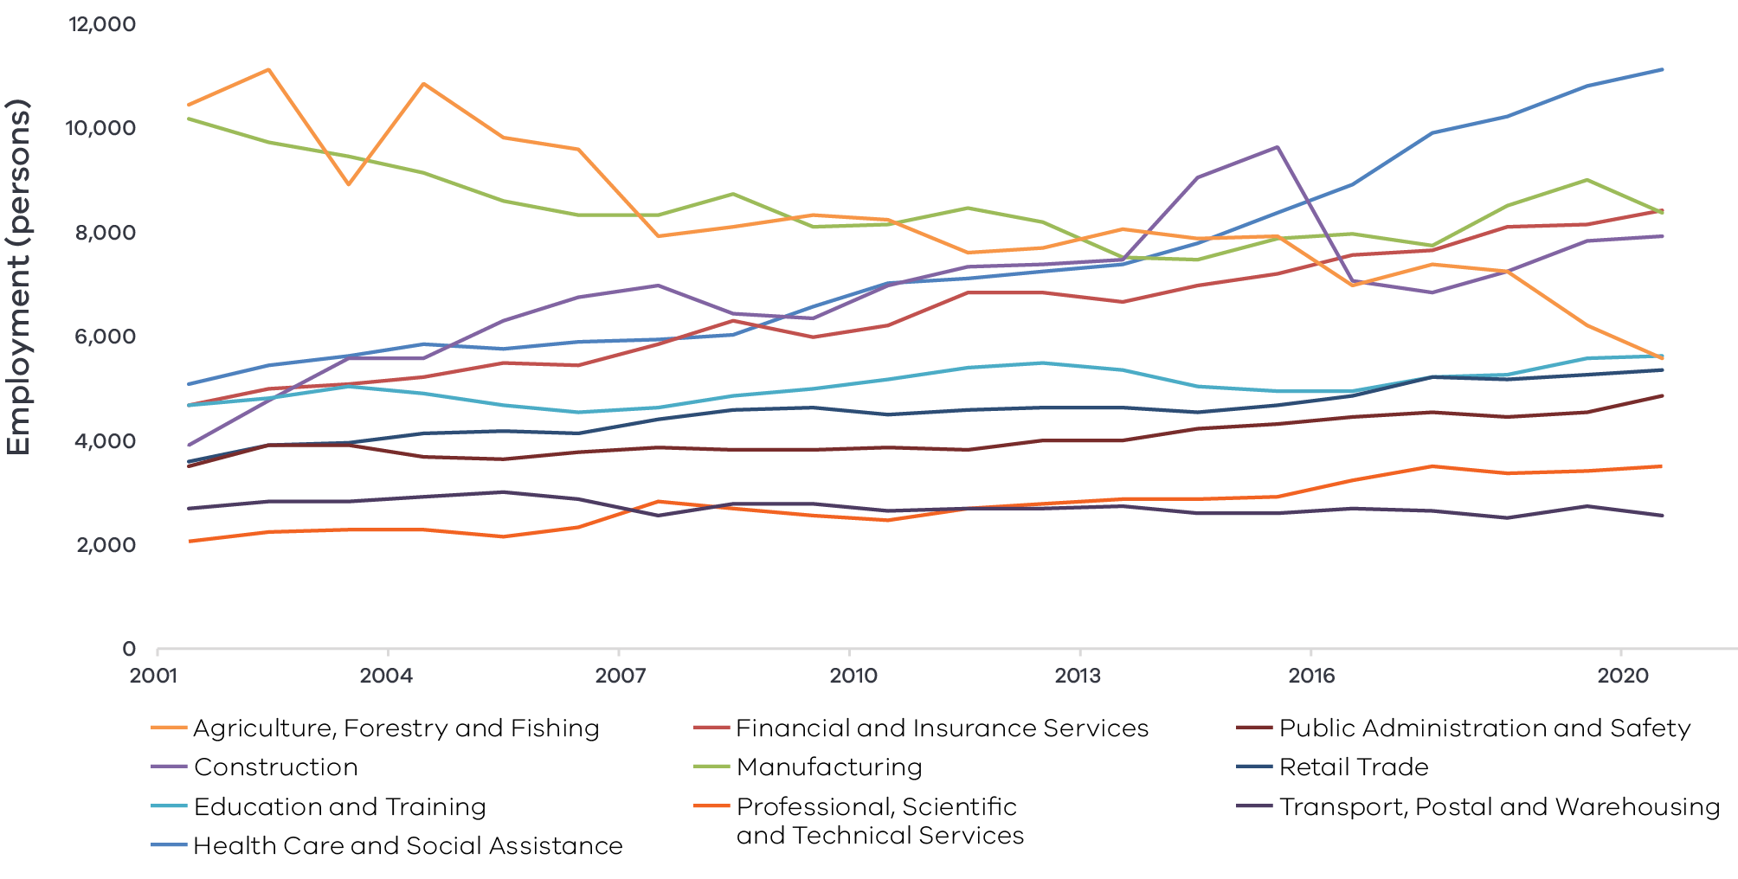

Figure 4 Loddon Campaspe industry output (gross value add) – Long Alternate Text

Source: National Institute of Economic and Industry Research, 2020

## Regional exports

Strong road networks and key arterial links to Melbourne and Geelong support the regions export sector totalling $1.56 billion. In 2020 top exports were:

1. Manufacturing: $812.9 million
   * 1. Food product manufacturing: $590.5 million
     2. Primary metal and metal product manufacturing: $65.3 million
     3. Machinery and equipment manufacturing: $33.5 million
2. Agriculture, forestry and fishing: $330.7 million
3. Accommodation and food services: $90.9 million
4. Wholesale trade: $65.5 million
5. Education and training: $56.3 million

# 03 Comparative advantage

For the purposes of the REDS, ‘comparative advantage’ is defined simply as a description of what the region does well compared to other regions. This includes both the relative competitiveness of the region’s businesses as well as cultural, social and environmental factors.

Contemporary place-based development emphasises the importance of local endowments as a driver of comparative advantage. In economic terms, endowments refer to any natural, human, cultural and built resources present in a place which can be harnessed to support economic activity. Regional economic strengths can also be identified using other measures including location quotient analysis, shift share analysis and industry cluster analysis.

A comprehensive assessment of these measures is included in the Loddon Campaspe Regional Economic Development Strategy – Supporting Analysis.

## 3.1 Endowments

### Natural endowments

#### Fertile land and water access

The region has fertile land that is suited to a variety of agriculture uses, including horticulture, dairy, cropping, and sheep and beef grazing. The region has three major river catchments (Loddon, Campaspe and Avoca) as well as extensive irrigation infrastructure, including in the Goulburn Murray Irrigation District.

#### Mineral resources

Loddon Campaspe is a historic gold region and is home to the state’s largest gold mine (Fosterville). Gold mining activities still occur in the region and the mining industry is expected to be a large contributor to the region’s economy with the announcement of new exploration licenses and growth opportunities in associated mining, engineering and technical services (METS) industries.

#### Environmental assets

Across the region, there are five National Parks and a further six State and Regional Parks. In addition, the region is home to the iconic Hanging Rock, a significant tourist attraction. Along the northern border is the Murray River which provides unique environmental, social, cultural and economic value to the region.

### Cultural endowments

#### Aboriginal sites and heritage

The region is home to the Dja Dja Wurrung, Wurundjeri, Yorta Yorta and Taungurung Traditional Owners, as well as the Barapa Barapa people. There are several heritage sites across the region which hold economic, social, environmental, and spiritual value. The Dhelkunya Dja Land Management Board, a Traditional Owner Land Management Board of the Dja Dja Wurrung, manages four parks through Joint Management Plans: Greater Bendigo National Park, the Paddys Ranges State Forest, Kooyoora State Park and Wehla Natura Conservation Reserve.

#### Goldmining heritage

As a historic gold region, Loddon Campaspe is home to several significant gold rush era sites such as Castlemaine Diggings National Heritage Park, Bendigo Mining Exchange, Maldon historic streetscape and Hotel Shamrock among many others throughout the region.

#### Cultural attractions

Loddon Campaspe is home to key cultural attractions including the Bendigo Art Gallery, drawing high visitation numbers for its high-profile exhibits, and the Ulumbarra Theatre, a redeveloped gaol hosting major national and international performing artists and touring companies. There are also several townships such as Castlemaine and Kyneton that boast historic streetscapes, galleries, music halls, and thriving arts, food, beverage and entertainment scenes that draw visitors from across the region. The region was awarded UNESCO Creative Cities designation as a “City and Region of Gastronomy” in 2019.

### Built endowments

#### Transport connections

The region is well connected to domestic markets via an extensive road and rail network, including two major rail corridors and seven highway connections – most notably the Calder Freeway, Midland Highway, Bendigo and Maryborough Rail Lines. This network also ensures access to international markets via key seaports and airports. Bendigo Airport, which hosts inter-state flights including a Bendigo-Sydney route, is the main airport with other aerodromes located across the region.

#### Tertiary education institutions

La Trobe University has a campus in Bendigo, and other universities (Monash, Deakin, Melbourne and RMIT) also have a presence in the region. The principal vocational training organisation is Bendigo Kangan Institute, which has campuses in Bendigo, Castlemaine and Echuca. It hosts the Food and Fibre Centre of Excellence, which offers training in food and fibre production, animal care management, plants and landscapes, primary food processing, environment and national resource management, and other related applied sciences.

### Human endowments

#### Innovative culture

The region has a culture of innovation, centred around the growth corridor between metropolitan Melbourne and Greater Bendigo. Increased interactions and relationships between industries, professionals, local businesses and institutions are supported by tertiary education attainment rates that are 2 per cent higher than regional Victoria averages. A thriving skilled workforce has outstripped regional Victorian growth averages in the five years to 2019. New business growth over the past five years has been largely concentrated in the Bendigo and Macedon Ranges areas.

## 3.2 Revealed industry specialisation

Location Quotient (LQ) analysis provides further insight into the local economy’s underlying structure and comparative advantages that may not be evident from a region’s endowments. This form of analysis compares an industry’s size and growth (as measured by employment and output) as a proportion of total economic activity relative to the Victorian average. The higher the LQ, the more concentrated, and therefore significant, an industry is to the local economy relative to Victoria on average. Scores above 1.25 indicate specialisation compared to the rest of the State.

Further analysis is provided in the Loddon Campaspe Regional Economic Development Strategy – Supporting Analysis.

### Employment specialisation

**Mining:** This sector employs a relatively small number of people but is Loddon Campaspe’s strongest employment concentration (coal mining has been excluded as the region has not mined coal since 2016). Compared to the Victorian average, mining employs 4.1 times as many people in Loddon Campaspe (as a proportion of the total workforce) and employment growth is occurring 28.1 percentage points faster. The industry is driven by metal ore mining, which proportionally employs 9.1 times as many people compared to the Victorian average and 3.5 times as many compared to the regional Victorian average.

**Agriculture:** With an LQ of 3.3, the agriculture sub-industry is a strong regional concentration. Employment in agriculture is growing 13.9 percentage points faster compared to the Victorian average. However, when compared to the regional Victorian average, Loddon Campaspe does not have a significant employment concentration in agriculture – this reflects the industry’s broad importance across rural and regional areas.

**Food product manufacturing:** With an LQ of 2.9, Loddon Campaspe has a regional employment concentration in food product manufacturing. Employment food product manufacturing is growing 7.9 percentage points faster compared to the Victorian average, which suggests the region is likely to increase its comparative advantage in this sub-industry. When compared with regional Victoria, Loddon Campaspe maintains its food product manufacturing concentration (employing 1.6 times as many people as the regional Victorian average). Combined with employment concentration in the agriculture sector, this indicates the particular importance and strength of the broader food industry in Loddon Campaspe, even by regional standards.

Figure 5 also reveals that, while the education and training and construction sectors are significant employers (see Figure 3), employment growth is slower than the Victorian average. Their growth is occurring within a context of widespread industry growth.

**Figure 5: Loddon Campaspe industry employment location quotient and growth**

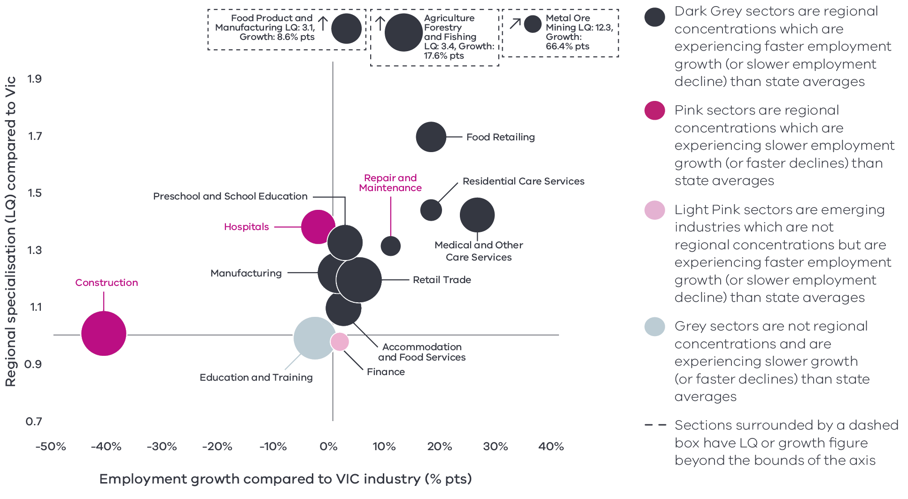

Figure 5 Loddon Campaspe industry employment location quotient and growth – Long Alternate Text

Source: National Institute of Economic and Industry Research, 2020

Note: This chart represents a selection of industries and sub-industries that represent a notable size and or concentration within the region. Some sub-industries presented are sub-sectors of industries that are presented alongside it and therefore measures cannot be aggregated between the two. Other industries are not displayed. For greater detail refer to the supporting analysis pack for this REDS strategy.

**Figure 5** depicts selected industries and sub-industries in the regional economy where:

* The size of each bubble indicates the number of people employed in the (sub)industry in 2020. The bigger the bubble, the more people employed in the industry.

The vertical position indicates the (sub)industry’s degree of employment concentration relative to the Victorian average. For example, a value of 1.77 means that, as a share of total employment in the local economy, the (sub)industry employs 1.77 times as many people as the Victorian average.

The horizontal position indicates the difference in (sub)industry’s employment growth (2015 to 2020) between the region and the Victorian average. For example, a 14 per cent value indicates that regional employment in the (sub)industry has grown 14 percentage points faster than the industry’s average growth rate in Victoria.

### Output specialisation

**Figure 6** identifies the region’s economic output specialisation in terms of Gross Value Added (GVA). Using the same approach as Figure 5, this analysis compares selected industries and sub-industries in the regional economy, including their size and growth as a proportion of total economic GVA relative to Victorian averages.

**Figure 6: Loddon Campaspe industry output (GVA) location quotient and growth**

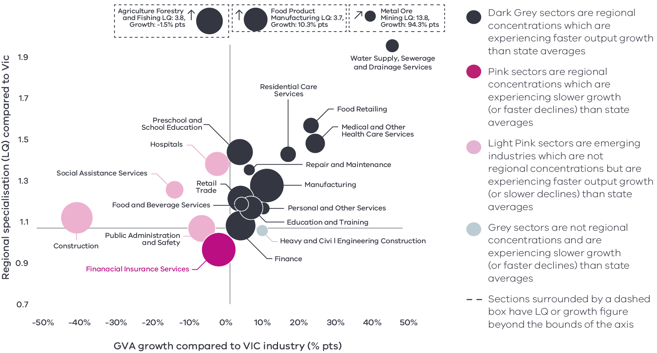

Figure 6 Loddon Campaspe industry output (GVA) location quotient and growth – Long Alternate Text

Source: National Institute of Economic and Industry Research, 2020

Note: this chart represents a selection of industries and sub-industries that represent a notable size and or concentration within the region. Some sub-industries presented are sub-sectors of industries that are presented alongside it and therefore measures cannot be aggregated between the two. Other industries are not displayed. For greater detail refer to the supporting analysis pack for this REDS strategy.

Consistent with employment concentrations, Figure 6 shows how output in Loddon Campaspe is strongly concentrated in agriculture, food product manufacturing and metal ore mining. Output in the food product manufacturing and metal ore mining is also growing faster than Victorian averages (by 10.5 percentage points and 94.3 percentage points respectively). In the case of agriculture, the sub-industry’s GVA is declining at a faster rate than the industry across the state and regional Victoria. This trend reflects the disproportionate impact of dry seasonal conditions throughout 2017-19 on the region relative to other parts of Victoria.

### Emerging areas of specialisation

While not yet concentrations, there are sub-sectors that show employment and output growth rates above the Victorian average which indicate they may become comparative advantages in the future. Food and beverage services as well as personal services are showing these signs of growth. Finance is the other sub-sector that is not yet a concentration but is experiencing above average growth. The legacy of the Bendigo and Adelaide Bank paired with internal migration from Melbourne could be a platform for a larger regional finance industry to grow.

**04 Strategic directions**

The five strategic directions for the Loddon Campaspe REDS have been identified based on the opportunities emerging from the region’s endowments, industry specialisations and socioeconomic context. The directions have been refined based on a review of local policies and strategic planning.

The following section discusses each strategic direction, providing:

* a rationale for its inclusion as part of the strategy
* an overview of opportunities and challenges which are likely to support or hinder future growth
* a summary of work underway and the policy context to support desired outcomes
* the implication of the direction for the region’s Aboriginal communities

examples of how the direction could be activated.

## Loddon Campaspe’s strategic directions

1. Support growth in agriculture and food product manufacturing to enhance value adding throughout the supply chain
2. Pursue diversification of the tourism sector by leveraging natural, cultural, and built endowments
3. Maximise gains in the ‘employment and innovation corridor’ to attract professional services workers and entrepreneurial activity
4. Foster better links between education providers, industry, research, employers and students to develop career pathways and a workforce that meets the future needs of the region
5. Leverage local opportunities to strengthen value chains and diversify into new industries, including in mining, renewable energy and waste processing.

## Enabling factors for economic growth

This REDS identifies opportunities in key areas that can help drive regional economic growth. However, each region’s capacity to activate these opportunities and grow is partly determined by cross-cutting enabling factors that support economic activity. Consideration of these enabling factors–and targeted investments and initiatives to strengthen them – will help support achievement of the strategic directions in this REDS.

|  |  |
| --- | --- |
| **Digital connectivity**  Access to reliable internet and mobile services allows for access to new markets, facilitates efficiency gains and opens opportunities for innovation. Good digital connectivity can also facilitate more inclusive access to services and flexible working arrangements. | 58 to 71 – Australian Digital Inclusion  Index Score in Loddon Campaspe in 2021[6]  (Victorian average: 71) |
| **Transport connectivity**  Road and rail infrastructure, ports and airports provide critical linkages between production locations and markets; efficient transport connections and public transport services are a key factor in workforce mobility and local amenity. | 4.3 – Overall access to roads, public transport in the Loddon Mallee RDA region[7]  (Regional Victoria: 4.1 and Victoria: 5) |
| **Workforce and population growth**  An adaptive and productive workforce is key to businesses competitiveness; access to both skilled and unskilled labour ensures business can sustain and expand activities. | 62.3% – Local workforce in Loddon Campaspe was employed in skilled occupations in 2021[8]  (Regional Victoria: 62.2%, Melbourne: 67.3%)  19% – Residents with a bachelor’s degree or higher in 2016[9]  (Regional Victorian: 17.0 %, Melbourne: 31.0%) |
| **Housing**  The availability and affordability of housing determines a region’s ability to attract and retain local staff and supports community cohesion and better life outcomes for individuals and families. | 0.7% – Average rental property vacancy rate in the 6 months leading up to June 2021[10]  (Compared to benchmark of 2.5%)  29.6% – Increase in median rent in Loddon Mallee RDA region from 2016 to 2020[11]  (Victoria, 6.9%, Regional Victoria 28.6%) |

Notes: 1. The Australian Digital Inclusion Index (ADII) is a composite index used to measure digital inclusion across three dimensions of Access, Affordability and Digital Ability. 2. ‘Access to roads and public transport was measured by asking respondents to rate their access to the following types of services in their local community, on a scale ranging from ‘very poor’ (1) to ‘very good’ (7): (i) Quality of local roads; and (ii) Access to public transport (including taxis, buses, and trains). A single measure of overall access to roads and public transport was then constructed based on the average score of a person’s responses to these two items. 3. Skill level is defined as a function of the range and complexity of the set of tasks performed in a particular occupation. Skilled workers are defined as being classed between an ANZSCO Skill level of 1-3, while low skilled is classed as 4 or 5. 4. A rental property vacancy rate of 2.5% refers to a benchmark at which the market is balanced between landlords and tenants.

## Integrating Aboriginal economic opportunities

The Victorian Government is taking concrete steps to align with Aboriginal self-determination principles. Key Victorian Government policies and processes to realise self-determination goals include the:

* Treaty Process which seeks to redefine the relationships between Aboriginal communities, the state and non-Aboriginal Victorians
* Victorian Aboriginal Affairs Framework 2018-23 (VAAF) which is the overarching framework for working with Aboriginal Victorians to drive positive socioeconomic outcomes across the state, including to activate economic opportunities and prosperity via achieving wealth equality, facilitating workforce participation in all sectors at all levels and realising Aboriginal income potential.

Self Determination Reform Framework, which guides public sector action to enable self-determination in line with the VAAF across four domains: people, systems, outcomes and accountability

The Victorian Government is also party to the National Agreement on Closing the Gap and has committed to meeting the associated outcomes – including in relation to increasing engagement of Aboriginal and Torres Strait Islanders in employment, education and training.

An analysis of relevant policies and commitments relating to Aboriginal economic development in the region (listed in the *Loddon Campaspe Regional Economic Development Strategy – Supporting Analysis*), including Traditional Owner strategic plans, where developed, has identified five potential opportunities for Aboriginal economic development:

* Identify opportunities to better **leverage natural resources for economic benefit**. This includes the scope to adopt traditional agricultural techniques and practices such as seed collection, carbon farming, kangaroo culling and apiculture.
* Pursue **greater Aboriginal responsibility as it relates to resource management**. This includes working through Joint Management Plans, and providing services including revegetation, fire management and pest control.
* Promote recognition of the land, its water and its cultural significance to **ensure that economic activities generate benefits in a way where degradation is avoided** and existing damage is healed.
* Encourage the **use of cultural places and practices** as a mechanism for telling stories, maintaining traditions, and creating economic opportunities, particularly in tourism.

Support **Aboriginal economic independence**, including through seed funding to enable enterprise development and an expanded asset base.

Each strategic direction in the Loddon Campaspe REDS considers the relevance of that direction to local Aboriginal communities in light of the above opportunities.

Self-determined priorities for Aboriginal economic development in the region will be aligned to the six pillars of the Victorian Aboriginal Employment and Economic Strategy. These priorities will also guide Victorian Government decision-making on economic development in the region and will be integrated into future updates of the REDS.

## 4.1 Support growth in agriculture and food product manufacturing to enhance value adding throughout the supply chain

### Significance

Representing 11.0 per cent of Victoria’s agricultural land, Loddon Campaspe’s ‘food industry’ is one of the region’s most important sectors. Across farming, processing, transporting and food service sectors, the industry contributes $6.8 billion in output and directly employs 20,500 people. This equates to 24.5 per cent of total regional output and 23.6 per cent of total employment. Significant agricultural commodities include dairy cattle, beef, sheep and pig meat, grains (maize, oats, barley), wool and poultry. Bendigo is home to the Food and Fibre Centre of Excellence, with significant food processing occurring throughout the region, and specifically along the employment and innovation corridor and in centres such as Castlemaine, Bendigo, Maryborough and Echuca.

It is a regional priority to strengthen the food industry supply chain, potentially through further diversification, value-adding and improving logistics activities within the region. The region has offset declines in employment and GVA outcomes in the traditional sectors of agriculture and manufacturing with job creation and innovation across the food product development, transport and hospitality sub-sectors. The region’s endowments, including its fertile land and access to domestic and export markets, support continued specialisation and development. Additional leverage from the designation of the region as a “City and Region of Gastronomy” is also evident, with more land being made available across the region for activities aligned to food manufacturing and processing strengths.

In maintaining its competitive edge, the region will continue to adopt new technologies and innovative practices to adapt to a changing climate and ever evolving domestic and global markets. Innovation in the industry is supported by research on smart farms and projects such as the ‘Internet of Things’ trials in Loddon Shire, investigating issues from the network level through to end-user devices and on farm machinery.

**Loddon Campaspe’s farms produce[12]**

* 11.1% of Victoria’s dairy
* 13.4% of Victoria’s sheep meat

7.4% of Victoria’s beef

**Figure 7: Agricultural Land Use in Loddon Campaspe**

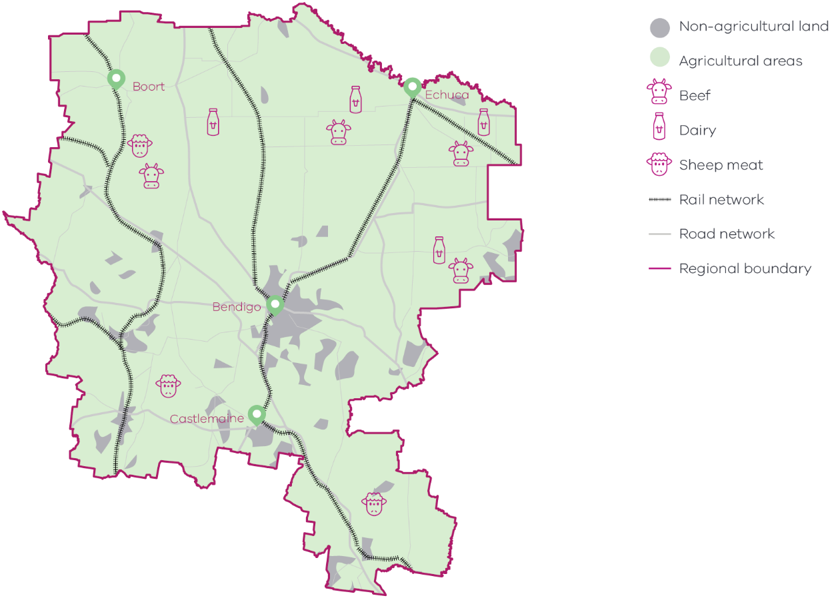

Figure 7 Agricultural land use in Loddon Campaspe – Long Alternate Text

Source: Agriculture Victoria, 2018, Loddon Campaspe; Invest in Victorian agriculture and food

### Opportunities

#### Strengthening the local supply chain and land availability

The food industry supply chains across the region are closely integrated with strong links between rural production, local manufacturing, wholesaling, and food service particularly in the meat and beverage industries. Despite these connections, there is still a large amount of raw product imported into the region and greater opportunities for efficiencies in product and process. Maximising food processing and industrial land availability in the region will be critical in attracting businesses and building local supply chain capability. Capturing greater value in the local supply chain will be a key growth pillar for the regions food industry to compete in the global environment.

#### Advanced capabilities

New technologies and globalisation are shaping the future of agriculture and food product manufacturing. Encouraging advanced capabilities contributes to regional productivity gains and provides the opportunity for agricultural technology careers to attract and retain the skilled workforce. For agriculture, the incorporation of information and communication technologies into farm equipment, and sensors into agricultural production systems can reduce the burden for accessing seasonal workforces. For food product manufacturing, embracing advanced capabilities allows for the greater personalisation of goods to meet demand and enhance the ability to implement origin and traceability systems.

#### Consumer preferences and product differentiation

Global consumer trends are increasingly preferencing healthy foods with a smaller environmental footprint, traceable supply chains and reliable safety standards. With its abundance of fertile agricultural land, Loddon Campaspe is well placed to meet demands for free range production, low use of chemicals, humane processing, heightened food safety, and greater consumption of plant-based foods. Meeting changing consumer preferences also offers the chance for producers to differentiate their product. Currently, many local medium-scale supply chains are focused on lower value, undifferentiated products. Adopting new technologies for production and processing practices could result in greater control of the local brand and increase the proportion of high value produce while strengthening the region’s reputation as a leading gastronomy destination.

### Challenges

#### Increasing competition

Local agricultural producers face increasing competition in global markets from lower cost producers, including Argentina and South Africa. The introduction of tariffs on certain agricultural products by some trading partners has added additional complexity to the international trading environment and highlighted the need for more diversity in trading partners.

#### Climate change

Climate variability and the need to reduce carbon emissions are key drivers of change for the food industry. Water availability, water quality, production yields and output quality will be influenced by changing climate conditions and high impact events. Support will be needed to strengthen food industry and supply chain resilience to a changing climate, which may include efforts to diversify water sources.

**By 2050s[13]**

* Average maximum temperatures could increase by 2.4°C
* Decline in average spring rainfall by 22%
* More than double the amount of extreme heat days in Bendigo (38°C) (10.1 days)

Increase in the median number of fire danger days in Bendigo (62%)

#### Land use and availability

Expansion of Melbourne’s urban fringe at the region’s southern border has the potential to intensify competing demands for land between agriculture and residential or industrial uses. Management of land for farming, including protecting productive agricultural land, is a key regional issue. The role of land use planning, particularly as it relates to land availability, remains an important policy consideration for the sector as it can impact confidence on future investment prospects.

### The policy environment

Strengthening the agriculture and food product manufacturing sectors in Loddon Campaspe is closely aligned with national, state and local priorities. In particular:

The Australian Government’s *Make it Happen – The Australian Government’s Modern Manufacturing Strategy* and the Victorian Government’s *Food and Fibre Sector Strategy* both highlight that food and beverage manufacturing is a priority industry.

The Victorian Government’s *Stronger, innovative, sustainable: A new strategy for agriculture in Victoria* focuses on themes of recovery, growth, modernisation, protection and promotion in the agriculture industry.

The *Loddon Campaspe Economic Growth Strategy 2019* identifies the food industry as a regional focal investment and articulates a preferred economic future where strong links between research and the manufacturing and agriculture sectors produce world class exports for the highly competitive household food produce markets of Asia and the Middle East.

The *Goulburn Murray Resilience Strategy* identifies ‘futures of agriculture’ as one of five interventions to build the ability of the agriculture sector to address climate change and other future challenges.

### Aboriginal inclusion

This strategic direction aligns with the Aboriginal economic opportunity to better leverage natural resources for economic benefit. Aboriginal organisations such as the Dja Dja Wurrung Aboriginal Clans Corporation actively aspire to build expertise and influence in food and fibre and participate in wildlife management and biodiversity protection. Aboriginal-led initiatives, such as the Corporation’s *Djakitjuk Djanga* program, will continue to be important to increase Aboriginal representation in the agriculture and food processing sectors.

### How can we unlock this strategic direction?

To unlock this opportunity and drive growth, local, State and Commonwealth partners could work together to:

Better understand opportunities and investment for supply chain improvement, including input replacement, product diversification, and where additional value be identified for key primary outputs.

Improve awareness of new and emerging opportunities associated with changing consumer preferences, and new technologies that allow for greater automation and rapidly responsive decision-making across the entire food value chain.

Engage the public and private sectors to unlock future opportunities and take advantage of existing funding and incentives to support local food product development and manufacturing and new and emerging agricultural enterprises.

Ensure local producers are engaged in conversations about climate change adaptation and mitigation practices in the agriculture and manufacturing sectors.

Support research and development that strengthens the capacity of the agriculture and food manufacturing sectors to adapt to rapidly changing conditions, including climate change, market trends, and opportunities arising from technological advances.

Advocate for market access opportunities and strengthen biosecurity, food safety capabilities and traceability across supply chains.

Foster partnerships with Traditional Owners to support the development of an authentic native foods and botanicals industry building off the existing *Djakitjuk Djanga* program.

Encourage effective utilisation of the available surface and ground water to maximise the value of production from this limited resource.

## 4.2 Pursue diversification of the tourism sector by leveraging natural, cultural, and built endowments

### Significance

Regional tourism generated $1.3 billion in visitor expenditure in Loddon Campaspe between March 2019 and March 2020, from 7.4 million visitor trips. This supports a range of industries including accommodation and food services, arts and recreation, and retail trade. Loddon Campaspe has architecturally significant buildings and landscapes that were at the heart of Victoria’s gold rush, as well as key attractions including Hanging Rock, Bendigo Art Gallery, riverside activities, and other popular environmental and Aboriginal sites. Loddon Campaspe is well-placed to establish itself as a premier food and wine destination, based on the mature wine and cider industry with strong global brand recognition and a growing number of niche and artisanal enterprises.

The region benefits from a diverse array of smaller scale, but genuinely unique experiences that further strengthen its comparative advantages. These include the widely recognised cultural communities of Mount Alexander, the Macedon Ranges peri-urban fringe, the goldfields history of Bendigo and the Central Goldfields and the wide-open spaces and river communities of the Loddon and Campaspe. This diversity, along with the region’s central location in the state, provides a significant opportunity for diversification that the region can continue to build upon.

### Opportunities

#### Cultural tourism

The City of Greater Bendigo and City of Ballarat are currently leading a campaign on behalf of 13 councils across the Goldfields region to inscribe significant gold rush-era sites on the World Heritage list. The sites put forward as part of the campaign include mines, architecturally significant buildings and natural landscapes. Within the Loddon Campaspe region, this includes the Castlemaine Diggings National Heritage Park, Bendigo Mining Exchange, Maryborough Train Station, Maldon and historic street scapes and Hotel Shamrock Bendigo. Maintaining the condition of heritage buildings is also important to ensure that these cultural assets continue to attract visitors into the future. The region is also positioned to leverage opportunities from its Aboriginal cultural heritage. Aboriginal tourism presents an opportunity for the community to share their culture, heritage and stories whilst boosting economic outcomes. In addition to its gold mining and Aboriginal heritage, the region also has a unique connection between the historical townships and creative industries which is showcased by the numerous art galleries and events held across the year. Regional events play an essential role in driving visitation and provide opportunities to reinforce regional brand identity. Pursuing cultural tourism development opportunities in the region has the potential to increase international and interstate visitation and length of stay in the region.

#### City of Gastronomy

In 2019, Bendigo and the region became the first Australian location to be admitted to the UNESCO Creative Cities Network as a creative city of gastronomy. Collaboration across the food and tourism industries can strengthen the epicurean tourism pillar in Loddon Campaspe. Bendigo City’s application to the Network focused on the ways creative, food, hospitality, agriculture and an Aboriginal food system are shaping the future of the Bendigo and surrounding regions. Bendigo City will focus on celebrating and prioritising Aboriginal culture and knowledge, local creativity and innovation, health and wellbeing outcomes, and sustainable agriculture and food production.

#### Changing visitation trends

In the year leading up to the COVID-19 pandemic, 72.2 per cent of visitors to the region were domestic day-trippers. With international border closures limiting options in favour of domestic travel, there is a short- to medium-term opportunity to influence tourist preferences and habits in favour of longer trips. This trend is already evident, as while total visitor numbers to the region were substantially lower in 2020 than 2019, the average visitor spend has increased in part due to increases in the average length of stay. Direct flights between Bendigo and Sydney provides an interstate gateway to explore the region while there are opportunities for rail connections to support more visitors to experience the region.

**Figure 8: Loddon Campaspe visitor expenditure by visitor type (2015-20)**

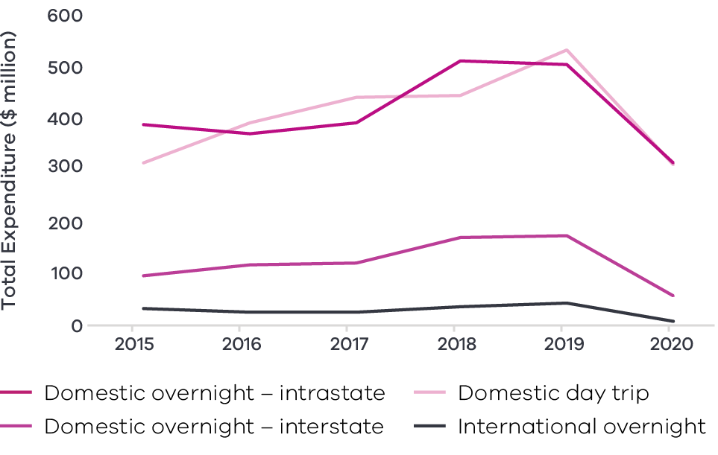

Figure 8 Loddon Campaspe visitor expenditure by visitor type (2015-2020) – Long Alternate Text

**Figure 9: Loddon Campaspe visitor numbers by visitor type (2015-20)**

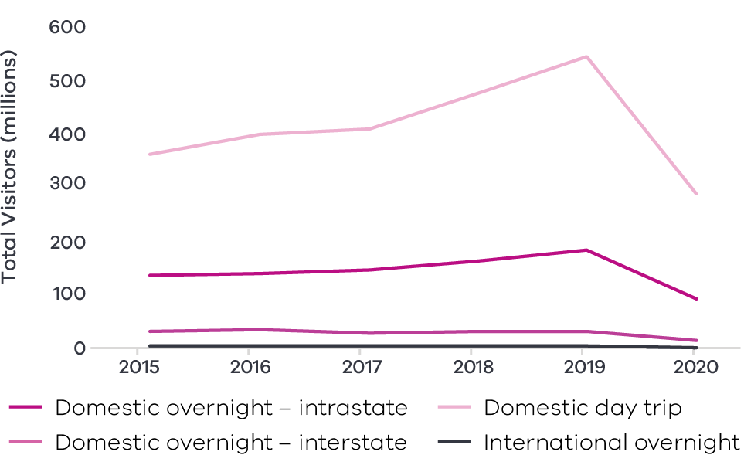

Figure 9 Loddon Campaspe visitor numbers by visitor type (2015-2020) – Long Alternate Text

Source: Tourism Research Australia research data, as reported by DJPR – Tourism, Events and the Visitor Economy Research 2021

#### Cross-border community of interest

This connected cross-border community offers opportunities to attract complementary businesses on both sides of the border and additional capacity to link to key experiences along the Murray River corridor and adjacent regions.

### Challenges

#### Social harmony

Increased tourist numbers can be met with resistance from the local community if demands on services and infrastructure are poorly managed and there is an associated impact on local amenity, heritage and environment.

#### Digital accessibility and capability

Visitors are increasingly relying on digital platforms to experience and access tourism opportunities and information. Tourism operators will need to invest in and adapt to new technologies to remain competitive. Fixed access broadband has an intermediate or major supply shortfall throughout the region, affecting 19 of the 22 towns or localities assessed for the Loddon Campaspe digital plan.

### The policy environment

Diversifying the tourism sector in Loddon Campaspe is in line with state and local priorities:

* The Victorian Government’s *Visitor Economy Recovery and Reform Plan* (2021) aims to attract more tourists to the State, support regional jobs and deliver a significant recovery from the combined effects of the 2020 summer bushfires and the COVID-19 pandemic. This includes delivering a state-wide destination master plan underpinned by priority sector plans (the first sector priorities to be developed will be the *Nature-Based Tourism Plan* and the *First Peoples’ Tourism Plan*) and the establishment of Visitor Economy Partnerships across Victoria.

The *Loddon Campaspe Economic Growth Strategy* focuses on opportunities in nature and food and artisan tourism development, in addition to traditional strengths in heritage tourism.

### Aboriginal inclusion

This strategic direction strongly aligns with the aspiration to use cultural places and practices to share Aboriginal heritage while boosting economic outcomes. One in five Aboriginal workers (19.2 per cent) are employed in industries which support tourism in Loddon Campaspe (accommodation and food services, arts and recreation, and retail trade). Further growth in the tourism sector is therefore likely to provide significant opportunities for Aboriginal employment, but should also recognise the importance of traditional lands, waters and the environment.

### How can we unlock this strategic direction?

To unlock this opportunity and drive growth, local, State and Commonwealth partners could work together to:

* Recognise and meet the challenge of balancing conservation of the region’s natural environment with aligned and integrated tourism investment and development.
* Invest in the development and activation of tourism attractions that build on the existing cultural and natural heritage of the region, acknowledging the challenge of maintaining historic sites and heritage buildings and the need to streamline approval processes.
* Foster partnerships between industry and training providers to develop career pathways in tourism and hospitality dependent sectors.
* Build the international and domestic brand of the region utilising the City of Gastronomy and the potential Central Victorian Goldfields World Heritage listing, alongside the region’s existing strengths in arts and culture.
* Take advantage of existing incentives and funding in place to support tourism providers to pursue digital innovation and improve capability across the share economy and digital marketing platforms.
* Support Traditional Owner groups to develop and promote regional Victorian Aboriginal tourism offerings and support Aboriginal tourism businesses.
* Build partnerships and collaboration across the region to identify future opportunities and build social license for the tourism industry to address community concerns.

Continue to improve and advocate for transport connectivity improvements including additional regular passenger flights to and from the region.

## 4.3 Maximise gains in the ‘employment and innovation corridor’ to attract professional services workers and entrepreneurial activity

### Significance

The corridor from Gisborne on the peri-urban outskirts of metropolitan Melbourne, along the Calder Freeway, through Bendigo to Echuca-Moama on the New South Wales border is attracting interest from new residents and businesses. Between 2011 and 2020, the region’s population growth was largely concentrated in the Greater Bendigo area as an employment and training hub and Mount Alexander and the Macedon Ranges, which is the gateway to the employment and innovation corridor from metropolitan Melbourne. In the five years to 2020, nearly 4,700 new businesses opened in the Loddon Campaspe region, primarily clustered in the Macedon Ranges and Greater Bendigo. Of these, 22 per cent were in the Construction sector, 11 per cent in Agriculture, Forestry and Fishing, and a further 11 per cent in the Professional, Scientific and Technical Services sectors.

The regional employment and innovation corridor sustains a solid base of enabling infrastructure to support ongoing investment. This includes the presence of three universities, a state-of-the-art hospital, major financial institution, substantial high-value manufacturing and a bourgeoning start-up culture.

Connectivity is critical to the future success of the region. The employment and innovation corridor sits at a pivotal location with a unique set of attributes to explore significant growth, new investment opportunities, and emerging value capture initiatives. Additional consideration of how to integrate and connect the employment and innovation corridor with areas to its east and west also needs to be examined, particularly in the Macedon Ranges and Central Goldfields.

### Opportunities

#### Encourage collaboration

Growing regional entrepreneurism requires an environment where enterprises and innovators can come together to collaborate and connect with partners across industries. Local stakeholders have been establishing start-up and co-share environments across the whole region to create spaces for local businesses and social enterprises to start, cultivate ideas, collaborate and grow. Supporting these collaborative environments to thrive through developing networks or expanding in size could enable further growth of the regions innovative culture.

#### Population movement

Spurred by the widespread shift to working from home among professional services industries due to the COVID-19 pandemic, there has been significant movement of people from major cities to regional Victoria. High-amenity locations such as the Macedon Ranges, Mount Alexander, and regional cities such as Greater Bendigo and Echuca-Moama, have been preferred destinations. These were already projected to be strong population growth areas, with Greater Bendigo projected to be the third largest regional population growth centre in Victoria.

#### Finance hub

The region demonstrates and employment specialisation in financial and insurance services relative to regional Victoria. Beyond simply attracting people who work from home for Melbourne-based organisations, Loddon Campaspe is uniquely positioned to offer opportunities which attract financial services workers to support local organisations.

### Challenges

#### Access to suitable housing

Improving housing stock quality and quantity is a key mechanism to attract skilled workers. As the region becomes a popular destination for domestic migrants, the housing market may face increased rents and decreasing housing stock (particularly for affordable housing) if growth in new dwellings does not match new demand. These trends would disproportionately impact low-income households who face relatively higher living costs and are more at risk of being priced out of towns.

#### Intra-regional transport

Greater Bendigo is an employment and commuter hub, receiving an influx of workers from across Loddon Campaspe and other areas of Victoria. However, public transport mobility across the region is substantially lower than the state as a whole – in all municipalities apart from Greater Bendigo, less than half the residents have access to public transport.[14] Equitable access to transport systems is essential for worker mobility and to ensure residents of all ages and abilities can access the employment and innovation corridor from across the region.

#### Digital connectivity

Poor digital connectivity continues to be a challenge across Loddon Campaspe, in rural areas and in some urban settings. There are 312 registered mobile black spots in the region, the second highest for a Victorian Regional Partnership area. Improving access to fast and reliable phone and internet services is crucial for existing businesses to innovate and expand as well as attracting further businesses to the region.

### The policy environment

Maximising gains in the ‘employment and innovation corridor’ is in line with State and local priorities. In particular:

* The *Loddon Campaspe Economic Growth Strategy* focuses on opportunities in the employment and innovation corridor between Gisborne and the Macedon Ranges through Bendigo and north to Echuca-Moama and surrounds. The opportunities build upon the region’s creativity, innovation, sustainability, and liveability and leverage the population growth and associated significant public investment.
* The Victorian Government is developing a new GovHub in central Bendigo to create jobs, boost the local economy and revitalise the northern end of the city. The Bendigo GovHub will centralise the delivery of a range of government services and accommodate up to 1000 local and State Government workers.
* The Victorian Government is making significant rail investments under the *Regional Network Development Plan* to improve service quality and capacity along the corridor. There will be:
* A train every 20 minutes at peak times between Melbourne and Bendigo
* Five services every weekday between Melbourne and Echuca.

### Aboriginal inclusion

Only 5.7 per cent of the region’s Aboriginal workforce are employed in the professional services industries which characterise the region’s innovation corridor (professional, scientific, and technical services, information media and telecommunications, and financial and insurance services). However, pursuit of this strategic direction aligns with the opportunity to support Aboriginal economic independence through enterprise development. To ensure Aboriginal communities can capitalise on this strategic direction, capacity building activities may need to occur to equip the community with core entrepreneurial skills.

### How can we unlock this strategic direction?

To unlock this opportunity and drive growth local, State and Commonwealth partners could work together to:

* Create opportunities to grow research and development efforts and capability within the region, specifically targeting innovation that supports the region’s main industry sectors: food and fibre; manufacturing; mining; supporting Aboriginal economic opportunity and models of rural and digital health.
* Identify the dynamic ecosystem of businesses, academics, ambitious startups, community groups, and not for profits, along the employment and innovation corridor to enable crosspollination of ideas and practise to accelerate success.
* Unlock digital potential in the region utilising existing fibre optic networks to provide ultrafast broadband speeds to business within the corridor.
* Examine the relationship between connectivity (transport and digital) and increase the frequency of transport services (air, road, and rail) operating within the corridor to promote improved commuting within the region.
* Investigate eastwest connections with the employment and innovation corridor for towns and subregions, particularly in the Macedon Ranges and Central Goldfields.
* Maintain the liveability of the innovation corridor through service delivery and preserving the built and natural environment (including investigating opportunities to streamline planning).
* Better coordinate housing and infrastructure developments to support current and future industry development and encourage residents to stay, live, and work in the region.
* Provide improved support and expand networks for entrepreneurs and emerging businesses especially aligned to digital health, agriculture and food processing, mining (gold exploration and development) and mining, engineering and technical services (METS) sector, advanced manufacturing, and new aboriginal entrepreneurial opportunities.

Better position the region to attract large and small scale investment for business growth and infrastructure.

## 4.4 Foster better links between education providers, industry, research, employers and students to develop career pathways and a workforce that meets the future needs of the region

### Significance

Ensuring employers can find labour with appropriate skills and competencies is a key enabler of future growth and development. Achieving this goal requires connection and alignment across the whole jobs ecosystem (education providers, industry, research, employers, and students) to provide the right pathways and opportunities that match the demand for skills and labour.

While Loddon Campaspe currently has a relatively low unemployment rate, employment growth over the past decade has been sluggish compared to that of metropolitan Melbourne and the regional Victoria average. The percentage of skilled workers has been slightly below the average across regional Victoria, with 60.4 per cent of the region’s workforce in skilled occupations. Health care and social assistance and education and training, two top employing industries, have seen the highest average growth in employment and are the sectors where the skilled workforce has seen significant growth.

Like other regions, inefficiencies in the labour market have emerged and pose a threat to realising potential growth. In 2019, 45 per cent of employers in the Loddon Campaspe region had difficulty (or faced risks) filling vacancies. This proportion was 7 percentage points higher than in 2018 and is particularly prevalent among vacancies requiring at least a Certificate Level III or IV qualification. Furthermore, economic and employment growth across the region masks distributional differences across Loddon Campaspe’s diverse population cohorts, including females, young people, Aboriginal people, and those living with a disability.

### Opportunities

#### New workplace practices

Traditionally, one of the reasons regional employers face challenges attracting and retaining talent is because the (prospective) employee’s partner faces challenges sourcing a job of their own. The shift in workplace practices, specifically the widespread move among professional workers to working from home, enhances worker mobility across the State, particularly in the case of Loddon Campaspe where high-amenity locations and a large regional city make the region a popular option for ‘tree-changers’.

#### Regional coordination

Better coordination and collaboration between education providers is essential to harnessing the region’s potential. The region’s largest vocational training organisation: Bendigo Kangan Institute, has campuses in Echuca, Bendigo, and Castlemaine, ensuring that it is well-placed to understand unique regional needs. La Trobe University has a large presence across the region which continues to expand across Northern Victoria and initiatives from key institutions, including Deakin University’s collaboration with Bendigo Kangan Institute and the Bendigo Manufacturing Group, and space-sharing between La Trobe University and Bendigo Tech School, ensure courses are fit for purpose and there are appropriate pathways for students.

#### Inclusive employment

Encouraging and supporting businesses to provide employment opportunities for population cohorts that have lower participation rates provides a place-based avenue for addressing skill shortages. This can also encourage a more diverse and inclusive workforce where inequality is reduced, and economic benefits are better shared across the region. Ensuring work practices, policies and strategies are inclusive will be critical to ensuring that inclusive employment generates long term and lasting benefits. Work integration and services such as Jobs Victoria will also be an important part of connecting people who experience disadvantage to employment opportunities.

**Table 2: Labour force participation in Loddon Campaspe**

|  |  |  |  |  |  |  |
| --- | --- | --- | --- | --- | --- | --- |
|  | Aboriginal | Non- Aboriginal | Females | Males | Living with a disability | Not living with a disability |
| Unemployment | 16.5% | 5.6% | 5.5% | 6.0% | 14.5% | 5.6% |
| Participation | 52.6% | 61.3% | 57.1% | 65.2% | 10.6% | 65.1% |
| Low income (less than $650 per week) | 61.3% | 49.8% | 58.5% | 41.2% | 85.6% | 47.4% |

Source: ABS, 2016

#### Growing health care and social assistance sector

The health care and social assistance sector is the most important employing sector in Loddon Campaspe, and is expanding in response to population growth and an ageing population. The Bendigo Hospital Project is the largest regional hospital development in Victoria and has strong connections with training providers. The sector offers significant potential for local employment opportunities. The Loddon Campaspe region is advocating for a ‘Grow Our Own’ place-based workforce model which focuses on attracting, developing, supporting and retaining local people to create a sustainable pipeline of workers for the region’s health industry.

### Challenges

#### Youth participation

In Loddon Campaspe, 11.4 per cent of young people (aged 15 to 24 years old) are not in employment, education or training, which is higher than state and regional averages. Relative to state averages, fewer students complete high school and fewer progress to tertiary study and training. High disengagement creates challenges for the region to meet future workforce needs.

#### Tight labour market

At a regional level, there is not significant spare capacity in the labour market. Loddon Campaspe has a 61.0 per cent participation rate and 3.6 per cent unemployment rate, both marginally outperforming regional Victoria averages. This suggests that the region cannot simply rely on the existing workforce to fill job vacancies. Strategies to attract new residents and increase engagement among key cohorts such as women, youth and Aboriginal people will be critical to securing the workforce of the future.

#### Migration uncertainty

In 2018-19, every municipality relied on a net inflow of international arrivals to fill skill requirements. International migrants are a significant contributor towards regional population growth. With international borders closed due to the COVID-19 pandemic and the uncertain ongoing impact on skilled worker attraction, regional growth and development could be stymied.

### The policy environment

The Loddon Campaspe *Health Sector Skills and Pathways Road Map 2021* outlines focus areas to address the health sector’s skill pathway challenges and opportunities which focus on collaboration, industry perception, skill shortages and growing a local workforce. There is evidence of the health care sector leveraging training pathways to address skill shortages and ensure a job ready workforce for the future, these include:

* Maryborough District Health Service is working with vocational training organisations to develop tailored training solutions, including the Centre for Inspired Learning which offers a Diploma of Nursing on site.
* Bendigo Health provides clinical placements across 51 weeks of the year to undergraduate students.
* There are agreements between Bendigo TAFE and La Trobe University regarding pathways to convert diplomas and graduate certificates into nursing, dental and health science tertiary qualifications.

The La Trobe Rural Health School’s mission is to improve the recruitment and retention of health professionals in rural Australia.

The Victorian Government has committed to develop a Regional Skills Demand Profile for Loddon Campaspe to better understand local skills shortages, future workforce training needs and identify opportunities for investment. Industry leaders are increasingly collaborating with government and training organisations to develop sector-specific strategies to address labour gaps. These include the Health Sector Skills Roadmap and Regional Engineering and Advanced Manufacturing Skills Road Map.

### Aboriginal inclusion

There is significant workforce capacity in Aboriginal communities: only 51.9 per cent of working age Aboriginal people participate in the labour force, 16.5 per cent of this labour force is unemployed, and 28 per cent of young Aboriginal people are not engaged in employment, education or training. Efforts to better align career pathways and address skills shortages may provide opportunities to increase Aboriginal employment and incomes and support economic independence. This is particularly true for the health care and social assistance sector, where Aboriginal employment participation is higher.

### How can we unlock this strategic direction?

To unlock this opportunity and drive growth, local, State and Commonwealth partners could work together to:

* Ensure that employment, training and workforce planning initiatives are tailored to meet the needs of under-represented cohorts including youth, women, and Aboriginal people.
* Develop a clear and comprehensive understanding of the ‘future of work’ for the region understanding the skill requirements for current and future industries, inclusive of clear coordination, development training, and multiple career pathways.
* Encourage partnerships between industry and education providers to deliver solutions to real-world problems to help develop graduates who are job ready.

Provide more enabling support, including developing childcare facilities in rural areas, potentially co-located with workplaces, to encourage more female participation in the workforce.

## 4.5 Leverage local opportunities to strengthen value chains and diversify into new industries, including in mining, renewable energy and waste processing

### Significance

The Loddon Campaspe region has endowments, including natural resources and local manufacturing capabilities, that can be leveraged to strengthen and diversify the local economy. Mining is the region’s fastest growing major industry, with 34.2 per cent growth in employment and 66.1 per cent growth in output over the past five years. There are mining businesses located in each municipality and Loddon Campaspe is home to Victoria’s most productive gold zone (Bendigo Zone) and largest mine (Fosterville Gold Mine). The recent announcement of new mining exploration licences presents an opportunity to build the region’s value chain add by increasing local capability in mining, engineering and technical services. The long-term nature of gold mining enterprises in the Loddon Campaspe region provides stability and promotes ongoing investment to capture innovation in mining technology and practices, as well as the development of professional and technical service expertise throughout the mining value supply chain, both pre- and post- extraction.

There is also strong support in the region for renewable energy and circular economy initiatives, and the state-wide move towards a net zero emissions economy also offers local opportunities. The Australian Energy Market Operator has identified two renewable energy zones which comprise parts of the Loddon Campaspe region, Murray River and Central North; the region is also proximate to the Western Victoria zone. Solar and wind projects are planned in the Loddon, Campaspe and Central Goldfield Shires, which will complement the region’s existing strength in rooftop solar. Loddon Campaspe has been an early adopter rooftop solar with 24.4 per cent of all homes and businesses in the region have panels installed (as at October 2019), the highest rate across Victoria.

### Opportunities

#### Mining value chains and local innovation

The recent announcement of new mining exploration licences solidifies the long-term importance of mining and mineral resource extraction to the Loddon Campaspe economy. Unlike in other settings, these mining enterprises are embedded in the Loddon Campaspe region, as are staff and associated service providers. This has the potential to facilitate ongoing investment in local innovation, technologies, expertise and capability along the mining value chain.

#### Manufacturing hub

Loddon Campaspe hosts a large and growing advanced manufacturing sector which is already playing an important role producing parts for renewable energy and waste recovery technologies. With local tertiary institutions offering courses which equip students with the required skills to step into the manufacturing field, the region is well placed support the renewable transition and as well as further strengthening of mining value chains.

#### Bioenergy

Home to a significant agriculture sector, Loddon Campaspe is positioned to pursue bioenergy technologies which convert biomass to energy and create useful by-products such as water, biochar, and nutrients. Since biomass can often be stored, and therefore energy generated when required, bioenergy generation is particularly valuable for the region’s many primary producers. It offers an avenue to reduce costs of purchasing gas or electricity from the grid and builds resilience by diversifying income streams. Across the broader Loddon Mallee region, use of all biomass resources is estimated to be able to generate approximately 40 per cent of local electricity consumption. There are a variety of potential biomass resources in Loddon Campaspe, with straw and chaff the most common.

#### Waste recovery

Most recyclables produced within Loddon Campaspe are transported to Melbourne due to the current lack of waste recovery infrastructure, meaning that opportunities to process and reuse recyclables are being lost. A growing population, strong agricultural output, and reduced ability to export waste internationally could be leveraged to unlock the region’s waste and resource recovery potential. Improved processing would not only reduce landfill and improve the circular economy in the region, but importantly, unlock opportunities for future investment, employment and innovation growth.

### Challenges

#### Social licence in mining and associated industries

The mining sector recognises that building social licence, through the adoption of socially and environmentally friendly mining practices and engagement and collaboration with local communities, is critical to success. It is important for the mining sector, which is widely spread across the region, to maintain positive relationships with local communities, including Traditional Owner groups, to continue building social licence and promoting the sustainable and productive development of the mining sector and the growth of associated industries and service providers across the mining value supply chain.

#### Transmission infrastructure

The strength of two of the three major energy transmission lines which run through the region (from Bendigo to Ballarat and Bendigo to Kerang) are rated as ‘very weak’ and the third (from Bendigo to Shepparton) is rated as ‘weak’. As a result, several businesses have turned to microgrids as a preferential means to efficiently access reliable energy. Weak or variable supply leaves businesses which rely on the existing distribution network at risk of declining competitiveness, particularly in more remote locations which are susceptible to outages. Infrastructure deficiencies are particularly important as businesses seek to meet industry’s emissions reductions pledges.

### Work underway and the policy environment

Diversification of the local economy into growing and new industries, including those in mining, mineral resource extraction, renewable energy and waste recovery and their associated value chains is closely aligned with national, state, and local priorities. In particular:

* *Victorian State of discovery: Mineral resources strategy 2018-2023* seeks to grow investment and jobs in Victoria’s mineral sector and outlines areas for priority action associated with social licence, advancing and encouraging mineral exploration, establishing Victoria as a gold mining hub and delivering an efficient regulatory environment
* *Victoria’s Climate Change Strategy* provides a roadmap towards net-zero emissions by 2050. It includes interim targets to reduce emissions and pledges for energy, agriculture, transport, waste, and forestry sectors.
* Victoria’s *Recycling Victoria: A new economy* is the state’s circular economy policy and 10-year action plan to reduce waste and pollution and improve recycling in a way which delivers economic benefit.
* The *Loddon Mallee Renewable Energy Roadmap* provides an overview of the opportunities and obstacles facing the region to build current and future renewable capabilities, including through solar and distributed energy resources.
* The *Loddon Mallee Waste and Resource Recovery Implementation Plan 2016-26* addresses the waste and recovery resources required by the region over the 10-year period.

The Victorian government has a suite of state-wide policies and initiatives to support the State’s energy sector to transition to net-zero emissions, which are available on [**energy.vic.gov.au**](http://www.energy.vic.gov.au/).

### Aboriginal inclusion

Local Aboriginal stakeholders strongly emphasise the importance of sustainably managing resources in a way which protects the natural environment. The Dja Dja Wurrung have led Government-supported renewable energy projects and are currently developing a climate change strategy. The Yorta Yorta Nation Strategic Plan and Taungurung Country Plan also advocate for effective solutions to mitigate the harmful effects of climate change on future generations.

Investment under this strategic direction is likely to create employment opportunities in the construction, mining, manufacturing, energy and waste services and professional, scientific and technical services industries. The Aboriginal workforce is well represented in the construction and manufacturing industries but poorly represented in other relevant sectors. Targeted interventions or measures may be required to ensure Aboriginal people are able to access economic benefits.

### How can we unlock this strategic direction?

To unlock this opportunity and drive growth, local, State and Commonwealth partners could work together to:

* Work with industry, education providers and the local community to identify diversification opportunities in the mining, engineering and technical services industries
* Support the objectives of the *Victorian State of discovery: Mineral resources strategy 2018-2023* by continuing to promote investment in Victoria’s mineral sector and encourage mineral exploration, to establish Victoria as a gold mining hub
* Foster connections between the mining sector and local education and research institutions to develop a better understanding of local opportunities to leverage economic benefits from the mining supply chain
* Improve coordination of existing and prospective investments to maximise the local benefits of renewable energy and waste recovery (circular economy) initiatives
* Be led by local entrepreneurs to explore new economic opportunities and innovative solutions that address local climate challenges and ensure benefits are localised, circular and diffused
* Support coordinated efforts to enable industry to take steps which reduce emissions and waste while maintaining or improving business competitiveness

Promote the use of Traditional Owner cultural practices and ownership of economic activity in mining, professional services, renewable energy and waste recovery.

# 05 Implementation

The Loddon Campaspe REDS outlines the strategic approach of the Rural and Regional Victoria Group (RRV) in the Department of Jobs, Precincts and Regions for focusing its future economic development activities – including through policy, investment, and program delivery – in the region. The REDS is not a prescriptive roadmap for Victorian Government economic development action in Loddon Campaspe.

## RRV will use the REDS to coordinate investments and activities in place

RRV is committed to pursuing the strategic directions through future policy design, investment and program implementation, as well as through collaboration across government and with regional partnerships, to deliver positive economic outcomes for the region. The Loddon Campaspe REDS will provide a central point for coordination for current and future work streams and investments.

RRV recognises that effective planning policy and controls will be a key enabler of inclusive, sustainable economic growth in the Loddon Campaspe region. Victoria’s Regional Growth Plans provide broad direction for land use and development, and enable economic growth by ensuring that infrastructure investment is coordinated, appropriate services are provided, and development meets community expectations. The Regional Development and Planning portfolios will pursue opportunities to ensure that as relevant state-led land use planning strategies, policies and controls are updated, they are aligned with the REDS strategic directions.

In regional cities and peri-urban towns with shortages of zoned land (as identified through the Urban Development Program), Councils should consider asking the Minister for Planning to appoint the Victorian Planning Authority to lead structure planning and rezoning for designated areas.

## Local stakeholders, industry leaders and government service providers can use the REDS to advocate for shared outcomes

The Loddon Campaspe REDS, along with the supporting *Loddon Campaspe Regional Economic Development Strategy – Supporting Analysis* document, provides a starting point for an evidence-based, strategic approach to regional development. This approach is an ongoing process where specific development actions and projects can be proposed and considered in the context of alignment with the REDS.

Regional Development Victoria – Loddon Mallee will remain the main point of contact in the region for facilitating and coordinating regional development outcomes.

The Loddon Campaspe Regional Partnership, which comprises community and business leaders, CEOs of constituent Local Governments, State Government personnel and a representative from Regional Development Australia, will continue to be the main advisory body to the Minister for Regional Development and other government decision-makers on local issues and priorities.

The Loddon Campaspe REDS will provide Jobs Victoria with important context and understanding of local economic priorities and opportunities that will be a critical input into the planning and prioritisation of Jobs Victoria’s work and collaboration activities with our Service Partners. Jobs Victoria assists people looking for work, connects employers with the staff they need, administers wage subsidy programs and supports significant local employment transitions.

## RRV will monitor the implementation of the REDS

The strategic directions in the Loddon Campaspe REDS focus on medium- to long-term drivers of growth and opportunity but will be used immediately to guide investment in the region. Notwithstanding this timeframe, the strategic directions will continue to evolve and progress as actions and investment are made. To ensure ongoing relevance and accuracy, RRV will periodically update and refresh this strategy.

## Contact us

Department of Jobs, Precincts and Regions

Level 31, 121 Exhibition Street, Melbourne, VIC 3000

T: +61 (03) 9651 9999

[djpr.vic.gov.au](https://djpr.vic.gov.au/)

Authorised and published by the Victorian Government.

Department of Jobs, Precincts and Regions  
Level 31, 121 Exhibition Street,   
Melbourne, VIC 3000  
Telephone (03) 9651 9999

March 2022

Unless indicated otherwise, this work is made available under the terms of the Creative Commons Attribution 3.0 Australia Licence. To view a copy of this licence, visit [creativecommons.org/licenses/by/3.0/au](https://creativecommons.org/licenses/by/3.0/au/)

It is a condition of this Creative Commons Attribution 3.0 Licence that you must give credit to the original author who is the State of Victoria.

ISBN 978-1-76090-551-4 (Print)

ISBN 978-1-76090-552-1 (pdf/online/MS word)

# Appendix

## Figure 1: Map of Regional Partnerships – Long Alternate Text

The **Mallee** region is located in northwest Victoria and contains the LGAs of Mildura, Swan Hill, Buloke and Gannawarra.

The **Wimmera Southern Mallee** region is located in western Victoria and contains the LGAs of West Wimmera, Hindmarsh, Yarriambiack, Horsham and Northern Grampians.

The **Great South Coast** region is located in southwest Victoria and contains the LGAs of Glenelg, Southern Grampians, Moyne, Warrnambool and Corangamite.

The **Barwon** region is located to southwest of metropolitan Melbourne and contains the LGAs of Geelong, Queenscliffe, Surf Coast and Colac Otway.

The **Central Highlands** region is to the west of metropolitan Melbourne and contains the LGAs of Ararat, Pyrenees, Golden Plains, Moorabool, Ballarat and Hepburn.

The **Loddon Campaspe** region is northwest of metropolitan Melbourne and contains the LGAs of Macedon Ranges, Mount Alexander, Central Goldfields, Loddon Campaspe and Bendigo.

The **Goulburn** region is north of metropolitan Melbourne and contains the LGAs of Mitchell, Murrindindi, Strathbogie, Greater Shepparton and Moira.

The **Ovens Murray** region is located in the northeast of Victoria and contains the LGA’s of Mansfield, Benalla, Wangaratta, Alpine, Indigo, Towong and Wodonga.

The **Gippsland** region is located in the east of Victoria and contains the LGAs of Bass Coast, South Gippsland, Baw Baw, Latrobe, Wellington and East Gippsland.

Click here to return to document

## Figure 2 Map of Loddon Campaspe – Long Alternate Text

The Loddon Campaspe region is made up of the Loddon, Campaspe, Bendigo, Central Goldfields, Mount Alexander and Macedon Ranges Local Government Areas.

The Loddon Campaspe region has major road and rail connections to Melbourne (South). Rail connects Gisborne, Macedon, Woodend, Kyneton, Castlemaine and Bendigo, Rochester and Echuca with Melbourne. Boort, Inglewood, Dunolly and Maryborough are also connected by a line that runs south and on to the Central Highlands in the region’s west. Several major arterial roads and highways connect towns across the region.

Bendigo has an airport connection, while Kyneton and Maryborough each have an aerodrome.

Click here to return to document

## Figure 3 Loddon Campaspe industry Employment (2001-20) – Long Alternate Text

The largest employing industries in descending order are Health Care and Social Assistance, Retail Trade, Construction, Education and Training, Agriculture, Forestry and Fishing, Accommodation and Food Services, Public Administration and Safety, Other Services and Professional, Scientific and Technical Services.

All of these ten industries have grown in employment since 2001.

|  | Health Care and Social Assistance | Retail Trade | Manufacturing | Construction | Education and Training | Agriculture, Forestry and Fishing | Accommodation and Food Services | Public Administration and Safety | Other Services | Professional, Scientific and Technical Services |
| --- | --- | --- | --- | --- | --- | --- | --- | --- | --- | --- |
| 2001 | 8542 | 9655 | 10053 | 4673 | 6183 | 7944 | 4585 | 3023 | 3105 | 2618 |
| 2002 | 8980 | 10234 | 10004 | 5450 | 6585 | 7739 | 4610 | 3205 | 3185 | 2640 |
| 2003 | 9207 | 10764 | 10246 | 6031 | 6909 | 7594 | 4701 | 3578 | 2945 | 2727 |
| 2004 | 9524 | 10675 | 10398 | 6415 | 6570 | 7424 | 4974 | 3691 | 2944 | 2749 |
| 2005 | 9909 | 10732 | 10344 | 6705 | 6508 | 7254 | 5182 | 3980 | 2928 | 2755 |
| 2006 | 10461 | 11047 | 10325 | 7376 | 6673 | 7004 | 5010 | 4192 | 2919 | 2967 |
| 2007 | 10777 | 11453 | 10494 | 7779 | 7078 | 6897 | 5284 | 4386 | 3065 | 3627 |
| 2008 | 11172 | 11585 | 10538 | 6983 | 7329 | 6709 | 5446 | 4531 | 3378 | 3636 |
| 2009 | 11694 | 11419 | 10209 | 6573 | 7440 | 6663 | 5484 | 4521 | 3188 | 3226 |
| 2010 | 11977 | 11297 | 9860 | 7594 | 7665 | 6873 | 5607 | 4487 | 3271 | 3259 |
| 2011 | 12524 | 11631 | 9907 | 7952 | 7802 | 6699 | 5844 | 4622 | 3359 | 3473 |
| 2012 | 12821 | 11591 | 9975 | 7917 | 7878 | 6608 | 5888 | 4647 | 3434 | 3594 |
| 2013 | 13091 | 11226 | 9670 | 8525 | 7854 | 6524 | 5976 | 4613 | 3421 | 3615 |
| 2014 | 13403 | 10866 | 9497 | 10769 | 7804 | 6579 | 6091 | 4606 | 3394 | 3620 |
| 2015 | 13890 | 10809 | 9831 | 11235 | 8091 | 6631 | 6308 | 4696 | 3510 | 3719 |
| 2016 | 15055 | 11107 | 9978 | 8278 | 8568 | 7206 | 6731 | 4850 | 3752 | 3957 |
| 2017 | 16479 | 11943 | 10039 | 8341 | 8305 | 7326 | 6879 | 5039 | 3789 | 4148 |
| 2018 | 16050 | 11461 | 11375 | 8974 | 8348 | 7373 | 6810 | 4888 | 3916 | 3963 |
| 2019 | 16148 | 11759 | 12069 | 9516 | 8516 | 7931 | 6686 | 5051 | 4291 | 4112 |
| 2020 | 17295 | 12027 | 11006 | 9801 | 8491 | 8170 | 6428 | 5138 | 4246 | 4204 |

Click here to return to document

## Figure 4 Loddon Campaspe industry output (gross value add) – Long Alternate Text

The industries with the largest gross value add in 2020 in descending order are Health Care and Social Assistance Financial and Insurance Services, Manufacturing, Construction, Education and Training, Agriculture, Forestry and Fishing, Retail Trade, Public Administration and Safety, Professional, Scientific and Technical Services and Transport and Postal Warehousing.

The following industries have grown in gross value add since 2001; Health Care and Social Assistance Financial and Insurance Services, Construction, Education and Training, Agriculture, Forestry and Fishing, Retail Trade, Public Administration and Safety, Professional, Scientific and Technical Services and Transport and Postal Warehousing.

The following industry has declined in gross value add since 2001; Manufacturing, Transport and Postal Warehousing.

Simplified Table of data for Figure 4. Data in this table is in ($) millions.

|  | Health Care and Social Assistance | Financial and Insurance Services | Manufacturing | Construction | Education and Training | Agriculture, Forestry and Fishing | Retail Trade | Public Administration and Safety | Professional, Scientific and Technical Services | Transport, Postal and Warehousing |
| --- | --- | --- | --- | --- | --- | --- | --- | --- | --- | --- |
| 2001 | 590 | 543 | 1186 | 455 | 545 | 1216 | 417 | 404 | 237 | 310 |
| 2002 | 631 | 582 | 1131 | 556 | 561 | 1299 | 453 | 456 | 261 | 326 |
| 2003 | 652 | 591 | 1102 | 649 | 585 | 1036 | 458 | 453 | 262 | 326 |
| 2004 | 678 | 607 | 1064 | 650 | 568 | 1263 | 483 | 425 | 265 | 337 |
| 2005 | 672 | 640 | 999 | 734 | 545 | 1146 | 485 | 424 | 250 | 346 |
| 2006 | 688 | 634 | 969 | 786 | 527 | 1119 | 483 | 438 | 268 | 335 |
| 2007 | 689 | 680 | 971 | 812 | 540 | 925 | 513 | 448 | 326 | 294 |
| 2008 | 703 | 733 | 1015 | 750 | 562 | 944 | 532 | 443 | 313 | 320 |
| 2009 | 765 | 694 | 943 | 738 | 582 | 971 | 537 | 445 | 294 | 322 |
| 2010 | 815 | 725 | 951 | 812 | 601 | 961 | 520 | 447 | 283 | 307 |
| 2011 | 828 | 797 | 985 | 852 | 625 | 886 | 534 | 445 | 310 | 312 |
| 2012 | 845 | 795 | 955 | 860 | 641 | 899 | 541 | 466 | 321 | 312 |
| 2013 | 857 | 775 | 876 | 870 | 623 | 938 | 540 | 464 | 331 | 318 |
| 2014 | 908 | 811 | 868 | 1056 | 583 | 919 | 528 | 490 | 331 | 303 |
| 2015 | 975 | 840 | 916 | 1124 | 575 | 925 | 541 | 499 | 336 | 300 |
| 2016 | 1038 | 878 | 925 | 821 | 574 | 811 | 567 | 518 | 377 | 312 |
| 2017 | 1156 | 893 | 903 | 796 | 609 | 862 | 606 | 530 | 406 | 308 |
| 2018 | 1193 | 942 | 990 | 844 | 613 | 845 | 600 | 519 | 393 | 291 |
| 2019 | 1260 | 950 | 1048 | 910 | 649 | 725 | 614 | 526 | 395 | 317 |
| 2020 | 1299 | 980 | 975 | 920 | 657 | 649 | 625 | 567 | 405 | 298 |

Click here to return to document

## Figure 5 Loddon Campaspe industry employment location quotient and growth – Long Alternate Text

The graph is divided into four quadrants.

The first quadrant identifies the industries that are a) experiencing slower employment growth (or faster declines) than state averages and b) have higher levels of employment specialization than state averages

The following industries are in quadrant 1:

* Construction

Hospitals

The second quadrant identifies the industries that are a) experiencing faster employment growth (or slower declines) than state averages and b) have higher levels of employment specialization than state averages.

The following industries are in quadrant 2:

* Agriculture, Forestry and Fishing
* Residential Care Services
* Manufacturing
* Food Product Manufacturing
* Metal Ore Mining
* Food Retailing
* Medical and Other Care Services

Accommodation and Food Services

The third quadrant the industries that are a) experiencing slower employmentgrowth (or faster declines) than state averages and b) have lower levels of employment specialization than state averages.

The following industries are in quadrant 3:

Education and Training

The fourth quadrant identifies industries that are a) experiencing faster employment growth (or slower declines) than state averages an b) have lower levels of employment specialization than state averages.

The following industries are in quadrant 4:

Finance

Click here to return to document

## Figure 6 Loddon Campaspe industry output (GVA) location quotient and growth – Long Alternate Text

The first quadrant identifies the industries that are a) experiencing slower GVA growth (or faster declines) than state averages and b) have higher levels of GVA specialization than state averages.

The following industries are in quadrant 1:

* Construction
* Social Assistance Services
* Hospitals

Public Administration and Safety

The second quadrant identifies the industries that are a) experiencing faster GVA growth (or slower declines) than state averages and b) have higher levels of GVA specialization than state averages.

The following industries are in quadrant 2:

* Agriculture, Forestry and Fishing
* Food Product Manufacturing
* Metal Ore Mining
* Water Supply, Sewerage and Drainage Services
* Medical and Other Health Care Services
* Repair and Maintenance
* Preschool and School Education
* Manufacturing
* Retail Trade
* Food and Beverage Services
* Personal and Other Services
* Education and Training

Finance

The third quadrant the industries that are a) experiencing slower GVA growth (or faster declines) than state averages and b) have lower levels of GVA specialization than state averages.

Financial and Insurance Services are in quadrant three.

The fourth quadrant identifies industries that are a) experiencing faster GVA growth (or slower declines) than state averages an b) have lower levels of GVA specialization than state averages.

The following industries are in quadrant 4:

Heavy and Civil Engineering Construction

Click here to return to document

## Figure 7 Agricultural land use in Loddon Campaspe – Long Alternate Text

The Loddon Campaspe region has several agricultural areas, with the three main activities being dairy cattle, beef cattle and sheep meat farming. Dairy farming and beef cattle farming take place in much of the north and east of the region, including around Echuca and Boort. Sheep meat farming is located primarily towards the southern part of the region closer to Castlemaine, however there is also sheep meat farming around Boort.

Click here to return to document

## Figure 8 Loddon Campaspe visitor expenditure by visitor type (2015-2020) – Long Alternate Text

In terms of total expenditure by visitor type in Loddon Campaspe, Intrastate domestic overnight and Domestic day trips visitors consistently spent the most. This was followed by Domestic interstate visitors and then international overnight visitors. Spending by all visitor types grew between 2015 and 2019 and dropped in 2020.

The data in the following table is in million dollars.

|  | 2015 | 2016 | 2017 | 2018 | 2019 | 2020 |
| --- | --- | --- | --- | --- | --- | --- |
| Domestic daytrip | 308 | 385 | 435 | 438 | 525 | 307 |
| Domestic overnight – Interstate | 95 | 114 | 117 | 164 | 169 | 95 |
| Domestic overnight – Intrastate | 384 | 363 | 384 | 503 | 496 | 384 |
| International overnight | 30 | 23 | 23 | 35 | 40 | 5 |

Click here to return to document

## Figure 9 Loddon Campaspe visitor numbers by visitor type (2015-2020) – Long Alternate Text

In terms of total number of visitors in Loddon Campaspe, the most significant was Domestic day trips. This was followed by Intrastate domestic overnight, then domestic interstate visitors and finally international overnight visitors. Visits by all visitor types grew between 2015 and 2019 and dropped in 2020.

|  | 2015 | 2016 | 2017 | 2018 | 2019 | 2020 |
| --- | --- | --- | --- | --- | --- | --- |
| Domestic daytrip | 3,600 | 3,947 | 4,046 | 4,722 | 5,379 | 2,846 |
| Domestic overnight – Interstate | 306 | 320 | 275 | 299 | 309 | 132 |
| Domestic overnight – Intrastate | 1,341 | 1,362 | 1,431 | 1,603 | 1,810 | 892 |
| International overnight | 31 | 34 | 34 | 47 | 46 | 6 |

Click here to return to document

1. Australian Bureau of Statistics, 2020a
2. Victoria in Future 2019, Department of Environment, Land, Water and Planning. The COVID-19 pandemic has changed Victoria’s population pathway from near-record growth levels to population losses. However, Victoria’s regions appear to have experienced little disruption to growth patterns. Migration from Melbourne to the regions has been at record levels according to the latest ABS data, offsetting most regional losses to overseas or interstate. There remains considerable uncertainty around the distribution of the increased regional migration, and the permanence of this trend, but available evidence points to continuing regional growth. Data from the 2021 Census will be vital in determining the impacts on the strongest migration attractors (eg regional centres and peri-urban areas) versus those regions which may have experienced losses from the temporary migrant workforce. Given current information, the pre-pandemic VIF2019 projections remain fit for purpose for regional planning.
3. National Skills Commission, 2022
4. National Skills Commission, 2022
5. National Institute of Economic and Industry Research, 2020
6. Thomas J. et al., 2021, *Australian Digital Inclusion Index*
7. Regional Wellbeing Survey, 2020
8. Department of Education and Training, 2021
9. ABS Census, 2016
10. RRV analysis, SQM, 2021
11. DHHS rental Report – June Quarter, 2021
12. Agriculture Victoria, 2021 (using Regional Industry Structure and Employment (RISE) model 2021)
13. Department of Environment, Land, Water and Planning, 2019, Loddon Campaspe Climate Projection 2019 (based on ‘high emissions’ scenario where 2050s refers to the period from 2040 to 2059)
14. Infrastructure Victoria, 2019, Loddon Campaspe Regional Profile March 2019