Great South Coast

Regional Economic Development Strategy – Summary

State Government of Victoria

The Great South Coast REDS uses data and evidence to profile the region’s economy and identify key strategic directions to drive economic growth.

Regional Profile

Great South Coast Regional Profile
Population (2020) | 104,200
Population growth (2011-20) | 2.4%
Gross regional product (2020) | $5.8 Billion
Figure 1: Map of Great South Coast
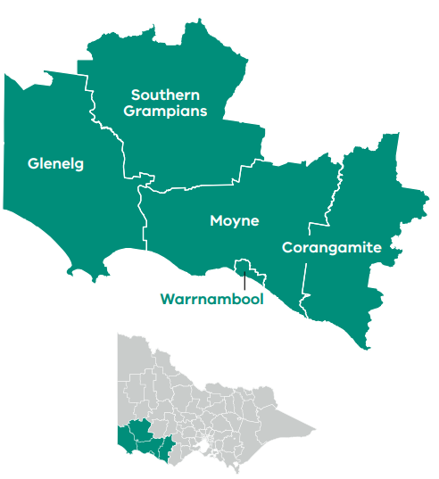

Employment
Unemployment rate (September 2021) | Average annual employment growth (2011–20)
Great South Coast: 3.9%  Regional average: 4.2%  Metropolitan Melbourne: 6.0% | Great South Coast: 0.2%  Regional average: 1.0%  Metropolitan Melbourne: 2.1%

Top employing sectors (2020)
Industry | Workers
Agriculture, forestry and fishing | 10,700
Health care and social assistance | 7,200
Retail trade | 4,800
Manufacturing | 4,600
Education and training | 4,000
Construction | 3,500

Top sectors by gross value add (2020)
Industry | Gross value add
Agriculture, forestry and fishing | $1.2 Billion
Health care and social assistance | $530.4 Million
Manufacturing | $477.0 Million
Construction | $324.4 Million
Education and training | $321.3 Million
Retail Trade | $269.8 Million

Strategic Directions
Great South Coast’s five strategic directions have been identified using an evidence base that considers the region’s unique attributes, existing and emerging industries, and socioeconomic context.

1. Add value to and diversify within the agri-food supply chain
Diversification of the region’s agricultural commodities, investment in advanced manufacturing capabilities and an increase in local value add will ensure the region is adaptive and responsive to new opportunities.

2. Maximise the potential of the region’s energy resources
Growth in wind, solar and bioenergy generation capabilities position the region to harness opportunities to develop renewable hydrogen technology and embed renewable energy sources across the local economy. The region also benefits from new opportunities in natural gas exploration and production.

3. Grow and equip the workforce needed to enable future economic opportunities
Specialised research and skills, harnessing technological change, inclusive employment and stimulating migration will ensure a workforce able to both capitalise on growth opportunities and meet the needs of an ageing population.

4. Expand existing strengths in cultural and nature-based visitation
Investment in agritourism, ‘hero experiences’, natural attractions and Aboriginal heritage such as Budj Bim Cultural Landscape will allow the region to encourage longer stays and take advantage of changing visitation trends towards domestic travel.

5. Capture the greater potential of the ‘Green Triangle’ cross-border economic zone
Improving cross-border collaboration and the flow of goods, services and people will bolster the region’s economic potential. Great South Coast’s existing forestry supply chain positions the region to capitalise on increasing global demand for wood fibre and to grow into a world-leading sustainable forestry hub.
Please refer to the Great South Coast REDS and Supporting Analysis for further detail and sources.
Prepared by the Department of Jobs, Precincts and Regions, May 2022. For more information see: rdv.vic.gov.au.

