Barwon

Regional Economic Development Strategy

State Government of Victoria

Department of Jobs, Precincts and Regions

# Acknowledgement of Country

The Department of Jobs, Precincts and Regions acknowledge the Traditional Owners of the lands and waters on which we live and work, and pay our respects to their Elders past, present and emerging.

We acknowledge that the Barwon Regional Partnership region is on traditional lands, including those lands of the Wadawurrung people and Eastern Maar Nations, as well as other Traditional Owner groups in Victoria who are not formally recognised.

We acknowledge the diversity of Aboriginal Victorians, their communities and cultures, the intrinsic connection to Country, the contribution and interest of Aboriginal people and organisations in developing a prosperous region. This Strategy is committed to advancing the principles of Aboriginal self-determination and supporting communities to realise self-determined economic development objectives.

# Preface

Rural and regional Victoria is home to 1.6 million, or 1 in 4, of Victoria’s residents and over 147,000 businesses. The Victorian Government is committed to making Victoria home to the nation’s most vibrant and successful regional economies.

The Department of Jobs, Precincts and Regions (DJPR) is delivering Regional Economic Development Strategies (REDS) for Victoria’s nine Regional Partnership regions. The REDS contribute to DJPR’s vision for regional Victoria to be a resilient and thriving place to live, work and do business. The REDS provide a consistent socioeconomic evidence base, and strategic framing of medium- to long-term directions to activate economic development opportunities.

**The REDS seek to:**

1. Identify a socioeconomic evidence base for the region, including demographics, business and industry dynamics, and local endowments that can be used by all stakeholders, and will provide a baseline for monitoring future performance.
2. Acknowledge and reveal the depth of work, analysis, and planning already in place in regions and create a mechanism to support and progress established regional directions, where supported by the current evidence base.
3. Harness and enhance the region’s comparative strengths as drivers of growth in the medium- to long-term.
4. Identify opportunities for public and private investment.
5. Influence and inform rural and regional economic policy and program design across government.
6. Support the prosperity and well-being of rural and regional Victoria through increased rural competitiveness and productivity.

The REDS do not replace existing local strategies. Rather, the REDS are informed by local work to identify economic development priorities and provide a platform to increase the visibility of these priorities and support regional communities to advocate for shared outcomes.

## How have the REDS been developed?

The REDS have been developed using a consistent methodology across the state, comprising:

* data analysis to consistently describe each region’s industry composition, economic and socioeconomic trends and existing regional endowments
* policy analysis to identify existing local strategies and plans to understand regional development priorities and shape an economic narrative for the region
* stakeholder engagement to identify opportunities and challenges under each strategic direction.

## How can I use the REDS?

The REDS can be used by all levels of government, regional communities and business to coordinate investment and collaborate for shared outcomes.

DJPR will use the REDS to drive strategic whole-of-government activity in the regions, informed by a contemporary understanding of economic performance and comparative advantage.

Regional communities and businesses can use the REDS to:

* communicate innovative capacity in their region, now and in the future
* collaborate with government to better understand regional strengths, challenges and opportunities
* attract investment to the region based on clearly identified strategic priorities.

The REDS should be read in conjunction with the relevant REDS Supporting Analysis which provides the consistent evidence base for each region.

**Figure 1: Map of Regional Partnership Regions and Constituent LGAs**

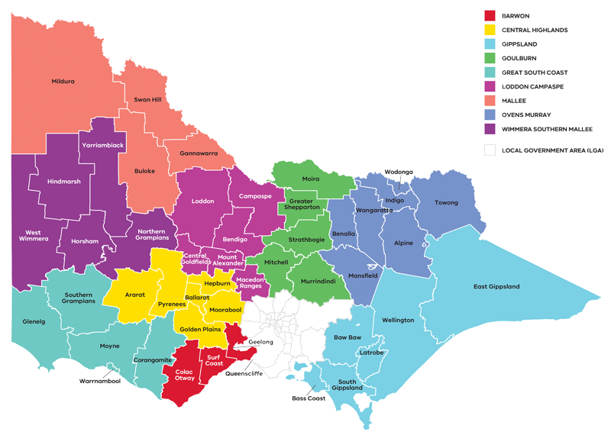

Figure 1: Map of Regional Partnerships – Long Alternate Text

Contents

01 Introduction 5

Strategic directions 5

Regional readiness to activate strategic directions 6

Local priorities and strategies 6

02 Regional profile 7

Employment by industry 9

Output by industry 11

Regional exports 13

03 Comparative advantage 13

3.1 Endowments 13

3.2 Revealed industry specialisation 16

04 Strategic directions 21

Enabling factors for economic growth 21

Integrating Aboriginal economic opportunities 23

4.1 Accelerate the transition to new and high-value manufacturing opportunities 24

4.2 Further the innovation and skills ecosystem 29

4.3 Realise the potential of the visitor economy 31

4.4 Maximise the economic benefit from expanding service-based sectors 37

4.5 Build a sustainable and climate-resilient economy 40

05 Implementation 44

Appendix 47

Figure 1: Map of Regional Partnerships – Long Alternate Text 47

Figure 2 Map of Barwon – Long Alternate Text 47

Figure 3 Barwon industry Employment (2001–20) – Long Alternate Text 48

Figure 4 Barwon industry output (gross value add) 2001-20 – Long Alternate Text 50

Figure 5 Barwon industry employment location quotient and growth – Long Alternate Text 52

Figure 6 Barwon industry output (GVA) location quotient and growth – Long Alternate Text 53

Figure 7 Agricultural land use in Barwon – Long Alternate Text 54

Figure 8 Barwon visitor expenditure by visitor type (2015-2020) – Long Alternate Text 54

Figure 9 Barwon visitor numbers by visitor type (2015-2020) – Long Alternate Text 54

Figure 10 Net internal migration (proportion by age group), annual average (2016–19) 55

Figure 11 How renewable hydrogen is made and used – Long Alternate Text 55

Figure 12 Proportion of households in Barwon with solar installed compared to other regions and states – Long Alternate Text 55

# 01 Introduction

The Barwon Regional Economic Development Strategy (Barwon REDS) lays out the medium- to long-term strategic directions for driving economic growth and development across the region.

The Barwon Regional Partnership region (the region) is situated southwest of Melbourne, encompassing the local government areas of City of Greater Geelong, Surf Coast Shire, Colac Otway Shire and Borough of Queenscliffe. The region is home to Eastern Maar and Wadawurrung peoples, who are the recognised Traditional Owners that have lived, worked and cared for their Country and resources for many thousands of years.

The region spans diverse landscapes from the Great Ocean Road coastline to the streets of Victoria’s biggest regional city, Geelong. The southern border of the region forms part of the iconic south-eastern Australian coastline, extending from Cape Otway to the heads of Port Phillip Bay at Queenscliff. To the west of the region is a strong agricultural community centred around the industrial, commercial and service centre of Colac which is situated on the main highway that connects the region to the western parts of the state. To the north, the region borders the urban fringe of Melbourne with many parts of the region now within commuting distance of the state’s capital. The region’s economic narrative is one of diversity as it has navigated the transition from a traditional manufacturing base to a high-value manufacturing and a service sector-oriented economy.

## Strategic directions

The Barwon REDS explores the region’s unique socioeconomic context through comprehensive data analysis and policy review and defines five strategic directions:

1. Accelerate the transition to new and high-value manufacturing opportunities
2. Further the innovation and skills ecosystem
3. Realise the potential of the visitor economy
4. Maximise the economic benefit from the expanding service-based sectors
5. Build a sustainable and climate-resilient region.

**For each of the directions, the REDS provides:**

* a rationale for its inclusion as part of the strategy
* an overview of opportunities and challenges which are likely to support or hinder future growth
* a summary of work underway and the policy context to support desired outcomes
* the implication of the direction for the region’s Aboriginal communities
* examples of how the direction could be activated.

The Barwon REDS recognises that approaches to regional development occur in an uncertain environment. While most of the analysis focuses on internal development drivers, it also considers the impact of, and opportunities emerging due to external trends, including the COVID-19 pandemic, patterns in global trade, a changing climate and technological change.

The Barwon REDS acknowledges that the Aboriginal communities within the region face unique challenges and opportunities, which are also reflected in the strategic directions.

## Regional readiness to activate strategic directions

Continuous place-based business innovation and collaboration are key to building resilience and activating economic opportunities. The 2017 designation of Geelong as a UNESCO City of Design has raised the international profile of the Geelong region and presents an opportunity for collaboration with the network of other design cities.

Some of the key institutions and projects that contribute to regional innovation include:

* ManuFutures, a purpose-built, advanced manufacturing innovation hub located in Deakin University’s Geelong Future Economy Precinct that is designed as an accelerator to support emerging Australian enterprises.
* The Pivot City Innovation District, located in the northern suburbs of Geelong – a 50,000sqm tech hub that supports over 50 organisations to collaborate and grow their businesses.
* The Advanced Fibre Cluster Geelong, an initiative of a group of highly innovative companies and organisations centred around Deakin University and the Geelong region, accelerating the growth of Australian advanced fibre and composites capabilities.
* Deakin University’s renewable energy microgrid provides education and training opportunities for energy professionals of the future as well as a touchpoint for community learning.

## Local priorities and strategies

The G21 – Geelong Region Alliance, a formal alliance of government, business and the community, is a key economic development organisation for the Barwon region. The G21 Geelong Region Plan – a sustainable growth strategy is the foundation of all G21 activities and projects. The plan looks towards 2050 addressing the challenges and opportunities the G21 region will face in the areas of environment, settlement, land use, community strength and the economy. Companion documents to this plan include the G21 Regional Growth Plan, released in April 2013, and the G21 Economic Development Strategy adopted in 2014.

The Geelong Economic Futures report (2017) is another key strategy for the region that identifies five emerging economic opportunities for the region with strong credentials for attracting large-scale investment and achieving economic growth. All three strategies have been relied upon as key information sources to inform the Barwon REDS.

The Barwon REDS also takes into consideration other state, regional and sub-regional policies and strategies as set out in the supporting documentation, including those developed by the Barwon Regional Partnership.

**Figure 2: Map of Barwon**

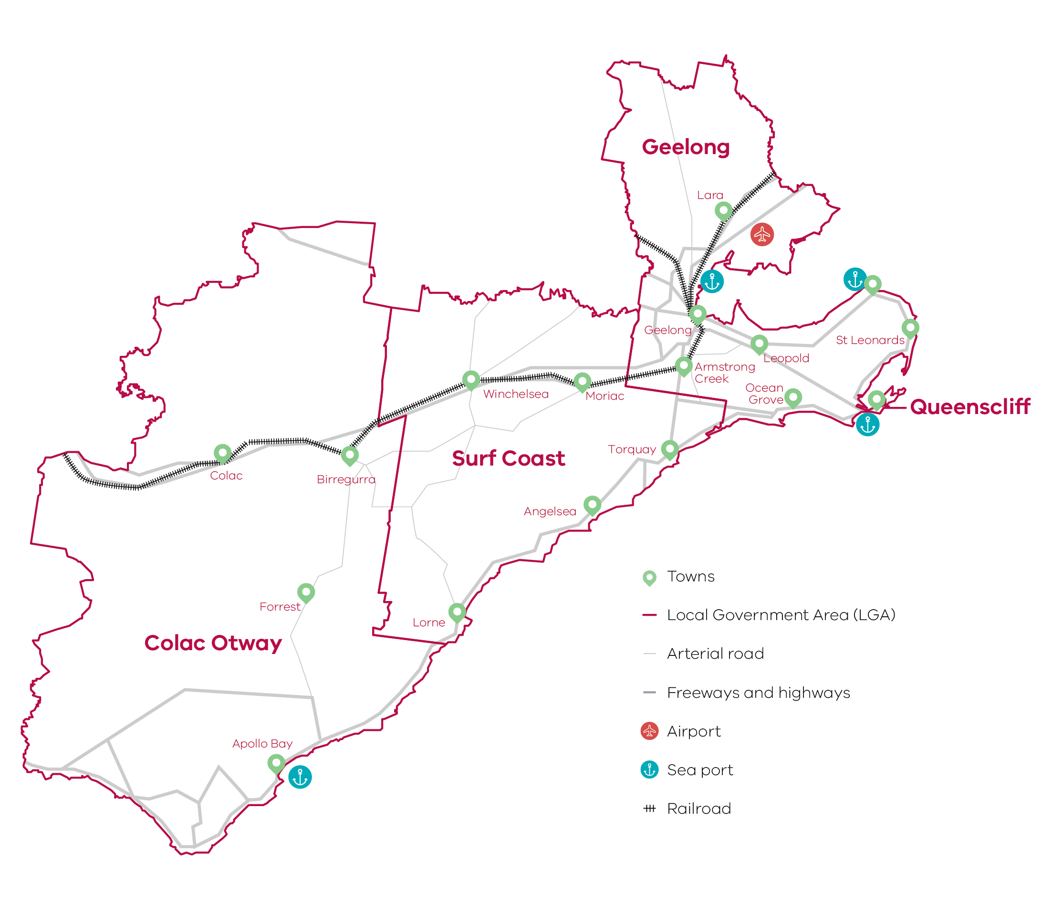

Figure 2 Map of Barwon – Long Alternate Text

# 02 Regional profile

**Barwon Regional Profile**

|  |  |
| --- | --- |
| $17.6 billion | Gross regional product (2020) |
| 324,300 | Population (2020) |
| 21.8% | Population growth (2011-20) |
| 40 | Median age (2020) |
| 62.8% | Working age (15-64) (2020) |
| 18.8% | Population aged over 65 (2020) |
| 1.0% | Are Aboriginal and/or Torres Strait Islander (2016) |
| 10.0% | Speak a language other than English at home (2016) |
| 16.3% | Were born overseas (2016) |

| **LGA** | **Population[1] (2020)** | **Projected growth[2] (2021–2036)** |
| --- | --- | --- |
| Greater Geelong | 264,900 | 32.8% |
| Surf Coast | 34,800 | 30.5% |
| Colac-Otway | 21,700 | 3.3% |
| Queenscliffe | 3,000 | 4.3% |

Population growth in the region has been strong over the past decade and well above the regional Victorian average of 13.3 per cent. Growth is focused around the major socioeconomic and population hub of Geelong with the Surf Coast Shire also experiencing notable growth.

The region is experiencing high levels of domestic migration from outside the region, especially into Greater Geelong, Queenscliffe and the southern parts of the Surf Coast. For these areas, there has been positive net internal migration across all age cohorts and an influx of residents aged between 15-24 – which is well above the negative regional growth average for this cohort. This indicates that the region is attractive for young people looking for study or employment opportunities. There has also been a large population inflow for residents aged between 0-14 and 25-44 into the Surf Coast and Queenscliffe, far exceeding regional Victorian averages. This reflects the liveability of these locations and suitability for families seeking change but remaining in close proximity to the socioeconomic hubs and markets of Geelong and Melbourne.

While there are strong demographic trends in the east of the region, Colac Otway Shire has seen subdued population growth and internal migration out of the region, especially in younger cohorts.

| **Unemployment rate[3] (March 2021)** | **Labour force participation rate[4] (2016)** | **Average annual employment growth[5] (2011–20)** |
| --- | --- | --- |
| Barwon: 3.4%  Regional average: 4.2%  Metropolitan Melbourne: 6.0% | Barwon: 61.9%  Regional average: 60.9%  Metropolitan Melbourne: 65.8% | Barwon: 2.0%  Regional average: 1.0%  Metropolitan Melbourne: 2.1% |

The labour force participation rate in Barwon (61.9 per cent) is higher than the regional Victorian average. The female participation rate (57.7 per cent) is significantly lower than for men (65.2 per cent). The largest employing sectors for women are healthcare and social assistance, retail trade, education and training and accommodation and food services.

**Table 1: Employment in largest employing industries by worker (2020) gender (2016)**

|  |  |  |  |
| --- | --- | --- | --- |
| **Industry** | **Workers** | **Male** | **Female** |
| Healthcare and social assistance | 22,700 | 19.3% | 80.7% |
| Retail trade | 18,800 | 41.4% | 58.6% |
| Construction | 14,800 | 90.1% | 9.9% |
| Education and training | 14,000 | 31.7% | 68.4% |
| Manufacturing | 11,300 | 76.8% | 23.2% |

Source: National Institute of Economic and Industry Research, 2020 and ABS Census, 2016

## Employment by industry

Over the past 20 years, the region has seen substantial employment growth across many industries. There has been steady employment growth in the health care and social assistance industry, which has been the region’s largest employer since 2010. This is likely the result of strong population growth as well as the increase in population aged over 65. Similar patterns of growth have also been observed in the retail trade, construction, and education and training industries, indicating that these sectors are also experiencing growth related to the expanding population in the region.

The manufacturing industry was the biggest employer for most of 2001-05 but experienced large declines in employment from 2007 to 2017. Much of the reduction in employment is due to the closing down of large multinational manufacturing operations and increased mechanisation and automation of business processes. A large part of the decline can also be attributed to declines in the petroleum and coal product manufacturing sector which is the largest component of the manufacturing industry.

Figure 3 – Barwon industry employment (2001–2020**)**

Figure 3 Barwon industry Employment (2001–20) – Long Alternate Text

Source: National Institute of Economic and Industry Research, 2020

Note: Top 10 employing industries in 2020 presented in chart, based on Journey to Work employment estimates.

Top 10 Barwon industry employment in 2020:

1. Health care and social assistance
2. Retail trade
3. Construction
4. Education and training
5. Manufacturing
6. Public administration and safety
7. Accommodation and food services
8. Professional, scientific and technical services
9. Other services
10. Transport, postal and warehousing

## Output by industry

The region has experienced large increases in output over the last 20 years, despite a period of stagnation from around 2008 to 2013 following the Global Financial Crisis. Growth has been supported by strong population increases and the demand for services in the region, borne out by significant gains to the construction and health care and social assistance industries. Other service-based sectors including education and training and retail trade industries have also had consistent output growth over the past two decades.

Traditionally, manufacturing has been the largest contributor to the region’s economy, but output value has declined significantly since 2006. Manufacturing was overtaken by the construction and health care and social assistance sectors in 2017 but remains the region’s third largest industry by output. The decline in manufacturing output is likely due to similar factors described in the employment section above. Despite this, the region still has one of the strongest and most diverse manufacturing industries in regional Victoria.

### $13.8 billion Gross Value Added (GVA) (2020)

Top sectors by GVA:

1. Construction: $1.9 billion
2. Health care and social assistance: $1.8 billion
3. Manufacturing: $1.5 billion
4. Public administration and safety: $1.2 billion
5. Education and training: $1.2 billion

**Figure 4 – Barwon industry output (Gross Value Add) (2001-2020)**

Figure 4 Barwon industry output (gross value add) 2001-20 – Long Alternate Text

Source: National Institute of Economic and Industry Research, 2020

Top 10 Barwon industry output in 2020:

1. Construction
2. Health care and social assistance
3. Manufacturing
4. Education and training
5. Public administration and safety
6. Retail trade
7. Financial and insurance services
8. Professional, scientific and technical services
9. Transport, postal and warehousing
10. Electricity, gas, water and waste services

## Regional exports

Strong connections to international markets via major freight routes and expertise in education and training support the top export sectors (2020):

1. Manufacturing: $830.0 million
2. Agriculture, forestry and fishing: $206.3 million
3. Education and training: $190.5 million.

# 03 Comparative advantage

For the purpose of the REDS, ‘comparative advantage’ is defined simply as a description of what the region does well compared to other regions. This includes both the relative competitiveness of the region’s businesses as well as cultural, social and environmental factors.

Contemporary place-based development emphasises the importance of local endowments as a driver of comparative advantage. In economic terms, endowments refer to any natural, human, cultural and built resources present in a place which can be harnessed to support socioeconomic activity. Regional economic strengths can also be identified using other measures including location quotient analysis, shift share analysis, and industry cluster analysis. A comprehensive assessment of these measures is included in the Barwon Regional Economic Development Strategy – Supporting Analysis.

## 3.1 Endowments

### Natural endowments

#### Location

Barwon is located in close proximity to metropolitan Melbourne as well as other regional cities including Ballarat and Warrnambool. This places the region at a natural, economic, cultural and social advantage as it attracts significant back and forth business, workers, visitors and residents from major consumer hubs.

#### Environmental assets

The region is home to many iconic landscapes that attract visitors all year round and provide environmental, social and cultural amenity. Major landscapes include the Great Ocean Road coastline, Corio Bay, the Surf Coast and Hinterland, the Barwon River, the Otway National Park, the Bellarine Peninsula and the You Yangs Regional Park. The region’s fertile soil and rainfall support the agriculture sector.

### Cultural endowments

#### Aboriginal heritage

The Wadawurrung and Eastern Maar peoples are the Registered Aboriginal Parties under the Aboriginal Heritage Act 2006 for Barwon. The Narana Aboriginal Cultural Centre in Geelong is a significant attraction, providing arts and cultural activities as well as access to the adjacent four-acre Curragundi Native Garden. The Barwon coastline and the Barrabool Hills area to the west of Geelong have diverse and important Aboriginal cultural heritage sites.

#### City of Geelong

The city of Geelong is the economic and cultural hub of the region. It was recently designated as Australia’s first UNESCO City of Design which reflects the city’s dynamic, creative and innovative culture. The city also hosts many significant cultural, creative, culinary and sporting events throughout the year.

#### Cultural events

The region hosts several significant food and wine, music, sport and art-based festivals throughout the year that attracts visitors and supports the creative economy in the region. These include:

* The Falls Music & Arts Festival
* Festival of Sails
* Amy’s Gran Fondo
* Toast to the Coast
* Geelong’s Pako Festa
* Rip Curl Pro (surfing event)

### Built endowments

#### Transport connections

The region is well connected by rail, air, sea and road for both freight and passengers. Key transport infrastructure includes:

* Avalon Airport, located on the northern fringe of Geelong, which is Victoria’s second largest freight and passenger airport.
* The Princes Freeway, Midland Highway and the south-western rail line that provide connection and access to Melbourne and other major regional hubs.
* The Port of Geelong which is a major deep water port and an important piece of regional infrastructure, handling more than 10.5 million tonnes of product annually.
* Ferries that travel between Portarlington and Melbourne Docklands, Geelong and Melbourne Docklands, and Queenscliff and Sorrento.

#### Tertiary and research institutions

The region has a broad range of tertiary education options including university, TAFE, and trade schools. Deakin University has two campuses in Geelong (Geelong Waterfront and Waurn Ponds). The university has a growing international presence with a strong focus on manufacturing, materials, data analytics, agriculture and health. Other institutions include the Gordon Institute of TAFE and Marcus Oldham College. The CSIRO Australian Centre for Disease Preparedness facility is also located in the region. It is a high-containment facility designed to protect Australia’s multi-billion dollar livestock and aquaculture industries and the general public, from emerging infectious disease threats.

#### Medical facilities

The region is serviced by a number of medical facilities predominantly located in Geelong and coordinated by Barwon Health. Barwon Health is a major employer for the region and key education provider through relationships with Deakin University, Melbourne University, Monash University, the Gordon Institute of TAFE and a number of other educational centres and universities. Facilities include Geelong Hospital, St John of God Hospital, Epworth Hospital Geelong and the McKellar Centre.

#### Energy assets

There is a network of 220kV transmission lines that connect Geelong and the wider region to the major energy generation sources. There is also a 500kV transmission line that runs from the Latrobe Valley to the aluminium smelter in Portland that cuts through the region north of Geelong. The Victorian Big Battery has been constructed at the Moorabool Terminal Station, near Geelong, which provides 300 MW of storage – enough to power over one million homes for half an hour. The Geelong Refinery processes oil into a wide range of products, including petrol, diesel and jet fuel, and supplies over 50 per cent of fuel in Victoria and 10 per cent nationally.

#### Employment and innovation precincts

There are several commercial and innovation precincts situated in the region that generate collaboration and innovation amongst businesses. These include:

* Pivot City Innovation Precinct
* Geelong Future Economy Precinct

### Human endowments

#### Population growth

The region has benefitted from above average population growth over the past decade. It has been a catalyst in industry transition and led the region to growth in key population-driven sectors such as construction, health care and social assistance and education and training.

#### Educational attainment

Educational attainment in the region exceeds regional averages. The proportion of the population with Bachelor’s degrees or higher in Barwon is 22 per cent, compared to the regional Victorian average of 17 per cent.

#### Specialised skills and knowledge

A number of large public administration and insurance institutions are based in the region, including the Transport Accident Commission, Ports Victoria, WorkSafe Victoria, the National Disability Insurance Agency, the Australian Bureau of Statistics and the Australian Taxation Office. The co-location of these institutions has generated significant expertise in the local workforce, positioning the region to further attract and develop similar institutions and skilled workers.

#### Manufacturing clusters

There are significant clusters of manufacturing businesses and knowledge, particularly in advanced fibres and materials. These clusters have propelled the region from a traditional manufacturing base to high value low volume manufacturing by sharing information, technology, skills and expertise as well as advocating for mutually beneficial outcomes. Clusters include:

* Geelong Manufacturing Council
* Advanced Fibre Cluster Geelong
* Engineering Network Geelong
* Cleantech Innovations Geelong
* Geelong Defence Alliance
* Greater Geelong Hydrogen Technology Cluster

#### Collaboration between private, public and not-for profit sectors

A number of well-established coalitions of organisations made up of community leaders work together to set the strategic directions for the region and to advocate on behalf of communities and businesses.

## 3.2 Revealed industry specialisation

Location Quotient (LQ) analysis provides further insight into the local economy’s underlying structure and comparative advantages that may not be evident from a region’s endowments. This form of analysis compares an industry’s size and growth (as measured by employment and output) as a proportion of total economic activity, relative to the Victorian average. The higher the LQ, the more concentrated, and therefore significant, an industry is to the local economy relative to Victoria on average. Scores above 1.25 indicate specialisation compared to the rest of the state. Further analysis is provided in the Barwon Regional Economic Development Strategy – Supporting Analysis.

### Employment specialisation

Over the past five years, the region has seen employment growth outpace the state average in 11 of 19 sectors. Notable sectors and sub-sectors are explored in more detail below:

**Retail trade:** With an LQ of 1.35, the region has an employment specialisation in the retail trade sector that employs 13 per cent of the workforce. Employment growth in the sector also exceeds that of the Victorian average by 13 percentage points. The ‘motor vehicle and motor vehicle parts’ retailing sub-industry has the highest sub-industry employment LQ of 1.71, which builds off the regions relatively large population and legacy of motor vehicle manufacturing. This strong regional performance in the retail trade sector is likely due to the region’s proximity and greater ability to service the major population centres of Greater Geelong and Metropolitan Melbourne.

**Public administration:** The public administration sub-industry has an employment LQ of 1.55 and has experienced employment growth 56 percentage points above the Victorian average. Together, these measures suggest a strong employment specialisation for public administration supported by a number of federal and state government institutions operating in the region. In addition, public administration and safety has been the fastest growing sector for employment in the region since 2016 as can be seen in Figure 3.

**Accommodation:** The accommodation sub-industry has an employment LQ of 1.58 and an employment growth rate that is six per cent higher than the Victorian average. This reflects the strong visitor economy in the region.

**Health care and social assistance:** Health care and social assistance has been the highest employing sector in the region since 2010. There is a specialisation in the residential care services sub-industry, which has an LQ of 1.7 and employment growth that is exceeding the state’s average by 35 percentage points.

**Figure 5: Barwon industry employment location quotient and growth**

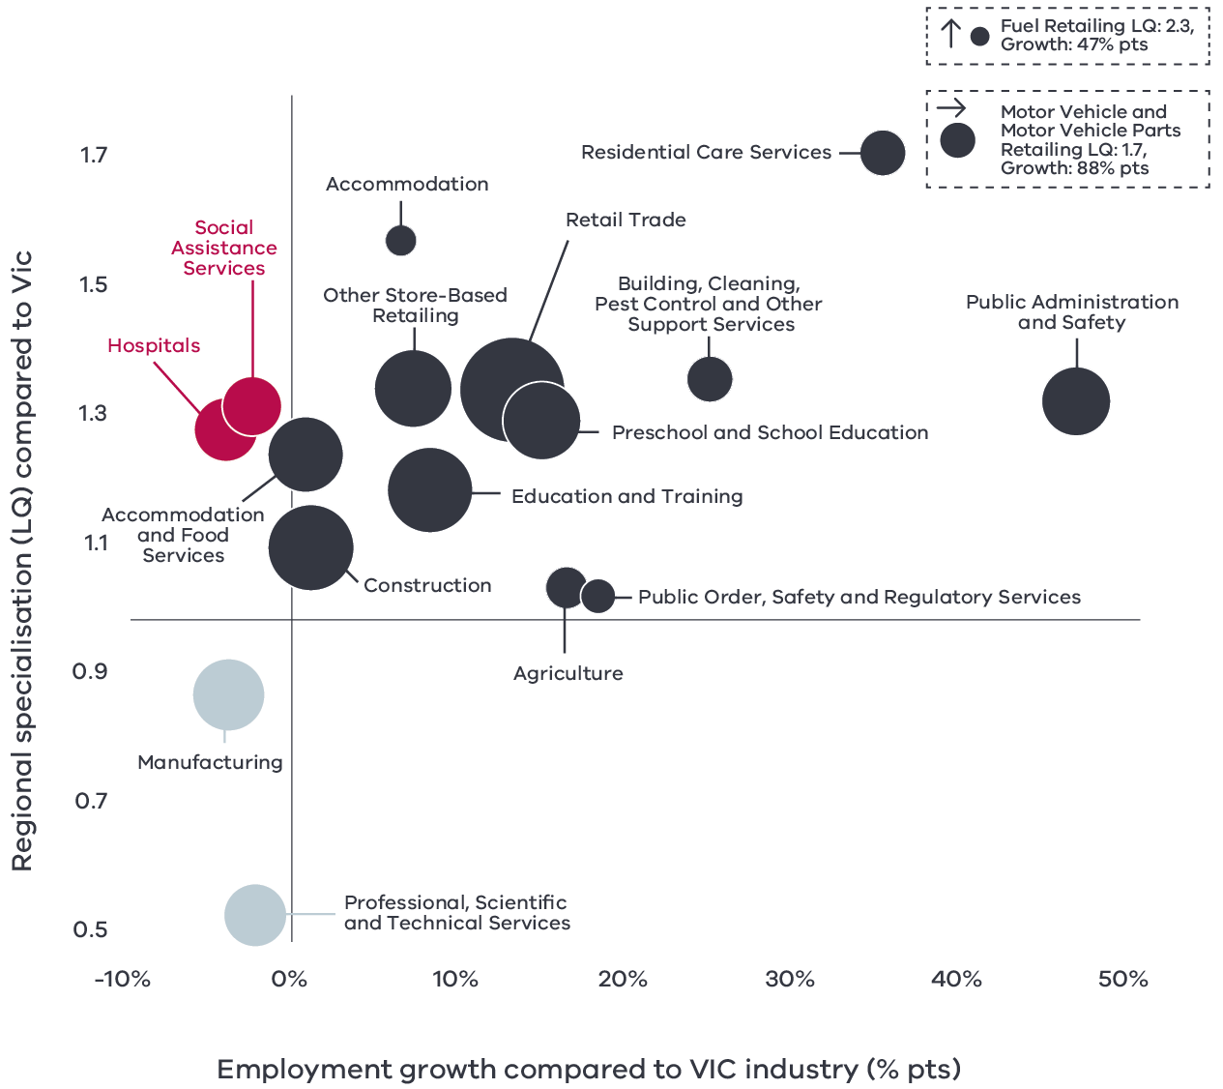

Figure 5 Barwon industry employment location quotient and growth – Long Alternate Text

Source: National Institute of Economic and Industry Research (2020).

Note this chart represents a selection of industries and sub-industries that represent a notable size and or concentration within the region. Some sub-industries presented are sub-sectors of industries that are presented alongside it and therefore measures cannot be aggregated between the two. Other industries are not displayed. For greater detail refer to the supporting analysis pack for this REDS strategy.

* Dark Grey sectors are regional concentrations which are experiencing faster employment growth (or slower employment decline) than state averages
* Red sectors are regional concentrations which are experiencing slower employment growth (or faster declines) than state averages
* Light Red sectors are emerging industries which are not regional concentrations but are experiencing faster employment growth (or slower employment decline) than state averages
* Grey sectors are not regional concentrations and are experiencing slower growth (or faster declines) than state averages
* Sections surrounded by a dashed box have LQ or growth figure beyond the bounds of the axis

Figure 5 depicts selected industries and sub-industries in the regional economy in 2020 where:

* The size of each bubble indicates the number of people employed in the (sub)industry. The bigger the bubble, the more people employed in the industry.
* The vertical position indicates the (sub)industry’s degree of employment concentration relative to the Victorian economy. For example, a value of 1.77 means that, as a share of total employment in the local economy, the (sub)industry employs 1.77 times as many people than the Victorian average.
* The horizontal position indicates the difference in the (sub)industry’s employment growth (2015 to 2020) between the region and the Victorian average. For example, a 14 per cent value indicates that regional employment in the (sub)industry has grown 14 percentage points faster than the industry’s average growth rate in Victoria.

### Output specialisation

Similar to employment specialisations, the region demonstrates output specialisations in the public administration and safety as well as a range of population-based industries such as construction, retail trade, education and training.

Due to the capital-intensive nature of manufacturing, it is not a specialisation for employment but is for output. While recent declines show the manufacturing industry growth below the state average, there are sub-sectors such as fabricated metal product manufacturing that are outpacing state averages in recent years.

### Emerging areas of specialisation

Within the overall expansion of the region’s economy, there are some sub-sectors that are not yet specialised in employment or GVA but are showing growth rates above the Victorian average and could point towards future specialisation. Agriculture and food retailing both fall into this category. Personal and other services is also emerging which could be reflective of historical population growth and should continue to grow with current population projections. The growth of public order, safety and regulatory services is underpinned by the relocation of a number of Victorian and Commonwealth government agencies moving to the region. The Finance sub-sector forms part of this category because of its signs of growth in GVA rather than employment.

**Figure 6: Barwon industry output (GVA) location quotient and growth**

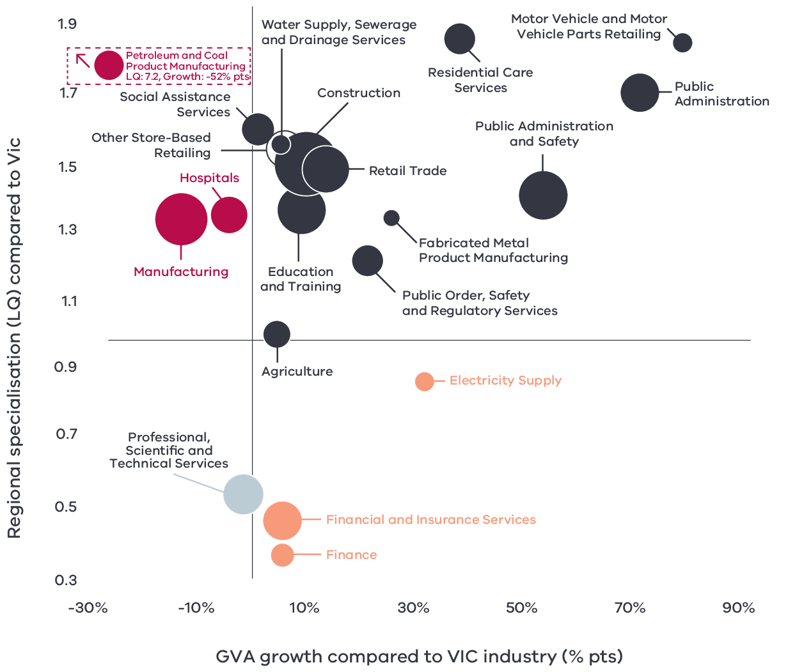

Figure 6 Barwon industry output (GVA) location quotient and growth – Long Alternate Text

Source: National Institute of Economic and Industry Research (2020).

Note this chart represents a selection of Industries and Sub-industries that represent a notable size and or concentration within the region. Some sub-industries presented are sub-sectors of industries that are presented alongside it and therefore measures cannot be aggregated between the two. Other industries are not displayed. For greater detail refer to the supporting analysis pack for this REDS strategy.

* Dark Grey sectors are regional concentrations which are experiencing faster output growth than state averages
* Red sectors are regional concentrations which are experiencing slower growth (or faster declines) than state averages
* Light Red sectors are emerging industries which are not regional concentrations but are experiencing faster output growth (or slower declines) than state averages
* Grey sectors are not regional concentrations and are experiencing slower growth (or faster declines) than state averages
* Sections surrounded by a dashed box have LQ or growth figure beyond the bounds of the axis

Figure 6 identifies the Barwon’s economic output specialisation in terms of GVA. Using the same approach as Figure 5, this analysis compares selected industries and sub-industries in the regional economy, including their size and growth as a proportion of total economic GVA relative to Victorian averages.

# 04 Strategic directions

The five strategic directions for the Barwon region have been identified based on the opportunities emerging from the region’s endowments, industry specialisations, and socioeconomic context. The directions have been refined based on a review of local policies and strategic planning.

The following section discusses each strategic direction, providing:

* a rationale for its inclusion as part of the strategy
* an overview of opportunities and challenges which are likely to support or hinder future growth
* a summary of work underway and the policy context to support desired outcomes
* the implication of the direction for the region’s Aboriginal communities
* examples of how the direction could be activated.

**Barwon’s strategic directions**

1. Accelerate the transition to new and high-value manufacturing opportunities
2. Further the innovation and skills ecosystem
3. Realise the potential of the visitor economy
4. Maximise the economic benefit from the expanding service-based sectors
5. Build a sustainable and climate-resilient region.

## Enabling factors for economic growth

This REDS identifies opportunities in key areas that can help drive regional economic growth. However, each region’s capacity to activate these opportunities and grow is partly determined by cross-cutting enabling factors that support economic activity. Consideration of these enabling factors – and targeted investments and initiatives to strengthen them – will help support achievement of the strategic directions in this REDS.

|  |  |
| --- | --- |
| **Digital connectivity**  Access to reliable internet and mobile services allows for access to new markets, facilitates efficiency gains and opens up opportunities for innovation. Good digital connectivity can also facilitate more inclusive access to services and flexible working arrangements. | 63 to 70 – Australian Digital Inclusion Index Score in Barwon in 2021[6]  (Victorian average: 71) |
| **Transport connectivity**  Road and rail infrastructure, ports and airports provide critical linkages between production locations and markets; efficient transport connections and public transport services are a key factor in workforce mobility and local amenity. | 4.2 – Overall access to roads and public transport in Barwon South West RDA region[7]  (Regional Victoria: 4.1 and Victoria: 5) |
| **Workforce and population growth**  An adaptive and productive workforce is key to businesses competitiveness; access to both skilled and unskilled labour ensures business can sustain and expand activities. | 61.7% – Local workforce in Barwon was employed in skilled occupations[8]  (Regional Victoria: 62.2%, Melbourne: 67.3%) (2021)  22% – Residents with a bachelor’s degree or higher in 2016[9]  (Regional Victorian: 17.0%, Melbourne: 31.0%) |
| **Housing**  The availability and affordability of housing determines a region’s ability to attract and retain local staff and supports community cohesion and better life outcomes for individuals and families. | 0.9% – Average rental property vacancy rate in the six months leading up to June 2021[10]  (Compared to benchmark of 2.5%)  31.1% – Increase in median rent in Barwon South West RDA region from 2016 to 2020[11]  (Victoria, 6.9%, Regional Victoria 28.6%) |

Notes: 1. The Australian Digital Inclusion Index (ADII) is a composite index used to measure digital inclusion across three dimensions of Access, Affordability and Digital Ability. 2. ‘Access to roads and public transport was measured by asking respondents to rate their access to the following types of services in their local community, on a scale ranging from ‘very poor’ (1) to ‘very good’ (7): (i) Quality of local roads; and (ii) Access to public transport (including taxis, buses, trains). A single measure of overall access to roads and public transport was then constructed based on the average score of a person’s responses to these two items. 3. Skill level is defined as a function of the range and complexity of the set of tasks performed in a particular occupation. Skilled workers are defined as being classed between an ANZSCO Skill level of 1-3, while low skilled is classed as 4 or 5. 4. A rental property vacancy rate of 2.5% refers to a benchmark at which the market is balanced between landlords and tenants.

## Integrating Aboriginal economic opportunities

The Victorian Government is taking concrete steps to align with Aboriginal self-determination principles. Key Victorian government policies and processes to realise self-determination goals include the:

* Treaty Process which seeks to redefine the relationships between Aboriginal communities, the state and non-Aboriginal Victorians.
* Victorian Aboriginal Affairs Framework 2018-23 (VAAF) which is the overarching framework for working with Aboriginal Victorians to drive positive socioeconomic outcomes across the state, including to activate economic opportunities and prosperity via achieving wealth equality, facilitating workforce participation in all sectors at all levels and realising Aboriginal income potential.
* Self Determination Reform Framework, which guides public sector action to enable self-determination in line with the VAAF across four domains: people, systems, outcomes and accountability.

The Victorian Government is also party to the National Agreement on Closing the Gap and has committed to meeting the associated outcomes – including in relation to increasing engagement of Aboriginal and Torres Strait Islanders in employment, education and training.

An analysis of relevant policies and commitments relating to Aboriginal economic development in the region (listed in the *Barwon Regional Economic Development Strategy – Supporting Analysis*), including Traditional Owner strategic plans, where developed, has identified five opportunities for Aboriginal economic development:

* Identify opportunities to leverage natural resources for economic benefit, including through adopting traditional agricultural techniques and practices.
* Invest in the growth and awareness of Aboriginal-owned industry, including nature based and cultural tourism, business enterprise and procurement.
* Pursue greater Aboriginal ownership of land to sustainably manage resources.
* Promote recognition of the land, its waters and its cultural significance to ensure that economic activities generate benefits in circumstances where degradation or destruction can be avoided, and existing damage is healed.
* Engage with young people to ensure there are opportunities to access secure jobs and build an economic future on Country while, at the same time, learning about culture and traditions.

Each strategic direction in the Barwon REDS considers the relevance of that direction to local Aboriginal communities in light of the above opportunities.

Self-determined priorities for Aboriginal economic development in the region will be aligned to the six pillars of the Victorian Aboriginal Employment and Economic Strategy. These priorities will also guide Victorian Government decision-making on economic development in the region and will be integrated into future updates of the REDS.

## 4.1 Accelerate the transition to new and high-value manufacturing opportunities

### Significance

Manufacturing has historically been the principal driver of economic growth in the region. However, manufacturing output has declined over the last decade and been surpassed by other population-based industries. Deindustrialisation is not unique to the region with developed economies around the world having a similar experience brought on by rapid technological advancement and globalisation. Despite the declining trajectory, there is strong evidence of industry evolution across the region supported by the rich manufacturing legacy, skills and infrastructure that has remained.

Today, the region is producing a diverse range of products for both domestic and international markets – specialising in the manufacture of food products, construction materials, chemicals and plastics, oil refining, carbon fibre products and industrial structures. The region’s manufacturers have benefitted from collaborative partnerships amongst themselves and with the research and education institutions that operate within the region, particularly Deakin University. These partnerships boast many innovative success stories and have propelled the industry narrative from a declining trajectory to one that is increasingly delivering high value future focused products to the world.

### Opportunities

#### Developing future-focused products

Having the ability to proactively develop, commercialise and produce new or modified products that meet the demands of emerging and future industries is a strong indicator of manufacturing success. The strong linkages between research and industry in the region make it well-placed to capture future-focused opportunities particularly in advanced materials, re-manufacturing, defence and medical technologies. The establishment of the Advanced Fibre Cluster Geelong through Carbon Nexus, a world-leading non-aerospace carbon fibre research facility in Geelong, is an example of the region being at the forefront of product development and commercialisation. Decarbonising the economy also presents opportunities for the region to develop low emissions technologies such as wind turbines, batteries and electric buses and components.

#### Advanced manufacturing capabilities

The digitisation of manufacturing enhanced by data and machine learning has taken the production of goods across the globe to new heights. Manufacturers in the region are already taking up the challenge of modernising their capabilities with strong clusters of innovative institutions and businesses adopting new technologies across multiple sectors. Cultivating these clusters and supporting the industry to invest in advanced capabilities will enable the region to maintain and grow its reputation as a globally renowned centre of excellence for high value-add activities. Advanced capabilities refer to the implementation of new technologies and techniques such as smart robotics, automation, augmented and virtual reality, and additive manufacturing (3D printing) as well as the human skills required to activate these improvements.

#### Food supply chain

Access to quality agricultural product from within the region and the western parts of the state, coupled with logistical infrastructure and accessibility to major markets has consolidated the region’s position as a major food producer for Victoria and a significant supply chain contributor to national and international markets. As of 2020, food product manufacturing was the second largest manufacturing sub-sector in the region. International food product export value has realised strong growth, reaching $252.4 million in 2020, up from $161.1 million in 2010. Further end to end food supply chain growth can be realised through:

**Product differentiation and consumer preferences:** Global consumer trends are increasingly preferencing healthy and functional foods, greater environmental sustainability, traceability and production integrity. The main types of food processing in the region are dairy and meat. Tailoring, marketing and differentiating the regions quality products to meet consumer preferences will be important for the future success of supply chains.

**Strengthening supply chain resilience:** Securing high quality agricultural inputs, maximising the output from agricultural land and increasing collaboration between producers allows the region to strengthen and expand the food supply chains while maintaining its brand of quality output. High-security, low-cost water solutions and infrastructure have been identified by the G21 Economic Futures Report to drive high-value, drought-proof and lower emissions regional farming. Enhanced water security can drive secure farming of more profitable, export-focused inputs such as fruit, vegetables and nuts.

**Small scale producers:** Food production is also an important contributor to the visitor economy with food trails, farmgate experiences and wineries predominantly located in the Surf Coast, Otway Ranges and Bellarine Peninsula. Supporting these small-scale end-to-end producers to commercialise and market their produce could elevate the region’s reputation for quality produce while attracting visitors to the region.

#### Maximising transport infrastructure

Maximising the potential of the region’s key infrastructure assets would enhance the region’s ability to export goods across the country and internationally. The Avalon Airport precinct has significant room for growth as an international freight terminal airport.

**Figure 7: Agricultural land use in Barwon**

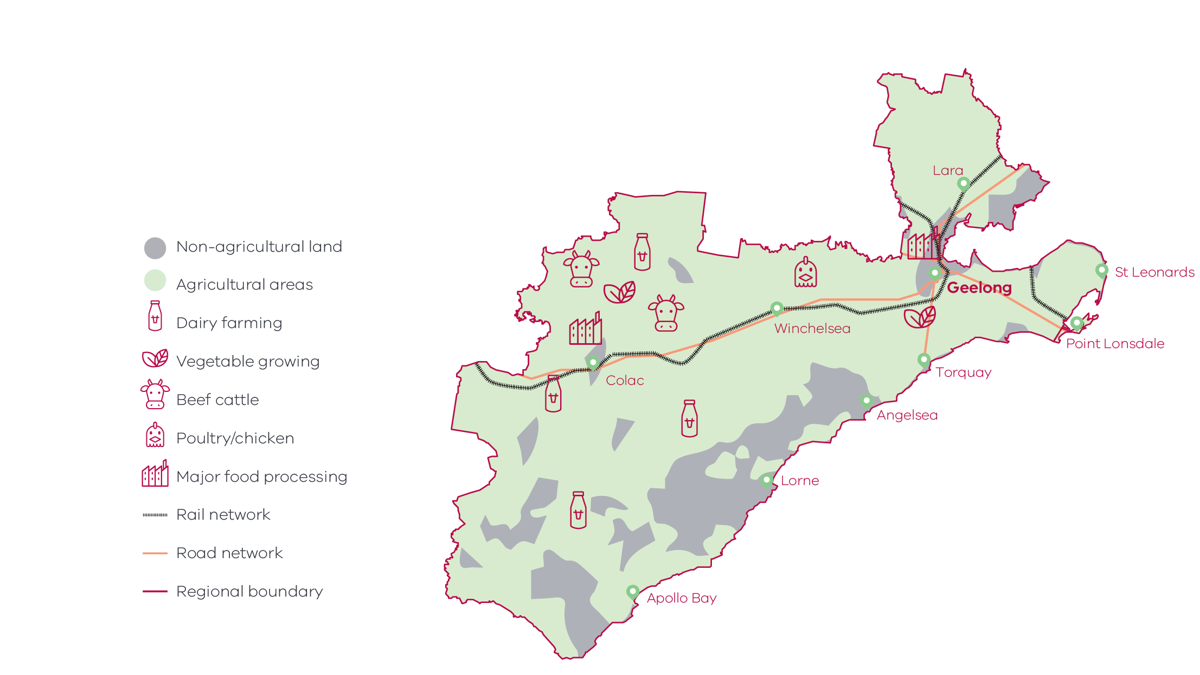

Figure 7 Agricultural land use in Barwon – Long Alternate Text

Source: Invest Victoria (2018)

### Challenges

#### Global competition

Being able to compete with international producers has been a long-standing challenge for manufacturers in the region that face high labour and energy costs, long distances to markets and relatively small domestic demand. While technological improvements have closed the gap, competitiveness challenges have been compounded by an increasingly hostile international trade environment, including the introduction of tariffs on certain products and the use of carbon emissions in international trade.

#### Digital infrastructure

Internet speed is a critical enabler to doing business in advanced manufacturing. The Barwon Digital Plan identifies that the digital intensity of the region’s manufacturing industry is set to increase considerably in the short term. In the next 5 years, the industry will demand greater access to more sophisticated networks to use technologies such as industrial Internet of Things (IoT), fault prevention and data analytics.

#### Adequate workforce

Projections show the region’s manufacturing industry is expected to have the largest total decline in workforce among all industries to 2024. While this can partly be attributed to automation and the increased use of technology, access to workers and skillsets has the potential to also challenge the economic potential of the industry in the region. Current perceptions of working in the industry present a barrier to attracting prospective workers particularly for young people exploring potential career pathways and women who have historically had low levels of participation in the industry.

#### Climate change

Increased adverse weather events, higher temperatures and decreased rainfall as a result of climate variability, as well as the need to reduce carbon emissions, will be key drivers of change across the region’s production industries. Changing conditions and high-impact events will put pressure on supply chains, infrastructure and water availability, and create uncertainty around production yields and output quality. Adapting to a warmer and drier climate, transitioning to renewable energy sources, establishing low emission practices and securing water supply by diversifying the region’s water sources present short-term hurdles for the manufacturing and agriculture industries, but will also secure their long-term sustainability.

**By 2050s[12]:**

* Median temperature could rise by 1.9°C
* Decline in average spring rainfall by 22%
* Average sea level rise in Geelong of 24cm
* Almost double the amount of extreme hot days in Geelong (12.6 days, over 35°C) in Geelong

### The policy environment

Transitioning to new and high-value manufacturing opportunities is closely aligned with national, state and local priorities. In particular:

* The Federal Government’s Make it happen – The Australian Government’s Modern Manufacturing Strategy focuses on six sub sectors of priority and advantage to the nation and getting the economic conditions right for manufacturing businesses to succeed.
* The State Government’s Advancing Victoria’s Manufacturing: A Blueprint for the Future also focuses on six future industries to guide future investment and activity.
* The State Government’s Connecting Victoria initiative is fast-tracking new mobile and broadband infrastructure across Victoria to support productivity and economic growth.
* CSIRO as part of their Futures series have prepared the Advanced Manufacturing Roadmap which provides a comprehensive analysis of the current state of play and what strategic moves need to be made by the industry in the next 20 years to remain competitive.
* The 2017 Geelong Economic Futures Report identifies industrial scale advanced carbon fibre manufacturing and high value drought proof regional farming as priority projects for the region.
* The Sustainable Agribusiness Strategy for the G21 Region 2017 – 2022 is an industry wide strategy that sets a strategic framework to sustainably grow the region’s diverse food sector.
* The G21 Innovative Agribusiness Collaboration Roadmap highlights ways that agribusinesses can collaborate to achieve greater productivity as a collective.

### Aboriginal inclusion

The Aboriginal workforce is poorly represented in the region’s manufacturing industry. Future investments and activities could be focused on creating pathways to Aboriginal employment in this sector and promoting Aboriginal owned manufacturing businesses – including around the processing of native foods which are increasing in demand.

### How can we unlock this strategic direction?

To unlock this opportunity and drive growth, local, state and Commonwealth partners could work together to:

* Provide supportive enabling conditions for the manufacturing sector to implement and commercialise new products, technologies and techniques.
* Cultivate the innovative culture growing between manufacturers and institutions within the region.
* Facilitate partnerships between industry and educational institutions to ensure that the next generation have the required skills to meet the needs of the advanced manufacturing workforce.
* Promote careers in the region’s food and manufacturing industry to the local and external workforce.
* Ensure local producers are engaged in local, state and national conversations about climate change adaptation and mitigation practices.
* Advocate for market access opportunities and strengthen biosecurity, food safety capabilities and traceability across supply chains.
* Governments and telecommunications providers should continue to work together to deliver high-quality digital connectivity that supports regional economic priorities.

## 4.2 Further the innovation and skills ecosystem

### Significance

The Barwon region has harnessed its advantages and embraced a culture of innovation that is delivering new sources of growth and maintaining high-wage jobs. Geelong is at the forefront of the innovation ecosystem and is home to research and innovation precincts clustered around specialised industries and education assets. There is a strong innovative focus on legacy industries of manufacturing and engineering, but the growing diversity of the region’s economy has unlocked innovative opportunities in other sectors such as health and construction as well as providing cross industry collaboration. There is a comprehensive system of support where start-up businesses, entrepreneurs and innovators can connect with institutions, incubators and accelerators. The Surf Coast also has a history of innovation, particularly in the surfing industry, which is expected to continue as the next generation of entrepreneurs populate the region.

The strength of the region’s education assets and research institutions has enabled the innovation ecosystem to thrive by producing and attracting skilled workers to the region. People in the region are highly educated – 22 per cent of the population holds a Bachelor degree or higher, as compared to 17 per cent in regional Victoria. Skilled employment is expanding in the Barwon region and the number of skilled workers is increasing at rates higher than both regional and metropolitan averages.

### Opportunities

#### Innovation hubs

There are now multiple purpose-built innovation precincts that attract investment and unlock opportunities throughout the region. Deakin University’s Geelong Future Economy Precinct in Waurn Ponds alone is home to a range of hubs including ManuFutures, an advanced manufacturing hub and the Future Fibres Hub, which develops novel fibre technologies to facilitate more sustainable advanced manufacturing of fibre materials. Further down the coastline, the Surf Coast region is positioned to grow as a hub for niche and emerging industries due to its strong identity with surfing, creativity and wellbeing as well as an attractive place for knowledge-based professionals and digital nomads. Growing and supporting these innovation hubs with the right services, economic conditions and infrastructure will be critical for their success and development.

#### Research expertise

The region is home to research institutions that specialise in engineering, advanced materials and fibres, intelligent systems, robotics, haptics, primary industries, health, biosecurity, animal health and infectious diseases. For example, partnerships between Deakin University and Barwon Health combine Deakin’s research capabilities with Barwon Health’s clinical and healthcare expertise to develop improvements in the delivery of health services. Continuing to specialise in these fields as well as identifying new opportunities as they emerge will be a key support for furthering innovative activities and also provide employment opportunities.

#### Future skills

New technologies are reducing the labour intensity of the region’s major industries, and economy-wide trends such as the transition to net-zero carbon emissions will require new skills and training pathways. The future workforce will require a broad interdisciplinary skillset, combining scientific expertise, software and data skills with softer skills in leadership, creative problem solving, communication and collaboration. Positioning educational institutions and businesses to provide apprenticeships and courses in these areas will serve the region and the state economy into the future.

### Challenges

#### Economic inclusion

The region has the facilities and jobs growth to support local upskilling and local employment however there are lags in economic participation and unemployment within key cohorts that risk further entrenching disadvantage. The G21 Regional Opportunities for Work (GROW) model was pioneered in the region to address disadvantage by focusing on and supporting local businesses and people. The model provides a pathway to improving economic inclusion and sharing the benefits of a strong education sector and employment growth more evenly across the region. Increasing access to services such as childcare or skill development could also remove barriers to employment and boost participation in these cohorts.

**Table 2: Key employment indicators across the Barwon’s demographic cohorts**

|  | **Aboriginal[13]** | **Non- Aboriginal** | **Females** | **Males** | **Living with a Disability** | **Not Living with a Disability** |
| --- | --- | --- | --- | --- | --- | --- |
| Unemployment | 11.0% | 5.8% | 5.6% | 6.2% | 15.1% | 5.8% |
| Participation | 57.5% | 62.2% | 57.7% | 66.5% | 9.6% | 66.2% |

Source: ABS Census (2016)

### The policy environment

Furthering the innovation and skills ecosystem in the region is closely aligned with state and local priorities. In particular:

* The Victorian Government’s $2 billion Breakthrough Victoria Fund will drive investment in translational research, innovation and commercialisation outcomes to accelerate growth in key industry sectors and create jobs.
* The 2019 Barwon Regional Partnership Outcomes Roadmap seeks to expand Barwon’s reputation for business innovation by strong collaboration across sectors that helps the region achieve its full economic potential.
* Runway Geelong, funded by the Victorian Government’s startup agency LaunchVic, supports incubator programs, intensive accelerator programs and business idea competitions.

### Aboriginal inclusion

Innovation and the potential for business development and productivity gains cut across several sectors. For sectors with low Aboriginal employment – such as professional, scientific and technical services and manufacturing – specific interventions may be required to ensure Aboriginal communities can realise economic development opportunities through innovation and new business growth. Traditional Owner groups have identified that tailored mentoring and support for Aboriginal business incubation could achieve greater Aboriginal participation in economic activities.

### How can we unlock this strategic direction?

To unlock this opportunity and drive growth, local, state and Commonwealth partners could work together to:

* Foster partnerships between all levels of government, industry and research institutes to support business incubation, acceleration and commercialisation.
* Prioritise projects that have strong commercial potential to accelerate productivity, grow exports, support domestic manufacturing and create jobs.
* Promote the region as an innovation hub and location of choice for new businesses.

## 4.3 Realise the potential of the visitor economy

### Significance

Barwon’s diverse natural and built environments have provided significant opportunities to attract visitors to the region. The region was the most popular visitor destination in regional Victoria in 2019, having received the most visitors across all visitor types. The restrictions associated with the COVID-19 pandemic have had a profound impact on the visitor economy, but there is growing optimism in the region that there is still untapped potential for growth. Some of the assets that have driven visitation numbers in the past have been elevated by recent investment and are well placed to capitalise on future opportunities.

The current and future success of the visitor economy can be attributed to:

* The natural landscapes including the gateway to the world-renowned Great Ocean Road, the Otway National Park, the You Yangs, the Bellarine Peninsula and the Surf Coast.
* The UNESCO recognised cultural city of Geelong that is a hub for the arts, design and events.
* The proximity and connectivity of the region to visitor markets.
* Coordinated and focused development of tourism products and brand for the region fostered through the Regional Tourism Boards.

### Opportunities

#### Changing visitor trends

The region has the opportunity to capture greater visitor demand and spend from domestic markets. The region is already realising growth in this market with average visitor spend substantially higher in 2020 than 2019 among domestic intrastate visitors. This is in part due to increases in the average length of time domestic overnight visitors are staying in the region. The COVID-19 pandemic has been a major catalyst for this trend with international travel ceasing and borders closing but other trends such as sustainable travel also signal positive signs for long term domestic market growth. There are opportunities to actively target this segment’s potential such as increasing local awareness of product and experiences, improving low emissions vehicle infrastructure or leveraging the region’s strong and emerging events calendar as facilitators to regional exploration. Improving access for visitors through Avalon Airport and via the Spirit of Tasmania is also a key opportunity for directing visitation from interstate visitors to the region.

#### Creative industries

Geelong’s recent designation as Australia’s first UNESCO City of Design, the arts, recreation and culture highlight the important role that the creative industries play in the identity of the region and its economy. The industries support many jobs and are a driving force for innovation and creativity across other sectors. The visitor economy is heavily linked to the creative industries as a major driver of visitation to the region, attracting visitors all year around through events and exhibitions. Supporting the creative industries to grow and strengthening the relationship between the sectors, particularly as they recover from the impacts of the COVID-19 pandemic, provides opportunities for both the visitor economy and the creative industries to thrive. The next stage of the Geelong Arts Centre redevelopment (due for completion in 2023) will provide the region with multiple new creative spaces that will attract local, national and international performances.

#### Aboriginal heritage

The region is home to important cultural heritage assets of the Wadawurrung and Eastern Maar people. Through these assets the region has the opportunity to capitalise on the increased interest in Aboriginal knowledge, culture and experiences by the wider community. Stronger connections with local Aboriginal groups and businesses could be developed to promote visitor-based enterprises, strengthen regional links to arts, innovation and training and ensure recognition of culturally significant traditions and landscapes.

#### Agri-tourism

There is an emerging boutique food and wine culture in the region, particularly in the Bellarine Peninsula and the Otway and Surf Coast hinterland. There has been investment in dining, farm gate and cellar door experiences through initiatives such as the Bellarine Taste Trail. There are further opportunities to strengthen the agri-tourism sector as a complement to the region’s coastal, nature-based settings and niche arts and cultural experiences.

### Challenges

#### Pandemic recovery

Given its proximity to metropolitan Melbourne, the region has particularly felt the negative impacts of restrictions on movement between the capital and regional Victoria and lack of international visitors during the COVID-19 pandemic. Prior to the COVID-19 pandemic, Barwon was growing in visitor numbers and expenditure as seen in Figure 8 and 9. The total number of visitors (daytrip and overnight, domestic and international) fell from 10.4 million in 2019 to 5.3 million in 2020, and associated visitor expenditure fell from $2.0 billion to $1.1 billion. As a result, visitor economy businesses have been unable to operate at capacity. Furthermore, the pandemic has made employment in the visitor economy, already perceived as insecure, more unstable with many workers leaving the industry to look for more secure work elsewhere. Attracting and retaining workers will be a key component of pandemic recovery for the visitor economy.

**Figure 8: Barwon visitor expenditure by visitor type (2015-2020)**

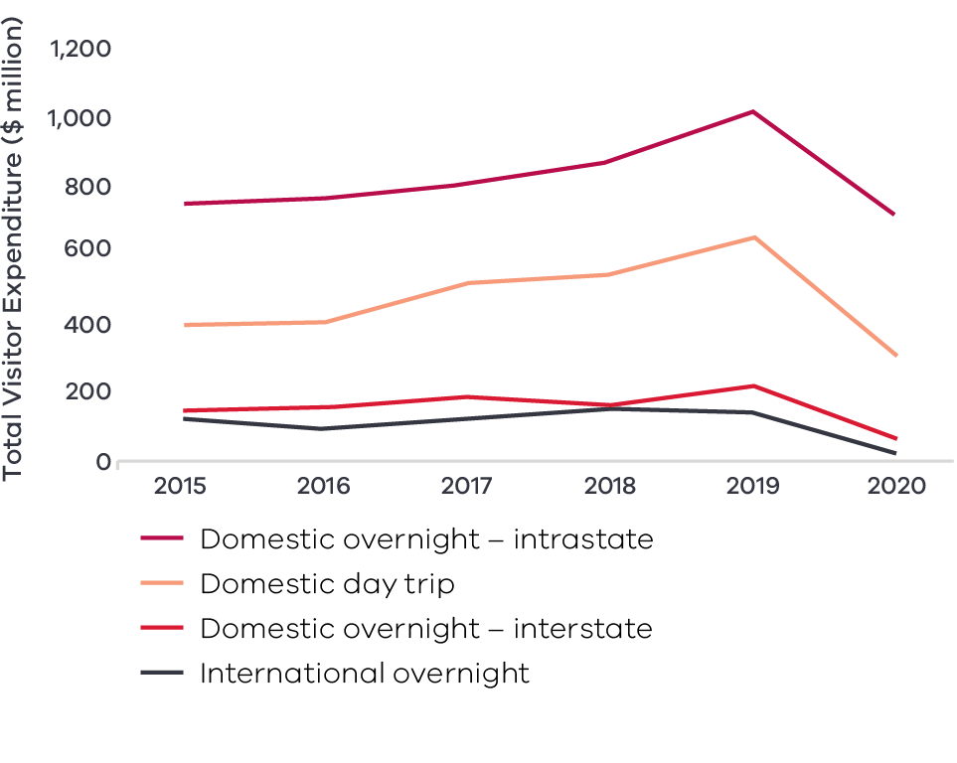

Figure 8 Barwon visitor expenditure by visitor type (2015-2020) – Long Alternate Text

Top 4 visitor expenditure by type 2020:

1. Domestic overnight– intrastate
2. Domestic daytrip
3. Domestic overnight – interstate
4. International overnight

**Figure 9: Barwon visitor numbers by visitor type (2015-2020)**

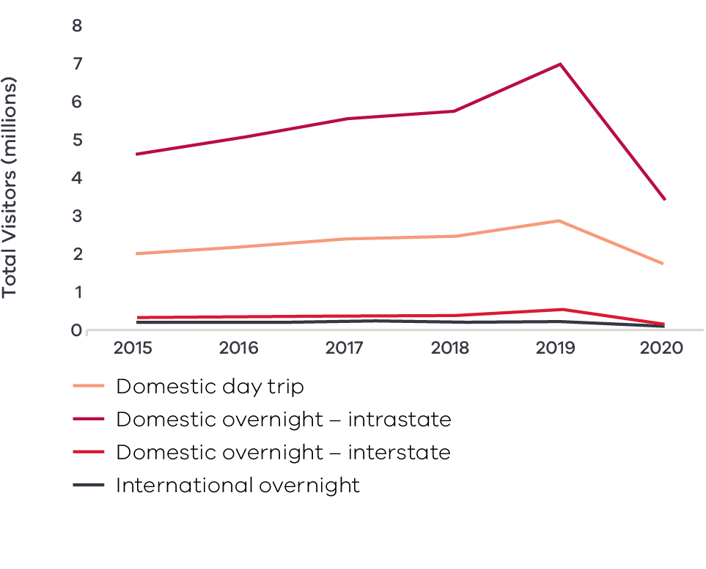

Figure 9 Barwon visitor numbers by visitor type (2015-2020) – Long Alternate Text

Source: Tourism Research Australia research data, as reported by DJPR – Tourism, Events and the Visitor Economy Research 2021

Top 4 visitor numbers by type 2020:

1. Domestic daytrip
2. Domestic overnight – intrastate
3. Domestic overnight – interstate
4. International overnight

#### Degradation and loss of amenity

A large section for the visitor economy relies on coastal assets to attract visitation. Projected sea level rises, extreme weather events and coastline degradation as a result of climate change may threaten nature-based experiences in the region. Concentrated visitation to environmental attractions can also harm the environmental amenity through overcrowding and pollution as well as impacting visitor experience.

#### Seasonality

Visitation to the region is often concentrated at certain times due to a number of highly popular assets, the climate and the coastal nature of the region. The impact of seasonality leads to over-demand at peak periods such as school holidays or Christmas break and limited demand at other times that generate profitless outcomes for some visitor economy businesses. The trends in domestic visitation have also increased the demand for weekends and dampened demand for mid-week stays which is a major challenge for operators. These trends are also placing pressure on infrastructure, which needs to support high visitor numbers but only for short or specific periods.

#### Digital connectivity

Recent consultations as part of the Connecting Victoria initiative have highlighted that poor connectivity impacts on the visitation experience and is a constraint on economic growth. More remote areas rely on lower capacity fixed wireless and satellite broadband services. Tourist locations such as walking trails and national parks can experience weak mobile coverage. Also some areas experience network limitations when there are large influxes of visitors to attend events.

### Work underway and the policy environment

Growing the visitor economy is closely aligned with national, state and local priorities. In particular:

* The Victorian Government’s Visitor Economy Recovery and Reform Plan (2021) aims to attract more tourists to the State, support regional jobs and deliver a significant recovery from the combined effects of the 2020 summer bushfires and the COVID-19 pandemic. This includes delivering a state-wide destination master plan underpinned by priority sector plans (the first sector priorities to be developed will be the Nature-Based Tourism Plan and the First Peoples’ Tourism Plan) and the establishment of Visitor Economy Partnerships across Victoria.
* Creative State 2025 is the Victorian Government’s four-year creative industries strategy designed to grow jobs and skills and secure Victoria’s reputation as a global cultural destination and bold creative leader.
* A Creative Industries Strategy for the G21 Region 2021-2026 sets the strategy and the vision for the region to foster a culture of collaboration and aspiration and deliver creative industry leadership and innovation connected to global networks.
* The Geelong City Deal is a 10-year plan to revitalise Geelong and unlock the potential of the Great Ocean Road visitor economy.
* The deal will deliver on key tourism infrastructure projects within Geelong and along the Great Ocean Road.
* The State Government’s Connecting Victoria initiative is fast-tracking new mobile and broadband infrastructure across Victoria to support productivity and economic growth.
* Victoria’s Great Outdoors Investment and Public Land Economic Stimulus are two Victorian government initiatives to deliver more accessible and affordable opportunities to promote visitation and support local economies.

### Aboriginal inclusion

Growth in the region’s visitation numbers will likely have a positive impact on Aboriginal economic opportunities and aligns with the opportunity identified by local Aboriginal groups to use cultural places and practices to share Aboriginal heritage. The visitor economy is an important employer for Aboriginal workers. Over a quarter of Aboriginal workers (26.1 per cent) are employed in industries which support the visitor economy in the region (accommodation and food services, arts and recreation, and retail trade). This indicates that there is a skilled and capable workforce ready to activate opportunities and grow Aboriginal businesses in the visitor economy, especially Aboriginal experiences.

### How can we unlock this strategic direction?

To unlock this opportunity and drive growth, local, state and Commonwealth partners could work together to:

* Promote the region as a premiere location for international and domestic events.
* Increase the number of night-time arts, cultural and hospitality events and activities.
* Explore innovative solutions to address seasonality, concentrated visitation and workforce shortages.
* Work with training providers and tourism operators to undertake workforce planning and develop training courses to meet industry needs and develop professional career pathways in tourism.
* Encourage coordination and alignment between all levels of the stakeholder environment to align priorities and maximise investment outcomes.
* Leverage incentives and funding in place to support visitor economy providers to pursue digital innovation and improve capability across the sharing economy and digital marketing platforms.
* Support interested Traditional Owner groups to develop and promote regional Victorian Aboriginal tourism offerings.
* Develop solutions to help the visitor economy to adapt to a warmer climate and rising sea levels.
* Build partnerships across the region to alleviate community concern about over tourism or impact of tourism on local amenity.
* Support nature-based tourism operators to diversify their offerings to improve resilience to potential future environmental change.
* Governments and telecommunications providers continue to work together to deliver high-quality digital connectivity that supports regional economic priorities.
* Improve the liveability and accessibility of the region to ensure it continues to be attractive for visitors.

## 4.4 Maximise the economic benefit from expanding service-based sectors

### Significance

The region has experienced above average population growth over the past decade compared to the rest of regional Victoria. This growth has been one of the key contributors for the region’s shift from a traditional manufacturing and agricultural-based economy to a service-based economy. The growing demand for services has seen population-driven sectors such as construction, health care and social assistance, and education and training grow to the point where they have become specialisations that warrant considered direction and focus.

Strong population growth in the region is expected to continue, propelled by the impacts of the COVID-19 pandemic and the trend towards regional living. Service sectors will naturally expand with the population, but there are opportunities to maximise their potential and entrench their long-term significance to the region’s economy.

### Opportunities

#### Changing demographics

Net internal migration patterns as well as the shift towards remote working and regional living suggest the region is an attractive destination for youth, families and those in the later part of their careers. Population growth in these age cohorts is driving demand and creating employment and business opportunities across service sectors and supporting industries. Capitalising on the growth will require providing attractive liveability conditions for these cohorts to continue migrating. Cost of living, access to services, amenity, community connections, lifestyle and opportunity are key considerations when looking to improve the liveability of a regional area.

**Figure 10: Net internal migration (proportion by age group), annual average (2016–2019)**

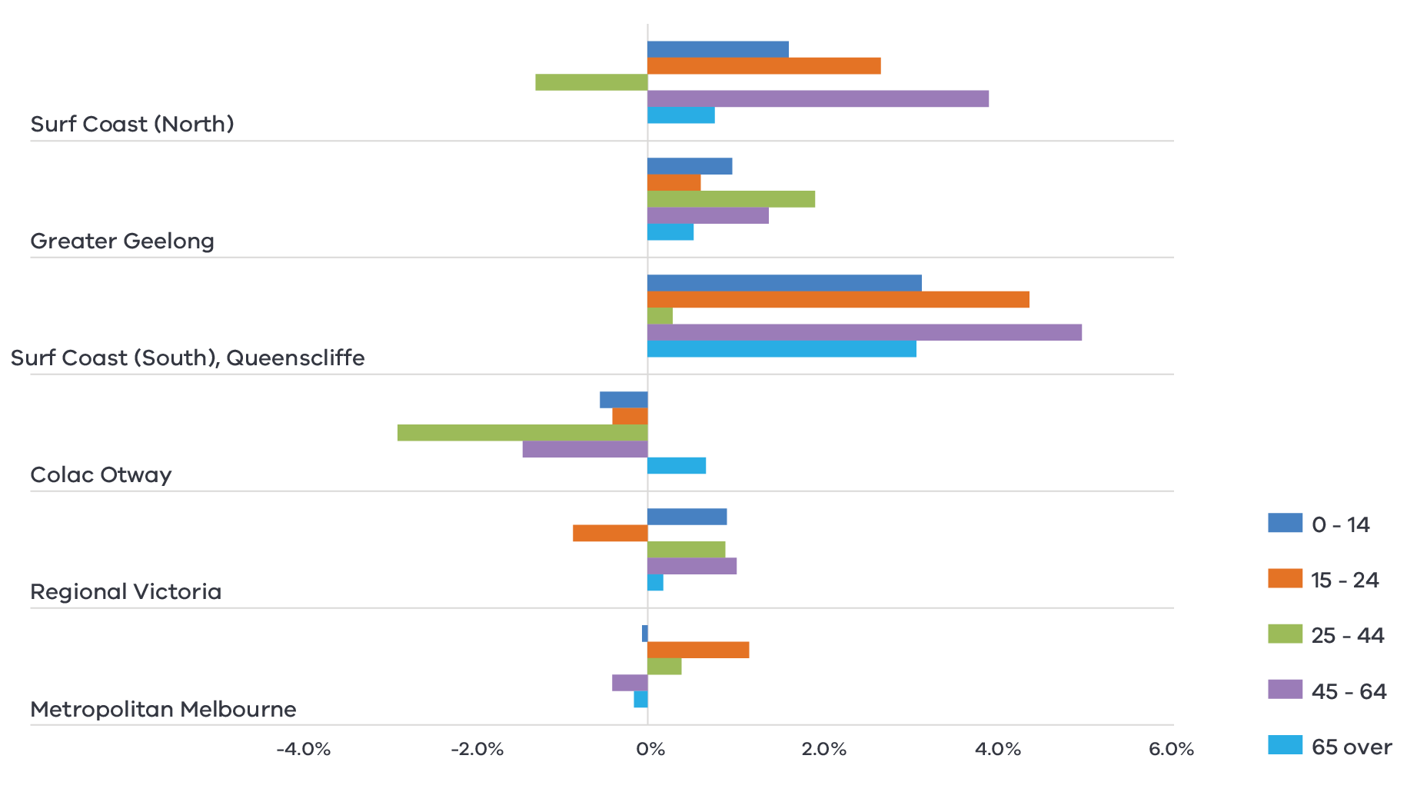

Figure 10 Net internal migration (proportion by age group), annual average (2016–19)

Source: Australian Bureau of Statistics, 2021b

#### Education hub

The region’s network of learning institutions means it is a strategic education and training location for the future workforce of Victoria. The education and training sector is a major employer and has developed a strong reputation across a number of industries such as health, engineering and advanced manufacturing. Focusing the development of this industry by building an environment that is attractive to both domestic and international students as well as meeting the needs of future industries will position the region for long term growth.

#### Specialised knowledge and services

The cumulative effect of an expanding population and an influx of skilled workers opens up opportunities in services sectors that are not, by nature, dependent on population. Analysis suggests that financial, insurance, professional, scientific and technical services sectors are gaining momentum in the region in both output and employment and there is already a strong public administration sector. Cultivating the specialisation in these emerging sectors is a key opportunity for long term employment and output growth as they provide new service industries that are detached from the ebbs and flows of population growth.

### Challenges

#### Rapid population growth

The pace and size of population growth can bring significant challenges and pressures to an economy that may negate positive benefits. Rapid population growth puts pressure on accommodation markets, services and infrastructure that take time to respond to the increased demand. This can result in increased disadvantage for some cohorts. This was evident during the COVID-19 pandemic, when the region experienced the short-term impacts of rapid population growth through housing price increases and low availability.

#### Access to services

Parts of the region experience a high level of disadvantage, particularly in the more rural western areas and pockets within Geelong. Often these areas have lower rates of access to health and education services for a range of reasons including remoteness that risk further entrenching disadvantage.

### The policy environment

Maximising the economic benefit from the expanding service-based sectors in Barwon is closely aligned with state and local priorities. In particular:

* The City of Greater Geelong’s Greater Geelong: A Clever and Creative City is a visionary strategy underpinned by Geelong’s designation as a UNESCO City of Design. Sustainable development that supports population growth, a prosperous economy and jobs and education opportunities are key priorities of the strategy.
* The 2017 Geelong Economic Futures Report identifies commercialised international education and training in farming and agribusiness as a priority project for the region.
* Public Land Economic Stimulus programs, includes support for tourism, maintaining and upgrading public land facilities that support local trade, future tourism and restoration of the natural environment Central Geelong Framework is a document that will guide the future use and development of land in central Geelong area and provide specific directions for urban design of the area. The Structure Plan provides the vision and specific land use and development directions in the themes of land use, built environment, design and residential growth and housing choices.
* Several works and initiatives have been planned and progressed through the Revitalising Central Geelong Partnership including projects funded under the Geelong City Deal.

### Aboriginal inclusion

Service sectors such as health, food and retail are major employers of the region’s Aboriginal workforce. Growth in these sectors will likely improve employment outcomes for Aboriginal people, although targeted interventions may be required to increase participation in the education and training sector. As service sectors continue to expand with overall population growth, there are opportunities to close the overall gap in unemployment and labour participation between the Aboriginal and non-Aboriginal workforce. Traditional Owners have also identified economic opportunities for cultural services and targeted research in cultural land, water and sea management which align with this strategic direction.

### How can we unlock this strategic direction?

To unlock this opportunity and drive growth, local, state and Commonwealth partners could work together to:

* Seek to maintain and improve the liveability of the region to ensure it continues to be attractive for migration.
* Better coordinate housing and infrastructure developments to meet the current and future needs of residents and industry.
* Ensure the growth in service provision meets the needs of areas that are experiencing disadvantage.
* Advocate for national migration settings that support the placement of skilled workers and international students in regional areas.
* Encourage initiatives that support the specialisation in education, financial, professional, scientific and technical services.
* Encourage initiatives to increase the residential population in central Geelong.

## 4.5 Build a sustainable and climate-resilient economy

### Significance

The region is well positioned to play a leading role in Victoria’s transition to cleaner and more sustainable practices. By leveraging its regional strengths, endowments and an engaged community it can realise opportunities to develop and support the generation of clean fuels and energy as well as facilitate the shift to a circular economy.

Parts of the economy such as the tourism or agriculture industry rely on environmental inputs and conditions, directly or indirectly, which are already being affected by climate change. While mitigation of climate change and pollution through sustainable practices is the focus, there is a recognition that communities will need to adjust to the changing conditions. Building an economy and communities that can adapt to the new environmental conditions will be critical in the long term to manage economic risk and take advantage of opportunities for job creation, supply chain development and industry growth.

### Opportunities

#### Renewable hydrogen

The technology to develop renewable hydrogen as a sustainable energy storage and fuel source continues to evolve and improve. Early in 2021, National Energy Resources Australia designated the Greater Geelong area as a Hydrogen Technology cluster due to its unique access to renewable energy, water sources, skilled workforce, deep water ports, gas networks and research institutions. The region is positioned to be a major contributor in developing renewable hydrogen technology as well as commercialising for export and integrating into local supply chains. While still in its early stages, a renewable hydrogen industry will seek to build a more sustainable future and create economic opportunities through new employment and business growth.

**Figure 11: How renewable hydrogen is made and used**

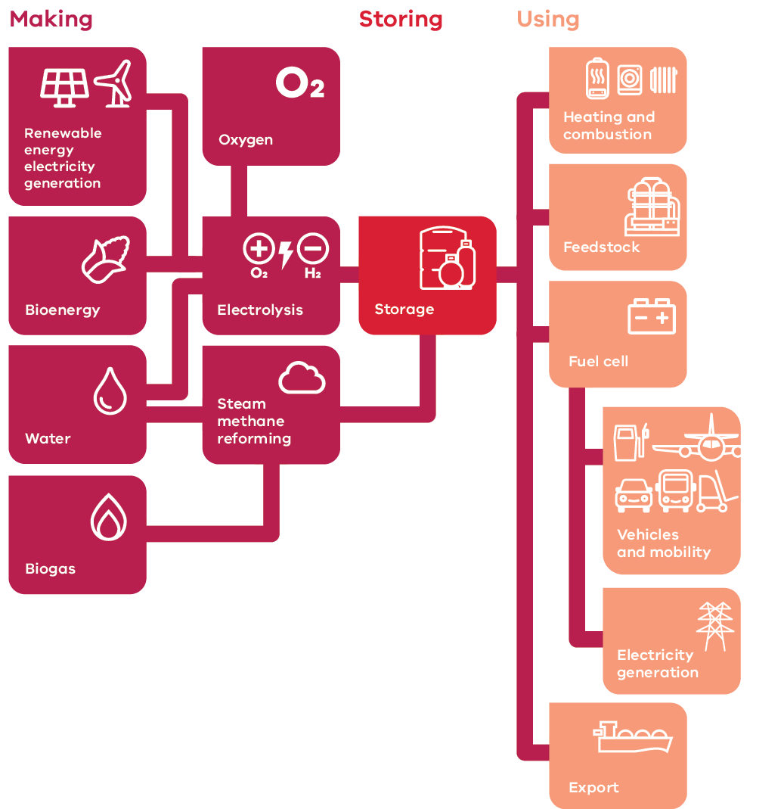

Figure 11 How renewable hydrogen is made and used – Long Alternate Text

Source: Victorian Renewable Hydrogen Industry Development Plan, 2021

**Renewable energy generation**

The region currently has over 200MW of renewable energy capacity currently deployed as existing rooftop solar, large-scale solar and wind farms with more generators approved or under construction. Many parts of Australia manage levels of rooftop solar vastly greater than what currently exists in the region, indicating that there is room for rooftop solar to meet a far greater proportion of the region’s electricity needs. Momentum is also building in the bioenergy market with opportunities to deploy further solutions throughout the region particularly across the agriculture sector.

**Figure 12: Proportion of households in Barwon with solar installed compared to other regions and states**

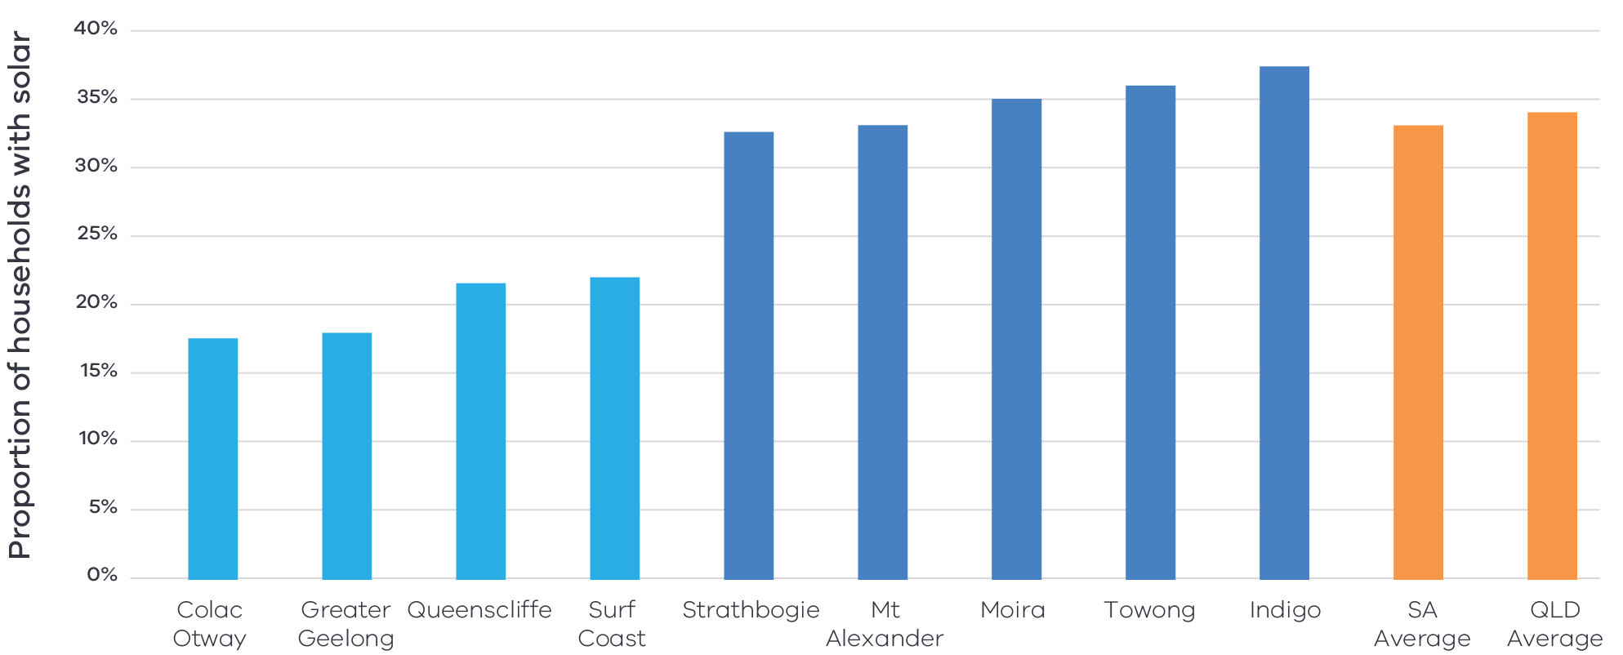

Figure 12 Proportion of households in Barwon with solar installed compared to other regions and states – Long Alternate Text

Source: Barwon South West Renewable Energy Roadmap, 2020

#### Resource recovery and recycling

There is strong community interest in supporting a zero-waste economy in the region. Geelong and the surrounding area has been identified as a potential location for recycling and resource recovery infrastructure facilities, building on the availability of accessible land and the proximity to Melbourne. There are opportunities and support for businesses in the region to develop solutions for increasingly complex waste disposal challenges, such as plastics, solar panels and batteries.

#### Adaptive practices

The region’s coastline is at the forefront of the impacts of a changing climate with forecast increased erosion events, storm surges and rising sea levels. Developing and implementing innovative coastal infrastructure solutions that protect the environment, infrastructure and retain the aesthetic beauty should be a priority for the future of the region’s visitor economy. As access to water becomes more scarce for industry and the environment, solutions for water security will need to be developed such as recycled water to support primary production, manufacturing or a future renewable hydrogen industry.

### Challenges

#### Equitable transition

Global experience suggests that the transition to a net zero emissions and zero waste economy does not automatically lead to broader and longer-term regional development outcomes. Successful ‘developmental spillover’ comes from policy which considers renewable energy and sustainable practices in a place-based, integrated perspective and encourages linkages to the wider regional economy. Ensuring that the benefit of the transition is shared equitably amongst communities is a challenge that requires concerted effort.

#### Amenity impacts

Given the visual impact of renewable energy projects on regional landscapes, there remain concerns in sections of the community around investment in projects such as wind farms and the impact this might have on the visitor economy.

### The policy environment

Building a sustainable and climate-resilient economy is closely aligned with state and local priorities. In particular:

* Victoria’s Climate Change Strategy provides a roadmap towards net-zero emissions by 2050. It includes interim targets to reduce emissions and pledges for energy, agriculture, transport, waste and forestry sectors.
* The Barwon South West Renewable Energy Roadmap describes the current and future renewable capabilities of the region identifying solar and bioenergy as key priorities for the region and hydropower as an emerging opportunity.
* The Victorian Renewable Hydrogen Industry Development Plan sets out a blueprint to capitalise on renewable hydrogen’s economic opportunity, including creating long-term jobs and new career pathways and enabling the state’s transition to net-zero emissions.
* The City of Greater Geelong’s Greater Geelong: A Clever and Creative City details the ambition of the region to be carbon-neutral and be at the forefront of developing and implementing sustainable solutions.
* Victoria’s Recycling Victoria: A new economy is the state’s circular economy policy and 10-year action plan to reduce waste and pollution and improve recycling in a way which delivers economic benefit.
* The Cleantech Innovations Geelong initiative (funded by the Victorian Government, Geelong Manufacturing Council and the City of Greater Geelong) aims to develop markets for clean technologies.
* The Victorian government has a suite of state-wide policies and initiatives to support the State’s energy sector to transition to net-zero emissions, which are available on [energy.vic.gov.au](http://www.energy.vic.gov.au).

### Aboriginal inclusion

Local Traditional Owners are focused on maximising benefits from investments in renewable energy projects. The Wadawurrung Healthy Country Plan aims for Wadawurrung wind farms to be generating income and employment by 2027. Increased investment in the renewable energy sector and the circular economy is likely to create employment opportunities in the construction, energy and waste services and professional, scientific and technical services industries.

### How can we unlock this strategic direction?

To unlock this opportunity and drive growth, local, state and Commonwealth partners could work together to:

* Encourage the uptake of rooftop solar for both households and businesses to realise the full potential of the region’s generation capabilities.
* Foster a culture of innovation that explores new opportunities and provides solutions to local and external renewable energy challenges.
* Plan for a wide range of possible futures to build the region’s resilience towards uncertain conditions.
* Promote the use of Traditional Owner cultural practices and ownership of economic activity in renewable energy.
* Ensure solutions to renewable energy challenges are equitable, just and fair for all.

# 05 Implementation

The Barwon REDS outlines the Rural and Regional Victoria (RRV) Group’s strategic approach for focusing its future economic development activities, including through policy, investment and program delivery, in the region. It is not a prescriptive roadmap for Victorian Government economic development action in Barwon.

## RRV will use the REDS to coordinate investments and activities in place

RRV is committed to pursuing the strategic directions through future policy design, investment and program implementation, as well as through collaboration across government and with regional partnerships, to deliver positive economic outcomes for the region.

RRV recognises that effective planning policy and controls will be a key enabler of inclusive, sustainable economic growth in the Barwon region. Victoria’s Regional Growth Plans provide broad direction for land use and development, and enable economic growth by ensuring that infrastructure investment is coordinated, appropriate services are provided, and development meets community expectations. The Regional Development and Planning portfolios will pursue opportunities to ensure that as relevant state-led land use planning strategies, policies and controls are updated, they are aligned with the REDS strategic directions.

In regional cities and peri-urban towns with shortages of zoned land (as identified through the Urban Development Program), councils should consider asking the Minister for Planning to appoint the Victorian Planning Authority to lead structure planning and rezoning for designated areas.

## Local stakeholders, industry leaders and government service providers can use the RED to advocate for shared outcomes

The Barwon REDS, along with the supporting Barwon Regional Economic Development Strategy – Supporting Analysis document, provides a starting point for an evidence-based, strategic approach to regional development. This approach is an ongoing process where specific development actions and projects can be proposed and considered in the context of alignment with the REDS.

Regional Development Victoria – Barwon South West will remain the main point of contact in the region for facilitating and coordinating regional development outcomes.

The Barwon Regional Partnership which comprises community and business leaders, CEOs of constituent Local Governments, State Government personnel and representatives from Regional Development Australia will continue to be the main advisory body to the Minister for Regional Development and other government decision-makers on local issues and priorities.

The Barwon REDs will provide Jobs Victoria with important context and understanding of local economic priorities and opportunities that will be a critical input into the planning and prioritisation of Jobs Victoria’s work and collaboration activities with our Service Partners. Jobs Victoria assists people looking for work, connects employers with the staff they need, administers wage subsidy programs and supports significant local employment transitions.

## RRV will monitor the implementation of the REDS

The strategic directions in this REDS focus on medium- to long-term drivers of growth and opportunity but will be used immediately to guide investment in the region. Notwithstanding this timeframe, the strategic directions will continue to evolve and progress as actions and investments are made. To ensure ongoing relevance and accuracy, Rural and Regional Victoria will periodically update and refresh this REDS.

## Contact us

Department of Jobs, Precincts and Regions

Level 31, 121 Exhibition Street, Melbourne, VIC 3000

T: +61 (03) 9651 9999

[djpr.vic.gov.au](https://djpr.vic.gov.au/)

Authorised and published by the Victorian Government.

Department of Jobs, Precincts and Regions  
Level 31, 121 Exhibition Street,   
Melbourne, VIC 3000  
Telephone (03) 9651 9999

March 2022

Unless indicated otherwise, this work is made available under the terms of the Creative Commons Attribution 3.0 Australia Licence. To view a copy of this licence, visit [creativecommons.org/licenses/by/3.0/au](https://creativecommons.org/licenses/by/3.0/au/)

It is a condition of this Creative Commons Attribution 3.0 Licence that you must give credit to the original author who is the State of Victoria.

ISBN 978-1-76090-553-8 (Print)

ISBN 978-1-76090-554-5 (pdf/online/MS word)

# Appendix

## Figure 1: Map of Regional Partnerships – Long Alternate Text

The **Mallee** region is located in northwest Victoria and contains the LGAs of Mildura, Swan Hill, Buloke and Gannawarra.

The **Wimmera Southern Mallee** region is located in western Victoria and contains the LGAs of West Wimmera, Hindmarsh, Yarriambiack, Horsham and Northern Grampians.

The **Great South Coast** region is located in southwest Victoria and contains the LGAs of Glenelg, Southern Grampians, Moyne, Warrnambool and Corangamite.

The **Barwon** region is located to southwest of metropolitan Melbourne and contains the LGAs of Geelong, Queenscliffe, Surf Coast and Colac Otway.

The **Central Highlands** region is to the west of metropolitan Melbourne and contains the LGAs of Ararat, Pyrenees, Golden Plains, Moorabool. Ballarat and Hepburn.

The **Loddon Campaspe** region is northwest of metropolitan Melbourne and contains the LGAs of Macedon Ranges, Mount Alexander, Central Goldfields, Loddon Campaspe and Bendigo.

The **Goulburn** region is north of metropolitan Melbourne and contains the LGAs of Mitchell, Murrindindi, Strathbogie, Greater Shepparton and Moira.

The **Ovens Murray** region is located in the northeast of Victoria and contains the LGA’s of Mansfield, Benalla, Wangaratta, Alpine, Indigo, Towong and Wodonga.

The **Gippsland** region is located in the east of Victoria and contains the LGAs of Bass Coast, South Gippsland, Baw Baw, Latrobe, Wellington and East Gippsland.

Click here to return to document

## Figure 2 Map of Barwon – Long Alternate Text

The Barwon region is made up of the Geelong, Queenscliffe, Surf Coast and Colac Otway Local Government Areas.

The Barwon region has major rail and road connections to Melbourne, an airport in Geelong and sea ports at Geelong, Portarlington, Point Lonsdale and Apollo Bay.

Geelong is a hub for the region with rail, road and sea connections to Melbourne and other towns in the region.

Towns between Colac and Geelong (Birregurra, Winchelsea, Moriac, Armstrong Creek) are connected by both road and rail, while coastal towns (Geelong, Portarlington, Queenscliff, Ocean Grove, Torquay, Angelsea, Lorne, Apollo Bay) are connected by major roads.

Click here to return to document

## Figure 3 Barwon industry Employment (2001–20) – Long Alternate Text

The largest employing industries in descending order are Health Care and Social Assistance, Retail Trade, Construction, Education and Training, Manufacturing, Public Administration and Safety, Accommodation and Food Services, Professional, Scientific and Technical Services, Other Services, Transport, Postal and Warehousing.

The following industries have grown in employment since 2001; Health Care and Social Assistance, Retail Trade, Construction, Education and Training, Public Administration and Safety, Accommodation and Food Services, Professional, Scientific and Technical Services, Other Services, Transport, Postal and Warehousing.

The following industry has declined in employment since 2001; Manufacturing.

Simplified Table of data for Figure 3.

| **Values** | **Health Care and Social Assistance** | **Retail Trade** | **Construction** | **Education and Training** | **Manufacturing** | **Public Administration and Safety** | **Accommodation and Food Services** | **Professional, Scientific and Technical Services** | **Other Services** | **Transport, Postal and Warehousing** |
| --- | --- | --- | --- | --- | --- | --- | --- | --- | --- | --- |
| 2001 | 11589 | 12857 | 6495 | 7377 | 13496 | 3874 | 6930 | 4216 | 3912 | 3058 |
| 2002 | 11915 | 13760 | 7313 | 7976 | 13358 | 4076 | 7103 | 4076 | 4002 | 3171 |
| 2003 | 12179 | 13653 | 7739 | 8276 | 13811 | 4059 | 7382 | 4127 | 3994 | 3381 |
| 2004 | 12155 | 13652 | 8145 | 8178 | 13894 | 4243 | 7419 | 4124 | 3829 | 3534 |
| 2005 | 12144 | 13907 | 9262 | 8326 | 14028 | 4595 | 7502 | 4176 | 3786 | 3618 |
| 2006 | 12926 | 14523 | 9920 | 8692 | 13924 | 4961 | 7715 | 4259 | 4008 | 3827 |
| 2007 | 13922 | 15056 | 10242 | 9213 | 14004 | 5247 | 8365 | 4569 | 4059 | 4074 |
| 2008 | 14549 | 15306 | 10663 | 9603 | 13906 | 5401 | 8496 | 4772 | 4188 | 4022 |
| 2009 | 15197 | 15440 | 10184 | 9879 | 13635 | 5487 | 8635 | 4801 | 4159 | 4062 |
| 2010 | 16194 | 15363 | 10207 | 10187 | 13209 | 5598 | 8952 | 4990 | 4205 | 4136 |
| 2011 | 16633 | 15525 | 11123 | 10541 | 12631 | 5761 | 9194 | 5254 | 4306 | 4097 |
| 2012 | 16960 | 15643 | 11067 | 10868 | 12345 | 5828 | 9394 | 5426 | 4381 | 3988 |
| 2013 | 17916 | 15694 | 11466 | 11288 | 11971 | 6021 | 9709 | 5609 | 4477 | 3998 |
| 2014 | 18643 | 15486 | 11298 | 11402 | 11085 | 6123 | 9785 | 5649 | 4455 | 3983 |
| 2015 | 19169 | 15657 | 11598 | 12102 | 10593 | 6330 | 10055 | 5824 | 4511 | 4006 |
| 2016 | 20424 | 16084 | 11786 | 12707 | 10224 | 6599 | 10599 | 6128 | 4650 | 4100 |
| 2017 | 21401 | 17190 | 12003 | 12357 | 10827 | 7157 | 10588 | 6414 | 5067 | 4806 |
| 2018 | 21147 | 16469 | 12873 | 13003 | 11378 | 8190 | 10771 | 7015 | 4966 | 5465 |
| 2019 | 21084 | 17901 | 14129 | 14149 | 11217 | 9879 | 10689 | 7455 | 4957 | 5218 |
| 2020 | 22694 | 18760 | 14772 | 13975 | 11346 | 10298 | 10152 | 7518 | 5163 | 4697 |

Click here to return to document

## Figure 4 Barwon industry output (gross value add) 2001-20 – Long Alternate Text

The industries with the largest gross value add in 2020 in descending order are Construction, Health Care and Social Assistance, Manufacturing, Public Administration and Safety, Education and Training, Retail Trade, Financial and Insurance Services, Professional, Scientific and Technical Services, Transport, Postal and Warehousing, Electricity, Gas, Water and Waste Services.

The following industries have grown in gross value add since 2001; Construction, Health Care and Social Assistance, Public Administration and Safety, Education and Training, Retail Trade, Financial and Insurance Services, Professional, Scientific and Technical Services, Transport, Postal and Warehousing, Electricity, Gas, Water and Waste Services.

The following industry has declined in gross value add since 2001; Manufacturing.

Simplified table of data for Figure 4. Data in this table is in ($) millions.

|  | **Construction** | **Health Care and Social Assistance** | **Manufacturing** | **Public Administration and Safety** | **Education and Training** | **Retail Trade** | **Financial and Insurance Services** | **Professional, Scientific and Technical Services** | **Transport, Postal and Warehousing** | **Electricity, Gas, Water and Waste Services** |
| --- | --- | --- | --- | --- | --- | --- | --- | --- | --- | --- |
| 2001 | 613 | 729 | 1951 | 475 | 694 | 520 | 414 | 376 | 367 | 379 |
| 2002 | 732 | 786 | 2031 | 546 | 734 | 583 | 439 | 413 | 393 | 377 |
| 2003 | 830 | 842 | 2285 | 535 | 784 | 596 | 447 | 421 | 428 | 377 |
| 2004 | 838 | 869 | 2489 | 506 | 788 | 638 | 450 | 419 | 447 | 409 |
| 2005 | 1049 | 847 | 2741 | 514 | 792 | 663 | 471 | 402 | 441 | 456 |
| 2006 | 1118 | 900 | 2351 | 564 | 811 | 679 | 475 | 412 | 469 | 413 |
| 2007 | 1147 | 971 | 2357 | 587 | 836 | 727 | 524 | 437 | 493 | 355 |
| 2008 | 1190 | 997 | 2563 | 565 | 863 | 777 | 560 | 446 | 516 | 397 |
| 2009 | 1179 | 1065 | 2510 | 573 | 904 | 821 | 541 | 488 | 527 | 433 |
| 2010 | 1118 | 1178 | 2363 | 585 | 930 | 808 | 571 | 488 | 506 | 426 |
| 2011 | 1206 | 1161 | 2296 | 578 | 971 | 831 | 604 | 529 | 503 | 376 |
| 2012 | 1246 | 1164 | 2066 | 598 | 1009 | 850 | 625 | 544 | 497 | 355 |
| 2013 | 1285 | 1212 | 1977 | 615 | 1031 | 862 | 641 | 565 | 505 | 356 |
| 2014 | 1308 | 1303 | 2004 | 660 | 981 | 860 | 661 | 556 | 503 | 353 |
| 2015 | 1445 | 1385 | 1746 | 681 | 987 | 892 | 674 | 557 | 480 | 383 |
| 2016 | 1481 | 1450 | 1510 | 711 | 989 | 930 | 706 | 608 | 496 | 483 |
| 2017 | 1494 | 1510 | 1491 | 782 | 1037 | 977 | 727 | 657 | 553 | 464 |
| 2018 | 1568 | 1623 | 1476 | 904 | 1076 | 976 | 840 | 724 | 602 | 394 |
| 2019 | 1798 | 1740 | 1421 | 1080 | 1199 | 1051 | 888 | 749 | 562 | 419 |
| 2020 | 1890 | 1803 | 1468 | 1173 | 1162 | 1115 | 844 | 752 | 509 | 468 |

Click here to return to document

## Figure 5 Barwon industry employment location quotient and growth – Long Alternate Text

The graph is divided into four quadrants.

The first quadrant identifies industries that are a) experiencing slower employment growth (or faster declines) than state averages and b) have higher levels of employment specialization than state averages

The following industries are in the first quadrant:

* Hospitals
* Social Assistance services

The second quadrant identifies industries that are a) experiencing faster employment growth (or slower declines) than state averages and b) have higher levels of employment specialization than state averages.

The following industries are in the second quadrant:

* Accommodation
* Accommodation and Food Services
* Construction
* Education and Training
* Agriculture
* Public Order, Safety and Regulatory Services
* Preschool and School Education
* Retail Trade
* Other Store-Based Retailing
* Residential Care Services
* Building, Cleaning, Pest Control and Other Services,
* Public Administration and Safety
* Fuel Retailing
* Motor Vehicle and Motor Vehicle Parts Retailing

The third quadrant identifies industries that are a) experiencing slower employment growth (or faster declines) than state averages and b) have lower levels of employment specialization than state averages.

The following industries are in the third quadrant:

* Manufacturing
* Professional, Scientifical and Technical Services

The fourth quadrant identifies industries that are a) experiencing faster employment growth (or slower declines) than state averages an b) have lower levels of employment specialization than state averages.

There are no industries in the fourth quadrant.

Click here to return to document

## Figure 6 Barwon industry output (GVA) location quotient and growth – Long Alternate Text

The graph is divided into four quadrants.

The first quadrant identifies industries that are a) experiencing slower GVA growth (or faster declines) than state averages and b) have higher levels of GVA specialization than state averages.

The following industries are in the first quadrant 1:

* Manufacturing
* Accommodation and Food Services

The second quadrant identifies industries that are a) experiencing faster GVA

growth (or slower declines) than state averages and b) have higher levels of GVA specialization than state averages.

The following industries are in the second quadrant:

* Construction
* Education and Training
* Agriculture, Forestry and Fishing
* Retail Trade
* Other Services
* Electricity, Gas, Water and Waste Services

The third quadrant identifies industries that are a) experiencing slower GVA

growth (or faster declines) than state averages and b) have lower levels of GVA specialization than state averages.

The following industries are in the third quadrant:

* Rental, Hiring and Real Estate Services
* Arts and Recreation
* Administrative and Support Services
* Professional and Scientific Services
* Mining
* Information Media and Telecommunications

The fourth quadrant identifies industries that are a) experiencing faster GVA growth (or slower declines) than state averages an b) have lower levels of GVA specialization than state averages.

The following industries are in the fourth quadrant:

* Transport, Postal and Warehousing
* Wholesale Trade
* Financial and Insurance Services

Click here to return to document

## Figure 7 Agricultural land use in Barwon – Long Alternate Text

This is a map showing agricultural activities across the Barwon region.

The Barwon region has several agricultural areas. Dairy farming and beef cattle farming take place in much of the west and south of the region (around Colac), with some concentration of poultry/chicken near Winchelsea and vegetable growing near both Colac and Geelong. Food processing also occurs in both Colac and Geelong.

Click here to return to document

## Figure 8 Barwon visitor expenditure by visitor type (2015-2020) – Long Alternate Text

The largest source of visitor expenditure in Barwon is Domestic overnight, intrastate visitors followed by Domestic Day trips. Both forms of expenditure experienced steady growth between 2015 and 2019 before dropping significantly in 2020.

Domestic overnight interstate and international overnight visitors have lower expenditure. They both experienced some growth between 2015 and 2019 and similarly dropped in 2020.

Simplified table of data for figure 8. Data in this table is in ($) millions.

|  |  |  |  |  |  |  |
| --- | --- | --- | --- | --- | --- | --- |
| **Year ending March** | **2015** | **2016** | **2017** | **2018** | **2019** | **2020** |
| Domestic daytrip | 352 | 414 | 429 | 562 | 600 | 535 |
| Domestic Overnight Interstate | 190 | 111 | 160 | 183 | 171 | 219 |
| Domestic Overnight Intrastate | 686 | 749 | 824 | 771 | 913 | 1,058 |
| International overnight | 90 | 110 | 107 | 154 | 147 | 106 |

Click here to return to document

## Figure 9 Barwon visitor numbers by visitor type (2015-2020) – Long Alternate Text

The largest source of visitor numbers in Barwon is Domestic overnight, intrastate visitors followed by Domestic Day trippers. Both experienced steady growth between 2015 and 2019 before dropping significantly in 2020.

Domestic overnight interstate and international overnight visitors were significantly lower.

Simplified table of data for figure 8.

|  |  |  |  |  |  |  |
| --- | --- | --- | --- | --- | --- | --- |
| **Year ending March** | **2015** | **2016** | **2017** | **2018** | **2019** | **2020** |
| Domestic daytrip | 4,160,000 | 4,684,000 | 5,256,000 | 5,807,000 | 6,314,000 | 6,053,000 |
| Domestic overnight *Interstate* | 347,000 | 232,000 | 323,000 | 321,000 | 349,000 | 435,000 |
| Domestic overnight *Intrastate* | 1,908,000 | 2,079,000 | 2,213,000 | 2,271,000 | 2,732,000 | 2,625,000 |
| International overnight | 118,000 | 148,000 | 158,000 | 156,000 | 179,000 | 162,000 |

Click here to return to document

## Figure 10 Net internal migration (proportion by age group), annual average (2016–19)

|  |  |  |  |  |  |
| --- | --- | --- | --- | --- | --- |
|  | **0–14** | **15–24** | **25–44** | **45–64** | **65 and over** |
| Surf Coast (North) | 2.9% | -1.6% | 4.4% | 0.8% | 0.1% |
| Greater Geelong | 0.5% | 1.7% | 1.4% | 0.6% | 0.6% |
| Surf Coast (South), Queenscliffe | 4.8% | 1.1% | 5.3% | 3.3% | 1.6% |
| Colac-Otway | -0.4% | -2.8% | -1.2% | 0.5% | -0.3% |
| Regional Vic | 1.0% | -0.7% | 0.9% | 1.1% | 0.2% |
| Metro Melbourne | -0.1% | 1.0% | 0.4% | -0.4% | -0.1% |

Click here to return to document

## Figure 11 How renewable hydrogen is made and used – Long Alternate Text

This infographic shows a high-level snapshot of how renewable hydrogen is made and used. It highlights two processes: electrolysis (which may have the following inputs: renewable energy electricity generation, bioenergy, water, oxygen) and steam methane reforming (which may have the following inputs: water and biogas). After it is made renewable hydrogen can be stored and used for the following purposes: heating and combustion, feedstock, fuel cells (for vehicles and mobility or electricity generation), export.

Click here to return to document

## Figure 12 Proportion of households in Barwon with solar installed compared to other regions and states – Long Alternate Text

This graph compares the proportion of households with solar in the Barwon region’s Local Government Areas (LGAs) with other LGAs across Victoria and with the state average in South Australia and Queensland.

The following LGAs have between 15 and 25% of households with solar power:

* Colac Otway
* Greater Geelong
* Queenscliffe
* Surf Coast

The following Victorian LGAs have between 30 and 40% of households with solar power:

* Strathbogie
* Mount Alexander
* Moira
* Towong
* Indigo

South Australia and Queensland on average similarly have 30-35% of households with solar power.

Click here to return to document

1. Australian Bureau of Statistics, 2021
2. *Victoria in Future 2020, Department of Environment, Land, Water and Planning*. The COVID pandemic has changed Victoria’s population pathway from near-record growth levels to population losses. However, Victoria’s regions appear to have experienced little disruption to growth patterns. Migration from Melbourne to the regions has been at record levels according to the latest ABS data, offsetting most regional losses to overseas or interstate. There remains considerable uncertainty around the distribution of the increased regional migration, and the permanence of this trend, but available evidence points to continuing regional growth. Data from the 2021 Census will be vital in determining the impacts on the strongest migration attractors (eg regional centres and peri-urban areas) versus those regions which may have experienced losses from the temporary migrant workforce. Given available information, the current projections remain fit for purpose for regional planning.
3. National Skills Commission, 2022
4. ABS Census, 2016
5. National Institute of Economic and Industry Research, 2020
6. Thomas, J. B.-J. (2021). Australian Digital Inclusion Index.
7. Regional Wellbeing Survey, 2020
8. Department of Education and Training, 2021
9. ABS Census, 2016
10. RRV analysis, SQM, 2021
11. DHHS rental Report, June Quarter, 2021
12. Department of Environment, Land, Water and Planning, 2019, *Barwon Climate Projection 2019* (based on ‘high emissions’ scenario where 2050s refers to the period from 2040 to 2059)
13. Includes Aboriginal and/or Torres Strait Islander