Mallee

Regional Economic Development Strategy

**State Government of Victoria**

**Department of Jobs, Precincts and Regions**

**Acknowledgement of Country**

The Department of Jobs, Precincts and Regions acknowledge the Traditional Owners of the lands and waters on which we live and work, and pay our respects to their Elders past, present and emerging.

We acknowledge that the Mallee Regional Partnership region is on traditional lands, including those lands of the First Peoples of the Millewa-Mallee (being Latji Latji, Ngintait and Nyeri Nyeri Traditional Owners), the Wotjobaluk, Jaadwa, Jadawadjali, Wergaia and Jupagalk Nations and Dja Dja Wurrung and Yorta Yorta People, as well as other Traditional Owner groups in Victoria who are not formally recognised.

We acknowledge the diversity of Aboriginal Victorians, their communities and cultures, the intrinsic connection to Country, the contribution and interest of Aboriginal people and organisations in developing a prosperous region. This Strategy is committed to advancing the principles of Aboriginal self-determination and supporting communities to realise self-determined economic development objectives.

# Preface

Rural and regional Victoria is home to 1.6 million, or 1 in 4, of Victoria’s residents and over 147,000 businesses. The Victorian Government is committed to making Victoria home to the nation’s most vibrant and successful regional economies.

The Department of Jobs, Precincts and Regions (DJPR) is delivering Regional Economic Development Strategies (REDS) for Victoria’s nine Regional Partnership regions. The REDS contribute to DJPR’s vision for regional Victoria to be a resilient and thriving place to live, work and do business. The REDS provide a consistent socioeconomic evidence base, and strategic framing of medium- to long-term directions to activate economic development opportunities.

**The REDS seek to:**

1. Identify a socioeconomic evidence base for the region, including demographics, business and industry dynamics, and local endowments that can be used by all stakeholders, and will provide a baseline for monitoring future performance.
2. Acknowledge and reveal the depth of work, analysis, and planning already in place in regions and create a mechanism to support and progress established regional directions, where supported by the current evidence base.
3. Harness and enhance the region’s comparative advantages as drivers of growth in the medium- to long-term.
4. Identify opportunities for public and private investment.
5. Influence and inform rural and regional economic policy and program design across government.
6. Support the prosperity and well-being of rural and regional Victoria through increased rural competitiveness and productivity.

The REDS do not replace existing local strategies. Rather, the REDS are informed by local work to identify economic development priorities and provide a platform to increase the visibility of these priorities and support regional communities to advocate for shared outcomes.

## How have the REDS been developed?

The REDS have been developed using a consistent methodology across the state, comprising:

* data analysis to consistently describe each region’s industry composition, economic and socioeconomic trends and existing regional endowments
* policy analysis to identify existing local strategies and plans to understand regional development priorities and shape an economic narrative for the region

stakeholder engagement to identify opportunities and challenges under each strategic direction.

## How can I use the REDS?

The REDS can be used by all levels of Government, regional communities and business to coordinate investment and collaborate for shared outcomes.

DJPR will use the REDS to drive strategic whole-of-government activity in the regions, informed by a contemporary understanding of economic performance and comparative advantage.

Regional communities and businesses can use the REDS to:

* communicate innovative capacity in their region, now and in the future
* collaborate with government to better understand regional strengths, challenges and opportunities

attract investment to the region based on clearly identified strategic priorities.

The REDS should be read in conjunction with the relevant REDS Supporting Analysis which provides the consistent evidence base for each region.

**Figure 1: Map of Regional Partnership Regions and Constituent LGAs**

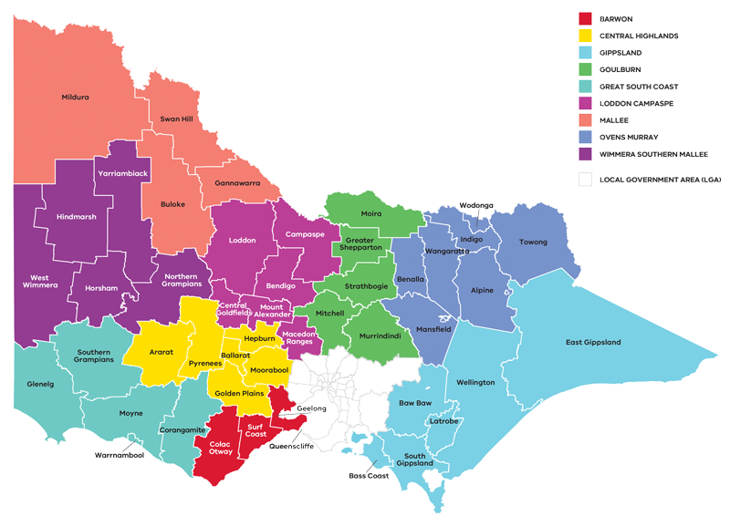

Figure 1: Map of Regional Partnerships – Long Alternate Text

Contents

01 Introduction 4

02 Regional profile 7

03 Comparative advantage 11

3.1 Endowments 11

3.2 Revealed industry specialisation 14

04 Strategic directions 17

4.1 Drive sustainable growth in the food industry 20

4.2 Leverage natural endowments to diversify the economy into emerging industries 25

4.3 Enhance the visitor economy by developing natural, cultural and built attractions 30

4.4 Ensure an accessible and suitably qualified workforce to unlock the growth potential 35

4.5 Harness the economic potential of the region’s cross-border zones 38

05 Implementation 42

Appendix 44

# 01 Introduction

The *Mallee Regional Economic Development Strategy* (the Mallee REDS) lays out the medium to long-term strategic directions for driving economic growth and development across the region.

The Mallee Regional Partnership region (the region) is situated in the northwest corner of Victoria comprising the local government areas of Mildura Rural City, Swan Hill Rural City, Gannawarra Shire and Buloke Shire. The region is home to Latji Latji, Ngintait, Nyeri Nyeri, Wotjobaluk, Jaadwa, Jadawadjali, Wergaia, Jupagalk, Barengi Gadjin, Dja Dja Wurrung, Taungurung and Yorta Yorta Nations who have lived, worked and cared for their lands and waters for thousands of years.

Bounded by New South Wales to the north and South Australia to the west, the region is home to some of Victoria’s most remote communities whose residents live several hours by road from capital cities. For three of the region’s four LGAs, prosperity is driven by their proximity to the Murray River. The region’s two regional cities, Mildura and Swan Hill, are located on the river’s banks and the waterway remains vital for driving economic, sociocultural, and environmental outcomes. Agriculture and related industries such as food and beverage manufacturing are the principal engines for economic activity. Areas proximate to the Murray typically produce horticultural goods while inland areas focus on dryland farming for commodities such as grains. The sunny climate and water infrastructure which support this ‘agri-food’ sector also underpins the region’s growing renewable energy industry. Sharing borders with South Australia and New South Wales, the region is home to key road, rail and air infrastructure, with the main freight route between Adelaide and Sydney passing through the Mildura LGA.

## Strategic directions

The Mallee REDS identifies five strategic directions for economic development in the region, based on comprehensive data analysis, a review of existing policies and strategies, and stakeholder engagement:

1. Drive sustainable growth in the food industry
2. Leverage natural endowments to diversify the economy into emerging industries
3. Enhance the visitor economy by developing natural, cultural and built attractions
4. Ensure an accessible and suitably qualified workforce to unlock the growth potential
5. Harness the economic potential of the cross-border zones.

For each of the directions, the Mallee REDS provides:

* a rationale for its inclusion as part of the strategy
* an overview of opportunities and challenges which are likely to support or hinder future growth
* a summary of the policy context to support desired outcomes
* the implication of the direction for the region’s Aboriginal communities

examples of how the direction could be activated.

The Mallee REDS recognises that approaches to regional economic development occur in an uncertain environment. While most of the analysis focuses on internal development drivers, it also considers the impact of, and opportunities emerging due to external trends, including the COVID-19 pandemic, patterns in global trade, climate change and technological advances.

The Mallee REDS acknowledges that the Aboriginal and cross-border communities within the Mallee face unique challenges and opportunities, which are also reflected in the strategic directions.

## Regional readiness to activate strategic directions

Continuous business innovation, specialisation and collaboration are key to building resilience and activating economic opportunities. There is strong evidence of innovation or innovative capacity across the region particularly in the food and energy industries.

Through continuous innovation, the region is proactively managing uncertainties related to climate, energy and labour availability. Several institutions and projects are already providing solutions, creating new processes and crafting new products that will underpin future economic success.

Some of the key institutions and projects that contribute to regional innovation include the:

* Mallee Regional Innovation Centre, which is a joint venture between the University of Melbourne, La Trobe University and the Sunraysia Institute of TAFE (SuniTAFE). The Centre aims to drive collaboration and promote innovation in practical research, development and adoption to address regional challenges in horticulture, energy and natural resource management
* Mallee Sustainable Farming and Birchip Cropping Group, which bring farmers and researchers together to build more efficient, profitable and sustainable farming businesses in the region
* ‘Internet of Things’ trials in Buloke Shire, covering Victoria’s major agriculture sectors of dairy, broad-acre cropping, meat production and horticulture to investigate issues from the network level through to end-user devices and on-farm machinery

SuniTAFE SmartFarm campus which comprises a fully operational, 30-hectare horticultural training institute in Mildura.

## Local priorities and strategies

The 2019 Mallee Economic Growth Strategy is the most contemporary body of work that has informed the REDS economic narrative and strategic directions. The strategy was developed by the Regional Development Australia Loddon Mallee committee in collaboration with the Mallee Regional Partnership and the community. It outlines focal investment areas for the region to guide current and future industries, invest in skills, build capability and leverage natural and physical infrastructure through a package of targeted investments.

The Mallee REDS also considers other State, regional and sub-regional policies and strategies as set out in the supporting documentation.

**Figure 2: Map of Mallee**

Map showing an overview of Mallee, with key transport infrastructure. A detailed description is provided via the link below.

Figure 2 Map of Mallee – Long Alternate Text

# 02 Regional profile

* $5.3 – Gross regional product (billion) (2020)
* 92,900 – Population (2020)
* 3.8% – Population growth (2011-20)
* 42 – Median age (2020)
* 60.9% – Working age (15-64) (2020)
* 20.4% – Population aged over 65 (2020)
* 3.5% – Are Aboriginal and/or Torres Strait Islander (2016)
* 9.5% – Speak a language other than English at home (2016)

11.2% – Were born overseas (2016)

Mildura and Swan Hill are the region’s major population centres. The region has realised slow population growth relative to average rates across regional Victoria, due in part to its remote location. However, Mildura and Swan Hill do service a larger population in the Riverland-Sunraysia and Central Murray cross-border zones respectively.

Migration data indicates that a significant number of local residents are migrating out of the region: young people (aged 15-24) are leaving at higher rates than the regional average. This has been largely offset by overseas migration and natural increase in the larger LGAs, but reliance on inflows of international workers presents a significant challenge, particularly in the short and medium term COVID-19 environment where migration flows are constrained.

| Local Government Area | Population (2020)[1] | Projected growth (2021–36)[2] |
| --- | --- | --- |
| Mildura | 55,900 | 10.4% |
| Swan Hill | 20,500 | -0.8% |
| Gannawarra | 10,400 | -5.3% |
| Buloke | 6,100 | -17.4% |

|  | Mallee % | Regional average % | Victorian Average % |
| --- | --- | --- | --- |
| Unemployment rate[3] (September 2021) | 3.3 | 4.2 | 6.0 |
| Labour force participation rate[4] (2016) | 60.3 | 60.9 | 65.8 |
| Average annual employment growth[5] (2011–20) | -0.1 | 1.0 | 2.1 |

The labour force participation rate in Mallee (60.3 per cent) is below the regional Victorian average. The female participation rate (55.5 per cent) is significantly lower than for men (65.4 per cent). The largest employing sectors for women are healthcare and social assistance, retail trade, education and training and accommodation and food services.

**Table 1: Employment in largest employing industries by workforce (2020) and gender (2016)**

|  | Workers | Male | Female |
| --- | --- | --- | --- |
| Healthcare and social assistance | 5,800 | 17.1% | 82.9% |
| Agriculture, forestry and fishing | 5,700 | 74.8% | 25.2% |
| Retail trade | 4,500 | 39.8% | 60.2% |
| Construction | 3,700 | 88.8% | 11.2% |
| Manufacturing | 3,500 | 73.7% | 26.3% |

Source: National Institute of Economic and Industry Research, 2020 and ABS Census, 2016

## Employment by industry

In 2020, there were 41,400 employed persons in the region. Agriculture, forestry and fishing[6] was the largest employing sector in the region until 2020, when it was overtaken by health care and social assistance. Consistent with trends across the state and supported by population growth and ageing, the health care industry has now become the major employment sector, currently employing 13.9 per cent of the region’s total workforce. Other population-driven sectors, including retail trade, education and training, and construction, have similarly experienced steady growth and are among the region’s six largest employing sectors.

The agriculture, forestry and fishing sector has experienced a steady decline in employment since 2003 with employment levels beginning to level out in 2013. Although underpinned by the region’s diverse production systems of irrigated horticulture, dryland cropping and livestock grazing, the sector has felt the impacts of the Millennium Drought and consolidation of farming enterprises, as well as technological advancements that have increased capital intensity in production.

**Figure 3: Mallee industry employment (2001-20)**

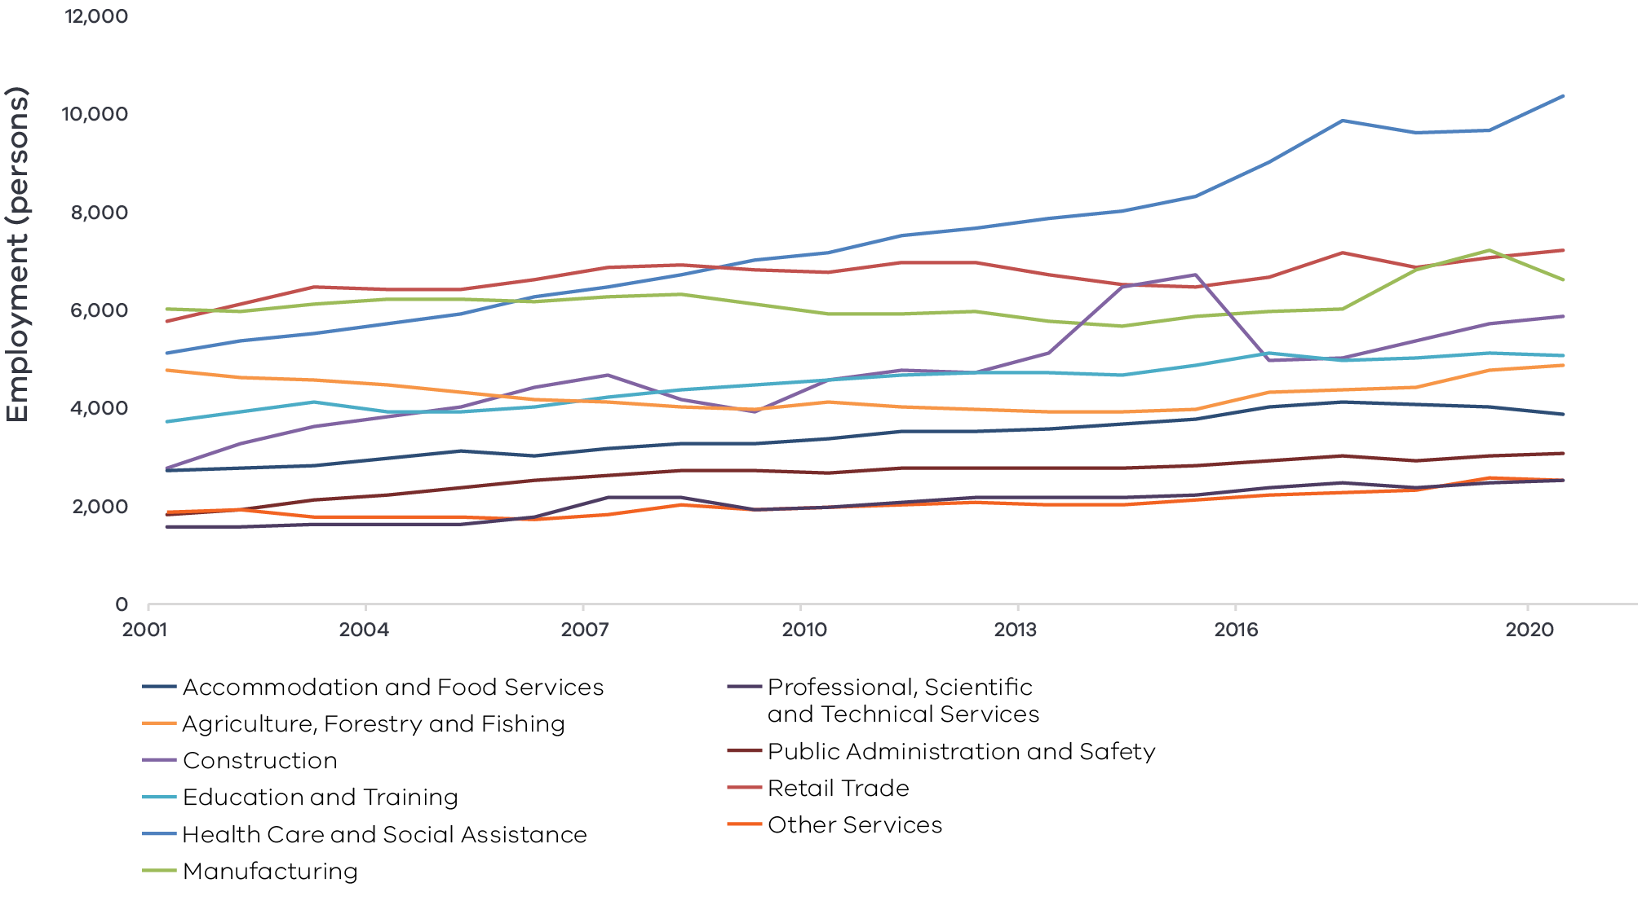

Figure 3 Mallee industry Employment (2001-20) – Long Alternate Text

Note: Top 10 employing industries in 2020 presented in chart, based on Journey to Work employment estimates.

Source: National Institute of Economic and Industry Research, 2020

## Output by industry

Total GVA has been in steady decline since 2001, particularly between 2012 and 2016 where GVA fell from $5.4 billion to $4.1 billion; it has since increased to $4.3 billion in 2020. The long-term trend has largely been driven by output declines for the region’s two largest industries—agriculture and manufacturing. Agriculture was negatively impacted by the Millennium drought, which led to significant structural changes in the sector. However, the long-term decline in GVA for agriculture has been less significant than employment declines in the sector (and declines in agricultural GVA for other regions), indicating that the industry has made productivity gains throughout the period, particularly with the increase in nut farming. Consistent with the employment growth story for population driven sectors, health and social assistance, construction and education and training have seen steady or stable output growth over the past 20 years.

### $4.3 billion Gross Value Added (GVA) (2020)

**Top sectors by GVA:**

1 Agriculture, forestry and fishing: $1,253.6

2 Health care and social assistance: $429.1

3 Public administration and safety: $326.7

4 Manufacturing: $303

5 Construction: $301

**Figure 4: Mallee industry output (Gross Value Add) (2001-2020)**

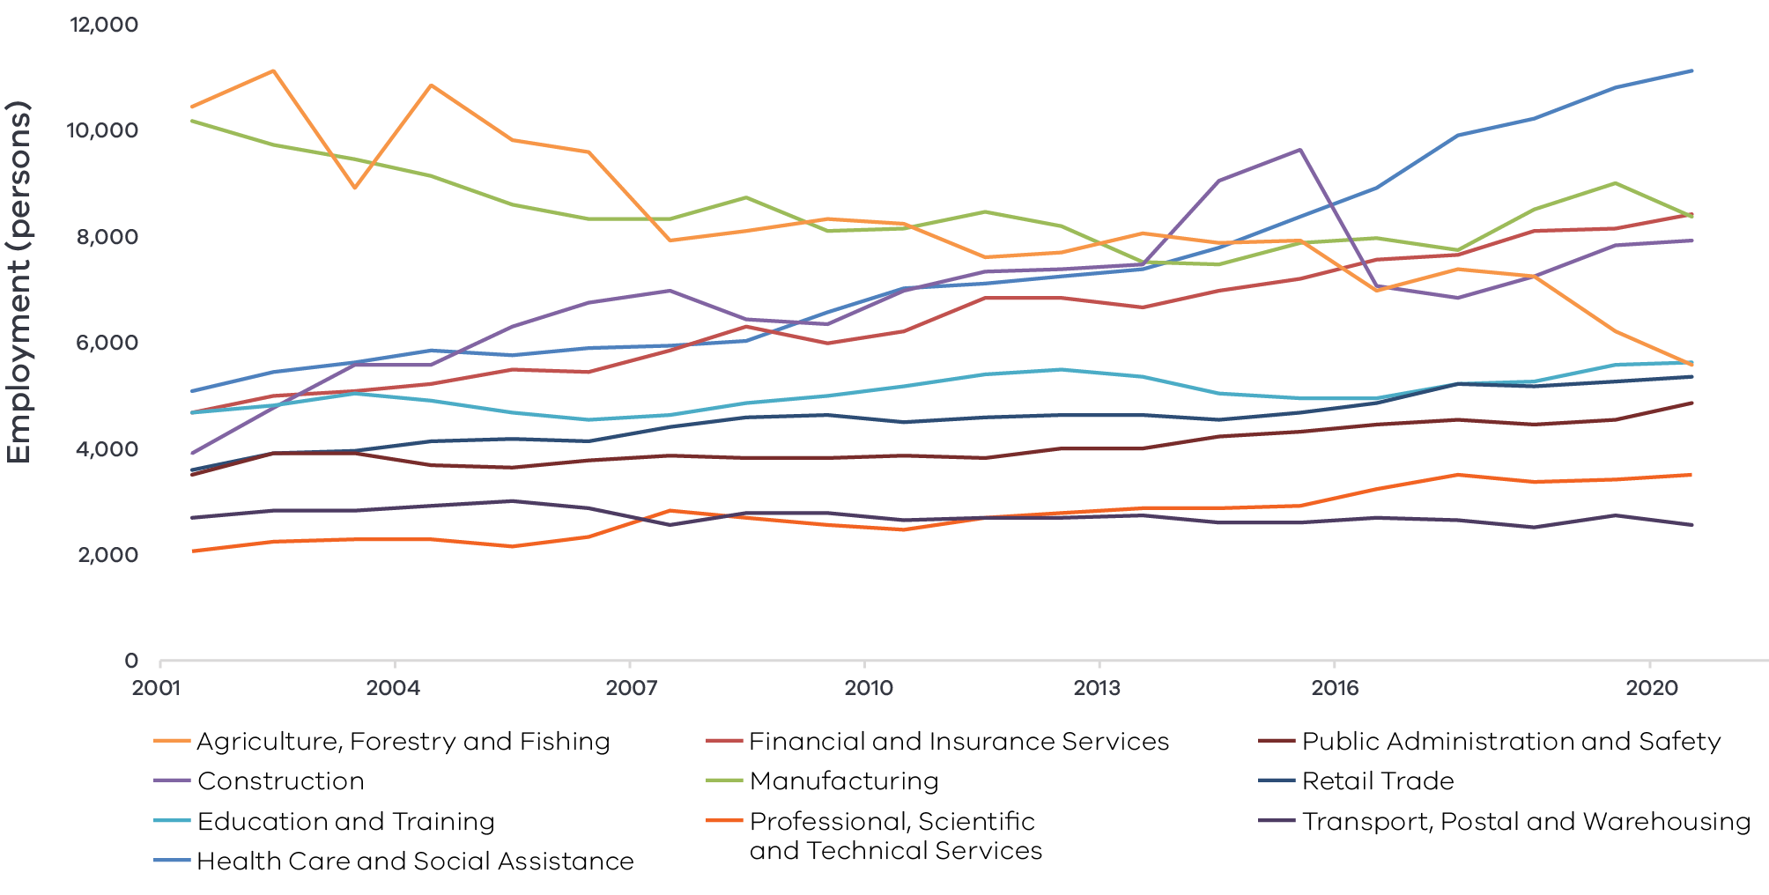

Figure 4 Mallee industry output (gross value add) – Long Alternate Text

*Source: National Institute of Economic and Industry Research, 2020*

## Regional exports

Industry in the region provides a strong connection to markets via major freight routes, and international demand for agricultural products supports the top export sectors (2020):

1. Agriculture, forestry and fishing: $529.3 million
2. Manufacturing: $211.6 million
3. Accommodation and food services: $91.9 million

# 03 Comparative advantage

For the purposes of the REDS, ‘comparative advantage’ is defined simply as a description of what the region does well compared to other regions. This includes both the relative competitiveness of the region’s businesses as well as cultural, social and environmental factors.

Contemporary place-based development emphasises the importance of local endowments as a driver of comparative advantage. In economic terms, endowments refer to any natural, human, cultural and built resources present in a place which can be harnessed to support economic activity. Regional economic strengths can also be identified using other measures including location quotient analysis, shift share analysis and industry cluster analysis. A comprehensive assessment of these measures is included in the Mallee Regional Economic Development Strategy – Supporting Analysis.

## 3.1 Endowments

### Natural endowments

#### Murray River

The iconic Murray River stretches along the northern border providing the region with water resources for irrigated agricultural production and industry as well as recreation, tourism and amenity.

#### Large fertile agricultural acreage

The Mallee has extensive land zoned for agricultural use that is more affordable and less subject to land use competition than other regions of Victoria. This land is made up of large irrigated areas along the Murray River used mostly for horticulture; elsewhere broadacre dryland farming, particular grains production, predominates.

#### Mediterranean climate

The region’s northern Victorian location means it has a high number of sunlight hours and a warm semi-arid climate. The long hot growing season and cool winters are key elements that enable high value agricultural production. The volume of sunlight hours also positions the region to be a major contributor of solar renewable energy, with many large-scale generation projects completed or under development.

#### Mineral resources

Known mineral reserves in the region include clay, clayshale, limestone, sand, gravel, granite, gypsum mineral sands and rare earths. There are several resource extraction operations throughout the region including new mineral sands projects that are being considered for approval.

#### Environmental amenity

Across the region, there are five National Parks, a State forest, numerous lakes and lakebeds as well as other environmental assets including floodplains, wetlands, rivers, grasslands and forests. Many of these assets are associated with Aboriginal Cultural heritage and provide unique environmental, social, cultural and economic value to the region, with many of the sites providing amenity to locals and tourists alike.

### Cultural endowments

#### Aboriginal sites and heritage

The region is home to the First Peoples of the Millewa-Mallee, the Wotjobaluk, Jaadwa, Jadawadjali, Wergaia and Jupagalk Nations and Dja Dja Wurrung and Yorta Yorta People. Important heritage sites on the land of the First Peoples of the Millewa-Mallee[7] are found in the Murray River (Moorundie), Hattah-Kulkyne National Park, the Murray-Sunset National Park and Lake Tyrrell situated to the north of Sea Lake.

#### Silo Art Trail

The Silo Art Trail that stretches over 200 kilometres from the Wimmera Southern Mallee into the southern townships of the Mallee is emblematic of the unique landscape, agricultural heritage and culture of the region, and is a significant visitor attraction.

#### Major events

The region hosts several significant food and wine, music, sport and art-based festivals throughout the year that attract tourists to the region and support the creative economy throughout the region. These include the Murray River International Music Festival, Mildura Jazz Food and Wine Festival, Mildura Country Music Festival, and similar events.

#### Local heritage

The Swan Hill Pioneer Settlement is an open air, living history museum of the region’s early settlers and includes historic equipment and buildings in working order. It is complemented by the Heartbeat of the Murray, a multi-media show that tells the story of the Murray River from 30 million years ago to the present day.

### Built endowments

#### Transport connections

The region is the only in Victoria that has direct tri-state access, with road, rail and air connections that connect the region to Melbourne, Adelaide and Sydney. Road transport is particularly important with six major highways crossing the region. There is a major regional airport based at Mildura, which is the third busiest passenger airport in Victoria, and several smaller regional airports based at Robinvale, Swan Hill and Kerang.

#### Education institutions

Mildura is home to two university campuses: La Trobe Mildura and Monash University’s School of Rural Health. SuniTAFE extends training opportunities throughout the region with campuses in Mildura and Swan Hill. The Mallee Regional Innovation Centre is a partnership between the University of Melbourne, La Trobe University and SuniTAFE, which aims to drive collaboration and promote innovation in practical research, development and adoption to address regional challenges in horticulture and natural resource management.

#### Energy assets

The region is connected into the National Electricity Market through two 220kV transmission lines to Ballarat and Melbourne (via Moorabool) and interconnectors to New South Wales and South Australia.

#### Regional cross border hubs

Mildura and Swan Hill regional hubs provide economic diversity, services and employment to the region and to the cross-border communities that extend into New South Wales and South Australia. Both of these hubs have a large regional hospital that services residents on both sides of the border.

### Human endowments

#### Community innovation

The Mallee contains a high concentration of small towns, with 15 per cent of the population living in settlements of fewer than 2500 people. As a result, there has been many examples of small-town communities working together as volunteers with a common purpose to produce innovative solutions to issues that a small town faces such as loss of services and remoteness.

#### Agricultural knowledge and skill base

The agricultural knowledge and skills that have been accumulated over time are an asset that will generate significant economic benefit for the region into the future. The region has the third highest proportion of skilled agricultural workers compared to other regional areas. Further, there is strong evidence of innovative institutions and activities in the agriculture sector.

## 3.2 Revealed industry specialisation

Location Quotient (LQ) analysis provides further insight into the local economy’s underlying structure and comparative advantages that may not be evident from a region’s endowments. This form of analysis compares an industry’s size and growth (as measured by employment and output) as a proportion of total economic activity relative to Victorian averages. The higher the LQ, the more concentrated, and therefore significant, an industry is to the local economy relative to Victoria on average. Scores above 1.25 indicate specialisation compared to the rest of the state. Further analysis is provided in the Mallee Regional Economic Development Strategy – Supporting Analysis.

### Employment specialisation

Agriculture: The agriculture, forestry and fishing industry has the strongest employment concentration and is the largest of all industries. When excluding forestry and fishing, the agriculture sub-industry has an even stronger concentration. The sector employs 6.6 times as many people in the region (as a proportion of the total workforce) compared to the Victorian average. However, the Mallee’s employment growth in agriculture has been lower than the Victorian average by 18 percentage points.

Food product manufacturing: The Mallee has a strong employment concentration in food product manufacturing, with an LQ of 2.0 and growth 46 percentage points faster than the Victorian average. Combined with the employment concentration in the agriculture sector, this indicates the importance and strength of the broader food industry to the region.

Health care and assistance: With an LQ of 1.1, the region has a slight employment concentration in the health care and social assistance sector. However, employment growth is 13 percentage points lower than the average when compared to Victoria, likely due to lower levels of population growth in the region which dampens demand for services. The social assistance services sub-industry however has a much stronger narrative, with an LQ of 1.37 and strong employment growth that is 12 percentage points greater than the Victorian average. This is signalling a notable regional strength in the social assistance services sub-industry likely driven by Mallee’s ageing population.

**Figure 5: Mallee employment location quotient and growth**

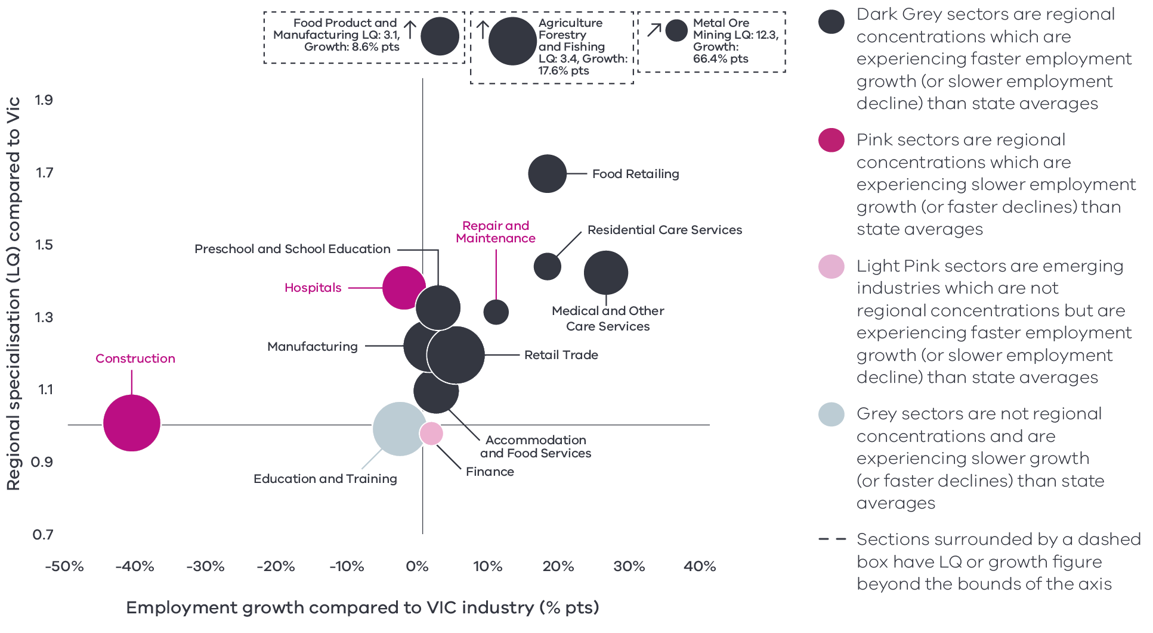

Figure 5 Mallee industry employment location quotient and growth – Long Alternate Text

Source: National Institute of Economic and Industry Research, 2020

Note: this chart represents a selection of industries and sub-industries that represent a notable size and or concentration within the region. Some sub-industries presented are sub-sectors of industries that are presented alongside it and therefore measures cannot be aggregated between the two. Other industries are not displayed. For greater detail refer to the supporting analysis pack for this REDS strategy.

Figure 5 depicts selected industries and sub-industries in the regional economy where:

* The size of each bubble indicates the number of people employed in the (sub)industry in 2020.
* The position of each bubble relative to the vertical axis indicates the (sub)industry’s degree of employment concentration relative to the Victorian economy. For example, a value of 6.0 means that, as a share of total employment in the local economy, the (sub)industry employs six times as many people as the Victorian average.

The position on the horizontal axis indicates the difference in each (sub)industry’s employment growth (2015-20) between the region and the Victorian average. For example, a 7 per cent value indicates that regional employment in the (sub)industry has grown 7 percentage points faster (between 2015 and 2020) relative to the industry’s average growth rate in Victoria.

### Output specialisation

Output concentrations are consistent with employment concentrations. Figure 6 shows how output in the region is strongly concentrated in agriculture, forestry and fishing (LQ 17.2) with food product manufacturing also showing a concentration (LQ 1.9). One key difference between output and employment is in the agriculture sector, where output growth has outpaced the Victorian average by 22 percentage points – driven largely by the expanding horticultural industry in the Mallee. Output in the population driven sectors is the same as employment, showing a concentration but below-average growth, which is likely associated with lower rates of population growth in the Mallee which dampens demand for services.

### Emerging areas of specialisation

While not yet specialisations, some sub-sectors are showing employment and output growth rates above the Victorian average which indicates they may become comparative advantages in the future. Some metal and equipment manufacturing and wholesaling sub-sectors are showing these signs of growth, signalling that there is some vertical supply chain integration occurring. Social assistance services and adult, community and other education is another cluster of sub-sectors that is emerging.

**Figure 6: Mallee industry output (GVA) location quotient and growth**

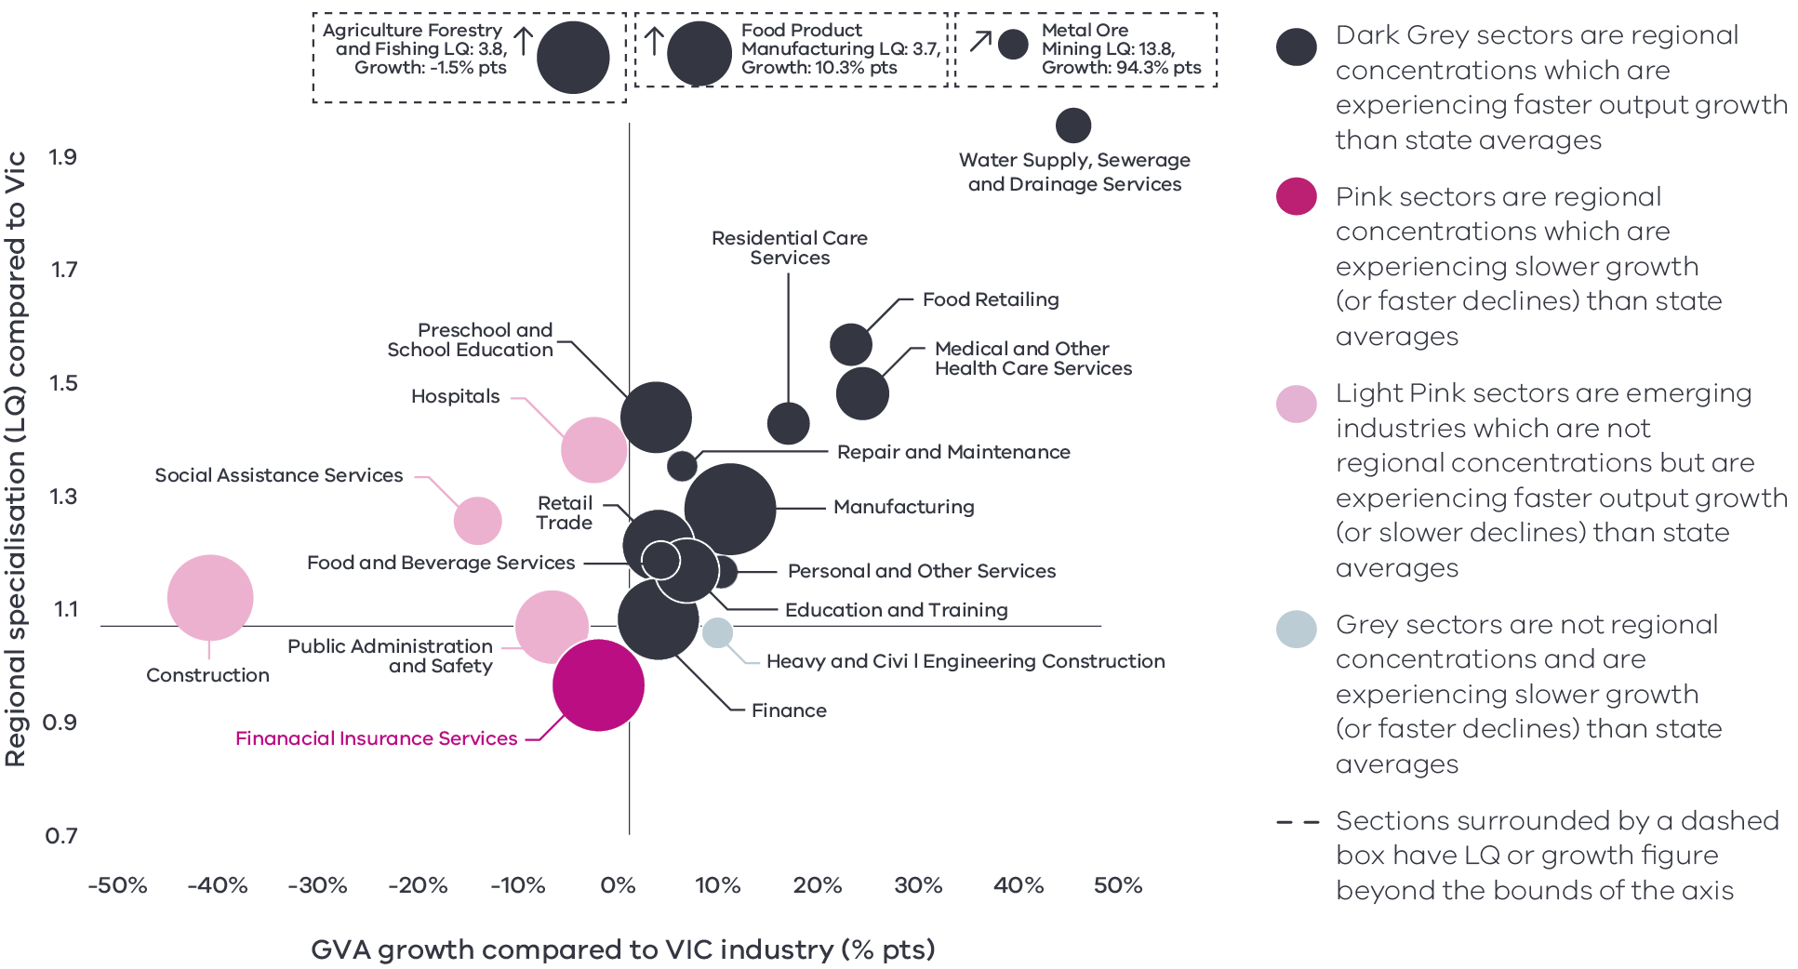

Figure 6 Mallee industry output (GVA) location quotient and growth – Long Alternate Text

Source: National Institute of Economic and Industry Research, 2020

Note: this chart represents a selection of industries and sub-industries that represent a notable size and or concentration within the region. Some sub-industries presented are sub-sectors of industries that are presented alongside it and therefore measures cannot be aggregated between the two. Other industries are not displayed. For greater detail refer to the supporting analysis pack for this REDS strategy.

Figure 6 identifies the Mallees’ economic output specialisation in terms of Gross Value Added (GVA). Using the same approach as Figure 5, this analysis compares selected industries and sub-industries in the regional economy, including their size and growth as a proportion of total economic GVA relative to Victorian averages.

# 04 Strategic directions

The five strategic directions for the region have been identified based on the opportunities emerging from the region’s endowments, specialisations and socioeconomic context. The directions are based on analysis of regional strengths and opportunities – including an examination of industry specialisations – and have been refined based on a review of local policies and strategic planning.

The following section discusses each strategic direction, providing:

* a rationale for its inclusion as part of the strategy
* an overview of opportunities and challenges which are likely to support or hinder future growth
* a summary of work underway and the policy context to support desired outcomes
* the implication of the direction for the region’s Aboriginal communities

examples of how the direction could be activated.

## Mallee’s strategic directions

1. Drive sustainable growth in the food industry
2. Leverage natural endowments to diversify the economy into emerging industries
3. Enhance the visitor economy by developing natural, cultural and built attractions
4. Ensure an accessible and suitably qualified workforce to unlock the growth potential
5. Harness the economic potential of the cross-border zones.

## Enabling factors for economic growth

This REDS identifies opportunities in key areas that can help drive regional economic growth. However, each region’s capacity to activate these opportunities and grow is partly determined by cross-cutting enabling factors that support economic activity. Consideration of these enabling factors – and targeted investments and initiatives to strengthen them – will help support achievement of the strategic directions in this REDS.

#### Digital connectivity

Access to reliable internet and mobile services allows for access to new markets, facilitates efficiency gains and opens up opportunities for innovation. Good digital connectivity can also facilitate more inclusive access to services and flexible working arrangements.

* 60 to 64 Australian Digital Inclusion Index Score in Mallee in 2021[8] (Victorian average: 71)

#### Transport connectivity

Road and rail infrastructure, ports and airports provide critical linkages between production locations and markets; efficient transport connections and public transport services are a key factor in workforce mobility and local amenity.

* 4.3 Overall access to roads, public transport in the Loddon Mallee RDA region[9] (Regional Victoria: 4.1 and Victoria: 5)

#### Workforce and population growth

An adaptive and productive workforce is key to businesses competitiveness; access to both skilled and unskilled labour ensures business can sustain and expand activities.

* 62.2% Local workforce in Loddon Mallee is employed in skilled occupations[10] (Regional Victoria: 62.2%, Melbourne: 67.3%) (2021)

13% Residents with a bachelor’s degree or higher in 2016[11] (Regional Victoria: 17.0 %, Melbourne: 31.0%)

#### Housing

The availability and affordability of housing determines a region’s ability to attract and retain local staff and supports community cohesion and better life outcomes for individuals and families.

* 0.5% Average rental property vacancy rate in the 6 months leading up to June 2021[12] (Compared to benchmark of 2.5%)

29.6% Increase in median rent in Loddon Mallee RDA region from 2016 to 2020[13] (Victoria, 6.9%, Regional Victoria 28.6%)

Note: 1. The Australian Digital Inclusion Index (ADII) is a composite index used to measure digital inclusion across three dimensions of Access, Affordability and Digital Ability. 2. ‘Access to roads and public transport was measured by asking respondents to rate their access to the following types of services in their local community, on a scale ranging from ‘very poor’ (1) to ‘very good’ (7): (i) Quality of local roads; and (ii) Access to public transport (including taxis, buses, trains). A single measure of overall access to roads and public transport was then constructed based on the average score of a person’s responses to these two items. 3. Skill level is defined as a function of the range and complexity of the set of tasks performed in a particular occupation. Skilled workers are defined as being classed between an ANZSCO Skill level of 1-3, while low skilled is classed as 4 or 5. 4. A rental property vacancy rate of 2.5% refers to a benchmark at which the market is balanced between landlords and tenants.

## Integrating Aboriginal economic opportunities

The Victorian Government is taking concrete steps to align with Aboriginal self-determination principles. Key Victorian Government policies and processes to realise self-determination goals include the:

* Treaty Process which seeks to redefine the relationships between Aboriginal communities, the state and non-Aboriginal Victorians
* Victorian Aboriginal Affairs Framework 2018-23 (VAAF) which is the overarching framework for working with Aboriginal Victorians to drive positive socioeconomic outcomes across the state, including to activate economic opportunities and prosperity via achieving wealth equality, facilitating workforce participation in all sectors at all levels and realising Aboriginal income potential.

Self Determination Reform Framework, which guides public sector action to enable self-determination in line with the VAAF across four domains: people, systems, outcomes and accountability.

The Victorian Government is also party to the National Agreement on Closing the Gap and has committed to meeting the associated outcomes – including in relation to increasing engagement of Aboriginal and Torres Strait Islanders in employment, education and training.

An analysis of relevant policies and commitments relating to Aboriginal economic development in the region (listed in the Mallee Regional Economic Development Strategy – Supporting Analysis), including Traditional Owner strategic plans, where developed, has identified five opportunities for Aboriginal economic development:

* Focus on **training, employment pathways and general life skills** to ensure the Aboriginal population, particularly young people, are equipped to enter the workforce.
* Pursue greater Aboriginal ownership of land to sustainably manage resources.
* Promote recognition of the land, its waters and its cultural significance to ensure that economic activities generate benefits in circumstances where degradation or destruction can be avoided, and existing damage is healed.
* Encourage the use of cultural places and practices as a mechanism for telling stories, maintaining traditions and creating economic opportunities, particularly in the tourism sector.

Enhance Aboriginal participation across in economic activities with a particular focus on occupations which serve the local Aboriginal population.

Each strategic direction in the Mallee REDS considers the relevance of that direction to local Aboriginal communities in light of the above opportunities.

Self-determined priorities for Aboriginal economic development in the region will be aligned to the six pillars of the Victorian Aboriginal Employment and Economic Strategy. These priorities will also guide Victorian Government decision-making on economic development in the region and will be integrated into future updates of the REDS.

## 4.1 Drive sustainable growth in the food industry

## Significance

With a long history in agricultural production, the food industry is the region’s most important sector by output and employment. The region’s diverse production systems of irrigated horticulture, dryland cropping and livestock grazing support significant outputs of high value fruit, nuts and grains. The food industry’s success is attributed to the warm climate and the unique water infrastructure provided by the Murray River while extensive land zoned for agricultural use, modern infrastructure, a skilled workforce and access to markets provide beneficial economic conditions.

The industry as a whole has kept constant levels of productivity in the face of major disruptions such as drought, technological change and increasing global competition. In 2017, productivity of a food industry worker in the region was measured as approximately $138,000 in annual value added, $15,000 higher in value add than the regional Victoria average. Throughout this period, low value, undifferentiated commodity type produce and production methods have been making way for higher value adding operations and products. The region has also seen a significant expansion in irrigated horticulture, particularly in the production of almonds and table grapes. The region is also leading significant innovation, research and development in the food industry through a network of institutions including Birchip Cropping Group, Mallee Sustainable Farming and the Mallee Region Innovation Centre.

**Mallee farms produce**[14]

* 66.0% of Victoria’s nuts
* 48.1% of Victoria’s wine grapes

23.9% of Victoria’s grain

**Workforce employment**

The agri-food supply chain is an important employer[15]

* 18.7% Agriculture, Forestry & Fishing and Food Product Manufacturing together employ 18.7% of the workforce

32.5% Agriculture, Forestry & Fishing and Food Product Manufacturing together produce 32.5% of regional output

**Figure 7: Agricultural land use in Mallee**

Map showing Agricultural land use in Mallee. A detailed description is provided via the link below.

Figure 7 Agricultural land use in Mallee – Long Alternate Text

Source: Agriculture Victoria, 2018

## Opportunities

#### Accessing global markets

Growing demand for safe and high-quality food in Asia and other emerging markets as well as natural pharmaceutical products creates export opportunities for the regions food industry. International export value from the region, predominantly from agriculture and manufacturing, has steadily increased over the past decade at an average rate of 7 per cent per year, totalling $906.6 million in 2020. Supply chain improvements such as the Murray Basin Rail project, Calder Highway and Mildura Airport upgrades will support the region to access markets.

#### Advanced capabilities

New technologies and globalisation are transforming the outlook of the manufacturing and agricultural industries. Positioning the local supply chain to invest in advanced capabilities has the potential to offset traditional market barriers of cost and distance while increasing the productivity of the industry. For food product manufacturing, embracing advanced capabilities allow for the greater personalisation of goods to meet demand and enhance the ability to implement origin and traceability systems for strong product integrity. For agriculture, the incorporation of information and communication technologies into farm equipment, and sensors into agricultural production systems can reduce the burden for accessing seasonal workforces.

#### Increasing value add

Most agricultural production leaves the region as raw product. Capturing greater value in these products prior to leaving the region will be a key growth pillar for the regions food industry requiring coordination, investment and greater linkages across the region’s major value chains. Cooperative relationships between value chain partners is a potential pathway to creating better value in the regions produce because takes advantage of economies of scale and of the knowledge, skills and experience of others.

#### Small-scale farming and agritourism

The region has several small-scale farms which contribute towards local food systems. Fostering the continued success of these farms may create further agritourism opportunities which directly connect primary producers of food and drink with the end consumer and showcase the region’s amenity and produce. Supporting small-scale activities, including connecting businesses through farmgate trails and enhancing major food and wine events will attract visitors to the region, raise the profile of region’s produce and benefit other tourism businesses. Identifying export pathways for smaller producers and niche products could increase the profile of the region as well.

**By 2050s[16]**

* Median temperature could rise by 2.2%
* Median spring rainfall could decline by 16%

More than double the amount of extreme heat days (14.2 days, 38°C)

## Challenges

#### Global competition

Local agricultural producers face increasing competition in global markets from lower cost producers. The introduction of tariffs on certain agricultural products, including wine and barley by some trading partners has added additional complexity to the international trading environment and highlighted the need for customer diversity.

#### Climate change

The region is expected to experience higher temperatures and decreased rainfall as a result of climate variability, which will be a key driver of change and innovation in the food industry – along with the need to reduce carbon emissions. Changing conditions and high-impact events will put pressure on infrastructure, influence the distribution of pests and diseases, and create uncertainty around production yields and output quality. The impact of drier conditions on water availability will also require a greater focus on securing water supplies, including through the diversification of water sources. The industry is responding to these challenges, including through adopting alternative fertilisers and crop selection, however further adaptive practices are likely to be required. Beyond farming activities, a broader range of stakeholders are responsible for strengthening the management and sustainable use of the region’s natural resources and environmental assets.

#### Digital connectivity and integration

Despite high demand from community, industry and visitors, poor digital access continues to be a barrier to innovation and the adoption of technology, particularly as it relates to primary production. A recent audit showed that there continues to be fixed broadband supply issues for businesses and households and intermediate mobile supply issues throughout the region.

#### Workforce constraints

Agriculture is becoming increasingly skill and capital intensive. Projected skill demand for the industry includes an increase to agronomists, farm managers, irrigation managers which will require greater attraction or upskilling efforts from the current workforce. Full-time industry employment is expected to decrease over the next five years as small land holdings are merged to create larger, and more competitive corporate businesses. At the same time, farmers consistently face difficulties attracting seasonal workers to assist with harvesting, and consequently rely on migrant labour.

## The policy environment

Driving sustainable growth in the agricultural and food manufacturing sectors is closely aligned with national, state and local priorities. In particular:

* The Australian Government’s Make it Happen – The Australia’s Government’s Modern Manufacturing Strategy and the Victorian Government’s Food and Fibre Sector Strategy both highlight food and beverage manufacturing as a priority industry.
* The Victorian Government’s Stronger, innovative, sustainable: A new strategy for agriculture in Victoria focuses on themes of recovery, growth, modernisation, biosecurity and promotion in the agriculture industry.
* Victoria’s Agriculture Sector Pledge will deliver foundational actions that will ensure farmers are preparing to achieve emissions reductions towards 2030. New technologies and practices will be tested for the Victorian context, and farmers will be supported to use information and tools that will help to realise emissions reduction opportunities on-farm.
* The Mallee Economic Growth Strategy articulates a preferred economic future where the food industry is more productive with available resources, adopting new technologies, adapting and implementing business level innovation to create greater efficiency and increased local value adding.

The Connecting Victoria initiative, announced in mid-2021, is fast-tracking new mobile and broadband infrastructure through a $550 million investment across Victoria.

## Aboriginal inclusion

This direction aligns with the Aboriginal economic opportunity for cultural food cultivation practices to be promoted as a mechanism for maintaining traditions and creating economic opportunities. For example, First People of the Millewa-Mallee Aboriginal Corporation have identified the opportunity to establish a native fish hatchery as well as a native plant seed bank, nursery and industrial planting capacity.

Aboriginal employment in the agriculture, forestry and fishing and manufacturing sectors makes up over 15 per cent of the Aboriginal workforce but this is proportionately lower than the non-Aboriginal workforce. As such, food industry growth may have a smaller impact on Aboriginal communities than the population as a whole. Specific interventions, such as promoting career pathways and Aboriginal enterprises, could maximise the benefits to the Aboriginal community of this strategic direction.

## How can we unlock this strategic direction?

To unlock this opportunity and drive growth, local, State and Commonwealth partners could work together to:

* Activate opportunities identified to improve the food industry supply chains through:
* Diversification and value-adding
* Replacing inputs imported into the region, where it is economically efficient to do so
* Exploring new logistics arrangements and better freight connections
* Adding a cost-effective new supply chain link
* Collaboration among regional businesses.
* Support businesses to identify and develop new and emerging product opportunities to keep pace with changing consumer preferences
* Ensure local producers are engaged in local, State and national conversations about major issues that affect the food industry including climate change, water security, disease management or trade relationships
* Strengthen the capability and depth of the agricultural R&D and extension-focused institutions within the region that can respond to the threats and opportunities to the agriculture and manufacturing sectors
* Advocate for market access opportunities and strengthen biosecurity, food safety capabilities and traceability across supply chains

Provide fit-for-purpose networks to allow uptake and implementation of new technologies such as automation, Internet of Things and big data

## 4.2 Leverage natural endowments to diversify the economy into emerging industries

## Significance

The move towards a decarbonised, net zero emissions economy offers economic growth and diversity opportunities for the region. Existing rich natural resources paired with technological advancements and infrastructure upgrades has unlocked solar, wind and biomass renewable energy opportunities throughout the region. To date, renewable energy development in the region has focused on solar due to several places with high potential solar energy.

Beneath the region’s soils there are large mineral sand deposits that include zircon, titanium and rare earth elements. These deposits have been successfully developed in west and northwest Victoria since the 1980’s. There are significant future opportunities, especially given the regional infrastructure including a route to market (e.g., rail to port) and planned renewable energy projects that could result in the responsible development of a premium product. Global demand for rare earth elements contained in mineral sands has grown in recent years due to their use in high technology and renewable energy applications such as permanent magnets, which are essential in the construction of wind turbines and electric vehicles and also in modern rechargeable batteries.

## Opportunities

#### Solar energy

The majority of Victoria’s large-scale solar generation is concentrated in the region. Solar energy projects from large to small are appearing all across the region with many more in the planning phase. Facilitating sustainable and innovative growth of the solar energy industry will support the region to become energy self-sufficient and an exporter of its surplus energy to other regions. Interconnectors across state boundaries such as the proposed KerangLink and Project Energy Connect will help enable the export and storage of excess renewable energy. Beyond large-scale production, the region’s sunny climate provides opportunities for the uptake of rooftop solar as a key distributed energy resource (DER). Nationally, these ‘behind the meter’ resources are forecast to supply almost half of all electricity by 2050. The region is well-placed to continue adopting these technologies which reduce electricity costs to homes and businesses.

**Figure 8: Large scale solar power projects in Mallee**

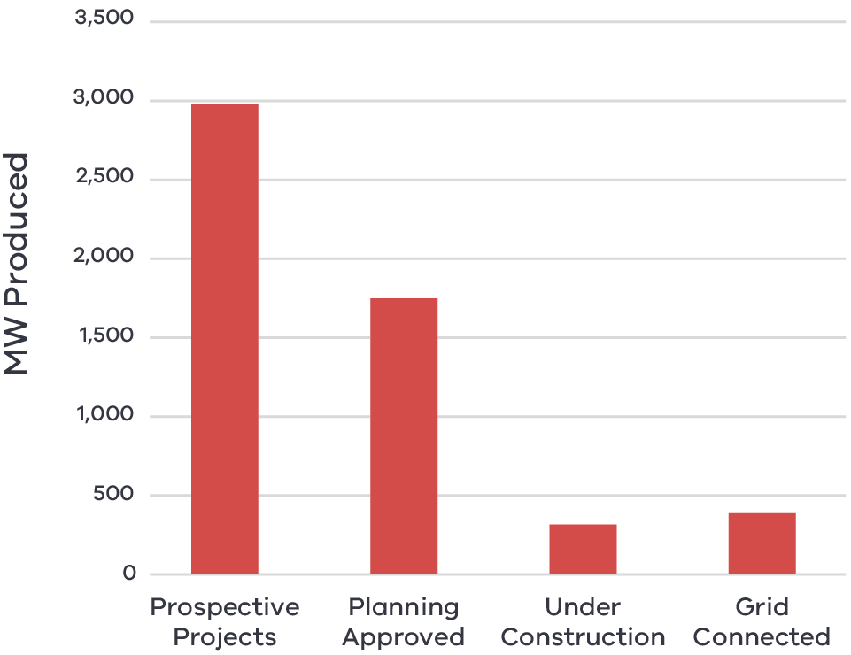

Figure 8 Large scale solar power projects in Mallee – Long Alternate Text.

Source: RDV (2019) Loddon Mallee Renewable Energy Projects.

#### Renewable hydrogen

The technology to develop renewable hydrogen as a sustainable energy and fuel source continues to evolve and improve with significant interest both domestically and internationally. The Mallee has been recognised as a region with conditions that could support a thriving renewable hydrogen industry. Solar energy capacity, access to land and water resources, heavy transport infrastructure and agricultural production for biomass are key advantages that provide a platform for the industry to establish. A safe and efficient renewable hydrogen storage industry also strengthens the renewable energy industry’s ability to deliver far greater, more diverse and stable economic and environmental benefit. The more immediate steps for the Mallee Hydrogen Technology Cluster involves establishing hydrogen projects, resource and infrastructure planning and building social licence.

#### Mineral extraction

Capitalising on rare earth and mineral sand deposits while demand is high will bring diversification benefits and resilience to the region’s economy. Efforts to grow the region’s mining industry will need to be supported by a skilled workforce and adequate freight infrastructure. There is an opportunity to leverage infrastructure that already exists or build new infrastructure that could benefit multiple industries such as water pipelines.

#### Strengthening local supply chains

Maximising ‘developmental spillover’ can occur through ensuring that renewable energy projects strengthen existing local supply chains in regional Victoria. The Loddon Mallee Renewable Energy Roadmap estimates that by mid-decade, renewable could deliver over $1 billion in supply chain benefits to the region and create over 3200 jobs during construction.

## Challenges

#### Grid capacity deficiencies

Potential solar regions in the Mallee are on the peripheries of Victoria’s existing network where the grid is weaker, more easily overloaded and generated energy must travel further to load centres. Existing transmission and distribution infrastructure is ageing and not designed for energy input at the proposed scale the region has to offer. Unlocking the full potential of renewable energy in the region would require an upgrade and upscale of the transmission grid. Transmission planning is driven by costs and benefits to electricity consumers and any investments in the region will need to be compared with other options across the network.

#### Optimising the freight network

There is a strong road and rail network in the region that transports goods to consumer markets. However, investment and long-term planning is needed for it to be utilised to its full potential. The development of new industries, notably the expansion of the horticulture sector, has resulted in increased volumes of road traffic, and improvements are needed to match the current and projected growth in road usage. A single line and lack of standard gauge across large parts of the rail network also constrains the use of rail freight to transport goods for both existing and emerging industries, such as minerals or hydrogen, and may deter investment and hinder business competitiveness.

#### Lack of coordination and collective action

Commitments to move towards a net zero economy are occurring across Australia and as such, there are multiple interested parties, and initiatives under design and implementation. Regional stakeholders are more likely to be able to access programs when they take a coordinated approach as the scale of the offering and breadth of the impact is far greater. However, coordination between the various stakeholders across the region can be difficult due to differing resources, boundaries, priorities, roles and responsibilities and therefore can undermine attempts to pursue initiatives.

## The policy environment

Encouraging sustainable growth in emerging natural resource industries is closely aligned with national, state and local priorities. In particular:

#### Renewable energy

* The Australian Energy Market Operator has identified the region as a Renewable Energy Zone: V2 Murray River. The Renewable Energy Zones Development Plan Directions Paper sets out the Victorian Government’s intention to develop Renewable Energy Zones targeting investment to strengthen the transmission network in Victoria, support an orderly and coordinated transition to renewable energy and engage with Traditional Owners and local communities to ensure that they benefit.
* Victoria’s Climate Change Strategy provides a roadmap towards net-zero emissions by 2050. It includes interim targets to reduce emissions and pledges for energy, agriculture, transport, waste and forestry sectors.
* The Victorian Renewable Hydrogen Industry Development Plan sets out a blueprint to capitalise on renewable hydrogen’s economic opportunity, including creating long-term jobs and new career pathways and enabling the State’s transition to net-zero emissions.
* The Loddon Mallee Renewable Energy Roadmap describes the current and future renewable capabilities of the region identifying solar and bioenergy as the key contributors. Other priorities include upgrading the grid infrastructure to realise the region’s solar potential, maximising community benefit sharing, and planning for the future jobs and training needs.
* The Mallee Hydrogen Roadmap outlines the potential of the hydrogen industry and outlines the steps that need to be taken to for it to become a reality. The roadmap has led to the designation of the Mallee Hydrogen Technology Cluster, one of Australia’s 13 hydrogen network clusters, which will be guided by the Mallee Regional Innovation Centre.
* Loddon Mallee Regional Climate Ready Plan aims to strengthen the resilience of people, places and sectors to adapt to new conditions, take advantage of opportunities that arise and become climate ready.
* The Victorian government has a suite of state-wide policies and initiatives to support the State’s energy sector to transition to net-zero emissions, which are available on [energy.vic.gov.au](https://creativecommons.org/licenses/by/3.0/au/).
* Victoria’s Recycling Victoria: A new economy is the state’s circular economy policy and 10- year action plan to reduce waste and pollution and improve recycling in a way which delivers economic benefit.

#### Mining

* Australia’s Critical Mineral Strategy (2019) outlines the Australian Government’s policy framework for critical mineral markets, with a focus on investment, downstream processing, innovation to lower costs and increase competitiveness and connecting critical minerals projects with infrastructure development

The Victorian State of discovery: Mineral resources strategy 2018-2023 seeks to grow investment and jobs in Victoria’s mineral sector and outlines areas for priority action associated with social licence, advancing and encouraging mineral exploration, establishing Victoria as a gold mining hub and delivering an efficient regulatory environment.

## Aboriginal inclusion

Increased investment in the renewable energy and resource sector is likely to create employment opportunities in the mining, construction and professional, scientific and technical services industries where there is a relatively small Aboriginal workforce. As such, pursuing this strategic direction may have a smaller impact on Aboriginal employment outcomes and specific interventions should be considered to increase Aboriginal participation in these industries.

Opportunities in this strategic direction may have implications for environmental amenity, particularly in the mining sector. Engagement with Aboriginal communities is necessary to ensure impacts are minimised and cultural places protected.

## How can we unlock this strategic direction?

To unlock this opportunity and drive growth, local, State and Commonwealth partners could work together to:

* Improve coordination of existing and prospective new energy, waste and resource recovery and mining investments to maximise the local benefits by aiming to:
* source resident labour and local inputs
* leverage existing and required infrastructure for other compatible developments
* encourage social responsibility contributions to the local community
* Advocate for transmission infrastructure that unlocks the region’s renewable energy potential
* Support the development of a hydrogen economy through the work of the Mallee Hydrogen Technology Cluster
* Foster partnerships between industry and training providers to develop professional career pathways in emerging industries
* Coordinate and streamline processes to help businesses negotiate the range of statutory planning and other regulations
* Examine funding and support models for businesses.

## 4.3 Enhance the visitor economy by developing natural, cultural and built attractions

## Significance

The region’s various natural and cultural attractions make the visitor economy a significant contributor to its economic prosperity. Visitation supports several industries including accommodation and food, retail and arts and recreation services. These industries combined contribute over 2500 jobs (7.1 per cent of employment) and $474 million in spend to the economy. Prior to COVID-19, visitation numbers and expenditure were growing throughout the entire region, with domestic daytrip visitors the fastest growing type of visitors.

Visitation to the region has traditionally centred around the Murray River but there are many more nature-based tourism attractions such as the Mallee National Parks, Lake Tyrrell, the Silo Art Trail, Gunbower State Forest, Kerang Lakes as well as the abundant Aboriginal culture and pioneer heritage. The region’s iconic food industry also plays an important role in agritourism and artisanal experiences for visitors.

## Opportunities

#### Building the brand

Regions with a clear and specific brand have seen strong success in visitor economy growth. The 2018 Murray Regional Destination Management Plan recognised the region as having primary tourism strengths in rivers and waterways, history and heritage, food and wine and agritourism, nature and parks and golf. These strengths align with the experience pillars of nature based, epicurean and arts and culture. Recognition, coordination, investment and development of the regional brand from the individual operators up to all levels of Government will pave the way to success for the region’s visitor economy.

#### Hero experiences

‘Hero’ experiences attract high levels of domestic and international visitation and, in doing so, create a ‘halo’ effect of private investment in surrounding areas. Experiences can be a group of complementary experiences, or a single major hero project. The region has existing hero experiences in the Murray River (including the Murray River Adventure Trail, Heart of the Murray / Pioneer Settlement), Lake Tyrrell and the Silo Art Trail. There are also attractions beyond the state border such as Mungo National Park that generate significant visitation to the region and warrant a coordinated approach to maximising their hero potential.

#### Aboriginal heritage

Tourism product development leveraging the connection of the region to local Traditional Owner groups, natural assets and stories has been identified as a significant gap in the local offering. Stronger connections with local Aboriginal communities could be developed to support self-determination, promote Aboriginal enterprise, strengthen regional links to arts, encourage innovation and ensure recognition of culturally significant traditions, landscapes and waterways.

## Challenges

#### Digital capabilities and capacity

The way visitors experience a region and access information are changing. Visitors increasingly use internet research and social media to plan holidays and gather visitor information. Visitor economy businesses need to invest and adapt to new technologies such as digital marketing and share economy platforms to enhance the visitor experience, but this requires reliable internet connectivity. The 2020 Mallee Digital Plan highlights inadequate access for the region’s top visitor locations and a significant digital capability divide in comparison to other regional and metropolitan areas. All of the twelve visitor locations assessed had issues with fixed access broadband services. Just under half appear to have inadequate mobile coverage based on public coverage data.

**Figure 9: Analysis of access to digital connectivity for tourist locations in Mallee**

Map showing digital accessibility ratings for key tourist locations in Mallee. A detailed description is provided via the link below.

Figure 9 Analysis of access to digital connectivity for tourist locations in Mallee – Long Alternate Text

*Note that there are reservations, based on local mobile access experience, about the good coverage indicated by public coverage maps.

Source: Mallee Regional Partnership 2020, Regional Digital Plan – Summary

#### COVID-19 impacts and global competition

International and state border closures due to the COVID-19 pandemic along with density limits on hospitality venues have reduced visitation and expenditure opportunities throughout regional Victoria. The total number of domestic daytrip, and domestic and international overnight visitors halved from 1.8 million in 2019 to 908,000 in 2020. This 49.5 per cent decline is the highest among Regional Partnership regions and led to a fall in total visitor expenditure; from $551 million in 2019 to $277 million in 2020. Prior to the COVID-19 pandemic, Victoria’s regions were facing significantly greater competition from international and domestic visitor markets. Other states and territories are now more aware than ever of the importance of the visitor economy to diversify the economy and drive long-term growth. Coming out of the COVID-19 pandemic, there will be strong competition to attract tourists which may have lasting effects on visitation patterns to the region.

#### Lack of coordination and collective investment

Many stakeholders contribute to the success of regional visitation across government, industry and the community. Coordination between the various stakeholders can be difficult with differing resources, boundaries, priorities, roles and responsibilities. This difficulty extends to investment with the visitor economy constrained by a lack of supporting infrastructure for its major tourism assets as well as low investment into ‘high end’ accommodation. As such, the lack of a collective approach to building a comprehensive product can undermine efforts to attract visitors.

**Figure 10: Mallee visitor expenditure by visitor type (2015-2020)**

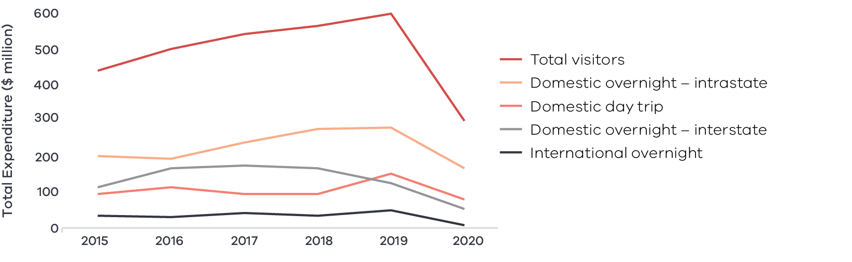

Figure 10 Mallee visitor expenditure by visitor type (2015-2020) – Long Alternate Text

**Figure 11: Mallee visitor numbers by visitor type (2015-2020)**

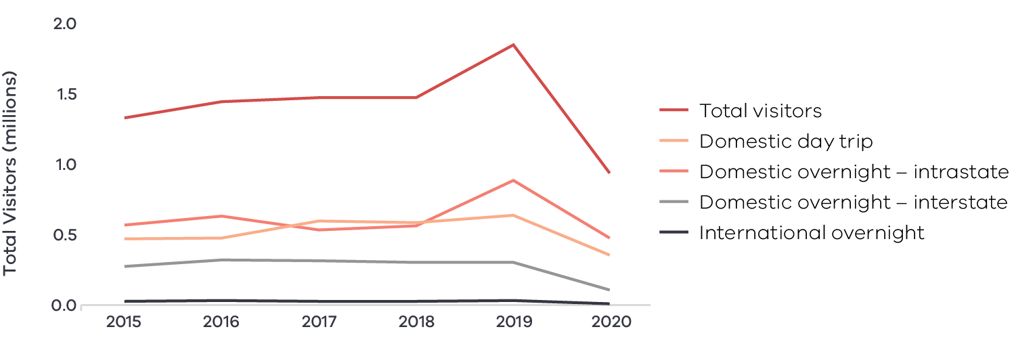

Figure 11 Mallee visitor numbers by visitor type (2015-2020) – Long Alternate Text

Source: Tourism Research Australia research data, as reported by DJPR – Tourism, Events and the Visitor Economy Research 2021

## The policy environment

Growing the visitor economy is closely aligned with national, state and local priorities. In particular:

* The Victorian Government’s Visitor Economy Recovery and Reform Plan (2021) aims to attract more tourists to the State, support regional jobs and deliver a significant recovery from the combined effects of the 2020 summer bushfires and the COVID-19 pandemic. This includes delivering a state-wide destination master plan underpinned by priority sector plans (the first sector priorities to be developed will be the Nature-Based Tourism Plan and the First Peoples’ Tourism Plan) and the establishment of Visitor Economy Partnerships across Victoria.
* The Mallee Economic Growth Strategy identifies actions to reinforce the visitor economy through improving overall liveability and infrastructure while building the value of the region’s tourism assets.

Murray Region Destination Management Plan and Wimmera Mallee Destination Management Plan provides an overarching tourism strategy, a clear developmental direction, focused product development and support for infrastructure across the region.

## Aboriginal inclusion

This direction strongly aligns with the Aboriginal economic opportunity to use cultural places and practices to share Aboriginal heritage while boosting economic outcomes. Aboriginal cultural tourism in the region is a significant opportunity for Aboriginal communities to share their culture, heritage and stories and is an important employer of Aboriginal workers.

The region’s visitor economy is an important employer of the Aboriginal workforce with one in five Aboriginal workers (21.2 per cent) employed in industries which support the sector (accommodation and food services, arts and recreation and retail trade). Growth in the region’s visitation numbers will likely have a positive impact on Aboriginal economic opportunities.

## How can we unlock this strategic direction?

To unlock this opportunity and drive growth, local, State and Commonwealth partners could work together to:

* Foster partnerships between industry and training providers to develop professional career pathways and skills for the visitor economy workforce
* Audit existing tourism assets to ensure they are of the type and quality to meet future needs.
* Coordinate and strengthen tourism planning across governments and tourism boards to align priorities and maximise investment outcomes
* Invest in regional tourism offerings that have current and future ‘hero’ potential as well as the supporting offerings that elevate the region
* Take advantage of existing incentives and funding in place to support visitor economy providers to pursue digital innovation and improve capability across the share economy and digital marketing platforms

Support interested Traditional Owner groups to develop and promote regional Victorian Aboriginal tourism offerings, in line with the principles of self-determination

## 4.4 Ensure an accessible and suitably qualified workforce to unlock the growth potential

## Significance

The region’s economy is positioned for a growth period as its major industries grow and the population-based service sectors expand. The region has four sectors (agriculture, manufacturing, wholesale trade and public administration) that are experiencing output growth at faster rates than Victorian averages. Employment is also expected to grow in most sectors to 2024, with health care and social assistance, education and training, accommodation and food services, construction and wholesale trade sectors projected for the strongest growth.

Compounding workforce challenges threaten the ability of growing industries to gain access to the quantity of skilled workers required to scale up. Employment figures suggest that the region has mobilised much of its local workforce and the COVID-19 pandemic has reduced the ability to bring in labour from overseas. Labour shortages across the economy are predicted to increase without inflows of workers to the region. At present, 57 per cent of businesses within the region have vacant positions. 45 per cent of businesses in Robinvale say it takes longer than four weeks to fill job vacancies. Mobilising, upskilling and training the local workforce and attracting skilled workers from beyond the region will be critical to support the region to achieve its growth potential.

## Opportunities

#### Stimulating inward migration

The Mallee Skills Demand Profile Pulse Check revealed that the nature of the region’s labour shortages generally falls into three categories (specialised, high volume and seasonal) each with their own structural barriers to attracting and retaining workers. Addressing barriers to labour mobility and participation such as housing, childcare and transport is the highest priority to attracting prospective workers. Targeted recruitment campaigns could be used to fill specialised roles while widespread communications of the need for workers across industries could also be used as a tool for attracting labour.

#### Strengthening local institutions and connections

There is local institutional capability to support the training and ongoing development of local workers at the La Trobe University Mildura campus, Monash University’s School of Rural Health in Mildura and the Sunraysia Institute of TAFE (SuniTAFE), which extends training opportunities throughout the region. Clearer career pathways and stronger collaboration across all levels of education and industry could strengthen the development of job ready working aged people, reduce the out-flow of young people from the region and increase levels of education attainment. This is particularly important in the agriculture sector and could mitigate seasonal labour requirements by providing a local workforce to work across the diverse sub sectors.

**Table 2: Key employment indicators across the Mallee’s demographic cohorts**

|  |  |  |  |  |  |  |
| --- | --- | --- | --- | --- | --- | --- |
|  | Aboriginal[17] | Non- Aboriginal | Female | Male | Living with a Disability | Not Living with a Disability |
| Unemployment17 | 21.0% | 6.0% | 5.9% | 6.8% | 15.0% | 6.2% |
| Participation | 49.5% | 60.8% | 55.5% | 65.4% | 8.9% | 64.9% |

Source: ABS Census, 2016

#### Improving economic inclusion

There is evidence of low economic participation and high socioeconomic disadvantage across particular demographic cohorts and in remote rural communities that have difficulty in accessing the same opportunities as in more populated areas. Limited access to childcare, particularly in rural settings, significantly affects the ability of women to enter the workforce. Encouraging and boosting employment opportunities in under-participating cohorts provides an avenue for maximising local labour capacities while building a more diverse and inclusive workforce. Addressing the underlying issues that result in low economic participation and ensuring work practices, policies and strategies are also inclusive will be critical to ensuring that inclusive employment generates long term and lasting benefits.

## Challenges

#### Housing shortages

Limited access to appropriate housing constrains the region’s ability to attract workers and sustain population growth. Most communities throughout the Mallee experience housing shortages, where locals and seasonal workers face lower-than-average rental vacancy rates, illegal rooming issues and long wait times for building new homes. The lack of land ready for development, difficulty obtaining investment finance, availability of skilled tradespeople and the rising cost of materials all contribute to this complex issue.

#### Low education attainment

A relatively high proportion (58 per cent) of the region’s residents have only completed Year 12 compared to the regional Victorian average (51 per cent). In the past, 12 per cent of residents progressed to university and 29 per cent to TAFE/other tertiary institutions, compared to the regional/state average of 17 per cent and 32 per cent respectively. This is in part due to an older population who completed their education when opportunities were less available.

#### Access to services

Liveability and a certain level of service provision are major factors in attracting workforce to a region. Approximately 15 per cent of the region’s population lives in towns of fewer than 2500 residents. Many of these towns are in rural areas and are experiencing stagnant or declining population and the subsequent loss of services due to the expense of providing services to small populations over large distances.

#### Migration trends

Historically, the region has depended on attracting migrants to fill skilled and unskilled roles, while there are significant outflows of younger working age people in seek of education and external employment opportunities. Temporary migrants are particularly important for the seasonal labour requirements of the agricultural sector. There will likely be short-term impacts on the ability to attract migrant workers into the region due to the COVID-19 pandemic and the resulting border restrictions. Reducing dependence on seasonal labour and stemming the outflow of young workers is a priority for the region to build resilience to external shocks.

## The policy environment

Ensuring a job ready workforce sector in the region is closely aligned with local priorities. In particular:

* The Mallee Regional Skills Demand Profile forecasts the demand and supply for labour in the region and identifies both labour force inefficiencies and opportunities to better support the Mallee’s next phase of growth. To prevent labour shortages, it will be necessary to tackle structural barriers and misalignment of training and industry needs.

The Try, Test & Learn program which aims to relocate migrants and refugees to the Loddon Mallee region to fill workforce gaps while supporting participants to achieve social and economic independence and participation.

## Aboriginal inclusion

Directions to better equip the workforce to meet future job and skill needs strongly aligns with the Aboriginal economic direction to focus on training and employment pathways to ensure the Aboriginal population are equipped to participate in the workforce. The Aboriginal population experiences lower economic engagement than the general population, particularly among young people. Efforts to better align career pathways and increase employment readiness and opportunities are likely to significantly benefit Aboriginal communities and close the gap in participation rates. Adapting and developing curriculum in a way that is culturally appropriate for Aboriginal people could enhance the uptake of training and career pathways.

## How can we unlock this strategic direction?

To unlock this opportunity and drive growth, local, State and Commonwealth partners could work together to address labour shortages by implementing the recommendations from the Mallee Regional Skills Demand Profile Pulse Check to:

* Actively promote the region as an attractive region to live and work and provide targeted and well-formed training pathways and recruitment campaigns
* Invest in liveability (amenity and provision of services) across the region
* Ensure that the voices of underrepresented cohorts, such as youth, women, those living in rural settings and Aboriginal people are included in employment, training and workforce planning initiatives
* Improve the provision of childcare in rural settings
* Encourage more local youth to take up learning and job opportunities that are aligned to the region’s industry strengths
* Encourage partnerships between industry and education providers to deliver solutions to real-world problems and graduates who are job ready
* Advocate for national migration settings that support the placement of skilled workers in regional areas
* Address structural barriers to labour participation and mobility
* Improve access to employment and support services across the region

Reduce dependence on seasonal labour through automation.

## 4.5 Harness the economic potential of the region’s cross-border zones

### Significance

The Mallee is Victoria’s only tri-state region, bordering New South Wales to the north and South Australia to the west, creating economic and social flows that stretch well beyond Victorian state borders. These flows contribute to economic prosperity in the region but risk being overlooked or under-valued in state-based policy and investment decisions. Recognition of these cross-border zones allows for a coordinated approach to economic development that reflects the true size and capacity of the local economy.

There are three recognised cross border zones that cover most of the region and each play a significant role in the economy’s agricultural value chain.

**Figure 12: Mallee cross-border zones**

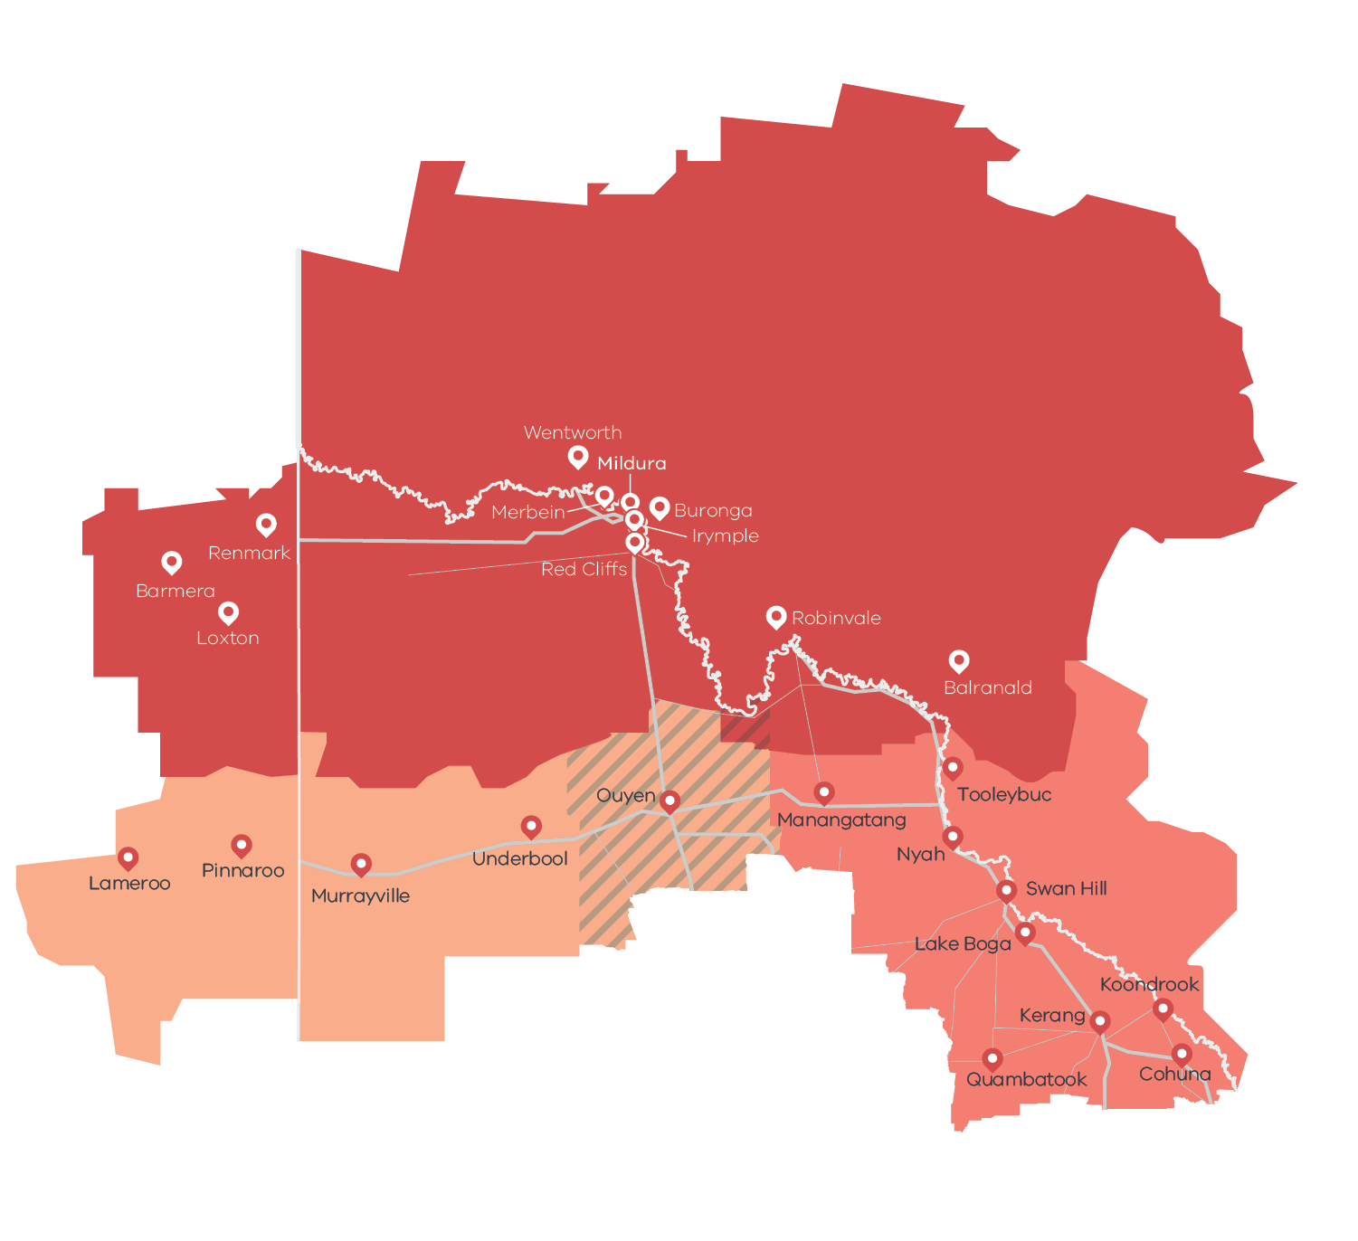

Figure 12 Mallee cross-border zones – Long Alternate Text

#### Riverland-Sunraysia

* **Population:** 97,000
* **Size:** 74,035 km2

**Journey to work flows[18]:** 2,537 of total flows between Victoria, NSW and South Australia per day

#### Western Mallee

* **Population:** 5,900
* **Size:** 16,621 km2

**Journey to work flows:** 50 of total flows between Victoria, NSW and South Australia per day

#### Central Murray

* **Population**: 34,400
* **Size**: 13,840 km2

**Journey to work flows**: 1001 of total flows between Victoria, NSW and South Australia per day

Source: ABS Census, 2016

### Opportunities

#### Transport connections

Flows of goods and services throughout the cross-border zones do not recognise administrative boundaries, but the infrastructure that they travel on is managed by different jurisdictions. Many cross-border businesses, particularly in the agriculture sector, operate across state boundaries, with interstate produce being processed in Victoria and transported through Victorian ports. Coordinated, consistent and equitable investment into the transportation network will allow the flow of goods and services, especially in food industries, to become more efficient, productive and profitable. For example, connecting the rail network across borders, especially to South Australia, has been highlighted as a key project for the region that would allow more cost-effective access to consumer and export markets.

#### Coordination and advocacy

Coordination is at the heart of addressing cross-border challenges. When all levels of government and the community are working towards a common interest it creates an environment for the region to thrive. There are already signs of coordinated activities such as some joint tourism campaigns and fruit fly management initiatives. Supporting and resourcing community-based platforms for the cross-border regions and its industries to come together and coordinate their activities will enable the region to achieve better and more aligned outcomes. The Mallee region is the only tri-state region in Victoria, a status which is rarely recognised in policy and investment decisions.

#### Socioeconomic hubs

In the case of the Victorian-New South Wales border, the major service centres are in Victoria, including Mildura and Swan Hill. These hubs attract New South Wales residents for work, education and leisure. In many cases, the economic opportunities in the Mallee, including in agri-food, renewable energy and mineral sands, are also opportunities in New South Wales. The benefits from these opportunities in New South Wales are likely to be jointly realised on both sides of the cross-border region. The resulting value chains are far more likely to flow into Victoria, meaning that Victoria should see, and sometimes even facilitate, those cross-border opportunities as being complementary to its own growth potential.

### Challenges

#### Regulatory inefficiency

The unintended consequences of regulatory structures that straddle the Murray River and South Australian border impact communities and businesses daily. Differing regulations for construction, biosecurity, transportation and vocational education are currently restricting some economic activity and can make it more difficult for the region to capture economies and scale. Addressing regulatory overlap will allow businesses to operate seamlessly and more efficiently in the region.

#### Funding services and infrastructure

Cross-border communities may be adversely impacted because of the difficulties in service delivery planning and investment in regions where some users reside in another jurisdiction. In many cases, this can undermine productivity, deter investment and limit economic opportunities for cross-border communities. For example, if digital access is inconsistent in each jurisdiction, or tends to avoid the border areas for fear of a state investment servicing the other side, farms which operate across state borders are less likely to invest in internet-based technology. Coordinated service planning, and coordinated investment, can help overcome these barriers and lead to more efficient investment decisions.

### The policy environment

Recognising the potential of the Cross Border Zones is supported by state and local priorities. In particular:

* The Victorian and New South Wales Cross Border Commissioners advocate for cross-border communities, businesses and organisations to their respective State Governments. They administer a Memorandum of Understanding between the two jurisdictions to auspice policy and investment coordination and activity in the cross-border regions.
* The Mallee Economic Growth Strategy recognises the Murray Mallee Economic Region as one of the key focal investment areas to increase productivity and prosperity in the region.

The Central Murray Regional Transport Strategy brings together councils on both sides of the border to provide an evidence-based framework for ensuring a ‘fit for purpose’ transport network for the region, now and into the future.

### Aboriginal inclusion

To the extent that harnessing the potential of cross-border zones creates more economic activity in sectors like agriculture, construction or tourism, there could be opportunities for Aboriginal employment. Traditional Owner boundaries do not match administrative boundaries. The aspirations of Traditional Owners that straddle the Victorian border or are located beyond the border but still in the cross border economic zone should be considered.

### How can we unlock this strategic direction?

To unlock this opportunity and drive growth, local, State and Commonwealth partners could work together to:

* Explicitly consider the impacts and opportunities for cross-border communities when developing or reviewing policy, regulatory or investment settings.
* Seek opportunities for joint action or investment between different jurisdictions that recognises the cross-border flow of people, products and services.

Proactively make improvements to differing regulatory conditions.

# 05 Implementation

The Mallee REDS outlines the RRV Group’s strategic approach for focusing its future economic development activities, including through policy, investment and program delivery, in the region. It is not a prescriptive roadmap for Victorian Government economic development action in Mallee.

## RRV will use the REDS to coordinate investments and activities in place

RRV is committed to pursuing the strategic directions through future policy design, investment and program implementation, as well as through collaboration across government and with regional partnerships, to deliver positive economic outcomes for the region. The Mallee REDS will provide a central point for coordination for current and future work streams and investments.

RRV recognises that effective planning policy and controls will be a key enabler of inclusive, sustainable economic growth in the Mallee region. Victoria’s Regional Growth Plans provide broad direction for land use and development, and enable economic growth by ensuring that infrastructure investment is coordinated, appropriate services are provided, and development meets community expectations. The Regional Development and Planning portfolios will pursue opportunities to ensure that as relevant state-led land use planning strategies, policies and controls are updated, they are aligned with the REDS strategic directions.

## Local stakeholders, industry leaders and government service providers can use the REDS to advocate for shared outcomes

The Mallee REDS, along with the supporting Mallee Regional Economic Development Strategy – Supporting Analysis document, provides a starting point for an evidence-based, strategic approach to regional development. This approach is an ongoing process where specific development actions and projects can be proposed and considered in the context of alignment with the REDS.

Regional Development Victoria – Loddon Mallee will remain the main point of contact in the region for facilitating and coordinating regional development outcomes.

The Mallee Regional Partnership which comprises community and business leaders, CEOs of constituent Local Governments, State Government personnel and a representative from Regional Development Australia will continue to be the main advisory body to the Minister for Regional Development and other government decision-makers on local issues and priorities.

The Mallee REDs will provide Jobs Victoria with important context and understanding of local economic priorities and opportunities that will be a critical input into the planning and prioritisation of Jobs Victoria’s work and collaboration activities with our Service Partners. Jobs Victoria assists people looking for work, connects employers with the staff they need, administers wage subsidy programs and supports significant local employment transitions.

## RRV will monitor the implementation of the REDS

The strategic directions in this Strategy focus on medium- to long-term drivers of growth and opportunity but will be used immediately to guide investment in the region. Notwithstanding this timeframe, the strategic directions will continue to evolve and progress as actions and investment are made. To ensure ongoing relevance and accuracy, Rural and Regional Victoria will periodically update and refresh this Strategy.

# Appendix

## Figure 1: Map of Regional Partnerships – Long Alternate Text

The **Mallee** region is located in northwest Victoria and contains the LGAs of Mildura, Swan Hill, Buloke and Gannawarra.

The **Wimmera Southern Mallee** region is located in western Victoria and contains the LGAs of West Wimmera, Hindmarsh, Yarriambiack, Horsham and Northern Grampians.

The **Great South Coast** region is located in southwest Victoria and contains the LGAs of Glenelg, Southern Grampians, Moyne, Warrnambool and Corangamite.

The **Barwon** region is located to southwest of metropolitan Melbourne and contains the LGAs of Geelong, Queenscliffe, Surf Coast and Colac Otway.

The **Central Highlands** region is to the west of metropolitan Melbourne and contains the LGAs of Ararat, Pyrenees, Golden Plains, Moorabool, Ballarat and Hepburn.

The **Loddon Campaspe** region is northwest of metropolitan Melbourne and contains the LGAs of Macedon Ranges, Mount Alexander, Central Goldfields, Loddon Campaspe and Bendigo.

The **Goulburn** region is north of metropolitan Melbourne and contains the LGAs of Mitchell, Murrindindi, Strathbogie, Greater Shepparton and Moira.

The **Ovens Murray** region is located in the northeast of Victoria and contains the LGA’s of Mansfield, Benalla, Wangaratta, Alpine, Indigo, Towong and Wodonga.

The **Gippsland** region is located in the east of Victoria and contains the LGAs of Bass Coast, South Gippsland, Baw Baw, Latrobe, Wellington and East Gippsland.

Click here to return to document

## Figure 2 Map of Mallee – Long Alternate Text

The Mallee region is made up of the Mildura, Swan Hill, Buloke and Gannawarra Local Government Areas.

Towns in the Mallee region are connected by several highways and arterial roads. The Mallee region has several rail links south, including rail from the major regional centres of Mildura and Swan Hill. Rail lines also connect with Irymple, Red Cliffs, Ouyen, Birchip, Donald, Lake Boga, Kerang, Sea Lake, Wycheproof, Charlton and Quambatook. A rail connection from Ouyen also heads west into South Australia.

Mildura, Robinvale, Swan Hill and Kerang each have an airport.

Click here to return to document

## Figure 3 Mallee industry Employment (2001-20) – Long Alternate Text

The largest employing industries in descending order are Health Care and Social Assistance, Agriculture, Forestry and Fishing, Retail Trade, Construction, Manufacturing, Education and Training, Public Administration and Safety, Accommodation and Food Services, Transport, Postal and Warehousing and Other Services.

The following industries have grown in employment since 2001; Health Care and Social Assistance, Retail Trade, Construction, Manufacturing, Education and Training, Public Administration and Safety, Accommodation and Food Services, Transport, Postal and Warehousing and Other Services.

The following industry has declined in employment since 2001; Agriculture, Forestry and Fishing.

Simplified Table of data for Figure 3.

|  |  |  |  |  |  |  |  |  |  |  |
| --- | --- | --- | --- | --- | --- | --- | --- | --- | --- | --- |
|  | Health Care and Social Assistance | Agriculture, Forestry and Fishing | Retail Trade | Construction | Manufacturing | Education and Training | Public Administration and Safety | Accommodation and Food Services | Transport, Postal and Warehousing | Other Services |
| 2001 | 3647 | 9590 | 4372 | 2098 | 2993 | 2531 | 1306 | 1953 | 1418 | 1383 |
| 2002 | 3827 | 9619 | 4809 | 2124 | 2999 | 2755 | 1404 | 2027 | 1437 | 1365 |
| 2003 | 3882 | 8905 | 5032 | 2168 | 3122 | 2959 | 1573 | 2089 | 1464 | 1383 |
| 2004 | 4027 | 8714 | 4799 | 2339 | 3259 | 2807 | 1575 | 2136 | 1553 | 1424 |
| 2005 | 4078 | 8468 | 4755 | 2558 | 3351 | 2819 | 1644 | 2158 | 1569 | 1330 |
| 2006 | 4355 | 8019 | 4888 | 3059 | 3465 | 2976 | 1766 | 2205 | 1637 | 1308 |
| 2007 | 4713 | 7734 | 5070 | 3145 | 3541 | 3284 | 1871 | 2242 | 1658 | 1350 |
| 2008 | 4431 | 7465 | 5127 | 2713 | 3497 | 3328 | 1926 | 2319 | 1704 | 1417 |
| 2009 | 4558 | 7154 | 5051 | 2367 | 3376 | 3176 | 1943 | 2360 | 1722 | 1393 |
| 2010 | 4685 | 6871 | 4982 | 2834 | 3137 | 3150 | 1943 | 2479 | 1734 | 1392 |
| 2011 | 4742 | 6565 | 5165 | 2774 | 3202 | 3274 | 2028 | 2528 | 1861 | 1470 |
| 2012 | 4739 | 6224 | 5088 | 2649 | 3223 | 3254 | 2000 | 2452 | 1840 | 1467 |
| 2013 | 4921 | 6352 | 4898 | 2717 | 2954 | 3266 | 1969 | 2479 | 1755 | 1471 |
| 2014 | 5143 | 6646 | 4979 | 2849 | 2873 | 3398 | 1999 | 2610 | 1837 | 1653 |
| 2015 | 5341 | 6537 | 5019 | 2904 | 2951 | 3505 | 2005 | 2715 | 2007 | 1831 |
| 2016 | 5400 | 6271 | 4746 | 3027 | 2915 | 3424 | 1924 | 2742 | 1849 | 1489 |
| 2017 | 5345 | 6231 | 4962 | 3158 | 2795 | 3538 | 2000 | 2953 | 1963 | 1511 |
| 2018 | 5525 | 6458 | 5174 | 3797 | 2687 | 3544 | 2016 | 2862 | 1943 | 1473 |
| 2019 | 5676 | 6435 | 4864 | 4002 | 2939 | 3375 | 2077 | 2736 | 1719 | 1590 |
| 2020 | 5752 | 5722 | 4522 | 3681 | 3463 | 3327 | 2536 | 2484 | 1665 | 1494 |

Click here to return to document

## Figure 4 Mallee industry output (gross value add) – Long Alternate Text

The industries with the largest gross value add in 2020 in descending order are; Agriculture Forestry and Fishing, Health Care and Social Assistance, Public Administration and Safety, Manufacturing, Construction, Education and Training, Retail Trade, Financial and Insurance Services, Wholesale Trade and Transport, Postal and Warehousing.

The following industries have grown in gross value add since 2001; Health Care and Social Assistance, Public Administration and Safety, Construction, Education and Training, Retail Trade

The following industry has declined in gross value add since 2001; Agriculture, Forestry and Fishing, Manufacturing, Financial and Insurance Services, Wholesale Trade and Transport, Postal and Warehousing

Simplified table of data for Figure 4. Data in this table is in ($) millions.

|  |  |  |  |  |  |  |  |  |  |  |
| --- | --- | --- | --- | --- | --- | --- | --- | --- | --- | --- |
|  | Agriculture, Forestry and Fishing | Health Care and Social Assistance | Public Administration and Safety | Manufacturing | Construction | Education and Training | Retail Trade | Financial and Insurance Services | Wholesale Trade | Transport, Postal and Warehousing |
| 2001 | 1537 | 322 | 195 | 689 | 227 | 281 | 234 | 222 | 209 | 229 |
| 2002 | 1668 | 348 | 227 | 682 | 249 | 294 | 261 | 246 | 202 | 247 |
| 2003 | 1334 | 342 | 222 | 659 | 267 | 300 | 257 | 226 | 200 | 232 |
| 2004 | 1672 | 347 | 186 | 615 | 266 | 277 | 254 | 205 | 176 | 221 |
| 2005 | 1547 | 317 | 170 | 615 | 308 | 254 | 243 | 200 | 170 | 197 |
| 2006 | 1534 | 313 | 172 | 604 | 349 | 248 | 232 | 187 | 152 | 190 |
| 2007 | 1281 | 332 | 174 | 529 | 338 | 271 | 239 | 192 | 136 | 168 |
| 2008 | 1317 | 296 | 169 | 473 | 293 | 269 | 247 | 201 | 131 | 185 |
| 2009 | 1369 | 311 | 172 | 410 | 267 | 251 | 247 | 185 | 129 | 194 |
| 2010 | 1346 | 334 | 175 | 384 | 304 | 250 | 237 | 179 | 125 | 185 |
| 2011 | 1283 | 329 | 175 | 344 | 294 | 262 | 244 | 177 | 117 | 198 |
| 2012 | 1318 | 328 | 178 | 320 | 285 | 263 | 246 | 165 | 135 | 193 |
| 2013 | 1432 | 334 | 177 | 292 | 271 | 258 | 243 | 154 | 172 | 185 |
| 2014 | 1402 | 358 | 190 | 294 | 270 | 254 | 250 | 159 | 136 | 188 |
| 2015 | 1396 | 383 | 194 | 303 | 275 | 252 | 260 | 159 | 121 | 191 |
| 2016 | 1272 | 376 | 191 | 294 | 268 | 232 | 252 | 154 | 118 | 182 |
| 2017 | 1451 | 376 | 204 | 263 | 262 | 261 | 259 | 157 | 124 | 192 |
| 2018 | 1575 | 413 | 211 | 248 | 348 | 263 | 277 | 168 | 130 | 183 |
| 2019 | 1396 | 449 | 228 | 270 | 372 | 263 | 263 | 165 | 154 | 163 |
| 2020 | 1254 | 429 | 327 | 303 | 301 | 266 | 243 | 188 | 164 | 147 |

Click here to return to document

## Figure 5 Mallee industry employment location quotient and growth – Long Alternate Text

The graph is divided into four quadrants.

The first quadrant identifies the industries that are a) experiencing slower employment growth (or faster declines) than state averages and b) have higher levels of employment specialisation than state averages

The following industries are in quadrant 1:

* Agriculture, Forestry and Fishing
* Accommodation
* Motor Vehicle and Motor Vehicle Parts Retailing
* Preschool and School Education
* Retail Trade
* Education and Training

Accommodation and Food Services

The second quadrant identifies the industries that are a) experiencing faster employment growth (or slower declines) than state averages and b) have higher levels of employment specialisation than state averages.

The following industries are in quadrant 2:

* Food Product Manufacturing
* Social Assistance Services
* Construction Services
* Public Administration and Safety
* Public Order, Safety and Regulatory Services

Machinery and Equipment Wholesaling

The third quadrant the industries that are a) experiencing slower employment growth (or faster declines) than state averages and b) have lower levels of employment specialisation than state averages.

The following industries are in quadrant 3:

Health Care and Social Assistance

The fourth quadrant identifies industries that are a) experiencing faster employment growth (or slower declines) than state averages an b) have lower levels of employment specialisation than state averages.

The following industries are in quadrant 4:

* Construction
* Manufacturing

Adult, Community and Other Education

Click here to return to document

## Figure 6 Mallee industry output (GVA) location quotient and growth – Long Alternate Text

The first quadrant identifies the industries that are a) experiencing slower GVA growth (or faster declines) than state averages and b) have higher levels of GVA specialisation than state averages

The following industries are in quadrant 1:

* Health Care and Social Assistance
* Preschool and School Education
* Road Transport
* Food Retailing

Retail Trade

The second quadrant identifies the industries that are a) experiencing faster GVA growth (or slower declines) than state averages and b) have higher levels of GVA specialisation than state averages.

The following industries are in quadrant 2:

* Agriculture, Forestry and Fishing
* Food Product Manufacturing
* Water Supply, Sewerage and Drainage Services
* Education and Training
* Public Order, Safety and Regulatory Services
* Public Administration and Safety

Social Assistance Services

The third quadrant the industries that are a) experiencing slower GVA growth (or faster declines) than state averages and b) have lower levels of GVA specialisation than state averages.

The following industry in in quadrant 3:

Construction

The fourth quadrant identifies industries that are a) experiencing faster GVA growth (or slower declines) than state averages an b) have lower levels of GVA specialisation than state averages.

The following industries are in quadrant 4:

* Manufacturing
* Finance

Heavy and Civil Engineering Construction

Click here to return to document

## Figure 7 Agricultural land use in Mallee – Long Alternate Text

Map showing agricultural activities across the Mallee region.

The Mallee region has a large amount of agricultural land. Grains farming covers much of the region, from Donald in the south to the areas around Murrayville and Ouyen and also in the agricultural area to the south and west of Mildura.

Fruit and nut farming is concentrated around Mildura, Swan Hill and the areas along the Murray River. Some dairy farming is also concentrated to the south and east of Swan Hill. Mildura also has major food processing activities.

Click here to return to document

## Figure 8 Large scale solar power projects in Mallee – Long Alternate Text.

There is a potential 3,000 Megawatts to be produced by prospective solar power projects I Mallee. There is between 1,500 and 2,000 Megawatts to be produced by projects that has planning approved and between 0 and 500 being produced by solar projects that are under construction and a further 0-500 Megawatts being produced by projects that are connected to the grid.

Click here to return to document

## Figure 9 Analysis of access to digital connectivity for tourist locations in Mallee – Long Alternate Text

Simplified summary of analysis (as at 2020) is set out below.

| Mallee tourist location | Digital connectivity analysis |
| --- | --- |
| Cullulleraine Music Festival  Nyah Vinifera State Forest  Kerang Lakes  Gateway to Gannawarra Visitor Centre  Big Cohuna Festival  Esoteric Music Festival  Mount Wycheproof | Fixed access broadband – major supply shortfall; Mobile service coverage – current supply meets or exceeds demand |
| Lake Tyrell  Silo Art Trail  Hattah Kulkyne National Park | Fixed access broadband – major supply shortfall;  Mobile service coverage – intermediate supply shortfall |
| Wooroonook Lakes Campground  Gunbower Island | Fixed access broadband – major supply shortfall;  Mobile service coverage – major supply shortfall |

Click here to return to document

## Figure 10 Mallee visitor expenditure by visitor type (2015-2020) – Long Alternate Text

The largest source of visitor expenditure in Mallee is Domestic overnight, intrastate visitors followed by Domestic Day trips. Both forms of expenditure experienced steady growth between 2015 and 2019 before dropping significantly in 2020.

Domestic overnight interstate and international overnight visitors have lower expenditure. They both experienced some growth between 2015 and 2019 and similarly dropped in 2020.

Simplified table of data for figure 8. Data in this table is in ($) millions.

|  |  |  |  |  |  |  |
| --- | --- | --- | --- | --- | --- | --- |
| Expenditure by visitor type | 2015 | 2016 | 2017 | 2018 | 2019 | 2020 |
| Domestic daytrip | 84 | 105 | 84 | 86 | 138 | 72 |
| Domestic overnight *– Interstate* | 105 | 151 | 158 | 151 | 113 | 46 |
| Domestic overnight *– Intrastate* | 185 | 177 | 220 | 253 | 257 | 154 |
| International overnight | 31 | 28 | 36 | 30 | 43 | 5 |

Click here to return to document

## Figure 11 Mallee visitor numbers by visitor type (2015-2020) – Long Alternate Text

The largest source of visitor numbers in Mallee is Domestic Day trippers followed by Domestic overnight, intrastate visitors. Both experienced steady growth between 2015 and 2019 before dropping significantly in 2020.

Domestic overnight interstate and international overnight visitors were significantly lower. The similarly experienced growth between 2015 and 2019 before dropping in 2020.

Simplified table of data for figure 11.

| Number of Visitors by visitor type | 2015 | 2016 | 2017 | 2018 | 2019 | 2020 |
| --- | --- | --- | --- | --- | --- | --- |
| Domestic daytrip | 552,000 | 612,000 | 520,000 | 547,000 | 859,000 | 459,000 |
| Domestic overnight – Interstate | 262,000 | 307,000 | 304,000 | 291,000 | 295,000 | 101,000 |
| Domestic overnight – Intrastate | 453,000 | 460,000 | 581,000 | 569,000 | 618,000 | 343,000 |
| International overnight | 25,000 | 27,000 | 25,000 | 25,000 | 28,000 | 5,000 |

Click here to return to document

## Figure 12 Mallee cross-border zones – Long Alternate Text

This map describes key statistics about the Mallee’s three cross-border zones.

**Riverland-Sunraysia cross-border zone**

Population – 97,000

Size – 74,035km2

Journey to work flows – 2,537 total flows between Victoria, New South Wales and South Australia per day.

**Western Mallee cross-border zone**

Population – 5,900

Size – 16,621km2

Journey to work flows – 50 total flows between Victoria, New South Wales and South Australia per day.

**Central Murray cross-border zone**

Population – 34,400

Size – 13,840km2

Journey to work flows – 1,001 total flows between Victoria, New South Wales and South Australia per day.

Click here to return to document

1. Australian Bureau of Statistics, 2021
2. Victoria in Future 2019, Department of Environment, Land, Water and Planning – The COVID pandemic has changed Victoria’s population pathway from near-record growth levels to population losses. However, Victoria’s regions appear to have experienced little disruption to growth patterns. Migration from Melbourne to the regions has been at record levels according to the latest ABS data, offsetting most regional losses to overseas or interstate. There remains considerable uncertainty around the distribution of the increased regional migration, and the permanence of this trend, but available evidence points to continuing regional growth. Data from the 2021 Census will be vital in determining the impacts on the strongest migration attractors (e.g., regional centres and peri-urban areas) versus those regions which may have experienced losses from the temporary migrant workforce. Given current information, the pre-pandemic VIF2019 projections remain fit for purpose for regional planning
3. National Skills Commission, 2022
4. Australian Bureau of Statistics, Census 2016
5. National Institute of Economic and Industry Research, 2020
6. Forestry and fishing make up a very small portion of the agriculture, forestry and fishing industry in the Mallee. Almost all of the employment is in the agriculture and support services sub sectors.
7. Note that the First People of the Millewa-Mallee group is a combined group of Traditional Owners who identify as Latji Latji, Ngintait and Nyeri Nyeri.
8. Thomas J. et al., 2021, Australian Digital Inclusion Index.
9. Regional Wellbeing Survey,2020
10. Department of Education and Training, 2021
11. ABS Census, 2016
12. RRV analysis,2021, SQM
13. DHHS,2021, rental Report QTR
14. Agriculture Victoria analysis, 2021, using Regional Industry Structure and Employment (RISE) model 202
15. National Institute of Economic and Industry Research, 2020
16. Department of Environment, Land, Water and Planning, 2019, Mallee Climate Projection 2019 (based on ‘high emissions’ scenario where 2050s refers to the period from 2040 – 2059)
17. More recent data indicates that unemployment has decreased in the region – standing at 3.5 per cent in the 2021 March quarter (National Skills Commission, 2021)
18. Note that journey to work flows have been sourced from the 2016 Census and as such, are likely to understate the amount of current commuting activity in the region. Moreover, work flows are just one of the multifaceted interstate socioeconomic interactions including (but not limited to): accessing health and education services, freight movements, arts and recreation participation, and supply chain exchanges. The number of journeys to work flows should therefore not be considered to cover the extent of interstate socioeconomic integration.