Loddon Campaspe

Regional Economic Development Strategy – Summary

State Government of Victoria

The Loddon Campaspe REDS uses data and evidence to profile the region’s economy and identify key strategic directions to drive economic growth.

Regional Profile

Loddon Campaspe Regional Profile
Population (2020) | 249,200
Population growth (2011-20) | 13.4%
Gross regional product (2020) | $11.7 billion
Figure 1: Map of Loddon Campaspe
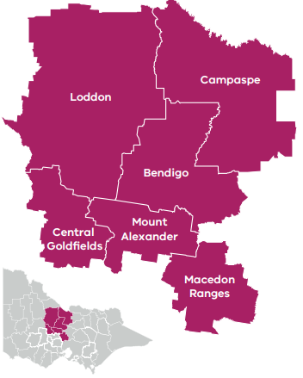

Employment
Unemployment rate (September 2021) | Average annual employment growth (2011–20)
Loddon Campaspe: 4.1%  Regional average: 4.2%  Metropolitan Melbourne: 6.0% | Loddon Campaspe: 1.3%  Regional average: 1.0%  Metropolitan Melbourne: 2.1%

Top employing sectors (2020)
Industry | Workers
Health care and social assistance | 17,300
Retail trade | 12,000
Manufacturing | 11,000
Construction | 9,800
Education and training | 8,500
Agriculture, forestry and fishing | 8,200

Top sectors by gross value add (2020)
Industry | Gross value add
Health care and social assistance | $1,298.5 Million
Financial and insurance services | $979.9 Million
Manufacturing | $974.8 Million
Construction | $920.4 Million
Education and training | $656.6 Million
Agriculture, forestry and fishing | $648.9 Million

Strategic Directions
Loddon Campaspe’s five strategic directions have been identified using an evidence base that considers the region’s unique attributes, existing and emerging industries, and socioeconomic context.

1. Support growth in agriculture and food product manufacturing to enhance value adding throughout the supply chain
New technologies and advanced manufacturing capabilities provide opportunities for the region to increase the value of local supply chains and take advantage of changing consumer preferences for safe and healthy food products.

2. Further pursue diversification of the tourism sector by leveraging natural, cultural, and built endowments
Cultural tourism, heritage and food and gastronomy will shape the tourism industry, providing opportunities to showcase the region’s unique experiences, including Aboriginal culture and knowledge, local creativity and natural landscapes.

3. Maximise gains in the ‘employment and innovation corridor’ to attract professional services workers and entrepreneurial activity
Entrepreneurship, business collaboration and higher levels of population movement will drive opportunities to attract and retain professionals and continue to develop the region as a finance hub.

4. Foster better links between education providers, industry, research, employers and students to develop career pathways and a workforce that meets the future needs of the region
Regional coordination and collaboration between education and industry offers opportunities to embrace new workplace practices and the growth of health care and social assistance sectors to drive inclusive employment and workforce diversity.

5. Leverage local opportunities to strengthen value chains and diversify into new industries, including in mining, renewable energy and waste processing.
Local innovation and advanced manufacturing capabilities present opportunities to drive investment in mining value chains and promote the growth of bioenergy generation and circular economy processing in the region.
Please refer to the Loddon Campaspe REDS and Supporting Analysis for further detail and sources.
Prepared by the Department of Jobs, Precincts and Regions, May 2022. For more information see: rdv.vic.gov.au.

