Central Highlands

Regional Economic Development Strategy

**State Government of Victoria**

**Department of Jobs, Precincts and Regions**

**Acknowledgement of Country**

The Department of Jobs, Precincts and Regions acknowledge the Traditional Owners of the lands and waters on which we live and work, and pay our respects to their Elders past, present and emerging.

We acknowledge that the Central Highlands Regional Partnership region is on traditional lands, including those lands of the Eastern Maar, Wadawarrung, Dja Dja Wurrung and Wurundjeri People and the Wotjobaluk, Jaadwa, Jadawadjali, Wergaia and Jupagalk Nations, as well as other Traditional Owner groups in Victoria who are not formally recognised.

We acknowledge the diversity of Aboriginal Victorians, their communities and cultures, the intrinsic connection to Country, the contribution and interest of Aboriginal people and organisations in developing a prosperous region. This Strategy is committed to advancing the principles of Aboriginal self-determination and supporting communities to realise self-determined economic development objectives.

# Preface

Rural and regional Victoria is home to 1.6 million, or 1 in 4, of Victoria’s residents and over 147,000 businesses. The Victorian Government is committed to making Victoria home to the nation’s most vibrant and successful regional economies.

The Department of Jobs, Precincts and Regions is delivering Regional Economic Development Strategies (REDS) for Victoria’s nine Regional Partnership regions. The REDS contribute to DJPR’s vision for regional Victoria to be a resilient and thriving place to live, work and do business. The REDS provide a consistent socioeconomic evidence base, and strategic framing of medium- to long-term directions to activate economic development opportunities.

**The REDS seek to:**

1. Identify a socioeconomic evidence base for the region, including demographics, business and industry dynamics, and local endowments that can be used by all stakeholders, and will provide a baseline for monitoring future performance.
2. Acknowledge and reveal the depth of work, analysis, and planning already in place in regions and create a mechanism to support and progress established regional directions, where supported by the current evidence base.
3. Harness and enhance the region’s comparative strengths as drivers of growth in the medium- to long-term.
4. Identify opportunities for public and private investment.
5. Influence and inform rural and regional economic policy and program design across government.
6. Support the prosperity and well-being of rural and regional Victoria through increased rural competitiveness and productivity.

The REDS do not replace existing local strategies. Rather, the REDS are informed by local work to identify economic development priorities and provide a platform to increase the visibility of these priorities and support regional communities to collaborate for shared outcomes.

## How have the REDS been developed?

The REDS have been developed using a consistent methodology across the state, comprising:

* data analysis to consistently describe each region’s industry composition, economic and socioeconomic trends and existing regional endowment.
* policy analysis to identify existing local strategies and plans to understand regional development priorities and shape an economic narrative for the region.
* stakeholder engagement to identify opportunities and challenges under each strategic direction.

## How can I use the REDS?

The REDS can be used by all levels of Government, regional communities and business to coordinate investment and collaborate for shared outcomes.

DJPR will use the REDS to drive strategic whole-of-government activity in the regions, informed by a contemporary understanding of economic performance and comparative advantage.

Regional communities and businesses can use the REDS to:

* communicate innovative capacity in their region, now and in the future.
* collaborate with government to better understand regional strengths, challenges and opportunities.
* attract investment to the region based on clearly identified strategic priorities.

The REDS should be read in conjunction with the relevant REDS Supporting Analysis which provides the consistent evidence base for each region.

**Figure 1: Map of Regional Partnership Regions and Constituent LGAs**

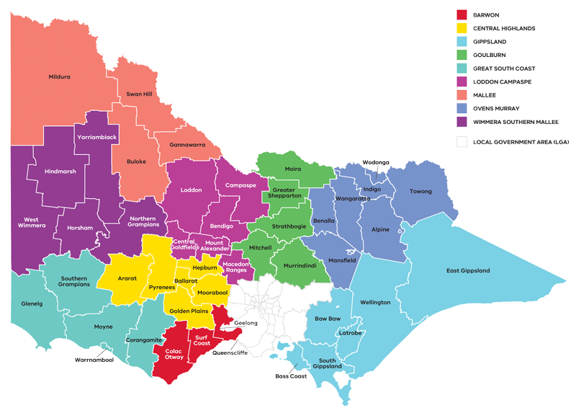

Figure 1: Map of Regional Partnerships – Long Alternate Text

Contents

Preface 1

How have the REDS been developed? 2

How can I use the REDS? 2

01 Introduction 4

Strategic directions 5

Regional readiness to activate strategic directions 6

Local priorities and strategies 6

02 Regional profile 7

Employment by industry 9

Output by industry 10

Regional exports 11

03 Comparative advantage 11

3.1 Endowments 12

3.2 Revealed industry specialisation 14

04 Strategic directions 18

Central Highland’s strategic directions 19

Enabling factors for economic growth 19

Integrating Aboriginal economic opportunities 20

4.1 Enhance local value add and collaboration across the agri-food supply chain 22

4.2 Continue to grow and develop the visitor and creative economies 26

4.3 Strengthen the renewable energy and waste management industries 30

4.4 Realise economic opportunity in the health, aged care, social assistance and education sectors 34

4.5 Enhance the innovation ecosystem 37

05 Implementation 40

RRV will use the REDS to coordinate investments and activities in place 40

Local stakeholders, industry leaders and government service providers can use the REDS to advocate for shared outcomes 41

RRV will monitor the implementation of the REDS 41

Contact us 42

Appendix 43

Figure 1: Map of Regional Partnerships – Long Alternate Text 43

Figure 2 Map of Central Highlands – Long Alternate Text 43

Figure 3 Central Highlands industry Employment – Long Alternate Text 44

Figure 4 Central Highlands industry output (gross value add) – Long Alternate Text 46

Figure 5 Central Highlands industry employment location quotient and growth – Long Alternate Text 48

Figure 6 Central Highlands industry output (GVA) location quotient and growth – Long Alternate Text 49

Figure 7 Participation rate by gender (2016) – Long Alternate Text 50

# 01 Introduction

The Central Highlands *Regional Economic Development Strategy* (the Central Highlands REDS) sets out the medium – to long-term strategic directions for driving economic growth and development across the region.

The Central Highlands Regional Partnership region spans the east-west transport corridor connecting Melbourne to western Victoria. It comprises six local government municipalities—Ararat Rural City, City of Ballarat, Golden Plains Shire, Hepburn Shire, Moorabool Shire and Pyrenees Shires. The region is home to the Eastern Maar, Wadawarrung, Dja Dja Wurrung and Wurundjeri People, as well as the Wotjobaluk, Jaadwa, Jadawadjali, Wergaia and Jupagalk Nations, who are the recognised Traditional Owners who have lived, worked and cared for their country and its and resources for many thousands of years.

Ballarat, as the regional capital, is an employment and education hub and is experiencing sustained population growth across all age cohorts. The Central Highlands is one of five regions that border metropolitan Melbourne, which has a strong influence on the region’s population and economy. The regional economy has evolved from a traditional reliance on manufacturing and agriculture towards service-based sectors, including health and education-driven by population growth and strong tertiary education assets. Agriculture and manufacturing nonetheless remain important local industries, drawing on the region’s natural assets and strategic connections to markets via road and rail freight networks.

## Strategic directions

The Central Highlands REDS defines five strategic directions for economic development in the region, based on comprehensive data analysis and review of existing policies and strategies:

1. Enhance local value add and collaboration across the agri-food supply chain
2. Continue to grow and develop the visitor and creative economies
3. Strengthen the renewable energy and waste management industries
4. Realise economic opportunity in health, aged care, social assistance and education sectors
5. Enhance the innovation ecosystem.

For each of the directions, the Central Highlands REDS provides:

* a rationale for its inclusion as part of the strategy
* an overview of opportunities and challenges which are likely to support or hinder future growth
* a summary of work underway and the policy context to support desired outcomes
* the implication of the direction for the region’s Aboriginal communities
* examples of how the direction could be activated.

The Central Highlands REDS recognises that approaches to regional development occur in an uncertain environment. While most of the analysis focuses on internal development drivers, it also considers the impact of, and opportunities emerging due to external trends, including the COVID-19 pandemic, patterns in global trade, a changing climate and technological change.

The Central Highlands REDS acknowledges that the Aboriginal communities within Central Highlands face unique challenges and opportunities, which are also reflected in the strategic directions.

## Regional readiness to activate strategic directions

Continuous place-based business innovation, specialisation and collaboration are key to building resilience and activating economic opportunities. Innovation in the Central Highlands region focuses on partnerships and collaboration. Federation University hosts the Ballarat Technology Park and the recently announced Ararat Jobs and Technology Precinct, which support business incubation and partnerships with business, researchers and government.

The Ballarat West Employment Zone will be an important player in activating economic opportunities in the region and is expected to become an engine room for jobs and economic growth in Ballarat over the next 20 years. The project involves the development of surplus Crown Land for industrial, wholesale, logistics, construction, commercial and residential uses, encouraging employment growth in Ballarat and the surrounding region.

## Local priorities and strategies

The Central Highlands REDS leverages a range of existing strategies, frameworks and plans developed by local stakeholders. This includes:

* the Central Highlands Regional Partnership’s Outcomes Roadmap, which outlines the regional long-term outcomes and priorities, and Digital Plan, which analyses the supply and demand for digital services and skills to inform regional digital policy and program development.
* research and plans commissioned by the Grampians’ Regional Development Australia Committee including the Grampians Regional Roadmap to Net Zero Emissions, which sets out pathways to net zero emissions by 2050 and the For want of a worker project, which examines and seeks to address the trends, drivers and barriers shaping the region’s workforce.

The Central Highlands REDS also takes into consideration other Victorian, regional and sub-regional policies and strategies as set out in the supporting documentation.

**Figure 2: Map of Central Highlands**

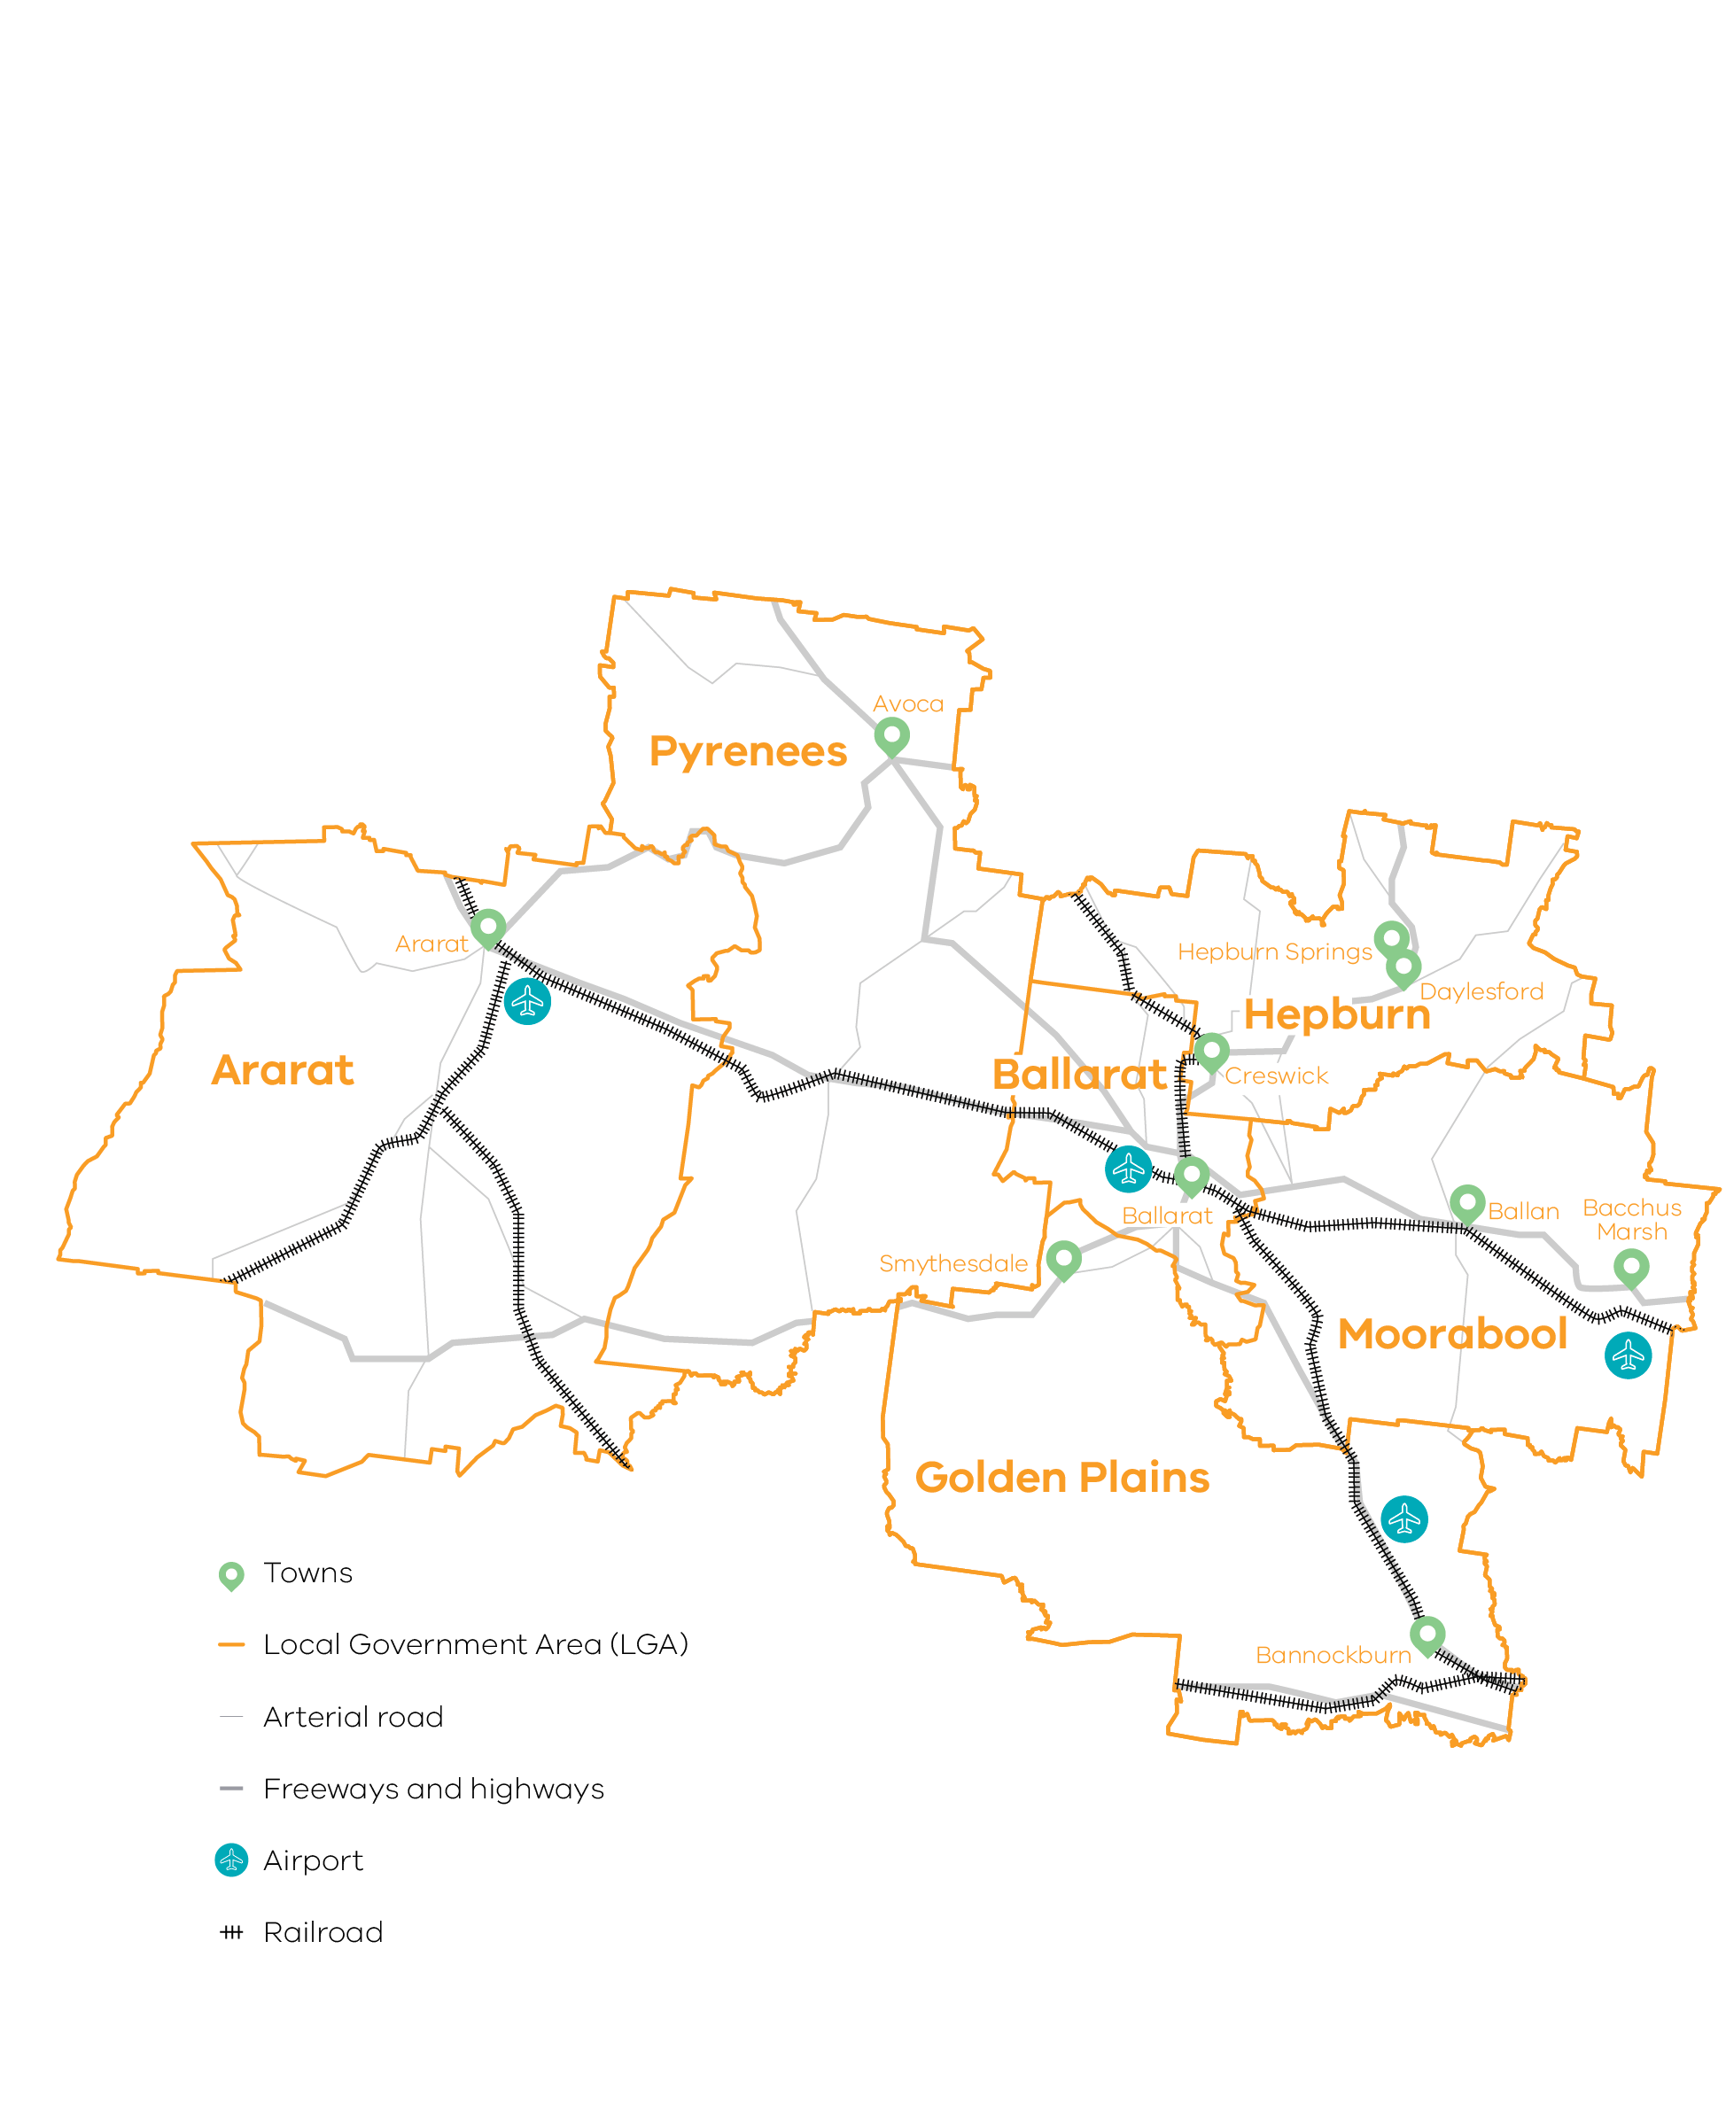

Figure 2 Map of Central Highlands – Long Alternate Text

# 02 Regional profile

**Central Highlands Regional Profile**

|  |  |
| --- | --- |
| $10.2 | Gross regional product (billion) (2020) |
| 207,300 | Population (2020) |
| 18.1% | Population growth (2011-20) |
| 40 | Median age (2020) |
| 62.7% | Working age (15-64) (2020) |
| 18.0% | Population aged over 65 (2020) |
| 1.0% | Are Aboriginal and/or Torres Strait Islander (2016) |
| 5.2% | Speak a language other than English at home (2016) |
| 11.1% | Were born overseas (2016) |

Population growth in the past decade has been higher in Central Highlands than the regional Victoria average. The population in Ballarat, Hepburn, Moorabool and Golden Plains is expected to grow, while the population in the relatively rural Ararat and Pyrenees local government areas (LGAs) is expected to remain stable. There are opportunities to pro-actively support growth in these LGAs by ensuring that the necessary infrastructure and amenities (include appropriate housing) are in place to attract workers.

The region is attractive to families seeking lower costs of living or greater housing choice. Except for the Rural City of Ararat, there are large numbers of people between the ages of 0-15 and 25-44 migrating into the Central Highlands region. This is particularly the case in areas which are part of Melbourne and Geelong’s peri-urban fringes such as Moorabool Shire and Golden Plains.

All LGAs, except Ballarat, experience a significant outflow of people between the ages of 15-24, likely in search of employment or education. This reinforces the role of Ballarat as a regional hub.

| Local Government Area | Population[1] (2020) | Projected growth[2] (2021–36)1 |
| --- | --- | --- |
| Ballarat | 111,400 | 28.3% |
| Moorabool | 36,000 | 34.8% |
| Golden Plains | 24,200 | 33.9% |
| Hepburn | 16,200 | 10.1% |
| Ararat | 12,000 | -0.4% |
| Pyrenees | 7,600 | 4.5% |

|  | Central Highlands % | Regional average % | Metro Melbourne % |
| --- | --- | --- | --- |
| Unemployment rate[3] (September 2021) | 4.6 | 4.2 | 6.0 |
| Labour force participation rate[4] (2016) | 62.0 | 60.9 | 65.8 |
| Average annual employment growth[5] (2011–20) | 1.6 | 1.0 | 2.1 |

The labour force participation rate in Central Highlands (62.0 per cent) is higher than the regional Victorian average. The female participation rate (58.0 per cent) is significantly lower than for men (65.2 per cent). The largest employing sectors for women are health care and social assistance, education and training, retail trade and accommodation and food services.

**Table 1: Employment in largest employing industries by workforce (2020) and gender (2016)**

|  |  |  |  |
| --- | --- | --- | --- |
|  | Workers | Male | Female |
| Healthcare and social assistance | 14,400 | 19.8% | 80.2% |
| Retail trade | 9,700 | 41.2% | 58.8% |
| Construction | 8,700 | 89.9% | 10.1% |
| Education and training | 7,700 | 29.1% | 70.9% |
| Manufacturing | 7,500 | 73.6% | 26.4% |

Source: National Institute of Economic and Industry Research, 2020 and ABS Census, 2016

## Employment by industry

Employment growth is strong in population-based sectors, closely linked with a rapidly growing population in Ballarat and the region’s peri-urban areas. Employment in the health care and social assistance sectors has experienced steady growth over the past 20 years. Retail trade and construction have experienced some periods of employment decline; however they have since experienced a sharp increase in employment since 2015-2016.

Employment in more traditional sectors of the economy is mixed. Employment in agriculture, forestry and fishing has fluctuated since 2014, likely associated with the increasing role of intensive agriculture in the eastern parts of the region, which requires year-around access to labour. Sharp declines since 2019 are associated with access to seasonal workers during the COVID-19 pandemic. Employment in manufacturing has fluctuated, with increases in other sub-sectors offsetting declines in petroleum and coal product manufacturing.

**Figure 3: Central Highlands industry employment (2001-20)**

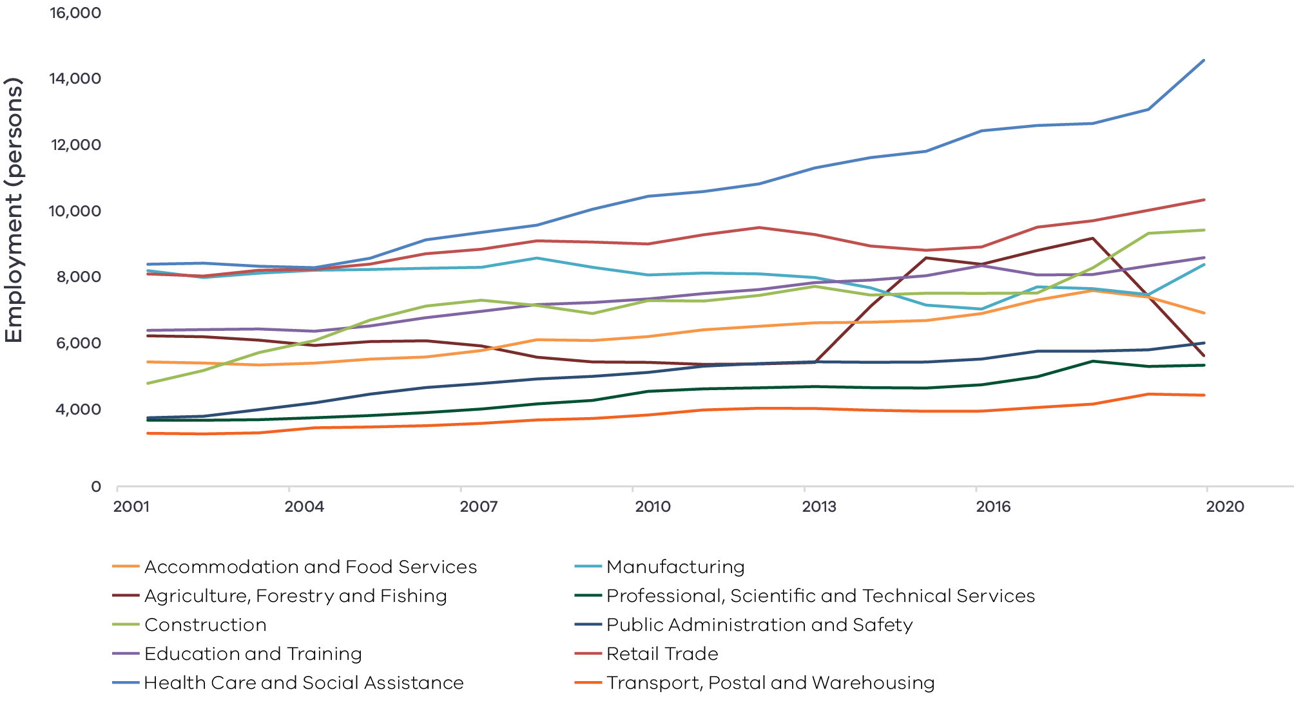

Note: Top 10 employing industries in 2020 presented in chart, based on Journey to Work employment estimates.

Source: National Institute of Economic and Industry Research (2020)

Figure 3 Central Highlands industry Employment – Long Alternate Text

## Output by industry

GVA across the region has steadily grown since 2001 with a minor decline around the Global Financial Crisis. The health care and social assistance and education and training sectors have achieved consistent growth since 2001 with only limited periods of decline, likely due sustained population growth across the region. The construction sector, consistent with increasing demand for housing and infrastructure, experienced a sharp increase in GVA since 2017 but has since experienced a decline in 2020, a likely result of the COVID-19 pandemic. Agriculture, forestry and fishing has experienced the most volatile GVA over time with many periods of growth and decline associated with seasonal conditions, industry transition and changes to market access.

### $8.2 billion Gross Value Added (GVA) (2020)

Top sectors by GVA:

|  |  |  |
| --- | --- | --- |
| 1 | Health care and social assistance: | $1.2 billion |
| 2 | Construction: | $1.0 billion |
| 3 | Agriculture, forestry and fishing: | $663.9 million |
| 4 | Education and training: | $656.7 million |
| 5 | Manufacturing: | $655.4 million |

**Figure 4: Central Highlands industry output (Gross Value Add) (2001-20)**

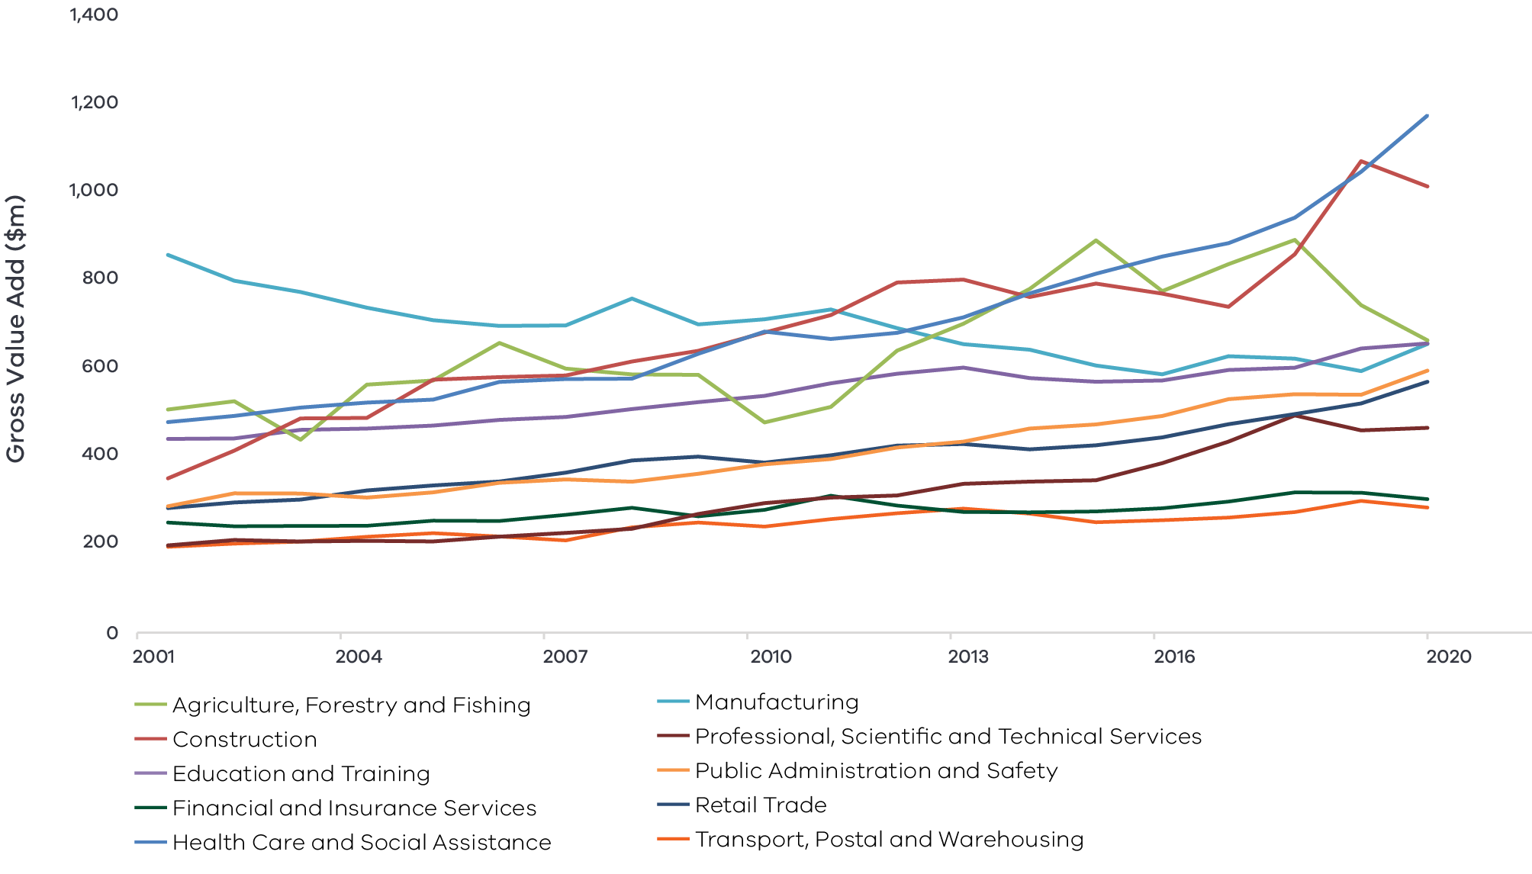

Figure 4 Central Highlands industry output (gross value add) – Long Alternate Text

## Regional exports

Strong connections to international markets via major freight routes and expertise in education and training support the top export sectors (2020):

1. Manufacturing: $508.6 million
2. Food product manufacturing: $327.4 million
3. Primary metal and metal product manufacturing: $42.8 million
4. Transport equipment manufacturing: $42.0 million
5. Agriculture, forestry and fishing: $368.5 million
6. Education and training: $91.9 million.

# 03 Comparative advantage

For the purposes of the REDS, ‘comparative advantage’ is defined simply as a description of what the region does well compared to other regions. This includes both the relative competitiveness of the region’s businesses as well as cultural, social and environmental factors.

Contemporary place-based development emphasises the importance of local endowments as a driver of comparative advantage. In economic terms, endowments refer to any natural, human, cultural and built resources present in a place which can be harnessed to support economic activity. Regional economic strengths can also be identified using other measures including location quotient analysis, shift share analysis and industry cluster analysis. A comprehensive assessment of these measures is included in the Central Highlands Regional Economic Development Strategy – Supporting Analysis.

## 3.1 Endowments

### Natural endowments

#### Fertile land and forests

Most of the land (79 per cent) in the Central Highlands region is used for primary production. Primary production is focused on dryland grazing, cropping and intensive livestock with some irrigation-based business throughout the region. Public and private forests are scattered throughout the region, supporting a commercial forestry industry based on hard and softwood plantations. The Pyrenees wine region is embedded in the south west extension of the Great Dividing Range and supports a mix of microclimates that allow for a wealth of grape varieties to be grown. These assets support the agri-food supply chain and strengthen food and wine tourism in the region.

#### Mineral resources

The Central Highlands is historically a gold mining region and the region continues to have ongoing mining operations. Mineral resources in the Central Highlands region include coal (primarily in Moorabool Shire), coal seam gas, copper, gold and other precious metals. Moorabool and Golden Plains shires are among the top 20 LGAs with strategic resources supporting cost-effective extractive resources in Victoria.[6]

#### Environmental assets

There are three National Parks in the Central Highlands region, nine state forests or state parks and other reserves that support nature based tourism in the region. Most significantly, the Central Highlands region is the gateway to the Grampians (Gariwerd) National Park. The region has comparatively strong wind resources and is an attractive location for the development of wind farms, particularly in Ararat, Pyrenees, Golden Plains and Moorabool shires.

### Cultural endowments

#### Aboriginal heritage

There are several heritage sites across the region which hold economic, social, environmental, and Aboriginal cultural heritage value. Within the region, the Dhelkunya Dja Land Management Board of Dja Dja Wurrung manages Hepburn Regional Park through a Joint Management Plan. The Dja Dja Wurrung Clans Aboriginal Corporation and the Wadawurrung Traditional Owner Aboriginal Corporation are Registered Aboriginal Parties under the Aboriginal Heritage Act 2006 that undertake a function to protect and manage their Aboriginal cultural heritage.

#### Goldfields heritage

The discovery of gold at Ballarat in 1851 sparked Victoria’s gold rush. There are many significant gold mining sites and examples of heritage architecture in the Central Highlands region. Sovereign Hill is an open-air museum in Ballarat that depicts Ballarat’s first 10 years after discovering gold.

#### Creative cities

Ballarat is a UNESCO Creative City of Craft and Folk Art and is focused on developing a resilient and sustainable creative sector. The Ballarat Art Gallery is at the heart of Ballarat’s creative precinct and hosts an extensive permanent collection as well as diverse temporary exhibitions. Various local artists groups and networks provide mentorship, exhibition and incubation opportunities for creative professionals. These networks include Ballarat Arts Alive, Ballarat Society of Artists Inc., Ballarat Evolve and a range of craft-specific groups.

#### Major events

Central Highlands hosts several significant music, sport and art-based festivals throughout the year that attract tourists to the region and support the creative economy throughout the region. These include:

* Meredith Music Festival in Golden Plains Shire
* Rainbow Serpent Festival and Avoca Races in Pyrenees
* The International Foto Biennale and Western Bulldogs Australian Football League games in Ballarat.

### Built endowments

#### Transport connections

Central Highlands is proximate to metropolitan Melbourne and is an important transport corridor connecting the east and west of the state. Road and rail infrastructure underpins the region’s market access, supports regional mobility and provides transport infrastructure for prospective tourists and commuters.

* The road network (Western, Midland, Glenelg, Sunraysia and Pyrenees highways) connects the region with major regional centres; seaports in Melbourne, Geelong and Portland; and passenger and airfreight options at Tullamarine and Avalon airport.
* Rail freight provides routes to Melbourne, Geelong and Portland.
* Ballarat, as the hub of passenger rail, connects the northern and western parts of the region to Melbourne and Geelong.

#### Tertiary education institutes

Ballarat is an education hub creating education and employment pathways for local residents and migrants alike. Ballarat is home to three university campuses including Federation University, the Australian Catholic University and a Melbourne University Rural Clinic School. Federation University also offers TAFE campuses in Ballarat Central and Ararat. Ballarat is the gateway to a broader ‘knowledge corridor’ stretching into the western parts of Victoria that includes tertiary and research institutes in Central Highlands and the Wimmera Southern Mallee (e.g. Horsham Grains Innovation Centre and the Stawell Underground Physics Laboratory).

#### Energy storage

The Ballarat Energy Storage System is a 30 megawatt (MW) / 20 megawatt-hour (MWh) large-scale, grid connected battery located at the Ballarat electricity station capable of powering 20,000 homes for an hour.

### Human endowments

#### Skilled workforce

There are high levels of educational attainment in the region and since 2001, labour productivity has gradually increased and is now equal with the regional Victorian average.

#### An innovator ecosystem

The region hosts a thriving innovation ecosystem complemented by the presence of tertiary and research institutions. Federation University innovation precincts in Ballarat and Ararat support business incubation and foster collaboration across research and industry to support local solutions to local problems, business growth and innovation.

## 3.2 Revealed industry specialisation

Location Quotient (LQ) analysis provides further insight into the local economy’s underlying structure and comparative advantages that may not be evident from a region’s endowments. This form of analysis compares an industry’s size and growth (as measured by employment or output) as a proportion of total economic activity, relative to the regional Victorian average. The higher the LQ, the more concentrated, and therefore significant, an industry is to the local economy relative to regional Victoria on average. Scores above 1.25 are considered to indicate notable specialisation compared to the rest of the state. Further analysis is provided in the Central Highlands Regional Economic Development Strategy – Supporting Analysis.

### Employment specialisation

Population services: Relatively strong population growth is driving demand for population services in the Central Highlands creating employment opportunities across health care and education.

* The region is specialised in health care and social assistance. Residential care services (LQ 2.02), hospitals (LQ 1.47) and social assistance services (LQ 1.19) are important regional concentrations. Employment in residential care services is growing 115 percentage points faster than the Victorian average, signifying an even more concentrated regional strength. By contrast, employment in hospitals is growing 9 percentage points slower than the Victorian average.
* The region is specialised in preschool and education with an LQ score of 1.34 and employment growth 6 percentage points faster than Victorian averages. This is consistent with net internal migration among family-aged cohorts (0-14 and 24-44).

Visitor and creative economies: Activity in the visitor and creative economies cuts across multiple sub-sectors. The Central Highlands demonstrates employment concentrations across a range of contributing sub-sectors. The region has employment specialisations in heritage activities, accommodation and food retailing. Heritage activities in particular is highly specialised, with an LQ value of 4.16 and employment growth exceeding the Victorian average by 127 percentage points. The region also has employment concentrations in food and beverage services and sports and recreation. These results are most likely due to the region’s economically significant cultural endowments, including in relation to Aboriginal and goldfields heritage as well as a bourgeoning food, wine and arts scene.

Agri-food supply chain: The region is specialised in a range of sub-sectors that make up the agri-food supply chain. Food product manufacturing is a regional specialisation with an employment LQ of 1.77 and employment in growing 24 percentage points faster than the Victorian average. Agriculture, forestry and fishing is also a regional specialisation (LQ score of 2.19) but employment in the sector is growing 56 percentage points slower than the Victorian average. This is despite significant increases in agricultural employment between 2013-18, which suggests that employment growth is happening at slower rates than other regions. Other contributing regional strengths include food retail and food and beverage services. The region is one of Victoria’s biggest food producers and is also home to the Pyrenees wine region. This, coupled with the major culinary hub of Ballarat and market access, is likely supporting the strong agri-food industry.

Transport equipment manufacturing: The region is home to companies specialising in the manufacture of rail, road and agriculture transport equipment. These companies underpin a regional employment specialisation in transport equipment manufacturing, with an LQ score of 1.37 and employment growth 14 percentage points faster than the Victorian average.

**Figure 5: Central Highlands employment location quotient and growth**

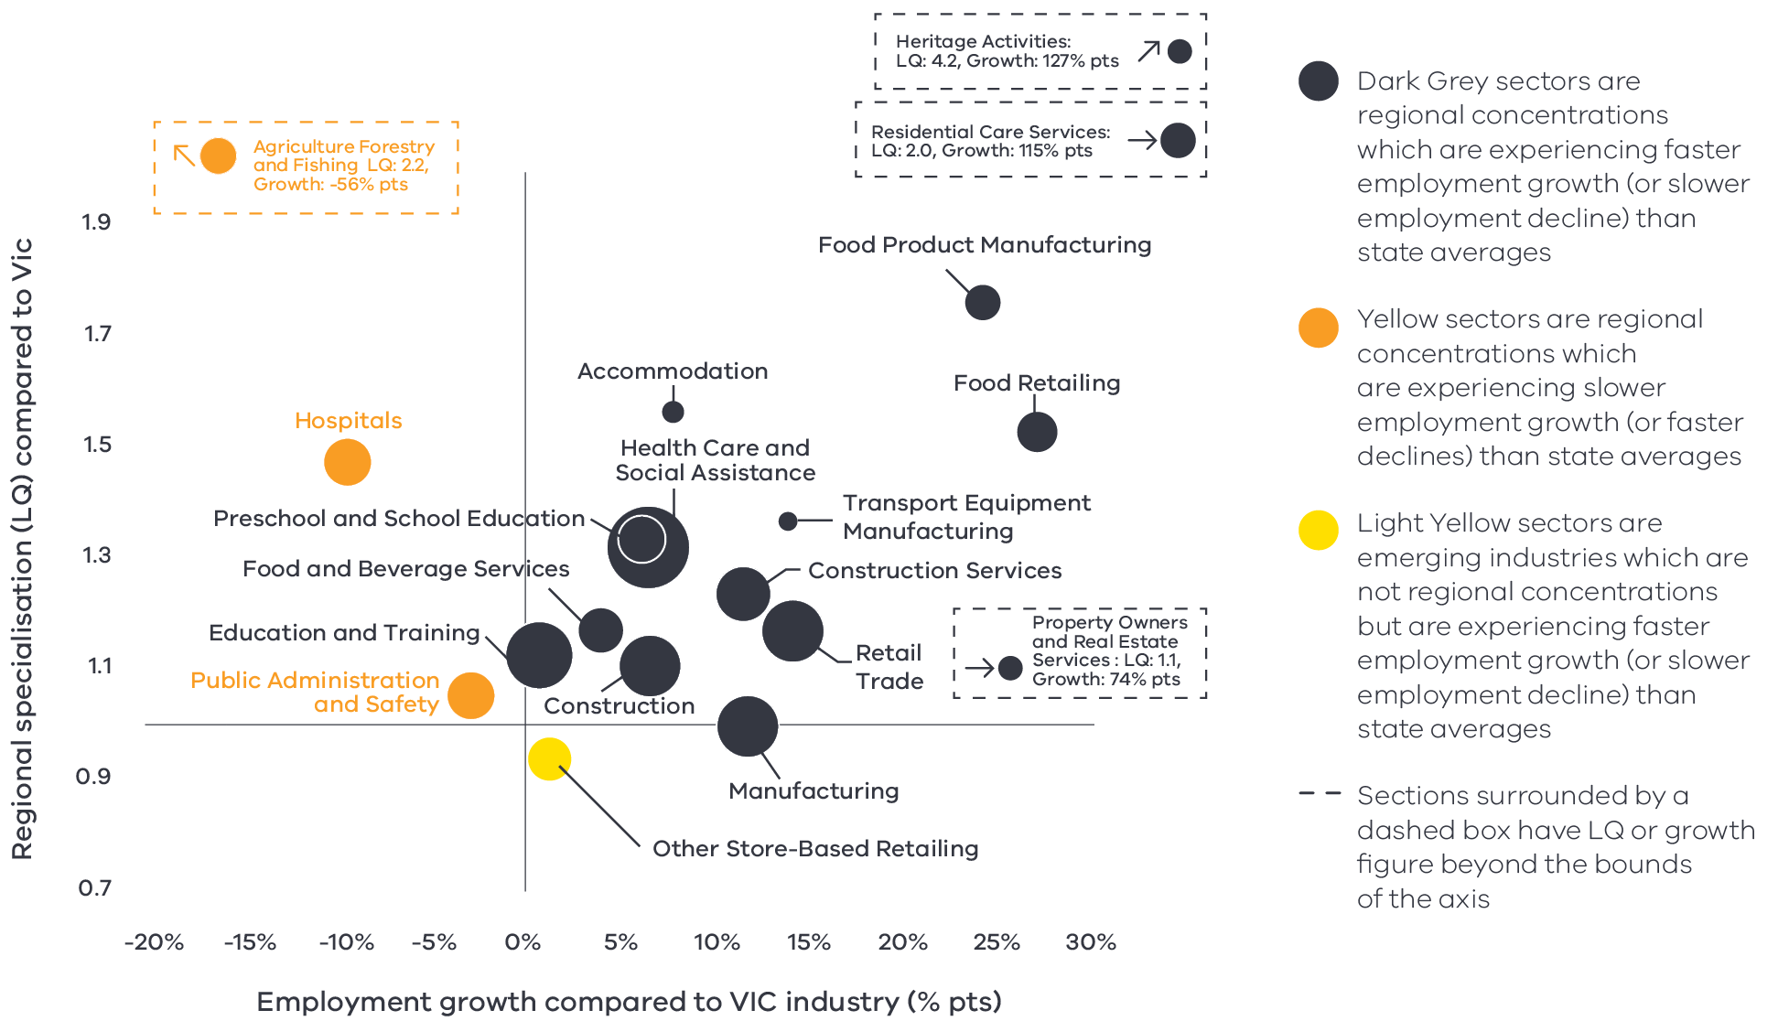

Figure 5 Central Highlands industry employment location quotient and growth – Long Alternate Text

Source: National Institute of Economic and Industry Research, 2020

Note: this chart represents a selection of industries and sub-industries that represent a notable size and or concentration within the region. Some sub-industries presented are sub-sectors of industries that are presented alongside it and therefore measures cannot be aggregated between the two. Other industries are not displayed. For greater detail refer to the supporting analysis pack for this REDS strategy.

**Figure 5** depicts selected industries and sub-industries in the regional economy in 2020 where:

* The size of each bubble indicates the number of people employed in the (sub)industry in 2020. The bigger the bubble, the more people employed in the industry.
* The vertical position indicates the (sub)industry’s degree of employment concentration relative to the Victorian economy. For example, a value of 1.77 means that, as a share of total employment in the local economy, the (sub)industry employs 1.77 times as many people than the Victorian average.
* The horizontal position indicates the difference in each (sub)industry’s employment growth (2015-20) between the region and the Victorian average. For example, a 14 per cent value indicates that regional employment in the (sub)industry has grown 14 percentage points faster (between 2015 and 2020) relative to the industry’s average growth rate in Victoria.

### Output specialisation

Similar to employment concentrations, the Central Highlands region demonstrates output concentration in a range of population services and the agri-food supply chain. Unlike employment concentrations, sectors associated with the visitor and creative economies are not as prominent except those associated with food and beverage services.

There are however some differences within the agri-food supply chain and population services.

Agri-food supply chain: The region is specialised in agriculture. It is a regional concentration, has an output LQ of 4.30 and is growing 2 percentage points faster than the Victorian average. This suggests the region is remaining competitive and achieving greater productivity gains than other parts of the state. Food product manufacturing (LQ 2.15), food retailing (LQ 1.72) and food and beverage services (LQ 1.21) are regional output concentrations experiencing output growth at faster rates than Victorian averages.

Population services: The region is specialised in a range of population services. The region is specialised in:

* construction with an output LQ of 1.35. The building construction and construction services sub-sectors, which service housing and infrastructure demand form new residents and businesses, are regional output specialisations experiencing growth at faster rates than the Victorian average.
* education and training with an LQ score of 1.31 and output growth that is 6 percentage points faster than state averages. This growth is primarily supported by the preschool and school education sub-sector which is connected to demand from population growth throughout the region.
* water supply, sewerage and drainage services with an LQ score of 2.3 and output growth 81 percentage points faster than the Victorian average. In addition to meeting local demand for these services, the Central Highlands region hosts large catchments for metropolitan Melbourne.

#### Emerging areas of specialisation

Some sub-sectors are not concentrated enough to be considered areas of regional specialisation, but employment and output growth patterns suggest they could emerge as areas of specialisation in the future.

Property operators and real estate services and other store-based retailing both have mild output concentrations (LQ1.01 and 1.03 respective) and are experiencing both output and employment growth at faster rates than the Victorian average. Both these sub-sectors have the potential to become areas of regional specialisation in the future, given they provide population services and Central Highlands is expected to grow rapidly in the coming years.

Telecommunications services and professional scientific and technical services (except computer system design and related services) are also showing output growth rates above the state average, although this is not reflected in the employment growth rate.

**Figure 6: Central Highlands industry output (GVA) location quotient and growth**

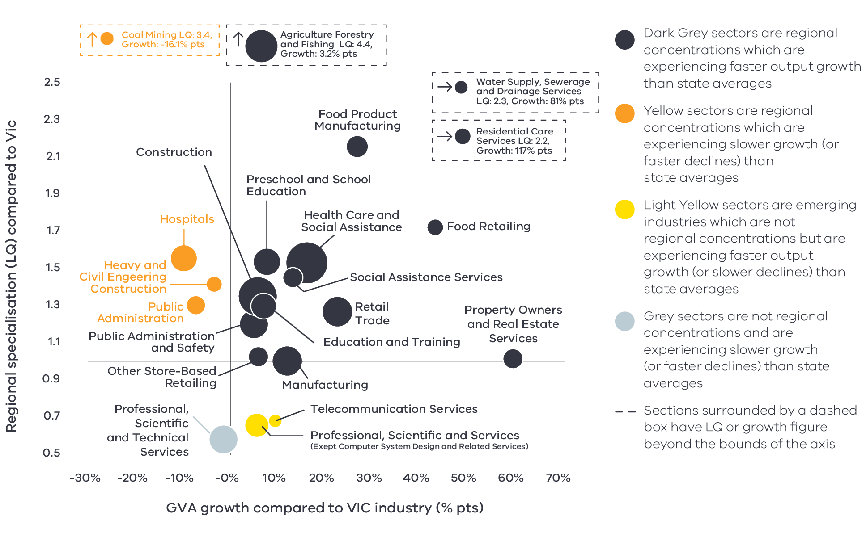

Figure 6 Central Highlands industry output (GVA) location quotient and growth – Long Alternate Text

Source: National Institute of Economic and Industry Research, 2020

Note: this chart represents a selection of industries and sub-industries that represent a notable size and or concentration within the region. Some sub-industries presented are sub-sectors of industries that are presented alongside it and therefore measures cannot be aggregated between the two. Other industries are not displayed. For greater detail refer to the supporting analysis pack for this REDS strategy.

**Figure 6** identifies the Central Highlands’ economic output specialisation in terms of Gross Value Added (GVA). Using the same approach as Figure 5, this analysis compares selected industries and sub-industries in the regional economy, including their size and growth as a proportion of total economic GVA relative to Victorian averages.

# 04 Strategic directions

The five strategic directions for the Central Highlands region have been identified based on the opportunities emerging from the region’s endowments, industry specialisation and socioeconomic context. The directions have been refined based on a review of local policies and strategic planning.

The following section discusses each strategic direction, providing:

* a rationale for its inclusion as part of the strategy
* an overview of opportunities and challenges which are likely to support or hinder future growth
* a summary of work underway and the policy context to support desired outcomes
* the implication of the direction for the region’s Aboriginal communities
* examples of how the direction could be activated.

## Central Highland’s strategic directions

1. Enhance local value add and collaboration across the agri-food supply chain
2. Continue to grow and develop the visitor and creative economies
3. Strengthen the renewable energy and waste management industries
4. Realise economic opportunity in health, aged care, social assistance and education sectors
5. Enhance the innovation ecosystem.

## Enabling factors for economic growth

This REDS identifies opportunities in key areas that can help drive regional economic growth. However, each region’s capacity to activate these opportunities and grow is partly determined by cross-cutting enabling factors that support economic activity. Consideration of these enabling factors – and targeted investments and initiatives to strengthen them – will help support achievement of the strategic directions in this REDS.

|  |  |
| --- | --- |
| **Digital connectivity**  Access to reliable internet and mobile services allows for access to new markets, facilitates efficiency gains and opens up opportunities for innovation. Good digital connectivity can also facilitate more inclusive access to services and flexible working arrangements. | 62 to 69 – Australian Digital Inclusion Index Score in Central Highlands in 2021[7]  (Victorian average: 71) |
| **Transport connectivity**  Road and rail infrastructure, ports and airports provide critical linkages between production locations and markets; efficient transport connections and public transport services are a key factor in workforce mobility and local amenity. | 3.9 – Overall access to roads, public transport in the Grampians RDA region[8]  (Regional Victoria: 4.1 and Victoria: 5) |
| **Workforce and population growth**  An adaptive and productive workforce is key to businesses competitiveness; access to both skilled and unskilled labour ensures business can sustain and expand activities. | 61.4% – Local workforce in Central Highlands was employed in skilled occupations[9]  (Regional Victoria: 62.2%, Melbourne: 67.3%) (2021)  20.0% – Residents with a bachelor’s degree or higher in 2016[10]  (Regional Victorian: 17.0 %, Melbourne: 31.0%) |
| **Housing**  The availability and affordability of housing determines a region’s ability to attract and retain local staff and supports community cohesion and better life outcomes for individuals and families. | 0.7% – Average rental property vacancy rate in the 6 months leading up to June 2021[11]  (Compared to benchmark of 2.5%)  32.1% – Increase in median rent in Grampians RDA region from 2016 to 2020[12]  (Victoria, 6.9%, Regional Victoria 28.6%) |

Note: 1. The Australian Digital Inclusion Index (ADII) is a composite index used to measure digital inclusion across three dimensions of Access, Affordability and Digital Ability.2. ‘Access to roads and public transport was measured by asking respondents to rate their access to the following types of services in their local community, on a scale ranging from ‘very poor’ (1) to ‘very good’ (7): (i) Quality of local roads; and (ii) Access to public transport (including taxis, buses, trains). A single measure of overall access to roads and public transport was then constructed based on the average score of a person’s responses to these two items.3. Skill level is defined as a function of the range and complexity of the set of tasks performed in a particular occupation. Skilled workers are defined as being classed between an ANZSCO Skill level of 1-3, while low skilled is classed as 4 or 5. 4. A rental property vacancy rate of 2.5% refers to a benchmark at which the market is balanced between landlords and tenants.

## Integrating Aboriginal economic opportunities

The Victorian Government is taking concrete steps to align with Aboriginal self-determination principles. Key Victorian Government policies and processes to realise self-determination goals include the:

* Treaty Process which seeks to redefine the relationships between Aboriginal communities, the state and non-Aboriginal Victorians.
* Victorian Aboriginal Affairs Framework 2018-23 (VAAF) which is the overarching framework for working with Aboriginal Victorians to drive positive socioeconomic outcomes across the state, including to activate economic opportunities and prosperity via achieving wealth equality, facilitating workforce participation in all sectors at all levels and realising Aboriginal income potential.
* Self Determination Reform Framework, which guides public sector action to enable self-determination in line with the VAAF across four domains: people, systems, outcomes and accountability.

The Victorian Government is also party to the National Agreement on Closing the Gap, and has committed to meeting the associated outcomes – including in relation to increasing engagement of Aboriginal and Torres Strait Islanders in employment, education and training.

An analysis of local policies and commitments relating to Aboriginal economic development in the region (listed in the Central Highlands Regional Economic Development Strategy – Supporting Analysis), including Traditional Owner strategic plans, where developed, has identified six potential opportunities for Aboriginal economic development:

* Identify opportunities to leverage natural resources and traditional practices for economic benefit. This includes the scope to adopt traditional hunting and agricultural techniques.
* Pursue greater Aboriginal ownership of land and water to sustainably manage resources. The economic opportunities afforded through Joint Management Plans are one example of a way that caring for the land can have benefits across cultural, environmental and economic benefits.
* Promote recognition of the land, its waters and its cultural significance to ensure that economic activities (such as nature based or cultural tourism) generate benefits in circumstances where degradation or destruction can be avoided, and existing damage is healed.
* Encourage the use of cultural places and practices as a mechanism for telling stories, maintaining traditions and creating economic opportunities, particularly in the visitor economy and agriculture and education sectors.
* Enhance Aboriginal participation across industries with a particular focus on occupations which serve the local Aboriginal population and the environment e.g. health care and social services, land management, agriculture, circular economy, renewable energy and education and training.
* Pursue opportunities for greater Aboriginal participation in economic activities including small to medium enterprise development and investment which create employment opportunities.

Each strategic direction in the Central Highlands REDS considers the relevance of that direction to local Aboriginal communities in light of the above opportunities.

Self-determined priorities for Aboriginal economic development in the region will be aligned to the six pillars of the Victorian Aboriginal Employment and Economic Strategy. These priorities will also guide Victorian Government decision-making on economic development in the region and will be integrated into future updates of the REDS.

## 4.1 Enhance local value add and collaboration across the agri-food supply chain

### Significance

The Central Highlands is a major food producer, with specialisations in the agriculture and food product manufacturing sub-sectors. Highly productive agricultural land supports broadacre grazing and cropping with some areas of intensive agriculture supporting horticulture, viticulture, livestock and poultry. The agricultural industry is well established, employs over 4000 people and supports many small and rural settlements throughout the region.

Ballarat, Ararat and Bacchus Marsh host food processing centres focused on fruit and vegetables, meat, and beverage (beer and wine) processing. Food product manufacturing is the most significant contributor to the region’s growing international exports, worth $327.4 million in 2020.

Central Highlands farms produce:[13]

17.2% – of Victoria’s sheep

9.3% – of Victoria’s grain

8.2% – of Victoria’s poultry

The agri-food supply chain is an important employer[14] of the total workforce in the Central Highlands:

4.2% – work in agriculture

3.6% – work in food product manufacturing

4.6% – work in food retailing

5.9% – work in food and beverage services

### Opportunities

#### Localised value-add

There is significant agricultural production in the Central Highlands region. Despite a well-established food manufacturing base in Ballarat and to a lesser extent in Ararat, Bacchus Marsh and Bannockburn, most agricultural commodities leave the region as raw products. There are further opportunities for value add in the region, including for processing raw goods from the neighbouring region of the Wimmera Southern Mallee. In particular, meat and meat product manufacturing and grain mill and cereal manufacturing offer opportunities for more value add to occur in the region. There are also opportunities to capture more niche food product manufacturing in the wine, spirit, snack food and animal food manufacturing industries.

#### Market access and global demand

Producers in the Central Highlands region are well connected to domestic and international markets via the Western and Midland Highways and food product manufacturing and agriculture are the region’s top exporting sectors. Growing demand for clean, safe and high-quality food in Asia and other emerging markets creates further export opportunities for the region’s food product supply chain, particularly meat and poultry. As Australia’s trading partners move to low-carbon economies, using low emission inputs will be critical to remain competitive and meet stringent international trade requirements. Strengthening food safety capabilities, broadening traceability and exploring specialised food product opportunities will support the region to maintain its existing reputation of premium, high quality food products and expand into new markets.

#### Agritourism and gastronomic destination

The productive agricultural sector and industry collaboration from paddock to plate support niche agritourism and gastronomic opportunities. The Daylesford Macedon Ranges region has more awards per capita (chef’s hats, wine gold medals) than any other region and hosts a thriving restaurant and farmers market scene. Ballarat will soon be home to the Craft Beer Centre of Excellence and the region is renowned for its cool-climate red wines. Prior to the COVID-19 pandemic, year-on-year visitation was increasing and the proximity to Melbourne provides exceptional foundation for further agritourism growth.

### Challenges

#### Digital connectivity and capability

Limited access to fast and reliable internet services in the region’s rural LGAs, compared to metropolitan regions, constrains farm businesses from implementing the latest technology. Availability and knowledge of low bandwidth Internet-of-Things networks and applications is limited. It is important for regional businesses to engage with these next generation sensor-based business practices. Early adoptions across the region can underpin productivity growth and competitiveness of industries.

#### Climate change and water availability

Higher temperatures and decreased rainfall as a result of climate change will be key drivers of change, potentially slowing economic growth in the region and increasing environmental degradation. Regional agricultural and manufacturing industries depend on access to irrigation, surface and underground water to maintain their operations. Strengthening the management and sustainable use of the region’s natural resources and environmental assets, including by diversifying water sources, is critical to maintain current industry advantages and expand into new opportunities.

**By 2050s[15]**

* Median temperature could rise by 2.1°C
* Average spring rainfall could decline by 18%
* More than double the amount of extreme heat days (35°C)

#### Demand for skilled workers

There is evidence of seasonal workforce shortages and professional skill deficits within qualified agricultural staff. In the long-term, automation and structural adjustment in the agricultural and manufacturing sectors will change the demand for workers and the skills and qualification requirements of the workforce. Since 2011, employment in agriculture has declined and this trend is expected to continue with increasing automation. Resurgent or emerging technical industries will require appropriately skilled workers to innovate and apply new techniques. Ensuring an appropriately skilled workforce will be critical to realise the benefits of innovation.

### The policy environment

Enhancing local value add in agri-food industries is closely aligned with national, state and local priorities. In particular:

* The Australian Government’s Make it Happen – The Australia’s Government’s Modern Manufacturing Strategy and the Victorian Government’s Food and Fibre Sector Strategy both highlight that food and beverage manufacturing is a priority industry.
* The Australia Government’s Agriculture Workforce Strategy and Roadmap details the plan to attract, retain, upskill and modernise the agriculture workforce.
* The Victorian Government’s Stronger, innovative, sustainable: A new strategy for agriculture in Victoria focuses on themes of recovery, growth, modernisation, biosecurity and promotion in the agriculture industry.
* The Grampians Regional Development Australia committee is focused on localised value add opportunities, including better understanding local value add capabilities and the flow of commodities.
* The Central Highlands Regional Partnership is prioritising activities that support a productive, diverse and resilience food and agricultural industry.
* The Victorian Planning Authority is working with Moorabool Shire Council to investigate the economic and employment potential of an agribusiness precinct at Parwan.

All levels of government are also investing in irrigation infrastructure that will increase water security for agricultural producers in the region. This includes the:

* $116 million Western Irrigation Network, which is a major new recycled water irrigation scheme for the Parwan-Balliang agricultural district in the peri-urban fringe of Moorabool Shire and Melbourne.
* $85.2 million East Grampians Water Supply Project, which will provide secure water supply for up to 1500 rural farming properties in the Ararat Rural City, Pyrenees and Northern Grampians shires.

The Victorian Government is taking action to reduce Victoria’s emissions to net zero by 2050 and build resilient communities prepared to adapt to the impacts of climate change. Further development of Central Highlands’ agri-food supply chain will be shaped by the sector pledges which outline the actions to cut emissions from each sector, including in agriculture, energy, industrial processes, land use, transport and waste.

### Aboriginal inclusion

This direction is aligned with the Aboriginal economic development opportunity of enhancing Aboriginal participation in land management and agriculture. This direction is also aligned with identifying opportunities to leverage natural resources and traditional practices for economic benefit, including adopting traditional hunting and agricultural techniques. The Dja Dja Wurrung Aboriginal Clans Corporation aspire to develop their expertise and influence in agricultural-food and fibre. This includes investigating projects to trial and develop the case for agriculture development of native crops in line with the corporation’s country plan.

### How can we unlock this strategic direction?

To unlock this opportunity and drive growth, local, State and Commonwealth partners could work together to:

* Take advantage of funding and incentives in place to support greater local food product manufacturing.
* Ensure local producers are engaged in local, State and national conversations about climate change and are supported to adopt innovative adaptation and mitigation practices.
* Advocate for market access opportunities and strengthen biosecurity, food safety capabilities and traceability across supply chains.
* Explore opportunities to partner with Traditional Owners and the local Aboriginal communities to support the development of an authentic native foods and botanicals industry and culturally appropriate and safe training and career development.

## 4.2 Continue to grow and develop the visitor and creative economies

### Significance

The Central Highlands is home to historic gold towns, Australia’s largest concentration of natural mineral springs and a series of nature trails. Ballarat is a bourgeoning hub for creative professionals and in 2019 was designated a UNESCO Creative City of Craft and Folk Art. This focuses the city’s attention on the development of a resilient and sustainable creative sector, including working with Traditional Owners to support the sharing, documentation and reinstatement of traditional crafts. The visitor and creative economies not only attract tourists but increase liveability for current and prospective residents.

Critical visitor and creative precincts include:

* The regional city of Ballarat, which hosts goldfield heritage and a bourgeoning creative scene
* The Pyrenees wine region
* Daylesford and Hepburn springs
* Goldfield assets, including Sovereign Hill
* High value environmental assets, including the eastern fringes of the Grampians National Park and Hanging Rock
* Aboriginal cultural heritage assets, which includes the traditional lands of the Wadawurrung and the Djab Waarung peoples.

The visitor economy is a significant contributor to the regional economy, particularly for Hepburn Shire. Prior to COVID-19, visitor numbers and expenditure were growing year-on-year, supported by the region’s proximity to metropolitan Melbourne and other significant urban centres such as Bendigo and Geelong.

**Table 2: Change in average visitor spend in Central Highlands between 2019 and 2020**

|  | Average Visitor spend 2019 | Average Visitor spend 2020 | Change in value $ | Percentage change % |
| --- | --- | --- | --- | --- |
| Domestic Daytrip | $104 | $118 | +$14.00 | +13.5% |
| Domestic Intrastate Overnight | $325 | $369 | +$44.00 | +13.5% |
| Domestic Interstate Overnight | $471 | $663 | +$192.00 | +40.8% |
| International Overnight | $852 | $496 | -$383.00 | -45.0% |

Source: Tourism Research Australia, 2021

### Opportunities

#### Capitalising on increasing overnight visitor spend

The COVID-19 pandemic is changing the way people travel, with many Australian substituting overseas holidays with domestic travel. Due to its proximity to metropolitan Melbourne and other regional centres, the Central Highlands region can capture domestic visitor demand. Average visitor spend among domestic intra- and inter-state overnight visitors has substantially increased in 2020 as compared to 2019. This has not however offset significant declines in visitor numbers. Better understanding and harnessing this higher spend could create ongoing opportunities once visitor numbers can return to normal.

#### Hero experiences

‘Hero’ experiences attract high levels of domestic and international visitation and encourage private investment in surrounding areas. Experiences can be a group of complementary experiences or a single, major hero project. Hero experiences should harness and enhance areas of comparative advantage in the Central Highlands, such as gold mining heritage and Sovereign Hill, Aboriginal heritage, art and culture, nature-based experiences, agri-food and the Ballarat Central Business District. Identified opportunities that leverage the existing regional strengths include agritourism, cycle tourism, spa and wellness packages and touring routes.

#### Strengthen Ballarat’s creative precinct

Ballarat’s Creative City Strategy works towards economic resilience of the creative economy and creative professionals. Ballarat has a creative competitive edge, hosting Federation University’s historic arts school, a network of creative professionals, the Ballarat Art Gallery and other flagship cultural institutions and events. Activating Ballarat’s central business district and identifying new audiences would create pathways for skilled artists to relocate and remain in Ballarat while also increasing participation among residents and tourists.

Ballarat is also positioning itself as an important player in Victoria’s screen industry with a specific focus on digital games for online, console, mobile and virtual reality. Ballarat Get into Games Expo (GiG) shows possible careers within the gaming industry and potential business opportunities within the Ballarat region to Australian game developers.

#### Aboriginal heritage

The region is home to important Aboriginal cultural heritage assets. There are opportunities for Traditional Owners and other Aboriginal stakeholders to capitalise on increased interest in Aboriginal knowledge and culture by the wider community. Stronger connections with local Aboriginal groups could be developed to support self-determination, promote enterprise, strengthen regional links to arts, innovation and training and ensure recognition of culturally significant traditions and landscapes.

#### Inclusive workforce

The Ballarat & Grampians Visitor Economy: Workforce Development Strategy identified the visitor economy as a key growth employment industry for the region, with jobs expected to double by 2036. Labour supply is not keeping pace with the growing demand for workers, which may limit the capacity of the industry to grow. Innovative solutions are required to address worker shortages. There are opportunities to support greater engagement of the local workforce, for example by promoting careers in the visitor economy, leveraging local training assets to create training and employment pathways and targeting under-engaged population segments for employment and training. These under-engaged segments include Aboriginal people, mature female job seekers, migrants, disengaged youth and secondary school students and school leavers.

### Challenges

#### Recovery from economic shocks

The visitor economy is vulnerable to shocks, which has flow on impacts for employees. For example, restrictions associated with COVID-19 including international and state border closures, stay-at-home orders and venue density limits have significantly impacted the region’s visitor economy. The total number of domestic daytrippers, and domestic and international overnight visitors fell from 5.9 million in 2019 to 3.1 million in 2020. This decline led to a fall in total visitor expenditure; from $1.1 billion in 2019 to $586 million in 2020. The Central Highlands’ proximity to Melbourne means its visitor economy is more vulnerable to restrictions on movement between metropolitan Melbourne and regional Victoria.

#### Climate change

Increasing temperatures and environmental degradation pose a threat to nature-based tourism experiences. More extreme heat days may reduce access to nature-based tourism, while increased bushfire risk days may pose challenges to tourism operators and to visitor mobility to parts of the region. As well as seeking ways to mitigate climate change, parts of the visitor economy that rely on nature-based assets will need to adapt to the conditions by diversifying their offerings.

#### Digital capabilities and capacity

The ways visitors experience and access information about the visitor economy are changing. Visitors increasingly use internet research and social media to plan holidays and gather visitor information. The 2020 Central Highlands Digital Plan highlights inadequate fixed access broadband and mobile service coverage for many of the region’s top visitor locations. There is also a significant digital capability divide in comparison to other regional and metropolitan areas, which limits tourism businesses and creative professionals from investing or adapting to new digital marketing, share economy platforms or business planning.

#### Poor industry perception

The visitor economy is highly seasonal and can create insecure work. Further, some parts of the visitor economy are perceived to offer low pay or poor working conditions, particularly in hospitality. Local creative and tourism professionals are working to raise the profile of the industry and increase awareness of professional careers in the creative and visitor economies.

### The policy environment

Growing the visitor and creative economies in the Central Highlands is in line with state and local priorities:

* The Victorian Government’s Visitor Economy Recovery and Reform Plan (2021) aims to attract more tourists to the State, support regional jobs and deliver a significant recovery from the combined effects of the 2020 summer bushfires and the COVID-19 pandemic. This includes delivering a state-wide destination master plan underpinned by priority sector plans (the first sector priorities to be developed will be the Nature-Based Tourism Plan and the First Peoples’ Tourism Plan) and the establishment of Visitor Economy Partnerships across Victoria.
* The Victorian Government’s screen strategy VICSCREEN seeks to invigorate Victoria’s screen industry (including electronic gaming), create jobs, foster new talent and generate significant economic returns.
* The City of Ballarat and City of Greater Bendigo are leading a campaign on behalf of 13 councils across the Goldfields region to inscribe significant gold rush-era sites on the World Heritage list. This has the potential to increase international and interstate visitor attraction.
* The 2019 Ballarat & Grampians Visitor Economy: Workforce Development Strategy Action Plan identifies and presents a range of strategies to address skill shortages and training gaps in the visitor economy workforce.
* Creative State 2025 is the Victorian Government’s four-year creative industries strategy, designed to grow jobs and skills, and secure Victoria’s reputation as a global cultural destination and bold creative leader.
* City of Ballarat’s Creative City Strategy embraces the role of creative professionals, networks and events and links creative activity to the economic resilience of Ballarat.

### Aboriginal inclusion

The visitor and creative economies are important employers for Aboriginal workers. Over 26 per cent of Aboriginal workers are employed across a range of sub-sectors that make up the visitor and creative economies, such as accommodation and food services, arts and recreation and retail trade. This indicates that there is a skilled and capable workforce ready to activate opportunities in the visitor economy.

This direction strongly aligns with the aspiration to use cultural places and practices to share Aboriginal heritage while boosting economic outcomes for Aboriginal people. Efforts to increase visitor numbers, visitor expenditure are creative careers are likely to boost Aboriginal employment, incomes and wealth.

### How can we unlock this strategic direction?

To unlock this opportunity and drive growth, local, State and Commonwealth partners could work together to:

* Coordinate tourism planning across government and tourism boards to align priorities and maximise investment outcomes.
* Identify regional tourism offerings that have current and future ‘hero’ potential to elevate the region.
* Focus on place-based solutions to workforce shortages within the visitor economy drawing on existing training assets to make them culturally safe and tapping into under-engaged population cohorts.
* Facilitate digital accessibility and capability to support business and creative professionals to innovate and improve capability across marketing, share economy platforms and business planning.
* Work with Aboriginal communities to develop and promote Aboriginal tourism opportunities in the region, including supporting interested groups, in line with the principles of self-determination.
* Strengthen data sources to give more timely and rounded information about the visitor and creative economies.

## 4.3 Strengthen the renewable energy and waste management industries

### Significance

The Grampians New Energy Taskforce—which comprises representatives from local government, community leaders, the Clean Energy Council and the Department of Environment, Land, Water and Planning—has committed to a strategic goal of reducing greenhouse gas emissions in the Grampians region from their current level to zero by 2050. Investments in renewable energy generation, storage and transmission as well as industry uptake is critical to support this goal as well as adopting circular economy principles to better manage waste.

Renewable energy resources in the Central Highlands region include wind and solar. To date renewable energy generation has focused on wind power. The region is home to several existing and proposed wind farms including large facilities at Moorabool (Bungeeltap and Ballark), Ararat, Lal Lal, Mount Mercer and Waubra. Central Highlands is captured in the Western Victoria and South West Renewable Energy Zone (REZ), which focuses on the region’s existing comparative advantage in wind.

### Opportunities

#### Strengthening local supply chains

Maximising ‘developmental spillover’ can occur through ensuring that renewable energy projects strengthen existing local supply chains in regional Victoria. Developing linkages with other sectors such as manufacturing, agriculture and extractive resources can generate additional economic activity and capability throughout the regional economy.

#### Maintaining the competitive edge in agri-food industries

The future success of the agriculture sector will be closely linked to global efforts to cut greenhouse gas emissions. Decarbonisation and adoption of renewable energy technologies to support low-emissions agricultural and manufactured products will ensure the region maintains its ‘clean and green’ credentials. Renewable energy is also a complementary land use in rural areas that could provide alternative income streams for farmers or reduce energy costs for large energy consumers such as dairies, intensive livestock facilities and food product manufacturers.

#### Local absorption of renewable energy

The region is a net exporter of renewable energy. Other economic activities with high electricity demand – such as food processing or the emerging hydrogen production sector – could be considered to absorb local renewable energy generation. Local stakeholders are also interested in exploring options in electric vehicles, including fleet vehicles or complementary charging stations, that could have wider community benefits for the provision of public transport or tourism operators.

#### Waste management

The waste sector encompasses services and activities essential to Victoria’s community, including the management of household, construction and business waste and recycling, and the treatment of wastewater. Central Highlands is strategically positioned to take advantage of economic opportunities associated with waste management due to its proximity to metropolitan Melbourne, rapid population growth and significant industry activity. Agriculture and manufacturing activity creates organic and other waste materials. There are opportunities for industry to efficiently manage waste to minimise waste, reduce emissions and diversify production. This includes greater uptake of circular economy principles through waste to energy trials (including bio-waste), bio-waste to fertiliser trials and investigating the viability of locally produced fertiliser using renewable energy.

### Challenges

#### Transmission infrastructure

While there is opportunity to generate significant amounts of solar and wind power in the region, the Grampians Regional Roadmap to Net Zero Emissions identifies the limitations of the transmission infrastructure and current storage capabilities in the region. The Western Victoria REZ and associated projects to strengthen the renewable energy system will contribute to infrastructure upgrades and investment in the region.

#### Social licence

Some community members have concerns regarding renewable energy and landfill or waste management investments. Concerns include the visual and amenity impact of projects on regional landscapes and the lack of perceived benefits to regional communities. Land use conflicts present another challenge, with Victorian stakeholders concerned about the impact of renewable energy or landfill activities on agricultural land.

### The policy environment

Growing the renewable energy sector in the region is closely aligned with state and local priorities. In particular:

* Victoria’s Climate Change Strategy provides a roadmap towards net-zero emissions by 2050. It includes interim targets to reduce emissions and pledges for energy, agriculture, transport, waste and forestry sectors.
* Victoria’s Recycling Victoria: A new economy is the state’s circular economy policy and 10-year action plan to reduce waste and pollution and improve recycling in a way which delivers economic benefit.
* The Grampians New Energy Taskforce (GNET) represents, leads and advocates for the development of a net carbon economy in the Grampians region, which includes the Central Highlands region. Their 2020 Roadmap to Net Zero Emissions commits to a strategic goal of reducing greenhouse gas emissions to zero by 2050 and sets out scenarios to achieve this goal.
* The Central Highlands Regional Partnership is prioritising activities that support sustainable, secure and affordable energy.
* The Victorian government has a suite of state-wide policies and initiatives to support the State’s energy sector to transition to net-zero emissions, which are available on [energy.vic.gov.au](https://www.energy.vic.gov.au/).

The Victorian Government’s Renewable Energy Zones will shape future investment in large scale renewable energy generation and transmission through Victoria. The Australian Energy Market Operator (AEMO) identified two renewable energy zones that cross into the Central Highlands region: South West and Western Victoria.

Local projects that contribute to growth in renewables include:

* Ballarat Renewable Energy and Zero Emissions (BREAZE), a not-for-profit provider of renewable energy solutions with education and engagement programs to help Ballarat achieve a zero-emissions future.
* Federation University’s Asia Pacific Renewable Energy Training Centre, which is industry-funded to train local workers in Victoria and increase the domestic talent pool.
* Hepburn Wind, which is Australia’s first community-owned wind farm that hosts two turbines at Leonards Hill.
* Hepburn Z-NET, which is a collaborative partnership bringing together community groups, organisations, exports and council to shift the Hepburn Shire to zero-net energy by 2025 and zero-net emissions by 2030.

### Aboriginal inclusion

Increased investment in renewable energy and waste management will likely create jobs in professional services, construction, energy and waste services. The construction industry is the third largest employer of Aboriginal people in the region. Increased construction activity could also increase labour participation and income in energy and waste services and professional services. Dedicated interventions should be considered to ensure the Aboriginal community benefits from the broad range of enterprise and job opportunities in renewable energy and waste management.

There may also be direct benefits associated with Aboriginal-owned renewable energy initiatives. This aligns with the Aboriginal economic development direction to enhance Aboriginal participation across industries with a particular focus on occupations that serve the local Aboriginal population and the environment, such as land management and renewable energy. Renewable energy and waste management investments should consider the needs of Traditional Owners and Aboriginal communities and any potential land use conflicts.

### How can we unlock this strategic direction?

To unlock this opportunity and drive growth, local, State and Commonwealth partners could work together to:

* Improve coordination of existing and prospective investments to maximise the local benefits of renewable energy.
* Understand how large-scale renewables can contribute to existing land-uses and consider opportunities to mitigate any potential land use conflicts.
* Foster partnerships between industry and training providers to develop professional career pathways in emerging industries such as renewable energy.
* Work with Aboriginal communities to develop and promote Aboriginal-owned renewable energy initiatives, based on principles of self-determination.

## 4.4 Realise economic opportunity in the health, aged care, social assistance and education sectors

### Significance

Strong population growth and demographic changes in the Central Highlands region is increasing demand for population-based services such as health care, aged care, social assistance and education. Consistent with other regions experiencing rapid growth, the Central Highlands region is specialised in both the health care and social assistance and education and training sectors, with employment and GVA growth outpacing regional averages.

Ballarat is an education and employment hub, attracting residents from across Australia and internationally. The education and training sector is the third largest export industry, worth $91.9 million in 2020, supported by growing international student numbers at Federation University in Ballarat. The COVID-19 pandemic and the associated border closures has affected the international education sector. International education is a priority sector for Victoria and the International Education Short-term Recovery Plan 2020/21 seeks to position Victoria as Australia’s number one study destination.

### Opportunities

#### Changing demographics

The region’s population is expected to continue to grow leading to long-term demand for population-based services. Net internal migration patterns suggest the region is an attractive destination for families and those in the later part of their careers. Population growth in these age cohorts is driving demand for health, education and recreational infrastructure and services and associated employment and career options (e.g. residential care, preschool and school education, social assistance services). This creates opportunities for employment and business creation both within these sectors and in supporting industries (e.g. hospitality), and for associated community services. Strengthening training pathways for local under-engaged cohorts may ease potential skill shortages in service-based sectors.

#### International education

International students offer regional areas flow on benefits associated with cultural diversity, opportunities to grow the visitor economy through visiting friends and families, and opportunities to attract skilled workers who choose to stay in their region of study. Promoting regional advantages, developing international partnerships as well as tailoring course or qualification offerings could increase the attractiveness of regional study to international students. As at 2018, Ballarat was the ninth largest regional centre for international students across Australia, with 1,199 enrolments[16].

#### Product innovation

People in rural and regional areas face challenges that affect their mental and physical health and wellbeing needs and their ability to access appropriate services and supports. These challenges include, but are not limited to, geographic isolation, prevalence of extreme weather events and social determinants. In the face of these challenges, there are opportunities for product innovation to ensure health care is accessible and place sensitive. This includes innovation in telehealth, hub-and-spoke models and mobile care models.

#### Improving labour market inclusion

There is evidence of a correlation between low economic participation and high socioeconomic disadvantage. Difficulty accessing the same opportunities and services as those in more populated areas has implications for workforce participation and labour outcomes. Encouraging and boosting employment opportunities for disengaged cohorts provides an avenue for maximising local labour capacities while building a more diverse and inclusive workforce. Addressing the underlying issues that result in low economic participation and ensuring work practices, policies and strategies are also inclusive will be critical to ensuring that inclusive employment generates long term and lasting benefits.

Consistent with the pattern across the state and in regional Victoria, the female participation rate in the Central Highlands region is significantly lower than the male participation rate. This disparity presents an opportunity to boost future economic growth by addressing the comparatively high proportion of part-time workers relatively lower participation rate for female workers.

**Figure 7: Participation rate by gender (2016)**

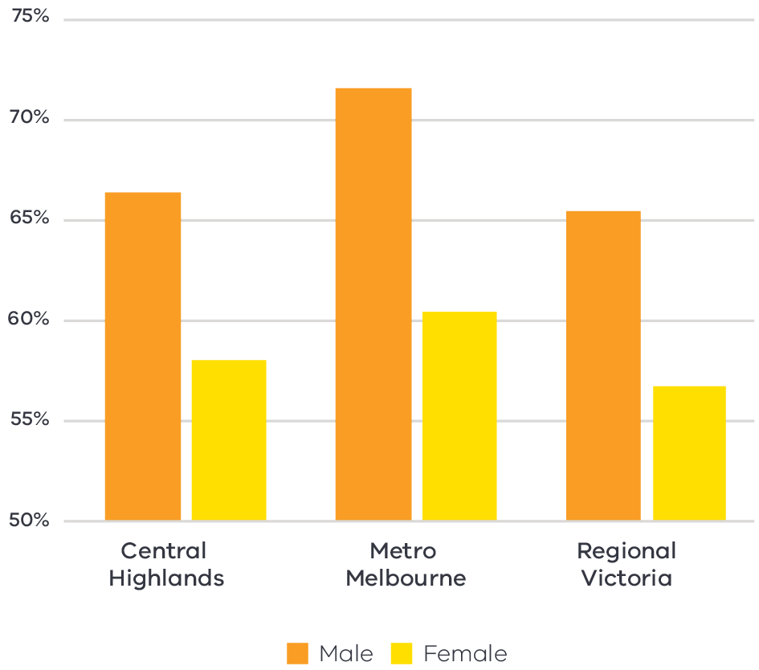

Figure 7 Participation rate by gender (2016) – Long Alternate Text

Source: ABS Census, 2016

### Challenges

#### Skill shortages

Pre-COVID projections forecast employment in the Central Highlands region to increase by 6.0 per cent between 2019 and 2024 with high rates of growth expected in service-based sectors, including education and training and health care and social assistance. There is evidence that demand for workers in service-based sectors may outpace the supply of skilled workers.

#### Housing availability

A lack of affordable housing is impacting the ability for industry to attract skilled workers to the region. Pre-COVID population forecasts suggest population growth will be stronger in Central Highlands than the regional average, with Ballarat projected to be home to an additional 38,600 people by 2036[17]. Plan Melbourne notes the peri-urban areas of Bacchus Marsh and Ballan in Moorabool Shire have capacity for more housing and employment generating development without impacting on the economic and environment roles that surrounding non-urban areas serve.

### The policy environment

The Victorian Government is investing in the region’s health and education advantages, including to:

* redevelop and expand the Ballarat Base Hospital, due to be complete in 2027.
* establish a state-of-the-art Business Centre of Excellence at Federation University, due to be complete in 2022.

The Ballarat Innovation and Research Collaboration for Health is a research collaboration between major hospitals and educational institute in Ballarat aiming to achieve a healthier Ballarat, advance careers in the health sector and increase the visibility of Ballarat as a centre of excellence for regional health research.

The Victorian Government and local stakeholders are also focused on the current and future needs of industry and how to create pathways to employment:

* The Regional Development Australia committee for Grampians is leading the For want of a worker project, which seeks to attract and retain the kind of workforce the region needs for long term growth.
* Opportunities Pyrenees, Ararat and Northern Grampians (OPAN) is a joint initiative between the three councils to address skill shortages across the sub-region by focussing on workforce planning, migration, housing and transport.
* The Victorian Skills Authority will establish a Skills Demand Taskforce for Central Highlands, which aims to better understand industry skill need, local skills shortages, future workforce training needs and identify opportunities for investment.

### Aboriginal inclusion

This direction aligns with the local Aboriginal economic development priority to enhance Aboriginal participation across industries with a particular focus on occupations which serve the local Aboriginal population and the environment, including health care and social services and education and training.

The health and education industries are important employers of Aboriginal people in the Central Highlands. Growth in these sectors will likely improve employment outcomes for Aboriginal people.

### How can we unlock this strategic direction?

To unlock this opportunity and drive growth, local, State and Commonwealth partners could work together to:

* Better understand the current skill base and future skill need and develop training and career pathways to support the health, aged care and education workforce of the future.
* Advocate for national migration settings that support the placement of skilled workers and international students in regional areas.
* Work with the education and health sectors to design initiatives that support regional specialisations for health, aged care and education services.
* Coordinate housing and infrastructure developments to support current and future industry and residents to stay and work in the region.
* Support initiatives and programs that aim to attract women in health care and social service sectors to work in regional and rural areas.
* Support investment in infrastructure and services that could promote inclusive labour market outcomes including care facilities, training and upskilling facilities.

## 4.5 Enhance the innovation ecosystem

### Significance

Innovation is critical to deliver new sources of growth and maintain high-wage jobs. The Central Highlands region is specialised or experiencing above average growth in several highly technical sub-industries that require ongoing innovation to support businesses to scale-up and address economic and environmental challenges.

Ballarat is the gateway to the region’s innovation ecosystem that extends from Ballarat to Ararat and into the western parts of the state. In addition to research and innovation precincts at Federation University, there is a comprehensive system of support for startup businesses, entrepreneurs and innovators of all ages in the Ballarat region. This includes formal education to support lifelong learning, start-up community support such as meet up and masterclasses, business idea competitions, incubator and accelerator programs, co-working spaces, fabrication laboratories and technology parks for emerging and existing digital technology-based enterprises. As a result, Ballarat is an attractive destination for new residents and businesses. In the five years to 2020, nearly 4,400 new businesses have opened in the Central Highlands region, with a heavy concentration in the Ballarat region.

Planning is underway for the Parwan Agribusiness Precinct, which has the potential to extend the innovation corridor into the south-eastern part of the region. The Precinct could strengthen agri-innovation and create stronger links between Bacchus Marsh, Melbourne, Geelong and Ballarat.

### Opportunities

#### Advanced manufacturing and capabilities

Central Highlands is specialised in food product manufacturing, transport equipment manufacturing and agriculture, and emerging strengths in other construction and professional services. Combined with research expertise and a culture of innovation, the region is well positioned to activate opportunities in these sectors associated with new technologies and globalisation. With existing clusters of transport equipment manufacturing, Ballarat has the potential to be a leader in the transition to low emissions transport solutions. Research and development can address local problems, encourage advanced capabilities and contribute to productivity gains. This supports local businesses to offset traditional market barriers such as costs, distance and traceability and to build their own resilience and capacity to adapt to the impacts of climate change.

#### Research expertise

Federation University in Ballarat has developed capability across core innovation fields including artificial intelligence, advanced automation and machine to machine communication while the Ararat Jobs and Technology precinct will focus on agri-food innovation. To retain talent in rural and regional areas and compete for research funding with metropolitan universities, it is important to strengthen partnerships with industry to address problems and export solutions to other regions.

#### Attract emerging and new businesses

Business support services, including incubators and accelerators, create opportunities for high-amenity areas to attract and retain new businesses and skilled residents. The Central Highlands region, and Ballarat in particular, benefits from attractive liveability factors combined with business support services. Maintaining the current innovator ecosystem and promoting Ballarat as a business hub will contribute to sustained business growth in the region.

**Top four sectors for new businesses in the Central Highlands[18]**

22.9% – Construction

10.9% – Transport, postal and warehousing

10.4% – Professional, scientific and technical services

8.2% – Agriculture, forestry and fishing

### Challenges

#### Digital connectivity

Pockets of the region have limited access to adequate digital infrastructure, which limits technological uptake and innovation. The Central Highlands Digital Plan highlights three key issues for the region inadequate mobile coverable, lack of NBN business-grade services and low uptake of Internet of Things applications. Establishing multipurpose Digital Hubs is a regional priority. Digital Hubs support people and businesses to access reliable high speed broadband services and build digital capability and literacy.

### The policy environment

The Victorian Government is supporting start-up culture and innovation across the state. LaunchVic is Victoria’s startup agency, responsible for developing Victoria’s startup ecosystem and empowering businesses to build global companies. The Victorian Government’s $2 billion Breakthrough Victoria Fund will drive investment in translational research, innovation and commercialisation outcomes to accelerate growth in key industry sectors and create jobs. The Central Highlands region demonstrates expertise across most of the focus industries, including health and life-sciences, agri-food, advanced manufacturing, clean energy and digital technologies.

The system of support for businesses, entrepreneurs and innovators in Ballarat includes[19]:

* Education: Ballarat Tech School, Federation University Australia and Upstart offer formal and industry education.
* Start up community support: StartUp Ballarat, supported by City of Ballarat and LaunchVic, provides a series of coworking days, meetups, masterclasses and hackathons to upskill and connect community members.
* Co-working spaces: There are four co-working spaces in Ballarat, each offering a range of short- to long-term office and meetings spaces.
* Incubator and accelerator programs: Runway Ballarat, funded by the Victorian Government, supports incubator programs, intensive accelerator programs and business idea competitions.
* Fabrication laboratories (Fab Lab): Runway Ballarat hosts Victoria’s only Fab Lab, where innovators can access the latest technology to take their ideas from concept to reality; Eurekative and Ballarat Hackerspace assist with prototyping and access to technology programming and production.
* Ballarat Technology Parks: Federation University operated two technology parks in Ballarat to encourage and support the development of emerging and existing enterprises, primarily in the information and technology sector.

### Aboriginal inclusion

Innovation and the potential business development and productivity gains cuts across several sectors. For sectors with lower levels of Aboriginal employment—such as professional, scientific and technical services and agriculture, forestry and fishing—specific interventions may be required to ensure Aboriginal communities can realise their economic development opportunities through innovation. Innovation and business incubation could support greater Aboriginal participation in economic activities including entrepreneurial activity.

### How can we unlock this strategic direction?

To unlock this opportunity and drive growth, local, State and Commonwealth partners could work together to:

* Foster partnerships between all levels of government, industry and research institutes to support business incubation, acceleration and commercialisation.
* Prioritise projects that have strong commercial potential to accelerate productivity, grow exports, support domestic manufacturing and create jobs.
* Promote Ballarat as a research hub and location of choice for new businesses.
* Provide support and networks for entrepreneurs and emerging businesses.
* Collaborate with telecommunications providers to deliver high quality digital connectivity.

# 05 Implementation

The Central Highlands REDS outlines Rural and Regional Victoria (RRV) Group’s strategic approach for focusing its future economic development activities, including through policy, investment and program delivery, in the region. It is not a prescriptive roadmap for Victorian Government economic development action in Central Highlands.

## RRV will use the REDS to coordinate investments and activities in place

RRV is committed to pursuing the strategic directions through future policy design, investment and program implementation, as well as through collaboration across government and with regional partnerships, to deliver positive economic outcomes for the region. The Central Highlands REDS will provide a central point for coordination for current and future work streams and investments.

RRV recognises that effective planning policy and controls will be a key enabler of inclusive, sustainable economic growth in the Central Highlands region. Victoria’s Regional Growth Plans provide broad direction for land use and development, and enable economic growth by ensuring that infrastructure investment is coordinated, appropriate services are provided, and development meets community expectations. The Regional Development and Planning portfolios will pursue opportunities to ensure that as relevant state-led land use planning strategies, policies and controls are updated, they are aligned with the REDS strategic directions.

In regional cities and peri-urban towns with shortages of zoned land (as identified through the Urban Development Program), Councils should consider asking the Minister for Planning to appoint the Victorian Planning Authority to lead structure planning and rezoning for designated areas.

## Local stakeholders, industry leaders and government service providers can use the REDS to advocate for shared outcomes

The Central Highlands REDS, along with the supporting Central Highlands Regional Economic Development Strategy – Supporting Analysis document, provides a starting point for an evidence-based, strategic approach to regional development. This approach is an ongoing process where specific development actions and projects can be proposed and considered in the context of alignment with the REDS.

Regional Development Victoria – Grampians will remain the main point of contact in the region for facilitating and coordinating regional development outcomes.

The Central Highlands Regional Partnership which comprises community and business leaders, CEOs of constituent Local Governments, State Government personnel and a representative from Regional Development Australia will continue to be the main advisory body to the Minister for Regional Development and other government decision-makers on local issues and priorities.

The Central Highlands REDs will provide Jobs Victoria with important context and understanding of local economic priorities and opportunities that will be a critical input into the planning and prioritisation of Jobs Victoria’s work and collaboration activities with our Service Partners. Jobs Victoria assists people looking for work, connects employers with the staff they need, administers wage subsidy programs and supports significant local employment transitions.

## RRV will monitor the implementation of the REDS

The strategic directions in the REDS focus on medium- to long-term drivers of growth and opportunity but will be used immediately to guide investment in the region. Notwithstanding this timeframe, the strategic directions will continue to evolve and progress as actions and investment are made. To ensure ongoing relevance and accuracy, RRV will periodically update and refresh this Strategy.

## Contact us

Department of Jobs, Precincts and Regions

Level 31, 121 Exhibition Street, Melbourne, VIC 3000

T: +61 (03) 9651 9999

[djpr.vic.gov.au](https://djpr.vic.gov.au/)

Authorised and published by the Victorian Government.

Department of Jobs, Precincts and Regions  
Level 31, 121 Exhibition Street,   
Melbourne, VIC 3000  
Telephone (03) 9651 9999

March 2022

Unless indicated otherwise, this work is made available under the terms of the Creative Commons Attribution 3.0 Australia Licence. To view a copy of this licence, visit [creativecommons.org/licenses/by/3.0/au](https://creativecommons.org/licenses/by/3.0/au/)

It is a condition of this Creative Commons Attribution 3.0 Licence that you must give credit to the original author who is the State of Victoria.

ISBN 978-1-76090-545-3 (Print)

ISBN 978-1-76090-546-0 (pdf/online/MS word)

# Appendix

## Figure 1: Map of Regional Partnerships – Long Alternate Text

The **Mallee** region is located in northwest Victoria and contains the LGAs of Mildura, Swan Hill, Buloke and Gannawarra.

The **Wimmera Southern Mallee** region is located in western Victoria and contains the LGAs of West Wimmera, Hindmarsh, Yarriambiack, Horsham and Northern Grampians.

The **Great South Coast** region is located in southwest Victoria and contains the LGAs of Glenelg, Southern Grampians, Moyne, Warrnambool and Corangamite.

The **Barwon** region is located to southwest of metropolitan Melbourne and contains the LGAs of Geelong, Queenscliffe, Surf Coast and Colac Otway.

The **Central Highlands** region is to the west of metropolitan Melbourne and contains the LGAs of Ararat, Pyrenees, Golden Plains, Moorabool, Ballarat and Hepburn.

The **Loddon Campaspe** region is northwest of metropolitan Melbourne and contains the LGAs of Macedon Ranges, Mount Alexander, Central Goldfields, Loddon Campaspe and Bendigo.

The **Goulburn** region is north of metropolitan Melbourne and contains the LGAs of Mitchell, Murrindindi, Strathbogie, Greater Shepparton and Moira.

The **Ovens Murray** region is located in the northeast of Victoria and contains the LGA’s of Mansfield, Benalla, Wangaratta, Alpine, Indigo, Towong and Wodonga.

The **Gippsland** region is located in the east of Victoria and contains the LGAs of Bass Coast, South Gippsland, Baw Baw, Latrobe, Wellington and East Gippsland.

Click here to return to document

## Figure 2 Map of Central Highlands – Long Alternate Text

The Central Highlands region is made up of the Pyrenees, Ararat, Ballarat, Hepburn, Moorabool and Golden Plains Local Government Areas.

The Central Highlands region has major road and rail connections to Melbourne (south east) and to the north, west and south west. Ballarat and Ararat are major regional centres in the Central Highlands region, with other prominent towns being Avoca, Hepburn Springs, Daylesford, Creswick, Ballan, Bacchus Marsh, Smythesdale and Bannockburn.

Ararat and Ballarat are connected both rail and road, with several major roads connecting these centres with the surrounding regional towns, and those towns with each other. Both Ararat and Ballarat have airports.

Click here to return to document

## Figure 3 Central Highlands industry Employment – Long Alternate Text

The largest employing industries in descending order are Health Care and Social Assistance, Retail Trade, Construction, Education and Training, Manufacturing, Accommodation and Food Services, Public Administration and Safety, Agriculture Forestry and Fishing, Professional, Scientific and Technical Services, Transport, Postal and Warehousing.

The following industries have grown in employment since 2001; Health Care and Social Assistance, Retail Trade, Construction, Education and Training, Manufacturing, Accommodation and Food Services, Public Administration and Safety, Professional, Scientific and Technical Services, Transport, Postal and Warehousing.

The following industry has declined in employment since 2001; Agriculture, Forestry and Fishing.

Simplified Table of data for Figure 3.

|  |  |  |  |  |  |  |  |  |  |  |
| --- | --- | --- | --- | --- | --- | --- | --- | --- | --- | --- |
|  | Health Care and Social Assistance | Retail Trade | Construction | Education and Training | Manufacturing | Accommodation and Food Services | Public Administration and Safety | Agriculture, Forestry and Fishing | Professional, Scientific and Technical Services | Transport, Postal and Warehousing |
| 2001 | 7500 | 7171 | 3478 | 5267 | 7284 | 4202 | 2315 | 5083 | 2234 | 1791 |
| 2002 | 7536 | 7102 | 3913 | 5293 | 7052 | 4163 | 2366 | 5051 | 2232 | 1771 |
| 2003 | 7432 | 7299 | 4517 | 5314 | 7199 | 4098 | 2589 | 4936 | 2251 | 1806 |
| 2004 | 7385 | 7330 | 4922 | 5239 | 7298 | 4161 | 2819 | 4758 | 2317 | 1977 |
| 2005 | 7704 | 7505 | 5616 | 5417 | 7323 | 4296 | 3115 | 4889 | 2391 | 2005 |
| 2006 | 8325 | 7855 | 6088 | 5695 | 7364 | 4368 | 3336 | 4915 | 2490 | 2048 |
| 2007 | 8576 | 8007 | 6286 | 5911 | 7397 | 4586 | 3472 | 4741 | 2611 | 2126 |
| 2008 | 8820 | 8291 | 6108 | 6137 | 7710 | 4951 | 3626 | 4361 | 2783 | 2241 |
| 2009 | 9357 | 8249 | 5835 | 6208 | 7397 | 4925 | 3714 | 4201 | 2901 | 2292 |
| 2010 | 9796 | 8185 | 6274 | 6329 | 7139 | 5058 | 3848 | 4186 | 3208 | 2409 |
| 2011 | 9956 | 8497 | 6258 | 6509 | 7203 | 5287 | 4058 | 4119 | 3292 | 2580 |
| 2012 | 10215 | 8740 | 6449 | 6646 | 7175 | 5406 | 4147 | 4133 | 3328 | 2637 |
| 2013 | 10753 | 8503 | 6753 | 6881 | 7051 | 5523 | 4206 | 4185 | 3369 | 2629 |
| 2014 | 11101 | 8115 | 6460 | 6964 | 6704 | 5543 | 4189 | 6077 | 3334 | 2571 |
| 2015 | 11314 | 7972 | 6521 | 7112 | 6121 | 5599 | 4198 | 7715 | 3320 | 2535 |
| 2016 | 12007 | 8084 | 6518 | 7453 | 5987 | 5835 | 4299 | 7499 | 3429 | 2540 |
| 2017 | 12187 | 8753 | 6529 | 7139 | 6736 | 6292 | 4562 | 7965 | 3701 | 2663 |
| 2018 | 12254 | 8969 | 7378 | 7154 | 6675 | 6613 | 4565 | 8377 | 4226 | 2777 |
| 2019 | 12727 | 9322 | 8545 | 7446 | 6476 | 6389 | 4610 | 6414 | 4049 | 3115 |
| 2020 | 14396 | 9675 | 8653 | 7722 | 7489 | 5854 | 4840 | 4405 | 4090 | 3078 |

Click here to return to document

## Figure 4 Central Highlands industry output (gross value add) – Long Alternate Text

The industries with the largest gross value add in 2020 in descending order are Health Care and Social Assistance, Construction, Agriculture, Forestry and Fishing, Education and Training, Manufacturing, Public Administration and Safety, Retail Trade, Professional, Scientific and Technical Services, Financial and Insurance Services and Transport, Postal and Warehousing.

The following industries have grown in gross value add since 2001; Health Care and Social Assistance, Construction, Agriculture, Forestry and Fishing, Education and Training, Public Administration and Safety, Retail Trade, Professional, Scientific and Technical Services, Financial and Insurance Services and Transport, Postal and Warehousing.

The following industry has declined in gross value add since 2001; Manufacturing.

|  | Health Care and Social Assistance | Construction | Agriculture, Forestry and Fishing | Education and Training | Manufacturing | Public Administration and Safety | Retail Trade | Professional, Scientific and Technical Services | Financial and Insurance Services | Transport, Postal and Warehousing |
| --- | --- | --- | --- | --- | --- | --- | --- | --- | --- | --- |
| 2001 | 477 | 349 | 506 | 439 | 858 | 286 | 281 | 196 | 248 | 193 |
| 2002 | 491 | 412 | 525 | 440 | 800 | 315 | 294 | 209 | 240 | 200 |
| 2003 | 510 | 486 | 437 | 460 | 774 | 315 | 301 | 205 | 241 | 205 |
| 2004 | 522 | 487 | 563 | 463 | 738 | 305 | 322 | 207 | 241 | 216 |
| 2005 | 529 | 574 | 572 | 469 | 710 | 317 | 333 | 205 | 253 | 224 |
| 2006 | 569 | 580 | 658 | 482 | 697 | 339 | 342 | 216 | 252 | 217 |
| 2007 | 576 | 584 | 599 | 489 | 698 | 347 | 362 | 225 | 266 | 208 |
| 2008 | 576 | 616 | 586 | 507 | 759 | 342 | 390 | 234 | 282 | 237 |
| 2009 | 633 | 640 | 585 | 523 | 700 | 360 | 399 | 268 | 263 | 248 |
| 2010 | 684 | 681 | 477 | 537 | 712 | 381 | 385 | 293 | 277 | 239 |
| 2011 | 667 | 721 | 512 | 566 | 734 | 393 | 402 | 305 | 310 | 256 |
| 2012 | 681 | 796 | 640 | 588 | 692 | 419 | 424 | 310 | 287 | 270 |
| 2013 | 716 | 802 | 702 | 602 | 655 | 433 | 427 | 337 | 273 | 280 |
| 2014 | 771 | 762 | 781 | 578 | 642 | 463 | 415 | 342 | 272 | 269 |
| 2015 | 816 | 793 | 892 | 569 | 606 | 472 | 425 | 345 | 274 | 249 |
| 2016 | 855 | 770 | 776 | 572 | 586 | 491 | 443 | 384 | 281 | 254 |
| 2017 | 885 | 740 | 837 | 596 | 628 | 530 | 473 | 433 | 296 | 260 |
| 2018 | 943 | 860 | 893 | 601 | 622 | 541 | 496 | 493 | 317 | 272 |
| 2019 | 1048 | 1072 | 744 | 645 | 594 | 540 | 520 | 459 | 316 | 298 |
| 2020 | 1176 | 1015 | 664 | 657 | 655 | 595 | 569 | 464 | 302 | 283 |

Click here to return to document

## Figure 5 Central Highlands industry employment location quotient and growth – Long Alternate Text

The graph is divided into four quadrants.

The first quadrant identifies the industries that are a) experiencing slower employment growth (or faster declines) than state averages and b) have higher levels of employment specialization than state averages

The following industries are in quadrant 1:

* Hospitals
* Public Administration and Safety
* Agriculture, Forestry and Fishing

The second quadrant identifies the industries that are a) experiencing faster employment growth (or slower declines) than state averages and b) have higher levels of employment specialization than state averages.

The following industries are in quadrant 2:

* Accommodation
* Food Retailing
* Heritage Activities
* Food Product Manufacturing
* Construction
* Education and Training
* Preschool and School Education
* Retail Trade
* Property Owners and Real Estate Services
* Manufacturing
* Construction Services
* Food and Beverage Retailing
* Health Care and Social Assistance
* Transport Equipment Manufacturing

The third quadrant the industries that are a) experiencing slower employment growth (or faster declines) than state averages and b) have lower levels of employment specialization than state averages.

There are no industries in the third quadrant.

The fourth quadrant identifies industries that are a) experiencing faster employment growth (or slower declines) than state averages an b) have lower levels of employment specialization than state averages.

Other store-based retailing is the only industry in the fourth quadrant.

Click here to return to document

## Figure 6 Central Highlands industry output (GVA) location quotient and growth – Long Alternate Text

The graph is divided into four quadrants. The first quadrant identifies the industries that are a) experiencing slower GVA growth (or faster declines) than state averages and b) have higher levels of GVA specialization than state averages

The following industries are in quadrant 1:

* Coal Mining
* Hospitals
* Heavy and Civil Engineering Construction
* Public Administration

The second quadrant identifies the industries that are a) experiencing faster GVA growth (or slower declines) than state averages and b) have higher levels of GVA specialization than state averages.

The following industries are in quadrant 2:

* Construction
* Education and Training
* Agriculture, Forestry and Fishing
* Retail Trade
* Food Product Manufacturing
* Water Supply, Sewerage and Draining Services
* Residential Care Services
* Social Assistance Services
* Manufacturing
* Other Store Based Retailing
* Property Owners and Real Estate Services
* Food Retailing
* Preschool and School Education
* Public Administration and Safety

The third quadrant the industries that are a) experiencing slower GVA growth (or faster declines) than state averages and b) have lower levels of GVA specialization than state averages.

The following industries are in quadrant 3:

* Professional and Scientific Services

The fourth quadrant identifies industries that are a) experiencing faster GVA growth (or slower declines) than state averages an b) have lower levels of GVA specialization than state averages.

The following industries are in quadrant 4:

* Telecommunication Services
* Professional, Scientific Services

Click here to return to document

## Figure 7 Participation rate by gender (2016) – Long Alternate Text

Graph showing workforce participation by gender in Central Highlands. Participation of both males and females is slightly higher in Central Highlands than in regional Victoria as a whole, while still lower than Metro Melbourne.

|  |  |  |
| --- | --- | --- |
|  | Male | Female |
| Central Highlands | 66.3% | 58.0% |
| Metro Melbourne | 71.5% | 60.4% |
| Regional Victoria | 65.4% | 56.6% |

Click here to return to document

1. Australian Bureau of Statistics, 2020a
2. Victoria in Future 2020, Department of Environment, Land, Water and Planning - The COVID pandemic has changed Victoria’s population pathway from near-record growth levels to population losses. However, Victoria’s regions appear to have experienced little disruption to growth patterns. Migration from Melbourne to the regions has been at record levels according to the latest ABS data, offsetting most regional losses to overseas or interstate. There remains considerable uncertainty around the distribution of the increased regional migration, and the permanence of this trend, but available evidence points to continuing regional growth. Data from the 2021 Census will be vital in determining the impacts on the strongest migration attractors (eg regional centres and peri-urban areas) versus those regions which may have experienced losses from the temporary migrant workforce. Given available information, the current projections remain fit for purpose for regional planning.
3. National Skills Commission, 2022
4. ABS Census, 2016
5. National Institute of Economic and Industry Research, 2020
6. DEDJTR, 2018, Helping Victoria Grow; Extractive Resource Strategy
7. Thomas J. et al., 2021, *Australian Digital Inclusion Index*
8. Regional Wellbeing Survey, 2020
9. Department of Education and Training, 2021
10. ABS Census, 2016
11. RRV analysis, SQM, 202
12. DHHS rental Report – June Quarter, 2021
13. Agriculture Victoria analysis, using Regional Industry Structure and Employment (RISE) model 2021
14. NIEIR, National Institute of Economic and Industry Research Estimates. (2020).
15. Department of Environment, Land, Water and Planning, 2019, Central Highlands Climate Projection 2019 (based on ‘high emissions’ scenario, where 2050s refers to the period from 2040 to 2059)
16. Department of Education and Training, 2021, Research Snapshot; International students studying in regional areas
17. Department of Environmental, Land, Water and Planning, 2019, Victoria in Future 2019; Population Projections 2016 to 2056
18. September 2015 to September 2020; REMPLAN, Accessed October 2021
19. StartUp Ballarat, Ballarat – Creative and Innovative