Ovens Murray

Regional Economic Development Strategy

**State Government of Victoria**

**Department of Jobs, Precincts and Regions**

**Acknowledgement of Country**

The Department of Jobs, Precincts and Regions acknowledge the Traditional Owners of the lands and waters on which we live and work, and pay our respects to their Elders past, present and emerging.

We acknowledge that the Ovens Murray Regional Partnership region is on traditional lands, including those lands of the Taungurung, Yorta Yorta and Gunaikurnai Nations, as well as other Traditional Owner groups in Victoria who are not formally recognised.

We acknowledge the diversity of Aboriginal Victorians, their communities and cultures, the intrinsic connection to Country, the contribution and interest of Aboriginal people and organisations in developing a prosperous region. This Strategy is committed to advancing the principles of Aboriginal self-determination and supporting communities to realise self-determined economic development objectives.

# Preface

Rural and regional Victoria is home to 1.6 million, or 1 in 4, of Victoria’s residents and over 147,000 businesses. The Victorian Government is committed to making Victoria home to the nation’s most vibrant and successful regional economies.

The Department of Jobs, Precincts and Regions (DJPR) is delivering Regional Economic Development Strategies (REDS) for Victoria’s nine Regional Partnership regions. The REDS contribute to DJPR’s vision for regional Victoria to be a resilient and thriving place to live, work and do business. The REDS provide a consistent socioeconomic evidence base, and strategic framing of medium- to long-term directions to activate economic development opportunities.

**The REDS seek to:**

1. Identify a socioeconomic evidence base for the region, including demographics, business and industry dynamics, and local endowments that can be used by all stakeholders, and will provide a baseline for monitoring future performance.
2. Acknowledge and reveal the depth of work, analysis, and planning already in place in regions and create a mechanism to support and progress established regional directions, where supported by the current evidence base.
3. Harness and enhance the region’s comparative strengths as drivers of growth in the medium- to long-term.
4. Identify opportunities for public and private investment.
5. Influence and inform rural and regional economic policy and program design across government.
6. Support the prosperity and well-being of rural and regional Victoria through increased rural competitiveness and productivity.

The REDS do not replace existing local strategies. Rather, the REDS are informed by local work to identify economic development priorities and provide a platform to increase the visibility of these priorities and support regional communities to advocate for shared outcomes.

## How have the REDS been developed?

The REDS have been developed using a consistent methodology across the state, comprising:

* data analysis to consistently describe each region’s industry composition, economic and socioeconomic trends and existing regional endowments
* policy analysis to identify existing local strategies and plans to understand regional development priorities and shape an economic narrative for the region

stakeholder engagement to identify opportunities and challenges under each strategic direction.

In line with place-based principles, each strategy is tailored according to local preferences and circumstances.

## How the REDS will be used

The REDS can be used by all levels of Government, regional communities and business to coordinate investment and collaborate for shared outcomes.

DJPR will use the REDS to drive strategic whole-of-government activity in the regions, informed by a contemporary understanding of economic performance.

Regional communities and businesses can use the REDS to:

* communicate innovative capacity in their region, now and in the future
* collaborate with government to better understand regional strengths, challenges and opportunities

attract investment to the region based on clearly identified strategic priorities.

The REDS should be read in conjunction with the relevant REDS Supporting Analysis which provides the consistent evidence base for each region.

**Figure 1: Map of Regional Partnership Regions and Constituent LGAs**

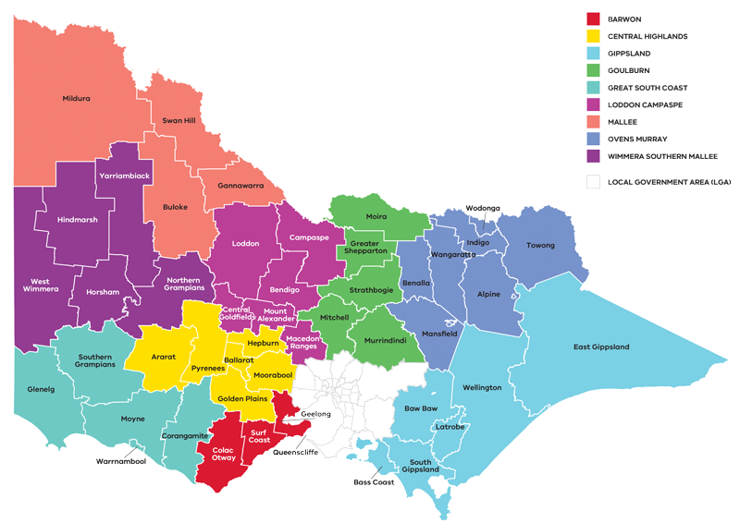

Figure 1: Map of Regional Partnerships – Long Alternate Text

Contents

01 Introduction 4

02 Regional profile 7

03 Comparative advantage 11

3.1 Endowments 11

3.2 Revealed industry specialisation 15

04 Strategic directions 19

[4.1 Expand business and employment opportunities in the transport,   
distribution and logistics industries 22](#_Toc109889066)

[4.2 Strengthen and diversify the visitor economy through leveraging   
the region’s nature, epicurean and cultural tourism industries 26](#_Toc109889067)

[4.3 Expand on existing strength in manufacturing to take advantage   
of opportunities in new industries 31](#_Toc109889068)

[4.4 Support and expand economic and employment opportunities in   
growing sectors (health, social services, education) 36](#_Toc109889069)

4.5 Position the region to benefit from emerging growth opportunities in natural resources 40

05 Implementation 43

Appendix 45

Figure 1: Map of Regional Partnerships – Long Alternate Text 45

Figure 2 Map of Ovens Murray – Long Alternate Text 45

Figure 3 Ovens Murray industry Employment (2001-20) – Long Alternate Text 46

Figure 4 Ovens Murray industry output (gross value add) 2001-20 – Long Alternate Text 48

Figure 5 Ovens Murray industry employment location quotient and growth – Long Alternate Text 50

Figure 6 Ovens Murray industry output (GVA) location quotient and growth – Long Alternate Text 51

Figure 7 Participation rate by gender (2016) – Long Alternate Text 52

# 01 Introduction

The *Ovens Murray Regional Economic Development Strategy* (Ovens Murray REDS) lays out medium– to long-term strategic directions for driving economic development in the region.

Ovens Murray is known for its lifestyle and thriving tourism sector based on cycling, snow, nature-based tourism, food, wine, craft beer and cultural heritage. The region has a specialised manufacturing sector, benefiting from surrounding agricultural industries, and is strategically located on national freight and transport routes that facilitate access to inter-state and overseas markets. Wodonga is part of the cross-border Albury-Wodonga economic zone, a diverse regional hub supporting population growth and employment opportunities. Other regional centres include Wangaratta and Benalla. The region is home to the Taungurung, Yorta Yorta, and Gunaikurnai peoples who are the Traditional Owners who have lived, worked and cared for their country and its resources for many thousands of years.

## Strategic directions

The Ovens Murray REDS defines five strategic directions for economic development in the region based on comprehensive data analysis and review of existing policies and strategies:

1. Expand business and employment opportunities in the **transport, distribution and logistics industries**
2. Strengthen and diversify the **visitor economy** through leveraging **the region’s nature and epicurean tourism industries**
3. Expand on existing strength in **manufacturing** to take advantage of opportunities in new industries
4. Support and expand economic and employment opportunities in growing sectors **(health, social services, education)**
5. Position the region to benefit from **emerging growth opportunities** in natural resources.

For each of the directions, the Ovens Murray REDS provides:

* a rationale for its inclusion as part of the strategy
* an overview of opportunities and challenges which are likely to support or hinder future growth
* a summary of work underway and the policy context to support desired outcomes
* the implication of the direction for the region’s Aboriginal communities

examples of how the direction could be activated.

The Ovens Murray REDS recognises that approaches to regional development occur in an uncertain environment. While most of the analysis focuses on internal development drivers, it also considers the impact of, and opportunities emerging due to external trends, including the COVID-19 pandemic, patterns in global trade, a changing climate and technological change.

The Ovens Murray REDS also acknowledges that the Aboriginal and cross-border communities within the Ovens Murray region face unique challenges and opportunities. Through comprehensive analysis and engagement, the Oven Murray REDS identifies strategic directions for these communities and considers the wider alignment to the overall REDS.

## Regional readiness to activate strategic directions

There is strong evidence of innovation or innovative capacity, cross-sector collaboration and entrepreneurship in the Ovens Murray Regional Partnership region, including a vibrant network of regional cities and centres. The Hume Freeway and Melbourne-Sydney rail link through Wodonga provide a platform for freight transport and logistics industries. The region is home to several tertiary institutions including La Trobe University Wodonga and Wodonga TAFE, Charles Stuart University campus at the Wangaratta Regional Study Centre. The University of Melbourne also operates a Rural Clinical School adjacent to Northeast Health Wangaratta. The region also benefits from a strong network of health and community services, predominantly operating out of key service locations in Wangaratta and Wodonga. The region has developed an innovative capacity to develop and implement several action plans and strategies through their collaborative and responsive implementing approach to bushfire recovery across the region.

## Strategic alignment

The Ovens Murray REDS has been informed by the depth of work, analysis and planning already undertaken for the Ovens Murray region. Several strategic documents, policies and reports have been reviewed including but not limited to:

* The Ovens Murray Regional Partnership’s Outcomes Roadmap and Digital Plan
* The Hume Strategy for Sustainable Communities 2010-2020
* Albury-Wodonga Regional Economic Development Strategy 2018-22 (NSW Government)
* 2021 Victorian Alpine Resorts: Visitor Economy Development Plan

2019 Defence Industry in the Hume Region (RDA)

The Ovens Murray REDS has also drawn on background research and analysis, data collation and analysis of relevant economic and demographic trends, and stakeholder input. The REDS should be viewed in conjunction with the Ovens Murray REDS Supplementary Information, which includes relevant data insights.

Map showing an overview of Ovens Murray, with key transport infrastructure. A detailed description is provided via the link below.

Figure 2 Map of Ovens Murray – Long Alternate Text

# 02 Regional profile

* $6.5 – Gross regional product (billion) (2020)
* 131, 400 – Population (2020)
* 11.1% – Population growth (2011-20)
* 44 – Median age (2020)
* 60.4% – Working age (15-64) (2020)
* 21.1% – Population aged over 65 (2020)
* 1.6% – Are Aboriginal and/or Torres Strait Islander (2016)
* 5.1% – Speak a language other than English at home (2016)

10.3% – Were born overseas (2016)

Much of the region’s population lives in the major cities of Wodonga and Wangaratta. The areas with the fastest population growth over the last 10 years have been the City of Wodonga and the Shire of Mansfield, while the Alpine and Benalla LGAs have experienced more subdued growth.

Across the region, there are higher outflows of residents aged 15-24 compared to the regional Victorian average, potentially indicating a lack of suitable and affordable housing and employment or training opportunities that might retain younger residents – even in parts of the region with higher urbanisation such as Wodonga and Wangaratta. However, the Shire of Mansfield is experiencing levels of internal migration in the 0-14 and 25-44 age groups that are over double the regional Victorian average, suggesting that it is a popular destination for families given the attractive lifestyle and proximity to Melbourne’s economic and education centres.

| Local Government Area | Population[1] (2020) | Projected growth[2] (2021–36)1 |
| --- | --- | --- |
| Alpine | 12,900 | 4.5% |
| Benalla | 14,100 | 3.5% |
| Indigo | 16,900 | 9.7% |
| Mansfield | 9,500 | 16.9% |
| Towong | 6,100 | 2.4% |
| Wangaratta | 29,200 | 8.4% |
| Wodonga | 42,700 | 33.4% |

|  | Ovens Murray % | Regional average % | Metro Melbourne % |
| --- | --- | --- | --- |
| Unemployment rate[3] (September 2021) | 3.1 | 4.2 | 6.0 |
| Labour force participation rate[4] (2016) | 62.4 | 60.9 | 65.8 |
| Average annual employment growth[5] (2011–20) | 0.4 | 1.0 | 2.1 |

The labour force participation rate in Ovens Murray (62.4 per cent) is relatively higher compared to the regional average, but the participation rate for women (53.8 per cent) is significantly lower than for men (66.7 per cent). The largest employing sectors for women are health care and social assistance, education and training, and finance and insurance services.

**Table 1: Employment in largest employing industries by workforce (2020) and gender (2016)**

|  |  |  |  |
| --- | --- | --- | --- |
|  | Workers | Male | Female |
| Healthcare and social assistance | 7,800 | 16.9% | 83.1% |
| Manufacturing | 7,200 | 75.7% | 24.3% |
| Agriculture, forestry and fishing | 5,800 | 69.5% | 30.5% |
| Retail Trade | 5,600 | 40.7% | 59.3% |
| Construction | 5,400 | 88.5% | 11.5% |

Source: National Institute of Economic and Industry Research, 2020 and ABS Census, 2016

## Employment by industry

The region has realised considerable growth in the health care and social assistance sector, which overtook the manufacturing industry to be the largest employer in the region from 2013. Employment in the health care and social assistance sector is consistent with trends across the State in a response to a growing ageing population in the Ovens Murray region. Other population driven sectors such as construction and education and training have also seen steady long-term growth over the period from 2001 to 2020.

The manufacturing sector and agriculture, forestry, and fishing industries were the region’s second and third most significant employers in 2020. The employment numbers in both industries have been volatile over the past 20 years, and both have been on a slight downward trend, indicating a greater level of automation and an increased reliance on capital inputs in the production process. However, in 2020, employment in the agriculture, forestry and fishing sector increased by 30 per cent.

**Figure 3: Ovens Murray industry employment (2001-20)**

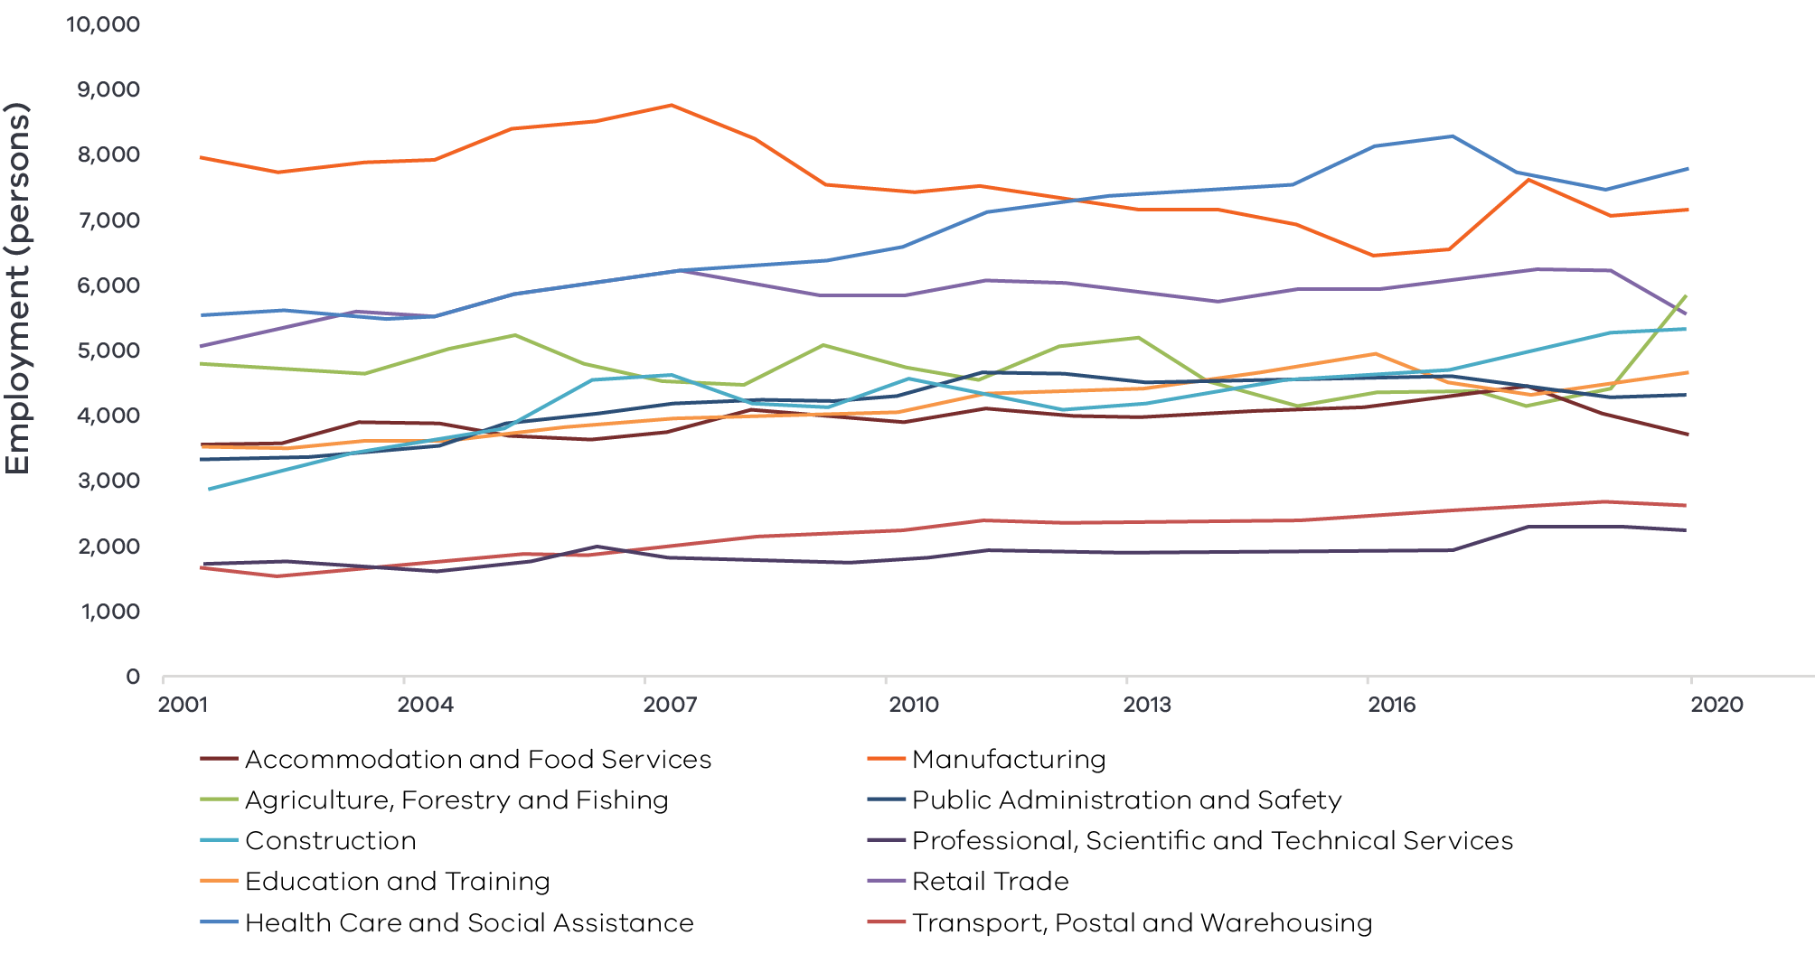

Figure 3 Ovens Murray industry Employment (2001-20) – Long Alternate Text

Source: National Institute of Economic and Industry Research, 2020

Note: Top 10 employing industries in 2020 presented in chart, based on Journey to Work employment estimates.

## Output by industry

The region experienced a steady increase in GVA from 2001 until 2018, but a decrease in 2019 and 2020. This may partly be attributed to the COVID-19 pandemic which drastically reduced visitation numbers to the region and had a range of other impacts including on supply chains and production. Manufacturing was the largest contributor to the region’s GVA between 2001 and 2020. The sector is, however, experiencing a general decrease in total GVA which has been driven by a steep decline in beverage and tobacco product manufacturing.

Health care and social assistance has experienced strong output growth in the region, and since 2017 has surpassed the construction, public administration and safety, and agriculture, forestry and fishing sectors to become the second largest contributor to GVA.

### $5.2 billion Gross Value Added (GVA) (2020)

**Top sectors by GVA ($ million):**

1. Manufacturing: $743.2
2. Health care and social assistance: $660.0
3. Construction: $531.2
4. Public administration and safety: $488.5
5. Education and training: $448.3

**Figure 4: Ovens Murray Industry Output (Gross Value Add) 2001-20**

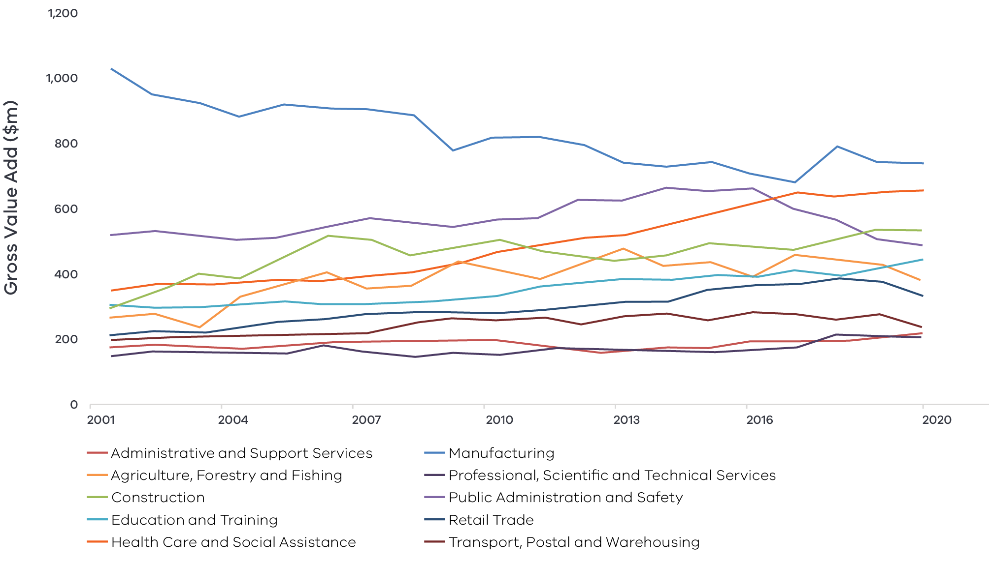

Figure 4 Ovens Murray industry output (gross value add) 2001-20 – Long Alternate Text

Source: National Institute of Economic and Industry Research, 2020

Note: Top 10 employing industries in 2020 presented in chart, based on Journey to Work employment estimates.

## Regional exports

The region derives significant export value from the manufacturing and agriculture, forestry and fishing industries which together comprised 72.8 per cent of all export value in the region in 2020. International export value from the region has steadily increased over the past decade from $656.3 million in 2010 to $907.4 million in 2020. The region has important food processing centres in Wodonga, Wangaratta, Wahgunyah, and Benalla which enable it to have a strong presence in international markets. The region’s largest exports are food and beverage products such as beer and wine, grain and cereal products, and dairy products, but it also has significant exports in metal products as well as machinery and equipment.

# 03 Comparative advantage

For the purpose of the REDS, ‘comparative advantage’ is defined simply as a description of what the region does well compared to other regions. This includes both the relative competitiveness of the region’s businesses as well as cultural, social and environmental factors.

Contemporary place-based development emphasises the importance of local endowments as a driver of comparative advantage. In economic terms, endowments refer to any natural, human, cultural and built resources present in a place which can be harnessed to support economic activity. Regional economic strengths can also be identified using other measures including location quotient analysis, shift share analysis, and industry cluster analysis. A comprehensive assessment of these measures is included in the Ovens Murray Regional Economic Development Strategy – Supporting Analysis.

## 3.1 Endowments

### Natural endowments

#### Reliable access to fertile land and water

The region has a specialisation in the agriculture, forestry and fishing sector with a primary focus on beef production. This regional strength is supported by rich soil and a highly secure water source from key lakes and rivers in the Murray-Darling Basin.

#### Environmental amenity

Natural assets present significant opportunities for nature tourism in the Ovens Murray region. The Alpine, Mansfield and Towong shires have a range of landscapes, reserves and national parks. The Indigo Shire and Alpine Shire boasts parks and key cycling infrastructure (Beechworth and Yackandandah Mountain Bike Track network), with plans also in place to develop the Indigo Epic Trail project. These locations are the most popular cycling destination in Victoria. In addition, the region is also home to the town of Bright, which is known for its autumn foliage and outdoor trails, which are part of a network contributing to the region’s reputation a premier cycle tourism destination. Warby Ranges and the King Valley in the Wangaratta Council offer considerable environmental amenities. These areas draw a large amount of tourism throughout the year and provide significant economic and ecological value in the region.

#### Alpine environment

The Ovens Murray region is home to the Victorian Alps and the Alpine resorts that are situated within the Alpine and Mansfield LGAs. Popular locations such as Falls Creek, Mount Hotham and Mount Buller as well as the surrounding parks are a key asset for tourism both during the summer for activities such as hiking, mountain biking, camping and recreational fishing and are some of the best destinations in the state and country for winter sports.

#### Natural resources

The region has a range of environmental and mineral resources that provide economic opportunities. The main opportunities in mining have been in gold and tin, but there are also operations in sand and stone extraction in the region. In addition, there is a large softwood and commercial timber industry in the region, particularly in the Alpine and Towong shires where the Berringama and Shelley timber plantations are located. The region has strong potential for hydropower generation and already has a strong uptake of rooftop solar and supporting infrastructure such as community batteries. The region is already home to large-scale hydropower generators at McKay Creek, Bogong, Clover and West Kiewa.

### Cultural endowments

#### Aboriginal heritage

The region is home to three legally recognised Traditional Owners (Yorta Yorta, Taungurung and Gunaikurnai) and there are many culturally significant sites within Ovens Murray. Some important Aboriginal cultural heritage assets in the region include Marnong (Mount Buller), Mount Stirling, Winton Wetlands and Lake Eildon. These sites are used for food as well as traditional ceremony purposes and hold notable archaeological artefacts and scar trees.

#### Cultural experiences

The Ovens Murray region has a rich offering of cultural events, attractions and historical sites year-round. As a major agricultural hub, the region offers many culinary experiences such as the Beechworth Harvest Festival and the Rutherglen Winery Walkabout and is also home to the King Valley wine region. In addition, the region plays host to the Yackandandah Folk Festival and Cool Summer Festival and holds the International Kangaroo Hoppet XC Ski Race, Audax Alpine Classic cycling event and The Man from Snowy River Bush Festival. Ovens Murray also has several historical attractions including the Beechworth Historic and Cultural Precinct, Beechworth Historic Walking Tours, the Benalla Costume and Kelly Museum, Benalla and Wangaratta art galleries, and other important sites related to the infamous bushranger Ned Kelly.

Wodonga’s new library features upgraded library and arts gallery space and workshops and community room. The library is expected to attract numerous exhibitions and arts performances hence support the growth of cultural tourism in Wodonga and visitor spending in the region. Mount Buffalo Chalet, which is listed in the Victorian Heritage Register, has had a significant presence in early tourism of North East Victoria. Through a range of state and federal funding, the building has become an important architectural, cultural attraction for visitors in the region.

### Built endowments

#### Manufacturing hub

Food product manufacturing remains one of the most important sub-industries in Ovens Murray and is providing significant employment opportunities and GVA growth in the region. Ovens Murray is home to a number of strong manufacturing centres with established food manufacturing businesses. In addition, the region also serves as a defence manufacturing hub which generates more than 5,600 jobs and contributes a total value of $185 million per year to the economy.

#### Transport connections

The region is an important transport and logistics hub with strong road and rail assets. LOGIC Centre is strategically located on Australia’s premium fright corridor, the Hume Freeway with significant potential for intermodal freight. Key road infrastructure in Ovens Murray includes the Hume Freeway, connecting Melbourne to Canberra and Sydney, the Midland Highway connecting the region to Melbourne and Geelong, and the Maroondah Highway connects the shire of Mansfield to Melbourne. The region also has strong rail links to Melbourne and Sydney with both freight and passenger routes via Wodonga and Wangaratta. Recent investment in track upgrades for Inland Rail will enhance connectivity and reliability of rail services for the local community and visitors to the region.

#### Tertiary education institutions

Ovens Murray has regionally important education infrastructure including a La Trobe University campus in Wodonga and several TAFE campuses throughout the region, including GOTAFE in Wangaratta and Benalla and Wodonga TAFE. The region is also supported by educational institutions. Charles Sturt University has a university campus at the Wangaratta Regional Study Centre, and Melbourne University operates a Rural Clinical School adjacent to Northeast Health Wangaratta. Riverina TAFE is also an important asset for the Albury Wodonga cross-border zone and the region more broadly.

#### Energy assets

The region has access to a high voltage transmission line (from Shepparton to Wodonga via Glenrowan and Dederang), and two major electrical terminal stations in Mt Beauty and Wodonga. The region has excellent solar resources and generates a lot of energy through large scale solar farms and through distributed (“rooftop”) systems owned by homes and businesses. A significant solar farm project is under construction in Winton. The project is envisaged to have a capacity of up to 85MWac. The first community-owned solar power system in north east Victoria was established in 2019, in Indigo Shire. The region also has the largest single hydro generator in Victoria, with 180MW capacity and 217GWh annual output, in Dartmouth.

### Human endowments

#### Growing culture of digital innovation

The region is already positioning itself as a digitally connected and future focused region with initiatives such as tele-health arrangements to increase access to health care and social assistance, the embracing of e-commerce businesses in the region as well as digital and innovation hubs that have been established in Wangaratta and Wodonga. While the region at present is experiencing difficulties with digital inclusion especially in less urbanised environments, it has the willingness and human capital in place to develop digital capability.

#### Renewable energy groups

The Hume region, which includes Ovens Murray, has the highest number of community energy groups within a single region in Australia. Community energy groups manage community energy projects to benefit the local region. This contributes to a strong social licence for renewable energy activities and developments.

#### Skilled workforce

The proportion of residents with a bachelor’s degree or higher is in line with the regional Victorian average, and the proportion of residents with Certificate III and IV qualifications is 2.0 percentage points higher than the regional average. This gives the region good access to a well-trained workforce for its major employing sectors such as health care and social assistance as well as manufacturing and construction. In 2021, 40,000 workers in Ovens Murray were employed in skilled occupations (62.1 per cent of the labour force), which was comparable to regional Victoria (62.2 per cent). In the five years to 2021, the number of skilled workers increased by 6.6 per cent (approximately 2,500 workers), while the number of low skilled workers decreased by approximately 7.0 per cent (around 1,800 workers). Rising employment in skilled occupations is expected to support reductions in the region’s level of disadvantage. This increase in skills demand reflects the changing nature of the region’s industry structure, for example as demand for registered nurses and primary school teachers increases.

#### Thriving cross-border community

Ovens Murray is home to the unique cross-border community of Albury Wodonga, which is the only city to share a state border in Australia. This unique environment has fostered a strong degree of inter-state business and economic opportunities. The COVID-19 imposed border closures have highlighted the fundamental connections and social and economic dependencies on cross-border mobility.

## 3.2 Revealed industry specialisation

Location Quotient (LQ) analysis provides further insight into the local economy’s underlying structure and comparative advantages that may not be evident from a region’s endowments. This form of analysis compares an industry’s size and growth (as measured by employment, output or other indicators) as a proportion of total economic activity, relative to the regional Victorian average. The higher the LQ, the more concentrated, and therefore significant, an industry is to the local economy relative to regional Victoria on average. Scores above 1.25 are considered to indicate notable specialisation compared to the rest of the state. Further analysis is provided in the Ovens Murray Regional Economic Development Strategy – Supporting Analysis.

### Employment specialisation

#### Agriculture, forestry and fishing

The agriculture, forestry and fishing sector is the major industry classification with the highest employment concentration (employment LQ of 4.3). Employment in the sector has been growing at a rate 33.1 percentage points higher than the regional average. Together, these indicators illustrate a significant regional strength in the agriculture, forestry, and fishing sector. Among its sub-industries, the most pronounced regional strengths are in forestry and logging, agriculture, forestry and fishing support services, and agriculture sub-sectors.

#### Defence

The defence sub-sector (part of the public administration and safety sector) has the highest employment concentration in the region, with an LQ of 9.7. Employment is also growing slightly (1.4 percentage points) faster than the Victorian average. Despite this regional specialisation, total defence employment has declined in the region in recent years, in line with trends in the industry across the state.

#### Manufacturing

Manufacturing as a major industry classification has an employment concentration in the region with an employment LQ of 1.4 However, it has experienced employment growth 8.0 percentage points lower than the average for the state. This reflects varying performance in different manufacturing sub-sectors. Wood product manufacturing has the highest employment concentration (employment LQ of 4.4) followed by beverage and tobacco product manufacturing (LQ of 4.0) but both of these sub-sectors have experienced a faster decline in employment than the Victorian average – driven in part by the phasing out of tobacco manufacturing in 2009. There is a strong regional specialisation in fabricated metal product manufacturing, with an employment LQ of 2.1 and employment growing 44.0 percentage points faster than the Victorian average.

### Employment specialisation

**Figure 5: Ovens Murray industry employment location quotient and growth**

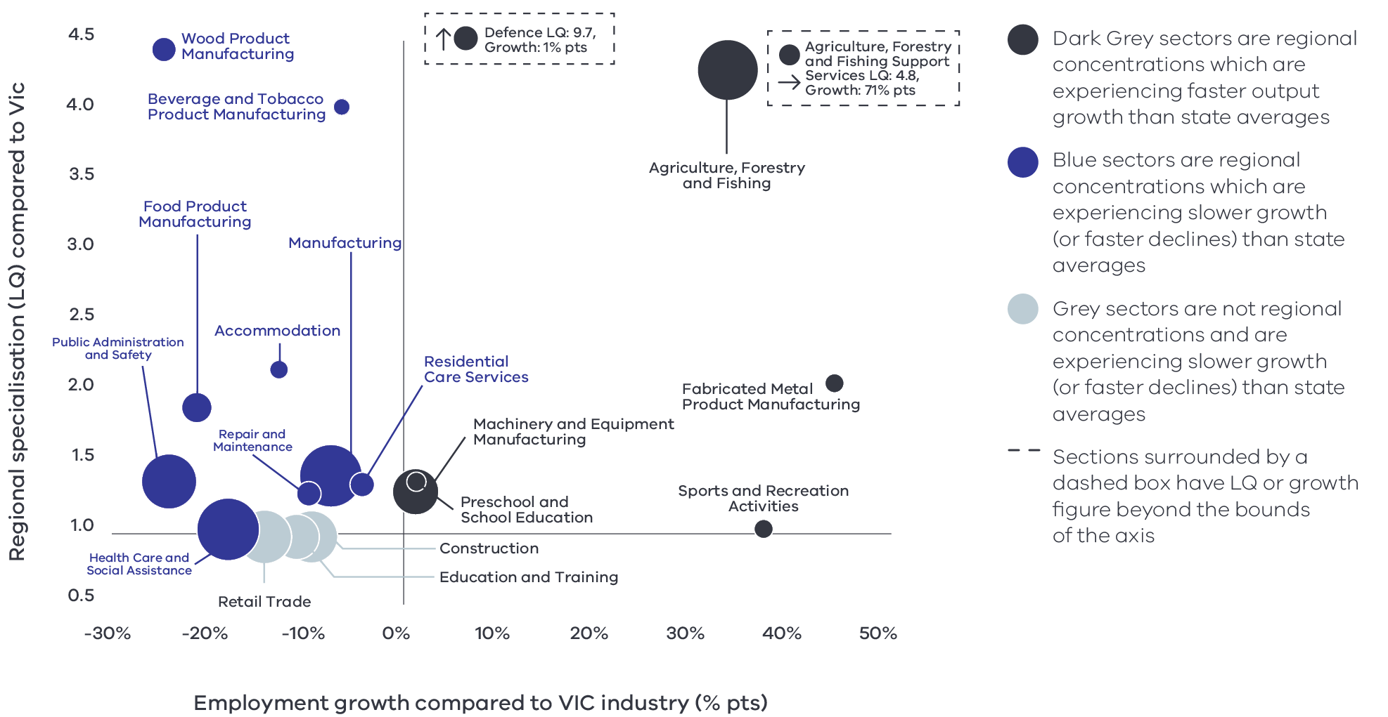

Figure 5 Ovens Murray industry employment location quotient and growth – Long Alternate Text

Source: National Institute of Economic and Industry Research, 2020

Note this chart represents a selection of industries and sub-industries that represent a notable size and or concentration within the region. Some sub-industries presented are sub-sectors of industries that are presented alongside it and therefore measures cannot be aggregated between the two. Other industries are not displayed. For greater detail refer to the supporting analysis pack for this REDS strategy.

**Figure 5** depicts selected industries and sub-industries in the regional economy in 2020 where:

* The size of each bubble indicates the number of people employed in the (sub)industry in 2020. The bigger the bubble, the more people employed in the industry.
* The vertical position indicates the (sub)industry’s degree of employment concentration relative to the Victorian average. For example, a value of 1.77 means that, as a share of total employment in the local economy, the (sub)industry employs 1.77 times as many people as the Victorian average.

The horizontal position indicates the difference in (sub)industry’s employment growth (2015 to 2020) between the region and the Victorian average. For example, a 14 per cent value indicates that regional employment in the (sub)industry has grown 14 percentage points faster than the industry’s average growth rate in Victoria.

As presented in Figure 5, the region is specialised in Agriculture, forestry and fishing; Manufacturing; and Public administration and safety (driven by Defence employment).

### Output specialisation

**Figure 6: Ovens Murray industry output (GVA) location quotient and growth**

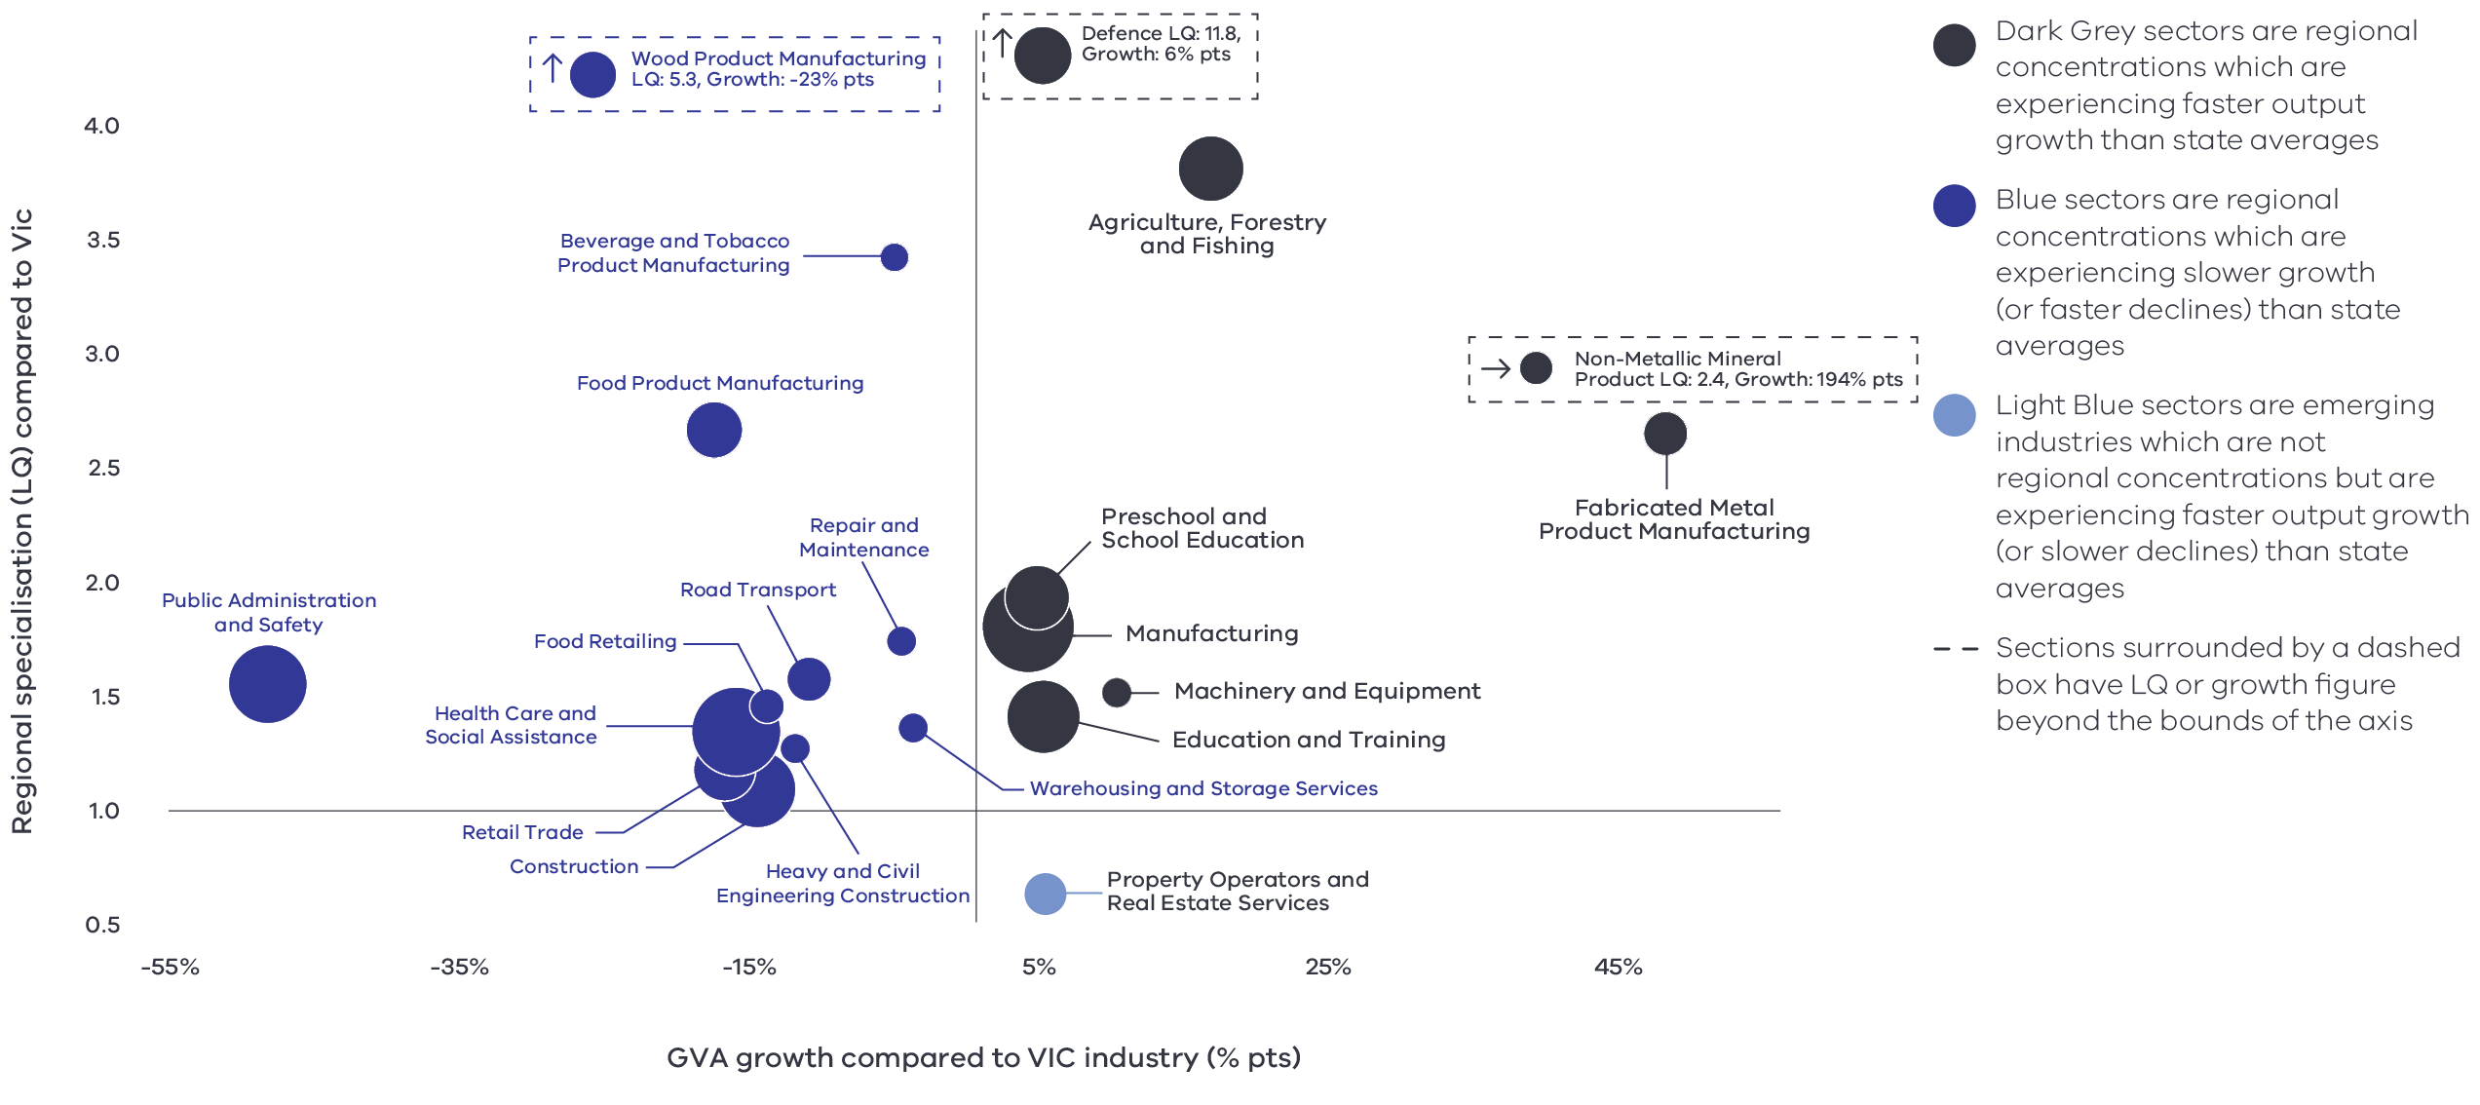

Figure 6 Ovens Murray industry output (GVA) location quotient and growth – Long Alternate Text

Source: National Institute of Economic and Industry Research, 2020

Note this chart represents a selection of industries and sub-industries that represent a notable size and or concentration within the region. Some sub-industries presented are sub-sectors of industries that are presented alongside it and therefore measures cannot be aggregated between the two. Other industries are not displayed. For greater detail refer to the supporting analysis pack for this REDS strategy.

**Figure 6** identifies the region’s economic output specialisation in terms of Gross Value Added (GVA). Using the same approach as Figure 5, this analysis compares selected industries and sub-industries in the regional economy, including their size and growth as a proportion of total economic GVA relative to Victorian averages.

#### Manufacturing

Manufacturing has been the biggest contributor to the region’s GVA since 2001. It has an output LQ of 1.8 and is experiencing output growth that is 4 percentage points greater than the corresponding average for the state. Regional specialisations vary depending on the sub-sector. Wood product manufacturing, beverage and tobacco, and food product manufacturing all have high GVA LQ scores of 5.3,3.4 and 2.7 respectively but are experiencing declining output relative to the Victorian average. However, there is a strong output specialisation in the manufacturing of fabricated metal products and non-metallic minerals.

#### Agriculture, forestry and fishing

Agriculture, forestry and fishing is an important driver of economic growth and employment in the region. The industry has an output LQ score of 3.8 and is experiencing an output growth that is 16.0 percentage points higher than the average for the state. Within the sector, forestry and logging and agriculture support services each have output LQ scores of 7.8 and 5.4, which indicate significant output concentration.

#### Education and training

The Education and training industry’s GVA has experienced steady growth since 2001. The industry has an output LQ of 1.4 and is experiencing output growth 4.0 percentage points higher than the average of the state. Within the sector, preschool and school education has an output LQ of 1.93. The output growth is 4.0 percentage points higher than the average of the state.

### Emerging sectors

The growth analysis undertaken for the region’s industries also revealed industries and sectors that have experienced significant growth in output or/and employment, but do not currently indicate a regional specialisation (i.e., the LQ score is below 1.35). The experienced growth may, however, demonstrate a potential to develop a GVA/Employment specialisation in the future. These emerging sectors include:

* Arts and recreation services: employment growth is 31.0 percentage points higher than average employment growth in this sector in Victoria, and output growth is 34.0 percentage points above the Victorian average (despite a low output LQ of 0.8). The ‘sports and recreation activities’ sub-sector accounts for a significant part of this employment and output growth, with growth rates of 37.0 and 28.0 percentage points above average respectively. There is also a notable contribution from the ‘heritage activities’ sub-sector.
* Mining: the industry has shown an employment growth of 43.0 percent point relative to the Victorian average, although this is not reflected in the output growth. It is also noted that mining’s share of employment in the region is not significant.

Property operators and real estate services: the sector has shown an output growth of 4.6 percentage points relative to Victorian average. The growth is mainly attributed to unprecedented demand for properties in regional locations.

# 04 Strategic directions

The five strategic directions for the Ovens Murray REDS have been identified based on the opportunities emerging from the region’s endowments, industry specialisations and socioeconomic context. The directions have been refined based on a review of local policies and strategic planning.

The following section discusses each strategic direction, providing:

* a rationale for its inclusion as part of the strategy
* an overview of opportunities and challenges which are likely to support or hinder future growth
* a summary of work underway and the policy context to support desired outcomes
* the implication of the direction for the region’s Aboriginal communities

examples of how the direction could be activated.

## Ovens Murray’s strategic directions

1. Expand business and employment opportunities in the **transport, distribution and logistics industries**
2. Strengthen and diversify the **visitor economy** through leveraging **the region’s nature and epicurean tourism industries**
3. Expand on existing strength in **manufacturing** to take advantage of opportunities in new industries
4. Support and expand economic and employment opportunities in growing sectors **(health, social services, education)**
5. Position the region to benefit from **emerging growth opportunities** in natural resources.

## Enabling factors for economic growth

This REDS identifies opportunities in key areas that can help drive regional economic growth. However, each region’s capacity to activate these opportunities and grow is partly determined by cross-cutting enabling factors that support economic activity. Consideration of these enabling factors – and targeted investments and initiatives to strengthen them – will help support achievement of the strategic directions in this REDS.

**Digital connectivity**

Access to reliable internet and mobile services allows for access to new markets, facilitates efficiency gains and opens up opportunities for innovation. Good digital connectivity can also facilitate more inclusive access to services and flexible working arrangements.

61 to 69 Australian Digital Inclusion Index Score in Ovens Murray in 2021[6] (Victorian average: 71)

**Transport connectivity**

Road and rail infrastructure, ports and airports provide critical linkages between production locations and markets; efficient transport connections and public transport services are a key factor in workforce mobility and local amenity.

4.0 Overall access to roads and public transport in Hume RDA region[7] (Regional Victoria: 4.1 and Victoria: 5)

**Workforce and population growth**

An adaptive and productive workforce is key to businesses competitiveness; access to both skilled and unskilled labour ensures business can sustain and expand activities.

* 62.1% Local workforce in Ovens Murray was employed in skilled occupations in 2021[8] (Regional Victoria: 62.2%, Melbourne: 67.3%) (2021)

17.0% Residents with a bachelor’s degree or higher in 2016[9] (Regional Victorian: 17.0 %, Melbourne: 31.0%)

**Housing**

The availability and affordability of housing determines a region’s ability to attract and retain local staff and supports community cohesion and better life outcomes for individuals and families.

* 0.5% Average rental property vacancy rate in the 6 months leading up to June 2021[10] (Compared to benchmark of 2.5%)

29.6% Increase in median rent in Hume RDA region from 2016 to 2020[11] (Victoria, 6.9%, Regional Victoria 28.6%)

Note: 1. The Australian Digital Inclusion Index (ADII) is a composite index used to measure digital inclusion across three dimensions of Access, Affordability and Digital Ability. 2. ‘Access to roads and public transport was measured by asking respondents to rate their access to the following types of services in their local community, on a scale ranging from ‘very poor’ (1) to ‘very good’ (7): (i) Quality of local roads; and (ii) Access to public transport (including taxis, buses, trains). A single measure of overall access to roads and public transport was then constructed based on the average score of a person’s responses to these two items. 3. Skill level is defined as a function of the range and complexity of the set of tasks performed in a particular occupation. Skilled workers are defined as being classed between an ANZSCO Skill level of 1-3, while low skilled is classed as 4 or 5. 4. A rental property vacancy rate of 2.5% refers to a benchmark at which the market is balanced between landlords and tenants.

## Integrating Aboriginal economic opportunities

The Victorian Government is taking concrete steps to align with Aboriginal self-determination principles. Key Victorian Government policies and processes to realise self-determination goals include the:

* Treaty Process which seeks to redefine the relationships between the Aboriginal community, the state and non-Aboriginal Victorians.
* Victorian Aboriginal Affairs Framework 2018-23 (VAAF) which is the overarching framework for working with Aboriginal Victorians to drive positive socioeconomic outcomes across the state, including to activate economic opportunities and prosperity via achieving wealth equality, facilitating workforce participation in all sectors at all levels and realising Aboriginal income potential.

Self Determination Reform Framework, which guides public sector action to enable self-determination in line with the VAAF across four domains: people, systems, outcomes and accountability. Each strategic direction in the Ovens Murray REDS considers the relevance of that direction to local Aboriginal communities in light of the above opportunities.

The Victorian Government is also party to the National Agreement on Closing the Gap and has committed to meeting the associated outcomes – including in relation to increasing engagement of Aboriginal and Torres Strait Islanders in employment, education and training.

An analysis of local policies and commitments relating to Aboriginal economic development in the region (listed in the Ovens Murray Regional Economic Development Strategy – Supporting Analysis), including determined Traditional Owner strategic plans, where developed, has identified six potential opportunities for Aboriginal economic development:

* Identify opportunities to leverage natural resources and traditional practices for economic benefit. This includes the scope to adopt traditional hunting and agricultural techniques.
* Pursue greater Aboriginal ownership of land and water to sustainably manage resources. The economic opportunities afforded through Joint Management Plans are one example of a way that caring for the land can have benefits across cultural, environmental and economic benefits.
* Promote recognition of the land, its waters and its cultural significance to ensure that economic activities (such as nature based or cultural tourism) generate benefits in circumstances where degradation or destruction can be avoided, and existing damage is healed.
* Encourage the use of cultural places and practices as a mechanism for telling stories, maintaining traditions and creating economic opportunities, particularly in the visitor economy and agriculture and education sectors.
* Enhance Aboriginal participation across industries with a particular focus on occupations which serve the local Aboriginal population and the environment e.g. health care and social services, land management, agriculture, circular economy, renewable energy and education and training.

Pursue opportunities for greater Aboriginal participation in economic activities including small to medium enterprise development and investment which create employment opportunities.

Each strategic direction in the Ovens Murray REDS considers the relevance of that direction to local Aboriginal communities in light of the above opportunities.

Self-determined priorities for Aboriginal economic development in the region will be aligned to the six pillars of the Victorian Aboriginal Employment and Economic Strategy. These priorities will also guide Victorian Government decision-making on economic development in the region and will be integrated into future updates of the REDS.

## Integrating cross-border opportunities

The Ovens Murray REDS recognises the significant economic contribution of the Albury Wodonga region, with a gross regional product (GRP) of approximately $8.2 billion in 2019-20, equivalent to almost 10.5 per cent of the regional Victorian economy. The projected increase in population is expected to support economic expansion potential for clustering services and emerging industries including health and education. Numerous training and education providers10 in the cross-border community contribute to the Ovens Murray region’s workforce readiness. The cross-border community benefits from strong transport linkages and access to the Hume Freeway (a key transport route for agribusiness and manufacturing).

The Ovens Murray region will tap into significant opportunities provided by the Albury Wodonga Regional Deal, announced on 20 March 2019. This collaboration between the Australian, New South Wales and Victorian Governments, the Albury City Council and the City of Wodonga Council, and local communities is expected to include projects to support health, economic development, liveability, regional education, infrastructure and connectivity.

The Regional Deal is an opportunity to ensure that Albury Wodonga prospers over the next decade by supporting population growth and economic development while also ensuring it remains a nationally significant, liveable and prosperous region.

## 4.1 Expand business and employment opportunities in the transport, distribution and logistics industries

### Significance

The transport and logistics industry is vital to productivity and growth in the Ovens Murray region. The region’s strategic location includes access to Melbourne and Sydney through well-established road and rail infrastructure. Wodonga’s proximity to Albury Airport also allows access to air transportation routes. Over the past five years, 192 transport, postal, and warehousing businesses have opened in the region to support and complement business growth across different sectors (manufacturing, agriculture). Strong investment in logistic infrastructure nationally and within the region is expected to contribute to growth in transport and logistics.

The region also has experienced growth in agriculture and manufacturing and the value of export in the region has been steadily increasing over recent years, peaking at $1.01 billion in 2019. This expansion flows through to an increasing demand for transportation of agriculture and manufacturing products. Freight transport represents a significant part of overall production cost for many industries and regional businesses. As freight volume in regional Victoria is expected to grow at an average annual rate of 1.5 per cent between 2014 and 2051[12], the capacity of the region to cope with the projected increase depends on reliable and cost-effective transport and logistics industries.

Further strengthening the transport and logistics industries will provide significant employment opportunities, allow regional businesses to better access inputs, and enable industries to compete both domestically and internationally and support greater economic resilience of the region in the event of major disruptions in trade and supply chain such as the COVID-19 pandemic.

### Opportunities

#### Industrial precincts

The Albury Wodonga region has several industrial precincts to attract small, medium and large-scale industries, including:

* The 576-hectare Logic industrial estate in Wodonga, located between Sydney and Melbourne on the Hume Freeway. Several industries including manufacturing, transport and logistics are operating at the site. The site has access to significant infrastructure and services.
* Airport Park and Airside North Industrial Estate, located in central Albury.
* Bandiana Industrial Estate, located in Wodonga, with a wide range of lot sizes.
* Lavington Industrial Precinct in Albury’s northern suburbs.

The 450-hectare NEXUS Industrial Precinct, located 10km north of Albury’s CBD, zoned to support large or heavy industrial development.

These industrial precincts are projected to generate a significant number of jobs and employment opportunities in logistics, warehousing and manufacturing.

#### Inland Rail

Inland Rail project will complete the ‘spine’ of the national freight rail network by connecting Melbourne and Brisbane via regional Victoria, New South Wales and Queensland. The project is expected to be completed by 2027 and will reduce freight transit time between Melbourne and Brisbane to less than 24 hours. Inland Rail includes the Tottenham (Victoria) to Albury (New South Wales) project, which will feature enhancement works along the rail corridor in Mitchell and through North East Victoria.

Wodonga is able to reach 75 per cent of Australia’s population within 24 hours through its intermodal transport and logistics hub[13]

#### Vocational training opportunities

Wodonga TAFE is the largest vocational training provider in the region, and includes course offerings relating to transport, logistics, warehousing and civil construction and forestry. The Wodonga TAFE is also the largest heavy vehicle training organisation in Australia and is planning to expand on an existing partnership with the Australian Defence Force to develop a Heavy Vehicle Technology Program.

### Challenges

#### Labour force shortage

A significant shortage of drivers is noted within the transport and logistics industry in the region, as the industry struggles to attract people due to negative perceptions of future work progression, long driving hours and a risky working environment.[14]

#### Road and freight infrastructure maintenance and upgrades

Road and freight maintenance and upgrades are necessary to ensure the reliability and accessibility of critical infrastructure for the transport and logistics sectors. Infrastructure Victoria’s Infrastructure Strategy 2021-2051 makes two recommendations around delivering funding certainty for regional road maintenance and upgrades and funding an ongoing regional rail freight maintenance program.[15]

#### Digital exclusion

The region’s growing transport, distribution and logistics sector is increasingly dependent on reliable digital connectivity. For example, road and rail transport corridors need good mobile coverage for consistent mobile connectivity. The region however faces digital infrastructure challenges including variable NBN service quality, prevalence of mobile telephone blackspots, low capacity and unreliable mobile 3G, ADSL internet and satellite broadband services, limited availability of low-bandwidth network and shortage of free public wi-fi. The region’s topography and dispersed population has also contributed to inequalities in access to telecommunication services. There are also significant gaps in digital literacy, supply of IT professionals and workforce readiness for the future. As a result, Northern Victoria has a been the lowest ranked region in the state for digital inclusion.[16]

### The policy environment

* 2019 Ovens Murray Regional Partnership Outcomes Roadmap, seeks significant growth across the region’s key and emerging economic sectors including tourism, agriculture, manufacturing, and transport, distribution and logistics with a strong culture of innovation and collaboration supported by long term investment and planning linked to job creation.
* Wodonga Growth Strategy, provides clear direction across a range of the council functions to provide certainty for residents, investors and businesses, thereby developing confidence in the long-term direction and growth of Wodonga.
* Victoria’s Infrastructure Strategy 2021-2051, contains recommendations for projects, policies, and reforms spanning many types of infrastructure, divided into four themes focused on: confronting long term challenges, managing urban change, harnessing infrastructure for productivity growth and developing regional Victoria.
* Ovens Murray Digital Plan 2019, prioritises increased digital awareness among business and industry; improved digital skills and improved access to digital technology infrastructure.
* Hume Strategy for Sustainable Communities 2010-20: seeks to develop an integrated network of efficient and high functioning transportation systems.

Albury Wodonga Regional Economic Development Strategy 2018-22 (NSW Government): identifies growing the transport and logistics sector as strategic direction.

### Aboriginal inclusion

The transport, postal and warehousing sectors employ 6.4 per cent of the Aboriginal workforce in the region. This strategic direction strongly aligns with Aboriginal economic development opportunities. The Traditional Owner groups within the region have outlined goals to improve access to training and work opportunities. Leveraging future opportunities in the transport and logistics industry can provide training and employment opportunities for the Aboriginal workforce. It also offers opportunities to encourage growth in social procurement and capacity building for Aboriginal-owned enterprises. Construction of additional transport infrastructure must consider the impact on traditional lands, waters and the environment.

### How can we unlock this strategic direction?

To unlock this opportunity and drive growth, local, State, and Commonwealth partners could work together to:

* Coordinate training programs to address skills shortages in collaboration with relevant training centres and VET system in the region and promote career options within schools.
* Raise awareness of a range industrial precincts and facilities available within the region.
* Realise business development opportunities to locally supply goods and services required for the proposed Inland rail (Tottenham to Albury) and North East Rail Line Upgrade project in the region and broader area.[17]
* Identify opportunities to engage local Aboriginal businesses to supply required goods and services based on principles of self-determination.
* Review the need for further investment to improve digital connectivity through collaboration across all levels of government and with relevant regional stakeholders. Identify pressing mobile and broadband improvements in the region and develop business cases to leverage available funding through the Connecting Regional Communities Program.

Examine recommendations in Infrastructure Victoria’s Infrastructure Strategy 2021-2051.

## 4.2 Strengthen and diversify the visitor economy through leveraging the region’s nature, epicurean and cultural tourism industries

### Significance

The region’s diverse natural assets and landscapes, vibrant food and wine industry, and cultural assets contribute to a growing visitor economy. Ovens Murray has four of Victoria’s alpine resorts (Mt Hotham, Falls Creek, Mt Buller and Mt Stirling), several national parks and lakes including Lake Eildon. The natural endowments of the region provide significant opportunities for the region. Visitation supports numerous industries, including accommodation, food and retail, arts and recreation services in the region. Visitation is a significant contributor to the economy of Alpine and Mansfield shires.

Prior to COVID-19, visitation numbers and spend were growing year-on-year, with international overnight visitors the fastest growing type of visitor. However, restrictions associated with COVID-19 including international and state border closures, regional travel restrictions and hospitality density limits have significantly impacted the region’s visitor economy. The total number of domestic daytrips, and domestic and international overnight visitors have fallen from 4.0 million in 2019 to 2.1 million in 2020. This decline led to a fall in total visitor expenditure; from $1.0 billion in 2019 to $547 million in 2020.

### Opportunities

#### Tourism growth post COVID-19

While the pandemic has significant ramifications for the region’s economy and businesses, as Australia’s vaccine rollout progresses and international travel remains limited, the region will be presented with greater opportunities to capture domestic demand for holidaying locally. To a certain extent, the region is already realising these benefits; average visitor spend was higher in 2020 than 2019 among domestic daytrip and domestic intrastate overnight tourists, in part due to longer stays. Since the region shares a border with New South Wales, it is well positioned to attract higher spending and longer staying overnight visitors.

**Table 2: Change in average visitor numbers and spend (2019–20)**

|  | Number of visitors 2020 | Number of visitors 2019 | Number of visitors % Change | Average Visitor Spend 2020 | Average Visitor Spend 2019 |
| --- | --- | --- | --- | --- | --- |
| Domestic Daytrip | 1,209,000 | 2,063,000 | -41.40% | $115 | $95 |
| Domestic Intrastate Overnight | 754,000 | 1,474,000 | -48.85% | $482 | $410 |
| Domestic Interstate Overnight | 121,000 | 443,000 | -72.69% | $359 | $475 |
| International Overnight | 7,000 | 30,000 | -76.67% | $178 | $659 |

Source: Tourism Research Australia, 2021

#### Agritourism

A growing agritourism sector continues to offer opportunities for cross-sector collaboration to support the visitor economy. The high quality of local agricultural produce and presence of boutique farm/cellar door businesses already make the region an attractive agritourism destination. Further opportunities exist to develop niche offerings for artisan and gourmet food, tap into the growing visitor interest in farmers markets and craft beer, wines, distilleries and couple agritourism offerings with nature-based tourism and other attractions to further enhance the visitor experience.

#### Investing in infrastructure that supports the visitor economy

Targeted investment in infrastructure will expand the visitation experience related to culture, events, heritage, food and beverages and strengthen these opportunities for higher visitor attractions. Investment in Ovens Murray’s tourism infrastructure announced as part of the Victorian Government’s Building Works stimulus package and the Victorian Budget 2020-21, including development of the Falls to Hotham Alpine Crossing, the Benalla foreshore, early works on King Valley Prosecco Road experience and investment in Ned Kelly attractions in Beechworth and Glenrowan, will expand visitation opportunities in the region. Furthermore, planning for additional investment in walking trails supports the High Country’s accessibility and attractions beyond winter peaks. Public investment in infrastructure is expected to encourage further private investment and business formation in the region delivering quality accommodation and visitor experiences.

#### Events to drive visitation

Regional events play an essential role in driving visitation, provide opportunities to showcase regions and reinforce regional brand identity. The region has further opportunities to tap into existing initiatives (e.g. Business Events Victoria) and funding to promote business events and visitation. Events also encourage all-year-round visitation to maintain jobs during the low tourism season and summer holiday period.

### Challenges

#### Short visit duration

In 2020, the most common type of visitors were domestic day trippers, representing 57.8 per cent of total visitation, followed by intrastate overnight visitors at 36.1 per cent. The relatively low proportion of interstate and international visitors impacts the typical length of stay and the amount which visitors contribute towards the local economy. In 2020, day trippers spent on average $115 per trip, whereas domestic overnight visitors spent $482 per trip (if coming from within Victoria) or $359 per trip (if coming from interstate).

#### Climate change

Climate change, including projected increasing temperatures and reduced precipitation in the alpine region, poses significant risks to nature-based visitation in the region. Potential impacts include reduced snow depths, a shorter snow season and increasing bushfire risks. Climate change could also create significant opportunities for the adaptation of sustainable and less carbon-intensive economic activities.

#### Impacts of economic shocks

The Ovens Murray region was significantly impacted by the 2019-20 severe bushfires, both directly with damage to tourism infrastructure and indirectly through the impact of State of Disaster measures and supply chain disruptions. There was a significant reduction in visitor numbers over the peak summer season, and medium-term visitation impacts were expected as a result of reputational damage from the fires. Recovery from the 2019-20 summer bushfires is likely to have negative short-term impacts on the visitor economy. The visitor sector has also been deeply affected by the COVID-19 pandemic and associated restrictions on travel. It is noted that areas that are heavily reliant on tourism, such as Alpine Shire, have been significantly affected and that many of the region’s tourist-related businesses have suspended or downscaled operations.

#### Reliable and accessible infrastructure

The tourism and supporting service sectors need public amenities, road signage and road infrastructure to enable development of tourism in the region. Limited access to foot and bicycle paths to link tracks through towns which are only accessible by cars is recognised as particular challenge. Limited major infrastructure assets (such as wastewater treatment) are also identified by stakeholders as inhibitors to private investment in several areas.

#### Labour force shortages

The industry faces a shortage of skilled, qualified and casual staff, which risks the industry’s capacity to realise great potential for the industry’s growth. In addition, limited affordable accommodation options and public transport connectivity restrict labour force attraction and retention in the region. Therefore, long-term planning is necessary to adequately address skills shortages. A recent Workforce Planning and Skills Audit has been undertaken to identify gaps and opportunities and develop initiatives to address such challenges across different regions as part of the Visitor Economy Recovery and Reform Plan recommendation.

#### Digital capabilities and capacity

The ways visitors experience tourist activities and access information are changing. Visitors increasingly use internet research and social media to plan holidays and gather visitor information. Increasing international and interstate competition in the visitor market requires implementing effective digital marketing, planning and anticipating future customers. The current level of digital connectivity and telecommunications capacity shortfalls during peak tourism period and events in the region poses challenges for tourism operators. There is also a significant digital capability divide in comparison to other regional and metropolitan areas, which limits tourism businesses from investing or adapting to new digital marketing or share economy platforms that help them reach new visitors and enhance the visitor experience. The Ovens Murray Digital Plan and initiatives underway, including a digital upskilling program for tourism operators, has highlighted significant commitment to digital inclusion and upskilling as critical enablers for regional digital engagement.

### The policy environment

* 2019 Ovens Murray Regional Partnership Outcomes Roadmap: seeks significant growth across the region’s key and emerging economic sectors including tourism.
* Victoria’s High-Country Destination Management Plan 2013-2023: seeks to increase total visitation and the proportion of domestic, international and overnight visitors with a focus on, cycle tourism, Food, wine and beer industry innovation, year-round alpine tourism, arts and culture and digital excellence.
* 2021 Victorian Alpine Resorts: Visitor Economy Development Plan: aims to determine a collective tourism development framework for the Victorian Alpine Resorts that identifies priority projects best positioned to drive resort growth and positive visitor economy outcomes.
* The Victorian Government’s Visitor Economy Recovery and Reform Plan (2021): aims to attract more tourists to the State, support regional jobs and deliver a significant recovery from the combined effects of the 2020 summer bushfires and the COVID-19 pandemic. This includes delivering a state-wide destination master plan underpinned by priority sector plans (the first sector priorities to be developed will be the Nature-Based Tourism Plan and the First Peoples’ Tourism Plan) and the establishment of Visitor Economy Partnerships across Victoria.
* Regional Tourism Partnership aims to create region-specific COVID recovery and tourism workforce growth strategies.

Murray Regional Tourism’s Murray Region Destination Management Plan provides an overarching tourism strategy, a clear developmental direction, focused product development and support for infrastructure.

### Aboriginal inclusion

Industries which service the visitor economy such as accommodation and food services employ about 10.0 per cent the Aboriginal workforce. There are opportunities to facilitate and strengthen Traditional Owners’ aspirations to use the visitor economy as a tool for economic development and inclusion by developing and promoting Aboriginal heritage, culture, and tradition and growing the industry capability of Aboriginal tourism businesses and markets. This direction is aligned with the Aboriginal economic development opportunity for the use of cultural places and practices as a mechanism for telling stories, maintaining traditions and creating economic opportunities.

### How can we unlock this strategic direction?

To unlock this opportunity and drive growth, local, State and Commonwealth partners could work together to:

* Increase visitor growth, length of stay and visitor spending by leveraging the region’s key product pillars: cycle tourism, food, wine and beer, snow and nature-based activities, and arts and culture. Encourage the use of cultural places and practices to tell stories and preserve traditions to create economic opportunities in the visitor sector.
* Identify priority projects through co-ordination and alignment between all levels of stakeholders, facilitate business case development and assessment, and identify potential gaps in funding for targeted investment in partnership with other stakeholders.
* Identify projects and initiatives to realise the Victorian Alpine resorts’ full potential as an iconic Victorian visitor destination, leveraging their unique environment to create a sustainable and thriving year-round visitor economy.
* Foster partnerships between industry, state government, local councils and Traditional Owners and Aboriginal communities based on principles of self-determination to develop short- and medium-term solutions to address key challenges in attracting and retaining workforce (e.g. housing, training).
* Advocate, communicate and promote outcomes of recent analysis undertaken to understand regional skills demand profiles in the region to guide short term to medium term planning for skills training and development of professional career pathways in tourism.
* Identify key short- to long-term initiatives to protect and enhance natural resources for current and future generations with focus on climate change adaptation, water resource management and protection of native habitat and biodiversity in collaboration with Traditional Owners and Aboriginal communities to utilise traditional natural resource management methods.

Work with all levels of government to ensure branding and tourism product development meet the needs of international customers and leverage Visit Victoria and Tourism Australia effort and budgets in key international markets. Investment in new data sources to capture data for planning and communication of relevant information.

## 4.3 Expand on existing strength in manufacturing to take advantage of opportunities in new industries

### Significance

The manufacturing sector has historically been an important sector in the region and an essential driver of economic growth and employment. However, the industry has experienced a period of transition following a steep decline in Beverage and Tobacco Product Manufacturing between 2000-10, in line with trends seen across the state – which has largely contributed to the decline in the manufacturing GVA. The manufacturing industry contributes to over 12 per cent of the region’s employment – the defence and food product manufacturing sub-sectors are particularly strong, with each having over 1,000 employees. The regional specialisation in these industries directly and indirectly supports manufacturing growth in the region.

Building on its natural endowments and unique comparative advantages, the manufacturing industry in Ovens Murray could take advantage of growing consumer demand for differentiated produce, niche offerings, and gourmet food to strengthen its brand and increase its market share. The region’s unique advantages include access to industrial land, high-quality raw materials and resources, strategic road and rail links to Melbourne and Sydney, proximity to renewable energy sources and the presence of tertiary institutions that provide training/skills for the manufacturing workforce.

### Opportunities

#### Tertiary institutions and innovation hubs

Having the ability to proactively develop, commercialise and produce new or modified products that meet the demands of emerging and future industries is a strong indicator of manufacturing success. The Ovens Murray region has a number of education and training centres which are fostering innovation and providing capabilities across the agricultural and food processing supply chains. Technological advancement and innovation are supported by three TAFE institutes and four universities, including GOTAFE (Wangaratta), Wodonga TAFE, Riverina TAFE (Albury), La Trobe Wodonga, and Charles Sturt Albury. Recent investments and initiatives focusing on establishing business and innovation networks provide opportunity for rural and regional entrepreneurship, innovation and business development. Recent initiatives include the “Two Cities One Community” development and “Wodonga Innovation Project”.[18] Additionally, the GoTAFE Innovation Hub provides start-ups with space to develop ideas from concept through to design and construction and marketing. The Old Beechworth Gaol in partnership with the Australian Centre for Rural Entrepreneurship ACRE and collaboration between LaunchVic and the region’s innovation network provides opportunities for rural entrepreneurship and supports a diverse range of innovative business in the region.

#### Defence

The Hume region hosts the largest Australian Defence Force presence in Victoria – in Ovens Murray, this includes the Albury Wodonga Military Area (AWMA), which hosts the Joint Logistics Unit Victoria and the Army Logistics Training Centre, and other facilities throughout the region. AWMA represents 23 separate Defence units providing training, strategic level logistics and maintenance support to the Australian Defence Force and providing logistics training for the army. The AWMA supports local spending and growth in other related industries, including maintenance support for equipment and vehicles, development of defence-related technology, and chemical and explosives manufacturing.

#### Food product manufacturing

Ovens Murray is well placed to respond to growing demand for safe and high-quality food products in overseas markets by leveraging existing major food processing centres in Wodonga, Wangaratta and Wahgunyah, and Benalla. The sector could also respond to a growing demand for sustainable production practices to transition to less emissions intensive operations and gain efficiency and resilience over time. Building on expected tourism growth, food manufacturing for the domestic market is also expected to grow, particularly in producing craft beer, wine and other food services. Wodonga is home to an expanding commercial area, and food manufacturing businesses benefit from high security water access from Lake Hume, access to industrial land, and the presence of complementary services e.g. product packaging. Wangaratta is also home to a number of food manufacturing businesses.

#### Circular economy

There are significant business growth and jobs opportunities in producing food, product and services while harnessing environment sustainability and reducing waste particularly in materially intensive sectors such as manufacturing, food and fibre and construction. Greater emphasis in recycling, reuse of materials within a circular economy could also lower the cost of reducing emissions in these industries. The shift in production approach also brings further opportunity for adaptation of new technology, new business models and increasing business competitiveness and productivity.

#### Construction boom

The trend of Victorians moving into the regions from Melbourne, partly due to the COVID-19 pandemic and flexible working arrangements, is expected to support residential construction. This drives demand in some parts of the manufacturing industry, including for manufacturing metal and wood products (a regional strength).

**Table 3: Top sectors for new businesses in the Ovens Murray (2015-20)**

|  | Percentage |
| --- | --- |
| Construction | 19.32% |
| Agriculture, forestry and fishing | 17.12% |
| Professional, scientific and technical services | 9.42% |
| Accommodation and food services | 7.51% |

Source: REMPLAN 2021, Accessed October 2021

### Challenges

#### Supply chain, logistics and freight challenges

The COVID-19 pandemic has caused the business community to re-evaluate the security of its supply chain, with significant impacts observed in the agribusiness and food and beverage industries. Major supply chain disruptions have been experienced due to flight cancellations, restrictions on air-freight capacity, uncertainty about border restrictions and slow customer clearance. All of these challenges may constrain growth in the manufacturing sector by limiting access to markets for inputs and outputs, and by reducing the productivity and efficiency of manufacturing businesses in the region.

#### Labour supply challenge

An ageing population and a low proportion of people of working age compared with the Victorian average is compounded by high youth out-migration, with many people born in the region leaving to pursue education and work opportunities in other parts of Australia.

#### Limited access to telecommunication infrastructure

Access to telecommunication and broadband services are increasingly important for the application of automated technologies in manufacturing processes. Ovens Murray, as part of the Northern Victoria region, has consistently experienced the lowest level of digital inclusion in the state – 16 towns and localities have been assessed as having an intermediate or major supply shortfall for fixed access broadband.[19] The Ovens Murray region has a highly dispersed population and associated business activity, however the region’s topography creates particular inequities in access to telecommunications services for businesses operating outside regional centre CBDs. In addition to numerous mobile black spots, many regional locations are dependent on access to unreliable and low capacity mobile 3G, ADSL and satellite services, unless they invest in high cost customised solutions. Without access to modern and fast digital and telecommunication technologies, the region’s manufacturers will be at a disadvantage to other regions.

### The policy environment

* The 2019 Ovens Murray Regional Partnership Outcomes Roadmap seeks significant growth across the region’s key and emerging economic sectors including tourism, agriculture, manufacturing, and transport, distribution and logistics with a strong culture of innovation and collaboration supported by long term investment and planning linked to job creation.
* The 2019 Defence Industry in the Hume Region (RDA) Seeks to identify how Hume can leverage existing defence industry presence for the region’s economic growth; makes recommendations to address existing challenges to industry growth (infrastructure limitations, skilled workforce shortages).
* The State Government’s Advancing Victoria’s Manufacturing: A Blueprint for the Future also focuses on six future industries to guide future investment and activity.
* CSIRO as part of their Futures series have prepared the Advanced Manufacturing Roadmap which provides a comprehensive analysis of the current state of play and what strategic moves need to be made by the industry in the next 20 years to remain competitive.
* Victoria’s Infrastructure Strategy 2021-2051 contains recommendations for projects, policies, and reforms spanning may types of infrastructure, divided into four themes focused on: confronting long term challenges, managing urban change, harnessing infrastructure for productivity growth and developing regional Victoria.
* The National Agriculture Workforce Strategy and Roadmap confirms that Australian agriculture is a complex and sophisticated system. Its performance relies heavily on the quality of its people. The roadmap details the plan to attract, retain, upskill and modernise the agriculture workforce.

Victoria’s Recycling Victoria: A new economy is the state’s circular economy policy and 10-year action plan to reduce waste and pollution and improve recycling in a way which delivers economic benefit.

### Aboriginal inclusion

Around 7.8 per cent of the Aboriginal workforce is employed in the manufacturing sector. Additional initiatives may be needed to ensure that pursuit of this strategic direction offers benefits to the Aboriginal community, for example by supporting the establishment of Aboriginal-owned enterprises for value-adding to traditional agricultural products or promoting career pathways in manufacturing and making workplace culturally safe for Aboriginal youth.

### How can we unlock this strategic direction?

To unlock this opportunity and drive growth, local, State and Commonwealth partners could work together to:

* Target the development and acquisition of skills in digital literacy, STEM, leadership and management.
* Understand barriers to attracting and retaining a younger workforce in the industry and promote collaboration across relevant stakeholders, education providers and industry bodies to address skilled workforce shortages. Connect school leavers with opportunities in the region and advocate for manufacturing as a desired career path among young students to address the limited attraction of young, skilled workforce into the industry.
* Encourage and advocate for undertaking Research and Development (R&D) in the industry and facilitate greater collaboration between industry and the existing regional education institutes and relevant state and national organisations.
* Identify barriers to Aboriginal participation in the manufacturing industry and support self-determined Aboriginal workforce participation and labour market outcomes.
* Identify infrastructure gaps impacting manufacturing and investment in addressing barriers in accessing utilities and sewerage.
* Identify future needs for land use planning and rezoning to enable construction to meet a growing demand for different housing types.
* Identify the current and future skill gaps and develop pathways for training and education to enable skill development to address labour supply shortages.
* Support and facilitate initiatives that aim to upskill women and create training pathways into occupations and industries which are experiencing a shortage of workers, e.g. construction, manufacturing and the agriculture food supply chain.

Advocate for investment to increase scale of the projects and initiatives and support and incentives for commercialisation of new, innovative manufacturing products.

## 4.4 Support and expand economic and employment opportunities in growing sectors (health, social services, education)

### Significance

Service-based sectors in the region have experienced growth in GVA over the past two decades, and healthcare and social assistance are the second most valuable industries by GVA in the region. The growth is attributed to several factors, including population growth coupled with an ageing population, national and state reforms in social services, including the roll-out of the NDIS, and aged care reform. The median age of the population in the region is 44, which is slightly higher than the regional Victorian average and significantly higher than Melbourne metropolitan area, and 21 per cent of the population in the region is 65 and older.

Demand for health and social services is also expected to grow given the relatively poor health outcomes in the region relative to Victorian averages (including indicators on life expectancy, obesity, type two diabetes, and mental health), and the prevalence of disadvantage in some local government areas. Industry expansion and targeted delivery of services will address social challenges associated with recent community shocks (e.g. bush fire events) and progress efforts to alleviate socioeconomic disadvantages. Growth in the provision of health and social services can provide significant employment opportunities and multiplier effects for the local economy.

### Opportunities

#### Population growth in Wodonga and Wangaratta

Population growth in the region is expected to be concentrated in the City of Wodonga and Rural City of Wangaratta. This offers economic opportunities associated with the clustering of health and social services and development of health precincts. The cross-border community of Albury Wodonga and the regional town of Wangaratta has access to a range of health care facilities and assets. The population-driven expansion of health care services also creates opportunities in construction and refurbishment, as evidenced in the recent hospital redevelopments in both Albury Wodonga and Wangaratta.

#### Product innovation

People in rural areas can face challenges that affect their mental and physical health and wellbeing needs and their ability to access appropriate services and supports. These challenges include, but are not limited to, geographic isolation, prevalence of extreme weather events and social determinants. In the face of these challenges, there are opportunities for product innovation to ensure health care is accessible and place sensitive. The region has significant opportunities to further develop and progress with innovation in telehealth, hub-and-spoke models and mobile care models.

#### Education and training centre

The region could leverage key tertiary education providers including La Trobe University (Albury Wodonga Campus) Charles-Sturt University (Albury Wodonga Campus) and Wodonga TAFE to train the workforce needed to support the expanding health and social services sectors. These education centres provide opportunities to incentivise workforce retention and build a sustainable local workforce.

#### Improving labour market inclusion

There is evidence of a correlation between low economic participation and high socioeconomic disadvantage. Difficulty in accessing the same opportunities and services as those in more populated areas has implications for workforce participation and labour outcomes. Encouraging and boosting employment opportunities for disengaged cohorts provides an avenue for maximising local labour capacities while building a more diverse and inclusive workforce. Addressing the underlying issues that result in low economic participation and ensuring work practices, policies and strategies are also inclusive will be critical to ensuring that inclusive employment generates long term and lasting benefits.

**Figure 7: Participation rate by gender (2016)**

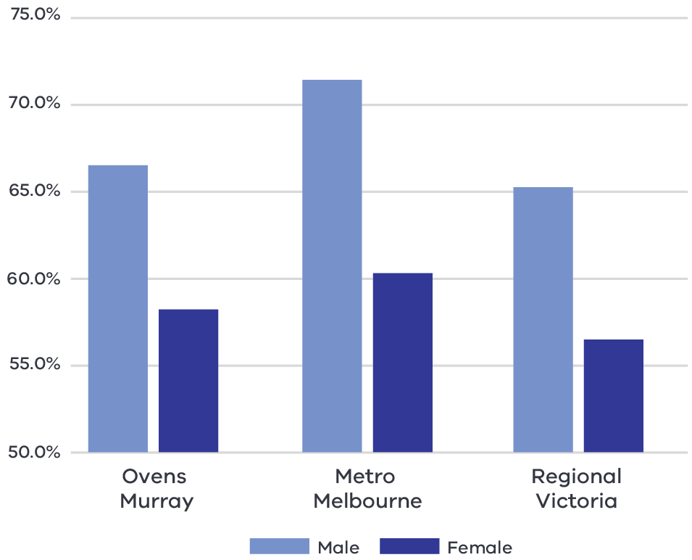

Figure 7 Participation rate by gender (2016) – Long Alternate Text

Source: ABS Census, 2016

Consistent with the pattern across the state and regional Victoria, the female participation rate in the Ovens Murray region (58.3 per cent) is significantly lower than the male participation rate (66.7 per cent). This disparity presents an opportunity to boost future economic growth in the region by addressing the comparatively high proportion of part-time workers and relatively lower participation rate for female workers.

### Challenges

#### Digital exclusion

Social and geographical isolation in the region because of a dispersed population has been exacerbated by relatively lower rates of internet connection, gaps in internet connectivity and less reliable mobile coverage. Unreliable internet connection is one of the major constraints for the development of modern and efficient health care services.

#### Attraction and retention of skilled workers

The workforce supply in the region is currently not meeting the industry’s demand for skilled labour and most organisations are facing challenges to employ workers across all parts of the sector.[20] Several factors are expected to contribute the shortage in the future including out-migration of young people, access to local housing, access to digital infrastructure, amenities and affordable transport links between settlements. In the short term, the challenge to attract and retain workers will be exacerbated by restrictions on international migration as a result of the COVID–19 pandemic.

### The policy environment

* Albury Wodonga Health Master Plan aims to identify the infrastructure required to enable Albury and Wodonga to meet the future needs of the cross-border community.
* Hume Region Chronic Care Strategy 2012-2022 encourages coordinated action in response to the growing impact of chronic disease. The strategy provides a collective focus on the management of chronic care and identifying priorities such as maximising information technology opportunities, alignment of workforce development and explore opportunities for new and innovative service models capacity.
* Hume Region – Health and Aged Care Plan 2013-2018 is a five-year plan that identifies regional priorities and provides direction for departmental programs and healthcare providers in Hume Region.
* Koolin Balit: Victorian Government Strategic Directions for Aboriginal Health 2012-2022, provides a whole of life framework based around a set of key priorities and enablers with the aim to make a significant and measurable impact on improving the length and quality of the lives of Aboriginal Victorians.

Health 2040: A discussion paper on the future of healthcare in Victoria a conversation about working together to build and strengthen the Victorian health system and presents improving the way the system works together as one of the key themes in the paper.

### Aboriginal inclusion

The health care and social assistance sector is the largest employer of Aboriginal people in the region, accounting for 17.2 per cent of Aboriginal employment in the region. This direction aligns with the local Aboriginal economic development priorities to enhance Aboriginal participation across industries with a particular focus on occupations which serve the local Aboriginal population and the environment, including health care and social services and education and training.

Growth in the sector is likely to present opportunities for increased labour force participation and incomes, but this should ensure that attracting new workers to the region does not displace the current Aboriginal workforce or reduce opportunities for the current population.

### How can we unlock this strategic direction?

To unlock this opportunity and drive growth, local, State and Commonwealth partners could work together to:

* Communicate and share the outcomes of the regional skills demand profile to demonstrate the current skill base and future skill need and develop training and career pathways to support the health, aged care and education workforce of the future.
* Advocate for national migration settings that support the placement of skilled workers and international students in regional areas.
* Encourage initiatives that support regional specialisations for health, aged care and education services.
* Enhance Aboriginal workforce participation across health and social services to deliver improved health and labour market outcomes for the Aboriginal community in the region.
* Support initiatives and programs aim to attract women in health care and social service sectors to work in regional and rural areas.
* Support investment in infrastructure and services that could promote inclusive labour market outcomes including care facilities, training, and upskilling facilities.

Explore the potential impacts of population growth in part of the region, during the pandemic, its implications on demand for essential services and supporting infrastructure.

## 4.5 Position the region to benefit from emerging growth opportunities in natural resources

### Significance

Primary mineral resources in the Ovens Murray region include gold, tin, sand and stone. Historically, gold mining has influenced the settlement pattern in the region and led to substantial land clearing around some areas, such as Wangaratta. Currently there are several exploration licences and exploration applications active in the Alpine, Indigo and Towong Shires and few active mining operations in the region. Recent quality gold discoveries in the Myrtleford area have attracted investment into the region. The mining sector has recently experienced rapid growth in employment, which has been 54 percentage points faster than the industry’s state average from 2014-19. The future economic viability of the mining activities depends on several factors including the accessibility of commercially viable deposits, licencing, future investment interest, and responding to community concerns around environmental degradation.

Natural resource endowments in the Ovens Murray also support further development of renewable energy. The region has a mix of renewable energy sources available including hydroelectric power, significant solar, wind and agriculture waste resources. Hydropower is generated through Lake Dartmouth at the Dartmouth Power Station, located approximately 100 kilometres south-east of Wodonga. There are a number of opportunities for further renewable energy development in areas that are close to existing distribution infrastructure.

### Opportunities

#### Global demand

A recent increase in global demand for Australia’s mineral resources for emerging high-tech applications in a variety of sectors (including renewable energy, aerospace, defence, automotive – particularly electric vehicles, telecommunications and agri-tech) provides opportunity and economic viability for further mineral exploration and investigation. Ovens Murray’s strategic road and rail links to Melbourne and Sydney make it well placed to capitalise on this growing demand for mineral resources.

#### Business development opportunity

Mining exploration and related activities provide opportunities for local businesses to provide services and products for the supply chain. Businesses could be supported to capitalise on these opportunities, potentially drawing on the experience of existing programs such as the Victorian Government ‘METS Regional Innovative Accelerator Program’ – which helps regionally based businesses to engage with local mining companies and promote their services and products (e.g. construction, consulting, etc.).

#### Renewable Energy Zone investment

The Victorian Government has allocated $540 million to establish six Renewable Energy Zones (REZs) as part its commitment to reach net-zero emissions by 2050, including a REZ in the Ovens Murray region. Identification of REZs enables government to target investment towards strengthening the transmission network, development of renewable energy resources, expansion of the grid, connecting new generation and reducing network congestion and costs. The benefits of developing Victoria’s REZs extend beyond direct increases to renewable energy generation, to include supporting investment in local economies, creating local jobs, and strengthening local supply chains.

#### Community energy groups

There is strong community interest in renewable energy generation, which provides a strong social licence for activities in this space. A number of renewable energy projects are owned and run by local communities, including solar panels, hot water bulk buying, and wind farms. For example, Renewable Energy Benalla works with Beyond Zero Emission to support local communities with information sharing and running a community solar bulk buy[21] and Totally Renewable Yackandandah is a 100 per cent volunteer community group with an aim to transition Yackandandah to clean, local sources of energy. The Taungurung Land and Waters Council is seeking to expand its investment in the renewable energy sector in the region and broader Hume area.

### Challenges

#### Housing and services for key workers

The construction and operational phase of mining activities requires a surge in the locally based workforce. Limited availability of housing options may impede the attraction and retention of workers into region. A rapid local population increase may also put pressure on social and community services and infrastructure in the region.

#### Land use conflicts, environmental impacts and social licence

Existing land uses for agriculture and nature-based recreation may constrain mineral exploration and development activities. There may be community concerns around mining expansion, particularly given the gold mining history of the region which has resulted in several areas of contaminated land. Environmental impacts may be exacerbated by the effects of climate change and reduced water availability, which may require consideration of diversified water sources.

### The policy environment

Several Australian and Victorian strategies underpin the strategic policy environment for the mining sector, these strategies have a focus on gold and mineral mining. For example:

* Australia’s Critical Mineral Strategy (2019) outlines the Australian Government’s policy framework for critical mineral markets, with a focus on investment, downstream processing, innovation to lower costs and increase competitiveness and connecting critical minerals projects with infrastructure development.
* Victorian State of discovery: Mineral resources strategy 2018-2023 seeks to grow investment and jobs in Victoria’s mineral sector and outlines areas for priority action associated with social licence, advancing and encouraging mineral exploration, establishing Victoria as a gold mining hub and delivering an efficient regulatory environment.
* Victoria’s Climate Change Act 2017 establishes a long-term target of net zero greenhouse gas emissions by 2050. This increases viability of renewable energy investments into the future.
* Victoria’s Climate Change Strategy provides a roadmap towards net-zero emissions by 2050. It includes interim targets to reduce emissions and pledges for energy, agriculture, transport, waste and forestry sectors.
* Victoria’s Community Engagement and Benefit Sharing in Renewable Energy Development in Victoria outlines leading practice community engagement and benefit sharing for renewable energy development in Victoria.
* The Hume Renewable Energy Roadmap describes the current and future renewable capabilities of the region identifying solar and bioenergy as a key priority for the region and hydropower as an emerging opportunity.

The Victorian government has a suite of state-wide policies and initiatives to support the State’s energy sector to transition to net-zero emissions, which are available on [energy.vic.gov.au](https://www.energy.vic.gov.au/).

### Aboriginal inclusion

There are significant opportunities to draw on the knowledge and skills of Traditional Owners across the mining lifecycle as part of development and operation and planning for eventual rehabilitation. Potential benefits include training and employment opportunities for the Aboriginal workforce, and procurement opportunities for Aboriginal-owned businesses.

Local Aboriginal stakeholders are focused on maximising benefits from investments in renewable energy projects. Both the Yorta Yorta Nation Strategic Plan and Taungurung Country Plan advocate for effective solutions to mitigate harmful the effects of climate change on our future generations. Increased investment in the renewable energy sector is likely to create employment opportunities in the construction, energy and waste services and professional, scientific and technical services industries. Proportionately, the Aboriginal workforce is well represented in these industries except professional, scientific and technical services industries. A targeted intervention will be required to increase Aboriginal participation in this sector.

### How can we unlock this strategic direction?

To unlock this opportunity and drive growth, local, State, and Commonwealth partners could work together to:

* Develop a regional resource prospectus to attract investment in collaboration with relevant local and State authorities.
* Proactively identify future jobs and training needs and support diverse opportunities by coordinating relevant training and upskilling programs in the resource industry.
* Examine ways to support the region’s liveability and ensure attraction and retention of the required workforce without putting pressure on the region’s social infrastructure.
* Explore opportunities in Victoria’s resource processing industries, with the potential to tap into the region’s advanced manufacturing sector.
* Better understand land-use or resource-use conflicts to maintain social license and develop innovative uses for land following the completion of mining and rehabilitation, including through Traditional Owner engagement.

Support development of the capacity of community organisations to develop business ideas, business case and commercialisation of renewable energy projects across the region.

# 05 Implementation

The Ovens Murray REDS outlines the Rural and Regional Victoria (RRV) Group’s strategic approach for focusing its future economic development activities, including through policy, investment and program delivery, in the region. It is not a prescriptive roadmap for Victorian Government economic development action in Ovens Murray.

#### RRV will use the REDS to coordinate investments and activities in place

RRV is committed to pursuing the strategic directions through future policy design, investment and program implementation, as well as through collaboration across government and with regional partnerships, to deliver positive economic outcomes for the region. The Ovens Murray REDS will provide a central point for coordination for current and future work streams and investments.

RRV recognises that effective planning policy and controls will be a key enabler of inclusive, sustainable economic growth in the Ovens Murray region. Victoria’s Regional Growth Plans provide broad direction for land use and development, and enable economic growth by ensuring that infrastructure investment is coordinated, appropriate services are provided, and development meets community expectations. The Regional Development and Planning portfolios will pursue opportunities to ensure that as relevant state-led land use planning strategies, policies and controls are updated, they are aligned with the REDS strategic directions.

#### Local stakeholders, industry leaders and government service providers can use the REDS to advocate for shared outcomes

The Ovens Murray REDS, along with the supporting Ovens Murray Regional Economic Development Strategy – Supporting Analysis document, provides a starting point for an evidence-based, strategic approach to regional development. This approach is an ongoing process where specific development actions and projects can be proposed and considered in the context of alignment with the REDS.

Regional Development Victoria – Hume will remain the main point of contact in the region for facilitating and coordinating regional development outcomes.

The Ovens Murray Regional Partnership which comprises community and business leaders, CEOs of constituent Local Governments, State Government personnel and a representative from Regional Development Australia will continue to be the main advisory body to the Minister for Regional Development and other government decision-makers on local issues and priorities.

The Ovens Murray REDS will provide Jobs Victoria with important context and understanding of local economic priorities and opportunities that will be a critical input into the planning and prioritisation of Jobs Victoria’s work and collaboration activities with our Service Partners. Jobs Victoria assists people looking for work, connects employers with the staff they need, administers wage subsidy programs and supports significant local employment transitions.

#### RRV will monitor the implementation of the REDS

The strategic directions in this Strategy focus on medium- to long-term drivers of growth and opportunity but will be used immediately to guide investment in the region. Notwithstanding this timeframe, the strategic directions will continue to evolve and progress as actions and investment are made. To ensure ongoing relevance and accuracy, Rural and Regional Victoria will periodically update and refresh this Strategy.

# Appendix

## Figure 1: Map of Regional Partnerships – Long Alternate Text

The **Mallee** region is located in northwest Victoria and contains the LGAs of Mildura, Swan Hill, Buloke and Gannawarra.

The **Wimmera Southern Mallee** region is located in western Victoria and contains the LGAs of West Wimmera, Hindmarsh, Yarriambiack, Horsham and Northern Grampians.

The **Great South Coast** region is located in southwest Victoria and contains the LGAs of Glenelg, Southern Grampians, Moyne, Warrnambool and Corangamite.

The **Barwon** region is located to southwest of metropolitan Melbourne and contains the LGAs of Geelong, Queenscliffe, Surf Coast and Colac Otway.

The **Central Highlands** region is to the west of metropolitan Melbourne and contains the LGAs of Ararat, Pyrenees, Golden Plains, Moorabool, Ballarat and Hepburn.

The **Loddon Campaspe** region is northwest of metropolitan Melbourne and contains the LGAs of Macedon Ranges, Mount Alexander, Central Goldfields, Loddon Campaspe and Bendigo.

The **Goulburn** region is north of metropolitan Melbourne and contains the LGAs of Mitchell, Murrindindi, Strathbogie, Greater Shepparton and Moira.

The **Ovens Murray** region is located in the northeast of Victoria and contains the LGA’s of Mansfield, Benalla, Wangaratta, Alpine, Indigo, Towong and Wodonga.

The **Gippsland** region is located in the east of Victoria and contains the LGAs of Bass Coast, South Gippsland, Baw Baw, Latrobe, Wellington and East Gippsland.

Click here to return to document

## Figure 2 Map of Ovens Murray – Long Alternate Text

The Ovens Murray region is made up of the Mansfield, Benalla, Wangaratta, Indigo, Wodonga, Towong and Alpine Local Government Areas.

The Ovens Murray region has a rail connection that links Wodonga, Chiltern, Wangaratta and Benalla to the Melbourne and the South of the state. Several major highways and roads link towns across the region, including those linking Mansfield, Bright, Myrtleford, Rutherglen, Tallangatta and Corryong to major centres.

The Ovens Murray region has several regional airports including at Benalla, Wangaratta, Mansfield, Wodonga, Corryong and at Mount Hotham.

Click here to return to document

## Figure 3 Ovens Murray industry Employment (2001-20) – Long Alternate Text

The largest employing industries in descending order are Health Care and Social Assistance, Manufacturing, Agriculture, Forestry and Fishing, Retail Trade, Construction, Education and Training, Public Administration and Safety, Accommodation and Food Services, Transport, Postal and Professional, Scientific and Technical Services.

The following industries have grown in employment since 2001; Health Care and Social Assistance, Agriculture, Forestry and Fishing, Retail Trade, Construction, Education and Training, Public Administration and Safety, Accommodation and Food Services, Transport, Postal and Professional, Scientific and Technical Services.

The following industry has declined in employment since 2001; Manufacturing.

Simplified Table of data for Figure 3

|  |  |  |  |  |  |  |  |  |  |  |
| --- | --- | --- | --- | --- | --- | --- | --- | --- | --- | --- |
|  | Agriculture, Forestry and Fishing | Manufacturing | Construction | Retail Trade | Accommodation and Food Services | Transport, Postal and Warehousing | Professional, Scientific and Technical Services | Public Administration and Safety | Education and Training | Health Care and Social Assistance |
| 2001 | 4777 | 7915 | 2834 | 5102 | 3556 | 1670 | 1707 | 3301 | 3526 | 5521 |
| 2002 | 4724 | 7728 | 3174 | 5365 | 3600 | 1612 | 1719 | 3333 | 3567 | 5586 |
| 2003 | 4647 | 7871 | 3462 | 5581 | 3873 | 1665 | 1656 | 3447 | 3619 | 5526 |
| 2004 | 4988 | 7924 | 3599 | 5513 | 3879 | 1749 | 1645 | 3574 | 3621 | 5540 |
| 2005 | 5196 | 8403 | 3899 | 5831 | 3685 | 1857 | 1756 | 3876 | 3785 | 5811 |
| 2006 | 4712 | 8501 | 4585 | 6022 | 3644 | 1907 | 1977 | 4017 | 3852 | 5998 |
| 2007 | 4493 | 8733 | 4632 | 6174 | 3758 | 2027 | 1857 | 4179 | 3958 | 6248 |
| 2008 | 4505 | 8252 | 4183 | 6056 | 4048 | 2132 | 1822 | 4257 | 3998 | 6346 |
| 2009 | 5099 | 7513 | 4127 | 5847 | 3971 | 2156 | 1781 | 4246 | 3973 | 6383 |
| 2010 | 4810 | 7465 | 4564 | 5856 | 3926 | 2250 | 1824 | 4356 | 4090 | 6618 |
| 2011 | 4601 | 7498 | 4354 | 6059 | 4118 | 2401 | 1930 | 4635 | 4344 | 7084 |
| 2012 | 5081 | 7324 | 4102 | 6026 | 4031 | 2356 | 1926 | 4648 | 4373 | 7282 |
| 2013 | 5199 | 7132 | 4213 | 5899 | 3991 | 2365 | 1902 | 4567 | 4399 | 7392 |
| 2014 | 4434 | 7140 | 4441 | 5788 | 4068 | 2398 | 1910 | 4552 | 4531 | 7460 |
| 2015 | 4175 | 6946 | 4578 | 5934 | 4101 | 2418 | 1922 | 4550 | 4754 | 7552 |
| 2016 | 4321 | 6433 | 4597 | 5961 | 4157 | 2509 | 1948 | 4593 | 4923 | 8139 |
| 2017 | 4385 | 6564 | 4722 | 6114 | 4294 | 2564 | 1969 | 4607 | 4483 | 8252 |
| 2018 | 4172 | 7628 | 5003 | 6267 | 4441 | 2594 | 2298 | 4438 | 4315 | 7685 |
| 2019 | 4436 | 7078 | 5288 | 6220 | 4014 | 2682 | 2305 | 4312 | 4394 | 7501 |
| 2020 | 5780 | 7166 | 5359 | 5559 | 3716 | 2645 | 2266 | 4311 | 4613 | 7800 |

Click here to return to document

## Figure 4 Ovens Murray industry output (gross value add) 2001-20 – Long Alternate Text

The industries with the largest gross value add in 2020 in descending order are Manufacturing, Health Care and Social Assistance, Construction, Public Administration and Safety, Education and Training, Agriculture, Forestry and Fishing, Retail Trade, Transport, Postal and Warehousing, Administrative and Support Services and Professional, Scientific and Technical Services

The following industries have grown in gross value add since 2001; Health Care and Social Assistance, Construction, Education and Training, Agriculture, Forestry and Fishing, Retail Trade, Transport, Postal and Warehousing, Administrative and Support Services and Professional, Scientific and Technical Services

The following industry has declined in gross value add since 2001; Manufacturing, Public Administration and Training,

Simplified table of data for Figure 4. Data in this table is in ($) millions.

|  |  |  |  |  |  |  |  |  |  |  |
| --- | --- | --- | --- | --- | --- | --- | --- | --- | --- | --- |
|  | Manufacturing | Health Care and Social Assistance | Construction | Public Administration and Safety | Education and Training | Agriculture, Forestry and Fishing | Retail Trade | Transport, Postal and Warehousing | Administrative and Support Services | Professional, Scientific and Technical Services |
| 2001 | 1030 | 350 | 295 | 523 | 298 | 271 | 208 | 202 | 174 | 146 |
| 2002 | 955 | 365 | 345 | 539 | 298 | 282 | 221 | 206 | 182 | 160 |
| 2003 | 928 | 369 | 401 | 522 | 308 | 236 | 227 | 208 | 175 | 158 |
| 2004 | 886 | 376 | 388 | 506 | 307 | 330 | 240 | 210 | 168 | 157 |
| 2005 | 917 | 379 | 454 | 514 | 313 | 368 | 255 | 210 | 177 | 158 |
| 2006 | 910 | 381 | 515 | 545 | 305 | 404 | 261 | 212 | 191 | 179 |
| 2007 | 906 | 397 | 503 | 571 | 304 | 357 | 280 | 222 | 197 | 160 |
| 2008 | 887 | 406 | 461 | 563 | 313 | 370 | 283 | 248 | 198 | 152 |
| 2009 | 778 | 427 | 482 | 547 | 322 | 434 | 282 | 264 | 200 | 161 |
| 2010 | 817 | 466 | 504 | 564 | 339 | 412 | 279 | 261 | 197 | 157 |
| 2011 | 825 | 489 | 474 | 575 | 366 | 385 | 287 | 261 | 181 | 170 |
| 2012 | 800 | 512 | 458 | 626 | 380 | 430 | 298 | 250 | 166 | 167 |
| 2013 | 744 | 522 | 446 | 632 | 387 | 476 | 314 | 269 | 163 | 164 |
| 2014 | 732 | 552 | 461 | 662 | 385 | 432 | 317 | 281 | 175 | 163 |
| 2015 | 743 | 585 | 494 | 653 | 394 | 439 | 352 | 263 | 181 | 160 |
| 2016 | 704 | 618 | 487 | 663 | 397 | 394 | 363 | 282 | 197 | 169 |
| 2017 | 684 | 654 | 481 | 600 | 411 | 465 | 368 | 279 | 191 | 175 |
| 2018 | 787 | 639 | 509 | 561 | 401 | 445 | 383 | 266 | 195 | 213 |
| 2019 | 742 | 650 | 540 | 504 | 424 | 425 | 377 | 274 | 204 | 210 |
| 2020 | 743 | 660 | 531 | 489 | 448 | 381 | 336 | 242 | 222 | 209 |

Click here to return to document

## Figure 5 Ovens Murray industry employment location quotient and growth – Long Alternate Text

The graph is divided into four quadrants.

The first quadrant identifies the industries that are a) experiencing slower employment growth (or faster declines) than state averages and b) have higher levels of employment specialisation than state averages.

The following industries are in quadrant 1:

* Accommodation
* Wood Product Manufacturing
* Beverage and Tobacco Product Manufacturing
* Food Product Manufacturing
* Manufacturing
* Public Administration and Safety
* Repair and Maintenance
* Health Care and Social Assistance

Residential Care Services

The second quadrant identifies the industries that are a) experiencing faster employment growth (or slower declines) than state averages and b) have higher levels of employment specialisation than state averages.

The following industries are in quadrant 2:

* Defence
* Agriculture, Forestry and Fishing
* Agriculture, Forestry and Fishing Support Services
* Fabricated Metal Product Manufacturing
* Machinery and Equipment Manufacturing
* Preschool and School Education

Sports and Recreation Activities

The third quadrant the industries that are a) experiencing slower employment growth (or faster declines) than state averages and b) have lower levels of employment specialisation than state averages.

The following industries are in quadrant 3:

* Retail Trade
* Construction

Education and Training

The fourth quadrant identifies industries that are a) experiencing faster employment growth (or slower declines) than state averages an b) have lower levels of employment specialisation than state averages.

There are no industries in the fourth quadrant.

Click here to return to document

## Figure 6 Ovens Murray industry output (GVA) location quotient and growth – Long Alternate Text

The first quadrant identifies the industries that are a) experiencing slower GVA growth (or faster declines) than state averages and b) have higher levels of GVA specialisation than state averages

The following industries are in quadrant 1:

* Wood Product Manufacturing
* Beverage and Tobacco Product Manufacturing
* Food Product Manufacturing
* Public Administration and Safety
* Food Retailing
* Health Care and Social Assistance
* Road Transport
* Repair and Maintenance
* Retail Trade
* Construction
* Heavy and Civil Engineering Construction

Warehousing and Storage Services

The second quadrant identifies the industries that are a) experiencing faster GVA growth (or slower declines) than state averages and b) have higher levels of GVA specialisation than state averages.

The following industries are in quadrant 2:

* Defence
* Agriculture, Forestry and Fishing
* Non-Metallic Mineral Product
* Fabricated Metal Product Manufacturing
* Preschool Education
* Manufacturing
* Machinery and Equipment

Education and Training

The third quadrant the industries that are a) experiencing slower GVA growth (or faster declines) than state averages and b) have lower levels of GVA specialisation than state averages.

There are no industries in quadrant three.

The fourth quadrant identifies industries that are a) experiencing faster GVA growth (or slower declines) than state averages an b) have lower levels of GVA specialisation than state averages.

Property Operators and Real Estate Services is the only industry in quadrant four.

Click here to return to document

## Figure 7 Participation rate by gender (2016) – Long Alternate Text

|  |  |  |
| --- | --- | --- |
|  | Male | Female |
| Ovens Murray | 66.7% | 58.3% |
| Metro Melbourne | 71.5% | 60.4% |
| Regional Vic | 65.4% | 56.6% |

Click here to return to document

1. Australian Bureau of Statistics, 2021
2. Victoria in Future 2019, Department of Environment, Land, Water and Planning – The COVID pandemic has changed Victoria’s population pathway from near-record growth levels to population losses. However, Victoria’s regions appear to have experienced little disruption to growth patterns. Migration from Melbourne to the regions has been at record levels according to the latest ABS data, offsetting most regional losses to overseas or interstate. There remains considerable uncertainty around the distribution of the increased regional migration, and the permanence of this trend, but available evidence points to continuing regional growth. Data from the 2021 Census will be vital in determining the impacts on the strongest migration attractors (e.g., regional centres and peri-urban areas) versus those regions which may have experienced losses from the temporary migrant workforce. Given current information, the pre-pandemic VIF2019 projections remain fit for purpose for regional planning.
3. National Skills Commission, 2022
4. Australian Bureau of Statistics, Census, 2016
5. National Institute of Economic and Industry Research, 2020
6. Thomas J. et al., 2021, *Australian Digital Inclusion Index*
7. Regional Wellbeing Survey, 2020
8. Department of Education and Training, 2021
9. ABS Census, 2016
10. RRV analysis, 2021, SQM
11. DHHS rental Report, 2021, June Quarter
12. Infrastructure Victoria ,2020, *Infrastructure Priorities for the Regions, Key findings to inform Victoria’s 30-year infrastructure strategy update.*
13. Invest Victoria, 2018
14. Victorian Skills Authority, 2021, Ovens Murray Regional Skills Demand Profile
15. Infrastructure Victoria ,2021, *Victoria’s Infrastructure Strategy 2021-2051*, <https://www.infrastructurevictoria.com.au/report/chapter-4-develop-regional-victoria/>
16. Regional Partnerships Ovens Murray, 2019, *Ovens Murray Digital Plan*, Part 1, Regional context and priorities
17. ARTC ,2021, Victoria Projects quarterly newsletter, <https://inlandrail.artc.com.au/where-we-go/projects/tottenham-to-albury/works-and-planning/>
18. The project aims to develop more robust, innovative and resilient business community and support innovation in businesses.
19. Regional Partnerships Ovens Murray (2019) Ovens Murray Digital Plan, Part 1, Regional context and priorities
20. VSA, 2021, Ovens Murray Regional Skills Demand Profile
21. Regional Partnership Ovens Murray, Hume Region Renewable Energy Roadmap <https://www.energy.vic.gov.au/__data/assets/pdf_file/0031/464728/Roadmap-Hume.pdf>