Mallee

Regional Economic Development Strategy – Summary

State Government of Victoria

The Mallee REDS uses data and evidence to profile the region’s economy and identify key strategic directions to drive economic growth.

Regional Profile

Mallee Regional Profile
Population (2020) | 92,900
Population growth (2011-20) | 3.8%
Gross regional product (2020) | $5.3 Billion
Figure 1: Map of Mallee
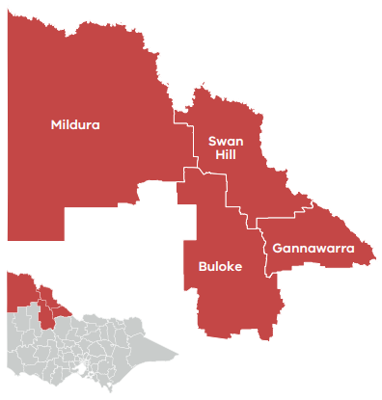

Employment
Unemployment rate (September 2021) | Average annual employment growth (2011–20)
Mallee: 3.3%  Regional average: 4.2%  Metropolitan Melbourne: 6.0% | Mallee: -0.1%  Regional average: 1.0%  Metropolitan Melbourne: 2.1%

Top employing sectors (2020)
Industry | Workers
Health care and social assistance | 5,800
Agriculture, forestry and fishing | 5,700
Retail trade | 4,500
Construction | 3,700
Manufacturing | 3,500
Education and training | 3,300

Top sectors by gross value add (2020)
Industry | Gross value add
Agriculture, forestry and fishing | $1,253.6 Million
Health care and social assistance | $429.1 Million
Public administration and safety | $326.7 Million
Manufacturing | $303 Million
Construction | $301 Million
Education and training | $266.4 Million

Strategic Directions
Mallee’s five strategic directions have been identified using an evidence base that considers the region’s unique attributes, existing and emerging industries, and socioeconomic context.

1. Drive sustainable growth in the food industry
Advanced capabilities in agriculture and food manufacturing along with small-scale farming and agritourism offer opportunities to increase value add, access global markets and drive ongoing sustainability in the food industry.

2. Leverage natural endowments to diversify the economy into emerging industries
Existing rich natural resources along with growth in solar energy generation and development of renewable hydrogen technology all present opportunities to diversify the region’s economy and create ‘spillover’ opportunities to strengthen local supply chains.

3. Enhance the visitor economy by developing natural, cultural and built attractions
Highlighting ‘hero’ experiences, including Aboriginal heritage, nature-based and agri-tourism, will help to build the region’s brand and present opportunities to enhance the existing visitor economy and develop new attractions.

4. Ensure an accessible and suitably qualified workforce to unlock the growth potential
Stimulating inward migration and addressing barriers to labour mobility can be complemented by stronger connections between industry and education institutions to improve economic inclusion and workforce sustainability.

5. Harness the economic potential of the region’s cross-border zones
Active coordination and advocacy is at the heart of maximising the economic potential of the region’s tri-state location, which positions it as a critical transport and socioeconomic hub.
Please refer to the Mallee REDS and Supporting Analysis for further detail and sources.
Prepared by the Department of Jobs, Precincts and Regions, May 2022. For more information see: rdv.vic.gov.au.

