Loddon Campaspe Regional Partnership
Information for applicants

About Us
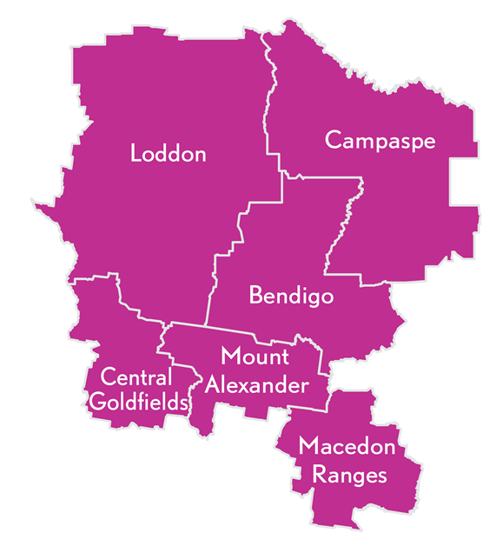
Our region in central Victoria covers an area with a diverse population and a buoyant economy based on agriculture, retail, health, property and manufacturing.

Bendigo, one of Victoria’s largest and fastest growing regional cities, lies at the heart of the region and is a prosperous and vibrant hub of cultural and economic activity. Many migrant and refugee communities have settled in the area.

Our region covers six municipalities - Campaspe Shire, Central Goldfields Shire, City of Greater Bendigo, Loddon Shire, Macedon Ranges Shire, and Mount Alexander Shire, and has:
- A Gross Regional Product of $11.4 billion;
- A population of 246,400;
- Nearly one in 10 residents born overseas.

What is the role of Regional Partnerships?
The Loddon Campaspe Regional Partnership is one of nine Partnerships across the state, established by the Victorian Government, recognising that local communities are in the best position to understand the challenges and opportunities faced by their region. Regional Partnerships act as a voice for their regions and advise the Victorian Government on regional priorities that reflect the unique needs and strengths of their region.
This involves engaging with rural and regional communities and a range of Government agencies, business and industry groups, community based organisations, Traditional Owner groups and Regional Development Australia Committees.

Major achievements of the Loddon Campaspe Regional Partnership include:
- Working with the Department of Health and Human Services to develop the Healthy Heart of Victoria initiative, which received $5 million in funding to improve the health of our community.
- Launching the Keep in Touch (KIT) Van and App which was co-designed by young people and supports positive messaging about youth mental health.
- Development of the Loddon Campaspe Regional Economic Growth Strategy which identifies the strengths and opportunities for the region.

Who are we looking for?
We acknowledge that Loddon Campaspe Regional Partnership business is conducted on Aboriginal land, including the lands of the Wurundjeri Woi Wurrung, Dja Dja Wurrung, Taungurung and Yorta Yorta people, as well as other Traditional Owner groups in Victoria who are not yet formally recognised. We are aiming to attract people from all parts of the Loddon Campaspe region and people from diverse backgrounds. We encourage applications from Aboriginal and Torres Strait Islander Victorians, as well as:
- people from LGBTIQ+ communities;
- people with disability;
- people from culturally and linguistically diverse backgrounds;
- young people; and
- women.
We are seeking a combination of emerging and experienced regional leaders for all Partnerships.

FAQs

What happens after I apply?
Your application will be assessed by a selection panel. Interviews are expected to be completed during October 2020, with the final outcomes of the application process expected in January 2021.

If you proceed to interview, we will ask if you require any adjustments to the interview process. This can include changing the way we conduct the interview (for example, by phone or video conference instead of in person) or having a support person or advocate present.

If you are interested in applying, we encourage you to contact your local Regional Development Victoria office for a confidential discussion (see Key Contacts below).

What is expected of Regional Partnership members?
During the time where restrictions are in place, the Loddon Campaspe Regional Partnership is meeting monthly for a 1.5 hour meeting. When it is business as usual, the partnership hosts up to seven half-day meetings a year, in various locations throughout the region. Most members also participate in working groups focusing on different aspects of Regional Partnership work and attend events and stakeholder engagement sessions from time to time.

Other expectations are laid out in the Position Description.

I am running for the upcoming Local Government elections. Can I also apply for the Regional Partnership?

Each Local Government area is represented on its relevant Partnership by its Chief Executive Officer. The Partnerships span multiple Local Government Areas and take a strategic, region-wide lens to most of the issues they tackle. Any interested person from a regional Victorian community is welcome to apply to be a Regional Partnership member. Please consider the time you will be able to commit to the Partnership.

If you wish to withdraw your application at any stage in the process, please let us know.

Key Contacts
The below contacts are available Monday–Friday, 9am–5pm, using the National Relay Service 133 677 if required.
Executive Officer:
Rachel Lee, Regional Director
Regional Development Victoria Loddon Mallee
t: 0408 346 124
Coordinator:
Hayley Cail, Regional Partnership Coordinator
Regional Development Victoria Loddon Mallee
t: 0472 868 782
e: loddoncampaspe.partnership@rdv.vic.gov.au

