Gippsland

**Regional Economic Development Strategy**

**State Government of Victoria**

**Department of Jobs, Precincts and Regions**

**Acknowledgement of Country**

The Department of Jobs, Precincts and Regions acknowledge the Traditional Owners of the lands and waters on which we live and work, and pay our respects to their Elders past, present and emerging.

We acknowledge that the Gippsland Regional Partnership region is on traditional lands, including those lands of the Gunaikurnai, Bunurong, Wurundjeri and Taungurung Nations, as well as other Traditional Owner groups in Victoria who are not formally recognised.

We acknowledge the diversity of Aboriginal Victorians, their communities and cultures, the intrinsic connection to Country, the contribution and interest of Aboriginal people and organisations in developing a prosperous region. This Strategy is committed to advancing the principles of Aboriginal self-determination and supporting communities to realise self-determined economic development objectives.

# Preface

Rural and regional Victoria is home to 1.6 million, or 1 in 4, of Victoria’s residents and over 147,000 businesses. The Victorian Government is committed to making Victoria home to the nation’s most vibrant and successful regional economies.

The Department of Jobs, Precincts and Regions is delivering Regional Economic Development Strategies (REDS) for Victoria’s nine Regional Partnership regions. The REDS contribute to DJPR’s vision for regional Victoria to be a resilient and thriving place to live, work and do business. The REDS provide a consistent socioeconomic evidence base, and strategic framing of medium- to long-term directions to activate economic development opportunities.

The REDS seek to:

* Identify a socioeconomic evidence base for the region, including demographics, business and industry dynamics, and local endowments that can be used by all stakeholders, and will provide a baseline for monitoring future performance.
* Acknowledge and reveal the depth of work, analysis, and planning already in place in regions and create a mechanism to support and progress established regional directions, where supported by the current evidence base.
* Harness and enhance the region’s comparative strengths as drivers of growth in the medium- to long-term.
* Identify opportunities for public and private investment.
* Influence and inform rural and regional economic policy and program design across government.

Support the prosperity and well-being of rural and regional Victoria through increased rural competitiveness and productivity.

The REDS do not replace existing local strategies. Rather, the REDS are informed by local work to identify economic development priorities and provide a platform to increase the visibility of these priorities and support regional communities to advocate for shared outcomes.

## How have the REDS been developed?

The REDS have been developed using a consistent methodology across the state, comprising:

* data analysis to consistently describe each region’s industry composition, economic and socioeconomic trends and existing regional endowments
* policy analysis to identify existing local strategies and plans to understand regional development priorities and shape an economic narrative for the region
* stakeholder engagement to identify opportunities and challenges under each strategic direction.

## How can I use the REDS?

The REDS can be used by all levels of Government, regional communities and business to coordinate investment and collaborate for shared outcomes.

DJPR will use the REDS to drive strategic whole-of-government activity in the regions, informed by a contemporary understanding of economic performance and comparative advantage.

Regional communities and businesses can use the REDS to:

* communicate innovative capacity in their region, now and in the future
* collaborate with government to better understand regional strengths, challenges and opportunities
* attract investment to the region based on clearly identified strategic priorities.
* The REDS should be read in conjunction with the relevant REDS Supporting Analysis which provides the consistent evidence base for each region.

**Figure 1: Map of Regional Partnership Regions and Constituent LGAs**

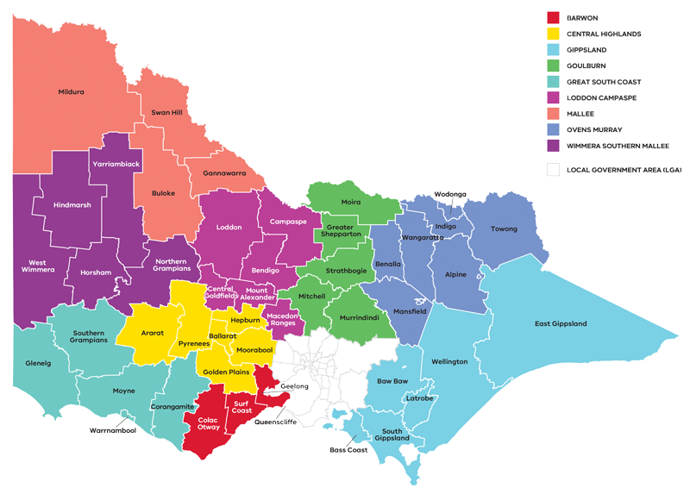

Figure 1: Map of Regional Partnerships – Long Alternate Text

Contents

Preface 1

How have the REDS been developed? 2

How can I use the REDS? 2

01 Introduction 4

A region in transition 5

Strategic directions 5

Regional readiness to activate strategic directions 6

Local priorities and strategies 8

02 Regional profile 9

Employment by industry 11

Output by industry 12

Regional exports 13

03 Comparative advantage 14

3.1 Endowments 14

3.2 Revealed industry specialisation 17

Emerging sectors 21

04 Strategic directions 21

Gippsland’s strategic directions 22

Enabling factors for economic growth 23

Integrating Aboriginal economic opportunities 23

4.1 Maximise the role of the food and fibre industry in the local economy 25

4.2 Accelerate advanced manufacturing capabilities in the region 29

4.3 Pursue opportunities emerging from energy industry transition, including in clean and renewable energy and earth resources 32

The policy environment 35

Aboriginal inclusion 36

How can we unlock this strategic direction? 37

4.4 Support growth and diversification in the visitor economy 37

Significance 37

Opportunities 38

Challenges 39

The policy environment 39

Aboriginal inclusion 40

How can we unlock this strategic direction? 40

4.5 Enhance regional specialisation in health care and social assistance 41

Significance 41

Opportunities 41

Challenges 42

The policy environment 43

Aboriginal inclusion 43

How can we unlock this strategic direction? 44

05 Implementation 44

RRV will use the REDS to coordinate investments and activities in place 44

Local stakeholders, industry leaders and government service providers can use the REDS to advocate for shared outcomes 45

RRV will monitor the implementation of the REDS 45

Appendix 46

Figure 1: Map of Regional Partnerships – Long Alternate Text 46

Figure 2 Map of Gippsland – Long Alternate Text 46

Figure 3 Gippsland industry Employment – Long Alternate Text 47

Figure 4 Gippsland industry output (gross value add) – Long Alternate Text 49

Figure 5 Gippsland industry employment location quotient and growth – Long Alternate Text 51

Figure 6 Gippsland industry output (GVA) location quotient and growth – Long Alternate Text 52

Figure 7 GVA of mining and energy industries 2001-20 – Long Alternate Text 53

Figure 8 Participation rate by gender (2016) – Long Alternate Text 55

# 01 Introduction

The *Gippsland Regional Economic Development Strategy* (the Gippsland REDS) lays out the medium-to long-term strategic directions for driving economic growth and development across the region.

The Gippsland Regional Partnership region extends from outer Melbourne to the eastern-most point of Victoria and includes the local government areas (LGAs) of Bass Coast, Baw Baw, East Gippsland, Latrobe City, South Gippsland and Wellington. The region is home to the Gunaikurnai, Bunurong, Wurundjeri and Taungurung Nations who are the recognised Traditional Owners who have lived, worked and cared for their country and its resources for thousands of years.

Latrobe City is the most populous LGA in the Gippsland region and hosts several large centres including Traralgon, Moe and Morwell. The Latrobe Valley is a resource rich area and the traditional energy powerhouse of Victoria, home to large brown coal resources and significant electricity production. Beyond Latrobe City, the Gippsland region has abundant natural resources supporting new energy generation, agriculture and forestry as well as manufacturing. A bourgeoning food and wine scene along with arts and cultural festivals underpin a thriving visitor and creative economy while health and education precincts extend innovative service provision throughout the region.

The western parts of the region have more concentrated population centres connected with metropolitan Melbourne. The more rural communities in the eastern part of the region support agriculture, fishing and visitor economy enterprises. East Gippsland Shire borders New South Wales (NSW), influencing economic activity in both states.

## A region in transition

As the historical energy powerhouse of Victoria, the Gippsland region is in a period of transition away from a reliance on coal-fired power. Some areas of the region will also be impacted by the timber industry’s transition away from native forest timber harvesting. This will see the shape and structure of the regional economy change with a renewed focus on:

* strengthening areas of existing specialisation, including new energy and food and fibre

expanding areas of emerging specialisation, including value add manufacturing, health and wellness services, sustainability and the circular economy, and nature-based tourism.

## Strategic directions

The Gippsland REDS defines five strategic directions for economic development in the region, based on comprehensive data analysis and review of existing policies and strategies:

1. Maximise the role of the food and fibre industry in the local economy
2. Accelerate advanced manufacturing capabilities in the region
3. Pursue opportunities emerging from energy industry transition, including in clean and renewable energy and earth resources
4. Support growth and diversification in the visitor economy
5. Enhance regional specialisation in health care and social assistance.

For each of the directions, the Gippsland REDS provides:

* a rationale for its inclusion as part of the strategy
* an overview of opportunities and challenges which are likely to support or hinder future growth
* a summary of work underway and the policy context to support desired outcomes
* the implication of the direction for the region’s Aboriginal communities

examples of how the direction could be activated.

The Gippsland REDS recognises that approaches to regional economic development occur in an uncertain environment. While most of the analysis focuses on internal development drivers, it also considers the impact of, and opportunities emerging due to external trends, including the COVID-19 pandemic, patterns in global trade, a changing climate and technological change.

The Gippsland REDS acknowledges that the Aboriginal and cross-border communities within the region face unique challenges and opportunities, which are also reflected in the strategic directions.

## Regional readiness to activate strategic directions

There is evidence of adaptive capacity in the Gippsland region and local stakeholders and industries have shown resilience in the face of industry transition. Local leaders are focused on opportunities in a range of future initiatives, including:

* value-added horticulture, food and fibre
* entrepreneurship among young people
* international investment in defence and new energy
* circular economy
* eco-tourism networks

agri-tech adoption.

The Latrobe Valley Authority conducted a survey in 2019 to better understand the type and degree of innovation in businesses across Gippsland. A sample of 453 businesses indicated that:

* 63 per cent had undertaken innovation in either product, process, organisation or marketing.
* Most innovation occurred in businesses with 20 or more employees.

Cross-business innovation is low within an industry, across multiple industries and outside the Gippsland region.

The Gippsland Regional Partnership and Regional Development Australia Committee elevate priority economic projects for consideration by the Victorian and Commonwealth governments. In addition, a range of local leadership networks and entities guide economic development and priority setting in Gippsland. These networks include:

* One Gippsland, which brings together local government and a selection of industry and education representatives to collaborate and advocate for a range of place-based priorities and initiatives.
* Committee for Gippsland, a member-driven advocacy organisation that takes a whole of region approach to shape and advocate for Gippsland’s future growth and development.
* Food & Fibre Gippsland, an industry-led organisation and membership peak body that brings industry partners and stakeholders together to lead capacity building, advocacy and innovation and knowledge sharing.
* Destination Phillip Island and Destination Gippsland, the regional tourism boards and peak tourism organisations for the region focusing on strategic tourism development across Gippsland.

Latrobe Valley Authority, the entity established by the State Government to support the Latrobe Valley and Gippsland through social and economic transition.

Local education institutions and innovation precincts provide the infrastructure to unlock future economic opportunity, including business growth and employment. Federation University provides tertiary education and research and development expertise and TAFE Gippsland, through its nine campuses across the region, leads the delivery of vocational education and training. Several institutions foster industry innovation and collaboration. These include:

* Hi-Tech Precinct Gippsland and the Morwell Innovation Centre, which host a mix of private sector commercial tenants, industry project teams focused on transitional or transformative projects and university research teams.
* Latrobe Health Innovation Zone, which gives voice to community aspirations in the planning and delivering of better health and wellbeing outcomes.
* Gippsland Community Power Hub, a collaborative effort between the Gippsland Climate Change Network, Energy Innovation Cooperative and the Mallacoota Sustainable Energy group to develop and deliver community energy projects to promote reduced energy costs, energy self-reliance and income generation.
* Gippsland Drought Resilience Adoption and Innovation Hub Node hosted at Food and Fibre Gippsland, which gives farmers and communities the tools to address vulnerability to drought.

Gippsland Agricultural Group, a volunteer, not for profit organisation that carries out research and activities to deliver benefits to farmers.

## Local priorities and strategies

The Gippsland Regional Plan 2020-25 and the 2021 Aboriginal Economic Development Strategy; Building on the Legacy are the most contemporary bodies of work that have informed the REDS economic narrative and strategic directions for Gippsland.

The Gippsland Regional Plan 2020-25 is a strategic plan for improving economic, social and environmental outcomes for the Gippsland region. It outlines a long-term vision to be Australia’s most liveable region by 2040 and identifies priority actions to achieve this vision, including investment in leadership, environmental assets, regional innovation, enabling infrastructure, lifelong learning and inclusive communities over the next five years. The Plan was developed by the Gippsland Regional Plan Leadership Group who continue to monitor regional priorities and will lead a refresh of the Plan in the coming years. This group brings together the Gippsland Regional Partnership, Regional Development Australia Gippsland, Committee for Gippsland and One Gippsland.

The Aboriginal Economic Development Strategy, developed by the Gunaikurnai Land and Waters Aboriginal Corporation (GLaWAC), facilitates and promotes opportunities for all Aboriginal communities in Gippsland to make a significant contribution to the economic development of the region. The Strategy identifies four focus areas: getting on with business, relationships and connections, business support and business innovation and growth.

Other local strategic planning that has informed the REDS includes strategic plans and studies commissioned by the Latrobe Valley Authority and other regional stakeholders. The Gippsland REDS also considers other State, regional and sub-regional policies and strategies as set out in the supporting documentation.

**Figure 2: Map of Gippsland**

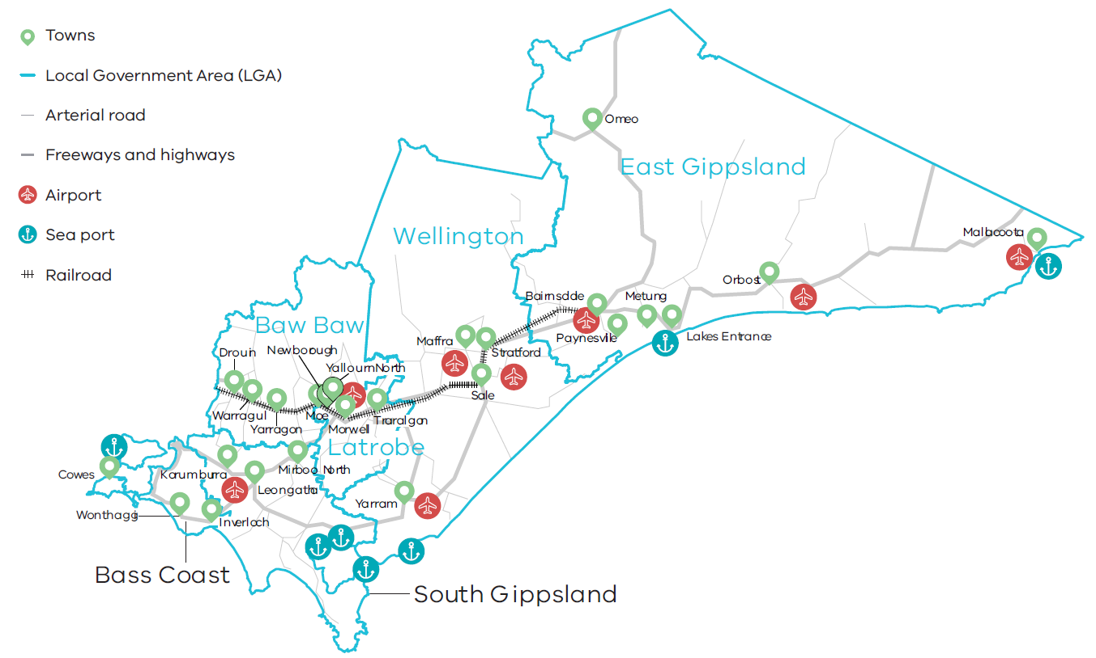

Figure 2 Map of Gippsland – Long Alternate Text

# 02 Regional profile

|  |  |
| --- | --- |
| $18.0 | Gross regional product (billion) (2020) |
| 291,000 | Population (2020) |
| 12.0% | Population growth (2011-20) |
| 45 | Median age (2020) |
| 59.4% | Working age (15-64) (2020) |
| 22.7% | Population aged over 65 (2020) |
| 1.5% | Are Aboriginal and/or Torres Strait Islander (2016) |
| 5.0% | Speak a language other than English at home (2016) |
| 12.8% | Were born overseas (2016) |

Gippsland is one of the largest regions in Victoria, covering 41,600 square kilometres with many population centres and townships dispersed throughout the region. East Gippsland and Wellington LGAs are the dominant areas by landmass but contain only 28.3 per cent of the region’s total population. Latrobe City has three large population centres – Moe, Morwell and Traralgon – and is considered the economic and business hub of Gippsland, home to 26 per cent of Gippsland residents. Other regional centres include Bairnsdale, Sale, Warragul, Drouin, Newborough, Inverloch, Leongatha, Maffra, Lakes Entrance, Wonthaggi and Cowes.

Gippsland is experiencing slightly lower population growth than the regional average for Victoria. Population growth is concentrated in the peri-urban shires of Baw Baw and Bass Coast, which are proximate to Melbourne and have higher levels of workers commuting into metropolitan Melbourne’s employment markets.

Population flows suggest Baw Baw, East Gippsland, Bass Coast and South Gippsland are attractive locations for families or people in the latter part of their careers. These areas experience inflows of residents aged between 0-14, 25-44 and 45-64. These regions also have higher than average inflows of residents aged over 65, which signals the attractiveness of the region as a retirement location. Similar to patterns across rural and regional Victoria, all shires, except Baw Baw, experience sizeable outflows of younger residents aged 15-25, likely due to fewer education and employment opportunities in Gippsland as compared to metropolitan centres in both Victoria and NSW.

|  |  |  |
| --- | --- | --- |
| Local Government Area | Population[1] (2020) | Projected growth[2] (2021–36) |
| Latrobe City | 75,900 | 8.8% |
| Baw Baw | 54,900 | 35.6% |
| East Gippsland | 47,700 | 15.8% |
| Wellington | 44,800 | 9.4% |
| Bass Coast | 37,400 | 27.8% |
| South Gippsland | 30,200 | 12.1% |

|  |  |  |  |
| --- | --- | --- | --- |
|  | Gippsland % | Regional average % | Metropolitan Melbourne % |
| Unemployment rate[3] (September 2021) | 6.1 | 4.2 | 6.0 |
| Labour force participation rate[4] (2016) | 57.7 | 60.9 | 65.8 |
| Average annual employment growth[5] (2011–20) | 0.8 | 1.0 | 2.1 |

The labour force participation rate in Gippsland (57.7 per cent) is significantly lower than the average for regional Victoria. The female participation rate (53.5 per cent) is significantly lower than for men (62.1 per cent). The largest employing sectors for women are health care and social assistance, education and training, and financial and insurance services.

**Table 1: Employment in largest employing industries by workers (2020) and gender (2016)**

|  |  |  |  |
| --- | --- | --- | --- |
|  | Workers | Male | Female |
| Health care and social assistance | 17,100 | 16.5% | 83.5% |
| Retail trade | 11,800 | 40.5% | 59.5% |
| Construction | 11,400 | 90.0% | 10.0% |
| Agriculture, forestry and fishing | 10,300 | 66.6% | 33.4% |
| Education and training | 10,200 | 25.1% | 74.9% |

Source: National Institute of Economic and Industry Research, 2020 and ABS Census, 2016

## Employment by industry

The health care and social assistance sector has been the region’s largest employer since 2009. This is consistent with the region’s growing demand for population services due to population growth and ageing. Other sectors associated with population growth have also grown consistently over the past two years, these include education and training and public administration and safety.

Other significant employing sectors in the region include retail trade, construction, agriculture, forestry and fishing, and manufacturing. Employment growth in these sectors has been more variable over time. Employment variability in the construction sector is likely due to housing demand in the rapidly growing peri-urban areas and the timing of large-scale infrastructure projects such as road and rail upgrades, specialist infrastructure and precinct development. Employment variability in the agriculture, forestry and fishing sector is likely due to seasonal conditions and shocks associated with industry transition. More recent fluctuations in 2019 and 2020 are likely due to bushfires, flood events and constrained access to labour during   
the COVID-19 pandemic.

**Figure 3: Gippsland industry employment (2001-20)**

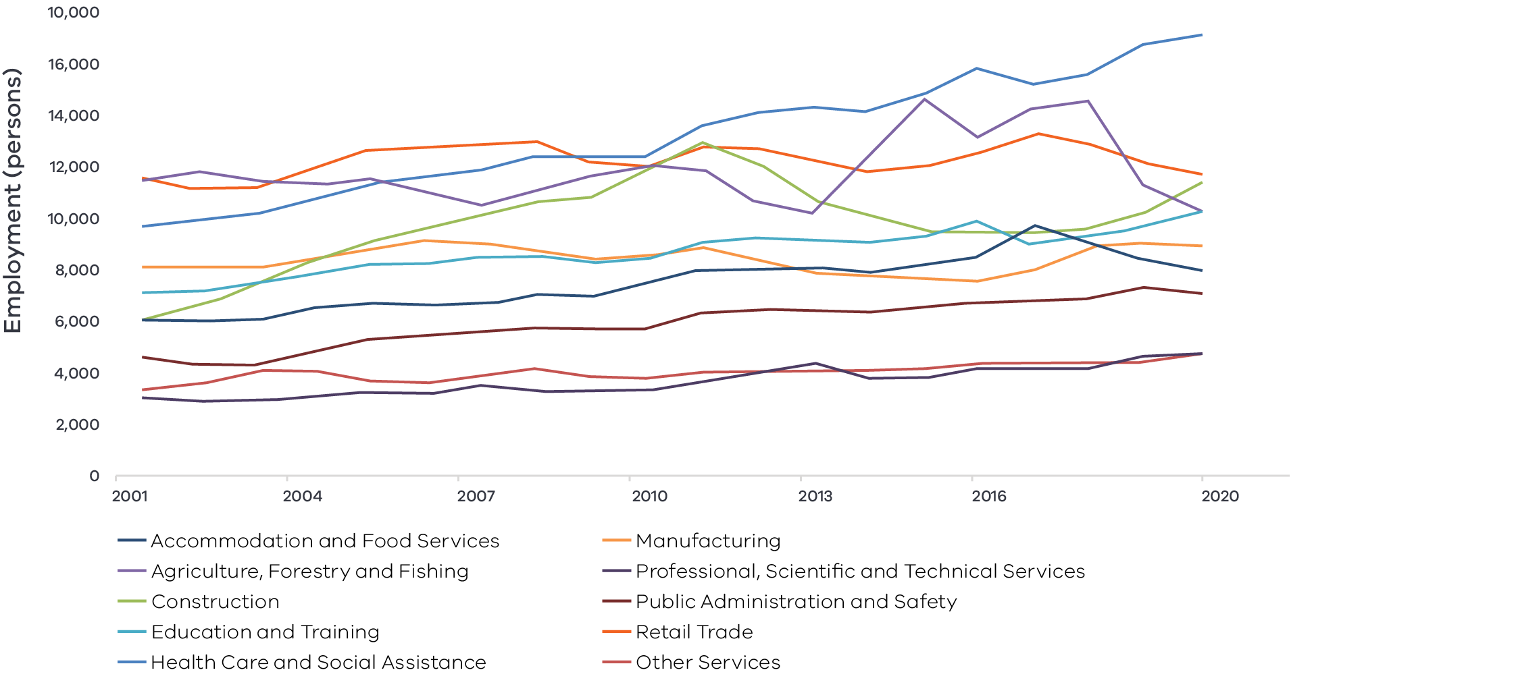

Figure 3 Gippsland industry Employment – Long Alternate Text

Source: National Institute of Economic and Industry Research, 202

Note: Top 10 employing industries in 2020 presented in chart, based on Journey to Work employment estimates.

## Output by industry

Mining is the largest contributor to regional GVA despite being one of the smallest employing industries. Mining output has fluctuated over the past 20 years, with a significant dip in 2012 and 2014 coinciding with declines in global coal prices and Australian policy changes. Since 2014 there has been an upward trend in mining value, largely due to an increase in oil and gas extraction in the state which began in 2012.

The electricity, gas, water and waste services sector has been on a downward trend since 2001 and has fallen from the second most important sector by output in 2001 to the fifth most important in 2020. During this time, the sector has lost ground to the construction, health care and social assistance, and agriculture, forestry and fishing sectors. Health care and social assistance has seen particularly steady output growth over the past 20 years associated with population growth, ageing of the population, and investments in the region’s health system.

### $15.2 billion Gross Value Added (GVA) (2020)

Top sectors by GVA:

|  |  |  |
| --- | --- | --- |
| 1 | Mining: | $4.3 billion |
| 2 | Construction: | $1.4 billion |
| 3 | Health care and social assistance: | $1.2 billion |
| 4 | Agriculture, forestry and fishing: | $1.0 billion |
| 6 | Electricity, gas, water and waste services: | $975.7 million |

**Figure 4: Gippsland industry output (Gross Value Add) (2001-20)**

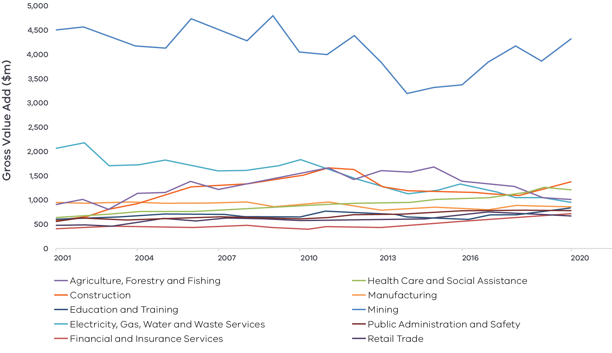

Figure 4 Gippsland industry output (gross value add) – Long Alternate Text

Source: National Institute of Economic and Industry Research, 2020

## Regional exports

Strong connections to international markets and rich natural resources have seen international export value double over the past decade to $2.5 billion in 2020. Top export sectors for 2020 were:

1. Mining: $871.8 million
2. Agriculture, forestry and fishing: $564.6 million
3. Manufacturing: $551.4 million

# 03 Comparative advantage

For the purposes of the REDS, ‘comparative advantage’ is defined simply as a description of what the region does well compared to other regions. This includes both the relative competitiveness of the region’s businesses as well as cultural, social and environmental factors.

Contemporary place-based development emphasises the importance of local endowments as a driver of local comparative advantage. In economic terms, endowments refer to any natural, human, cultural and built resources present in a place which can be harnessed to support economic activity. Regional economic strengths can also be identified using other measures including location quotient analysis, shift share analysis and industry cluster analysis. A comprehensive assessment of these measures is included in the Gippsland Regional Economic Development Strategy – Supporting Analysis.

## 3.1 Endowments

### Natural endowments

#### Fertile land and water access

Gippsland includes 28 per cent of Victoria’s agricultural land, which supports significant dairy, beef, horticultural and forestry production. The Macalister Irrigation District is the largest irrigation district in southern Victoria. Agriculture, forestry and fishing is an important employer and is also the third largest export earner for the region. There is also a significant amount of agri-tourism, supported by Gippsland’s wineries, distilleries, breweries and gourmet food offerings.

#### Forest, timber resources

Gippsland has vast native timber resources in the north-east and in East Gippsland as well as an extensive Radiata Pine plantation estate, mainly to the south of Latrobe City. Native forests in the region are also unique and present significant opportunities for nature-based tourism.

#### Environmental assets

Gippsland is a popular regional destination for visitors, largely due to the region’s diverse nature-based tourism experiences. Environmental precincts include Phillip Island Nature Park, Wilsons Promontory National Park, Mount Baw Baw Alpine Resort, Croajingolong National Park and the Gippsland Lakes.

Gippsland also has access to ample solar, wind and geothermal resources. The ideal locations for wind generation development are along the coastline and following the Great Dividing Range, with unique opportunities to develop offshore wind generation as well as renewable hydrogen.

The Gippsland region has a number of high-quality waterways and related assets which support nature-based tourism and urban and industrial water supply for the Gippsland and metropolitan Melbourne region. These include part or all of 13 significant river catchments, nationally and internationally significant wetlands and assets along the 700km of coastline (including Western Port, Wilsons Promontory, Corner Inlet, Ninety Mile Beach and the waterways of the Gippsland Lakes). Water from the extensive range of catchments as well as the Wonthaggi desalination plant provide a significant comparative advantage for industry, settlement planning and environmental amenity.

#### Earth resources

Gippsland is rich in natural mineral resources. The Latrobe Valley is estimated to contain approximately a quarter of the world’s known brown coal reserves[6] and the Gippsland Basin, in the south of the region, is Victoria’s most productive petroleum area. Gippsland’s mining export value has surged from $41.2 million in 2010 to $871.8 million in 2020.

Gippsland has been identified as a suitable area to deploy Carbon Capture and Storage, with the CarbonNet Project, supported by the Australian and Victorian Governments currently underway to establish a commercial scale system and network for Carbon Capture and Storage in the region.

#### Fishing

The Gippsland coastline and lakes provide marine resources for commercial and recreational purposes. Lakes Entrance is home to the State’s largest commercial fishing fleet and offshore support vessels servicing the Bass Straight oil and gas fields. Commercial fishing has been phased out of the Gippsland Lakes to restore the Lakes as a recreational fishing destination. There are expansive, lake, sea and rivers fishing opportunities across the region including Anderson Inlet, Lake Tyers and Port Albert.

### Cultural endowments

#### Aboriginal heritage

Gippsland has a long history of Aboriginal cultural heritage and is home to the Gunaikurnai, Bunurong, Wurundjeri and Taungurung peoples. Victoria has a joint management plan with the Gunaikurnai which provides governance for the joint management of several reserves and parks throughout the region. The region is home to the Bataluk Cultural Trail, which follows traditional routes used by the Gunaikurnai peoples for over 30,000 years stretching from Won Wron to Cape Conran in East Gippsland. Along the trail are numerous culturally significant sites such as The Knob Reserve, Burnt Bridge Reserve, Krowathunkoolong Keeping Place, and Buchan Caves.

#### Creative spaces

Gippsland has a diverse range of creative spaces and events that attract visitors to the region and increase liveability for current and prospective residents. A range of independent galleries and artist studios complement the calendar of local and international exhibitions at the Gippsland Art Gallery in Sale and the Latrobe Regional Gallery in Morwell. Performing arts centres – including the Regent Theatre in Yarram, the Wedge in Sale and the West Gippsland Arts Centre in Warragul – attract local and international musical, performance, comedy and cinema events. Creative Gippsland is a cooperative agreement between the six Gippsland LGAs to encourage and coordinate arts, culture and heritage activity to enrich the Gippsland experience for visitors and the community.

### Built endowments

#### Transmission and other energy infrastructure

The region is home to a network of oil and gas pipelines and some of Victoria’s strongest electricity transmission infrastructure, including high voltage 500kV and 220kV transmission lines connecting the region’s large-scale coal and gas generators in the Latrobe Valley with population centres in Melbourne. The terminal at Loy Yang Power Station connects the mainland Australia and Tasmanian energy grids via the BassLink interconnector.

#### Macalister Irrigation District

Irrigation infrastructure supports pastures and horticultural production. The Macalister Irrigation District covers 53,000 hectares[7], stretching from Cowwarr to East Sale in Wellington Shire. The system mainly sources water from Lake Glenmaggie and distributed to irrigators by a gravity fed system of channels and pipes. Over 430 farms in the region now have an irrigation farm plan and significant productivity gains and environmental outcomes have been generated due to its operation.

#### Transport connections

Gippsland is connected to domestic and international markets via road and rail. The Princes Highway links the region with Melbourne and Sydney via Latrobe City and Bairnsdale, while direct passenger and freight rail routes connect Bairnsdale to Melbourne through Latrobe City and Warragul. Other roads connect the region with significant centres, including Canberra and Wangaratta. The region does not have a major airport. However it does have several smaller regional airports and the East Sale Royal Australian Air Force base. Regional airports play a significant role in delivering emergency responses when roads are inaccessible.

### Human endowments

#### Skilled workers

Gippsland has a highly specialised engineering workforce that has historically supported the mining and energy supply industries. These specialised workers have skills that are transferable to other and emerging areas of regional specialisations. More broadly, above average attainment rates of Certificate III &IV demonstrate there is a highly skilled trade workforce in Gippsland.

#### Tertiary education institutions

There is a strong education network throughout the region built around Federation University, Monash Rural Health, TAFE Gippsland and the Chisholm Institute of TAFE in Wonthaggi. The Churchill campus of Federation University offers a wide range of courses such as art and design, business and commerce and nursing. TAFE Gippsland has campuses in Bairnsdale, Leongatha, Morwell, Traralgon, Lakes Entrance, Warragul, Yallourn, Sale and Kalimna West, and provides specialist training in areas such as forestry and fishing, as well as providing pathways to students for further undergraduate study. Chisholm Institute of TAFE provides courses for school leavers and mature students as well as focusing on accessible learning options for secondary and tertiary students to work their way into an apprenticeship or pre-apprenticeship. An innovative study hub in Bairnsdale (Gippsland East Study Hub) provides resources and facilities to local students. These education institutes are known for their collaborative efforts to develop pathways for students and life-long learning in Gippsland.

## 3.2 Revealed industry specialisation

Location Quotient (LQ) analysis provides further insight into the local economy’s underlying structure and comparative advantages that may not be evident from a region’s endowments. This form of analysis compares an industry’s size and growth (as measured by employment and output) as a proportion of total economic activity, relative to the Victorian average. The higher the LQ, the more concentrated, and therefore significant, an industry is to the local economy relative to Victoria on average. Scores above 1.25 indicate specialisation compared to the rest of the state. Further analysis is provided in the Gippsland Regional Economic Development Strategy – Supporting Analysis.

### Employment specialisation

Agriculture, forestry and fishing: The industry is the strongest employment specialisation in the region, employing four times as many workers as the Victorian average. The sector is however experiencing employment declines at a faster pace than the Victorian average. This is consistent with a general downward trend in agricultural employment since 2011 because of technology advancements and automation, and recent natural and economic shocks associated with drought, bushfires and flood events and transition in the forestry and dairy sector.

Population services: The Gippsland region is specialised in several population services:

* The preschool and school education sub-sector has an LQ score of 1.45 and is experiencing employment growth 5.0 percentage points above the Victorian average. Specialisation in school level education is consistent with strong migration of family aged residents to Baw Baw, East Gippsland, South Gippsland, and Bass Coast shires and relatively high levels of people aged 0-14 across the region.
* The medical and other health care services sub-sector has an LQ score of 1.42 and is experiencing employment growth 31.7 percentage points above the Victorian average. In recent years, local health care and training providers have been focused on building up expertise in allied health services, which falls into this sub-sector.

The residential care services sub-sector has an LQ score of 1.49, which is consistent with the age profile in Gippsland and the resulting demand for aged care services. This sub-sector is however experiencing employment growth at a slower rate than the Victorian average, which could suggest the region faces workforce shortages among residential care services.

Electricity supply: The coal-fired power stations Yallourn and Loy Yang and the gas-fired power station Jeeralang are important employers in the region, and electricity infrastructure in the region requires ongoing servicing and management. Electricity supply is a small regional employer but an important area of employment specialisation with an LQ score of 2.14. Employment growth in the sector however is lagging the Victorian average, likely due to transition in the energy sector and structural adjustment.

Visitor economy: Activity in the visitor economy cuts across multiple sub-sectors. Gippsland demonstrates employment specialisation in accommodation and sports and recreation, with employment growth in both sub-sectors outpacing Victorian averages. Together these sectors imply Gippsland may have unique strengths in the visitor economy drawing on significant natural and cultural attractions.

**Figure 5: Gippsland industry employment location quotient and growth**

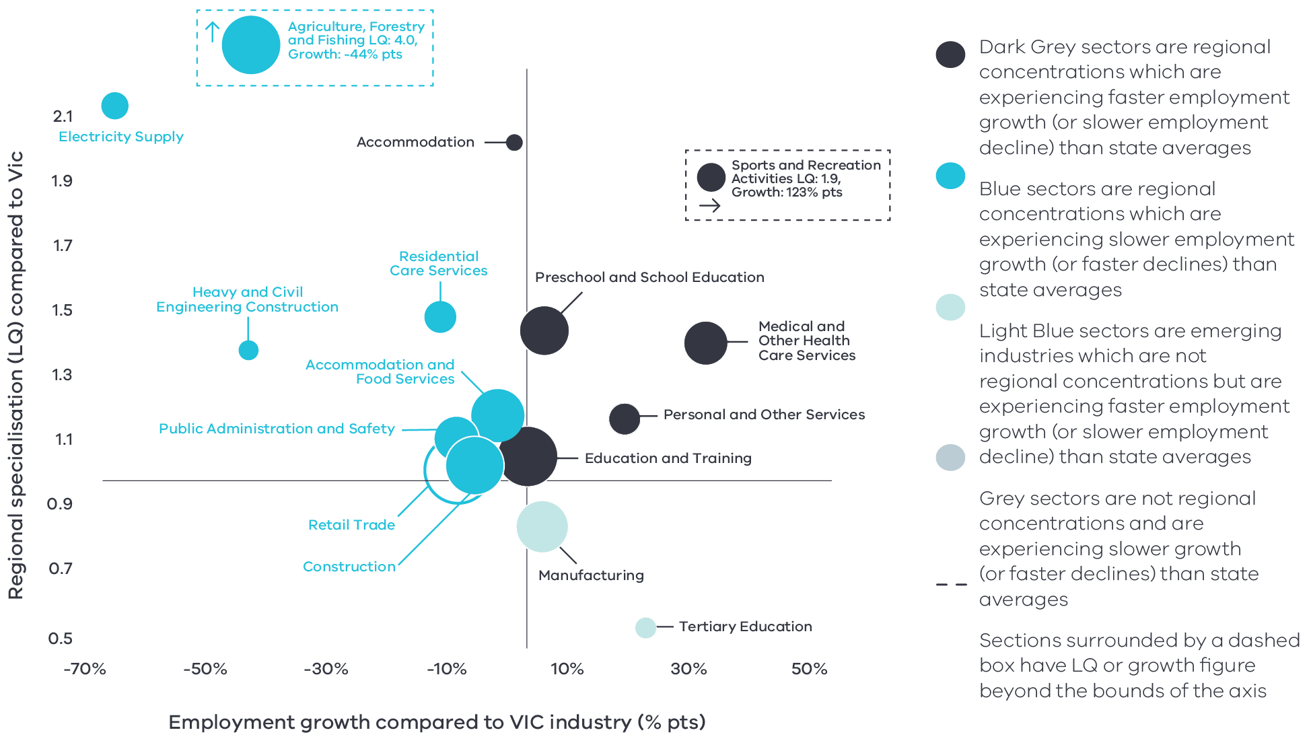

Figure 5 Gippsland industry employment location quotient and growth – Long Alternate Text

Source: National Institute of Economic and Industry Research, 2020, Note: This chart represents a selection of industries and sub-industries that represent a notable size and or concentration within the region. Some sub-industries presented are subsectors of industries that are presented alongside it and therefore measures cannot be aggregated between the two. Other industries are not displayed. For greater detail refer to the supporting analysis pack for this REDS strategy.

Figure 5 depicts selected industries and sub-industries in the regional economy in 2020 where:

* The size of each bubble indicates the number of people employed in the (sub)industry in 2020. The bigger the bubble, the more people employed in the industry.
* The vertical position indicates the (sub)industry’s degree of employment concentration relative to the Victorian economy. For example, a value of 1.4 means that, as a share of total employment in the local economy, the (sub)industry employs 1.4 times as many people as the Victorian average.

The horizontal position indicates the difference in each (sub)industry’s employment growth (2015-20) between the region and the Victorian average. For example, 31.7 percentage point indicates that regional employment in the (sub)industry has grown 31.7 percentage points faster (between 2015 and 2020) relative to the industry’s average growth rate in Victoria.

### Output specialisation

Figure 6 identifies Gippsland’s output specialisation in terms of Gross Value Added (GVA). Using the same approach as Figure 5, this analysis compares selected industries and sub-industries in the regional economy, including their size and growth as a proportion of total economic GVA relative to Victorian averages

Output specialisation in the Gippsland region is dominated by mining activities. Mining has an output LQ of 62.61 and output growth in the mining sector is 64.5 percentage points higher than the Victorian average. Important sub-sectors contributing to this specialisation include coal mining and oil and gas extraction with LQ scores of 242.5 and 62.9 respectively, and each experiencing growth 82.0 percentage points higher than the Victorian average.

**Figure 6: Gippsland industry output (GVA) location quotient and growth**

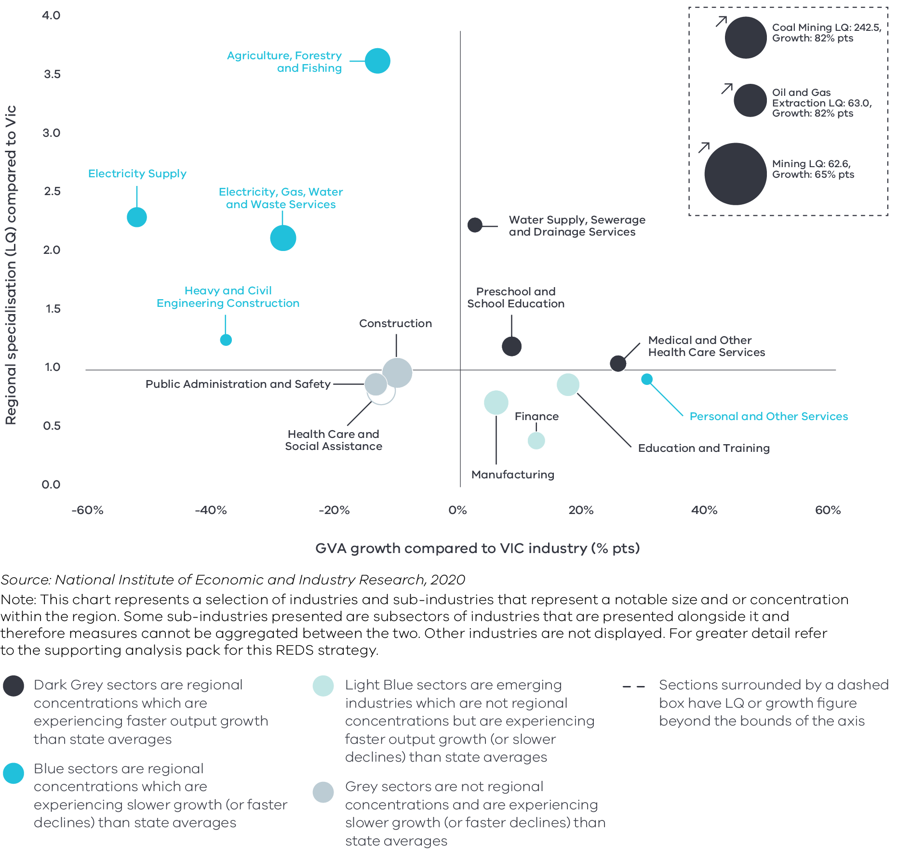

Figure 6 Gippsland industry output (GVA) location quotient and growth – Long Alternate Text

Source: National Institute of Economic and Industry Research, 2020

Note: This chart represents a selection of industries and sub-industries that represent a notable size and or concentration within the region. Some sub-industries presented are subsectors of industries that are presented alongside it and therefore measures cannot be aggregated between the two. Other industries are not displayed. For greater detail refer to the supporting analysis pack for this REDS strategy.

Consistent with employment specialisation, the region has output specialisation in:

* Agriculture, forestry and fishing with an output LQ of 3.6. Output growth lags the Victorian average by 13.2 percentage points, however this does not capture the full value chain impacts from food and fibre produce flowing from or through the region.

Electricity supply with an output LQ of 2.3 and output growth that lags the Victorian average by 51.5 percentage points.

Unlike employment specialisation, however, the region also has output specialisation in other sectors:

* Heavy and civil engineering construction emerges as an area of output specialisation, with an LQ score of 1.25. This is likely due to significant capital investment in the Gippsland region as well as maintenance of existing energy and mining infrastructure.

Preschool and school education and medical and other health care services are regional output concentrations that are experiencing output growth above the Victorian averages. Their LQ scores are not however high enough to be areas of regional specialisation.

## Emerging sectors

Several sectors in Gippsland do not have concentrations strong enough to be areas of specialisation but are experiencing output or employment growth faster than the Victorian average, which may indicate future areas of strength.

* Manufacturing activity is not as concentrated in Gippsland as in other parts of the state, with an employment and output LQ score of 0.85 and 0.71 respectively. Employment growth and output growth, however, are both outpacing the Victorian averages, which suggests the region is experiencing a surge in manufacturing activity.
* Finance has an output LQ score of 0.40 but is experiencing output growth above the Victorian average. This suggests there may be significant potential for the sub-sector to emerge as an important player in the region’s transition.
* Tertiary education has an employment LQ score of 0.55 but is experiencing employment growth above the Victorian average. In time the sub-sector could become a regional strength, particularly given the focus on the role of Federation University and TAFE Gippsland to provide lifelong learning opportunities and to work with industry to identify current and future training needs to prepare the workforce of the future.

# 04 Strategic directions

The five strategic directions for the Gippsland region have been identified based on the opportunities emerging from the region’s endowments, industry specialisations, and socioeconomic context. The directions have been refined based on a review of local policies and strategic plans.

The following section discusses each strategic direction, providing:

* a rationale for its inclusion as part of the strategy
* an overview of opportunities and challenges which are likely to support or hinder future growth
* a summary of work underway and the policy context to support desired outcomes
* the implication of the direction for the region’s Aboriginal communities

examples of how the direction could be activated.

## Gippsland’s strategic directions

1. Maximise the role of the food and fibre industry in the local economy
2. Accelerate advanced manufacturing capabilities in the region
3. Pursue opportunities emerging from energy industry transition, including in clean and renewable energy and earth resources
4. Support growth and diversification in the visitor economy
5. Enhance regional specialisation in health care and social assistance.

|  |  |
| --- | --- |
| **Digital connectivity**  Access to reliable internet and mobile services allows for access to new markets, facilitates efficiency gains and opens up opportunities for innovation. Good digital connectivity can also facilitate more inclusive access to services and flexible working arrangements. | 62 to 66 – Australian Digital Inclusion Index Score in Gippsland in 2021[8]  (Victorian average: 71) |
| **Transport connectivity**  Road and rail infrastructure, ports and airports provide critical linkages between production locations and markets; efficient transport connections and public transport services are a key factor in workforce mobility and local amenity. | 4.0 – Overall access to roads, public transport in the Gippsland RDA region[9]  (Regional Victoria: 4.1 and Victoria: 5) |
| **Workforce and population growth**  An adaptive and productive workforce is key to businesses competitiveness; access to both skilled and unskilled labour ensures business can sustain and expand activities. | 62.3% – Local workforce in Gippsland was employed in skilled occupations[10]  (Regional Victoria: 62.2%, Melbourne: 67.3%) (2021)  14.9% – Residents with a bachelor’s degree or higher in 2016[11]  (Regional Victorian: 17.0 %, Melbourne: 31.0%) |
| **Housing**  The availability and affordability of housing determines a region’s ability to attract and retain local staff and supports community cohesion and better life outcomes for individuals and families. | 0.8% – Average rental property vacancy rate in the 6 months leading up to June 2021[12]  (Compared to benchmark of 2.5%)  34.6% – Increase in median rent in Gippsland RDA region from 2016 to 2020[13]  (Victoria, 6.9%, Regional Victoria 28.6%) |

## Enabling factors for economic growth

This REDS identifies opportunities in key areas that can help drive regional economic growth. However, each region’s capacity to activate these opportunities and grow is partly determined by cross-cutting enabling factors that support economic activity. Consideration of these enabling factors – and targeted investments and initiatives to strengthen them – will help support achievement of the strategic directions in this REDS.

## Integrating Aboriginal economic opportunities

The Victorian Government is taking concrete steps to align with Aboriginal self-determination principles. Key Victorian Government policies and processes to realise self-determination goals include the:

* Treaty Process which seeks to redefine the relationships between Aboriginal communities, the state and non-Aboriginal Victorians
* Victorian Aboriginal Affairs Framework 2018-23 (VAAF) which is the overarching framework for working with Aboriginal Victorians to drive positive socioeconomic outcomes across the state, including to activate economic opportunities and prosperity via achieving wealth equality, facilitating workforce participation in all sectors at all levels and realising Aboriginal income potential.

Self Determination Reform Framework, which guides public sector action to enable self-determination in line with the VAAF across four domains: people, systems, outcomes and accountability.

The Victorian Government is also party to the National Agreement on Closing the Gap, and has committed to meeting the associated outcomes – including in relation to increasing engagement of Aboriginal and Torres Strait Islander in employment, education and training.

An analysis of relevant policies and commitments relating to Aboriginal economic development in the region (listed in the Gippsland Regional Economic Development Strategy – Supporting Analysis), including Traditional Owner strategic plans, where developed, has identified four opportunities for Aboriginal economic development:

1. Identify opportunities to leverage unique strengths for economic benefit, including natural resource management, cultural tourism, art and design and food and hospitality.
2. Pursue greater Aboriginal ownership of land to sustainably manage resources. The economic opportunities afforded through Joint Management Plans are one example of a way that caring for the land can have benefits across cultural, environmental and economic benefits.
3. Enhance Aboriginal business growth and entrepreneurial activity, with a particular focus on partnerships with both Aboriginal and non-Aboriginal businesses, creation of employment opportunities and industries of interest and relevant to Aboriginal communities such as cultural tourism, creative arts, land management, food and hospitality, professional services and health.
4. Pursue opportunities for greater Aboriginal participation in entrepreneurship and employment, particularly among youth, women and other vulnerable cohorts.

“A strong Aboriginal business sector is an important factor in empowering Aboriginal communities and contributes significantly to self-determination, wealth creation, and health and well-being… As businesses grow and develop, they allow the next generation of entrepreneurs to step forward. Over time, this strengthens the economic position of Aboriginal communities.

Fully participating in the economy provides Aboriginal Victorian with the resources they need to determine the future they want. Economic participation is therefore key to Aboriginal self-determination.”

Aboriginal Economic Development Strategy Gippsland; Building on the legacy, 2021, GLaWAC

Each strategic direction in the Gippsland REDS considers the relevance of that direction to local Aboriginal communities considering the above opportunities.

Self-determined priorities for Aboriginal economic development in the region will be aligned to the six pillars of the Victorian Aboriginal Employment and Economic Strategy. These priorities will also guide Victorian Government decision-making on economic development in the region and will be integrated into future updates of the REDS.

## 4.1 Maximise the role of the food and fibre industry in the local economy

### Significance

The food and fibre industry is an important employer and export industry in Gippsland, with particular strengths in dairy, meat, horticulture, forestry and seafood, and includes a range of activities associated with primary production, processing, manufacturing and distribution. In Gippsland, 36 per cent of land is used for primary production while timber resources have supported a large timber industry. The region’s unique combination of natural assets, transport hubs, innovation centres and regional universities make it a location of choice for agri-food and fibre businesses. In the five years to 2020, over 6000 new businesses opened in the Gippsland region, with 16 per cent in the agriculture, forestry and fishing sector. Road and rail freight infrastructure connects Gippsland with Melbourne’s major export hubs and domestic markets in Melbourne, Canberra and Sydney, which will support ongoing market access.

Local leadership and stakeholder groups are committed to positioning the food and fibre industry as the backbone of Gippsland’s economy. The region is developing a unique food brand which provides significant opportunities to further capture consumer demand. The food and fibre sector is an inter-connected industry, with strong ties to the environment, manufacturing, and visitor experience, and significant potential for farmgate tourism growth.

Recent environmental and economic shocks –including the 2019-20 summer bushfires, flood events, drought and dry seasonal conditions, industry transition and the COVID-19 pandemic –highlight the challenges facing the food and fibre industry and supply chains in the region. Innovation and continued supply chain collaboration will support the region to remain competitive and unlock future growth.

**Gippsland farms produce[14]**

* 28.6% of Victoria’s dairy
* 23.4% of Victoria’s beef

19.0% of Victoria’s vegetables

### Opportunities

#### Food and fibre innovation ecosystems

Gippsland has the tools to activate a food and fibre innovation ecosystem to translate innovative ideas into commercial adoption. This will involve bringing together actors across the supply chain to address practical issues and identify new opportunities, including enhanced local value-adding, input efficiency measures and climate change adaptation and mitigation activities.

* On-farm innovation: adoption of the Internet of Things (IoT) and other technologies will enhance remote monitoring and decision making.
* Research and development: local innovation precincts will be critical to active collaboration across primary production industry clusters, processors, skilled workers and researchers. This includes the Ellinbank SmartFarm, research institutions, Food &Fibre Gippsland, the Hi-Tech Precinct Gippsland, Gippsland Agriculture Group, and Morwell Food Manufacturing Precinct.

Attracting and training skilled people: highlighting job opportunities and career pathways in the food and fibre sector by industry and Federation University and TAFE Gippsland will be critical to attract, train and retain skilled workers.

#### Developing future industries

Dairy, livestock, forestry and the associated processing activities are the traditional strengths of the Gippsland region. There are opportunities for the region to build on existing strengths to deliver innovative new value-added food and fibre products that create new markets, enhance resource efficiency and minimise waste. These opportunities include:

* Supporting the growing horticultural industry to specialise in niche and high value products such as olives, garlic, saffron and truffles.
* Accelerating dairy innovation in specialised and high-value products such as organic and biodynamic milk, cheese, butter and other dairy goods.
* Building on existing paper manufacturing capabilities to capitalise on demand for alternative sustainable packaging in the transition away from single-use plastic in hospitality and other industries.
* Growing products for the pharmaceutical industry and developing a plantation value chain within the health sector.

Plant-based protein is another potential growth area and provides opportunities for the horticulture growers in the region.

#### Circular economy

Firms in Gippsland’s timber, paper and horticultural industries are already generating bioenergy on-site to power their operations. The food and fibre industry across Gippsland creates organic waste that offers further resource recovery and value-adding opportunities. This includes developing higher order products and markets from food and garden organics and bioenergy. With growing expertise in resource recovery, there may also be further opportunities to expand services into metropolitan Melbourne or other parts of Victoria.

### Challenges

#### Climate change and environmental shocks

The region faces an increasing frequency of adverse weather and variable conditions. Drought and dry conditions, flooding and bushfire events have recently disrupted production across Gippsland. Climate change is predicted to put pressure on infrastructure, influence water availability and limit production yields and output quality. However, some parts of Gippsland may be less adversely affected by climate change, and could as a result play an increasingly significant role as food and fibre producers in the State.

**By 2050s[15]**

* Median temperatures could rise by 2.0°C
* Decline in average spring rainfall by 19%
* Sea levels could rise 24 cm in Inverloch

11.5 days Extreme heat days (over 35°C) in Bairnsdale.

#### Transport connectivity

Gippsland has diverse and vast landscapes which poses challenges to regional connectivity. Transport connectivity is critical to support worker mobility and market access. While Gippsland has strong connections to Melbourne, Sydney and other centres via road, parts of Gippsland are relatively distant from Melbourne’s airport and deep-water ports. Further investments in intermodal facilities, rail freight, efficient transport links and greater utilisation of regional airport and ports would help to bolster regional connectivity.

#### Forestry transition

Gippsland’s extensive areas of native forests provide high quality sawlogs for over 11 hardwood sawmills in Gippsland, the Yarra Valley and Opal Australian’s Paper’s paper mill in Maryvale. The Victorian Government’s Victorian Forestry Plan is transitioning the timber industry to one that is wholly plantation-based by 2030. The Plan provides a variety of measures for businesses, workers and communities to support them through the transition and minimise significant risks to local jobs, loss of skills and community cohesion.

Since the release of the Plan in 2019, the focus has been on helping businesses plan for the transition and supporting businesses to trial innovative ideas. There are several worker transition support services which will focus on financial support for displaced workers, mental health and wellbeing support, training and assistance in seeking new job opportunities.

Alongside the business support, funding is available for six Gippsland communities to prepare local development strategies helping affected communities to transition to new, sustainable industries and preparing project plans ready for government and private investment. Funding will be available from 2022 to assist businesses create jobs in the affected communities, aligning with the outcomes of the local development strategies.

### The policy environment

Gippsland’s industry body, Food & Fibre Gippsland, advocates for a growth target for the sector of 5 per cent per annum to 2025 with a focus on increasing the quantity of food production, value add through manufacturing and logistics, research and innovation and export market growth.

Strengthening the food and fibre sector in Gippsland is closely aligned with national, state and local priorities. In particular:

* The Australian Government’s Make it Happen – The Australian Government Modern Manufacturing Strategy and the Victorian Government’s Food and Fibre Sector Strategy both highlight that food and beverage manufacturing is a priority industry.
* The Australian Government’s Agriculture Workforce Strategy and Roadmap details the plan to attract, retain, upskill and modernise the agriculture workforce.
* The Victorian Government’s Stronger, innovative, sustainable: A new strategy for agriculture in Victoria focuses on themes of recovery, growth, modernisation, biosecurity and promotion in the agriculture industry.
* The Latrobe Valley Authority’s Smart Specialisation work, which identifies food and fibre as one of Gippsland’s identified future growth industries.
* The Gippsland Regional Plan 2020-25 highlights encouraging innovation and investment to sustainably grow key industries, including food and fibre, as a ‘game changer’ priority.
* The Gippsland Regional Partnership’s 2019 report Accelerating growth for the Gippsland food and fibre industry which seeks to position food and fibre as the backbone of Gippsland’s economy by focusing on innovation, future industries, connectivity, sustainable resource management and industry leadership.

Victoria’s Recycling Victoria: A new economy is the state’s circular economy policy and 10- year action plan to reduce waste and pollution and improve recycling in a way which delivers economic benefit.

The Victorian Government is taking action to reduce Victoria’s emissions to net zero by 2050 and build resilient communities prepared to adapt to the impacts of climate change. Further development of Gippsland’s food and fibre industry will be shaped by the sector pledges which outline the actions to cut emissions from each sector, including in agriculture, energy, industrial processes, land use, transport and waste.

### Aboriginal inclusion

This strategic direction aligns with the Aboriginal economic opportunity to identify opportunities to leverage unique strengths for economic benefit, including natural resource management and food and hospitality. There is an opportunity to consider initiatives to increase Aboriginal representation in the food and fibre sector, including through initiatives led by the GLaWAC to investigate Aboriginal enterprise opportunities and forestry management. Food and fibre investments should consider the needs of Traditional Owners and Aboriginal communities and any potential land use conflicts.

### How can we unlock this strategic direction?

To unlock this opportunity and drive growth, local, State and Commonwealth partners could work together to:

* Maintain and build Gippsland’s unique brand and reputation for clean, safe and nutritious food.
* Take advantage of existing funding and incentives in place to support new or expanding food and fibre enterprises.
* Support collaboration across industry, government, community and research institutions to enhance innovation that strengthens the capacity of Gippsland’s food and fibre industry.
* Improve awareness of new and emerging opportunities associated with the circular economy, new technologies and niche industries.
* Support continued implementation of the Victorian Forestry Plan, including opportunities for an ongoing sustainable plantation industry in Gippsland and community transition.
* Ensure local producers are engaged in local, State and national conversations about climate change adaptation and mitigation practices in the agriculture and manufacturing sectors.
* Advocate for improved connectivity to support digital capabilities, worker mobility and market access.
* Encourage and promote a consistent uptake and application of best practices in agriculture.

Support investment to access appropriate water resources for food production.

## 4.2 Accelerate advanced manufacturing capabilities in the region

### Significance

The Gippsland region has a long tradition in manufacturing including the production of food, energy, pulp and paper, high-tech machinery and aircraft. Significant transport infrastructure—including major highways, railways and regional airports—connect the region’s manufacturers with consumers across Australia and internationally. International exports of manufactured goods have continued to grow since 2016, primarily driven by food and fibre product manufacturing.

Despite declines in the manufacturing sector over the past decade, Gippsland is seeing a resurgence of manufacturing, with output and employment growth outpacing state averages. Local stakeholders are focused on encouraging innovation and investment to sustainably grow the advanced manufacturing sector.

### Opportunities

#### Industry 4.0 and collaborative research

Industry 4.0 – the digitisation of manufacturing enhanced by data and machine learning—has changed the way goods are produced. The Morwell Innovation Centre and Hi-Tech Precinct Gippsland acts as a gateway to establish connections between advanced manufacturing businesses, research and industry to strengthen development and innovation along the sector’s entire supply chain. Enhancing collaboration and supporting clustering of manufacturing supply chains enable the region to maintain and grow its reputation as a globally renowned centre of excellence for advanced manufacturing. Many of the principles of Industry 4.0, including innovation, productivity and efficiency gains, can be rolled out to other sectors including agriculture and service provision.

#### Manufacturing to strengthen regional specialisations

Advanced manufacturing principles apply to a broad range of production activities and could be harnessed to strengthen the region’s specialisation. There may be immediate opportunities in the agriculture, energy and health manufacturing industry. These include:

* Niche food product manufacturing: Gippsland has a highly specialised agricultural industry with productive dairy, meat and vegetable industries that underpin food product manufacturing. Enhancing collaboration, innovation and traceability across the supply chain can create significant processing and value adding potential to meet growing domestic and global demand for safe, high-quality and provenance-based food and fibre products.
* Energy supply chain: The region has a strong foundation for the development of smart technology infrastructure for Victoria’s clean and renewable energy boom. This foundation is based on existing competitive industries, a skilled workforce and vibrant education and research facilities. There are opportunities in manufacturing high-value wind and solar infrastructure components and in maintenance and repair of renewable energy products.

Health manufacturing: The Gippsland region is focused on enhancing specialisation in health and wellbeing. There are considerable opportunities to develop key health supplies and pharmaceuticals locally both for export and to scale up local production in times of need.

**Table 2: Digital inclusion by geography in Victoria shows that Gippsland performs relatively poorly**

|  | Victoria | Melbourne | Rural Victoria | East Victoria (Gippsland) |
| --- | --- | --- | --- | --- |
| **Access**   * Internet access * Internet technology * Internet data allowance | 76.3 | 77.1 | 73.0 | 72.2 |
| **Affordability**   * Relative expenditure * Value of expenditure | 60.7 | 62.5 | 53.7 | 50.5 |
| **Digital ability**   * Attitudes * Basic skills * Activities | 52.2 | 53.7 | 46.8 | 45.0 |
| **Digital inclusion index** | 52.2 | 64.4 | 57.8 | 55.9 |

Source: Roy Morgan, 2020, Measuring Australia’s Digital Divide; The Australian Digital Inclusion Index 2020

### Challenges

#### Digital connectivity and capability

Digital connectivity is critical to innovation. The 2020 Australian Digital Inclusion Index shows that East Victoria, which includes Gippsland, performs below both regional Victoria and metropolitan Melbourne in terms of digital inclusion. This includes digital access, ability and affordability. Internet speed and digital capability is a critical enabler to doing business in advanced manufacturing. The Gippsland Digital Plan identifies that the digital intensity of the region’s manufacturing industry is set to increase considerably in the short term. In the next 5 years, their digital needs will require greater access, more sophisticated networks such as industrial IoT, fault prevention and data analytics for logistics.

### The policy environment

Accelerating advanced manufacturing capabilities is closely aligned with national, state and local priorities. In particular:

* The Federal Government’s Make it happen – The Australian Government’s Modern Manufacturing Strategy focuses on six sub-sectors of priority and advantage to the nation and getting the economic conditions right for manufacturing businesses to succeed.
* The State Government’s Advancing Victoria’s Manufacturing: A Blueprint for the Future also focuses on six future industries to guide future investment and activity.
* CSIRO as part of their Futures series have prepared the Advanced Manufacturing Roadmap which provides a comprehensive analysis of the current state of play and what strategic moves need to be made by the industry in the next 20 years to remain competitive.

The Gippsland Regional Plan 2020-25 identifies advanced manufacturing as a key economic sector and encourages Gippsland manufacturers to invest in collaborative research to exploit innovative technologies and embrace the fourth industrial revolution.

### Aboriginal inclusion

The manufacturing sector is a relatively small employer of Aboriginal people in Gippsland, employing only 6.3 per cent of the Aboriginal workforce. Although manufacturing has not been identified as a priority area to date for GLaWAC and other Aboriginal stakeholders, there are opportunities related to promoting Aboriginal business or employment participation along the manufacturing supply chain. This could include looking at opportunities relating to existing areas of interest such as bush medicine and wellbeing products and seafood and aquaculture including yabbies.

### How can we unlock this strategic direction?

To unlock this opportunity and drive growth, local, state and Commonwealth partners could work together to:

* Provide the right enabling conditions (e.g investment in upskilling, reskilling and digital technology) for the manufacturing sector to implement and commercialise new products and technologies.
* Support collaborative research across sectors to bolster other regional specialisations such as agriculture, fibre and health.

Access existing funding programs that improve digital capability and accessibility.

## 4.3 Pursue opportunities emerging from energy industry transition, including in clean and renewable energy and earth resources

### Significance

Gippsland has historically been the energy production powerhouse of Victoria. Legacy electricity and gas generation and transmission infrastructure supports the region’s comparative strength in the energy sector and puts Gippsland in an advantageous position to benefit from the increasing state-wide focus on renewable energy generation.

The Latrobe Valley contains Victoria’s remaining coal-fired power stations and almost all of Victoria’s coal reserves. Off-shore oil and gas extraction in the Bass Strait supplies much of the state’s natural gas. Global trends and the pending closure of coal-fired power stations are accelerating transition in Gippsland’s energy and extractives services. Coal mining and electricity supply have been the most important contributors to the local economy. Activation of emerging opportunities, such as in the renewable energy economy, as well as support for transitioning workers will be critical to navigate energy transition in Gippsland. The renewable energy sector, particularly wind and solar, has planned significant capital expenditure in Gippsland which is expected to increase local demand for technical skills. The investment in renewables will lead to growth in the value of the construction and electricity sectors.

Gippsland also has the potential to supply Melbourne and regional growth areas with the extractive resources needed for construction of housing, community infrastructure and renewable energy infrastructure, such as rock, sand and gravel. Gippsland is an important future supply area for Melbourne’s growth to replace depleted long standing production areas in Melbourne’s west.

### Opportunities

#### Clean energy potential

The region has natural endowments that can support future clean and renewable energy growth. This includes wind resources creating both on- and off-shore renewable energy opportunities; high levels of agricultural activity that provide bioenergy potential; and other natural assets supporting solar, small scale hydro, geothermal and marine wave power. The diversity of potential clean and renewable energy sources combined with existing transmission infrastructure means the region can be at the forefront of any new technologies or developments as global momentum continues to increase the demand for renewable energy. Co-locating renewable energy, such as solar and bioenergy, could support on-farm income diversification and reduce input costs.

#### Carbon capture and storage (CCS)

Global pathways to limit global warming include initiatives that remove carbon dioxide from the atmosphere, including CCS. The CarbonNet project in Gippsland, funded by the Australian and State governments, is seeking to develop commercial-scale CCS that could become an important piece of enabling economic infrastructure. CCS and its associated industries have the potential to assist the decarbonisation of multiple sectors across the Victorian economy and support new enterprises.[16]

#### Resources for the construction boom

The quarry sector is playing a key role in Victoria’s post-COVID-19 economic recovery effort. Demand for extractive resources in Victoria is expected to more than double 2015 levels by 2050.[17] Gippsland is rich in natural resources, including in-demand sand for construction, that will support the significant investment in infrastructure across Victoria, including for housing, community infrastructure and renewable energy projects. The proximity of the region to Melbourne allows advantages in cost effective exports transport of these resources across Victoria.

#### Hydrogen – fuel of the future

Global demand for hydrogen is expected to grow and hydrogen is projected to supply up to a fifth of global energy needs by 2050.[18] The Hydrogen Energy Supply Chain project is testing the feasibility of producing liquid hydrogen and shipping it to Japan. If successfully commercialised, this supply chain could generate significant future investment, trade opportunities and employment in the region. Gippsland has also been chosen by National Energy Resources Australia as one of 13 clusters across Australia that will play a pivotal role in accelerating the development, deployment and commercialisation of the Australian hydrogen industry.

Any new projects would need to comply with the Victorian Government’s Statement on Future Uses of Brown Coal, including consideration of environmental, economic and social factors.

### Challenges

#### Social licence and land use tensions

Competing pressures to maintain or restore land values may impact opportunities in the new energy and earth resources sectors. For extractive resources to continue to be available as Victoria grows, industry should work with the community to build a social licence to operate.

The Gippsland region is home to highly productive agricultural land and the Macalister Irrigation District, which underpins the region’s agri-food supply chain. New renewable energy activities can create land use and resource (water) competition as well as amenity impacts. Future renewable energy activity needs to consider the potential impact on the agricultural and resources sectors, including the Victorian Government’s objective to plan and manage for sustainable change within irrigation districts under the Victorian Planning Provisions. Exploring opportunities to co-locate solar farms with agriculture and extractive industries could lead to farm income diversification and reduce land-use tensions.

#### Structural transition in mining and energy

Both the coal mining and energy sectors in Gippsland face pressures as coal-fired power stations in the Latrobe Valley are set to close within 30 years. This will continue the existing downward trend in output from mining and energy (oil and gas) sectors. This trend will change the structure of the Gippsland economy, and will require carefully managed transition, including skills retraining, to ensure local livelihoods are supported through the adjustment period. Rehabilitation of mines may also offer opportunities for economic activity and will be guided by the Latrobe Valley Regional Rehabilitation Strategy, which supports integrated planning and decision-making for the rehabilitation of Hazelwood, Yallourn and Loy Yang coal mines. Capital investment in the development of renewables, particularly wind power, will also support local jobs and the transition in the region.

**Figure 7: GVA of mining and energy industries 2001-20**

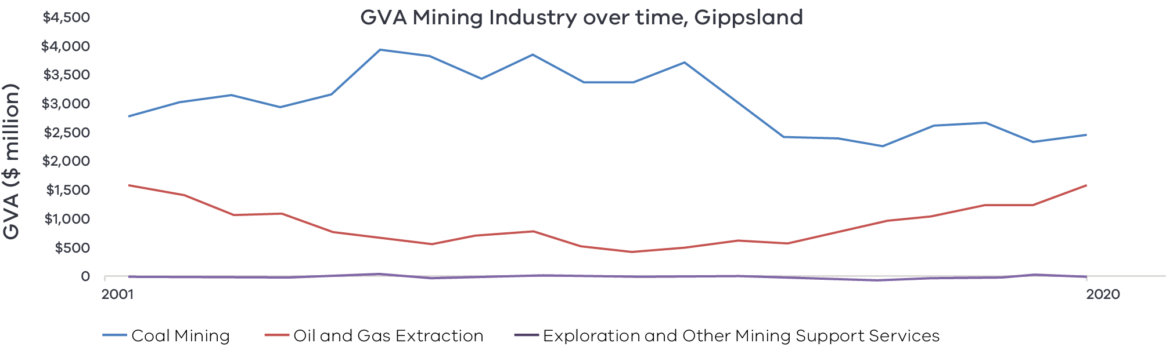

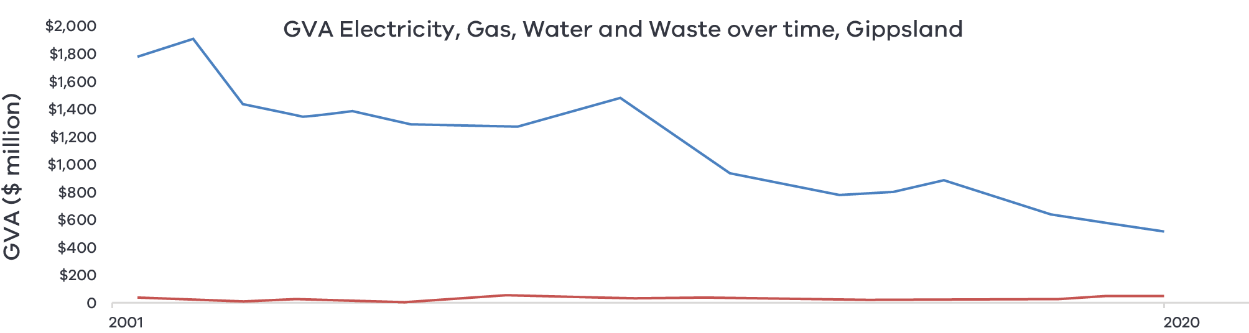

Figure 7 GVA of mining and energy industries 2001-20 – Long Alternate Text

## The policy environment

Growing the opportunities in new energy is closely aligned with state and local priorities. In particular:

* Victoria’s Climate Change Strategy provides a roadmap towards net-zero emissions by 2050. It includes interim targets to reduce emissions and pledges for energy, agriculture, transport, waste and forestry sectors. The Energy Sector pledge will accelerate Victoria’s transition to a clean and efficient energy future, ensuring that 50 per cent of Victoria’s electricity will come from renewable sources by 2030.
* The Statement on Future Uses of Brown Coal provides clarity to industry and local communities about uses of Victoria’s brown coal reserves in a low-emissions setting to ensure new projects comply with Victoria’s commitment to net zero emissions by 2050 and are assessed through a transparent and robust framework.
* The Latrobe Valley Authority’s Smart Specialisation work, which identifies new energy as one of Gippsland’s identified future growth industries and the Latrobe Valley New Energy Jobs and Investment Prospectus positions the region to transport the energy sector and drive investment in new energy technologies.
* The Gippsland Regional Plan 2020-25 identifies renewable, clean and community energy initiatives as game changers for the region.
* The Southern Gippsland Renewable Energy Roadmap identifies existing and potential opportunities for renewable energy development and transmission.
* The Central and Gippsland Region Sustainable Water Strategy (under development) will set out the Victorian Government’s plan for a climate-resilient future in the region, and will explore the options available to meet the range of water needs.
* The Victorian Offshore Wind Policy Directions Paper sets out a pathway to establish an offshore wind industry and sets a state-wide target of 9GW of offshore wind energy generation by 2040.

The Victorian government has a suite of state-wide policies and initiatives to support the State’s energy sector to transition to net-zero emissions, which are available on [energy.vic.gov.au](https://www.energy.vic.gov.au/).

Victoria’s Renewable Energy Zones (REZs) target investment towards strengthening the transmission network in Victoria to enable an orderly and coordinated transition to renewable energy and engage with local communities to ensure that they benefit from REZs. The Australian Energy Market Operator (AEMO) has identified two renewable energy zones that cross into the Gippsland region.

Safeguarding Victoria’s resources for future growth is also a Victorian Government priority:

* The Helping Victoria Grow: Extractive Resources Strategy helps ensure that high quality extractive resources continue to be available at a competitive price to support Victoria’s growth. All six of Gippsland’s LGAs are recognised in the Strategy as being among the top 20 strategic resource local government areas.
* The Strategic Extractive Resources Roadmap supports Helping Victoria Grow: Extractive Resources Strategy by advancing actions under the resource and land use planning theme. Actions include updates to mapping and planning provisions that better identify and secure strategic extractive resources in priority locations across Victoria. South Gippsland, Bass Coast, Baw Baw and Latrobe are recognised as priority extractive resource supply LGAs for detailed investigation, and implementation of stronger planning controls.

Strategic Extractive Resource Areas (SERAs) are now in place in South Gippsland. SERAs have been developed to provide greater certainty to industry, land use planners and the community by indicating the future land use in the planning scheme. SERAs identify strategic extractive resource locations, and apply planning controls to manage the impact of land uses that are incompatible with extractive industries. The development of SERAs considers other existing land uses, environmental assets, and community interests.

## Aboriginal inclusion

There may be opportunities for Aboriginal owned renewable energy projects. The Southern Gippsland Renewable Energy Roadmap recognises that Aboriginal organisations are investigating mid-scale solar projects in Southern Gippsland. Aboriginal leaders and technical experts are exploring pathways to generate long-term positive impacts in health and education through income streams from solar farms. Renewable energy and mining investments should consider the needs of Traditional Owners and Aboriginal communities and any potential land use conflicts.

## How can we unlock this strategic direction?

To unlock this opportunity and drive growth, local, State and Commonwealth partners could work together to:

* Position Gippsland as a centre of excellence for new energy and energy innovation and attract new energy investments that leverage the existing high-capacity electricity and gas transmission infrastructure
* Build workforce skills and industry capability to support the new energy sector.
* Prepare industry and workers to support transition in the mining and energy sectors, including proactively preparing for the closure of the remaining power stations.
* Maximise the extent to which local job seekers are skilled to meet the need of major projects, including energy and resource projects.
* Support the development of Aboriginal owned renewable energy projects based on the principles of self-determination.
* Engage communities on the importance of extractive resources through all stages of the quarry lifecycle, and gain confidence that quarry operations will be well managed.
* Explore transport connectivity challenges and address connectivity barriers that could hinder renewable energy development and expansion in the region.

Support programs and initiatives that aim to upskill regional business owners and entrepreneurs, and advocate for upskilling community cohorts that are likely to be unrepresented in this field.

## 4.4 Support growth and diversification in the visitor economy

## Significance

Gippsland’s appeal as a visitor destination is underpinned by its diverse natural attractions, engaging towns and villages, established tourism brands, Aboriginal heritage and an emerging creative industry.

Significant attractions include:

* Phillip Island, which is one of Victoria’s premier tourist destinations.
* High value environmental assets, including Wilsons Promontory National Park, Gippsland Lakes, Croajingolong National Park, Strzelecki Ranges, Yallock-Bulluk Marine and Coastal Park and Buchan Caves Reserve.
* Long established food tourism networks, offering speciality goods, wine and farmer market experiences.
* Alpine areas, such as Mt Baw Baw and parts of the Australian Alps national parks.
* Museums, galleries and performing arts centres in Latrobe, Warragul, Traralgon, Sale, Bairnsdale and Wonthaggi.

Lardner Park in Baw Baw, which normally hosts around 150 events annually.

The visitor economy is a significant contributor to the regional economy and the industry has performed strongly in recent years. Prior to COVID-19 and the 2019-20 summer bushfires, visitor numbers and expenditure were growing year-on-year, with domestic intrastate overnight visitors the fastest growing type of tourist. The south-eastern region of Gippsland is also strategically located along the coastal journey between Melbourne and Sydney. Visitation to the South East Coast offers significant opportunities to market a ‘through journey’ narrative that benefits tourism operators and coastal towns in both New South Wales and Victoria.

## Opportunities

### Year-round visitation

Creating experiences that enable year-round visitation is a priority for the region, particularly in areas attractive for seasonal visitation such as the coast, lakes and alpine areas. Maintaining strong regional and intra-regional transport is critical to attract visitors and support mobility throughout the year. These could include ‘hero’ experiences that attract high levels of visitation and encourage private investment in surrounding areas. Year-round opportunities could be developed through leveraging the region’s critical tourism precincts surrounding Phillip Island and the national parks, capturing adventure tourism potential at Mount Baw Baw and wellness tourism opportunities through the Metung Hot Springs and Nunduck Spa Retreat, and increasing the agri-tourism offering. Tourism opportunities can be grouped as complementary experiences or a single, major hero experience to encourage high level of visitation, length of stay and spending. Enabling year round visitation requires strong regional and intra-regional transport to attract visitors and support mobility throughout the year.

### Aboriginal heritage

Cultural tourism provides an opportunity for the community to connect with the Gippsland Aboriginal community’s culture, history, and language. Working with Gunaikurnai Land and Waters Aboriginal Corporation, Destination Gippsland and others, there is an opportunity to build and mature a dedicated Aboriginal tourism product and align and enhance existing products through Traditional Owner knowledge of culture, heritage and caring for country. In addition, growing cultural tourism provides an opportunity to deliver improved economic outcomes for Aboriginal Victorians and support Aboriginal-owned experiences.

### Agritourism

Agritourism offers growth potential for the region, given the presence of niche farms in a variety of agricultural production areas in close proximity to Melbourne. Investing in agritourism such as farm stay, food and winery experiences will expand on the visitor destination opportunities that currently exist in the region.

## Challenges

### Recovery from natural and economic shocks

Gippsland has faced consecutive economic and environmental shocks in recent years, including bushfires, drought and dry seasonal conditions and flood events and the COVID-19 pandemic. Despite year-on-year growth in visitation and visitor expenditure prior to the COVID-19 pandemic, these shocks have affected the local workforce, tourism operators and infrastructure. Recovery is the first step in enhancing the visitor economy.

### Climate change

Increasing temperatures and environmental degradation pose a long-term threat to nature-based tourism experiences. More extreme heat days may reduce access to nature-based tourism, while increased bushfire risk days may pose challenges to tourism operators and to visitor mobility to parts of the region. Warmer weather conditions are likely to shorten the snow season at Mt Baw Baw and Mt Hotham will lead to a natural increase in the abundance and variety of algae and other organisms in the Gippsland Lakes, which could lead to increased algae blooms. As well as seeking ways to mitigate climate change, parts of the visitor economy that rely on nature-based assets will need to adapt to the conditions by diversifying their offerings.

Table 3: Overview of year-on-year total visitation and expenditure in Gippsland 2016-20

|  |  |  |  |  |  |
| --- | --- | --- | --- | --- | --- |
|  | 2016 | 2017 | 2018 | 2019 | 2020 |
| Annual visitation (million people) | 7.3 | 7.8 | 7.7 | 8.7 | 5.7 |
| Annual expenditure ($ billion) | $1.2 | $1.4 | $1.4 | $1.6 | $1.2 |

Source: Tourism Research Australia research data, as reported by DJPR – Tourism, Events and the Visitor Economy Research 2021.

Note: From 2021 tourism data for Regional Partnership regions is defined based on SA2 boundaries. Prior data is based on LGA boundaries and therefore estimates may differ slightly.

## The policy environment

Growing the visitor economy in Gippsland is in line with state and local priorities:

* The Victorian Government’s Visitor Economy Recovery and Reform Plan (2021) aims to attract more tourists to the State, support regional jobs and deliver a significant recovery from the combined effects of the 2020 summer bushfires and the COVID-19 pandemic. This includes delivering a state-wide destination master plan underpinned by priority sector plans (the first sector priorities to be developed will be the Nature-Based Tourism Plan and the First Peoples’ Tourism Plan) and the establishment of Visitor Economy Partnerships across Victoria.
* The Latrobe Valley Authority’s Smart Specialisation work, which identifies the visitor economy as one of Gippsland’s identified future growth industries.
* Destination Gippsland’s Towards 2030 Gippsland Destination Management Plan provides a clear vision for achieve long-term, sustainable growth in Gippsland’s visitor economy with a focus on nature-based, epicurean, adventure and heritage tourism.

The Gippsland Regional Plan 2020-25 identifies the visitor economy as a key economic sector with opportunities across a range of visitor economy pillars (nature-based, gourmet food and beverage, heritage and culture and sporting events).

The Victorian Government is also investing in a range of visitor economy initiatives to diversify Gippsland’s economy and support recovery from bushfires and the COVID-19 pandemic.

## Aboriginal inclusion

GLaWAC’s Aboriginal Economic Development Strategy; Building on the legacy recognises cultural tourism, art and design and food and hospitality as unique strengths of local Aboriginal communities. With over 17 per cent of the local Aboriginal workforce employed in sectors that directly support the visitor economy—including accommodation and food services, arts and recreation and retail trade—efforts to enhance the visitor economy will create enterprise and employment opportunities for Aboriginal communities in Gippsland.

## How can we unlock this strategic direction?

To unlock this opportunity and drive growth, local, State and Commonwealth partners could work together to:

* Support development of experiences that enable year-round visitation, particularly in areas which currently have a seasonal visitation focus such as coastal, lakes and alpine regions.
* Coordinate tourism planning across government and tourism boards to align priorities and maximise investment outcomes, including with representatives in NSW.
* Identify regional tourism offerings that have current and future ‘hero’ potential to elevate the region.
* Focus on place-based solutions to support the region recover from natural and economic shocks.
* Support Aboriginal communities to activate business opportunities in the visitor economy and land management based on the principles of self-determination.

Support development and delivery of a pipeline of projects with a focus on business development, product offerings and management of natural assets to enhance visitors’ experience in the region.

## 4.5 Enhance regional specialisation in health care and social assistance

## Significance

Health care and social assistance is the region’s largest employer and is expected to grow significantly in the coming years in line with demographic changes. This will create employment opportunities in diverse fields and create opportunities for workers transitioning from other fields. Local stakeholders are focused on how innovation in the health care and social assistance sector can strengthen regional specialisation and meet the increasing and diversified demand for population services.

## Opportunities

### Product innovation

Gippsland is characterised by unique geography with concentrated population centres in the west and central regions and dispersed or remote populations to the east. The region also has relatively high levels of socioeconomic disadvantage which can create poorer health and education outcomes. These challenges require health providers to explore innovative activities to reach and service the local population through hub and spoke models, digital health innovation, telehealth or other methods.

### Address labour participation and youth outmigration

Between 2019 and 2024, an additional 3,000 people are projected to find employment in health care and social assistance. Meanwhile, at 57.7 per cent, Gippsland has relatively low levels of labour force participation and young people aged 15-24 migrate out of most parts of Gippsland at higher rates than regional averages. There are opportunities to support greater engagement of the local workforce to meet this increasing demand for workers and stem the outflow of young people from the region. Promoting careers in the health care and social services sector, leveraging local training assets and creating training and employment pathways that target under engaged population segments may assist with this.

### Partnership with education and training providers

Gippsland’s growing culture of innovation includes strong connections between industry and training providers to ensure access to lifelong learning and to skilled workers. Stronger partnerships between the health care and social assistance sector and education and training providers—including TAFE Gippsland, Federation University and Monash Rural Health—are critical to ensure delivery of appropriate courses, encourage clinical placements in Gippsland and enhance the profile of a career in the health care and social assistance sector.

### Improving labour market inclusion

There is evidence of a correlation between low economic participation and high socioeconomic disadvantage. Difficulty in accessing the same opportunities and services as those in more populated areas has implications for workforce participation and labour outcomes. Encouraging and boosting employment opportunities for disengaged cohorts provides an avenue for maximising local labour capacities while building a more diverse and inclusive workforce. Addressing the underlying issues that result in low economic participation and ensuring work practices, policies and strategies are also inclusive will be critical to ensuring that inclusive employment generates long term and lasting benefits.

Figure 8: Participation rate by gender (2016)

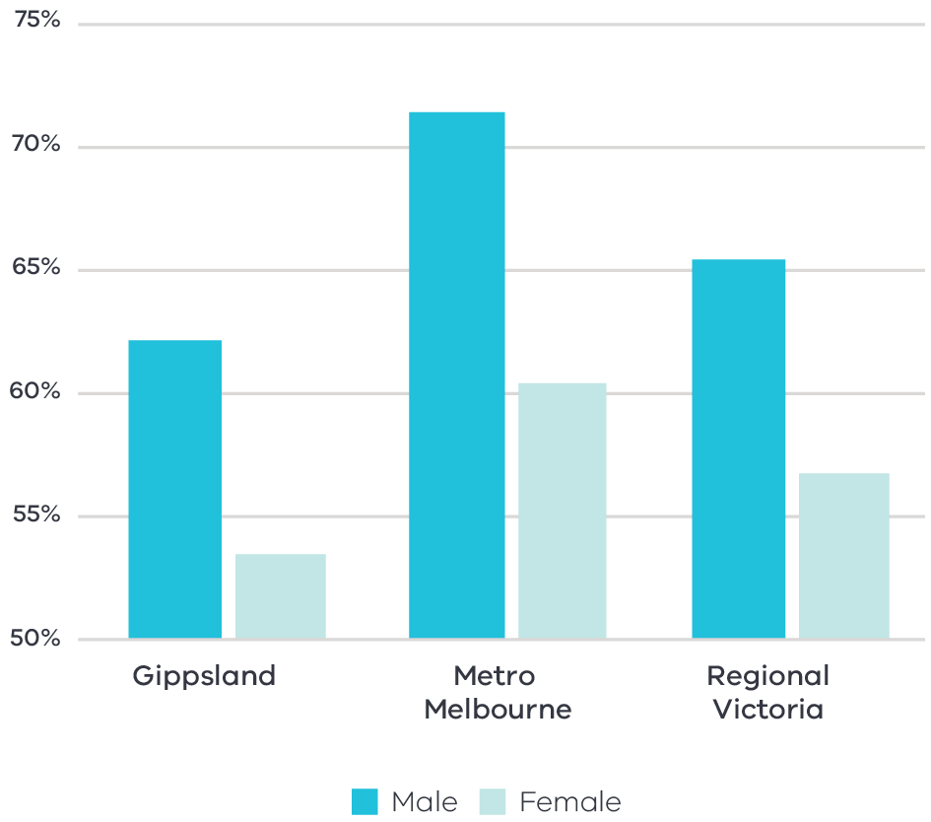

Figure 8 Participation rate by gender (2016) – Long Alternate Text

Source: ABS Census, 2016

Consistent with the pattern across the state and regional Victoria, the female participation rate in the Gippsland region is significantly lower than the male participation rate. This disparity presents an opportunity to boost future economic growth by addressing the comparatively high proportion of part-time workers and relatively lower participation rate for female workers.

## Challenges

### Workforce attraction and retention

Local stakeholders report serious and persistent shortages of qualified health care professionals. The drivers of these shortages include youth out-migration, an aging population, lower participation rates and limited local training pathways to some health care professions. Housing availability and the perception that small-scale rural or remote services may not have the same benefits as large centres also limits the ability of the region to attract skilled healthcare workers.

### Digital inequalities

The Gippsland Regional Digital Plan notes that digital intensity in the health care and social assistance sector is expected to increase significantly in the coming years with the roll out of telehealth, digitisation of records and analysis and robot assisted operations. Gippsland has relatively lower levels of digital inclusion compared to both regional and metropolitan areas of Victoria. This limits service provision and innovation in the health care and social assistance sector:

* Service provision: mobile blackspots can limit the provision of in-home care and emergency response.

Innovation: Gippsland’s regional universities and hospitals need to compete with metropolitan organisations for research and private investment in digital health innovation. Metropolitan organisations often have superior digital connectivity, existing research records and private sector investment. This may challenge some of Gippsland’s efforts to create place-based responses to health care challenges or commercialise digital health innovations.

## The policy environment

Enhancing regional specialisation in health care and social assistance in the Gippsland region is in line with state and local priorities:

* The Victorian Government established the Latrobe Health Innovation Zone in 2016 to improve health and wellbeing of residents in Latrobe City, with partners, local health providers and the community working together to drive innovation and change.
* The Latrobe Valley Authority, through Gippsland’s Smart Specialisation Strategy project, identifies health and wellbeing as an area of regional strength and is exploring the role of partnerships, workforce planning and health and education hubs to realise economic opportunities.

The Gippsland Regional Plan 2020-25 identifies health care and social assistance as a key economic sector and notes population and aging will create further demand for health-related employment and capability development.

The Australian and Victorian Governments are investing in digital and telecommunications infrastructure that is critical to the provision of care and digital health innovation. This includes the Mobile Blackspot program and Connecting Victoria.

## Aboriginal inclusion

The health care and social assistance and education and training sectors are important employers among the Aboriginal workforce in Gippsland, employing over 30 per cent of the workforce. Efforts to enhance the specialisation in these sectors will likely have positive employment outcomes for Aboriginal workers. The region is home to several of Victoria’s Aboriginal Community Controlled Health Organisations, which are crucial local stakeholders in delivering community, health and cultural heritage services.

## How can we unlock this strategic direction?

To unlock this opportunity and drive growth, local, State and Commonwealth partners could work together to:

* Better understand the current skill base and future skill needs within the health care and social assistance sector to develop training and career pathways.
* Support local initiatives and programs to attract broader workforce in regional and rural areas and increase workforce participation in the health care and social assistance sector among priority cohort, including Aboriginal communities and women.
* Encourage partnerships between industry, training providers and government to build regional research capability and expertise and career pathways for local students.
* Advocate for policy settings that encourage the placement of students and skilled migrations in regional areas.
* Coordinate activities to improve the quality of amenities and services to attract and retain population into the region.

Support investment in infrastructure and services that could promote inclusive labour market outcomes including care facilities, training and upskilling facilities.

# 05 Implementation

The Gippsland REDS outlines Rural and Regional Victoria (RRV) Group’s strategic approach for focusing its future economic development activities, including through policy, investment and program delivery, in the region. It is not a prescriptive roadmap for Victorian Government economic development action in Gippsland.

## RRV will use the REDS to coordinate investments and activities in place

RRV is committed to pursuing the strategic directions through future policy design, investment and program implementation, as well as through collaboration across government and with regional partnerships, to deliver positive economic outcomes for the region. The Gippsland REDS will provide a central point for coordination for current and future work streams and investments.

RRV recognises that effective planning policy and controls will be a key enabler of inclusive, sustainable economic growth in the Gippsland region. Victoria’s Regional Growth Plans provide broad direction for land use and development, and enable economic growth by ensuring that infrastructure investment is coordinated, appropriate services are provided, and development meets community expectations. The Regional Development and Planning portfolios will pursue opportunities to ensure that as relevant state-led land use planning strategies, policies and controls are updated, they are aligned with the REDS strategic directions.

## Local stakeholders, industry leaders and government service providers can use the REDS to advocate for shared outcomes

The Gippsland REDS, along with the supporting Gippsland Regional Economic Development Strategy – Supporting Analysis document, provides a starting point for an evidence-based, strategic approach to regional development. This approach is an ongoing process where specific development actions and projects can be proposed and considered in the context of alignment with the REDS.

Regional Development Victoria – Gippsland will remain the main point of contact in the region for facilitating and coordinating regional development outcomes in close collaboration with regional stakeholders such as the Latrobe Valley Authority and relevant industry bodies.

The Gippsland Regional Partnership which comprises community and business leaders, CEOs of constituent Local Governments, members from the Regional Development Australia Gippsland Committee and State Government personnel will continue to be the main advisory body to the Minister for Regional Development and other government decision-makers on local issues and priorities.

The Gippsland REDs will provide Jobs Victoria with important context and understanding of local economic priorities and opportunities that will be a critical input into the planning and prioritisation of Jobs Victoria’s work and collaboration activities with our Service Partners. Jobs Victoria assists people looking for work, connects employers with the staff they need, administers wage subsidy programs and supports significant local employment transitions.

## RRV will monitor the implementation of the REDS

The strategic directions in the REDS focus on medium- to long-term drivers of growth and opportunity but will be used immediately to guide investment in the region. Notwithstanding this timeframe, the strategic directions will continue to evolve and progress as actions and investment are made. To ensure ongoing relevance and accuracy, RRV will periodically update and refresh this Strategy.

# Appendix

## Figure 1: Map of Regional Partnerships – Long Alternate Text

The **Mallee** region is located in northwest Victoria and contains the LGAs of Mildura, Swan Hill, Buloke and Gannawarra.

The **Wimmera Southern Mallee** region is located in western Victoria and contains the LGAs of West Wimmera, Hindmarsh, Yarriambiack, Horsham and Northern Grampians.

The **Great South Coast** region is located in southwest Victoria and contains the LGAs of Glenelg, Southern Grampians, Moyne, Warrnambool and Corangamite.

The **Barwon** region is located to southwest of metropolitan Melbourne and contains the LGAs of Geelong, Queenscliffe, Surf Coast and Colac Otway.

The **Central Highlands** region is to the west of metropolitan Melbourne and contains the LGAs of Ararat, Pyrenees, Golden Plains, Moorabool, Ballarat and Hepburn.

The **Loddon Campaspe** region is northwest of metropolitan Melbourne and contains the LGAs of Macedon Ranges, Mount Alexander, Central Goldfields, Loddon Campaspe and Bendigo.

The **Goulburn** region is north of metropolitan Melbourne and contains the LGAs of Mitchell, Murrindindi, Strathbogie, Greater Shepparton and Moira.

The **Ovens Murray** region is located in the northeast of Victoria and contains the LGA’s of Mansfield, Benalla, Wangaratta, Alpine, Indigo, Towong and Wodonga.

The **Gippsland** region is located in the east of Victoria and contains the LGAs of Bass Coast, South Gippsland, Baw Baw, Latrobe, Wellington and East Gippsland.

Click here to return to document

## Figure 2 Map of Gippsland – Long Alternate Text

The Gippsland region is made up of the Bass Coast, South Gippsland, Latrobe, Baw Baw, Wellington and East Gippsland Local Government Areas.

The Gippsland region has major rail and road connections to Melbourne. The rail connection, ending in Bairnsdale, links several Gippsland towns (Drouin, Warragul, Yarragon, Moe, Newborough, Morwell, Traralgon, Sale, Stratford). Major road connections link the remaining towns across the Gippsland region

The towns of Mallacoota, Orbost, Bairnsdale, Sale, Maffra, Morwell, Yarram and Leongatha also have local airports, while several coastal towns have sea ports (Cowes, Lakes Entrance, Mallacoota).

Click here to return to document

## Figure 3 Gippsland industry Employment – Long Alternate Text

The largest employing industries in descending order are Health Care and Social Assistance, Retail Trade, Construction, Agriculture, Forestry and Fishing, Education and Training, Manufacturing, Accommodation and Food Services, Public Administration and Safety, Other Services and Professional, Scientific and Technical Services.

The following industries have grown in employment since 2001 Health Care and Social Assistance, Retail Trade, Construction, Education and Training, Manufacturing, Accommodation and Food Services, Public Administration and Safety, Other Services and Professional, Scientific and Technical Services.

The following industry has declined in employment since 2001; Agriculture, Forestry and Fishing.

Simplified Table of data for Figure 3.

|  |  |  |  |  |  |  |  |  |  |  |
| --- | --- | --- | --- | --- | --- | --- | --- | --- | --- | --- |
|  | Health Care and Social Assistance | Retail Trade | Construction | Agriculture, Forestry and Fishing | Education and Training | Manufacturing | Accommodation and Food Services | Public Administration and Safety | Other Services | Professional, Scientific and Technical Services |
| 2001 | 9619 | 11451 | 5972 | 11492 | 7140 | 8061 | 6044 | 4515 | 3368 | 3064 |
| 2002 | 9907 | 11186 | 6678 | 11767 | 7236 | 8186 | 6040 | 4309 | 3652 | 2978 |
| 2003 | 10156 | 11248 | 7507 | 11418 | 7522 | 8131 | 6125 | 4415 | 4109 | 2968 |
| 2004 | 10690 | 11927 | 8429 | 11330 | 7877 | 8347 | 6522 | 4829 | 4059 | 3100 |
| 2005 | 11289 | 12615 | 9050 | 11512 | 8217 | 8723 | 6735 | 5326 | 3746 | 3261 |
| 2006 | 11569 | 12763 | 9669 | 10903 | 8328 | 9056 | 6606 | 5499 | 3681 | 3298 |
| 2007 | 11911 | 12808 | 10112 | 10532 | 8525 | 9010 | 6700 | 5620 | 3867 | 3455 |
| 2008 | 12372 | 12893 | 10614 | 10960 | 8486 | 8793 | 6984 | 5766 | 4140 | 3309 |
| 2009 | 12424 | 12181 | 10830 | 11572 | 8339 | 8414 | 7014 | 5718 | 3873 | 3292 |
| 2010 | 12434 | 12032 | 11986 | 12031 | 8453 | 8509 | 7473 | 5822 | 3747 | 3388 |
| 2011 | 13524 | 12748 | 12850 | 11811 | 9098 | 8799 | 7967 | 6305 | 4100 | 3686 |
| 2012 | 14062 | 12657 | 12025 | 10667 | 9280 | 8347 | 8055 | 6429 | 4126 | 3977 |
| 2013 | 14258 | 12290 | 10704 | 10226 | 9183 | 7899 | 8001 | 6378 | 4118 | 4273 |
| 2014 | 14183 | 11846 | 10143 | 12460 | 9000 | 7738 | 7885 | 6308 | 4054 | 3827 |
| 2015 | 14798 | 12068 | 9514 | 14535 | 9308 | 7748 | 8154 | 6513 | 4196 | 3868 |
| 2016 | 15725 | 12505 | 9404 | 13098 | 9775 | 7621 | 8511 | 6770 | 4386 | 4054 |
| 2017 | 15222 | 13293 | 9436 | 14213 | 9045 | 7976 | 9684 | 6849 | 4357 | 4113 |
| 2018 | 15592 | 12884 | 9665 | 14507 | 9349 | 8831 | 9005 | 6914 | 4317 | 4169 |
| 2019 | 16711 | 12197 | 10324 | 11271 | 9779 | 8962 | 8354 | 7235 | 4549 | 4573 |
| 2020 | 17052 | 11791 | 11371 | 10323 | 10227 | 8914 | 7934 | 7095 | 4705 | 4659 |

Click here to return to document

## Figure 4 Gippsland industry output (gross value add) – Long Alternate Text

The industries with the largest gross value add in 2020 in descending order are Mining, Construction, Health Care and Social Assistance, Agriculture, Forestry and Fishing, Electricity, Gas, Water and Waste Services, Manufacturing, Education and Training, Public Administration and Safety, Financial and Insurance Services and Retail Trade.

The following industries have grown in gross value add since 2001; Construction, Health Care and Social Assistance, Agriculture, Forestry and Fishing, Manufacturing, Education and Training, Public Administration and Safety, Financial and Insurance Services and Retail Trade.

The following industries have declined in gross value add since 2001; Mining and Electricity, Gas, Water and Waste Services.

Simplified Table of data for Figure 4. Data in this table is in ($) millions.

|  |  |  |  |  |  |  |  |  |  |  |
| --- | --- | --- | --- | --- | --- | --- | --- | --- | --- | --- |
|  | Mining | Construction | Health Care and Social Assistance | Agriculture, Forestry and Fishing | Electricity, Gas, Water and Waste Services | Manufacturing | Education and Training | Public Administration and Safety | Financial and Insurance Services | Retail Trade |
| 2001 | 4500 | 578 | 646 | 920 | 2066 | 950 | 632 | 597 | 414 | 472 |
| 2002 | 4565 | 683 | 689 | 980 | 2190 | 940 | 634 | 642 | 431 | 497 |
| 2003 | 4377 | 840 | 717 | 833 | 1719 | 956 | 664 | 616 | 454 | 500 |
| 2004 | 4189 | 933 | 769 | 1111 | 1734 | 963 | 696 | 606 | 472 | 560 |
| 2005 | 4151 | 1140 | 769 | 1174 | 1822 | 946 | 706 | 620 | 450 | 597 |
| 2006 | 4743 | 1278 | 772 | 1337 | 1704 | 933 | 702 | 647 | 433 | 592 |
| 2007 | 4531 | 1309 | 802 | 1229 | 1594 | 946 | 704 | 650 | 455 | 614 |
| 2008 | 4288 | 1363 | 824 | 1331 | 1603 | 972 | 675 | 627 | 467 | 635 |
| 2009 | 4800 | 1427 | 843 | 1414 | 1695 | 873 | 669 | 616 | 422 | 606 |
| 2010 | 4043 | 1519 | 869 | 1537 | 1833 | 905 | 677 | 627 | 417 | 581 |
| 2011 | 3997 | 1666 | 909 | 1657 | 1660 | 963 | 725 | 644 | 450 | 609 |
| 2012 | 4389 | 1626 | 941 | 1427 | 1451 | 859 | 740 | 687 | 452 | 611 |
| 2013 | 3837 | 1309 | 942 | 1555 | 1298 | 807 | 714 | 692 | 433 | 617 |
| 2014 | 3187 | 1201 | 957 | 1566 | 1156 | 832 | 660 | 723 | 477 | 609 |
| 2015 | 3322 | 1214 | 1028 | 1660 | 1197 | 855 | 655 | 745 | 523 | 644 |
| 2016 | 3387 | 1188 | 1067 | 1395 | 1309 | 830 | 648 | 783 | 577 | 688 |
| 2017 | 3829 | 1136 | 1059 | 1361 | 1224 | 820 | 666 | 763 | 605 | 742 |
| 2018 | 4154 | 1122 | 1133 | 1283 | 1074 | 893 | 688 | 782 | 644 | 729 |
| 2019 | 3867 | 1217 | 1235 | 1097 | 1053 | 897 | 742 | 806 | 684 | 685 |
| 2020 | 4306 | 1364 | 1198 | 1001 | 976 | 870 | 824 | 805 | 719 | 677 |

Click here to return to document

## Figure 5 Gippsland industry employment location quotient and growth – Long Alternate Text

The graph is divided into four quadrants.

The first quadrant identifies the industries that are a) experiencing slower employment growth (or faster declines) than state averages and b) have higher levels of employment specialisation than state averages

The following industries are in quadrant 1:

* Agriculture, Forestry and Fishing
* Electricity Supply
* Heavy and Civil Construction
* Residential Care Services
* Accommodation and Food Services
* Public Administration and Safety

The second quadrant identifies the industries that are a) experiencing faster employment growth (or slower declines) than state averages and b) have higher levels of employment specialisation than state averages.

The following industries are in quadrant 2:

* Sports and Recreation Activities
* Preschool and School Education
* Medical and Other Healthcare Services
* Education and Training

The third quadrant the industries that are a) experiencing slower employment growth (or faster declines) than state averages and b) have lower levels of employment specialisation than state averages.

There are no industries in the third quadrant.

The fourth quadrant identifies industries that are a) experiencing faster employment growth (or slower declines) than state averages an b) have lower levels of employment specialisation than state averages.

The following industries are in quadrant 4:

* Manufacturing
* Tertiary Education

Click here to return to document

## Figure 6 Gippsland industry output (GVA) location quotient and growth – Long Alternate Text

The first quadrant identifies the industries that are a) experiencing slower GVA growth (or faster declines) than state averages and b) have higher levels of GVA specialisation than state averages

The following industries are in quadrant 1:

* Agriculture, Forestry and Fishing
* Electricity Supply
* Heavy and Civil Engineering construction
* Electricity, Gas, Water and Waste Services

The second quadrant identifies the industries that are a) experiencing faster GVA growth (or slower declines) than state averages and b) have higher levels of GVA specialisation than state averages.

The following industries are in quadrant 2:

* Water Supply, Sewerage and Drainage Services
* Preschool and School Education
* Medical and other healthcare services

The third quadrant the industries that are a) experiencing slower GVA growth (or faster declines) than state averages and b) have lower levels of GVA specialisation than state averages.

The following industries are in quadrant 3:

* Construction
* Health Care and Social Assistance
* Public Administration and Safety

The fourth quadrant identifies industries that are a) experiencing faster GVA growth (or slower declines) than state averages an b) have lower levels of GVA specialisation than state averages.

The following industries are in quadrant 4:

* Manufacturing
* Education and Training
* Finance

Click here to return to document

## Figure 7 GVA of mining and energy industries 2001-20 – Long Alternate Text

The mining subindustries with the largest GVA in 2020 in descending order are; Coal Mining, Oil and Gas Extraction, Non-Metallic Mineral Mining and Quarrying, Exportation of Other Mining Support Services and Metal Ore Mining.

Coal Mining and Oil and Gas Extraction has declined between 2001 and 2020 whilst Metal Ore Mining, Non-Metallic Mineral Mining and Quarrying and Exportation of Other Mining Support Services have grown over the same period.

Simplified Table of data for mining subindustry GVA 2001-20. Data in this table is in ($) millions.

| Year | Coal Mining | Oil and Gas Extraction | Metal Ore Mining | Non-Metallic Mineral Mining and Quarrying | Exploration and Other Mining Support Services |
| --- | --- | --- | --- | --- | --- |
| 2001 | 2795.5 | 1651.2 | 1.5 | 8.7 | 43.1 |
| 2002 | 3050.7 | 1465.3 | 1.9 | 12.4 | 34.9 |
| 2003 | 3136.6 | 1183.2 | 2.2 | 19.7 | 34.9 |
| 2004 | 2955.5 | 1171.5 | 1.7 | 19.3 | 40.9 |
| 2005 | 3199.8 | 866.5 | 1.5 | 18.4 | 65.0 |
| 2006 | 3914.2 | 750.4 | 2.5 | 15.0 | 60.9 |
| 2007 | 3802.7 | 660.8 | 3.5 | 22.9 | 41.1 |
| 2008 | 3432.1 | 793.4 | 5.5 | 19.9 | 37.2 |
| 2009 | 3860.7 | 865.6 | 5.2 | 19.2 | 49.9 |
| 2010 | 3380.7 | 604.3 | 5.7 | 19.1 | 33.3 |
| 2011 | 3389.5 | 534.2 | 8.3 | 23.4 | 41.6 |
| 2012 | 3711.8 | 599.1 | 6.5 | 17.2 | 54.4 |
| 2013 | 3045.3 | 725.3 | 5.1 | 15.0 | 46.1 |
| 2014 | 2464.4 | 670.0 | 7.8 | 15.7 | 29.1 |
| 2015 | 2447.3 | 829.9 | 7.3 | 20.8 | 17.0 |
| 2016 | 2306.5 | 1029.7 | 9.6 | 27.1 | 14.3 |
| 2017 | 2621.7 | 1142.1 | 3.7 | 41.8 | 19.4 |
| 2018 | 2706.7 | 1338.0 | 5.7 | 77.0 | 26.5 |
| 2019 | 2397.2 | 1306.8 | 13.8 | 84.1 | 65.3 |
| 2020 | 2466.9 | 1621.6 | 25.9 | 138.6 | 53.3 |

The Electricity, Gas and Water Supply subindustries with the largest GVA in 2020 in descending order are; Electricity Supply, Water Supply and Drainage Services, Gas Supply and Waste Collection, Treatment and Disposal Services.

Electricity Supply and Gas Supply has declined between 2001 and 2020 whilst Waste Collection, Treatment and Disposal Services and Water Supply and Drainage Services have grown over the same period.

Simplified Table of data for energy subindustry GVA 2001-20. Data in this table is in ($) millions.

|  |  |  |  |  |
| --- | --- | --- | --- | --- |
| Year | Electricity Supply | Gas Supply | Water Supply, Sewerage and Drainage Services | Waste Collection, Treatment and Disposal Services |
| 2001 | 1777.7 | 87.9 | 170.0 | 30.7 |
| 2002 | 1894.3 | 99.1 | 171.4 | 25.2 |
| 2003 | 1413.4 | 78.1 | 207.6 | 20.2 |
| 2004 | 1347.5 | 61.2 | 292.4 | 32.6 |
| 2005 | 1373.4 | 56.9 | 365.0 | 26.5 |
| 2006 | 1295.6 | 55.2 | 325.5 | 27.6 |
| 2007 | 1275.3 | 59.2 | 207.5 | 51.8 |
| 2008 | 1277.1 | 52.9 | 208.9 | 63.6 |
| 2009 | 1372.9 | 35.7 | 227.3 | 59.3 |
| 2010 | 1479.5 | 31.9 | 267.7 | 53.7 |
| 2011 | 1208.7 | 30.4 | 364.6 | 56.0 |
| 2012 | 938.2 | 34.3 | 428.3 | 50.0 |
| 2013 | 871.2 | 43.8 | 338.7 | 44.4 |
| 2014 | 791.1 | 48.8 | 277.2 | 38.7 |
| 2015 | 796.5 | 63.6 | 293.9 | 43.0 |
| 2016 | 889.2 | 82.2 | 294.0 | 43.7 |
| 2017 | 781.6 | 101.0 | 296.6 | 44.8 |
| 2018 | 642.4 | 100.4 | 284.9 | 46.6 |
| 2019 | 577.1 | 122.4 | 288.4 | 65.1 |
| 2020 | 530.1 | 114.3 | 264.4 | 66.9 |

Click here to return to document

## Figure 8 Participation rate by gender (2016) – Long Alternate Text

|  | Male | Female |
| --- | --- | --- |
| Gippsland | 62.1% | 53.5% |
| Metro Melbourne | 72.5% | 60.4% |
| Regional Victoria | 65.4% | 56.6% |

Click here to return to document

1. Australian Bureau of Statistics, 2021
2. Victoria in Future ,2020, Department of Environment, Land, Water and Planning - The COVID pandemic has changed Victoria’s population pathway from near-record growth levels to population losses. However, Victoria’s regions appear to have experienced little disruption to growth patterns. Migration from Melbourne to the regions has been at record levels according to the latest ABS data, offsetting most regional losses to overseas or interstate. There remains considerable uncertainty around the distribution of the increased regional migration, and the permanence of this trend, but available evidence points to continuing regional growth. Data from the 2021 Census will be vital in determining the impacts on the strongest migration attractors (eg regional centres and peri-urban areas) versus those regions which may have experienced losses from the temporary migrant workforce. Given available information, the current projections remain fit for purpose for regional planning.
3. National Skills Commission, 2022
4. ABS Census, 2016
5. National Institute of Economic and Industry Research, 2020
6. Victorian State Government, 2021, Earth Resources, Geology & exploration, Coal
7. West Gippsland Catchment Management Authority, 2021, Macalister Irrigation District (MID) irrigation efficiency incentive program
8. Thomas J. et al., 2021, *Australian Digital Inclusion Index*
9. Regional Wellbeing Survey, 2020
10. Department of Education and Training, 2021
11. ABS Census, 2016
12. RRV analysis, SQM, 2021
13. DHHS rental Report – June Quarter, 2021
14. Agriculture Victoria analysis, using Regional Industry Structure and Employment (RISE) model 2021.
15. Department of Environment, Land, Water and Planning, 2019, Gippsland Climate Projections 2019 (based on ‘high emissions’ scenario where 2050s refers to the period from 2040 to 2059)
16. HESC, Hydrogen Energy Supply Chain Project. Available at https://hydrogenenergysupplychain.com/hydrogen-energy/, Accessed December 2021.
17. HESC, Hydrogen Energy Supply Chain Project. Available at https://hydrogenenergysupplychain.com/hydrogen-energy/, Accessed December 2021
18. COAG Energy Council, 2019, Australia’s National Hydrogen Strategy, <https://www.industry.gov.au/sites/default/files/2019-11/australias-national-hydrogen-strategy.pdf>