Wimmera Southern Mallee

Regional Economic Development Strategy
State Government of Victoria
Department of Jobs, Precincts and Regions
Acknowledgement of Country
The Department of Jobs, Precincts and Regions acknowledge the Traditional Owners of the lands and waters on which we live and work, and pay our respects to their Elders past, present and emerging.
We acknowledge that the Wimmera Southern Mallee Regional Partnership region is on traditional lands, including those lands of the Wotjobaluk, Jaadwa, Jadawadjali, Wergaia and Jupgalk Nations, Dja Dja Wurrung and Gunditjmara Nations, as well as other Traditional Owner groups in Victoria who are not formally recognised.
We acknowledge the diversity of Aboriginal Victorians, their communities and cultures, the intrinsic connection to Country, the contribution and interest of Aboriginal people and organisations in developing a prosperous region. This Strategy is committed to advancing the principles of Aboriginal self-determination and supporting communities to realise self-determined economic development objectives.

Preface
Rural and regional Victoria is home to 1.6 million, or 1 in 4, of Victoria’s residents and over 147,000 businesses. The Victorian Government is committed to making Victoria home to the nation’s most vibrant and successful regional economies.
The Department of Jobs, Precincts and Regions (DJPR) is delivering Regional Economic Development Strategies (REDS) for Victoria’s nine Regional Partnership regions. The REDS contribute to DJPR’s vision for regional Victoria to be a resilient and thriving place to live, work and do business. The REDS provide a consistent socioeconomic evidence base, and strategic framing of medium- to long-term directions to activate economic development opportunities.
The REDS seek to:
- Identify a socioeconomic evidence base for the region, including demographics, business and industry dynamics, and local endowments that can be used by all stakeholders, and will provide a baseline for monitoring future performance.
- Acknowledge and reveal the depth of work, analysis, and planning already in place in regions and create a mechanism to support and progress established regional directions, where supported by the current evidence base.
- Harness and enhance the region’s comparative strengths as drivers of growth in the medium- to long-term.
- Identify opportunities for public and private investment.
- Influence and inform rural and regional economic policy and program design across government.
- Support the prosperity and well-being of rural and regional Victoria through increased rural competitiveness and productivity.
The REDS do not replace existing local strategies. Rather, the REDS are informed by local work to identify economic development priorities and provide a platform to increase the visibility of these priorities and support regional communities to advocate for shared outcomes.

How have the REDS been developed?
The REDS have been developed using a consistent methodology across the state, comprising:
- data analysis to consistently describe each region’s industry composition, economic and socioeconomic trends and existing regional endowments
policy analysis to identify existing local strategies and plans to understand regional development priorities and shape an economic narrative for the region
stakeholder engagement to identify opportunities and challenges under each strategic direction.

How can I use the REDS?
The REDS can be used by all levels of Government, regional communities and business to coordinate investment and collaborate for shared outcomes.
DJPR will use the REDS to drive strategic whole-of-government activity in the regions, informed by a contemporary understanding of economic performance.
Regional communities and businesses can use the REDS to:
- region, now and in the future
- collaborate with government to better understand regional strengths, challenges and opportunities
attract investment to the region based on clearly identified strategic priorities.
The REDS should be read in conjunction with the relevant REDS Supporting Analysis which provides the consistent evidence base for each region.
Figure 1: Map of Regional Partnership Regions and Constituent LGAs
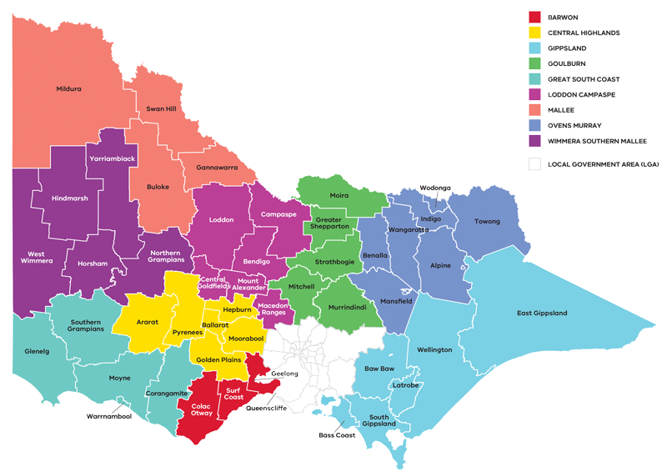
Figure 1: Map of Regional Partnerships – Long Alternate Text
Contents
01 Introduction 4
02 Regional profile 8
03 Comparative advantage 12
3.1 Endowments 13
3.1 Revealed industry specialisation 15
04 Strategic directions 19
4.1 Strengthen agriculture and food product manufacturing
through diversification 24
4.2 Promote growth and development of the visitor economy,
leveraging natural assets and Aboriginal heritage 29
4.3 Support and expand economic opportunities in growing sectors
(health and social services) 34
4.4 Position the region to benefit from emerging growth opportunities
in natural resources 39
05 Implementation 42
Appendix 44
Figure 1: Map of Regional Partnerships – Long Alternate Text 44
Figure 2 Map of Barwon – Long Alternate Text 44
Figure 3 Wimmera Southern Mallee industry Employment (2001-20) –
Long Alternate Text 45
Figure 4 Wimmera Southern Mallee industry output (gross value add)
2001-20 – Long Alternate Text 47
Figure 5 Wimmera Southern Mallee industry employment location
quotient and growth – Long Alternate Text 49
Figure 6 Wimmera Southern Mallee industry output (GVA) location
quotient and growth – Long Alternate Text 50
Figure 7 Agricultural land use in Wimmera Southern Mallee –
Long Alternate Text 51
Figure 8 Participation rate by gender (2016) – Long Alternate Text 51

01 Introduction
The Wimmera Southern Mallee Regional Economic Development Strategy (the Wimmera Southern Mallee REDS) sets out the medium- to long-term strategic directions for driving economic growth and development.
The Wimmera Southern Mallee region is in Western Victoria, and comprises five Local Government Areas: Hindmarsh, Horsham, Northern Grampians, West Wimmera and Yarriambiack. The region has a rich farming heritage and natural beauty. The population is relatively dispersed – Horsham, as a regional centre, accounts for about 42 per cent of the population, followed by the Northern Grampians Shire (24 per cent). The region is home to the traditional lands of the Wotjobaluk, Jaadwa, Jadawadjali, Wergaia and Jupagalk Nations, and also includes some lands of the Dja Dja Warrung and Gunditjmara People, who are recognised Traditional Owners who have lived, worked and cared for their country and its resources for many thousands of years.
Agriculture is the economic driver in the region. Agriculture production predominantly comprises broadacre cropping of cereals, pulses and oilseeds in the central and northern parts of the region and livestock grazing in the southern parts. Other key employers in the region are healthcare, manufacturing, retail and construction.
The Western Highway, one of only two major interstates freight routes, provides the main road transport corridor in the region. It connects Horsham, Stawell and Nhill with Melbourne (via Ballarat) and Adelaide. Farming, grain production, regional visitation and a range of manufacturing services rely heavily on this highway. The Henty Highway runs north south through the region and provides access to the Port of Portland to export bulk commodities such as grain and mineral sands. The region also benefits from several regional airports including Horsham and Stawell, servicing emergency medical, fire and rescue, and agriculture and related businesses. The transport infrastructure in Wimmera Southern Mallee provides strong links to the neighbouring regions.

Strategic directions
The Wimmera Southern Mallee REDS defines four strategic directions for economic development in the region, based on comprehensive data analysis and review of existing policies and strategies:
- Strengthen agriculture and food product manufacturing through diversification
- Promote growth and development of the visitor economy, leveraging natural assets and Aboriginal heritage
- Support and expand economic opportunities in growing sectors (health and social services)
- Position the region to benefit from emerging growth opportunities in natural resources.
For each of the directions, the Wimmera Southern Mallee REDS provides:
- a rationale for its inclusion as part =of the strategy
- an overview of opportunities and challenges which are likely to support or hinder future growth
- a summary of the policy context to support desired outcomes
- the implication of the direction for the region’s Aboriginal communities
examples of how the direction could be activated.
The Wimmera Southern Mallee REDS recognises that approaches to regional economic development occur in an uncertain environment. Therefore, while most of the analysis focuses on internal development drivers, it also considers the impact of external trends, including the COVID-19 pandemic, patterns in global trade, a changing climate and technological change.
The Wimmera Southern Mallee REDS acknowledges that the Aboriginal and cross-border communities within the region face unique challenges and opportunities, reflects these opportunities and challenges in the relevant strategic directions.

Regional readiness to activate strategic directions
Future growth and innovation opportunities in the Wimmera Southern Mallee region are supported through existing research and development activities. The region has a long history of working collaboratively and leveraging existing regional networks and partnership programs. These programs include:
- The Wimmera Southern Mallee Regional Partnership, one of nine partnerships across the state that advocates and promotes development opportunities across the region.
- The Grampians Regional Development Australia Committee, one of five committees jointly supported by Australian, State and local governments to advance economic development, attract investment and create jobs across Victoria.
- Wimmera Development Association, working with the community and government to attract new investment, further develop existing businesses and promote the Wimmera’s sustainable development opportunities.
- The Grampians New Energy Taskforce, formed to represent and advocate for the development of a net zero carbon economy in the Grampians region, including identifying potential investments.
- AgTIDE DATA Farm Project, a demonstration project for the latest digital agricultural technologies that will be based at Longerenong College
- BY FIVE, a joint initiative between the Wimmera Southern Mallee Regional Partnership and the state Government and the Murdoch Children’s Research Institute, which will support better early years developmental outcomes as an economic development initiative to reduce generational poverty.
Development of ‘Behind the Grid’ energy connection opportunities between renewable projects and local industries.
Local education institutions and innovation centres provide infrastructure and capability to unlock future economic opportunities including workforce development and business growth. These include Birchip Cropping Group, Longerenong College and Federation and Melbourne Universities.
Building on the region’s strength in agriculture will enable competitive food and agritourism sectors, which in turn will provide diverse experiences to attract visitation. The natural assets and landscapes of the region and local arts, culture and heritage provide opportunities for economic diversification to support an emerging visitor economy and renewable energy. Several essential health facilities and education services are in Horsham, addressing the increasing demand for health and social services and growing demand for a skilled workforce.

Local priorities and strategies
The Wimmera Southern Mallee REDS leverages a range of existing strategies, frameworks and plans developed by local stakeholders. These include:
- The Wimmera Southern Mallee Outcomes Roadmap, which outlines the long term social, economic, environmental and cultural outcomes for the region, and Digital Plan, which identifies gaps in the region’s digital infrastructure and makes recommendations on how these can be addressed.
- Victorian Renewable Energy Zones (REZ) Development Plan, which includes parts of the Wimmera Southern Mallee region in the Western Victoria zone, working to create targeted investment to strengthen network infrastructure.
- Growing What Is Good Country Plan (Voices of the Wotjobaluk Nations), 2016, defines the self-determined vision for the future of the Wotjobaluk People, with strong desire to pursue job security as a means for economic stability for Wotjobaluk families and self-esteem for young people.
The Victorian Government’s Visitor Economy Recovery and Reform Plan (2021) aims to attract more tourists to the State, support regional jobs and deliver a significant recovery from the combined effects of the 2020 summer bushfires and the COVID-19 pandemic. This includes delivering a state-wide destination master plan underpinned by priority sector plans (the first sector priorities to be developed will be the Nature-Based Tourism Plan and the First Peoples’ Tourism Plan) and the establishment of Visitor Economy Partnerships across Victoria.
The Wimmera Southern Mallee REDS also takes into consideration other state, regional and sub-regional policies and strategies as set out in the supporting documentation.
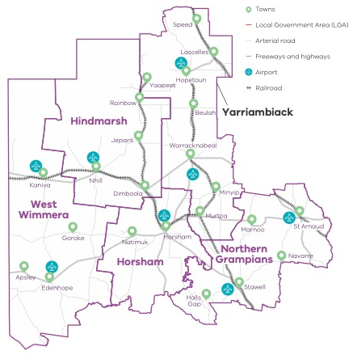
Figure 2 Map of Wimmera Southern Mallee – Long Alternate Text

02 Regional profile
- $2.5 – Gross regional product (billion) (2020)
- 47,400 – Population (2020)
- 3.1% – Population growth (2011-20)
- 46 – Median age (2020)
- 58.6% – Working age (15-64) (2020)
- 23.9% – Population aged over 65 (2020)
- 14.0% – Are Aboriginal and/or Torres Strait Islander (2016)
- 3.7% – Speak a language other than English at home (2016)
7.1% – Were born overseas (2016)
Local Government Area | Population (2020) | Projected growth (2021–36)
Horsham | 20,000 | 3.0%
Northern Grampians | 11,400 | -8.9%
Yarriambiack | 6,600 | -14.4%
Hindmarsh | 5,600 | -16.8%
West Wimmera | 3,800 | -18.2%

The Wimmera Southern Mallee region has experienced an overall population decline over the past two decades, driven by both natural decline and local people leaving the region. In line with the rest of regional Victoria, outflows have been highest in the 15-24 years and 24-44 years age groups but has also occurred in the over 65 cohort. The Horsham local government area (LGA) is the only area to have experienced steady population growth since 2000, which is projected to continue.
Population decline in Wimmera Southern Mallee has been partly offset by positive net overseas migration. In 2019- 20, the Horsham and Northern Grampians LGAs attracted the highest number of overseas migrants across the region. There has also been some inflow of residents (i.e., net internal migration) in the 0-14 years and 45-65 years age groups, but at levels lower than the Victorian average.
Employment opportunities in both established and emerging industries could provide population attraction and retention opportunities in the Wimmera Southern Mallee region. The job creation expectation in the region could result into a population increase in Horsham Rural City and Northern Grampians Shire and, to some extent, mitigate population decline in other local government areas. Job creation opportunities would be complemented by forward-looking planning in housing and the provision of other essential services and infrastructure.
 | Wimmera Southern Mallee % | Regional average % | Metro Melbourne %
Unemployment rate (September 2021) | 2.8 | 4.2 | 6.0
Labour force participation rate (2016) | 59.4 | 60.9 | 65.8
Average annual employment growth (2011–20) | -0.9 | 1.0 | 2.1

Table 1: Employment in largest employing industries by workforce (2020) and gender (2016)
 | Workers | Male | Female
Agriculture, forestry and fishing | 3,800 | 76.0% | 24.0%
Health care and social assistance | 3,800 | 18.2% | 81.8%
Retail trade | 2,000 | 42.6% | 57.4%
Construction | 1,800 | 90.2% | 9.8%
Manufacturing | 1,600 | 71.6% | 28.4%
Source: National Institute of Economic and Industry Research, 2020 and ABS Census, 2016

Employment by industry
In 2020, there were 22,099 employed persons in Wimmera Southern Mallee. While the agriculture, forestry and fishing sector has historically been a major employer, total employment in this industry has declined substantially (by about 40 per cent) over the past two decades. This is reflective of a broader trend across regional Victoria driven in part by increasing capital intensiveness in the agriculture sector. Employment in the health care and social assistance sector has increased over the same period, and this sector now accounts for a similar proportion of employees as agriculture, forestry and fishing.
Figure 3: Wimmera Southern Mallee industry employment (2001-20)
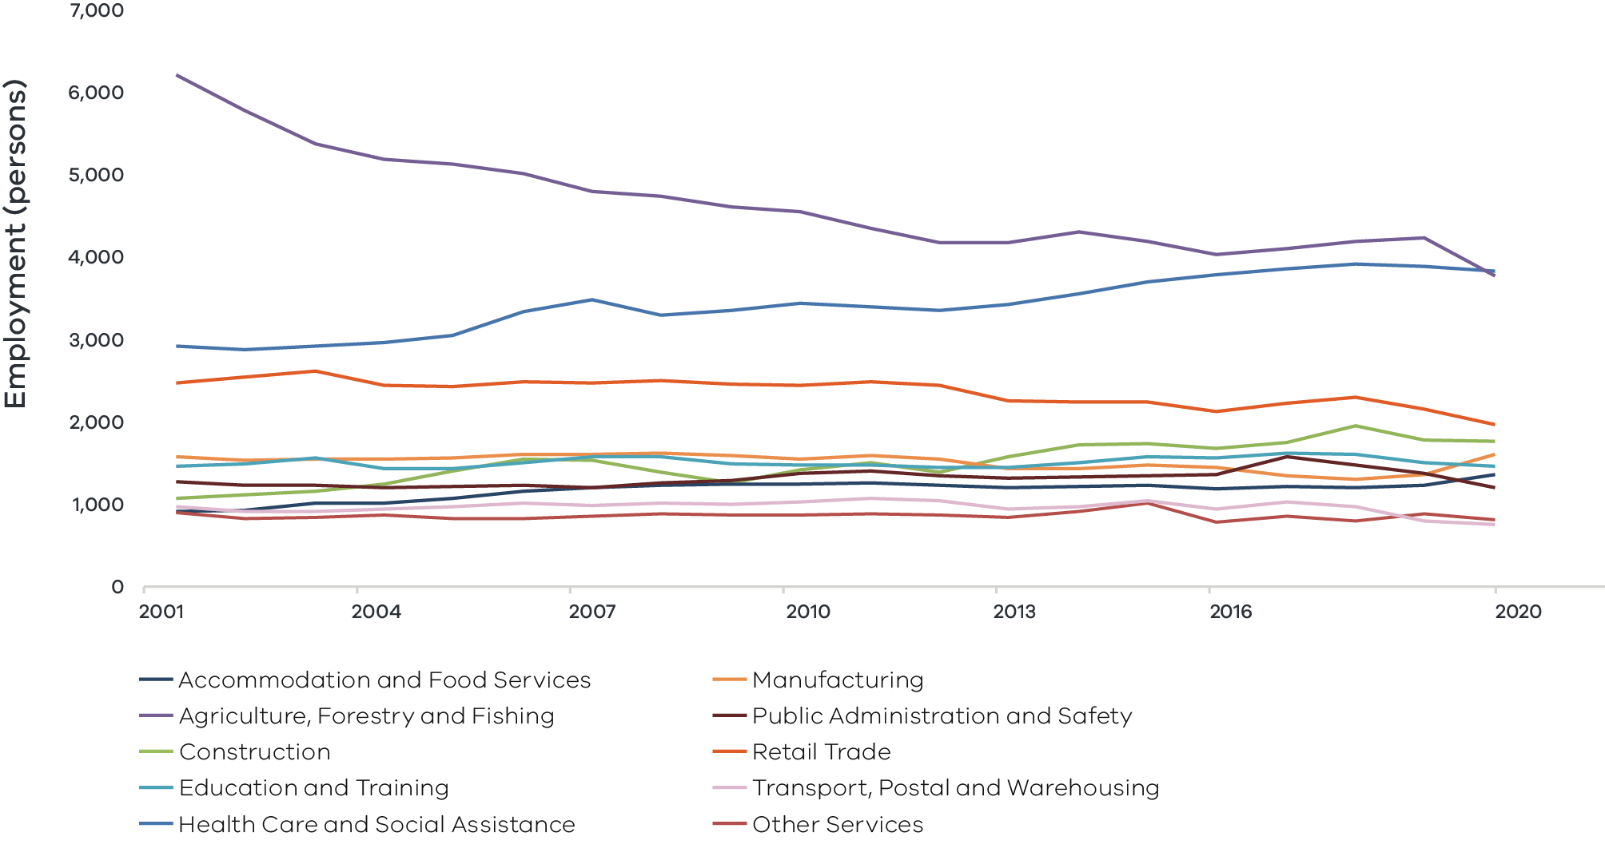
Figure 3 Wimmera Southern Mallee industry Employment (2001-20) – Long Alternate Text
Note: Top 10 employing industries in 2020 presented in chart, based on Journey to Work employment estimates.
Source: National Institute of Economic and Industry Research (2020)

Output by industry
Agriculture, forestry and fishing has historically been the most significant contributor to the region’s output, as measured by gross value add (GVA), and remains the largest sector in 2020 despite significant declines – driven in part by the impact of drought, high water prices, and more recently the COVID-19 pandemic. Manufacturing (especially food product manufacturing) and the health care and social assistance sector continue to be contributors to GVA in the region, although the manufacturing sector overall has seen a downward trend in output since 2001.

$2.0 billion Gross Value Added (GVA) (2020)
Top sectors by GVA ($ million):
- Agriculture forestry and fishing: $423.0 million
- Health care and social assistance: $292.4 million
- Public administration and safety: $144.2 million
- Construction: $122.9 million
Retail trade: $117.8 million
Figure 4: Wimmera Southern Mallee industry output (Gross Value Add) (2001-20)
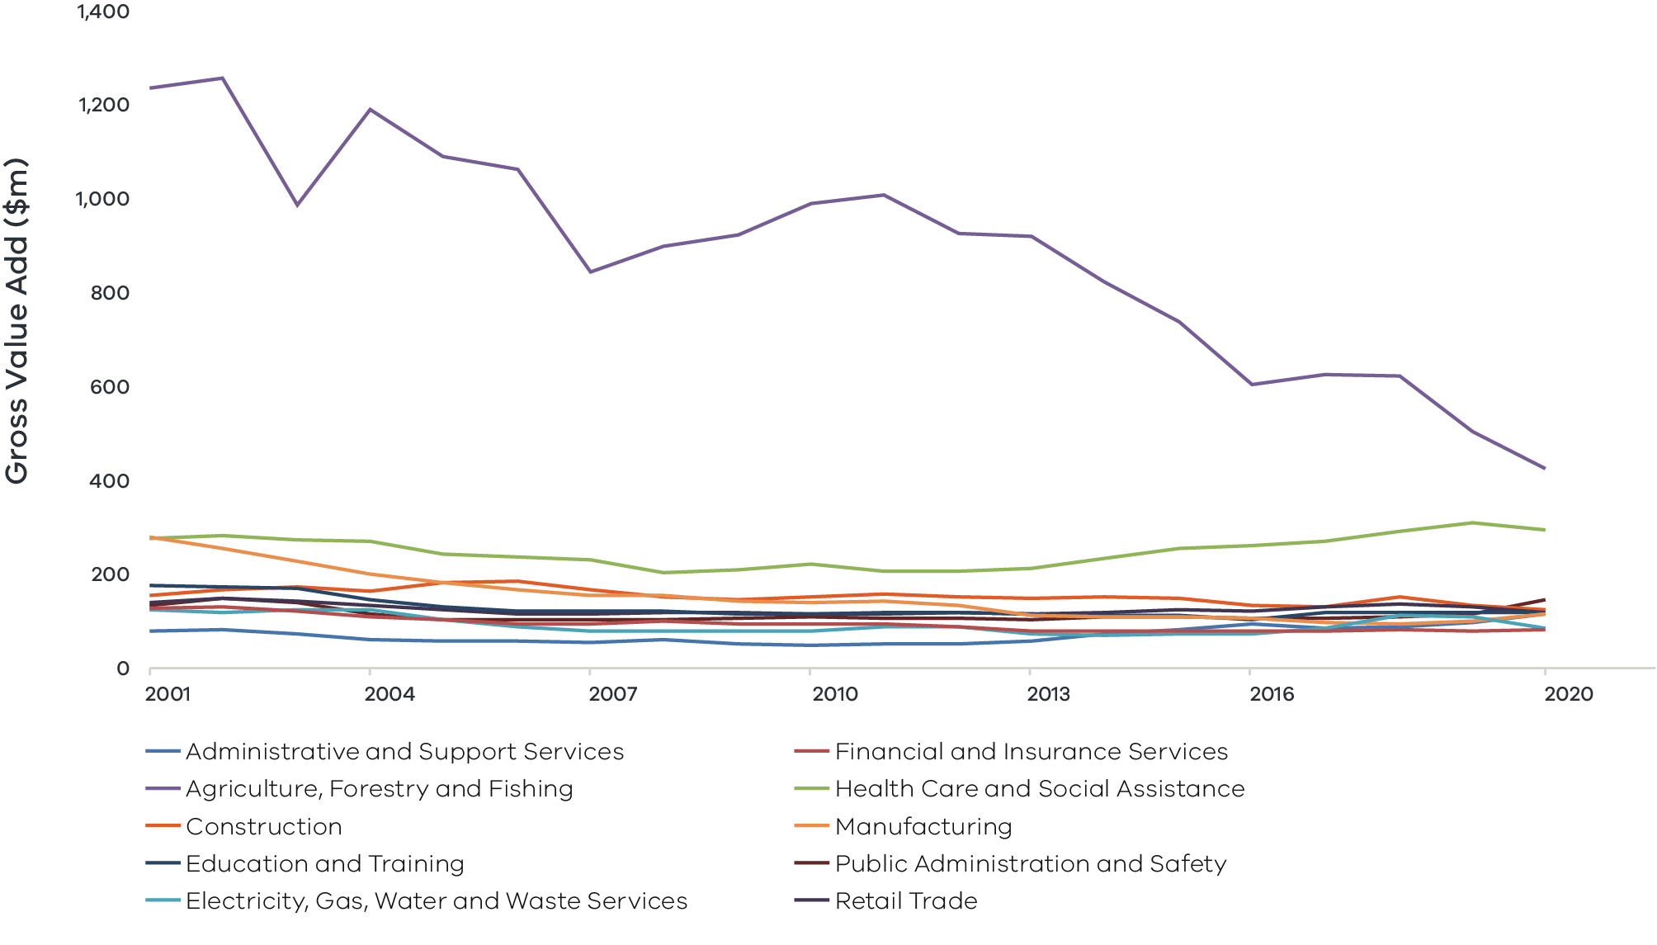
Figure 4 Wimmera Southern Mallee industry output (gross value add) 2001-20 – Long Alternate Text
Source: National Institute of Economic and Industry Research (2020)

Regional exports
The regions international export value has increased from $329 million in 2010 to
$349.6 million in 2020, with agricultural products and manufacturing representing 80 per cent of total value in 2020.
Small but relatively significant export sectors (2020):
- Accommodation and food services: $18.7 million
- Wholesale trade: $12.9 million
- Transport, postal and warehousing: $9.9 million

03 Comparative advantage
For the purpose of the REDS, ‘comparative advantage’ is defined simply as a description of what the region does well compared to other regions. This includes both the relative competitiveness of the region’s businesses as well as cultural, social and environmental factors.
Contemporary place-based development emphasises the importance of local endowments as a driver of comparative advantage. In economic terms, endowments refer to any natural, human, cultural and built resources present in a place which can be harnessed to support economic activity. Regional economic strengths can also be identified using other measures including location quotient analysis, shift share analysis, and industry cluster analysis. A comprehensive assessment of these measures is included in the Wimmera Southern Mallee Regional Economic Development Strategy – Supporting Analysis.

3.1 Endowments

Natural endowments

Environmental amenity
The Wimmera Southern Mallee region has a diverse range of landscapes, including plains, mountains, wetlands, deserts and forests. Environmental assets include Wyperfeld National Park, Little Desert National Park, the Pink Lake, the Wimmera River and Mount Arapiles. The Grampians National Park (Gariwerd) is a prime destination and the most significant contributor to the region’s visitation and economy.

Fertile land
The majority of land (77 per cent) in the Wimmera Southern Mallee is used for primary production, including broad acre cropping of cereals, pulses and oilseeds across the central and northeast regions. These cropping zones are bordered by livestock grazing, particularly in the south, as well as mixed farming (both cropping and grazing). Grains, sheep meat and wool are the region’s most valuable agricultural products and a staple of the region’s exports.

Natural resources
The Wimmera Southern Mallee region’s main mineral resource has historically been gold, with some mining operations remaining ongoing. The region is also home to 75 per cent of Victoria’s mineral sand deposits, concentrated in the western and northern areas, which have been mined since the early 2000s. Renewable energy production has been focused on wind power, but there is also considerable solar energy generation potential in the region.

Cultural endowments

Cultural experiences
The region is home to agritourism events such as the Grampians Grape Escape, a weekend festival of regional wine, food and music. The 200km Silo Art trail is Australia’s largest outdoor gallery, a significant attraction showcasing murals in Sheep Hills, Brime, Sea Lake, Albacutya, Patchewollock, Lascelles, Nullawil, Rosebery, Goroke, Kaniva and Rupanyup.

Aboriginal heritage
The Wimmera Southern Mallee region includes the traditional lands of the Wotjobaluk, Jaadwa, Jadawadjali, Wegaia and Jupgalk Nations, as well as sections of the lands of the Dja Dja Wurrung and Gunditjmara People. The region is also home to Aboriginal Community Controlled Organisations (ACCOs), including the Budja Budja Aboriginal Cooperative and the Goolum Goolum Aboriginal Co-Operative, and the Barengi Gadjin Land Council, all of which play a central role in the provision of services and the promotion and protection of Aboriginal people’s rights. Other Aboriginal heritage assets in the region include the Dalki Garringa Native Nursery (also known as Wail Nursery).

Built endowments

Food manufacturing hub
Food manufacturing represents an emerging sub-industry in the Wimmera Southern Mallee and the largest contributor to the region’s total manufacturing exports. A considerable part of the manufacturing sector’s output remains linked to the agriculture sector. The main types of food processing are grain mills, cereal products and meat processing. The region is serviced by food processing centres in Stawell, Nhill and Horsham.

Stawell underground particle physics laboratory
A team of scientist and engineers are building a laboratory one-kilometre underground in Stawell gold mine (Northern Grampians Shire). The project provides opportunities for the local community and collaboration with the international scientific community.

Transport connections
The region is well connected to air and seaports via an extensive road and rail network. This includes freight lines from Yaapeet to Hopetoun that connect Horsham with ports in Geelong, Portland and Melbourne. The Western Highway also connects the region to Melbourne and Adelaide. The Henty Highway, Wimmera Highway and Sunraysia Highway provide further links to the key regional hubs of Portland, Bendigo and Ballarat respectively. The region does not have a major airport, however, it benefits from several smaller regional airports including Horsham and Stawell.

Renewable energy assets
The region has several wind farms which power local grids and export energy out of the region. This includes operational farms at Kiata, Yawong and Murra Warra, with additional sites under construction or in permit application stages. Solar energy has been identified as a strong future opportunity for the region, particularly in the north.

Human endowments

Agricultural innovation
The Grain Innovation Park in Horsham is a world class agricultural research facility which attracts staff from over 30 countries to the Wimmera Southern Mallee region with its state-of-art facilities and collaborative science teams. Since opening in 1968, the facility has grown to over 150 staff from a wide range of government departments and authorities, including Agriculture Victoria and the Department of Environment, Land, Water and Planning, working in collaborative teams. The Park places the Wimmera Southern Mallee region and its community members at the centre of innovations in crop genetics, farming systems and crop protection along with biosecurity and animal health services. The region is also home to the Australian Grains Genebank (AGG), a national program for preserving grain crop genetic resource for Australia. The AGG underpins the development of new, more productive temperature and tropical grain crop varieties for Australia.

Tertiary education institutions
The Wimmera Southern Mallee region is home to Federation University’s Wimmera campus, which delivers TAFE programs and bachelor courses in social sciences and business as well as masters programs and PhD research. Specialised on-campus training facilities including a hairdressing salon and plumbing, automotive, building and construction workshops. The University aims to undertake quality research that adds to the region’s body of knowledge. SuniTAFE Horsham, established in August 2019, delivers trade and non-trade training into local communities across the Grampians, Wimmera and Mallee area. Longerenong College also offers vocational training in agriculture and land management.

Community engagement and partnership
The Wimmera Southern Mallee is home to several community partnership and engagement activities. The Wimmera Development Association is a key development organisation attracting new opportunities in the region. The Wimmera Primary Care Partnership made up of local governments, health providers, health and social services and education providers, aims to improve the experiences and outcomes of people who access primary care services and reduce the preventable use of hospitals, medical and residential services.

3.1 Revealed industry specialisation
Location Quotient (LQ) analysis provides further insight into the local economy’s underlying structure and comparative advantages that may not be evident from a region’s endowments. This form of analysis compares an industry’s size and growth (as measured by employment and output) as a proportion of total economic activity, relative to the Victorian average. The higher the LQ, the more concentrated, and therefore significant, an industry is to the local economy relative to Victoria on average. Scores above 1.25 indicate specialisation compared to the rest of the state. Further analysis is provided in the Wimmera Southern Mallee Regional Economic Development Strategy – Supporting Analysis.

Employment specialisation
Figure 5: Wimmera Southern Mallee industry employment location quotient and growth
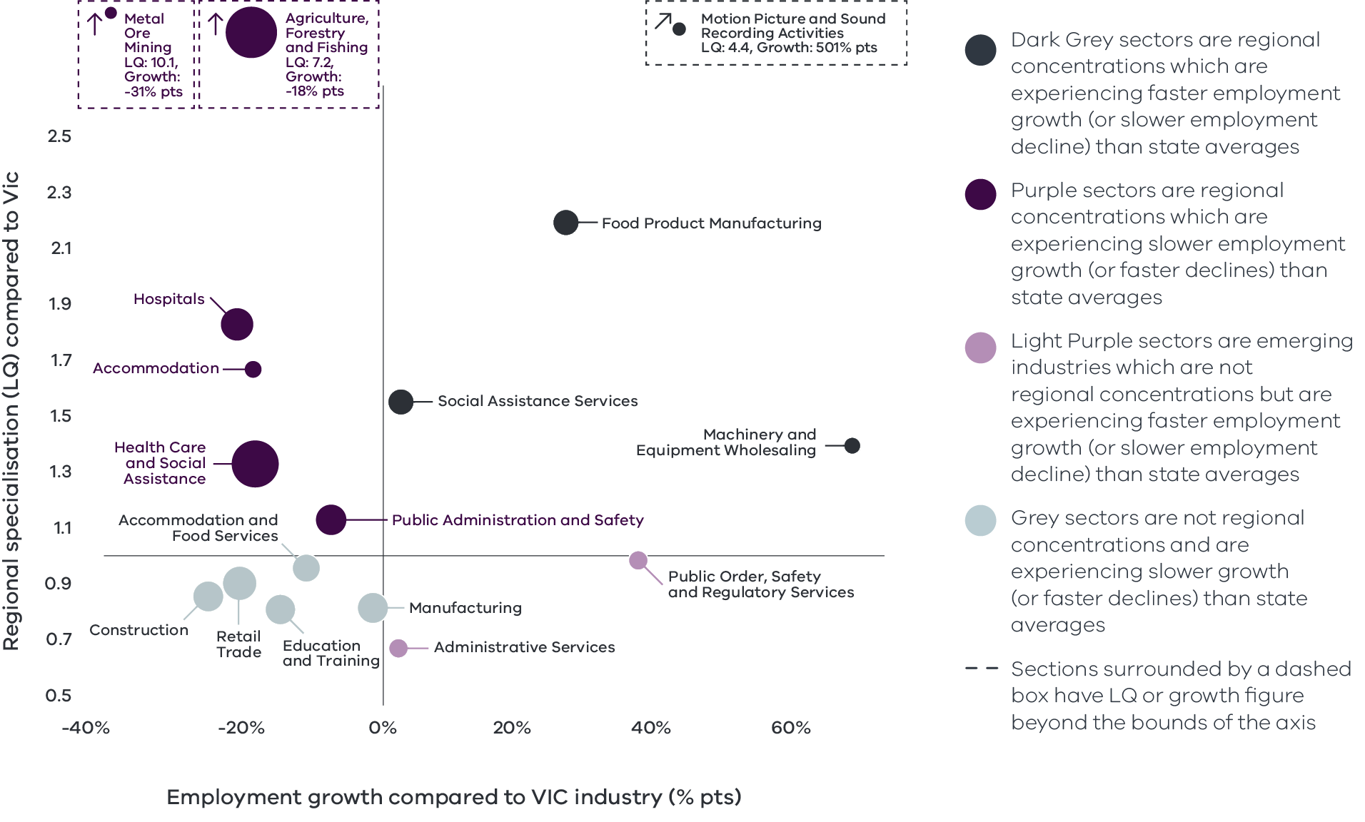
Figure 5 Wimmera Southern Mallee industry employment location quotient and growth – Long Alternate Text
Source: National Institute of Economic and Industry Research (2020).
Note this chart represents a selection of industries and sub-industries that represent a notable size and or concentration within the region. Some sub-industries presented are sub-sectors of industries that are presented alongside it and therefore measures cannot be aggregated between the two. Other industries are not displayed. For greater detail refer to the supporting analysis pack for this REDS strategy.
Figure 5 depicts selected industries and sub-industries in the regional economy in 2020 where:
- The size of each bubble indicates the number of people employed in the (sub)industry in 2020. The bigger the bubble, the more people employed in the industry.
- The vertical position indicates the (sub)industry’s degree of employment concentration relative to the Victorian average. For example, a value of 1.77 means that, as a share of total employment in the local economy, the (sub)industry employs 1.77 times as many people as the Victorian average.
The horizontal position indicates the difference in (sub)industry’s employment growth (2015 to 2020) between the region and the Victorian average. For example, a 14 per cent value indicates that regional employment in the (sub)industry has grown 14 percentage points faster than the industry’s average growth rate in Victoria.
Agriculture, forestry and fishing: The agriculture, forestry and fishing sector has historically been the biggest employer in the region and remains the second largest employing industry. This prominence is reflected in the industry’s employment LQ of 7.2, indicating a high level of employment concentration in the region relative to the Victorian average. However, the industry employment growth is
18.0 percentage points lower than that of the Victorian average.
Food product manufacturing: While the manufacturing sector is less concentrated in the region compared to the Victorian average, the constituent food product manufacturing sub-industry has an employment LQ of 2.2 and is experiencing employment growth that is 25.3 percentage points higher than the rest of the state. This shows a significant specialisation in the region for food product manufacturing, likely supported by regional output from the food processing centres in Stawell, Nhill and Horsham.
Health care and social assistance: The social assistance sub-sector indicates a degree of specialisation with an employment LQ of 1.6 and a growth rate 2.5 percentage points higher than the Victorian average. Driven by the region’s ageing population and relatively low socioeconomic and health outcomes in part of the region, this suggests that there is substantial demand for services such aged care and disability services. The growth is likely to provide significant employment opportunities.
Motion picture and sound recording activities: The motion picture and sound recording activities sub-industry has an employment specialisation, with an employment LQ score of 4.4. The sub-industry recently experienced the largest employment growth above the Victorian average, driven by production of the Australian film “The Dry” in 2020. The Wimmera Southern Mallee has previously been used as the backdrop for a major production, with scenes of 2015 film “The Dressmaker” filmed in Horsham. While these surges in activity are not a driver of sustained economic growth in the region, the sub-industry does provide a potential source of diversification – both into further filming opportunities, and into associated visitor attractions.
Figure 6: Wimmera Southern Mallee industry output (GVA) location quotient and growth
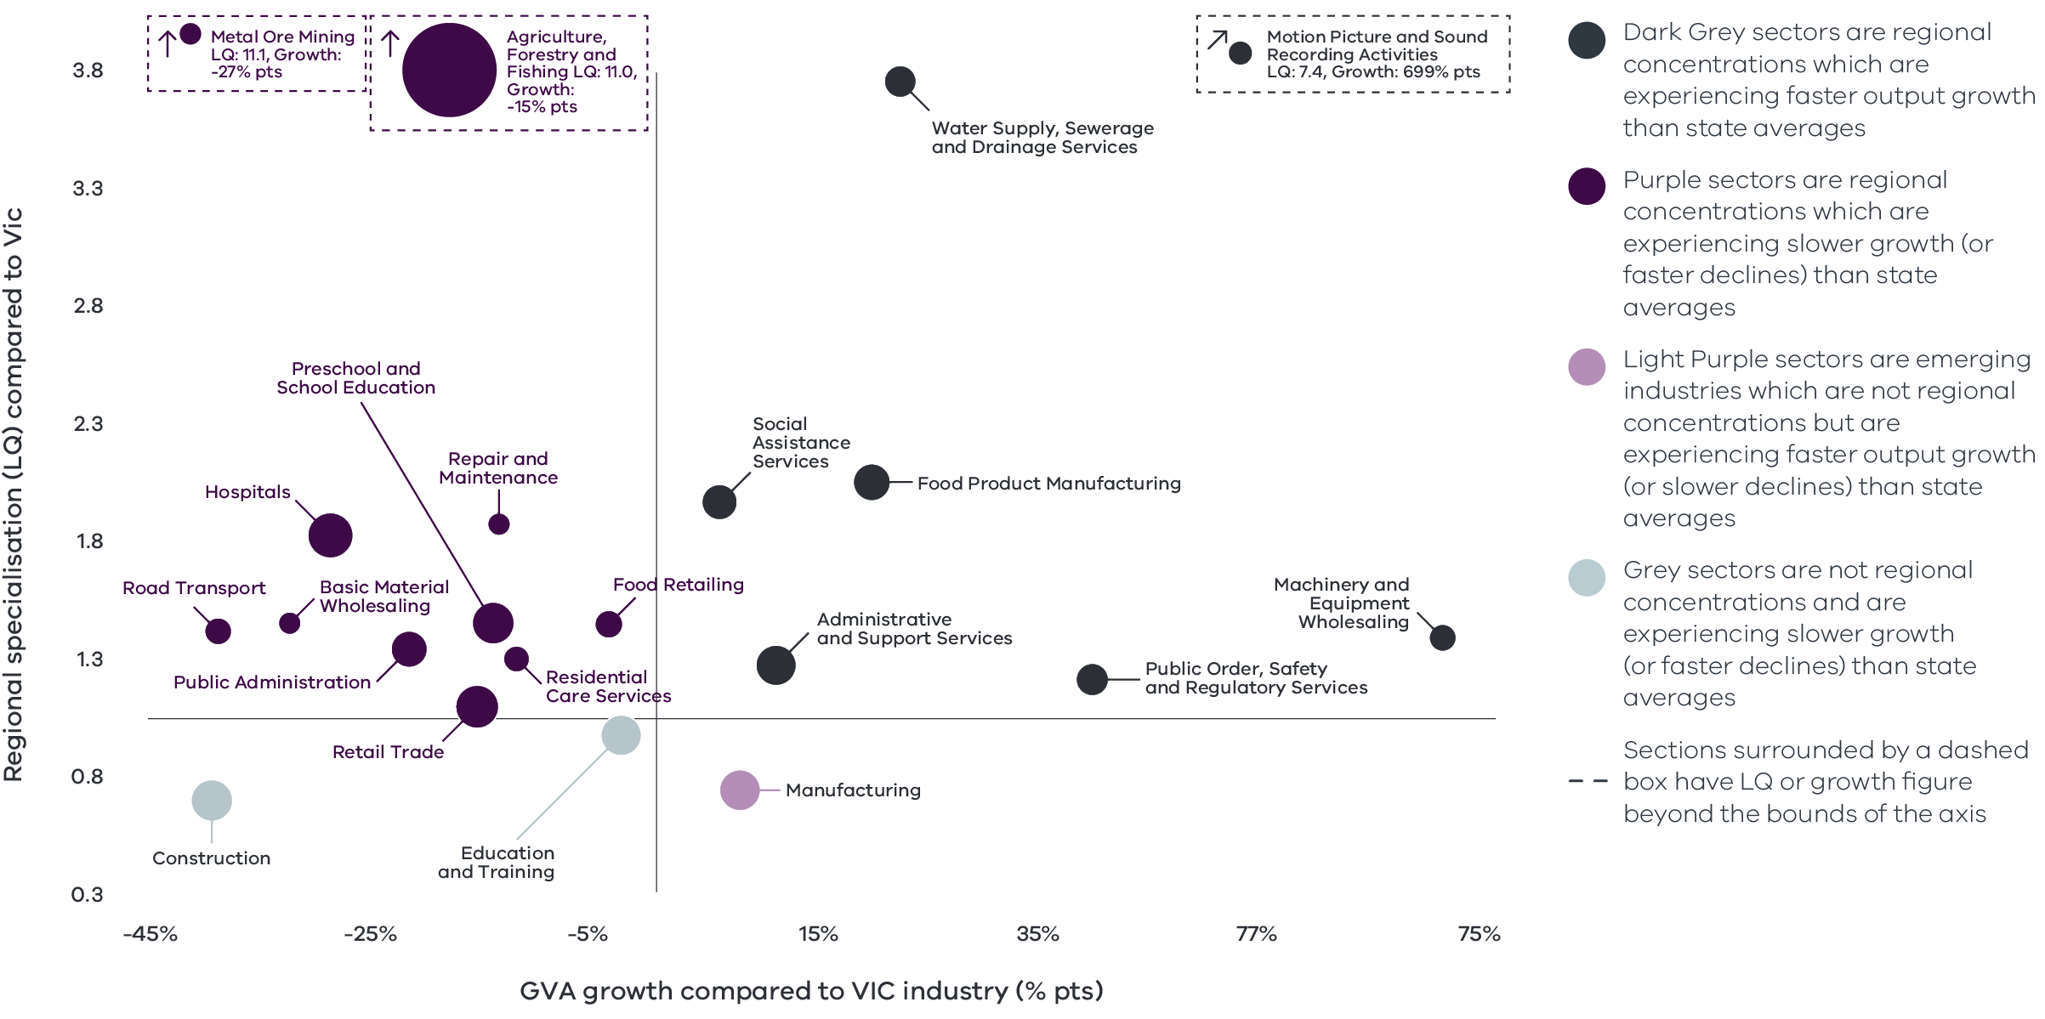
Figure 6 Wimmera Southern Mallee industry output (GVA) location quotient and growth – Long Alternate Text
Source: National Institute of Economic and Industry Research (2020).
Note this chart represents a selection of industries and sub-industries that represent a notable size and or concentration within the region. Some sub-industries presented are sub-sectors of industries that are presented alongside it and therefore measures cannot be aggregated between the two. Other industries are not displayed. For greater detail refer to the supporting analysis pack for this REDS strategy.
Figure 6 identifies the Wimmera Southern Mallees’ economic output specialisation in terms of Gross Value Added (GVA). Using the same approach as Figure 5, this analysis compares selected industries and sub-industries in the regional economy, including their size and growth as a proportion of total economic GVA relative to Victorian averages between 2015 and 2020. Many of the regional strengths from an employment perspective remain important industries when looking at output.

Output specialisation
Agriculture, forestry and fishing: agriculture, forestry and fishing has the highest output LQ of 11.0. However, the industry’s output underperformed the Victorian average by 15 percentage points. The agriculture, forestry and fishing industry in the region is declining faster than the average for Victoria.
Motion picture and sound recording activities also has the highest output growth compared with the Victorian average indicated by an output LQ of 7.4 and growth that is 699.0 percentage points greater than the average for the state.
Water supply, sewerage and drainage: the sub-sector has an output LQ of 3.7 and is experiencing output growth that is 21.7 percentage points higher than the Victorian average. The growth can be attributed to recent development for the newly constructed Yaapeet Lake, and the completion of the South West Loddon Pipeline, which provides a secure reticulated water supply for 1500 rural properties in Inglewood, Newbridge, St Arnaud and Wedderburn.
Food product manufacturing has also demonstrated a reasonably strong concentration in the region. The sub-sector has an output LQ of 2.0 and the output growth that is 19.1 percentage points higher than the average of the state.
Health and social assistance: Within the sector, social assistance services has an output LQ score of 3.7. The sector output has grown 21.7 percentage points higher than the average for Victoria. Growth rates and industry concentrations relative to the rest of the state largely reflect the demographic structure of the region and increasing demand for health and social services. Two other sub-sectors, hospital and preschool and school education, have output specialisations indicated by LQ of 1.8 and 1.4, however the output growth has underperformed the average Victoria by 28.8 and 14.4 percentage points.

Emerging sectors
In addition to some of the regional strengths and specialisations identified above, there are several industries that are not currently showing high concentrations either in employment or output when compared to Victorian averages but are still experiencing growth in some industries that is currently higher in the region compared to the rest of the state. These industries, while not currently regional concentrations or specialisations, may have the potential for growth opportunities and greater prominence in future.
The administrative services and public order, safety and regulation services sub-industries have employment LQs of 0.7 and 1.0 respectively, indicating that these sectors are not as highly concentrated in the region compared to the average for the state. They are however experiencing employment growth that is outpacing the Victorian average by 2.0 and 36.0 per cent respectively, giving reason to suggest that there are significant opportunities for these sectors to grow in prominence and become a larger proportion of the region’s economy. In addition, the manufacturing sector in the region has an output LQ of 0.7 and an employment LQ of 0.8 but is currently experiencing output growth that is greater than that of the state-wide average by 8.0 per cent. This is despite its employment growth currently being lower than the Victorian average by 2.0 per cent. This may very well be indicative of an increase in the efficiency of the manufacturing industry and the reduced relative demand for labour inputs in manufacturing processes and may grow in prominence in the region in future.

04 Strategic directions
The four strategic directions for the Wimmera Southern Mallee region have been identified based on the region’s endowments, industry specialisations, and socioeconomic context. The directions have been refined based on a review of local policies and strategic plans.
The following section discusses each strategic direction, providing:
- a rationale for its inclusion as part of the strategy
- an overview of opportunities and challenges which are likely to support or hinder future growth
- a summary of work underway and the policy context to support desired outcomes
- the implication of the direction for the region’s Aboriginal communities
examples of how the direction could be activated.

Wimmera Southern Mallee’s strategic directions
- Strengthen agriculture and food product manufacturing through diversification
- Promote growth and development of the visitor economy, leveraging natural assets and Aboriginal heritage
- Support and expand economic opportunities in growing sectors (health and social services)
- Position the region to benefit from emerging growth opportunities in natural resources.

Enabling factors for economic growth
This REDS identifies opportunities in key areas that can help drive regional economic growth. However, each region’s capacity to activate these opportunities and grow is partly determined by cross-cutting enabling factors that support economic activity. Consideration of these enabling factors – and targeted investments and initiatives to strengthen them – will help support achievement of the strategic directions in this REDS.
Digital connectivity
Access to reliable internet and mobile services allows for access to new markets, facilitates efficiency gains and opens up opportunities for innovation. Good digital connectivity can also facilitate more inclusive access to services and flexible working arrangements.
61 to 65 Australian Digital Inclusion Index Score in Wimmera Southern Mallee in 2021 (Victorian average: 71)
Transport connectivity
Road and rail infrastructure, ports and airports provide critical linkages between production locations and markets; efficient transport connections and public transport services are a key factor in workforce mobility and local amenity.
3.9 Overall access to roads and public transport in Grampians RDA region (Regional Victoria: 4.1 and Victoria: 5)
Workforce and population growth
An adaptive and productive workforce is key to businesses competitiveness; access to both skilled and unskilled labour ensures business can sustain and expand activities.
- 65.0% Local workforce in Wimmera Southern Mallee was employed in skilled occupations in 2021 (Regional Victoria: 62.2%, Melbourne: 67.3%) (2021)
13.0% Residents with a bachelor’s degree or higher in 2016 (Regional Victorian: 17.0 %, Melbourne: 31.0%)
Housing
The availability and affordability of housing determines a region’s ability to attract and retain local staff and supports community cohesion and better life outcomes for individuals and families.
- 0.5% Average rental property vacancy rate in the 6 months leading up to June 2021 (Compared to benchmark of 2.5%)
32.1% Increase in median rent in Grampians RDA region from 2016 to 2020 (Victoria, 6.9%, Regional Victoria 28.6%)
Note: 1. The Australian Digital Inclusion Index (ADII) is a composite index used to measure digital inclusion across three dimensions of Access, Affordability and Digital Ability. 2. ‘Access to roads and public transport was measured by asking respondents to rate their access to the following types of services in their local community, on a scale ranging from ‘very poor’ (1) to ‘very good’ (7): (i) Quality of local roads; and (ii) Access to public transport (including taxis, buses, trains). A single measure of overall access to roads and public transport was then constructed based on the average score of a person’s responses to these two items. 3. Skill level is defined as a function of the range and complexity of the set of tasks performed in a particular occupation. Skilled workers are defined as being classed between an ANZSCO Skill level of 1-3, while low skilled is classed as 4 or 5. 4. A rental property vacancy rate of 2.5% refers to a benchmark at which the market is balanced between landlords and tenants

Integrating Aboriginal economic opportunities
The Victorian Government is taking concrete steps to align with Aboriginal self-determination principles. Key Victorian Government policies and processes to realise self-determination goals include the:
- Treaty Process which seeks to redefine the relationships between the Aboriginal communities, the state and non-Aboriginal Victorians.
- Victorian Aboriginal Affairs Framework 2018-23 (VAAF) which is the overarching framework for working with Aboriginal Victorians to drive positive socioeconomic outcomes across the state, including to activate economic opportunities and prosperity via achieving wealth equality, facilitating workforce participation in all sectors at all levels and realising Aboriginal income potential.
Self Determination Reform Framework, which guides public sector action to enable self-determination in line with the VAAF across four domains: people, systems, outcomes and accountability.
The Victorian Government is also party to the National Agreement on Closing the Gap and has committed to meeting the associated outcomes – including in relation to increasing engagement of Aboriginal and Torres Strait Islanders in employment, education and training.
An analysis of local policies and commitments relating to Aboriginal economic development in the region (listed in the Wimmera Southern Mallee – Supporting Analysis), including determined Traditional Owner strategic plans, where developed, has identified six potential opportunities for Aboriginal economic development:
- Identify opportunities to leverage natural resources and traditional practices for economic benefit. This includes the scope to adopt traditional hunting and agricultural techniques.
- Pursue greater Aboriginal ownership of land and water to sustainably manage resources. The economic opportunities afforded through Joint Management Plans are one example of a way that caring for the land can have benefits across cultural, environmental and economic benefits.
- Promote recognition of the land, its waters and its cultural significance to ensure that economic activities (such as nature based/ cultural tourism) generate benefits in circumstances where degradation or destruction can be avoided, and existing damage is healed.
- Encourage the use of cultural places and practices as a mechanism for telling stories, maintaining traditions and creating economic opportunities, particularly in the tourism, agriculture and education sectors.
- Enhance Aboriginal participation across industries with a particular focus on occupations which serve the local Aboriginal population and the environment e.g., health care and social services, land management, agriculture, circular economy, renewable energy and education and training. Service to the land and community is a way to strengthen cultural and community connections.
Pursue opportunities for greater Aboriginal participation in economic activities including small to medium enterprise development and investment which creates employment opportunities.
Each strategic direction in the Wimmera Southern Mallee REDS considers the relevance of that direction to local Aboriginal communities in light of the above opportunities.
Self-determined priorities for Aboriginal economic development in the region will be aligned to the six pillars of the Victorian Aboriginal Employment and Economic Strategy. These priorities will also guide Victorian Government decision-making on economic development in the region and will be integrated into future updates of the REDS.

Integrating cross-border opportunities
The Wimmera Southern Mallee REDS recognises the economic and social contribution of the Western -Wimmera cross-border community. The Western Wimmera cross-border zone is centred on the Western border of Victoria (and east of South Australia). The north-east boundary stretches to Rainbow in Victoria, down to Penola in the south-west (in South Australia). The key industrial assets and health infrastructure located in the Western Wimmera community drives the movement of residents across the state border. For example, Naracoorte (in South Australia) is a key retail and services centre which serves residents on both sides of the border, while West Wimmera Health Services supports access to specialist services for residents across the region. Agricultural products also move between states along key transport corridors between primary producers and processors located (primarily) on the South Australian side of the border.
Western Wimmera cross-border economy (2019-20)
- Estimated Gross Regional Product (GRP): $1.6 billion
- Businesses: 2,500
Jobs: 14,000
Agriculture, forestry and fishing:
- Gross value added: 44%
Local employment: 30%

4.1 Strengthen agriculture and food product manufacturing through diversification

Significance
The Wimmera Southern Mallee region is home to rich natural resources and endowments that underpin agriculture and related industries as the pillars of economic activity and growth. Primary production includes cereals, pulses and oilseeds as well as livestock. Despite recent declines, the agriculture sector remains the region’s top contributor to economic output and the second-highest contributor to employment, and there are opportunities to capitalise on the region’s strengths to further diversify within the sector. The location of the Grains Innovation Park at Horsham underscores the region’s reputation as a leading centre for grain growing innovation in Australia. The combination of applied grain growing research, together with the adoption of new digital management technologies by farmers has the potential to drive further significant gains in on-farm productivity.
There is also a strong link between the agriculture sector and local food product manufacturing, which is focused on grain mills, cereal products and meat processing. The food manufacturing sub-sector is also a significant contributor to regional gross value added and accounts for about 81.2 per cent of total manufacturing exports.
Wimmera Southern Mallee farms produce:
- 26.4% of Victoria’s grains
28.1% of Victoria’s sheep meat

Opportunities

Cluster of agriculture activities
The agriculture industry in the region is supported by a combination of Victoria’s regional rail and road freight network and the Wimmera Mallee Pipeline which corresponds with many transport routes in the region. Encouraging industry clusters that build on regional strengths will aid investment, create expansion in certain sectors such as supply chain and improve productivity. These opportunities include a piggery and poultry cluster to the east of the region and a grain production cluster to the north and west.
To realise these opportunities, further investigation of significant constraints, including road and rail freight infrastructure to cope with an increasing demand for freight travelling between rural producers and supply chain entities, and storage capabilities are particularly critical. Development of the opportunity also requires consideration of the land use planning, heritage and cultural significance of the land for the community.
Figure 7: Agricultural land use in Wimmera Southern Mallee
Figure 7 Agricultural land use in Wimmera Southern Mallee – Long Alternate Text
Source: Agriculture Victoria, 2018, Wimmera Southern Mallee; Invest in Victorian agriculture and food

Knowledge corridor
Exponential advances in digital technology, genetics and automation and increasing demand for transition to less emission intensive operations in agriculture will disrupt and change how food is made, marketed and delivered. Positioning the region to take advantage of these opportunities requires new skills, partnerships and collaboration, and investment in enabling infrastructure. Future opportunities will emerge for collaboration in agriculture knowledge and services which in return will expand on the region’s existing strengths in research and development activities and innovation. For example, the AgTIDE data farm is a new initiative which showcases the latest agriculture technologies and encourages farmers and industry to engage with digital agriculture to enhance decision making. The smart farm provides partnering multi -disciplinary opportunities across industry, agribusiness and the education sector and communities. The region benefits from an emerging network of research and education activities in Horsham, Ballarat and Ararat (in the neighbouring Central Highlands region) which could turn the area into a knowledge corridor with significant potential for research and development activities, visitation and higher spending.

Consumer preferences
Greater awareness of the environmental and ethical impact of producing and consuming meat and dairy based products, an increase in health lifestyle choices and demand for premium and quality products have driven changes in consumer behaviour in Australia and globally. The increase in demand for plant protein presents a new significant opportunity in the region’s agriculture and food manufacturing industries. Australian Plant Proteins (APP) is Australia’s first premium plant-based powder processing, packaging and distribution business. One of the two facilities of APP is in Horsham, where the protein extraction facility produce and supply protein isolate powders, sourced exclusively from Australian grown raw materials. As many food businesses are pursuing a strategic direction to produce and sell more plant-based protein, there is an increasing opportunity for new product development, research and development, or production.

Horticulture
The extension of reliable piped water supply into the Northern Grampians Shire through the commissioning of the Eastern Grampians Pipeline will create opportunities to establish and grow intensive horticulture. Several regional winemaking enterprises have signed on for pipeline supply, and the presence of additional water supply could spur new vineyard investment activity in the region; given its reputation for premium and super premium red wines. Similarly, access to reliable water supply opens the potential for other intensive horticulture, including glasshouse specialty vegetable production and flower growing for the cut flower trade, including native flowers for the export trade.

Increasing value add
There are opportunities to extend the production of value-added products supplied by the cropping sector and build on the example of existing enterprises. Other smaller food value-adding enterprises are also tapping regional grain and pulse production targeting the market for non-organic and organic pulses, including the growing vegetarian and vegan markets. Grains, pulses, oilseed and hay provide significant opportunity for the production of livestock feed pellet for animal enterprise in the region and broader areas.

Challenges

Digital connectivity
The Wimmera Southern Mallee Digital plan has identified several key digital connectivity issues, including inadequate mobile coverage, low digital literacy, the low uptake of the Internet of Things, and a lack of NBN business-grade services. Digital exclusion is a significant barrier to the uptake of agriculture technology and increased productivity. Analysis of digital access and quality of connectivity across primary production in the region, including for cropping, wool and sheep meat and food processing enterprises, confirmed major shortfalls in digital inclusion and connectivity as impediments to addressing the region’s primary production needs. Recent consultations as part of the Connecting Victoria initiative have confirmed that digital connectivity challenges and a gap in digital literacy, particularly in the most remote areas across the region, are the key issues restraining the technology advancement in the agriculture.

Labour market disadvantages
The region’s relatively low labour productivity compared to the Victorian average can be attributed to several factors, including a decrease in agriculture production due to drought and somewhat higher socioeconomic and health disadvantages that are concentrated within rural cropping areas. There are several challenges to attracting and retaining skilled workers, which, along with population decline and the ageing population, exacerbates workforce shortages and productivity across the region. Throughout the harvest season, the Wimmera Southern Mallee agricultural sector relies significantly on the transient workforce, including backpackers and contractors, especially for horticulture, grains, and livestock. A reduction in this workforce segment, as seen with the impact of COVID-19 restrictions on labour mobility, is likely to have some significant impacts on these industries.

Climate change
Climate change will put further pressure on farming activities with an increased likelihood of drought, bushfire conditions and water security challenges. The impact of climate change on the region may limit its growth potential and exacerbate socioeconomic challenges. However, a changing climate also offers opportunities for long-term changes in rural land uses, such as innovative approaches in the production of low-emissions meat and dairy. Climate variability will also require new approaches to water management and securing water supplies. including by diversifying water sources.
By 2050s
- Median temperature could rise 2.2%
- Median spring rainfall could decline
- Horsham could have 14.2 extreme heat days (over 38°C)
Increase in the number of extreme fire danger days by 48%

The policy environment
Enhancing productivity and resilience in the agricultural sectors is closely aligned with national, state and local priorities. In particular:
- The Australian Government’s Make it Happen: The Australia’s Government’s Modern Manufacturing Strategy and the Victorian Government’s Food and Fibre Sector Strategy both highlight that food and beverage manufacturing is a priority industry.
- The Victorian Government’s Stronger, innovative, sustainable: A new strategy for agriculture in Victoria focuses on themes of recovery, growth, modernisation, biosecurity and promotion in the agriculture industry.
- The 2019 Wimmera Southern Mallee Regional Partnership Outcomes Roadmap prioritises safe, accessible and connected roads and rails as a strategic outcome for the region to support economic activity and diversification.
- CSIRO as part of their Futures series have prepared the Advanced Manufacturing Roadmap which provides a comprehensive analysis of the current state of play and what strategic moves need to be made by the industry in the next 20 years to remain competitive.
- The State Government’s Advancing Victoria’s Manufacturing: A Blueprint for the Future also focuses on six future industries to guide future investment and activity.
- The National Agriculture Workforce Strategy and Roadmap: The Strategy confirms that Australian agriculture is a complex and sophisticated system. Its performance relies heavily on the quality of its people. The Roadmap details the plan to attract, retain, upskill and modernise the agriculture workforce.
- The Connecting Victoria initiative, announced in mid-2021, is fast-tracking new mobile and broadband infrastructure through a $550 million investment across Victoria.
- Victoria’s Climate Change Strategy: The strategy is a roadmap to net-zero emissions and a climate resilient Victoria by 2050. The initiatives in the Climate Change Strategy will support communities and businesses to make the changes we need to reduce the impacts of climate change and continue to support our economy to grow.
Primary Production Climate Change Adaptation Action Plan 2022-2026: The plan builds on the work that primary industries are doing to adopt to climate change and enables partnership to stimulate new research and innovation, boost capacity across the system and build capacities within government to respond to the changing climate.

Aboriginal inclusion
The Agriculture sector is the second largest employer of Aboriginal people in the region, employing about 18.9 per cent of the Aboriginal workforce. Further growth in the industry can provide significant economic outcomes for the Aboriginal community in the region. Consideration should be given for traditional agricultural practices to be promoted to maintain traditions and create economic opportunities. Specific interventions, such as promoting career pathways and Aboriginal enterprises, could also be considered to maximise the benefits to the Aboriginal community of this strategic direction.

How can we unlock this strategic direction?
To unlock this opportunity and drive growth, local, state, and Commonwealth partners could work together to:
- Improve awareness and leadership skills to expand on cross – cutting opportunities in different sectors through collaboration with research centres and relevant national, state and regional organisations.
- Support local research capabilities and linkages between research and innovation institutes and industry and business sectors.
- Ensure local producers are engaged in local, state and national conversations about climate change adaptation and mitigation practices in agriculture and manufacturing.
- Foster partnerships to support the development of Aboriginal-led food businesses.
- Target development of and acquisition of skills in digital literacy, STEM, leadership and management.
- Support initiatives to address digital exclusion
- Targeted investment and initiatives to improve the liveability of the region, including improving the quality of housing in rural agriculture communities, access to essential services and digital connectivity.
- Support and facilitate initiatives that aim to upskill women and create training pathways into occupations and industries which are experiencing a shortage of workers, e.g. construction, manufacturing and the agriculture food supply chain.

4.2 Promote growth and development of the visitor economy, leveraging natural assets and Aboriginal heritage

Significance
The region has diverse natural assets, landscapes, and cultural heritage that contribute to the visitor economy, including the Grampians (Gariwerd) National Park, the Silo Art Trail, the Wimmera River and agritourism events. Recent investments in new initiatives such as the Grampians Peak Trail is expected to further increase visitation to the region.
Before COVID-19, visitor numbers and expenditure grew year-on-year, with domestic interstate overnight visitors the fastest growing type of tourist. However, restrictions associated with COVID-19, including international and state border closures, density limits, have impacted the region’s visitor economy. Interstate visitors are likely to stay longer and spend relatively more than other types of visitor, and the region’s proximity to South Australia positions it to attract higher visitation and spending. The flow on impacts of visitor spending on accommodation, food and retail, and arts and recreation services could play an essential role in the region’s future economic growth.

Opportunities

Building the brand
Regions with a clear and specific brand have seen substantial success in visitor economy growth. In Wimmera Southern Mallee, a relatively high proportion of visitors engage in nature-based and outdoor adventure activities. There are opportunities for food, wine and heritage-related products to attract further visitation. Recognition, coordination, investment and development of the regional brand will support further success for the region’s visitor economy. Fostering an environment for small businesses development in the broader visitor economy (including marketing, tour operators, accommodation, retail, food) will enhance and support the tourism brand of the region.

Hero experiences
‘Hero’ experiences attract high levels of domestic and international visitation and encourage private investment in surrounding areas. Experiences can be a group of complementary experiences, or a single major hero project. Examples of such experiences in the Wimmera Southern Mallee include the Grampians (Gariwerd) National Park and the Silo Art Trail. There are other natural assets and projects in the region that have the potential to become hero experiences, such as the Grampians Peak Trail.
Initiatives that aim to enhance facilities, accommodation, accessibility to nature based activities (walking and cycling trails) will prevent dispersal of visitation within the region. Investment in complementary services and products including cultural activities (story telling), online information about the particular experience and associated activities, local businesses, food and beverage options could realise the full visitation and economic potential of Hero Experiences.

Aboriginal heritage
The region is home to significant cultural heritage assets of the Wotjobaluk, Jaadwa, Jadawadjali Wergaia Jupgalk Nations, Dja Dja Wurrung and Gunditjmara People and Brambuk Cultural Centre. Through these assets, the region has the opportunity to capitalise on the increased interest and demand for Aboriginal knowledge and culture by the wider community. Stronger connections with local Aboriginal groups should be developed to promote enterprise, strengthen regional links to arts, training, and ensure recognising of culturally significant traditions and landscapes. Traditional Owners and Aboriginal communities have a strong interest in creating Aboriginal tourism experiences.

Food, wine agritourism
The region’s strong agriculture industry has potential to produce artisan food and beverages with several breweries, wineries and artisan food producers looking to increase their presence in the region. Expanding on the region’s agriculture strengths and developing unique food and agritourism products and experiences can support higher visitation and increase visitor yield.

Challenges

Digital capabilities and capacity
The ways visitors experience tourism and access information are changing. Visitors increasingly use internet research and social media to plan holidays and gather visitor information. Tourism businesses need to invest and adapt to new technologies such as digital marketing and share economy platforms to enhance the visitor experience, but this requires reliable internet connectivity. The Wimmera Southern Mallee Digital Plan highlighted inadequate digital connectivity for the region’s tourist locations, noting that all locations have an issue with fixed access broadband services. Tourist spots appear to have variable mobile coverage, and more remote places like national parks generally have significant coverage shortfalls. Recent consultations as part of the Connecting Victoria initiative also confirmed the need for digital connectivity for businesses and tourism locations to meet visitor demand, particularly during peak tourism season.

Low visitor spending
Tourism expenditure in the region is highest in the Northern Grampians but still relatively low compared to many other regional destinations in Victoria. Visitation is very seasonal and restricted mainly to domestic visitors. In 2020, the most common type of visitors travelling to the Wimmera Southern Mallee were domestic day-trippers, representing 56.9 per cent of total visitation, followed by intrastate overnight visitors at 39.2 per cent. The relatively low proportion of interstate and international visitors impacts the typical length of stay, and the amount visitors contribute to the local economy. A review of visitor activities in the Grampians region (domestic overnight visitors) confirmed that a relatively high proportion of visitors engage in bushwalking, camping and visiting national parks, which can have limited flow-on impacts for the local economy (e.g. eating out at restaurants and shopping). The relatively low flow-on spending may suggest a lack of awareness amongst visitors of what the region has to offer or a limited range of tourism offerings.
Table 2: Visitation & Average Spend (2019 – 2020)
 | Number of visitors 2019 | Number of visitors 2020 | Average visitor spend 2019 | Average visitor spend 2020
Domestic daytripper | 828,000 | 671,000 | $116 | $114
Domestic intrastate overnight | 521,000 | 462,000 | $293 | $388
Domestic interstate overnight | 233,000 | NA* | $537 | NA*
International overnight | 52,000 | 13,000 | $324 | $291
* Due to low sample size some figures are not available for publication.
Source: Tourism Research Australia, 2021

Risk management
The international and state border closures due to the COVID-19 pandemic are likely to have lasting effects on visitation patterns to the region and highlight the importance of risk management and planning as well as building business resilience to recover from the external shocks. Before the COVID-19 pandemic, Victoria’s regions were facing significantly greater competition from international and domestic tourism markets. Other states and territories are now more aware than ever of the importance of the visitor economy to support diversification and drive long-term growth. Coming out of the COVID-19 pandemic, there will be strong competition to attract visitors to the region. Other risks that could impact future visitation to the region include climate change, which may increase the likelihood of bushfires or extreme weather events, and the effect of net zero emissions targets on consumer travel preferences.

Transport connections
Distance and transport connections are significant factors in the region’s tourism offering and competitiveness. The region is isolated from capital cities and stronger transport connections (including public transport) between the national parks and major population centres could be explored. Improvements to local roads and key transport corridors to enable visitors travelling and better connecting visitors to farms, food and cultural experiences could be explored to support growth in the visitor economy.

Labour and skilled shortages
Many regional businesses find it challenging to attract and retain staff to cope with seasonal fluctuations, and there are ongoing shortages of essential skilled workers (such as chefs). Industry seasonality, lack of availability of housing and housing affordability are critical factors that are directly linked to the labour and skills challenges. Other reasons for labour shortages include the small population size of the region, recent experiences of population decline and limited familiarity with tourism as a career.

The policy environment
Growing the visitor economy is closely aligned with national, state and local priorities. In particular:
- The Wimmera Southern Mallee Tourism Collaboration Plan (2019) provides the foundation for developing the Wimmera Mallee Destination Management Plan and provides an essential strategic framework for tourism development within the Wimmera Mallee region.
- The Victorian Government’s Visitor Economy Recovery and Reform Plan (2021) aims to attract more tourists to the State, support regional jobs and deliver a significant recovery from the combined effects of the 2020 summer bushfires and the COVID-19 pandemic. This includes delivering a state-wide destination master plan underpinned by priority sector plans (the first sector priorities to be developed will be the Nature-Based Tourism Plan and the First Peoples’ Tourism Plan) and the establishment of Visitor Economy Partnerships across Victoria.
- The Victorian Trails Strategy 2014-24 – aims to provide a strategic framework for trail investment and support the effective planning, development and maintenance of trails.
- The Grampians Tourism Destination Plan & Investment Roadmap (2014) outlines projects and priorities that grow the tourism potential of the Grampians Region.
- The Wine Tourism and Culinary Masterplan provides one principal plan for the marketing and development of the Grampians and Pyrenees wine regions for tourism purposes.
- The Connecting Victoria initiative, announced in mid-2021, is fast-tracking new mobile and broadband infrastructure through a $550 million investment across Victoria.
Natural Environment Climate Change Adaptation Action Plan 2022-2026: The plan aims to establish practices, systems, and knowledge to enable effective adaptation to climate impacts on Victoria’s natural systems.

Aboriginal inclusion
The Aboriginal workforce participates in industries that service the visitor economy, such as accommodation and food services. These sectors employ around 13.1 per cent of the Aboriginal workforce in the region, compared to 5.9 per cent of the non-Aboriginal workforce. Further development of the visitor economy in the Wimmera Southern Mallee can offer significant opportunities for the Aboriginal workforce in terms of increased income, wealth, and labour participation, particularly if cultural and natural heritage are emphasised. The pursuit of tourism opportunities aligns well with identified Aboriginal economic aspirations and, therefore, could provide great opportunity for improved economic outcomes for the Aboriginal community.

How can we unlock this strategic direction?
To unlock this opportunity and drive growth, local, state and Commonwealth partners could work together to:
- Coordinate tourism planning across governments and tourism boards to align priorities and maximise investment outcomes.
- Identify regional tourism offerings that have current and future ‘hero’ potential as well as the supporting offerings that elevate the region, identify and address barriers and improve access to data sources and timely information for visitors and business operators.
- Take advantage of existing incentives and funding in place to support tourism providers to pursue digital innovation and improve capability across the shared economy and digital marketing platforms.
- Support Aboriginal communities to pursue self-identified tourism opportunities and develop the regions’ Aboriginal cultural heritage offerings.
- Collaborate with telecommunications providers work together to identify digital connectivity needs across regional industries and ensure the delivery of high-quality digital connectivity is aligned with these priorities.
Support programs and initiatives that aim to upskill regional business owners and entrepreneurs and advocate for upskilling community cohorts that are likely to be unrepresented in this field.

4.3 Support and expand economic opportunities in growing sectors (health and social services)

Significance
Service-based sectors, particularly health and social services, have experienced notable growth since 2001. In 2020, the health and social services sector accounted for 16.9 per cent of employment in Wimmera Southern Mallee. The growth is attributed to several factors, including a shift in demographics (ageing population), and national and state reforms in social services, including the roll-out of the National Disability Insurance Scheme and aged care reforms.
Projected growth in demand for health and social services will drive employment in the region. Demand for health and social services is expected to grow given the relatively poor health and social outcomes in the region when compared to Victorian average. The Index of Relative Socio-economic Disadvantage (IRSD), measuring several variables including income, education and employment skill level, indicates mixed levels of socio-economic disadvantage in the Wimmera Southern Mallee region. West Wimmera and Horsham exhibit relatively lower levels of disadvantage, while Hindmarsh, Yarriambiack and Northern Grampians are amongst the ten most disadvantaged LGAs in the state. The Wimmera Southern Mallee will also face challenges associated with an ageing population. Positioning the region to address the projected increasing demand through targeted investment in skills development, physical and social infrastructure, and enhancing the provision of health and social service models can provide significant growth and employment opportunities and multiplier effects for the local economy.

Opportunities

Product innovation
People in rural areas face challenges that affect their mental and physical health and wellbeing needs and their ability to access appropriate services and supports. These challenges include, but are not limited to, geographic isolation, prevalence of extreme weather events and social determinants. In the face of these challenges, there are opportunities for product innovation to ensure health care is accessible and place sensitive. This includes innovation in telehealth, hub-and-spoke models and mobile care models.

Horsham as a regional training hub
Horsham is the regional hub in the Wimmera Southern Mallee, and home to approximately 43 per cent of the region’s population. The population of the Horsham Rural City Council is projected to increase by 4 per cent between 2016 and 2036. Horsham is the only area in the region that is expected to experience population growth. It is also the only LGA in the region that is expected to see an increase in population in the age cohort of 15-24 by 2036. The projected population growth offers opportunities to leverage a range of educational institutes, including Federation University and Wimmera Base Hospital, to train and develop skilled healthcare and social services workers. The region also benefits from numerous collaborative opportunities that emerge from a network of research and development activities including but not limited to Ballarat’s medical research activities and capabilities (cancer research).
- Horsham’s population has been growing in recent years
Horsham is a major centre of employment and services for residents across Wimmera Southern Mallee

The Wimmera Primary Care Partnership
The Wimmera Primary Care Partnership is made up of 28 member agencies, including local government, welfare, disability, primary health care, health services, social services and education. The partnership has four services spread over fourteen campuses and two bush nursing centres. The partnership positively contributes to efficient care delivery, improving co-ordination and targeted care and provides a platform for further collaboration, advocacy and development of projects and training programs.
Wimmera Southern Mallee experienced a significant net migration of 15–24-year olds from 2016-19, challenging the region’s ability to meet skilled workforce demands.
- 2.9% net outward migration in Wimmera Southern Mallee
0.7% net outward migration in Regional Victoria

Improving labour market inclusion
There is evidence of a correlation between low economic participation and high socioeconomic disadvantage. Difficulty in accessing same opportunities and services as those in more populated areas has implications for workforce participation and labour outcomes. Encouraging and boosting employment opportunities for disengaged cohorts provides an avenue for maximising local labour capacities while building a more diverse and inclusive workforce. Addressing the underlying issues that result in low economic participation and ensuring work practices, policies and strategies are also inclusive will be critical to ensuring that inclusive employment generates long term and lasting benefits.
Figure 8: Participation rate by gender (2016)
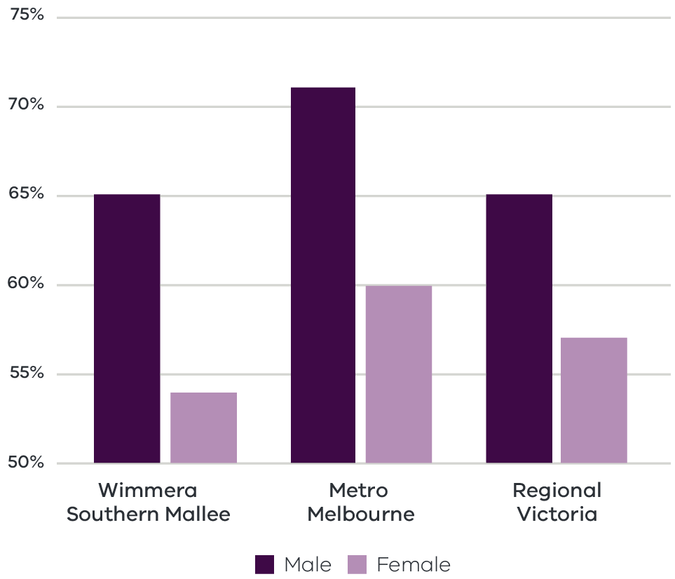
Figure 8 Participation rate by gender (2016) – Long Alternate Text
Source: ABS Census, 2016
Consistent with the pattern across the state and regional Victoria, the female participation rate in Wimmera Southern Mallee region is significantly lower than the male participation rate. This disparity presents an opportunity to boost future economic growth by addressing the comparatively high proportion of part-time workers relatively lower participation rate for female workers.

Challenges

Digital exclusion
Social and geographical isolation in the region has been exacerbated by relatively lower rates of internet connection, gaps in internet connectivity, and less reliable mobile coverage. Unreliable internet connections are significant constraints for developing a range of technologies that can be used to treat patients and collect and share information, telehealth, and robotic and artificial intelligence. Digital technology in health improves accessibility, quality, safety and efficiency, and innovation that directly impacts the development of future jobs in health and related services in decades to come. Recent consultations as part of the Connecting Victoria initiative recognised an increasing need for better connectivity to address equity and digital inclusion, which in turn supports remote learning and tele health services.

Skill shortages
By 2025, the number of health professionals and workers required to meet community health care needs in Victoria is forecast to increase up to a third. Responding to this increasing demand requires new skills and different approaches to workforce planning and composition. However, several factors are expected to limit the success of the region in attracting and retaining skilled workers, including out-migration of young people, population decline (apart from Horsham), and housing shortages. In the short term, these challenges may have been exacerbated by the impact of the COVID related border restrictions. Advocacy and attraction of skilled migrant workers to the region are key opportunities to address the skills shortages, as the sector has historically benefited from an inflow of international migrants.

The policy environment
Supporting economic and employment opportunities in the health and social services sector is aligned with national, state and local priorities. In particular:
- Wimmera Primary Care Partnership Strategic Plan 2017-2021, has been developed to identify health sector priorities, identify regional challenges, opportunities to form a framework and guide relevant decision making over a period of four years. The plan aims to improve the health and well-being of the Wimmera Southern Mallee communities, reducing health inequality across the region
- Victorian Health Priorities Framework 2012-2022: Rural and Remote Health Plan provides the blueprint for the planning and development priorities for the Victorian healthcare system for the coming decade. The framework provides the foundation for the Rural and Regional Health Plan. It has been applied to the rural and regional health system to drive the development of key actions that will deliver services in rural and regional Victoria that are more responsive to people’s needs and rigorously informed and informative.
- Victoria’s 10-year Mental Health plans to guide investment and drive better mental health outcomes for Victorians. The plan focuses on addressing workforce shortages through incentive schemes and increasing placements in rural and regional Victoria.
The Connecting Victoria initiative, announced in mid-2021, is fast-tracking new mobile and broadband infrastructure through a $550 million investment across Victoria.

Aboriginal inclusion
This direction aligns with the local Aboriginal economic development priorities to enhance Aboriginal participation across industries with a particular focus on occupation which serves the local Aboriginal population including health care and social assistance. Health care and social assistance is the largest employer of Aboriginal people in the region, with about 27 per cent of the Aboriginal workforce employed in this sector. Growth in the sector is likely to present opportunities for increased labour force participation and incomes, but this should ensure that attracting new workers to the region does not displace the current Aboriginal workforce.

How can we unlock this strategic direction?
To unlock this opportunity and drive growth, local, state and Commonwealth partners could work together to:
- Communicate and share the outcomes of the forthcoming regional skills demand profile to demonstrate the current skill base and future skill needs and develop training and career pathways to support the health and aged care workforce.
- Advocate for national migration settings that support the placement of skilled workers and international students in regional areas.
- Examine ways to support the region’s liveability and ensure attraction and retention of the required workforce without putting pressure on the region’s social infrastructure.
- Encourage initiatives that support regional specialisations for health and social services.
- Enhance Aboriginal workforce participation across health and social services to deliver improved labour market outcomes for the Aboriginal community in the region.
- Collaborate with telecommunications providers collaborate to deliver high quality digital connectivity that aligns with regional health priorities.
- Support initiatives and programs aim to attract women in health care and social service sectors to work in regional and rural areas.
Support investment in infrastructure and services that could promote inclusive labour market outcomes including care facilities, training and upskilling facilities.

4.4 Position the region to benefit from emerging growth opportunities in natural resources

Significance
The Wimmera Southern Mallee region has notable potential for renewable energy generation. To date, renewable energy generation has been focused on wind power: the region has several wind farms that power local grids and export out of the region. These include operational farms at Kiata (31MW), Yawong (7.2MW) and Murra Warra (429MW capacity once complete, stage one construction already completed providing 226MW), and a number under construction or in permit application stages.
The region also has considerable solar energy generation potential (1400 to 1700 kWh/kWp per year), particularly in the north of the region. The Grampians Regional Roadmap to Net Zero Emissions identifies the progressive expansion of solar as important in the region’s energy mix. The Western Victoria Transmission project upgrades the state’s transmission network to connect large scale wind and solar in the west into the grid. The project proposes a new transmission line starting at Bulgana, near Stawell in Victoria’s west, and covering approximately 190km to Sydenham in Melbourne’s northwest. The project will connect new renewable energy generated in western Victoria into the National Electricity Market and increase the Victorian transmission capacity. The proposed investment complements the potential provided by recent renewable energy investment in the region, including two projects under-construction: the Bulgana Green Power Hub and Murra Warra Windfarm.
Renewable energy offers excellent opportunities for future employment in the region: research conducted by the Clean Energy Council has estimated that around 70 per cent of renewable energy job opportunities to 2035 could be distributed across regional and rural Australia. Investment in the development of renewable energy production and associated infrastructure supports employment growth in professional, scientific and technical services and other sectors like construction, manufacturing and retail.
Key drivers of change in the energy sector, in particular structural adjustment in coal-fired energy production, the falling cost of renewable energy technologies, and climate change policy development nationally and in Victoria, are the catalyst for further renewable energy production and uptake.
The region also contains around three quarters of Victoria’s mineral sands deposits by area, concentrated in the western and northern parts of the region. There are also several quarries which produce limestone, sand and gypsum. Global demand for rare earth elements contained in mineral sands has grown in recent years due to their use in high technology and renewable energy applications such as used in permanent magnets, which are essential in the construction of wind turbines and electric vehicles and also in modern rechargeable batteries.

Opportunities

Leveraging investments in energy infrastructure
The Victorian Government has allocated $540 million to establish six Renewable Energy Zones (REZs) as part of its commitment to reach net-zero emissions by 2050. Parts of Wimmera Southern Mallee (such as Horsham and surrounds) are captured in the ‘Western Victoria’ REZ identified as having high potential for renewable energy development. Identification of REZs enables the government to target investment towards strengthening the transmission network, developing renewable energy resources, expanding the grid, connecting new generation, and reducing network congestion and costs. The benefits of developing Victoria’s REZs extend beyond direct increases to renewable energy generation, to include supporting investment in local economies, creating local jobs, and strengthening local supply chains.

Low-carbon future
Low cost renewable energy has the potential to meet the needs of energy-intensive industries such as manufacturing, agriculture and mining. As Australia’s trading partners move to low-carbon economies, access to low emission inputs will be critical to remain competitive and meet stringent international trade requirements.

Industry diversification
Renewable energy generation offers potential diversification opportunities along existing production chains. For example, bioenergy has potential within the region because of the availability of agricultural by-products and the added value advantage of converting waste into an income-generating asset. Investment in local renewable energy generation can also drive demand for construction materials and construction activity.

Circular economy
A circular economy seeks to reduce the environmental impacts of production and consumption, while enabling economic growth through more productive uses of natural resources. There are opportunities for industry to efficiently manage waste to minimise waste, reduce emissions and diversify production. This includes greater uptake of circular economy principles through waste to energy trials (including bio-waste), bio-waste to fertiliser trials and investigating the viability of locally produced fertiliser using renewable energy.

Mineral extraction
Capitalising on rare earth and mineral deposits while demand is high will bring diversification benefits and resilience to the region’s economy. Efforts to grow the region’s mining industry will need to be supported by a skilled workforce and adequate freight infrastructure. There is an opportunity to leverage infrastructure that already exists or build new infrastructure that could benefit multiple industries such as water pipelines.

Challenges

Housing
The construction and operation of new renewable energy generation and mineral extraction will require a skilled workforce. However, current housing shortages present a challenge to attracting and retaining this workforce. This is a concern in the western parts of the Grampians Region, particularly in the Wimmera. There is a need for short-term and long-term housing responses for skilled workers to support the construction and operational phases of a renewable energy transition and mining activities.

Social licence
Given the visual impact of renewable energy projects on regional landscapes, there remains concern in some sections of the community around investment in projects such as wind farms. Communities may also raise concerns around productive agricultural land being used for renewable energy projects. Government will need to work with communities to ensure that social licence is maintained and that land use impacts are considered, particularly on high value agricultural land.

The policy environment
Several Australian and Victorian strategies underpin the strategic policy environment for the renewable energy sector, for example:
- Victoria’s Climate Change Act 2017 establishes a long-term target of net zero greenhouse gas emissions by 2050. This increases viability of renewable energy investments into the future.
- Victoria’s Climate Change Strategy provides a roadmap towards net-zero emissions by 2050. It includes interim targets to reduce emissions and pledges for energy, agriculture, transport, waste and forestry sectors.
- Victoria’s Community Engagement and Benefit Sharing in Renewable Energy Development in Victoria outlines leading practice community engagement and benefit sharing for renewable energy development in Victoria.
- Grampians Roadmap to Net Zero Emission by 2050, envision and guide the decarbonising of the complete Grampians region, which includes Ballarat, Central Highlands and Wimmera Southern Mallee.
- The Victorian government has a suite of state-wide policies and initiatives to support the State’s energy sector to transition to net-zero emissions, which are available on energy.vic.gov.au.
Victoria’s Recycling Victoria: A new economy is the state’s circular economy policy and 10-year action plan to reduce waste and pollution and improve recycling in a way which delivers economic benefit

Aboriginal inclusion
Increased investment in the renewable energy sector and the circular economy will likely create employment opportunities in the construction, energy and waste services and professional, scientific and technical services industries. The construction industry is a large employer of Aboriginal people in the region, employing about 9.8 per cent of the Aboriginal workforce. Targeted interventions should be considered to increase Aboriginal participation in professional, scientific and technical services and ensure the Aboriginal community benefits from the broad range of enterprise and job opportunities in renewable energy.

How can we unlock this strategic direction?
To unlock this opportunity and drive growth, local, state, and Commonwealth partners could work together to:
- Proactively identify future jobs and training needs and support diverse opportunities by coordinating relevant training and upskilling programs in the renewable energy and mining industries.
- Better understand potential land use conflicts to maintain social license.
- Improve coordination and facilitation of existing and prospective investments to maximise the local benefits of renewable energy and mining activities.
- Build the capacity of Aboriginal organisations to develop plans, feasibility studies and business cases for community-owned renewable energy generation projects.
- Identify gaps in enabling infrastructure for the development and growth of the renewable energy and mining activities in the region.
Coordinate and streamline processes to help businesses negotiate the range of statutory planning and other regulations.

05 Implementation
The Wimmera Southern Mallee REDS outlines the Rural and Regional Victoria (RRV) Group’s strategic approach for focusing its future economic development activities, including through policy, investment and program delivery, in the region. It is not a prescriptive roadmap for Victorian Government economic development action in Wimmera Southern Mallee.

RRV will use the REDS to coordinate investments and activities in place.
RRV is committed to pursuing the strategic directions through future policy design, investment and program implementation, as well as through collaboration across government and with regional partnerships, to deliver positive economic outcomes for the region. The Wimmera Southern Mallee REDS will provide a central point for coordination for current and future work streams and investments.
RRV recognises that effective planning policy and controls will be a key enabler of inclusive, sustainable economic growth in the Wimmera Southern Mallee region. Victoria’s Regional Growth Plans provide broad direction for land use and development, and enable economic growth by ensuring that infrastructure investment is coordinated, appropriate services are provided, and development meets community expectations. The Regional Development and Planning portfolios will pursue opportunities to ensure that as relevant state-led land use planning strategies, policies and controls are updated, they are aligned with the REDS strategic directions.

Local stakeholders, industry leaders and government service providers can use the REDS to advocate for shared outcomes
The Wimmera Southern Mallee REDS, along with the supporting Wimmera Southern Mallee REDS – Supporting Analysis document, provides a starting point for an evidence-based, strategic approach to regional development. This approach is an ongoing process where specific development actions and projects can be proposed and considered in the context of alignment with the REDS.
Regional Development Victoria – Grampians will remain the main point of contact in the region for facilitating and coordinating regional development outcomes.
The Wimmera Southern Mallee Regional Partnership, which comprises community and business leaders, CEOs of constituent Local Governments, state Government personnel and a representative from Regional Development Australia, will continue to be the main advisory body to the Minister for Regional Development and other government decision-makers on local issues and priorities.
The Wimmera Southern Mallee REDs will provide Jobs Victoria with important context and understanding of local economic priorities and opportunities that will be a critical input into the planning and prioritisation of Jobs Victoria’s work and collaboration activities with our Service Partners. Jobs Victoria assists people looking for work, connects employers with the staff they need, administers wage subsidy programs and supports significant local employment transitions.

RRV will monitor the implementation of the REDS
The strategic directions in this Strategy focus on medium- to long-term drivers of growth and opportunity but will be used immediately to guide investment in the region. Notwithstanding this timeframe, the strategic directions will continue to evolve and progress as actions and investment are made. To ensure ongoing relevance and accuracy, RRV will periodically update and refresh this Strategy.

Appendix

Figure 1: Map of Regional Partnerships – Long Alternate Text
The Mallee region is located in northwest Victoria and contains the LGAs of Mildura, Swan Hill, Buloke and Gannawarra.
The Wimmera Southern Mallee region is located in western Victoria and contains the LGAs of West Wimmera, Hindmarsh, Yarriambiack, Horsham and Northern Grampians.
The Great South Coast region is located in southwest Victoria and contains the LGAs of Glenelg, Southern Grampians, Moyne, Warrnambool and Corangamite.
The Barwon region is located to southwest of metropolitan Melbourne and contains the LGAs of Geelong, Queenscliffe, Surf Coast and Colac Otway.
The Central Highlands region is to the west of metropolitan Melbourne and contains the LGAs of Ararat, Pyrenees, Golden Plains, Moorabool. Ballarat and Hepburn.
The Loddon Campaspe region is northwest of metropolitan Melbourne and contains the LGAs of Macedon Ranges, Mount Alexander, Central Goldfields, Loddon Campaspe and Bendigo.
The Goulburn region is north of metropolitan Melbourne and contains the LGAs of Mitchell, Murrindindi, Strathbogie, Greater Shepparton and Moira.
The Ovens Murray region is located in the northeast of Victoria and contains the LGA’s of Mansfield, Benalla, Wangaratta, Alpine, Indigo, Towong and Wodonga.
The Gippsland region is located in the east of Victoria and contains the LGAs of Bass Coast, South Gippsland, Baw Baw, Latrobe, Wellington and East Gippsland.
Click here to return to document

Figure 2 Map of Barwon – Long Alternate Text
The Wimmera Southern Mallee region is made up of the West Wimmera, Hindmarsh, Horsham, Yarriambiack and Northern Grampians Local Government Areas.
The Wimmera Southern Mallee region has several major road connections, including west into South Australia and with to the south and east (connecting the region to the neighbouring Great South Coast, Central Highlands, Loddon Campaspe and Mallee regions).
A rail line heads north through Stawell to Murtoa. From Murtoa there are two lines heading north, one through Minyip, Warracknabeal Beulah and Hopetoun, and another heading to Horsham, Dimboola, Jeparit, Rainbow and Yaapeet. A line also splits off from Dimboola and heads west to Nhill and Kaniva before heading into South Australia.
The Wimmera Southern Mallee region has several regional airports including: Stawell, St Arnaud, Horsham, Warracknabeal, Hopetoun, Nhill, Kaniva and Edenhope.
Click here to return to document

Figure 3 Wimmera Southern Mallee industry Employment (2001-20) – Long Alternate Text
The largest employing industries in descending order are Health Care and Social Assistance, Agriculture, Forestry and Fishing, Retail Trade, Construction, Manufacturing, Education and Training, Public Administration and Safety, Accommodation and Food Services, Other Services and Transport, Postal and Warehousing.
The following industries have grown in employment since 2001; Health Care and Social Assistance, Construction, Manufacturing, Education and Training, Public Administration and Safety
The following industry has declined in employment since 2001; Agriculture, Forestry and Fishing, Retail Trade, Accommodation and Food Services, Other Services and Transport, Postal and Warehousing.

Simplified Table of data for Figure 3.
 | Agriculture, Forestry and Fishing | Manufacturing | Construction | Retail Trade | Accommodation and Food Services | Transport, Postal and Warehousing | Public Administration and Safety | Education and Training | Health Care and Social Assistance | Other Services
2001 | 6216 | 1585 | 1079 | 2477 | 1280 | 970 | 924 | 1473 | 2923 | 905
2002 | 5789 | 1541 | 1125 | 2557 | 1243 | 925 | 929 | 1492 | 2888 | 834
2003 | 5378 | 1558 | 1167 | 2630 | 1243 | 918 | 1014 | 1572 | 2925 | 852
2004 | 5188 | 1552 | 1247 | 2447 | 1214 | 955 | 1027 | 1435 | 2969 | 880
2005 | 5141 | 1563 | 1404 | 2429 | 1217 | 973 | 1083 | 1437 | 3060 | 833
2006 | 5017 | 1609 | 1548 | 2493 | 1243 | 1021 | 1159 | 1512 | 3345 | 834
2007 | 4799 | 1609 | 1546 | 2476 | 1207 | 994 | 1202 | 1578 | 3486 | 855
2008 | 4747 | 1622 | 1390 | 2512 | 1264 | 1013 | 1238 | 1582 | 3303 | 896
2009 | 4612 | 1601 | 1272 | 2470 | 1297 | 1011 | 1245 | 1501 | 3362 | 875
2010 | 4560 | 1551 | 1430 | 2452 | 1386 | 1028 | 1251 | 1485 | 3449 | 875
2011 | 4356 | 1594 | 1507 | 2491 | 1406 | 1084 | 1271 | 1481 | 3405 | 892
2012 | 4176 | 1553 | 1397 | 2454 | 1349 | 1044 | 1242 | 1450 | 3360 | 872
2013 | 4177 | 1439 | 1578 | 2264 | 1318 | 943 | 1213 | 1455 | 3436 | 842
2014 | 4309 | 1444 | 1735 | 2253 | 1333 | 971 | 1226 | 1514 | 3567 | 926
2015 | 4196 | 1477 | 1736 | 2255 | 1355 | 1057 | 1235 | 1579 | 3712 | 1015
2016 | 4041 | 1453 | 1683 | 2136 | 1371 | 951 | 1196 | 1575 | 3786 | 790
2017 | 4110 | 1349 | 1760 | 2231 | 1589 | 1035 | 1222 | 1621 | 3869 | 862
2018 | 4198 | 1312 | 1955 | 2302 | 1488 | 979 | 1211 | 1614 | 3916 | 809
2019 | 4237 | 1368 | 1788 | 2167 | 1375 | 808 | 1233 | 1518 | 3889 | 884
2020 | 3776 | 1614 | 1768 | 1975 | 1212 | 756 | 1369 | 1473 | 3835 | 820
Click here to return to document

Figure 4 Wimmera Southern Mallee industry output (gross value add) 2001-20 – Long Alternate Text
The industries with the largest gross value add in 2020 in descending order are Agriculture, Forestry and Fishing, Health Care and Social Assistance, Public Administration and Safety, Construction, Retail Trade, Education and Training, Administrative and Support Services, Manufacturing, Electricity, Gas, Water and Waste Services and Wholesale Trade.
The following industries have grown in gross value add since 2001; Health Care and Social Assistance, Public Administration and Safety and Administrative and Support Services.
The following industry has declined in gross value add since 2001; Agriculture, Forestry and Fishing, Construction, Retail Trade, Education and Training, Manufacturing, Electricity, Gas, Water and Waste Services and Wholesale Trade

Simplified table of data for Figure 4. Data in this table is in ($) millions.
 | Agriculture, Forestry and Fishing | Health Care and Social Assistance | Public Administration and Safety | Construction | Retail Trade | Education and Training | Administrative and Support Services | Manufacturing | Electricity, Gas, Water and Waste Services | Wholesale Trade
2001 | 1234 | 275 | 132 | 154 | 139 | 173 | 76 | 276 | 124 | 97.0
2002 | 1255 | 282 | 146 | 165 | 147 | 170 | 79 | 254 | 116 | 92.9
2003 | 986 | 273 | 138 | 171 | 139 | 167 | 70 | 226 | 123 | 91.8
2004 | 1190 | 267 | 113 | 162 | 132 | 145 | 57 | 199 | 122 | 80.8
2005 | 1090 | 240 | 102 | 181 | 123 | 128 | 56 | 179 | 103 | 76.9
2006 | 1063 | 234 | 102 | 183 | 115 | 119 | 54 | 166 | 87 | 69.1
2007 | 843 | 228 | 102 | 165 | 113 | 118 | 54 | 152 | 76 | 62.2
2008 | 897 | 202 | 100 | 151 | 117 | 119 | 58 | 153 | 78 | 63.5
2009 | 923 | 209 | 103 | 144 | 117 | 113 | 51 | 140 | 76 | 66.1
2010 | 989 | 219 | 106 | 151 | 113 | 115 | 48 | 138 | 77 | 69.1
2011 | 1008 | 206 | 105 | 157 | 113 | 117 | 49 | 141 | 85 | 70.4
2012 | 925 | 204 | 105 | 149 | 115 | 117 | 50 | 132 | 87 | 90.3
2013 | 920 | 210 | 101 | 147 | 112 | 113 | 57 | 110 | 72 | 112.0
2014 | 821 | 232 | 106 | 149 | 115 | 111 | 70 | 108 | 68 | 81.0
2015 | 736 | 254 | 107 | 148 | 122 | 110 | 81 | 108 | 72 | 67.3
2016 | 603 | 261 | 104 | 131 | 121 | 102 | 93 | 104 | 71 | 64.4
2017 | 624 | 269 | 106 | 130 | 127 | 115 | 83 | 96 | 84 | 67.2
2018 | 621 | 289 | 108 | 149 | 136 | 116 | 87 | 93 | 109 | 69.4
2019 | 502 | 308 | 114 | 131 | 129 | 116 | 96 | 99 | 108 | 81.6
2020 | 423 | 292 | 144 | 123 | 118 | 117 | 113 | 112 | 83 | 81.1
Click here to return to document

Figure 5 Wimmera Southern Mallee industry employment location quotient and growth – Long Alternate Text
The graph is divided into four quadrants.
The first quadrant identifies the industries that are a) experiencing slower employment growth (or faster declines) than state averages and b) have higher levels of employment specialisation than state averages
The following industries are in quadrant 1:
- Hospitals
- Accommodation
- Health Care and Social Assistance
Public Administration and Safety
The second quadrant identifies the industries that are a) experiencing faster employment growth (or slower declines) than state averages and b) have higher levels of employment specialisation than state averages.
The following industries are in quadrant 2:
- Food Product Manufacturing
- Social Assistance Services
Machinery and Equipment Wholesaling
The third quadrant the industries that are a) experiencing slower employment growth (or faster declines) than state averages and b) have lower levels of employment specialisation than state averages.
The following industries are in quadrant 3:
- Construction
- Retail Trade
- Education and Training
- Accommodation and Food Services
Manufacturing
The fourth quadrant identifies industries that are a) experiencing faster employment growth (or slower declines) than state averages an b) have lower levels of employment specialisation than state averages.
The following industries are in quadrant 4:
- Administrative Services
Public Order
Click here to return to document

Figure 6 Wimmera Southern Mallee industry output (GVA) location quotient and growth – Long Alternate Text
The first quadrant identifies the industries that are a) experiencing slower GVA growth (or faster declines) than state averages and b) have higher levels of GVA specialisation than state averages
The following industries are in quadrant 1:
- Metal Ore Mining
- Agriculture, Forestry and Fishing
- Preschool and School Education
- Repair and Maintenance
- Hospitals
- Road Transport
- Public Administration
- Retail Trade
- Basic Material Wholesaling
- Residential Care Services
Food Retailing
The second quadrant identifies the industries that are a) experiencing faster GVA growth (or slower declines) than state averages and b) have higher levels of GVA specialisation than state averages.
The following industries are in quadrant 2:
- Food Product Manufacturing
- Public Order, Safety and Regulatory Services
- Social Assistance Services
- Water Supply, Sewerage and Draining Services
- Motion Picture and Sound Recording Activities
Machinery and Equipment Wholesaling
The third quadrant the industries that are a) experiencing slower GVA growth (or faster declines) than state averages and b) have lower levels of GVA specialisation than state averages.
The following industries are in quadrant 3:
- Construction
Education and Training
The fourth quadrant identifies industries that are a) experiencing faster GVA growth (or slower declines) than state averages an b) have lower levels of GVA specialisation than state averages.
The following industries are in quadrant 4:
Manufacturing
Click here to return to document

Figure 7 Agricultural land use in Wimmera Southern Mallee – Long Alternate Text
This is a map showing agricultural activities across the Wimmera Southern Mallee region.
Agricultural areas cover much of the Wimmera Southern Mallee region. Wool and sheep meat farming covers much of the southern and western part of the region, around the towns of Edenhope, Natimuk, Stawell and Navarre. Some wool and Sheep meat farming also occurs in the area north of Nhill.
Grains farming is prominent across the northern part of the region, occurring around the towns of speed and Lascelles in the north of the region down to Warracknabeal and west to Kaniva. Some grains farming also occurs near the towns of Natimuk and Marnoo.
The towns of Nhill and Stawell both have major food processing activities.
Click here to return to document

Figure 8 Participation rate by gender (2016) – Long Alternate Text
 | Male | Female
Wimmera Southern Mallee | 65% | 54%
Metro Melbourne | 71% | 60%
Regional Victoria | 65% | 57%
Click here to return to document

Australian Bureau of Statistics, 2021
Victoria in Future 2020, Department of Environment, Land, Water and Planning – The COVID pandemic has changed Victoria’s population pathway from near-record growth levels to population losses. However, Victoria’s regions appear to have experienced little disruption to growth patterns. Migration from Melbourne to the regions has been at record levels according to the latest ABS data, offsetting most regional losses to overseas or interstate. There remains considerable uncertainty around the distribution of the increased regional migration, and the permanence of this trend, but available evidence points to continuing regional growth. Data from the 2021 Census will be vital in determining the impacts on the strongest migration attractors (e.g., regional centres and peri-urban areas) versus those regions which may have experienced losses from the temporary migrant workforce. Given available information, the current projections remain fit for purpose for regional planning.
National Skills Commission, 2022
ABS Census, 2016
National Institute of Economic and Industry Research, 2020
Thomas J. et al., 2021, Australian Digital Inclusion Index
Regional Wellbeing Survey, 2020
Department of Education and Training, 2021
ABS Census, 2016
RRV analysis, SQM, 2021
DHHS rental Report – June Quarter, 2021
Deloitte Access Economics, 2021, Cross-Border Economic Zones Analysis – Western Wimmera
Agriculture Victoria, 2018, Wimmera Southern Mallee; Invest in Victorian agriculture and food
Regional Partnership, Wimmera Southern Mallee, Regional Digital Plan Summary, https://www.rdv.vic.gov.au/__data/assets/pdf_file/0011/1930871/Wimmera-Southern-Mallee-Digital-Plan-Summary-web.pdf
Department of Environment, Land, Water and Planning, 2019, Wimmera Southern Mallee Climate Projections 2019 (based on high emissions scenario, where 2050’s refers to the period from 2040 to 2059)
Wimmera Southern Mallee Regional Partnership, Regional Digital Plan Summary https://www.rdv.vic.gov.au/__data/assets/pdf_file/0011/1930871/Wimmera-Southern-Mallee-Digital-Plan-Summary-web.pdf
Tourism Research Australia, 2021
Grampians Tourism Destination Plan and Investment Roadmap, 2014, https://grampianstourism.com.au/wp-content/uploads/sites/4/2014/06/grampians-tourism-destination-plan.pdf
Wimmera Primary Care Partnership ,2021, Community Health and Wellbeing Profile, http://www.wimmerapcp.org.au/wp-gidbox/uploads/2021/05/Wimmera-PCP-Cmmty-Profile_17Dec_2020_Revision_9thMarch21.pdf
ABS, 2020
Health Victoria, Health 2040, a discussion paper on the future of healthcare in Victoria.
Clean Energy Council ,2020, Clean Energy at work study reveals enormous jobs opportunity, https://www.cleanenergycouncil.org.au/news/clean-energy-at-work-study-reveals-enormous-jobs-opportunity
RDA Grampians, 2020, For Want of a Worker: Grampians Region Workforce Literature Review and Analysis

