Ovens Murray

Regional Economic Development Strategy – Summary

State Government of Victoria

The Ovens Murray REDS uses data and evidence to profile the region’s economy and identify key strategic directions to drive economic growth.

Regional Profile

Ovens Murray Regional Profile
Population (2020) | 131,400
Population growth (2011-20) | 11.1%
Gross regional product (2020) | $6.5B
Figure 1: Map of Ovens Murray
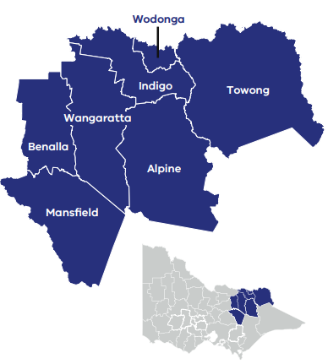

Employment
Unemployment rate (September 2021) | Average annual employment growth (2011–20)
Ovens Murray: 3.1%  Regional average: 4.2%  Metropolitan Melbourne: 6.0% | Ovens Murray: 0.4%  Regional average: 1.0%  Metropolitan Melbourne: 2.1%

Top employing sectors (2020)
Industry | Workers
Health care and social assistance | 7,800
Manufacturing | 7,200
Agriculture, forestry and fishing | 5,800
Retail trade | 5,600
Construction | 5,400
Education and training | 4,600

Top sectors by gross value add (2020)
Industry | Gross value add
Manufacturing | $743.2 Million
Health care and social assistance | $660.0 Million
Construction | $531.2 Million
Public administration and safety | $488.5 Million
Education and training | $448.3 Million
Agriculture, forestry and fishing | $381.1 Million

Strategic Directions
Ovens Murray’s five strategic directions have been identified using an evidence base that considers the region’s unique attributes, existing and emerging industries, and socioeconomic context.

1. Expand business and employment opportunities in the transport, distribution and logistics industries
The region’s strategic location between Melbourne and Sydney is poised to generate significant growth, productivity and employment through its transport and logistics sector and local industrial precincts.

2. Strengthen and diversify the visitor economy through leveraging the region’s nature, epicurean and cultural tourism industries
Diverse natural assets and landscapes along with a vibrant food and wine industry will contribute to a growing visitor economy, including opportunities in agritourism and events to drive year-round visitation.

3. Expand on existing strength in manufacturing to take advantage of opportunities in new industries
Access to industrial land, high-quality raw materials and natural resources, tertiary institutions and strategic transport links offer opportunities to maximise the value of the existing strengths (defence, food product manufacturing) and to develop the circular economy.

4. Support and expand economic and employment opportunities in growing sectors (health, social services, education)
Population growth is driving demand for health, social services and education in the region. Developing these sectors can provide significant employment opportunities, create a sustainable local workforce and improve local labour market inclusion.

5. Position the region to benefit from emerging growth opportunities in natural resources
The region is poised to benefit from the economic opportunities associated with natural resources, including mining exploration, global demand for mineral resources, Renewable Energy Zone (REZ) development, and interest in community based energy generation.
Please refer to the Ovens Murray REDS and Supporting Analysis for further detail and sources.
Prepared by the Department of Jobs, Precincts and Regions, May 2022. For more information see: rdv.vic.gov.au.

