Wimmera Southern Mallee

Regional Economic Development Strategy – Summary

State Government of Victoria

The Wimmera Southern Mallee REDS uses data and evidence to profile the region’s economy and identify key strategic directions to drive economic growth.

Regional Profile

Wimmera Southern Mallee Regional Profile
Population (2020) | 47,400
Population growth (2011-20) | 3.1%
Gross regional product (2020) | $2.5 Billion
Figure 1: Map of Wimmera Southern Mallee
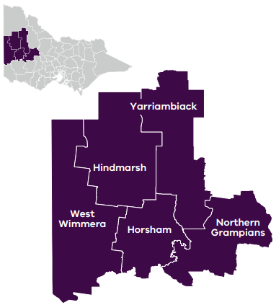

Employment
Unemployment rate (September 2021) | Average annual employment growth (2011–20)
Wimmera Southern Mallee: 2.8%  Regional average: 4.2%  Metropolitan Melbourne: 6.0% | Wimmera Southern Mallee: -0.9%  Regional average: 1.0%  Metropolitan Melbourne: 2.1%

Top employing sectors (2020)
Industry | Workers
Agriculture, forestry and fishing | 3,800
Health care and social assistance | 3,800
Retail trade | 2,000
Construction | 1,800
Manufacturing | 1,600
Education and training | 1,500

Top sectors by gross value add (2020)
Industry | Gross value add
Agriculture, forestry and fishing | $423.0 Million
Health care and social assistance | $292.4 Million
Public administration and safety | $144.2 Million
Construction | $122.9 Million
Retail trade | $117.8 Million
Education and training | $116.8 Million

Strategic Directions
Wimmera Southern Mallee’s four strategic directions have been identified using an evidence base that considers the region’s unique attributes, existing and emerging industries, and socioeconomic context.

1. Strengthen agriculture and food product manufacturing through diversification
Harnessing the region’s cluster of agriculture and horticulture activities and its potential as a food industry ‘knowledge corridor’ will facilitate opportunities for value adding and innovation in food product manufacturing.

2. Promote growth and development of the visitor economy, leveraging natural assets and Aboriginal heritage
The region’s diverse natural landscapes, Aboriginal heritage and cultural offerings, in addition to agritourism, offer significant opportunities to build its brand and grow the visitor economy.

3. Support and expand economic opportunities in growing sectors (health and social services)
Innovation in the region’s service-based sectors, particularly in health and social services, along with the role of Horsham as a regional training hub, present ongoing opportunities to improve labour market inclusion and generate multiplier effects for the local economy.

4. Position the region to benefit from emerging growth opportunities in natural resources
The region’s notable potential for mineral extraction and renewable energy generation positions it strongly to take advantage of government investment in energy infrastructure, diversify local industries, and build a low-carbon future.
Please refer to the Wimmera Southern Mallee REDS and Supporting Analysis for further detail and sources.
Prepared by the Department of Jobs, Precincts and Regions, May 2022. For more information see: rdv.vic.gov.au.

