Ovens Murray Regional Partnership
Information for applicants

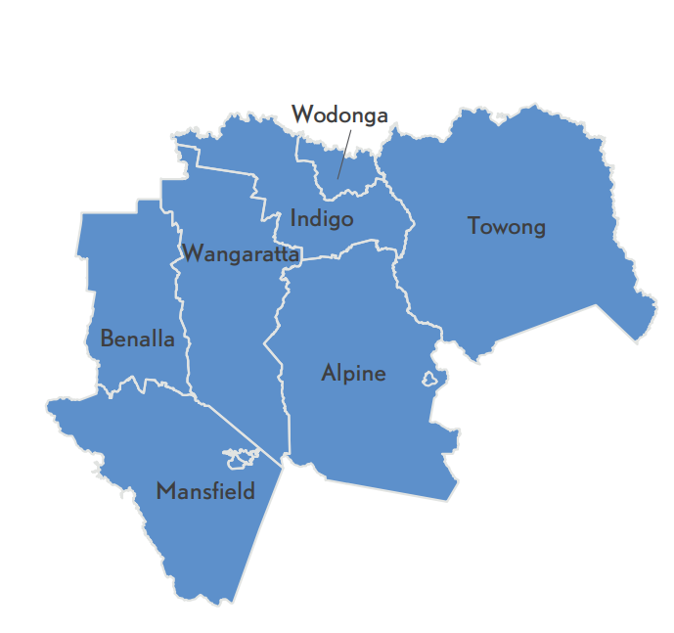
About Us
Bordering the Murray River to the north and with unique access to Victoria's High Country, the Ovens Murray region is best known for its lifestyle advantages and thriving tourism sector based on cycling, snow, nature-based tourism, food, wine, craft beer and cultural heritage. The region is also strategically located on national freight and transport routes servicing Australia’s east coast and has a number of strong manufacturing and service centres.
Our region includes covers seven municipalities - Alpine Shire, Benalla Rural City, Indigo Shire, Mansfield Shire, Towong Shire, Wangaratta Rural City, and Wodonga City, and has:
- Four Alpine Resorts – Mount Buller, Mount Stirling, Mount Hotham and Falls Creek
- Gross Regional Product of $6.5 billion
- Population of 130,000
- Nearly 4 million High Country visitors a year.

What is the role of Regional Partnerships?
The Ovens Murray Regional Partnership is one of nine Partnerships across the state, established by the Victorian Government, recognising that local communities are in the best position to understand the challenges and opportunities faced by their region. Regional Partnerships act as a voice for their regions and advise the Victorian Government on regional priorities that reflect the unique needs and strengths of their region.
This involves engaging with rural and regional communities and a range of Government agencies, business and industry groups, community based organisations, Traditional Owner groups and Regional Development Australia Committees.

Major achievements of the Ovens Murray Regional Partnership include:
- Securing investment in high priority regional initiatives including passenger rail, freight logistics, cycle tourism and other major tourism projects in alpine resorts, national parks and along the Ned Kelly trail.
- Launching the Ovens Murray Digital Plan in December 2019, and implementing digital inclusion, connectivity and innovation initiatives in partnership with business, communities, government, telco providers and stakeholders in the tourism, education and health sectors.
- Helping young people share their stories about mental health experiences and needs as part of the Wodonga Youth Mental Health and Wellbeing Deep Dive Engagement project.

Who are we looking for?
We acknowledge that Ovens Murray Partnership business is conducted on Aboriginal land, including the lands of the Taungurung people and Yorta Yorta people, as well as other Traditional Owner groups in Victoria who are not yet formally recognised. We are aiming to attract people from all parts of the Ovens Murray region and people from diverse backgrounds. We encourage applications from Aboriginal and Torres Strait Islander Victorians, as well as:
- people from LGBTIQ+ communities;
- people with disability;
- people from culturally and linguistically diverse backgrounds;
- young people; and
- women.
We are seeking a combination of emerging and experienced regional leaders for all Partnerships.

FAQs

What happens after I apply?
Your application will be assessed by a selection panel. Interviews are expected to be completed during October 2020, with the final outcomes of the application process expected in January 2021.

If you proceed to interview, we will ask if you require any adjustments to the interview process. This can include changing the way we conduct the interview (for example, by phone or video conference instead of in person) or having a support person or advocate present.

If you are interested in applying, we encourage you to contact your local Regional Development Victoria office for a confidential discussion (see Key Contacts below).

What is expected of Regional Partnership members?
The Ovens Murray Regional Partnership is currently holding informal monthly one-hour online meetings in conjunction with longer quarterly meetings of approximately two hours duration. Members also participate in working groups focusing on different aspects of Regional Partnership work and attend events and stakeholder engagement sessions from time to time.

Other expectations are laid out in the Position Description.

I am running for the upcoming Local Government elections. Can I also apply for the Regional Partnership?
Each Local Government area is represented on its relevant Partnership by its Chief Executive Officer. The Partnerships span multiple Local Government Areas and take a strategic, region-wide lens to most of the issues they tackle. Any interested person from a regional Victorian community is welcome to apply to be a Regional Partnership member. Please consider the time you will be able to commit to the Partnership.

If you wish to withdraw your application at any stage in the process, please let us know.

Key Contacts
The below contacts are available Monday–Friday, 9am–5pm, using the National Relay Service 133 677 if required.
Regional Director:
Matt Nelson, Regional Director - Hume
Regional Development Victoria
t: 0400 841 732
Coordinator:
Robyn Guiney, Regional Partnership Coordinator – Ovens Murray
Regional Development Victoria
t: 0400 051 622
e: ovensmurray.partnership@rdv.vic.gov.au

