Wimmera Southern Mallee
Regional Partnership
Information for applicants

About Us
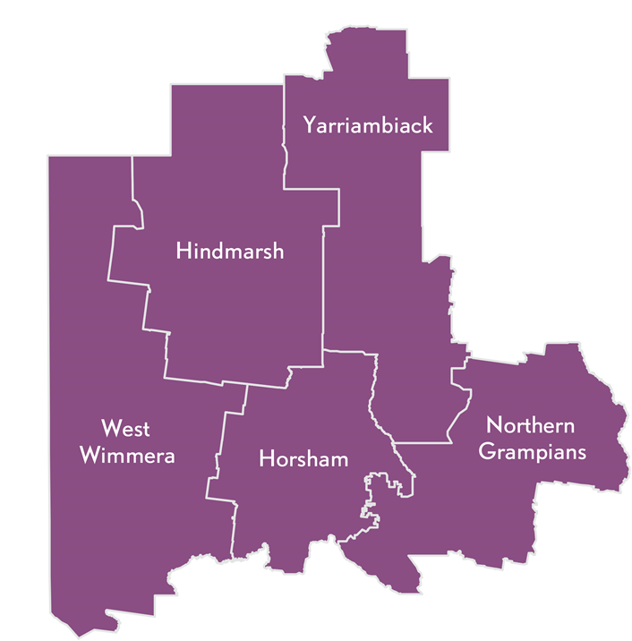
Our region in central western Victoria encompasses one of the world’s great grain growing areas. It is home to a number of small, vibrant communities and is served by the major regional centres of Horsham and Stawell. The region provides residents and visitors with many recreational and outdoor pursuits in vast and open landscapes. The region recorded relatively low levels of unemployment prior to coronavirus (COVID-19), however unemployment is expected to rise as a result of the pandemic.

Home to some of Victoria’s iconic natural attractions, including the Grampians and Little Desert National Parks, the Wimmera River and many wetlands and lakes, our region covers five municipalities - Hindmarsh Shire, Horsham Rural City, Northern Grampians Shire, West Wimmera Shire, and Yarriambiack Shire, and has:
- A Gross Regional Product of $2.5 billion;
- A population of 47,400;
- High levels of volunteerism and strong community networks.

What is the role of Regional Partnerships?
The Wimmera Southern Mallee Regional Partnership is one of nine Partnerships across the state, established by the Victorian Government, recognising that local communities are in the best position to understand the challenges and opportunities faced by their region. Regional Partnerships act as a voice for their regions and advise the Victorian Government on regional priorities that reflect the unique needs and strengths of their region. This involves engaging with rural and regional communities and a range of Government agencies, business and industry groups, community based organisations, Traditional Owner groups and Regional Development Australia Committees.
Major achievements of the Wimmera Southern Mallee Regional Partnership include:
- Initiating the BY FIVE Project (with involvement from State Government, local government and the
Murdoch Children’s Research Institute) which is improving learning and health outcomes for young
children and won a Victorian Early Years Award for Continuity of Early Learning; and
- Securing $20 million funding to complete the Warracknabeal Education Precinct.

Who are we looking for?
We acknowledge that Wimmera Southern Mallee Regional Partnership business is conducted on Aboriginal land, including the lands of the Gunditjmara, Dja Dja Wurrung and (as represented by the Barengi Gadjin Land Council) the Wotjobaluk, Jaadwa, Jadawadjali, Wergaia and Jupagulk people, as well as other Traditional Owner groups in Victoria who are not yet formally recognised. We are aiming to attract people from all parts of the Wimmera Southern Mallee region and people from diverse backgrounds. We encourage applications from Aboriginal and Torres Strait Islander Victorians, as well as:
- people from LGBTIQ+ communities;
- people with disability;
- people from culturally and linguistically diverse backgrounds;
- young people; and
- women.
We are seeking a combination of emerging and experienced regional leaders for all Partnerships.

FAQs

What happens after I apply?
Your application will be assessed by a selection panel. Interviews are expected to be completed during October 2020, with the final outcomes of the application process expected in January 2021.

If you proceed to interview, we will ask if you require any adjustments to the interview process. This can include changing the way we conduct the interview (for example, by phone or video conference instead of in person) or having a support person or advocate present.

If you are interested in applying, we encourage you to contact your local Regional Development Victoria office for a confidential discussion (see Key Contacts below).

What is expected of Regional Partnership members?
The Wimmera Southern Mallee Regional Partnership is currently holding meetings every two months on average for approximately 2 hours. Most members also participate in working groups focusing on different aspects of Regional Partnership work and attend events and stakeholder engagement sessions from time to time.

Other expectations are laid out in the Position Description.

I am running for the upcoming Local Government elections. Can I also apply for the Regional Partnership?
Each Local Government area is represented on its relevant Partnership by its Chief Executive Officer. The Partnerships span multiple Local Government Areas and take a strategic, region-wide lens to most of the issues they tackle. Any interested person from a regional Victorian community is welcome to apply to be a Regional Partnership member. Please consider the time you will be able to commit to the Partnership.

If you wish to withdraw your application at any stage in the process, please let us know.

Key Contacts
The below contacts are available Monday–Friday, 9am–5pm, using the National Relay Service 133 677 if required.
Executive Officer:
Anthony Schinck, Regional Director
Regional Development Victoria Grampians
t: 0400 884 433
Coordinator:
Greg Fletcher, Regional Partnership Coordinator
Regional Development Victoria Grampians
t: 0408 454 792
e: wimmerasouthernmallee.partnership@rdv.vic.gov.au

