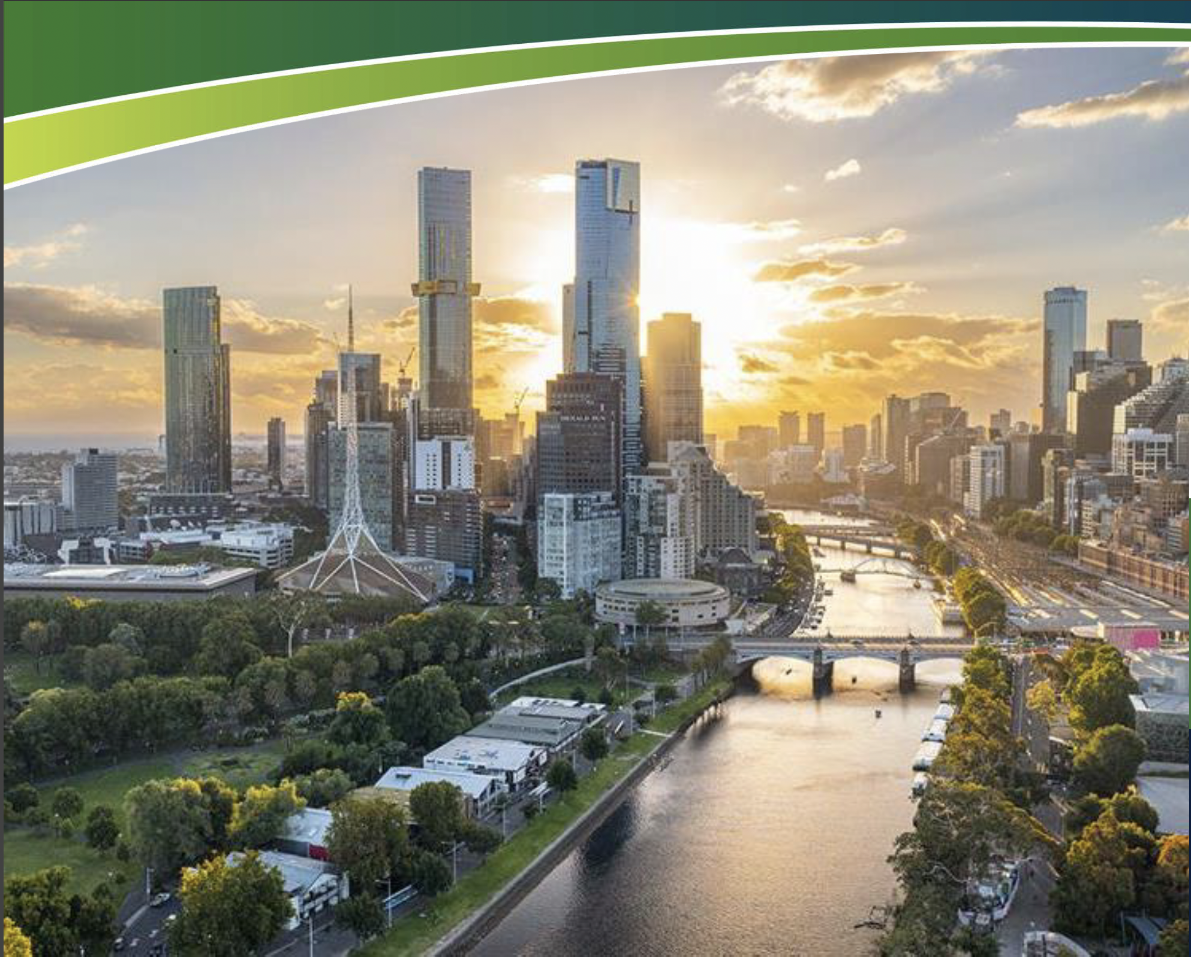

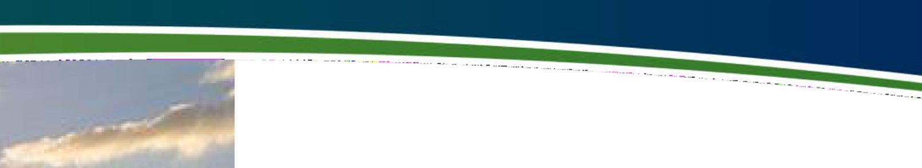

An Australian Government Initiative
Regional Development 1.
A.,..s-fvc,.fic,.
RD A M EL BOU RN E
N A A R M
BU S INE SS P LA N
2 0 2 5 - 26

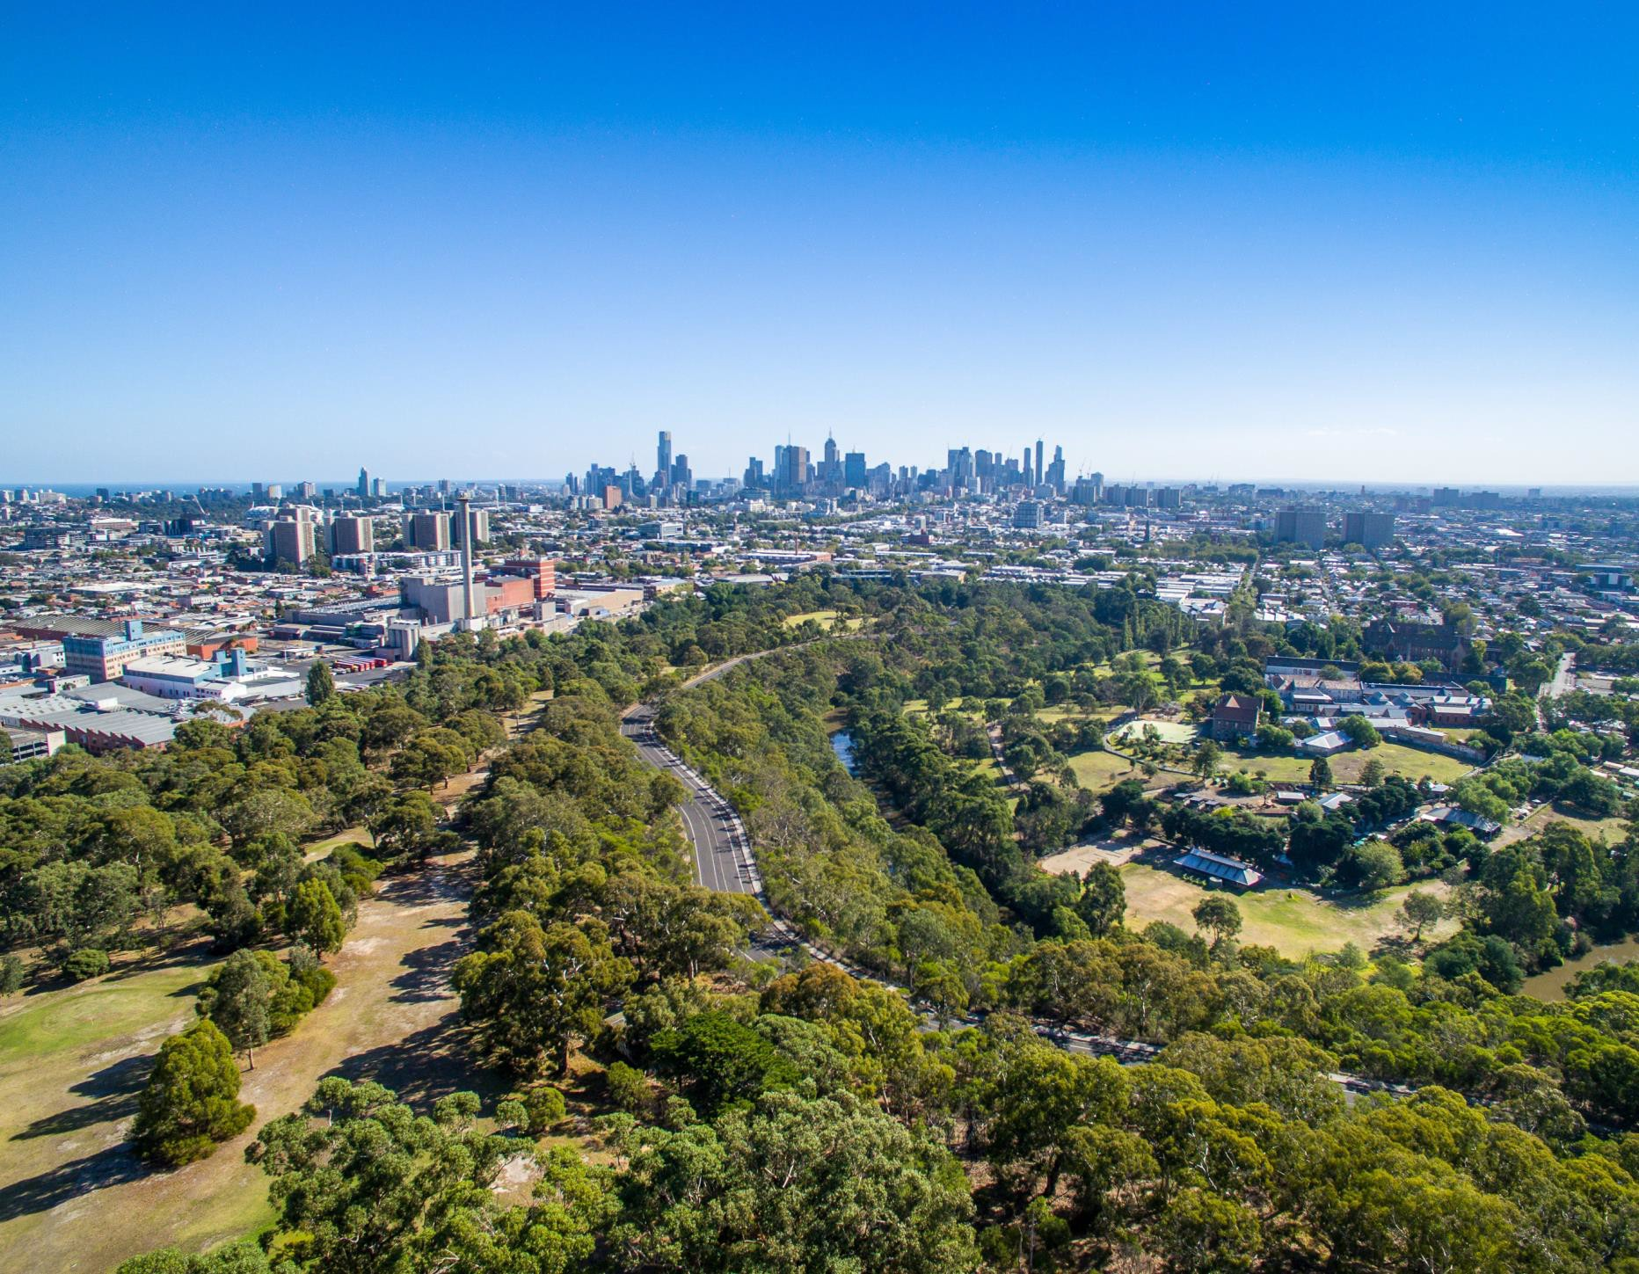
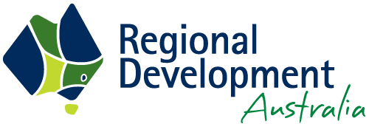

Acknowledgement of Country
Regional Development Australia (RDA) Melbourne acknowledges the Wurundjeri people of the Kulin Nation as the traditional custodians of the land from which we work. We recognise their continuing connection to land, waters and culture and pay our respects to their Elders past, present and emerging.
We further acknowledge the diversity of Aboriginal Victorians, their communities and cultures, their intrinsic connection to Country, and the contribution and interest of Aboriginal people and organisations in developing prosperous regions.
We are committed to advancing the principles of Aboriginal self-determination and supporting communities to realise self-determined economic development objectives.
N A A R M


Message from the Chair
In another dynamic year for regional development,
Regional Development Australia (RDA) Melbourne has continued
to deliver tangible value for regional Victoria by leveraging metropolitan networks, insights and investment channels. In 2024–25, our Committee deepened collaboration with government, industry and research partners to unlock opportunities that strengthen economic growth, resilience and innovation in our regions.
Through industry briefings, regional events, and collaborative planning initiatives, we helped connect regional RDAs with Melbourne’s innovation ecosystem and policy influencers. A standout example
was our Regional Artificial Intelligence Summit in Bendigo, which drew over 200 participants and sparked events in Wangaratta and Torquay, strengthening digital capability, awareness and confidence across regional Victoria.
We progressed practical initiatives aligned with state-wide priorities, such as hybrid work models that analysed the benefits and opportunities for workers and businesses in regional Victoria, exploration of co-designed housing solutions, and investment pathways for food and fibre value-add in regional Victoria.
Our contributions to Plan Victoria included an analysis of the growth opportunities between peri-urban Melbourne and regional Victoria. Participation in the Land Forces 2024 International Land Defence Expo aimed at introducing potential investors to advanced manufacturing capability in regional Victoria.
Our facilitation of RDA Chairs meetings continues to open new doors for cross-regional collaboration and findings from our Food & Fibre
Regional Investment Attraction Project and our Hybrid Work Opportunities in Regional Victoria research report will inform follow-up activities in 2025-26.
As the current RDA Melbourne Committee term draws to a close, I would like to extend my heartfelt thanks to each of our members for their insight, energy and commitment over the past five years. Your contributions have positioned RDA Melbourne as a trusted and influential connector between metropolitan capabilities and regional priorities.
With continued Australian Government funding secured through
to 2030, the newly appointed Committee will have an exciting opportunity to consider longer-term strategic directions in 2025-26. This will include exploring opportunities in advanced manufacturing, renewable energy, critical minerals, MedTech, agribusiness and digital innovation, drawing on the unique strengths of Melbourne
as a gateway to growth.
I would also like to thank our executive support team, regional colleagues, and government partners for their ongoing collaboration. We look forward to continuing this work in 2025-26 and beyond.
Steve Kozlowski
Chair, RDA Melbourne Committee
Steve Kozlowski
Chair, RDA Melbourne Committee
M E L B O U R N E

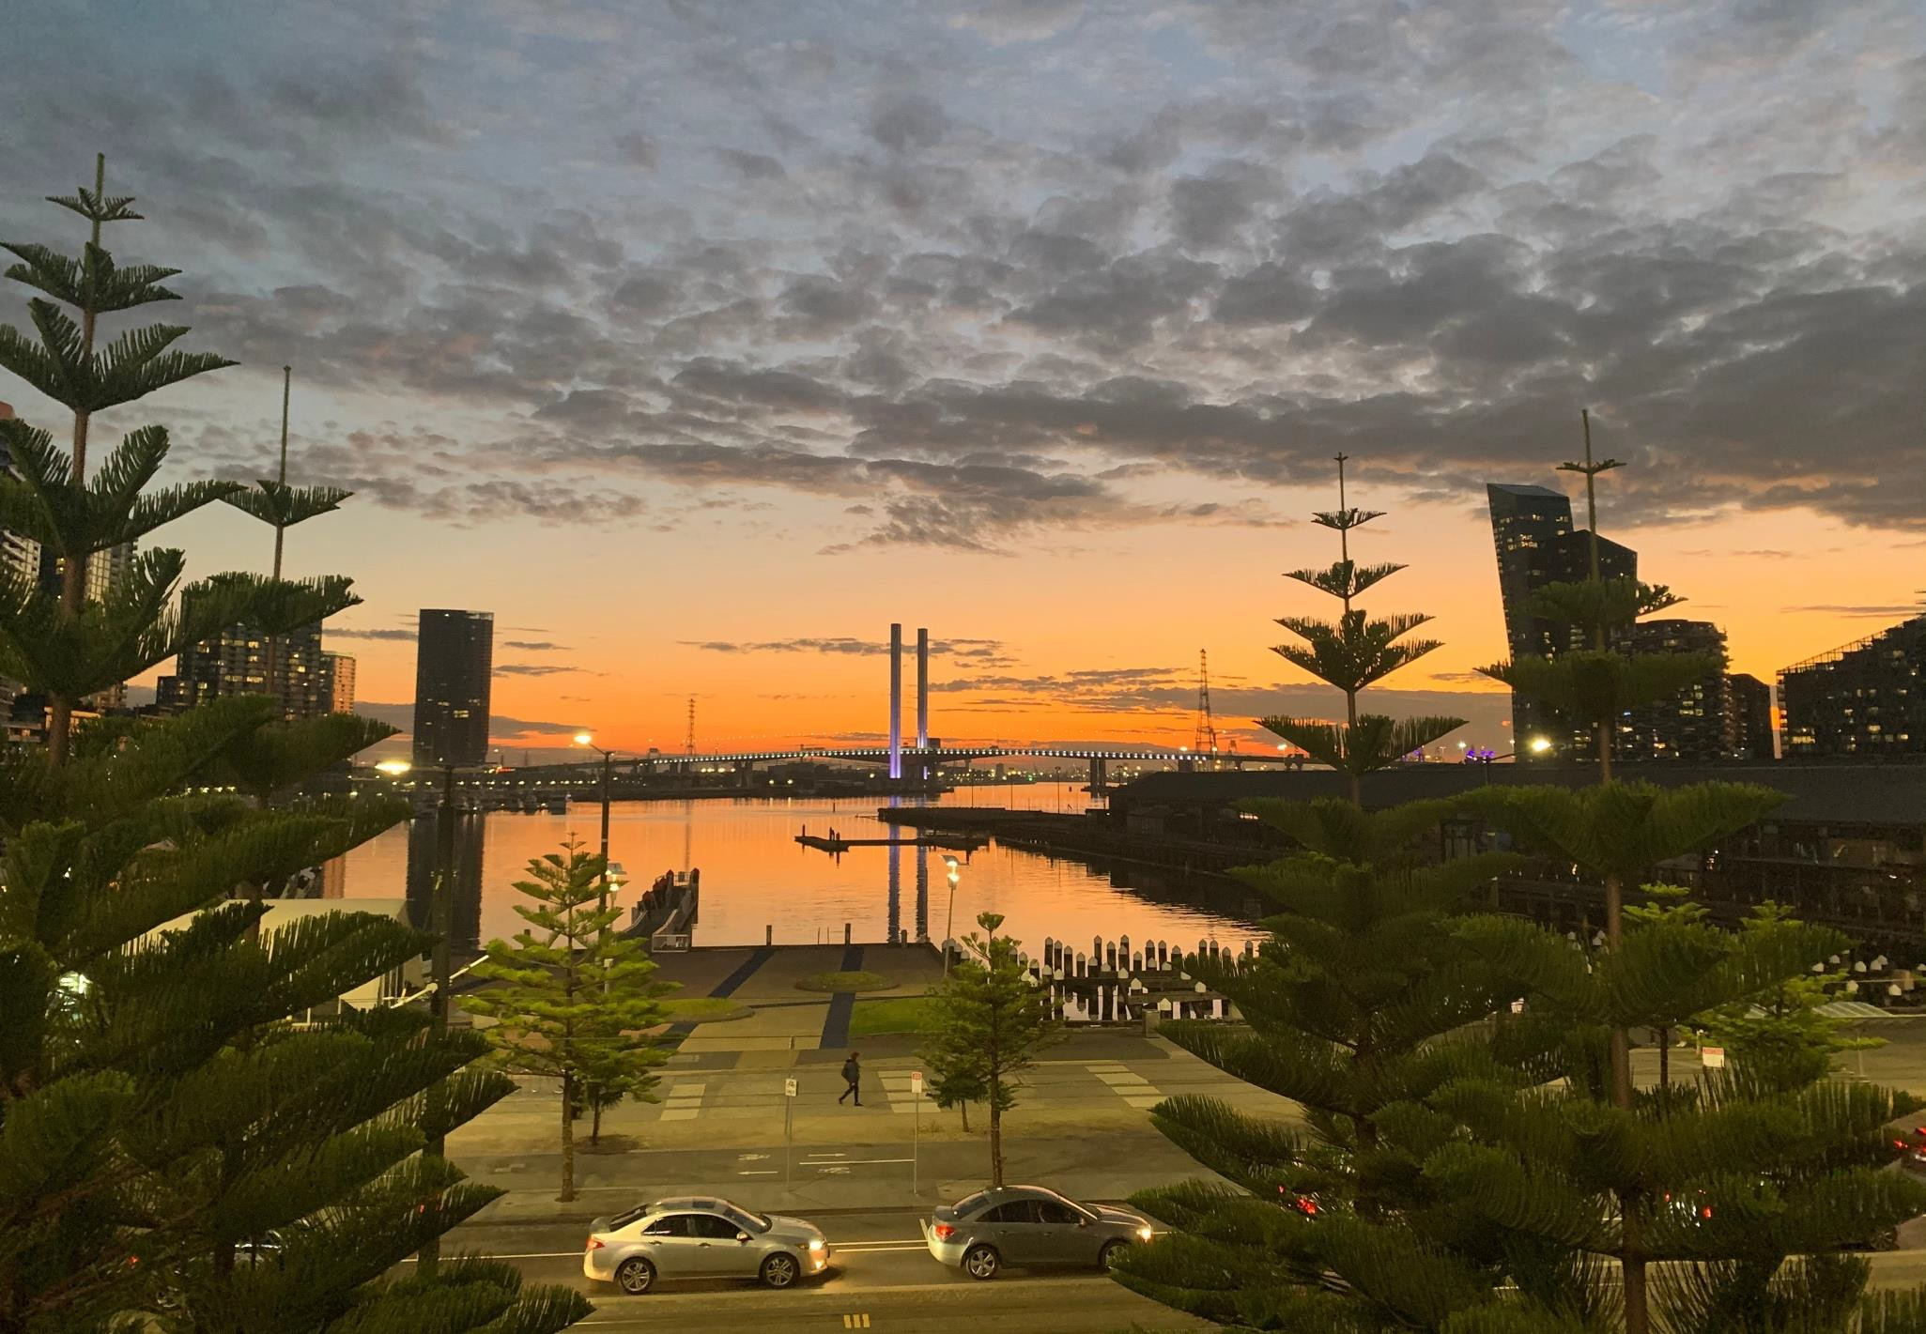

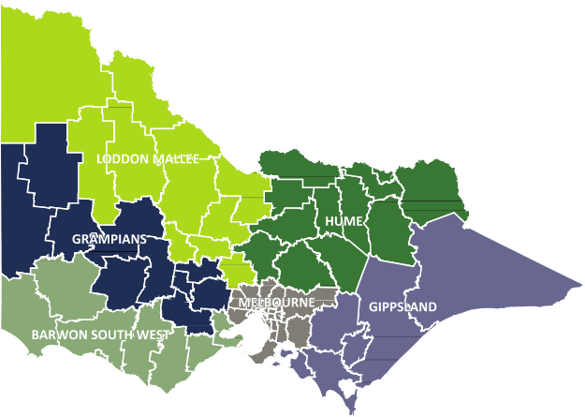
About RDA Melbourne
Regional Development Australia (RDA) is a national network of committees made up of local leaders who work across government, business and community to support economic and workforce development.
In Victoria, there are six RDA Committees covering all areas of the state, including an RDA Melbourne Committee that provides capital city business connections for the five regional RDA Committees.
Victorian RDA Committees are unincorporated advisory committees supported by a Commonwealth/State funding agreement. It is a unique model that has resourcing from the Victorian government which shares many of the priorities of the Victorian regional RDAs.
RDA Melbourne opens doors to capital city
resources that create sustainable economic
growth opportunities in regional Victoria
C A P I TA L C I T Y C O N N E C T I O N S
F O R R E G I O N A L V I C T O R I A
M E L B O U R N E

RDA Melbourne connects regional and city-based
businesses, researchers and investors to support economic growth opportunities in regional Victoria. We advocate for policy, planning and decentralisation initiatives that support the objectives of Victoria’s RDA Committees.
The term of the new RDA Melbourne Committee starts in July 2025 and funding for RDA Committees has been confirmed to 2030. The 2025-26 Business Plan aligns with key strategies including the Victorian Economic Growth Statement and provides flexibility for the incoming RDA Melbourne Committee to leverage their collective strengths for its best implementation.
Our strategic priorities are informed by evidence provided in Regional Economic Development Strategies (REDS) developed by the Victorian Government in collaboration with our regions (see page 12). The REDS will be updated later this year, which will further inform our activities.
RDA Melbourne plays a connecting role in assisting our regions to achieve objectives identified in the REDS in alignment with the objectives of the RDA Charter and the Australian Government’s Regional Investment Framework (RIF).
As illustrated in the table to the left, we will engage in five key business activities to progress our strategic priorities in the three key outcome areas presented on pages 5-7 of this plan.
S T R AT E G I C
P R I O R I T I E S
2 0 2 5 - 26
M E L B O U R N E
STRATEGIC PRIORITY 1
STRATEGIC PRIORITY 2
STRATEGIC PRIORITY 3
STRATEGIC PRIORITY 4
STRATEGIC PRIORITY 5

Collaborate
to leverage Australian Government research, policies and grant funding opportunities

Connect our regions
to Melbourne’s innovation, investment, business and supply chain opportunities

Support state-wide priorities identified in Victorian Regional Economic Development Strategies (REDS)

Encourage innovation and support emerging industries in our regions

Advocate to influence Government on regional issues and opportunities

K E Y B U S I N E S S A C T I V I T I E S 2 0 2 5 - 26
1: Facilitate meetings, roundtables, industry briefings and regional showcases for Victoria’s RDA Committees.
2: Engage with RDA Committees and Victoria’s Regional Partnerships, industry, local government, and First Nations people.
3: Support regional initiatives to equitably address state-wide issues and identify opportunities for collaboration.
4: Promote regional investment, innovation and employment opportunities to Melbourne audiences.
5: Provide evidence-based advice to the Australian Government that leverages Melbourne’s assets to benefit our regions.

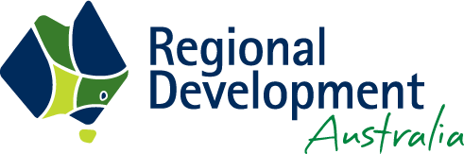
Facilitate regional economic development outcomes, through investment in:
- Skills and local leadership
•
•
•
•
•
Opportunities for First Nations people
Infrastructure Connectivity Decarbonisation Industry growth.
O U T C O M E
1
M E L B O U R N E
What will we do?
Initiative type
RDA Role
Timeframe
Expected Outcome
ACTIVITY 1.1
Invest in a program of engagements that leverage RDA Melbourne Committee networks and expertise to connect regional RDAs with capital city innovation, investment, research and supply chain opportunities.
- Determine networks and expertise areas of the RDA Melbourne Committee to identify opportunities for engagements that support regional economic growth.
- Skills and local
leadership
- Opportunities for First Nations people
- Infrastructure
- Connectivity
- Decarbonisation
- Industry Growth

Lead/ champion heavily involved with the outcome

July 2025 –
June 2026

- Aligns with Strategic Priorities 1, 2, and 4 by enabling cross-regional collaboration and connecting
regional RDAs with Melbourne’s innovation and investment ecosystem.
- Regional RDAs will gain direct access to networks, knowledge and partnerships that accelerate the uptake of new technologies, funding opportunities, and scalable business models.
- Strengthens the economic capacity of regional RDAs by opening new pathways for regional businesses and industries to co-partner and participate in capital city-led innovation and growth opportunities.
- Estimated percentage of budget allocated to activity = 60%
- Measurable outcomes: At least 6 engagement events or facilitated interactions annually;
at least 10 regional businesses connected to Melbourne-based innovation or supply chain partners.

ACTIVITY 1.2
Explore opportunities emerging from previous RDA Melbourne projects to address state- wide economic development priorities.
- Facilitate engagement between regional RDAs and capital city stakeholders and enable regional collaboration.
- Explore activities arising from regional AI Summits, in alignment with Australian Government AI Strategy 2025-37.
- Skills and local
leadership
- Opportunities for First Nations people
- Infrastructure
- Connectivity
- Decarbonisation
- Industry Growth

Lead/ champion heavily involved with the outcome

July 2025 –
June 2026

- Aligns with Strategic Priorities 1, 3, and 5 by leveraging prior learnings to contribute to state-wide
initiatives and influence broader economic development agendas.
- Builds on tested models to scale successful programs (e.g. in decarbonisation, digital capability, or
regional innovation) and apply them across new locations or sectors.
- Benefits regional RDAs by enabling them to replicate proven strategies, reducing duplication, and
accelerating impact aligned with regional and state government priorities.
- Estimated percentage of budget allocated to activity = 40%
- Measurable outcomes: At least 3 follow-up activities developed from previous project learnings;
2 new collaborative proposals submitted for funding or policy adoption;
increased regional participation in state-wide economic development initiatives.


Contribute to, and where appropriate, drive regional economic planning and strategy development.
O U T C O M E
2
M E L B O U R N E
What will we do?
Expected Outcome
ACTIVITY 2.1
Complete Advanced Air Mobility Project to inform regional economic planning across regional Victoria.

- Aligns with Strategic Priorities 1, 3, 4 and 5 by leveraging Australian Government research, supporting state-wide regional priorities (transport, health, decarbonisation), fostering innovation in an emerging industry, and informing policy and investment through strong advocacy and evidence -based planning.
- Delivers a clear roadmap for integrating advanced air mobility (AAM) into regional Victoria’s transport,
health and logistics systems, enabling more resilient, connected, and future-focused communities.
- Provides regional RDAs with a shared understanding of how to unlock local applications of AAM in freight, emergency services, passenger transport, and resource management, backed by current trial data, government support, and economic modelling.
ACTIVITY 2.2
Explore state-wide priorities and opportunities for collaboration arising from key Victorian economic policies including the Regional Economic Development Strategies (REDS) and the Economic Growth Statement.
- Aligns with Strategic Priorities 1, 3 and 5 by drawing on RDA Melbourne’s past work to influence policy,
contribute to state strategies, and coordinate regional efforts.
- Identifies high-impact projects or policy levers that can be scaled or adapted to support cross-regional
priorities such as decarbonisation, digital economy, or supply chain resilience.
- Regional RDAs benefit by incorporating proven models into their own strategic planning, increasing
alignment with state and federal priorities, and boosting their chances of program funding and influence.
ACTIVITY 2.3
Promote and leverage Australian Government grant opportunities for regional economic development.

- Aligns with Strategic Priorities 1, 2 and 5 by enhancing access to government funding and fostering alignment between regional needs and national investment programs.
- Increases awareness and uptake of grants, enabling more regional projects to be realised through
well-supported applications and partnerships.
- Regional RDAs benefit through improved access to resources and tools to assist local stakeholders, greater participation in competitive grant rounds, and increased project delivery capacity.


Contribute relevant data and local intelligence to support the
evidence base to inform regional development strategies, program design and policy responses.
O U T C O M E
3
M E L B O U R N E
What will we do?
Expected Outcome
ACTIVITY 3.1
Contribute data and local intelligence insights from RDA Melbourne projects, engagements, events and capital city meetings to support collaboration between regional stakeholders and provide advice to government.
- Aligns with Strategic Priorities 1, 3 and 5 by strengthening the evidence base for regional policy, ensuring
local insights inform national and state decision-making.
- Delivers high-quality intelligence that enhances the design, targeting and effectiveness of regional development strategies and funding programs.
- Regional RDAs benefit through better-informed planning processes, improved advocacy support, and access to insights that reflect both metro and regional perspectives.

ACTIVITY 3.2
Share and respond to Victorian and Australian Government programs and policies that may assist delivery of state-wide regional economic development priorities.

- Aligns with Strategic Priorities 1, 3 and 5 by keeping regional RDAs informed and responsive to policy developments and funding programs.
- Ensures timely dissemination of relevant government initiatives and enables regional RDAs to act quickly to align projects and partnerships with evolving priorities.
- Regional RDAs benefit by improving their policy awareness and capacity to respond to emerging opportunities that support local economic outcomes, including channeling grant opportunities.
ACTIVITY 3.3
Increase online visibility of RDA Melbourne
activities, opportunity, outcomes and insights.

- Aligns with Strategic Priorities 2, 4 and 5 by raising awareness of RDA Melbourne’s role in regional
innovation, collaboration and advocacy.
- Enhances credibility and influence of RDA Melbourne through strategic communication of achievements, insights and opportunities to internal and external stakeholders.
- Regional RDAs benefit from increased exposure of shared work, creating opportunities for knowledge
sharing and collaboration.


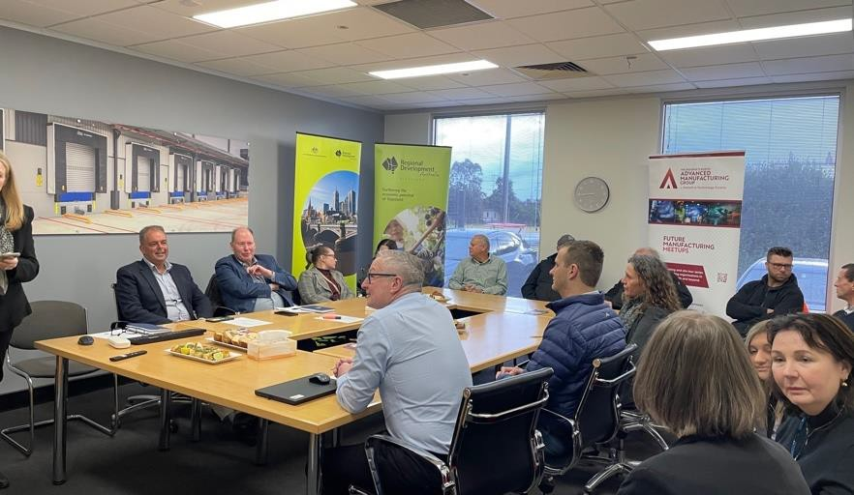
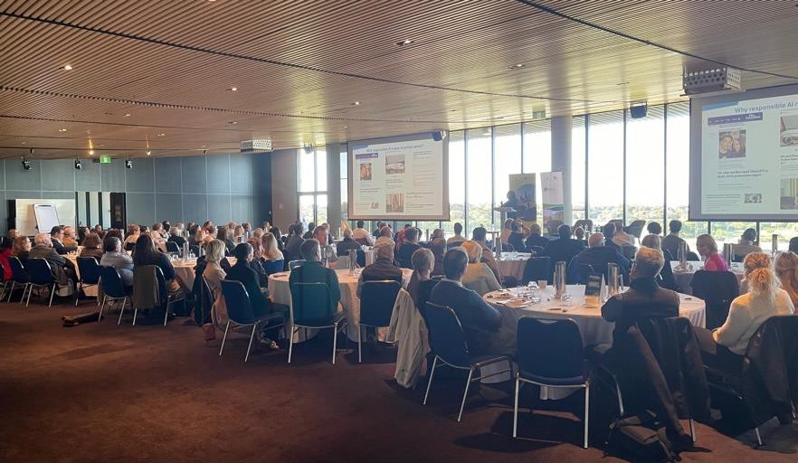


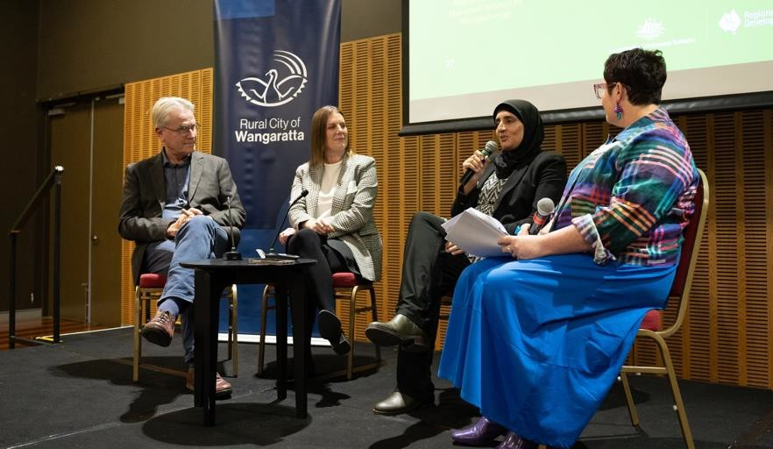

Communications Approach
All RDA Melbourne projects will include a detailed communication plan designed to target stakeholders, increase exposure of the RDA Melbourne work and influence outcomes. Key communication channels and opportunities that we will leverage in 2025-26 include:
- Engagement with Regional RDA Committee members via RDA Melbourne Committee members
- Collaborative RDA Chairs Meetings
- RDA online presence improvements
- Reports and submissions
- Roundtables, workshops and forums
- Industry showcases, tours and briefings
- Advocacy delegations.
We will explore ways to improve our online presence to promote our role, priorities, connections, resources, activities and outcomes, utilising our website, LinkedIn account and other appropriate platforms.
We will improve our reach by leveraging the extensive
business, political and community networks of RDA Committee members in Melbourne and beyond.
We will also explore opportunities to increase direct communication between our committee members and regional RDA committee members, potentially by adopting a portfolio approach to regional RDAs.
M E L B O U R N E


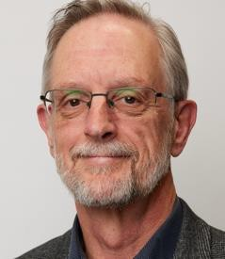


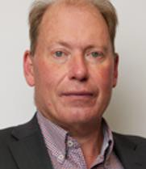
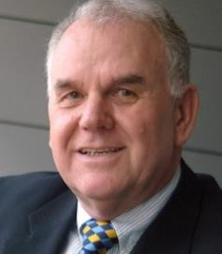

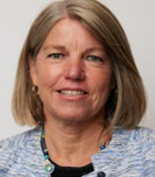
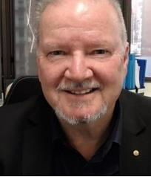

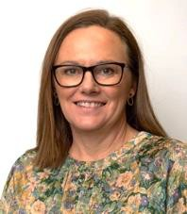
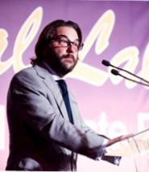

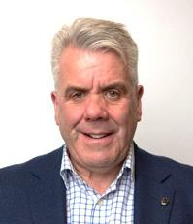
R DA M E L B O U R N E C O M M I T T E E
2 0 2 5 - 26
Tess Barling
Tess brings senior leadership experience in higher education, the arts and the visitor economy. Her
expertise spans strategy, communications, operations and stakeholder engagement. Tess currently manages major strategic initiatives with the University of Melbourne and is recognised for her ability to deliver impact across complex institutional environments.
Kath Buden
Kath has more than 20 years’ executive experience across policy, infrastructure and regional development. She is currently a Non- Executive Director at Wimmera Southern Mallee Development. Kath has led cross-functional teams, founded advisory firms, and is highly regarded for her governance expertise in multi-stakeholder settings, ensuring strong compliance and performance outcomes.
Stacey Daniel
Stacey is an award-winning consultant and non- executive director with deep experience across government, industry and the not-for-profit sector.
She is the founder of Board Presence, and serves on the board of Engineers Without Borders Australia. Stacey is a Graduate of the Australian Institute of Company Directors and a Fellow of Engineers Australia, known for her leadership in sustainable business
and governance.
David Gregory OAM
David is a recognised leader in Australia’s small business sector, awarded the Order of Australia in 2022. He has held CEO roles at SBMS and TSBI, and served on the Victorian Small Business Ministerial Advisory Council. David is involved with
Beyond Blue’s small
business program, the Order of Australia Association (Victoria), and is Executive Producer of the rural mental health film Just a Farmer.
Roslyn (Ros) Hore
Ros has over 25 years’ senior leadership experience across the public and private sectors, with a focus on research, innovation and stakeholder engagement.
She held senior roles at CSIRO and Swinburne University, working at the intersection of academia, government and industry. Ros now leads her own consultancy supporting large-scale collaboration and strategic partnerships.
Chris James
Chris is Executive Director at NORTH Link, bringing extensive experience in economic development, strategic planning and industry engagement. He has built strong networks across government, business, education, unions
and community groups, and is known for fostering regional growth and collaborative partnerships across northern Melbourne.
Jürgen Schneider
Jürgen is an experienced executive and director with a background in advanced manufacturing, energy and infrastructure. He was a Director of Monash University spinout Additive Assurance, and held senior roles at Siemens including Regional General Manager. Jürgen has led business development in the smart cities and mobility sectors across Australia and internationally.
Christine Tursky Christine is a director and governance expert with experience across
engineering, education and technology. She co-founded SouthTech Systems and has chaired several University of Melbourne advisory boards. Christine brings leadership and governance expertise from both multinational corporations and public sector institutions, with a strong commitment to advancing engineering
and innovation.
Steve Kozlowski, Chair With over 35 years’ experience in local government leadership, Steve is the CEO of
Maroondah City Council, a role he has held since 2014. Prior to this, he was CEO of East Gippsland Shire for nearly 11 years, and has held executive roles at Ringwood, Oakleigh and Maroondah councils. Steve is known for his collaborative approach, working across sectors to support economic development, resolve local issues and strengthen community outcomes.
We open doors to capital city resources that create, support and promote sustainable economic growth opportunities in regional Victoria
T H E R D A M E L B O U R N E E X E C U T I V E S U P P O R T T E A M
L-R: Anthony Schinck, Executive Director Regions Regional Development Victoria
Hayley Cail, Manager Place Based Partnerships
Michael Anderson, Senior Project and Policy Officer, RDA Melbourne
Lucy Hayes, Place Based Partnerships Policy Officer
M E L B O U R N E

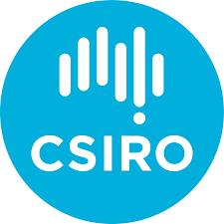



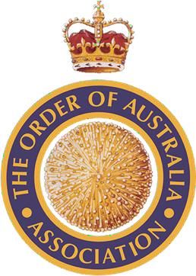
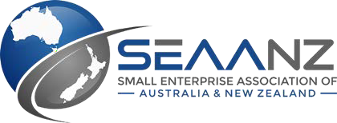
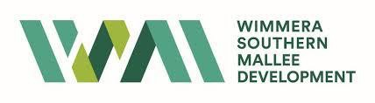

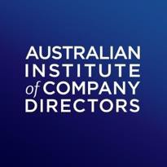
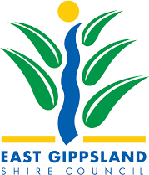


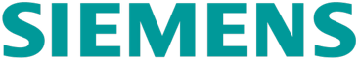

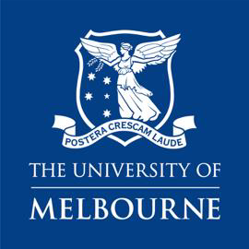
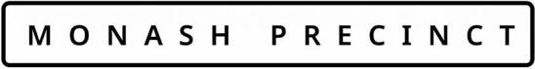


R DA
M E L B O U R N E
C O M M I T T E E
2 0 2 5 - 26
Capital City Connections
RDA Melbourne Committee members are selected for their industry expertise and deep understanding of how our communities function. With extensive international and local experience, the RDA Melbourne Committee members offer their regional colleagues direct access to Melbourne’s capital city resources as well as introductions to influential leaders across business and industry, research and education, government, logistics and resource sectors. The RDA Melbourne Committee members hold current or legacy leadership positions with the organisations represented on this page.
Executive Support
The RDA Melbourne executive support team promotes the region’s activities to all levels of government, industry, business and community, highlighting competitive advantages and encouraging decentralisation and relocation opportunities. They oversee RDA projects and report on activities, including the management and monitoring of the Commonwealth and State grants programs. RDA Melbourne hosts meetings and events in locations in Melbourne and across regional Victoria.
M E L B O U R N E


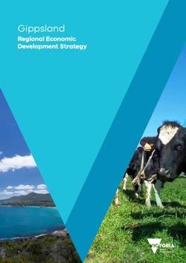
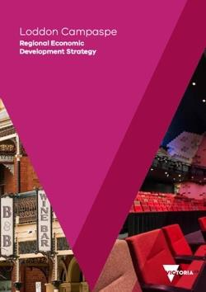

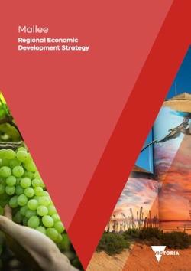

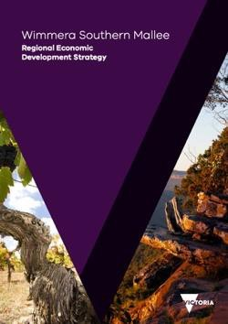

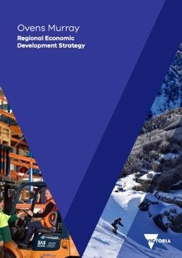

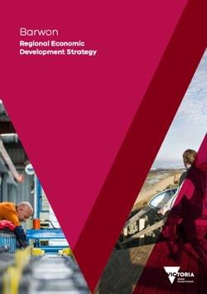
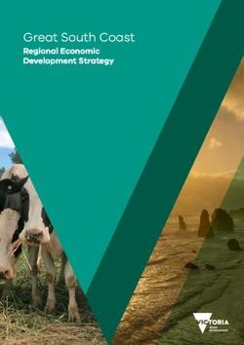
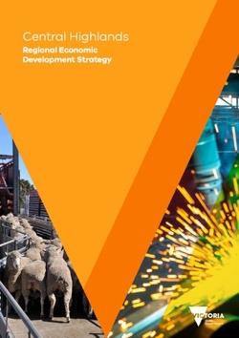

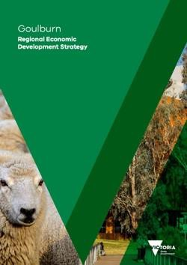

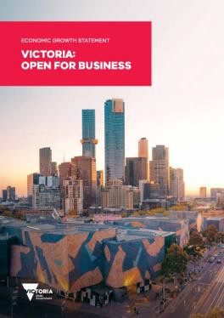

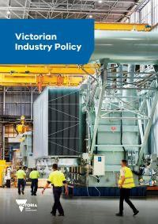
E C O N O M I C G R O W T H S TAT E M E N T &
Victorian Government
Strategic Alignments
In determining the strategic priorities and key business activities of this plan, RDA Melbourne considered the key actions and priority sectors presented in Victoria’s Economic Growth Statement, the Victorian Industry Policy, along with the evidence, themes and enablers presented in the Regional Economic Development Strategies (REDS).
The Economic Growth Statement is centred around four key actions: Open doors, Cut red tape, Build new skills, and Reach every community. It’s five key priority sectors are: Advanced manufacturing and defence, Health technologies and medical research, Circular economy, Digital technologies, and Agribusiness.
The REDS help to inform the strategic directions and business activities of all Victorian RDA Committees. They provide a consistent evidence base, the strategic framing of economic opportunities, and identify enabling factors that support economic activity in all regions of Victoria: Housing, Workforce, Digital Connectivity and Transport Connectivity.
The REDS also identified potential opportunities for Aboriginal economic development based on analysis of relevant policies and commitments including Traditional Owner strategic plans.
We will monitor our ongoing alignment with the REDS as they are updated during 2025.
R E G I O N A L
E C O N O M I C
D E V E L O P M E N T
S T R AT E G I E S
In late 2024, the Victorian Government released its Economic Growth Statement, complementing the Regional Economic Development
Strategies (REDS) that were previously developed with the regions, based on a strong evidence base that will be updated during 2025.
The REDS identified strategic directions and four key enablers of economic growth: housing, workforce, digital connectivity and transport connectivity. RDA Melbourne Business Plan 2025-26 business activities are informed by the REDS and the Economic Growth Statement.
M E L B O U R N E
REGIONAL PROFIILE
POLICY INSIGHTS
COMPARATIVE ADVANTAGE
STRATEGIC DIRECTIONS

Demographic, social and
economic indicators

Review of policies and local plans, informed by stakeholder engagement

Analysis of strengths and areas of
emerging specialisation

Medium to long-term priorities for future economic development

Australian Government
Strategic Alignments
The Australian Government’s Regional Investment Framework (RIF) is designed to provide an integrated and coordinated framework for regional development regardless of a region’s economic circumstances.
The Framework’s Guiding Principles are applied to all Australian Government investments in regions.
The Framework’s Priority Focus Areas include:
R E G I O N A L
I N V E S T M E N T F R A M E W O R K
P r i o r i t y F o c u s A r e a s
Meeting the needs of,
and providing opportunities for,
First Nations people
Supporting the transformation to
a net zero economy and
decarbonisation
•
Meeting the needs of, and providing opportunities
for, First Nations people.
Supporting the transformation to a net zero
economy and decarbonisation
Achieving gender equality.
Supporting gender equality opportunities
•
•
https://www.infrastructure.gov.au/territories-regions-
cities/regional-australia/regional-investment-framework
R D A M E L B O U R N E ’ S
U N D E R P I N N I N G P R I N C I P L E S
RDA Melbourne has considered the guiding principles, priority focus areas, key objectives and implementation process of the Regional Investment Framework
and the Yuma Yirramboi (Invest in Tomorrow) Strategy (2023) in determining the strategic priorities and key business activities of this plan.
We consider the impacts of all our activities through a lens of the RIF Priority Focus Areas and we will identify and facilitate initiatives that progress their objectives.
M E L B O U R N E

Investing in People

Investing in Places

Investing in Services

Investing in Industries
and Local Economies
Listening to local voices and partnering with communities. Targeted investment in skills, education, training and local leadership capacity.
Supporting adaptive, accessible, sustainable and liveable regions. Delivering infrastructure where and when it is needed.

Enhancing connectivity, accessibility
and equity of services. Investment including across communications, health, water, and transport.
Investment to help activate economic and industry growth. Supporting the conditions needed for industries to diversify
and grow.



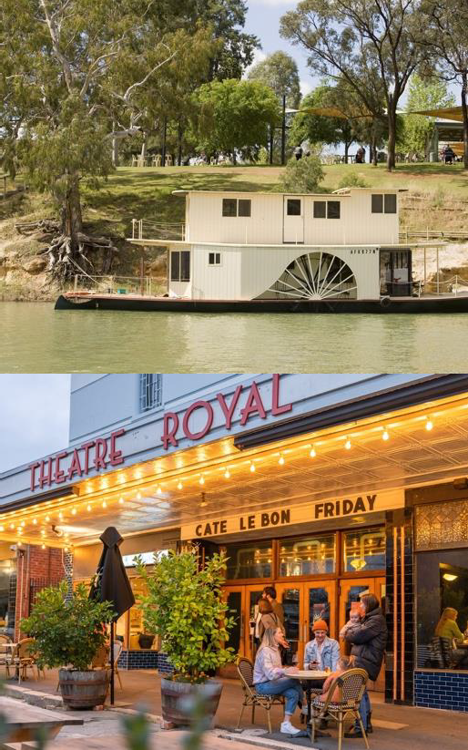
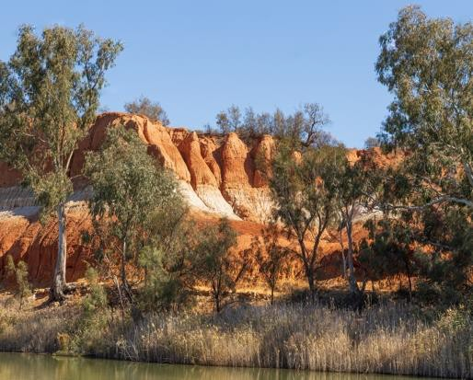

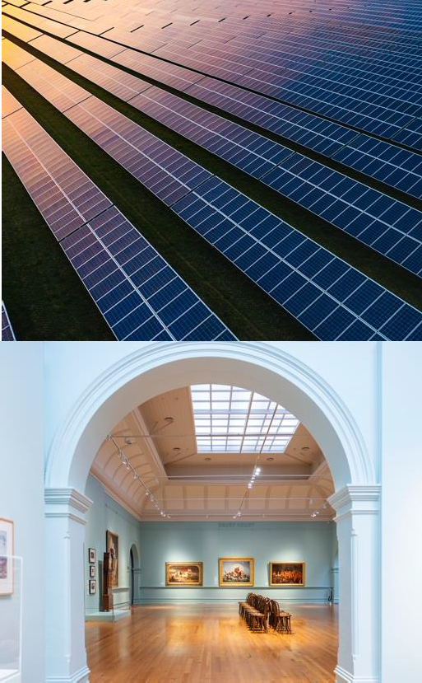
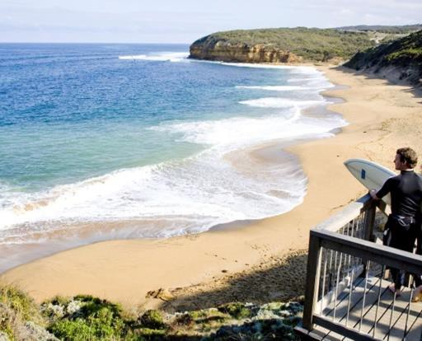




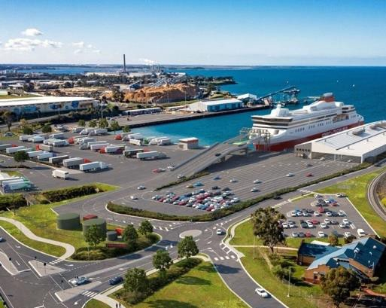


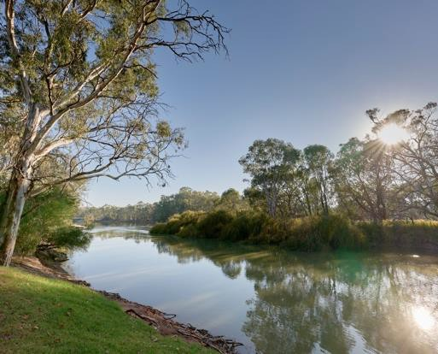

Contact us
RDA Melbourne provides advice to the
Australian Government and is committed to working with stakeholders across Victoria on critical development issues affecting the regions.
Hayley Cail
Manager, Place Based Partnerships
Phone: +61 472 868 782
Hayley.Cail@ecodev.vic.gov.au
Michael Anderson
Senior Project and Policy Officer, RDA Melbourne Phone: +61 411 021 226
Michael.Anderson@ecodev.vic.gov.au
RDA Melbourne
Level 31, 121 Exhibition Street Melbourne VIC 3000
M E L B O U R N E

